SCREENING OF GRAPE VARIETIES FOR RESISTANCE TO ANTHRACNOSE UNDER NATURAL CONDITIONS

ABSTRACT
Grape (Vitis vinifera L.) is an economically important fruit crop, but its production is severely constrained by several fungal diseases such as downy mildew (Plasmopara viticola), powdery mildew (Erysiphe necator), anthracnose (Colletotrichum gloeosporioides) and Botrytis bunch rot (Botrytis cinerea). Among them anthracnose caused by Colletotrichum gloeosporioides significantly reduce 80-100 per cent yield, fruit quality and marketability under favourable conditions. Anthracnose severity was evaluated on eight grape varieties during the back pruning seasons of 2024 and 2025 at Raichur. Thompson Seedless showed the earliest onset, fastest progression and highest Per cent disease index (PDI) (100% in both years) with the highest area under disease progress curve (AUDPC) and apparent infection rate. Other varieties recorded high PDI such as Manik Chaman (85.25-88.63%), 2-A Clone (79.25-84.73%), Sharad Seedless (69.50-65.73%), K.R. White (66.63-62.25%), Manjari Naveen (64.25–59.63%), Fantacy Seedless (58.75-53.75%) and Medica (62.73-57.25%). Fantacy Seedless and Medica progressed slowly, while Sharad Seedless, K.R. White and Manjari Naveen were moderately progressed. All varieties were classified as highly susceptible, emphasizing varietal differences and the need for timely disease management.
Keywords: Anthracnose, Colletotrichum gloeosporioides, Screening, Tolerant, Susceptible

1. Introduction
The grape (Vitis vinifera L.) is one of the most economically important fruit crops in the world and has many uses. Fruit is eaten fresh or made into juice, fermented to wines and brandy and dried into raisins and sultanas (Roger and Goheen, 1998). Grapes are a major temperate fruit that adapted well to subtropical and tropical climates. They are rich in sugars, acids (tartaric and malic), vitamins (B₁, B₂), minerals (calcium, phosphorus, iron) and anthocyanidin pigments (Radha and Mathew, 2007). Globally, grapes are cultivated on approximately 7.1 million ha, producing 77.7 million tonnes with a productivity of 10.9 t/ha (2024), with major producers including China, Italy, France, Spain, USA, Turkey and India (Anon., 2025). In India, the table grape industry mainly relies on varieties such as ‘Thompson Seedless’ and ‘Sharad Seedless’. About 85 per cent of India’s 179.63 thousand hectares grape area lies in tropical regions, producing 3904.29 thousand tonnes with an average productivity of 21.74 t/ha, with major contributions from Maharashtra, Karnataka, Telangana and Tamil Nadu. Among these, Karnataka produced 1224.67 thousand tonnes of grapes from 47.12 thousand hectares, achieving an average productivity of 25.99 t/ha (Anon., 2024).
Anthracnose is one of the most damaging diseases of grape but its production is severely constrained by several fungal diseases such as downy mildew (Plasmopara viticola), powdery mildew (Erysiphe necator), anthracnose (Colletotrichum gloeosporioides) and Botrytis bunch rot (Botrytis cinerea) and anthracnose caused by Colletotrichum gloeosporioides responsible for yield losses in commercial grape production. In wet humid regions the disease incidence and severity on various cultivars of grape can be very serious (Kummuang et al., 1996). These pathogens differ in their modes of infection, biotrophic fungi such as E. necator and P. viticola feed on living tissues, while necrotrophic pathogens like B. cinerea colonize dead tissues. Anthracnose pathogens exhibit a hemibiotrophic lifestyle, beginning as biotrophs and later becoming necrotrophs (Pieterse et al., 2009). In north India, it appears every year from July to September with peak damage during August and reduces the quality and quantity of produce. In south India, the disease prevails from March to October with peak damage during May-July. Bedi et al. (1969) reported 15-20 per cent losses in various grape varieties in Punjab and Haryana. Sridhar and Sohi (1976) observed severe crop damage in Karnataka. Jindal and Bhavani (2002) recorded to be 10-46.5 per cent reduction in grape yield in Punjab. In Maharashtra, Deshmukh (2006) reported annual losses ranging from 15 to 30 per cent, while under favourable conditions, severely impacts fruit quality and marketability. Globally, Anderson (1956) documented that during 1950-51 in Chile, anthracnose resulted in devastating crop failures across several hundred acres, particularly affecting susceptible grape varieties with losses ranging from 83 to 100 per cent. Similarly, Winkler (1965) reported yield reductions of up to 80 per cent in Russia due to this disease. In China, He (1999) observed that anthracnose accounted for an 18.5 per cent decline in grape production.
The disease affects all the aerial parts in the green stage, mostly on the new shoots and fruits. On leaves small circular to irregular, 1-5 mm diameter in size, dark brown spots appear which later turn grey in the centre and dark brown at the margins. The central necrotic tissue often falls off leaving a shot hole appearance. In severe cases the complete drying of leaves is also noticed. On petioles and stems, light brown spots appear which are first circular in outline but later elongating into elliptical, sunken necrotic cankers. On shoots and tendrils, small isolated light brown spots develop which elongate to form elliptical, slightly sunken lesions. Later, the central area of the lesion develops into ashy grey colour bordered by darker rim. The affected shoots may be restricted in growth as well as shedding of inflorescence/flower buds takes place due to infection. On berries, typical bird’s eye spot symptoms appear having violet to greyish centre and dark brown margins.
Several studies have reported the occurrence of resistant sources against grape anthracnose. however, most findings indicate that the widely cultivated variety of the region, Thompson Seedless is highly susceptible to the disease. Identifying alternative cultivars that combine resistance with desirable commercial traits would therefore provide valuable options for farmers to manage anthracnose more effectively. Considering the economic importance of the grape and the need to identify varietal reactions under local conditions, a systematic screening of available grape varieties was undertaken during successive back pruning seasons to assess their response to Colletotrichum gloeosporioides under field conditions.
2. Material and Methods
A collection of eight grape varieties planted at the Horticultural Farm, College of Agriculture, Raichur, was evaluated for their response to anthracnose disease under natural epiphytotic conditions during the cropping season 2024-25. Back pruning was carried out on 15th April 2024 and 20th March 2025. The screening was conducted to assess the severity of the disease among the genotypes and to identify potential sources of resistance for management strategies. Observations were meticulously recorded by randomly selecting 40 leaves from eight representative branches per vine across all genotypes, ensuring a reliable and unbiased estimation of disease intensity. The disease severity on each leaf Based on the PDI values, the cultivars were categorized into five distinct reaction groups following the scale proposed by Chatta (1992): tolerant (0.1-5.0), moderately tolerant (5.1-10.0), moderately susceptible (10.1-25.0), susceptible (25.1-50.0) and highly susceptible (50.1 and above). This classification provided a clear understanding of the resistance or susceptibility levels of each genotype under field conditions, offering valuable insights for selecting resistant cultivars for anthracnose management in grape cultivation. The grape varieties tested against anthracnose included Thomson Seedless, Manik Chaman, Sharad Seedless, 2-A Clone, K. R. White, Manjari Naveen, Fantacy Seedless and Medica.
List 1. Categorisation depending on the percentage of infection of leaf
Category | Numerical value | Description
I | 0 | Healthy foliage or leaf spots in traces
II | 1 | Up to 10 per cent leaf area covered with anthracnose lesions
III | 2 | 10.1-25 per cent leaf area covered with slight twig infection i.e., 1-3 cankers per twig
IV | 3 | 25.1-50 per cent leaf area covered with heavy twig infection i.e., 4-10 cankers per twig
V | 4 | Above 50 per cent leaf area covered with very heavy twig infection i.e., above 10 cankers per twig and heavy berry infection
Per cent disease intensity (PDI) was recorded by using formula:
$$\text{Per cent disease index}=\frac{\text{Sum of the individual disease ratings}}{\text{Number of leaves observed}}×\frac{\text{100}}{\text{Maximum disease grade}}$$
List 2. . Categorisation of resistance or susceptibility levels
Reaction category | Per cent disease index
Tolerant | 0.1-5.0
Moderately tolerant | 5.1-10.0
Moderately susceptible | 10.1-25.0
Susceptible | 25.1-50.0
Highly susceptible | 50.1 and above

3. Results and Discussion
During the back pruning season of 2024, all the evaluated grape varieties exhibited high disease severity under natural epiphytotic conditions. The variety Thomson Seedless recorded the highest disease severity with a 100 per cent disease index (PDI), serving as the check. Among the other varieties, Manik Chaman (85.25%), 2-A Clone (79.25%), Sharad Seedless (69.50%), K. R. White (66.63%), Manjari Naveen (64.25%), Medica (62.73%) and Fantacy Seedless (58.75%) also showed significant levels of infection. A similar trend was observed during the 2025 back pruning season. Thomson Seedless again showed maximum disease severity with 100 PDI, confirming its high susceptibility to anthracnose. Other varieties also displayed significant infection levels, ranging from 53.75 per cent in Fantacy Seedless to 88.63 per cent in Manik Chaman. Sharad Seedless (65.73%), 2-A Clone (84.73%), K.R. White (62.25%), Manjari Naveen (59.63%) and Medica (57.25%) followed a similar pattern of disease reaction. Based on the 0-4 disease rating scale, all the screened varieties were rated as highly susceptible to anthracnose, with none of the varieties falling under the tolerant or moderately susceptible categories (Table 1 and 2 and Plate. 1).
The results from both years revealed that, all the screened varieties were susceptible with no varieties showing tolerance or moderate tolerance to anthracnose. The constant 100 per cent disease severity in Thomson Seedless and high PDI values in all other varieties indicated that the widespread susceptibility of commercial grape cultivars to anthracnose under natural conditions. The slight reduction in PDI values in 2025 compared to 2024 might be due to differences in seasonal weather conditions, particularly variations in the humidity, temperature and varietal differences during the infection period.
Similar trends were observed by Shetty et al. (2015) who screened 266 grape genotypes at the National Active Germplasm Site, ICAR-NRC for Grapes, Pune and identified 61 genotypes as resistant to anthracnose, while all major commercial cultivars were found susceptible. Among the 18 cultivars screened for tolerance to anthracnose under natural epiphytotic conditions, the cultivars Marroo, Himrod, Khalilli, Flame Beauty and Sonaka exhibited a tolerant reaction. Four cultivars Manik Chaman, Crimson Seedless, Ararat and Hussaini were moderately tolerant. The remaining cultivars showed either susceptible or highly susceptible reactions. Notably, Anab-e-Shahi and Perlette grape cultivars were found to be susceptible to Sphaceloma ampelina (Banday, 2013). Similarly, Jamadar (2007) evaluated 19 grape genotypes reported that Arka Majestic and Bangalore Blue were highly resistant, whereas widely cultivated varieties such as Thompson Seedless, Anab-e-Shahi, Cheema Sahebi and IIHR genotypes Arka Hans and Arka Nilamani were highly susceptible exhibiting more than 50 per cent infection.
4. Conclusion
Anthracnose severity was evaluated on eight grape varieties during the back pruning seasons of 2024 and 2025 at Raichur. Thompson Seedless showed the earliest onset, fastest progression and highest PDI (100% in both years) with the highest AUDPC and infection rate. Other varieties recorded high PDI such as Manik Chaman (85.25-88.63%), 2-A Clone (79.25-84.73%), Sharad Seedless (69.50-65.73%), K. R. White (66.63-62.25%), Manjari Naveen (64.25-59.63%), Fantacy Seedless (58.75-53.75%) and Medica (62.73-57.25%). Fantacy Seedless and Medica progressed slowly, while Sharad Seedless, K. R. White and Manjari Naveen were moderately progressed. All varieties were classified as highly susceptible, emphasizing varietal differences and the need for timely disease management.
Disclaimer (artificial intelligence)
Author(s) hereby declare that NO generative AI technologies such as Large Language Models (ChatGPT, COPILOT, etc.) and text-to-image generators have been used during the writing or editing of this manuscript.

References
Anderson, H. W., 1956, Disease of fruit crops. Tata Mcgraw hill book Co. Inc, New York, USA.
Anonymous, 2024, India stat, area, yield and production for the year 2023-2024. http://www.indiastat.com
International Organisation of Vine and Wine. (2025). World Wine Production Outlook I - OIV First Estimates 2025. International Organisation of Vine and Wine. https://www.oiv.int/what-we-do/statistics
Banday, S., 2013, Histopathology, epidemiology and management of anthracnose disease of grapes in Kashmir. Ph. D. Thesis, Sher-e-Kashmir Univ. Agric. Sci. and Technol, Jammu and Kashmir, Shalimar (India).
Bedi, P. S., Singh, G., & Suryanarayana, D. (1969). Field testing of aureofungin and other chemicals to control anthracnose disease of grape in the Punjab. Hindustan Antibiotics Bulletin, 11(4), 251–253. https://pubmed.ncbi.nlm.nih.gov/5352000/
Chatta, S. K., 1992, Biology, perpetuation and control of grape vine anthracnose caused by Sphaceloma ampelinum Shear (Elsinoe ampelina Shear). M. Sc. Thesis, Sher-e-Kashmir Univ. Agric. Sci. Technol., Jammu and Kashmir, Shalimar (India).
Deshmukh, R. B., 2006, Grape research in Maharashtra. In Proc. Int. Symp. Grape Prod. Process, pp. 6-11.
He, P. C., 1999, Viticulture. China Agric. Press, Beijing, China.
Jamadar, M. M., 2007, Etiology, epidemiology and management of anthracnose of grapevine. Ph. D Thesis, Univ. of Agric. Sci. Dharwad (India).
Jindal, P. C. and Shankar Bhavani, 2002, Screening of grape germplasm against anthracnose (Sphaceloma ampelinum de bary). Indian J. Agric. Res., 36(2): 11-14.
Kummuang, N., Smith, B. J., Diehl, S. V., & Graves, C. H., Jr. (1996). Muscadine Grape Berry Rot Diseases in Mississippi: Disease Identification and Incidence. Plant Disease, 80, 238-243. https://doi.org/10.1094/PD-80-0238
Pieterse, C. M. J., Leon-Reyes, A., Van der Ent, S., & Van Wees, S. C. M. (2009). Networking by small-molecule hormones in plant immunity. Nature Chemical Biology, 5(5), 308-316. https://doi.org/10.1038/nchembio.164
Radha, T. and Mathew, L., 2007, Fruit Crops. New Delhi publishing Agency, India.
Pearson, R. C., & Goheen, A. C. (1988). Compendium of grape diseases. APS Press.
Shetty, D. S., Sawant, I. S., Narkar, S. P., Ghule, S., Satisha, J., & Karibasappa, G. S. (2015). Screening of Grape Genotypes to Identify Sources of Resistance to Anthracnose Disease and Identifying Biochemical Marker Associated With Resistance. Indian Phytopathology, 68(4), 424-431. https://epubs.icar.org.in/index.php/IPPJ/article/view/54624
Sridhar, T. S. and Sohi, H. S., 1976, Control of diseases. Proceedings of All India Coordinated Fruit Improvement Project Workshop. Hyderabad. p. 51.
Winkler, A. J., Cook, J. A., Kliewer, W. M., & Lider, L. A. (1974). General viticulture. University of California Press. https://www.ucpress.edu/book/9780520025912/general-viticulture
S

Table 1. Screening of grape varieties against anthracnose under natural epiphytotic conditions of Kharif 2024 and 2025
Sl. No. | Varieties | Back pruned stage  PDI (Apr. 2024) | Back pruned stage  PDI (Apr. 2025) | Disease ratings (0-4) | Overall reaction
1 | Thomson Seedless | 100.00 (Check) | 100 (Check) | 4 | Highly susceptible
2 | Manik Chaman | 85.25 | 88.63 | 4 | Highly susceptible
3 | Sharad Seedless | 69.50 | 65.73 | 4 | Highly susceptible
4 | 2-A Clone | 79.25 | 84.73 | 4 | Highly susceptible
5 | K. R. White | 66.63 | 62.25 | 4 | Highly susceptible
6 | Manjari Naveen | 64.25 | 59.63 | 4 | Highly susceptible
7 | Fantacy Seedless | 58.75 | 53.75 | 4 | Highly susceptible
8 | Medica | 62.73 | 57.25 | 4 | Highly susceptible

Table 2. Reaction of grape varieties to anthracnose disease under field conditions during back pruning season of 2024 and 2025
Reaction category | Per cent disease index | Variety
Tolerant | 0.1-5.0 | -
Moderately tolerant | 5.1-10.0 | -
Moderately susceptible | 10.1-25.0 | -
Susceptible | 25.1-50.0 | -
Highly susceptible | 50.1 and above | Thomson Seedless, Manik Chaman, Sharad Seedless, 2-A Clone, K. R. White, Manjari Naveen, Fantacy Seedless, Medica

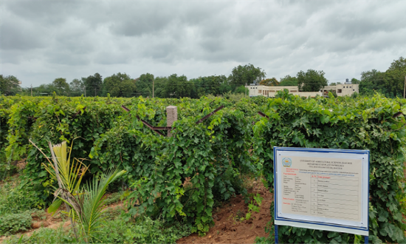 |  | 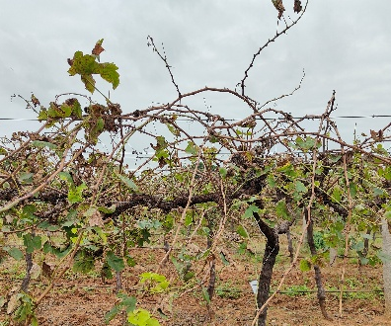 | 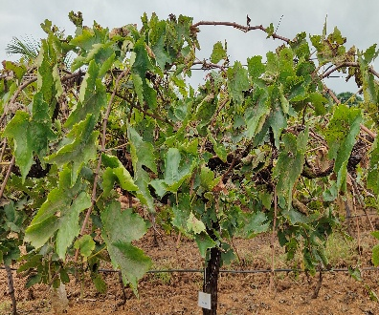 | 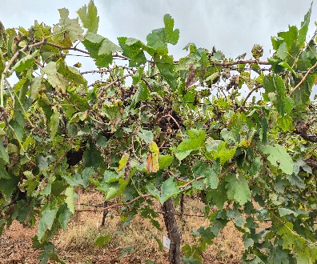
Field view |  | Thompson Seedless | 2 A Clone | Sharad Seedless
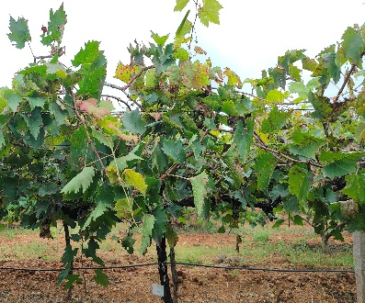 | 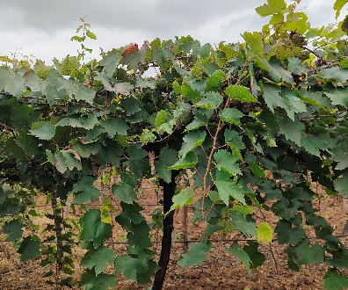 | 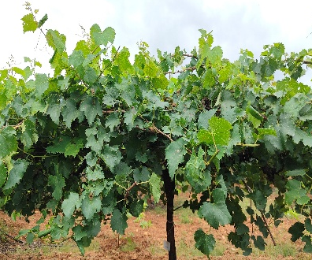 | 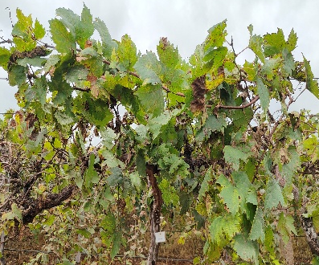 | 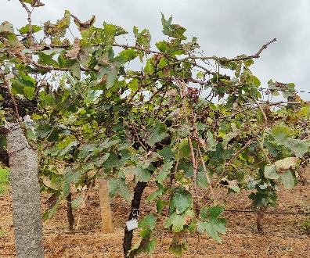
Manjari Naveen | Medica | Fantacy Seedless | K. R. White | Manik Chaman

Plate 1. Response of grape varieties against anthracnose under natural conditions during Kharif 2025

