Role of Farm Machinery Innovations in Enhancing Crop Yields in Smallholder Systems: A Review

Abstract
Smallholder farmers produce a large share of food in many low- and middle-income countries, yet persistently low yields limit food security and rural incomes. Recent innovations in scale-appropriate farm machinery including two-wheel tractors and dedicated small implements (seeders, transplanters, rotary weeders), digital decision tools, and innovative service models (custom hire, tool banks, rental/co-op arrangements) are changing how smallholders access power, do timely field operations, and adopt conservation agriculture. Evidence indicates mechanization can increase timeliness of operations, reduce drudgery and labor bottlenecks, and contribute to higher productivity when paired with good agronomy and input access. However, constraints such as cost, access to finance and after-sales services, gendered labor impacts, land fragmentation, and risks to sustainability remain. This review synthesizes recent evidence, highlights pathways by which machinery raises yields, discusses barriers, and proposes policy, design, and research priorities to maximize benefits for smallholders.
Keywords: smallholder mechanization, two-wheel tractors, custom hiring, conservation agriculture, yield enhancement, service models, appropriate technology
Introduction
Smallholder agriculture forms the backbone of rural livelihoods, food supply chains, and national economies across Asia, Africa, and Latin America. In many low- and middle-income countries, more than 70% of farms are less than two hectares in size, with these farming systems collectively producing a substantial share of staple cereals, pulses, fruits, and vegetables. Improving productivity for these smallholder systems is thus essential to achieving relevant SDGs on food security, reduction of rural poverty, and climate resilience (Reddy, 2022).
Historically, mechanization has been associated with large-scale, capital-intensive technologies designed for commercial farms. In contrast, over the last few decades, there has been a paradigm shift towards the development of scale-appropriate farm machinery designed to respond to the needs, constraints, and resource endowments of smallholders (Stewart, et al., 2015). This changing landscape has included the development of two-wheel tractors, mini-tillers, small combine harvesters, precision seeders, potato planters, solar-powered irrigation pumps, and smart digital-enabled machinery. These technologies are designed to reduce drudgery, enhance timeliness, improve operational accuracy, and support climate-smart agricultural practices (Stewart, et al., 2016).
Flow chart 1
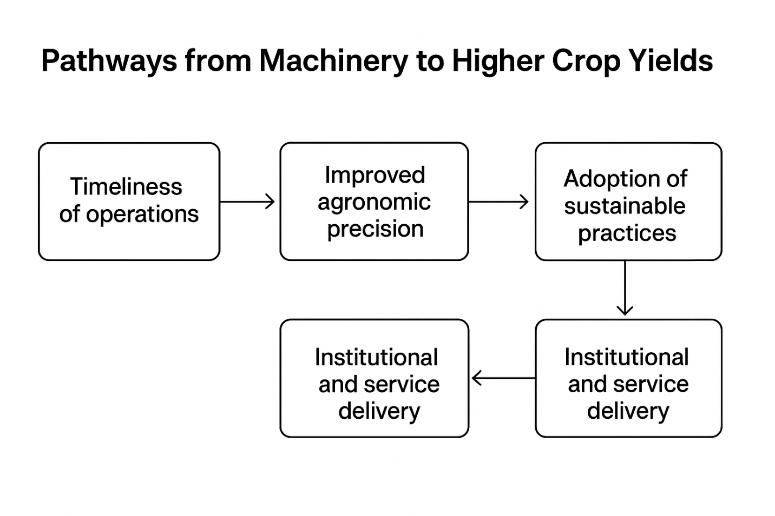

Timeliness of agricultural operations land preparation, sowing, weeding, and harvesting, in particular is a critical determinant of crop yield (Gaffney, et al., 2019). Innovations in farm machinery assist farmers in conducting these operations within optimum windows and, therefore, reduce yield penalties due to late planting and poor weed control. Precision machinery, like no-till seeders and micro-dosing implements, also supports efficient resource use, including seeds, fertilizers, and irrigation water (Sims, and Kienzle, 2017).
Mechanization does more than substitute labor: it paves the way for transition to conservation agriculture by allowing retention of residue, reducing tillage, and improving soil health (Singh, et al., 2020). In addition, mechanization can facilitate integrated crop management, RCTs, and precision farming. There is growing empirical evidence that mechanization leads to increased yields, reduced post-harvest losses, lower production costs, and greater labor productivity; however, the outcomes vary according to the local context, availability of services, training, and type of machinery adopted (de Araúujo, et al., 2020)

Importantly, mechanization is increasingly delivered through innovative service provision models, which include but are not limited to custom hiring centers, machinery rings, and digital "Uber-like" platforms, that allow farmers to access machines without owning them (de Sousa e al., 2024). These models address affordability constraints and reduce risk while generating rural employment for machinery operators and service providers.
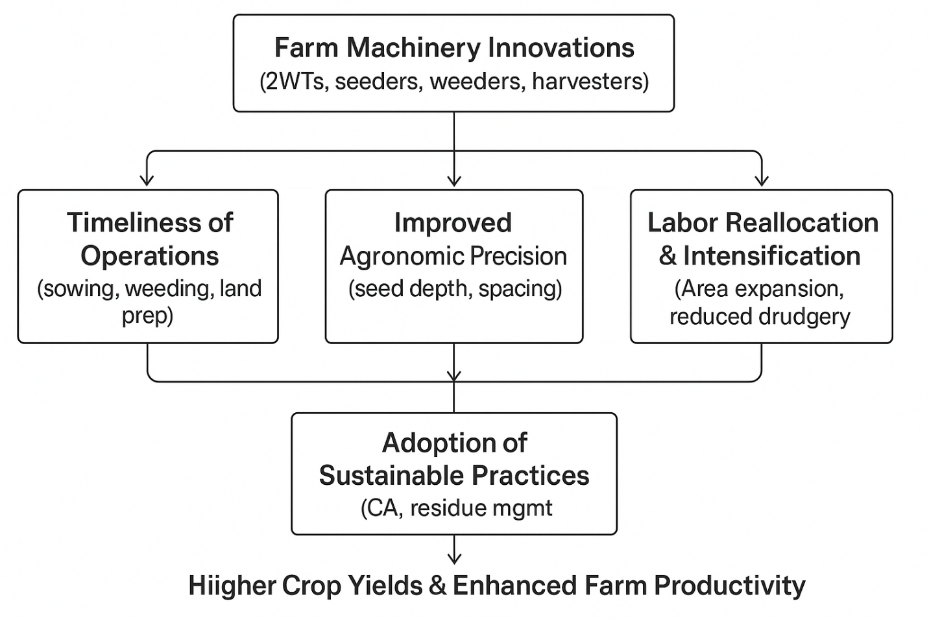
Flow chart 2
The prevalent issues include limited access to credit, weak repair and maintenance ecosystems, a lack of technical training, and fragmented policies. The environmental concerns, such as the risk of soil compaction or over-tillage, equally raise concerns on machinery use and training that should be context-specific. A systematic review of such dynamics will, therefore, be important in informing policymakers, researchers, and practitioners working toward scaling smallholder-relevant mechanization solutions. This review synthesizes recent innovations, assesses their impact on crop yields in the smallholder context, and identifies enabling conditions and research gaps for sustainable pathways of mechanization.
Types of Farm Machinery Innovations Relevant to Smallholders
Farm machinery innovations designed for a smallholder context are generally focused on affordability, operational suitability for small and fragmented plots, reduction of labor drudgery, and compatibility with climate-smart farming (Porwal, et al., 2023). These innovations could, therefore, be divided into four categories: scale-appropriate power units, small implements, digital/precision tools, and service delivery models. Each of these makes different contributions toward productivity enhancement and sustainable intensification.
Seeder
Seeders, transplanters, and rotary weeders play a crucial role in modern agricultural mechanization by improving precision, reducing labor requirements, and enhancing overall field efficiency. Seeders ensure uniform placement of seeds at the correct depth and spacing, which improves germination and crop establishment compared to traditional broadcasting (Singh, et al., 2020). Modern seed drills such as multi-row seeders, zero-till seeders, pneumatic precision seeders, and two-wheel tractor (2WT) seeders help farmers reduce seed rates by 20–40% while enabling timely sowing and supporting conservation agriculture practices. Although highly efficient, these machines require periodic calibration and involve relatively higher initial costs, especially in the case of pneumatic precision models (Mkomwa, et al., 2014).
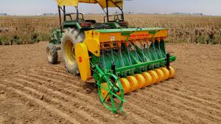

Figure-1:- Image of Seeder
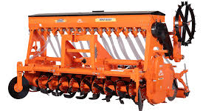

Figure-2:- Image of Super Seeder
Transplanter
Transplanters mechanize the process of shifting seedlings from nurseries to the field, thereby reducing the labor-intensive nature of manual transplanting (Singh, et al., 2016). Rice transplanters and vegetable transplanters maintain uniform planting depth and spacing, improving plant stand and yield while cutting labor use by 60–80%. They also enhance timeliness, especially in crops like rice, where delays in transplanting can significantly affect productivity. However, transplanters require well-prepared fields and uniform seedlings, and their high cost may limit adoption among smallholder farmers (Chaitanya, et al., 2018).
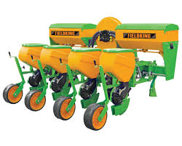

Figure 3- Image of transplanter
Rotary weeders
Rotary weeders offer an effective mechanical solution for weed management by uprooting weeds between crop rows while simultaneously aerating the soil. Manual and power-operated rotary weeders are widely used in rice, vegetables, maize, and other row crops, reducing labor needs by 40–60% and lowering dependence on herbicides. Despite their advantages, rotary weeders perform best in fields with proper row spacing and moderate soil moisture, as excessively wet or densely weeded fields can reduce their efficiency.
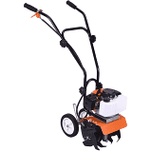

Figure 4- image of weeder
Together, seeders, transplanters, and rotary weeders significantly enhance crop establishment, reduce input wastage, and support sustainable and labor-efficient agricultural production, particularly when integrated with small-scale mechanization solutions like two-wheel tractors.
Scale-Appropriate Power Units
Scale-appropriate mechanization focuses on appropriate power sources considering the small landholdings, low investment capacity, and field condition variability commonly associated with smallholder farming systems (Loeks, 2023). 2WTs-or power tillers-have become a "best-fit" technology between manual or animal traction and large four-wheel tractors. As relatively small and maneuverable power units with the ability to operate a range of attachments, 2WTs can be used for puddling, rotavation, inter-cultivation, irrigation pumping, and transport (Saha, et al., 2021).

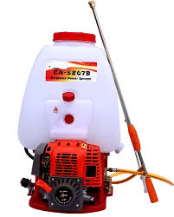

Figure 5- Image of power sprayer
Recent innovations include lightweight four-wheel tractors adapted for narrow plots and rough terrains, often designed to work with specialized small implements like precision seeders, seed-cum-fertilizer drills, rippers, and happy seeders (Daum, et al., 2023). These units support the adoption of conservation agriculture practices, particularly no-till seeding, minimum soil disturbance, and retention of residues that favorably affect soil structure and reduce turnaround time, with often improved yields as well (Bawden, 2015). Studies indicate a reduction of operational time by 40–60% without compromising crop productivity in 2WT-based no-till systems (Hoque, et al., 2021).
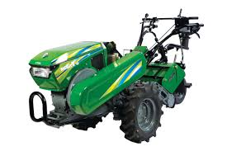

Figure 6-Image of Power tiller

Small Implements and Labor-Saving Tools
Beyond tractors, small implements and labor-saving devices play an important role in enabling mechanization for those farmers who cannot invest in even modest power units. This includes innovations like:
Low-cost seeders and planters, manual or animal-drawn, that provide uniform seed placement for better germination (Kumar, 2018)
Mechanical transplanters for rice, vegetables, and oilseed crops that reduce labor demand during peak planting periods (Rahaman, et al., 2022).
Rotary weeders and mechanical weeders that enhance efficiency of weed control, reduce reliance on herbicides, and improve crop stand establishment (Zawada, et al., 2023).

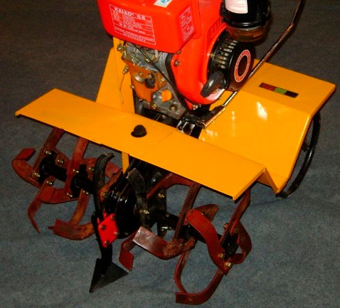

Figure 7. Datang 2 WT with rotary cultivator. (Photo: Brian Sims).
(Source, Sims, and Kienzle, 2016).
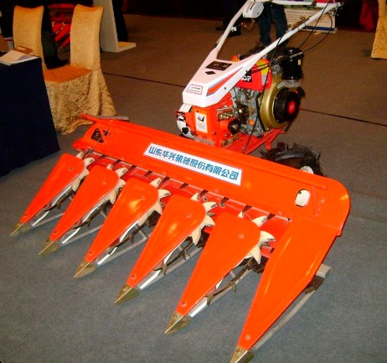

Figure 8. Huaxing cereal harvester mounted on a 4 kW (5.4 hp) 2 WT. (Photo: Brian Sims).
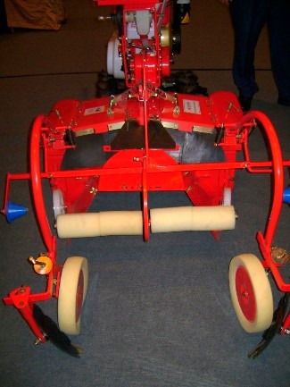
(Source, Sims, and Kienzle, 2016).

Figure 9. Huaxing plastic mulch-laying machine. The tractor forms the 1 m-wide ridge before applying the mulching film (Photo: Brian Sims).
(Source, Sims, and Kienzle, 2016).

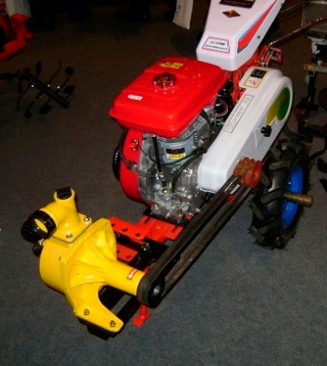

Figure 10. Huaxing 2 WT driving a water pump for crop irrigation (Photo: Brian Sims).
(Source, Sims, and Kienzle, 2016).
Hand-operated tools include jab planters, cono weeders, and drum seeders.
- Micro-harvesters and reapers are designed for small and fragmented fields for crops such as rice, wheat, and sugarcane.
Participatory trials have improved design efficiencies, durability, and cultural acceptance. Field testing has continually shown reductions in labor hours and drudgery along with gains in speed, precision, and operational uniformity. In general, these advantages will become increasingly important in areas facing rural labor shortages or rising rural wage rates.
Digital and Precision Tools Integrated with Machinery
Recent mechanization programmes are increasingly incorporating digital tools and precision agriculture technologies to improve the efficiency of use of machinery (Seid Ahmed, et al., 2025). Smallholder-appropriate precision tools include:
- Mobile-based advisory platforms providing satellite-driven advisories on planting windows, irrigation scheduling, and pest management.
- AI-powered applications that tune machinery settings, like seeding depth or application rates of fertilizers.
- Low-cost sensors measure soil moisture, nutrient levels, or machine performance.
- Decision support systems to help optimize fertilizer micro-dosing, pesticide spraying, and mechanical weeding.
These digital enhancements maximize the agronomic gains from mechanization, through improvement in the precision and timeliness of operations. This bundling of advisory services with machinery training even reduces misuse, enhances input-use efficiency, and increases yield gains associated with mechanized practices.

Smart Irrigation & Water Management
Water scarcity remains one of the most pressing global agricultural challenges, with irrigation accounting for nearly 70% of total freshwater withdrawals, much of it used inefficiently (FAO, 2020). Smart irrigation systems, which integrate IoT-based sensors and advanced drip irrigation technologies, are transforming water management by optimizing water use, minimizing losses, and increasing crop yields. Soil moisture sensors including capacitive probes and tensiometers provide real-time information on water availability at different root-zone depths, which helps farmers design precise irrigation schedules. These sensors typically send data through LoRaWAN or cellular networks to cloud platforms, where AI-driven analytics evaluate moisture trends and automate irrigation decisions (Goap et al., 2018).
Microsoft’s FarmBeats, for example, integrates IoT devices with drone and satellite imagery to generate high-resolution soil moisture maps, enabling farmers to reduce irrigation water use by 20–30% in pilot applications. Alongside these sensing systems, automated drip irrigation systems deliver water directly to the crop root zone through pressurized emitters, significantly reducing evaporation and runoff losses (Bwambale et al., 2022). Advanced commercial solutions such as Netafim’s Precision Irrigation use real-time weather forecasts and evapotranspiration (ET) data to dynamically adjust drip rates, increasing water-use efficiency (WUE) by 40–60% compared with traditional flood irrigation (Jägermeyr et al., 2021). These innovations have proven especially valuable in water-scarce regions like Israel and California, where efficient drip systems have sustained agricultural production despite chronic water shortages.
However, smart irrigation systems face challenges, including high initial investment costs, sensor calibration issues, and the energy requirements of IoT infrastructure limitations that are more pronounced in developing countries. Despite these barriers, smart water management technologies enhance both sustainability and climate resilience. Integrated satellite–IoT systems, such as NASA’s OpenET, combine remote-sensing data with ground-level measurements to estimate field-scale water use, supporting drought planning and policy development (Melton et al., 2022). In India’s Punjab region, IoT-enabled drip irrigation has reduced groundwater extraction in rice–wheat systems by nearly 35% without compromising yields. Emerging innovations, such as electrochemical nutrient-leaching sensors, enable precise fertigation by detecting nutrient loss in real time, helping prevent environmental pollution. Solar-powered IoT irrigation systems are also becoming popular for off-grid regions; for instance, Sun Culture’s solar drip kits in Kenya have reduced both water and energy costs by about 50% for smallholder farmers (Burney et al., 2010). Additionally, block chain-based water trading platforms such as those piloted in Australia’s Murray Darling Basin ensure transparent and equitable allocation of conserved water resources (Wheeler, 2022). Scaling these technologies will require supportive policies, including subsidies for drip systems, farmer training on IoT-based irrigation, and standardized, interoperable digital platforms (Wheeler, 2022).

Automation & Robotics Technologies
Automation and robotics are redefining agricultural productivity by mitigating labor shortages, lowering operational expenses, and enhancing precision in field operations. Autonomous tractors such as the John Deere 8R Autonomous model and Case IH’s Autonomous Concept Vehicle use GPS, LiDAR, and advanced computer-vision systems to navigate fields with centimeter-level accuracy, enabling uninterrupted 24/7 operation (Lowenberg-DeBoer et al., 2020). These tractors employ real-time kinematic (RTK) positioning and machine-learning algorithms to avoid obstacles, optimize navigation paths, and adjust for uneven terrain, ultimately reducing fuel consumption by 15–20% compared with conventional tractors. In addition to autonomous tractors, robotic implements such as self-operating planters and precision sprayers apply seeds, fertilizers, and pesticides at variable rates based on IoT-linked soil and crop data, reducing input wastage by 30–50% (Zhang et al., 2022).
Service Delivery and Business Model Innovations
In many smallholder contexts, the main constraint is not the absence of machinery but the inability to own it due to high capital costs, small land sizes, and inconsistent demand. Therefore, access-oriented business models have become central to mechanization expansion. Key innovations include:
There are custom hiring centers that provide services like tractors, harvesters, and planters on a pay-per-use basis. Machine banks and cooperatives, where farm groups manage machinery resources collectively. Emerging rental platforms and digital marketplaces provide "Uber-like" service matching of machine owners to farmers in need.
Entrepreneur-driven mechanization services, usually supplemented by government subsidies or private sector credit schemes. Evidence shows that these models significantly expand access, increase machine utilization rates, and reduce the upfront investment burden. However, the distribution of benefits may depend on social networks, local power structures, and the inclusiveness of the service model. Well-designed delivery models are thus very important for ensuring that mechanization benefits are widely enjoyed in smallholder landscapes.
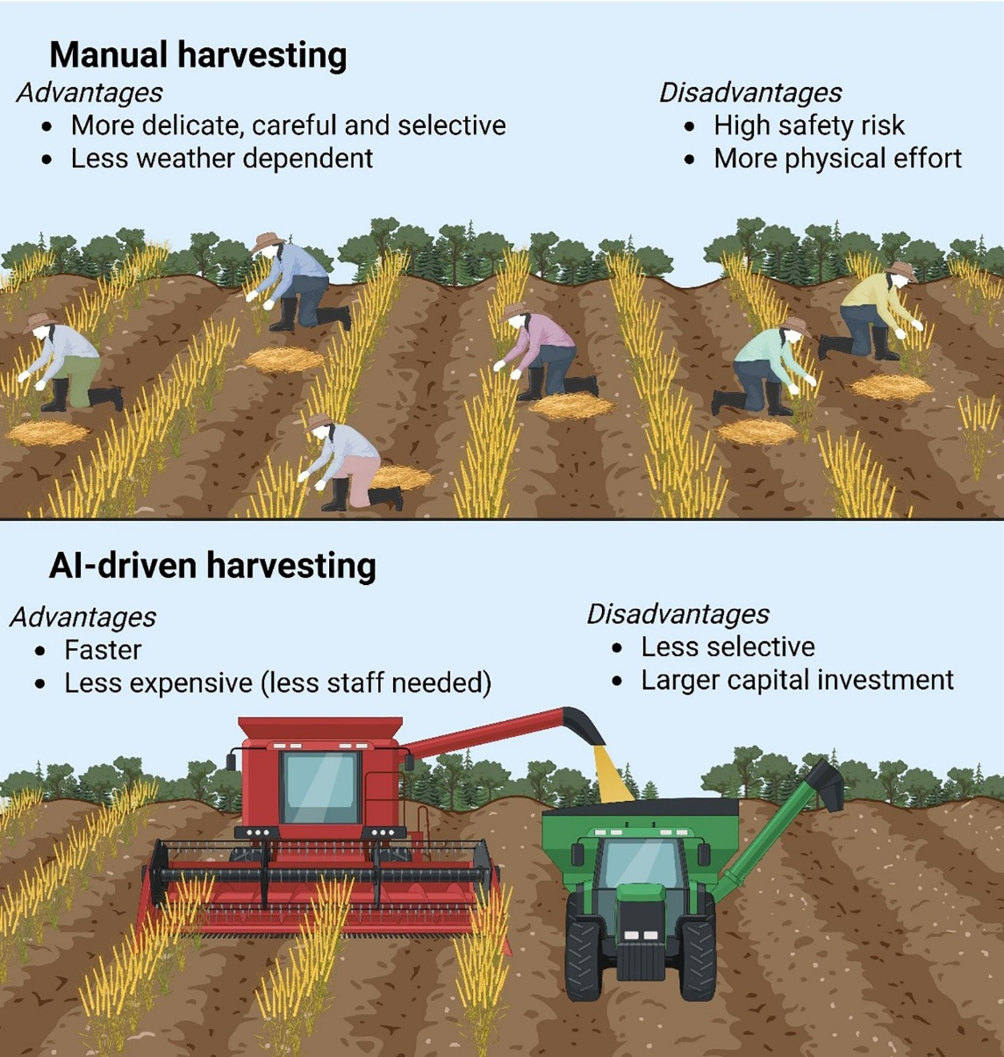

FIGURE 11 Automation and AI-driven harvesting technologies and their advantages and disadvantages. This figure was prepared through Biorender application sources
Source, (www.biorender.com) and Chen,2025)
4. Mechanization Pathways to Higher Crop Yields
Farm machinery innovations influence crop yields in smallholder systems through several intertwined pathways. First, mechanization improves the timeliness of operations, one of the strongest determinants of crop productivity (Liu, and Li, 2023). The faster preparation of land, sowing, fertilization, and weeding allow farmers to conduct critical field operations within narrow agronomic windows, thus reducing yield losses due to late planting and early weed competition. Evidence from Frontiers in Sustainable Food Systems shows that timely mechanized land preparation and sowing prevent yield losses that occur when planting is delayed by labor shortages or weather disruptions. Mechanization enhances agronomic precision by accurately placing seeds at the appropriate depth with proper spacing and applying a uniform rate of fertilizer (Olasehinde-Williams, 2020). Precision seeders, mechanical planters, and fertilizer applicators reduce gaps and overlaps while improving germination and crop establishment; hence, it enhances resource-use efficiency and, therefore, contributes to higher yields (Gautam, et al., 2019).

Third, machinery influences yield through an improvement in labor efficiency and reallocation. By decreasing drudgery and time spent on hard physical work, mechanization frees household labor for other productive activities or allows farmers to cultivate a larger area. Machines substitute for scarce labor at peak agricultural seasons and allow farmers to increase cropping intensity through shortening the turnaround time between crops (Islam, et al., 2020). Agricultural Systems research also points out that mechanization results in system-level productivity gains not just due to higher yields per hectare but also through facilitating extra crop cycles per year (Stagnari, et al., 2017). Fourth, mechanization supports the adoption of sustainable and improved agronomic practices, particularly conservation agriculture. Tools like zero-till seeders, residue-managing seed drills, and mechanical weeders make it possible for smallholders to adopt practices like reduced tillage, retaining soil cover, and managing crop residues. These result in improved soil structure, increased organic matter, better conservation of moisture, and reduced erosion, which, in turn, translate into long-term yield gains (Nhamo, and Lungu, 2017). CA-based mechanization can realize a 5–15% yield increase in addition to reducing the demands on fuel, water, and labor (Bethi, and Deshmukh 2023). Fifth, machinery improves yields through institutional and service delivery pathways, especially when integrated with custom hiring centers, cooperative ownership models, and digital machinery rental platforms. Such systems enhance smallholders' access to machinery, reduce transaction costs, and ensure timely availability of the equipment even for resource-poor farmers (Mukundi, 2025). FAO indicates that yield benefits from mechanization are significantly higher when supported by strong service models that ensure maintenance, operator training, and affordable access. On the whole, an increasing body of empirical research demonstrates that farm machinery raises yields through a nexus of timely operations, greater precision, improved soil and crop management, increased labor use efficiency, and sustained adoption of climate-resilient practices (Amare,and Endalew 2016). However, yield gain magnitude varies by crop type, region, machine category, and the general management environment, while reported increases range from 5% to 40% when mechanization is combined with appropriate agronomy, quality inputs, and efficient service provision (Islam, 2020).

Major Categories of Machinery Innovations and Pathways to Yield Gains
Farm machinery innovations include a wide range of tools, technologies, and engineered systems that collectively aim to reduce drudgery, improve timeliness, enhance precision, and minimize losses throughout the agricultural production cycle (Reddy, 2022). For smallholders, who dominate farming systems across Asia and Sub-Saharan Africa, appropriately scaled machines, digital tools, and post-harvest technologies have shown substantial potential to enhance both biological yield and overall economic returns. The following sub-sections describe the major categories of machinery innovations and outline how each contributes to yield improvement (Banerjee, and Punekar, 2020).

Appropriate, Small-Scale Mechanisation (Implements, 2WTs, Pedal/Animal-Powered Hybrids)
Appropriate mechanization refers to the deployment of lightweight, affordable, and plot-sized equipment suitable for small and fragmented landholdings. Examples include two-wheel tractors (2WTs) fitted with rippers, seeders, rotavators, and planters, as well as mini rice and wheat transplanters, hand or power-operated weeders, pedal-operated or animal-drawn tools for tillage and intercultural operations, micro-tillers, and portable harvesting aids (Loeks, 2023). These machines are increasingly made accessible through custom hiring centres (CHCs) and village-level service providers, thereby reducing the need for farmers to make large capital investments (Gulati, and Juneja, 2021).
Small-scale mechanization enhances yields primarily through improved timeliness of agricultural operations, enabling farmers to complete land preparation and sowing within optimal planting windows. This reduces yield losses associated with delays. Mechanization also improves agronomic quality by ensuring uniform seed placement and depth, leading to better germination, plant populations, and early crop vigour (Singh, et al., 2020). Labour-saving benefits allow timely weeding, fertilization, and intercultural activities that are often delayed in manual systems. Furthermore, implements such as rippers and direct seeders facilitate conservation agriculture practices, improving soil moisture retention, residue management, and long-term soil health (Sayed, et al., 2022).
Evidence from India, Bangladesh, Nepal, Tanzania, and Kenya shows that 2WT-based direct seeding can increase yields by 5–20%, while faster turnaround between crops enhances cropping intensity. Market-based service provision models for 2WTs have proven effective in reducing ownership costs and improving access for marginal farmers. However, yield gains remain context-specific, influenced by labour availability, rainfall patterns, and general input-use efficiency (Ströh de Martínez, et al., 2016).

Precision Agriculture, IoT, and Sensor-Based Systems
Precision agriculture technologies for smallholders include low-cost soil moisture probes, tensiometers, capacitive sensors, nutrient sensing tools, handheld optical meters, IoT-based gateways, GSM-enabled controllers, real-time dashboards, mobile-based decision support systems, and small-scale variable-rate applicators. These technologies enable farmers to adopt data-driven approaches for irrigation scheduling, nutrient management, and monitoring field conditions (García, et al., 2020).
Precision agriculture improves yields by ensuring accurate and timely irrigation, preventing water stress and waterlogging. Optimized nutrient management reduces over- or under-application, increasing nutrient-use efficiency and crop uptake (Singh, and Sharma, 2022). Real-time alerts help farmers respond promptly to soil moisture deficits or nutrient imbalances, reducing stress periods during critical crop growth stages. These technologies also contribute to input savings and environmental sustainability by reducing unnecessary fertilizer and water use (Sengupta, et al., 2021).
Field demonstrations and pilot studies in India, China, Israel, and East Africa report 10–25% gains in water-use efficiency and 8–20% yield increases in various field and horticultural crops. Uniformity in crop growth and reduced fertilizer wastage are additional benefits. However, challenges such as sensor affordability, digital literacy gaps, maintenance supply chains, and network connectivity continue to limit widespread adoption (Shukla, et al., 2023).

Unmanned Aerial Vehicles (Drones) and Remote Sensing
Unmanned aerial vehicles (UAVs), or drones, equipped with multispectral, RGB, or thermal cameras are increasingly used for crop scouting, monitoring plant health, detecting early pest and disease symptoms, mapping intra-field variability, and performing precision spraying of pesticides and micronutrients (Yao, et al., 2019). Policy support in India, including the Drone Rules 2021 and subsidies for drone-based CHCs, has accelerated adoption (Prakash, et al., 2022).
Drones contribute to yield gains by enabling early detection of stress symptoms, which allows farmers to undertake timely interventions that prevent yield losses (Guebsi, et al., 2024). Precision spraying results in uniform chemical application, reduced drift, and lower exposure of farmers to hazardous chemicals. The technology improves resource efficiency by reducing pesticide and water use while maintaining or improving crop performance (Ameer, et al., 2024). Additionally, drones reduce labour dependency, which is particularly valuable during peak seasons.
Field trials in India, China, and Japan demonstrate 15–30% reductions in spray volumes and 5–12% yield improvements in crops such as paddy, cotton, sugarcane, and vegetables. Drones also reduce application time and operator fatigue (Pathak, et al., 2020). However, adoption remains constrained by high initial costs, regulatory requirements, and the need for skilled operators, although drone-as-a-service (DaaS) models are rapidly expanding (Daniel Lawrence et al., 2025).

Robotics and Automation (Harvesting and Orchard Systems)
Robotics and automation in agriculture involve technologies such as vision-guided robotic fruit pickers, automated pruning systems, robotic harvesters for crops like strawberries and tomatoes, and autonomous platforms for orchard navigation. These technologies are predominantly used in high-value horticultural systems and protected cultivation environments (Zhang, et al., 2019).
Robotic innovations improve yields and profitability by reducing harvest losses, as timely and gentle harvesting lowers the likelihood of mechanical damage, especially in perishable crops (Bloch, et al., 2018). Automation speeds up harvesting operations, which is crucial for fruits that must be harvested within narrow windows to maintain quality. Robotic systems also reduce dependence on seasonal labour and ensure consistent quality and uniformity of produce, thereby increasing market returns (Mao, et al., 2022).
Although still emerging, robotic technologies show promise in apple, citrus, and grape orchards, greenhouse vegetables, and high-value berry crops. The major barriers include high capital costs and the need for technical skills, but cooperative ownership models and service-based arrangements are gradually improving accessibility.

Post-Harvest Machinery and Value-Adding Equipment
Post-harvest innovations include small-scale threshers, shellers, portable and solar dryers, grading and sorting units, hermetic storage technologies such as PICS bags and metal silos, and mini-processing units like oil extractors and flour mills. These technologies reduce quantitative and qualitative losses by enabling efficient drying, cleaning, processing, and safe storage (Chen, et al., 2024).
Post-harvest machinery enhances effective yields by minimizing losses due to fungal attacks, insect infestations, and spoilage (McGlone, and Walsh 2021). Improved grading and sorting help farmers secure premium prices in the market. Better storage extends the shelf-life of produce, allowing farmers to avoid distress sales and capture higher off-season prices. Additionally, mini-processing units enable value addition, converting raw materials into higher-value products and generating supplementary income streams (Sudheer, et al., 2021).
Evidence from South Asia and Africa indicates that hermetic storage can reduce grain losses from 10–15% to below 3%, while mechanical and solar dryers cut moisture-related losses by 20–30%. Grading units increase market returns by 10–25%, and small-scale processing enterprises significantly enhance household income through local value addition.
Evidence of Yield and Productivity Impacts
Recent syntheses and empirical assessments provide growing evidence that farm machinery innovations have the potential to raise crop yields and overall farm productivity in smallholder systems, although the magnitude of these benefits can vary widely across agroecological and socioeconomic contexts. Such studies highlight that operations made possible by machinery such as timely land preparation, rapid planting, and efficient weeding allow farmers to better align management practices with optimal agronomic windows, thereby avoiding potential yield penalties linked to either delayed sowing or early-season weed pressure (Jena, et al., 2023).

Evidence from regions adopting 2WT-based technologies, such as direct seeding and ripping, shows additional benefits. In addition to increasing the speed of land operations, these mechanized soil-management practices improve soil-water relations. For instance, ripping in semi-arid areas enhances water infiltration, while direct seeding allows better maintenance of soil cover with consequent moisture conservation and improved root-zone conditions. Together, these can lead to measurable yield gains within CA systems, especially when combined with residue retention and reduced tillage (Reddy, 2022).

Mechanization's impact also comes through the operations of custom hiring centers and mechanization service providers. Research has revealed that farmers who have rental services for plowing, seeding, inter-cultivation, or harvesting are usually in a position to increase the area under cultivation due to reduced labor constraints (Parvin, et al., 2022). This automatically increases total output, even with a modest gain in yield per unit. However, some evidence suggests that larger smallholders are benefiting disproportionately from CHCs, partly because of lower transaction costs but mainly because they can afford the cost of services, hence the equity challenge in these models (Hamilton, 2022).

Quantitative estimates of the yield improvements due to mechanization are highly context-specific. Some controlled trials report modest increases of 5–15% in yields that are often associated with timely sowing and better seed placement, whereas other studies documenting conservation agriculture-based mechanization have reported major gains of more than 30%, particularly in water-stressed environments where ripping or zero tillage enhances moisture use efficiency. Note also that robust estimates must control for confounding factors, including farmer self-selection into mechanization programs, concurrent use of improved inputs such as fertilizer or improved varieties, and variations in farm size affecting the profitability and timeliness of machinery use. The overall evidence suggests that machine innovations generally tend to give significant productivity benefits when adopted with improved agronomy and input management in an integrated package (Hamilton, et al., 2022).
Barriers and Risks
Despite this encouraging evidence of mechanization's positive contributions, a number of barriers and risks persist that restrict its wider diffusion and potential impact among smallholders in most low- and middle-income countries. The primary barrier includes high capital costs, which deter most smallholder farmers from directly purchasing machinery in the absence of access to affordable credit, subsidies, or cooperative ownership arrangements. While willingness to pay for 2WT-based services is generally positive, it often is sensitive to rental prices, fuel costs, and farmers' perceptions of machine efficiency or reliability. Beyond these financial constraints, such tailored financing models have had limited availability and there has been an absence of structured lending options for small-scale machinery.

Another major barrier is the lack of reliable repair, manufacturing, and spare-parts networks, particularly in remote rural areas. Notably, the absence of access to local workshops and skilled mechanics increases machine downtime, raising overall costs while discouraging sustained use. Participatory approaches, such as local design modification, fabrication by village artisans, and decentralized workshops, significantly improve the sustainability and affordability of mechanization, say country case studies.

In many smallholder landscapes, land fragmentation and small plot size also limit the economic viability of mechanization. Irregularly shaped fields and small holdings can make operating larger machinery difficult, and even 2WTs can be inefficient on certain terrains. The “best-fit mechanization” approach guides technology selection from improved animal-drawn implements to lightweight 2WTs or modular attachments that fit the farming system in such situations. Besides, access to machinery is also entangled with issues of gender and social equity: it is mediated by a number of structural barriers, which include credit access, mobility restrictions, and social norms. Unless service models explicitly address their needs, women farmers, who constitute a large proportion of the agricultural labor force, may face particular challenges in accessing and benefiting from mechanization. In that regard, gender-sensitive CHC models, women-led machinery groups, and targeted financing mechanisms can help mitigate these barriers. Finally, there are environmental risks to mechanization when this technology is poorly adapted to local conditions. Inappropriate use of heavy machinery leads to soil compaction, erosion, and excessive fuel consumption. These risks put an onus on integrating mechanization with sustainable practices through conservation tillage, residue retention, and precision operations that reduce environmental footprints. When tied to principles of climate-smart agriculture, farm machinery innovations have the potential to enhance resilience while minimizing long-term ecological harm.
9. Conclusions and Recommendations
Farm machinery innovations have the potential to transform smallholder agriculture by improving timeliness, enhancing precision, reducing labor drudgery, and ultimately increasing crop yields. When machinery is appropriately matched to smallholders’ biophysical, economic, and social contexts, the benefits extend beyond yield improvements to include greater labor efficiency, expanded cultivated area, and improved resilience to climatic variability. Two-wheel tractors and a suite of lightweight, modular implements represent particularly promising solutions for smallholder systems, especially when integrated into well-functioning rental or cooperative service models.

To maximize these benefits, policymakers and practitioners should prioritize several key actions. First, expanding service delivery models, including CHCs and machine banks, can democratize access and promote more efficient use of scarce resources. Second, investment in local maintenance ecosystems, fabrication units, and spare-parts supply chains is essential for maintaining affordability and operational reliability. Third, integrating mechanization with extension services, input delivery, and conservation agriculture practices ensures that farmers derive maximum yield gains from machinery use. Fourth, adopting gender-sensitive design and financing mechanisms will enable women farmers to benefit more fully from mechanization. Finally, governments and research institutions should support rigorous impact assessments and participatory design processes to refine technologies and inform policy decisions.

References
Amare, D., & Endalew, W. (2016). Agricultural mechanization: Assessment of mechanization impact experiences on the rural population and the implications for Ethiopian smallholders. Engineering and Applied Sciences, 1(2), 39-48. https://doi.org/10.11648/j.eas.20160102.15
Ameer, S. A., Alkhafaji, M. A., Jaffer, Z., & Al-Farouni, M. (2024). Empowering farmers with IoT, UAVs, and deep learning in smart agriculture. In E3S Web of Conferences (Vol. 491, p. 04007). EDP Sciences. https://doi.org/10.1051/e3sconf/202449104007
Banerjee, S., & Punekar, R. M. (2020). A sustainability-oriented design approach for agricultural machinery and its associated service ecosystem development. Journal of Cleaner Production, 264, 121642. https://doi.org/10.1016/j.jclepro.2020.121642
Bawden, O. J. (2015). Design of a lightweight, modular robotic vehicle for the sustainable intensification of broadacre agriculture (Doctoral dissertation, Queensland University of Technology). https://eprints.qut.edu.au/84988/1/Owen_Bawden_Thesis.pdf
Bethi, S. K., & Deshmukh, S. S. (2023). Custom Hiring Centers in Indian Agriculture: Evolution, Impact, and Future Prospects. Asian Journal of Agricultural Extension, Economics & Sociology, 41(11), 193-203. https://doi.org/10.9734/ajaees/2023/v41i112276
Bloch, V., Degani, A., & Bechar, A. (2018). A methodology of orchard architecture design for an optimal harvesting robot. Biosystems Engineering, 166, 126-137. https://doi.org/10.1016/j.biosystemseng.2017.11.006
Burney, J., Woltering, L., Burke, M., Naylor, R., & Pasternak, D. (2010). Solar-powered drip irrigation enhances food security in the Sudano–Sahel. Proceedings of the National Academy of Sciences, 107(5), 1848-1853. https://doi.org/10.1073/pnas.0909678107
Chaitanya, D. N. V., Arunkumar, S., Akhilesh, G. B., & Babu, K. A. (2018, June). Design of rice transplanter. In IOP Conference Series: Materials Science and Engineering (Vol. 377, No. 1, p. 012037). IOP Publishing. https://doi.org/10.1088/1757-899X/377/1/012037
Chen, T., Xiong, J., Zhang, Y., & Cai, R. (2024). Case Study of Post-Harvest Processing and Value Addition in Fresh-Eating Sweet Potato. Bioscience Methods, 15. https://doi.org/10.5376/bm.2024.15.0032
Chen, X. (2025). The role of modern agricultural technologies in improving agricultural productivity and land use efficiency. Frontiers in Plant Science, 16, 1675657. https://doi.org/10.3389/fpls.2025.1675657
Chethan, C. R., Singh, P. K., Dubey, R. P., Chander, S., Gosh, D., Choudhary, V. K., & Fagodiya, R. K. (2020). Crop residue management to reduce GHG emissions and weed infestation in Central India through mechanized farm operations. Carbon Management, 11(6), 565-576. https://doi.org/10.3389/fpls.2025.1675657
Daniel Lawrence, I., Pavitra, A. R. R., Karu, R., & Saravanan, M. P. (2025). An Advanced Application of UAV–Drone Technologies in Precision Agriculture for Seed Dropping, Fertilizers and Pesticides Spraying and Field Monitoring. Computer vision in smart agriculture and crop management, 139-157. https://doi.org/10.1002/9781394186686.ch7
Daum, T., Seidel, A., Awoke, B. G., & Birner, R. (2023). Animal traction, two-wheel tractors, or four-wheel tractors? A best-fit approach to guide farm mechanization in Africa. Experimental Agriculture, 59, e12. https://doi.org/10.1017/S0014479723000091
de Araúujo, A. G., Sims, B., Desbiolles, J., Bolonhezi, D., Haque, E., Jin, H., ... & Friedrich, T. (2020). The status of mechanization in Conservation Agriculture systems. In Advances in conservation agriculture (pp. 427-496). Burleigh Dodds Science Publishing. https://doi.org/10.1201/9780429268724
de Sousa, R. N., & Grichar, W. J. (2024). Strategic Tillage and Soil Management: New Perspectives. BoD–Books on Demand. https://doi.org/10.5772/intechopen.111208
FAO (2020). The State of Food and Agriculture 2020 Report - GFAiR. Available online at: https://doi.org/10.4060/cb1447en
Gaffney, J., Challender, M., Califf, K., & Harden, K. (2019). Building bridges between agribusiness innovation and smallholder farmers: A review. Global food security, 20, 60-65. https://doi.org/10.1016/j.gfs.2018.12.008
García, L., Parra, L., Jimenez, J. M., Lloret, J., & Lorenz, P. (2020). IoT-based smart irrigation systems: An overview on the recent trends on sensors and IoT systems for irrigation in precision agriculture. Sensors, 20(4), 1042. https://doi.org/10.3390/s20041042
Gautam, P. V., Kushwaha, H. L., Kumar, A., & Kushwaha, D. K. (2019). Mechatronics application in precision sowing: A review. International Journal of Current Microbiology and Applied Sciences, 8(4), 1793-1807. https://doi.org/10.20546/ijcmas.2019.804.208
Goap, A., Sharma, D., Shukla, A., and Krishna, C. (2018). An IoT based smart irrigation management system using Machine learning and open source technologies. Comput. Electron. Agri. 155, 41–49. doi: 10.1016/j.compag.2018.09.040 https://doi.org/10.20546/ijcmas.2019.804.208
Guebsi, R., Mami, S., & Chokmani, K. (2024). Drones in precision agriculture: A comprehensive review of applications, technologies, and challenges. Drones, 8(11), 686. https://doi.org/10.3390/drones8110686
Gulati, A., & Juneja, R. (2021). Institutional innovations in accessing land, water, farm machinery and extension services in Indian agriculture. In From Food Scarcity to Surplus: Innovations in Indian, Chinese and Israeli Agriculture (pp. 227-268). Singapore: Springer Singapore. https://doi.org/10.1007/978-981-15-9484-7_7
Hamilton, S. F., Richards, T. J., Shafran, A. P., & Vasilaky, K. N. (2022). Farm labor productivity and the impact of mechanization. American Journal of Agricultural Economics, 104(4), 1435-1459. https://doi.org/10.1111/ajae.12273
Hamilton, S. F., Richards, T. J., Shafran, A. P., & Vasilaky, K. N. (2022). Farm labor productivity and the impact of mechanization. American Journal of Agricultural Economics, 104(4), 1435-1459. https://doi.org/10.1111/ajae.12273
Hoque, M. A., Hossain, M. M., Ziauddin, A. T. M., Krupnik, T. J., & Gathala, M. K. (2021). Furrow design for improving crop establishment of two-wheel tractor operated strip tillage planters in loam and clay loam soils. International Journal of Agricultural and Biological Engineering, 14(3), 130-139. https://doi.org/10.25165/j.ijabe.20211403.5906
Islam, A. K. M. S. (2020). Mechanized cultivation increases labour efficiency. Bangladesh Rice Journal, 24(2), 49-66. https://doi.org/10.3329/brj.v24i2.53448
Islam, A. K. M. S. (2020). Mechanized cultivation increases labour efficiency. Bangladesh Rice Journal, 24(2), 49-66. https://doi.org/10.3329/brj.v24i2.53448
Jägermeyr, J., Müller, C., Ruane, A., Elliott, J., Balkovic, J., Castillo, O., et al. (2021). Climate impacts on global agriculture emerge earlier in new generation climate and crop models. Nature Food, 2(11), 875–878. https://doi.org/10.1038/s43016-021-00400-y
Jena, P. R., & Tanti, P. C. (2023). Effect of farm machinery adoption on household income and food security: evidence from a nationwide household survey in India. Frontiers in Sustainable Food Systems, 7, 922038. https://doi.org/10.3389/fsufs.2023.922038
Liu, X., & Li, X. (2023). The influence of agricultural production mechanization on grain production capacity and efficiency. Processes, 11(2), 487. https://doi.org/10.3389/fsufs.2023.922038
Loeks, Z. (2023). The Two-Wheel Tractor Handbook: Small-Scale Equipment and Innovative Techniques for Boosting Productivity. New Society Publishers. https://newsociety.com/books/t/the-two-wheel-tractor-handbook
Lowenberg-DeBoer, J., Huang, I. Y., Grigoriadis, V., and Blackmore, S. (2020). Economics of robots and automation in field crop production. Precis. Agric. 21, 278–299. doi: 10.1007/s11119-019-09667-5 https://doi.org/10.1007/s11119-019-09667-5
Mao, W., Liu, H., Hao, W., Yang, F., & Liu, Z. (2022). Development of a combined orchard harvesting robot navigation system. Remote Sensing, 14(3), 675. https://doi.org/10.3390/rs14030675
McGlone, A., & Walsh, K. (2025). Post-harvest Sorting and Grading. In Precision Agriculture in Field Horticulture: The Potential for Agri-technology to Facilitate Innovation and Promote Value in Outdoor Fruit and Vegetable Production (pp. 197-223). Cham: Springer Nature Switzerland. https://doi.org/10.1007/978-3-031-96534-0_9
Melton, S., Alley, R., Anandakrishnan, S., Parizek, B., Shahin, M., Stearns, L., et al. (2022). Meltwater drainage and iceberg calving observed in high-spatiotemporal resolution at Helheim Glacier, Greenland. Journal of Glaciology, 68(270), 812–828. https://doi.org/10.1017/jog.2021.141
Mkomwa, S., Kaumbutho, P., & Makungu, P. (2014). Farm machinery for conservation agriculture. In Conservation agriculture (pp. 109-131). Cham: Springer International Publishing https://doi.org/10.1007/978-3-319-11620-4_5 .
Mukundi, J. M. (2025). Tractor Rental Services In Kenya: Understanding Mechanization and Changes in Agricultural Production among Smallholder Farmers (Doctoral dissertation, Virginia Tech). https://vtechworks.lib.vt.edu/handle/10919/116900
Nhamo, N., & Lungu, O. N. (2017). Opportunities for smallholder farmers to benefit from conservation agricultural practices. In Smart technologies for sustainable smallholder agriculture (pp. 145-163). Academic Press. https://doi.org/10.1016/b978-0-12-810521-4.00007-4
Olasehinde-Williams, G., Adedoyin, F. F., & Bekun, F. V. (2020). Pathway to achieving sustainable food security in Sub-Saharan Africa: The role of agricultural mechanization. Journal of Labor and Society, 23(3), 349-366. https://doi.org/10.1111/wusa.12483
Parvin, N., Coucheney, E., Gren, M., Andersson, H., Elofsson, K., Jarvis, N., & Keller, T. (2022). On the relationships between the size of agricultural machinery, soil quality and net revenues for farmers and society. Soil Security, 6, 100044. https://doi.org/10.1016/j.soisec.2022.100044
Pathak, H., Kumar, G., Mohapatra, S. D., Gaikwad, B. B., & Rane, J. (2020). Use of drones in agriculture: Potentials, Problems and Policy Needs. ICAR-National Institute of Abiotic Stress Management, 300, 4-15. http://117.239.43.83/sites/default/files/pdfs/Use-of-Drone-in-Indian-Agriculture.pdf
Porwal, M., Verma, B., & Jha, A. K. (2023). New and innovative technologies and machinery in conservation agriculture. Climate smart agriculture. Principles and practices, 113-127. https://www.kdpublications.in
Prakash, S., Kumar, M., Jat, D., Jyoti, B., Subeesh, A., Agrawal, K., ... & Singh, K. K. (2022). Applications of drones in agriculture: Status and scope. Research Gate. https://doi.org/10.13140/RG.2.2.10549.96480/1
Rahaman, H., Rahman, M. M., Islam, A. S., Huda, M. D., & Kamruzzaman, M. (2022). Mechanical rice transplanting in Bangladesh: current situation, technical challenges, and future approach. Journal of Biosystems Engineering, 47(4), 417-427. https://doi.org/10.1007/s42853-022-00161-x
Reddy, R. (2022). Innovations in agricultural machinery: Assessing the impact of advanced technologies on farm efficiency. Journal of Artificial Intelligence and Big Data, 2(1), 10-31586. https://doi.org/10.31586/jaibd.2022.1156
Saha, K. K., Hossain, A., Hoque, M. A., Jahan, M. A. H. S., Ahmed, S., & Timsina, J. (2021). Development and performance evaluation of a two-wheeled power-tiller multi-row weeder. Journal of Biosystems Engineering, 46(1), 36-47. https://doi.org/10.1007/s42853-021-00086-x
Sayed, H. A. A., Ding, Q., Odero, A. J., & Korohou, T. (2022). Selection of appropriate mechanization to achieve sustainability for smallholder farms: a review. Al-Azhar Journal of Agricultural Engineering, 3(1), 52-60. https://doi.org/10.21608/azeng.2022.252902
Seid Ahmed, Y., & Amorim, F. L. (2025). Advances in computer numerical control geometric error compensation: integrating AI and on-machine technologies for ultra-precision manufacturing. Machines, 13(2), 140. https://doi.org/10.3390/machines13020140
Sengupta, A., Debnath, B., Das, A., & De, D. (2021). FarmFox: A quad-sensor-based IoT box for precision agriculture. IEEE Consumer Electronics Magazine, 10(4), 63-68. https://doi.org/10.1109/MCE.2021.3064818
Shukla, B. K., Maurya, N., & Sharma, M. (2023). Advancements in sensor-based technologies for precision agriculture: an exploration of interoperability, analytics and deployment strategies. Engineering proceedings, 58(1), 22. https://doi.org/10.3390/ecsa-10-16051
Sims, B., & Kienzle, J. (2016). Making mechanization accessible to smallholder farmers in sub-Saharan Africa. Environments, 3(2), 11. https://doi.org/10.3390/environments3020011
Sims, B., & Kienzle, J. (2017). Sustainable agricultural mechanization for smallholders: what is it and how can we implement it?. Agriculture, 7(6), 50. https://doi.org/10.3390/agriculture7060050
Singh, P. K., & Sharma, A. (2022). An intelligent WSN-UAV-based IoT framework for precision agriculture application. Computers and Electrical Engineering, 100, 107912. https://doi.org/10.1016/j.compeleceng.2022.107912
Singh, T. P. (2016). Farm machinery. PHI Learning Pvt. Ltd.. https://www.phi.co.in/book/farm-machinery/
Singh, Y., Sidhu, H. S., Jat, H. S., Singh, M., Chhokar, R. S., Setia, R., & Jat, M. L. (2020). Conservation agriculture and scale of appropriate agricultural mechanization in smallholder systems. https://hdl.handle.net/10568/111206
Stagnari, F., Maggio, A., Galieni, A., & Pisante, M. (2017). Multiple benefits of legumes for agriculture sustainability: an overview. Chemical and Biological Technologies in Agriculture, 4(1), 2. https://doi.org/10.1186/s40538-016-0085-1
Ströh de Martínez, C., Feddersen, M., & Speicher, A. (2016). Food security in sub-Saharan Africa: a fresh look on agricultural mechanisation. How adapted financial solutions can make a difference (No. 91). Studies. http://www.die-gdi.de/studies/article/food-security-in-sub-saharan-africa-a-fresh-look-on-agricultural-mechanisation-how-adapted-financial-solutions-can-make-a-difference/
Sudheer, K. P., Sreelakshmi, K. U., & Prabha, V. (2021). Post-harvest Management Through Convergence of Innovation and Technology. In Innovations in Agriculture for a Self-Reliant India (pp. 595-625). CRC Press. https://doi.org/10.1201/9781003245384
Wheeler, S. (2022). Debunking Murray-Darling Basin water trade myths. Australian Journal of Agricultural and Resource Economics, 66(4), 797–821. doi: 10.1111/1467- 8489.12490 https://doi.org/10.1111/1467-8489.12490
Yao, H., Qin, R., & Chen, X. (2019). Unmanned aerial vehicle for remote sensing applications—A review. Remote sensing, 11(12), 1443. https://doi.org/10.3390/rs11121443
Zawada, M., Legutko, S., Gościańska-Łowińska, J., Szymczyk, S., Nijak, M., Wojciechowski, J., & Zwierzyński, M. (2023). Mechanical weed control systems: methods and effectiveness. Sustainability, 15(21), 15206. https://doi.org/10.3390/su152115206
Zhang, Q., Karkee, M., & Tabb, A. (2019). The use of agricultural robots in orchard management. In Robotics and automation for improving agriculture (pp. 187-214). Burleigh Dodds Science Publishing. https://doi.org/10.19103/AS.2019.0056.14
Zhang, X., Zhang, J., Li, L., Zhang, Y., and Yang, G. (2022). Digital agriculture and sustainability: A meta-analysis. Nat. Food 3, 221–229. doi: 10.1038/s43016-022-00456-4
FAO. (2016). Agricultural Mechanization: A Key Input for Sub-Saharan African Agriculture. Food and Agriculture Organization of the United Nations. http://www.fao.org/3/a-i6044e.pdf
FAO. (2018). Sustainable Agricultural Mechanization – A Fra mework for Africa. Rome: Food and Agriculture Organization of the United Nations. http://www.fao.org/3/CA1136EN/ca1136en.pdf
Stewart, R., Langer, L., Da Silva, N. R., & Muchiri, E. (2016). Effects of training, innovation and new technology on African smallholder farmers’ economic outcomes and food security. Systematic Review Summary, 6, 10-15. https://doi.org/10.23846/SRS006
Stewart, R., Langer, L., Da Silva, N. R., Muchiri, E., Zaranyika, H., Erasmus, Y., ... & De Wet, T. (2015). The effects of training, innovation and new technology on African smallholder farmers' economic outcomes and food security: A systematic review. Campbell Systematic Reviews, 11(1), 1-224. https://doi.org/10.4073/csr.2015.16

