Computational Investigation of Eugenol–Triazole Derivatives Targeting Breast Cancer Proteins

.
ABSTRACT

Aims: The present study aimed to evaluate the binding affinity and interaction profiles of newly designed eugenol–triazole derivatives against key breast cancer–associated protein targets using structure-based molecular docking, in order to identify promising lead compounds for anti-breast cancer drug development.
Study design: Computational in silico molecular docking study.
Place and Duration of Study: The study was carried out using molecular modeling facilities with Schrödinger Maestro software during the course of the present research work.
Methodology: A series of eugenol–triazole derivatives were designed and subjected to structure-based molecular docking against breast cancer-related protein targets retrieved from the Protein Data Bank, including 1M17, 1SQN, 5DXT, 4RJ3, 4OAR, 2IOG, 4L2Y, 5GBD, and 4DRH. Protein preparation, ligand optimization, grid generation, and docking were performed using Schrödinger Maestro. Binding affinities were evaluated based on docking scores, hydrogen bonding interactions, hydrophobic contacts, and π–π stacking interactions. The performance of the designed eugenol-triazole derivatives was compared with standard reference ligands for each target.
Results: Several eugenol–triazole derivatives demonstrated favorable docking scores and stable binding conformations within the active sites of multiple breast cancer-related proteins. Key interactions included hydrogen bonding with crucial active-site residues and π–π stacking interactions, attributed mainly to the presence of the triazole moiety. In multiple targets, the binding affinities of selected derivatives were comparable to or better than those of standard reference ligands, indicating enhanced protein–ligand complementarity.
Conclusion: This in silico study suggests that eugenol–triazole derivatives possess significant potential as anti-breast cancer agents. The incorporation of the triazole ring enhances molecular interactions and binding stability with breast cancer-associated proteins. These findings provide a strong computational rationale for further in vitro and in vivo biological evaluation of these compounds.

Keywords: Eugenol, Triazole derivatives, Breast cancer, Molecular docking, In silico studies, Anticancer agents.

1. INTRODUCTION

Breast cancer is the most frequently diagnosed malignancy among women and represents a major global health challenge worldwide. Despite significant advancements in early diagnosis and therapeutic strategies, challenges such as multidrug resistance, systemic toxicity, and limited selectivity of existing chemotherapeutic agents continue to hinder effective disease management. Consequently, the discovery and development of new anticancer agents with improved efficacy and safety profiles remain an urgent unmet need. ^{[1-4]}
Natural products have historically played a pivotal role in anticancer drug discovery, serving either as direct therapeutic agents or as lead scaffolds for structural optimization. Their immense structural diversity and biological relevance have contributed significantly to the development of many clinically used anticancer drugs. ^{[5,6]} Eugenol (4-allyl-2-methoxyphenol), a phenylpropanoid obtained predominantly from clove oil, has attracted considerable attention due to its wide range of pharmacological activities, including antioxidant, anti-inflammatory, antimicrobial, and anticancer effects. However, the moderate potency and limited selectivity of native eugenol necessitate structural modification to enhance its anticancer efficacy. ^{[7,8]}

Triazoles are nitrogen-rich heterocycles widely recognized for their chemical stability, favorable pharmacokinetic properties, and strong ability to form hydrogen-bond interactions with biological targets. These features make triazole motifs highly valuable in medicinal chemistry, particularly for anticancer drug development. ^{[9]} Recent studies have demonstrated that 1,2,4-triazole derivatives can effectively modulate key oncogenic pathways, including cell cycle regulation and apoptosis, through enhanced ligand–protein interactions. ^{[10]}

Molecular docking is a key computational tool in early-stage drug discovery used to predict binding modes, affinities, and interaction patterns between small molecules and biological targets, thereby supporting rational lead identification prior to experimental validation. ^{[11,13]} Recent studies have successfully applied docking-based approaches to screen and optimize anticancer candidates, including heterocyclic and natural-product-based hybrids, against breast cancer–related protein targets. ^{[14,15]} In the present study, newly designed eugenol–triazole derivatives were subjected to comprehensive in silico molecular docking against multiple breast cancer targets using Schrödinger Maestro software to assess their potential anticancer activity.

Breast cancer progression is driven by dysregulation of multiple signaling pathways involving hormone receptors and growth factor–mediated kinases. Several receptors and enzymes have been strongly implicated in breast cancer initiation, proliferation, survival, and therapeutic resistance, making them attractive molecular targets for anticancer drug discovery. ^{[16,17]} Among these, estrogen receptor alpha (ERα), progesterone receptor (PR), epidermal growth factor receptor (EGFR), phosphoinositide 3-kinase alpha (PI3Kα), and mammalian target of rapamycin (mTOR) play central roles in hormone-dependent and hormone-independent breast cancer subtypes ^{[18-20]}

The estrogen receptor (ER), represented by PDB ID 2IOG, is a key transcription factor regulating cell proliferation, differentiation, and apoptosis in breast tissue. Elevated estrogen signaling is closely associated with increased breast cancer risk and tumor progression, particularly in ER-positive breast cancers ^{[21]}. Similarly, the progesterone receptor (PR), represented by 1SQN, functions as an important prognostic and predictive biomarker and contributes to hormone-driven tumor growth and endocrine therapy response ^{[22]}.
EGFR, represented by Pdb id 1M17 is a transmembrane tyrosine kinase receptor frequently overexpressed in aggressive and triple-negative breast cancers. Activation of EGFR promotes cell proliferation, invasion, angiogenesis, and resistance to chemotherapy, making it a critical therapeutic target. Aberrant EGFR signaling also activates downstream pathways such as PI3K/Akt/mTOR, further enhancing tumor survival ^{[23, 24]}.
PI3Kα, represented by 5DXT, is a catalytic subunit frequently mutated in breast cancer and plays a pivotal role in regulating cell growth, metabolism, and survival. PI3Kα mutations lead to constitutive pathway activation and are strongly associated with poor prognosis and drug resistance ^{[25]}. Downstream of PI3K, mTOR (PDB ID 4DRH) serves as a master regulator of protein synthesis, cell cycle progression, and cancer metabolism, and its dysregulation is commonly observed in advanced breast cancer ^{[26]}.
The molecular docking study was performed to evaluate the anticancer potential of newly designed eugenol–triazole derivatives against key breast cancer–related targets. The crystal structures of estrogen receptor (PDB ID: 2IOG), progesterone receptor (PDB ID: 1SQN), epidermal growth factor receptor (EGFR; PDB ID: 1M17), phosphoinositide 3-kinase alpha (PI3Kα; PDB ID: 5DXT), and mammalian target of rapamycin (mTOR; PDB ID: 4DRH) were selected based on their established roles in breast cancer development, progression, and therapeutic resistance ^{[27,28,29,30]}. The availability of co-crystallized ligands and well-defined active sites in these protein structures enabled reliable docking validation and justified their selection as suitable targets for the present in silico investigation.^{[31,32]}

2. material and methods

This section consists of four sections drug-likeness, protein preparation, ligand preparation, Receptor grid generation and molecular docking.
Drug-likeness
Drug-likeness and physicochemical properties of the designed compounds were predicted using the SwissADME web tool, including molecular weight, lipophilicity (logP), hydrogen bond donors (HBD), and hydrogen bond acceptors (HBA) ^{[33]}. Drug-likeness was further evaluated based on Lipinski’s rule of five, which assesses the suitability of compounds for oral bioavailability and biological activity ^{[34]}. According to this rule, acceptable limits include molecular weight ≤ 500 g/mol, logP ≤ 5, HBD < 5, HBA < 10, topological polar surface area (TPSA) ≤ 140 Å², and rotatable bonds ≤ 10.
Protein preparation
The three-dimensional crystal structures of selected breast cancer targets were retrieved from the Protein Data Bank (PDB) (https://www.rcsb.org) ^{[35]}, including estrogen receptor (PDB ID: 2IOG; 1.60 Å) ^{[36]}, progesterone receptor (PDB ID: 1SQN; 1.45 Å) ^{[37]}, epidermal growth factor receptor (EGFR; PDB ID: 1M17; 2.60 Å) ^{[38]}, PI3Kα (PDB ID: 5DXT; 2.25 Å) ^{[39]}, and mTOR (PDB ID: 4DRH; 2.30 Å) ^{[40]}. The downloaded protein structures were prepared for docking using the Protein Preparation Wizard in Schrodinger Maestro, where water molecules were removed, bond orders and charges were assigned, hydrogens were added, selenomethionines were converted to methionines, and the proteins were optimized and energy-minimized to obtain biologically relevant conformations suitable for molecular docking.
Ligand Preparation

The structures of all ligands were drawn using ChemDraw Professional, and their SMILES notations were used to import the two-dimensional structures into the project workspace. Structures of standard drugs were obtained from the PubChem database in SDF format and similarly imported. Ligand preparation was carried out using the LigPrep module in Schrodinger Maestro employing the OPLS 2005 force field at pH 7.0 ± 2.0 with Epik for ionization state generation. Stereochemical settings were maintained as retain specified chiralities (vary other chiral centers), and a maximum of 32 stereoisomers per ligand was generated.
Receptor grid generation

The receptor grid defines the area of interaction between the protein and the ligand. This was carried out with the receptor grid generation tool in Maestro, which defines the area around the active site in terms of x, y, and z coordinates.
Molecular docking
Molecular docking was performed using the Glide module in Schrödinger Maestro. The prepared ligands were docked into the active sites of the prepared target proteins using the standard precision (SP) mode with flexible ligand sampling. Binding interactions were evaluated using the Glide score, which reflects the best-fit orientation of the ligand within the receptor binding pocket, and ligands were ranked based on their docking scores (more negative values indicating stronger binding affinity). The ligand interaction diagram tool was employed to visualize key interactions between ligands and active-site residues. The structures of ligands are showed in the Fig.1.

Fig.1: Eugenol-triazole derivatives 2D structures
3. results and discussion

SwissADME and Lipinski’s rule of five were applied to evaluate the molecular properties and drug-likeness of the designed eugenol–triazole derivatives. Lipinski’s rule is a key criterion in rational drug design, as it helps predict oral bioavailability and potential biological activity of drug-like molecules. Compounds exhibiting more than one Lipinski violation were excluded from further analysis. Among the designed series, 14 compounds showed no violations of the Lipinski rule of five. The calculated molecular properties of the eugenol triazole derivatives are summarized in Table 1.
Table 1. Druglikness properties of Eugenol-triazole derivatives

Compound Code | Drug likeness (Lipinski rule)
 | Mol. Wt. (g/mol) | No. Hydrogen bond | No. Hydrogen acceptor | TPSA  (Å²) | No of rotatable bonds | Log P value
Eugenol | 164.20 | 1 | 2 | 29.46 | 3 | 2.37
Tria-1 | 368.45 | 0 | 5 | 97.58 | 7 | 3.75
Tria-2 | 402.90 | 0 | 5 | 97.58 | 7 | 3.93
Tria-3 | 437.34 | 0 | 5 | 97.58 | 7 | 4.32
Tria-4 | 402.90 | 0 | 5 | 97.58 | 7 | 3.84
Tria-5 | 437.34 | 0 | 5 | 97.58 | 7 | 4.12
Tria-6 | 447.35 | 0 | 5 | 97.58 | 7 | 4.09
Tria-7 | 447.35 | 0 | 5 | 97.58 | 7 | 3.93
Tria-8 | 447.35 | 0 | 5 | 97.58 | 7 | 3.92
Tria-9 | 526.24 | 0 | 5 | 97.58 | 7 | 4.50
Tria-10 | 526.24 | 0 | 5 | 97.58 | 7 | 4.39
Tria-11 | 386.44 | 0 | 6 | 97.58 | 7 | 3.96
Tria-12 | 386.44 | 0 | 6 | 97.58 | 7 | 3.78
Tria-13 | 386.44 | 0 | 6 | 97.58 | 7 | 3.82
Tria-14 | 404.43 | 0 | 7 | 97.58 | 7 | 4.06
Tria-15 | 494.35 | 0 | 5 | 97.58 | 7 | 4.22
Tria-16 | 494.35 | 0 | 5 | 97.58 | 7 | 3.85
Tria-17 | 413.45 | 0 | 7 | 143.40 | 8 | 3.29
Tria-18 | 413.45 | 0 | 7 | 143.40 | 8 | 3.25
Tria-19 | 413.45 | 0 | 7 | 143.40 | 8 | 3.38
Tria-20 | 458.45 | 0 | 9 | 133.10 | 9 | 2.75
Tria-21 | 458.45 | 0 | 9 | 189.22 | 9 | 2.72
Tria-22 | 384.45 | 1 | 6 | 117.81 | 7 | 3.27
Tria-23 | 384.45 | 1 | 6 | 117.81 | 7 | 3.03
Tria-24 | 384.45 | 1 | 6 | 117.81 | 7 | 3.26
Tria-25 | 400.45 | 2 | 7 | 138.04 | 7 | 3.14
Tria-26 | 400.45 | 2 | 2 | 138.04 | 7 | 3.19
Tria-27 | 383.47 | 1 | 5 | 123.60 | 7 | 352
Tria-28 | 383.47 | 1 | 5 | 123.60 | 7 | 3.53
Tria-29 | 398.48 | 0 | 6 | 106.81 | 8 | 3.51
Tria-30 | 398.48 | 0 | 6 | 106.81 | 8 | 3.98
Tria-31 | 428.50 | 1 | 7 | 116.04 | 9 | 4.13
Tria-32 | 414.48 | 1 | 7 | 127.04 | 8 | 3.42
Tria33 | 358.41 | 0 | 6 | 110.72 | 7 | 3.29
Tria-34 | 382.48 | 0 | 5 | 97.58 | 7 | 4.15
Tria-35 | 382.48 | 0 | 5 | 97.58 | 7 | 3.45

Docking studies
In the present study, virtual screening was carried out on 35 eugenol–triazole derivatives designed using ChemDraw Professional, and their binding affinities were evaluated against selected breast cancer–related protein targets ^{[41]}. The primary therapeutic targets included human estrogen receptor alpha (ERα), progesterone receptor (PR), epidermal growth factor receptor (EGFR), phosphatidylinositol 3-kinase (PI3K), and mammalian target of rapamycin (mTOR). The prepared ligands were docked into the active sites of each target protein using Schrödinger Maestro, with grid box dimensions fixed at 10 × 10 × 10 Å along the x, y, and z axes. Standard anticancer drugs doxorubicin, erlotinib, letrozole, gefitinib, progesterone, tamoxifen, and fulvestrant were used as reference compounds for comparative analysis. Binding affinity energies were calculated, and the docking results of eugenol–triazole derivatives exhibiting hydrogen-bond interactions comparable to those of the co-crystallized ligands in the respective protein structures (PDB IDs) are summarized in Table 2.

Table 2. List docking scores and its interactions

PDB ID | S. No | Compound name/code | Binding affinity (kcal/ mol) | H-Bonds
PDB ID:2IOG | 1 | 2-arylindole (co-crystal) | -13.922 | GLU353,ARG394
PDB ID:2IOG | 2 | 4-hydroxytamoxifen | -11.736 | ASP351,GLU353,ARG394
PDB ID:2IOG | 3 | Methylpiperidinopyrazole | -10.895 | ARG394
PDB ID:2IOG | 4 | Letrozole | -9.072 | ARG394,LYS531
PDB ID:2IOG | 5 | Fulvestrant | -10.903 | LEU387,LEU536
PDB ID:2IOG | 6 | Eugenol | -6.116 | GLU353,ARG394
PDB ID:2IOG | 7 | Tria-23 | -10.102 | GLU353,ARG394
PDB ID:2IOG | 8 | Tria-28 | -9.347 | GLU353
PDB ID:2IOG | 9 | Tria-24 | -9.057 | LEU346,GLU353
PDB ID:1SQN | 1 | NDR (co-crystal) | -11.531 | GLN725
PDB ID:1SQN | 2 | Progesterone | -10.893 | GLN725
PDB ID:1SQN | 3 | Eugenol | -5.923 | MET759
PDB ID:1SQN | 4 | Tria-8 | -8.976 | GLN725
PDB ID:1SQN | 5 | Tria-34 | -8.180 | GLN725
PDB ID:1SQN | 6 | Tria-18 | -8.161 | GLN725,LEU718
PDB ID:1SQN | 7 | Tria-14 | -7.778 | GLN725
PDB ID:1M17 | 1 | Erlotinib (co-crystal) | -8.412 | CYS773,MET769
PDB ID:1M17 | 2 | Gefitinib | -7.676 | LYS721,MET769
PDB ID:1M17 | 3 | Eugenol | -4.514 | -
PDB ID:1M17 | 4 | Tria-25 | -7.637 | MET769,THR766,ASP831,GLU738
PDB ID:1M17 | 5 | Tria-24 | -7.422 | GLN767,ASP831,GLU738
PDB ID:1M17 | 6 | Tria-13 | -6.974 | MET769,ASP831
PDB ID:1M17 | 7 | Tria-11 | -6.809 | MET769,THR766
PDB ID:1M17 | 8 | Tria-22 | -6.752 | MET769,ASP831
PDB ID:5DXT | 1 | Alplesilib (co-crystal) | -10.264 | GLN859(2), SER854, VAL851(2)
PDB ID:5DXT | 2 | Tamoxifen | -6.396 | GLU798
PDB ID:5DXT | 3 | Eugenol | -5.8809 | GLU849,VAL851(2)
PDB ID:5DXT | 4 | Tria-24 | -6.808 | SER774,VAL851
PDB ID:5DXT | 5 | Tria-29 | -6.264 | ARG770(2),VAL851,SER854
PDB ID:4DRH | 1 | RAP | -6.457 | LYS 52, SER 80, GLN 85, GLY84,ILE87, TYR 113
PDB ID:4DRH | 2 | Doxorubicin | -5.693 | GLY84,ILE87,ALA112
PDB ID:4DRH | 3 | Letrozole | -4.862 | ILE87,LYS121
PDB ID:4DRH | 4 | Nertinib | -5.202 | ALA112,TYR113,SER118
PDB ID:4DRH | 5 | Eugenol | -4.315 | ASP68
PDB ID:4DRH | 6 | Tria-25 | -5.434 | LYS121
PDB ID:4DRH | 7 | Tria-14 | -5.405 | TYR113
PDB ID:4DRH | 8 | Tria-22 | -5.397 | TYR113
PDB ID:4DRH | 9 | Tria-1 | -5.302 | LYS121
PDB ID:4DRH | 10 | Tria-24 | -4.962 | LYS121
PDB ID:4DRH | 11 | Tria-21 | -4.803 | TYR113

Eugenol, a phenylpropanoid primarily derived from clove oil, has attracted considerable attention for its anticancer potential against breast cancer. Previous studies have demonstrated that eugenol inhibits breast cancer cell proliferation by inducing apoptosis, causing cell cycle arrest, and suppressing tumor metastasis, while modulating oxidative stress and inflammatory signaling pathways ^{[8,15]}. Both eugenol and its derivatives have shown activity against hormone-dependent and hormone-independent breast cancer cell lines, underscoring their broad therapeutic relevance ^{[42]}. However, poor bioavailability and dose-dependent toxicity limit the direct clinical application of eugenol ^{[43]}. Consequently, structural modification and advanced formulation strategies are being explored to enhance the breast cancer–targeted efficacy of eugenol-based compounds ^{[7]}.
In the present study, 35 eugenol–triazole derivatives were virtually screened, among which 20 compounds exhibited docking energies and hydrogen-bonding interactions comparable to those of co-crystallized ligands across key breast cancer targets, including ERα, PR, EGFR, PI3K, and mTOR receptors. Molecular docking was performed to evaluate the binding interactions of eugenol, standard anticancer drugs, co-crystallized ligands, and designed eugenol–triazole derivatives against ERα (PDB ID: 2IOG), PR (1SQN), EGFR (1M17), PI3K (5DXT), and mTOR (4DRH). Binding affinity scores (kcal/mol) and hydrogen-bond interactions with conserved active-site residues were analyzed to assess binding stability and biological relevance.

The molecular docking study evaluated the binding affinities and interaction profiles of various ligands within the Estrogen Receptor α (ERα) active site using the crystal structure (PDB ID: 2IOG). Binding free energy (ΔG, kcal/mol) was used as the primary metric of interaction strength, with more negative values indicating stronger binding. The co-crystallized ligand, 2-arylindole, exhibited the highest binding affinity (ΔG = −13.922 kcal/mol), reflecting its optimal accommodation within the ERα binding pocket. This superior binding arises from strong hydrogen bond interactions with the conserved residues GLU353 and ARG394, complemented by extensive hydrophobic and π–π stacking interactions with surrounding aromatic residues.
Clinically established ERα inhibitors also demonstrated strong binding affinities. 4-Hydroxytamoxifen showed a high binding score (ΔG = −11.736 kcal/mol), interacting with ASP351, GLU353, and ARG394, consistent with its known competitive binding mode. Fulvestrant (ΔG = −10.903 kcal/mol) and methylpiperidinopyrazole (ΔG = −10.895 kcal/mol) exhibited comparable affinities, engaging ARG394 and hydrophobic residues such as LEU387 and LEU536, indicating flexibility in ligand accommodation within the ERα binding cavity.
The designed eugenol–triazole derivatives displayed promising binding profiles. Tria-23 emerged as the most potent compound in the series (ΔG = −10.102 kcal/mol), forming strong hydrogen bonds with GLU353 and ARG394, closely mimicking the interaction pattern of the co-crystallized ligand. Tria-28 also showed favorable binding (ΔG = −9.347 kcal/mol), whereas eugenol exhibited the weakest affinity (ΔG = −6.116 kcal/mol), despite interacting with the same key residues. This observation underscores the importance of optimal molecular geometry and hydrophobic complementarity for enhanced binding stability. Letrozole and Tria-24 demonstrated moderate binding affinities of approximately −9.0 kcal/mol.
As illustrated in Fig. 1a and 1b, interaction analysis revealed that both 2-arylindole and Tria-23 are anchored by strong hydrogen bonds with GLU353 and ARG394, reinforced by extensive hydrophobic and van der Waals interactions involving residues such as LEU354, LEU391, ILE424, and PHE404. Notably, Tria-23 formed a very short hydrogen bond (~1.8 Å) with GLU353, contributing significantly to enhanced complex stability (Fig. 1c).
Superposition of the docked eugenol–triazole derivatives confirmed a shared binding mode within the ERα active site, with strong overlap of the triazole and aromatic cores identifying key pharmacophoric elements. The observed variability in peripheral substituents suggests opportunities for further structural optimization (Fig. 1d).
Strong ERα binding is governed by specific hydrogen bonding with GLU353 and ARG394, favorable geometric fit, and extensive hydrophobic interactions. While 2-arylindole remains the most potent binder, Tria-23 stands out as a promising lead compound that warrants further optimization and experimental validation.

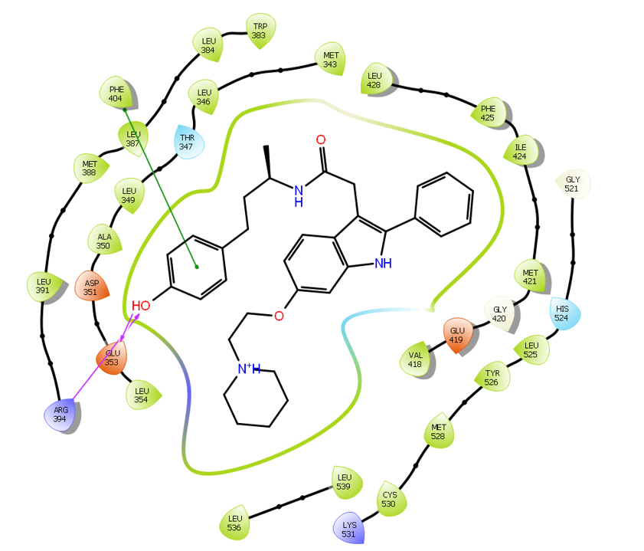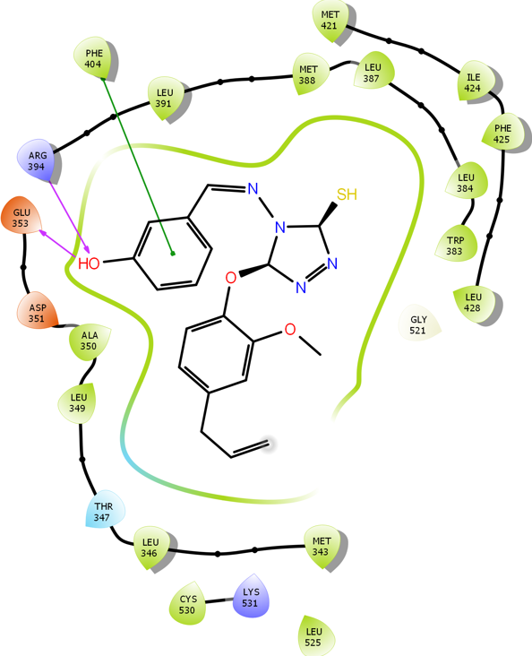
- b)

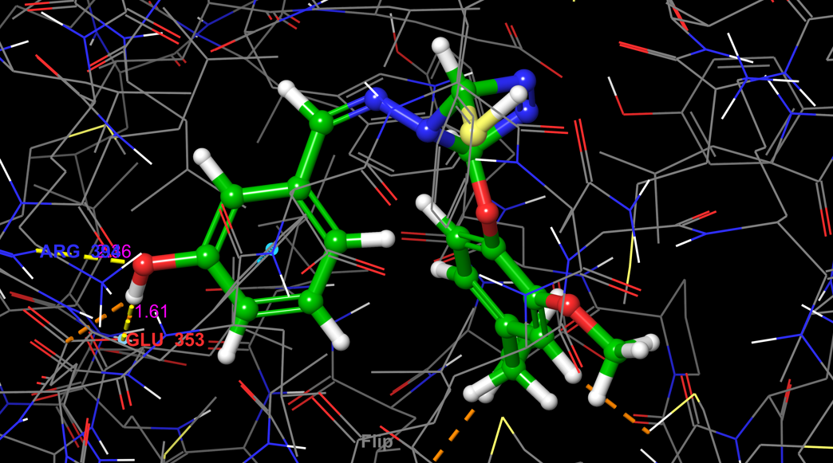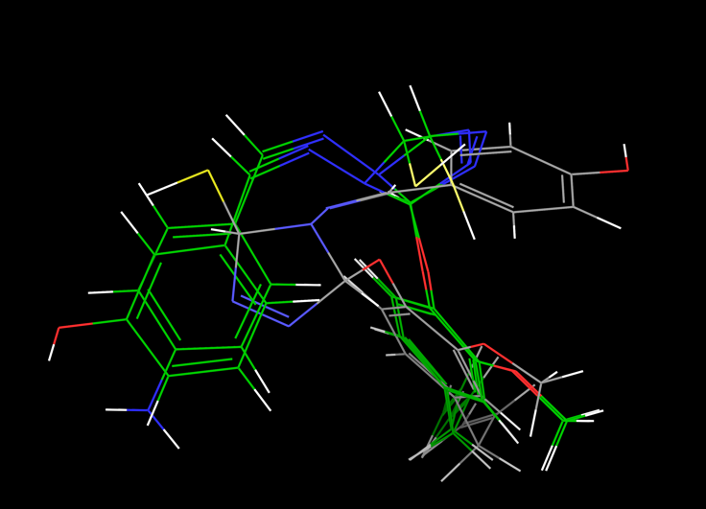

- d)
Fig 1. a) 2D interaction diagram of 2-arylindole (Co-crystal ligand), b) 2D interaction diagram of Tria-23, c) 3D docking pose of Tria-23, d) Superimposed docked eugenol-triazole ligands.
Molecular docking studies were performed to evaluate the binding affinities and interaction patterns of selected ligands within the active site of the target protein (PDB ID: 1SQN). Binding free energy (ΔG, kcal/mol) was used as an indicator of ligand–protein interaction strength. The co-crystallized ligand, NDR, exhibited the strongest binding affinity (ΔG = −11.531 kcal/mol), serving as a reliable reference for validating the docking protocol. Its interaction with the conserved residue GLN725 highlights the critical role of this residue in stabilizing ligands within the binding pocket.
Progesterone also demonstrated strong binding affinity (ΔG = −10.893 kcal/mol), closely comparable to that of NDR. Its interaction with GLN725 suggests a similar binding mode, further confirming the importance of this residue as a key anchoring site for potent ligands. In contrast, eugenol showed the weakest binding affinity (ΔG = −5.923 kcal/mol), interacting primarily with MET759, indicating poor complementarity and limited stabilization within the active site.
The designed eugenol- triazole derivatives exhibited improved binding affinities relative to eugenol, underscoring the positive impact of triazole incorporation. Among them, Tria-8 emerged as the most potent compound (ΔG = −8.976 kcal/mol), forming a stabilizing interaction with GLN725, analogous to the reference ligands. Tria-34 (ΔG = −8.180 kcal/mol) and Tria-18 (ΔG = −8.161 kcal/mol) also showed favorable binding profiles, with Tria-18 uniquely engaging both GLN725 and LEU718, suggesting additional hydrophobic stabilization. Tria-14 displayed moderate affinity (ΔG = −7.778 kcal/mol), interacting mainly with GLN725.
As shown in Fig. 2a, the 2D interaction map of NDR reveals a key hydrogen bond between the carbonyl oxygen of the ligand and the backbone amide hydrogen of GLN725, which serves as the primary anchoring interaction. This polar contact is supported by extensive hydrophobic interactions involving residues such as LEU715, LEU721, ILE722, MET759, MET760, LEU763, VAL762, and LEU867. Together, these interactions stabilize the steroidal core of NDR within the hydrophobic pocket, explaining its superior binding affinity.
The 3D binding pose of NDR (Fig. 2b) further confirms these interactions, highlighting a strong hydrogen bond with GLN725 at a distance of approximately 2.31 Å, which falls within the optimal range for hydrogen bonding. Numerous short-range van der Waals contacts (generally <4.0 Å) with residues such as MET759, LEU718, and LEU721 contribute to a snug and energetically favorable fit within the active site.
The 3D interaction analysis of Tria-8 (Fig. 2c) reveals a very short hydrogen bond (~1.75 Å) with GLN725, indicative of a highly stabilizing interaction that likely serves as the primary anchor for this ligand series. This interaction is reinforced by multiple hydrophobic contacts with surrounding residues, including LEU718 and MET759, resulting in enhanced binding stability relative to other triazole derivatives.
The CPK (space-filling) representation (Fig. 2d) illustrates the steric complementarity between the docked eugenol-triazole ligand and the protein binding pocket. The absence of steric clashes and the extensive surface contact area highlight the dominance of van der Waals interactions and confirm a favorable “lock-and-key” fit. This visualization emphasizes the importance of molecular shape, size, and hydrophobic surface complementarity in achieving stable ligand binding.
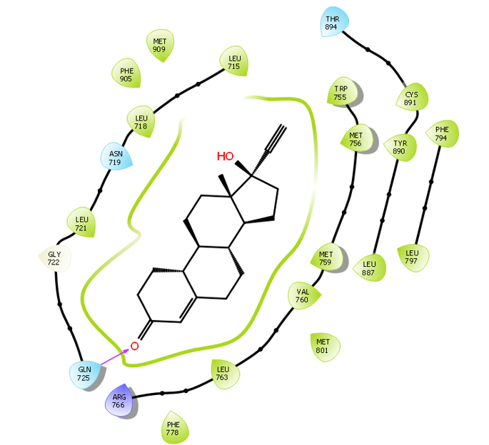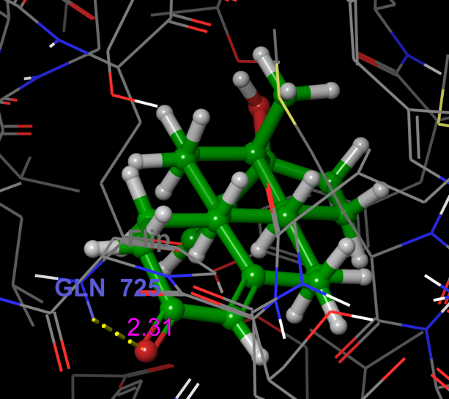
- b)

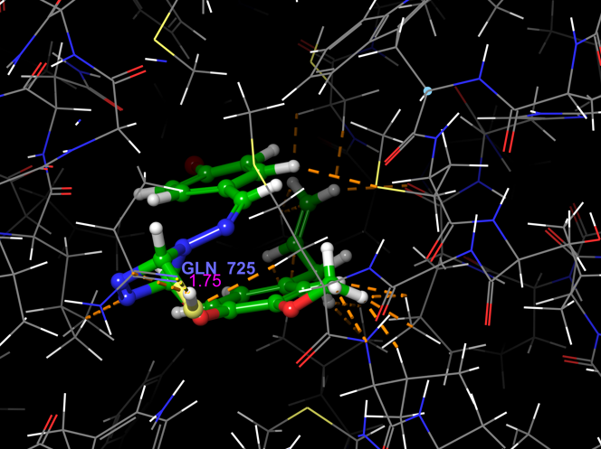
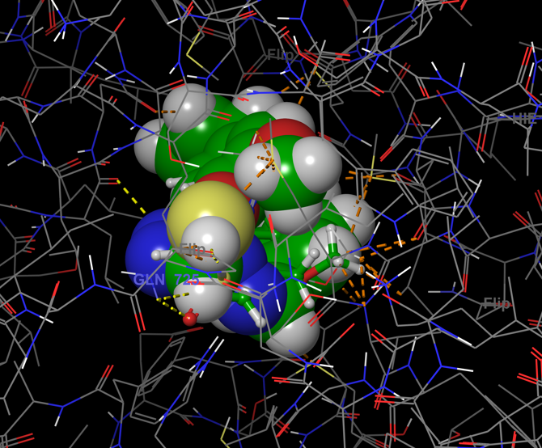
- d)
Fig 2. a) 2D ligand–protein interaction map of NDR (co-crystallized ligand), b) 3D binding interactions of NDR (co-crystallized ligand) within the active site, c) 3D binding interactions of Tria-8 in the target protein active site, d) 3D CPK representation showing interactions of eugenol–triazole ligands within the binding pocket.

Molecular docking studies were conducted to evaluate the binding affinities and interaction profiles of eugenol-based triazole derivatives within the active site of the target protein (PDB ID: 1M17). Binding free energy (ΔG, kcal/mol) was used to assess ligand–protein interaction strength, where more negative values indicate stronger binding. Erlotinib, the co-crystallized ligand, exhibited the highest binding affinity (ΔG = −8.412 kcal/mol), validating the docking protocol and serving as a benchmark for comparison. Its strong binding arises from key interactions with residues CYS773 and MET769, which are known to play critical roles in stabilizing inhibitors within the active site.
The clinically approved inhibitor Gefitinib also showed favorable binding (ΔG = −7.676 kcal/mol), interacting with LYS721 and MET769, suggesting a binding mode comparable to Erlotinib. In contrast, eugenol displayed very weak binding affinity (ΔG = −4.514 kcal/mol) and lacked significant interactions with key active-site residues, indicating poor complementarity and limited stabilization within the binding pocket.
Incorporation of the triazole moiety significantly enhanced binding affinity relative to eugenol. Among the desgined derivatives, Tria-25 demonstrated the strongest binding (ΔG = −7.637 kcal/mol), closely approaching that of Gefitinib. Its improved affinity is attributed to multiple hydrogen bond interactions involving MET769, THR766, ASP831, and GLU738, along with extensive hydrophobic contacts that stabilize the ligand within the pocket. Tria-24 also showed strong binding (ΔG = −7.422 kcal/mol), interacting with GLN767, ASP831, and GLU738, suggesting that engagement of acidic residues contributes positively to binding stability.
Other triazole derivatives exhibited moderate binding affinities. Tria-13 (ΔG = −6.974 kcal/mol), Tria-11 (ΔG = −6.809 kcal/mol), and Tria-22 (ΔG = −6.752 kcal/mol) primarily interacted with MET769 and ASP831, indicating partial occupation of the active site and fewer stabilizing interactions compared to Tria-25 and Tria-24. These results highlight the importance of multiple hydrogen-bond donors and acceptors, along with optimal orientation of substituents, for improved binding.
Interaction analysis of Erlotinib (Fig. 3a and 3b) revealed that its high affinity is driven by multiple hydrogen bonds involving the quinazoline core and residues such as CYS773, MET769, and GLN791, reinforced by extensive hydrophobic and π–π stacking interactions within a well-defined non-polar binding pocket. These interactions collectively ensure tight and specific binding. Similarly, Tria-25 (Fig. 3c) formed several hydrogen bonds with key residues and was further stabilized by hydrophobic contacts with surrounding non-polar amino acids, explaining its favorable docking score.
Superposition of the docked eugenol–triazole derivatives (Fig. 3d) confirmed that all ligands occupy the same binding region within the active site, indicating a shared binding mode across the series. The conserved alignment of the triazole core and aromatic rings identifies these features as essential pharmacophoric elements, while variability in peripheral substituents suggests opportunities for further structural optimization.
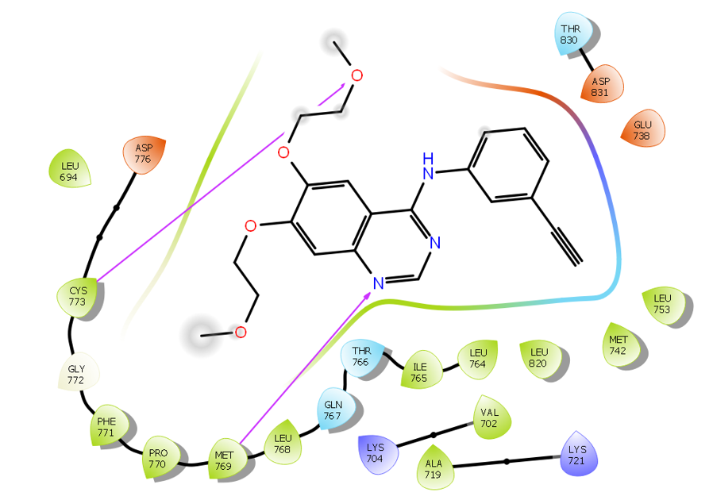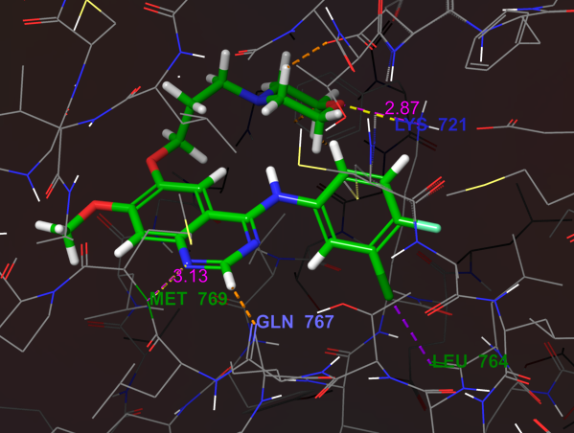
a) b)

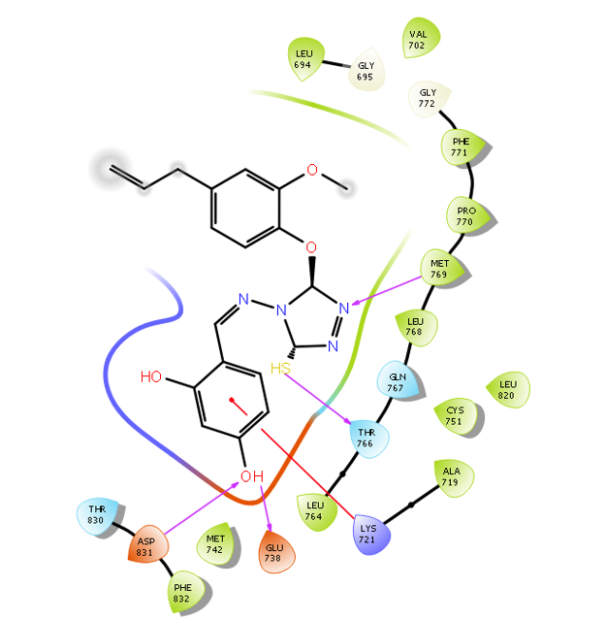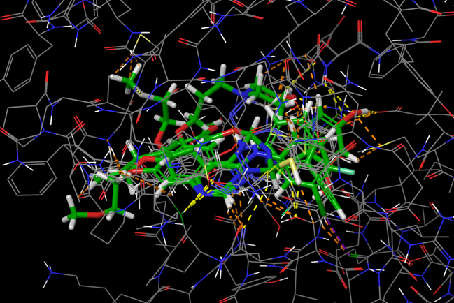

- d)

Fig 3. a) 2D ligand–protein interaction map of Erlotinib (co-crystallized ligand), b) 3D binding interactions of Erlotinib (co-crystallized ligand) within the active site, c) 2D ligand–protein interaction map of Tria-25, d) 3D ligand interactions of eugenol–triazole ligands within the binding pocket.

Molecular docking studies against the PI3Kα target (PDB ID: 5DXT) were performed to assess the binding affinities and interaction profiles of reference drugs, eugenol, and the designed triazole derivatives. The co-crystallized inhibitor Alpelisib exhibited the strongest binding affinity (ΔG = −10.264 kcal/mol), forming multiple stabilizing hydrogen bonds with GLN859 and SER854, along with extensive hydrophobic interactions involving VAL851, HIS850, and ILE848, thereby validating the docking protocol. In comparison, Tamoxifen showed moderate binding (ΔG = −6.396 kcal/mol) with limited interaction primarily involving GLU798, while eugenol displayed weaker affinity (ΔG = −5.8809 kcal/mol), forming minimal contacts with GLU849 and VAL851, indicating suboptimal engagement of the binding pocket.
The 2D and 3D interaction analyses (Fig. 4a–b) reveal that Alpelisib is deeply embedded within the PI3K catalytic cavity, where short and stable hydrogen bonds with GLN859 (~2.4 Å) and SER854 (~2.6 Å), together with a well-defined hydrophobic socket, contribute to its high binding stability. Among the desgined compounds, Tria-24 demonstrated improved binding affinity (ΔG = −6.808 kcal/mol) relative to Tamoxifen and eugenol. Its binding is stabilized by key hydrogen bonds with SER774, MET772, and VAL851, supplemented by hydrophobic interactions and a notable π–π stacking interaction with TRP790 (Fig. 4c–d). Tria-29 exhibited comparable affinity (ΔG = −6.264 kcal/mol), interacting mainly with ARG770, SER854, and VAL851.

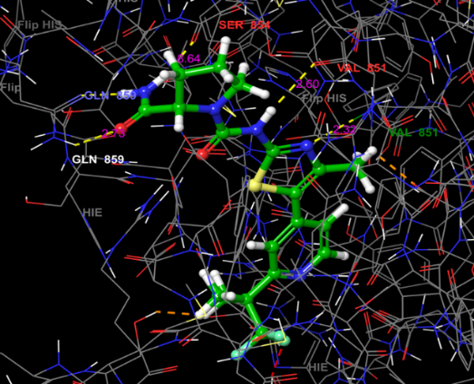
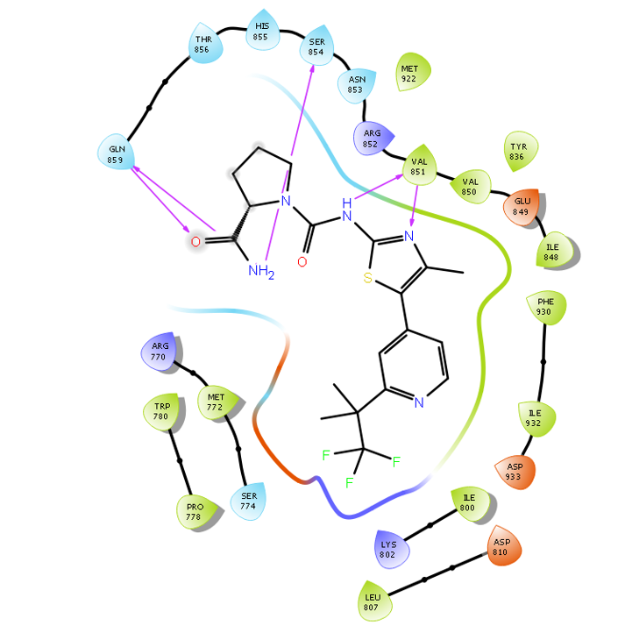
a) b)
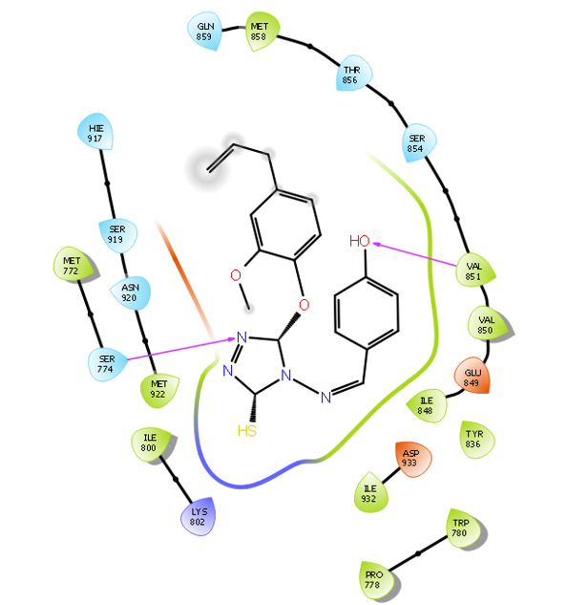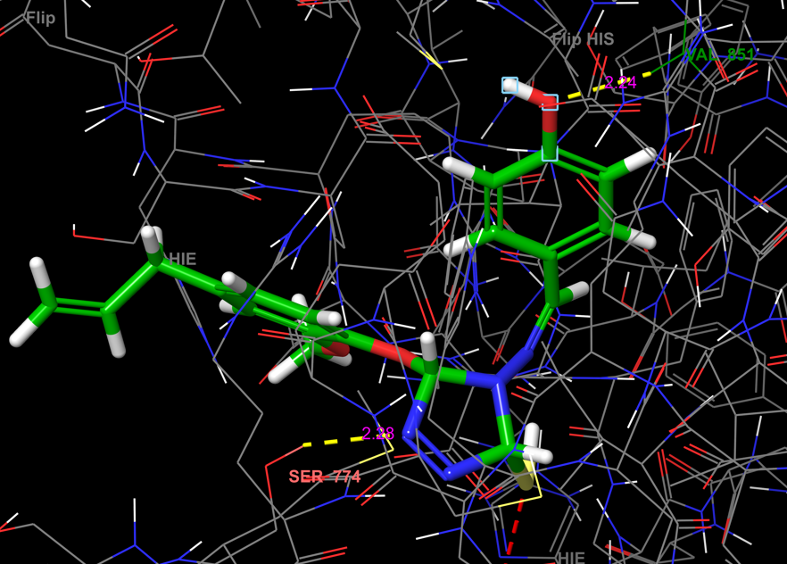
c) d)
Fig 4. a) 2D interaction map of Alpelisib (co-crystallized ligand), b) 3D binding mode of Alpelisib in the active site, c) 2D interaction map of Tria-24, and d) 3D binding mode of Tria-24 within the binding pocket.
Rapamycin, the co-crystallized inhibitor, exhibited the strongest binding affinity (–6.457 kcal/mol) and formed multiple stabilizing hydrogen bonds with critical residues LYS52, SER80, GLN85, GLY84, ILE87, and TYR113, confirming the reliability of the docking protocol. Standard ligands such as doxorubicin (–5.693 kcal/mol), nertinib (–5.202 kcal/mol), and letrozole (–4.862 kcal/mol) also demonstrated moderate binding through interactions with residues including ILE87, ALA112, TYR113, and LYS121.
In contrast, eugenol showed the weakest binding affinity (–4.315 kcal/mol) and formed only a single hydrogen bond with ASP68, indicating poor stabilization within the mTOR binding pocket. This weak interaction profile explains its limited inhibitory potential toward mTOR when compared to reference inhibitors.
Notably, several triazole-substituted eugenol derivatives displayed improved binding affinities and interaction patterns. Tria-25 showed a binding affinity of –5.434 kcal/mol with a stabilizing hydrogen bond to LYS121, while Tria-14 (–5.405 kcal/mol) and Tria-22 (–5.397 kcal/mol) interacted strongly with TYR113, a residue critical for ligand recognition in the mTOR active site. Other derivatives, including Tria-1, Tria-24, and Tria-21, also demonstrated favorable binding through hydrogen bonding with LYS121 or TYR113, although with slightly lower docking scores.
The 2D ligand–protein interaction maps (Fig. 5b) reveal that Tria-8 establish both hydrogen bonding and hydrophobic interactions with key residues such as ILE87, TYR57, LEU128, PHE 130 and TYR113, closely resembling the interaction pattern of rapamycin (Fig. 5a). Furthermore, the 3D binding conformation of RAP (Fig. 5d) confirms optimal accommodation of the ligand within the mTOR pocket, supporting the relevance of these residues for effective inhibition.
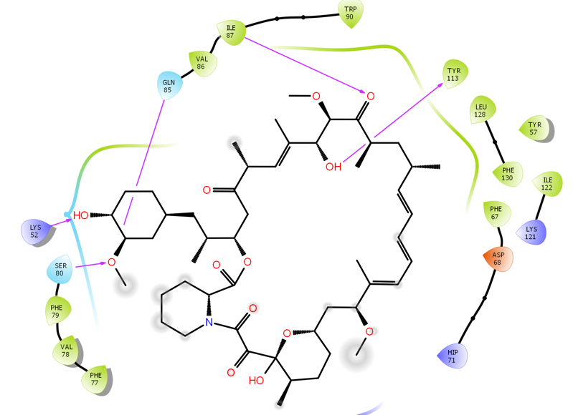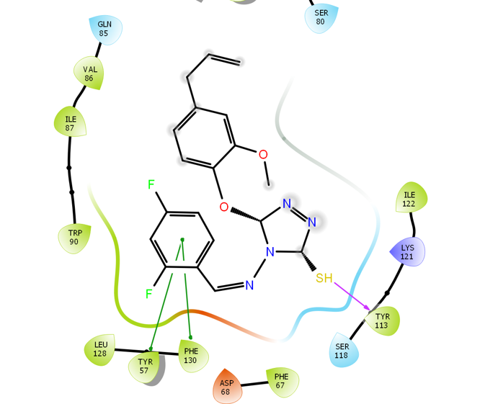

- b)

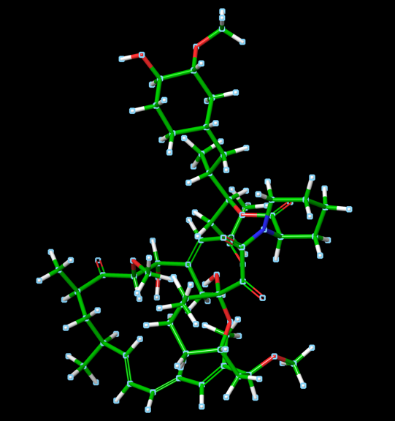
c)
Fig 5. (a) Two-dimensional ligand–protein interaction map of rapamycin (RAP, co-crystallized ligand) within the mTOR binding site, (b) two-dimensional interaction map of Tria-8, (c) three-dimensional binding conformation of rapamycin inside the mTOR active pocket.
4. CONCLUSION

The molecular docking results confirm that structural modification of eugenol through triazole hybridization significantly improves binding affinity and active-site engagement across multiple breast cancer–associated receptors. Several derivatives demonstrated binding energies and interaction profiles closely matching those of co-crystallized inhibitors and approved drugs, particularly within hormone receptor and kinase signaling pathways. The poor binding of parent eugenol underscores the importance of rational molecular design in enhancing therapeutic potential. Collectively, these findings support the further optimization and biological evaluation of eugenol–triazole hybrids, with future studies focusing on molecular dynamics, pharmacokinetic profiling, and in vitro anticancer assays.

COMPETING INTERESTS DISCLAIMER:
Authors have declared that they have no known competing financial interests OR non-financial interests OR personal relationships that could have appeared to influence the work reported in this paper.

REFERENCES

- Siegel, r. L., miller, k. D., wagle, n. S., & jemal, a. (2023). Cancer statistics, 2023. Ca: a cancer journal for clinicians, 73(1), 17–48.
- Sung, h., ferlay, j., siegel, r. L., laversanne, m., soerjomataram, i., jemal, a., & bray, f. (2021). Global cancer statistics 2020: globocan estimates of incidence and mortality worldwide for 36 cancers in 185 countries. cancer journal for clinicians, 71(3), 209–249.
- Vasan, n., baselga, j., & hyman, d. M. (2019). A view on drug resistance in cancer. Nature, 575(7782), 299–309.
- Bukowski, k., kciuk, m., & kontek, r. (2020). Mechanisms of multidrug resistance in cancer chemotherapy. International journal of molecular sciences, 21(9), 3233.
- Atanasov, a. G., zotchev, s. B., dirsch, v. M., & supuran, c. T. (2021). Natural products in drug discovery: advances and opportunities. Nature reviews drug discovery, 20(3), 200–216.
- Rodrigues, t., reker, d., schneider, p., & schneider, g. (2016). Counting on natural products for drug design. Nature chemistry, 8(6), 531–541.
- Fernandes melo reis, r. C., pontes silva, a. V., veiga torres, a. D., et al. (2024). From clove oil to bioactive agents: synthetic routes, antimicrobial and antiparasitic activities of eugenol derivatives. Future medicinal chemistry, 16(20), 2169–2188.
- Nazreen, s., elbehairi, s. E. I., malebari, a. M., et al. (2023). New natural eugenol derivatives as antiproliferative agents: synthesis, biological evaluation, and computational studies. Acs omega, 8(21), 18811–18822.

- Matin, m. M., matin, p., rahman, m. R., et al. (2022). Triazoles and their derivatives: chemistry, synthesis, and therapeutic applications. Frontiers in molecular biosciences, 9, 864286.
- Naeem, n., mughal, e. U., sadiq, a., othman, g. A., & shakoor, b. (2025). Recent advances in 1,2,4-triazole-based anticancer agents: structural optimization, mechanisms, and therapeutic potential (2022–2025). Archiv der pharmazie, 358(7), e70059.
- Agu, p. C., afiukwa, c. A., orji, o. U., et al. (2023). Molecular docking as a tool for the discovery of molecular targets of nutraceuticals in disease management. Scientific reports, 13(1), 13398.
- Pagadala, n. S., syed, k., & tuszynski, j. (2017). Software for molecular docking: a review. Biophysical reviews, 9(2), 91–102.
- Ayub, m. A., tyagi, a. R., srivastava, s. K., & singh, p. (2025). Quantum dft analysis and molecular docking investigation of potential breast cancer drugs. Journal of materials chemistry b, 13(1), 218–238.
- Sowa-kasprzak, k., totoń, e., kujawski, j., et al. (2023). Synthesis, cytotoxicity and molecular docking of new hybrid compounds combining curcumin and oleanolic acid. Biomedicines, 11(6), 1506. Https://doi.org/10.3390/biomedicines11061506
- Alam, m. M. (2023). Synthesis and anticancer activity of novel eugenol derivatives against breast cancer cells. Natural product research, 37(10), 1632–1640.
- Newman, d. J., & cragg, g. M. (2020). Natural products as sources of new drugs over nearly four decades from 1981 to 2019. Journal of natural products, 83(3), 770–803.
- Naeem, a., hu, p., yang, m., et al. (2022). Natural products as anticancer agents: current status and future perspectives. Molecules, 27(23), 8367.
- Osborne, c. K., & schiff, r. (2011). Mechanisms of endocrine resistance in breast cancer. Annual review of medicine, 62, 233–247.
- Costa, r. L. B., & gradishar, w. J. (2017). Differences are important: breast cancer therapy in different ethnic groups. Journal of global oncology, 3(4), 281–284.
- Mayer, i. A., & arteaga, c. L. (2016). The pi3k/akt pathway as a target for cancer treatment. Annual review of medicine, 67, 11–28.
- Yager, j. D., & davidson, n. E. (2006). Estrogen carcinogenesis in breast cancer. New england journal of medicine, 354(3), 270–282.
- Mohammed, h., russell, i., stark, r., et al. (2015). Progesterone receptor modulates erα action in breast cancer. Nature, 523, 313–317.
- Normanno, n., de luca, a., bianco, c., et al. (2006). Epidermal growth factor receptor signaling in cancer. Gene, 366(1), 2–16.
- Hu, j., zhang, h., cao, m., et al. (2018). Auranofin enhances ibrutinib’s anticancer activity in egfr-mutant lung adenocarcinoma. Molecular cancer therapeutics, 17(10), 2156–2163.
- Thorpe, l. M., yuzugullu, h., & zhao, j. J. (2015). Pi3k in cancer: divergent roles of isoforms and therapeutic targeting. Nature reviews cancer, 15(1), 7–24.
- Laplante, m., & sabatini, d. M. (2012). Mtor signaling in growth control and disease. Cell, 149(2), 274–293.
- Berman, h. M., westbrook, j., feng, z., et al. (2000). The protein data bank. Nucleic acids research, 28(1), 235–242.
- Dykstra, k. D., guo, l., birzin, e. T., et al. (2007). Estrogen receptor ligands: 2-aryl indoles as selective erα ligands. Bioorganic & medicinal chemistry letters, 17(8), 2322–2328.
- Madauss, k. P., deng, s. J., austin, r. J., et al. (2004). Progesterone receptor ligand binding pocket flexibility. Journal of medicinal chemistry, 47(13), 3381–3387.
- Stamos, j., sliwkowski, m. X., & eigenbrot, c. (2002). Structure of the egfr kinase domain. Journal of biological chemistry, 277(48), 46265–46272.
- Heffron, t. P., heald, r. A., ndubaku, c., et al. (2016). Rational design of selective pi3kα inhibitors. Journal of medicinal chemistry, 59(3), 985–1002.
- März, a. M., fabian, a. K., kozany, c., & hausch, f. (2013). Fk506-binding proteins and rapamycin pharmacology. Molecular and cellular biology, 33(7), 1357–1367.
- Rasul, h. O., aziz, b. K., ghafour, d. D., & kivrak, a. (2022). In silico docking and dynamics of eugenol compounds against breast cancer targets. Journal of molecular modeling, 28(1), 17.
- Lipinski, c. A. (2000). Drug-like properties and causes of poor solubility and permeability. Journal of pharmacological and toxicological methods, 44(1), 235–249.
- Berman, h. M., westbrook, j., feng, z., gilliland, g., bhat, t. N., weissig, h., & bourne, p. E. (2000). The protein data bank. Nucleic acids research, 28(1), 235–242.
- Dykstra, K. D., Guo, L., Birzin, E. T., Chan, W., Yang, Y. T., Hayes, E. C., et al. (2007). Estrogen receptor ligands. Part 16: 2-Aryl indoles as highly subtype-selective ligands for ERα. Bioorganic & Medicinal Chemistry Letters, 17(8), 2322–2328.
- Madauss, K. P., Deng, S. J., Austin, R. J., Lambert, M. H., McLay, I., Pritchard, J., et al. (2004). Progesterone receptor ligand-binding pocket flexibility: Crystal structures of the norethindrone and mometasone furoate complexes. Journal of Medicinal Chemistry, 47(13), 3381–3387.
- Stamos, J., Sliwkowski, M. X., & Eigenbrot, C. (2002). Structure of the epidermal growth factor receptor kinase domain alone and in complex with a 4-anilinoquinazoline inhibitor. Journal of Biological Chemistry, 277(48), 46265–46272.
- Heffron, T. P., Heald, R. A., Ndubaku, C., Wei, B., Augistin, M., Do, S., et al. (2016). The rational design of selective benzoxazepin inhibitors of the α-isoform of phosphoinositide 3-kinase culminating in the identification of GDC-0326. Journal of Medicinal Chemistry, 59(3), 985–1002.
- März, A. M., Fabian, A. K., Kozany, C., Bracher, A., & Hausch, F. (2013). Large FK506-binding proteins shape the pharmacology of rapamycin. Molecular and Cellular Biology, 33(7), 1357–1367. https://doi.org/10.1128/MCB.00678-12
- Rasul, H. O., Aziz, B. K., Ghafour, D. D., & Kivrak, A. (2022). In silico molecular docking and dynamic simulation of eugenol compounds against breast cancer. Journal of Molecular Modeling, 28(1), 17.
- da Silva, F. F. M., Monte, F. J. Q., de Lemos, T. L. G., do Nascimento, P. G. G., de Medeiros Costa, A. K., & de Paiva, L. M. M. (2018). Eugenol derivatives: Synthesis, characterization, and evaluation of antibacterial and antioxidant activities. Chemical Central Journal, 12(1), 34.
- Fadilah, F., Yanuar, A., Arsianti, A., & Andrajati, R. (2017). Phenylpropanoids, eugenol scaffold, and its derivatives as anticancer agents. Asian Journal of Pharmaceutical and ClinicalResearch,10(3),41–46.

