Original Research Article
In Vitro Assessment of Bioactivities of Seagrass and its Zinc Oxide Nanoparticles

ABSTRACT
Background
Halophila beccarii, a seagrass dwelling in shallow coastal water belongs to the family Hydrocharitaceae, is well-known for its wide spectrum of bioactive secondary metabolites, including phenolics, flavonoids, terpenoids and sulphated polysaccharides. In the current study, we explored the anti inflammatory, antioxidant and the antimicrobial activities of aqueous extract of Halophila beccarii and its zinc oxide nanoparticles.
Methods
The aqueous extract prepared from H.beccarii was utilized for the synthesis of zinc oxide nanoparticles by green technology. The anti inflammatory, antioxidant and antibacterial activity of both aqueous extract and zinc oxide nanoparticles was determined by membrane stabilization assay, radical scavenging activity and the disc diffusion method respectively.
Results
Both aqueous extract and zinc oxide nanoparticles exhibited significant antioxidant, membrane stabilization effects when correlated with the standard drug such as ascorbic acid and diclofenac. Hb-ZnO NPs showed nearly identical activity to Diclofenac, with inhibition values of 65.41% and 70.14% respectively at 80 µg/ml. Hb-ZnO NPs showed strongest antibacterial effect, producing inhibition zones of 24.6 ± 0.5 mm against B.subtilis, 18 ± 0.1 mm against P. aeruginosa, 19.66 ± 0.5 mm against K.pneumoniae, and S.aureus 14 ± 0.5 mm, closely matching the activity of the standard antibiotic gentamycin.
Conclusion
The study demonstrated superior therapeutical potential of zinc oxide nanoparticles compared to aqueous extract of H.beccarii

Key words : Seagrass, Halophila beccarii , anti inflammatory, antibacterial activity, zinc oxide nanoparticles.

- INTRODUCTION
Seagrasses are marine angiosperms and the only flowering plants that have fully adopted to marine environment inhabiting shallow coastal waters across tropical, subtropical and temperate regions (Vasarri et al.,2021, Gono et al.,2022). Seagrasses namely Halophila beccarii, Halophila ovalis, Thalassia hemprichii, Enhalus acoroides etc are well-known for their wide spectrum of bioactive secondary metabolites, including phenolics, flavonoids, terpenoids and sulphated polysaccharides (Shaffai et al.,2023, Wehbe et al.,2024]. These compounds play critical role in antioxidative and anti-inflammatory responses and their pharmacological relevance in terrestrial medicinal plants highlights seagrasses as promising marine sources of therapeutic agents (De leo et al.,2025, Ameen et al.,2024)
Oxidative stress, arising from the excessive generation of reactive oxygen species (ROS), disrupts cellular integrity , fueling chronic inflammation, diabetes and infections through lipid peroxidation and protein damage (Tanu et al.,2025, Jomova et al.,2023). Natural antioxidants capable of restoring redox homeostasis are important. Several studies have demonstrated the antioxidant activity of seagrass extract which are frequently correlated with high total phenol and flavonoid contents of seagrass (Santoso et al.,2023). Inflammation is a fundamental biological response to tissue injury and infection. However chronic inflammation underlies many pathological conditions (Ptaschinski et al.,2018, Medzhitov et al.,2021). There is growing interest in identifying natural anti-inflammatory drugs. Seagrass derived extracts and isolated compounds have demonstrated anti-inflammatory potential through the inhibition of pro-inflammatory enzymes such as cyclooxugenase-2 and inducible nitric oxide synthase.(Mathakala et al.,2024).In addition to antioxidant and anti-inflammatory activities, seagrass may exhibit notable anti-microbial properties due to the phytochemical constituents which interfere with the microbial cell membrane or biofilm formation ( (Danaraj et al.,2024). Despite the accumulating evidence supporting therapeutic potential the studies are limited to fewseagrasses.
The current study focuses on investigating the antioxidant, antimicrobial, anti-inflammatory along with the minimum inhibitory concentration (MIC) of aqueous extract of Halophila beccarii (HBAE) and zincoxide nanoparticles (Hb-ZnO NPs) synthesized using H. beccarii through green approach.

- MATERIALS AND METHODS
2.1 Anti inflammatory activity of H.beccarii
The invitro anti-inflammatory potential of HBAE and Hb-ZnO NPs was measured using HRBC membrane stabilization assay. The Halophila beccarii was collected from the Pulicat lake, Andhra Pradesh, India. The H.beccarii aqueous extract was prepared by rota evaporatoration under reduced pressure followed by lyophilization. The blood sample was collected from an active individual and instantly mixed with equal amount of alsever’s solution and 10% HRBC solution was prepared with saline.To 1ml of HRBC solution, 1ml of different concentrations of HBAE (100,200,300,400 & 500µg) & Hb-ZnO NPs (5,10,20,40,80µg) were added respectively. After incubation at 37°c for 30 min in a water bath the mixtures were centrifuged and the supernatant was carefully collected and the absorbance was read at 560nm. Diclofenac was used as standard for comparative analysis. (Abdelbaky et al.,2022). The percentage of hemolysis was calculated.
2.2 Antioxidant activity of H.beccarii

The anti-oxidant ability of the HBAE and Hb-ZnO NPs was measured by DPPH (2,2-diphenyl-1-picryl hydrazyl) radical scavenging activity. The stock solution of the HBAE and Hb-ZnO NPs (1mg/ml ) were prepared and incubated with 0.01mM of the DPPH solution at room temperature for 15min, and the absorbance was recorded at 517 nm. Ascorbic acid was used as a standard for comparative studies (Abdelghany et al.,2023, Tejaswini et al.,2025) and the percentage of DPPH radical scavenging potential was measured.

2.3 Antimicrobial activity of H.beccarii

The antimicrobial potential of HBAE and Hb-ZnO NPs against Bacillus subtilis (MTCC 441), Pseudomonas aeruginosa (MTCC 424), Klebsiella pneumoniae (MTCC 109) and Staphylococcus aureus (MTCC 96).was determined by the disc diffusion method. Nutrient agar plates were inoculated with 1ml of actively growing 24h old bacterial suspension. After inoculation, sterile paper discs which were impregnated with HBAE (100, 150, 200, 250 μg/mL) and Hb-ZnO NPs (5,10, 20 & 40 μg/mL) were placed at equidistant on the agar plate. Gentamycin (10 μg/mL) served as positive control. The plates were then incubated at 37 °C for 18–24 h. The antimicrobial activity was evaluated by calculating the zone of inhibition and results were reported as mean ± standard error of the mean (SEM) (Rajeswaran et al.,2019).

2.4 Minimum Inhibitory Concentration.

The minimum inhibitory concentration of HBAE and Hb-ZnO NPs was measured by using broth micro dilution method (Vanegas et al.,2021). Briefly the fresh overnight cultures of B.subtilis, (MTCC 441), K.Pneumoniae (MTCC 109), P.aeruginosa (MTCC 424), and S.aureus (MTCC 96) was adjusted to 5 x !0⁵ cfu/ml using mueller hinton broth. The HBAE (64 - 0.5 μg/ml and Hb-ZnO NPs (32 – 0.125 μg/ml) were subjected to serial dilutions in mueller hinton broth. Aliquots (100 μl) of each dilution were dispensed into sterile 96 well microtitre plates followed by addition of 100 μl of gram positive and gram negative bacterial suspension to each well with a total volume of 200 μl in each well and incubated at 37 °C for 18–24 h. The absorbance was measured at 600nm.The lowest concentration of HBAE and Hb-ZnO NPs that completely inhibited the visible growth was considered as minimum inhibitory concentration of the particular sample.

- RESULTS
3.1 Anti Inflammatory activity
The anti-inflammatory effect of the HBAE extract was assessed at concentrations ranging from 100 to 500 µg/mL and compared with the standard diclofenac. As shown in the graph, both Diclofenac and HBAE exhibited a clear concentration-dependent increase in percentage inhibition. Diclofenac demonstrated higher inhibition across all concentrations, rising from 74.8% at 100µg/mLto97.63% at 500 µg/mL. Similarly, the HBAE extract showed a progressive increase in activity, with inhibition values ranging from 40.6% at 100 µg/mLto81.26% at 500 µg/mL. (Figure 1a) Although the extract showed lower activity than the standard, it displayed a strong and consistent dose-dependent anti-inflammatory effect, with the highest inhibition recorded at the maximum tested concentration. Both diclofenac (standard) and Hb-ZnO nanoparticles showed a dose-dependent increase in anti-inflammatory activity in the HRBC membrane stabilization assay. At lower concentrations (5–20 µg/ml), Diclofenac exhibited slightly higher inhibition (32.84–51.25%) compared to Hb-ZnO NPs (29.45–50.02%). However, at higher concentrations (40 and 80 µg/ml), Hb-ZnO NPs showed nearly identical activity to Diclofenac, with inhibition values of 65.41% and 70.14% respectively (Figure 1b). Overall, Hb-ZnO nanoparticles demonstrated comparable membrane-stabilizing and anti-inflammatorypotential to the standard drug at higher doses. Statistical analysis was performed using two-way ANOVA, followed by tukey’s multiple comparison test at the corresponding concentration.
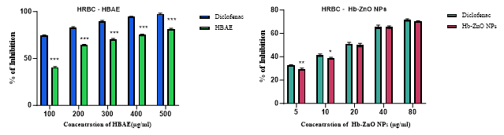
Fig. 1. Percentage inhibition of Hemolysis a : Aqueous extract of H.beccarii b : Hb-ZnO NPs.
Values are expressed as mean±SD of three independent experiments statistical analysis was performed using two-way ANOVA, followed by Tukey’s multiple comparision test at the corresponding concentration.(Statistical significance at ⃰ ⃰⃰ ⃰ p ˂ 0001, ⃰ ⃰ p ˂ 001 & *p< 0.05).
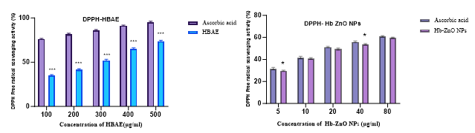
Fig. 2 a. DPPH radical scavenging activity of HBAE b. Hb-ZnO NPs
Data are expressed as mean±SD of three independent experiments, statistical analysis was performed using two way ANOVA followed by tukey’s multiple comparision test compared to ascorbic acid at the corresponding concentration (significant at ⃰⃰ ⃰ ⃰ p ˂ 0.001, ⃰ ⃰ p ˂ 0.01 & *p< 0.05).
3.2 Antioxidant activity
The DPPH assay showed a clear dose-dependent increase in antioxidant activity for both ascorbic acid and HBAE extract.(Figure 2a) Ascorbic acid exhibited high scavenging activity at all tested doses (76.26–95.35%). HBAE showed moderate activity at lower concentrations (35–52%) but increased substantially at higher concentrations, reaching 73.77% at 500 µg/ml. Hb-ZnO NPs showed a rapid increase in DPPH free radical scavenging activity from 5–80 µg/ml. Hb-ZnO NPs increased gradually from 29.68% at 5 µg/mlto59.78% at 80 µg/ml, but remained slightly lower than the standard at every dose.(Figure 2b).Statistical analysis was performed using two way ANOVA followed by tukey’s multiple comparison test compared to ascorbic acid at the corresponding concentration.
3.4 Evaluation of Antimicrobial Activity (Inhibition Zone)
The antimicrobial screening of HBAE (200 µg/mL), Hb-ZnO nanoparticles (20 µg/mL), and gentamycin (10 µg/mL) showed distinct level of inhibition against gram positive and gram negative bacteria (Figure 3a). ZnO NPs showed the strongest antibacterial effect, producing inhibition zones of 24.6 ± 0.5 mm against B.subtilis, 18 ± 1 mm against P. aeruginosa, 19.66 ± 0.5 mm against K.pneumoniae, and S.aureus 14 ± 0.5 mm, closely matching the activity of the standard antibiotic gentamycin.(Figure 3b) In comparison, HBAE exhibited moderate antibacterial activity, with inhibition zones ranging from 14 ± 1 mm (P. aeruginosa) to 18 ± 1 mm (B. subtilis), indicating that the extract possesses bioactive constituents capable of suppressing both gram-positive and gram-negative bacteria, though less effectively than ZnO NPs (Table 1)
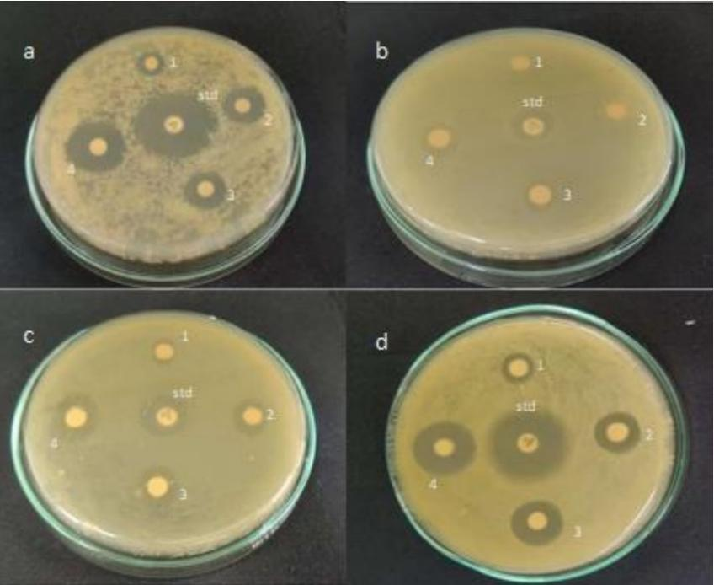
Fig. 3a. Antimicrobial activity of HBAE against a. B.subtilis b. S.aureus
c. P.aeruginosa d. K.pneumoniae at Concentrations 1) 100µg 2) 150µg
3) 200µg 4) 250µg & std-gentamycin- 10 µg

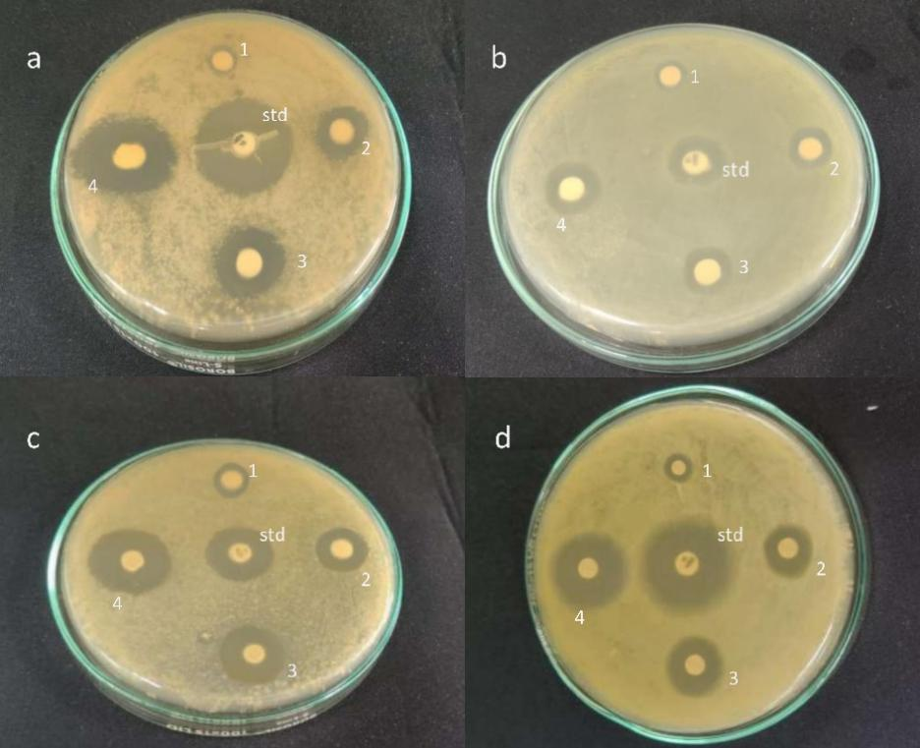
Fig. 3b. Antimicrobial activity of Hb-ZnO NPs of a. B.subtilis b. S.aureus
c. P.aeruginosa d. K.pneumoniae at Concentrations 1) 5µg 2) 10µg
3) 15µg 4) 20µg & std-gentamycin- 10 µg

Table 1. Antibacterial activity of HBAE and Hb-ZnO NPs against pathogens
Bacteria | Zone of Inhibition (mm)
Bacteria | HBAE (µg/mL) | ZnO NPs (20 µg/mL) | Gentamycin (10 µg/mL)
B.subtilis | 18 ± 0.15c | 24.6 ± 0.5 | 24.6 ± 0.5
P.aeruginosa | 14 ± 0.11c | 18 ± 0.12b | 12.3 ± 0.5
K.pneumoniae | 17.33 ± 0.5c | 19.66 ± 0.5b | 22.3 ± 0.5
S.aureus | 14 ± 0.5c | 14 ± 0.5 | 14 ± 0.5

Values are expressed as mean±SD (n=3), statistical analysis was performed,‘b’ means ⃰ ⃰ significant at p ˂ 0.01 & ‘c’ significant at * p < 0.05.
3.5 Minimum Inhibitory Concentration (MIC)
MIC results further confirmed the superior potency of Hb-ZnO NPs over the crude extract as shown in Figure 4. HBAE recorded MIC values between 32 and 64 µg/mL, with the lowest MIC observed for B. subtilis (32 µg/mL), suggesting relatively higher susceptibility of this organism. Conversely, P. aeruginosa, K.pneumoniae, and S.aureus displayed higher MICs of 64 µg/mL, indicating lower sensitivity to the extract. In contrast, Hb-ZnO NPs demonstrated lower MIC ranges of 16–32 µg/mL, with B. subtilis and K.pneumoniae. showing the greatest susceptibility (16 µg/mL). The overall MIC pattern aligns with the inhibition zone results, reinforcing that Hb-ZnO NPs possess significantly stronger antibacterial activity compared to HBAE. Statistical analysis showed significant differences (p < 0.05) between Hb-ZnO NPs and HBAE for all tested pathogens, indicating stronger antimicrobial activity of Hb-ZnO NPs. No significant difference was observed between Hb-ZnO NPs and gentamycin against B. subtilis, whereas gentamycin showed significantly higher inhibition than HBAE.

Fig. 4. MIC of HBAE and Hb-ZnO NPs against gram positive and gram negative bacteria.

- DISCUSSION
The current study illustrates that both HBAE and Hb-ZnO NPs exhibit remarkable antioxidant, anti-inflammatory, and antimicrobial effects while Hb-ZnO NPs generally show stronger effect compared to the crude extract, HBAE. These bioactivities support the phytomedicinal relevance of H.beccarii and featuring the ability of ZnO NPs green synthesized by making use of seagrass metabolites. H.beccarii is a prolific seagrass well-known for its substantial content of phenols, flavonoids, sterols, and antioxidant compounds (Mathakala et al.,2022). The medicinal properties of this particular species is under-studied when compared to other seagrasses. The findings of this study furnish empirical evidence supporting its function as a reliable source for the green synthesis of bioactive Hb-ZnO NPs.
H. beccarii methanolic extract exhibits considerable anti-inflammatory potential by inhibiting pro-inflammatory markers namely TNF-α, PGE-2 and COX-2 (Mathakala et al.,2024). In alignment with these findings, our study showed significant HRBC membrane stabilization, further confirming the anti-inflammatory nature of both the aqueous extract and Hb-ZnO NPs.
The DPPH assay disclosed a concentration-based increase in antioxidant activity for both HBAE and Hb-ZnO NPs. Hb-ZnO NPs persistently showed higher radical-scavenging activity, likely due to electron-donating capacity from bioactive compounds from HBAE during green synthesis and neutralize free radicals. Significantly, this study exposes the preliminary evidence of antioxidant activity in H.beccarii (Kar et al.,2019).Previous literature have stated that Red Sea seagrass, Enhalus acoroides alcoholic leaf extract with the high antioxidant activity(76%) followed by the root(70%) and the rhizome(66%) displaying that various plant parts differ in radical scavenging activity (Shaffai et al.,2023).The scavenging ability of H.pinifolia and C.rotundata may be due to phenolics, flavonoids and tannins. In particular the higher levels of p-coumaric acid in C.rotundata plays a key role in enhanced antioxidant potential which is well known for its free radical neutralizing properties (Kannan et al., 2013) In consistent with these results the present work also elucidates a clear dose dependent response in antioxidant activity. The HBAE showed moderate but considerably increasing scavenging activity, whereas Hb-ZnO NPs exhibited strong activity 60% at 80µg/ml. Together these studies validate the idea that the antioxidant efficiency of seagrass extracts and their green synthesized nanoparticles are impacted by their phytochemical profile with superior radical scavenging efficacy.
Most of the studies carried so far featured on H.Ovalis with Yuvraj et al,2012, highlighting antimicrobial/MIC, antioxidant and anti-inflammatory potential against various microbes. However data remains sparse on H.beccarii. The present work therefore fills the gap by signifying that H.beccarii also expresses strong antibacterial activity even against pathogens that were not studied earlier, such as B.subtilis, P.aeruginosa, K.pneumoniae and S.aureus. Notably while earlier works have focused on H.ovalis, Posidonia oceanica, ,Thalassia, Cymodocea serrulate , the current work evaluated the biological activities of H.beccarii and its Hb-ZnO NPs (Ozbil et al.,2024. Patil et al.,2023, Bharathi et al.,2019).

- CONCLUSION
This study demonstrates that both the sea grass extract and the corresponding green-synthesized zinc oxide nanoparticles exhibit significant antioxidant, anti-inflammatory, and antimicrobial activities. Comparative evaluation indicates that nanoparticle formation leads to improved antimicrobial efficacy and sustained bioactivity relative to the extract alone, likely due to nanoscale effects and surface functionalization by phytochemicals of H.beccarii. Over all, these findings highlight the complementary roles of the H.beccarii extract and its derived nanoparticles and support their potential as multifunctional bioactive materials for further pharmaceutical investigation.

- CONSENT AND ETHICAL APPROVAL
It is not applicable.
DISCLAIMER (ARTIFICIAL INTELLIGENCE)
The authors hereby declare that NO generative AI technologies such as Large Language Models (ChatGPT, COPILOT, etc) and text-to-image generators have been used during the writing or editing of this manuscript.
COMPETING INTERESTS DISCLAIMER:
Authors have declared that they have no known competing financial interests OR non-financial interests OR personal relationships that could have appeared to influence the work reported in this paper.

REFERENCES
Vasarri, M., De Biasi, A. M., Barletta, E., Pretti, C., & Degl’Innocenti, D. (2021). An overview of new insights into the benefits of the seagrass Posidonia oceanica for human health. Marine Drugs, 19(9), 476. https://doi.org/10.3390/md19090476
Gono, C. M. P., Ahmadi, P., Hertiani, T., Septiana, E., Putra, M. Y., & Chianese, G. (2022). A comprehensive update on the bioactive compounds from seagrasses. Marine Drugs, 20(7), 406. https://doi.org/10.3390/md20070406
Shaffai, A. E., Mettwally, W. S., & Mohamed, S. I. (2023). A comparative study of the bioavailability of Red Sea seagrass, Enhalus acoroides (L.f.) Royle (leaves, roots, and rhizomes) as anticancer and antioxidant with preliminary phytochemical characterization using HPLC, FT-IR, and UPLC-ESI-TOF-MS spectroscopic analysis. Beni-Suef University Journal of Basic and Applied Sciences, 12(1), 41. https://doi.org/10.1186/s43088-023-00376-7
Wehbe, N., Bechelany, M., Badran, A., Al-Sawalmih, A., Mesmar, J. E., & Baydoun, E. (2024). A phytochemical analysis and the pharmacological implications of the seagrass Halodule uninervis: An overview. *Pharmaceuticals*, *17*(8), 993. https://doi.org/10.3390/ph17080993
De Leo M, Ciccone L, Menicagli V, Balestri E, Braca A, Nieri P, Testai L. Cymodocea nodosa, a Promising Seagrass of Nutraceutical Interest: Overview of Phytochemical Constituents and Potential Therapeutic Uses. Nutrients. 2025 Apr 1;17(7):1236.https://doi.org/10.3390/nu17071236
Ameen, H. M., Jayadev, A., Prasad, G., & Nair, D. I. (2024). Seagrass Meadows: Prospective Candidates for Bioactive Molecules. Molecules. https://doi.org/10.3390/molecules29194596
Tanu, R., Chaudhary, A. A., Prakash, G., Yasmeen, N., Ali, M. A. M., Raza, N., Sharma, P. K., Kumar, A., Yadav, T., & Kumar, V. (2025). Exploring the potential of photodynamic therapy in overcoming multidrug resistance: Mechanisms, synergies, and clinical advancements in infectious diseases. Frontiers in Cellular and Infection Microbiology. https://doi.org/10.3389/fcimb.2025.1624036
Jomova, K., Raptova, R., Alomar, S. Y., Alwasel, S. H., Nepovimova, E., Kuca, K., & Valko, M. (2023). Reactive oxygen species, toxicity, oxidative stress, and antioxidants: chronic diseases and aging. Archives of Toxicology, 97(10), 2499–2574. https://doi.org/10.1007/s00204-023-03562-9
Santoso, J., Purwaningsih, S., Ramadhan, W., & Noveliyana, Y. (2023). Bioactive compounds, phenol content and antioxidant activity of tropical seagrass Halodule pinifolia. Coastal and Ocean Journal (COJ), 7(2), 62-75. https://doi.org/10.29244/coj.v7i1.47784
Ptaschinski, C., & Lukacs, N. W. (2018). Acute and chronic inflammation induces disease pathogenesis. In Molecular Pathology (pp. 25-43). Academic Press. https://doi.org/10.1016/B978-0-12-802761-5.00002-X
Medzhitov, R. (2021). The spectrum of inflammatory responses. Science, 374(6571), 1070-1075. https://doi.org/10.1126/science.abi5200
Mathakala, V., Ullakula, T., & Palempalli, U. M. (2024). Seagrass as a potential nutraceutical to decrease pro-inflammatory markers. BMC Complementary Medicine and Therapies, 24(1), 260. https://doi.org/10.1186/s12906-024-04532-z
Danaraj J, Uthirakrishnan U, Kumaresan S, Natarajan PK, Krishna J, Perumal AS, Selvakumar K, Karami Z, Pugazhendhi A. Multifunctional application of seagrass-derived rosmarinic acid in mitigating biofilm and quorum-sensing virulence transcripts of methicillin-resistant Staphylococcus aureus. Journal of Environmental Chemical Engineering. 2024 Aug 1;12(4):113086. https://doi.org/10.1016/j.jece.2024.113086
Abdelbaky, A. S., Abd El-Mageed, T. A., Babalghith, A. O., Selim, S., & Mohamed, A. M. (2022). Green synthesis and characterization of ZnO nanoparticles using Pelargonium odoratissimum (L.) aqueous leaf extract and their antioxidant, antibacterial and anti-inflammatory activities. Antioxidants, 11(8), 1444. https://doi.org/10.3390/antiox11081444

Abdelghany, T. M., Al-Rajhi, A. M. H., Yahya, R., Bakri, M. M., Al Abboud, M. A., Yahya, R., Qanash, H., Bazaid, A. S., & Salem, S. S. (2023). Phytofabrication of zinc oxide nanoparticles with advanced characterization and its antioxidant, anticancer, and antimicrobial activity against pathogenic microorganisms. Biomass Conversion and Biorefinery, 13(1), 417-430. https://doi.org/10.1007/s13399-022-03412-1
Tejaswini Ullakula, Vani Mathakala, Umamaheshwari Amineni, Umakanth Naik Vankadoth, Uma Maheshwari Devi Palempalli(2025) , "Anti-Inflammatory Activity of Marine Red Algae through Dual Inhibition of Cyclooxygenase-2 and 5-Lipoxygenase," Advances in Pharmacology and Pharmacy, Vol. 13, No. 3, pp. 399 - 410, 2025. DOI: 10.13189/app.2025.130311.
Rajeswaran, S., Thirugnanasambandan, S. S., Subramaniyan, S. R., Kandasamy, S., & Vilwanathan, R. (2019). Synthesis of eco-friendly facile nano-sized zinc oxide particles using aqueous extract of Cymodocea serrulata and its potential biological applications. Applied Physics A, 125(2), 105. https://doi.org/10.1007/s00339-019-2404-4
Vanegas, D., Abril-Novillo, A., Khachatryan, A., Jerves-Andrade, L., Peñaherrera, E., Cuzco, N., Wilches, I., Calle, J., & León-Tamariz, F. (2021). Validation of a method of broth microdilution for the determination of antibacterial activity of essential oils. BMC Research Notes, 14(1), 439. https://doi.org/10.1186/s13104-021-05838-8
Mathakala V, Muppuru MK, Palempalli UM. Halophila beccarii extract ameliorate glucose uptake in 3T3-L1 adipocyte cells and improves glucose homeostasis in streptozotocin-induced diabetic rats. Heliyon. 2022 Aug 1;8(8).https://doi.org/10.1016/j.heliyon.2022.e10252
Kar, S. K., Sahoo, S. U., Kar, B. A., Naik, S. K., & Panda, P. C. (2019). Antioxidant activity of Halophila ovalis and Halophila beccarii (Hydrocharitaceae): two important seagrass species of Chilika Lagoon, India. Asian Journal of Pharmaceutical and Clinical Research, 12(3), 1-5. https://doi.org/10.22159/ajpcr.2019.v12i.3.28838
Kannan, R. R., Arumugam, R., Thangaradjou, T., & Anantharaman, P. (2013). Phytochemical constituents, antioxidant properties and p-coumaric acid analysis in some seagrasses. *Food Research International*, *54*(1), 1229-1236. https://doi.org/10.1016/j.foodres.2013.01.027
Yuvaraj, N., Kanmani, P., Satishkumar, R., Paari, A., Pattukumar, V., & Arul, V. (2012). Seagrass as a potential source of natural antioxidant and anti-inflammatory agents. Pharmaceutical biology, 50(4), 458-467. https://doi.org/10.3109/13880209.2011.611948

Ozbil, E., Ilktac, M., Ogmen, S., Isbilen, O., Ramirez, J. M. D., Gomez, J., ... & Volkan, E. (2024). In vitro antibacterial, antibiofilm activities, and phytochemical properties of Posidonia oceanica (L.) Delile: An endemic Mediterranean seagrass. Heliyon. https://doi.org/10.1016/j.heliyon.2024.e35592

Patil, R., & Mallya, R. (2023). A mini review on biological activities of genus Thalassia: A marine seagrass. Journal of Pharmacognosy and Phytochemistry, 12(6), 215-222. https://doi.org/10.22271/phyto.2023.v12.i6c.14783

Bharathi, N. P., Jayalakshmi, M., Amudha, P., & Vanitha, V. (2019). Phytochemical screening and in vitro antioxidant activity of the seagrass Cymodocea serrulata. Indian Journal of Geo-Marine Sciences, 48(8) http://nopr.niscair.res.in/handle/123456789/49710

