Original Research Article
Ethnopharmacological survey of medicinal plants used against sexually transmitted infections in the Korhogo department, northern Côte d’Ivoire

ABSTRACT
Resistance to commonly used antibiotics in the treatment of sexually transmitted infections (STIs) is a major problem, especially in reproductive health. Aim of this study was to identify the medicinal plants traditionally used by herbalists against STIs in the Korhogo department. To this end, an ethnopharmacological survey was conducted using an oral questionnaire administered to 80 traditional medicine practitioners in city and surrounding villages of Korhogo (Côte d'Ivoire). The investigations identified 17 plant species, among which Adansonia was the most frequently cited. digitata (17.65%), Trichilia emetica (11.76%) and Carica papaya (11.76%), as well as Olax subscorpioidea (9.76%). The plant parts used in preparation of medicinal recipes are primarily leaves (58.82%), followed by fruits (23.53%), stem bark (11.79%), and roots (5.88%). Furthermore, main preparation techniques used for administering remedies are infusion (55%), decoction (16.66%), maceration (16.66%), and hydrodistillation (11.68%). The duration of treatment with aforementioned plants varied from one to three weeks, with oral administration being the preferred route (73.68%). This data will contribute to valorization of natural resources in fight against sexually transmitted infections in the Korhogo department.
Keywords: Sexually transmitted infections, medicinal plants, ethnopharmacology, Korhogo

1. INTRODUCTION
Sexually transmitted infections (STIs) are among the most widespread public health problems globally, with over one million curable cases reported every day. This alarming increase is fueled by various factors, including low condom use, insufficient testing, social stigma, and increased vulnerability of young adults (Stewart et al., 2020). Several pathogens are implicated in STIs, including Trichomonas vaginalis (5.0%), Chlamydia trachomatis (4.2%), and Neisseria . Gonorrhea (1.6%) and Treponema pallidum (0.5%) (WHO, 2024). The fight against these pathogens relies primarily on use of specific or broad-spectrum antibiotics (Julie, 2025). Antibiotic therapy has indeed revolutionized the management of bacterial infections, contributing to a significant reduction in morbidity and mortality related to STIs. However, excessive and sometimes inappropriate use of these drugs has fostered the emergence of microbial resistance, transforming antibiotic resistance into a major public health issue. This worrying situation is increasingly stimulating the search for new antibacterial molecules derived from our plant heritage, capable of neutralizing multidrug-resistant germs (WHO, 2023).
It is within this context that the present work is situated, its objective being to catalogue the medicinal plants used in Korhogo department (northern Côte d'Ivoire) for treatment of sexually transmitted infections, through an ethnopharmacological survey. Indeed, previous studies have highlighted that northern Côte d'Ivoire possesses a rich floral diversity with therapeutic properties, constituting a source of pride and ancestral knowledge for local populations (Konan et al., 2019; Soro et al., 2023).
2. MATERIALS AND METHODS
2.1. Equipment
2.1.1. Study Area
The study was conducted in Poro region, located in northern Côte d'Ivoire, specifically in the Korhogo department. This area covers approximately 13,400 km² and is characterized by a hot, dry climate, typical of the Sudanian-Sahelian regions (Fig 1). Dominant vegetation is wooded savanna, composed mainly of trees and shrubs ranging in height from 8 to 12 meters. The local population is predominantly Senufo, an ethnolinguistic group deeply rooted in traditional practices and ancestral knowledge, particularly in traditional medicine ( Silué et al ., 2019).

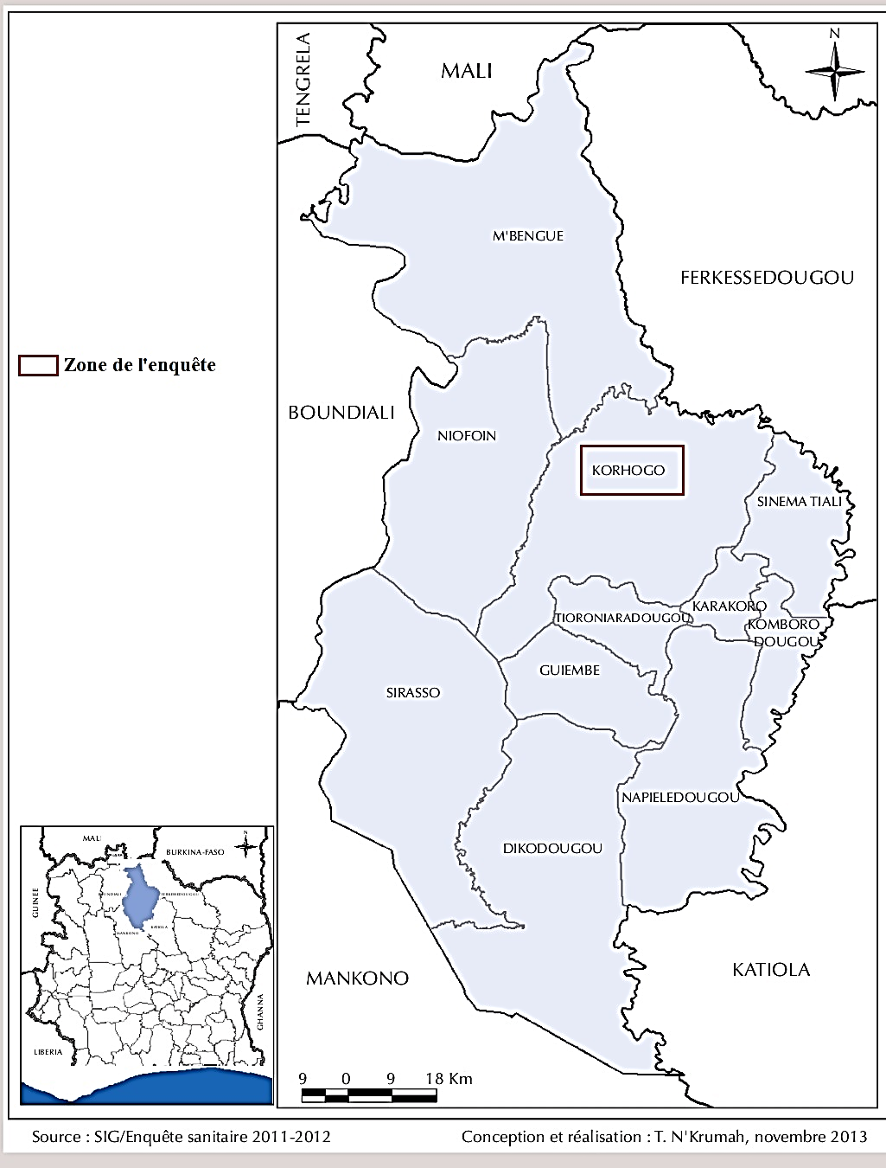

Fig 1 : Map of Poro region, in northern Côte d’Ivoire (Tanoh et al., 2014)
2.1.2. Technical Equipment
Technical equipment used for this ethnopharmacological study included a data collection form with an integrated questionnaire. This form was administered to traditional medicine practitioners, particularly herbalists and traditional healers working in city of Korhogo and surrounding villages. A digital camera (LCD TFT) was also used to photograph the plant parts mentioned, for botanical identification.
2.2. Methods
The ethnopharmacological survey took place from March 6 to May 5, 2024, with 40 herbalists and 40 traditional healers practicing in Korhogo department (Côte d'Ivoire). This investigation was conducted through oral interviews, using a standardized form with a structured questionnaire focusing on the following elements: plant names, organs or parts used, methods of preparing herbal remedies, routes of administration, and treatment duration. Subsequently, plant samples were collected and photographed either at markets from herbalists or directly in vegetation under the guidance of a local guide. Following sampling, a preliminary identification was carried out using the PlantNet software. The works of Arbonnier (2002) and Aké-Assi (2011) were consulted to confirm the identification. Finally, nomenclature of the recorded plant species was harmonized according to the Angiosperm Phylogeny Group IV classification (APG IV, 2016).
2.3. Statistical Analysis
Statistical analyses were performed using SPHINX software (Le Sphinx Plus²), and data entry was carried out with Word and Excel 2013. The Chi-square test, based on the assumption of distributional equality, was applied to compare the percentages of plants cited, plant organs used, preparation techniques, and routes of administration at a 5% significance level.
3. RESULTS AND DISCUSSION
3.1. Results
3.1.1. Botanical classes and plant organs used
The results of the survey conducted on plants used in the treatment of venereal diseases in the Korhogo department are presented in Table I. Analysis of this table reveals that 17 species of medicinal plants, distributed across 17 genera and 14 botanical families, were identified. The most represented families were Myrtaceae, Fabaceae, and Euphorbiaceae, each with a frequency of 11.76 %. The results also highlight a predominance of Adansonia digitata (17.65 %), followed by Trichilia emetica and Carica papaya (11.76 % each), and Olax subscorpioidea (9.76%). The analysis further revealed a predominance of leaves (58.82 %) and fruits (23.53 %) in the preparation of phytomedicines. In contrast, stem bark and roots were cited less frequently, with respective frequencies of 11.79 % and 5.88 % (Fig. 2).
3.1.2. Methods of preparing herbal medicines and duration of treatments
Regarding the preparation methods of herbal medicines, the survey data indicated that infusion was the most frequently used technique, reported by 55% of respondents, followed by maceration and decoction (16.66% each). In contrast, hydrodistillation was the least employed method, at 11.68% (Fig. 3).
Furthermore, it appears that different routes are used to administer phytomedicines. The oral route was the most frequently employed (73.68%), whereas the rectal and cutaneous routes were the least used, with respective frequencies of 15.80% and 10.52% (Fig. 4).
Finally, regarding the duration of treatments, the survey revealed that it ranged from one to eight weeks. Plants demonstrating treatment efficacy of one week (41.18%), two weeks (23.53%), and three weeks (23.53%) were the most frequently reported, whereas those with efficacy extending to four or eight weeks were the least cited, at 5.88% (Fig. 5).

Table I : Directory of medicinal plants used to treat venereal diseases in the Department of Korhogo
Scientific names | Families | Organs used | Preparation methods | Administrative channels | Treatment duration | Frequency of citation (%)
Adansonia digitata | Malvaceae | Stem bark | Decoction | Oral | 1 Week | 17.65
Trichilia emetica | Meliaceae | Leaves | Infusion | Oral | 1 Week | 11.76
Carica papaya | Caricaceae | Leaves / Roots | Maceration | Oral | 1 Week | 11.76
Olax subscorpioidea | Olacaceae | Leaves | Infusion | Oral | 2 Weeks | 9.76
Syrygium aromaticum | Myrtaceae | Fruits | Infusion | Oral | 2 Weeks | 4.91
Cassytha filiformis | Lauraceae | Leaves | Infusion | Oral | 4 Weeks | 4.79
Tetrapleura tetraptera | Fabaceae | Fruits / Leaves | Maceration | Oral | 1 Week | 4.64
Heliotropium indicator | Boraginaceae | Leaves | Infusion | Oral | 2 Weeks | 4.37
Moringa oleifeira | Moringaceae | Fruits | Decoction | Oral | 1 Week | 4.07
Vernomia amygdalina | Asteraceae | Leaves | Decoction | Oral | 4 Weeks | 3.82
Cocos nucifera | Arecaceae | Fruits | Hydrodistillation | Cutaneous | 4 Weeks | 3.82
Aloe vulgaris | Asphodelaceae | Leaves | Hydrodistillation | Cutaneous | 3 Weeks | 3.8
Guajava psidium | Myrtaceae | Leaves | Infusion | Toilet | 1 Week | 3.45
Alchornea cordifolia | Euphorbiaceae | Leaves | Infusion | Oral / Toilet | 1 Week | 3.37
Parkia biglobosa | Fabaceae | Stem bark | Maceration | Oral / Toilet | 4 Weeks | 3.28
Annona muricata | Annonaceae | Leaves / Roots | Infusion | Oral | 8 Weeks | 2.38
hyllanthus amur | Euphorbiaceae | Leaves | Infusion | Oral | 2 Weeks | 2.37

Frequency (%)

c

b
a
a

Parts used

Fig. 2: Parts of plants used in the preparation of the recipes
Bands bearing the same letter do not show a significant difference (P >0.05)

Frequency (%)
b

a
a
a

Preparation method

Fig. 3: Methods of preparing herbal medicines
Bands bearing the same letter do not show a significant difference (P >0.05)

Frequency (%)

b

a
a
Administrative channels

Fig. 4: Routes of administration of drug recipes
Bands bearing the same letter do not show a significant difference (P >0.05)

Frequency (%)

b
c
Treatment duration

b

a
a
Treatment duration

Fig. 5: Duration of treatments with herbal medicines

Bands bearing the same letter do not show a significant difference (P >0.05)

  - Discussion
During the ethnopharmacological study, traditional healers in Korhogo department cited a variety of medicinal plants. Among these plants, Adansonia was the most prominent. digitata (17.65%), Trichilia emetica and Carica papaya (11.76% each), then Olax subscorpioidea (9.76%), which are more commonly used in treatment of sexually transmitted infections (STIs). These results are consistent with those reported in several surveys conducted in West and sub-Saharan Africa (Kodjo et al., 2022), which confirm the predominance and therapeutic significance of these plants in the traditional management of STIs. The frequent traditional use of these species can be explained by their richness in bioactive phytochemical compounds and their recognized biological properties. Indeed, phytochemical screening of the leaves and fruits of Adansonia digitata and Trichilia emetica revealed the presence of flavonoids, alkaloids, sterols, tannins, terpenoids, and phenols in these organs (Perumal et al., 2020; Ajayi and Ogunjobi, 2024). This significant phytochemical composition therefore confers antioxidant, anti-inflammatory, and antibacterial properties to these plants. With regard to Carica papaya and Olax subscorpioidea, studies have also shown that these plants contain several secondary metabolites that inhibit the growth of bacterial strains involved in STIs (Ahmad et al., 2021; Kumarasinghe et al., 2024).
All parts of the plants are used in the preparation of herbal medicines, with a clear predominance of leaves (58.82%). These results corroborate those reported by several researchers in Côte d’Ivoire (Konan et al., 2019; Soro et al., 2023) and in Benin (Azonbakin et al., 2021), who observed respective usage frequencies of 35%, 64.40%, and 35.77% in the treatment of various conditions. This predominance could be explained by the central role of leaves in the biosynthesis of secondary metabolites with pharmacological properties, as well as by their generally non-destructive harvesting (Manodra and Kele, 2024). Various methods are used to extract the active ingredients or phytochemical compounds from plant organs. Among these, infusion was the most frequently cited, with a frequency of 55%. This observation is consistent with that of Chaachouay et al (2019) in Morocco, who reported an infusion usage rate of 53.9%. Indeed, infusion is a simple and accessible method for all. This technique allows for the efficient extraction of water-soluble secondary metabolites while preserving their thermal stability (Mousa et al., 2025). Furthermore, the various treatments are predominantly administered orally, with a frequency of 73.68%. These results are similar to those obtained by Soro et al (2023), who reported a frequency of 66.7% in an ethnopharmacological survey on plants used to treat infertility. This convergence could be explained by the fact that some infections are caused by bacteria and parasites located within the body. To reach them, treatment must pass through the digestive system, which facilitates absorption and optimizes its action (Kayombo et al., 2013). Regarding treatment durations, the survey showed that the majority of plants exhibit a very short duration of action, ranging from one to three weeks. This could be explained by the desire among traditional healers to respond rapidly to acute symptoms, often associated with infections. Indeed, a short duration reduces the constraints linked to prolonged use of traditional remedies. The duration of medicinal plant use may therefore serve as a relevant indicator of local therapeutic strategies, influenced by empirical experience, availability of plant resources, and the perception of efficacy (Khan et al., 2021).
- CONCLUSION
The ethnopharmacological survey cataloged medicinal plants used by populations in northern Côte d’Ivoire for the treatment of sexually transmitted infections (STIs). Seventeen medicinal plants were identified based on information provided by herbalists and traditional healers. In this region, Adansonia digitata is most sought-after species, and its leaves are the most commonly used parts for preparing remedies. Infusion is the preferred preparation method, while oral route is the most frequently employed for administering herbal medicines. Majority of the listed plants are reported to be effective against STIs with a short treatment duration. Therefore, phytochemical screening and pharmacological testing of extracts from these plants could provide valuable insights into their effects on the bacterial and fungal strains involved in these infections.
CONFLICTS OF INTEREST
The authors declare that they have no conflict of interest.
DISCLAIMER (ARTIFICIAL INTELLIGENCE)
Author (s) hereby declared that NO generative AI technologies such as Large Language Models ( ChatGPT , COPILOT, etc.) and text -to-image generators have been used during the writing or editing of this manuscript .

COMPETING INTERESTS DISCLAIMER:
Authors have declared that they have no known competing financial interests OR non-financial interests OR personal relationships that could have appeared to influence the work reported in this paper.

REFERENCES
Ahmad, M. H., Jatau, A. I., Alshargi, O. Y., Julde, S. A. M., Mohammed, M., Muhammad, S., Mustapha, S., Bala, A. A., Wada, A. S., Aminu, M., & Usman, A. M. (2021). Ethnopharmacological uses, phytochemistry, pharmacology, and toxicology of Olax subscorpioidea Oliv (Olacaceae): a review. Future Journal of Pharmaceutical Sciences, 7(1), 115. https://doi.org/10.1186/s43094-021-00264-w
Ajayi, B.E., & Ogunjobi, A.A. (2024). Antibacterial activities and antioxidant potential of Adansonia digitata leaves. GSC Biological and Pharmaceutical Sciences, 28(1), 114-131. https://doi.org/10.30574/gscbps.2024.28.1.0260
Aké-Assi, L. (2011). Abrégé de médecine et de pharmacopée Africaines : quelques plantes employées traditionnellement dans la couverture des soins de santé primaire. NEI-CEDA. https://www.nlm.nih.gov/catalog/bib/101583504
Angiosperm Phylogeny Group. (2016). An update of the Angiosperm Phylogeny Group classification for the orders and families of flowering plants: APG IV. Botanical Journal of the Linnean Society, 181, 1-20. https://doi.org/10.1111/boj.12385
Arbonnier, M. (2004). Trees, shrubs and lianas of West African dry zones. Editions Quae, Muséum national d'Histoire naturelle, CIRAD, Margraf Publishers. https://www.librairie-quae.com/produit/100/9782759206742/trees-shrubs-and-lianas-of-west-african-dry-zones
Azonbakin, S., Dangbemey, P., Osseni, R., Yaude, S. A., Kora, F., Adovoekpe, D., Djego, F., Laleye, A., & Awede, B. (2021). Ethnobotanical survey of plants used in the treatment of male infertility in Benin. *International Journal of Biological and Chemical Sciences*, *15*(4), 1667-1677. https://doi.org/10.4314/ijbcs.v15i4.28
Chaachouay, N., Benkhnigue, O., Fadli, M., El Ibaoui, H., & Zidane, L. (2019). Ethnobotanical and ethnopharmacological studies of medicinal and aromatic plants used in the treatment of metabolic diseases in the Moroccan Rif. Heliyon, 5(10), e02191. https://doi.org/10.1016/j.heliyon.2019.e02191
Infections sexuellement transmissibles : de nouvelles recommandations dans la prise en charge. (2025). Santé sur le Net. https://www.sante-sur-le-net.com/infections-sexuellement-transmissibles-de-nouvelles-recommandations-dans-la-prise-en-charge/
Kayombo, E. J., Mahunnah, R. L. A., & Uiso, F. C. (2013). Prospects and challenges of medicinal plants conservation and traditional medicine in Tanzania. *Anthropology*, *1*(3), 1-8. https://doi.org/10.4172/antp.1000108
Kayombo, E. J., Mahunnah, R. L. A., & Uiso, F. C. (2013). Prospects and challenges of medicinal plants conservation and traditional medicine in Tanzania. *Anthropology*, *1*(3), 1-8. https://doi.org/10.4172/antp.1000108
Kodjo, A.M., Tchacondo, T., et Karou, S.D. (2022). Ethnobotanical study of medicinal plants used against sexually transmitted infections in West Africa. African Journal of Traditional Medicine , Complement . Altern . Med., 19(3), 45–56.
Koman, S. R., Kpan, W. B., Yao, K., & Ouattara, D. (2019). Plants used in the traditional treatment of female infertility in the department of Dabakala (Ivory Coast). *Journal of Animal & Plant Sciences*, *42*(1), 7086-7099. https://doi.org/10.35759/JAnmPlSci.v42-1.1
Kumarasinghe, H. S., Kim, J. H., Kim, S. L., Kim, K. C., Perera, R. M. T. D., Kim, S. C., & Lee, D. S. (2024). Bioactive constituents from Carica papaya fruit: implications for drug discovery and pharmacological applications. Applied Biological Chemistry, 67(1), 103. https://doi.org/10.1186/s13765-024-00962-y
Manodra, R.N., et Kele, V.D. (2024). A review of the clinical properties of different leaves . Int. J. Appl . Home Sci., 11(9 and 10), 556–565.
Mousa, R. B., Elalim, R. M. A., Atala, N. E., Elkayaly, H. A., & Shalaby, E. A. (2024). New methods for extraction of phenolic, flavonoids and catechin compounds from natural sources. Chemical Papers, 79(1), 247-263. https://doi.org/10.1007/s11696-024-03778-8
WHO. (2024). Implementing global health sector strategies on HIV, viral hepatitis and sexually transmitted infections, 2022–2030, accessed on 10 August 2024 at: https://www.who.int/publications/i/item/9789240094925
World Health Organization. (2023, April 14). WHO/ECDC report: antimicrobial resistance threatens patient safety in European Region. WHO/Europe. https://www.who.int/europe/fr/news/item/who-ecdc-report--antimicrobial-resistance-threatens-patient-safety-in-european-region
Perumal, A., Naidu Krishna, S. B., Sershen, Pillay, K., & Govender, P. (2020). Phytochemical composition and biological investigation of Trichilia emetica Vahl. seed extracts. Letters in Applied NanoBioScience, 9(2), 1111–1116. https://doi.org/10.33263/lianbs92.11111116
Silué, P.D., Koudou, D., Assi-kaudjhis, J.P. (2019). Hydro-agricultural dams in northern Côte d'Ivoire put to the east by the spatial diffusion of innovations. Int. J. humanity . Soc. Sci. Res., 15 (5):63-70.
Soro, T., Kamagaté, T., Touré, A., Méité, S., Kablan, A. L. C., & Coulibaly, A. (2023). Ethno-pharmacological investigation of medicinal plants used for treatment of human infertility in department of korhogo , north of ivory coast. *European Journal of Biomedical and Pharmaceutical Sciences*, *10*, 15-21. https://www.ejbps.com/abstract/ethno-pharmacological-investigation-of-medicinal-plants-used-for-treatment-of-human-infertility-in-department-of-korhogo-north-of-ivory-coast-10000.html
Stewart, J., Bukusi, E., Celum, C., Delany-Moretlwe, S., & Baeten, J. M. (2020). Sexually transmitted infections among African women: an opportunity for combination sexually transmitted infection/HIV prevention. AIDS, 34(5), 651-658. https://doi.org/10.1097/QAD.0000000000002472
N'Krumah, T. A. S. R., Koné, B. A., Tiembré, I., Mbaye, I., Tanner, M., & Cissé, G. (2014). Variabilité climatique et incidence de la méningite cérébro-spinale dans le district sanitaire de Korhogo (Nord de la Côte d'Ivoire). Environnement Risques & Sante, 13(2), 144-152. https://doi.org/10.1684/ERS.2014.0687

