Antimicrobial evaluation, HPTLC fingerprint profiling, and GC–MS analysis of the leaves of Henckelia humboltiana (Gardner) A. Weber & B. L. Burtt

Abstract

Henckelia humboldtiana is a member of the Gesneriaceae family and comprises medium-sized plants belonging to the order Lamiales. This species is known to contain a diverse range of bioactive compounds, including tannins, flavonoids, and terpenes, which contribute to its various biological and pharmacological activities. In this study, the methanolic and hexane leaf extracts of the plant were subjected to phytochemical analysis using chromatographic techniques such as High-Performance Thin Layer Chromatography (HPTLC) and Gas Chromatography–Mass Spectrometry (GC–MS). Major compounds obtained from methanol extract of leaves include caryophyllene, neophytadiene, trans-cinnamic acid, neointermedeol and hexane extract of leaves include dodecane, ylangene, caryophyllene, humulene. Plant extract exhibit antimicrobial effect on diffusion method.

Keywords: Henckelia humboltiana, GC-MS, HPTLC, Anti microbial, Caryophyllene
1. Introduction

The Gesneriaceae family is known for it’s high ornamental value. The family includes approximately 3,400 species, with about one-third occurring in the Neotropics and two-thirds in the Paleotropics, along with a few scattered representatives in Europe and the Southern Hemisphere (Weber et al., 2013). Gesneriaceae are a moderately sized plant family belonging to the order Lamiales. (Schäferhoff et al.,2010)This species grows on wet rocks with abundant water seepage or in shaded and sun-exposed rock crevices. In drier regions, it is typically restricted to moist forest patches on isolated hills. It is also found on wet rocks near waterfalls and occasionally in savanna grasslands. Flowering occurs from late July to September, and fruiting takes place from September to December. The stem consists of a very short, erect rhizome with indistinct internodes and numerous adventitious roots. Leaves are arranged in whorls, with two, three, or four occurring at each node, and exhibit whorled aestivation. The petiole is narrowly winged and varies in length. Leaf blades are broadly ovate to orbicular, ranging from 3–20 cm in total length, including the petiole. The inflorescence is a compound cyme, sometimes extensively branched and forming a paniculate structure, divided three to six times. The calyx has five lobes that are deeply cut, while the corolla measures 1–2 cm in length and varies in both size and colour.

2.Materials and Methods
2.1 Antimicrobial activity

Agar Well Diffusion method as describedin European pharmacopeia with slight modification, was followed for antibacterial testing (Thankamaniet al., 2011; Wayne, 2009). Sterile MHAplates were used for the test. Wells were cut using a sterile well bore of 8 mm diameter. Freshly sub-cultured bacterial strains were suspended in 1 ml Nutrient broth and incubated at 37°C for 2-3 hours to obtain log phase cultures. Opacity was checked with 0.5 McFarland turbidity standards (approximately 1 to 2 x 10⁸ colony forming units per ml). 100 µl of the pure cultures of teststrains were swabbed uniformly using a sterile swab on the surface of the MHA plate to obtainan even inoculum. The plates were allowed to dry for 5 minutes and differentconcentration samples, DMSO and standard drug were transferred to respective wells. The antibacterial activity wasobserved after incubating the plates for 24 hours at 37°C and the zone of inhibition surroundingthe well was noted in mm.

2.2 Antifungal activity

The Agar well Method as describedin European pharmacopeia with slight modification was used for antifungal testing (Berkowet al., 2020). Sterile SDA plates were used for the test. The freshly sub-cultured fungal strain was suspended in one ml SDB and incubated at 37⁰C for 2-3 hours to obtain log phase cultures, opacity was checked with 0.5 McFarland turbidity standards (approximately 1 to 2 x 10⁸ colony forming units per ml). 100 µl of the pure culture of the test strain was swabbed uniformly using a sterile swab on the surface of the SDA plate to obtain an even inoculum. The plates were allowed to dry for 5 minutes. Then, a hole with a diameter of 8 mm is punched aseptically with a sterile cork borer, and a volume (25µL) of the antimicrobial agent or extract solution at the desired concentration is introduced into the well. The antifungal activity was observed after incubating the plates for 24 hours at 37⁰C and the zone of inhibition surrounding the well was noted in mm.

2.3 HPTLC fingerprint profile

HPTLC analyses were performed on aluminium backed pre-coated silica gel 60 F254 TLC plates. Samples were applied to the plates by means of CAMAG Automatic sampler V. HPTLC fingerprint profile was carried out by using methanol extracts of the leaf,rhizome and root of Henckelia humboltiana. The results were presented in table 3 and 4.The better mobile phase for methanolic extract was toluene, ethyl acetate and methanol in 7:3:1 ratio, and that of hexane extract was toluene and ethyl acetate in 9:1 ratio.

2.4 GC-MS analysis

Chemical composition was determined by GC-MS (Shimadzu QP-2010 plus with Thermal Desorption System TD 20, fitted with a 60 m x 2025 mm x 0.25 m WCOT column coated with diethylene glycol (AB-Innowax 7031428, Japan). Helium was used as a carrier gas at a flow rate of 1.21 mL/min at a column pressure of 77.6 kPa. Both injector and detector temperatures were maintained at 260 ⁰C. Samples (6 µL) were injected in to the column with a split ratio of 10:0. Component separation was achieved following a linear temperature program of 70- 260 ⁰C at 3⁰C/min and then held at 260⁰C for 6 min, with a total run time of 44.98 min. The MS parameters used were : electron ionization (EI) voltage 70 eV, peak width 2 s, mass range 40-850 m/zand detector voltage 1.5 V. The constituents were identified by comparison of their linear retention indices. The MS fragmentation pattern was checked with National Institute of Standards and Technology (NIST) mass spectra libraries and with those in the literature (Adams, 2001).

3. Results & Discussion
3.1Antimicrobial activity

Anti microbial activity including anti bacterial and antifungal activity of methanol extract of leaves and stem of Henckelia humboltiana was determined by agar well diffusion method (Thankamaniet al., 2011; Wayne, 2009). In the present study the antimicrobial activity was evaluated by determining the zone of inhibition developed for each extracts. Gram positive bacteria including Staphylococcus aureus and gram negative bacteria like Escherichia coli were tested in present study. Candida albicans and Aspergillus niger were fungal strains tested for antifungal activity. 200,400 µg/1ml of plant extracts were used to derive maximum activity against the microbes under investigation. The result showing zone of inhibition obtained against tested organism is given in table and corresponding plate were shown in figure.

Table1: Antibacterial screening of Sample Henckelia humboltiana against Streptococcus aureus and Escherichia coli, NA indicates no activity

Sample mg/ml | Zone of inhibition (mm in diameter)
Sample mg/ml | S.aureus | E.Coli
Streptomycin (+CP) | 29 | 21
Negative Control (-CN) | NA | NA
200mg ( Stem) | 11 | NA
400mg (Stem) | 19 | NA
200mg (Leaf) | 15 | NA
400mg (Leaf) | 18 | NA

Table 2: Antifungal screening of Sample Henckelia humboltiana against Candida albicans and Aspergillus niger, NA indicates No Activity.

Sample mg/ml | Zone of inhibition (mm in diameter)
Sample mg/ml | Candida albicans | Aspergillus niger
Streptomycin (+CP) | 20 | 18
Negative Control (-CN) | NA | NA
200mg ( Stem) | 9 | 14
400mg (Stem) | 11 | 14
200mg (Leaf) | 11 | 13
400mg (Leaf) | NA | NA
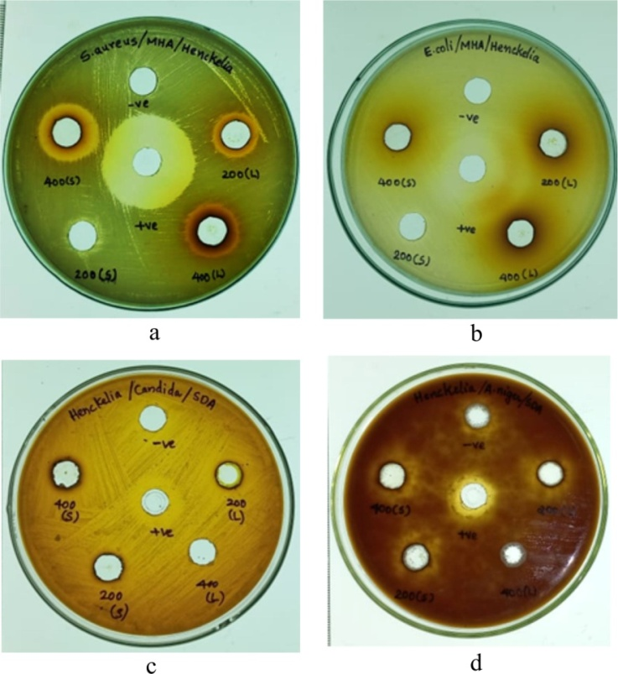

Fig1.Antimicrobial activity of leaves extract of a.S.aureus, b.E.coli, c. C.albicans d.A.niger

The present study of the antibacterial activity of leaf and stem extract of H.humboltiana exhibited inhibitory against Streptococcus aureus. There is no inhibitory effect was shown against E.Coli. The zone of inhibition of the extract of streptococcus aureus 400 mg of leaf is 18, 200 mg of leaf is 15, 400 mg of stem is 19, and 200 mg of stem is 11.The present study of the antifungal activity of leaf and stem extract of H.humboltiana exhibited inhibitory against Candida albicans and Aspergillus niger.
There is no inhibition of the extract of Candida albicans and Aspergillus niger in 400 mg of leaf. Zone of inhibition of 200 mg of leaf of Candida albicans is 11 and Aspergillus niger is 13. Zone of inhibition of 400 mg of stem of Candida albicans is 11 and Aspergillus niger is 14. Zone os inhibition of 200 mg stem of Candida albicans is 9 and Aspergillus niger is 14.

3.2 HPTLC fingerprint profile of Methanol extract of leaves of H.humboltiana at different wave length
Table.3 HPTLC fingerprint profile of Methanol extract of leaves of H.humboltiana at different wave length

254 nm |  |  | 366nm
No of peaks | R_{f}value | Area % | No of peaks | R_{f}value | Area %
1 | 0.03 | 2.02 | 1 | 0.02 | 0.63
2 | 0.08 | 0.71 | 2 | 0.04 | 0.13
3 | 0.14 | 0.80 | 3 | 0.07 | 0.22
4 | 0.26 | 6.98 | 4 | 0.08 | 1.27
5 | 0.31 | 3.67 | 5 | 0.31 | 5.55
6 | 0.39 | 2.43 | 6 | 0.39 | 3.04
7 | 0.45 | 6.55 | 7 | 0.50 | 11.74
8 | 0.52 | 6.26 | 8 | 0.57 | 19.19
9 | 0.57 | 11.88 | 9 | 0.64 | 6.12
10 | 0.64 | 2.39 | 10 | 0.78 | 3.78
11 | 0.74 | 0.24 | 11 | 0.87 | 48.33
12 | 0.78 | 3.41
13 | 0.87 | 24.19
14 | 0.94 | 28.46

The results showing number of peaks, R_{f} values, and area percentage are presented in table. In the HPTLC densitometric the finger print profile of henckelia leaf in chloroform extract under 254nm revealed 14 peaks, major peak at R_{f} 0.94 with area percentage of 28.46, followed by peak at 0.87 with area percentage 24.19 a minor peak at 0.03 with area percentage of 2.02. In 366nm revealed 11 peaks major peak at R_{f} 0.87 with area percentage 48.33 followed by peak at 0.78 with area percentage 3.78, minor peak at 0.02 with area percentage 0.63.

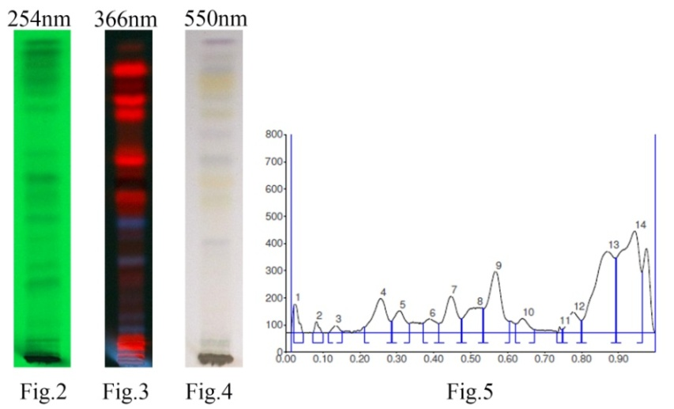

Fig. 2-4:Densitogram of methanol extract of leaves of H.humboltiana,Fig.5:Chromatogram of methanol extract of H.humboltiana
3.3 HPTLC fingerprint profile of methanol extract of leaves of H.humboltiana at different wave length
Table.4 HPTLC fingerprint profile of hexane extract of leaves of H.humboltiana at different wave length
254 nm |  |  | 366nm
No of peaks | R_{f}value | Area % | No of peaks | R_{f}value | Area %
1 | 0.32 | 2.65 | 1 | 0.08 | 0.41
2 | 0.36 | 3.42 | 2 | 0.32 | 3.87
3 | 0.42 | 4.56 | 3 | 0.36 | 4.24
4 | 0.50 | 0.76 | 4 | 0.47 | 5.42
5 | 0.54 | 0.64 | 5 | 0.54 | 4.67
6 | 0.67 | 4.81 | 6 | 0.58 | 1.77
7 | 0.76 | 13.27 | 7 | 0.61 | 2.79
8 | 0.85 | 45.76 | 8 | 0.67 | 2.33
9 | 0.90 | 24.12 | 9 | 0.76 | 10.81
 |  |  | 10 | 0.85 | 44.77
 |  |  | 11 | 0.89 | 18.93

The results showing number of peaks, R_{f} values, and area percentage are presented in table. In the HPTLC densitometric the finger print profile of henckelia leaf in hexane extract under 254nm revealed 9 peaks, major peak at R_{f} 0.90 with area percentage of 24.12, followed by peak at 0.85 with area percentage 45.76 a minor peak at 0.32 with area percentage of 2.65. In 366nm revealed 11 peaks major peak at R_{f} 0.89 with area percentage 18.93 followed by peak at 0.85 with area percentage 44.77, minor peak at 0.08 with area percentage 0.41.

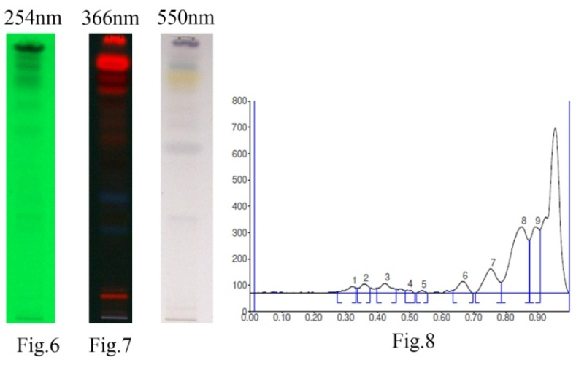

FIG 6- 8. Metabolite profiling by GC-MS methanol leaves
Table.5. GC MS analysis of methanol extract of leaves of H.humboltiana at different wave length
Peaks | RT | Area % | Name of compound | Biological activity
1 | 7.367 | 0.93 | 1,3,5-Triazine-2,4,6-triamine | Anti viral activity ( Mibu et al.,2014)
2 | 9.267 | 0.34 | 4H-Pyran-4-one, 2,3-dihydro-3,5-dihydroxy-6-methyl- | Anti oxidant activities ( Chen et al.,2021)
3 | 11.510 | 0.22 | 4-Vinylphenol | Anticancer and Anti-Metastatic Effects ( Leung et al.,2018)
4 | 16.055 | 0.86 | 2-Propenoic acid, 3-phenyl-, methyl ester | Anti oxidanr properties (
5 | 17.049 | 0.82 | Caryophyllene | Neuro protective effects( Machado et al.,2018)
6 | 17.302 | 0.77 | trans-cinnamic acid | Anti microbial activity( Macêdo et al.,2025)
7 | 17.689 | 2.50 | 4-Vinylbenzene-1,2-diol | Anti oxidant activities( Lakshmi et al.,2024)
8 | 17.969 | 0.34 | 1,4,7,-Cycloundecatriene, 1,5,9,9-tetramethyl-, Z,Z,Z- | Anti bacterial ( Mohammed et al.,2016)
9 | 18.413 | 0.57 | 4a,8-Dimethyl-2-(prop-1-en-2-yl)-1,2,3,4,4a,5,6,7-octahydronaphthalene | Anti oxidant ( Paula et al.,2022)
10 | 18.555 | 0.32 | 1R,4aS,8aR)-1-Isopropyl-4,7-dimethyl-1,2,4a,5,6,8a-hexahydronaphthale | Anti cancer activity(NCBI.,2025)
11 | 18.826 | 2.86 | Naphthalene, decahydro-4a-methyl-1-methylene-7-(1-methylethenyl)-, [4aR | Anti bacterial,antioxidant ( Feng et al.,2024)
12 | 21.935 | 0.28 | Neointermedeol | Anti oxidant activities( Sarikurkcu.,2018)
14 | 22.315 | 0.30 | 4a(2H)-Naphthalenol, 1,3,4,5,6,8a-hexahydro-4,7-dimethyl-1-(1-methylethyl | Anti inflammatory activity( Acharya et al.,2021)
15 | 22.805 | 0.37 | 2-Naphthalenemethanol, decahydro-.alpha.,.alpha.,4a-trimethyl-8-methylene | Anti-inflammatory / antioxidant( Acharya et al.,2021)
16 | 25.051 | 0.17 | Tetradecanoic acid | Anti viral activity( Parang et al.,1997)
17 | 25.765 | 0.06 | n-Heptadecanol-1 | Anti oxidant activity( Shivhare et al.,2023)
18 | 26.668 | 0.65 | Neophytadiene | Anti-inflammatory & Neuroprotective Effects ( Rajeswaran et al.,2025)
19 | 28.450 | 0.16 | Hexadecanoic acid, methyl ester | Anti inflammatory( Saeed et al.,2012)
20 | 29.219 | 3.33 | n-Hexadecanoic acid | Anti cancer activity( Bharath et al.,2021)
21 | 32.410 | 1.82 | 9,12-Octadecadienoic acid (Z,Z)- | Anti microbial activity(
22 | 32.529 | 2.15 | 7-Tetradecenal, (Z)- | Anti oxidant activity ( Palariya et al.,2019)
23 | 32.780 | 0.27 | 5-Hexenoic acid, 2,4-dioxo-6-phenyl-, ethyl ester | Anti microbial activities ( Pastorekova et al.,2019)
25 | 32.946 | 0.31 | Octadecanoic acid | Anti inflammatory activity ( Lin et al.,2005)
26 | 36.428 | 1.40 | 1,2-Bis(p-acetoxyphenyl)ethanedione | -
27 | 36.735 | 7.17 | 2,3-Dihydro-5-hydroxy-6,8,8-trimethyl-2-phenyl-4H-1-benzopyran-4,7(8H | Anti microbial activity ( Bonilla et al.,2005)
28 | 37.065 | 9.27 | 4H-1-Benzopyran-4-one, 2,3-dihydro-5-hydroxy-7-methoxy-2-phenyl-, (S)- | Anti oxidant,cyto protective ( Zhao et al.,2023)
29 | 38.550 | 0.30 | 2,3-Dihydro-5-hydroxy-6,8,8-trimethyl-2-phenyl-4H-1-benzopyran-4,7(8H | Anti microbial activity( Bonilla et al.,2005)
30 | 38.641 | 3.28 | 5-Hydroxy-7-methoxy-6-methyl-2-phenyl-chroman-4-one | Anticancer activity ( Emami et al.,2015)
31 | 43.220 | 0.43 | Squalene | Anti cancer activity ( Bidooki et al.,2024)
32 | 43.785 | 0.55 | 4',5,7-Trimethoxyflavanone | -
33 | 45.280 | 1.34 | (E)-1-(2-Hydroxy-4,6-dimethoxyphenyl)-3-(4-methoxyphenyl)prop-2-en-1- | Anti cancer activites ( Zi et al.,2005)
34 | 46.482 | 0.20 | 4,2'-Dihydroxy-4',6'-dimethoxychalcone (isomer 2) | Anti inflammatory ( Bae et al.,2004)

34 bioactive compounds have been identified in the leaves methanol extract of Henckelia humboltiana. The major compounds include 1,3,5-Triazine-2,4,6-triamine has anti viral activity, Caryophyllene has neuro protective activity , trans-cinnamic acid possess anti microbial activity, Neophytadiene showed anti inflammatory, neuro protective activity, squalene shows anti cancer activity, Octadecanoic acid has anti inflammatory activity.
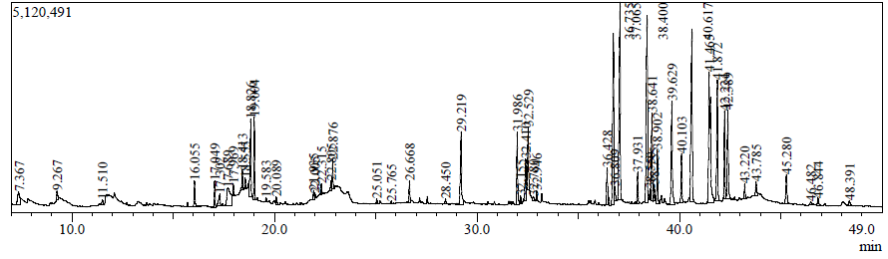

Fig 9. GC-MS chromatogram of methanol extract of leaves of H.humboltiana

3.4 Metabolite profiling by GC-MS hexane leaves
Table.6 HPTLC fingerprint profile of hexane extract of leaves of H.humboltiana at different wave length

Peaks | RT | Area % | Name of compound | Biological activity
1 | 7.440 | 0.16 | Dodecane | Anti microbial activity (Keke et al.,2020)
2 | 10.402 | 0.14 | Ylangene | Anti cancer activirty (Xio et al.,2013)
3 | 11.247 | 0.77 | Caryophyllene | Anti inflammatory(Francomano et al.,2019)
4 | 11.444 | 0.05 | .alpha.-Guaiene | Anti inflammatory (Chen et al.,2019)
5 | 11.814 | 0.41 | Humulene | Anti inflammatory( Becker et al.,2024)
6 | 12.815 | 0.15 | Selina-3,7(11)-diene | Anti fungal activity( Santos et al.,2018)
7 | 13.106 | 0.16 | .alpha.-Calacorene | Anti bacterial activity( Saravanan et al.,2025)
8 | 13.771 | 0.04 | Caryophyllene oxide | Anti cancer activity( Xiu et al.,2022)
9 | 17.133 | 0.48 | Neophytadiene | Anti inflammatory,anti oxidant,anti microbial( Rajeswaran et al.,2022)
10 | 17.450 | 0.09 | 3,7,11,15-Tetramethyl-2-hexadecen-1-ol | Anti inflammatory,anti arthritic effects ( Carvalho et al.,2020)
11 | 17.691 | 0.19 | Neophytadiene | -
12 | 20.495 | 1.96 | Phytol | Anti inflammatory ,anti arthritic effects ( Cala et al.,2022)
13 | 22.534 | 0.09 | Oxiraneoctanoic acid, 3-octyl-, methyl ester, cis- | -
14 | 23.596 | 4.65 | 2,3-Dihydro-5-hydroxy-6,8,8-trimethyl-2-phenyl-4H-1-benzopyran-4,7(8H)-d | Anti microbial activity (
15 | 23.802 | 3.96 | Pinostrobin | Anti obesity ( San et al.,2022)
16 | 24.097 | 1.18 | Oligandrol | Anti breast cancer activity ( Zingue et al.,2024)
17 | 24.332 | 0.53 | 1,6,10,14,18,22-Tetracosahexaen-3-ol, 2,6,10,15,19,23-hexamethyl-, (all-E)-(.+/-.)- | Anti cancer,anti microbial ( Khan et al.,2020)
18 | 24.906 | 2.07 | 5-Hydroxy-7-methoxy-6-methyl-2-phenyl-chroman-4-one | Anti inflammatory activity( Emami et al.,2015)
19 | 25.060 | 0.95 | Senkyunone | Antioxidant and Anti-thrombotic Actions ( Huang et al.,2023)
20 | 25.691 | 2.27 | 4H-1-Benzopyran-4-one, 2,3-dihydro-5,7-dimethoxy-2-phenyl- | Neuro protective activity ( Wu et al.,2012)
21 | 26.112 | 0.71 | 1H-Benzoimidazole, 5-ethoxy-2-phenethylsulfanyl- | -
22 | 26.588 | 10.27 | (E)-1-(2-Hydroxy-4,6-dimethoxyphenyl)-3-phenylprop-2-en-1-one | Anti cancer activity( Park et al.,2018)
23 | 27.352 | 3.88 | Oligandrol | -
24 | 27.473 | 1.84 | 5-Hydroxy-4',7-dimethoxyflavanone | Antioxidant Enzyme Inhibition( Mangoyi et al.,2015)
25 | 31.270 | 0.30 | Flavokavin A | Anti cancer effects ( Zi et al.,2005)
26 | 32.798 | 0.80 | .beta.-Tocopherol | Anti inflammatory effects( Ahsan et al.,2014)

26 bioactive compounds have been identified in the rhizome hexane extract of Henckelia humboltiana. The major compounds include Caryophyllene has anti inflammatory, Humulene has antiinflammoaty activity, Oligandrol possess anti breast cancer activity, Senkyunone has Antioxidant and Anti-thrombotic Actions activities, (E)-1-(2-Hydroxy-4,6-dimethoxyphenyl)-3-phenylprop-2-en-1-one has anti cancer activity, phytol has anti inflammatory ,anti arthritic effects, alpha.-Calacorene has anti bacterial activity.
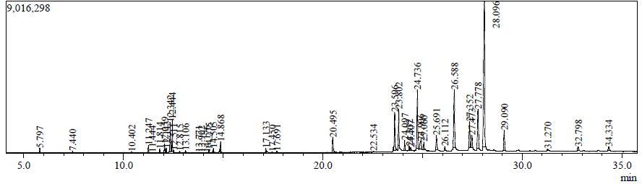
Fig 10. GC-MS chromatogram of hexane extract of leaves of H.humboltiana
Conclusion

The present study highlights the HPTLC and GC–MS analyses of the leaves of H. humboltiana. Plant extract exhibit antimicrobial effect on diffusion method. The GC–MS profile revealed the presence of diverse primary and secondary metabolites with notable biological and pharmacological activities. GC–MS fingerprinting has emerged as a valuable analytical tool due to its simplicity, sensitivity, and reliability. Many of the identified compounds possess well-documented therapeutic potentials, and their presence may contribute to the treatment of various ailments. Overall, this study provides important insights into the bioactive constituents of H. humboltiana leaves. Major compounds in methanolic extract of leaves include 1,3,5-Triazine-2,4,6-triamine has anti viral activity, caryophyllene possess neuro protective activity, squalene has anti cancer activity, major compounds in hexane extract of leaves include dodecane has antimicrobial activity, ylangene has anti cancer activity, humulene possess anti inflammatory activity, caryophyllene oxide has anti cancer activity, phytol has anti inflammatory ,anti arthritic effects.

COMPETING INTERESTS DISCLAIMER:
Authors have declared that they have no known competing financial interests OR non-financial interests OR personal relationships that could have appeared to influence the work reported in this paper.

Reference

Ranasinghe, S. W. (2017). Molecular species delimitation, taxonomy and biogeography of Sri Lankan Gesneriaceae (Doctoral dissertation, The University of Edinburgh). https://www.gesneriads.info/wp/wp-content/uploads/2017/11/Ranasinghe-2017-Molecular-species-delimitation-taxonomy-and-biogeography-of-sri-lankan-gesneriaceae.pdf

Schäferhoff, B., Fleischmann, A., Fischer, E., Albach, D. C., Borsch, T., Heubl, G., & Müller, K. F. (2010). Towards resolving Lamiales relationships: insights from rapidly evolving chloroplast sequences. BMC Evolutionary Biology, 10, 352. https://doi.org/10.1186/1471-2148-10-352

Keke, C. O., Nsofor, W. N., Kumabia, F. K. R., Iloabuchi, G. C., Ejiofor, J. C., & Osuagwu, O. L. (2023). GCMS and FTIR analysis of ethanol and methanol leave extract of Urena lobata (Caesar weed) for bioactive phytochemical constituents. Journal of Drug Delivery and Therapeutics, 13(1), 99-115. https://doi.org/10.22270/jddt.v13i1.5722

Xio, Y.-J., Su, J.-H., Chen, B.-W., Tseng, Y.-J., Wu, Y.-C., & Sheu, J.-H. (2013). Oxygenated ylangene-derived sesquiterpenoids from the soft coral Lemnalia philippinensis. Marine drugs, 11(10), 3735-3741. https://doi.org/10.3390/md11103735

Francomano, F., Caruso, A., Barbarossa, A., Fazio, A., La Torre, C., Ceramella, J., Mallamaci, R., Saturnino, C., Iacopetta, D., & Sinicropi, M. S. (2019). β-Caryophyllene: A Sesquiterpene with Countless Biological Properties. Applied Sciences, 9(24), 5420. https://doi.org/10.3390/app9245420

Ma, G. H., Chen, K. X., Zhang, L. Q., & Li, Y. M. (2019). Advance in biological activities of natural guaiane-type sesquiterpenes. Medicinal Chemistry Research, 28(9), 1339-1358. https://doi.org/10.1007/s00044-019-02385-7

Becker, L., & Holtmann, D. (2024). Anti-inflammatory effects of α-humulene on the release of pro-inflammatory cytokines in lipopolysaccharide-induced THP-1 cells. Cell Biochemistry and Biophysics, 82(2), 839-847. https://doi.org/10.1007/s12013-024-01235-7

Dos Santos, J. F. S., Rocha, J. E., Bezerra, C. F., do Nascimento Silva, M. K., de Matos, Y. M. L. S., de Freitas, T. S., Dos Santos, A. T. L., da Cruz, R. P., Machado, A. J. T., Rodrigues, T. H. S., de Brito, E. S., Sales, D. L., de Oliveira Almeida, W., da Costa, J. G. M., Coutinho, H. D. M., & Morais-Braga, M. F. B. (2018). Chemical composition, antifungal activity and potential anti-virulence evaluation of the Eugenia uniflora essential oil against Candida spp. Food Chemistry https://doi.org/10.1016/j.foodchem.2018.04.015

Saravanan, K., Alarfaj, A. A., Hirad, A. H., Ravindran, B., & Narasimhamoorthi, S. P. (2025). Anti-bacterial and in silico analysis of biogenic fabrication of CuO nanoparticles employing Coleus amboinicus leaf extract. Biomass Conversion and Biorefinery, 15(1), 327-339. https://doi.org/10.1007/s13399-023-05009-8

Xiu, Z., Zhu, Y., Han, J., Li, Y., Yang, X., Yang, G., Song, G., Li, S., Li, Y., Cheng, C., Li, Y., Fang, J., Li, X., & Jin, N. (2022). Caryophyllene oxide induces ferritinophagy by regulating the NCOA4/FTH1/LC3 pathway in hepatocellular carcinoma. Frontiers in pharmacology, 13, 930958. https://doi.org/10.3389/fphar.2022.930958

Rajeswaran, S., & Rajan, D. K. (2025). Neophytadiene: Biological Activities and Drug Development Prospects. Phytomedicine. https://doi.org/10.1016/j.phymed.2025.156872

Carvalho, A. M. S., Heimfarth, L., Pereira, E. W. M., Oliveira, F. S., Menezes, I. R. A., Coutinho, H. D. M., Picot, L., Antoniolli, A. R., Quintans, J. S. S., & Quintans-Júnior, L. J. (2020). Phytol, a chlorophyll component, produces antihyperalgesic, anti-inflammatory, and antiarthritic effects: Possible NFκB pathway involvement and reduced levels of the proinflammatory cytokines TNF-α and IL-6. Journal of Natural Products, 83(4), 1107-1117. https://doi.org/10.1021/acs.jnatprod.9b01116

Claro-Cala, C. M., Grao-Cruces, E., Toscano, R., Millan-Linares, M. C., Montserrat-de la Paz, S., & Martin, M. E. (2022). Acyclic diterpene phytol from hemp seed oil (Cannabis sativa L.) exerts anti-inflammatory activity on primary human monocytes-macrophages. Foods, 11(15), 2366. https://doi.org/10.3390/foods11152366

San, H. T., Khine, H. E. E., Sritularak, B., Prompetchara, E., Chaotham, C., Che, C.-T., & Likhitwitayawuid, K. (2022). Pinostrobin: An adipogenic suppressor from fingerroot (Boesenbergia rotunda) and its possible mechanisms. Foods, 11(19), 3024. https://doi.org/10.3390/foods11193024

Zingue, S., Fongang, Y. S. F., Ossomba, E. R., Tatsinda, V., Silihe, K. K., Mbou, W. D., Fogang, B., Essomba, R., Chouna, J. R., Njamen, D., & Ayong, L. (2024). Oligandrin from Croton oligandrus (Euphorbiaceae) exhibits anti-breast cancer activity through immune-boosting mechanisms: In vitro and in vivo study. Heliyon, 10(15) https://doi.org/10.1016/j.heliyon.2024.e35000

Khan, I. H., & Javaid, A. (2020). Anticancer, antimicrobial and antioxidant compounds of quinoa inflorescence. Advancements in Life Sciences, 8(1), 68-72. https://advancesinlifesciences.com.pk/index.php/advances/article/view/270

Emami, S., & Ghanbarimasir, Z. (2015). Recent advances of chroman-4-one derivatives: Synthetic approaches and bioactivities. European Journal of Medicinal Chemistry, 93, 539-563. https://doi.org/10.1016/j.ejmech.2015.02.048

Huang, Y., Wu, Y., Yin, H., Du, L., & Chen, C. (2023). Senkyunolide I: A Review of Its Phytochemistry, Pharmacology, Pharmacokinetics, and Drug-Likeness. Molecules, 28(8), 3636. https://doi.org/10.3390/molecules28083636

Wu, B., Lee, J. G., Lim, C. J., Jia, S. D., Kwon, S. W., Hwang, G. S., & Park, J. H. (2012). Sesquiterpenoids and 2‐(2‐Phenylethyl)‐4H‐chromen‐4‐one (= 2‐(2‐Phenylethyl)‐4H‐1‐benzopyran‐4‐one) Derivatives from Aquilaria malaccensis Agarwood. Helvetica Chimica Acta, 95(4), 636-642. https://doi.org/10.1002/hlca.201100409

Park, J., Shin, S. Y., Koh, D., Lee, Y. H., & Lim, Y. (2018). Relation between structures of naphthalenylchalcone derivatives and their cytotoxic effects on HCT116 human colon cancer cells. Applied Biological Chemistry, 61(3), 267-272. https://doi.org/10.1007/s13765-018-0356-6

Mangoyi, R., Midiwo, J., & Mukanganyama, S. (2015). Isolation and characterization of an antifungal compound 5-hydroxy-7,4'-dimethoxyflavone from Combretum zeyheri. BMC Complementary and Alternative Medicine. https://doi.org/10.1186/s12906-015-0934-7

Zi, X., & Simoneau, A. R. (2005). Flavokawain A, a novel chalcone from kava extract, induces apoptosis in bladder cancer cells by involvement of Bax protein-dependent and mitochondria-dependent apoptotic pathway and suppresses tumor growth in mice. Cancer Research, 65(8), 3479-3486. https://doi.org/10.1158/0008-5472.CAN-04-3803
Ahsan, H., Ahad, A., Iqbal, J., & Siddiqui, W. A. (2014). Pharmacological potential of tocotrienols: a review. Nutrition & Metabolism, 11(1), 52. https://doi.org/10.1186/1743-7075-11-52

Mibu, N., Yokomizo, K., Koga, A., Honda, M., Mizokami, K., Fujii, H., Ota, N., Yuzuriha, A., Ishimaru, K., Zhou, J., Miyata, T., & Sumoto, K. (2014). Synthesis and antiviral activities of some 2,4,6-trisubstituted 1,3,5-triazines. Chemical and Pharmaceutical Bulletin, 62(10), 1032-1040. https://doi.org/10.1248/cpb.c14-00421

Chen, Z., Liu, Q., Zhao, Z., Bai, B., Sun, Z., Cai, L., Fu, Y., & Xi, G. (2021). Effect of hydroxyl on antioxidant properties of 2,3-dihydro-3,5-dihydroxy-6-methyl-4H-pyran-4-one to scavenge free radicals. RSC advances, 11(55), 34456-34461. https://doi.org/10.1039/d1ra06317k

Leung, H. W., Ko, C. H., Yue, G. G. L., Herr, I., & Lau, C. B. S. (2018). The natural agent 4-vinylphenol targets metastasis and stemness features in breast cancer stem-like cells. Cancer chemotherapy and pharmacology, 82(2), 185-197. https://doi.org/10.1007/s00280-018-3601-0

National Center for Biotechnology Information. (2025). PubChem Compound Summary for CID 637520, Methyl Cinnamate. https://pubchem.ncbi.nlm.nih.gov/compound/Methyl-Cinnamate
Machado, K. D. C., Islam, M. T., Ali, E. S., Rouf, R., Uddin, S. J., Dev, S., Shilpi, J. A., Shill, M. C., Reza, H. M., Das, A. K., Shaw, S., Mubarak, M. S., Mishra, S. K., & Melo-Cavalcante, A. A. D. C. (2018). A systematic review on the neuroprotective perspectives of beta-caryophyllene. Phytotherapy Research, 32(12), 2376-2388. https://doi.org/10.1002/ptr.6199

Macêdo, N. S., de Sousa Silveira, Z., Dantas, D. M., dos Santos Barbosa, C. R., de Morais Oliveira-Tintino, C. D., Tintino, S. R., & da Cunha, F. A. B. (2025). Evaluation of the antibacterial and efflux inhibitory activity of trans-cinnamic acid in Staphylococcus aureus: Experimental Assays and In Silico Modeling. Phytomedicine Plus, 5, 100816. https://doi.org/10.1016/j.phyplu.2025.100816

Lakshmi, S., Padmavathy, K., UmaArasu, T., & Prabu, D. (2024). Phytochemical profiling and antioxidant potential of methanol extract of Vitis vinifera L seeds. Chulalongkorn Medical Journal, 68(4). https://doi.org/10.56808/2673-060X.5459

Mohammed, G. J., Omran, A. M., & Hussein, H. M. (2016). Antibacterial and phytochemical analysis of Piper nigrum using gas chromatography-mass Spectrum and Fourier-transform infrared spectroscopy. International Journal of Pharmacognosy and Phytochemical Research, 8(6), 977-996.

National Center for Biotechnology Information. (2025). PubChem Compound Summary for CID 12306047, Alpha-muurolene, (-)- https://pubchem.ncbi.nlm.nih.gov/compound/Alpha-muurolene

Sarikurkcu, C., Ceylan, O., Targan, S., & Ćavar Zeljković, S. (2018). Chemical composition and biological activities of the essential oils of two endemic Nepeta species. Industrial Crops and Products. https://doi.org/10.1016/j.indcrop.2018.09.001

VJ, D., Sivakumar, S. R., George, M., & Francis, S. (2019). GC–MS analysis of bioactive compounds present in different extracts of rhizome of Curcuma aeruginosa Roxb. Journal of Drug Delivery and Therapeutics, 9(2-s), 13-19. https://doi.org/10.22270/jddt.v9i2-s.2589

2-Naphthalenemethanol, decahydro-.alpha.,.alpha.,4a-trimethyl-8-methylene
Acharya, B., Chaijaroenkul, W., & Na‐Bangchang, K. (2021). Therapeutic potential and pharmacological activities of β‐eudesmol. Chemical biology & drug design, 97(4), 984-996. https://doi.org/10.1111/cbdd.13823

Parang, K., Wiebe, L. I., Knaus, E. E., Huang, J. S., Tyrrell, D. L., & Csizmadia, F. (1997). In vitro antiviral activities of myristic acid analogs against human immunodeficiency and hepatitis B viruses. Antiviral Research, 34(3), 75-90. https://doi.org/10.1016/s0166-3542(96)01022-4

Rajeswaran, S., & Rajan, D. K. (2025). Neophytadiene: Biological Activities and Drug Development Prospects. Phytomedicine, *143*, 156872. https://doi.org/10.1016/j.phymed.2025.156872

Saeed, N. M., El-Demerdash, E., Abdel-Rahman, H. M., Algandaby, M. M., Al-Abbasi, F. A., & Abdel-Naim, A. B. (2012). Anti-inflammatory activity of methyl palmitate and ethyl palmitate in different experimental rat models. Toxicology and applied pharmacology, 264(1), 84-93. https://doi.org/10.1016/j.taap.2012.07.020

Bharath, B., Perinbam, K., Devanesan, S., AlSalhi, M. S., & Saravanan, M. (2021). Evaluation of the anticancer potential of Hexadecanoic acid from brown algae Turbinaria ornata on HT–29 colon cancer cells. Journal of Molecular Structure. https://doi.org/10.1016/j.molstruc.2021.130229

Abulila, H. I., & Sabry, S. M. (2024). RETRACTED: Investigating the Cytotoxicity and Safety Profile of 9, 12-Octadecadienoic acid (Z, Z)-, methyl ester: Implications for Potential Therapeutic Applications.

Pastorekova, S., & Gillies, R. J. (2019). The role of carbonic anhydrase IX in cancer development: links to hypoxia, acidosis, and beyond. Cancer and Metastasis Reviews, 38(1), 65-77. https://doi.org/10.1007/s10555-019-09799-0

Magalhães, R. H. de P., de Menezes Filho, A. C. P., Ventura, M. V. A., Batista-Ventura, H. R. F., de Souza Castro, C. F., & Porfiro, C. A. (2022). Chemical profile and antioxidant, antibacterial, and cytotoxic activities on Artemia salina from the essential oil of leaves and xylopodium of Cochlospermum regium. Scientific Electronic Archives, 15(1). https://doi.org/10.36560/15120221506

Alakanse, O. S., Sulaiman, A., Arannilewa, A. J., Anjorin, F. F., Malachi, O. I., Ayo, I. E., Oladejo, A. A., Oluwole, O. A., Olanrewaju, O. O., Okeme, U., George, A. O., Amarachi, A. M., Taofeek, O. O., Araoyinbo, O. S., Bakare, A. A., & Bolarinwa, T. O. (2019). α-Selinene from Syzygium aqueum against aromatase p450 in breast carcinoma of postmenopausal women: in silico study. J. Biomed. Pharm. Sci, 2(1), 1-7. https://www.hilarispublisher.com/open-access/a-selinene-from-syzygium-aqueum-against-aromatase-p450-in-breast-carcinoma-of-postmenopausal-women-in-silico-study.pdf

Feng, L., Xu, F., Qiu, S., Sun, C., & Lai, P. (2024). Chemical Composition and Antibacterial, Antioxidant, and Cytotoxic Activities of Essential Oils from Leaves and Stems of Aeschynomene indica L. Molecules, 29(15), 3552. https://doi.org/10.3390/molecules29153552

Shivhare, B., Rani, R., Pandey, M., & Kumar, R. (2023). Antioxidant capacity and metabolic characterization of aqueous and ethanolic extraction of Saraca indica. Journal of Pharmacognosy and Phytochemistry. https://doi.org/10.22271/phyto.2023.v12.i1a.14547

Palariya, D., Singh, A., Dhami, A., Kumar, R., Prakash, O., Pant, A. K., & Kumar, R. (2019). Phytochemical analysis and biological activities of leaves and bark hexane extracts of Premna mucronata Roxb. collected from Kumaun hills of Uttarakhand. International Journal of Herbal Medicine, 7(5), 35-44. https://www.florajournal.com/archives

Lin, X. M., Chen, A. J., Zhang, H. M., Kuang, Z. Z., Chen, R., Wu, M. D., Chen, J., Ma, X., Zhao, L., Xing, Y., & Ni, H. (2025). Anti‐Inflammatory Activity and Mechanism of Stearic Acid Extract From Purslane. Food Science & Nutrition, 13(7), e70596. https://doi.org/10.1002/fsn3.70596

Bonilla, A., Duque, C., Garzón, C., Takaishi, Y., Yamaguchi, K., Hara, N., & Fujimoto, Y. (2005). Champanones, yellow pigments from the seeds of champa (Campomanesia lineatifolia). Phytochemistry, 66(14), 1736-1740. https://doi.org/10.1016/j.phytochem.2005.05.025

4H-1-Benzopyran-4-one, 2,3-dihydro-5-hydroxy-7-methoxy-2-phenyl-, (S)-
Zhao, L. L., Jayeoye, T. J., Ashaolu, T. J., & Olatunji, O. J. (2023). Pinostrobin, a dietary bioflavonoid exerts antioxidant, anti-inflammatory, and anti-apoptotic protective effects against methotrexate-induced ovarian toxicity in rats. Tissue and Cell, 85, 102254. https://doi.org/10.1016/j.tice.2023.102254

2,3-Dihydro-5-hydroxy-6,8,8-trimethyl-2-phenyl-4H-1-benzopyran-4,7(8H
Bonilla, A., Duque, C., Garzón, C., Takaishi, Y., Yamaguchi, K., Hara, N., & Fujimoto, Y. (2005). Champanones, yellow pigments from the seeds of champa (Campomanesia lineatifolia). Phytochemistry, 66(14), 1736-1740. https://doi.org/10.1016/j.phytochem.2005.05.025

Emami, S., & Ghanbarimasir, Z. (2015). Recent advances of chroman-4-one derivatives: synthetic approaches and bioactivities. European Journal of Medicinal Chemistry, 93, 539-563. https://doi.org/10.1016/j.ejmech.2015.02.048

Bidooki, S. H., Quero, J., Sánchez-Marco, J., Herrero-Continente, T., Marmol, I., Lasheras, R., Sebastian, V., Arruebo, M., Osada, J., & Rodriguez-Yoldi, M. J. (2024). Squalene in Nanoparticles Improves Antiproliferative Effect on Human Colon Carcinoma Cells Through Apoptosis by Disturbances in Redox Balance. International Journal of Molecular Sciences, 25(23), 13048. https://doi.org/10.3390/ijms252313048

Zi, X., & Simoneau, A. R. (2005). Flavokawain A, a novel chalcone from kava extract, induces apoptosis in bladder cancer cells by involvement of Bax protein-dependent and mitochondria-dependent apoptotic pathway and suppresses tumor growth in mice. Cancer Research, 65(8), 3479-3486. https://doi.org/10.1158/0008-5472.CAN-04-3803

Bae, S., Lee, J.-N., & Hyun, C.-G. (2024). Anti-Melanogenic and Anti-Inflammatory Effects of 2′-Hydroxy-4′,6′-dimethoxychalcone in B16F10 and RAW264.7 Cells. Current Issues in Molecular Biology, 46(6), 6018-6040. https://doi.org/10.3390/cimb46060359

