Original Research Article

Preparation, Property Control, and Microstructural Mechanisms of Red Mud–Metakaolin Composite Cement-Based Foamed Materials

.
ABSTRACT
To promote the efficient utilization of red mud solid waste and develop low-carbon, energy-efficient building materials, this study investigated cement-based foamed materials prepared using red mud, metakaolin, and cement as a composite cementitious system, with solid hydrogen peroxide employed as the foaming agent. A two-variable experimental design considering the presence or absence of a superplasticizer was adopted to systematically evaluate the influence of foaming agent dosage on the mechanical properties, pore structure, and thermal performance of the materials. Compressive strength tests, scanning electron microscopy (SEM), and thermal conductivity measurements were conducted to identify the optimal mix proportion and elucidate the underlying mechanisms.
The results show that the compressive strength increased significantly with curing age and exhibited a trend of initial increase followed by decrease with increasing foaming agent dosage. An optimal foaming agent dosage of 0.5% was identified, at which the 28-day compressive strength of specimens incorporating a superplasticizer reached 31.6 MPa. At this dosage, a uniform and fine closed-cell pore structure was formed. The reactive components in red mud and metakaolin participated in secondary hydration reactions, producing gel phases that effectively filled pores and enhanced structural compactness and mechanical performance. The addition of a superplasticizer further improved particle dispersion and hydration efficiency, leading to increased densification and strength.
This study demonstrates a feasible approach for producing high-performance cement-based foamed materials with high red mud content and provides mechanistic insights into the performance regulation of low-carbon, energy-efficient building materials.
Keywords：red mud; metakaolin; cement-based foamed concrete; solid hydrogen peroxide; compressive strength; microstructure; thermal conductivity
1. INTRODUCTION
1.1 Research Background and Significance
Driven by the global “dual-carbon” strategy, the construction industry is accelerating its transition toward low-carbon development and efficient resource utilization, with the recycling of industrial solid wastes and the development of innovative energy-saving building materials becoming key research priorities. Red mud, a major by-product of the aluminum industry, has a global annual output exceeding 175 million tons. Due to its strong alkalinity and potential environmental hazards, long-term stockpiling of red mud can easily lead to soil degradation and groundwater contamination. According to statistics from the China Nonferrous Metals Industry Association, the comprehensive utilization rate of red mud remains below 10% [1], highlighting the severe pressure of solid waste disposal. Meanwhile, conventional building envelope materials generally exhibit relatively high thermal conductivity, resulting in limited energy-saving performance and difficulty in meeting the requirements of green building development. Incorporating red mud into foamed concrete in combination with cementitious materials not only enables the high-value utilization of bulk solid waste but also addresses building energy-efficiency demands, demonstrating significant environmental benefits and engineering application potential. This approach has been validated by numerous studies [1,2]. Metakaolin, as a highly reactive mineral admixture, can enhance the performance of cementitious systems by participating in secondary hydration reactions, thereby providing performance assurance for the high-content incorporation of red mud [3]. Solid hydrogen peroxide (2Na₂CO₃·3H₂O₂), owing to its stable foaming behavior and ease of storage and transportation, has shown considerable application potential in foamed concrete. Its decomposition characteristics and their influence on pore structure regulation have been extensively investigated. In this study, a red mud–metakaolin–cement composite binder system is adopted to systematically examine the effects of solid hydrogen peroxide dosage and superplasticizer on material properties, with the aim of providing technical support for red mud resource utilization and the development of high-performance energy-efficient building materials.
1.2 Current Research Status at Home and Abroad

In recent years, the application of red mud in the field of building materials has attracted increasing attention from researchers worldwide. Li et al. [1,4] demonstrated through a comprehensive review that, when combined with cement-based materials, the reactive components in red mud can participate in hydration reactions and form cementitious products, providing a theoretical basis for the large-scale utilization of red mud. Existing studies indicate that the dosage of hydrogen peroxide has a direct influence on the pore structure of foamed concrete, thereby affecting its mechanical and thermal properties. By optimizing the hydrogen peroxide content, a synergistic improvement in multiple performance indices can be achieved. Fadi Althoey et al. [5] reported that red mud subjected to thermo-mechanical activation can be used as a pozzolanic material to partially replace cement clinker in the production of low-carbon composite cement, while simultaneously reducing the mobility of heavy metals. Liu et al. [2] prepared red-mud-based foamed lightweight soil by partially replacing cement with red mud, and the results showed that red mud could enhance material strength by promoting the formation of hydration products, thus providing experimental support for its high-content application. He et al. [6] developed a red-mud-based geopolymer foamed concrete, in which a 28-day compressive strength of 3.2 MPa was achieved even at a red mud content of 40%, confirming the feasibility of high red mud incorporation in foamed materials. However, in most existing studies, the red mud content is generally lower than 30%. The negative impact of high alkalinity on the stability of cementitious systems limits further increases in red mud dosage [7], and studies on composite cementitious systems with red mud contents as high as 50% remain scarce.

The performance regulation of foamed concrete primarily depends on the selection of foaming agents and the optimization of their dosages. Hydrogen peroxide is widely used due to its high foaming efficiency and environmentally friendly decomposition products. Li et al. [4] further confirmed that the amount of hydrogen peroxide significantly alters the pore structure of foamed concrete, thereby regulating its mechanical and thermal performance, and that an optimized dosage can lead to coordinated performance enhancement. Compared with liquid hydrogen peroxide, solid hydrogen peroxide exhibits superior storage convenience and foaming stability. Nevertheless, studies on its application in red mud–metakaolin–cement composite binder systems are still very limited [6]. In addition, although the beneficial effects of superplasticizers on improving the workability and compactness of solid-waste-based cementitious materials have been well established, the synergistic regulation mechanism between superplasticizers and solid hydrogen peroxide remains unclear [6,7]. In summary, two major research gaps can be identified: first, the feasibility of producing foamed concrete using a high-content red mud–metakaolin–cement composite system has yet to be fully verified; second, systematic investigations into the synergistic effects of solid hydrogen peroxide dosage and superplasticizer on the performance of this system, as well as the associated microstructural mechanisms, are still lacking. Addressing these gaps forms the focus of the present study and is of significant innovative value.

2 Materials and Methods

2.1 Raw Materials

(1) Red mud: A by-product generated from alumina production via the Bayer process at an aluminum refinery. XRF analysis indicates that its main chemical constituents (by mass fraction) are SiO₂ 22.5%, Al₂O₃ 18.3%, Fe₂O₃ 35.7%, CaO 8.2%, and Na₂O 6.8%. The median particle size (D50) is 15.2 μm, and the specific surface area is 2.8 m²/g.
(2) Metakaolin: Purity ≥ 95%, with a combined active SiO₂ + Al₂O₃ content ≥ 85%, and a specific surface area of 20,000 cm²/g.
(3) Cement: Ordinary Portland cement (P·O 42.5). The initial and final setting times are 185 min and 240 min, respectively; the compressive strengths are 25.3 MPa at 3 days and 48.6 MPa at 28 days.
(4) Solid hydrogen peroxide (2Na₂CO₃·3H₂O₂): Purity ≥ 98%, particle size of 80 mesh.
(5) Superplasticizer: Polycarboxylate-based high-range water reducer, with a solid content of 40% and a water-reduction rate of not less than 25%.
(6) Mixing water: Tap water conforming to GB/T 6388-2008 *Standard for Water Used in Concrete.

2.2 Mix Proportion Design

The mass ratio of red mud, metakaolin, and cement was fixed at 25:25:50, with a total solid mass of 100 g. Two experimental series were designed.
Series A incorporated a superplasticizer, with a water-to-binder ratio of 0.30 (30 g of water) and a superplasticizer dosage of 0.64% by mass of the binder (0.64 g).
Series B contained no superplasticizer and used 40 g of water.

The binder system investigated in this study consisted of a red mud–metakaolin–cement composite, and the water-to-binder ratio was calculated based on the total mass of the composite binder. For both series, solid hydrogen peroxide was added at four levels: 0% (blank control), 0.5%, 1.5%, and 2.5% by mass of total solids. The corresponding specimen codes were A0–A3 and B0–B3, respectively. For each mix proportion, three cubic specimens with dimensions of 40 mm × 40 mm × 40 mm were prepared to ensure the reliability of the test results. The detailed mix proportions and compressive strength data are summarized in Table 1.
Table 1- Mix Proportions and Compressive Strength Data
Table1 | Label | RM(g) | MK(g) | cement(g) | 2Na₂CO₃  ·3H₂O₂(g) | water(g) | SP(g  )
1 | A0 | 25 | 25 | 50 | 0 | 30 | 0.64
2 | A1 | 25 | 25 | 50 | 0.5 | 30 | 0.64
3 | A2 | 25 | 25 | 50 | 1.5 | 30 | 0.64
4 | A3 | 25 | 25 | 50 | 2.5 | 30 | 0.64
5 | B0 | 25 | 25 | 50 | 0 | 40 | -
6 | B1 | 25 | 25 | 50 | 0.5 | 40 | -
7 | B2 | 25 | 25 | 50 | 1.5 | 40 | -
8 | B3 | 25 | 25 | 50 | 2.5 | 40 | -
Note:RM: Red Mud；MK: Metakaolin；SP: superplasticizer（Water-Reducing Agent）
2.3 Specimen Preparation Procedure

The preparation of specimens involved four main steps: raw material pretreatment, mixing, casting, and curing. Prior to mixing, red mud was dried at 105 °C for 24 h, ground, and sieved through an 80-mesh sieve to remove impurities. Cement and metakaolin were stored in a dry environment before use. According to the designed mix proportions, red mud, metakaolin, cement, and solid hydrogen peroxide were successively added into the mixer and dry-mixed for approximately 2 min to ensure homogeneity. Subsequently, 30 g of water and the superplasticizer were added to Series A, while 40 g of water was added to Series B. The mixtures were then wet-mixed for 3–5 min until a uniform slurry without agglomeration was obtained and adequate workability for casting was achieved. The fresh slurry was slowly poured into cubic molds with dimensions of 40 mm × 40 mm × 40 mm, vibrated for 5–10 s to eliminate entrapped air and improve compaction, and leveled at the surface. The specimens were kept at room temperature (20 ± 2 °C) with a relative humidity of not less than 90% for 24 h before demolding. After demolding, the samples were transferred to a standard curing chamber (20 ± 2 °C, relative humidity ≥ 95%) and cured for 7, 14, and 28 days, respectively.

2.4 Testing Methods

Compressive strength tests were conducted in accordance with GB/T 50081-2019 Standard for Test Methods of Physical and Mechanical Properties of Concrete, using a computer-controlled electronic universal testing machine. For each mix and curing age, three parallel specimens were tested, and the average value was reported as the compressive strength, with standard deviations ranging from 0.3 to 0.8 MPa. The experimental data were processed and plotted using Origin software. For microstructural characterization, representative fracture surfaces of specimens after 28 days of compressive strength testing were selected, vacuum-dried, and gold-coated. A scanning electron microscope (SU8010, Hitachi, Japan) was employed at an accelerating voltage of 10 kV, and observations were performed at magnifications of ×500 and ×2000 to examine pore morphology, pore size distribution, and hydration products. Thermal conductivity was measured on 28-day specimens following GB/T 10294-2021 Thermal insulation—Determination of steady-state thermal resistance and related properties—Guarded hot plate and heat flow meter methods. Three parallel samples were tested for each group, and the results were statistically analyzed.
3. Results and Discussion

3.1 Results and Analysis of Compressive Strength
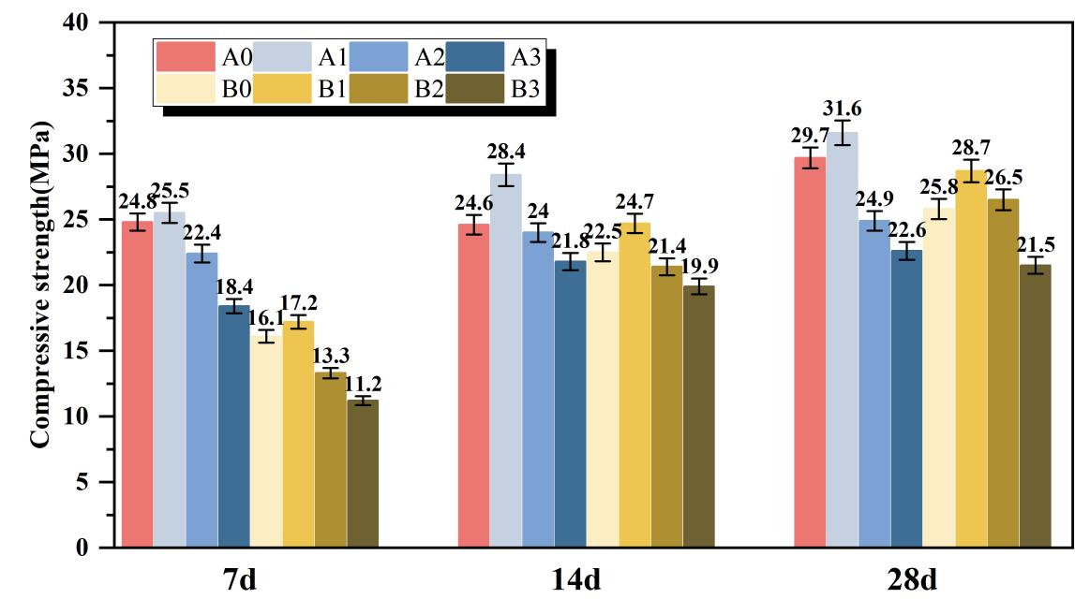
Figure 1 .Compressive strength at different curing ages as a function of solid hydrogen peroxide dosage
As illustrated in Fig. 1, the compressive strengths of both Series A and Series B specimens increase markedly with curing age, while exhibiting a typical trend of first increasing and then decreasing with increasing solid hydrogen peroxide dosage. Overall, the compressive strengths of Series A, incorporating a superplasticizer, are consistently higher than those of the corresponding Series B specimens at the same dosage and curing age, indicating the beneficial effect of the superplasticizer on the mechanical performance of the composite system.

From the perspective of curing age, the 28-day compressive strength shows an increase of 33.3% to 93.4% compared with that at 7 days. Notably, the strength growth rate of Series A is generally lower than that of Series B (for example, the strength of A1 increases by 23.9% from 7 to 28 days, whereas B1 shows an increase of 66.9% over the same period). This difference can be attributed to the regulatory effect of the superplasticizer on hydration kinetics. By reducing surface tension and enhancing the dispersion of cementitious particles, the superplasticizer promotes more complete hydration at early ages, causing the strength development to enter a stable stage earlier. This observation is consistent with the findings reported by Ma et al. [7] for red mud–metakaolin cementitious systems.

With respect to the effect of solid hydrogen peroxide content, both series reach their maximum compressive strength at a dosage of 0.5%. At this optimal level, the 28-day compressive strength of A1 reaches 31.6 MPa, representing a 19.7% increase compared with the blank sample A0, while B1 attains 28.7 MPa, corresponding to an improvement of 11.2% relative to B0. When the dosage exceeds 0.5%, the compressive strength decreases continuously. Specifically, the 28-day strength of A3 (2.5% dosage) drops to 22.6 MPa, which is 28.5% lower than that of A1, whereas B3 decreases to 21.5 MPa, showing a reduction of 25.1% compared with B1. The variation trends of compressive strength with respect to solid hydrogen peroxide dosage were plotted using Origin software, as shown in Fig. 1. These results clearly demonstrate the relationship between foaming agent content and compressive strength, providing direct guidance for mix proportion optimization in engineering applications and confirming the general role of foaming agent dosage in regulating the strength of solid-waste-based foamed concrete.

The observed strength evolution can be primarily attributed to the combined effects of pore structure regulation and hydration reaction synergy, with the superplasticizer further enhancing this coupling effect. At the optimal dosage of 0.5%, the decomposition of solid hydrogen peroxide generates an appropriate amount of CO₂ and O₂ bubbles, which are uniformly distributed within the slurry and form fine closed pores with diameters mainly ranging from 50 to 200 μm. Such a pore structure maintains sufficient effective load-bearing area while providing adequate space for the growth of hydration products, in agreement with the conclusions reported by Zhao et al. [8] on pore structure optimization in blast furnace slag foamed concrete. Meanwhile, the reactive SiO₂ and Al₂O₃ components in red mud and metakaolin participate in secondary hydration reactions with Ca(OH)₂ released during cement hydration, leading to the formation of abundant C–S–H gel and needle- or rod-like anorthite crystals (CaAl₂Si₂O₈·4H₂O). These hydration products interweave and fill the pore spaces, significantly enhancing the structural compactness of the material [8]. In this process, the pozzolanic activity of metakaolin plays a critical role, as its fine particles not only act as fillers but also provide active sites for the adsorption of hydration products and the promotion of secondary hydration reactions [9]. Consequently, the compressive strength reaches its maximum value, which is consistent with the “secondary hydration–pore filling” strengthening mechanism reported by Liu et al. [10] for red-mud-based foamed concrete.

When the solid hydrogen peroxide dosage exceeds 0.5%, excessive gas generation leads to frequent bubble collision and coalescence, resulting in large pores with diameters greater than 500 μm or even interconnected pore structures. This markedly increases internal defects and reduces the effective load-bearing area. In addition, excessive bubbles hinder the adhesion and growth of hydration products on pore walls, lowering the density of the pore structure and ultimately causing a pronounced deterioration in compressive strength. By contrast, the incorporation of a superplasticizer improves the dispersion of cementitious particles, thereby enhancing both the extent of hydration and the uniformity of the pore structure. On the one hand, the superplasticizer suppresses the agglomeration of red mud and metakaolin particles, allowing their active components to more effectively participate in secondary hydration reactions. On the other hand, the improved workability of the slurry facilitates a more stable and uniform distribution of bubbles during casting, reducing localized bubble accumulation and coalescence. As a result, Series A specimens exhibit a more optimized pore structure and more complete hydration, leading to superior mechanical performance compared with Series B, which is also supported by the findings of Tang et al. [11] regarding the influence of superplasticizers on solid-waste-based cementitious materials.

3.2 Microstructural (SEM) Characterization and Analysis
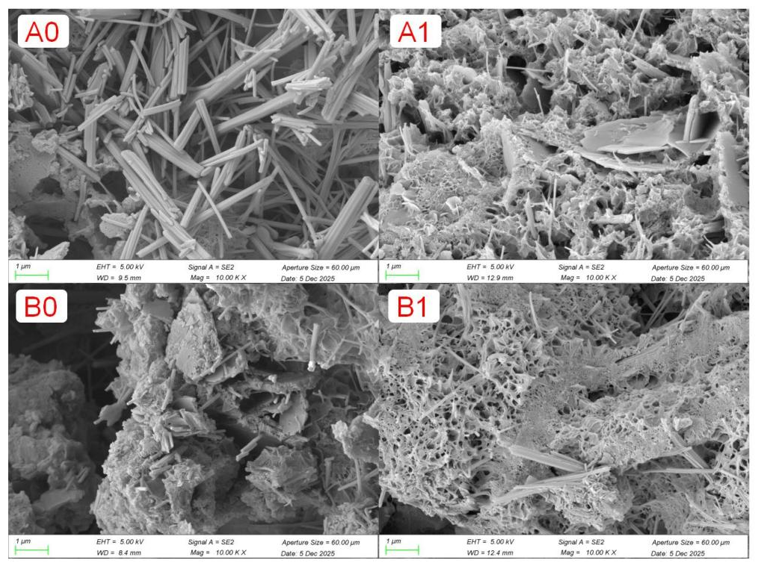
Figure 2.SEM microstructure
The scanning electron microscopy (Figure 2.SEM) observations reveal pronounced differences in the microstructures of the specimens, and the observed microstructural features show a strong correlation with the corresponding macroscopic mechanical properties. The A1 specimen, containing 0.5% solid hydrogen peroxide and a superplasticizer, exhibits a uniformly distributed fine closed-pore structure, with pore diameters predominantly ranging from 50 to 150 μm. The pore walls are dense and continuous, and abundant C–S–H gel interwoven with anorthite crystals can be observed filling the pore spaces. This microstructural configuration is the primary reason for the peak compressive strength of A1: an appropriate amount of gas bubbles provides sufficient space for hydration product development, while the dispersing effect of the superplasticizer promotes more complete secondary hydration of the reactive components, thereby enhancing the compactness of the matrix [10].

In contrast, the B3 specimen (2.5% solid hydrogen peroxide without superplasticizer) is characterized by extensive interconnected macropores, accompanied by severe disruption of matrix continuity and the presence of only limited amounts of loose cementitious material. This behavior can be attributed to excessive gas generation, which compromises the integrity of the slurry, as well as the absence of a superplasticizer, leading to particle agglomeration and inhibited hydration reactions. Although the compressive strength of this specimen is relatively low, its pore structure contributes to superior thermal insulation performance. A similar phenomenon was reported by Li et al. [9] in their study on circulating fluidized bed fly ash–based foamed lightweight soil.

For the remaining specimens, the A0 and B0 groups display comparatively dense microstructures but insufficient hydration, as indicated by the limited formation of hydration products. With increasing foaming agent content, specimens A2, A3, and B1, B2 exhibit progressive pore enlargement and coalescence, resulting in reduced structural integrity and a corresponding decline in compressive strength.

3.3 Results and Analysis of Thermal Conductivity
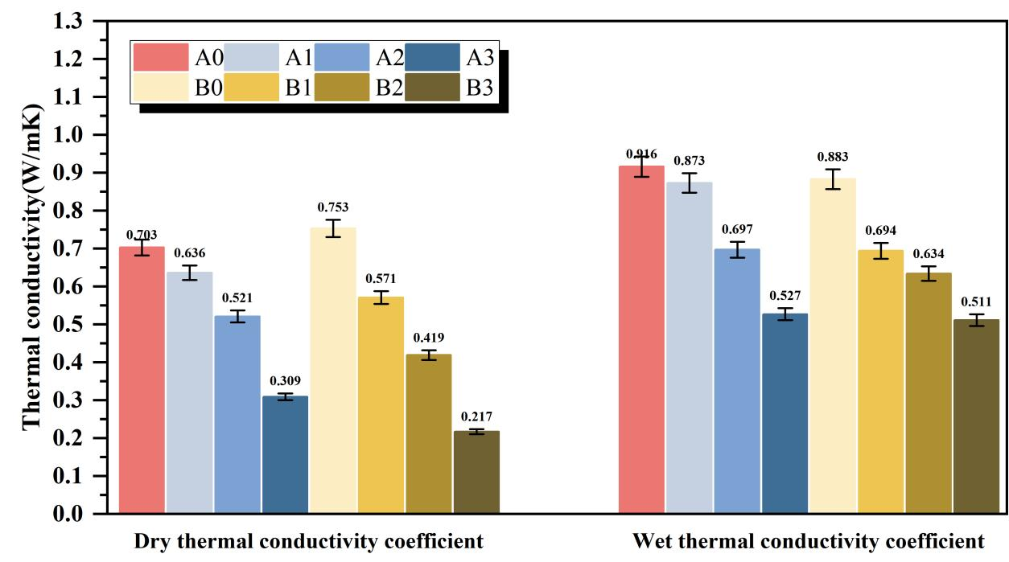
Figure 3. Dry and wet thermal conductivity tests at 28 days

The dry and wet thermal conductivity values of specimens with different solid hydrogen peroxide dosages at 28 days are summarized in Figure 3. As indicated by the results, the thermal conductivity of the specimens decreases markedly with increasing solid hydrogen peroxide content under both dry and saturated conditions. Moreover, for the same foaming agent dosage, the dry and wet thermal conductivity values of Series B (without superplasticizer) are generally lower than those of Series A (with superplasticizer), suggesting that the incorporation of a superplasticizer has a measurable influence on the thermal performance of the material.

In detail, the dry thermal conductivity of Series A decreases from 0.703 W/(m·K) for A0 to 0.309 W/(m·K) for A3, corresponding to an overall reduction of 56.0%. The wet thermal conductivity of Series A shows a similar trend, decreasing from 0.916 W/(m·K) to 0.527 W/(m·K), with a reduction of 42.5%. In comparison, Series B exhibits a more pronounced decrease in thermal conductivity. The dry thermal conductivity drops from 0.753 W/(m·K) for B0 to 0.217 W/(m·K) for B3, representing a reduction of 71.2%, while the wet thermal conductivity decreases from 0.883 W/(m·K) to 0.511 W/(m·K), corresponding to a reduction of 42.1%.

The observed reduction in thermal conductivity can be primarily attributed to the evolution of pore structure induced by increasing solid hydrogen peroxide dosage. Higher foaming agent contents lead to a significant increase in porosity, and since the thermal conductivity of air is much lower than that of the cementitious matrix, the increased presence of air-filled pores effectively disrupts heat transfer pathways, resulting in lower overall thermal conductivity. This finding is consistent with the conclusions reported by Liu et al. [2] regarding the relationship between porosity and thermal conductivity in red-mud-based foamed concrete. In addition, the thermal conductivity measured under wet conditions is consistently higher than that under dry conditions for all specimens. This behavior arises from the fact that water has a higher thermal conductivity than air; upon water absorption, pore water partially replaces entrapped air and becomes the dominant heat transfer medium, thereby increasing the thermal conductivity. This phenomenon is in accordance with the general principles governing the thermal performance of building materials [9].

4 Conclusions

(1) The compressive strength of red mud–metakaolin–cement-based foamed concrete increases significantly with curing age, showing an initial increase followed by a decrease as the dosage of solid hydrogen peroxide foaming agent increases. The optimal dosage was found to be 0.5%, at which the 28-day compressive strength reached 31.6 MPa, representing a 19.7% improvement over the blank sample, and 28.7 MPa for the sample without the water-reducing agent, reflecting an 11.2% increase.
(2) At the optimal foaming agent dosage of 0.5%, a fine, uniformly distributed closed-cell pore structure was formed. Hydration products, including C–S–H gel and anorthite crystals, densely filled the pores and were the key microstructural factors contributing to the peak compressive strength. However, excessive foaming agent content led to pore coalescence and enlargement, which increased internal defects and resulted in a decrease in mechanical strength.
(3) The addition of a water-reducing agent significantly enhanced particle dispersion in the binder system, promoting more complete hydration reactions and improving the compactness of the hardened material. As a result, samples containing a water-reducing agent exhibited higher compressive strength at all curing ages compared to those without it.
(4) Both dry and wet thermal conductivity values decreased significantly with increasing solid hydrogen peroxide dosage. For the same dosage of foaming agent, samples without a water-reducing agent generally exhibited lower thermal conductivity. The wet thermal conductivity was consistently higher than the dry values. Notably, the optimal sample, with a compressive strength of 31.6 MPa and dry thermal conductivity of 0.636 W/(m·K), demonstrated a balanced performance in both strength and thermal insulation, meeting the thermal performance requirements for building materials.
(5) The optimal mix proportion identified in this study—comprising 25% red mud, 25% metakaolin, 50% cement, 0.5% solid hydrogen peroxide, 0.64% water-reducing agent, and 30 g of water—provides a practical solution for incorporating high quantities of red mud into building materials. Compared to conventional Portland cement concrete, this mix can reduce carbon emissions by approximately 86 kg/m³, offering a significant contribution to the development of low-carbon, energy-efficient building materials.

References
1. Jiang J, Luo Q, Wang S, Wei D, Huang Y, Ou X: Sustainable utilization of red mud and bauxite tailings: mechanical and environmental perspectives in cemented backfill. Minerals Engineering 2025, 232:109489.
2. Liu S, Huang G, Gupta M, Jiang B, Pan F: Microstructures, mechanical properties and deformation mechanism of heterogeneous metal materials: A review. Journal of Materials Science & Technology 2026, 248:1-46.
3. Luo Q, Zhang X, Yu J, Geng G: Influence of metakaolin content on the microstructure and strength in hardened LC3 paste. CEMENT 2025, 19:100138.
4. Li P, Yan X, Gao S, Cao R: Boosting photocatalytic hydrogen production coupled with benzyl alcohol oxidation over CdS/metal–organic framework composites. Chemical Engineering Journal 2021, 421:129870.
5. Althoey F, Ansari WS, Sufian M, Deifalla AF: Advancements in low-carbon concrete as a construction material for the sustainable built environment. Developments in the Built Environment 2023, 16:100284.
6. He J, Gao Q, Song X, Bu X, He J: Effect of foaming agent on physical and mechanical properties of alkali-activated slag foamed concrete. Construction and Building Materials 2019, 226:280-287.
7. Ma Y, Du H, Zheng S, Zhou Z, Zhang H, Ma Y, Passerini S, Wu Y: High-Entropy Approach vs. Traditional Doping Strategy for Layered Oxide Cathodes in Alkali-Metal-Ion Batteries: A Comparative Study. Energy Storage Materials 2025, 79:104295.
8. Zhao G, Yan D, Ren G, Zhu Z, Wu T, Ding S, Shi M, Fan H: Influence of ground granulated blast furnace slag on the dispersivity and mechanical property of dispersive soil. Construction and Building Materials 2023, 409:134036.
9. Li Y, Cheng D, Tian J, Zhu Y, Xu H, Huang Y, Chi X: Unlocking high lithium-ion transport in solid polymer electrolytes with dynamic hydrogen-bonded zinc-adeninate framework. Cell Reports Physical Science 2025, 6(6):102624.
10. Liu Y-L, Liu C, Qian L-P, Wang A-G, Sun D-S, Guo D: Foaming processes and properties of geopolymer foam concrete: Effect of the activator. Construction and Building Materials 2023, 391:131830.
11. Tang X, Guo R, Pan T, Fu C, Zhu Y, Li Y: The effect of calcium silicate hydrate – polycarboxylate nanocomposites (CPNs) on hydration, microstructure, and mechanical properties of red mud–cement composites. Construction and Building Materials 2026, 506:144885.

