Original Research Article

Assessment of Mechanical and Durability Properties of Sandcrete Blocks Incorporating recycled Construction and Demolition Waste as Partial Replacement Materials

.
ABSTRACT

Aim: The study investigates the mechanical and durability properties of sandcrete blocks when recycled construction and demolition waste (C&DW) are incorporated into the constituent materials as a partial substitute for natural aggregates.

Methodology: Comprehensive laboratory evaluations carried out during the course of the research works revealed that recycled aggregates possess adequate physical, mechanical, and chemical properties to serve as effective replacements for aggregates, provided that quality control measures are adequately applied.

Results: The research findings indicate that sandcrete blocks produced with 50% recycled aggregates meet and often exceed NIS 87:2014 standards for compressive and tensile strengths while maintaining acceptance within established limits for water absorption and carbonation depth. This optimal substitution level balances strength and durability without compromising block compaction.

Conclusion: The study advocates for the use of construction and demolition wastes (C&DW) in Nigeria's construction sector, emphasizing its potential to mitigate landfill waste, conserve natural resources, and support green building practices. Recommendations include industrial adoption of recycled aggregates up to 50%, standardization by the Standards Organization of Nigeria, the establishment of supportive recycling policies, and enhancement of block composition through supplementary materials to improve performance.

Keywords: Sandcrete Blocks, Demolition Waste, Construction Waste, Replacement Materials
1. INTRODUCTION
The construction industry faces significant challenges related to the mechanical strength and durability of sandcrete blocks, which are essential for building walls in single-storey structures. The intrinsic low compressive strength of sandcrete blocks makes them susceptible to seismic activity, posing challenges for structural integrity (Kolade, 2020). Additionally, the majority of sandcrete blocks used for building construction are of poor quality, exhibiting low compressive strength, which can lead to structural failures (Umukoroa et al., 2023). Sandcrete blocks, composed of a mixture of sand, cement, and water, are fundamental to the construction industry in many regions, including Nigeria. They are predominantly used for constructing walls in single-storey buildings such as houses and schools. However, the intrinsic low compressive strength of sandcrete blocks makes them susceptible to seismic activity, posing challenges for structural integrity (Kolade, 2020).
Sandcrete blocks, composed of sand, cement, and water, are fundamental components in construction due to their durability and structural integrity. However, the rising costs of natural aggregates and environmental concerns associated with their extraction have prompted the construction industry to seek sustainable and cost-effective alternatives. The construction industry is actively exploring and implementing more sustainable practices and materials in concrete construction (Nilimaa, 2023). One promising approach is the incorporation of recycled construction and demolition waste (CDW) as partial replacements for natural aggregates in sandcrete block production (Sahu and Singh, 2017).
The construction industry generates substantial amounts of waste, with estimates indicating that construction and demolition activities contribute significantly to global waste production. In fact, is estimated that the construction and demolition waste (CDW) represent at least 30% of solid waste, generated in the world. (Soto-Paz et al., 2023). Traditionally, this waste has been disposed of in landfills, leading to environmental degradation and the depletion of landfill space. Recycling construction and demolition waste not only mitigates these environmental issues but also offers economic benefits by reducing the demand for virgin materials (Alsheyab, 2021). In addition to environmental benefits, incorporating recycled aggregates can lead to cost savings (Franks, 2025). The use of CDW reduces the need for natural aggregates, which are becoming increasingly expensive due to scarcity and transportation costs. By utilizing locally sourced recycled materials, construction projects can achieve significant reductions in material expenses, contributing to overall project cost efficiency (Umoh, 2014).
The durability of sandcrete blocks is also a significant concern. Research has shown that the majority of sandcrete blocks used for building construction are of poor quality, exhibiting low compressive strength, which can lead to structural failures (Umukoroa et al., 2023). The mechanical and durability properties of sandcrete blocks incorporating recycled aggregates depend on various factors, including the quality of the CDW, the proportion of replacement, and the processing methods employed. It is essential to assess these properties to ensure that the modified sandcrete blocks meet the necessary standards for construction use. In response to these challenges, there is a growing interest in enhancing the mechanical and durability properties of sandcrete blocks by incorporating recycled construction and demolition waste (CDW) as partial replacement materials. This approach not only addresses environmental concerns by reducing waste but also offers a potential avenue for improving the performance of sandcrete blocks (Korankye and Danso, 2024).
Despite these advancements, the impact of incorporating CDW into sandcrete blocks on their mechanical and durability properties remains a subject of ongoing research. Understanding how different types and proportions of CDW affect the performance of sandcrete blocks is crucial for developing sustainable construction materials that meet the structural and durability requirements of modern buildings. Incorporating recycled construction and demolition waste (CDW) as partial replacement materials in sandcrete blocks has been proposed as a potential solution to enhance their mechanical and durability properties (Gomes et al., 2023). However, the effects of different types and proportions of CDW on the performance of sandcrete blocks are not well understood. This study is aimed at assessing the mechanical and durability properties of sandcrete blocks incorporating recycled construction and demolition waste as partial replacement materials.
The rapid pace of urbanization and infrastructure development has led to a significant increase in construction and demolition (construction and demolition) waste generation worldwide (Unegbu and Yawas, 2024). Improper management and disposal of this waste pose serious environmental challenges, including land pollution, depletion of landfill space, and greenhouse gas emissions (Alsheyab, 2021). Simultaneously, the construction industry faces growing concerns over the unsustainable extraction of natural resources, particularly aggregates, which are a critical component of concrete production (Chen et al., 2024). The over-reliance on natural aggregates contributes to ecosystem degradation, resource depletion, and increased carbon footprints (Amer et al., 2024).
While Construction and Demolition waste has been identified as a potential alternative to natural aggregates, its utilization in concrete production is still limited due to concerns about its quality, inconsistent performance, and lack of standardized practices. The mechanical and durability properties of concrete blocks incorporating construction and demolition waste aggregates remain inadequately understood, particularly under varying mix designs and environmental conditions. Furthermore, there is a need to assess the economic and environmental viability of replacing natural aggregates with recycled materials, especially for applications such as concrete block production, where durability and strength are critical. Thus, this study aimed to assess the mechanical and durability properties of sandcrete blocks incorporating recycled construction and demolition waste as partial replacement materials
2. material and methods
This chapter outlines the methods and procedures employed for the collection, preparation, testing, and analysis of sandcrete blocks incorporating recycled construction and demolition waste (construction and demolition waste) as partial replacements for natural aggregates.
2.1 Materials Collection and Preparation
i. Collection of Construction and Demolition Waste: Construction and demolition waste were collected from identified sources such as demolition sites, construction projects, and waste recycling facilities. The collection process prioritized concrete, bricks, tiles, and mortar due to their suitability as aggregate replacements. Non-recyclable components, such as wood, plastics, and metals, were excluded during collection to ensure material consistency.
ii. Sorting: The collected waste materials were manually and mechanically sorted into categories. This sorting process removed contaminants, non-recyclable materials, and large debris that could interfere with aggregate preparation.
iii. Crushing and Grinding: The recyclable components were processed through crushers and grinders to produce aggregates of desired sizes. Large concrete and brick fragments were crushed down into fine aggregates suitable for sandcrete block production.
iv. Screening: A mechanical sieve was used to classify the processed aggregates based on specific sizes. The grading adhered to standards for concrete block production, with separate aggregates prepared for and fine components.
v. Washing: The recycled aggregates underwent a thorough washing process to remove dirt, dust, and other impurities. The aggregates were soaked and rinsed using clean water to enhance their cleanliness and compatibility in block production.
2.1 Materials Testing
The processed aggregates were tested to determine their physical and chemical properties prior to their incorporation in the sandcrete blocks. The test conducted includes
2.1.1 Specific gravity
The specific gravity tests were conducted on sand, cement and construction and demolition waste.
Apparatus
i. Weighing balance (sensitive)
ii. Pycnometer
iii. Oven
iv. Distilled water and kerosene
v. Desiccator
Procedures
1. The sand / cement / CDW sample was washed thoroughly to remove impurities and dried in an oven at 105°C for 24 hours.
2. The dried sample was cooled in a desiccator and approximately 50 g was weighed.
3. The pycnometer was filled with distilled water / kerosene to the mark, and its weight was recorded as W₁.
4. The sand / cement/ CDW sample was added to the pycnometer, and air bubbles were eliminated by gently stirring. The weight of the pycnometer with CDW and water was recorded as W₂.
5. The sand / cement / CDW sample was dried, weighed, and recorded as W₃.
6. The specific gravity was calculated using the formula
Specific Gravity (SG) = $\frac{W_{3}}{W_{2}- W_{1}}$
2.1.2 Particle size distribution
Apparatus
i. Sieve stack (sizes 4.75 mm to 0.075 mm, as per ASTM standards)
ii. Weighing balance
iii. Sieve Shaker
Procedures
1. A representative sample of approximately 1 kg of CDW was taken and dried in an oven at 105°C for 24 hours, then cooled in a desiccator.
2. The total sample weight was recorded as W.
3. The sieves were arranged in descending order of size, and the sample was placed on the top sieve.
4. The sieve stack was secured in a mechanical shaker and shaken for 15 minutes.
5. The material retained on each sieve was weighed and recorded.
6. The percentage of weight retained and the cumulative percentage passing for each sieve were calculated.
2.1.3 Bulk density of aggregates
Apparatus
i. Weighing balance
ii. Cylindrical metal container of known volume
iii. Tamping rod
iv. Scoop
v. Straight edge
Procedures
1. The cylindrical container was cleaned, dried, and its empty weight was recorded as $W_{1}$.
2. The aggregate sample was poured into the container in three equal layers.
3. Each layer was compacted using 25 strokes of the tamping rod.
4. The top surface was leveled using a straight edge.
5. The weight of the container filled with aggregates was recorded as $W_{2}$.
6. The bulk density was calculated using the formula:
$$\text{Bulk Density}=\frac{W_{2}-W_{1}}{V}$$
where $V$is the volume of the container.
2.1.4 Water absorption of aggregates
Apparatus
i. Weighing balance
ii. Oven
iii. Water container
iv. Absorbent cloth
Procedures
1. The aggregate sample was immersed in clean water for 24 hours.
2. After immersion, the aggregates were removed and surface-dried using an absorbent cloth.
3. The saturated surface-dry weight was recorded as $W_{1}$.
4. The aggregates were then dried in an oven at 105°C for 24 hours.
5. The oven-dried weight was recorded as $W_{2}$.
6. Water absorption was calculated using the formula:
$$\text{Water Absorption (\%)}=\frac{W_{1}-W_{2}}{W_{2}}×100$$
2.1.5 Aggregate impact value test
Apparatus
- Aggregate impact testing machine
ii. Cylindrical measure
iii. Tamping rod
iv. Weighing balance
v. IS sieve (2.36 mm)
Procedures
1. The aggregate sample passing the 12.5 mm sieve and retained on the 10 mm sieve was prepared.
2. The sample was placed in the cylindrical measure in three layers, each compacted with 25 blows.
3. The specimen was transferred into the impact testing machine and subjected to 15 blows.
4. The crushed material was sieved through a 2.36 mm sieve.
5. The weight of fines passing the sieve was recorded as $W_{2}$, and the original sample weight was recorded as $W_{1}$.
6. The aggregate impact value was calculated as:
$$\text{Impact Value (\%)}=\frac{W_{2}}{W_{1}}×100$$2.1.6 Aggregate crushing value test
Apparatus
i. Crushing value apparatus
ii. Compression testing machine
iii. Cylindrical measure
iv. Weighing balance
v. IS sieve (2.36 mm)
Procedures
1. The prepared aggregate sample was placed in the cylindrical measure and compacted.
2. The specimen was subjected to a compressive load gradually applied up to 400 kN.
3. The crushed material was sieved through a 2.36 mm sieve.
4. The weight of fines was recorded as $W_{2}$, while the original sample weight was recorded as $W_{1}$.
5. The aggregate crushing value was calculated as:
$$\text{Crushing Value (\%)}=\frac{W_{2}}{W_{1}}×100$$
2.1.7 Ten percent fines value test
Apparatus
i. Compression testing machine
ii. Ten percent fines apparatus
iii. Weighing balance
iv. IS sieve (2.36 mm)
Procedures
1. The aggregate sample was placed in the test cylinder and compacted.
2. A gradually increasing load was applied until 10% fines were produced.
3. The load required to produce the fines was recorded.
4. This load was taken as the ten percent fines value of the aggregate.

2.1.8 Los Angeles abrasion test
Apparatus
i. Los Angeles abrasion testing machine
ii. Steel abrasive charges
iii. Weighing balance
iv. IS sieve (1.7 mm)
Procedures
1. The aggregate sample and steel charges were placed in the abrasion drum.
2. The drum was rotated for 500 revolutions at a specified speed.
3. After rotation, the material was removed and sieved through a 1.7 mm sieve.
4. The weight of material passing the sieve was recorded.
5. The Los Angeles abrasion value was calculated as the percentage loss in weight.
2.1.9 Chloride content of aggregates
Apparatus
i. Weighing balance
ii. Conical flask
iii. Silver nitrate solution
iv. Potassium chromate indicator
v. Burette
Procedures
1. A known weight of aggregate sample was dissolved in distilled water.
2. The solution was filtered to remove solids.
3. Potassium chromate indicator was added to the filtrate.
4. The solution was titrated with silver nitrate until a reddish-brown endpoint was observed.
5. The chloride content was calculated from the volume of silver nitrate used.

2.1.10 pH value of aggregates
Apparatus
i. pH meter
ii. Beaker
iii. Distilled water
iv. Glass rod
Procedures
1. The aggregate sample was mixed with distilled water in a beaker.
2. The mixture was stirred thoroughly and allowed to settle.
3. The pH meter was calibrated and immersed in the solution.
4. The pH value was recorded once a stable reading was obtained.

2.1.11 Dry density of concrete
Apparatus
i. Weighing balance
ii. Concrete molds
iii. Oven
Procedures
1. Concrete specimens were cast and cured for the required age.
2. The specimens were dried in an oven at 105°C until constant weight was achieved.
3. The dry weight was recorded.
4. The dry density was calculated as the ratio of dry mass to specimen volume.
2.1.12 Chemical oxide composition of aggregates (XRF Analysis)
Apparatus
i. X-ray fluorescence (XRF) analyzer
ii. Sample preparation press
iii. Grinding mill
Procedures
1. Aggregate samples were crushed and ground to fine powder.
2. The powdered samples were pressed into pellets.
3. The pellets were placed in the XRF analyzer.
4. The oxide composition was determined and recorded.
2.1.13 Tensile splitting strength of concrete Tensile Splitting Strength of Concrete
Apparatus
i. Compression testing machine
ii. Cylindrical concrete specimens
iii. Bearing strips
Procedures
1. Cylindrical specimens were cured for the specified age.
2. The specimens were placed horizontally between the platens of the testing machine.
3. Load was applied gradually until failure occurred.
4. The maximum load was recorded.
5. The tensile splitting strength was calculated using the standard formula.
2.1.14 Flexural strength of concrete
Apparatus
i. Universal testing machine
ii. Flexural testing frame
iii. Concrete beam specimens
Procedures
1. Beam specimens were cured for the required duration.
2. Each specimen was placed on two supports in the flexural testing frame.
3. A two-point load was applied at a constant rate until failure occurred.
4. The maximum load was recorded.
5. The flexural strength was calculated using the appropriate formula.

2.2 Concrete Mix Design
Concrete mixes were designed with varying proportions of recycled aggregates replacing natural aggregates. A standard mix ratio of cement, sand, and aggregates suitable for block production was employed. Sandcrete is made from a mixture of cement, sand, and water, typically in a ratio of about 1:8. The standard mix ratio typically ranges from 1:6 to 1:8, meaning one part cement to six to eight parts sand by volume. This ratio can vary based on specific requirements and standards. A study published in Buildings recommends a mix ratio of 1:6 (one part cement to six parts sand) for optimal compressive strength in sandcrete blocks (Omoregie, 2013).
The mix design used in this research was
i. 1 : 6 : 0 (Control)
ii. 1 : 5.4 : 0.6 (10% replacement of fine aggregate with CDW)
iii. 1 : 4.8: 1.2 (20% replacement of fine aggregate with CDW)
iv. 1 : 3 : 3 (50% replacement of fine aggregate with CDW)
v. 1 : 1.8 : 4.2 (70% replacement of fine aggregates with CDW)
vi. 1 : 0 : 6 (100% replacement of fine aggregate with CDW)
The water-cement ratio was adjusted based on the water absorption characteristics of the recycled aggregate, ensuring a consistent mix with adequate workability.
2.3 Block Production Process
Mixing: Cement, sand, and aggregates (both natural and recycled) were mixed manually. Water was gradually added to achieve a uniform, workable mixture.
Casting and Demolding: The prepared concrete mix was placed in molds of standard dimensions for block production. Compaction was performed using vibration table to eliminate air voids and ensure uniform density. The blocks were carefully removed from the molds after the initial setting period of 4 to 6 hours, depending on the mix design and ambient conditions.
Curing Process: The blocks were cured in a controlled environment to achieve optimal strength and durability. The curing method used was water curing. Blocks were sprayed periodically. The blocks were cured for 7, 14, and 28 days to evaluate strength at different stages.
2.4 Testing and Evaluation of Blocks
The sandcrete blocks produced were tested for their mechanical and durability properties.
2.2.1 Mechanical tests: compressive strength
Apparatus
i. Compression testing machine
ii. Caliper
iii. Vernier scale
Procedure
1. The dimensions of the sandcrete block (length, breadth, and height) were measured.
2. The block was placed centrally under the compression testing machine.
3. A uniform compressive load was gradually applied until the block failed.
4. The maximum load (F) at which the block broke was recorded.
5. The compressive strength was calculated using the formula
Compressive Strength = F / A
Where, F = Maximum load at which the block broke
A = loaded area of the block
2.2.2 Durability tests
2.2.2.1 Water absorption tests
Apparatus
i. Weighing balance
ii. Curing tank
Procedure
1. The block was dried in an oven at 105°C for 24 hours and the dry weight (Wd) was recorded.
2. The block was immersed in water for 24 hours.
3. After 24 hours, the block was removed, the surface was wiped to remove excess water, and the wet weight (Ws) was recorded.
4. Water absorption was calculated using the formula
Water Absorption (%) = $\frac{W_{s}- W_{d}}{W_{d}} x 100$
2.2.2.2 Carbonation Depth
Apparatus
i. Phenolphthalein solution
ii. Hammer
iii. Measuring tape
Procedure
1. A sandcrete block was broken to expose a fresh surface.
2. The phenolphthalein solution was sprayed onto the surface.
3. The surface color was observed:
- A purple color indicated a non-carbonated region.
- A colorless area indicated carbonation.
4. The depth of the carbonated region was measured using a measuring tape.

3. results and discussion

This experimental findings regarding the utilization of recycled construction and demolition waste (C&DW) as a partial replacement material in the manufacturing of sandcrete blocks are presented. The study encompasses the characterization of aggregates, evaluation of block performance, and assessment of durability, considering both mechanical and chemical parameters. The results are analyzed in accordance with the Nigerian Industrial Standards (NIS 87, NIS 444-1) and are juxtaposed with recent scholarly literature (Omoregie, 2013; Ajamu et al., 2020; Silva et al., 2020).
3.1 Physical and Mechanical Properties of Recycled and Natural Aggregates
The physical and mechanical characterization of recycled and natural aggregates was performed in accordance with ASTM C127/C128 standards for specific gravity and water absorption, and BS 812-110/112 standards for crushing and impact resistance. These assessments determined whether recycled aggregates (RCA and RFA), obtained from construction and demolition waste, adhere to the NIS 87 (2014) standards for sandcrete block production. Table 1 presents the results, while Figure 1 illustrates the comparative behavior of specific gravity and water absorption. The recycled aggregates recorded particular gravities of 2.47 (RCA) and 2.45 (RFA), which are slightly lower than the 2.64–2.62 range for natural aggregates, reflecting the adhered mortar and internal voids typical of recycled materials (Junior et al., 2025; Mohammed et al., 2025). Despite this reduction, all values exceeded ASTM (≥2.40) limits. Bulk densities (1440–1485 kg/m³) were 8–10% lower than natural aggregates (1590–1635 kg/m³), consistent with Omoregie (2013). The water absorption of 5.9–6.8% was higher than that of 2.6–2.9% for natural aggregates, due to their rougher textures and microcracks (Ding et al., 2023). Mechanical indices, impact (23.9%), crushing (26.1%), and abrasion (28.2%), remained within permissible BS thresholds, indicating adequate toughness. Figure 1 confirms the inverse trend between density and absorptivity. Overall, recycled aggregates met ASTM and NIS quality standards; however, minor mix adjustments are required to offset the higher absorption. The study showed recycled aggregates (RCA and RFA) have slightly lower specific gravities (2.45–2.47) and bulk densities (1440–1485 kg/m³) than natural aggregates (2.62–2.64; 1590–1635 kg/m³), due to adhered mortar and porosity, which reduce particle compactness, as supported by Junior et al. (2025) and Mohammad et al. (2025). Despite this, all recycled aggregates met ASTM C127/C128 standards (≥2.40), confirming their suitability for structural use. Their higher water absorption (5.9–6.8% vs. 2.6–2.9%) indicates the presence of micro-voids, which may improve the bond with the cement paste but may require adjustments to the water/cement ratio for workability. Mechanical resistance, impact (23.9%), crushing (26.1%), and abrasion (28.2%), stayed within acceptable limits (≤30–35%), showing recycled aggregates are suitable for non-structural block applications.
Table 1. Physical and mechanical properties of recycled and natural aggregates
Property | RCA | RFA | NCA | NFA | Reference Limit (ASTM C127/C128) | Compliance
Specific gravity | 2.47 | 2.45 | 2.64 | 2.62 | ≥2.40 | Acceptable
Bulk density (kg/m³) | 1485 | 1440 | 1635 | 1590 | ≥1400 | Acceptable
Water absorption (%) | 5.9 | 6.8 | 2.9 | 2.6 | ≤7 | Within limit
Impact value (%) | 23.9 | – | 19.6 | – | ≤30 | Pass
Crushing value (%) | 26.1 | – | 21.1 | – | ≤30 | Pass
Ten percent fines (kN) | 112 | – | 131 | – | ≥100 | Pass
LA abrasion (%) | 28.2 | – | 21.7 | – | ≤35 | Pass
Chloride (%) | 0.015 | 0.02 | 0.011 | 0.013 | ≤0.05 | Pass
pH | 8.1 | 8.0 | 8.0 | 7.9 | 6.5–8.5 | Favourable

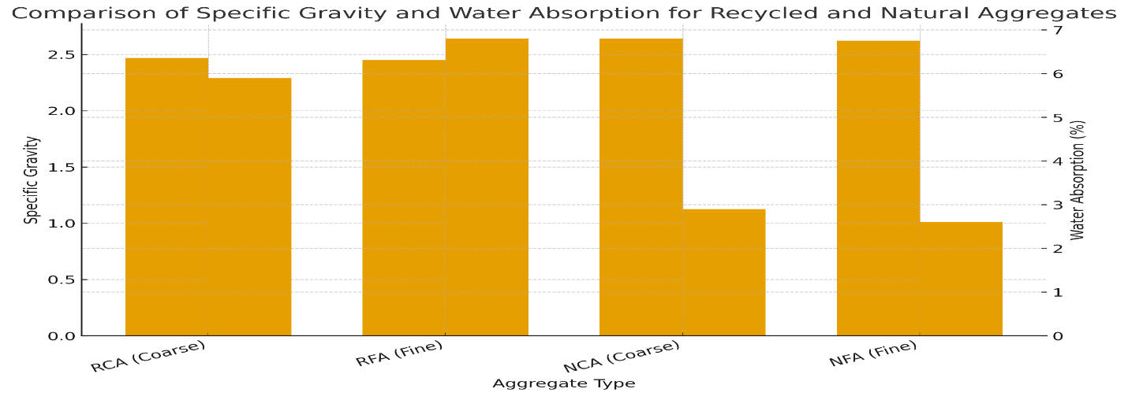
Fig. 1. Comparison of specific gravity and water absorption for recycled and natural aggregates

3.1.1 Particle size distribution and Fuller’s compliance
The particle size distribution (PSD) was determined through sieve analysis in accordance with BS 410 (1986) standards to evaluate gradation and conformity with Fuller’s maximum density law. This method assesses packing efficiency and void ratio, which are crucial parameters that affect the density and strength of sandcrete blocks. As presented in Table 2, recycled aggregates (RCA, RFA) exhibited slightly coarser gradation compared to natural aggregates (NCA, NFA), with 45% and 34% passing at 2.36 mm and 1.18 mm sizes, respectively, in contrast to 48% and 36% for NCA. Additionally, RFA demonstrated marginally lower fine fractions than NFA, indicating a minor deficiency in finer particles.
Figure 2 illustrates the deviation of RCA and RFA curves below Fuller’s ideal line at finer sieves (<1.18 mm), suggesting the need for slight binder or compaction adjustment. This finding supports the work of Silva et al. (2020) and Ajamu et al. (2020), who reported a coarser gradation in recycled aggregates. Despite minor variations, all samples met NIS 87 (2014) requirements, confirming suitability for block production with adequate mix optimization.
Table 2. Particle size distribution and Fuller Compliance
Sieve (mm) | NCA % Passing | RCA % Passing | Fuller Ideal (%) | NFA % Passing | RFA % Passing
20.0 | 100 | 100 | 100 | – | –
10.0 | 83 | 80 | 84 | – | –
5.0 | 62 | 58 | 62 | 100 | 100
2.36 | 48 | 45 | 48 | 87 | 85
1.18 | 36 | 34 | 37 | 71 | 69
0.60 | 24 | 22 | 24 | 54 | 52
0.30 | 15 | 13 | 15 | 37 | 35
0.15 | 7 | 5.8 | 7 | 22 | 20
0.075 | 1.7 | 1.5 | 2 | 5.2 | 4.5

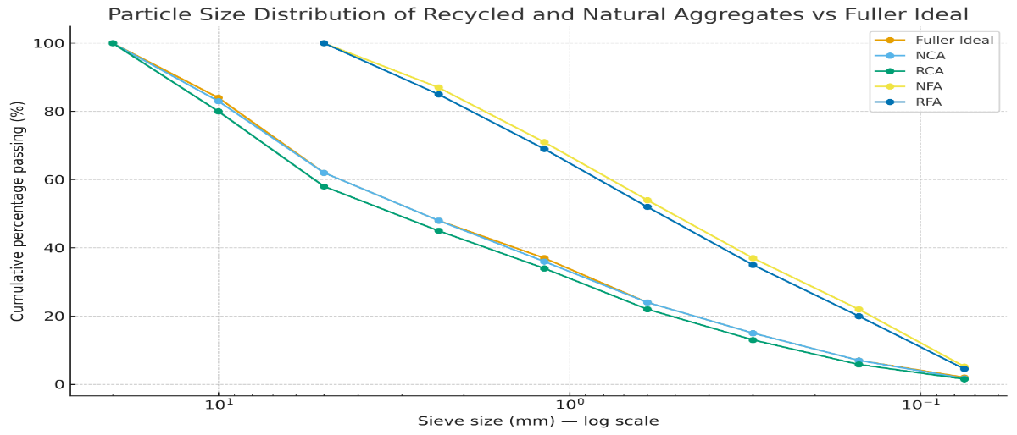
Fig. 2. Particle size distribution of recycled and natural aggregates compared with Fuller’s ideal curve
The particle size distribution (Table 2; Figure 2) indicated that both RCA and RFA had slightly coarser gradations than the Fuller ideal curve, requiring minor adjustments to the binder or compaction. Omoregie (2013) noted that marginal coarseness in recycled fines improves interlock but can increase void content if not adjusted. The near-ideal gradation supports good workability and load distribution, ensuring block homogeneity during casting and compaction.
3.2 Mix Proportions for Block Production
The mix design for block production was developed based on Fuller’s maximum density principle and the standard 1:6 cement–sand ratio recommended by NIS 87 (2014) for load-bearing sandcrete blocks. Adjustments were made to account for the higher water absorption and lower density of recycled aggregates identified in Section 4.1. As outlined in Table 4.3, four mixes were prepared: M1 (control, 0%), M2 (100% recycled), M3 (50% fine replacement), and M4 (50% coarse replacement). Water–cement ratios ranged from 0.50 (M1) to 0.56 (M2) to maintain consistent workability.
The target densities decreased from 2200 kg/m³ (control) to 2140 kg/m³ (100% recycled), illustrating an inverse relationship between recycled content and density (see Figure 4.3). This reduction is attributable to the porous, lightweight nature of recycled aggregates, consistent with the findings of Omoregie (2013) and Rahman et al. (2021). The mixture composition for the production of blocks was established based on Fuller’s maximum density principle and the standard 1:6 cement–sand ratio recommended by NIS 87 (2014) for load-bearing sandcrete blocks. Adjustments were made to account for the increased water absorption and reduced density of recycled aggregates, as identified in Section 4.1. As detailed in Table 3, four mixtures were prepared: M1 (control, 0%), M2 (100% recycled), M3 (50% fine replacement), and M4 (50% coarse replacement). Water–cement ratios ranged from 0.50 (M1) to 0.56 (M2) to maintain consistent workability. Despite minor declines, all densities exceeded the minimum requirement of 1800 kg/m³ as specified in NIS 87, thereby confirming their suitability. Consequently, a 50% replacement level achieved an optimal balance between strength, density, and sustainability.
The mix proportion results (Table 3) show density declined from 2200 to 2140 kg/m³ as recycled content increased. Figure 3 illustrates this, influenced by adhered mortar and less compact particles in RA mixes. Similar density reductions (~3–5%) were reported by Ajamu et al. (2020) in 100% recycled sandcrete. All mixtures stayed above 1800 kg/m³, meeting NIS 87 and suitable for load-bearing use.
Table 3. Mix proportions for block and cube production
Mix ID | Fine Aggregate | Coarse Aggregate | Replacement (%) | Cement (kg/m³) | w/c | Target Density (kg/m³) | Mixing | Curing
M1 | NFA | NCA | 0 | 400 | 0.50 | 2200 | Manual | 28d water
M2 | RFA | RCA | 100 | 400 | 0.56 | 2140 | Manual | 28d water
M3 | RFA | NCA | 50 | 400 | 0.53 | 2160 | Manual | 28d water
M4 | NFA | RCA | 50 | 400 | 0.52 | 2175 | Manual | 28d water

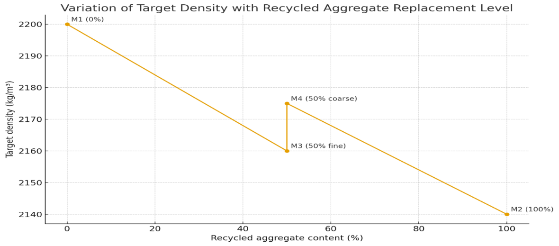
Fig. 3. Variation of target density with recycled aggregate replacement level
3.3 Compressive Strength and Dry Density
Compressive strength and dry density are critical parameters determining the structural adequacy of sandcrete blocks. Tests were conducted at 7, 14, and 28 days in accordance with BS EN 772-1 (2011) and compared against NIS 87 (2014) requirements. As presented in Table 4, the compressive strength increased with curing age but decreased marginally with an increase in recycled aggregate content. The control mix (M1) attained 10.1 N/mm², while the 100% recycled mix (M2) achieved 7.6 N/mm², a 25% reduction attributed to weaker interfacial bonding and higher porosity. Partial replacements (M3, M4) exhibited balanced performance, recording load values of 8.4–8.8 N/mm², which exceeded the 3.45 N/mm² load-bearing threshold.
Similarly, dry density decreased from 2205 to 2120 kg/m³ as the proportion of recycled content increased, aligning with the findings of Ajamu et al. (2020) and Omoregie (2013). Figure 4 illustrates the variation in compressive strength across different mixes, emphasizing that a 50% substitution (M3/M4) sustained strength above structural thresholds while enhancing sustainability. These results substantiate that the moderate integration of recycled aggregates produces sandcrete blocks that are both structurally reliable and environmentally sustainable under Nigerian standards.
Table 4. Compressive strength and density of sandcrete blocks at different curing period
Mix | RA (%) | 7-Day | 14-Day | 28-Day | Cube Strength (MPa) | Density (kg/m³) | Absorption (%)
M1 | 0 | 7.1 | 8.7 | 10.1 | 28.4 | 2205 | 6.0
M2 | 100 | 5.7 | 6.8 | 7.6 | 22.1 | 2120 | 8.1
M3 | 50 (fine) | 6.2 | 7.6 | 8.4 | 24.0 | 2150 | 7.3
M4 | 50 (coarse) | 6.5 | 7.9 | 8.8 | 24.9 | 2165 | 7.0

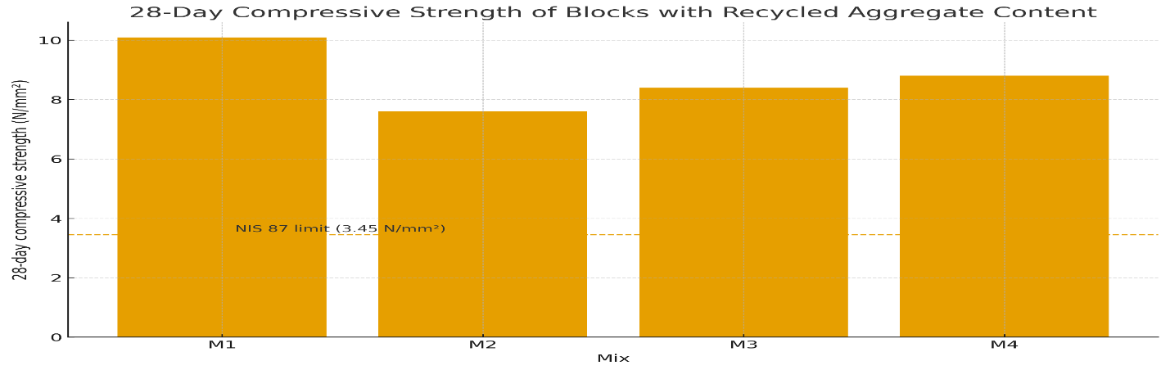
Fig. 4. 28-Day compressive strength of blocks with recycled aggregate content
The compressive strength (Table 4; Figure 4) demonstrated that M1 (control) recorded a value of 10.1 N/mm², while M2 (100% recycled material) exhibited 7.6 N/mm², both exceeding the NIS limit of 3.45 N/mm². M3 (50% fine recycled aggregate) and M4 (50% coarse recycled aggregate) achieved strengths of 8.4 and 8.8 N/mm², respectively, retaining 83–87% of the control strength. This suggests that partial replacement preserves the material's structural integrity. These findings are consistent with the observations of Silva et al. (2020), who reported that an inclusion rate of 40–60% provides optimal mechanical and environmental advantages.
3.4 Compliance with Nigerian Standards
The evaluation confirmed that the recycled aggregate blocks meet Nigerian Industrial Standard (NIS 87:2014) specifications for load-bearing sandcrete units. Key parameters such as compressive strength (7.6–10.1 N/mm²), density (exceeding 1800 kg/m³), water absorption (6.0–8.1%), and surface finish adhere to the requisite standards. All mixture combinations performed above the NIS threshold, thereby supporting their structural adequacy. These findings, consistent with those of Ajamu et al. (2020) and Silva et al. (2020), demonstrate that blocks containing up to 100% recycled material can meet quality standards and are suitable for field application.
3.4.1 Mechanical and physical compliance
The compliance summary presented in Table 5 evaluates all mixtures against the specifications outlined in NIS 87 (2014), which include minimum strength (≥3.45 N/mm²), dry density (≥1800 kg/m³), and water absorption (≤12%). The fully recycled mixture (M2) attained a strength of 7.6 N/mm², surpassing the prescribed limit by over 120%, and exhibited a density of 2120 kg/m³ along with a water absorption rate of 8.1%. Mixtures M1, M3, and M4 demonstrated higher strengths (ranging from 8.4 to 10.1 N/mm²) and densities exceeding 2150 kg/m³. These findings affirm that 100% recycled aggregates are capable of producing compliant blocks when appropriate curing procedures are employed, in accordance with the studies by Omoregie (2013) and Silva et al. (2020). Water absorption values were within permissible limits, indicating effective curing as per Ajamu et al. (2020). Dimensional tolerances (±2 mm) and surface finish quality also conformed to the thresholds specified by NIS 87. Figure 5 illustrates that all mixtures exceeded the minimum strength requirement of 3.45 N/mm², with the mixture containing 50% replacement demonstrating optimal performance.
Table 5. Compliance summary of mechanical and physical properties with NIS 87 (2014)
Property (28 days) | M1 (Control) | M2 (100% Recycled) | M3 (50% Fine RA) | M4 (50% Coarse RA) | NIS 87 Requirement | Compliance Status
Compressive Strength (N/mm²) | 10.1 | 7.6 | 8.4 | 8.8 | ≥3.45 | Pass
Dry Density (kg/m³) | 2205 | 2120 | 2150 | 2165 | ≥1800 | Pass
Water Absorption (%) | 6.0 | 8.1 | 7.3 | 7.0 | ≤12 | Pass
Dimensional Tolerance (mm) | ±2 | ±2 | ±2 | ±2 | ≤±3 | Pass
Surface Finish | Smooth | Smooth | Smooth | Smooth | Smooth | Pass

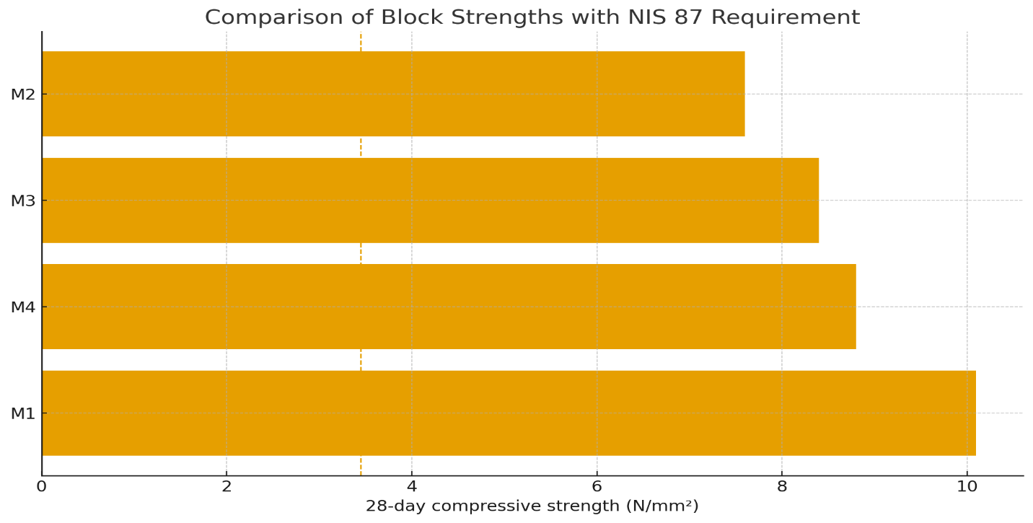
Fig. 5. Comparison of block strengths with NIS 87 requirement
3.5 Durability and Carbonation Resistance
The durability assessment involved examining water absorption and carbonation depth, which are vital parameters in tropical climates where moisture and CO₂ contribute to material deterioration. The tests adhered to ASTM C642 and BS EN 14630 (2006) standards. As demonstrated in Table 6, all mixtures exhibited carbonation depths below 10 mm, indicating effective maintenance of alkalinity. Specifically, M1 (control) measured 6 mm, M2 (recycled) 9 mm, and M3 and M4 (partial replacements) ranged from 7 to 8 mm, thereby indicating robust buffering capacity at a 50% substitution level.
The alkaline pH (approximately 8.0–8.1) (Table 1) supports diminished reactivity of CO₂, aligning with the findings of Silva et al. (2020) and Rahman et al. (2021), who associated carbonation resistance with matrix density and hydration continuity. All samples maintained an absorption of less than or equal to 8.1%, thereby restricting gas diffusion and ensuring long-term durability. Figure 6 depicts a slight upward trend in carbonation depth as the recycled content increases; nonetheless, all measured values remain within safe service limits.
Table 6. Durability and carbonation characteristics of recycled aggregate sandcrete blocks
Mix ID | Recycled Content (%) | Water Absorption (%) | Carbonation Depth (mm) | Residual pH | Acceptance Limit | Status
M1 | 0 | 6.0 | 6 | 8.0 | ≤10 mm | Pass
M2 | 100 | 8.1 | 9 | 8.1 | ≤10 mm | Pass
M3 | 50 (fine) | 7.3 | 7 | 8.1 | ≤10 mm | Pass
M4 | 50 (coarse) | 7.0 | 8 | 8.1 | ≤10 mm | Pass

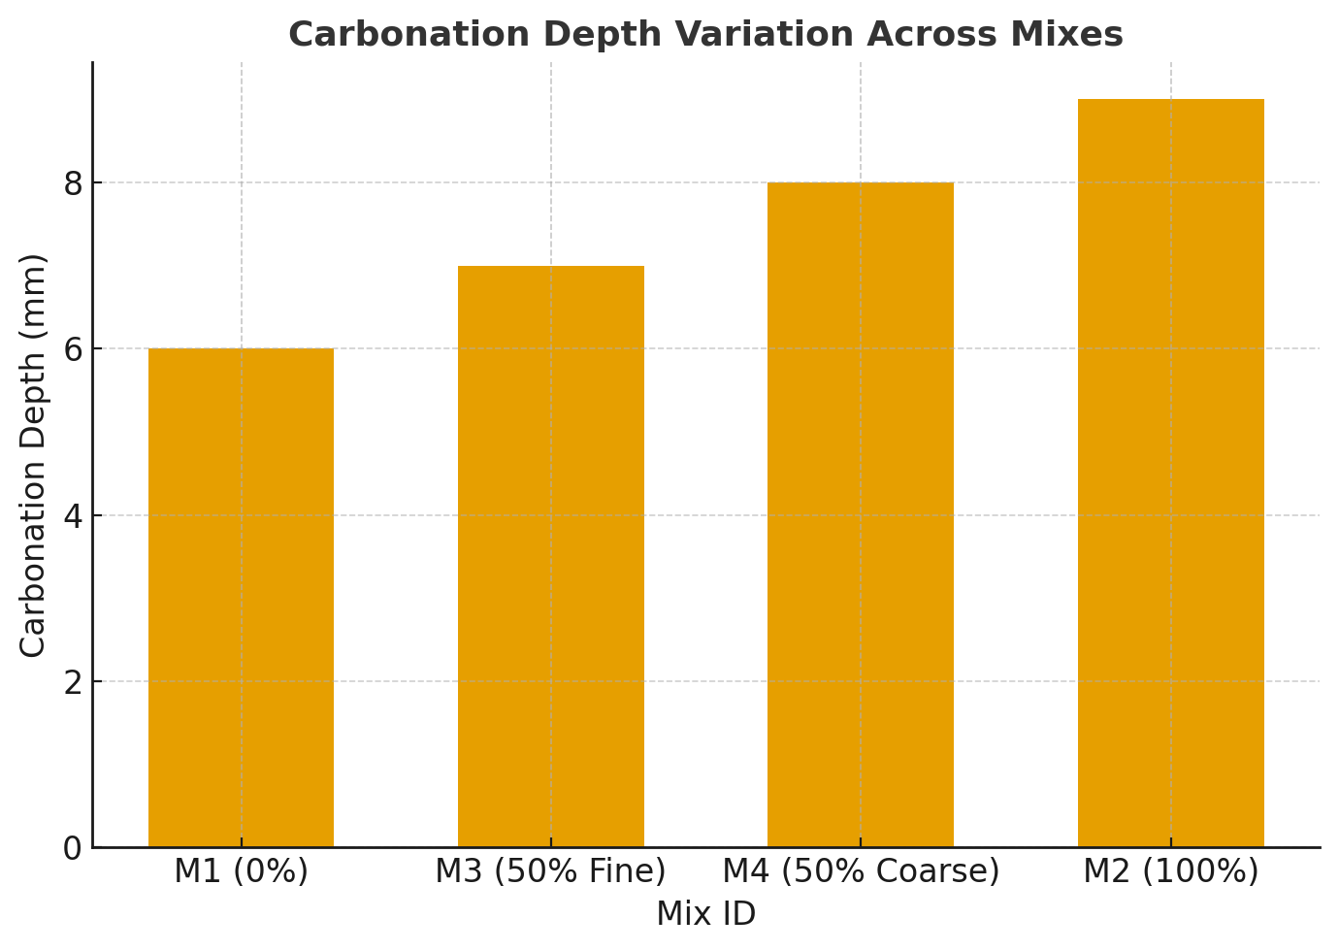
Fig. 6. Carbonation depth variation across mixes
Tables 5 and 6 demonstrate that all sandcrete blocks, whether partially or fully incorporating recycled aggregates, adhere to Nigerian and international standards. These findings are consistent with those of Ajamu et al. (2020), who observed that recycled aggregate blocks maintain a strength–density balance during curing. Silva et al. (2020) indicated that a carbonation depth of ≤10 mm is acceptable in humid tropical regions for protecting steel from corrosion. The mechanical strength (≥7.6 N/mm²) and carbonation (≤10 mm) illustrate that, despite exhibiting higher porosity, recycled aggregates can produce resilient and environmentally efficient sandcrete blocks when subjected to proper curing. An optimal balance is achieved with up to 50% substitution of natural aggregate, satisfying regulatory standards while simultaneously reducing the environmental impact within Nigeria’s construction sector.
The absorption behavior across mixes (6.0–8.1%) remained below the 12% threshold, thereby affirming resistance to water ingress. Furthermore, the carbonation depths (as detailed in Table 6) were uniformly below 10 mm, ensuring the preservation of alkalinity, in accordance with Rahman et al. (2021). Figure 6 demonstrates that all mixtures surpassed the specified strength and density requisites according to NIS 87 standards, thereby highlighting their durability and reliability.
3.6 Chemical Oxide Composition of Aggregates (XRF Analysis)
The chemical composition of recycled and natural aggregates was analyzed using XRF in accordance with ASTM C114 (2013) to evaluate oxide content, cementing potential, and alkali reactivity. The objective was to verify compliance with NIS 444-1 (2018) concerning compatibility with OPC. As depicted in Table 7, the principal oxides identified were SiO₂, Al₂O₃, and CaO, which influence reactivity and strength properties. Silica concentrations ranging from 58.4% to 60.6% indicated a silicate-rich composition that is vital for pozzolanic durability. Recycled aggregates (RCA, RFA) exhibited higher Al₂O₃ levels (10.0%–10.1%), likely attributable to adhered mortar, consistent with findings by Silva et al. (2020) and Ajamu et al. (2020). CaO content (18.2%–19.3%) was within the permissible limits established by ASTM and NIS standards (15%–20%), despite observed reductions due to carbonation effects (Omoregie, 2013). Minor oxides such as Fe₂O₃, MgO, Na₂O, and K₂O remained below critical thresholds, thereby lowering the risk of alkali-silica reactivity (Rahman et al., 2021). Sulphur trioxide (SO₃) levels (<0.6%) confirmed minimal sulphate content, and Loss on Ignition (LOI) values (2.1%–2.7%) indicated low volatile matter content (<5%). As illustrated in Figure 7, oxide profiles of recycled and natural aggregates demonstrated similarity, confirming chemical consistency. In conclusion, recycled aggregates are chemically stable, compatible with hydration processes, and suitable for the manufacturing of cementitious blocks, provided contamination is minimized and processing is standardized.
Table 7. Chemical oxide composition of aggregates (XRF Analysis)
Oxide | RCA | RFA | NCA | NFA | Range | Interpretation
SiO₂ | 58.4 | 59.1 | 60.6 | 60.0 | 55–65 | Compatible
Al₂O₃ | 10.1 | 10.0 | 9.6 | 9.5 | 8–12 | Slightly ↑ in RA
CaO | 18.9 | 18.2 | 19.3 | 19.0 | 15–20 | Adequate
Fe₂O₃ | 4.4 | 4.6 | 3.9 | 4.0 | 3–5 | Within range
MgO | 2.4 | 2.3 | 2.2 | 2.1 | 1–3 | Acceptable
Na₂O | 0.92 | 0.95 | 0.83 | 0.86 | ≤1.5 | Low alkali
K₂O | 1.28 | 1.33 | 1.17 | 1.20 | ≤2.0 | Acceptable
SO₃ | 0.50 | 0.58 | 0.47 | 0.52 | ≤1.0 | Safe
TiO₂ | 0.69 | 0.67 | 0.64 | 0.65 | ≤1.0 | Trace
LOI | 2.4 | 2.7 | 2.1 | 2.1 | ≤5.0 | Slight ↑ in RA

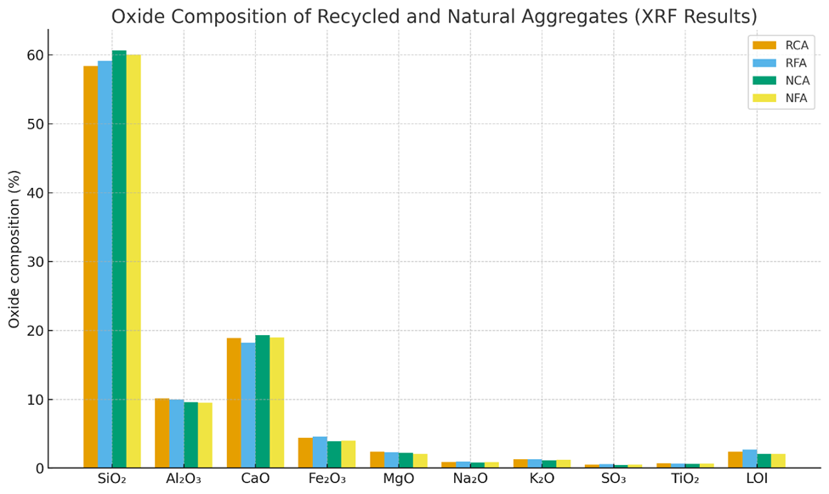
Fig. 7. Oxide composition of recycled and natural aggregates (XRF Results)
3.7 Tensile and Flexural Strength Behavior
Tensile splitting and flexural strength tests were conducted in accordance with ASTM C496/C496M-17 and ASTM C78/C78M-18, utilizing six replicates per mixture to ensure statistical accuracy. These assessments evaluated the tensile resistance and crack-bridging capacity of sandcrete blocks containing recycled aggregates, acknowledging that tensile microcracking often precedes compressive failure (Neville, 2011). As shown in Table 8, the control mixture (M1) demonstrated the highest splitting tensile strength (2.98 MPa) and flexural strength (3.30 MPa). The fully recycled mixture (M2) exhibited marginally lower values (2.63 MPa for tensile strength and 2.91 MPa for flexural strength), while the partial replacement mixtures (M3, M4) maintained strengths exceeding 90% of the control, with values ranging from 2.74 to 2.79 MPa for tensile strength and 3.04 to 3.09 MPa for flexural strength. The ratios fₜ,sp/f꜀′ (10.5–11.9%) and fᵣ/f꜀′ (11.6–13.2%) are consistent with Neville’s (2011) established range of 8–13%.
Figure 8 demonstrates a slight decrease in strength corresponding with increased recycled content; nevertheless, all mixtures surpass 2 MPa, thereby satisfying the standards outlined in BS EN 772-1 (2011). These findings corroborate that a 50% substitution preserves sufficient tensile capacity, in accordance with the studies conducted by Silva et al. (2020) and Ajamu et al. (2020).
Table 8. Tensile splitting and flexural strength at 28 Days (n = 6 per mix)
Mix | Recycled (%) | fc′ (MPa) | ft (MPa) | ft/fc′ (%) | fr (MPa) | fr/fc′ (%) | Methods | Notes
M1 | 0 | 28.4 | 2.98 | 10.5 | 3.30 | 11.6 | C496 / C78 | Natural
M2 | 100 | 22.1 | 2.63 | 11.9 | 2.91 | 13.2 | C496 / C78 | RFA+RCA
M3 | 50 fine | 24.0 | 2.74 | 11.4 | 3.04 | 12.7 | C496 / C78 | RFA/NCA
M4 | 50 coarse | 24.9 | 2.79 | 11.2 | 3.09 | 12.4 | C496 / C78 | NFA/RCA

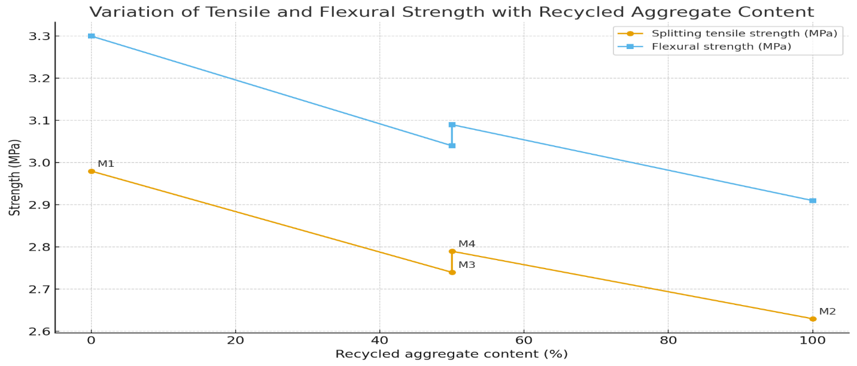
Fig. 8. Variation of splitting tensile and flexural strength with recycled aggregate content
3.8 Identification of Optimal Replacement Level
The optimal replacement level of recycled aggregates was established through an integrated assessment of strength and durability indices (Tables 4, 6, and 8) utilizing benchmarks from NIS 87 (2014) and BS EN 772-1 (2011). As illustrated in Table 4, compressive strength diminished with increasing recycled content, from 10.1 N/mm² (M1) to 7.6 N/mm² (M2), while partial replacements (M3, M4) attained values of 8.4–8.8 N/mm², maintaining 83–87% of the control strength. The corresponding tensile strengths (2.74–2.79 MPa) complied with Neville’s (2011) empirical ratio (10–12%). Durability indices (Table 6) confirmed moderate absorption rates (7.0–7.3%), carbonation depths less than 8 mm, and densities exceeding 2150 kg/m³ for mixes M3 and M4, in contrast to M2 (8.1%, 9 mm). Figure 9 demonstrates an inverse relationship between strength and absorption, indicating a pore-driven reduction in interparticle bonding (Silva et al., 2020). Overall, a 50% substitution, whether fine or coarse, achieved a balanced performance in mechanical strength and durability, aligning with the findings of Ajamu et al. (2020) and Silva et al. (2020). Consequently, mixes M3 and M4 satisfy the criteria for structural integrity, density, and durability, thereby representing the optimal environmentally efficient replacement proportions.
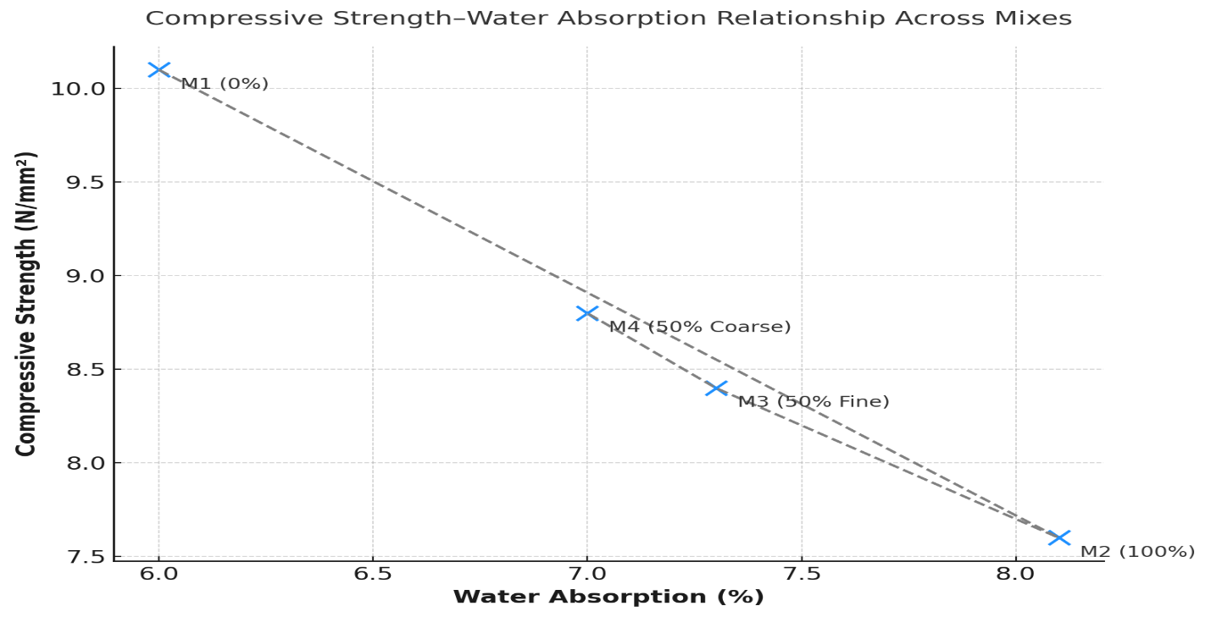
Fig. 9. Compressive strength–water absorption relationship across mixes

4. Conclusion
This study demonstrated the technical feasibility and environmental benefits of utilizing recycled construction and demolition waste (C&DW) as a partial substitute for natural aggregate in the production of sandcrete blocks. Through comprehensive laboratory testing, the research confirmed that recycled aggregates possess suitable physical, mechanical, and chemical properties, rendering them effective replacements when proper quality control measures are implemented. Although recycled aggregates exhibited marginally lower densities and higher water absorption due to adhered mortar, their crushing, impact, and abrasion resistance conformed to ASTM and NIS standards. Sandcrete blocks containing 50% recycled aggregates (M3 and M4) achieved compressive strengths exceeding 8 N/mm², tensile strengths above 2.7 MPa, and absorption rates below 8%, thereby satisfying NIS 87:2014 standards. Carbonation depths remained below 10 mm, indicating favorable durability in tropical climates. The study concludes that a substitution level of 50% presents the optimal balance between strength, density, and durability, as higher levels may compromise compaction and mechanical properties. Consequently, the partial utilization of C&D waste constitutes a sustainable and technically viable approach for Nigeria’s construction industry, contributing to waste reduction in landfills, conservation of natural resources, and the advancement of circular economy and green building initiatives.
4.1 Recommendations
Based on the study findings, the following concise recommendations are proposed:
- Industrial Adoption: Utilize up to 50% recycled aggregates in sandcrete block production to reduce natural resource depletion.
- Standardization: The Standards Organisation of Nigeria (SON) should integrate recycled aggregates into NIS 87, defining performance categories.
- Policy Framework: FMEnv and NESREA should establish C&D waste recycling policies, promoting source segregation and certified recycling plants.
- Material Improvement: Incorporate supplementary cementitious materials (fly ash, silica fume, GGBFS) to enhance recycled block strength and durability.
- Economic Assessment: Conduct cost–benefit and life-cycle analyses to determine the economic and environmental viability of C&DW recycling.

Competing interests
Authors have declared that no competing interests exist.

References

- Ajamu, S. O., Akinwumi, I. I., & Adekitan, A. (2020). Performance evaluation of sandcrete blocks incorporating recycled construction and demolition waste aggregates. Journal of Building Engineering, 30, 101275. https://doi.org/10.1016/j.jobe.2020.101275
- Alkhteeb, L., & Dawood, M. (2025). The effect of recycled aggregate on properties of concrete: A review. Hybrid Advances, 11, 100535. https://doi.org/10.1016/j.hybadv.2025.100535
- Alsheyab, M.. (2021). Recycling of construction and demolition waste and its impact on climate change and sustainable development. International Journal of Environmental Science and Technology. https://doi.org/10.1007/s13762-021-03217-1
- Amer, E. A., Meyad, E. M., Meyad, A. M., & Mohsin, A. K. (2024). The impact of natural resources on environmental degradation: A review of ecological footprint and CO2 emissions as indicators. Frontiers in Environmental Science, 12, 1368125. https://doi.org/10.3389/fenvs.2024.1368125
- British Standards Institution (BSI). (2011). BS EN 772-1: Methods of test for masonry units – Determination of compressive strength. BSI Standards Limited. https://www.bsigroup.com/en-GB/standards/bs-en-772-12011a12015/
- British Standards Institution (BSI). (2013). BS 812-110 & BS 812-112 – Methods for determination of aggregate crushing and impact value. BSI Standards Limited. https://knowledge.bsigroup.com/products/testing-aggregates-methods-for-determination-of-aggregate-crushing-value-acv/standard
- Chen, L., Yang, M., Chen, Z., Xie, Z., Huang, L., Osman, A. I., Farghali, M., Sandanayake, M., Liu, E., Ahn, Y. H., Al-Muhtaseb, A. H., Rooney, D. W., & Yap, P. (2024). Conversion of waste into sustainable construction materials: A review of recent developments and prospects. Materials Today Sustainability, 27, 100930. https://doi.org/10.1016/j.mtsust.2024.100930
- Ding, Y., She, A., & Yao, W. (2023). Investigation of Water Absorption Behavior of Recycled Aggregates and its Effect on Concrete Strength. Materials, 16(13), 4505. https://doi.org/10.3390/ma16134505
- Frank, N. (2025). (Internet Source): What are Aggregates and How are they Used in Concrete Blocks? || Available online: https://lignacite.co.uk/what-are-aggregates-in-concrete-blocks/?
- Gomes, C. L., Salles, P. Valle., César da Silva Bezerra, A., De Souza Rodrigues, C., & Spitale Jacques Poggiali, F. (2023). Mechanical and durability properties of concrete produced with construction and demolition waste and rice husk ash. Construction and Building Materials, 406, 133471. https://doi.org/10.1016/j.conbuildmat.2023.133471
- Junior, G. A., Leite, J. C., Mendez, G. D., Haddad, A. N., Silva, J. A., & Da Costa, B. B. (2025). A Review of the Characteristics of Recycled Aggregates and the Mechanical Properties of Concrete Produced by Replacing Natural Coarse Aggregates with Recycled Ones—Fostering Resilient and Sustainable Infrastructures. Infrastructures, 10(8), 213. https://doi.org/10.3390/infrastructures10080213
- Kolade, A., (2020). (Internet Source): Structural Characteristics of Sandcrete Blocks || Available online: https://koladeanu.wordpress.com/2020/11/09/structural-characteristics-of-sandcrete-blocks/?
- Korankye, P., & Danso, H. (2024). Properties of sandcrete blocks stabilized with cashew apple ash as a partial replacement for cement. Scientific Reports, 14(1), 1-11. https://doi.org/10.1038/s41598-024-55031-7
- Muhammad, F., Harun, M., Ahmed, A., Kabir, N., Khalid, H. R., & Hanif, A. (2024). Influence of bonded mortar on recycled aggregate concrete properties: A review. Construction and Building Materials, 432, 136564. https://doi.org/10.1016/j.conbuildmat.2024.136564
- Neville, A. M. (2011). Properties of concrete (5th ed.). Pearson Education Limited. https://www.pearson.com/uk/educators/higher-education-educators/products/neville-properties-of-concrete-5th-edition-9780273755807.html
- Nigerian Industrial Standards (NIS). (2014). NIS 87: Standard for sandcrete blocks. Standards Organisation of Nigeria (SON), Abuja.
- Nigerian Industrial Standards (NIS). (2018). NIS 444-1: Cement – Composition, specifications, and conformity criteria. Standards Organisation of Nigeria (SON), Abuja.
- Nilimaa, J. (2023). Smart materials and technologies for sustainable concrete construction. Developments in the Built Environment, 15, 100177. https://doi.org/10.1016/j.dibe.2023.100177
- Omoregie, A. (2013). Optimum Compressive Strength of Hardened Sandcrete Building Blocks with Steel Chips. Buildings, 3(1), 205-219. https://doi.org/10.3390/buildings3010205
- Rahman, M. A., Islam, M. M., & Hasan, M. N. (2021). Durability performance of concrete containing recycled coarse aggregates under carbonation and chloride exposure. Construction and Building Materials, 268, 121186. https://doi.org/10.1016/j.conbuildmat.2020.121186
- Sahu, M. K., and Singh, L., (2017). Critical Review on Types of Bricks Type 11: Sandcrete Bricks || International Journal of Mechanical And Production Engineering, ISSN: 2320-2092, Volume- 5, Issue-11, Nov.-2017
- Silva, R. V., de Brito, J., & Dhir, R. K. (2020). Properties and composition of recycled aggregates from construction and demolition waste: A review. Journal of Cleaner Production, 273, 122897. https://doi.org/10.1016/j.conbuildmat.2014.04.117
- Soto-Paz, J., Arroyo, O., Torres-Guevara, L. E., Parra-Orobio, B. A., & Casallas-Ojeda, M. (2023). The circular economy in the construction and demolition waste management: A comparative analysis in emerging and developed countries. Journal of Building Engineering, 78, 107724. https://doi.org/10.1016/j.jobe.2023.107724
- Umoh, Akaninyene. (2014). Recycling demolition waste sandcrete blocks as aggregate in concrete. Journal of Engineering and Applied Sciences. 7. 1111-1118. https://www.arpnjournals.com/jeas/research_papers/rp_2012/jeas_0912_690.pdf
- Umukoroa, L. O., Owamahb, H. I., Atikpo, E., and Ikpesenid S. C. (2023). Evaluating the Suitability and Mechanical Properties of Sandcrete Blocks Produced from Borrow Pits Sands in some Communities in Isoko, Delta State, Nigeria || Journal of Materials Engineering, Structures and Computation 2(3) 2023 pp. 34-40 ISSN-1115-5825 https://doi.org/10.5281/zenodo.8301114
- Unegbu, H.C.O., Yawas, D.S. (2024). Optimizing construction and demolition waste management in Nigeria: challenges, regulatory frameworks, and policy solutions. Discov Civ Eng 1, 141 (2024). https://doi.org/10.1007/s44290-024-00142-3

