Remote Sensing and GIS Based Terrain Analysis. A Case Study of Bhera River Watershed, Ranchi- Ramgarh Districts, Jharkhand

ABSTRACT
Remote sensing (RS) and geographic information system (GIS) based terrain analysis is essential for characterizing watershed dynamics and aids in sustainable land and water resource management. This study highlights the potential of geomatic techniques in assessing terrain parameters for the Bhera River watershed, Ranchi- Ramgarh districts, Jharkhand. Characterising terrain features can be very effective for assessing watershed’s behaviour and its sustainable management. The Bhera watershed, having an area of 269 sq. km, lies within the Chotanagpur Plateau and is characterised by dissected plateaus, undulating hills, and diverse lithology ranging from Precambrian granites and gneisses to Gondwana sediments. In the present study seven key terrain elements such as lithology, geomorphology, lineaments, soil, slope, drainage, and hydrological indices (NDWI, NDMI, EWI) were assessed. The thematic maps were generated using Visual and Digital Image interpretation, using the sources from existing thematic maps, satellite imageries- Landsat 8 and 9 (Date of acquisition-12th November 2023), SRTM (Date of acquisition- 1st November 2023), and survey of India toposheets at 1:50,000 scale. The study reveals geologically complex landscape with dominant pediplains (70% coverage) indicating moderate groundwater potential, moderately structurally controlled, luvisols as the dominant soil type with good nutrient retention, dendritic to sub-dendritic drainage pattern indicating uniform lithology and varied slopes influencing runoff and erosion risks within watershed. Hydrological indices highlight sparse water bodies (NDWI: -0.43 to 0.11), moderate vegetation moisture (NDMI: -0.09 to 0.26), and predominantly dry to sparsely vegetated soils (EWI: -0.60 to -0.35). These findings underscore the watershed's vulnerability to erosion and groundwater overexploitation despite adequate rainfall (1100-1400 mm annually), emphasizing the need for integrated RS-GIS approaches in terrain evaluation for informed conservation strategies.
Key words: Remote sensing, GIS, Watershed, Terrain Analysis.

1. INTRODUCTION
Terrain analysis is a fundamental component of geospatial studies, enabling the interpretation of land surface characteristics such as elevation, slope, aspect, and drainage patterns. These features are crucial for understanding geomorphological processes, watershed behavior, erosion risks, soil development, surface runoff, infiltration and land suitability (Burrough & McDonnell, 1998; Wilson & Gallant, 2000; Nag & Lahiri, 2011). In addition, hydrological indices like Normalized Difference Water Index (NDWI), Normalized Difference Moisture Index (NDMI), Evapotranspiration Water Index (EWI) derived from multispectral satellite imagery provide dynamic environmental information on watershed such as vegetation vigor and its health, evaporation behavior, moisture conditions and surface water availability. (McFeeters, 1996; Gao, 1996; Zha et al., 2003; Nag & Kundu, 2018; Tang, L., and Ma, W. 2018; and Zheng et al., 2021).
This paper presents a comprehensive appraisal of the geospatial techniques for accurately characterizing the terrain of Bhera Watershed, a key tributary of the Damodar River. The Bhera river traverses a landscape characterized by dissected plateaus and undulating hill ranges within Chotanagpur Granite Gneissic Complex (CGGC) (Kumar and Mallick, 2016). The area is geologically diverse, with formations ranging from hard rock lithology to alluvial deposits (Mahadevan,2002). Despite receiving sufficient rainfall, the region faces significant challenges due to lithological constraints and overexploitation of groundwater resources. The present study aims to analyze terrain parameters using remote sensing and GIS techniques to understand the watershed's physical and environmental characteristics, which are vital for the effective development and management of the watershed.

2. STUDY AREA
The Bhera River, an important tributary of the Damodar River, originates from west of Khirabera near Chuttupalu Ghat. The watershed falls within the administrative boundaries of Ranchi and Ramgarh districts of Jharkhand state and is well connected by national and state highways as well as railways. The study area lies between the Latitude 23° 25’N to 23° 40’N and Longitude 85° 25’E to 85° 45’E, occupying toposheet Nos: 73 E/6, 73 E/7, 73 E/10, 73 E/11. The total geographical area covered is about 269 sq. km. The region is predominated by tropical climates with minimal variation throughout the year. The annual average rainfall is around 1100 to 1400 mm (Ground Water Year Book, Jharkhand (2020-2021)). Summer temperatures (March to June) are generally high, with average maximum temperatures ranging between 35°C to 45°C, winter months (November to February) are relatively mild, with temperatures dropping to an average minimum of 8°C to 15°C. The study area features highly dissected terrain within the Chotanagpur Plateau. The region's varied topography is a result of agricultural fields, mining areas, forested tracts, alluvial plains and water bodies. The lithology is characterized by varied rock types such as granites, banded gneisses, amphibolites, charnockites, schists, phyllites with lateritic soils.
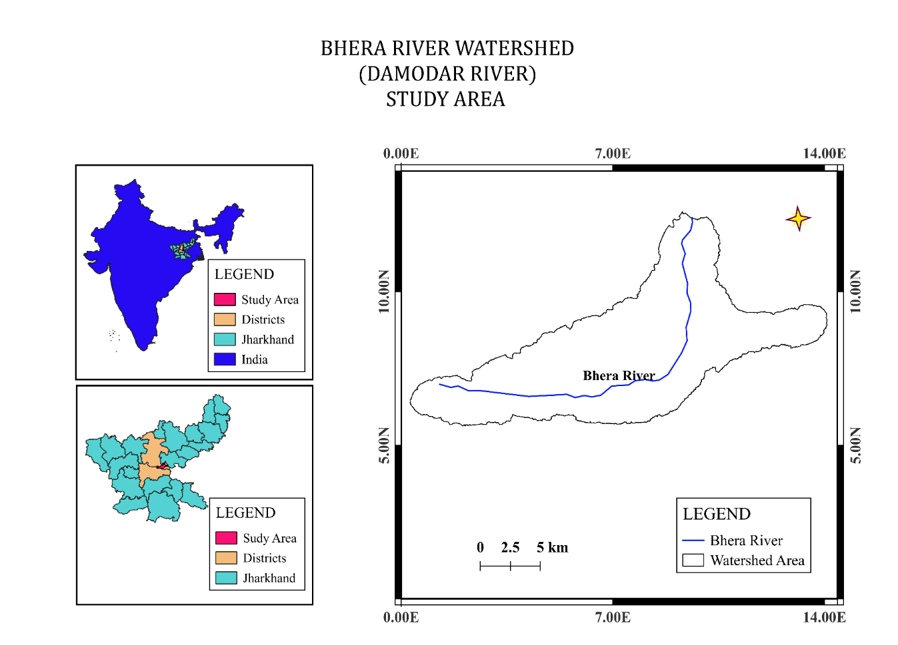
Figure 1. Location map of the study area.

3. DATA AND METHODOLOGY
The delineation of watershed boundary and generation of base map was done using the SOI toposheets No 73 E/6, 73 E/7, 73 E/10, 73 E/11 on 1:50,000 scale. The thematic maps were generated from Landsat 8 and 9 satellite data, procured from USGS Earth Explorer with acquisition dates of 20th and 22nd November 2023, respectively, ensuring minimal cloud cover for accurate terrain and hydrological analysis. SRTM 30m resolution data was used to derive the elevation and slope parameters. The published geological maps were used to identify and extract the lithology, which was further verified by ground truthing. Various thematic layers such as geomorphology, geology, drainage, soil, slope, etc, were extracted and generated for terrain evaluation. QGIS v 3.40.6 has proved beneficial for the extraction of raster datasets. The methodology flowchart is shown in Fig.2
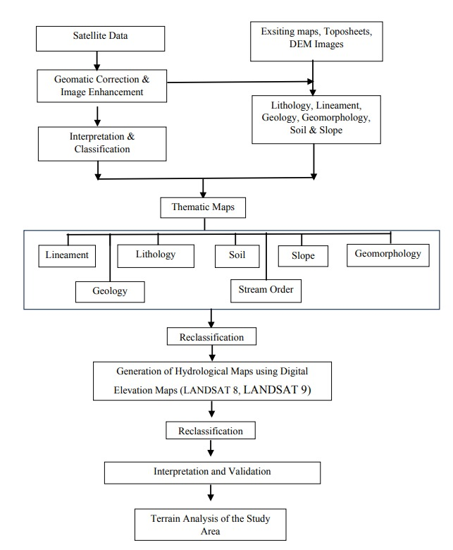
Fig. 2 Methodology Flowchart
4. RESULTS AND DISCUSSION
4.1 Lithology
The lithological composition of the Bhera River Watershed is diverse and reflects a complex geological history, which significantly influences the hydrological behaviour, soil characteristics, and groundwater potential of the area. The rock range in age from Paleoproterozoic to Cenozoic, representing multiple deformation events. The lithounits primarily comprise Chotanagpur granites and gneisses, metasediments, amphibolites, schist, quartzites, phyllites, etc. Gondwana coal-bearing sequence with sandstone and shales are observed in Rajrappa, located in the northern part of the study area. The lithological map is prepared and redrawn by digitizing the lithounits using the existing geological map of Jharkhand published by the Department of Mines and Geology, Government of Jharkhand (2023) with additional ground truthing.
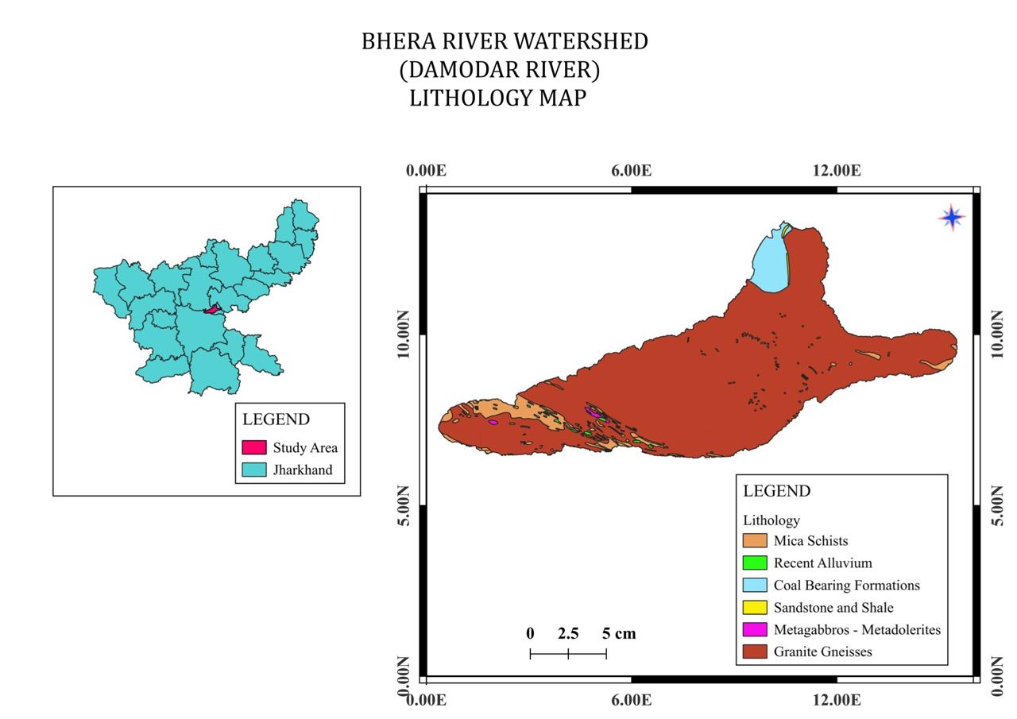
Fig. 3 Lithological map of the study area.
4.2 Geomorphology
Understanding geomorphology is important in terrain analysis because it provides insights on various parameters, such as processes behind the current landscape, understanding how geological processes have operated in past, how land use has changed over time and managing natural hazards and natural resources such as soil, water etc. The geomorphological map of the Bhera River Watershed reveals a varied terrain, shaped by both erosional and depositional processes. Geomorphological features such as pediplains, pediment-tor composite, residual hills, dissected hills, valleys, ridges, waterbody and active coal quarry indicating anthropogenic modification are observed. Pediplains dominate the region, occupying 70 percent of the study area, indicating good groundwater potential for the area. The geomorphic units (map) were prepared by digitizing the area using the Bhukosh and further upgraded using Landsat 8 and 9.
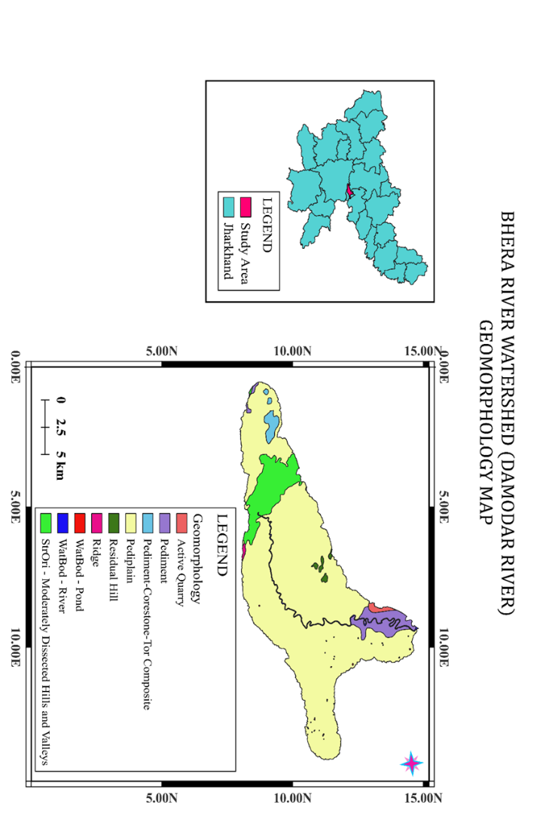
Fig. 4 Geomorphological map of the study area.
4.3 Lineaments
Lineaments are surface indicators of subsurface fractures and other planes of weakness (SubbaRao,2006). Lineaments are unevenly distributed across the watershed, with higher densities observed in the central and southwestern regions, suggesting intense tectonic activity and structural deformation. The lineaments show a predominant NW-SE trend. Lineaments are aligned with geomorphic features such as ridges and valleys in the study area, suggesting structural influence on landform development. The map was prepared using SRTM followed by cross-checking with google earth.
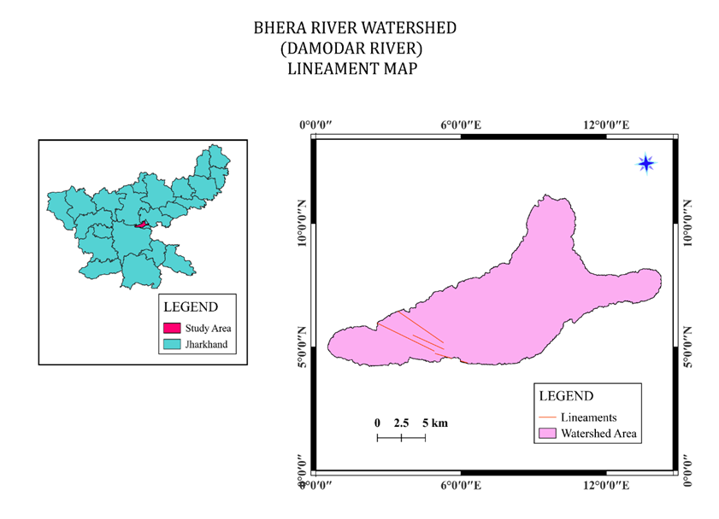
Fig. 5 Lineament map of the study area.
4.4 Soil
Soil is a natural body made up of mineral and organic components, with a distinct genesis and nature of its own (Dokuchaiev, 1900). Soil forms the controlling parameter for infiltration and surface water flow and is a function of climate, parent material, relief, organism and time (Toppo M.M. and Sinha J, 2023). Three predominant soil orders which have been identified in the study area, are Inceptisols, Luvisols, and Nitosols. Luvisols cover a major portion of the central and eastern part of the watershed. Characterised by a significant accumulation of clay in the subsoil, these soils typically have high base saturation and good nutrient-holding capacity associated with iron-rich conditions. Inceptisols are primarily located in the western part of the watershed, indicating relatively young age and are moderately developed. Nitosols are found in a narrow belt towards the central-western part of the watershed. These soils are deep, well-drained, and rich in iron, imparting reddish colour. The soil map was prepared using Food and Agricultural Organization (FAO) soil taxonomy in QGIS.
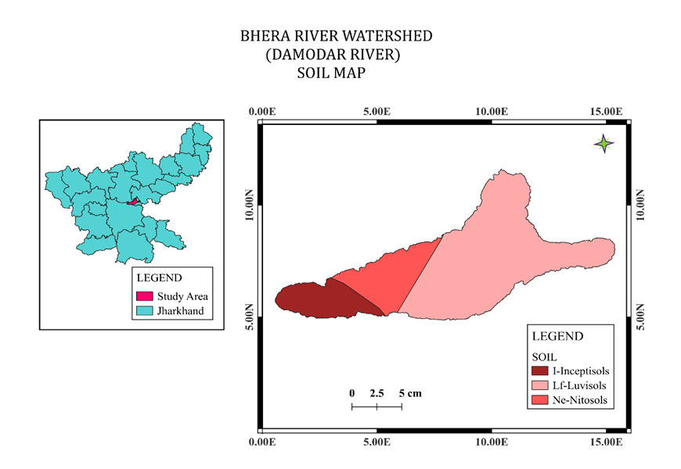
Fig. 6 Soil map of the study area.
4.5 Slope
The slope provides critical insights into the topographic variation of the region and its implications for soil erosion, runoff behaviour, land stability, and land use potential. The higher slope degree leads to rapid runoff, increased erosion rate, and limited recharge potential (Magesh et al.,2012; Basavarajappa et.al., 2013). Slope analysis has been done by QGIS on SRTM. Four categories of slope have been identified as very gentle, moderate, Steep and Very Steep.
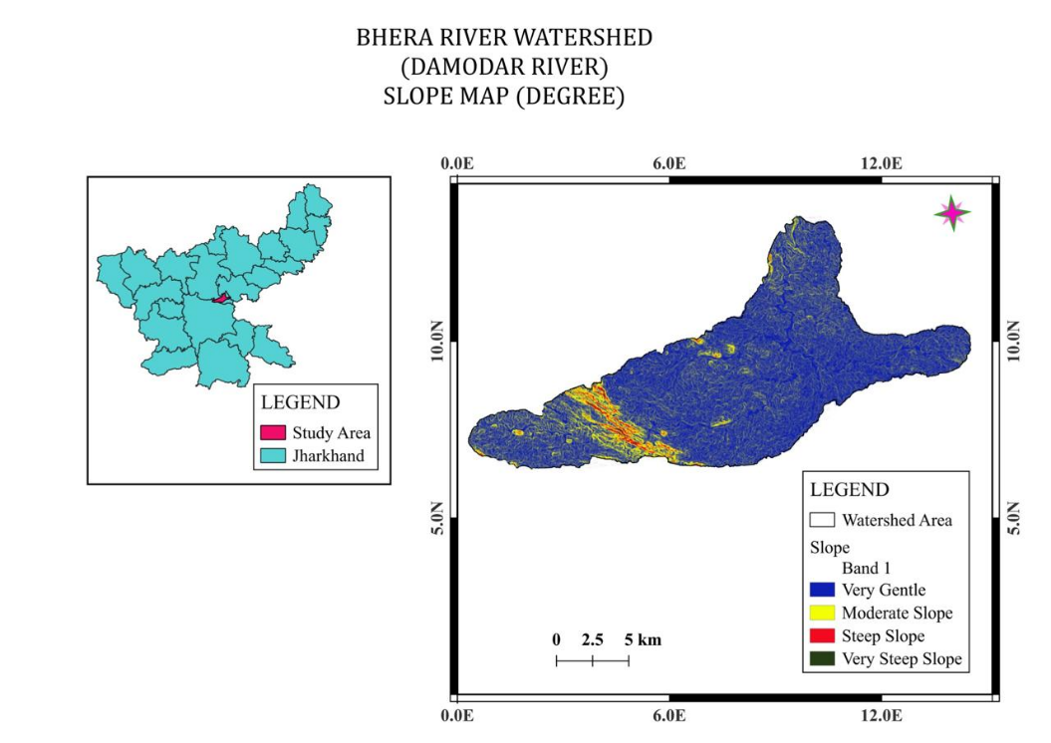
Fig. 7 Slope map of the study area.
4.6 Drainage
The Study of drainage is essential for understanding the fluvial structure and drainage hierarchy within the watershed. The Bhera River is a sixth-order stream flowing from the southwest to north. The drainage pattern varies from dendritic to sub-dendritic, and at few local places it exhibits parallel pattern. The stream ordering was done using Strahler’s method of stream classification. The dendritic to sub - dendritic drainage pattern is typical in regions representing almost uniform lithologies and strata that are horizontal or gently dipping (Toppo et al., 2024).
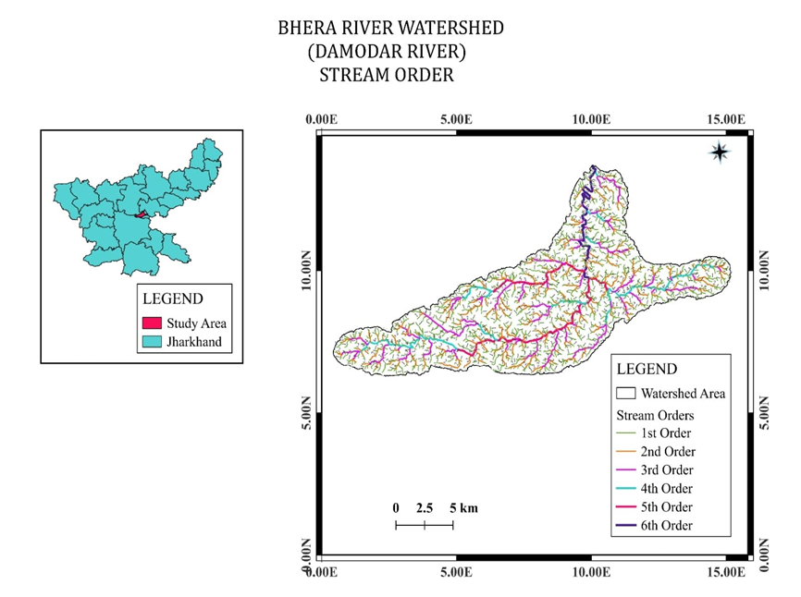
Fig. 8 Drainage map of the study area.

4.7 Hydrological indices
Remote Sensing and GIS have proven their efficacy in the timely monitoring of water bodies, leveraging the accessibility of satellite data, and aiding in decision-making and policy-making processes (Verpoorter et al., 2012). Numerous water extraction algorithms have been developed and applied for remotely sensed imageries. Among them, index methods such as Normalized Difference Water Index (NDWI) (McFeeters (1996), Normalized Difference Moisture Index (NDMI) (Gao 1996), and Enhanced Water Index (EWI) (Wang ,S. et al., 2015; Yang, J., and Du, X. 2017) are mostly used for surface water estimation which separates the water and background based on a threshold value. Generally, thresholds have fixed value of either 0 or 1, but are challenging in the case of shades, hills, forest, urban areas and even coastal lines (Acharya, T.D. et al., 2018). The hydrological indices were generated based on Landsat 8 data.
4.7.1 Normalized Difference Water Index (NDWI)
NDWI provides critical insights into the spatial distribution of water and non-water features across the watershed area. The NDWI values in the study area range from -0.4279 to 0.1137. The negative to low NDWI values (~ -0.42) are primarily indicative of non-water features, such as vegetation, bare soil, or built-up areas, and positive NDWI values (~ 0.11) represent the presence of water bodies, including streams, ponds, and parts of the Bhera River channel.
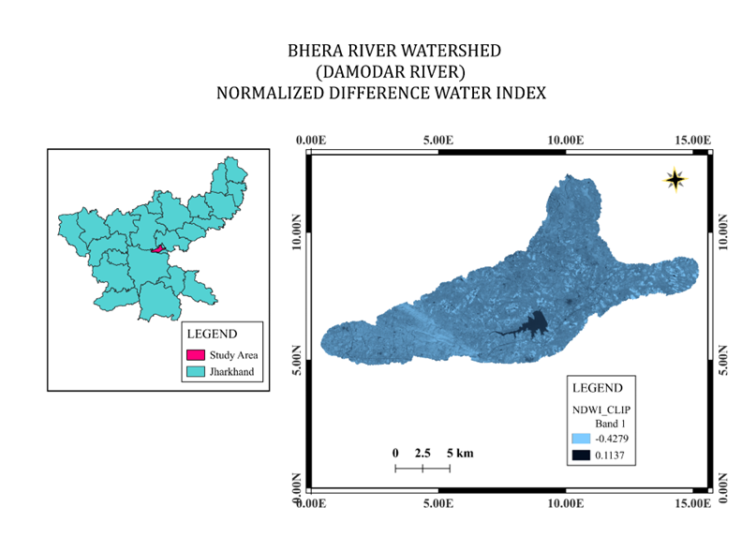
Fig. 9 NDWI map of the study area.

4.7.2 Normalized Difference Moisture Index (NDMI)
NDMI is valuable in understanding the vegetative health and hydrological conditions of a watershed. The NDMI values ranges from -0.0910 to 0.2622, and based on that the study area has been categorized into four classes as- Very Dry (-0.0910), Low Vegetation Moisture (0.0855), Moderate Vegetation Moisture (0.1739) and Dense Vegetation Moisture (0.2622).
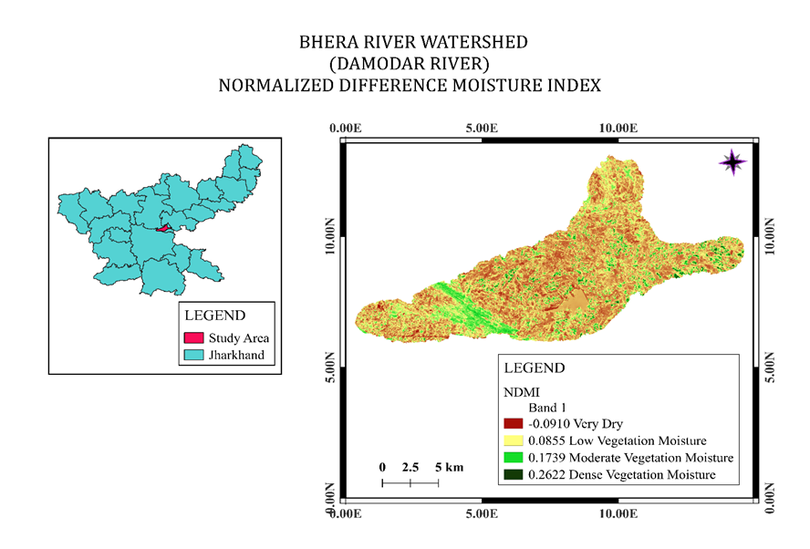
Fig. 10 NDMI map of the study area.
4.7.3 Enhanced Water Index (EWI)
The Enhanced Water Index (EWI) is a remote sensing-based indicator used to assess surface water presence and soil moisture conditions. The EWI values range from approximately -0.5972 to -0.3460, and accordingly the study area has been classified into three distinct categories as- Bare Land (-0.5972), Dry Soil (-0.4716) and Sparsely Vegetated Soil (-0.3460).
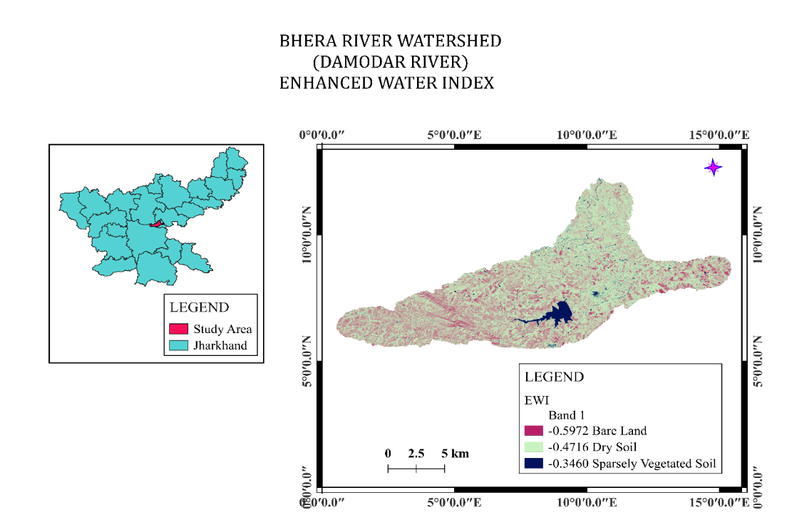
Fig. 11 EWI map of the study area.

5. CONCLUSION
This present investigation intends to highlight the importance of spatiotemporal assessment using integrated remote sensing and GIS technologies, which have proven instrumental in unravelling the multifaceted terrain characteristics of the Bhera River Watershed, tributary of the Damodar river, Jharkhand. The study intends to assess the cost effectiveness of geomatic tools for geomorphological and hydrological assessment. The variables analysed within the watershed include diverse lithological units from Paleoproterozoic granites and gneisses to Cenozoic alluvial, with dominant pediplains that signify favourable groundwater recharge zones amid rugged residual hills and dissected terrain. Structural lineaments, predominantly aligned NW-SE, correlate with geomorphic features like ridges and valleys, indicating moderate tectonic influences on landform evolution and potential aquifer zones. Luvisols, primarily found in the central-eastern regions, play a crucial role in supporting agricultural viability. Steep slopes gradients identified underscore the runoff and erosion risks. The dendritic drainage patterns are indicative of homogeneous lithology. NDWI values (-0.4279 to 0.1137) indicate limited perennial water bodies, NDMI (-0.0910 to 0.2622) reveals heterogeneous vegetation moisture critical for agroforestry planning, and EWI (-0.5972 to -0.3460) suggest prevalent dry soil conditions exacerbating evapotranspiration losses in the study area. Collectively, the study reveals that watershed is resilient in pediplain-dominated regions due to good groundwater recharge but fragile against anthropogenic pressures like coal quarrying and groundwater abstraction. For sustainable development, recommendations include targeted soil conservation in steep slopes, lineament-guided aquifer recharge structures, and vegetation restoration in low-moisture zones to enhance water security. This geospatial appraisal will provide policymakers with actionable intelligence for effective watershed governance in the study area promoting ecological balance and socioeconomic development in the hard rock terrain of Jharkhand.
REFERENCES
Burrough, P.A. and McDonnell, R.A. (1998). Principles of Geographical Information Systems. Oxford University Press, Oxford.
Wilson, D.J. and Gallant, J.C. (2000) Digital Terrain Analysis. In: Wilson, D.J. and Gallant, J.C., Eds., Terrain Analysis: Principles and Applications, John Wiley and Sons, New York, 1-27.
Nag, S.K, Anindita Lahiri. (2011) Integrated Approach Using Remote Sensing and GIS Techniques for Delineating Groundwater Potential Zones in Dwarakeswar Watershed, Bankura Distict, West Bengal. International Journal of Geomatics and Geosciences, 2, 430-442.
McFeeters, S.K. (1996). The Use of the Normalized Difference Water Index (NDWI) in the Delineation of Open Water Features. International Journal of Remote Sensing, 17, 1425-1432. http://dx.doi.org/10.1080/01431169608948714
Bo-cai Gao. (1996). NDWI—A normalized difference water index for remote sensing of vegetation liquid water from space, Remote Sensing of Environment, 58, 3, 257-266. https://doi.org/10.1016/S0034-4257(96)00067-3
Zha, Y., Gao, J., and Ni, S. (2003). Use of normalized difference built-up index in automatically mapping urban areas from TM imagery. International journal of remote sensing, 24, 3, 583-594. https://doi.org/10.1080/01431160304987
Nag, Sisir & Kundu, Anindita. (2018). Application of remote sensing, GIS and MCA techniques for delineating groundwater prospect zones in Kashipur block, Purulia district, West Bengal. Applied Water Science. 8. 10.1007/s13201-018-0679-9.
Tang, L., and Ma, W. (2018). Assessment and management of urbanization-induced ecological risks. International Journal of Sustainable Development & World Ecology, 25, 5, 383-386. https://doi.org/10.1080/13504509.2018.1446193
Yuanmao Zheng, Lina Tang, and Haowei Wang. (2021). An improved approach for monitoring urban built-up areas by combining NPP-VIIRS nighttime light, NDVI, NDWI, and NDBI, Journal of Cleaner Production, 328, 129488. https://doi.org/10.1016/j.jclepro.2021.129488
Kumar, U.S., & Mallick, N. (2016). Drainage Morphometric Analysis of Bhera River Watershed, Ranchi and Ramgarh Districts, Jharkhand, India.
Ground Water Year Book Jharkhand (2020 - 2021). Central Ground Water Board, Mid- Eastern Region, Patna. SUO Ranchi, Govt. of India, Ministry of Water Resources, River Development and Ganga Rejuvenation.
Mahadevan, T.M. (2002). Geology of Bihar and Jharkhand. Textbook Series. Geological Society of India, Bangalore, 567.
Subbarao N. (2006). Groundwater potential index in a crystalline terrain using remote sensing data. Environmental Geology, 50, 1067-1076.
Toppo, M. M., & Sinha, J. (2024). Geomatics Application for Assessment of Groundwater Prospective Zones – A case study of Kanchi River Sub Basin, Khunti- Ranchi districts, Jharkhand. Journal of Geomatics, 18(1), 12–20. https://doi.org/10.58825/jog.2024.18.1.69
Magesh, N.S., Chandrasekar, N., and Soundranayagam, J. P. (2012). Delineation of groundwater potential zones in Theni district, Tamil Nadu, using remote sensing, GIS and MIF techniques, Geoscience Frontiers, 3, 2, 189-196.
Basavarajappa, H. T., Pushpavathi, K.N., and Manjunatha, M. C. (2013). Applications of Remote Sensing and GIS on Geology and Geomorphological Landforms on Precambrian Rocks of Kollegal Taluk, Chamarajanagar District, Karnataka, South India. Environmental Geochemistry, 16, 1-10.
Toppo, M.M., Sinha, J., Priya, P. (2024). Drainage Morphometric Analysis of Kanchi River Sub-Basin, Khunti and Ranchi Districts, Jharkhand Using Remote Sensing and GIS. Internation Journal of Applied Science and Research, 7,3, 188-199. https://doi.org/10.56293/IJASR.2024.5917
Verpoorter Charles , Kutser Tiit , Tranvik Lars , (2012), Automated mapping of water bodies using Landsat multispectral data, Limnol. Oceanogr. Methods, 10, https://doi.org/10.4319/lom.2012.10.1037
S. Wang et al., "A Simple Enhanced Water Index (EWI) for Percent Surface Water Estimation Using Landsat Data," in IEEE Journal of Selected Topics in Applied Earth Observations and Remote Sensing, vol. 8, no. 1, pp. 90-97, Jan. 2015, doi: 10.1109/JSTARS.2014.2387196.
Yang, J., & Du, X. (2017). An enhanced water index in extracting water bodies from Landsat TM imagery. Annals of GIS, 23(3), 141–148. https://doi.org/10.1080/19475683.2017.1340339
Acharya, T. D., Subedi, A., & Lee, D. H. (2018). Evaluation of Water Indices for Surface Water Extraction in a Landsat 8 Scene of Nepal. Sensors (Basel, Switzerland), 18(8), 2580. https://doi.org/10.3390/s18082580
Das, S. (2020). Landscape variables in the Indian (Peninsular) catchments: insights into hydro-geomorphic evolution. DOI:10.31223/osf.io/hbsq2
Arefin, R., Mohir, M. M. I., and Alam, J. (2020). Watershed prioritization for soil and water conservation aspect using GIS and remote sensing: PCA-based approach at northern elevated tract Bangladesh. Applied Water Science, 10, 1-19.
Dillon, P., Stuyfzand, P., Grischek, T. (2019). Sixty years of global progress in managed aquifer recharge. Hydrogeol J., 27, 1–30.

