Original Research Article

Influence of Topographic Elements on Land Surface Temperature: A Case Study Using Remote Sensing and GIS

ABSTRACT
Land surface temperature (LST) is influenced not only by human activities but also by topographic and vegetation factors. This study analyzed the effects of topography and vegetation on LST in Ibadan, Nigeria, using Landsat 8 OLI/TIRS thermal imagery and AW3D30 DEM-derived parameters, including elevation, slope, aspect, and hillshade. NDVI was incorporated to quantify the effect of vegetation cover. LST was retrieved using a Radiative Transfer Equation-based approach, and a grid-based method was employed to extract LST and topographic attributes at consistent spatial locations. Statistical analyses, including bivariate correlations and multiple linear regression, were performed to quantify the relationships between LST and the environmental variables. Results indicate that topographic variables alone exert weak influences on LST, with R² values ranging from 0.0006 to 0.0243, but their combined effect is statistically significant. Vegetation has a strong cooling effect, with NDVI showing a negative correlation with LST (r = –0.7604, R² = 0.5782). The combined model of topography and NDVI explains 59% of LST variability, highlighting vegetation as the dominant factor controlling surface temperature in this tropical urban environment. These findings provide insights for urban heat mitigation and sustainable planning strategies.
Keywords: Land Surface Temperature; Topography; NDVI; Remote Sensing; GIS
1. INTRODUCTION
Urbanization is rapidly reshaping landscapes across the globe, particularly in developing nations such as Nigeria. By 2030, nearly 60% of the world’s population is projected to reside in urban areas (Bhadwal & Kumar, 2025). The accelerating pace of urban growth, coupled with the impacts of climate change, poses significant challenges for city planners and managers seeking to build sustainable and resilient cities (Fonseka et al., 2019). Increasing demand for land, often accompanied by unplanned development, further complicates urban sustainability. Asia and Africa, which together host about 90% of the global rural population, are urbanizing at unprecedented rates, with urbanization levels expected to reach 56% and 64%, respectively, by 2050 (Bhadwal & Kumar, 2025; Kookana et al., 2020). Consequently, cities will face intensified exposure to climate change impacts, including greenhouse gas (GHG)-induced radiative forcing and localized effects such as the Urban Heat Island (UHI) phenomenon (McCarthy et al., 2010).
The Earth’s surface temperature is a critical environmental parameter influencing climate systems, weather patterns, and ecological processes. Land Surface Temperature (LST) is a key indicator for understanding the surface energy balance, land–atmosphere interactions, and urban climate variations (He et al., 2018; Berg et al., 2014; Zhao-Liang et al., 2013). The spatio-temporal variability of surface energy fluxes, reflected in LST, makes it invaluable for environmental applications such as surface energy budget analysis (Peng et al., 2016; Anderson et al., 2012), vegetation monitoring (Raufu, 2024; Amiri et al., 2009), and urban climate studies (Zhou et al., 2013). Variations in LST are influenced by multiple factors at different scales, including topography, energy input, climatic conditions, land use, vegetation cover, and geographical location (Peng et al., 2018; Taripanah & Ranjbar, 2021).
Recent studies have increasingly explored the relationship between natural factors and LST, including vegetation–LST interactions (Raufu, 2024; Chen et al., 2006), the combined influence of vegetation and water (Yuan, 2007), and the effects of urban land expansion on surface temperature (Ramadan et al., 2004). Beyond conventional land cover types such as vegetation, water bodies, and built-up areas, topography has emerged as an important factor affecting LST. Broad geographic conditions, local terrain characteristics, and surface properties all influence temperature distribution. Studies have revealed a negative correlation between vegetation and LST (Raufu, 2024) and demonstrated that soil type significantly affects the heating and cooling dynamics of the land surface (Wu et al., 2019). Moreover, the influence of topography on LST varies with solar radiation exposure and changes over time (Peng et al., 2020). Despite growing research on LST, the effects of topographic variables across regions remain underexplored, warranting further investigation into which terrain factors most strongly determine surface temperature variability.
LST is typically investigated through terrestrial meteorological observations (Eludoyin et al., 2013) or remote sensing methods (Li et al., 2013). However, ground-based measurements are limited by high costs, time requirements, and sparse station networks, especially in mountainous or inaccessible regions (Taripanah & Ranjbar, 2021; Neteler, 2010). In contrast, remote sensing and Geographic Information Systems (GIS) have revolutionized LST studies by providing large-scale, continuous, and high-resolution thermal datasets (Ayansina, 2016). Satellite-based thermal infrared sensors, such as those onboard Landsat 8’s Operational Land Imager (OLI) and Thermal Infrared Sensor (TIRS), enable accurate estimation of surface temperatures. When combined with topographic data derived from Digital Elevation Models (DEM), these datasets facilitate detailed analyses of how terrain characteristics influence LST distribution.
Topographic elements substantially affect surface temperature through their control over solar radiation exposure, air circulation, and surface energy exchange (Peng et al., 2020). Regions with pronounced topographic variation display complex spatial and temporal patterns in meteorological, hydrological, and ecological processes, often with steep gradients across short distances (Bindajam et al., 2020; Van De Kerchove et al., 2012; Aguilar et al., 2010; Ivanov et al., 2008). Yang et al. (2020) demonstrated that LST decreases with increasing elevation and varies with slope and aspect due to differences in solar radiation exposure. Similarly, Peng et al. (2020) found a negative correlation between LST and both elevation and slope, with lower temperatures typically observed on shaded slopes compared to sun-facing ones. These findings emphasize that elevation, slope, and aspect strongly influence LST by modulating solar radiation and surface thermal load.
Urban areas exhibit distinct thermal characteristics due to the Urban Heat Island effect, wherein temperatures in cities are higher than in surrounding rural areas. Urban expansion replaces natural land cover with impervious surfaces such as asphalt and concrete, leading to greater heat retention and elevated LST. In cities with diverse terrain, such as Ibadan, Nigeria, the interaction between urbanization and topography further complicates LST patterns. Therefore, examining the influence of topography on LST in such environments is crucial for understanding local climate dynamics and guiding sustainable land use and climate adaptation strategies.
This study aims to investigate the relationship between LST and topographic factors in Ibadan using remote sensing and GIS techniques. By integrating Landsat 8 OLI/TIRS thermal data with DEM-derived topographic parameters, the research seeks to enhance understanding of how terrain characteristics shape LST variations in a tropical urban setting.
2. MATERIALS AND METHODS
2.1 Study area
The study was conducted in Ibadan, a major city located in the southwestern region of Nigeria (Fig. 1). The city is renowned for its undulating terrain, featuring prominent hills that not only shape its landscape but also serve as important ecological and tourism assets due to their rich biodiversity of flora and fauna. Ibadan covers a total area of approximately 6,800 km², with vegetation originally dominated by tropical rainforest species. Geographically, the city lies between latitudes 7°02’49” N and 7°43’21” N and longitudes 3°31’58” E and 4°08’20” E, with elevations ranging from 180 m to 275 m above sea level. According to the Nigerian Geological Society, the area is underlain by a mixture of hard silt, soft clay, and sedimentary soils, reflecting a heterogeneous landscape with varying terrain characteristics.
Ibadan experiences a tropical wet and dry climate, characterized by a long rainy season and relatively consistent temperatures throughout the year (Raufu, 2024). The average annual temperature is approximately 26.5°C, while mean annual rainfall is around 1,230 mm. The rainy season typically spans from March to October, with a short dry spell in August. Over the years, rapid population growth and urban expansion have significantly transformed the city’s natural vegetation cover, replacing much of it with impervious surfaces such as buildings, roads, and other urban infrastructure. This continuous urbanization has contributed to notable changes in the local land surface characteristics and thermal environment.
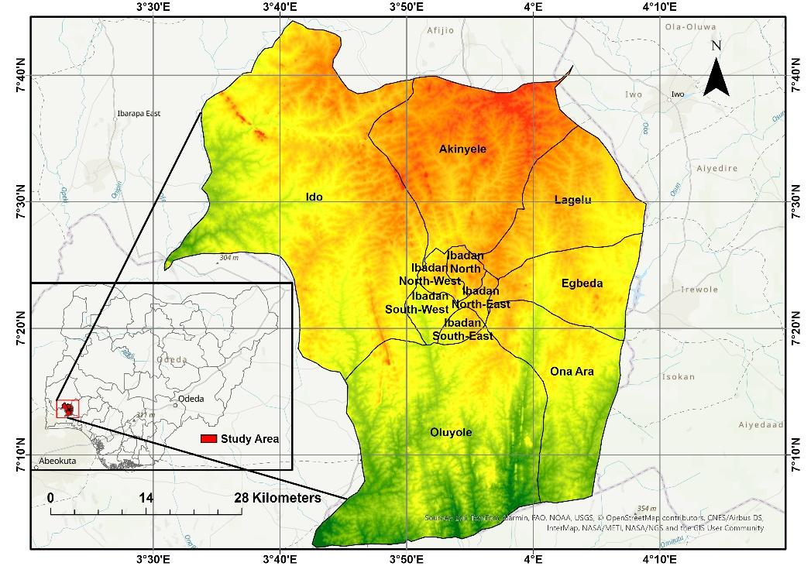
Fig. 1. Location and topography of the study area
2.2 Research data
In this study, Landsat 8 OLI/TIRS Level 2 thermal infrared data (Band 10) were utilized to estimate LST. One cloud-free scene covering the Ibadan area were selected for analysis. The acquisition date was December 10, 2024 (path/row 191/055). The period coincides with the dry season, characterized by minimal cloud cover and stable atmospheric conditions, thereby ensuring the capture of clear, high-quality imagery suitable for thermal analysis.
In addition, AW3D30 global digital elevation model (DEM) data were employed to extract topographic parameters such as elevation, slope, aspect, and to generate a shaded relief map. The AW3D30 DEM, produced by the Japan Aerospace Exploration Agency (JAXA) from Advanced Land Observing Satellite (ALOS) data, provides worldwide coverage at a 30-meter spatial resolution. The Landsat 8 dataset, offering a spatial resolution of 30 m for multispectral bands and 100 m for thermal bands, corresponds well with the AW3D30 DEM resolution, making it appropriate for assessing the influence of terrain characteristics on the surface thermal environment.
2.3 Research methods
The DEM was processed to derive the principal terrain attributes (elevation, slope, and aspect) together with a hillshade layer to aid visual interpretation of the landscape. Using Landsat 8 OLI/TIRS data, the LST was retrieved and resampled to match the spatial resolution of the DEM. The resulting temperature layer was integrated with the topographic datasets to allow pixel-level comparison. Statistical analyses were then applied to examine the relationship between LST and the terrain variables, offering a clearer understanding of how topographic conditions influence surface temperature distributions across the study area.
2.3.1 LST extraction and retrieval
LST was retrieved from the Landsat 8 TIRS Band 10 data using a workflow grounded in the Radiative Transfer Equation (RTE). The RTE framework remains one of the most robust approaches for LST estimation because it explicitly incorporates atmospheric effects and surface emissivity (Sobrino et al., 2004; Jiménez-Muñoz et al., 2009). Although Landsat 8 is equipped with two thermal bands, persistent stray-light contamination in Band 11 (Montanaro et al., 2014) limits its reliability for quantitative analysis. Consequently, Band 10 which is identified as the more stable thermal channel is commonly recommended for RTE-based retrievals (Rozenstein et al., 2014; Gerace & Montanaro, 2017).
The retrieval procedure comprised three main stages. First, NDVI was calculated from the Landsat 8 OLI red (Band 4) and near-infrared (Band 5) bands to represent vegetation cover:
$NDVI= \frac{NIR-RED}{NIR+RED}$ (1)
The resulting NDVI values were then used to estimate vegetation proportion (Pv) for each pixel following Sobrino et al. (2004):
${}_{}Pv = {\left(\frac{\left(NDVI- {NDVI}_{min}\right)}{\left({NDVI}_{max}- {NDVI}_{min}\right)}\right)}^{2}$ (2)
where $NDVI_{min}$and $NDVI_{max}$are the minimum and maximum NDVI values.
Second, land surface emissivity (ε) was derived using the NDVI-based emissivity model, which relates emissivity to vegetation abundance:
ε = 0.004 ∗ 𝑃𝑣 + 0.986 (3)
This step ensures that spatial variations in land cover are properly represented in the thermal correction, given that emissivity strongly influences the radiance emitted from the surface.
Finally, LST was computed by integrating emissivity, atmospheric parameters, and at-sensor brightness temperature into the RTE formulation. Brightness temperature (Tb) was obtained from the radiance-converted Band 10 data using the inverse Planck function. The surface temperature was then estimated using:
$LST= \left(\frac{T_{b}}{1+ \left(λ × \frac{T_{b}}{ρ}\right)\ln\left(ε\right)}\right)$ (4)
where $λ$ is the effective wavelength of Band 10,
$ρ=hc/σ=1.4388×{10}^{-2} m K$,
$h$ is Planck’s constant,
$c$ is the speed of light, and
$σ$ is the Boltzmann constant.
The resulting temperatures were converted from Kelvin to Celsius by subtracting 273.15. All LST outputs were resampled to 30 m to match the AW3D30 DEM resolution and to ensure consistent pixel alignment for subsequent correlation analysis.
2.3.2 Derivation of topographic elements
Elevation, slope, and aspect were extracted from the AW3D30 DEM, which provides 30-m spatial resolution coverage. The DEM was first clipped to the study area, and slope and aspect rasters were then produced using the Spatial Analyst toolbox in ArcGIS Pro.
- Elevation was used to characterize vertical terrain variation across the region.
- Slope was calculated as the rate of maximum change in elevation between neighboring pixels, expressed in degrees.
- Aspect (slope orientation) was derived to assess the directional influence of solar exposure on surface heating patterns.
Additionally, a hillshade model was produced for visual interpretation of terrain structure. All topographic layers were co-registered to the LST grid to ensure pixel-to-pixel comparability.
2.3.3 Relationship between LST and topographic variables
A numerical grid-based approach was employed to examine the relationship between LST, topographic variables, and vegetation cover. A rectangular grid of 500 × 500 m was generated across Ibadan, and a vector point was placed at the center of each cell, with each point assigned a unique identifier. Grid cells falling outside the Ibadan boundary were removed, resulting in 11,023 valid points.
For each point, LST values from Landsat 8 OLI/TIRS, topographic parameters (elevation, slope, aspect, and hillshade), and NDVI were extracted. This dataset allowed pixel-level comparison of LST with terrain and vegetation attributes. Statistical analyses, including correlation and regression, were conducted to quantify the individual and combined influences of topography and vegetation abundance on surface temperature patterns across the study area.
3. RESULTS AND DISCUSSION
3.1 LST Patterns
The spatial distribution of LST in the study area exhibits substantial variation. LST values ranged from 27.60 °C to 38.54 °C (Fig. 2), with a mean of 34.83 °C and a standard deviation of 3.41 °C. Hotspots of elevated temperatures were observed predominantly in densely built-up areas with minimal vegetation cover, whereas cooler regions were closely associated with vegetated zones.
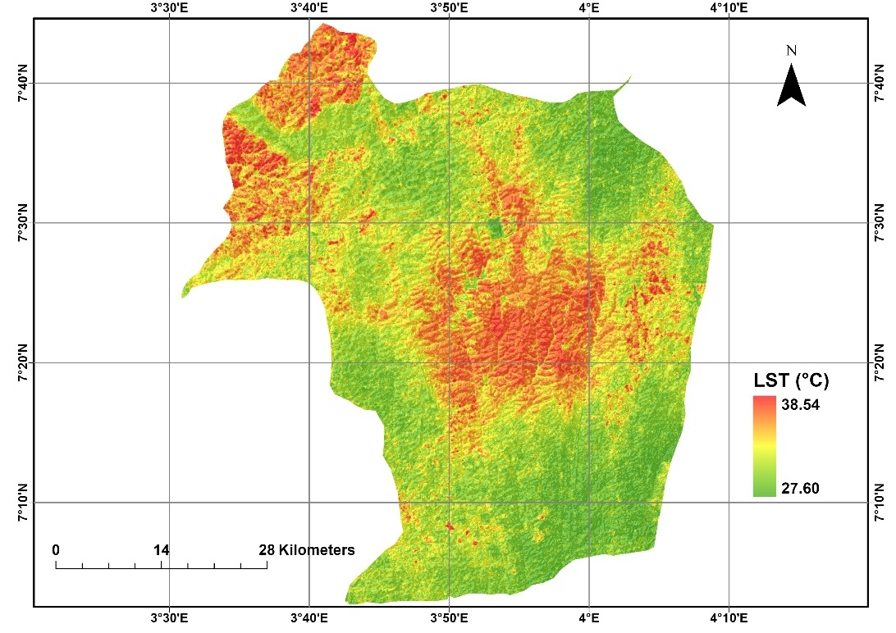
Fig. 2. Spatial distribution of LST
The observed LST patterns reflect the heterogeneous land cover and the complex interplay of local climate, solar exposure, and landscape structure. Spatial heterogeneity is also evident along peri-urban zones, where impervious surfaces absorb and retain more heat compared to vegetated areas.
3.2 Spatial Relationship Between LST and Topographic Variables
To investigate the effect of topography on surface temperature, LST was analyzed in relation to elevation, slope, aspect, and hillshade using bivariate correlation analysis. The topographic variables, including elevation, slope, aspect, and a hillshade layer, were derived from the AW3D30 DEM (Fig. 3). Both LST and terrain datasets were processed quantitatively to extract values corresponding to specific grid points across the study area. Scatter plots were generated and fitted with regression lines to examine the numerical relationships between LST and each topographic factor, providing insight into how terrain influences thermal patterns in Ibadan.
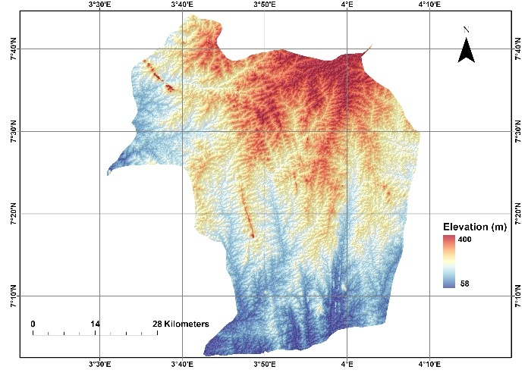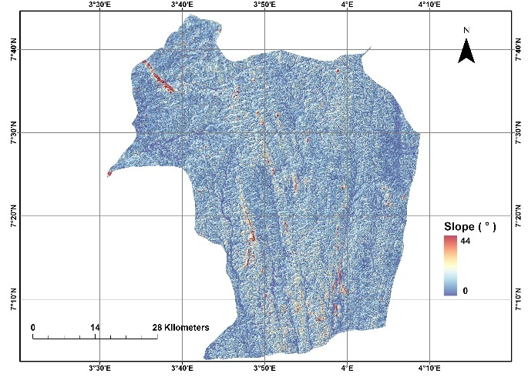
(a) (b)
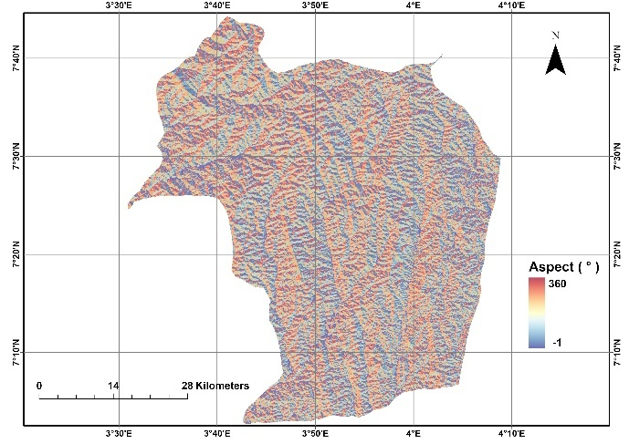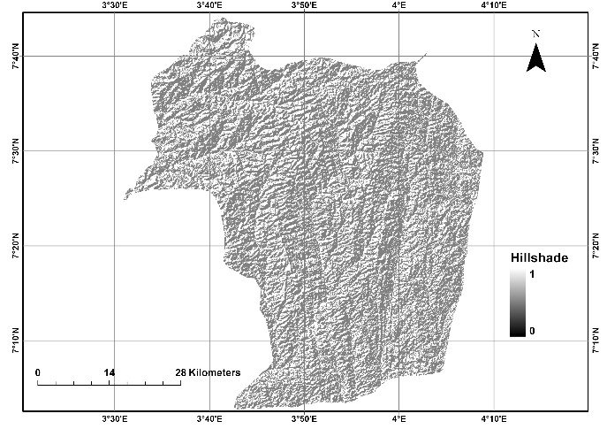
(c) (d)
Fig. 3. Topographic variables of the study area: (a) Elevation, (b) Slope, (c) Aspect, and (d) Hillshade.
3.2.1 Correlation between LST and elevation: The relationship between LST and elevation in the study area was examined using a bivariate correlation approach. A scatterplot (Fig. 4) was generated to visualize the distribution of LST values across varying elevations, and a linear regression line was fitted to quantify the direction and strength of the relationship. The result indicates a very weak positive correlation between LST and elevation (r = 0.1558; R² = 0.0243), meaning that elevation explains only about 2.4% of the variation in surface temperature across the study area. Although statistically significant due to the large sample size, the relationship is not strong enough to suggest a meaningful topographic control on LST.
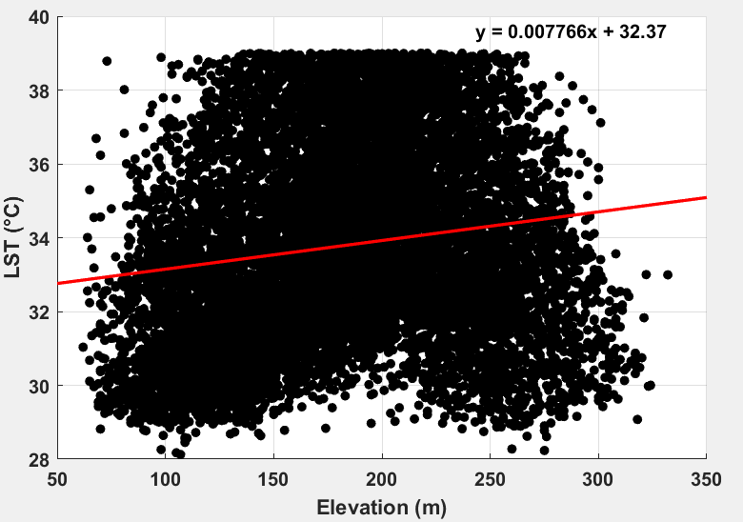
Fig. 4. Relationship between LST and elevation in the study area
Unlike studies conducted in mountainous or high-relief environments (Peng et al., 2020; Li et al., 2005), where temperature typically decreases with increasing altitude, Ibadan is characterized by gentle terrain, with most elevations falling within a relatively narrow range. This limited elevation gradient reduces the potential for temperature stratification linked to altitude. Furthermore, the urban structure of Ibadan exerts a much stronger influence on surface temperature than elevation. Built-up surfaces, paved areas, and reduced vegetation cover tend to dominate the thermal response, masking any potential cooling effect associated with higher elevations.
The weak positive association observed in this study may also be attributed to the spatial pattern of development in Ibadan. Some of the slightly elevated ridges have been converted into densely built-up neighbourhoods, resulting in localized warming that offsets the natural lapse-rate cooling typically expected at higher elevations. As a result, elevation alone does not play a substantial role in determining LST variations in the city.
3.2.2 Correlation between LST and slope: The relationship between LST and slope (Fig. 5) in the study area was weak and statistically insignificant. The correlation coefficient (r = –0.0568) and the corresponding coefficient of determination (R² = 0.0032) indicate that variations in slope explain less than 1% of the spatial variation in LST. This suggests that changes in surface steepness do not directly influence surface heating patterns at the scale of this study.
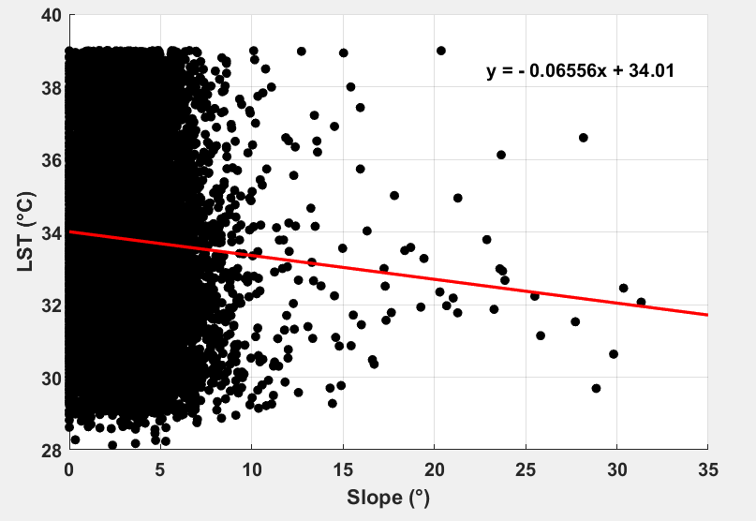
Fig. 5. Relationship between LST and slope in the study area
In relatively low-relief landscapes, slope angles typically do not vary sharply enough to create pronounced differences in insolation or surface energy exchange. Consequently, the thermal response remains largely uniform across gentle to moderate slopes. These results imply that slope is not a primary driver of LST variability in the region and that other biophysical factors play a more dominant role.
3.2.3 Correlation between LST and aspect: The relationship between LST and aspect (Fig. 6) was analyzed to determine whether slope orientation contributes to variations in surface heating across the study area. Aspect influences the amount and angle of incoming solar radiation received by different slope faces and is therefore an important determinant of microclimatic conditions in regions with pronounced topographic variability. However, the correlation results in this study revealed a very weak and statistically insignificant association between LST and aspect, with an R value of 0.0363 and an R² of 0.0013.
This extremely low correlation indicates that slope orientation exerts minimal influence on LST within the study area. Unlike classical mountainous or high-relief terrains, where south-facing slopes (in the Northern Hemisphere) typically receive greater solar exposure and therefore record higher temperatures, the terrain in this study area has relatively gentle slopes and limited elevation variability. As a result, differences in solar radiation resulting from aspect are not strong enough to generate measurable thermal contrasts.
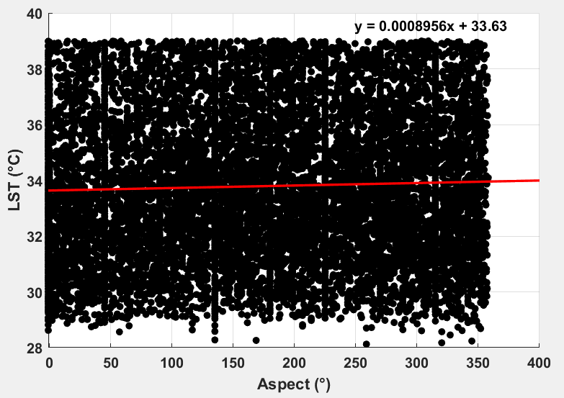
Fig. 6. Relationship between LST and aspect in the study area
3.2.4 Correlation between LST and hillshade: Hillshade represents the degree of illumination a surface receives based on slope, aspect, and the position of the sun. Values range from 0 (deep shade) to 255 (maximum illumination). In terrain analysis, hillshade is often used as a representation for potential solar exposure, which theoretically influences surface heating and, consequently, LST. Surfaces with higher illumination values typically receive more direct sunlight and are expected to record higher temperatures.
However, the relationship between LST and hillshade (Fig. 7) in this study was found to be very weak, with a correlation coefficient (r) of –0.0250 and an R² value of 0.0006. The extremely weak correlation between LST and hillshade indicates that illumination alone does not substantially influence the thermal regime of the study area. Land cover, vegetation conditions, and the physical properties of surface materials play a far more dominant role in controlling surface temperature. Even though hillshade theoretically affects solar heating, its practical influence is overshadowed by other environmental and anthropogenic factors.
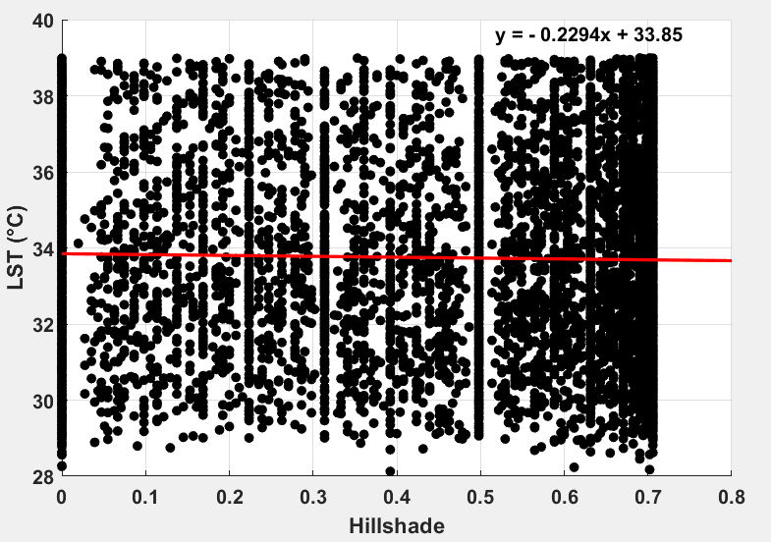
Fig. 7. Relationship between LST and hillshade in the study area
3.3 Influence of Vegetation on LST
Vegetation is widely recognized as one of the strongest biophysical controls on land surface temperature. In this study, the relationship between LST and NDVI was examined using a grid-based dataset derived from Landsat 8 imagery. The results show a strong negative correlation (Fig. 8) between the two variables (r = –0.7604, R² = 0.5782), indicating that NDVI alone explains more than 57% of the spatial variation in LST across the study area, far exceeding the explanatory power of all topographic variables combined.
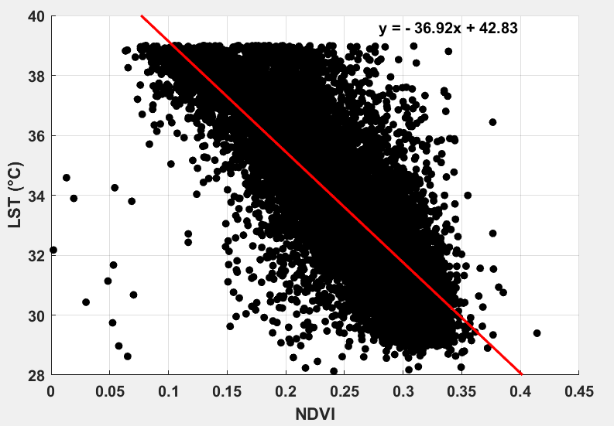
Fig. 8. Relationship between LST and NDVI in the study area
This inverse relationship shows that densely vegetated areas remain considerably cooler, while sparsely vegetated and built-up surfaces exhibit higher thermal intensities. These findings are consistent with established land–atmosphere processes and previous studies (Ullah et al., 2023; Kumar and Shekhar, 2015) that identify NDVI as a key predictor of surface temperature patterns in urban and peri-urban environments.
Vegetation moderates surface temperature through several interconnected mechanisms. High-NDVI areas possess dense canopies that reduce thermal loading through evapotranspiration, whereby absorbed energy is converted into latent heat as water vapor is released from leaf surfaces. This process markedly decreases the amount of sensible heat retained at the surface. Vegetation also provides shading, limiting the amount of direct solar radiation reaching the ground and thereby slowing the rate of surface heating. In addition, vegetated soils generally maintain higher moisture content, and moist surfaces require more energy to warm due to their higher heat capacity; this results in slower daytime heating and faster nighttime cooling. In contrast, impervious materials such as concrete, asphalt, and rooftops, lack evapotranspiration, store heat efficiently, and often release additional anthropogenic heat, leading to substantially higher LST in low-NDVI regions. The spatial pattern observed in the study area reflects these processes: zones with abundant vegetation consistently correspond to lower temperatures, whereas urbanized and vegetation-poor areas represent the highest thermal hotspots. Collectively, these mechanisms explain the strong negative correlation between NDVI and LST, highlighting vegetation cover as the most influential environmental factor shaping the thermal landscape of Ibadan.
3.4 Combined Influence of Topography on LST
To assess the cumulative effect of terrain on surface temperature, a multiple linear regression was performed using only the topographic variables: elevation, slope, aspect, and hillshade. The results indicate that while each variable is statistically significant (p < 0.001), their combined explanatory power is relatively low, with an R² of 0.033. This suggests that topography alone accounts for only about 3.3% of the spatial variation in LST across the study area.
The regression model is expressed as:
$$\text{LST}=32.5094+(0.0079×\text{Elevation})+(-0.0953×\text{Slope})+(0.0015×\text{Aspect})+(-0.5127×\text{Hillshade})$$
The coefficients indicate that LST increases slightly with elevation and aspect, whereas it decreases with slope and hillshade. These trends reflect the physical processes controlling surface heating: steeper slopes and areas with higher hillshade values (i.e., shadowed or less sun-exposed regions) tend to be cooler, while the slight positive effect of elevation and aspect may be related to the distribution of land cover and solar exposure patterns. Overall, the low R² underscores that, although topography contributes to local variations in LST, additional environmental factors are likely to play a dominant role.
3.5 Combined Effects of Topography and Vegetation on Surface Temperature
In order to capture the full range of environmental controls on surface temperature, NDVI was incorporated into the regression model alongside the topographic variables. Vegetation demonstrated a strong cooling effect on LST, and its inclusion greatly improved model performance. The OLS regression for all five predictors yielded an R² of 0.585, indicating that topography together with vegetation explains nearly 59% of the spatial variability in LST.
The full regression model is expressed as:
$$\text{LST}=42.8045+(0.0013×\text{Elevation})+(-0.0632×\text{Slope})+(0.0006×\text{Aspect})+(-0.6292×\text{Hillshade})+(-36.7086×\text{NDVI})$$
The coefficients show that NDVI exerts the strongest negative influence on LST, consistent with the observed strong negative correlation (r = -0.7604). In other words, areas with higher vegetation cover remain substantially cooler, while the influence of topography, though significant, is comparatively modest when considered alongside vegetation. The model highlights that evapotranspiration, shading, soil moisture retention, and the contrast between vegetated and impervious surfaces are key mechanisms by which vegetation regulates surface temperature. Consequently, while topographic features modulate local variations in LST, vegetation is the dominant environmental factor shaping thermal patterns across the study area.
4. CONCLUSION
This study investigated the influence of topographic elements on LST in Ibadan using remote sensing and GIS techniques. By integrating Landsat 8 OLI/TIRS thermal data with AW3D30 DEM-derived topographic parameters, including elevation, slope, aspect, and hillshade, the research quantified the extent to which terrain characteristics modulate surface temperature patterns. NDVI was also incorporated to assess the additional effect of vegetation cover. The findings indicate that topography alone has a limited influence on LST, with elevation, slope, aspect, and hillshade exhibiting weak correlations (R² = 0.0006–0.0243), suggesting that these factors individually explain only a small fraction of thermal variability. However, when combined in a multivariate regression model, the topographic variables were statistically significant, indicating that their collective effect contributes modestly to spatial LST variations. Vegetation, quantified via NDVI, showed a strong negative correlation with LST (r = –0.7604, R² = 0.5782), with densely vegetated areas experiencing substantially lower surface temperatures due to evapotranspiration, shading, soil moisture retention, and contrast with impervious surfaces. The combined multiple linear regression model, incorporating both topography and NDVI, explained 59% of the variability in LST, highlighting vegetation as the primary factor regulating thermal patterns in this tropical urban environment. Overall, the study provides valuable insights into the spatial dynamics of LST and emphasizes the importance of integrating vegetation management and urban planning strategies to mitigate heat stress in rapidly urbanizing cities.

REFERENCES
- Aguilar, C., Herrero, J., & Polo, M. J. (2010). Topographic effects on solar radiation distribution in mountainous watersheds and their influence on reference evapotranspiration estimates at watershed scale. Hydrology and Earth System Sciences, 14, 2479–2494. https://doi.org/10.5194/hess-14-2479-2010
- Amiri, R., Weng, Q., Alimohammadi, A., & Alavipanah, S. K. (2009). Spatial–temporal dynamics of land surface temperature in relation to fractional vegetation cover and land use/cover in the Tabriz urban area, Iran. Remote Sensing of Environment. https://doi.org/10.1016/j.rse.2009.07.021
- Anderson, M. C., Allen, R. G., Morse, A., & Kustas, W. P. (2012). Use of Landsat thermal imagery in monitoring evapotranspiration and managing water resources. Remote Sensing of Environment, 122, 50–65. https://doi.org/10.1016/j.rse.2011.08.025
- Ayansina, A. (2016). Seasonality in the daytime and night-time intensity of land surface temperature in a tropical city area. Science of the Total Environment, 557, 415–424. https://doi.org/10.1016/j.scitotenv.2016.03.027
- Berg, A., Lintner, B. R., Findell, K. L., Malyshev, S., Loikith, P. C., & Gentine, P. (2014). Impact of soil moisture–atmosphere interactions on surface temperature distribution. Journal of Climate, 27(21), 7976–7993. https://doi.org/10.1175/JCLI-D-13-00591.1
- Bhadwal, S., & Kumar, M. (2025). Assessing urban green infrastructure transformation in Delhi (1991–2021): A landscape ecology and remote sensing approach. Asian Journal of Geographical Research, 8(3), 1–22. https://doi.org/10.9734/ajgr/2025/v8i3272
- Bindajam, A. A., Mallick, J., AlQadhi, S., Singh, C. K., & Hang, H. T. (2020). Impacts of vegetation and topography on land surface temperature variability over the semi-arid mountain cities of Saudi Arabia. Atmosphere, 11(762). https://doi.org/10.3390/atmos11070762
- Chen, X., Zhao, H., Li, P., & Yin, Z. (2006). Remote sensing image-based analysis of the relationship between urban heat island and land use/cover changes. Remote Sensing of Environment, 104, 133–146. https://doi.org/10.1016/j.rse.2005.11.016
- Eludoyin, O. M., Adelekan, I. O., Webster, R., & Eludoyin, A. O. (2013). Air temperature, relative humidity, climate regionalization and thermal comfort of Nigeria. International Journal of Climatology, 34(6), 2000–2018.
- Fonseka, H. P. U., Zhang, H., Sun, Y., Su, H., Lin, H., & Lin, Y. (2019). Urbanization and Its Impacts on Land Surface Temperature in Colombo Metropolitan Area, Sri Lanka, from 1988 to 2016. Remote Sensing, 11(8), 957. https://doi.org/10.3390/rs11080957
- Ivanov, V. Y., Bras, R. L., & Vivoni, E. R. (2008). Vegetation-hydrology dynamics in complex terrain of semiarid areas: A mechanistic approach to modeling dynamic feedbacks. Water Resources Research, 44, W03429. https://doi.org/10.1029/2006WR005648
- He, J., Zhao, W., Li, A., Wen, F., & Yu, D. (2018). The impact of the terrain effect on land surface temperature variation based on Landsat-8 observations in mountainous areas. International Journal of Remote Sensing https://doi.org/10.1080/01431161.2018.1466082
- Kookana, R. S., Drechsel, P., Jamwal, P., & Vanderzalm, J. (2020). Urbanisation and emerging economies: Issues and potential solutions for water and food security. Science of the Total Environment https://doi.org/10.1016/j.scitotenv.2020.139057
- Kumar, D., & Shekhar, S. (2015). Statistical analysis of land surface temperature–vegetation indexes relationship through thermal remote sensing. Ecotoxicology and Environmental Safety, 121, 39–44. https://doi.org/10.1016/j.ecoenv.2015.07.004
- Li, D., Liu, M., Zhong, H., & Wu, Q. (2005). Interdecadal change trend of surface air and ground temperatures along Qinghai-Xizang Railway and relationship between the change and terrain. Plateau Meteorology. https://doi.org/10.1007/s10409-004-0010-x
- Li, X., Zhou, W., & Ouyang, Z. (2013). Relationship between land surface temperature and spatial pattern of greenspace: What are the effects of spatial resolution? Landscape and Urban Planning, 114, 1–8. https://doi.org/10.1016/j.landurbplan.2013.02.005
- McCarthy, M. P., Best, M. J., & Betts, R. A. (2010). Climate change in cities due to global warming and urban effects. Geophysical Research Letters, 37(9), L09705 https://doi.org/10.1029/2010GL042845
- Neteler, M. (2010). Estimating daily land surface temperatures in mountainous environments by reconstructed MODIS LST data. Remote Sensing, 2(1), 333–351. https://doi.org/10.3390/rs1020333
- Peng, J., Loew, A., Chen, X., Ma, Y., & Su, Z. (2016). Comparison of satellite-based evapotranspiration estimates over the Tibetan Plateau. Hydrology and Earth System Sciences, 20(8), 3167–3182. https://doi.org/10.5194/hess-20-3167-2016
- Peng, X., Wu, W., Zheng, Y., Sun, J., Hu, T., & Wang, P. (2020). Correlation analysis of land surface temperature and topographic elements in Hangzhou, China. Scientific Reports, 10(1), 10451. https://doi.org/10.1038/s41598-020-67423-6
- Ramadan, E., Feng, X., & Cheng, Z. (2004). Satellite remote sensing for urban growth assessment in Shaoxing City, Zhejiang Province. Journal of Zhejiang University-SCIENCE A, 5, 1095–1101. https://doi.org/10.1631/jzus.2004.1095
- Raufu, I. O. (2024). Exploring the relationship between remote sensing-based vegetation indices and land surface temperature through quantitative analysis. Journal of the Bulgarian Geographical Society, 50, 95–112. https://doi.org/10.3897/jbgs.e124098
- Taripanah, F., & Ranjbar, A. (2021). Quantitative analysis of spatial distribution of land surface temperature (LST) in relation Ecohydrological, terrain and socio-economic factors based on Landsat data in mountainous area. Advances in Space Research. https://doi.org/10.1016/j.asr.2021.07.008
- Ullah, W., Ahmad, K., Ullah, S., Tahir, A. A., Javed, M. F., Nazir, A., Abbasi, A. M., Aziz, M., & Mohamed, A. (2023). Analysis of the relationship among land surface temperature (LST), land use land cover (LULC), and normalized difference vegetation index (NDVI) with topographic elements in the lower Himalayan region. Heliyon, 9(2), e13322. https://doi.org/10.1016/j.heliyon.2023.e13322
- Van De Kerchove, R., Lhermitte, S., Veraverbeke, S., & Goossens, R. (2013). Spatio-temporal variability in remotely sensed land surface temperature, and its relationship with physiographic variables in the Russian Altay Mountains. International Journal of Applied Earth Observation and Geoinformation, 20, 4–19. https://doi.org/10.1016/j.jag.2011.09.007
- Wu, W., Jin, C., Pang, Y., Zhao, L., Song, Y., Hu, T., Zhang, D., & Xu, J. (2019). Distribution characteristics of surface thermal environment in Zhejiang province based on thermal infrared remote sensing. Journal of Remote Sensing, 23(4), 796–808. https://doi.org/10.11834/jrs.20197339
- Yang, J., El-Kassaby, Y. A., & Guan, W. (2020). The effect of slope aspect on vegetation attributes in a mountainous dry valley, Southwest China. Scientific Reports, 10, 1–11. https://doi.org/10.1038/s41598-020-73496-0
- Yang, J., El-Kassaby, Y. A., & Guan, W. (2020). The effect of slope aspect on vegetation attributes in a mountainous dry valley, Southwest China. Scientific Reports, 10, 1–11. https://doi.org/10.1038/s41598-020-73496-0
- Li, Z.-L., Tang, B.-H., Hua, W., Ren, H., Yan, G., Wan, Z., Trigo, I. F., & Sobrino, J. A. (2013). Satellite-derived land surface temperature: Current status and perspectives. Remote Sensing of Environment https://doi.org/10.1016/j.rse.2012.12.008
- Zhou, J., Chen, Y., Zhang, X., & Zhan, W. (2013). Modelling the diurnal variations of urban heat islands with multi-source satellite data. International Journal of Remote Sensing, 34(21), 7568–7588. https://doi.org/10.1080/01431161.2013.821576

