CHARACTERIZATION OF LAND SECURITY PRACTICES AND OBSTACLES THAT LIMIT WOMEN'S SECURE ACCESS TO LAND IN THE COMMUNE OF KPOMASSE

Abstract
In Africa, the realities of land access and management, the patriarchal system that dominates social organization in the continent, has long had a real impact on women's access to land. This study aims to characterize land security practices and obstacles that limit women's secure access to land in the commune of Kpomassè. The methodological approach adopted is based on documentary research, field surveys, data processing and analysis of results. The tables and graphs are produced using Excel 2016 software, for the representation of quantitative data. The SWOT and MACTOR models are respectively the model and analysis method used in this research.
The results of the field survey show three ways for women to access land in the commune of Kpomassè: inheritance (12 %), purchase (16 %) and loans and rentals (63 %). The main obstacles related to land inheritance are patriarchal norms (15 %), land resumption by in-laws (05%) and high administrative costs for registering plots. As for access by purchase, women encounter more obstacles related to administrative procedures. Purchasing land, although offering potential for securing land through formal titles, remains precarious for women. For land rentals and loans, women rely more on verbal contracts than men (73 %) and have fewer written contracts (8 %) than men (27 %), which increases their land vulnerability compared to men. Social and cultural norms and economic and institutional barriers limit women's access to secure land in the commune of Kpomassè.
Keywords: Land tenure security, Land tenure security practices, Patriarchal norms, Secure access to land, Kpomassè Commune.

- Introduction
Land has always been a major issue in economic and social development. As such, it is a matter of concern worldwide ( Tchaou , 2014, p. 12-13) ^{1.} In Africa, the realities of access to and management of land, and the patriarchal system that dominates social organization on the continent, have long had a real impact on the land situation. Women, for social or customary reasons, have difficulty accessing land. Indeed, alongside biological, anatomical sex, there is a social gender, a social and cultural construction of stereotypes and feminine and masculine roles (Y. Nicolas, 2008, p. 27) ^{2.} Women are disadvantaged in several ways due to the patriarchal and masculine nature of the state and politics (F. Sow , 2008, p. 15) ³ . Women have long occupied a position inferior to that of men in Africa, although it should be noted that in matrilineal communities, women were the sole source of inheritance and the legitimacy of all leadership (S. S. M. Kanji, 1997, p. 14) ⁴. According to J. Nyerere (year to be specified), “in Africa, women toil their entire lives on land they do not own to produce what they do not control, and if their marriage ends in divorce or the death of their husband, they can be sent away empty-handed” (F. Diop and L. Touré, 2012, p. 345) ^{5.} This quote summarizes the problem of women’s access to and control of land and its contribution to development. In Benin, the vast majority of rural women work in the agricultural sector, but they have the least secure access to land (I. Oumarou, 2008, p. 10) ^{6.} Compared to men, women generally own smallholdings on which they exercise precarious rights because they are excluded from land inheritance rights and have few financial resources to acquire land where a land market exists (Tchaou , 2014, p. 12-13) ^{1.} In 2013, according to the results of the modular survey on household living conditions, regardless of how plots were acquired, women had limited access to land. Indeed, 85% of landowners were men compared to only 14.9% women (INSAE, 2013, p. 16) ⁷ . Access to land and the securing of land rights, for poor and rural populations in general and for women in particular, is essential for food security. Yet this role is still insufficiently taken into account and women have less access to and control over land, natural resources, means of production and financial resources (S. Charlier et al., 2016, p. 1) ⁸ .
It is within this general context that the study conducted in the Commune of Kpomassè is situated . This commune, like many localities in Benin, is confronted with the dynamics of land pressure and local practices regarding access to and securing land tenure. It is relevant to analyze, in this specific environment, how the mechanisms for securing land rights operate in practice and, above all, what specific obstacles limit women's secure access to land, despite legislative developments and development challenges.
The overall objective of this research is to characterize existing land tenure security practices in the Commune of Kpomassè and to identify the obstacles that limit women's secure access to land in this locality.
Given the importance of land tenure security for the development and empowerment of women in Benin, this research attempts to answer the following main question:
What are the land tenure security practices and what are the major obstacles that, at the level of the Commune of Kpomassè , limit women's secure access to land?
- Study environment
The commune of Kpomassè is located in the southwest of the Atlantique department, between 6°20'20'' and 6°37'59'' north latitude and between 1°56'32'' and 2°5'18'' east longitude. It is one of the five (5) communes of the Intercommunal Eco-Development Zone (ZIED). It is bordered to the north by the commune of Allada , to the south by the commune of Ouidah, to the west by the communes of Comè and Bopa (with a natural boundary formed by Lake Ahémé and a tributary of the Couffo River ), and to the east by the commune of Tori. Bossito and Ouidah. The figure shows the map of the geographical location of the commune of Kpomassè .
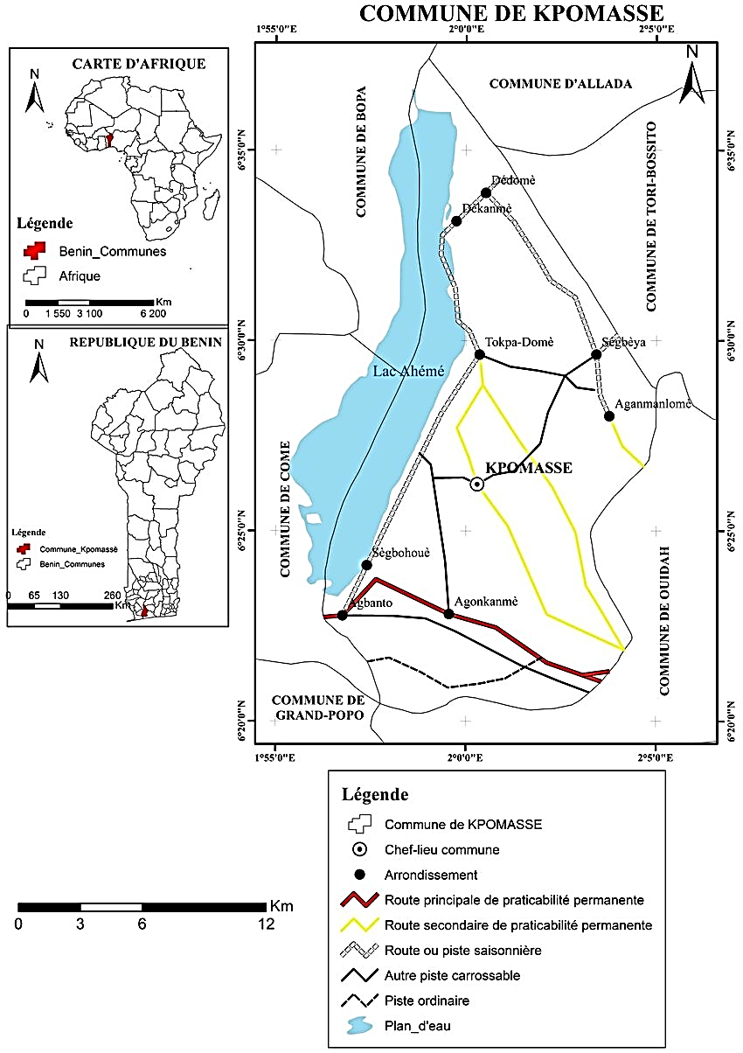
Figure 1: Map of the geographical location of the commune of Kpomassè
Source: IGN topographic map, 1992
  - Data and methods
In this study, the methodological approach adopted is based on both quantitative and qualitative data. Specifically, the data used includes demographic (1990 to 2020), socio-economic, agricultural, and legal/administrative data. To gather as much reliable data and information as possible, several techniques were employed, including direct observation. Focus groups of 6 to 10 people were also used to compare and supplement the information collected through questionnaires. The information gathered from the participants was processed using Word 2016 for text, Excel 2016 for tables and figures, and ArcView 3.2 for maps. The SWOT and MACTOR models were used for the analysis and interpretation of these results.
  - Determining the sample size
The selection of individuals to participate in the survey was based on a purposive sampling method. The target population consisted primarily of farming households, the municipal land registry office, SCDA Kpomassè agents , women landowners, traditional chiefs, and village chiefs. Three criteria determined the selection of individuals to participate in the survey:
- be a farmer and have at least 5 years of experience;
- to be an actor that deals with land issues;
- to be a regular actor.
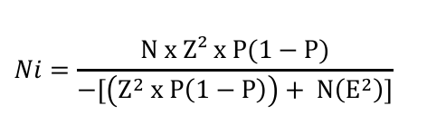
D. Schwartz's formula (1995, p. 13) ⁹ was used to determine the sample size for each site.
- Ni = the sample size
- N = The target population size for the selected sites is 21,094 (sum of the population sizes per district)
- Z = confidence level 96, or 1.96
- P = estimated standard proportion 30, or 0.03
- E = maximum error tolerance is 5 or 0.05
Applying this statistical formula gives the sample size
Ni = 327.
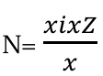
The number of people is chosen in each district according to a quota formula.
Or
N = the number of people surveyed per district
Xi = the total number of people per district
Z = the total number of people surveyed in the five districts
X = the total number of people in the six districts
The following table 1 must be announced
Table 1: Distribution of the sample by district
Municipality | Boroughs | Population size | Sample size
Kpomassè | Agonkanmè , | 4,422 | 68
Kpomassè | Aganmanlomè , | 3,591 | 56
Kpomassè | Dekanmè | 5,154 | 80
Kpomassè | Sègbea | 3,119 | 48
Kpomassè | Tokpa-domè | 4,808 | 75
TOTAL​ | 5 | 28,707 | 327
Source: INSAE/ INStaD data processing 2013, September 2024
In total, 327 people, spread across five districts, were selected for the survey. Additionally, 10 key informants were selected for the survey as part of this study. These key informants were identified based on their position and role in the development of the Kpomassè commune .

  - Data processing
The approach begins with a manual analysis of the questionnaires and interview guides administered to the target populations in the field. Two data processing methods were adopted:
- The qualitative data from the analysis were used to support the analysis and commentary of the results following a thematic grouping;
- The quantitative data collected was subjected to computer processing.
Various word processing and data processing software programs were used. These included: Microsoft Word 2016 for word processing, Microsoft Excel 2016 for tables and creating figures (histograms), and finally Microsoft Office Picture Manager for photos.
- Results and Discussion

  - Typology of land access methods and their impact on land tenure security
In the commune of Kpomassè , three main modes of access to land have been identified: inheritance, purchase, and loans or leases. These modes determine not only who has access to land, but also the degree of land tenure security, particularly for women, in a context marked by patriarchal norms and modern land reforms.
  - gender disparities in land transfer
Inheritance is the most common means of accessing land in the Kpomassè commune , accounting for 41%, reflecting customary practices deeply rooted in family and patriarchal systems. The dynamics of land transmission through inheritance highlight gender-based disparities in land access between men and women. Figure 2 illustrates the gendered distribution of land access.
Figure 2: Distribution of land inheritance by gender
Source: Results of field surveys, January 2025

Analysis of Figure 2 reveals that 68% of the men interviewed directly inherited agricultural or residential land, compared to only 12% of the women included in the survey. This figure illustrates a clear gender disparity , with a significantly higher proportion of men inheriting land. When women do inherit, they often receive plots of lesser economic value or precarious usage rights, which limits their ability to invest in agriculture or secure long-term access to land.
Women in Kpomassè face numerous obstacles to accessing land through inheritance. Patrilineal systems favor male heirs, who are seen as the guarantors of family continuity. This exclusion is particularly pronounced for married women, who are considered part of their husbands' families. Widows are especially vulnerable. Table 2 presents the obstacles to land inheritance for women in the Kpomassè commune .

Table 2: Obstacles to women's land inheritance in the Kpomassè commune
Obstacle | Percentage of women surveyed (%)
Patriarchal norms | 15
Land taken over by the in-laws | 05
Precarious usage rights without formalization | 38
High administrative costs | 42
Source: Field surveys, January 2025

Reading Table 2, it appears that the main obstacles related to land inheritance encountered by women in the commune of Kpomassè are patriarchal norms, the resumption of land by the in-laws, precarious usage rights without formalization and high administrative costs for registering plots.
  - Access through purchase: financial and administrative barriers to women's access
Access to land through the land market is a growing method of acquisition in the municipality of Kpomassè , particularly in peri-urban areas such as the Kpomassè -Centre district, where land pressure is increasing due to urbanization and the growing demand for residential and agricultural plots. Table 3 presents the distribution of land purchases by gender.

Table 3: Distribution of land purchases by gender
Village | Men buyers ($) | Average area (ha) Men | Women shoppers  (%) | Average area (ha) - Women
Agonkanmè | 27 | 20 | 02 | 1
Aganmanlomè | 08 | 6 | 02 | 1
Dekanmè | 11 | 9 | 03 | 2
Sègbea | 17 | 12 | 04 | 3
Tokpa-domè | 20 | 16 | 05 | 4
Total | 84 | 63 | 16 | 11
Source : Field surveys, January 2025
Analysis of Table 3 shows that women are underrepresented, accounting for only 16% of land transactions, and access to smaller plots totaling 11 hectares, thus limiting their potential for agricultural investment or real estate development. In contrast, men are better represented, with an 84% participation rate and a total of 63 hectares purchased.
Financial constraints pose a major obstacle for women seeking to acquire land. Surveys reveal that the average cost of a plot in Kpomassè -Centre is 4,000,000 FCFA for a 0.5-hectare residential plot and 2,000,000 FCFA for a 0.5-hectare agricultural plot in rural areas. These amounts are prohibitive for the majority of women, whose average income, according to the data collected, is 50,000 FCFA per month, compared to 100,000 FCFA for men. Figure 3 presents the average cost of 500 m² plots and monthly income by gender.

Figure 3 : Average cost of plots and monthly income by gender
Source: Field surveys, January 2024
Analysis of Figure 3 reveals significant gender disparities in access to land through purchase in the Kpomassè commune , with women facing far greater financial barriers than men. These constraints limit their ability to secure their land rights. The average cost of a 500m² plot in urban areas of Kpomassè is 1,500,000 FCFA, compared to 800,000 FCFA in rural areas. This equates to 30 and 16 times the average monthly income of women, respectively.
The administrative procedures required to formalize land purchases represent another major obstacle for women. Registering a land title, necessary to secure the purchase, involves high administrative fees of 75,000 FCFA, representing 2 to 4% of the plot's cost, and complex procedures with the town hall or notaries. Table 4 presents the administrative obstacles related to land registration by gender.
Table 4: Administrative obstacles related to the registration of plots by type by genre
Obstacles | Male Buyers (%) | Female Buyers  (%)
Complexity of the procedures | 68 | 79
High costs of formalities | 72 | 82
Lack of information on procedures | 70 | 90
Source: Field surveys, January 2025
Analysis of Table 4 reveals that women encounter more obstacles related to administrative procedures than men. While land purchases offer the potential for securing land tenure through formal titles, they remain precarious for women. Without official deeds of ownership, women are vulnerable to disputes, particularly in the event of claims by third parties.
  - Loans and rentals: the impact of verbal and written contracts on women's land tenure security
Land loans and leases constitute temporary forms of land access, particularly widespread in the commune of Kpomassè , where agricultural and residential land is often made available through informal or formal arrangements. These mechanisms allow some households, especially women, to access land without owning it, but their impact on land tenure security varies depending on the nature of the contracts, whether verbal or written. Table 5 presents the distribution of loans and rentals by gender.
Table 5 : Distribution of loans and rentals by gender
Boroughs | Loans and rentals  (Women) (%) | Loans and rentals  (Men) (%)
Agonkanmè , | 14 | 09
Aganmanlomè | 16 | 09
Dekanmè | 18 | 10
Sègbea | 07 | 04
Tokpa-domè | 8 | 05
Total | 63 | 37
Source: Field surveys, January 2025
Reading Table 5, it appears that women (63%) are more dependent on loans and rentals than men (37%).
The majority of these arrangements rely on verbal contracts, particularly in rural areas. These verbal contracts dominate loan and lease arrangements, accounting for 83% of the cases recorded. These agreements, often made with family members, heads of households, or neighbors, are based on trust and social relationships . However, they offer limited land security, especially for women. Surveys reveal that 33% of women receiving loans or leases reported insecurity, such as sudden evictions or disputes with landlords. Verbal contracts are particularly precarious for women due to their dependence on the decisions of landlords, who are often male. The women included in the survey reported that their access to land depended on the goodwill of the lender, without any legal guarantee. This precariousness limits their ability to invest in land, for example, in improving agricultural practices or planning for the long term. Figure 4 shows the proportion of verbal and written contracts entered into by gender.
Figure 4 : Proportion of verbal and written contracts entered into by gender
Source : Field surveys, January 2024
The analysis of figure 4 shows that women (92%) rely more on verbal contracts than men (73%) and have fewer written contracts (8%) than men (27%), which accentuates their land vulnerability compared to men.
  - Documents presuming ownership
Documents establishing presumed ownership in land law are provisional documents that attest to a person's presumed ownership of a plot of land. These documents are considered tools for securing land tenure because they serve as a guarantee before the finalization of administrative procedures leading to the definitive title deed. Table 6 presents the types of presumed ownership documents held by the individuals selected for the survey, categorized by gender, in the municipality of Kpomassè .
Table 6: Types of presumptive ownership documents by genre
Document types | Women (%) | Men (%)
ADC (Certificate of Customary Detention) | 05 | 28
Sales agreement | 03 | 22
Dump | 33 | 17
certificate of relocation | - | 10
tax assessments for the last three years | - | -
registration certificate | - | -
administrative certificate | - | -
rural land certificate | - | -
No document | 59 | 23
*- : Nothing
Source: Field survey results, January 2024

Analysis of Table 6 reveals that women possess only land discharges (33%), sales agreements (3 %), and land title deeds (5%) as documents presuming land ownership, making them more vulnerable in the event of conflict. The only document The formal document of presumed ownership identified at their level is the ADC (Attestation de Consommation de Commune - Certificate of Consumption of Ownership). In contrast, men hold ADCs (28%) and resettlement certificates (10%) as formal documents. They also hold unofficial documents such as discharges (17%) and sales agreements (22%). It should be noted that 59% of women hold no documents, compared to 23 % of men. Documents of presumed ownership, although inferior to property titles in terms of legal value, offer temporary recognition of rights, particularly in a context where few plots of land in the Kpomassè commune are titled.
  - Socio-cultural and economic obstacles to women's access to land
    - Discriminatory social and cultural norms
In the commune of Kpomassè , inheritance practices based on the patriarchal system largely exclude women from land inheritance rights, thus marginalizing them in terms of access to land. These norms, rooted in the traditions of the socio-cultural communities in the study area, favor the transmission of land to male heirs, relegating women to dependent roles. Traditional practices dominate, with 82% of respondents stating that land is primarily passed down to male children in the lineage. Women, particularly daughters and widows, are often excluded, except in cases where they obtain temporary access through their husbands or fathers. Figure 5 illustrates the impacts of inheritance exclusion on women in the commune of Kpomassè .
Figure 5: Impacts of inheritance exclusion on women
Source: Results of field surveys, specify the month of survey here: 2025
Analysis of Figure 5 reveals that the impacts of exclusion from inheritance include land insecurity (68%), followed by economic dependence (63%) and family conflicts (32%). The exclusion of women from land inheritance in the Kpomassè commune reflects deeply entrenched patrilineal norms.
    - Economic and institutional barriers
In the commune of Kpomassè , economic and institutional barriers significantly hinder women's access to land, exacerbating gender inequalities already entrenched in cultural and family norms. Figure 6 presents the costs of accessing land by district included in the survey.
Figure 6: Land access costs by borough and gender impact
Source: Field surveys, February 2025
Analysis of Figure 6 shows that in the districts of In Agonkanmè and Dékanmè , the average price of half a hectare is 4,000,000 and 3,000,000 FCFA respectively. In the Aganmanlomè district, the average price for half a hectare is 2,000,000 FCFA, while in the Sègbeya and Tokpa -domè districts, the average price is 1,500,000 FCFA and 2,500,000 FCFA. Rent in these districts ranges from 80,000 to 100,000 FCFA. The administrative fee to register a purchased plot is 75,000 FCFA. Figure 7 presents the costs of accessing land in relation to the average annual income of women.
Figure 7: Land access costs relative to women's average annual income
Source : Field surveys, February 2025
From the analysis of Figure 7, it is important to note that if we consider income Given that the average annual income of a rural woman in the Kpomassè commune is 600,000 FCFA, purchasing a half-hectare plot in a peri-urban area would cost 666% of her annual income, compared to 32% if she rented the same plot. In the case of a half-hectare plot in a rural area, it would cost 333% of her annual income, and only 16% if she rented. This situation highlights why women farmers most often choose to rent land. Purchasing is simply too expensive for them given their low incomes.
A linear regression shows that land access costs explain 62% of the variance in women's exclusion from land ownership (R² = 0.62, p < 0.01), with gender as the moderating variable (β = -0.38, p < 0.05). Key gender-related factors include unequal income . Women earn 60% less than men, making land purchase costs prohibitively expensive for them. Furthermore, women have limited access to credit because microfinance institutions often require collateral, which women rarely possess.

- Conclusion
The situation in Kpomassè clearly illustrates the structural challenges to women's land tenure security in Benin. These challenges are primarily the persistent strength of patriarchal norms, women's economic vulnerability due to low incomes, and the coexistence of customary and legal systems that reinforce each other, perpetuating inequalities. These interconnected constraints severely limit women's ability to secure their land rights, despite progress in national legislation. However, solutions exist, including the effective dissemination of the Land Code, the simplification of costly administrative procedures, and the implementation of gender-sensitive municipal policies that could contribute to more equitable land governance in Kpomassè .
- References
1. Tchaou Sèvègni (2014): The land issue remains a complex, multidimensional problem involving various actors and institutions, pp. 12-13.
2. NICOLAS Y., (2008): Introduction to the concept of gender and development, In "Gender and Development," where actors in women's rights and international solidarity meet and exchange on their practices, Harmattan, Paris, pp. 27-35.
3. SOW N. F., (2008): Women's access to land in West Africa: problems and solutions in Senegal and Burkina Faso, DIMITRA project, FAO, p. 52. http://www.fao.org/docrep/016/ap532f/ap532f.pdf
4. Kanji S. S. M., (1997): From yesterday's to tomorrow's rights of African women, Xamal, Saint-Louis, Senegal, p. 51. https://africultures.com/php/?nav=fiche_ouvrage&no=1000
5. Diop F., and Touré L., (2012): Contribution of the Geographic Information System (GIS) in understanding the problem of women's access to rural land in Senegal: Case of the rural communities of Keur Momar Sarr, Médina Ndiathbé (Valley and Sylvo-pastoral Zone), Diender (Niayes), Bandafassi (Eastern Senegal), Diendé (Casamance); Leïdi Laboratory Geography Review – ISSN 0851-2515 – No. 10, December 2012, p. 345. https://core.ac.uk/download/pdf/235896000.pdf
6. OUMAROU I., (2008): Women and local development: Analysis of land organization in Niger: the case of the Tillabéry region. Sociology. Doctoral thesis, University Rennes 2, 356 p. https://www.theses.fr/2008REN21003
7. INSAE, (2013): General Population and Housing Census (RGPH4), Provisional results; 124 p. https://instad.bj/rgph4-2013/
8. Charlier Sophie, Diop Sall Fatou, Lopez Graciela (2016): Land governance models through a gender lens. Case studies in Niger, Senegal, and Bolivia, 4 pages. https://doi.org/10.35690/978-2-7592-2163-9
9. Schwartz D., (1995): Statistical methods for physicians and biologists. 4th Edition (Flammarion Medical Publishing), Paris, 314 pages.
10. Republic of Benin. Law No. 2013-01 of August 14, 2013, establishing the Land and Property Code in the Republic of Benin. Official Gazette of the Republic of Benin; 2013. https://sgg.gouv.bj/document/loi-n-2013-01-du-14-aout-2013/

