Scalable Fraud Detection in High-Volume Financial Data Using Deep Learning Models

Abstract—In the evolving landscape of online transactions, fraudulent actions are becoming more sophisticated, fraud detection is still a significant difficulty. This study investigates the use of machine learning methods to improve online transaction fraud detection. In this research, a comprehensive machine learning-based fraud detection system using the PaySim dataset is presented, which is a simulated dataset replicating real-world mobile money transfer. It is methodologically based on thorough exploratory data analysis, MinMax normalization, and class balancing using SMOTE to deal with severe data imbalance. XGBoost and LightGBM are two advanced gradient boosting models that are assessed using standard measures such as ROC-AUC, accuracy, precision, recall, F1-score, and confusion matrices. The results of the experiment indicate that XGBoost is better than all the models compared 99.91% and 99.98% accuracy, and LightGBM is 96.72% with good overall performance. The proposed framework is also superior to the existing methods, such as FinSafeNet, Logistic Regression, and GAN-VAE, as it can be further verified through the comparative analysis. Despite the fact that synthetic data is used, and therefore it does not allow in replicating the complexities of real-world, the results of the study highlight the potential of gradient-boosting-based-based methods in scalable, high-precision fraud detection.
Keywords—Security, financial fraud detection systems, transaction analysis, machine learning, PaySim data.

Introduction
The advent of online banking, digital banking, online shopping and mobile payment modes, new avenues for fraud to be committed, resulting in billions of dollars in losses annually. Financial accounting fraud has increased in the current economic climate, investors, academic researchers, the media, the financial community, and regulators have become very interested in financial accounting fraud detection, or FAFD [1]. The need to identify, characterize, and disclose financial accounting fraud has grown as a result of several high-profile financial scams that were found and revealed at major corporations during the past ten years, including Enron, Lucent, WorldCom, and Satyam [2]. Because digitalization makes fraudsters more nimble, criminals are using technology to perpetrate online fraud on a larger scale and breadth than in the past [3][4]. The methods that fraudsters and attackers employ are becoming increasingly complex: Malicious software that have been modified for several banking apps might get past the security safeguards in place [5].
Enhancing the security and dependability of payment transactions for consumers and financial institutions alike requires effective fraud detection systems [6][7]. ML is one of the most popular approaches used in the numerous research on this subject conducted in the last several years. While machine learning (ML) can be useful for detecting fraud, there are certain obstacles that must be addressed. The main problem is that credit card transaction data is inherently unbalanced; fraudulent transactions make up just a small portion of total transactions [8][9]. Models suffer from this mismatch because it can lead to improper learning and a high false positive rate, which reports legal transactions as fraudulent. For models to be effective, they must be updated often since fraudsters are always changing their strategies [10]. The difficulty is in scaling and applying models in real-time while preserving low latency and high accuracy [11].
Financial accounting fraud detection has been motivated by the need to ensure that digital financial systems are protected and that people have trust in the systems. As online banking, mobile payments, and e-commerce increase in popularity, fraudsters are taking advantage of digitalization to commit more advanced crimes and result in billions of losses every year. Cases such as Enron and Satyam are of high profile and reflect the destructive effects of unnoticed fraud, and thus, an effective system of detecting fraud is important. Machine learning provides effective methods to detect anomalies in large datasets of transactions, yet issues like the imbalance of data, the development of new fraud strategies and future studies and advancements in the field are motivated by the need for precision in real-time. The following crucial elements of this study aid in the development of scalable financial fraud detection:
- Conduct data-pre-processing pipeline, including categorical encoding, and MinMax normalization, ensuring stable feature distributions for gradient-boosting frameworks.
- Development of a unified fraud-detection architecture that integrates EDA, and evaluation specifically optimized for large-scale mobile money transaction data from the PaySim dataset.
- SMOTE applied on the PaySim dataset to effectively balance fraud classes and enhance minority pattern learning.
- Propose and develop LightGBM and XGBoost, demonstrating their computational efficiency, scalability, and suitability for high-volume transactional fraud detection.
The necessity to propose the given framework is explained by the urgency of the need to detect fraud effectively and in a scalable manner, and process large and heavily imbalanced financial data. In contrast to the conventional methods, the piece combines a strict preprocessing pipeline with SMOTE-based balancing and tests two advanced gradient boosting models, including XGBoost and LightGBM, on the PaySim dataset. The difference is in the fact that these techniques are used in combination to detect subtle patterns of fraud with unmatched accuracy, as shown by the near perfection of XGBoost. Also, the paper gives the full comparison with the available models, proving the superiority and practical applicability of the proposed approach to contemporary financial fraud detection.

Structure of the Paper
The study is structured as follows: Section II reviews existing literature, Section III describes the dataset and the proposed framework, Section IV reports the experimental results, and Section V outlines the concluding remarks and future research directions.

Literature Review
This section discusses some review articles on fraud detection in financial and healthcare domains using ML and DL approaches. Table I brings out the paper, methods, data set, major findings, and limitations/research.
Athiththan and Ramanan (2025) on a dataset of 900 credit card transactions (450 of which were real and 450 were fraudulent). The model proposed has got an accuracy of 96%, the precision of legitimate transactions is 75% and the accuracy of fraudulent transactions is 90%. Recall rates were likewise high, accounting for 87% of fraudulent transactions and 86% of valid transactions. The findings suggest that the suggested model may prove to be a useful instrument in the fight against credit card fraud and it provides a high accuracy as well as strong privacy offers [12].
Hainan, Jin and Shang (2025) proposes a ChatGPT-guided method for healthcare fraud detection. By using ChatGPT-4.5 as the teacher model to generate fraud probability labels, and training a more efficient LightGBM student model, the approach achieves an accuracy of 88.47%ˈcompared with the traditional detection model, it has increased the accuracy rate by 15.3%.To address problems like data imbalance and privacy concerns, the proposed method provides a scalable and effective cross-institutional fraud detection solution [13].
Tang and Liu (2024) experimental testing of two datasets of financial data of varying sizes. Results on Datasets 1 and 2 show that, in terms of AUC-PR (0.882, 0.816) and AUC-ROC (0.982, 0.994), the suggested SDT model outperforms conventional detection techniques. Further improvement of the AUC-PR values (0.884, 0.892) and AUC-ROC values (0.963, 0.998) can be achieved by the implementation and testing of federated learning in a distributed environment [14].
Basani (2024) proposes a real-time, AI-based, XGBoost, and data engineering optimization fraud detection model that can process 10,000 transactions per second with a low latency of 7 ms. With the use of Explainable AI (XAI), the system solves the issue of data imbalance in fraud procedures and adds a transparent aspect. SHAP values allow users to make predictions using the model accessible. According to testing results on real-world financial transaction datasets, the suggested method is correct on 99.2% of the datasets, with accuracy and recall scores above 95% and 93%, respectively [15].
Mardani and Moradi (2024) suggest a healthcare provider fraud detection model, which uses the effect the interdependencies of the parties have on the claims data. The data and additional features can identify complex fraud tendencies. tested on the coverage provider fraud detection dataset and achieved 0.56 recall versus the finest accessible approaches, e.g. GTN with 0.5 and XGBoost with 0.46 recall[16].
Somkunwar et al. (2023) adds an efficient tool to the financial equipment’s, which boosts security and confidence, as it allows the detection of fake payments at the earliest stage. Through the use of machine learning and Benford's Law, this technology is essential in avoiding financial misconduct. Its 94.83% fraud detection accuracy rate attests to its effectiveness [17].
Al-Momani and Aljawarneh (2022) Therefore, monitoring suspicious transactions need to be a crucial part of any payment system. By analyzing customer behavior from previous transaction data, fraudulent transactions can be identified. In order to address the shortcomings of earlier research, a neural network model is suggested in this study to identify several fraudulent transaction types using a current data set. The suggested model produced an AUC of 99%, as shown by the experimental findings [18].
Although the financial and healthcare industries have made tremendous progress in detecting fraud via the application of deep learning and machine learning, there are still research gaps. The current literature indicates that most of the existing studies have high accuracy on small or domain-specific data sets, and scalability and generalization in various and real-life environments are under-investigated. The critical issues of extreme data imbalance, accelerating fraud schemes, privacy and the necessity of real-time detecting with minimal latency continue to exist. Besides, the approaches, Promising approaches include teacher-student models, explainable AI, and federated learning, yet they have not yet been implemented in large-scale and cross-institutional systems. Given such gaps, it is imperative to have powerful, adaptive, and interpretable models that can sustain performance in changing, heterogeneous fraud environments.

- Summary of background study for Fraud Detection using machine learning
Author (Year) | Methods / Models | Dataset | Key Findings | Limitations | Future Work
Athiththan and Ramanan (2025) | Machine Learning-based Fraud Detection Model | 900 credit card transactions (450 legitimate, 450 fraudulent) | Achieved 96% accuracy, precision: 75% (legit), 90% (fraudulent); recall: 86% (legit), 87% (fraud). High performance and privacy protection. | Limited dataset size (only 900 samples); potential overfitting due to class balance in small-scale data. | Apply on larger, real-world datasets; enhance model generalization and adaptability across financial institutions.
Hainan, Jin and Shang (2025) | ChatGPT-guided Fraud Detection using Teacher–Student Model (ChatGPT-4.5 → LightGBM) | Healthcare fraud dataset (cross-institutional) | Achieved 88.47% accuracy, improving traditional methods by 15.3%. Effectively addressed data imbalance and privacy concerns. | Dependent on ChatGPT-generated labels; model interpretability and reproducibility challenges. | Extend approach to other fraud domains (insurance, finance); integrate federated learning for privacy-preserving training.
Tang and Liu (2024) | Secure Decision Tree (SDT) with Federated Learning | Two financial datasets (different scales) | Outperformed traditional models: AUC-PR = (0.882, 0.816); AUC-ROC = (0.982, 0.994). Further improved under federated setup: AUC-PR = (0.884, 0.892), AUC-ROC = (0.963, 0.998). | Computational complexity of federated setup; scalability issues for large institutions. | Enhance optimization in federated environments; integrate privacy-preserving encryption techniques.
Basani (2024) | Real-time AI-driven System using XGBoost + XAI (SHAP) | Real-world financial transaction dataset | Achieved 99.2% accuracy, precision: >95%, recall: >93%; processes 10,000 TPS with 7ms latency. Transparent decision-making via SHAP. | High computational cost; may require specialized hardware for real-time processing. | Optimize model for edge devices; integrate adaptive learning for evolving fraud patterns.
Mardani and Moradi (2024) | Interdependency-based Fraud Detection Model (Healthcare) | Healthcare provider fraud dataset | Reached 0.56 recall, outperforming GTN (0.5) and XGBoost (0.46). Captures party interdependencies effectively. | Moderate recall improvement; lacks interpretability and scalability details. | Incorporate explainable AI and deep graph models; test on larger healthcare datasets.
Somkunwar et al. (2023) | Benford’s Law + Machine Learning | Financial transaction dataset | Achieved 94.83% accuracy, demonstrating early detection capability for fraudulent transactions. | Limited to datasets where Benford’s Law holds true; less effective on non-numeric anomalies. | Explore hybrid anomaly detection models; apply to diverse financial data sources.
Al-Momani and Aljawarneh (2022) | Neural Network-based Model | Recent financial transactions dataset | Achieved AUC = 99%, outperforming previous models in fraud detection efficiency. | No mention of precision/recall balance; may lack explainability and robustness to evolving fraud types. | Implement hybrid deep learning models (CNN-LSTM); enhance interpretability with XAI frameworks.

Methodology
A streamlined methodology for financial transactions starts with collecting the PaySim dataset, that Preprocessing, including handling missing values, one-hot encoding, normalization, and SMOTE is applied to correct class imbalance. Models for fraud detection dubbed XGBoost and LGBM are proposed, and the dataset is separated into training and testing sets. Model performance is assessed using accuracy, precision, recall, and F1-score, which helps in further analysis and progressive improvement, as shown in Fig. 1.

- Flowchart for Fraud Detection in Financial Data.
The other steps of the proposed methodology are discussed briefly as follows:

Data Collection
Synthetic Financial Dataset for Fraud Detection was created by means of the PaySim simulator that recreates the behavior of mobile money transfers and fraud patterns. It includes about 6.3 million transactions, with a minute fraction of them considered to be fraudulent, and this is a reflection of the extreme imbalance of real financial systems. Finding patterns and links in a data collection is made possible through the important process of exploratory data analysis, or EDA. Before creating predictive models, the paysim dataset was analyzed using several exploratory techniques to better understand the data.
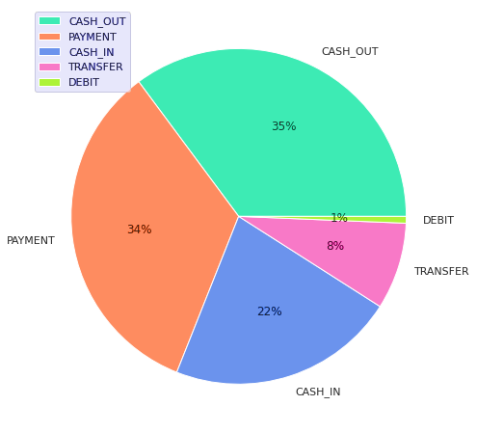
- Pie chart for different categories of Transactions.
In Fig. 2, illustrates the dataset's distribution of transaction kinds. The graphic displays many categories, each of which is denoted by a distinct color section. The majority of the data is concentrated in a few transaction types, while others form only small portions of the chart. This distribution reflects a clear imbalance, with some transaction types being much more prevalent than the rest.
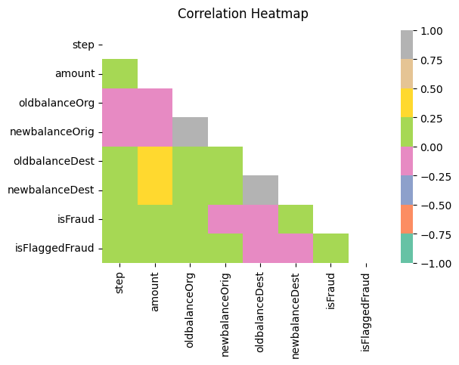
- Correlation Heatmap of dataset features.
Fig. 3 shows correlations between variables of the data set, and the variables of the fraud indicators isFraud and isFlaggedFraud. The heatmap is applied on a color scale of deep blue (strong negative correlation) to yellow-green (strong positive correlation), and the neutral correlations are displayed in gray. The visual representation to understand pattern and dependency between variables, including the negative relationship between oldbalanceOrg and newbalanceOrig or the low correlation between isFraud and most balance-related features, can provide information on possible predictors of a fraudulent activity.
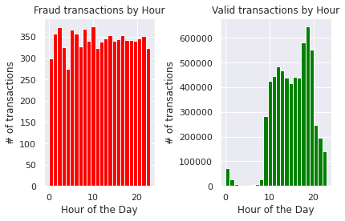
- Distribution of fraudulent and valid transactions.
The distribution of legitimate and fraudulent transactions throughout the day is shown in Fig. 4. The left plot shows that fraudulent activity occurs relatively uniformly throughout the day, with no specific hourly peak. In contrast, the right plot reveals that valid transactions are heavily concentrated during business hours, peaking around the late afternoon and evening. It means that fraudulent transactions are more evenly distributed unlike legitimate transactions which are normally carried out in normal ways of human activity.

Data Preprocessing
Preprocessing is necessary due to noise, inconsistency, and imbalance of classes in real-world data on fraud. It starts with an inspection of data, then elimination of the outliers, irrelevant features, and null entries to ensure integrity. Normalization and transformation gears the dataset towards the model training, which of high quality, scalable, and consistent. All of these measures yield a balanced, cleansed and well-organized data set to test a model reliably.
- Initial Data Inspection: Dataset analyzed with exploratory data analysis to get a feel of the structure and summary statistics, and deleting irrelevant columns (timestamps, identifiers, etc.).
- Handling Missing Values: Data that have a null value was deleted upon verification to ensure the integrity of the records and to eliminate bias.
- Outlier Removal: Eliminating outliers would perhaps remove important signs of fraudulence, and since the model is weak in determining real fraud cases, it would lessen its utility in detecting fraud cases.

Data Encoding
The label encoding used to encode categorical variables into numerical ones to be handled by machine learning models. The type of transaction and customer identifiers (nameOrig, nameDest) are coded in this work with LabelEncoder, but in this case, the categories are assigned a unique integer. This transformation does not modify the categorical information but only makes the data set fit in algorithms with numerical inputs. It also guarantees the uniform representation of the categories, decreases the complexity of models, and enhances the computation efficiency in the course of training.

Data Normalization
This study used MinMax normalizing, sometimes referred to as the MinMax Scaler, as its normalizing method. Equation (1) gives the transformation's mathematical formulation:
$z_{i}=\frac{z_{i}-z_{min}}{z_{min}-z_{max}}$ (1)
In this notation, the normalized value of the ith observation, which is limited to the interval [0, 1], is denoted by $z_{i}$ . The original, unnormalized observation is represented by the symbol $z_{i}$ , and the maximum and minimum values inside the associated feature are represented by the symbols $z_{max}$ and $z_{min}$.

SMOTE for Address Class Imblanace
To overcome the class imbalance depicted in Fig. 5, The Synthetic Minority Oversampling Technique (SMOTE) finds the closest neighbors and interpolates between them to create new instances of the minority class. This method not only balances the classes but also enables the model to discover the faintest fraud patterns since the data is not just copied. In this instance, SMOTE converted the initial data where Class 1 constituted only 0.1 of the data into a balanced dataset with 50% of each of the classes, enhancing the model's capacity to discover and recognize patterns of the minority classes.
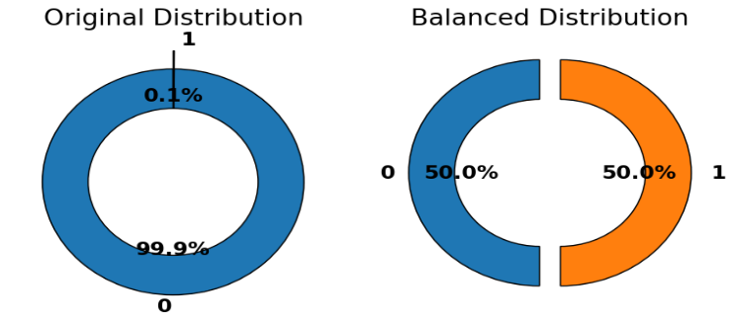
- Donut chart for Class Distribution.

Data Splitting
It partitions the dataset into 80:20 training and test sets. For training and hyperparameter adjustment, the training set was especially used. The test set assesses the generalizability and performance of the model.

Model Selection
In this exercise, use the Paysim dataset to train several models. Experiments are conducted using the XGBoost and LightGBM models.

XGBoost
A complex gradient tree boosting-based algorithm called XGBoost may be able to effectively tackle complex machine learning issues. A popular algorithm for medical data in a variety of research fields, XGBoost is renowned for its excellent performance and minimal memory and time complexity. But XGBoost is sensitive to this kind of information. Thus, it is quite fascinating to see how well these models perform when such data and balanced generated data are used. The regularized objective function optimized by the XGBoost method is displayed in Equation (2).
Large-scale machine learning issues may be effectively handled by XGBoost, an advanced gradient tree boosting-based approach [19][20]. The great performance and minimal time and memory complexity of XGBoost have made it popular for usage with medical data in a variety of research fields. XGBoost is susceptible to such information, though. Thus, it is quite intriguing to see how well these models perform when given such data, as well as balanced generated data[21]. Equation (2) displays the regularized objective function that the XGBoost method has optimized:
$L_{XYB}=\sum_{i=1}^{n}{l\left(y_{i},{\hat{y}}_{i}\right)+λ\sum_{k=1}^{T}{Ω(f_{k})}}$ (2)
Where has the logistic loss occurred${\hat{y}}_{i}$ is a regularization term that penalizes model complexity and represents the expected probability$Ω(f_{k})$ . By penalizing complex models, to avoid overfitting, the XGBoost regularized goal function is essential. In order to generalize to the unknown data, the model's accuracy and complexity are scaled using the regularization term $Ω(f_{k})$. This greatly increases the assurance that the forecasts are more accurate, this is necessary for the prediction models to function well in real-world applications.

LGBM
A LightGBM is a reliable technique for applying gradient boosting in decision trees[22][23]. LightGBM uses tree-based learning algorithms, making it a strong choice for gradient boosting. Because of its decentralized and efficient architecture, it offers faster training and increased output. Variable bucketing is carried out via a histogram-based technique called LightGBM, which uses less memory while increasing training speed and accuracy. It can handle big and complicated datasets and operates faster when taught. Both GPU-based and parallel learning are supported. In supervised learning contexts, the technique allows one to deduce information about a target Y from only X in Equation (3).
$\hat{f}=\arg{\min_{f}E_{y,X} L(y,f\left(x\right))}$ (3)
A supervised training set (X) and a loss function $L(y,f\left(x\right))$ whose predicted value is to be lowered are used in the LightGBM approach to achieve this$\hat{f}$(x).

Evaluation metrics
To evaluate the efficiency of the fraud detection system's categorization models, various performance metrics are employed, including the confusion matrix, which encapsulates the predicted and actual classification outcomes. TP indicates the number of correctly classified positive samples, TN indicates the number of correctly classified negative samples, FP indicates the number of mistakenly classified negative samples as positive, and FN indicates the number of incorrectly classed positive samples as negative. After that, Equations (4) through (7) can be used to define the performance measures:
$Accuracy= \frac{TP+TN}{Total Number of Instances}$ (4)
$Precision =\frac{TP}{TP+FP }$ (5)
$Recall =\frac{TP}{TP+FN }$ (6)
$F=\frac{2\left(Precision×Recall\right)}{Precision+Recall}$ (7)
Accuracy is the total proportion of correctly predicted cases among all instances. Precision is a measure of optimistic projections' accuracy. The percentage of real suspicious fraud that the model properly recognized is known as recall, or sensitivity. The center of precision is thus played by the F1-score equation, which blends recollection and accuracy. A Receiver Operating Characteristics (ROC) curve displays the false positive rate (FPR) on the x-axis and the true positive rate (TPR) on the y-axis.

Result Analysis and Discussion
This section reports the models' performance results for Fraud Detection in High-Volume Financial Data. Every experiment was conducted on a PC running Windows 11 (64-bit) with an Intel Core i9 CPU (3.6 GHz, 12 cores) and 32 GB of RAM. Standard metrics were employed to assess the model, including F1-score, recall, accuracy, and precision, as indicated in Table II. The LGBM model has an accuracy of 96.72, which is a good overall performance in classification. XGBoost has an accuracy of 99.91, and this means that it is very effective in detecting all of the important measures.
- Performance Evaluation of the propose Models for Fraud Detection
Measures | LGBM | XGB
Accuracy | 96.72 | 99.91
Precision | 98.79 | 99.89
Recall | 98.97 | 99.98
F1-score | 97.23 | 99.23
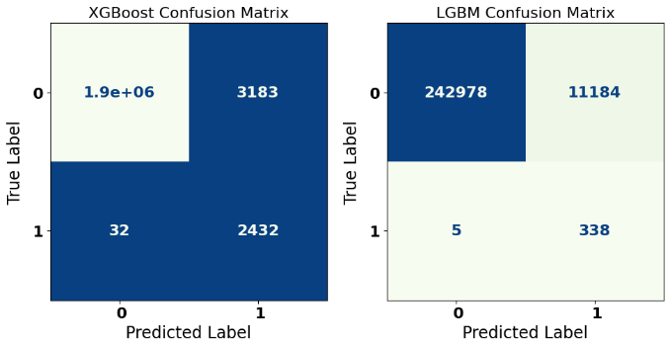
- Confusion Matrix of XGBoost and LGBM Model.
Fig. 6 presents the proposed models' confusion matrix, which shows how well they perform in binary classification. This model has high accuracy, with 1.9 million true negatives, 2,432 true positives which is high predictive ability of the two classes. False identifications are minimal and constitute just 3,183 false positives and 32 false negatives indicating superior recall and precision. This table shows the strength of XGBoost in the classification of the two categories and the error rate is quite low even with a large dataset.
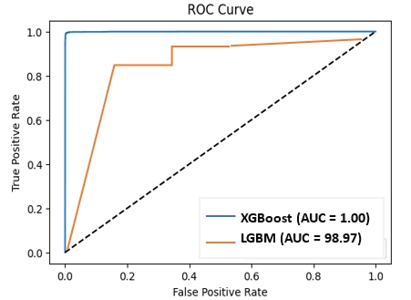
- ROC Curve of both Propose Models
Fig. 7 displays the ROC curves of the proposed XGBoost and LGBM models, which give a comparative view of classification performance. The XGBoost model has a perfect Area Under the Curve (AUC) of 1.00, which means that it has an ideal performance in discriminating between classes at all the thresholds. Conversely, LGBM model is also doing very well with the AUC of 98.97, which is a bit less than XGBoost. It displays low false positive rates and high true positive rates, and XGBoost can provide superior overall accuracy and dependability. The curve is anticipated to rise sharply on the top-left side.

Comparative Analysis and Discussion
Table III shows a comparative analysis of different models, as well as methods of detecting fraud, depending on key performance metrics. The results of the FinSafeNet are high with the accuracy 97.88 and F1-score of 95.12 whereas the Logistic Regression (LR) performance is not high according to all measures. The GAN VAE model offers a respectable level of precision but a lower recall and F1-score, making it challenging to identify fraudulent instances. Both XGBoost and LGBM exhibit good accuracy, recall, and F1-scores, demonstrating their power and dependability in identifying fraud in unbalanced datasets.
- Models performance comparison for Fraud Detection
Model / Method | Accuracy | Precision | Recall | F1-score
FinSafeNet [24] | 97.88 | 96.55 | 95.46 | 95.12
LR [25] | 88 | 77 | 88 | 82
GAN VAE [26] | 94.60 | 83.20 | 76.30 | 79.50
LGBM | 96.72 | 98.79 | 98.97 | 97.23
XGB | 99.91 | 99.89 | 99.98 | 99.23
The proposed fraud detection framework offers significant advantages, including high accuracy, strong scalability, and the ability to detect rare fraudulent patterns within large transactional datasets by combining effective preprocessing, SMOTE-based balancing, and advanced gradient boosting models. Simultaneously, ethical aspects are crucial to achieving the reasonable, clear, and accountable utilization of financial information. It involves protection of user privacy by ensuring their anonymity, eliminating bias in the algorithms, not labeling legitimate users as fraudulent, and making sure that the models make decisions that can be explained and used with legitimate purposes of financial monitoring.

Conclusion and Future Work
The concern of credit card fraud in the banking industry is on the rise as it is likely to pose risks to consumers and financial institutions. ML methods have been effective in identification of fraudulent transactions in the recent years. The study compares how well two well-known machine learning algorithms—XGBoost and LGBM—perform in detecting credit card fraud.. The study offers a robust fraud detection system that includes the following aspects developed preprocessing, and ML models which are viable in detecting fraud in PaySim dataset. The results indicate that XGBoost can achieve high performance with the accuracy of 99.91, recall and AUC of 99.98 and 1.00 which was better than 96.72 with LightGBM and 94.60 with GAN-VAE which is not available as FinSafeNet (97.88) and GAN-VAE (94.60) model. As much as these good results were obtained, the study has limitations in that it used synthetic data which may not be reflective of fraud complexities and large-scale model training which is very expensive to compute. The future research can elaborate on this study by verified the framework through real-life financial data, introducing deep learning-like anomaly detection, increasing the efficiency of computation and explainable AI techniques to make it more digestible, more transparent and deployable to a real banking environment.

References
[1] A. Sharma, “A Review of Financial Accounting Fraud Detection based on Data Mining Techniques,” vol. 39, no. 1, pp. 37–47, 2012.
[2] F. Zhang, Y. Ding, and Y. Liao, “Financial Data Collection Based on Big Data Intelligent Processing,” Int. J. Inf. Technol. Syst. Approach, vol. 16, pp. 1–13, 2023, doi: 10.4018/IJITSA.320514.
[3] S. J. Wawge, “A Survey on the Identification of Credit Card Fraud Using Machine Learning with Precision, Performance, and Challenges,” Int. J. Innov. Sci. Res. Technol., vol. 10, no. 4, pp. 3345–3352, May 2025, doi: 10.38124/ijisrt/25apr1813.
[4] V. Verma, “Deep Learning-Based Fraud Detection in Financial Transactions: A Case Study Using Real-Time Data Streams,” ESP J. Eng. Technol. Adv., vol. 3, no. 4, pp. 149–157, 2023, doi: 10.56472/25832646/JETA-V3I8P117.
[5] K. B. Thakkar and H. P. Kapadia, “The Roadmap to Digital Transformation in Banking: Advancing Credit Card Fraud Detection with Hybrid Deep Learning Model,” in 2025 2nd International Conference on Trends in Engineering Systems and Technologies (ICTEST), IEEE, Apr. 2025, pp. 1–6. doi: 10.1109/ICTEST64710.2025.11042822.
[6] M. Huang and W. L. B, Proceedings of the 2022 3rd International Conference on E-commerce and Internet Technology (ECIT 2022). Dordrecht: Atlantis Press International BV, 2023. doi: 10.2991/978-94-6463-005-3.
[7] B. R. Ande, “Federated Learning and Explainable AI for Decentralized Fraud Detection in Financial Systems,” J. Inf. Syst. Eng. Manag., vol. 10, no. 35s, pp. 48–56, 2025.
[8] V. Pal and S. K. Chintagunta, “Transformer-Based Graph Neural Networks for RealTime Fraud Detection in Blockchain Networks,” Int. J. Adv. Res. Sci. Commun. Technol., vol. 3, no. 3, pp. 1401–1411, Jul. 2023, doi: 10.48175/IJARSCT-11978Y.
[9] H. Kali, “Optimizing Credit Card Fraud Transactions Identification and Classification in Banking Industry Using Machine Learning Algorithms,” Int. J. Recent Technol. Sci. Manag., vol. 9, no. 11, pp. 85–96, 2024.
[10] Y. Macha and S. K. Pulichikkunnu, “An Explainable AI System for Fraud Identification in Insurance Claims via Machine-Learning Methods,” Int. J. Adv. Res. Sci. Commun. Technol., vol. 3, no. 3, pp. 1391–1400, Jul. 2023, doi: 10.48175/IJARSCT-11978X.
[11] S. B. Shah, “Advancing Financial Security with Scalable AI: Explainable Machine Learning Models for Transaction Fraud Detection,” in 2025 4th International Conference on Distributed Computing and Electrical Circuits and Electronics (ICDCECE), 2025, pp. 1–7. doi: 10.1109/ICDCECE65353.2025.11034838.
[12] V. Athiththan and Y. R. Ramanan, “Credit Card Fraud Detection Using Homomorphic Encryption Based On Unsupervised Anomaly Detection Network,” in 2025 International Research Conference on Smart Computing and Systems Engineering (SCSE), IEEE, Apr. 2025, pp. 1–6. doi: 10.1109/SCSE65633.2025.11030995.
[13] Y. W. Hainan, C. Jin, and W. Shang, “Healthcare Fraud Detection Based on ChatGPT-Guided Method,” in 2025 1st International Symposium on E-CARGO and Applications (E-CARGO), IEEE, Jul. 2025, pp. 88–92. doi: 10.1109/E-CARGO65996.2025.11139301.
[14] Y. Tang and Z. Liu, “A Credit Card Fraud Detection Algorithm Based on SDT and Federated Learning,” IEEE Access, vol. 12, pp. 182547–182560, 2024, doi: 10.1109/ACCESS.2024.3491175.
[15] M. A. R. Basani, “Data Engineering and ML for Real-Time Fraud Detection in Financial Transactions,” in 2024 IEEE 8th Conference on Energy Internet and Energy System Integration (EI2), IEEE, Nov. 2024, pp. 91–96. doi: 10.1109/EI264398.2024.10991757.
[16] S. Mardani and H. Moradi, “Using Graph Attention Networks in Healthcare Provider Fraud Detection,” IEEE Access, vol. 12, pp. 132786–132800, 2024, doi: 10.1109/ACCESS.2024.3425892.
[17] R. K. Somkunwar, M. P. Pimpalkar, K. M. Katakdound, A. S. Bhide, S. P. Chinchalkar, and Y. M. Patil, “A Fraud Detection System in Financial Networks Using AntiBenford Subgraphs and Machine Learning Algorithms,” in IEEE 1st International Conference on Ambient Intelligence, Knowledge Informatics and Industrial Electronics, AIKIIE 2023, 2023. doi: 10.1109/AIKIIE60097.2023.10390325.
[18] A. Al-Momani and S. A. Aljawarneh, “Fraudulent Transactions Prediction Using Deep Neural Network,” in 2022 International Conference on Engineering & MIS (ICEMIS), IEEE, Jul. 2022, pp. 1–7. doi: 10.1109/ICEMIS56295.2022.9914349.
[19] M. R. R. Deva and N. Jain, “Utilizing Azure Automated Machine Learning and XGBoost for Predicting Cloud Resource Utilization in Enterprise Environments,” in 2025 International Conference on Networks and Cryptology (NETCRYPT), IEEE, May 2025, pp. 535–540. doi: 10.1109/NETCRYPT65877.2025.11102235.
[20] N. Prajapati, “The Role of Machine Learning in Big Data Analytics: Tools, Techniques, and Applications,” ESP J. Eng. Technol. Adv., vol. 5, no. 2, pp. 16–22, 2025, doi: 10.56472/25832646/JETA-V5I2P103.
[21] C. Wang, C. Deng, and S. Wang, “Imbalance-XGBoost: leveraging weighted and focal losses for binary label-imbalanced classification with XGBoost,” Pattern Recognit. Lett., vol. 136, pp. 190–197, Aug. 2020, doi: 10.1016/j.patrec.2020.05.035.
[22] Y. Zhou, W. Wang, K. Wang, and J. Song, “Application of LightGBM Algorithm in the Initial Design of a Library in the Cold Area of China Based on Comprehensive Performance,” Buildings, vol. 12, no. 9, p. 1309, Aug. 2022, doi: 10.3390/buildings12091309.
[23] R. Q. Majumder, “Machine Learning for Predictive Analytics: Trends and Future Directions,” Int. J. Innov. Sci. Res. Technol., vol. 10, no. 4, pp. 3557–3564, May 2025, doi: 10.38124/ijisrt/25apr1899.
[24] A. R. Khan et al., “FinSafeNet: securing digital transactions using optimized deep learning and multi-kernel PCA(MKPCA) with Nyström approximation,” Sci. Rep., vol. 14, no. 1, pp. 1–24, 2024, doi: 10.1038/s41598-024-76214-2.
[25] W. T. Loo, K. W. Khaw, X. Y. Chew, A. Alnoor, and S. T. Lim, “Predicting the Loan Default Using Machine Learning Algorithms: A Case Study in India,” J. Eng. Technol., vol. 14, no. 2, pp. 2180–3811, 2023.
[26] T. Tang, J. Yao, Y. Wang, Q. Sha, H. Feng, and Z. Xu, “Application of Deep Generative Models forAnomalyDetection in Complex Financial Transactions,” Int. Conf. Artif. Intell. Internet Digit. Econ., pp. 1–6, 2025, doi: 10.48550/arXiv.2504.15491.

