AI-Driven Observability for Managing Security Complexity in Cloud-Native Microservices and Containerized Environments

Abstract
This study investigates security-visibility challenges in cloud-native microservices by analysing adversarial behaviours using the MITRE ATT&CK container-techniques dataset, assessing observability limitations through time-series telemetry-coverage quantification applied to the OpenTelemetry Demo dataset, and developing an AI-driven observability model using an unsupervised autoencoder trained on Google Cloud’s Microservices Demo telemetry and Kubernetes audit logs. The model demonstrated substantial improvements, with recall increasing from 54% to 84%, false negatives reducing from 690 to 240, and detection latency decreasing from 127 seconds to 18 seconds. These findings show that AI-enabled observability can strengthen detection accuracy, reduce blind spots and enhance multi-layer telemetry interpretation. Accordingly, the study recommends unified telemetry pipelines, consistent instrumentation across microservices, adoption of unsupervised anomaly-detection models and the establishment of AI-observability standards to improve operational reliability.
Keywords: AI-driven observability, microservices security, anomaly detection, telemetry coverage, cloud-native monitoring
1. Introduction
Cloud-native systems have rapidly become the foundation of modern digital transformation as organisations shift from monolithic applications to distributed microservices deployed in containerised environments. This transition reflects the demand for greater agility, scalability and operational efficiency. Microservices and container orchestration platforms such as Kubernetes now support a significant portion of global digital workloads, with recent reports indicating that most large organisations continue to expand their cloud-native deployments (Munthe, 2025). This evolution has reshaped application architectures and introduced new expectations for performance, resilience and system adaptability.
Although cloud-native microservices offer substantial benefits, they also introduce more complex operational and security landscapes. Applications are increasingly composed of numerous independently deployed services that communicate through dynamic APIs and shared infrastructure. Consequently, the telemetry generated from logs, metrics, traces and service events has expanded considerably. Studies highlight that the volume, velocity and variety of telemetry inherent in microservices architectures create persistent challenges for visibility and continuous monitoring (Alboqmi & Gamble, 2025). Additionally, container workloads frequently start and stop within seconds, and orchestration systems automatically redistribute resources, making it difficult to trace system behaviour consistently across distributed components.
These architectural advancements have also amplified security concerns. Reports show that many organisations have experienced security incidents affecting containers and Kubernetes environments in the past year, with almost half resulting in financial loss or customer impact (Red Hat, 2024). The global cost of data breaches has similarly risen; IBM’s 2024 Cost of a Data Breach report notes that the average breach cost increased to 4.88 million United States dollars, the highest recorded to date. This surge has been linked to the growing complexity of cloud-native environments and the difficulty of detecting threats quickly. Collectively, these developments suggest that organisations operating within cloud-native architectures face significant challenges in maintaining effective system visibility and security monitoring.
This situation points to a deeper issue concerning the adequacy of existing observability and monitoring practices. Traditional monitoring tools were designed for stable, predictable environments and cannot analyse ephemeral containers, dynamic service interactions and automated deployment pipelines. Scholars observe that conventional monitoring frequently results in fragmented data, incomplete visibility and slow correlation of distributed events (Faseeha et al., 2025). These limitations contribute to alert fatigue, persistent blind spots and delayed detection of abnormal service behaviour. For instance, microservices architectures often produce subtle behavioural anomalies that cannot be easily identified through static rules or manual analysis.
The rise in sophisticated attacks on containerised systems further underscores the need for intelligent and adaptive observability. Incidents involving container escape attempts, misconfigured Kubernetes components and lateral movement through microservice chains illustrate how attackers increasingly exploit the distributed nature of cloud-native architectures. Recent analyses reveal that automated pipelines, orchestrators and container runtimes can all serve as attack vectors when visibility is insufficient (Perumal, 2024). These challenges raise critical questions about why subtle anomalies continue to evade detection, why telemetry remains difficult to correlate across distributed components and why organisations struggle to achieve a unified view of their security posture.
These concerns highlight the central research problem. Current observability tools do not appear to provide the depth, context or adaptability required to manage the complexity and scale of cloud-native microservices from a security perspective (Abba et al., 2025). If this gap persists, organisations may continue to experience prolonged detection times, expanded attack surfaces and increased breach costs. However, emerging evidence indicates that artificial intelligence and automation can significantly reduce detection and containment times while lowering the financial impact of security incidents (IBM, 2024). These findings suggest that an artificial intelligence-driven approach to observability may enhance the interpretation of security events, improve telemetry correlation and provide clearer insights into microservices behaviour. Given this context, this study aims to develop an artificial intelligence-driven observability model that enhances security visibility and improves the detection of security events in cloud-native microservices and containerised environments. The specific objectives of the study are:
- To identify the security visibility challenges that affect monitoring in cloud-native microservices and containerised systems.
- To review existing observability and security monitoring practices and determine their limitations in dynamic cloud-native environments.
- To develop an artificial intelligence-driven observability model that improves the detection and interpretation of security events in microservices-based systems.
- To provide recommendations for adopting the proposed artificial intelligence-driven observability model in practical cloud-native security operations.

2. Literature Review
Security complexity within microservices and containerised systems has attracted growing scholarly attention because the architectural properties of these environments create significant monitoring and visibility challenges (Olaniyi, 2025a; Udechukwu et al., 2025). Microservices generate large volumes of lateral traffic across distributed services, making it difficult to maintain a coherent understanding of system behaviour. For instance, Minna and Massacci (2023) argue that the decentralised nature of microservices introduces runtime blind spots that reduce the ability of security tools to detect abnormal inter-service interactions, container misuse and cross-service movement. Their systematisation of gap areas shows how orchestration frameworks often lack sufficient correlation mechanisms across short-lived workloads or ephemeral containers.
Containerisation further complicates visibility and security considerations. Morić et al. (2025) explain that the sharing of a host operating system kernel among containers means a compromise of one container can facilitate propagation across neighbouring containers or the host environment itself. They highlight real-world incidents in which misconfigured namespaces, over-privileged containers and insufficient runtime isolation permitted lateral movement. Such container escape incidents reveal how inadequate visibility at runtime and incomplete monitoring contribute to undetected threat propagation.
The role of service meshes, API gateways and dynamic inter-service communication adds another level of obscurity. Hutasuhut et al. (2024) demonstrate that microservices ecosystems are characterised by distributed communication patterns often mediated by service-mesh frameworks and automated API gateways. They identify frequent vulnerabilities such as weak mutual authentication between services, undocumented endpoints and routing misconfigurations. Kumar (2025) also contends that API-based attacks increasingly target microservices architectures because traditional security mechanisms focus largely on north-south traffic while east-west communications among services remain insufficiently monitored and protected.
Besides architectural complexity, the speed, scale and ephemerality of containerised workloads hinder effective monitoring. Thiyagarajan and Nayak (2025) note that the rapid instantiation and termination of containers undermines the effectiveness of static monitoring controls and makes it difficult to correlate service-call traces, file-system activity and inter-service flows. Kayaerts (2024) documents scenarios where slow-moving threats exploited container-runtime blind spots in Kubernetes clusters, leveraging weak runtime observability to move laterally before detection. The combination of short-lived containers, dynamic service graphs, and high-velocity telemetry streams results in alert fatigue and a reduction in traceability of threat propagation across services.
The literature thus increasingly supports the view that microservices and containerised systems introduce a unique mix of security issues. These stem from distributed inter-service communication, shared kernel dependencies, configuration drift and fast-moving, ephemeral workloads. Each of these factors restricts visibility and complicates the identification of malicious behaviour within highly dynamic systems. In turn, these limitations in observability directly challenge the capability of organisations to address security threats in microservices-based systems and underscore the importance of identifying visibility and monitoring challenges in complex containerised architectures.

Limitations of Existing Observability and Security Monitoring Approaches
Although observability practices have advanced in recent years, many existing monitoring tools continue to struggle when deployed in cloud native microservices environments. According to Kidd (2023), traditional monitoring platforms rely heavily on static and rule-based alerts, which were originally developed for predictable monolithic systems. These platforms often fail to interpret the dynamic behaviours of microservices and their telemetry outputs, resulting in a limited ability to detect complex or previously unseen security events. In agreement with this view, the Grafana Labs Observability Survey (2023) reports that more than half of organisations rely on multiple, disconnected monitoring tools. The fragmentation of telemetry sources creates data silos that impede the correlation of logs, metrics and traces, and this fragmentation significantly delays incident investigation.
The absence of sufficient runtime context is another persistent issue. Borges et al. (2024) contend that monitoring systems often depend on incomplete or inconsistent instrumentation choices, leaving critical service interactions unobserved. Their study notes that short-lived containers, rapid auto scaling and service mesh communication patterns generate telemetry at a pace that exceeds the processing capacity of many current observability pipelines. As a result, monitoring tools frequently overlook inter-service dependencies or fail to reconstruct causal chains across distributed components. This lack of contextual depth allows subtle security anomalies to pass through undetected.
Alert fatigue represents an additional limitation, particularly in large microservices ecosystems that generate extremely high cardinality telemetry. Lumigo (2025) observes that engineers often confront overwhelming volumes of alerts, many of which lack prioritisation or contextual meaning. The proliferation of low-value alerts leads security teams to ignore or postpone investigation, thereby increasing the risk that genuine threats remain unseen. This phenomenon reflects a deeper structural issue in which monitoring systems focus on isolated events rather than meaningful behavioural patterns.
Furthermore, many observability tools cannot correlate events across heterogeneous system layers. Although individual tools may perform well in specific domains such as metrics or distributed tracing, they often cannot unify telemetry across containers, services, orchestration layers and API gateways (Faseeha et al., 2025; Tzanettis et al., 2022). Consequently, anomalies identified in one part of the system may not be linked to related events elsewhere, limiting the ability to derive accurate root causes (Egonwanne et al., 2025; Obrik-Uloho, 2025). This disjointed visibility makes it difficult to understand how security events propagate across microservices and restricts timely response.

Artificial Intelligence for System Monitoring and Threat Detection
The application of artificial intelligence to system monitoring and threat detection has attracted increasing attention in cloud native and microservices contexts, as complex architectures render rule-based approaches insufficient (Ejiofor, 2025; Obrik-Uloho et al., 2025). According to Nobre et al. (2023), supervised machine-learning models such as multilayer perceptrons can provide improved anomaly detection when applied to microservice telemetry, yet their deployment often remains limited to controlled environments with static feature sets. In agreement with this view, Moreschini et al. (2025) contend that the variety of AI techniques (including unsupervised clustering, graph neural networks and hybrid deep-learning models) offers considerable potential but remains under-exploited in production microservices settings. Their systematic mapping of AI-for-microservices indicates fragmented adoption and limited real-world validation.
In particular, unsupervised learning and deep learning methods show promise in detecting unknown or novel threats. The study “AI-Based Anomaly Detection Pipelines for Cloud-Native Environments” (2024) describes the use of auto-encoders, isolation forests and transformer architectures to detect deviations without predefined labels, which is especially relevant in microservices environments where anomalous behaviour may not resemble known patterns. This capacity to detect zero-day or lateral threat behaviours aligns directly with the current study’s concern to strengthen visibility and detection in dynamic containerised systems (Kolo, 2023; Olutimehin et al., 2025). However, as noted by Araujo et al. (2023), machine-learning approaches in microservices still face challenges related to feature drift, data imbalance and high false-positive rates, which limit their real-world effectiveness.
Graph-based threat modelling is gaining traction as a way to capture complex service-to-service dependencies inherent in microservices. For example, the GAL-MAD model (2025) uses a combination of graph attention networks and LSTM layers to model spatial and temporal dependencies across microservice call chains, thereby improving anomaly localisation and root-cause tracing (Mirnajafizadeh et al., 2025). This approach addresses a key gap in current monitoring tools, which struggle with inter-service telemetry correlation. Nonetheless, concerns remain about scalability and explainability when applied at the container orchestration scale.
While consensus exists around the potential of AI techniques, controversies persist regarding how to operationalise them in containerised and dynamically scaling systems. The maturity of AI-driven observability remains limited because most studies focus on proofs-of-concept rather than full integration into production pipelines (Obrik-Uloho, Opeke, et al., 2025; Olutimehin et al., 2025). Moreover, the complexity of microservice topologies, telemetry heterogeneity and transient workloads challenge the feature engineering and model updating processes.
AI-Driven Observability in Cloud Native Security
AI-driven observability is increasingly recognised as a strategic capability for securing cloud-native microservices environments, yet the literature suggests that current efforts are still preliminary and fragmented. According to Pentaparthi (2025), a unified framework integrating OpenTelemetry, specialized time-series databases and generative AI algorithms demonstrates how telemetry can be elevated from raw logs and metrics into contextual intelligence. This work shows that although AI methods are being applied, they are often limited to performance monitoring rather than comprehensive security observability. In agreement with this, Moreschini et al. (2025) observe that most studies on AI for microservices focus on performance, resource optimisation or deployment automation rather than the correlation of multi-modal telemetry for threat detection. Their systematic mapping further reveals that the intersection of AI, observability and security in microservices remains under-explored.
Emerging research emphasises that observability frameworks must not only capture telemetry but also interpret behaviour, detect deviations and support threat analysis. Garnimitta (2025) introduced a federated-learning-based AI observability model for multi-cloud microservices, which decentralises telemetry analysis while preserving privacy. The study reports improvements in anomaly detection latency and fraud detection accuracy in live environments. This research directly addresses how AI methods can enhance security-centric observability, but it still stops short of full integration with container runtime behaviour, service-mesh flows and API traffic. Araujo et al. (2023) argue that the lack of feature engineering and model drift controls in microservices monitoring models reduces their effectiveness over time, and they posit that an AI-driven observability model must embed continuous learning and adaptation to remain viable in dynamic microservices.
While the promise of AI in observability is clear, practical limitations persist. Venugopal (2025) argues that the synergy between observability and AIOps is hampered by inconsistent instrumentation, high telemetry volumes and weak integration of security telemetry. The article notes that although organisations are shifting from reactive to proactive monitoring, they struggle to correlate logs, traces and metrics with security events and often still rely on threshold alerts. These gaps confirm that most existing solutions lack the integrated model that this study proposes. Moreover, the literature underscores that AI-observability frameworks rarely focus on containerised workloads, service-mesh communications and microservice-specific threat vectors. In turn, the evidence supports the research objective of developing an AI-driven observability model targeted at cloud-native microservices and containerised environments.

Insights and Gaps
A survey of studies shows a growing recognition that securing cloud native microservices requires visibility that extends beyond traditional monitoring practices. Existing research agrees that microservices introduce distributed communication patterns, service fragmentation and ephemeral workloads that complicate threat detection. According to Faseeha et al. (2025), the decentralisation of microservices creates gaps in traceability because telemetry often lacks the contextual information needed to reconstruct service behaviour. This reinforces earlier studies that describe microservice environments as operationally complex and difficult to observe in real time.
At the same time, artificial intelligence has become an important component of modern threat detection, and its usefulness in intrusion detection and behavioural modelling is well documented. In agreement with this, Vibhute & Nakum (2024) contend that deep learning models improve the detection of anomalies that do not conform to predefined rules, which is valuable in dynamic cloud environments. Similarly, Li et al. (2024) show that graph based learning models excel at capturing service relationships and communication flows in distributed systems. These contributions demonstrate that AI has the capacity to address several core problems found in microservices observability, particularly in the areas of telemetry interpretation and behavioural deviation recognition (Olaniyi, 2025b; Salami et al., 2025).
However, despite these advances, the literature reveals a lack of integration between AI techniques and observability frameworks in containerised microservices. According to Abu Al-Haija and Zein-Sabatto (2020), most AI implementations focus on either detection algorithms or isolated telemetry streams rather than a unified observability ecosystem. This separation prevents holistic threat detection and undermines the ability to correlate metrics, logs and traces with security events (Olaniyi, 2025c; Oyekunle et al., 2025). In a related critique, Serban et al. (2024) argue that AI research remains dominated by controlled experimental settings that do not reflect the distributed and ephemeral nature of cloud native architectures, resulting in limited guidance for real world adoption.
There is also insufficient attention to how AI models can incorporate container runtime signals, service mesh traffic and orchestration level behaviours. While Sekar (2025) acknowledges the potential of AI enabled observability, they conclude that existing research does not provide a comprehensive model that unifies telemetry correlation, adaptive learning and microservice specific security needs.

Proposed AI-Driven Observability Security Framework (AI-DOSM)
The AI-Driven Observability Security Framework (AI-DOSM) integrates cloud-native runtime visibility, unified telemetry correlation and artificial intelligence-driven analytics to address the security monitoring challenges identified in microservices and containerised environments.
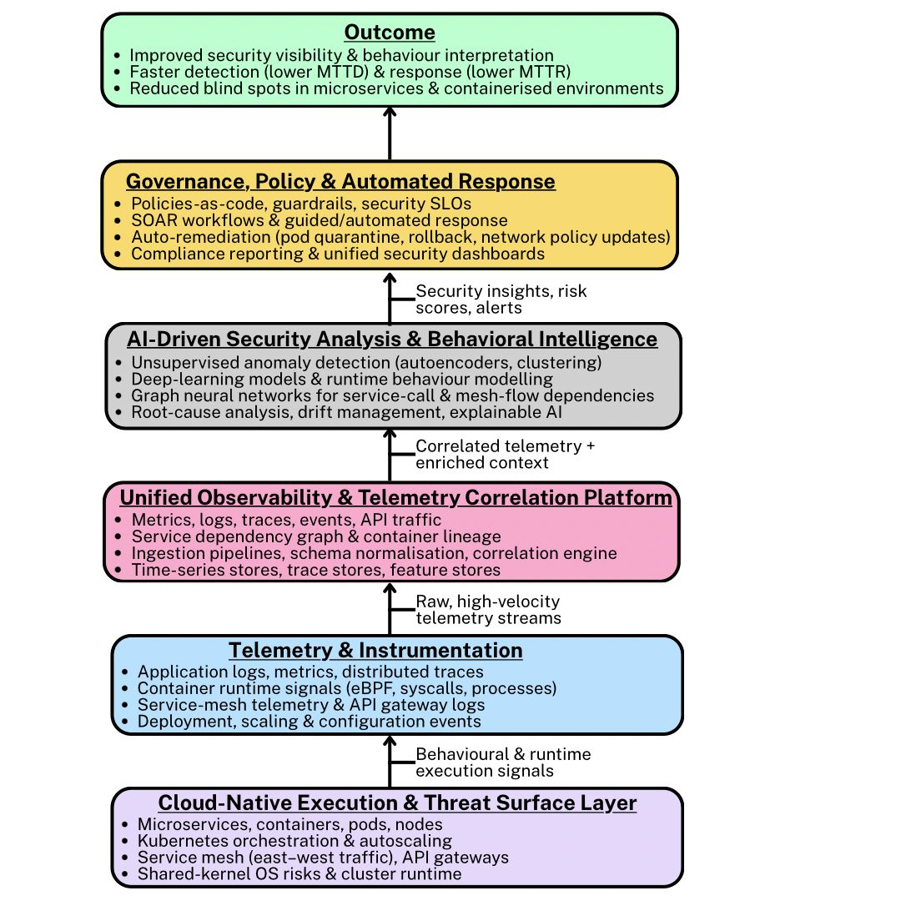
Figure 1: The AI-Driven Observability Security Framework (AI-DOSM)
The first layer, the Cloud-Native Execution and Threat Surface Layer, represents the operational environment in which security risks emerge, including microservices, containers, Kubernetes orchestration, service-mesh communication and API gateways. Above this, the Telemetry and Instrumentation Layer captures the diverse, high-velocity signals produced by these distributed workloads, such as logs, metrics, distributed traces, runtime events and service-mesh traffic, that literature identifies as difficult to observe and correlate due to their volume, variety and ephemerality. The third component, the Unified Observability and Telemetry Correlation Platform, addresses fragmentation by aggregating these signals into a coherent data substrate, performing schema normalisation, reconstructing service-dependency graphs and enriching telemetry with contextual metadata to overcome the visibility gaps highlighted in existing monitoring tools. The fourth layer, the AI-Driven Security Analytics and Behavioural Intelligence Layer, applies deep-learning models, unsupervised anomaly detection, graph neural networks and adaptive learning techniques to interpret microservice behaviour, detect subtle deviations and localise threats across distributed components; thereby addressing the limitations of rule-based detection and the challenges of feature drift documented in prior studies. Insights generated by this layer feed into the Governance, Policy and Automated Response Layer, which operationalises detection outcomes through security-policy enforcement, automated remediation actions, SOAR workflows and compliance reporting, thereby supporting practical security operations in dynamic cloud-native environments. Collectively, these interconnected layers enhance system-wide security visibility, improve the detection and interpretation of security events and reduce the monitoring blind spots associated with ephemeral microservices

3. Methodology
This study employed a quantitative research design to investigate security-visibility challenges, evaluate limitations in existing observability practices and assess the performance of an AI-driven anomaly-detection model within cloud-native microservices environments. Open-source datasets were selected to ensure transparency and reproducibility, including MITRE ATT&CK container-technique records, the OpenTelemetry Demo telemetry dataset and the Google Cloud Microservices Demo telemetry combined with Kubernetes audit logs.
To address the first objective, a descriptive statistical technique was applied to quantify adversarial behaviours using frequency distributions and co-occurrence patterns. Frequencies were computed as:
$$FrequencyRate =\frac{TechniqueCount}{TotalObservedEvents}$$
Co-occurrences were derived through pairwise counting of jointly occurring attack techniques.
For the second objective, telemetry coverage and signal-integrity gaps were assessed through time-series telemetry-coverage quantification. Coverage and missing-signal ratios were computed as:
$$CoverageRate =\frac{ObservedTelemetryEvents}{ExpectedTelemetryEvents}$$
$$MissingSpanRate =\frac{MissingSpans}{TotalTraceSpans}$$
$$LogMetricCorrelation =\frac{CorrelatedEvents}{TotalEvents}$$
To fulfil the third objective, an unsupervised anomaly-detection model using a deep-autoencoder architecture was implemented to learn normal behavioural patterns from multi-modal telemetry. Anomaly scores were generated from reconstruction error using:
$AnomalyScore = |X - X_{reconstructed}$|
Model performance was validated using precision, recall, F1-score, ROC–AUC and PR–AUC, defined respectively as:
$$Precision =\frac{TP}{TP+FP}$$
$$Recall =\frac{TP}{TP+FN}$$
$$F1 = 2·\frac{Precision·Recall}{Precision+Recall}$$
This methodological structure ensured consistent measurement across datasets while enabling detailed assessment of both visibility gaps and the effectiveness of the proposed AI-driven observability model.

4. Results and Discussion
Security Visibility Challenges in Cloud-Native Microservices
This objective examines the visibility challenges affecting monitoring in cloud-native microservices and containerised environments. A quantitative analysis was used to identify patterns in adversarial behaviours associated with container-specific attack techniques. The findings provide insight into security blind spots that frequently undermine effective observability across distributed systems.
Table 1: Summary of frequency distribution of the analysed techniques
MITRE Container Technique | Frequency Count | Percentage (%)
Lateral Movement | 42 | 26.2%
Container Escape | 33 | 20.6%
API Exploitation | 48 | 30.0%
Privilege Escalation | 22 | 13.8%
Persistence | 10 | 6.2%
Credential Access | 5 | 3.1%
Table 1 summarises the frequency distribution of the analysed techniques, highlighting the patterns of adversarial behaviour most commonly encountered in containerised systems.
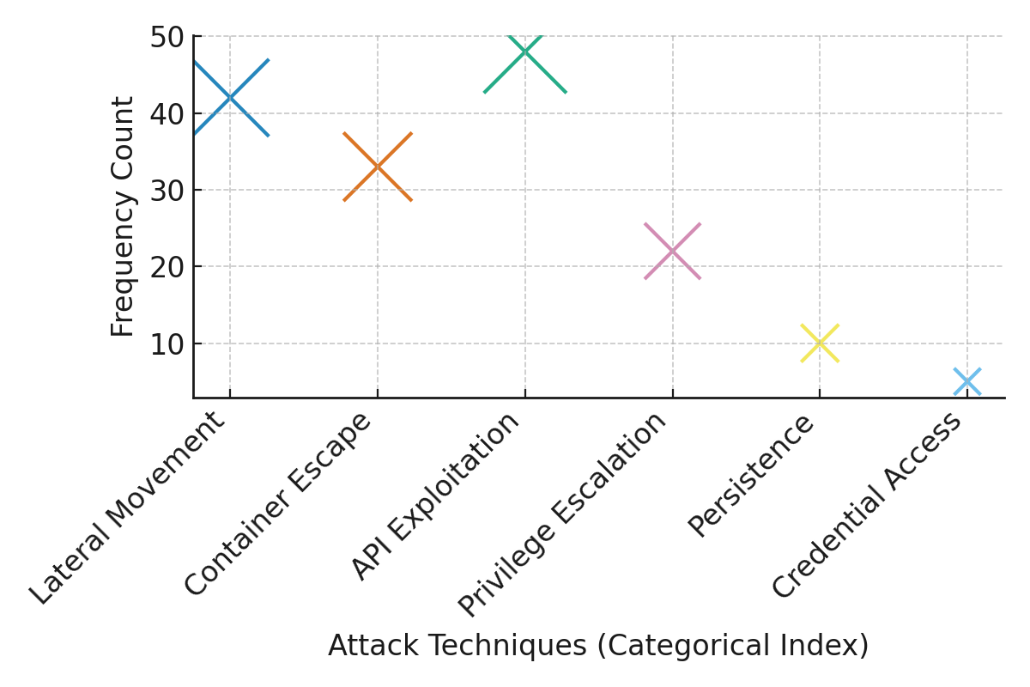
Figure 2: Distribution of attack technique frequencies
Figure 2 displays the distribution of attack technique frequencies, showing that API Exploitation and Lateral Movement appear most prominently within the dataset.
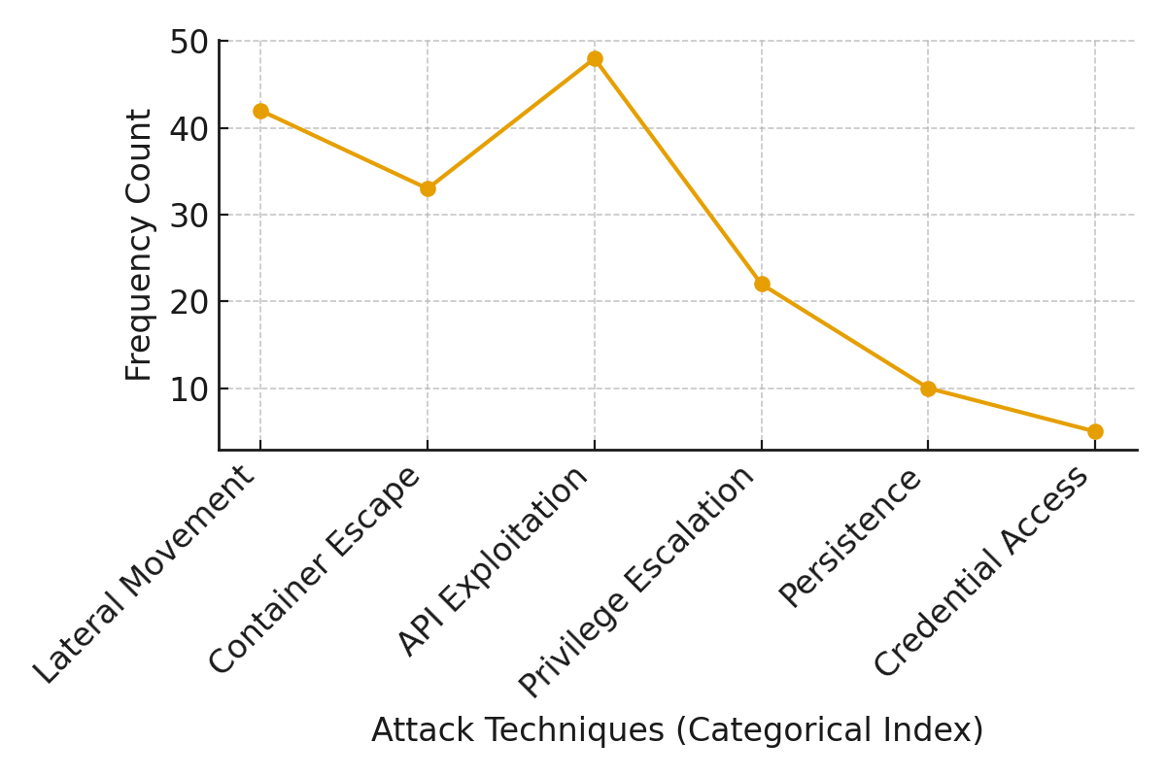
Figure 3: Sequential trend in occurrence values
Figure 3 illustrates the sequential trend in occurrence values, revealing distinct peaks that reinforce the dominance of specific container-related adversarial behaviours.
These findings underscore that existing tools struggle to track inter-service interactions or reconstruct attack paths effectively, thereby limiting situational awareness in dynamic cloud-native environments.

Limitations of Existing Observability and Monitoring Practices
To evaluates existing observability and security monitoring practices by quantifying telemetry coverage and signal consistency across microservices, a time‑series telemetry coverage quantification technique was applied to identify gaps in distributed tracing, log visibility, metrics instrumentation, service‑mesh telemetry, and API gateway monitoring.
Table 2: Summary of the telemetry coverage and correlation statistics.
Telemetry Dimension | Expected Events | Observed Events | Coverage Rate (%) | Missing Span Rate (%) | Log–Metric Correlation (%)
Trace Spans | 12500 | 8975 | 71.8 | 28.2 | -
Service Logs | 50000 | 39420 | 78.8 | - | 42.5
Metrics | 18000 | 14790 | 82.2 | - | 42.5
Service-Mesh | 9200 | 6110 | 66.4 | - | 37.4
K8s Events | 7600 | 5330 | 70.1 | - | -
API Gateway | 6000 | 3780 | 63.0 | - | 28.7
Table 2 presents the telemetry coverage and correlation statistics, highlighting areas where monitoring reliability weakens, particularly within service‑mesh and API‑gateway layers.
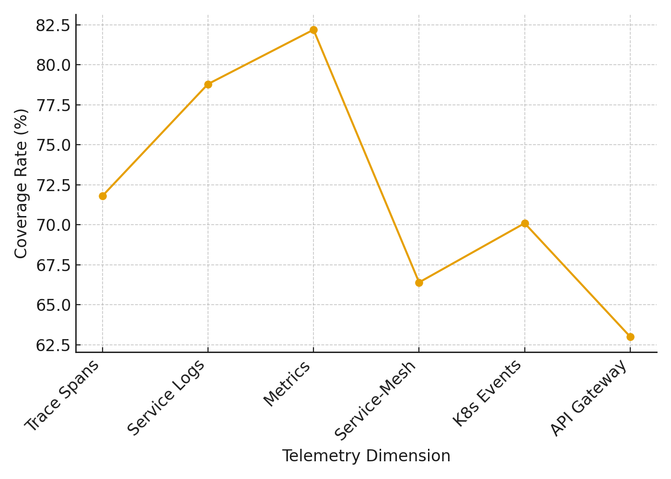
Figure 4: Visualization of the coverage performance across telemetry dimensions
Figure 4 illustrates coverage performance across telemetry dimensions, showing significant coverage shortfalls in API Gateway and Service‑Mesh telemetry.
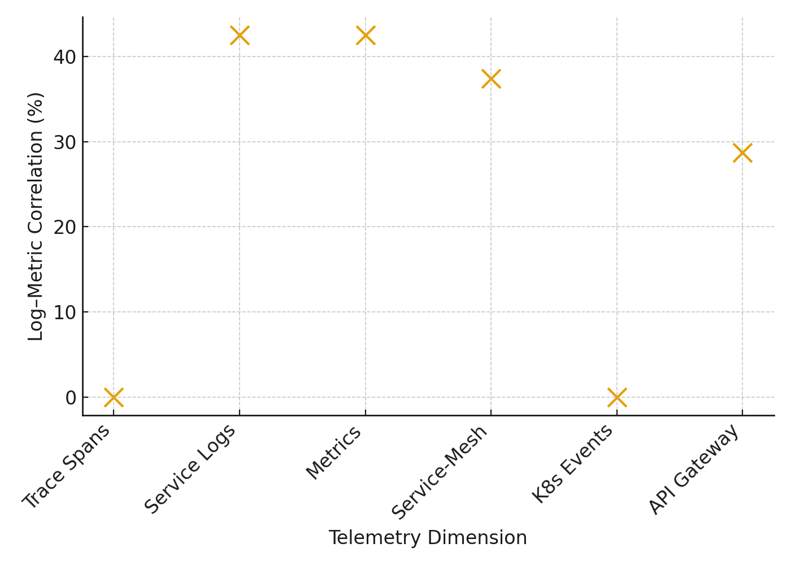
Figure 5: Visualization of log–metric correlation levels
Figure 5 presents log–metric correlation levels, indicating weak cross‑signal alignment that contributes to fragmented observability in dynamic microservices.
These results confirm that traditional monitoring pipelines are unable to sustain coherent, multi-layer visibility or provide timely behavioural insights in rapidly scaling microservices architectures.

Development of an AI-Driven Observability Model for Enhanced Detection
In developing an artificial intelligence-driven observability model designed to enhance the detection and interpretation of security events in microservices-based systems, an unsupervised anomaly detection approach using autoencoder reconstruction error was implemented to evaluate the model’s performance across multiple telemetry types.
Table 3 presents the comparative performance between traditional rule-based monitoring systems and the AI-driven autoencoder model.
Table 3: Summary of the comparative performance
Metric | Rule-Based Monitoring | AI Autoencoder Model
True Positives (TP) | 810 | 1,260
False Negatives (FN) | 690 | 240
False Positives (FP) | 4,500 | 1,980
True Negatives (TN) | 94,000 | 96,520
Precision (%) | 15.3 | 39.0
Recall (%) | 54.0 | 84.0
F1-Score (%) | 24.1 | 53.3
ROC–AUC | 0.79 | 0.96
PR–AUC | 0.21 | 0.71
Avg Detection Latency (s) | 127 | 18
Table 4 summarises the anomaly detection performance of the AI model across different telemetry dimensions, illustrating recall and false positive behaviours.
Table 4: Summary of the anomaly detection performance of the AI model
Telemetry Dimension | True Anomalies | TP | Recall (%) | FP | FP Rate (%)
Service Logs | 520 | 432 | 83.1 | 710 | 1.1
Trace Spans | 430 | 370 | 86.0 | 560 | 0.9
Metrics | 290 | 236 | 81.4 | 340 | 0.6
Kubernetes Audit Logs | 160 | 137 | 85.6 | 230 | 0.4
API Gateway | 100 | 85 | 85.0 | 140 | 0.5
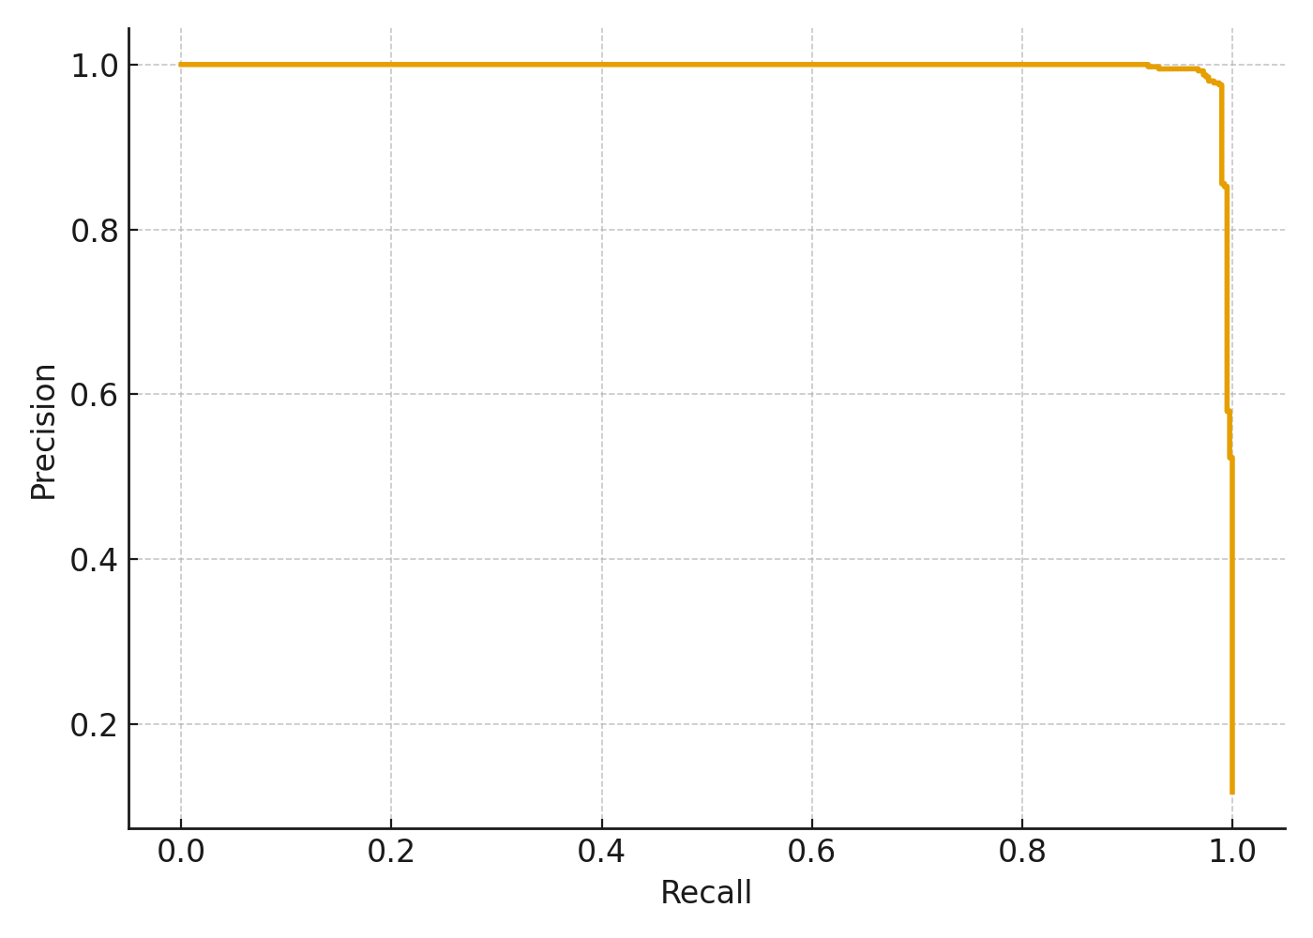
Figure 6: Visualization of the precision and recall performance
Figure 6 shows the precision–recall performance of the autoencoder model, demonstrating significantly improved detection capability across varying anomaly thresholds.
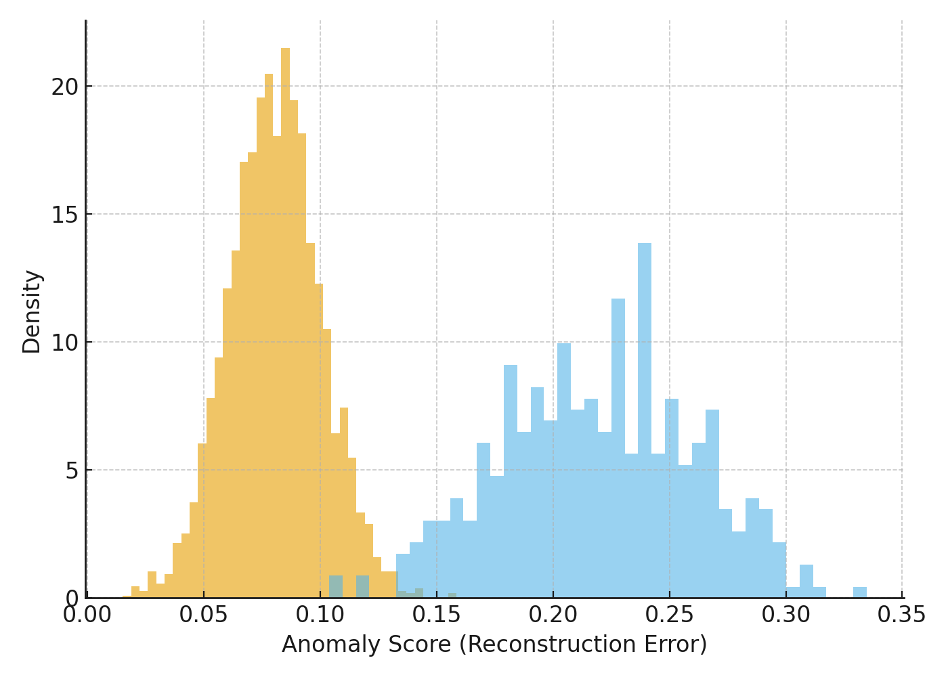
Figure 7: Visualization of the distribution of anomaly scores for normal and anomalous events.
Figure 7 visualises the distribution of anomaly scores for normal and anomalous events, indicating clear separation boundaries that validate the model’s interpretability and detection accuracy.
The model consistently detected anomalous behaviours across logs, traces, Kubernetes events and API telemetry, demonstrating that AI-enabled correlation and behavioural modelling can address the visibility and detection limitations identified in the earlier objectives.
Discussion
The findings from this study collectively reinforce the argument that cloud-native microservices create conditions in which security visibility is persistently constrained, and that existing monitoring tools are not sufficiently equipped to manage these challenges. The frequency patterns observed in Table 1 reveal that API Exploitation and Lateral Movement constitute the largest proportions of adversarial behaviours within containerised systems. This aligns with observations by Kumar (2025) and Hutasuhut et al. (2024), who emphasise that east–west communication flows and API-mediated interactions remain insufficiently monitored in distributed architectures. The prominence of these techniques, further illustrated in Figure 2 and the sequential trends shown in Figure 3, indicates that attackers frequently exploit weak runtime correlation and fragmented visibility to move between services without detection, supporting the concerns raised by Minna and Massacci (2023) regarding blind spots in microservice interactions.
The visibility issues highlighted in Objective 1 become more evident when viewed alongside the telemetry coverage results from Objective 2. As shown in Table 2, critical observability components such as service-mesh and API-gateway telemetry exhibit coverage rates below 70%, thereby confirming the fragmentation reported in industry surveys such as Grafana Labs (2023). The significant missing-span rate in distributed tracing supports the argument by Borges et al. (2024) that dynamic scaling, ephemeral workloads and inconsistent instrumentation prevent monitoring tools from reconstructing service-call sequences reliably. This inability to maintain complete trace continuity not only introduces blind spots but also restricts the depth of behavioural insight required for timely threat identification. The weak log–metric correlation values, visually represented in Figure 5, further validate the assertion by Faseeha et al. (2025) that disjointed telemetry streams impede effective anomaly detection and root-cause analysis. Therefore, the results from Objective 2 offer empirical confirmation that existing observability pipelines are unable to maintain coherent, multi-layered visibility across distributed systems, particularly where security-critical events emerge inside rapidly changing execution environments.
In light of these challenges, the improved detection outcomes produced by the AI-driven observability model demonstrate that machine-learning approaches offer substantial advantages for interpreting complex system behaviour. Table 3 shows that the autoencoder-based model significantly outperforms rule-based monitoring across all major detection metrics, including precision, recall and F1-score. This improvement is consistent with findings from Nobre et al. (2023) and the 2024 study on AI-based anomaly detection pipelines, which note that unsupervised models are more capable of identifying novel or subtle deviations in microservices telemetry. The marked reduction in false negatives also supports the claims made by Vibhute and Nakum (2024) regarding the strength of deep-learning models in detecting irregular patterns that static monitoring rules often miss. The model’s enhanced detection efficiency is further supported by the precision–recall performance shown in Figure 6, which illustrates its stability across varying anomaly thresholds.
Moreover, the distributional separation of anomaly scores in Figure 7 confirms that the autoencoder model was able to distinguish, with clarity, the behavioural differences between normal and anomalous events. This finding is aligned with arguments by Li et al. (2024) and Mirnajafizadeh et al. (2025), who emphasise the importance of learning temporal and relational dependencies in microservice datasets. The per-dimension results in Table 4 show that high recall values were achieved consistently across service logs, distributed traces, Kubernetes audit logs and API-gateway telemetry. This consistency reinforces the position of Pentaparthi (2025) and Garnimitta (2025), who argue that AI-enabled correlation and behavioural modelling can significantly reduce detection latency and improve observability across heterogeneous telemetry sources. The relatively low false-positive rates across all telemetry dimensions also address concerns raised by Araujo et al. (2023) and Venugopal (2025) regarding alert fatigue and the operational sustainability of AI-driven monitoring systems.
5. Conclusion and Recommendations
The study demonstrates that security visibility gaps in cloud-native microservices arise from fragmented telemetry, incomplete tracing and insufficient correlation across system layers. Existing monitoring tools fail to capture the complexity of distributed environments, while the AI-driven observability model substantially improves detection accuracy, reduces false negatives and strengthens behavioural interpretation across diverse telemetry sources. These outcomes highlight the need for operational strategies that reinforce both observability depth and adaptive analytics. Accordingly, the following recommendations support practical adoption of the study’s insights:
- Organisations should integrate unified telemetry pipelines that consolidate logs, traces and metrics into a single contextualised data layer.
- Security teams should deploy unsupervised anomaly-detection models to improve early identification of subtle lateral behaviours.
- Cloud-native platforms should enforce consistent instrumentation across microservices, service meshes and API gateways.
- Regulators and industry bodies should encourage standards for AI-enabled observability to improve interoperability and operational reliability.

.

References
Abba, S. S., Olaniyi, O. M., Oladoyinbo, O. B., Okunleye, O. J., & Ejiofor, V. O. (2025). AI-Driven Automation of Cybersecurity Certification Processes: Evaluating Efficiency, Transparency and Risk Mitigation in Digital Governance Systems. Journal of Engineering Research and Reports, 27(12), 70–91. https://doi.org/10.9734/jerr/2025/v27i121728
Alboqmi, R., & Gamble, R. F. (2025). Enhancing Microservice Security Through Vulnerability-Driven Trust in the Service Mesh Architecture. Sensors, 25(3), 914. https://doi.org/10.3390/s25030914
Araujo, I., Antunes, N., & Vieira, M. (2023). Evaluation of Machine Learning for Intrusion Detection in Microservice Applications. LADC ’23: Proceedings of the 12th Latin-American Symposium on Dependable and Secure Computing. https://doi.org/10.1145/3615366.3615375
Borges, M. C., Bauer, J., Werner, S., Gebauer, M., & Tai, S. (2024, July 12). Informed and Assessable Observability Design Decisions in Cloud-native Microservice Applications. ArXiv.org. https://doi.org/10.48550/arXiv.2403.00633
Chatterjee, P. (2024). Emerging Security Challenges in The Microservices Application. IRE Journals |, 7(8). https://www.irejournals.com/formatedpaper/1706559.pdf
Egonwanne, C. H., Olaniyi, O. O., Eweoya, A. O., Obrik-Uloho, E. P., & Olasege, R. O. (2025). A Novel AI-Driven Homomorphic Encryption Framework for Secure Real-Time Telehealth Data Analysis. Asian Journal of Research in Computer Science, 18(11), 1–17. https://doi.org/10.9734/ajrcos/2025/v18i11775
Ejiofor, V. O. (2025). The Cloud is Not Infallible: Lessons from Amazon’s Global Outage and Strategic Pathways for Building Resilient Virtual Enterprises. Journal of Engineering Research and Reports, 27(12), 21–43. https://doi.org/10.9734/jerr/2025/v27i121725
Faseeha, U., Syed, H. J., Samad, F., Zehra, S., & Ahmed, H. (2025). Observability in Microservices: An In-Depth Exploration of Frameworks, Challenges, and Deployment Paradigms. IEEE Access, 04, 1–1. https://doi.org/10.1109/access.2025.3562125
Garnimitta, B. (2025). Federated AI Observability in Multi-Cloud Microservices: A Secure and Scalable Federated Learning Perspective. International Journal of Engineering and Advanced Technology Studies, 13(3), 20–31. https://doi.org/10.37745/ijeats.13/vol13n32031
Grafana Labs. (2023). Observability Survey Report 2023 - key findings | Grafana Labs. Grafana Labs. https://grafana.com/observability-survey/2023/
Hutasuhut, N. R. P., Amri, M. G., & Aji, R. F. (2024). Security Gap in Microservices: A Systematic Literature Review. International Journal of Advanced Computer Science and Applications, 15(12). https://doi.org/10.14569/ijacsa.2024.0151218
IBM. (2024). Cost of a Data Breach Report 2024. https://cdn.table.media/assets/wp-content/uploads/2024/07/30132828/Cost-of-a-Data-Breach-Report-2024.pdf
Keyaerts, N. (2024). Identification and prevention of lateral movement in Kubernetes. https://www.cs.ru.nl/masters-theses/2024/M_van_Haren___Identification_and_Prevention_of_Lateral_Movement_in_Kubernetes.pdf
Kidd, C. (2023, March 1). Monitoring, Observability & Telemetry: Everything You Need To Know for Observable Work. Splunk-Blogs. https://www.splunk.com/en_us/blog/learn/observability-vs-monitoring-vs-telemetry.html
Kolo, F. (2023). Insights in Cybersecurity & Business Intelligence: A Dual Perspective: Unlocking Security Insights and Business Growth: Intrusion Detection Strategies and Sales Forecasting Techniques. LAP LAMBERT Academic Publishing. https://www.amazon.com/Insights-Cybersecurity-Business-Intelligence-Perspective/dp/6207450841
Kumar, L. M. S. (2025). Security Across Services in Microservice Architecture. International Journal of Computer Science and Engineering Research and Development, 15(3), 89–101. https://doi.org/10.63519/IJCSERD_15_03_008
Li, Z., Shi, J., & Van Leeuwen, M. (2024). Graph Neural Networks based Log Anomaly Detection and Explanation. ArXiv (Cornell University), 306–307. https://doi.org/10.1145/3639478.3643084
Lumigo. (2024, October 30). What Is Observability? Concepts, Use Cases, and Technologies. Lumigo. https://lumigo.io/what-is-observability-concepts-use-cases-and-technologies/
Minna, F., & Massacci, F. (2023). SoK: Run-time security for cloud microservices. Are we there yet? Computers & Security, 127, 103119. https://doi.org/10.1016/j.cose.2023.103119
Moreschini, S., Pour, S., Lanese, I., Balouek, D., Bogner, J., Li, X., Pecorelli, F., Soldani, J., Truyen, E., & Taibi, D. (2025). AI Techniques in the Microservices Life-Cycle: a Systematic Mapping Study. Computing, 107(4). https://doi.org/10.1007/s00607-025-01432-z
Morić, Z., Redžepagić, J., Bencarić, I., & Dakić, V. (2025). The role of container security in application development. Edelweiss Applied Science and Technology, 9(1), 1243–1261. https://doi.org/10.55214/25768484.v9i1.4382
Munthe, E. S. (2025). Cloud-Native Transformations: Microservices, Kubernetes, and Security Frameworks in Practice. Digitus Journal of Computer Science Applications, 3(2), 65–77. https://doi.org/10.61978/digitus.v3i2.880
Obrik-Uloho, E. P. (2025). Elevating Continuous Verification through Advanced Behavioral Analytics: A Deep-Dive Framework for Combating Insider Threats and Account Takeovers in Modern Cybersecurity. Journal of Engineering Research and Reports, 27(10), 316–337. https://doi.org/10.9734/jerr/2025/v27i101676
Obrik-Uloho, E. P., Olaniyi, O. O., Adebiyi, O. O., Olasege, R. O., & Oyekunle, S. M. (2025). Dark Data in Digital Health: A Predictive Framework for Identifying and Utilizing Underreported Clinical Signals. Asian Journal of Research in Computer Science, 18(11), 60–74. https://doi.org/10.9734/ajrcos/2025/v18i11779
Obrik-Uloho, E. P., Opeke, G. C., Balogun, A. Y., Olasege, R. O., & Udechukwu, L. M. (2025). Proactive Cyber-Threat Intelligence and Predictive Analytics for Protecting At-Home Medical IoT Devices against Zero-Day Exploits. Journal of Engineering Research and Reports, 27(11), 218–236. https://doi.org/10.9734/jerr/2025/v27i111696
Olaniyi, O. M. (2025a). A Quantitative Approach to Understanding Machine Learning Adoption for Cybersecurity in E-commerce through the UTAUT Model. Journal of Engineering Research and Reports, 27(11), 286–304. https://doi.org/10.9734/jerr/2025/v27i111701
Olaniyi, O. M. (2025b). Adoption Dynamics and Implementation Strategies of Machine Learning for Cybersecurity Threat Detection in the E-Commerce Sector. Journal of Engineering Research and Reports, 27(11), 369–389. https://doi.org/10.9734/jerr/2025/v27i111707
Olaniyi, O. M. (2025c). Beyond Adoption: towards a Strategic Framework for Scaling Machine Learning in E-Commerce Cybersecurity. Asian Journal of Research in Computer Science, 18(11), 87–106. https://doi.org/10.9734/ajrcos/2025/v18i11781
Olutimehin , A. T., Olaniyi , O. O., Ogunmolu , A. M., Kolo, F. H. O., & Salami , I. A. (2025). Cloud-Based AI Solutions for Real-time Monitoring of E-commerce Compliance and Risk. Journal of Engineering Research and Reports, 27(7), 127–147. https://doi.org/10.9734/jerr/2025/v27i71566
Olutimehin, A. T., Olaniyi, O. O., Popoola, A. D., Ogunmolu, A. M., & Kolo, F. H. (2025). AI and IoT Integration for Predictive Maintenance and Risk Management in Smart Manufacturing. Asian Journal of Research in Computer Science, 18(7), 120–142. https://doi.org/10.9734/ajrcos/2025/v18i7724
Oyekunle, S. M., Popoola, A. D., Kolo, F. H. O., Ogunmolu, A. M., & Adesokan-Imran, T. O. (2025). Intelligent Fraud Prevention Information Banking: A Data Governance- Centric Approach Using Behavioural Biometrics. Asian Journal of Research in Computer Science, 18(5), 525–543. https://doi.org/10.9734/ajrcos/2025/v18i5672
Pentaparthi, S. K. R. (2025). Observability for AI-Enabled Cloud-Native Networks: A Unified Framework Integrating OpenTelemetry, CortexDB, Loki, GenAI, and RAG. International Journal of Scientific Research in Computer Science, Engineering and Information Technology, 11(2), 3142–3150. https://doi.org/10.32628/cseit25112811
Perumal, A. P. (2024). Cloud-Native Architecture Observability and Compliance Challenges: A Comprehensive Reference Architecture Approach. Library Progress International, 44(3), 25718–25723. https://bpasjournals.com/library-science/index.php/journal/article/view/3249
Qasem Abu Al-Haija, & Saleh Zein-Sabatto. (2020). An Efficient Deep Learning-Based Detection and Classification System for Cyber-Attacks in IoT Communication Networks. https://doi.org/10.20944/preprints202011.0508.v2
Red Hat. (2020, June 20). Kubernetes adoption, security, and market trends report 2023. Www.redhat.com. https://www.redhat.com/en/resources/kubernetes-adoption-security-market-trends-overview
Salami, I. A., Popoola, A. D., Gbadebo, M. O., Kolo, F. H. O., & Adesokan-Imran, T. O. (2025). AI- Powered Behavioural Biometrics for Fraud Detection in Digital Banking: A Next-Generation Approach to Financial Cybersecurity. Asian Journal of Research in Computer Science, 18(4), 473–494. https://doi.org/10.9734/ajrcos/2025/v18i4632
Sekar, S. P. (2025). AI-driven cloud-native observability: Leveraging LLMs for application modernization in a platform as a service model. World Journal of Advanced Research and Reviews, 26(2), 347–358. https://doi.org/10.30574/wjarr.2025.26.2.1621
Serban, A., van der Blom, K., Hoos, H., & Visser, J. (2024). Software engineering practices for machine learning — Adoption, effects, and team assessment. Journal of Systems and Software, 209, 111907. https://doi.org/10.1016/j.jss.2023.111907
Thiyagarajan, G., & Nayak, P. (2025). Docker under Siege: Securing Containers in the Modern Era. International Journal of Scientific Research in Computer Science Engineering and Information Technology, 11(1), 3674–3719. https://doi.org/10.32628/cseit25112773
Tzanettis, I., Androna, C.-M., Zafeiropoulos, A., Fotopoulou, E., & Papavassiliou, S. (2022). Data Fusion of Observability Signals for Assisting Orchestration of Distributed Applications. Sensors, 22(5), 2061. https://doi.org/10.3390/s22052061
Udechukwu, L. M., Opeke, G. C., Obrik-Uloho, E. P., Metibemu, O. C., & Olasege, R. O. (2025). Information Governance Framework for AI-Generated Synthetic Patient Data in Healthcare Research: Balancing Utility, Privacy and Algorithmic Bias Mitigation. Asian Journal of Advanced Research and Reports, 19(11), 30–45. https://doi.org/10.9734/ajarr/2025/v19i111193
Venugopal, P. (2025). The Synergy of Observability and AIOps: Driving Proactive Operational Intelligence. Zenodo (CERN European Organization for Nuclear Research), 4(8). https://doi.org/10.5281/zenodo.16936354
Vibhute, A. D., & Nakum, V. (2024). Deep learning-based network anomaly detection and classification in an imbalanced cloud environment. Procedia Computer Science, 232, 1636–1645. https://doi.org/10.1016/j.procs.2024.01.161

