Original Research Article
IMPROVEMENT AND PERFORMANCE EVALUATION OF A DEVELOPED COCONUT DEHUSKING MACHINE

Abstract: Manual coconut dehusking is slow, labour-intensive, and often unsafe, which has led to the development of mechanised dehusking machines. However, many existing machines still suffer from long processing times and inefficient performance. This study presents the design improvement and performance evaluation of a developed coconut dehusking machine aimed at addressing these challenges. The major modifications were made to the existing machine, which included improvements to the drive system, dehusking blade configuration, and structural alignment. The performance of the improved machine was evaluated and compared with the original design using ten coconut samples. Also, the dehusking time and energy consumption were used as the main performance indicators. The results of the study showed a clear reduction in dehusking time, with the improved machine operating within 9–13 seconds per coconut, compared to 15–25 seconds for the original machine. The improved design also demonstrated better energy efficiency due to reduced processing time. Overall, the results confirm that the implemented improvements have significantly enhanced the performance of the coconut dehusking machine, making it more efficient and suitable for small- to medium-scale coconut processing.
Keywords: Coconut dehusking machine; design improvement; performance evaluation; dehusking time; energy consumption
INTRODUCTION
Coconut (Cocos nucifera) is one of the most important crops cultivated in tropical countries worldwide. It plays a major role in supporting rural livelihoods and national economies because almost every part of the coconut can be used. The coconut meat is processed into products such as copra and coconut oil, while the outer husk is used to produce coir fibre for ropes, mats, brushes, and other materials (Adedipe, 2024). Because of this wide range of uses, coconut processing provides income for farmers, processors, and traders in many developing countries. Before any of these useful products can be made, the hard outer husk of the coconut must first be removed. This process is known as dehusking. The coconut husk is very tough and tightly attached to the shell, which makes dehusking a difficult task. Traditionally, dehusking is done by hand using simple tools such as machetes, sharp metal spikes, or pointed wooden stakes fixed into the ground (CD3WD Project, n.d.). Although this method is common, it has many serious problems.
Manual dehusking is very slow and requires a lot of physical effort. Removing the husk from a single coconut can take several minutes, especially when the worker becomes tired (Adedipe, 2024). The work is also physically demanding because the husk is hard, fibrous, and heavy, which causes fatigue after long hours of work. In addition, manual dehusking is dangerous. Workers are often exposed to cuts, puncture wounds, and other injuries when the tool slips or when too much force is applied (Baskaran et al., 2024). Because of these challenges, farmers and small-scale processors are unable to dehusk large quantities of coconuts in a short time, which reduces productivity and increases labour costs. Due to these difficulties, researchers and engineers have long looked for better ways to remove coconut husks. This led to the development of mechanised coconut dehusking machines. These machines are designed to reduce human effort and improve safety by using mechanical power to remove the husk. Most mechanised dehusking machines operate with electric motors or other power sources that drive spiked rollers, blades, or gripping mechanisms that tear the husk away from the shell (Adebimpe et al., 2024). By using machines, the dehusking process becomes faster, more consistent, and less physically stressful for workers.
Studies have shown that mechanised dehusking machines can significantly improve productivity. Some machines are capable of processing dozens or even hundreds of coconuts per hour, which is far more than what can be achieved through manual labour (Baskaran et al., 2024). In addition, machines reduce the risk of injury because the worker no longer needs to hold the coconut close to sharp tools. Mechanisation also helps reduce labour costs, as fewer workers are required to process the same quantity of coconuts (Adedipe, 2024). However, despite these advantages, many existing coconut dehusking machines still have limitations. Some machines consume too much energy, making them expensive to operate, especially in areas with unstable electricity supply. Others are too large, complex, or costly for small- and medium-scale farmers to afford or maintain (Baskaran et al., 2024).
Although many studies have reported different designs of coconut dehusking machines, there is still a clear gap in the literature. Most previous studies either focus mainly on describing the design of the machine or on reporting performance results without clearly linking those results to specific design changes. This makes it difficult to understand how particular mechanical improvements, such as changes in blade arrangement, motor power, or transmission systems, directly affect performance indicators like processing time and energy consumption (Baskaran et al., 2024). To address this gap, the present study combines design improvement with performance evaluation in a single investigation. In this study, key components of an existing coconut dehusking machine were modified to improve efficiency. The improved machine was then tested and compared with the original design to measure differences in dehusking time and energy consumption.
LITERATURE REVIEW
Coconut dehusking has traditionally been performed manually using sharp tools, a method that requires considerable physical effort and exposes operators to injuries and fatigue. As coconut processing volumes increase, these limitations have driven the development of mechanised dehusking technologies aimed at improving safety and productivity (Owuama et al., 2025). Mechanised coconut dehusking machines reported in the literature employ different operating principles, including spiked rollers, cutting blades, gripping mechanisms, and automated feeding systems. Studies have shown that such machines can significantly reduce dehusking time and labour requirements when compared to manual methods (Pascua et al., 2018). For instance, Adebimpe et al. (2024) developed an automated coconut dehusking machine that achieved substantial reductions in processing time, while Onyenanu et al. (2025) highlighted the importance of structural integrity in ensuring consistent machine performance.
Several locally developed machines have also been reported, with emphasis on affordability and the use of locally sourced materials. Adedipe (2024) evaluated a cost-effective coconut dehusking machine and reported improved safety and reduced physical stress, although the dehusking time remained relatively high. Other studies have demonstrated that machine performance is strongly influenced by design parameters such as motor power, blade geometry, roller alignment, and transmission efficiency (Rahman et al., 2020; Singh & Kumar, 2019; Oladimeji et al., 2021).
Performance evaluation of coconut dehusking machines commonly focuses on indicators such as dehusking time, throughput capacity, efficiency, and energy consumption. Dehusking time, in particular, is a critical metric because it directly reflects productivity and operational efficiency (Rahman et al., 2020; Owuama et al., 2025). Despite the growing body of research, many studies either concentrate on machine development without a detailed performance comparison or present performance results without clearly linking them to specific design modifications.
From the reviewed literature, it is evident that there is limited work that systematically examines how specific design improvements influence the performance of an existing coconut dehusking machine through direct experimental comparison. This gap underscores the need for studies that integrate machine learning with quantitative performance evaluation. The present study addresses this gap by modifying a previously developed coconut dehusking machine (Oluwayanmife et al., 2026) and experimentally assessing the impact of the improvements on dehusking time and energy consumption.
MATERIALS AND METHODS
Description of the Developed Coconut Dehusking Machine
The coconut dehusking machine used in this study was originally designed, simulated, and fabricated in an earlier work by Oluwayanmife et al. (2026). In that study, the conceptual design, analytical calculations, CAD modelling, simulation, and fabrication of the machine were presented, and its basic operational feasibility was experimentally validated. The machine consists of a steel frame, a geared electric motor, dehusking rollers fitted with blades, a chain and sprocket transmission system, and supporting structural components (Oluwayanmife et al., 2026). Although the developed machine was functional and suitable for small- and medium-scale coconut processing, operational testing revealed certain performance limitations, including relatively long dehusking time and moderate energy efficiency. These limitations informed the present study, which focuses on improving key components of the original machine and evaluating the resulting performance enhancements. The description provided in this section, therefore, serves as a baseline, while detailed attention is given to the design improvements implemented in this work.
Design Improvements Implemented
The shortcomings of the machine showed that it needed improvement to work faster, use energy more efficiently, and handle coconuts more effectively. So, a careful inspection of the machine was done, and it was discovered that several problems were affecting its performance. One major issue was the electric gear reduction motor. The original motor seen in figure 1 did not provide enough turning force, known as torque, to handle the resistance created when the spikes tried to pull off tough coconut husks. Because of this, the machine struggled under load, which reduced productivity and slowed down the dehusking process. To address this limitation, a 3 hp geared electric motor was introduced, as shown in Figure 2, which provided higher torque and smoother operation under load. This modification significantly improved the dehusking performance of the machine.
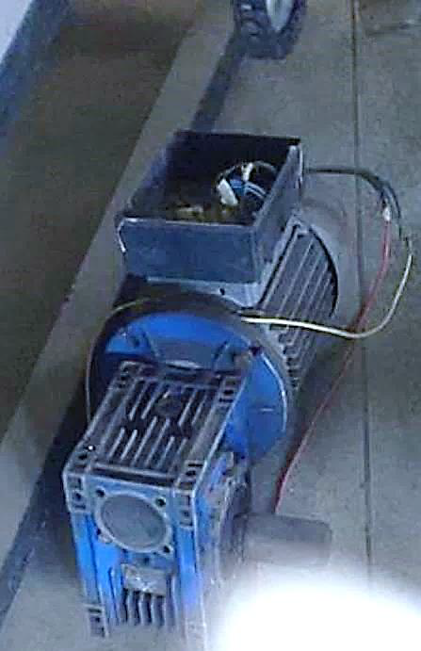
Figure 1 The 2hp Electric Gear Reduction Motor (FUTA Workshop, 2021)
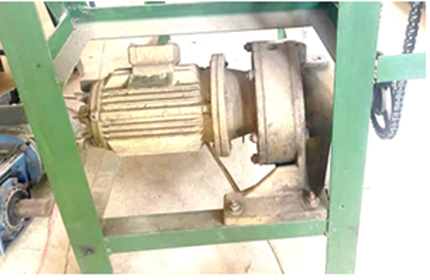
Figure 2: The 3hp Electric Gear Reduction Motor (FUTA Workshop, 2023)
The angle between the roller and the machine frame was another issue. This angle plays an important role in how well the coconut makes contact with the spikes. In the original configuration, the blades were positioned at an angle of 30° with the frame as illustrated in Figure 3. This made the design not steep enough and reduced proper contact between the coconut and the rollers. This poor alignment made the dehusking process slower and less effective. These problems were also observed with the chains and sprockets that transfer power from the motor to the rotating shaft. Many of these parts were slightly misaligned and worn out. These conditions reduced smooth power transmission and increased the risk of machine failure during operation. Similarly, several bolts and nuts holding the machine together were of poor quality. Some had already started to rust, while others had become loose. This weakened the machine structure, affected safety, and reduced the machine’s overall lifespan. To address this limitation, the angle betwenn the dehusking rollers and the machine frame was modified to improve coconut–roller contact. The improved design reduced the blade angle from 30° to 15°, as shown in Figure 4, allowing better contact between the coconut and the rollers and improving the effectiveness of the dehusking process
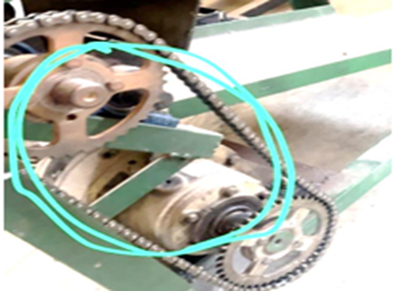
Figure 3: The blades positioned at an angle 30o (FUTA Workshop, 2023)
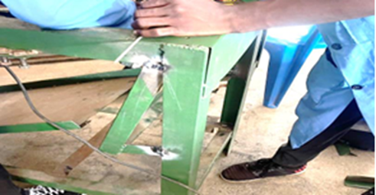
Figure 4: The blades positioned at an angle 15o (FUTA Workshop, 2023)
Another problem was found in the flap that guides the coconuts toward the dehusking rollers. The flaps were too short and could not properly position the coconuts before they reached the spikes as seen in figure 5. As a result, coconuts were sometimes poorly aligned, leading to inefficient dehusking and occasional damage to the coconut shell. Improvements were made to the roller flaps, which helped guide coconuts into the dehusking area. Initially, the flaps were only 160 mm long, which were further extended to 300 mm to provide better support and positioning. In addition, the flaps were moved 100 mm farther away from the blades as seen in figure 6. This reduced friction, prevented interference with the blades, and allowed coconuts to move more smoothly through the machine.
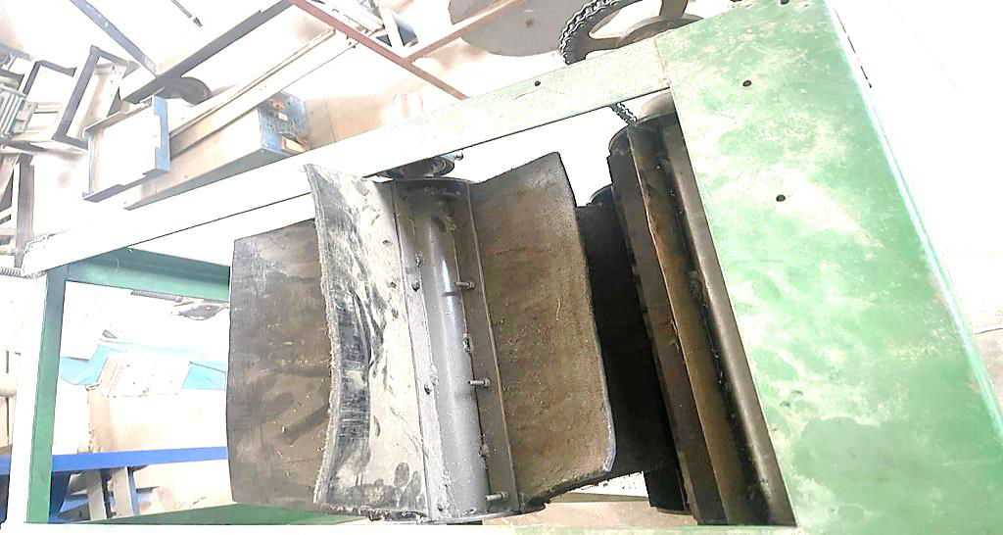
Figure 5 The old short flap (Futa Workshop, 2023)
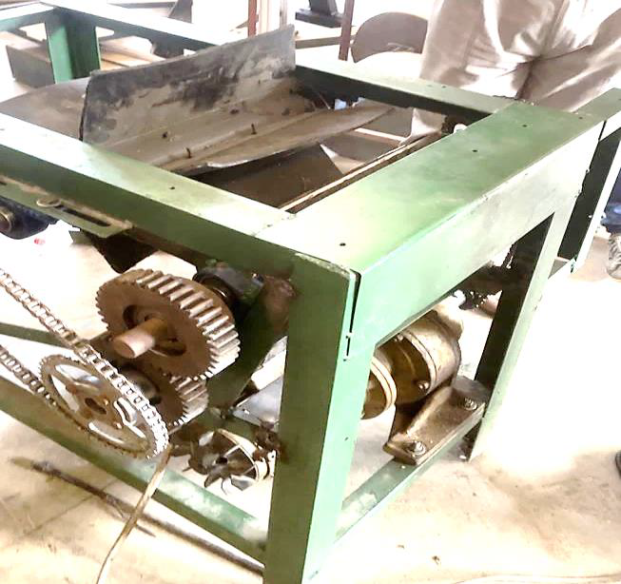
Figure 6: The New and Extended Flap (Futa Workshop)
Also, the cutting blades had a design problem. In the original machine, the blades were sharpened in the wrong direction. Instead of cutting smoothly into the husk, the blades mainly pressed against the coconut. This caused unnecessary force on the coconut, reduced cutting efficiency, and sometimes led to cracking or damage. A new design was used; the blade tips were reshaped into a triangular form. This new shape allowed the blade to pierce and slice through the husk more easily, rather than pressing against it. As a result, the dehusking process became faster, cleaner, and less damaging to the coconut.
The worn-out chains and sprockets were completely replaced with new ones. Before installing the new parts, the areas were carefully cleaned to remove rust and debris. During this process, it was discovered that changing the angle of the blade and frame affected the chain length. The existing chain connecting the lower roller and the flap was too short, so a longer chain was installed to ensure smooth movement and proper power transmission.
Finally, all rusted and weak bolts and nuts were replaced. The old fasteners were carefully removed, and the holes were cleaned to ensure a proper fit. New, stronger, and corrosion-resistant bolts and nuts were installed and tightened correctly. This improvement strengthened the machine structure, increased safety during operation, and improved the overall appearance of the machine. Through these combined improvements, the coconut dehusking machine became more powerful, more efficient, safer to use, and better suited for practical coconut processing. Table 1 presents a summary of the key differences between the original and improved machine configurations. These improvements were specifically targeted at reducing dehusking time and improving overall operational efficiency.
Table 1: Summary of design improvements
Component | Original Machine | Improved Machine | Purpose of Improvement
Electric Motor | Low-power motor | High-power motor | To provide sufficient torque and reduce dehusking time.
Dehusking spikes/blades | Basic spike geometry | Modified spike geometry with improved penetration | To enhance husk penetration and fast husk separation.
Shaft-frame alignment | Moderate alignment | Improved alignment | To reduce vibration and mechanical losses.
Transmission system | Worn chain and sprocket | Replaced and properly tensioned the chain and sprocket | To improve power transmission efficiency.
Machine frame | Light structural support | Reinforced frame members | To improve stability during operation.
Overall performance | Longer dehusking time | Reduced dehusking time | To enhance operational efficiency.

Experimental Procedure
Tests were carried out to see how well the improved coconut dehusking machine worked compared to the old version. For each test, ten coconuts were used. The coconuts were fed into the machine one at a time. A stopwatch was used to measure how long it took for the machine to completely remove the husk from each coconut. To make a fair comparison, the time results from the old machine were taken from previous test records. These results were then compared with the new results from the improved machine, which was tested under the same working conditions. During all the tests, the motor speed was kept the same so that the results would be accurate and consistent.
The machine’s performance was judged mainly by two things: how long it took to remove the husk and how much energy the machine used. The dehusking time simply means the time needed to fully remove the husk from one coconut. This shows how fast and efficient the machine is. The energy used by the machine was estimated using the motor’s power rating and the time taken to dehusk each coconut. These two measurements were chosen because they clearly show whether the changes made to the machine actually improved its performance. The results from the tests were arranged in tables and also shown in graphs, including box-and-whisker plots, to make it easy to see the difference between the old machine and the improved one.

RESULTS AND DISCUSSION
Results of Design Improvements
The design improvements implemented on the developed coconut dehusking machine had a noticeable impact on its operational behaviour. The upgraded motor supplied more power and torque, allowing the dehusking shaft to run smoothly even under load. The modified spikes penetrated the coconut husk more effectively, which helped reduce the time needed to remove the husk. In addition, improving the shaft alignment and strengthening the frame reduced vibration, making the machine more stable during operation. Table 2 summarises the main differences between the original and improved machine components. The increases in motor power and torque, along with the changes in flap length and roller angle, improved coconut gripping and overall machine performance.
Table 2: Design Analysis of the Components of the Improved Coconut Dehusking Machine
S/N | Faulty Components and Specification | Original results | Improved results
1 | Reduction motor:  - Torque  - Power  - Torque of motor  - Velocity ratio of the reduction gear | 450Nm  2hp  10.2kNm  1:19 | 550Nm  3hp  14.2kNm  1:25
2 | Flap (Length) | 160mm | 300mm
3 | Angle between roller and frame | 30º | 15º

Dehusking Time Performance
Dehusking time was used as the primary indicator of machine performance. Ten coconut samples were used for the evaluation, and the performance of the improved machine was compared directly with that of the original design. For dry coconuts, the original machine recorded dehusking times ranging from 15 to 25 seconds per coconut. In contrast, the improved machine achieved significantly lower dehusking times, operating within a range of 9 to 13 seconds per coconut. This represents a clear reduction in processing time and indicates improved efficiency of the redesigned machine. The comparative dehusking time results obtained from the experimental tests are presented in Table 3. The data show that the improved machine consistently achieved shorter dehusking times across all tested samples when compared with the original design, indicating enhanced operational efficiency.
Table 3: Dehusking time for dry coconuts (old vs improved machine)
Sample Number | Original Machine (s) | Improved Machine (s)
1 | 15 | 9
2 | 17 | 10
3 | 18 | 11
4 | 20 | 12
5 | 21 | 13
6 | 22 | 10
7 | 23 | 11
8 | 24 | 12
9 | 25 | 9
10 | 19 | 13
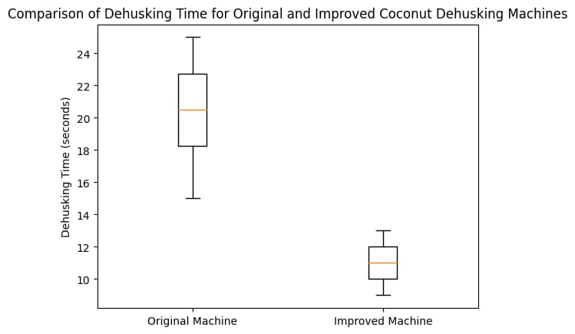
Figure 7: Box-and-whisker plot comparing the dehusking time of the original and improved machines

For wet coconuts, the original machine recorded higher dehusking times, typically ranging from 20 to 30 seconds per coconut. The improved machine showed better performance, with dehusking times ranging from 10 to 17 seconds. Although wet coconuts generally required more time due to increased moisture content and husk toughness, the improved machine consistently outperformed the original design. The results demonstrate that the improved machine achieved faster dehusking across different coconut conditions, further confirming the effectiveness of the design modifications.
Energy Consumption Analysis
The energy consumption (power x time) of the original and improved coconut dehusking machines was evaluated using the product of motor power rating and dehusking time for each experimental trial. Although the improved machine operated at a higher power rating (3 hp) compared to the original machine (2 hp), the results indicate a noticeable reduction in energy consumed per coconut in most trials. This improvement is primarily attributed to the significantly shorter dehusking time achieved by the enhanced roller–blade mechanism. As presented in Table 4, the original machine recorded energy consumption values ranging from approximately 22.38 to 37.30 kJ per coconut, while the improved machine exhibited a narrower range of about 20.14 to 29.09 kJ. The lower average energy consumption and reduced variability observed for the improved machine demonstrate superior energy efficiency and more consistent performance. These results suggest that the improved machine is better suited for continuous operation, particularly in small- and medium-scale coconut processing facilities where minimising energy cost and improving productivity are critical considerations.

Table 4: Comparative Energy Consumption of the Old and Improved Coconut Dehusking Machine)
Sample Number | Original Machine (KJ) | Improved Machine (KJ)
1 | 22.3 | 20.1
2 | 25.4 | 22.3
3 | 26.9 | 24.6
4 | 29..9 | 26.8
5 | 31.3 | 29.0
6 | 32.8 | 22.4
7 | 34.3 | 24.6
8 | 35.8 | 26.8
9 | 37.3 | 20.1
10 | 28.3 | 29.0
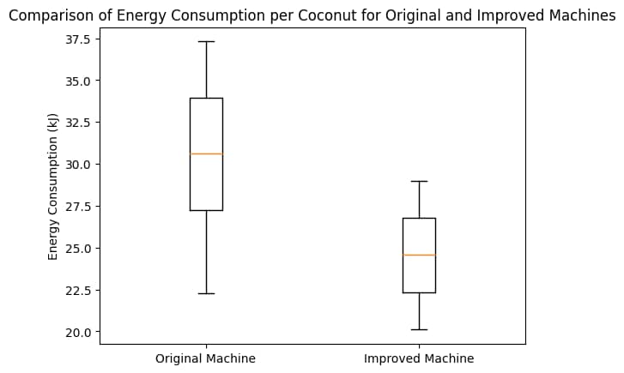
Figure 8: Comparison of energy consumption per coconut for original and improved machines
The box-and-whisker plot in Figure 8 shows that the improved machine has a lower median energy consumption and a smaller interquartile range compared to the original machine, indicating more efficient and consistent energy usage. Despite operating at a higher power rating, the improved 3 hp machine consumes comparable or even lower energy per coconut in several cases due to significantly reduced processing time. This demonstrates improved energy efficiency and productivity of the redesigned system.
Discussion of Results
The results obtained from this study clearly show that the improved coconut dehusking machine performed better than the original version in terms of dehusking time and overall efficiency. The improved machine achieved a dehusking time of 9–13 seconds per coconut, compared to 15–25 seconds recorded for the original machine. This reduction in processing time confirms that the design modifications introduced were effective in improving machine performance. Similar improvements have been reported in previous studies on coconut dehusking machines. For instance, Jimoh et al. (2023) reported that a modified motorised coconut dehusking machine achieved an efficiency of about 90% with a processing capacity of approximately 122 coconuts per hour. However, when translated to time per coconut, their system still required a longer processing duration than the improved machine developed in the present study. This suggests that the current design offers faster operation under similar mechanical conditions.
In another related study, Adedipe (2024) developed a cost-effective coconut dehusking machine aimed at reducing manual effort. Although the machine improved safety and reduced physical stress, it recorded an average dehusking time of over 90 seconds per coconut, which is significantly higher than the values obtained in this study. The large difference highlights the advantage of the improved mechanical configuration used in the present work, particularly in terms of spike arrangement and torque transmission. The findings of this study also compare favourably with other locally developed machines reported in the literature. Olorunfemi et al. (2022) recorded a processing capacity of about 80 coconuts per hour with an efficiency of 90.4% using a modified roller-based dehusking mechanism. By contrast, the improved machine in this study, operating at 9–13 seconds per coconut, corresponds to an estimated capacity of approximately 277–400 coconuts per hour under continuous operation. This places the machine among the higher-performing coconut dehusking systems reported in recent studies.
Studies that incorporated advanced design tools such as simulation and improved shaft alignment have also reported notable performance gains. Oluwayanmife et al. (2026) documented a coconut dehusking machine capable of processing between 200 and 250 coconuts per hour. While their design employed more complex fabrication techniques, the improved machine in the present study achieved comparable or higher throughput using relatively simple mechanical improvements, making it more suitable for small- and medium-scale processors. Energy consumption is another important aspect of machine performance, especially for rural and small-scale users. Previous studies have shown that machines with shorter processing times generally consume less energy per unit of output (Owuama et al., 2025). In this study, the reduction in dehusking time directly translated to lower energy consumption per coconut when compared to the original machine. This improvement enhances the economic viability of the machine and supports its potential adoption in areas where energy cost and availability are critical concerns.
Overall, the results demonstrate that targeted mechanical improvements can significantly enhance the performance of a coconut dehusking machine. Compared with existing designs reported in the literature, the improved machine offers faster dehusking time, higher processing capacity, and better energy efficiency. These findings confirm that locally developed machines, when properly improved and evaluated, can compete favourably with more complex and expensive systems reported by other researchers.
CONCLUSION
This study presented the improvement and performance evaluation of a developed coconut dehusking machine to enhance operational efficiency and reduce processing time. The key design modifications were implemented on the existing machine, including improvements to the drive system, dehusking spike geometry, structural alignment, and overall machine stability. The performance evaluation results showed that the improved machine significantly outperformed the original design. Dehusking time was reduced from a range of 15–25 seconds to 9–13 seconds per coconut, demonstrating a clear improvement in processing efficiency. In addition, the improved machine exhibited lower energy consumption per coconut, which can be attributed to the reduced dehusking time and improved power transmission efficiency. The findings confirm that targeted mechanical improvements can lead to substantial performance gains in coconut dehusking machines. The improved machine offers a more efficient and practical solution for small- and medium-scale coconut processing operations, with the potential to reduce labour effort, processing time, and energy costs. Overall, the study provides useful insight into how design optimisation can enhance the performance of agricultural processing machines.
RECOMMENDATION
Based on the findings of this study, further work is recommended to enhance the applicability of the improved coconut dehusking machine. Future studies may consider testing the machine under a wider range of operating conditions, including different coconut sizes and moisture levels. In addition, a detailed economic analysis could be carried out to assess the cost–benefit implications of the design improvements. Incorporating adjustable or automated features may also further improve usability and performance for large-scale processing applications.

COMPETING INTERESTS DISCLAIMER:
Authors have declared that they have no known competing financial interests OR non-financial interests OR personal relationships that could have appeared to influence the work reported in this paper.
REFERENCES
Adebimpe, A. M., Uguru-Okorie, D. C., Aribisala, A. A., & Lateef, A. K. (2024). Design of an automated coconut dehusking machine with radio frequency control and lead screw mechanism. FUDMA Journal of Sciences, 8(5). https://doi.org/10.33003/
Adedipe, J. O. (2024). Enhancing coconut processing efficiency: Design and evaluation of a cost-effective coconut de-husking machine. Jurnal Riset Perkebunan, 5(2), 94–102. https://doi.org/10.25077/
Baskaran, M., Aruneshwaran, A. C., Shyam, K. S., & Sreeharan, B. N. (2024). Advancements in coconut dehusking technologies and future trends: A review. Journal of Advancement in Machines, 9(2).
CD3WD Project. (n.d.). Coconut: Post-harvest operations—Dehusking.
Food and Agriculture Organisation of the United Nations (FAO). (2019). Small-scale coconut processing technologies. FAO.
Jimoh, R. O., Bello, M. K., Abiodun, L. O., Oyedokun, J. A., Oladipo, N. O., & Ogunjirin, O. A. (2023). Modification and performance evaluation of the NCAM motorised coconut dehusking machine. World Journal of Advanced Engineering Technology and Sciences, 09(01), 001–007. https://doi.org/10.30574/wjaets.2023.9.1.0120
Oladimeji, T. E., Akinola, A. A., & Yusuf, K. O. (2021). Effect of design parameters on the performance of agricultural processing machines. Journal of Engineering and Applied Sciences, 16(3), 85–93.
Olorunfemi, O. et al. (2022). Development of a modified dehusking machine for local varieties of coconut. Covenant Journal of Engineering Technology.
Oluwayanmife, J., Arogundade, I., Ayeni, O., & Akinnuli, O. (2026). Design, simulation and fabrication of a coconut dehusking machine. Journal of Engineering Research and Reports, 28(1), 13–24. https://doi.org/10.9734/jerr/2026/v28i11756
Onyenanu, I., Madu, K., Nzenwa, C., & Madukasi, A. (2025). Appraisal of the structural integrity of a coconut dehusking machine frame using modal analysis. NIPES Journal of Science and Technology Research, 7(3), 365–372. https://doi.org/10.37933/nipes/7.3.2025.1423
Owuama, K. C., Onyegirim, S. N. K., Nwankwo, E. I., & Onyenanu, I. U. (2025). Advancements in coconut dehusking technologies: A comprehensive review of mechanisation trends, performance metrics, and sustainability. IPS Journal of Engineering and Technology, 1(2), 101–110. https://doi.org/10.54117/ijet.v1i2.17
Pascua, A. M., Pascua, M. L. L., & Peralta, E. K. (2018). Performance characteristics of a coconut dehusking machine. International Journal of Advances in Agricultural Science and Technology, 5(2).
Rahman, M. M., Islam, M. S., & Hossain, M. A. (2020). Performance evaluation of a mechanical coconut dehusker. International Journal of Agricultural Engineering, 13(1), 45–52.
Singh, R., & Kumar, S. (2019). Energy efficiency assessment of agricultural processing equipment. Renewable and Sustainable Energy Reviews, 109, 205–214. https://doi.org/10.1016/j.rser.2019.04.038

