Original Research Article
Research on stereo vision based screw hole detection and distance measurement using YOLOv5

.
ABSTRACT

To address the low automation and inefficiency issues encountered during transformer top screw tightening operations in factories, this paper proposes a stereo vision-based object detection and ranging method utilizing YOLOv5. The approach employs a pre-trained YOLOv5 model combined with a custom dataset to train the object detection model. Distance measurement is achieved through stereo vision and the SGBM algorithm, enabling precise screw hole localization. An experimental platform was constructed, utilizing host-to-host communication for data exchange between PLC and PC to validate the method's effectiveness. This technique enables automatic screw hole recognition and positioning, making it suitable for automating transformer assembly lines to enhance efficiency..

Keywords: YOLOv5; Stereo Vision; Object Recognition; Modbus Communication; PLC.

1. INTRODUCTION

Precise positioning and operation in manufacturing assembly automation are critical components for achieving smart manufacturing^{[1]}. This process is vital for the intelligent upgrading of manufacturing industries^{[2]}. Currently, the assembly operation of locking the top screws on triangular transformers still relies on manual labor, resulting in issues such as accuracy fluctuations and low efficiency^{[3]}. This makes it difficult to meet the demands of mass production, making automation upgrades imperative^{[4]}.
Stereo vision-based ranging relies on the differences captured by two cameras when imaging the same object. Through computational processing, depth information of the object can be derived, enabling the determination of its three-dimensional coordinates. This method primarily involves camera calibration, stereo correction, stereo matching, and depth calculation.
With advancements in computer vision technology, applications utilizing stereo vision for target ranging are increasingly prevalent^{[5]}. Compared to ultrasonic or laser-based sensing technologies, image-based ranging offers lower costs while enabling automatic target acquisition and distance measurement^{[6]}. This paper proposes using the YOLOv5 algorithm for screw hole detection, combined with the SGBM algorithm for distance measurement and positioning^{[7]}. Modbus communication enables data exchange with the PLC, driving the end-effector to the designated position for operation. This solution is highly targeted, easy to implement, and balances cost with precision^{[8]}. It achieves full-process automation from recognition to distance measurement, positioning, and operation.

2. Object Detection Based on YOLOv5

2.1 Introduction to the YOLO Algorithm
YOLO (You Only Look Once) is a deep learning-based object detection algorithm proposed by Joseph Redmon et al^{[9]}. in 2016. Compared to traditional object detection algorithms , YOLO's key feature is its high real-time performance, enabling detection of objects in images or videos.
YOLOv5 is currently one of the most popular implementations for object detection. It adopts the more lightweight CSPnet architecture, which reduces computational load and memory usage, thereby accelerating both model training and inference processes. The main network structure of YOLOv5 can be divided into four parts: the input stage, the feature extraction network (Backbone), the feature fusion network (Neck), and the prediction output stage (Detection head) . This modular design enables YOLOv5 to maintain real-time detection capabilities while accurately detecting objects of varying sizes and categories, demonstrating particular proficiency in handling small objects and dense scenes^{[10]}.
This paper focuses on stereo real-time ranging based on object detection^{[11]}. To enhance recognition accuracy, it employs data collected from actual working conditions rather than generic datasets^{[12]}. The dataset comprises 2000 images covering varying angles, lighting conditions, and object counts^{[13]}. Screw holes were annotated using LabelImg (labeled as “hole”), generating YOLO-format TXT files^{[14]}. The dataset was divided into a training set (1600 images), validation set (200 images), and test set (200 images) at an 8:1:1 ratio (partial dataset shown in Figure 1).
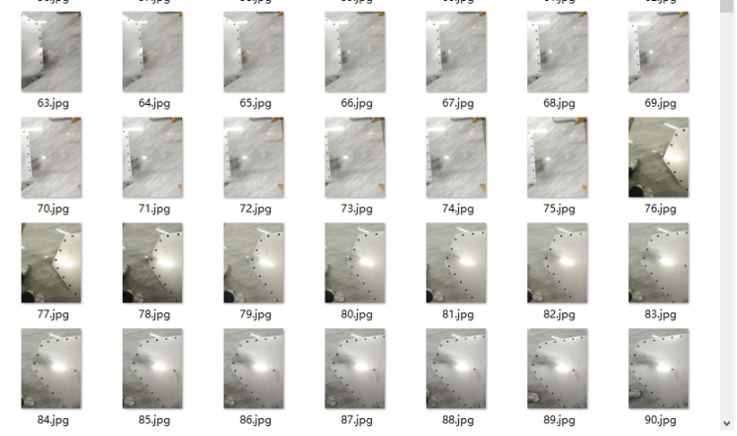
Fig. 1 Training Dataset
2.2 YOLOv5 Object Detection Model Comparison

YOLOv5 comprises five base network models: YOLOv5n, YOLOv5s, YOLOv5m, YOLOv5l, and YOLOv5x. These models share identical architectures, each built upon the YOLOv5n model by progressively increasing network depth and width. To investigate performance differences among scaled models within the YOLOv5 series, comparative experiments were conducted on the dataset used in this paper. Relevant results are presented in the charts below.

Table.1 Training parameters corresponding to different models
Model | Batch Size |  | IterationRounds/Round | Use Pre-trained Weights
YOLOv5n | 8 |  | 100 | Yes
YOLOv5s | 8 |  | 100 | Yes
YOLOv5m | 8 |  | 100 | Yes
YOLOv5l | 8 |  | 100 | Yes
YOLOv5x | 8 |  | 100 | Yes
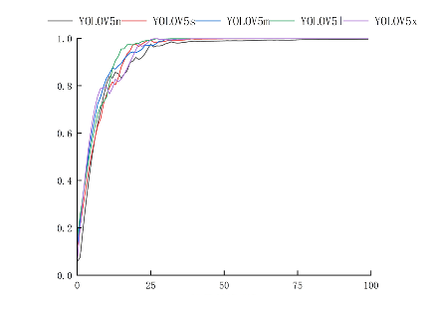 |  | 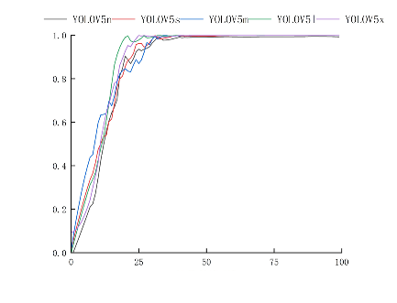
Fig.2: Recall of Different Models as Iteration Rounds Increase |  | Fig.3: Accuracy of Different Models as Iteration Rounds Increase
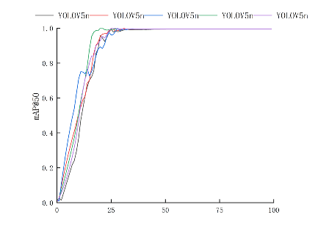 |  | 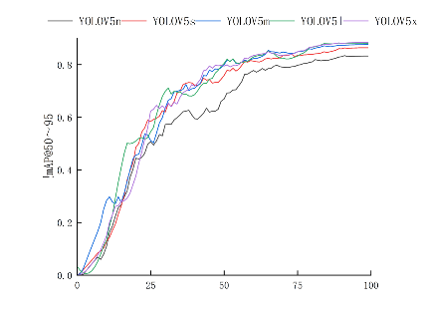
Fig.4: mAP@50 of Different Models as Iteration Rounds Increase |  | Fig.5: mAP@50–95 of Different Models as Iteration Rounds Increase
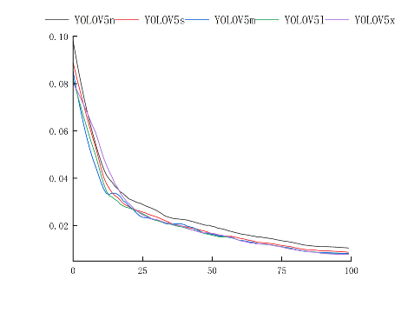
Fig. 6 Box Loss Variation Across Iteration Rounds for Different Models
Figure 2-6 shows the changes in recall, precision, mAP@50, mAP@50-95, and bounding box regression loss across models during training with identical batch sizes and iteration rounds. Results indicate that key metrics for all models converge rapidly and stabilize around 25–30 iterations. Smaller models (n, s) exhibit faster initial metric improvements but underperform larger models (l, x) in high-precision tasks (e.g., mAP@50–95) during later stages, with YOLOv5l and YOLOv5x demonstrating superior metrics. Box regression loss impacts stereo ranging accuracy, with YOLOv5s, m, l, and x outperforming n. However, YOLOv5x demands higher computational time and hardware requirements, leading to the selection of YOLOv5l for subsequent deployment.
3. Stereo Vision Ranging

Stereo vision-based ranging relies on the differences captured by two cameras when imaging the same object. Through computational processing, depth information of the object can be derived, enabling the determination of its three-dimensional coordinates. This method primarily involves camera calibration, stereo correction, stereo matching, and depth calculation.
Combining the YOLOv5 detection algorithm with stereo vision enables the acquisition of distance information for objects. Stereo vision-based ranging relies on observing the same scene from two viewpoints to obtain perceived images from different angles. It then calculates the object's parallax using the principle of triangulation , thereby determining the object's spatial position. The principle of parallax calculation is illustrated in the figure.
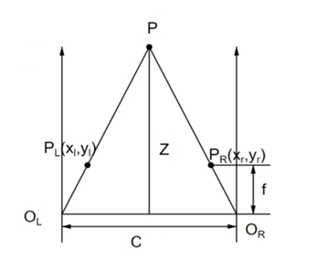
Fig. 7 Principle of Parallax

3.1 Stereo Camera Calibration
Single-objective calibration: Calculate the camera's intrinsic parameters, focal length f, the length dx and width dy of the camera's individual photosensitive unit chip, the center point error (cx, cy) of the camera's photosensitive chip in the x and y directions, and five distortion parameters. The five distortion parameters effectively address distortions caused by the camera itself and environmental factors, primarily including: ① Radial distortion in the image caused by the characteristics of the optical lens, represented by k1, k2, and k3; ② Tangential distortion (determined by p1 and p2) caused by assembly-related errors that may result in non-perfect parallelism between the sensor and optical lens, in addition to distortion effects from the camera's own parameters.
Dual-target calibration: First, acquire the internal and external parameters of the left and right cameras separately; then perform stereo calibration and alignment of the two images through stereo calibration.
The cameras used are 4-megapixel 1080p stereo cameras with a resolution of 1920×1080. They employ distortion-free lenses with a focal length of 3mm. Camera calibration is a crucial component of machine vision, involving the solution for mapping from three-dimensional world coordinates to two-dimensional image coordinates. To accurately compute the 3D information of objects from captured images, camera calibration is required beforehand. This paper employs the Zhang Zhengyou calibration method using the MATLAB toolbox for camera calibration experiments, obtaining both internal and external camera parameters. During stereo camera calibration, a standard 12×9 aluminum oxide checkerboard calibration plate was used. The black-and-white checkerboard squares were uniformly sized at 15mm×15mm. After fixing the stereo cameras, calibration images were captured by moving the calibration plate and adjusting different angles for both left and right cameras. Subsequently, the left and right camera images were segmented
The MATLAB Calibration Toolbox was used to calibrate the stereo camera system, yielding the internal and external camera parameters as shown in Table 2.
Table.2 Binocular Camera Calibration Results
Parameters | Left Camera | Right Camera
Internal Reference Matrix | $$\left(\begin{matrix}897.6688 & 0 & 552.2709 \\ 0 & 901.6117 & 507.0238 \\ 0 & 0 & 1.0000\end{matrix}\right)$$ | $$\left(\begin{matrix}893.0522 & 0 & 638.1948 \\ 0 & 899.9190 & 507.5913 \\ 0 & 0 & 1.0000\end{matrix}\right)$$
Distortion Matrix | $$\left(-0.0310，0.0588，-0.0009，-0.0095，1\right)$$ | $$\left(-0.0259，0.0468，-0.0013，-0.0115，1\right)$$
Rotation Matrix | $$\left(\begin{matrix}1.0000 & 0 & -0.0063 \\ -0.0004 & 1.0000 & -0.0040 \\ 0.0063 & 0.0040 & 1.0000\end{matrix}\right)$$
Translation Variable | $$\left(-59.2641，0.0515，1.2555\right)$$
3.2 Stereo Matching Algorithms

Stereo matching involves aligning pixels from the left and right viewpoints to establish correspondence between them. Since the target point is obtained through a target point detection algorithm, this paper employs a template matching method to calculate the correlation coefficient between pixels within a 7×7 window centered on the current target point and the matching pixel. The maximum value is selected as the matching point.
The ranging capability of depth stereo cameras is based on stereovision technology. Its core principle involves capturing the same target scene from different perspectives using two cameras, then estimating the actual distance of objects through the disparity information between the images. Disparity refers to the positional offset of corresponding pixels for the same object in the images captured by the left and right cameras. The process of solving for this offset is called stereo matching. Common stereo matching algorithms include sparse stereo matching and dense stereo matching. Dense stereo matching further encompasses local stereo matching, semi-global stereo matching, and global stereo matching. This study employs the SGBM algorithm from the semi-global stereo matching category. Compared to local algorithms (e.g., BM), SGBM handles weak textures and occluded regions to generate denser disparity maps. Compared to global algorithms (e.g., GC), SGBM offers higher computational efficiency, making it suitable for real-time applications. Its advantage lies in balancing accuracy and efficiency, while adaptable parameters enable performance across diverse scenarios.
4. Analysis of Experimental Results
4.1 System and Communication Design
The software operates within the industrial control host, enabling it to not only capture binocular images in real time from the binocular module for obstacle detection and three-dimensional spatial position measurement, but also display the measurement results to operators in a graphical format. Furthermore, when obstacles are in close proximity, it alerts operators through audible and visual means.
The host system features an Intel Core i5-12400F CPU, GeForce RTX 5060 graphics card (8GB VRAM), and 32GB RAM. Training was conducted on a Windows 10 operating system using PyCharm 2024.3.5 as the editor, employing a pre-trained YOLOv5L structure for object detection.
The host and PLC communicate via Ethernet using the Modbus TCP protocol, adhering to the standard MBAP header and data area structure (including transaction identifiers) to ensure data reliability and integrity. During configuration, the PLC end sets matching network parameters such as IP address and port (default 502). The PyCharm end utilizes the PyModbusTCP library to implement protocol parsing, connection management, and register operations, ultimately establishing a closed-loop bidirectional communication system.
4.2 Indoor Test Platform Setup
After system construction and algorithm completion, simulation experiments were conducted in the laboratory using the built model. During field equipment deployment, the stereo camera was mounted on the Z-axis to record the fixed coordinate transformation relationship between the camera's optical center and the end-effector tip. The end-effector tip was designated as the origin of the world coordinate system. The stereo camera moved with the end-effector, and when the system ran, the camera automatically initiated the capture program. To validate the feasibility of the solution, indoor simulation tests were conducted to replicate the camera capture and target recognition environment encountered in actual working conditions.

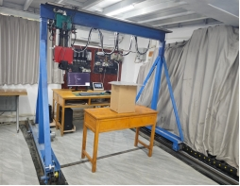
Fig. 8 Experimental Platform
4.3 Experiments and Results Analysis
Proportionally scaled triangular steel plates were cut to simulate the triangular top mounting plate of a transformer. Twenty-seven target mounting holes (with a central positioning hole) were machined into the plates, which were then placed horizontally on the test bench. Photographic recognition was performed at varying heights to determine the optimal shooting height. After system power-up, the stereo camera began real-time image capture for recognition. The impact of different heights on target hole recognition was tested under non-contact conditions (Figure 9). Results showed all 27 holes were accurately identified with 100% recognition coverage, confirming the model's practical applicability. Recognition accuracy varied with height: 45%-89% at 900mm, 68%-93% at 800mm, and 91%-95% at 700mm. Greater shooting distances blur hole boundaries, and combined with external lighting and angle effects, cause accuracy fluctuations. Comparative experimental results indicate the optimal shooting height is approximately 700 mm, providing reliable data support for stereo camera installation and three-dimensional coordinate measurement of target holes.
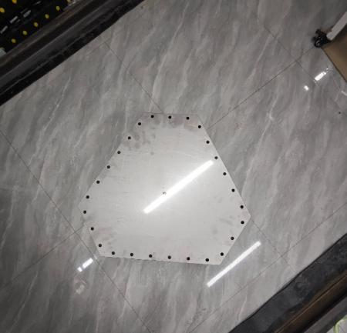 | 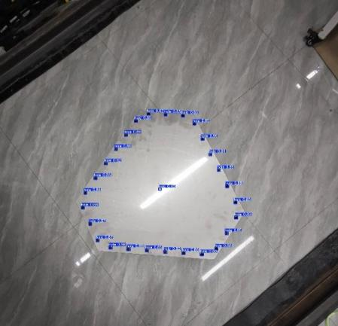
（a）Shooting height 900mm
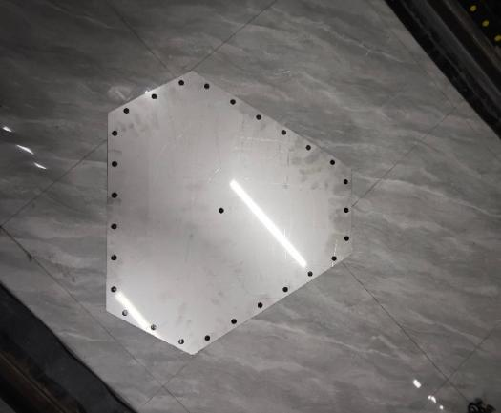 | 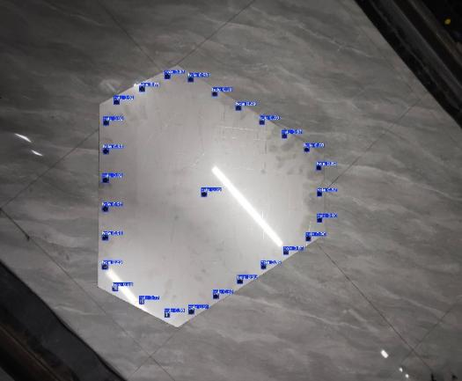
（b）Shooting height 800mm
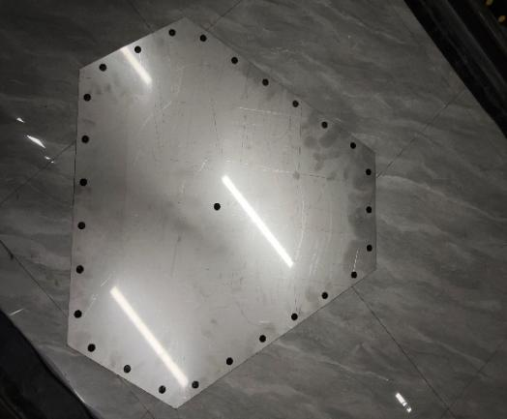 | 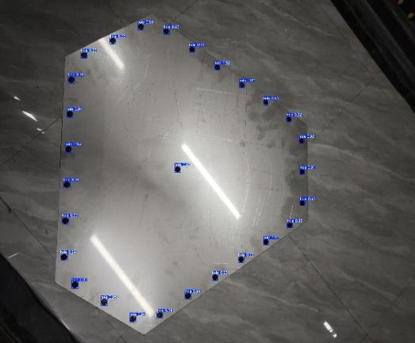
（c）Shooting height 700mm
Fig.9 Target hole recognition results
Based on recognition performance and workspace constraints, a mounting height of 750mm above 700mm was selected for the stereo camera. Prior to experimentation, a laser rangefinder was used to obtain the distance between the end-effector tip and the target. During motion, the accuracy of the recognized dimensions was verified by comparing the encoder values with the pre-experiment laser rangefinder readings. Figure 10 displays the original image and the recognized image. At a height of 750mm, the average accuracy rate for target recognition reached 93.4%, confirming the model's high-efficiency recognition capability. The experimental results further validate the model's accuracy.
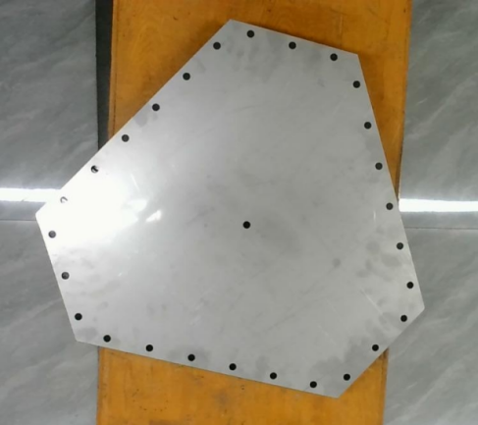 | 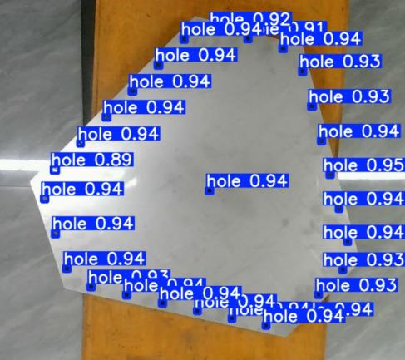
Original image at 750mm height | Image after recognition at 750mm height
Fig.10 On-site recognition results
Table 3 presents the 3D data of target points identified when the binocular camera height is 750 mm. Data is sorted clockwise into 27 groups based on the maximum absolute value of the X-coordinate, starting with ID 1. The 28th group represents the center positioning hole for manual cell installation, which is not displayed during actual operations. Since the target holes lie on the same plane, their Z-coordinate values are identical. Figure 11 illustrates the result when the PLC receives the target's 3D coordinate information after hole recognition and controls the motor to reach target No. 1.
Experimental results demonstrate that the trained YOLOv5L model accurately identifies target screw holes. The stereo camera precisely measures distances to recognized targets. The PLC ultimately controls the end-effector to reach the designated position. The displacement values from encoder feedback align closely with pre-experiment laser rangefinder measurements, with errors within acceptable limits, validating the feasibility of the entire solution.
Table.3 Measured 3D Coordinate Values of Recognized Targets
No. | X-Coordinate Value (Unit: mm) | Y-Coordinate Value (Unit: mm) | Z-Coordinate Value (Unit: mm) | No. | X-Coordinate Value (Unit: mm) | Y-Coordinate Value (Unit: mm) | Z-Coordinate Value (Unit: mm)
1 | -289.34 | -51.10 | 75 | 15 | 193.06 | 9.84 | 75
2 | -270.08 | -109.73 | 75 | 16 | 173.79 | 68.48 | 75
3 | -250.52 | -168.63 | 75 | 17 | 154.24 | 127.37 | 75
4 | -209.55 | -199.41 | 75 | 18 | 134.97 | 186.00 | 75
5 | -149.14 | -212.01 | 75 | 19 | 99.81 | 223.28 | 75
6 | -88.42 | -224.86 | 75 | 20 | 39.09 | 236.14 | 75
7 | -28.01 | -237.46 | 75 | 21 | -21.32 | 248.73 | 75
8 | 32.41 | -250.05 | 75 | 22 | -68.68 | 228.42 | 75
9 | 92.82 | -262.19 | 75 | 23 | -109.84 | 182.38 | 75
10 | 142.89 | -250.59 | 75 | 24 | -150.99 | 136.34 | 75
11 | 184.04 | -204.56 | 75 | 25 | -190.12 | 90.31 | 75
12 | 225.20 | -158.52 | 75 | 26 | -233.56 | 43.97 | 75
13 | 231.58 | -107.30 | 75 | 27 | -274.71 | -2.06 | 75
14 | 212.32 | -48.79 | 75 | 28 | -15.47 | -25.60 | 75
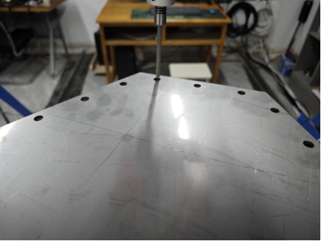
Fig.11 Recognition and Localization Experiment Results

5. Conclusion

This paper designs a stereo real-time ranging system based on YOLOv5 object detection. The system employs the YOLOv5 model with a custom training dataset. After comparing training results from different models, YOLOv5l was selected based on metrics including accuracy, recall, and mAP. It utilizes the SGBM algorithm for stereo matching and combines YOLOv5l detection results to achieve distance measurement. Validation demonstrated a screw hole recognition accuracy of 93.4% within the appropriate distance range, with distance measurement precision meeting application requirements, confirming the solution's effectiveness. This study proposes and validates an automated screw-driving solution based on visual recognition..

Competing interests

Authors have declared that no competing interests exist.

DISCLAIMER (ARTIFICIAL INTELLIGENCE)
Author(s) hereby declare that NO generative AI technologies such as Large Language Models (ChatGPT, COPILOT, etc.) and text-to-image generators have been used during the writing or editing of this manuscript.

References

[1] Chen C ,Dou D ,Wei J .Predicting density and particle size distribution of coal based on binocular vision and gray wolf optimization-support vector machine[J].Powder Technology,2026,470121993-121993.DOI:10.1016/J.POWTEC.2025.121993.
[2] Li S ,Zhu Y ,Cao Y , et al.Analysis and Simulation Verification of the Verticality Measurement Model for Single Offshore Pile Based on Binocular Vision[J].Sensors,2025,25(23):7374-7374.DOI:10.3390/S25237374.
[3] Dente A ,Manna E ,Poggi S , et al.Addressing Binocular Vision Challenges in Microsurgery.[J].Microsurgery,2025,45(8):e70135.DOI:10.1002/MICR.70135.
[4] Enhanced robotic path planning for complex curved surfaces repairing based on binocular vision 3D reconstruction point cloud[J].Industrial Robot: the international journal of robotics research and application,2025,52(6):923-933.DOI:10.1108/IR-12-2024-0568.
[5] Gao R ,Dang Z ,Wang Y , et al.Design of a High-Speed Pavement Image Acquisition System Based on Binocular Vision[J].Applied System Innovation,2025,8(6):173-173.DOI:10.3390/ASI8060173.
[6] Heng G ,Luo C ,Sun K , et al.SGBMYOLO: A high-precision obstacle detection algorithm for assistive navigation based on stereo vision and spatial attention mechanism[J].Applied Soft Computing,2026,186(PB):114144-114144.DOI:10.1016/J.ASOC.2025.114144.
[7] Shan P ,Zhang L ,Yan C , et al.Monitoring and Prediction of Deformation and Failure of Roadway Surrounding Rock Based on Binocular Vision and Random Forest[J].Applied Sciences,2025,15(22):12070-12070.DOI:10.3390/APP152212070.
[8]Solazzi L ,Rustighi E .Passive earthquake vibration mitigation of a steel tower crane by joint dampers[J].Journal of Physics: Conference Series,2024,2909(1):012028-012028.
[9] Xie M ,Wang X ,Li J .A Hybrid Strategy for Achieving Robust Matching Inside the Binocular Vision of a Humanoid Robot[J].Mathematics,2025,13(21):3488-3488.DOI:10.3390/MATH13213488.
[10]Thi L H ,Nguyen C V ,Nguyen L T .Adaptive finite-time extended state observer-based model predictive control with Flatness motivated trajectory planning for 5-DOF tower cranes[J].European Journal of Control,2025,81101149-101149.
[11] Richkind H ,Jody N ,Robbins L S , et al.But doctor, will I be able to drive? Car mirror placement design and viewing angles required for safe binocular vision for drivers.[J].The British journal of ophthalmology,2025,DOI:10.1136/BJO-2025-327186.
[12]Gidieman N ,Rina N .Factors determining visual detection distance to real flowers by bumblebees[J].Journal of Pollination Ecology,2017,201-12.DOI:10.26786/1920-7603(2017)one.
[13]Anand S ,Kundan D ,Marcus G , et al.RhizoVision Explorer: open-source software for root image analysis and measurement standardization[J].AoB PLANTS,2021,13(6):plab056-plab056.DOI:10.1093/AOBPLA/PLAB056.
[14]Haizhou G ,Zili L .Object Detection and Ranging System Based on Binocular Vision[J].Journal of Physics: Conference Series,2022,2284(1):DOI:10.1088/1742-6596/2284/1/012020.

