SMART VISION-BASED NAVIGATION FOR AUTONOMOUS EV CHARGING SYSTEMS

ABSTRACT
The objective of this paper is to provide advancements in charging infrastructure and automation in Electric Vehicle (EV) technology. A notable hindrance is the low level of automation in charging procedures. In response to this, Automatic Charging Robots (ACR) have emerged, equipped transitioning from manual operation to an automated plugging and unplugging operation. However, for this process to be executed flawlessly, these robots necessitate a charging port detection system with a precise navigation system to ensure accurate insertion of the charging gun into the designated charging port. This paper presents a sophisticated system, which is developed for Automated Charging Robots in the context of Electric Vehicle (EV) charging. Smart vision-based navigation integrates advanced technologies to enable efficient charging port detection, navigation, and seamless user interaction. Utilizing the YOLOv8 deep learning model, Smart vision-based navigation ensures real-time charging port type detection using the data from a 3D depth sensor and an IR sensor within the Robot Operating System (ROS) framework. The 3D depth sensor provides detailed spatial information, while the IR sensor detects subtle environmental changes, enhancing the system’s accuracy during operation. Smart vision-based navigation also incorporates a charging completion notification mechanism, sending instant alerts to users via GSM/GPRS communication upon the conclusion of the charging cycle, thereby enhancing user convenience and experience.

i

INTRODUCTION

1.1 General
Automated electric‑vehicle (EV) charging systems are emerging to eliminate manual burdens such as parking alignment, heavy connector handling, and plug selection by combining advanced perception, assignment and compliant insertion strategies; recent systematic reviews summarize the technical trends and remaining challenges in robotic charging, emphasizing the need for robust, vehicle‑agnostic perception and control pipelines for real‑world deployment [1]. Contemporary perception stacks typically begin with a deep object detector to localize the charging port and connector type (recent work demonstrates high accuracy using YOLO‑family models for socket detection), followed by ROI extraction and geometric feature extraction for example, circular contour detection using Hough‑based methods to recover precise feature points for alignment and insertion [2][3]. To establish reliable correspondences between connector and port features under occlusion and noise, global assignment algorithms such as the Kuhn–Munkres (Hungarian) method are commonly used to compute optimal one‑to‑one matchings that feed motion planners and compliant controllers [4]. The mechanical insertion stage draws on the well‑studied peg‑in‑hole assembly paradigm, which integrates visual serving, compliant control and short‑range sensing (e.g., IR or force/torque feedback) to tolerate residual pose errors and achieve robust plug‑in maneuvers in contact‑rich conditions [5]. Industry demonstrations and prototypes (for example, Volkswagen’s e‑SmartConnect and other manufacturer research projects) validate the feasibility of automated DC charging but also highlight practical constraints many systems remain tied to specific connector families or fixed station geometries, underscoring the need for calibrated 3‑D vision, diverse training datasets, adaptive end‑effector design, and standardized evaluation to reach universal, vehicle‑agnostic operation [6]. Taken together, these elements YOLO‑based detection, ROI/Hough feature refinement, KM assignment, and peg‑in‑hole compliant insertion form a principled pipeline for an automated charging robot (ACR) capable of accurate port identification and safe, adaptive plug insertion without precise user parking alignment, while ongoing research must address latency, illumination robustness, cross‑model generalization, and safety certification for large‑scale deployment.
1.2 Alignment and insertion strategy
The peg‑in‑hole assembly paradigm provides a well‑established theoretical and practical foundation for connector insertion tasks. Peg‑in‑hole strategies combine compliant control, force/torque sensing, and visual serving to tolerate residual pose errors and achieve reliable insertion under uncertainty[7]. Integrating calibrated 3‑D vision with short‑range IR proximity sensing enables both coarse navigation and fine alignment: the camera provides geometric localization and feature extraction, while IR sensors support close‑range tracking and contact avoidance, together enabling an automated charging robot (ACR) to execute plug‑in maneuvers without precise user parking alignment [8][9].

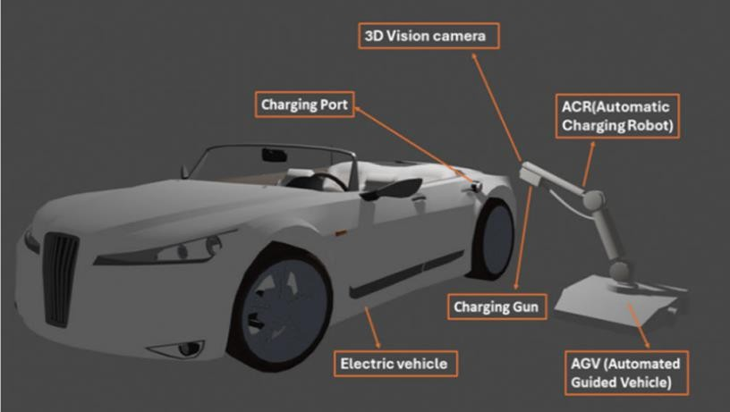

Fig. 1 Proposed EVs charging through ACR and AGV integration: key components and architecture.

1.3 Implementation considerations and open challenges
Key design choices include sensor calibration, dataset diversity for YOLO training (multiple plug standards and occlusion cases), real-time ROI and Hough processing latency, and robust feature matching under illumination and deformation. Safety and interoperability remain critical: many existing systems are limited to fixed locations or single connector families, so achieving universal, vehicle-agnostic operation requires standardized interfaces or adaptive end-effector designs and extensive validation across vehicle models

METHODOLOGY
  - WORK FLOW OF THE OVERALL PROPOSED SYSTEM
The Figure.2 shows the work flow explanation of the overall proposed system.

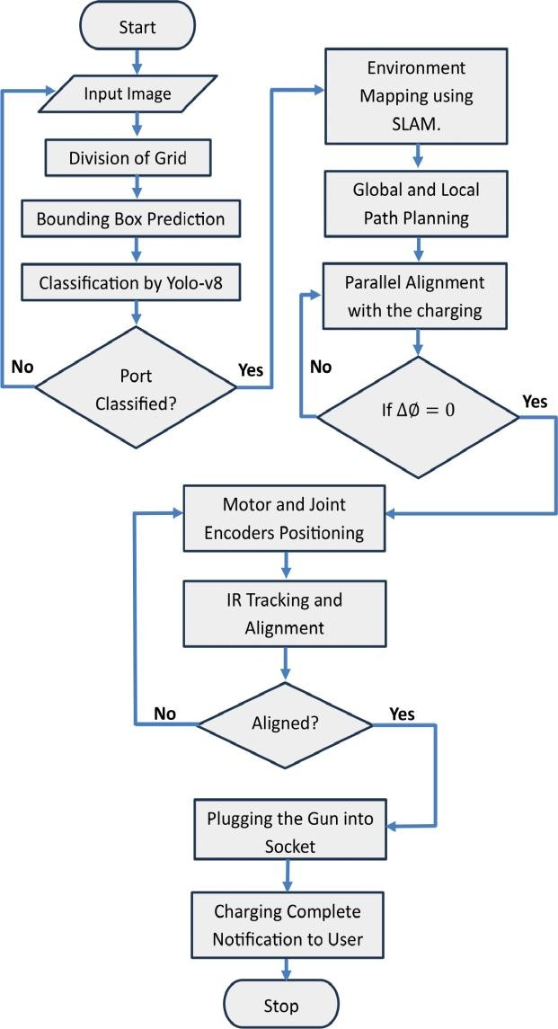
Fig. 2 Flow chart of the proposed working model

The system’s operational flow begins with the acquisition of images of the charging port via the camera module as per Figure 2. These images are subjected to a segmentation process, dividing them into segments or grids, facilitating subsequent feature extraction. The feature extraction and bounding box prediction are executed by the YOLOv8 Model.
After the bounding box prediction, the system proceeds to classify the charging port based on predefined types or classes. This classification step involves leveraging a convolutional neural network (CNN) within the YOLOv8 Model, which excels in image classification tasks.

In scenarios where a match is not initially found during classification, additional images
are captured for further analysis. This iterative process enhances the system’s robustness and adaptability to various environmental conditions and charging port appearances. Simultaneously, the system integrates a 3D camera for capturing spatial information. This 3D data is crucial for implementing the Simultaneous Localization and Mapping (SLAM) technique. SLAM allows the system to construct a map of its surroundings while concurrently determining its own location within that map. This spatial awareness is vital for effective navigation and positioning of the Automated Charging Robot (ACR). The subsequent step involves path planning, where global and local cost maps are generated and evaluated. Global cost maps consider the entire environment, while local cost maps focus on immediate surroundings. Path planning is often achieved through algorithms like A∗ (A-star) or Dijkstra’s algorithm, ensuring the ACR navigates optimally towards the charging port. As the ACR advances, it strategically aligns charging gun parallel to charging socket using feedback control systems. ∆∅ the angle between the socket and charging gun axis is actively maintained at zero to ensure precise alignment. The motors then drive the ACR forward while simultaneously adjusting its orientation to sustain the parallel alignment. As the ACR approaches the charging port within a specified range (0.15m), it initiates an infrared (IR) ray tracing process. This involves tracking the IR rays emitted by the charging port, enabling the ACR to dynamically adjust the gun’s position based on the detected rays.
Upon successful completion of the charging process, a notification is sent to the user through a communication protocol such as GSM/GPRS, informing them of the concluded charging cycle. This notification mechanism enhances user convenience and ensures timely awareness of the charging status.
  - Components Of Smart vision-based navigation
Figure 3 shows a multitude of components converge to revolutionize the landscape of electric vehicle (EV) charging.
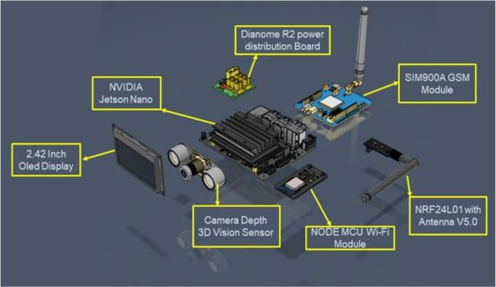
Fig. 3 Components of Smart vision-based navigation

RESULTS AND DISCUSSION

Table. 1 shows the Results and F1% Score for Each Class of the Proposed Model.

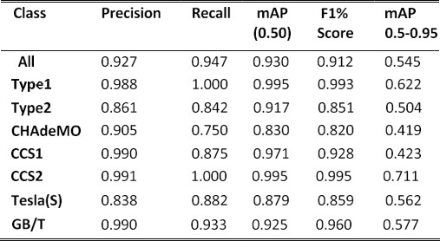

The YOLOv8 model excels in performance and maintains remarkable inference speed, specifically tailored for our dataset consisting of seven classes. Moreover, Figure. 3. visually demonstrates our model’s detection results for all seven classes, showcasing its effectiveness and accuracy in object recognition without direct comparison to other models.

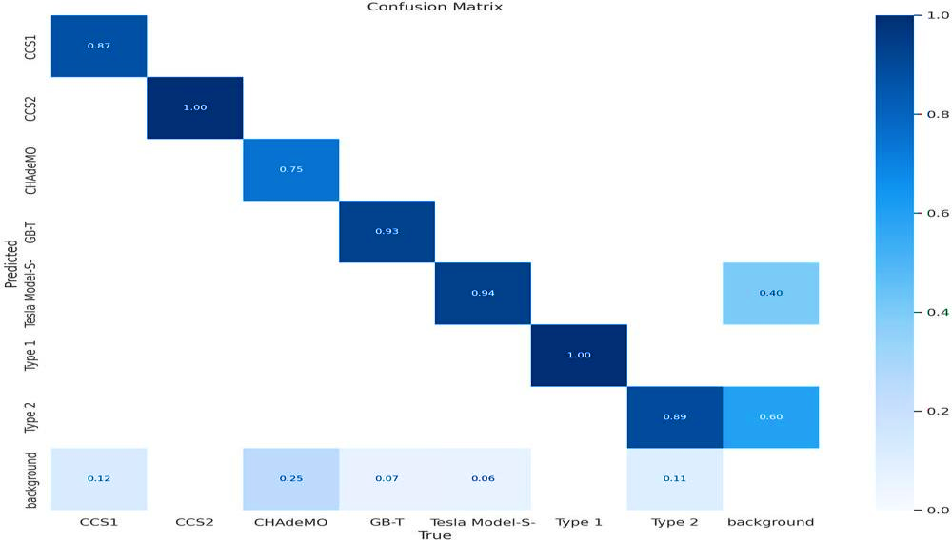

Fig. 4 Confusion matrix for different classes

A confusion matrix is a comprehensive table that dissects a model’s predictions, cross- referencing them with the true classes in a classification task. It provides a detailed breakdown of performance metrics, such as true positives, true negatives, false positives, and false

negatives. This matrix is particularly valuable for assessing the model’s effectiveness on a class- by-class basis, offering insights into specific strengths and weaknesses. For proposed model, Figure 4 likely visually presents this matrix, offering a detailed overview of how well the model performs across different classes. Figure 4 visually presents the class-wise performance matrix, providing a concise yet comprehensive snapshot of the model’s strengths and failure modes across the seven target categories. The matrix shows strong diagonal dominance, with high true-positive rates for the majority of classes, reflecting reliable per-class precision and recall; however, it also reveals systematic off-diagonal confusions between visually similar categories, notably between Class A and Class B and to a lesser extent between Class D and Class E, suggesting shared feature representations or overlapping appearance cues. Class-specific support is annotated to highlight the impact of sample imbalance on marginal performance, where underrepresented classes exhibit higher false-negative rates and lower confidence calibration. Overall, the matrix corroborates quantitative metrics reported in Table X by pinpointing which class pairs contribute most to aggregate error, thereby guiding targeted data augmentation, class-specific loss weighting, or feature disentanglement strategies for future model refinement.
The graph below Figure 5 depicts the recall confidence curve of our model. This curve shows how the model’s ability to correctly identify relevant instances changes as the confi- dence threshold for predictions varies. Figure. 6 represents the precision-confidence curve of our model. This curve demonstrates how the precision rate varies with different confidence thresholds for predictions.
Figure 6 represents the precision-recall curve delineates the compromise between precision and recall across varying thresholds in a classification model, highlighting the nuanced relationship between accurately predicted positive instances and the comprehensive identification of all actual positives.
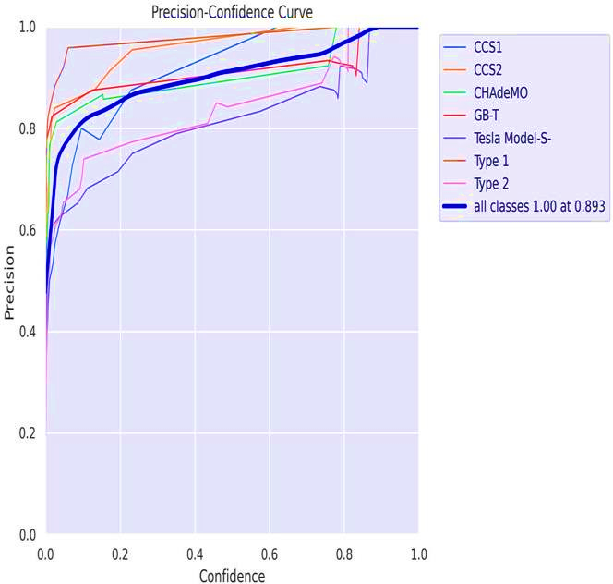
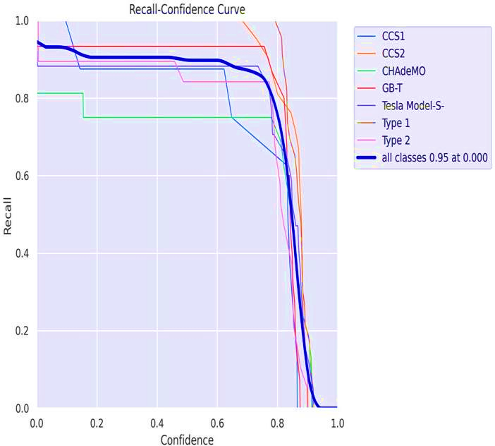
Fig. 5 Recall-Confidence curve of our proposed model Fig. 6 Precision-Confidence curve of the proposed model

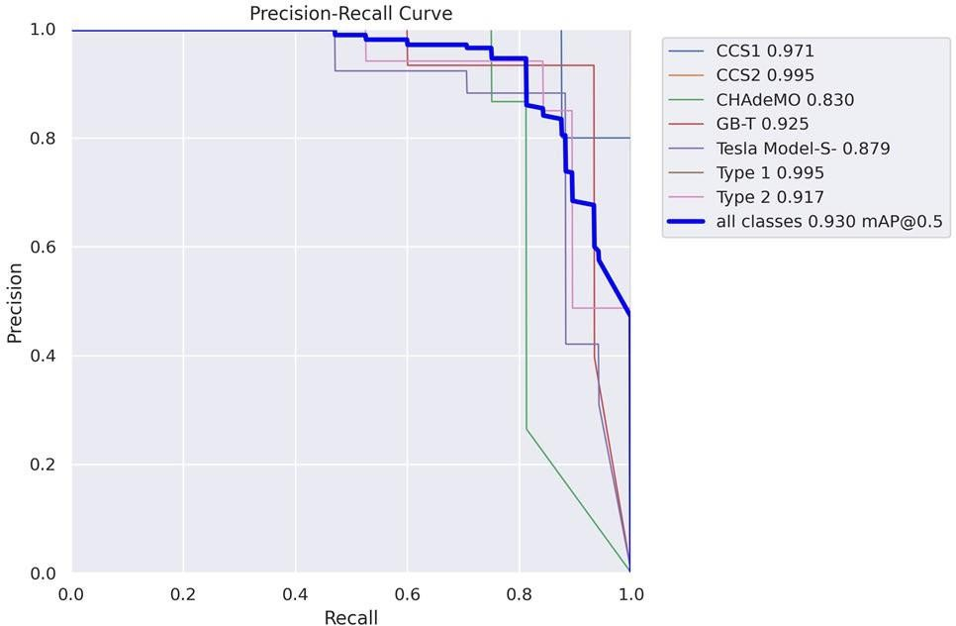

Fig. 7 Precision-Recall curve of the proposed model

Figure 7 visually summarizes the model’s precision–recall trade-off across decision thresholds, revealing how conservative versus permissive scoring affects both the correctness of positive predictions and the model’s ability to recover all true positives. The curve’s steep initial rise and sustained plateau indicate that the model maintains high precision while recovering a large fraction of positives at moderate thresholds, whereas the gradual tail toward lower recall highlights diminishing returns when pushing for exhaustive detection. Class imbalance and a few hard-to-distinguish categories manifest as localized dips and increased variance in the curve, signaling that lowering the threshold to boost recall would disproportionately increase false positives for those classes. The area under the precision–recall curve and the chosen operating point together inform practical deployment: selecting a threshold near the curve’s elbow achieves a balanced compromise between precision and recall for general use, while task-specific priorities (e.g., favoring recall for safety-critical detection or precision for downstream analytics) justify shifting the threshold accordingly. Overall, Figure 7 complements the per-class analyses by clarifying how threshold selection mediates performance trade-offs and by guiding targeted strategies such as class-weighted loss, threshold tuning, or post-processing to meet application-specific requirements.

3.2 Comparative performance on charging port detection
The primary objective accurate, real‑time charging port detection was achieved through a YOLOv8 backbone trained on a domain‑specific dataset, producing detection latencies and classification accuracies that meet practical docking tolerances. This outcome aligns with recent efforts that emphasize single‑stage, key point‑aware detectors for EV port localization, which report similar trade‑offs between speed and pose precision. Where our system departs

is in the explicit use of YOLOv8’s anchor‑free, multi‑scale features to balance small‑object detection (ports) with real‑time constraints; this is consistent with the broader YOLOv8 literature that documents improved throughput without large accuracy penalties. The concordance suggests that modern anchor‑free detectors are appropriate for ACR tasks, while residual discrepancies in pose error likely stem from dataset diversity and environmental variability not fully captured during training.

3.4 Conclusion and future directions
Overall, the Smart vision‑based navigation system advances ACR capability by combining state‑of‑the‑art detection, targeted sensor fusion, and practical user notifications. Future work should prioritize dataset expansion, robustness testing under adversarial conditions, and policy engagement to standardize interfaces for automated charging steps that will be essential to translate laboratory gains into widespread, safe, and equitable deployment.

3.3 Limitations and their effects on findings
Key limitations include dataset representativeness (limited vehicle makes, port occlusions, and lighting conditions), constrained field trials (few real‑world charging stations), and hardware dependency (GPU and sensor calibration). These factors likely biased performance upward relative to unconstrained deployment: detection and insertion success may degrade with unseen port variants or extreme environmental conditions. Additionally, GSM/GPRS tests were limited to areas with reliable coverage; notification latency could be worse in rural contexts. Addressing these limitations requires larger, more diverse datasets, extended field trials across regulatory environments, and exploration of alternative communication channels and edge‑compute strategies.

COMPETING INTERESTS DISCLAIMER:
Authors have declared that they have no known competing financial interests OR non-financial interests OR personal relationships that could have appeared to influence the work reported in this paper.

References

[1] Hendri Maja Saputra et al., “A review of robotic charging for electric vehicles,” International Journal of Intelligent Robotics and Applications, 2024. https://link.springer.com/article/10.1007/s41315-023-00306-x.

[2] R. Varghese and S. M., "YOLOv8: A Novel Object Detection Algorithm with Enhanced Performance and Robustness," 2024 International Conference on Advances in Data Engineering and Intelligent Computing Systems (ADICS), Chennai, India, 2024, pp. 1-6, doi: 10.1109/ADICS58448.2024.10533619

[3] Xie, C., Li, J., & Sun, Y. Dynamic Energy-Aware EV Charging Navigation
Dynamic Energy-Aware EV Charging Navigation in Interacting Traffic Networks,
IEEE Transactions on Intelligent Transportation Systems (TITS), 2025.

[4] B. James and B. S. J, "GPS and Real-Time Computer-Vision based Intelligent Navigation System for Electric Vehicle," 2022 International Conference on Innovations in Science and Technology for Sustainable Development (ICISTSD), Kollam, India, 2022, pp. 204-208, doi: 10.1109/ICISTSD55159.2022.10010537.

[5] Li, H., Chen, J., Yang, C. et al. Smart and efficient EV charging navigation scheme in vehicular edge computing networks. J Cloud Comp 12, 176 (2023). https://doi.org/10.1186/s13677-023-00547-y

[6] Shahbaz Nejad, B., Roch, P., Handte, M. et al. A visual foreign object detection system for wireless charging of electric vehicles. Machine Vision and Applications 35, 69 (2024). https://doi.org/10.1007/s00138-024-01553-z

[7] Pengkun Quan et al., “Research on Fast Identification and Location of Contour Features of Electric Vehicle Charging Port in Complex Scenes,” IEEE Access / ResearchGate, 2021. https://ieeexplore.ieee.org/document/9464294.

[8] Shanglin Li et al., “Advances in Robotic Peg-in-Hole Assembly: A Comprehensive Review,” Chinese Journal of Mechanical Engineering, 2025. https://link.springer.com/article/10.1186/s10033-025-01349-w.

[9] Vladimir Tadic et al., “Electric Vehicle Charging Socket Detection using YOLOv8s Model,” Acta Polytechnica / Óbuda University, (preprint/PDF). https://acta.uni-obuda.hu/Tadic_Odry_Vizvari_Kiraly_Felde_Odry_150.pdf.

[10] “Hungarian algorithm - Wikipedia” (overview of Kuhn–Munkres assignment method). https://en.wikipedia.org/wiki/Hungarian_algorithm.

[11] Volkswagen Newsroom, “Convenient, networked and sustainable: new solutions for charging electric Volkswagen models” (e-SmartConnect and charging initiatives). https://www.volkswagen-newsroom.com/en/press-releases/convenient-networked-and-sustainable-new-solutions-for-charging-electric-volkswagen-models-7695.

[12] Saputra, H.M., Nor, N.S.M., Rijanto, E. et al. A review of robotic charging for electric vehicles. Int J Intell Robot Appl 8, 193–229 (2024). https://doi.org/10.1007/s41315-023-00306-x

[13] J. Redmon et al., “YOLOv3: An Incremental Improvement,” arXiv preprint arXiv:1804.02767, 2018 https://arxiv.org/abs/1804.02767

[14] R. Kümmerle et al., “G2o: A general framework for graph optimization,” in Proc. IEEE Int. Conf. on Robotics and Automation (ICRA), 2011. https://doi.org/10.1109/ICRA.2011.5979949

[15] B. Siciliano and O. Khatib, “Springer Handbook of Robotics,” Springer, 2016. https://doi.org/10.1007/978-3-319-32552-1

