Review article
A Review of Shear and Bending Performance Tests of Wet Joint Connections between New and Old Bridges

.
ABSTRACT

The wet joint, as the core connection part for the splicing of new and old bridges and the assembly of prefabricated components, its shear and bending resistance directly determine the integrity, safety and durability of the bridge structure. This paper focuses on the shear and bending performance tests of the wet joint between new and old bridges, systematically reviewing the test methods, key influencing factors, mechanical calculation models and engineering application progress of related research. The study shows that the Z-type shear test is the mainstream method for evaluating the shear performance of the interface of the wet joint, and the height of the shear surface of the specimen, the loading rate and the testing technology significantly affect the reliability of the results; the bending performance of the wet joint plate is mainly characterized by cracking load, ultimate bearing capacity, crack width and stiffness attenuation; the interface treatment method, joint construction form, material properties, lateral prestress and size effect are the core factors affecting the two performances; calculation methods based on shear friction theory, tension-compression bar model and modified formula of the code have been preliminarily applied in engineering, but the adaptability to the fiber reinforcement effect of UHPC and the effect of dynamic loads still need to be improved. This paper can provide technical references for the design, test optimization and performance improvement of the wet joint in the splicing project of new and old bridges.

Keywords: Old and new concrete bridge; wet joints; Z-type shear resistance test; flexural performance; ultra-high performance concrete (UHPC); mechanical model.

- INTRODUCTION

With the industrialization of bridge engineering and the increasing demand for old bridge renovation, precast bridges have been widely promoted due to their advantages such as fast construction speed, low carbon emissions, and minimal interference with existing traffic [2][5]. The wet joint, as a key part for connecting new and old bridges or prefabricated components, needs to withstand both shear and bending forces, and its performance directly affects the overall reliability of the structure. The weak bonding between the new and old concrete interfaces is prone to cause cracking, voiding, and water seepage in the wet joint, seriously affecting the structural safety and service life [1][4]. According to statistics, about 30% of the diseases in existing bridges in China are caused by the deterioration of the wet joint performance [5]. Therefore, conducting research on the shear and bending performance of the wet joint has significant engineering significance.

The Z-type shear test, due to its ability to directly reflect the shear slip characteristics of the wet joint interface, has become the core method for evaluating the shear performance; the wet joint plate bending performance test simulates the actual bending moment to reveal the crack resistance and bearing capacity laws [3][9]. In recent years, the application of new materials such as ultra-high performance concrete (UHPC) has provided new approaches for improving the performance of the wet joint. Its ultra-high strength, high durability, and fiber reinforcement effect can significantly improve the interface bonding performance [1][4][17]. The research on related test methods, influencing mechanisms, and calculation models has also become increasingly in-depth, but there are still issues such as insufficient standardization of test methods, unclear coupling influence laws of multiple factors, and poor adaptability of calculation models [3][29]. Based on the existing research results, this paper systematically reviews the key technologies, performance influencing factors, mechanical models, and engineering applications of the two types of tests, clarifying the current research status and shortcomings, and providing references for subsequent research and engineering practice.

- Experimental Method Study

  - Z-type shear test method

The Z-type shear test is a classic method for simulating the direct shear action at the wet joint interface. It is divided into single-sided Z-shaped direct shear push-out test and double-sided direct shear push-out test. The core of this method is to cause the specimen to undergo shear slip along the wet joint interface through loading, thereby obtaining indicators such as shear strength, bond stiffness, and failure mode [9][22]. This method is recommended in the "Technical Code for the Application of Ultra-High Performance Concrete in Highway Bridges and Culverts" as the preferred method for testing the shear performance of wet joints [5].

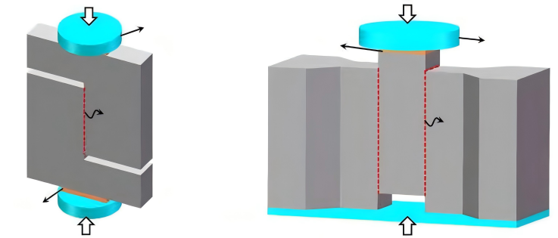
Figure 1 Schematic diagram of "Z" type direct shear test and double-sided direct shear test[3]

The specimens are usually cut in a "Z" shape, with the shear surface being the interface between the new and old concrete (or UHPC and ordinary concrete). The height of the shear surface is designed to be 50-150mm (covering the common size range in actual engineering), and the width is 100-200mm to ensure uniform distribution of shear stress [3][22]. Some studies have processed the shear surface by making slots (slot width 5-10mm, slot depth 10-15mm), using stress concentration to ensure that the failure occurs at the target interface, and the success rate of the tests can be increased to over 90% [3].

To simulate the lateral constraints in actual engineering, some tests apply lateral prestress of 0-8MPa by using jacks to explore the influence of lateral stress on the shear performance [3][25]. During specimen fabrication, the interval between the pouring of new and old materials is controlled to be 28-90 days to simulate the time difference between precast components and cast-in-place wet joints in actual engineering; the interface treatment method should be consistent with the engineering (such as high-pressure water jet roughening, interface agent brushing, etc.) to ensure the authenticity of the test [4][16].

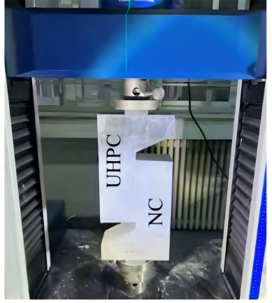
Figure 2 Z-shaped direct shear specimen [8]

In terms of loading method, the single-sided Z-shaped direct shear test applies symmetrical line loads at both ends of the specimen to cause relative sliding at the joint, with the loading rate controlled at 0.5 - 2mm/min to avoid the influence of impact loads [3][22]; this method is simple to operate but is prone to generating additional bending moments, resulting in an error of approximately 5% - 10% in the test. The double-sided direct shear test uses symmetrical three-point loading and applies parallel stresses on both sides of the specimen to reduce the eccentric effect, with the error controlled within 3%, but the loading equipment requires higher standards, and the failure mode is not ideal pure shear failure.

In terms of testing technology, the traditional method measures the shear slip amount using a displacement meter and obtains the load - slip curve by combining a load sensor; in recent years, digital image correlation technology (DIC) has been widely used, which can monitor the slip of the shear surface and the development of cracks in real time, with a spatial resolution of 0.01mm, significantly improving data accuracy [18]. Some studies also use ultrasonic testing instruments to assist in judging the interface bonding quality and evaluate the damage degree by assessing the wave velocity changes.
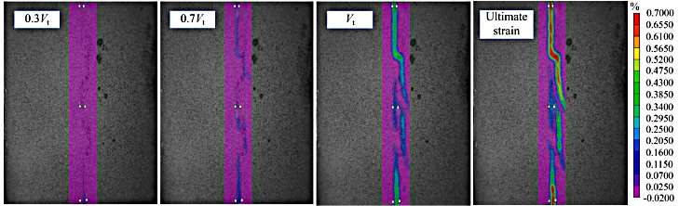
Figure 3 DIC failure cloud map from direct shear test [8]

2.2 Test method for flexural performance of wet joint plates​

The flexural performance test of the wet joint plate mainly simulates the bending moment acting on the wet joint in actual engineering through bending loading. Common test forms include the three-point bending test and the four-point bending test [14][16]. The core evaluation indicators are cracking load, ultimate bearing capacity, crack width, stiffness attenuation, and failure mode.

The specimens need to replicate the connection form of the actual bridge's wet joint. The common dimensions are 1000mm × 300mm × 150mm (length × width × height), and the length of the wet joint area is designed to be 100~200mm. The wet joint is poured using UHPC or ordinary grouting materials [18][22]. The joint structure includes shear pocket type, rhombic, comb-shaped, "V" type, and reinforced type (circular, with end heads, straight-shaped steel bars) etc. Among them, the UHPC comb-shaped joint is the most widely used in engineering [12].

In the reinforced wet joint, the overlapping length of the circular steel bars is usually designed to be 250~350mm, the anchoring length of the steel bars with end heads is not less than 6 times the diameter of the steel bar, and the lap length of the straight-shaped steel bars is not less than 30 times the diameter of the steel bar to ensure the anchoring performance [10]. During specimen fabrication, the concrete strength grade of the prefabricated section is C40~C60, and the strength grade of the wet joint material is not lower than that of the prefabricated section to ensure reasonable force transmission.

The four-point bending test, due to the uniform force distribution at the mid-span, can better simulate the actual force state of the wet joint and is widely used for assessing the crack resistance performance; the three-point bending test is suitable for quickly comparing the ultimate bearing capacity of different structures[14][17]. The loading rate is controlled at 0.1-0.5mm/min.Before cracking, the load control is adopted, and after cracking, the displacement control is used until the specimen fails [15].

The test contents include: measuring the mid-span deflection with a displacement meter and drawing the load - deflection curve; monitoring the crack development with a crack width meter and recording the cracking load (the load when the crack width reaches 0.05mm) and the ultimate load (the load when the deflection reaches 1/50 of the span); capturing the crack distribution and expansion path using DIC technology and analyzing the failure mechanism [17][18]. Some studies also conduct fatigue load tests (usually using 2 million cycles of load, with stress ratios ranging from 0.1 to 0.6), to evaluate the stability of the wet joint's bending resistance performance under long-term service conditions [33].
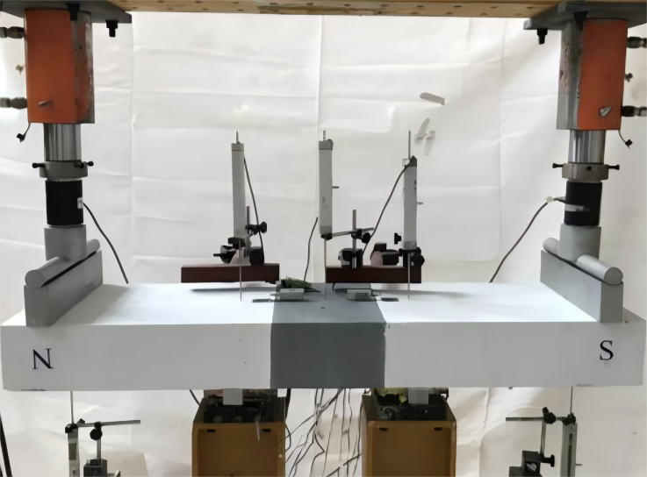
Figure 4 Four-point bending test of wet joints [13]

3. Analysis of Factors Affecting Mechanical Properties

- Interface handling method

The core objective of interface treatment is to enhance the bonding performance between new and old materials, which has a significant impact on both the Z-type shear and bending resistance. The mechanism of its effect involves the synergistic enhancement of mechanical interlocking force, chemical affinity, and friction force.

High-pressure water jet chiseling is the most commonly used method for interface treatment. By using high-pressure water flow (pressure 15-25 MPa) to wash the surface of prefabricated components, it removes loose mortar and forms a rough interface, significantly enhancing the mechanical bite force [22]. Tests show that the wet joints treated by high-pressure water jet chiseling can have shear strength of up to 46%-69% of the overall poured specimens, and the flexural bearing capacity is improved by more than 30% compared to those treated by pneumatic pick chiseling; the optimal chiseling depth is 3-8 mm and the flushing angle is 45°-60°. If the chiseling depth is too deep, it is easy to damage the base concrete, resulting in a decline in performance.

Manual chiseling and sandblasting methods have gradually decreased in application due to low construction efficiency or high costs, but the interface bonding strength after sandblasting treatment is still 20%-40% higher than that of manual chiseling, and is suitable for projects with higher performance requirements.

The interface agent improves the interface performance by enhancing chemical affinity and mechanical bite force. Common types include cement-based composite materials, polymer materials, and UHPC modified materials. Interface agents such as UHPC re-dispersible powder modified materials, expanded modified cement paste, etc., can increase the flexural strength by 7.1% to 30%, but some materials like styrene-butadiene latex modified cement paste may have adverse effects, causing a 5% to 10% decrease in shear strength [6][7].

Studies have shown that only when the strength of the interface agent is higher than that of the adjacent materials can a weak interface layer be effectively avoided; the silica fume-based interface agent can improve the interface transition zone between UHPC and ordinary concrete, increasing the bonding strength by 15% to 25%. The mechanism is that silica fume undergoes a secondary hydration reaction with calcium hydroxide, generating a dense C-S-H gel [4][16].

Grout reinforcement treatment can further enhance the shear bearing capacity. When the spacing of the grout reinforcement is 150-200mm and the diameter is 16-20mm, the shear strength is increased by more than 50% compared to simply troweling, and it can effectively improve ductility [29]. The mechanism of the grout reinforcement is the pin-retaining effect. It enables the steel bars to withstand the shear force, delaying the interface slip, and is suitable for strengthening the wet joints in the reinforcement projects of old bridges.

- Wet joint construction form

The joint structure affects the performance by altering the force path and constraints. A reasonable design of the structure can significantly enhance the shear and bending resistance [12].

In the Z-type shear test, the shear performance of the wet joints with key teeth (rectangular, trapezoidal, multi-tooth keys) is significantly better than that of the plain joints. When the key tooth depth is 30mm, the peak shear strength can reach 86.4% of the overall specimen. The shear capacity of the multi-tooth key structure is 2.12 to 9.59 times that of the plain joint [23][24]. The ductility of the double key tooth structure is better than that of the single key tooth. The ultimate shear strength is optimal when the tooth height ratio (key tooth height / total height of the shear surface) is 0.3 to 0.5 [25]; the tooth width of the multi-tooth key is usually designed to be 20 to 30mm, and the comprehensive shear effect is best when the tooth height is 30 to 50mm. An excessively large tooth height is likely to cause stress concentration and cracking at the root of the key tooth [24].

The comb-shaped joint enhances the mechanical shear strength to delay interface cracking. Its ultimate bending bearing capacity and crack control ability are superior to those of the rhombic and rectangular joints, and it is suitable for wet joints of large-span bridges [12][14]; The "V"-shaped prestressed joint increases the compression in the negative bending area by tensioning steel strands, significantly improving the crack resistance. The cracking load is 40% to 60% higher than that of the non-prestressed joint [18]; The bending bearing capacity of the dovetail joint is 30% to 40% higher than that of the rhombic joint. Due to its unique mechanical interlocking structure, it effectively inhibits crack expansion and has been applied in major projects such as the Fifth Nanjing Yangtze River Bridge [18][22].

The bending bearing capacity and crack width control effect of the embedded ring-shaped reinforcing bar wet joint are superior to those of the end-terminated reinforcing bar and the straight-shaped reinforcing bar, but the straight-shaped reinforcing bar can achieve comparable connection performance in the UHPC wet joint and is more convenient to construct [14]; when the anchorage length of the wet joint with end-terminated reinforcing bars is not less than 6 times the diameter of the reinforcing bar, the bending performance is stable and is suitable for the rapid assembly of prefabricated components [10].

- Material characteristics

Due to its low water-cement ratio (0.15 - 0.25), high density and fiber reinforcement effect, UHPC significantly improves the wet joint performance. The wet joints using UHPC have an anti-shear strength that is over 50% higher than that of ordinary grout materials, and the anti-bending cracking load can reach twice that of ordinary concrete wet joints; the volume content of steel fibers is a key parameter. The interface shear strength of the flat joint with a 3.0% volume content of steel fibers is 3.07 times that of the un-fibered test piece, and the improvement effect of steel fibers with a length-to-diameter ratio of 80 is the best. The bridging effect of irregular fibers is more significant than that of straight fibers, which can delay the crack expansion [26].

When the silica fume content is 15% - 20%, the interface bonding performance of UHPC is the best. An excessive content can lead to shrinkage cracking; when the fly ash content is controlled at 10% - 15%, it can improve workability and reduce shrinkage, and has no adverse effect on the bonding performance [16].

In the wet joints of the new and old bridges, the strength of ordinary concrete is positively correlated with the interface bonding performance. When the strength increases from C30 to C50, the shear bearing capacity increases by 10% to 20%. However, the improvement in the performance of UHPC wet joints is limited, as the high performance of UHPC has weakened the influence of the existing concrete strength [16]. When the surface moisture content of the existing concrete is controlled at the saturated surface dry (SSD) state, the interface bonding performance is the best. Excessively dry (with a moisture content < 3%) will cause water loss in UHPC, and excessive wetness (with a moisture content > 15%) will dilute the interface paste, both of which will cause the bonding strength to decrease by 10% to 15% [31].

- Other factors

Applying lateral prestress can significantly enhance the shear strength, stiffness and ductility of wet joints. When the lateral stress reaches 3 to 5 MPa, the differences in shear performance among different joint types become smaller. In key tooth wet joints, lateral prestress can increase the shear strength by 30% to 50%, and the mechanism is that the lateral pressure increases the interface friction force and mechanical bite force [25]. However, the nonlinear effects of high lateral stress (greater than 8 MPa) still need further study, and current experiments mainly focus on the low lateral stress range.

An increase in the height of the shear plane leads to a decrease in the ultimate shear strength of the wet joint of UHPC. The higher the content of steel fibers, the more significant the size effect becomes. When the height of the shear plane increases from 50mm to 150mm, the shear strength decreases by 15% to 25% [28]. The flexural performance of the wet joint plate is affected by the height of the section and the width of the joint. The recommended width of the UHPC wet joint is no less than 150mm. A too small width is prone to cause stress concentration, while a too large width increases the construction difficulty and cost.[11]

Steam curing at 60℃ can enhance the crack resistance and interface adhesion of the UHPC wet joint. After 48 hours of curing, the interface adhesion strength is 20% to 30% higher than that of normal temperature curing, as high temperature accelerates the hydration reaction and improves the structure of the interface transition zone [16]; however, high-temperature curing at 90℃ is prone to generate micro-cracks due to rapid shrinkage, reducing the mechanical properties. Therefore, it is not recommended. During normal temperature curing, the moisture retention curing time should be no less than 7 days, which can effectively reduce shrinkage cracking.

4. Mechanical model and calculation method

4.1 Z-type shear resistance calculation model

The shear friction theory is the core basis for calculating shear strength, and its formula is:
$$V=cA+μ(A_{vf}f_{y}+P_{c})$$
Where:
$c$ represents the cohesion (MPa),

$μ$ is the friction coefficient,

$A$ is the shear surface area (mm²),

$A_{vf}$ is the area of the shear-resistant reinforcement (mm²),

$f_{y}$ is the yield strength of the reinforcement (MPa),

$P_{c}$ is the lateral prestress (N).

For UHPC wet joints, a fiber reinforcement coefficient λf correction needs to be introduced. The correction formula is:
$$V=(1+λ_{f})cA+μ(A_{vf}f_{y}+P_{c})$$
The value of $λ_{f}$ ranges from 0.3 to 0.8 (positively correlated with the fiber content; it is 0.8 when the fiber content is 3%).

The formula proposed in the NFP18-710 specification takes into account interface adhesion, friction and the effect of steel bar dowel pins, and is more applicable:
$$τ=cf_{t}+μσ_{n}+ρf_{y}(μ\sin{θ}+\cos{θ})$$
Among them,

$f_{t}$ represents the tensile strength of UHPC (MPa),

$σ_{n}$ represents the lateral compressive stress (MPa),

$ρ$ represents the reinforcement ratio,

$θ$ represents the angle between the reinforcing bars and the shear plane (in degrees).

The Mohr stress circle criterion is applicable to unreinforced UHPC wet joints, and the representative formula is:
$$V=A_{k}f_{c}(1+0.18σ_{n})+0.6A_{sm}σ_{n}$$

Among them,
$A_{k}$ represents the area of the key teeth on the shear surface (mm²),

$f_{c}$ represents the compressive strength of UHPC (MPa),

$A_{sm}$ represents the area of the flat seam on the shear surface (mm²).

This can reflect the enhancing effect of lateral stress on the shear strength [30].

The shear friction formula proposed in the ACI 318-19 specification is applicable to wet joints of ordinary concrete.After modification for UHPC wet joints, the prediction accuracy is improved by 25% [16].
$$V_{u}=μρf_{y}A$$

4.2 Calculation model for the flexural performance of wet joint plates

Compression-tension bar model,It is widely used in the calculation of the bending resistance of UHPC wet joints. UHPC forms compression bars, and embedded reinforcing bars form tension bars. The typical formula is:
$$M_{u}=f_{cu}bx(d-\frac{x}{2})-f_{t}bx_{t}(\frac{x_{t}}{2}-a)$$

Among them,
$f_{cu}$ represents the compressive strength of the UHPC cube (in MPa),

$b$ is the width of the specimen (in mm),

$x$ is the height of the compression zone (in mm),

$d$ is the distance from the point of the tensile reinforcement's resultant force to the compression edge (in mm),

$x_{t}$ is the height of the tensile zone (in mm),

$a$ is the thickness of the protective layer (in mm).

In the model, the compressive strength of UHPC is taken as 0.85 times the axial compressive strength, and the tensile reinforcement's tensile strength is taken as the yield strength, which can more accurately calculate the bending bearing capacity [21].

For the wet joints of circular reinforcing bars, He et al. proposed to calculate the ultimate bending capacity indirectly based on the tensile bearing capacity:
$$M_{u}=P_{u}(d_{s}-\frac{T_{u}}{1.7f'_{c}b})$$

Among them,

$P_{u}$ represents the ultimate tensile bearing capacity (N),

$d_{s}$ represents the effective height of the section (mm),

$T_{u}$ represents the tensile force of the reinforcing bars (N),

$f'_{c}$ represents the axial compressive strength of the concrete (MPa) [20].

The formula for the flexural bearing capacity of the wet joint with end-attached reinforcing bars is the same as that of the ring-shaped wet joint [24]; for the UHPC wet joint, the interface bonding coefficient η (with a value of 0.8 to 1.0, and 1.0 when the interface treatment is good) needs to be introduced for correction to consider the influence of interface bonding on the bearing capacity [22].

4.3 Model applicability analysis

Among the existing models, the modified shear-friction theory formula has the smallest prediction error for the shear strength of UHPC wet joints (≤10%), and the tension-compression bar model has a relatively high prediction accuracy for the bending bearing capacity (error ≤15%). However, the models still do not adequately consider the coupling effects of multiple factors and size effects, and further optimization is needed; studies on calculation models under dynamic loads are scarce, and they are difficult to meet the design requirements for scenarios such as earthquakes and vehicle impacts [32].

5. Engineering application examples

5.1 The Fifth Bridge over the Yangtze River in Nanjing

This bridge uses UHPC dovetail joints to connect the bridge decks. Through Z-type shear and bending tests, the joint structure was optimized (the height of the dovetail teeth is 50mm, and the width is 30mm). The measured ultimate bending bearing capacity reached 38.6kN・m, which is close to that of a complete precast plate (40.2kN・m), and the shear strength reached above 15MPa. This solved the problem of the overall integrity of the bridge deck connection in large-span cable-stayed bridges. The bridge has been in safe service for 4 years, and the wet joints have not shown any diseases such as cracking or water seepage [18].
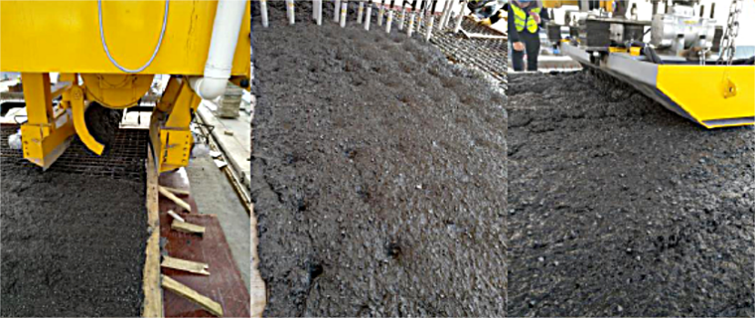
Figure5: Wet joint construction site [17]

5.2 Route 31 Bridge in New York, USA

The precast bridge slabs were connected by UHPC embedded steel bars with wet joints. The width of the joint was determined through flexural tests to be 150mm, and the overlap length of the ring-shaped steel bars was 300mm. During the service period (10 years), no cracking or interface detachment occurred, verifying the long-term reliability of the UHPC wet joints. This technology has been applied to the renovation projects of several old bridges in the northeastern United States [33].

5.3 Hongpo Bridge on the Changbao Expressway in Yunnan Province, China

The UHPC ring-shaped reinforcing bars were used for wet joints. The interface high-pressure water jet chipping process was optimized through Z-type shear resistance tests (with chipping depth of 5mm and chipping angle of 50°). The shear bearing capacity reached 12.8 MPa, meeting the design requirements (≥10 MPa). It was successfully applied in the widening project of the old bridge, and the width of the wet joint was reduced by 30% compared to the traditional design, while the construction efficiency was increased by 40% [35].
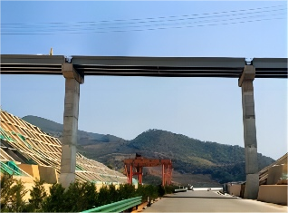
Figure 6: Hongpo Bridge of Chengbao Expressway in Yunnan [35]

5.4 Rainy Lake Bridge, Canada

The GFRP reinforcement-UHPC wet joint was adopted. The flexural resistance performance in the negative bending moment zone was verified through the flexural test. The crack width was controlled within 0.1mm. This bridge was suitable for bridge splicing in freezing and thawing environments. After 8 years of service, the performance of the wet joint showed no significant deterioration, and the number of freeze-thaw cycles reached more than 300 times [17].

5.5 Changsha Beichen Hongqiao

The UHPC box girders were assembled using prefabricated segments. The wet joints adopted a comb-shaped structure. Through the bending resistance test, the cracking load reached 1.5 times the designed load (18.2 kN·m). After 5 years of service, no cracks occurred, demonstrating the excellent durability of the UHPC wet joints [27].

6. conclusion and prospectives

1)The Z-type shear test and the wet joint plate flexural test are the core methods for evaluating the mechanical properties of wet joints in new and old bridges. The former focuses on the shear-slip characteristics of the interface, and the test results are most reliable when the specimen's shear face height is 50-150mm and the loading rate is 0.5-2mm/min; the latter pays attention to the overall bearing capacity and crack resistance, and the four-point bending test can better simulate the actual loading conditions.

2)Interface high-pressure water jet chipping (depth 3-8mm), UHPC material application (steel fiber content 3%), multi-groove/veneer mortise structure and lateral prestress (3-5MPa) are the key technical paths to improve the performance of wet joints, which can increase the shear strength by 46%-250% and the flexural cracking load by more than 50%.

3)The shear friction theory correction formula (introducing the fiber reinforcement coefficient) and the tension-compression bar model provide effective tools for calculating the performance of wet joints, but the existing models still do not fully consider the fiber reinforcement effect and size effect of UHPC, and further optimization is needed to improve the prediction accuracy.

4)Engineering practice shows that UHPC wet joints exhibit excellent mechanical properties and durability in the splicing of new and old bridges, and have been successfully applied in many major projects at home and abroad. Their long-term service performance is stable, and they can significantly reduce the maintenance cost of bridges.

Subsequent studies can focus on the coupling effect of fiber content, key parameters and lateral prestress, to reveal the interaction rules of multiple factors; deeply investigate the mechanism of performance degradation of wet joints under harsh conditions such as freeze-thaw cycles and dry-wet alternations, and establish a performance degradation model. Develop unified test piece dimensions, loading schemes and evaluation indicators for Z-type shear tests and bending tests, and promote the application of digital image correlation technology (DIC) and acoustic emission technology to solve the comparability problem of different research results.

REFERENCES

- Longquan, Y., Deweng, X., Huiqi, T., Fuhai, L., & Yijun, D. (2024). Research progress on influence factors of bending resistance of UHPC wet joints of prefabricated bridge members. Sichuan Building Materials, 50(03), 167-169. https://doi.org/10. 3969/j. issn. 1672－4011. 2024. 03. 061
- Hu, M., Jia, Z., Han, Q., Du, X., & Hui, B. (2025). Review of Configurations and Performance of Wet Joints for Prefabricated Bridge Deck Panels. China Journal of Highway and Transport, 38(02), 147-163. https://doi.org/10.19721/j.cnki.1001-7372.2025.02.012
- Zheng, F., Yuhe, H., Hao, W., Junyu, H., Yingli, H., & Chuanxi, L. (2025). Direct shear performance of ultra-high performance concrete(UHPC) components: a review. Journal of Transport Science and Engineering, 41(03), 39-53. https://doi.org/10.16544/j.cnki.cn43-1494/u.20250429001
- Yingxiong, W., Xinyan, Z., Wei, H., Xiangyu, Z., & Baochun, C. (2023). Review of Interface Bond Behavior Between Ultra-high Performance Concrete and Existing Normal Concrete. Materials Reports, 37(16), 144-154. https://link.cnki.net/urlid/50.1078.TB.20221017.1509.006
- Xin, J., Dayang, T., Suoting, H., Zhouyu, Z., & Long, S. (2021). Application of Ultra-High Performance Concrete in Bridge Engineeringall over the World. Railway Engineering, 61(12), 1-7. https://doi.org/10.3969/j.issn.1003⁃1995.2021.12.01
- Jun, C. (2015). Research on artificial chiseling with high pressure water jet andrepair materials of ultra-high performance concrete [master thesis, Hunan University].
- Liu, K. (2021). Study on Interfacial Bonding Mechanical Properties of NSC-UHPC WetJoint [Master's Degree, BEIJING UNIVERSITY OF CIVIL ENGINEERING AND ARCHITECTURE]. https://link.cnki.net/doi/10.26943/d.cnki.gbjzc.2021.000097
- Zeng, X., Wang, P., & You, X. (2024). Shear performance of interface between ultra-high performance concrete and normal concrete treated with ribs. Structures. https://doi.org/10.1016/j.istruc.2024.105867
- Sturm, A. B., Visintin, P., Farries, K., & Oehlers, D. J. (2018). New Testing Approach for Extracting the Shear Friction Material Properties of Ultra-High-Performance Fiber-Reinforced Concrete. Journal of Materials in Civil Engineering, 30(10), 04018235. https://doi.org/10.1061/(ASCE)MT.1943-5533.0002427
- Ma, Z. J., Lewis, S., Cao, Q., He, Z., Burdette, E. G., & French, C. E. W. (2012). Transverse joint details with tight bend diameter U-bars for accelerated bridge construction. Journal of Structural Engineering, 138(6), 697-707. https://doi.org/10.1061/(ASCE)ST.1943-541X.0000518
- Lee, J. K., & Lee, S. H. (2015). Flexural behavior of ultra-high-performance fiber-reinforced concrete moment connection for precast concrete decks. ACI Structural Journal, 112(4), 451-462. https://doi.org/10.14359/51687657
- Deng, Y. H., Phares, B. M., Putz, A. J., Carter, C., Nop, M., & Bierwagen, D. (2016). Performance Evaluation of Longitudinal Ultrahigh-Performance Concrete Closure Pour Connection for Use in Modular Bridge Construction: Pairwise Comparison of Capacity and Ductility at Failure Limit State. Transportation Research Record: Journal of the Transportation Research Board, 2592(1), 65-75. https://doi.org/10.3141/2592-08
- Tianlong, W. (2019). Experimental Study on the Flexural Behavior of the Monolithic Joint of New and Old Concrete Bridge [Master's Thesis, Guangdong University of Technology]. https://link.cnki.net/doi/10.27029/d.cnki.ggdgu.2019.000439
- Bei, C. (2018). The Research on Flexural Performance of Prefabricated NSCComponents with UHPC Wet Joints [Master's Thesis, Hunan University].
- Wenchao, L. (2018). RESEARCH ON JOINT CONSTRUCTION ANDMECHANICAL BEHAVIOR OF ASSEMBLYBRIDGE PANEL OF STEEL-CONCRETECOMPOSITE STRUCTURE [Master's Thesis, Southeast University].
- Zhang, Y., Zhu, P., Liao, Z., & Wang, L. (2020). Interfacial bond properties between normal strength concrete substrate and ultra-high performance concrete as a repair material. Construction and Building Materials. https://doi.org/10.1016/j.conbuildmat.2019.117431
- Arafa, A., Farghaly, A. S., Ahmed, E. A., & Benmokrane, B. (2016). Laboratory testing of GFRP-RC panels with UHPFRC joints of the Nipigon River cable-stayed bridge in northwest Ontario, Canada. Journal of Bridge Engineering, 21(11), 05016006. https://doi.org/10.1061/(ASCE)BE.1943-5592.0000976
- Qi, J., Bao, Y., Wang, J., Li, L., & Li, W. (2019). Flexural behavior of an innovative dovetail UHPC joint in composite bridges under negative bending moment. *Engineering Structures*, *200*, 109716. https://doi.org/10.1016/j.engstruct.2019.109716
- Lakavath, C., & Prakash, S. S. (2024). Interface shear behavior of ultrahigh-performance fiber-reinforced concrete using digital image correlation technique. Journal of Materials in Civil Engineering, 36(3), 04023389. https://doi.org/10.1061/(ASCE)MT.1943-5533.0005000
- Russell, H. G., & Graybeal, B. A. (2013). Ultra-high performance concrete: A state-of-the-art report for the bridge community. Federal Highway Administration. https://rosap.ntl.bts.gov/view/dot/26387/dot_26387_DS1.pdf
- He, Z. Q., Ma, Z. J., Chapman, C. E., & Liu, Z. (2013). Longitudinal joints with accelerated construction features in decked bulb-tee girder bridges: Strut-and-tie model and design guidelines. Journal of Bridge Engineering, 18(5), 372-379. https://doi.org/10.1061/(ASCE)BE.1943-5592.0000378
- Zheng, F., Li, C., Pan, R., Zhou, J., Lu, K., & Ke, H. (2021). Experimental Investigation and Calculation Method of UHPC Direct Shear Capacity. China Journal of Highway and Transport, 34(08), 78-90. https://doi.org/10.19721/j.cnki.1001-7372.2021.08.007
- Jang, H. O., Lee, H. S., Cho, K., & Kim, J. (2017). Experimental study on shear performance of plain construction joints integrated with ultra-high performance concrete (UHPC). *Construction and Building Materials*, *152*, 16-23. https://doi.org/10.1016/j.conbuildmat.2017.06.156
- LI L G, JIANG Z X. Flexural behavior and strut-and-tie model of joints with headed bar details connecting precast members[J]. Perspectives in Science, 2016, 7: 253-260. sciencedirect.com/science/article/pii/S2213020915000865
- Zheng, F., Chuanxi, L., Jiale, Z., Chuangwen, D., Hongjun, K., & Yoo, D.-Y. (2022). Di-rect shear test on UHPC key-wet-joints and the unified calculation formula of direct shear capacity of UHPC wet-joints. China Civil Engineering Journal, 55(06), 79-91. https://doi.org/10.15951/j.tmgcxb.21070693
- Zheng, F., Li, C., Li, H., Zhang, J., Peng, R., & Liu, G. (2021). Interfacial bond performance of ultrahigh performance concrete wet joints. Journal of the Chinese Ceramic Society, 49(11), 2393-2404. https://doi.org/10.14062/j.issn.0454-5648.20210198
- Zheng, H., Su, J., & Fang, Z. (2016). The first precast segmental box-girder road bridge in China. In C. Shi & D. Wang (Eds.), Proceedings of the 1st International Conference on UHPC Materials and Structures (pp. 622–628). RILEM Publications SARL. https://www.rilem.net/publications/proceedings/pro105-1st-international-conference-on-uhpc-materials-and-structures-2016-2016-2016/6296
- Pan, R. S., Song, X. B., He, W. W., & Qin, L. (2023). Direct shear strength of UHPC considering size effect: Theoretical model and experimental verification. Journal of Building Engineering, 71, 106381. https://doi.org/10.1016/j.jobe.2023.106381
- Tayeh B A, Bakar B, Johari M, et al. Shear transfer behavior of recycled aggregate concrete joints[J]. Procedia Engineering, 2013, 54: 554-561.
- Association Française de Normalisation (AFNOR). (2016). *National addition to Eurocode 2: Design of concrete structures—Specific rules for ultra-high performance fibre-reinforced concrete (UHPFRC)* (NF P18-710). AFNOR. https://www.boutique.afnor.org/en-gb/standard/nf-p18710/national-addition-to-eurocode-2-design-of-concrete-structures-specifique-r/fa180002
- Liu, T. X., Wang, Z., Guo, J., & Wang, J. (2019). Shear strength of dry joints in precast UHPC segmental bridges: Experimental and theoretical research. *Journal of Bridge Engineering*, *24*(1), 04018100. https://doi.org/10.1061/(ASCE)BE.1943-5592.0001323
- Walraven, J. C., & Reinhardt, H. W. (1981). Theory and experiments on the mechanical behaviour of cracks in plain and reinforced concrete subject to shear loading. Heron, 26(1A), 1-68. https://resolver.tudelft.nl/uuid:3d68bd1a-465d-4590-b33c-7ede99bbc251
- Graybeal, B. A. (2010). Behavior of field-cast ultra-high performance concrete bridge deck connections under cyclic and static structural loading. Federal Highway Administration. https://www.fhwa.dot.gov/publications/research/hrt/11023/11023.pdf
- Tayeh, B. A., Bakar, B. H. A., Johari, M. A. M., & Voo, Y. L. (2012). Mechanical and permeability properties of the interface between normal concrete substrate and ultra high performance fiber concrete overlay. Construction and Building Materials, 36, 538-548. https://doi.org/10.1016/J.CONBUILDMAT.2012.06.013
- Meiyun, H., Xiangwu, K., Yongfeng, Z., & Banfu, Y. (2023). Design and Construction of Steel-UHPC Lightweight Continuous Composite Beam Bridge. Highway Engineering, 48(02), 15-23+47. https://doi.org/10.19782/j.cnki.1674-0610.2023.02.003

