Original Research Article

Structural Strength Analysis of High-Head Curved Steel Gates

.
ABSTRACT

This paper systematically investigates the structural strength of a high-head submerged arc steel gate at a hydropower station, addressing complex loading issues such as immense hydraulic pressure, flow impact, and cavitation encountered in high-head environments. The study combines theoretical calculations with finite element analysis methods. Based on the thin-walled deep-beam lateral force bending theory, a stress calculation model for the main beam was established, accounting for the bending-shear coupling effect. An analytical solution for the stress distribution in a uniaxially symmetric I-shaped cross-section under uniformly distributed load was derived. Simultaneously, a three-dimensional gate model was created using SolidWorks, meshed with HyperMesh, and subjected to static finite element analysis in ANSYS under closed-gate conditions. This yielded stress and deformation distributions for the gate as a whole and its individual components. Results indicate the maximum equivalent stress of 272.03 MPa occurs at the support arm connection, remaining below the yield strength of Q345 steel. The discrepancy between the theoretical and finite element solutions for the main beam's maximum stress is within 4.1%, validating the model's reliability. This research provides theoretical foundations and numerical references for structural design and safety assessment of high-head curved gates.

Keywords: High-Head Curved Steel Gate; Structural Strength Analysis; Finite Element Analysis; CAD-CAE Software Integration; Bending-Shear Coupling Effect.

1. INTRODUCTION

Curved steel gates are commonly used water-retaining and discharge structures in hydraulic engineering. Their curved panels are typically fabricated from welded steel plates, enabling them to withstand significant hydraulic pressure. Their unique structural design allows them to perform critical functions under diverse operating conditions, making them widely applied in reservoirs, hydroelectric power stations, locks, and other hydraulic facilities. With the rapid advancement of water conservancy and hydropower development, hydraulic steel gates must inevitably evolve toward larger-scale and lighter-weight designs capable of handling high-head pressures, large openings, and substantial discharge capacities. Compared to flat gates, curved steel gates offer superior stability under high-head pressure. Their curved panels distribute water pressure evenly across the support arms and hinges. Under identical head and dimensional conditions, curved steel gates exhibit more rational stress distribution. This structural characteristic enables them to better resist deformation and failure in high-head environments. In high-head environments, curved steel gates endure immense pressure. The massive hydraulic forces generated by high heads subject the gate structure to greater stresses, potentially causing deformation and failure. Additionally, the impact force and pulsating pressure from high-velocity water flow exert intense forces on the gate surface. These impacts not only exhibit complex directions but also dynamic variability. When flow velocity reaches a certain threshold, localized pressure may drop below the vapor pressure of water, forming cavitation bubbles. As these bubbles collapse, they generate extremely high localized pressures, causing severe cavitation damage to the gate surface. In high-head spillway structures, cavitation is a critical factor affecting gate structural integrity. Simultaneously, pulsating flows induce vibrations in the gate structure. Prolonged vibration can lead to structural fatigue, reducing the gate's service life. In-depth research into the mechanical properties of high-head curved steel gates enables a better understanding of their stress states under complex conditions. This provides a scientific basis for gate structural design, optimization, and maintenance, ensuring the safety and reliability of high-head curved steel gates during long-term operation.

METHODOLOGY
Theoretical Strength Calculation of Curved Steel Gate Structures Under Closed-Gate Conditions

2.1 Overview of Curved Steel Gates
The curved working gates at a certain hydropower station primarily consist of a gate panel, main beams, longitudinal beams, secondary beams, and support arms. The opening dimensions are 5×8 m, with all structural dimensions determined according to the design drawings. The gate is primarily a welded steel plate structure, with the main structural material being Q345 steel. Its elastic modulus is 206 GPa, Poisson's ratio is 0.3, and mass density is ρ = 7850 kg/m³.
The gate components are connected by welding, with Q345 steel as the primary material. According to the “Design Specifications for Steel Gates in Hydraulic and Hydroelectric Engineering” (SL74-2019) and the “Technical Regulations for Safety Inspection of Hydraulic Steel Gates and Hoisting Machinery” (SL101-2014), the adjustment coefficient for this gate should be set at 0.95. Given the gate's operational lifespan exceeding 20 years, a time factor of 0.95 is applied. Thus, the comprehensive allowable stress adjustment factor for this gate is “0.95 × 0.95 = 0.9025.” Consequently, the allowable stresses for the gate are as shown in the table. For submerged-hole working gates, the maximum deflection of bending members relative to the calculated span shall not exceed 1/750.

Table.1 Allowable stress for gates
Material | Classification | Steel Thickness or Diameter（mm） | Allowable TensileCompressive, and Bending Stresses  （MPa） | Allowable Shear Stress  （MPa） | Yield Strength  （MPa） | Maximum Local Compressive Stress（MPa）
Q345 | Standard Value | ≤16 | 230 | 135 | 355 | 345
Q345 | Adjustment Value | ≤16 | 207.58 | 121.84 | 320.39 | 345
Q345 | Standard Value | ＞16~40 | 225 | 135 | 345 | 335
Q345 | Adjustment Value | ＞16~40 | 203.06 | 121.84 | 311.36 | 335

The main beams of water-head curved deep-hole steel gates typically employ composite I-shaped or box-type thin-walled cross-sections composed of flanges and web plates. According to elastic theory analysis, rectangular cross-section simply supported beams under uniformly distributed loads can be classified as slender beams or deep beams based on their span-to-height ratio. Beams with a span-to-height ratio exceeding 5 are termed slender beams, while those below this ratio are termed deep beams. Generally, for slender beams, the influence of shear forces on normal stresses is negligible, allowing stress calculations using the pure bending method. For deep beams, however, the effect of shear forces on normal stresses cannot be ignored, necessitating the use of the lateral-bending method for stress analysis.

2.2 Thin-Walled Deep Beam Shear Force Bending Method

For thin-walled deep beams, stress distribution is relatively complex, requiring comprehensive consideration of the combined effects of bending moments and shear forces. The main beams of curved steel gates typically feature I-shaped cross-sections, with uniaxially symmetric I-shaped cross-section shapes as shown in the figure1.
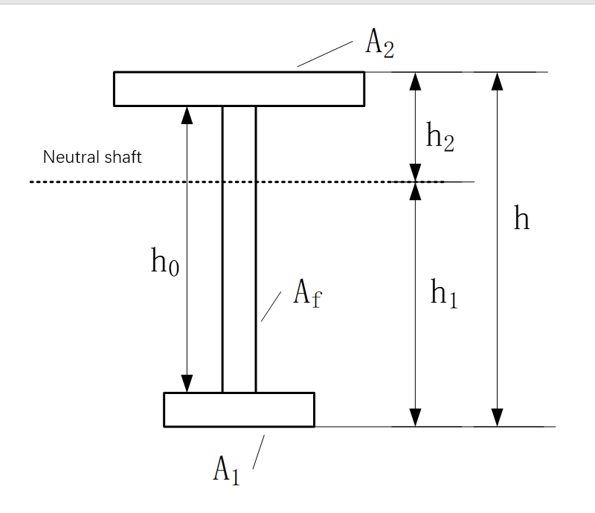
Fig.1 Single-axis symmetrical I-beam cross-section
Where:
A₁, A₂ — Areas of upper and lower flanges
h₁, h₂ — Distances from top edges of upper and lower flanges to neutral axis
A_{f,} h₀ — Web area and web height

For convenience in the following calculations, let:
$$\left\{ \begin{aligned}&\frac{A_{1}}{A_{f}}=β_{1},\frac{A_{2}}{A_{f}}=β_{2} \\ &\frac{h_{1}}{h}=α_{1},\frac{h_{2}}{h}=α_{2}\end{aligned}\right.$$
The geometric characteristic parameters of a single-axis symmetric I-beam section can be obtained by substitution into the calculation:
$$\left\{\begin{aligned}\begin{aligned}S_{1}=&\frac{\left(1+2β_{2}\right)β_{1}}{2\left(1+β_{1}+β_{2}\right)}h^{2},S_{2}=&\frac{\left(1+2β_{1}\right)β_{2}}{2\left(1+β_{1}+β_{2}\right)}h^{2}\end{aligned} \\ \begin{aligned}I_{x}=&\frac{h^{3}}{12}+\frac{{\left(1+2β_{2}\right)}^{2}β_{1}}{4{\left(1+β_{1}+β_{2}\right)}^{2}}h^{3}+\frac{{\left(1+2β_{1}\right)}^{2}β_{2}}{4{\left(1+β_{1}+β_{2}\right)}^{2}}h^{3}\end{aligned}\end{aligned}\right.$$
Where:
S₁, S₂ — Static distances of upper and lower flanges relative to the neutral axis
I_{x} — Section moment of inertia
A uniformly distributed load q acts on the upper flange of a simply supported deep beam of length l. The load is transmitted through the upper flange, web, and lower flange, inducing transverse bending in the main beam. Assuming the uniformly distributed load q on the top of the web is equivalent to that on the upper flange, the bending stress in the web is approximately equal to that in the upper flange. The calculation diagram for the web is shown in the figure2.
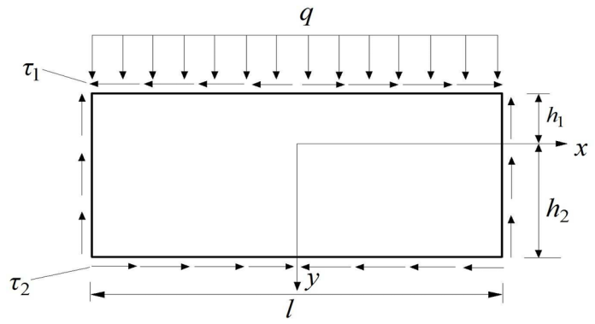
Fig.2 Simplified Calculation Diagram for Web
The reaction forces at both ends are 1/2ql. Therefore, the shear force and bending moment at any cross-section of the simply supported beam are:
$$F_{s}\left(x\right)=-qx$$
$$M\left(x\right)=\frac{q}{2}\left(\frac{l^{2}}{4}-x^{2}\right)$$
Using the semi-inverse solution method in elasticity theory to determine each stress component, we obtain:
$$\left\{\begin{aligned}σ_{x}=\frac{x^{2}}{2}\left(6Ay+2B\right)+x\left(6Ey+2F\right)-2Ay^{3}-2By^{2}+6Hy+2K \\ σ_{y}=Ay^{3}+By^{2}+Cy+D \\ τ_{xy}=-x\left(3Ay^{2}+2By+C\right)-\left(3Ey^{2}+2Fy+G\right) \end{aligned}\right.$$
Where: σx — bending stress in the web
σy — shear stress in the web
τxy — shear stress in the web
A, B, C, D, E, F, G, H, K — undetermined coefficients for each stress component
The uniaxially symmetric I-beam structure exhibits symmetry, such that σ_x and σ_y are even functions of x, while τ_xy is an odd function of x. This yields E = F = G = 0. Substituting these stress components into the stress boundary conditions and integral boundary conditions, and simultaneously setting：
$$\left\{\begin{aligned}L=α_{2}-α_{1}+2α_{2}β_{2}-2α_{1}β_{1} \\ &M=β_{2}+β_{1}+1 \\ N=4(3β_{2}β_{1}+β_{2}+β_{1})+1 \\ P=α_{2}^{3}+α_{1}^{3}+3α_{2}^{2}β_{2}+3α_{1}^{2}β_{1} \\ R=α_{2}^{4}-α_{1}^{4}+4α_{2}^{3}β_{2}-4α_{1}^{3}β_{1} \\ S=α_{2}^{5}+α_{1}^{5}+5α_{2}^{4}β_{2}+5α_{1}^{4}β_{1}\end{aligned}\right.$$
The remaining undetermined coefficients can be obtained as follows:
$$\left\{\begin{aligned}A=\frac{q}{I_{x}h^{3}}\left[h\left(S_{2}+S_{1}\right)-2I_{x}\right] \\ B=\frac{q}{2I_{x}h^{2}}\left\{h\left[\left(S_{2}-S_{1}\right)-3\left(α_{2}-α_{1}\right)\left(S_{2}+S_{1}\right)\right]+6I_{x}\left(α_{2}-α_{1}\right)\right\} \\ C=\frac{q}{I_{x}h}\left\{S_{2}h-α_{1}h\left[3α_{1}\left(S_{2}+S_{1}\right)+\left(S_{2}-S_{1}\right)\right]+6I_{x}α_{1}α_{2}\right\} \\ D=\frac{q}{2I_{x}}\left\{α_{2}^{2}h\left[\left(α_{2}+3α_{1}\right)\left(S_{2}+S_{1}\right)+\left(S_{2}-S_{1}\right)\right]-\left(2α_{2}^{3}+6α_{1}α_{2}^{2}\right)I_{x}-2S_{2}hα_{2}\right\} \\ H=-\frac{Al^{2}}{8N}\left(4PM-3L^{2}\right)+\frac{Ah^{2}}{10N}\left(88M-5RL\right)+\frac{Bh}{3N}\left(3RM-2PL\right) \\ K=\frac{Bl^{2}}{8N}\left(3L^{2}-4PM\right)+\frac{Ah^{3}}{5N}\left(5RP-6SL\right)+\frac{Bh^{2}}{6N}\left(8P^{2}-9RL\right) \end{aligned}\right.$$
Substituting the obtained coefficients into each stress component yields the elastic mechanical solution for stress components in a uniaxially symmetric I-shaped section under uniformly distributed loading.
Traditional elastic mechanics is based on generalized Hooke's law (for isotropic materials, shear strain induces only shear stress, not normal stress). In thin-walled deep beams with I-shaped cross-sections, differing shear stresses across cross-sections induce additional warping bending stresses, known as the bending-shear coupling effect. This additional bending stress cannot be neglected in thin-walled deep beams. The elastic solution is modified to account for the additional warping bending stress. Denoting this additional warping bending stress as σ_w, the value of σ_w for a uniaxially symmetric I-shaped section deep beam under uniformly distributed load is:
$$σ_{w}=\frac{2\left(1+μ\right)q}{I_{x}}\int_{0}^{y}{\frac{S^{*}}{b\left(y\right)}dy}$$
Where:
μ — Poisson's ratio
S^* — Static moment of the area of the cross-section beyond the neutral axis at distance y relative to the neutral axis
b(y) — Width of the cross-section at distance y from the neutral axis
Denote the elastic mechanical solution for bending stress as σ_e, and the modified bending stress solution as σ_x = σ_e + σ_w.

2.3 Main Beam Strength Stress Calculation
The hydrostatic pressure on an arched steel gate under fully closed water-retaining conditions can be decomposed into horizontal and vertical hydrostatic pressures. The distribution of hydrostatic pressure is shown in the figure3.
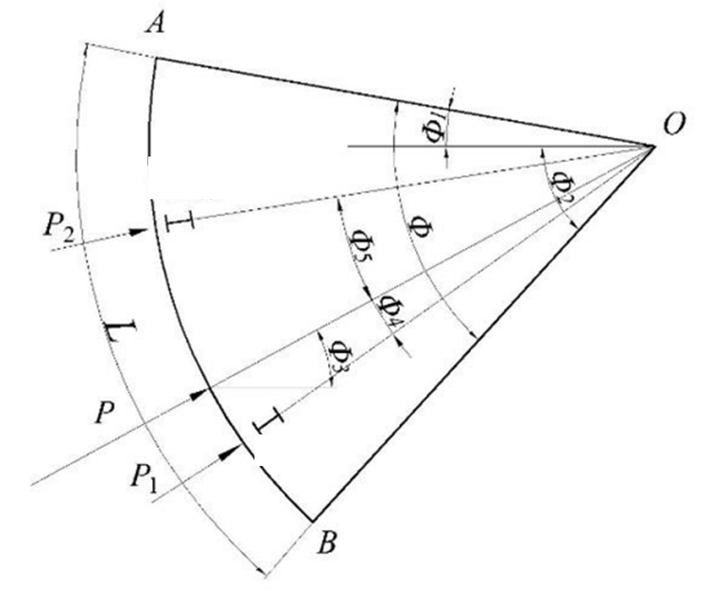
Fig.3 Distribution of hydrostatic pressure on the two main girders
$$P_{x}=\frac{1}{2}γ\left(H_{0}+H_{s}\right)hB$$
$$P_{y}=\frac{1}{2}γR^{2}B\left[Φ-2\sin{Φ_{1}\cos{Φ_{2}+\frac{1}{2}\left(\sin{2Φ_{1}-\sin{2Φ_{2}}}\right)}}\right]$$
$$P=\sqrt{P_{x}^{2}+p_{y}^{2}}$$
$$Φ_{3}=\tan^{-1}{\frac{P_{y}}{P_{x}}}$$
$$P_{1}=P×\frac{\sin{Φ_{5}}}{\sin\left(Φ_{4}+Φ_{5}\right)}$$
$$P_{2}=P×\frac{\sin{Φ_{4}}}{\sin\left(Φ_{4}+Φ_{5}\right)}$$
Where: P_x is the horizontal hydrostatic pressure; P_y is the vertical hydrostatic pressure; H_s is the design head; H₀ is the height from the top waterstop to the upstream water surface; h is the gate height (to the top waterstop); B is the opening width; R is the curvature radius of the gate panel; γ is the unit weight of water, taken as 10 kN/m³; Φ₃ is the direction of total water pressure; P₁ and P₂ are the loads acting on the lower and upper main frames of the curved steel gate.
Distribute the total water pressure across the two main frames using the above formula. The loads on each main beam are shown in the table below:
Table 2.Load Distribution Table for Main Beams：
Main Beam | 1 | 2
Water Pressure “×” 106/N | 15.9101 | 17.2138
Effective Width [l]/mm | 4700 | 4700
Uniformly Distributed Load [q] N/mm | 3385.13 | 3662.51

The main beam of the deep-hole curved steel gate in this paper is a box-section thin-walled deep beam. To establish a bending-shear coupled mechanical model for an I-section thin-walled deep beam, one only needs to merge the two webs of the box section into a single web. Moreover, the facing plate here serves not only as a water-retaining structure. When subjected to bending, the portion of the facing plate adjacent to the main beam participates in resisting bending together with the main beam. The width of this participating facing plate is termed the “effective width of the facing plate” and can be considered as the upper flange of the equivalent I-shaped section. According to design specifications, the effective width of the gate was calculated to be 738 mm.
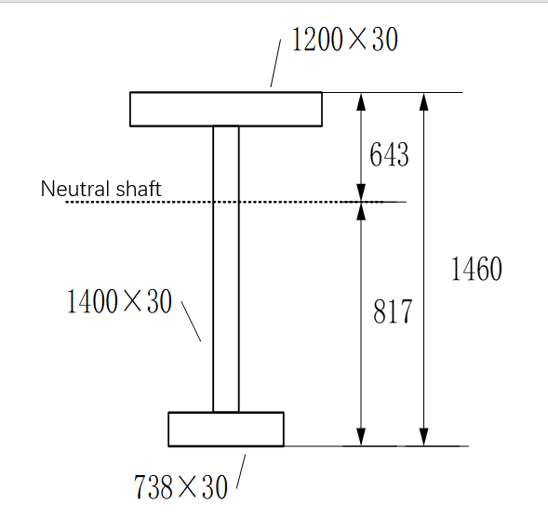
Fig.4 Main Beam I-Section (Unit: mm)

The main beam's I-section is shown in the figure. With a beam length of 4.7m, the span-to-height ratio α = 3.36. Substituting the relevant parameters of the curved steel gate into the formula yields α₁ = 0.56, α₂ = 0.44, β₁ = 0.4, β₂ = 0.64, and I_x = 38008891226.67 mm⁴ .The bending stress can be expressed as:
$$σ_{x}=\frac{M\left(x\right)y}{I_{x}}\left(1+λ\right)$$
$$λ=0.6667\left(\frac{2.6\left(6β+1\right)}{α^{2}}+\frac{0.4}{\left(6β+1\right)α^{2}}\right)$$
where λ represents the influence of shear strain on bending stress, α denotes the span-to-height ratio, and β indicates the area ratio of flange to web. The literature provides the dimensionless warping stress λ for biaxially symmetric I-sections. To determine the maximum bending stress for a deep beam with uniaxially symmetric I-section, combining the equivalent flange-to-web area ratio β = 0.52 from Reference 20, yielding σ_01 = 86.94 MPa, σ_02 = 80.36 MPa, σ_x1 = 142.5 MPa, and σ_x2 = 131.71 MPa. All values are below the allowable stress of 203.06 MPa.

RESULT & DISCUSSION

Finite Element Analysis of the Structural Strength of Curved Steel Gates in Closed-Door Conditions

3.1 Establishment of the Three-Dimensional Model for Curved Steel Gates
The deep-hole curved steel gate discussed herein serves as the working gate for the spillway bottom outlet of a hydropower station, designed for a head of 74 meters. It comprises gate leaves, support arms, and support beams. The overall structural layout is shown in the figure5.
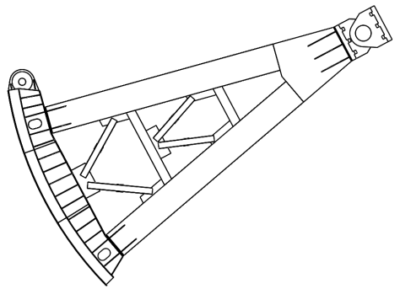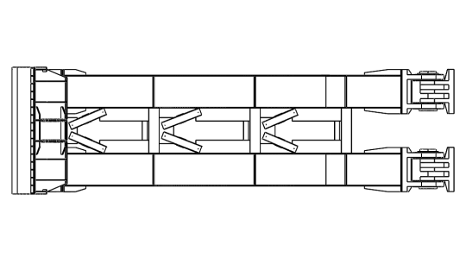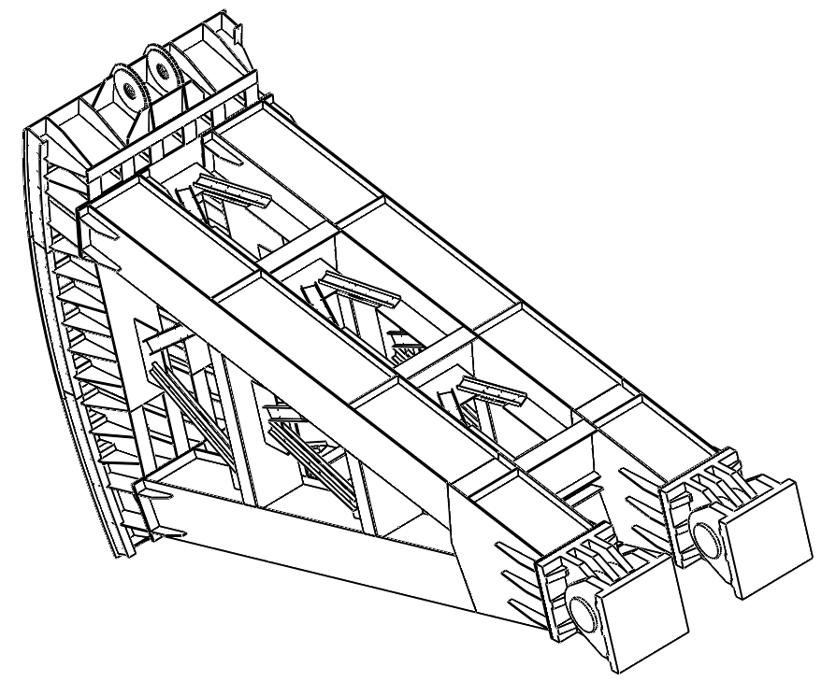
Fig.5 Overall Structural Layout Diagram
Create a three-dimensional solid model of the gate in SolidWorks software according to the drawings, employing a top-down modeling approach. First, construct the gate's overall framework to determine the positions and relative relationships of key components such as the gate leaf, support arms, and hinges. To facilitate subsequent finite element analysis, appropriately simplify the established 3D model. Minor details with negligible impact on structural strength—such as small chamfers, fillets, and bolt holes—were removed to reduce computational load and enhance analysis efficiency. Concurrently, a quality inspection ensured the model contained no surface breaks, gaps, or other defects, guaranteeing its integrity and continuity. To ensure accurate transmission of geometric information and assembly relationships, the established and simplified 3D model is saved in *.x_t format for import into subsequent software for discrete element and structural strength analysis. The 3D solid model of the curved steel gate is shown in the figure below
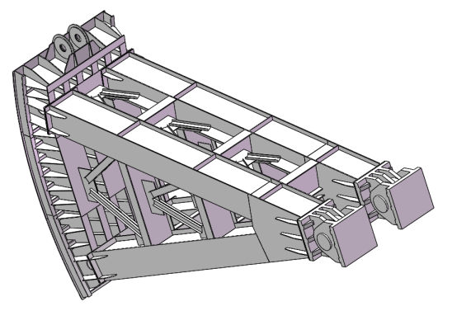
Fig.6 3D Solid Model of Curved Steel Gate

3.2 Finite Element Model of Curved Steel Gate
Import the saved 3D model into Hypermesh for discretization. To facilitate mesh generation for each gate component and subsequent processing and result visualization in ANSYS, categorize the automatically generated components in Hypermesh using the Organize function. Group them into sections such as stays, arms, panels, main beams, horizontal secondary beams, and longitudinal beams, as shown in the figure. The overall gate structure primarily employs hexahedral meshes, simulated using SOLID 185 solid elements. Except for the support columns, most components are thin-shell structures with internal continuity. To ensure force transfer between components, unified meshing is required. The Equivalence function was applied to share nodes between continuous components, guaranteeing mesh continuity at edge connections. The complete model comprises 888,028 nodes and 492,967 elements, as shown in the finite element model diagram. The meshed geometry underwent free-edge, T-edge, and quality checks. For the 3D mesh, the Check Elements panel evaluated metrics including warping ratio, aspect ratio, skew angle, and Jacobian, as illustrated. The overall mesh quality of the curved gate model is satisfactory and meets requirements.
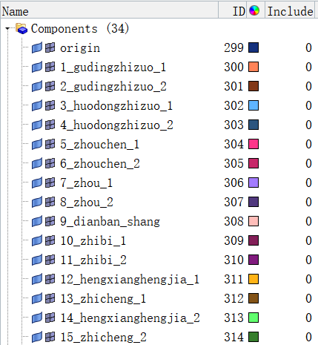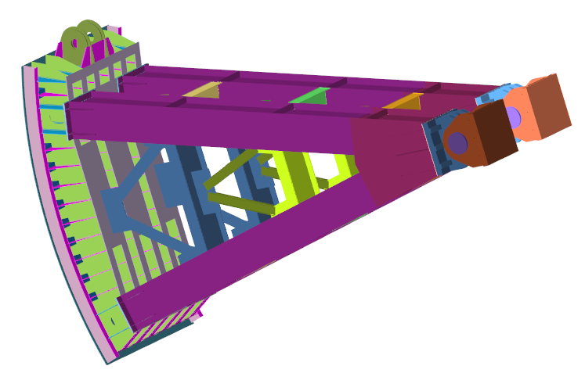
Fig.7 Component Division of the Model
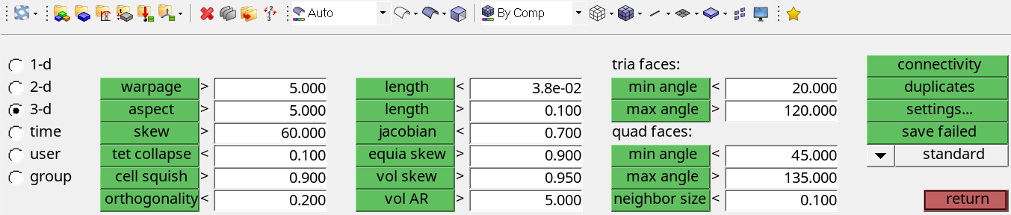
Fig.8 Check Elements Panel in HyperMesh
Save the finite element mesh model as an INP format file. Import the discretized mesh into Workbench using the External Model module. Set the origin at the center of the bottom surface. Define the Z-axis along the flow direction, the X-axis perpendicular to the flow direction, the Y-axis along the gate span direction, and the gravitational direction along the negative X-axis. For gate closure under design head conditions, loads include gate self-weight and hydrostatic pressure. Apply fixed constraints at the bottom of the gate's fixed supports. Apply displacement constraints on both sides of the gate leaf to restrict lateral movement. Apply a frictionless constraint at the bottom of the panel to simulate bottom support. Set a friction rotation between the movable support and the bearing bushings with a friction coefficient of 0.1 to simulate structural friction rotation.
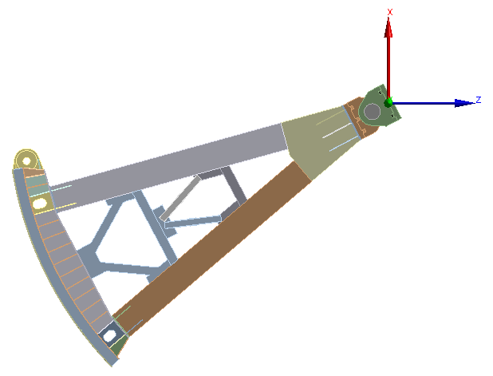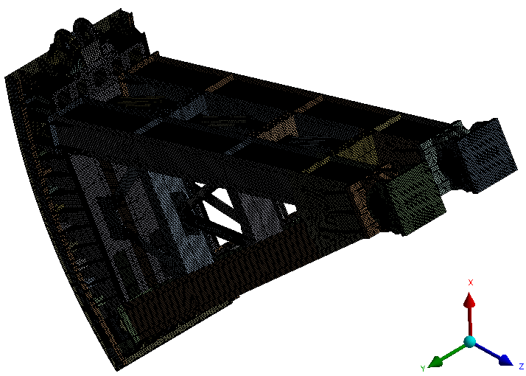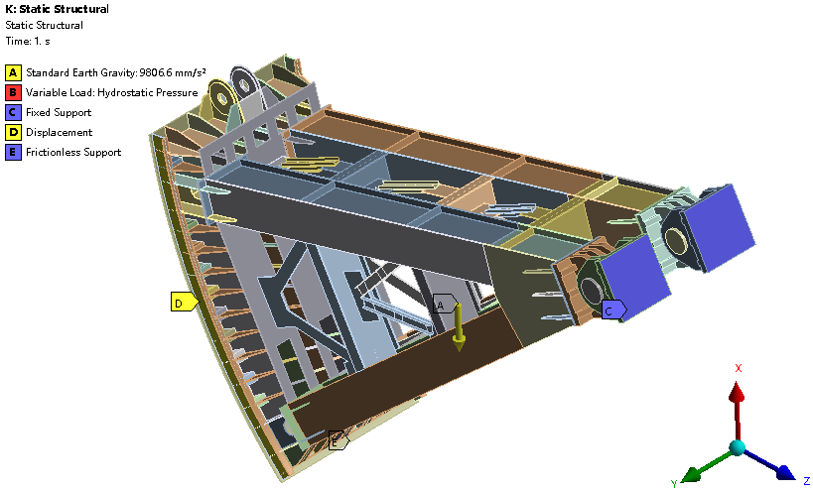
Fig.9 Finite Element Mesh Model

3.3 Finite Element Solution for Curved Steel Gate
The finite element calculation results for the gate's overall structure are shown in the figure below. It was found that the equivalent stress across most areas of the gate's overall structure remained below 241.8 MPa, with a maximum value of 272.03 MPa occurring at the support connection between the connecting plate and the transverse truss on the gate leaf connecting the gate arms. This value is lower than the yield strength of Q345 steel (311.36 MPa). Thus, the overall structure meets the yield strength requirement.
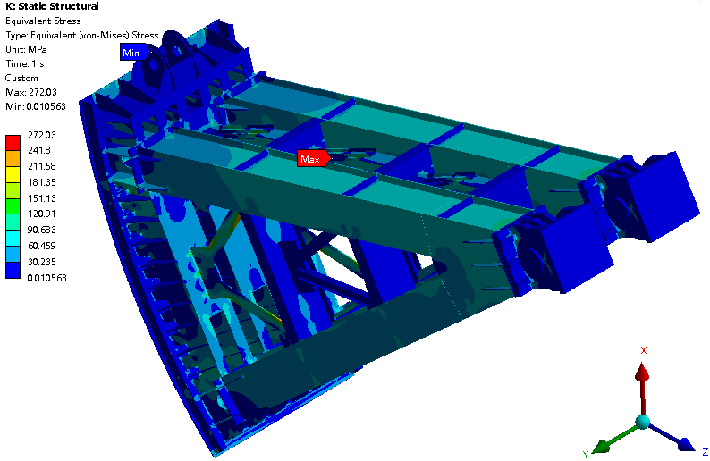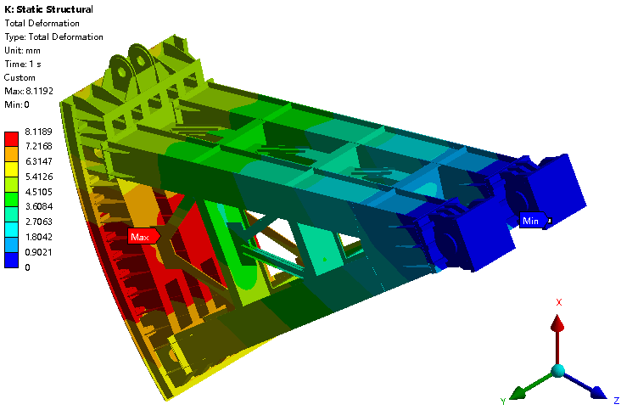
Fig.10 Equivalent stress of the gate assembly Total displacement of the gate assembly
The finite element calculation results for the main girder box-type structure are shown in the figure. The normal stress contour plot reveals that the maximum equivalent stresses occur in the mid-span regions of the main girders. After stress concentration correction, the maximum equivalent stress in Main Girder 1 is 142.26 MPa, while that in Main Girder 2 is 137.32 MPa. The distribution patterns of normal stresses at the mid-span sections of each main girder are largely consistent. Both the finite element solution and the theoretical solution for maximum stress are below the material's allowable compressive or tensile strength values.
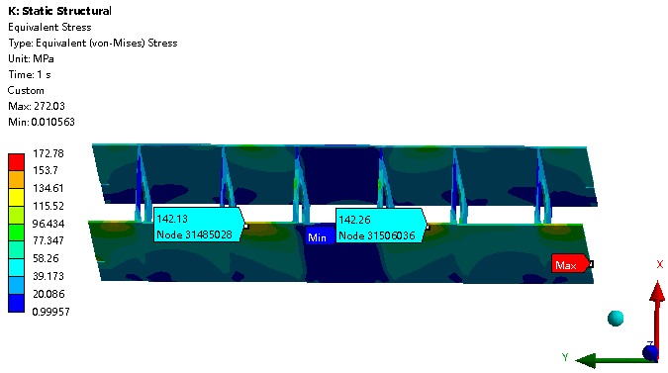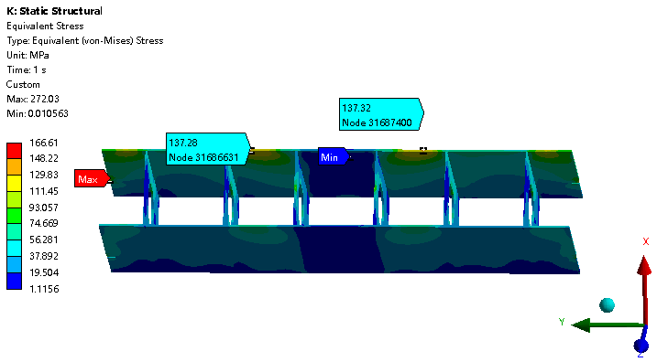
Fig.11 Equivalent stress of Main Beam 1 and equivalent stress of Main Beam 2
The theoretical stress calculations for the main beams and the finite element results are summarized in the table below. The lateral bending theoretical solution accounts for the influence of warping stresses, better reflecting the actual loading conditions of the structure. The calculated results from the finite element model established in this paper exhibit errors of 0.17% and 4.1% relative to the lateral bending theoretical solutions, both within acceptable ranges. This validates the accuracy of the finite element model calculations and provides assurance for subsequent finite element computations.
Table 3 Comparison of Finite Element Solution and Shear Force Bending Solution
Main Beam | 1 | 2
Shear Force Bending Solution | 142.5 | 131.71
Finite Element Solution | 142.26 | 137.32
Error | 0.17% | 4.1%

3.4 Stress and Deformation of Major Components in Curved Steel Gates
The equivalent stress and total displacement contour maps extracted for the panel are shown in Figures and . As depicted, the equivalent stress across most areas of the panel structure remains below 125.45 MPa, with the maximum equivalent stress value of 141.02 MPa occurring at the connection between the top main girder stiffener and the panel. The maximum deformation of 8.12 mm occurs at the midpoint of the panel between the two arms. The maximum equivalent stress on the arms is 222.43 MPa, occurring at the intersection point between the lower end of the transverse truss and the arm; the maximum deformation of 6.89 mm occurs at the contact area between the lower arm and the transverse truss, as well as at the contact area between the lower end of the arm and the lower section of the gate leaf.
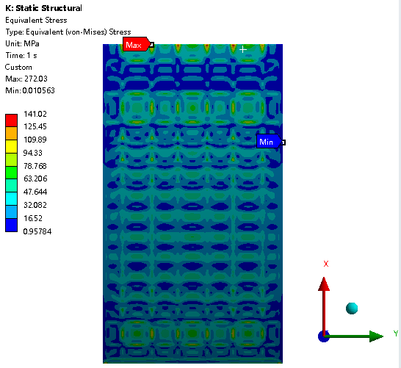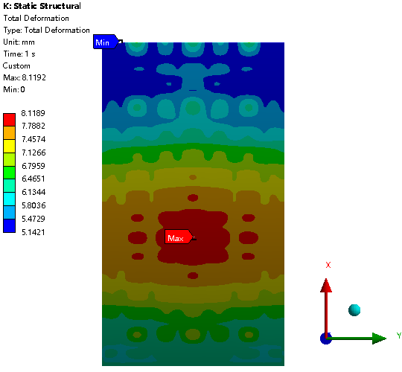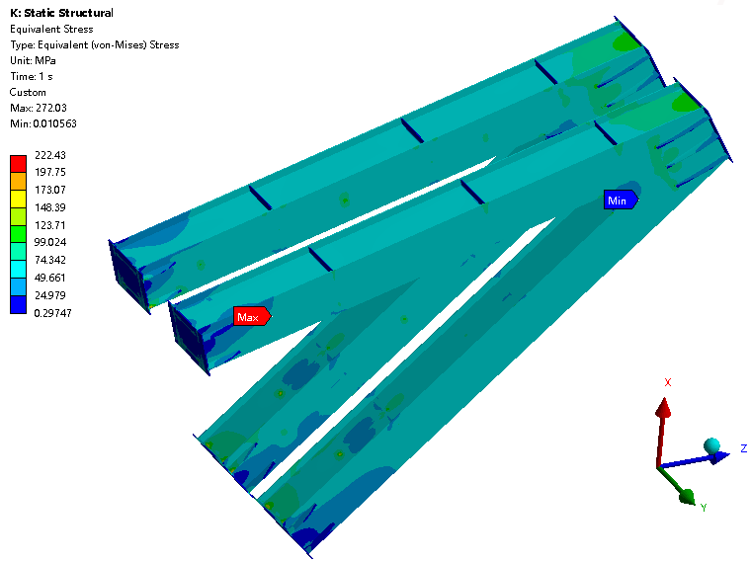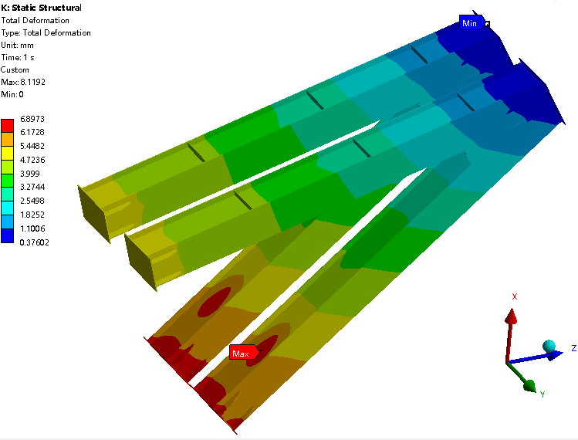
Fig.12 Equivalent Stress and Total Displacement Contour Plots

4. Summary & CONCLUSION
This paper employs a combined approach of theoretical calculations and finite element simulations to conduct a systematic analysis of the structural strength of high-head curved steel gates under closing conditions. First, based on elastic mechanics and bending-shear coupling theory, the analytical stress solution for a uniaxially symmetric thin-walled deep I-beam under uniformly distributed load was derived. Calculations yielded maximum bending stresses in the main beams of 142.5 MPa and 131.71 MPa, both below the material's allowable stress. Subsequently, a three-dimensional gate model was created using SolidWorks. After meshing with HyperMesh, the model was imported into ANSYS for static analysis, yielding stress and displacement distributions for the entire gate and its primary components (face plate, main beams, support arms, etc.). Finite element results indicated the maximum equivalent stress of 272.03 MPa occurred at the support arm connection, remaining below the material's yield strength. The finite element solution for main beam stress showed good agreement with the theoretical solution, with a maximum error of only 4.1%, validating the accuracy of the numerical model. Additionally, the maximum stress in the panel was 141.02 MPa with a maximum deformation of 8.12 mm; the maximum stress in the support arm was 222.43 MPa with a deformation of 6.89 mm. All components met the strength and stiffness requirements. This study provides important references for structural optimization, safe operation, and maintenance of high-head curved gates. Follow-up research can further explore fluid-structure interaction vibration and flow-induced vibration aspects.

Competing interests

Authors have declared that no competing interests exist.

DISCLAIMER (ARTIFICIAL INTELLIGENCE)
Author(s) hereby declare that NO generative AI technologies such as Large Language Models (ChatGPT, COPILOT, etc.) and text-to-image generators have been used during the writing or editing of this manuscript.

COMPETING INTERESTS DISCLAIMER:
Authors have declared that they have no known competing financial interests OR non-financial interests OR personal relationships that could have appeared to influence the work reported in this paper.

References

[1] Griffin, O. M. (1980). Vortex-Excited Cross-Flow Vibrations of a Single Cylindrical Tube. Journal of Pressure Vessel Technology, 102(2), 158-166. https://doi.org/10.1115/1.3263315
[2] Ishii, N., Imaichi, K., & Hirose, A. (1980). Dynamic instability of Tainter gates. In E. Naudascher & D. Rockwell (Eds.), Practical Experiences with Flow-Induced Vibrations (pp. 452–460). Springer. https://doi.org/10.1007/978-3-642-81528-7_49
[3] Ishii N. Folsom Dam gate failure evaluation based on modal analysis and suggestion[J]. USBR, 1995.
Thang, N. D., & Naudascher, E. (1986). Vortex-excited vibrations of underflow gates. Journal of Hydraulic Research, 24(2), 133-151. https://doi.org/10.1080/00221688609499309 .
[4] Kolkman, P. A. (1988). A simple scheme for calculating the added mass of hydraulic gates. Journal of Fluids and Structures, 2(4), 339–353. https://doi.org/10.1016/S0889-9746(88)90051-5
[5] Erdbrink, C. D., Krzhizhanovskaya, V. V., & Sloot, P. M. A. (2014). Reducing cross-flow vibrations of underflow gates: Experiments and numerical studies. Journal of Fluids and Structures, 50, 25-48. https://doi.org/10.1016/j.jfluidstructs.2014.06.010
[6] Lee, S. H., Hahm, H. G., & Ryu, G. S. (2015). Dynamic Characteristics of the Long Span Truss-Type Lift Gate by Model Test. Journal of The Korean Society of Agricultural Engineers, 57(6), 117-123. https://doi.org/10.5389/KSAE.2015.57.6.117 .
[7] Yang, X., Li, Z. G., Gong, C., & Ma, B. (2022). Analysis and research on sluice gate flow of a hydropower station under different working conditions. IOP Conference Series: Earth and Environmental Science, 1037(1), 012059. https://doi.org/10.1088/1755-1315/1037/1/012059 .
[8] Zhang, Z., Lan, J., Fan, F., & Zhi, X. (2021). Selection of New Type Radial Steel Gate and Analysis of Static and Dynamic Characteristics. International Journal of Steel Structures, 21(5), 1630–1643. https://doi.org/10.1007/s13296-021-00525-7
[9] Sun, S., Zhang, R., Liu, X., Liu, C., & Wang, A. (2024). Numerical Simulation and Application of Radial Steel Gate Structure Based on Building Information Modeling under Different Opening Degrees. Water. https://doi.org/10.3390/w16020636 .

