Original Research Article

Stabilization of Expansive Soil Using Gum Arabic and Quarry Dust Mixture for Highway Application

.
ABSTRACT
Aim: Expansive soils, characterized by their significant volume changes with moisture fluctuations, pose substantial challenges in highway construction due to their tendency to cause pavement distress and structural instability. This study investigates the potential of using a combination of Gum Arabic, a natural and biodegradable resin, and quarry dust, an industrial by-product, as sustainable alternatives for stabilizing expansive soils in highway subgrade applications.
Methodology: Laboratory experiments were conducted on expansive soil samples treated with varying proportions of Gum Arabic and quarry dust. The geotechnical properties assessed included Atterberg limits, compaction characteristics, California Bearing Ratio (CBR), and Shear strength.
Results: The soil was initially characterized as an inorganic clay of medium plasticity (CL) with a plasticity index of 29.46%, linear shrinkage of 10.71%, and specific gravity of 2.01, indicating high swell potential and poor suitability for engineering applications in its natural state. Stabilization was carried out using varying proportions of gum arabic (2%–8%) and stone dust (5%–20%). CBR results showed that the optimum improvement occurred at 4% gum arabic and 10% stone dust, achieving a 14-day CBR of 9%, compared to 41.5% in the untreated compacted soil. Shear strength was also enhanced, with the maximum shear strength of 33.12 kN/m² recorded at 2% gum arabic and 5% stone dust, driven by increased apparent cohesion.
Conclusion: The study concludes that moderate dosages of gum arabic and stone dust can significantly improve the strength characteristics of expansive soils, making them more suitable for subgrade applications. However, performance depends on proper dosage selection and adequate curing

Keywords: Soil stabilization, Gum Arabic, Quarry dust, Expansive soil.
1. INTRODUCTION

Expansive soils, known for their significant volume changes with moisture variations, pose challenges to infrastructure stability, particularly in highway construction (Almuaythir et al., 2024). The performance of their clay mineral ingredient causes expansive soils to display shrink-swell tendencies, which is troublesome. In their natural state, expansive soils are unsuitable for direct technical use due to their shrink-swell behaviors (Ikeagwuani and Nwonu, 2019; Puppala, 2021). These soils exhibit shrink-swell behavior, causing pavement heaving, cracking, and subgrade deformation, particularly in regions with alternating wet and dry conditions (Venkateshwara and Satyanarayana, 2024; Zhen et al., 2022). This behavior leads to structural instabilities, including pavement heaving, cracking, and eventual failure, particularly in highway subgrades.
Expansive soils, renowned for their substantial volumetric alterations in response to moisture variations, pose notable challenges to civil engineering infrastructure (Almuaythir et al., 2024). These soils, which are typically high in montmorillonite, swell when wet and shrink when dry, leading to structural damage, differential settlements, and increased maintenance costs (Almuaythir et al., 2024; Awang et al., 2021; Almuaythir and Abbas, 2023; Ishak et al., 2021; Wahab et al., 2022; Zaini and Hassan 2023a; Zaini and Hassan 2023b). These soils can lead to cracking and deformation of roadways, necessitating effective stabilization techniques to enhance their load-bearing capacity and durability.
Expansive soils lose shear strength and bearing capacity when water content changes, increasing compressibility and risking slope instability (Zhen et al., 2022). Cyclic wetting-drying exacerbates crack formation, accelerating erosion and differential settlement (Venkateshwara and Satyanarayana, 2024). Untreated expansive soils necessitate frequent repairs, raising maintenance costs and safety hazards (Zhen et al., 2022; Roodi and Zornberg, 2020).
Traditional stabilization methods, such as the use of lime or cement, have been employed to mitigate these issues. While traditional stabilization methods like lime and cement treatment are effective, they come with substantial environmental drawbacks, including high carbon emissions and significant energy consumption (Zaini and Hassan 2023c; Zhao et al., 2021; Zolkepli et al., 2019; Bian et al., 2024). These conventional stabilizers often come with environmental concerns and cost implications (Bian et al., 2024). Lime modification reduces swelling potential by cation exchange and pozzolanic reactions, improving soil plasticity and strength (Venkateshwara and Satyanarayana, 2024). However, long-term field studies show lime-stabilized sections may underperform compared to geosynthetic methods in crack mitigation (Roodi and Zornberg, 2020). These materials enhance tensile strength, distribute loads, and restrict lateral soil movement. Field tests demonstrate geosynthetic-stabilized sections achieve higher safety factors (e.g., 1.5–2.0) than lime-treated soils (Roodi and Zornberg, 2020; Venkateshwara and Satyanarayana, 2024). Research has also indicated that incorporating these additives not only enhances the soil's strength but also reduces its plasticity index, making it more suitable for construction applications (Waheed and Asmael, 2018; Khudhair et al., 2023; Karami et al., 2021).
Quarry dust, a byproduct of stone crushing processes, has emerged as a potential stabilizing agent (Zada et al., 2023). Its utilization not only addresses waste management concerns but also enhances soil properties. Studies have demonstrated that incorporating quarry dust into expansive soils can reduce plasticity and improve strength parameters, making it a viable option for subgrade enhancement (Zada et al., 2023). Simultaneously, Gum Arabic, a natural, biodegradable resin obtained from the Acacia tree, has been explored for its binding properties (Prasad et al., 2022; Mudgil and Mudgil, 2024). Its application in soil stabilization offers an eco-friendly alternative, improving soil cohesion and reducing permeability (Ajagbe et al., 2024). Research indicates that even minimal additions of Gum Arabic can lead to significant improvements in soil behavior under both soaked and unsoaked conditions (Ajagbe et al., 2024). Furthermore, Gum Arabic offers a sustainable substitute for conventional chemical stabilizers because it is a non-toxic and biodegradable substance (Aloqbi, 2020). Its use in soil stabilization may offer a long-term way to enhance soil behavior, especially in areas with a large acacia tree population and easy access to gum Arabic.
This study is therefore aimed as evaluating the effects of Gum Arabic and Quarry dust on the geotechnical properties of soil.

2. material and methods
2.1 Material Selection
i. Soil Sample: Soil samples was collected from a selected site in Ekiti State The top soils were removed to a depth of 0.5 m before the soil samples were taken, sealed in plastic bags and put in sack to avoid loss of moisture during transportation. The soil samples were allowed to dry before pulverizing to obtain particles passing sieve BS No. 4.75 mm.
ii. Quarry Dust: Quarry dust, which was sourced locally, was used as one of the stabilizing agents. The dust was finely ground to pass through a 2mm sieve.
iii. Gum Arabic: The Gum Arabic used in this study was sourced from the Acacia Senegal tree. It was purchased in a powdered form, which was dissolved in water to prepare the required concentrations for soil treatment.
2.2 Mix Proportions
Soil samples were mixed with different dosages of Gum Arabic and Quarry Dust to assess the effects of varying concentrations of these stabilizers on the geotechnical properties of the soil. Quarry Dust was added to the soils in proportions of 5%, 10%, 15%, and 20%, while Gum Arabic was added to the soil in proportions of 2%, 4%, 6%, and 8%. Soil Specimens were cured for 7 and 14 days.
2.3 Natural Moisture Content
Following BS 1377 (1990) Part 2 standard, the natural moisture content of the soil as it was taken from the site was ascertained. Three containers were cleaned then weighed as M₁ to the closest 0.01 g. The collected sample was crushed and loosely placed in the containers. The containers containing the samples were then weighed collectively and recorded to the closest 0.01 g as M₂. After that, the containers were dried for 24 hours at 105°C to 110°C in the oven. After oven-drying the samples weighed and recorded to the closest 0.01 g as M₃. The average of the natural moisture content is then computed as given by equation 1.
$Mc= \frac{M_{2} -M_{1}}{M_{3} -M_{1}} x 100$ Equation 1
Where:
Mc = Moisture content in percentage (%)
M₁ = Mass of Cup
M₂ = Mass of Wet
M₃ = Mass of Dry
2.4 Sieve Analysis
The sieve analysis test was aimed at determining the fineness modulus of the soil. The sieves were arranged in descending sequence of 4.75 mm, 2.36 mm, 2.0 mm, 1.7 mm, 850 µm, 300 µm, 150 µm, and 75 µm. One kilogramme (kg) of sand was collected oven-dried. The oven-dried soil sample was then poured into the top sieve, no. 4.75 mm, and the sieve set was covered. The sieves were stacked in the sieve shaker with the pan at the bottom and the cover at the top (Figure 1), and the sieve shaker was allowed to run for 10 mins. The weight retained in each sieve was noted and computed after sieving.
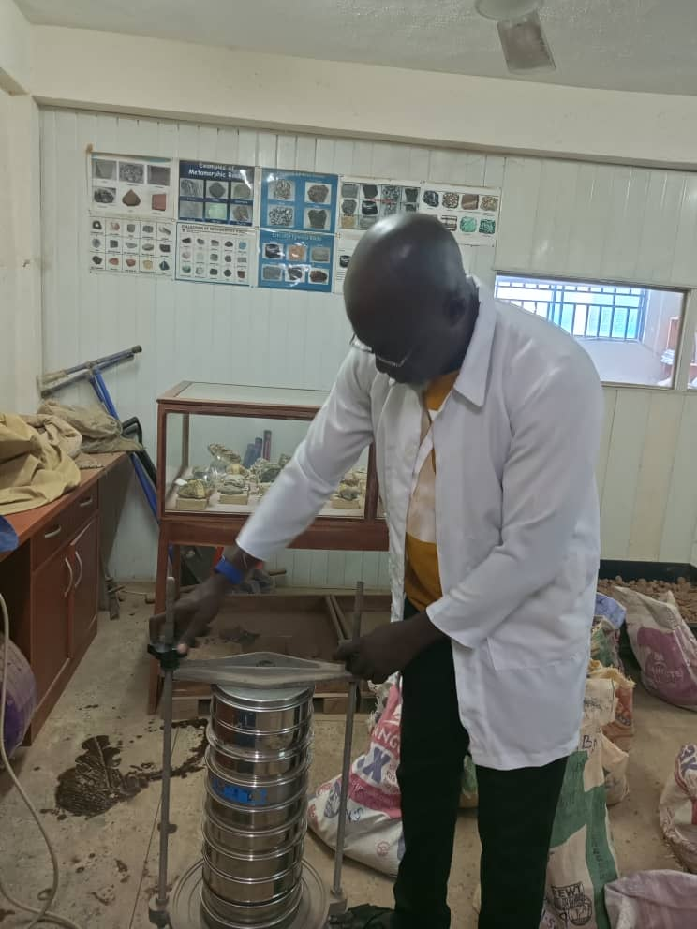
Fig. 1. Sieve Analysis of Soil Sample
2.5 Specific Gravity
The specific gravity test was carried out in accordance with the BS 1377 (1990) Test (B) for fine-grained soils (Hasan et al., 2021). The density bottle and stopper were weighed and recorded to the closest 0.01 g as M₁. Oven-dried soil samples was poured into the density bottle, and the bottle plus soil and stopper were weighed and recorded to the closest 0.01 g as M₂. Just enough water was added to cover the soil, and any air bubbles were gently agitated out of the mixture. After that, the bottle was fully filled and sealed. After wiping the covered vial dry, the entire sample was weighed and recorded to the closest 0.01 g as M₃. After that, the bottle was drained and filled all the way with water, dried, and weighed and recorded to the closest 0.01 g as M₄. The specific gravity was then calculated using equation 2.
$Gs= \frac{M_{2} -M_{1}}{\left(M_{4}-M_{1}\right)-\left(M_{3}-M_{1}\right)}$ Equation 2
Where:
M₁ = Mass of Dish (g)
M₂ = Mass of Dish + Dry Soil (g)
M₃ = Mass of Dish + Soil + Water (g)
M₄ = Mass of Dish + Water (g)
2.6 Atterberg Limits
Liquid limits, plastic limits, and the plasticity index for both natural and stabilized soils were determined during the test. They were carried out in compliance with BS 1924 (1990) for stabilized soils and Test1 (A) BS 1377 (1990) for natural soil (Tanyıldızı et al., 2023).
2.6.1 Liquid Limits
After air drying the soil sample for the liquid limit, 200 g of the material that passed through a BS No 4 sieve (425 µm aperture) was taken and combined with water to create a uniform paste on a flat glass plate.
After that, a quantity of the soil-water mixture is put into the Casagrande apparatus' cup, levelled off parallel to the base, and divided by passing the grooving tool through the hinge's centre along the diameter. The crank was then turned to raise and lower the cup until the two soil components meet at the bottom of the groove. The number of blows required to close the gap was recorded. A little amount of the soil is removed and its moisture content was determined. The liquid limit was determined as the moisture content equivalent to 25 blows, and the values of the moisture content (calculated) and the corresponding number of blows will be shown on a semilogarithmic graph (Tanyıldızı et al., 2023).
2.6.2 Plastic Limits
To determine the plastic limit, a little quantity of the soil mixture used in the liquid limit test were kept. Even though the soil was already comparatively drier than the ones used for the liquid limit, the ball of soil/soil admixture was shaped between the fingers and rubbed between the palms of the hand until it dried sufficiently. After that, the sample was separated into roughly four (4) equal portions. Between the thumb and the first finger, each component was coiled into a thread. Next, the thread was rolled between the glass and the tips of one hand's fingers. This continued until the diameter of the thread is reduced to around 3 mm in five to ten forward and backward movement of the hand. The movement persisted until the soil thread crumbled. The moisture content is then measured after the crumbled soil has been placed in the moisture container (Tanyıldızı et al., 2023).
2.6.3 Plasticity Index (PI)
The plasticity index of the soil was determined as the difference between the liquid limits of the natural different mixes of the soil and their corresponding plastic limits (Tanyıldızı et al., 2023). The plasticity index of the samples was calculated as:
$PI=LL-PL$ Equation 3
Where:
PI = Plasticity Index
LL = Liquid Limit
PL = Plastic Limit
2.7 Compaction Characteristics
The maximum dry density and matching ideal moisture content for both natural and stabilized soils were determined (Hasyimi and Syahril, 2021)..
2.7.1 Maximum dry density
Compaction tests were conducted using the British Standard Heavy in compliance with the Nigerian General Specification (1997) for both natural and stabilized soils (in varying percentages) in line with BS 1377 (1990) Part 4 (Hasyimi and Syahril, 2021).
The sample of soil admixtures was carefully mixed with the appropriate amount of water. The sample was then compressed into 2360 cm³ (of mass ml) by applying 27 2.5 kg rammer blows in three layers in accordance with British Standard with a 4.5 kg rammer.
Little amount of soil samples was extracted from the compacted soil to determine the moisture content. This process was repeated until in order to determine the optimum moisture content. The bulk density of the soil determined using equation 4
$Pb= \frac{M_{2}-M_{1}}{1000}$ Equation 4
Where:
P_{b} = Bulk Density (mg/m³)
M₂ = Mass of wet soil (g)
M₁ = Mass of Container (g)
The dry density was also calculated using equation 5:
Pd = ${100pb}/{100+W}$ Equation 5$ρδ={100ρ}/{\left(100+W\right)------------------eqn (3.5)}$
Where:
W = Moisture of each compacted layer.
Pd = Dry Density
Pb = Bulk Density.
Plotting the dry density values derived from equation (3.5) against the corresponding moisture contents will allow the Maximum Dry Density, or MDD, to be inferred as the highest point on the resulting curves (Hasyimi and Syahril, 2021)..

2.7.2 Optimum moisture content
The graph of dry density against moisture contents yields the Optimum Moisture Contents (OMC), which are the corresponding values of moisture contents at Maximum Dry Density (MDD).
2.8 California Bearing Ratio
For both natural and treated soils, the California Bearing Ratio (CBR) test was performed in compliance with BS1377 (1990) (Irokwe et al., 2022). The CBR was determined by noting the force that the plunger applied and the depth to which it penetrates the specimen. For each soil specimen at optimum moisture content, 3.5 kg of the sample was placed in a 2360 cm3 mould. The soil sample was placed in the mould in five layers, each compacted, with 62 blows from a 4.5 kg rammer. After compaction, the base plate was removed, and the compacted specimens were put in sealed plastic bags to cure for six days. On the sixth day, the specimens were submerged in water for twenty-four hours prior to testing in accordance with the Nigerian General Specification (1997). The specimens were moved to the CBR machine testing apparatus and placed on the bottom plate after the base plate was changed. The plunger continued piercing at a rate of 1.3 mm per minute until the specimens failed. After that, the mould was turned upside down, the base plate was taken out, and the process was repeated for the specimens' bases (Figure 2).
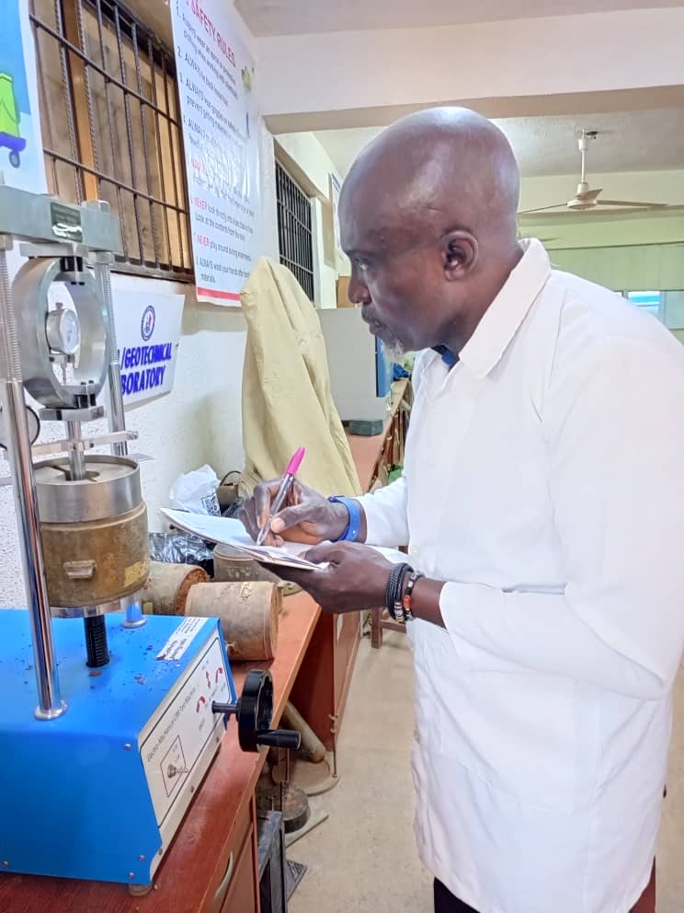
Fig. 2. Picking CBR readings from the CBR apparatus
A force versus penetration curve was created using the force and penetration measurements that were noted. The CBR's load was measured up to a penetration of 2.5 mm or 5.0 mm, whichever was greater, and then averaged when the readings were within 10% of one another. The CBR is computed from Equation 6:
CBR$=\frac{Measured load}{Standard load}× 100$ Equation 6
Where standard load $=13.24 kN of 2.5 mm penetratio$
$$=19.96 kN of 5.0 mm penetration$$
2.9 Direct Shear Strength test
The direct shear test measures the shear strength of soil by placing a soil sample in a shear box and applying a horizontal force until the sample fails (EL Afandi et al., 2023). The test provides data on the shear stress and the corresponding normal stress. The equipment used were direct shear box apparatus, loading frame, proving ring dial gauges for vertical and horizontal displacement.
The soil specimen of known dimension was prepared and placed in the shear box. A normal load was applied to the soil specimen. The dial gauges on the shear strength apparatus were set to zero, and a horizontal load was applied to the specimen at a constant rate of strain until failure occurred. The shear force and corresponding horizontal displacement at failure was recorded and the test was repeated for different normal loads.
2.10 X-Ray Diffraction Test
The X-Ray Diffraction (XRD) test was conducted to determine the mineralogical composition of the soil samples (Hamed et al., 2021). Prior to testing, the soil samples were air-dried thoroughly to eliminate moisture that could interfere with the results. The dried samples were then ground to a fine powder using a mortar and pestle to ensure uniform particle size, which is critical for accurate diffraction patterns.
After grinding, the powdered samples were mounted on sample holders using a standard back-loading technique to reduce preferred orientation of the particles. The samples were then placed in the XRD machine, and the test was carried out using Cu-Kα radiation as the X-ray source, operated at 40 kV and 30 mA. The scanning range was typically set between 5° and 70° 2θ at a scanning rate of 2° per minute.
As the X-rays interacted with the crystalline structure of the soil minerals, diffraction patterns were generated and recorded. The resulting diffractograms were analyzed using specialized software that compared the peak positions and intensities with reference patterns in a mineral database. This allowed for the identification of the various mineral phases present in the soil sample, such as quartz, kaolinite, illite, or montmorillonite

3. results and discussion
3.1 Characterization of Soil Sample
The initial properties of the soil sample prior to stabilization are presented on Table 1. It provides insight into the baseline engineering properties of the untreated expansive soil (Zhu, et al., 2025). The specific gravity of the soil was gotten to be 2.10, which is lower than the typical range of 2.60 to 2.75 for natural soils. This suggests that there may be a high clay content or the presence of organic matter. The Atterberg limits were used to assess the plasticity, consistency, and shrink-swell behavior of fine-grained soils. The liquid limit of the soil was determined to be 47.8% indicating moderate water retention ability, The plastic limit of the soil (18.34%), though lower than the liquid limit is typical of active clay soils.
The Plasticity Index (29.46%) confirms that the soil is highly plastic, and the Linear Shrinkage (10.71%) further supports its classification as an expansive clay, which poses significant challenges for pavement stability. The Liquidity Index (1.47) suggests the soil exists in a soft to plastic state in the field, indicating poor bearing capacity. Based on the data from the Atterberg limit, the Unified Soil Classification System (USCS) classifies the soil as CL (In organic clay of medium plasticity). These characteristics show that before the soil can be utilized successfully in highway applications, it must first undergo chemical stabilization or thermal activation (Zhu et al., 2025).

Table 1. Initial Characterization Test (Before Stabilization)
S/N | Parameters | Values
1. | Average Moisture Content (%) | 4.1%
2. | Average Specific gravity of Soil Sample | 2.01
3. | Plastic Limit (%) | 18.34 %
5. | Liquid limit (%) | 47.8 %
6. | Plastic Index | 29.46 %
7. | Liquidity index (%) | 1.47
8. | Consistency Index | 2.67
9. | Linear Shrinkage (%) | 10.71
10. | Classification | Inorganic clay of medium plasticity
11. | CBR | 41.5 %
12. | Direct Shear Strength | 24.93994 kN/m²

The Plasticity Index of the soil indicates active, expansive clay, particularly problematic in pavement subgrades. The high PI is consistent with the mineralogical identification of montmorillonite (33%) in the XRD results. Also, since the liquidity index, LI > 1, the soil naturally exists above the plastic limit, suggesting it is in a soft to very soft state in-situ, posing risks of instability under loading unless treated. The consistency index suggests that when the soil, is drier than the plastic limit, it behaves as a very stiff or hard material.
For highway application, the soil in its natural state, is unsuitable for use as a subgrade or untreated base material in pavement construction due to high plasticity and shrinkage, susceptibility to volume change and poor workability and stability in wet condition
3.2 Sieve Analysis of Soil Sample
Sieve analysis and hydrometer analysis (Table 2) were performed to determine the particle size distribution of the soil sample and classify it using the Unified Soil Classification System (USCS) (Sedláčkováet al., 2024). The soil was classified as with moderate sand content, falling within clayey or silty soil categories in the USCS system. This information helped in evaluating the engineering behavior of the soil, particularly its plasticity, permeability, and potential expansiveness. The hydrometer test breaks down the fines (< 0,075 mm) fraction into silt and clay. According to the USCS, the soil is classified as a fine-grained soil as it contained >50% fines

Table 2. Hydrometer analysis of soil sample
Hydrometer Analysis |  |  |  | Temp ºC = 26 |  |  | Temp. Corr. Fact (C_{T}) = 1.65
2 | 5 | 6 | 7 | 8 | 9 | 10 | 11 | 12 | 13
Time of Reading (min) | L | K | Actual Hydro. Reading R_{a} | Corr. Hydro. Reading R_{c} | % Finer | Hydro. Corr. Only for Meniscus R | L/t | D (mm) | % Finer P_{A}
0.5 | 7.4 | 0.0127 | 53 | 49 | 98 | 54.0 | 14.8 | 0.048858 | 53.312
1 | 7.8 | 0.0127 | 51 | 47 | 94 | 52.0 | 7.8 | 0.035469 | 51.136
2 | 8.1 | 0.0127 | 49 | 45 | 90 | 50.0 | 4.05 | 0.025558 | 48.96
4 | 8.8 | 0.0127 | 45 | 41 | 82 | 46.0 | 2.2 | 0.018837 | 44.608
8 | 9.4 | 0.0127 | 41 | 37 | 74 | 42.0 | 1.175 | 0.013766 | 40.256
15 | 9.9 | 0.0127 | 38 | 34 | 68 | 39.0 | 0.66 | 0.010318 | 36.992
30 | 10.5 | 0.0127 | 34 | 30 | 60 | 35.0 | 0.35 | 0.007513 | 32.64
60 | 10.7 | 0.0127 | 33 | 29 | 58 | 34.0 | 0.178333 | 0.005363 | 31.552
120 | 11.1 | 0.0127 | 31 | 27 | 54 | 32.0 | 0.0925 | 0.003863 | 29.376
240 | 11.4 | 0.0127 | 29 | 25 | 40 | 30.0 | 0.0475 | 0.002768 | 27.2
360 | 11.7 | 0.0127 | 27 | 23 | 46 | 28.0 | 0.0325 | 0.002290 | 25.024
480 | 11.9 | 0.0127 | 26 | 22 | 44 | 27.0 | 0.024792 | 0.002 | 23.936
1440 | 12.5 | 0.0127 | 22 | 18 | 36 | 23.0 | 0.008681 | 0.001183 | 19.584

The grain size analysis shows the soil was dominated by fines, particularly silt, with a notable clay fraction. With >35% silt and moderate clay, the soil is classified as either ML (Silt of low plasticity) or CL-ML (silty clay of low plasticity).
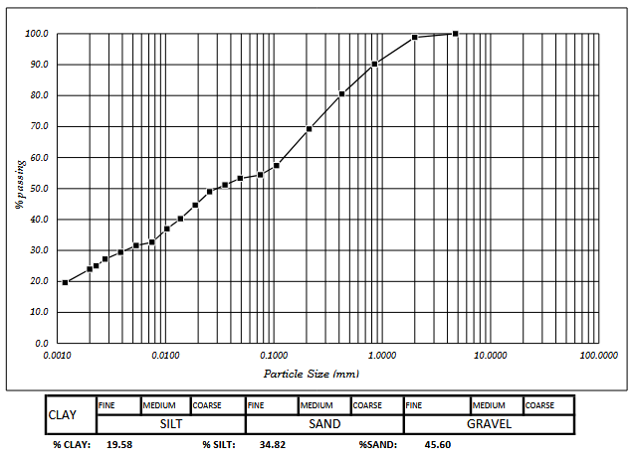
Fig. 3. Hydrometer Analysis of Soil Sample
3.3 Compaction Test
The compaction characteristics (In Figure 4) reveal that the soil has a high Optimum Moisture Content (26%) and a relatively low Maximum Dry Density (1.57 kg/m³). This behavior is typical of fine-grained, clay-rich soils with high plasticity (Ajagbe et al., 2024). The low dry density is consistent with the soil's high void ratio and low specific gravity, while the high OMC reflects its significant water absorption capacity and expansive nature. These characteristics support the previous classification and validate that stabilisation or modification is required prior to use in construction applications, particularly in pavement subgrades or as a raw material for geopolymer binders.

Maximum Dry Density | 1.57kg/m³
Optimum Moisture Content | 26%
Fig. 4. A graph of dry density against moisture content
3.3 Mineral Composition of the Expansive Soil Sample
To understand the mineralogical behavior of the expansive soil and its impact on the performance of soil, X-ray diffraction (XRD) and quantitative analysis were conducted (Hamed et al., 2021). The XRD data revealed that the soil sample contained major crystalline phases whice includes Montmorillonite (33%), Muscovite (18%), Clinochlore (44%) and Quartz (5.1%), Table 3 shows the crystalline mineral phases and their relevance in the soil sample.
Montmorillonite (33%) is a high-swelling smectite clay. Its presence indicates high plasticity and water sensitivity, which negatively affect dimensional stability in pavements (Utkarsh and Jain, 2024). However, under alkaline conditions in geopolymer systems, some montmorillonite structures may disintegrate or be immobilized within the aluminosilicate network. Still, pre-treatment or replacement is recommended for reliable concrete performance. Muscovite (18%), although less reactive, can act as a non-plastic filler and may slightly reduce the reactivity of the binder system. Its platy morphology can influence the flow properties of fresh mixes. Clinochlore (44%) is generally inert and contributes to the overall mineral matrix but plays a minor role in the geopolymerization process. Little Quartz suggests the soil is relatively fine-grained and reactive, but it also means it lacks stable, non-reactive aggregates, which might otherwise help in long-term dimensional stability.
Table 3. Identified Phases in the Soil Sample and their Relevance
Mineral | Chemical Formula | Weight % | Relevance
Montmorillonite | Al₂Si₄O₁₀(OH)₂·nH₂O | 33% | Expansive smectite clay, reactive and thermally activatable; important for geopolymer potential.
Muscovite | KAl₂(AlSi₃O₁₀)(OH)₂ | 18% | Mica-type mineral with moderate swelling potential, Mica group mineral, non-plastic filler, limited pozzolanic activity
Clinochlore | (Mg,Fe)₅Al(Si₃Al)O₁₀(OH)₈ | 44% | Primary phase; chlorite mineral, relatively inert in cement chemistry, but affects plasticity and particle shape.
Quartz | SiO₂ | 5.1 | Inert crystalline filler; contributes stability and mechanical packing.
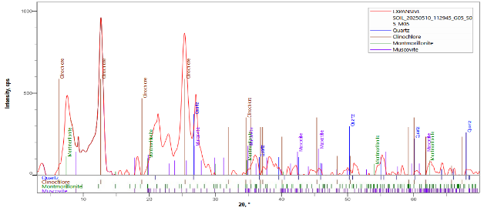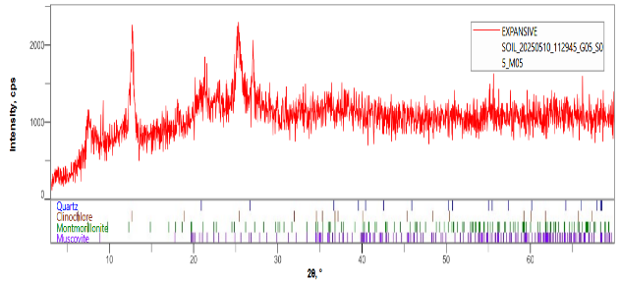
Fig. 5. Phase data view of soil sample Fig. 6. Multiply profile of soil sample
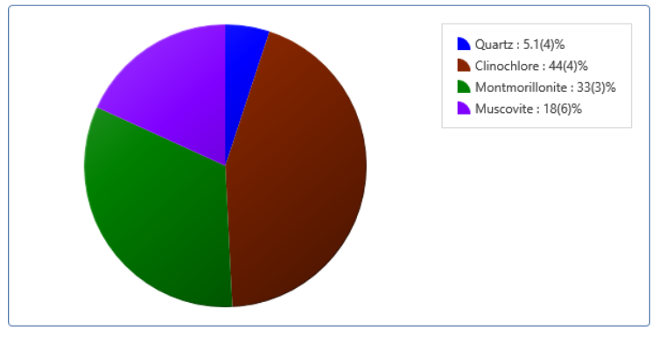
Fig. 7. Plot of results of soil sample
3.3 California Bearing Ratio
The California Bearing Ratio (CBR) test was used to evaluate the load-bearing capacity of expansive soil treated with varying dosages of gum Arabic and stone dust. The CBR values of soil stabilized with gum Arabic and stone dust in varying dosages is shown on Table 4 and Figure 8. The results show how stabilization using gum Arabic and stone dust affects the California Bearing Ratio (CBR) of expansive clay soil.
The control sample (untreated soil) had the highest 7-day CBR of 41.5%, which likely reflects a temporary increase in strength due to compaction rather than genuine long-term stability. Given the high plasticity and shrinkage of the soil, such a high value is not expected to sustain over time or moisture fluctuations. At 2% gum Arabic and 5% stone dust, the 7-day CBR significantly decreased to 3.25%, but improved to 5% after 14 days. This indicates delayed strength gain as the binding effect of gum Arabic and mechanical interlocking from stone dust begins to take effect. The 4% gum Arabic and 10% stone dust mix achieved the highest 14-day CBR of 9%, suggesting this dosage provides the most effective balance between organic binder content and mechanical reinforcement. Gum Arabic likely aids in bonding soil particles, while stone dust fills void and improves density. Increasing the dosage further (6–8% gum Arabic and 15–20% stone dust) did not lead to further improvement in CBR values. In fact, the 14-day CBR dropped slightly to 4.75%, likely due to, overuse of gum Arabic, which may begin to introduce too much organic content or reduce compatibility as well as excessive stone dust, which could disturb the optimal grading or bonding ratio.
The results shows that moderate doses of gum Arabic and stone dust (4%: 10%) offer the best improvement in bearing capacity over time. Excess dosages can lead to diminishing returns due to poor particle bonding or excess fines (Sugumaran and Neme, 2024).
Table 4: CBR values of soil samples at different dosage treatment
S/N | Treatment Dosage | CBR (%)
 |  | 7 days | 14 days
1. | Control (Untreated) | 41.5
2. | 2% Gum Arabic : 5% Stone Dust | 3.25 | 5
3. | 4% Gum Arabic : 10% Stone Dust | 2.25 | 9
4. | 6% Gum Arabic : 15% Stone Dust | 5 | 4.75
5. | 8% Gum Arabic : 20% Stone Dust | 5 | 4.75

Fig. 8: California Bearing Ratio of Soil Samples
3.3 Direct Shear Strength Test
The shear strength behavior of the soil samples treated with varying combinations of gum Arabic and stone dust was evaluated at 7 and 14 days to assess their stability under shear loading and the result is presented on Table 5 and Figure 9. The control sample consistently had the lowest shear strength (24.94 kN/m²) and cohesion (7.4 kN/m²), confirming its weaker natural structure, which is probably caused by poor inter-particle bonding and high plasticity.
The highest shear strength values were obtained at 7 days (31.72 kN/m²) and 14 days (33.12 kN/m²) with the treatment combination of 2% gum Arabic and 5% stone dust. This was mainly due to a significant increase in cohesion rather than friction angle. Interestingly, this 2%:5% treatment showed very low angles of shearing resistance (1.41° and 1.70°), suggesting that gum Arabic cohesive binding was very effective in increasing shear strength even though inter-particle friction was low. For higher dosages (4%:10%, 6%:15%, 8%:20%), cohesion moderately improved, and the angle of internal friction stabilized around 3.2° to 4.6°, resulting in steady shear strength values in the 24–28 kN/m² range
Gum Arabic functions as a binding agent, enhancing interparticle adhesion and boosting shear resistance, as evidenced by the increase in cohesiveness observed in all treated samples (Rimbarngaye et al., 2022). Stone dust likely contributed to matrix densification and reduction of voids, improving the mechanical interlocking to some extent—though less dominant than the cohesive contribution. The relatively low and fluctuating friction angles across treatments suggest that cohesion dominates shear behavior in treated expansive clay, typical of clay-rich soils.
The optimal treatment for shear strength enhancement appears to be 2% gum Arabic and 5% stone dust, offering a significant increase in cohesion and overall shear capacity. Increasing the dosage beyond this point does not produce proportional strength gains, and in some cases, may lower friction angles due to excess fines or binder saturation. These findings reinforce the importance of dosage optimization when using organic and mineral stabilizers for improving the strength behavior of expansive soils.
Table 5: Shear Strength Values of Soil Sample
Parameters | Shear Strength of Soil Samples
 | 7 days
 | Control | 2% 5% | 4% 10% | 6% 15% | 8% 20%
Apparent Cohesion C’ (kN/m²) | 7.4 | 26.8 | 11.62 | 11.62 | 13.01
Angle of shearing resistance | 5.012 | 1.41 | 4.61 | 3.57 | 3.25
Shear Strength (kN/m²) | 24.93994 | 31.72282 | 27.74675 | 24.0978 | 24.36682
 | 14days
 | Control | 2% 5% | 4% 10% | 6% 15% | 8% 20%
Apparent Cohesion C’ (kN/m²) | 7.4 | 27.18 | 12.39 | 11.94 | 12.83
Angle of shearing resistance | 5.012 | 1.7 | 4.59 | 3.54 | 4.46
Shear Strength | 24.93994 | 33.11586 | 28.44649 | 24.31268 | 28.42986

Fig. 9: Shear Strength of Soil Samples

4. Conclusion

This study investigated the effectiveness of using gum Arabic and stone dust as stabilizing agents to improve the geotechnical properties of expansive soil. The untreated soil was characterized by high plasticity, low specific gravity, high linear shrinkage, and poor shear strength, making it unsuitable for pavement subgrades without modification.
Based on the findings from this study, the following conclusions are given
i. The soil was classified as inorganic clay of medium plasticity (CL) with a plasticity index of 29.46% and a linear shrinkage of 10.71%, confirming its expansive nature.
ii. The soil had a low specific gravity of 2.01 and a maximum dry density of 1.57 kg/m³, with an optimum moisture content of 26%.
iii. XRD analysis revealed high proportions of clinochlore (44%), montmorillonite (33%), and muscovite (18%), minerals known to influence swelling behavior.
iv. The best improvement in unsoaked CBR at 14 days was observed at 4% gum Arabic and 10% stone dust, achieving 9%, indicating improved bearing capacity with curing.
v. The maximum shear strength (33.12 kN/m²) was obtained with 2% gum Arabic and 5% stone dust after 14 days, attributed to a major increase in apparent cohesion
4.1 Recommendations
Based on the findings on this study, the following recommendations are given
i. Since strength gains increased between 7 and 14 days, longer curing durations (e.g., 28 days) may yield further improvements and should be considered in future studies.
ii. The clay content and mineralogy suggest that the soil may serve as a potential geopolymer precursor if thermally activated. Further study is recommended to assess this potential.
iii. Investigate the long-term durability and environmental performance of gum Arabic-stabilized soils.

COMPETING INTERESTS DISCLAIMER:
Authors have declared that they have no known competing financial interests OR non-financial interests OR personal relationships that could have appeared to influence the work reported in this paper.

References

Ajagbe, W. O., Akolade, A. S., Ogunlade, O. D., Olaomotito, P. A., Odunewu, I. D., & Alabi, O. O. (2024). Application of gum Arabic on the geotechnical properties of subgrade materials. Acta Technica Jaurinensis. https://doi.org/10.14513/actatechjaur.00748
Almuaythir, S., & Abbas, M. F. (2023). Expansive soil remediation using cement kiln dust as stabilizer. Case Studies in Construction Materials, 18, e01983. https://doi.org/10.1016/j.cscm.2023.e01983
Almuaythir, S., Zaini, M. S. I., Hasan, M., & Hoque, M. I. (2024). Sustainable soil stabilization using industrial waste ash: Enhancing expansive clay properties. Heliyon, 10(20), e39124. https://doi.org/10.1016/j.heliyon.2024.e39124
Aloqbi, A. A. (2020). Gum Arabic as a natural product with antimicrobial and anticancer activities. Archives of Pharmacy Practice, 11(2), 107-112. https://archivepp.com/archive/volume.11/issue.2/
Awang, H., Salmanfarsi, A. F., Zaini, M. S. I., Mohamad Yazid, M. A. F., & Ali, M. I. (2021). Investigation of groundwater table under rock slope by using electrical resistivity imaging at Sri Jaya, Pahang, Malaysia. IOP Conference Series: Earth and Environmental Science, 682(1), 012017. https://doi.org/10.1088/1755-1315/682/1/012017
Bian, X., Ren, Z., Zeng, L., Zhao, F., Yao, Y., & Li, X. (2024). Effects of biochar on the compressibility of soil with high water content. Journal of Cleaner Production, 434, 140032. https://doi.org/10.1016/j.jclepro.2023.140032
Bishnoi, D. K. M. (2019). A result paper on experimental study on stabilization of soil subgrade by adding stone dust.
EL Afandi, M., Yehia, S., Landolsi, T., Qaddoumi, N., & Elchalakani, M. (2023). Concrete-to-concrete bond Strength: A review. Construction and Building Materials, 363, 129820. https://doi.org/10.1016/j.conbuildmat.2022.129820
Hamed, Heiam & Hale, William & Stern, Ben. (2021). X-RAY DIFFRACTION TO DETERMINE THE MINERALOGY IN SOIL SAMPLES IN THE UK. International Journal of Engineering Applied Sciences and Technology. 5. 10.33564/IJEAST.2021.v05i10.014.
Hasan, M., Zaini, M. S. I., Yie, L. S., Masri, K. A., Jaya, R. P., Hyodo, M., & Winter, M. J. (2021). Effect of optimum utilization of silica fume and eggshell ash to the engineering properties of expansive soil. Journal of Materials Research and Technology. https://doi.org/10.1016/j.jmrt.2021.07.023
Hasyimi, T., & Syahril, S. (2021). Improvement of Soft Soil for Subgrade Stabilized with Emulsified Asphalt and Tailing. In Advances in Engineering Research: Proceedings of the 2nd International Seminar of Science and Applied Technology (ISSAT 2021). Atlantis Press. https://doi.org/10.2991/aer.k.211106.074
Ikeagwuani, C. C., & Nwonu, D. C. (2019). Emerging trends in expansive soil stabilisation: A review. Journal of Rock Mechanics and Geotechnical Engineering, 11(2), 423–440. https://doi.org/10.1016/j.jrmge.2018.08.013
Irokwe, J. O., Nwaogazie, I. L., & Sule, S. (2022). Development of Empirical Models for the Estimation of CBR Value of Soil from Their Index Properties: A Case Study of the Ogbia-Nembe Road in Niger Delta Region of Nigeria. Open Journal of Civil Engineering, 12(4), 648–664. https://doi.org/10.4236/ojce.2022.124036
Karami, H., Pooni, J., Robert, D., Costa, S., Li, J., & Setunge, S. (2021). Use of secondary additives in fly ash based soil stabilization for soft subgrades. Transportation Geotechnics, 29, 100585. https://doi.org/10.1016/j.trgeo.2021.100585
Khudhair, A. A., Shaia, H., & Aodah, H. H. (2023). Improving of the subgrade soil using chemical additives. Maǧallaẗ Al Baṣraẗ Li l ʻulūm al Handasiyyaẗ, 23(1), 7–13. https://doi.org/10.33971/bjes.23.1.2
Mudgil, D., & Mudgil, S. (2024). Acacia gum: Chemistry, properties & food applications. Food and Humanity, 2, 100264. https://doi.org/10.1016/j.foohum.2024.100264
Prasad, N., Thombare, N., Sharma, S.C., & Kumar, S. (2022). Gum Arabic – A versatile natural gum: A review on production, processing, properties and applications. Industrial Crops and Products https://doi.org/10.1016/j.indcrop.2022.115304
Puppala, A. J. (2021). Performance evaluation of infrastructure on problematic expansive soils: Characterization challenges, innovative stabilization designs, and monitoring methods. Journal of Geotechnical and Geoenvironmental Engineering https://doi.org/10.1061/(ASCE)GT.1943-5606.0002518
Rimbarngaye, A., Mwero, J. N., & Ronoh, E. K. (2022). Effect of gum Arabic content on maximum dry density and optimum moisture content of laterite soil. Heliyon, 8(11). https://doi.org/10.1016/j.heliyon.2022.e11553
Roodi, G. H., & Zornberg, J. G. (2020). Long-term field evaluation of a geosynthetic-stabilized roadway founded on expansive clays. Journal of Geotechnical and Geoenvironmental Engineering, 146(4), 05020001. https://doi.org/10.1061/(ASCE)GT.1943-5606.0002206
Sedláčková, K., Ševelová, L., Igaz, D., & Aydın, E. (2024). Determination of Particle Size Distribution: Comparison of Standard Hydrometer Method and Laser Diffraction Analysis for Use in Forestry. Forests, 15(2), 327. https://doi.org/10.3390/f15020327
Sugumaran, B., & Neme, I. (2024). Effect of adsorption interactions of Arabic gum with cement. Materials Research Express, 11(6), 065503. https://doi.org/10.1088/2053-1591/ad51d8
Tanyıldızı, M., Uz, V. E., & Gökalp, İ. (2023). Utilization of waste materials in the stabilization of expansive pavement subgrade: An extensive review. Construction and Building Materials https://doi.org/10.1016/j.conbuildmat.2023.132435
Utkarsh, & Jain, P. K. (2024). Enhancing the properties of swelling soils with lime, fly ash, and expanded polystyrene -A review. Heliyon, 10(12), e32908. https://doi.org/10.1016/j.heliyon.2024.e32908
Reddy, K. L. V., & Murty Dasaka, S. (2024). Stabilization of expansive soil for highway embankment: A critical review. Japanese Geotechnical Society Special Publication, 10, 1554–1559. https://doi.org/10.3208/jgssp.v10.OS-30-06
Waheed, M., & Asmael, N. (2018). Improvement of engineering soil properties using non-traditional additives. MATEC Web of Conferences, 162, 01027 https://doi.org/10.1051/matecconf/201816201027
Wahab, A., Hasan, M., Mohd Kusin, F., Embong, Z., Zaman, Q. U., Babar, Z. U., & Imran, M. S. (2022). Physical Properties of Undisturbed Tropical Peat Soil at Pekan District, Pahang, West Malaysia. International Journal of Integrated Engineering, 14(4), 403–414. https://publisher.uthm.edu.my/ojs/index.php/ijie/article/view/8667
Zada, U., Jamal, A., Iqbal, M., Eldin, S. M., Almoshaogeh, M., Bekkouche, S. R., & Almuaythir, S. (2023). Recent advances in expansive soil stabilization using admixtures: Current challenges and opportunities. Case Studies in Construction Materials https://doi.org/10.1016/j.cscm.2023.e01985
Zaini, M. S. I., & Hasan, M. (2023). Effects of industrial and agricultural recycled waste enhanced with lime utilisation in stabilising kaolinitic soil. International Journal of Sustainable Construction Engineering and Technology, 14(4), 332–353. https://doi.org/10.30880/ijscet.2023.14.04.025
Zaini, M. S. I., & Hasan, M. (2023). Effectiveness of silica fume eggshell ash and lime use on the properties of kaolinitic clay. International Journal of Engineering and Technology Innovation, 13(4). https://doi.org/10.46604/ijeti.2023.11936
Zaini, M. S. I., Hasan, M., & Jusoh, W. N. B. W. (2025). Utilization of bottom ash waste as a granular column to enhance the lateral load capacity of soft kaolin clay soil. Environmental Science and Pollution Research, 32(22), 12951–12977. https://doi.org/10.1007/s11356-023-25966-x
Zhao, D., Zhang, B., Shen, W., Wu, M., Guan, Y., Wu, J., Zhang, Z., & Zhu, J. (2021). High industrial solid waste road base course binder: Performance regulation, hydration characteristics and practical application. Journal of Cleaner Production, 313, 127879. https://doi.org/10.1016/j.jclepro.2021.127879
Zhen, H., Shi, H., Zhang, W., Ma, S., Gao, F., & Ma, M. (2022). Expansive soil embankment filling and cutting treatment technology: A systematic review. Advances in Materials Science and Engineering https://doi.org/10.1155/2022/4045620
Zhu, M., Leo, C., Zeng, Q., Fanna, D. J., Hsi, J., Karimi, R., Fabbri, A., Liyanapathirana, S., Hu, P., & Alzghool, H. (2025). Efficacy of expansive soil stabilisation using un-calcinated Kaolinite-Based Alkali-Activated binders. Cleaner Materials, 16, 100315. https://doi.org/10.1016/j.clema.2025.100315
Zolkepli, M. F., Ishak, M. F., & Zaini, M. S. I. (2019). Slope stability analysis using modified Fellenius's and Bishop's method. IOP Conference Series: Materials Science and Engineering, 527(1), 012004. https://doi.org/10.1088/1757-899X/527/1/012004

