Original Research Article

Sustainable Landscape Strategies for Slope Stabilization and Land Usability in University Campus Planning

Abstract
Topography-sensitive design is essential in the creation of sustainable and practical landscapes within academic institutions, especially in areas where sloped topography presents both challenges and opportunities. This paper explores aspects of sustainable landscape design that enable slope stability and land use in a campus location. It builds on the similar research existing in the past, which deals with the landscape design of topographic slopes, and extends the scope of study to the issues of sustainability and ecological resilience at the institutional level. Through terrain-sensitive interventions, this paper aims to demonstrate how a challenging topography can be transformed into an opportunity for innovative, sustainable, and user-friendly campus planning. A qualitative case-based research approach was used in this study to explore six different cases located in a different geographic and institutional settings, This analytic framework consisted of morphological evaluation, ecological performance evaluation, and spatial mapping to clarify important design features that optimize slope stability, water-management capability, and functional utility. The results demonstrate that topography, considered as an element of the sustainable landscape principles, serves as a catalyst of spatial hierarchy, environmental adaptation, and social interaction. The use of design features like terracing, bioswales, retaining vegetation, adaptive zoning, and raised walkways has also been shown to increase the utility of the land, decrease erosion, and also enhance environmental performance. This paper presents practical recommendations to be implemented by institutions of higher learning and architectural professionals who wish to incorporate sustainability in campus planning on a topography characterized by slopes. It prefigures those strategies that combine ecological engineering, aesthetic design, and accessibility by users to get functional and resilient landscapes. This essay is part of the theoretical debate of landscape-responsive design in that the concept of topography is re-contextualized to stimulate architectural creativity and ecological awareness. It creates a bridge between local and global precedents, supplying a proven framework for the design of sustainable campuses built in the problematic terrain.
keywords: Campus Design, Ecological Intelligence, Land Usability, Sustainable Landscape Design, Slope Stabilization, Topography, And

1. Introduction
Understanding the connection between the landscape architecture and the complex topography has received significant scholarly attention in recent times, especially with the growing institutional demands of a sustainable and nature-oriented design (Widiantara et al., 2024). Sloped lands that were previously viewed as design limitations are now seen as the prospects of new spatial structures and environmental code innovation (Kirkwood, 2017). In the modern practice, landscape architecture can be considered as a fundamental element in unifying geology, architectural structure, and landscape through the exploitation of natural topographical features (Lu et al., 2023).
The difficulties that are involved in planning, designing, and constructing buildings on hilly terrain are profound, and it is necessary to recognize them (Hensel and Hensel, 2024). The need to elaborate on landscape planning is significant in university environments where academic, social, and ecological processes interact to ensure usability and stability on university sites is improved. However, it is important that construction methods are applied accurately. While it is the responsibility of the architects to gain a better understanding about the scope of the sloping terrains before assessing it to make sure that structures are adapted to the context (Brown et al., 2013).
Landscape architecture involves the use of landform and natural features not only to enhance look or form but also to meet technical and ecological requirements. Although sloped ground poses its own challenges, including erosion, drainage challenges, and vulnerability, at the same time, it creates an opportunity to implement new strategies that unite construction forms with the natural topography (Norris et al., 2008; Casino et al., 2024). In turn, landscape architecture may be formulated as a nexus between environmental systems, geological protections, and human goals (Pozo -Antonio et al., 2014). Such terrains have to be subject to an integrative approach that includes contour adaptation, soil stabilization, regulation of drainage, and spatial experience (Nektarios et al., 2014).
Despite the potential transformative nature of sloped terrains, their exploitation is often neglected by property developers and institutional planners who view their use as challenging to construct and prohibitively expensive, and prone to failure (Šantrůčková, 2016). Areas with steep gradients are frequently economically marginalized; however, the complexity of the development process requires advanced equipment that would not interfere with aesthetic or functional attributes (Irehie et al., 2018; Sleptsov and Karban, 2020). Traditional management methods like cutting and filling are likely to disregard the natural processes, thus leading to a degradation of the environment.
Study regarding landscape design has shown that the methods of terracing, retaining walls, bioengineering, and introduction of contours have potential to offer favorable approaches to control irregular or terraced surfaces (Strom et al., 2013). The practices are efficient in erosion reduction and facilitating the formation of level stratified architectural structures that allow circulation, visual accessibility, light penetration, and thermal supply. These interventions have the potential to change terrains into important components of the environmental structure, flow, and identity when connected with sustainable policies (Xu et al., 2021).
Sustainability paradigm has increased ethical responsibility of architects and landscape designers, whereby they are required to view land as an ecological asset but not a passive substrate. The expansion and contraction of cities and urban areas, the decline of biodiversity, and climate change necessitate the inclusion of environmental performance in campus planning (Soni et al., 2024). Impervious substrates, biowales, vegetative filtration, and rain gardens are landscape designs that increase hydrology and mitigate risks of flooding (Raymond et al., 2017). These advantages are not confined to the aesthetic appearance of the environment in academic campuses, as they affect well-being, outdoor learning, and socialization (Paudel and States, 2023).
The potential of the sloping land in most institutions, especially those in the emerging economies, is not yet fully realized due to technical, administrative, and conceptual deficiencies (FAO, 2025). This lack of a sustainable slope integration policy creates discontinuous planning that recreates the terrain instead of being observed (Widiantara et al., 2024). Additionally, campuses often overlook ecosystem-based solutions like vegetative stabilization, terraced learning landscapes, or water-sensitive landforms; thus, they fail to innovate and be environmental stewards.
Although the benefits of landscape architecture are obvious, the literature of campus slope design remains fragmented. The available literature focuses mainly on urban parks, hillside residential or large-scale civil engineering options, while few studies have been able to synthesize their landscape-scale strategies that explicitly couple slope stabilization and land utilization within institutions. This leads to the study attention in college/University campuses on the aesthetic, or even targeted practical approaches instead of a comprehensive approach that integrates the environmental process, movement, and application of teaching (Kirkwood, 2017). This disintegration is even severe in areas whereby technological capacity, policy setting, and capital allocation hinder the establishment of modern slope design techniques.
As such, this present study fills the gap by examining sustainable landscape design methods that can increase slope stability and land use in institutional environments. Rather than addressing the problem of slope design as an isolated geotechnical problem, the study assumes a design-oriented, landscape-sensitive approach: the research is aimed at developing a holistic approach that can be widely applied, such as soft engineering, terracing, permeable surfaces, vegetative systems, stormwater-sensitive landforms, and circulation patterns, which, when combined, create safe, attractive, and usable campus grounds.
Particularity, the study seeks to (1) determine the most appropriate landscape interventions to enhance slope stability and usability in various contexts, (2) evaluate the associated trade-offs and practical limitations, and (3) summarize the findings into a conceptual design framework that can be adopted by regional campus planners and landscape designers in the context of local environments. The study employed comparative analyses of both local and international cases as presented in the methodology and case study sections, therefore placing its recommendations into real-life practice, thus maintaining generalizable design principles.
Theoretically, the study makes contributions to the body of literature surrounding landscape and architectural reaction to the topography by anticipating the land usage as a direct result of the slope stability, social, and pedagogical purposes that are central to the interests of resilient campus design. In practice, the work offers practical advice to designers of buildings and landscapes and campus facilities managers to transform the technical and ecological information into spatial planning that results in the creation of easily accessible terraces, outdoor learning and interactive space, safe circulation patterns, and water-responsive landscape systems.

2. Literature Review

2.1 Conceptual Foundation of Landscape Design on Sloped Site
The landscape architecture of a hilly slope is one of the most significant aspects of the intersection of ecological responsibility, practicality, and aesthetic assimilation Liu, 2025). Topography in an institutional setting determines the way outdoor space is dealt with, experienced, and preserved over time (Sack, 2013). Slopes are problematic with regard to soil erosion, stormwater drainage, circulation, and safety. However, with sustainable landscape solutions, a sloping terrain can also complement spatial planning, as it will provide an option of visual drama, learning terraces, and outdoor meeting areas, thus promoting ecological restoration (Shukla, 2012).
Landscape design theory in the slopes is based on the site responsiveness principle, the environmental responsiveness principle, and the terrain responsiveness principle (LaGro, 2011). Landscape theorists argue that a place should not be forced to fit into architectural form; instead, the architecture should be a result of the landform itself. In modern landscape discourse, the hillsides, gradients, are seen as assets instead of disabilities, especially in the institutional campuses where the physical environment is part of the learning process and the well-being (Volynets, 2025). Topographical design as a part of this paradigm is a field that attempts to create a balance between the ecological stability and human access in a way that is able to combine beauty, safety, and sustainability.
In educational establishments, campus landscape can be viewed not only as a circulation area but also as an educational classroom, an outdoor laboratory, a community center, and an ecological laboratory (Wilson, 2018; Rafferty, 2012). In this regard, responses to sloping circumstances should assume an integrative as opposed to an exclusively engineering approach, enabling environmental custodianship, accessibility and fieldwork education. The issue is to convert landscape constraints into a new beginning of innovation in terms of sustainable practices that stabilize the slopes and allow multiple purposes.

2.2 Topographic Challenges and Need for Slope Stabilization
Sloping campus environments create severe physical limitations to the surroundings, thus posing a risk to the stability in the long run (Sack, 2013). Uncontrolled terrains are also prone to soil erosion, surface runoff, landslides, and foundation instability, which are more common in tropical areas (Casino et al., 2024). Slopes that are not well managed can limit movements, hamper human traffic, and divide university lands, and eventually create fragmented spatial experiences. These issues are typical in those situations when the vegetation is cleared or when earthworks have changed the original landscape but without environmental rehabilitation (Kirkwood, 2017).
Moraru (2017) noted that structures that are developed on hilly soil are prone to stability problems, especially when the bearing strength is minimal or the soil is likely to slip. Strengthened deep foundations and soil nailing might be necessary, such as the deployment of structures that trapped the soil or the fabric wrapping. The same observation was also made by Widiantara et al. (2024) when it comes to the fact that sloping surfaces have been a constant challenge to the architects and construction staff because of the topography they have and require specific design both in the form of drawing and engineering process.
Working on hilly slopes will also necessitate building walk ways, stairways, and vehicle sidewalks, which will support the rise and fall without affecting comfort and safety. Circulation layouts, which are meaningful, safe, and accessible by people with limited mobility, should be designed (Packard, 2010). The cost and difficulty of construction on sloping sites often increases due to special equipments and advanced construction techniques. Poor site conditions may lead to prolonged construction time and risky operations (Kukina et al., 2020). These problems can be mitigated by thorough design and using the modern construction methods.
Slope erosion is an established issue on the downslope land, which hastens degradation and reduces the vegetation cover. A lack of slope protection can cause the displacement of the sediment, which, in turn, can affect the drainage systems, water bodies, and the structural infrastructure (Melo et al., 2021). Traditional engineering constructions such as retaining walls, gabions, and concrete embankments are commonly used, but they fail to compete with aesthetics and ecological worth. This highlights the fact that there is a need to have sustainable landscape strategies that are functional and balanced ecologically.
Slope stabilization is not only a technical concern of the campus environment, but it is also a problem in spatial design (Fay et al., 2012). While it aims to preserve the integrity of landforms while improving accessibility, usability, and visual identity. To accomplish this goal, the extensive landscape approach based on sustainability has to be involved with the introduction of vegetation, water, land contouring, and usability considerations. However, a noticeable gap exists in the literature, a most of the current literature focuses on slope engineering; however, few studies explore slope treatment as a sustainable landscape practice on the academic campuses, especially in the developing nations.

2.3 Sustainable Landscape Design Strategies for Slope Stabilization
The sustainable slope design integrates environmental stability, functionality for people, and aesthetic integrity. In comparison to the conventional engineering measures of structural reinforcement, sustainable landscape measures are based on vegetative, structural, and hybrid options of fixing the terrain and maximizing its usability and aesthetic value (Zakharov and Zabalueva, 2025). The strategies will enhance the environmental performance and experiential quality in the campus setting, where slopes can add worth to student mobility, outdoor recreation, and spatial identity.
Vegetative and Ecological Strategies; the vegetation is important in stabilizing slopes by strengthening soil fabric and reducing the erosion of the surface. Plant species, such as groundcovers, shrubs, and native grasses, create a biomechanical web that holds the particles of soil, thus slowing the speed of surface runoff (Patil et al., 2022). Traditional methods like hydroseeding, bio-matting, and terraced planting are also used to accomplish two tasks at the same time: stabilizing the gradient and recreating biodiversity (Kolkos and Stergiadou, 2021). Ecological planting is a holistic cycle utilized in the ecologically conscious campuses in which the landscape is dynamic and allows making seasonal transitions and creating habitats.
Also, native and adaptive species are used, which encourages sustainability, reduces the need to irrigate fields, and contributes to ecological self-sufficiency. Even the slopes, which are green and are intended to be part of the landscape structure, can be transformed into the outdoor learning settings, thus helping the academic community to have the environmental awareness (Hardberger et al., 2025). However, the literature reveals that not much has been documented of the existence of slopes planted in African universities, especially where beauty aims tend to take priority over the ecological goals. The sparseness highlights an essential difference in the application of vegetation as a structural factor instead of a decorative addition.
Structural and Terracing Strategies: Structural measures like retaining walls, gabions, stepped terraces, and reinforced embankments are valuable contributors to areas that have steep slopes beyond the natural stability threshold (Qu et al., 2024). In particular, stepped terraces create horizontal levels that shorten the real slope length, thus providing movement for pedestrians, and it is possible to develop useful open spaces (Guo et al., 2020). Terracing, as it is historically used in the agricultural setting, has developed into an important architectural tool that transforms excessively steep terrain into usable space in the form of an amphitheater, plaza, or outdoor seating areas on the campuses (Perko et al., 2017).
Although concrete or stone retaining walls are useful, they need integration with drainage systems as well as infiltration mechanisms to reduce hydrostatic pressure (Ramli et al., 2013). However, structural interventions alone can impair the integration of the environment unless there is landscaping. The combination of structural and vegetative methods is getting more and more visible in the academic discussion, due to the need to balance the sustainability goals and the ecological ones.
Hybrid and Integrated Strategies: The most sound and sustainable methodology is becoming hybrid slope stabilization, or a combination of structural framework and ecological layering. Examples of methods that combine engineering accuracy with environmental sensitivity include green retaining walls, tiered bioengineering interventions, eco-revetment systems, etc. (Sujatha et al., 2023). These systems also stabilize the ground as well as support micro-ecosystems, encourage the stormwater to enter the terrain, and develop aesthetically unified landscapes.
Existing literature supports the incorporation of slope treatment into larger campus planning and therefore connects circulation systems, collection areas, and natural drainage systems. However, modern uses are often disjointed, missing systemic designs that provide platform capabilities, natural systems, and user-friendliness in the on-campus settings at the same time (Kirkwood, 2017; Opdam et al., 2018). This makes it clear that there is a need to integrate ecological performance, space use, and aesthetic continuity through design models, which are especially required in university environments where the topography veers strongly.

2.4 Land Use and Human Interaction on Sloped Campus
The applications of sloping topography in academic campuses do not just limit themselves to physical stability but are also applied in terms of accessibility, circulation, spatial identity, and socializing (Cerioli et al., 2025). With the growing embrace of open and participatory learning practices by higher education institutions, campuses located on topographically diverse grounds must begin to rethink slopes as an obstacle and begin to view them instead as an interactive and pedagogical experience. Based on this, the effectiveness of slope interventions is also evaluated not only by its engineering success, but also by its ability to promote movement, inclusion, and comfort in addition to encouraging innovation in campus life (Glenney, 2025; Irehie et al., 2020).
Accessibility and Movement on the Sloped Terrains: Fair movement among all users, including those that have mobility limitations, is one of the main challenges of sloped terrains in campuses. Poor gradient control often leads to the isolation of circulation routes, which causes users to take long detours or go through dangerous shortcuts (Vermeersch and Heylighen, 2015). The literature that has survived on best practices lays stress on the aspects of universal design, which purports the introduction of sighted paths with gradients that are mild, segmented ramps, switchbacks, and transitional platforms as a compromise between physical access and maintenance of natural boundaries.
In addition, the patterns of movement within campuses are usually informal; students are likely to create desire lines, especially on steep grounds, and indicate a disconnection between the planned circulation paths and the observed spatial practices. The sustainable landscape strategy should therefore consider ecological performance and also human ergonomics and intuitive navigation, making circulation a technical, experiential, and social dimension (Furman, 2012).
Sociability, Learning, and Outdoor Experience: In addition to the issue of mobility, the aspect of slope in campus terrain also has a significant impact on social life as well as the pedagogical opportunities of the campus (Kirkwood, 2017). Such tendencies can be transformed into colorful social areas by introducing the use of terraced slopes, amphitheater-like stages, seats on hills, and informal seating areas (Eva, 2018; Jauslin, 2019). Such terraced environments can be creatively used as an outdoor classroom, performance space, or even a contemplative retreat when user-friendly, thus resulting in creativity and cognitive renewal (Wenham, 2025).
According Ribeiro et al. (2024) the closeness to the natural surroundings enhances human wellness, as well the visual experience of elevated terrain, contributes to reduce stress and facilitated interactive collaboration. However, most institutional campuses neither develop nor utilize the hilly areas, thus wasting these precious spatial resources. This neglect underlines an untapped potential to make use of topography as a driving force behind new campus planning.
Safety, Comfort, and Microclimatic Consideration: A suitable slope design should consider the issue of microclimatic conditions and the safety of the users. Inequality in ground decision and dark walks on the hill can prevent movement and undermine security during rainy seasons (Irehie et al., 2018). Slopes can be made habitable by using vegetative shading, wind screening, and erosion-control planting and improve thermal comforts and the level of exposure to the environment.
In addition, the combination of drainage systems and bioswales into slope designs helps in managing stormwater besides offering aesthetic clarity (Chen, 2024). As a result of this, the concept of usability cannot stand on its own in terms of ecological performance; human comfort should be in line with environmental functioning.

2.5 Gap and Conceptual Framework
The existing literature about steep slopes largely reduces topography to be a technical constraint given, that much of the focus has been on engineering solutions like terracing, retaining walls, and drainage systems. Even though these studies are a part of the environmental and structural stability discussion, they do not include much on the spatial, cultural, and pedagogical possibilities of sloped grounds, especially in university campuses. Although landscape design in the case of uneven grounds could strengthen academic culture, interdisciplinary exchange, and enrich the experience of people, the scope of exploration of the discipline is still narrow concerning the nature of environmental landscape ecology and spatial imagination.
Furthermore, the studies on campus topography are highly concentrated in the developed areas, whereby complex planning systems make it easy to integrate the holistic design solution. On the contrary, land-flattening and aggressive terrain modification are usually used in developing countries like Nigeria, which often leads to the erosion of natural landforms and prevents the ability to develop sustainability-based campuses.
This gap reflects the lack of some integrated theoretical frameworks to balance slope stability, human exclusive design and institutional objective. Although biophilic design and ecological urbanism propose the symbiotic approach to geomorphology-architectural integration, topographically complex academic environments rarely operationalize these two paradigms through empirical scholarship and professional practice. Consequently, the terrains of campuses are rarely considered as active learning, teamwork, and environment management areas.
This paper therefore addresses this gap by exploring sloping terrains as strategic resources that would help develop innovative learning environments instead of burdens. It questions the existing campus design paradigms by creating a sustainability-based model that integrates land usability, ecological performance, and scholarly vigor and provides a novel conceptual framework on how sustainable landscape design can lead to slope stability and land utilization through landscape-oriented architecture within institutions Figure 1.
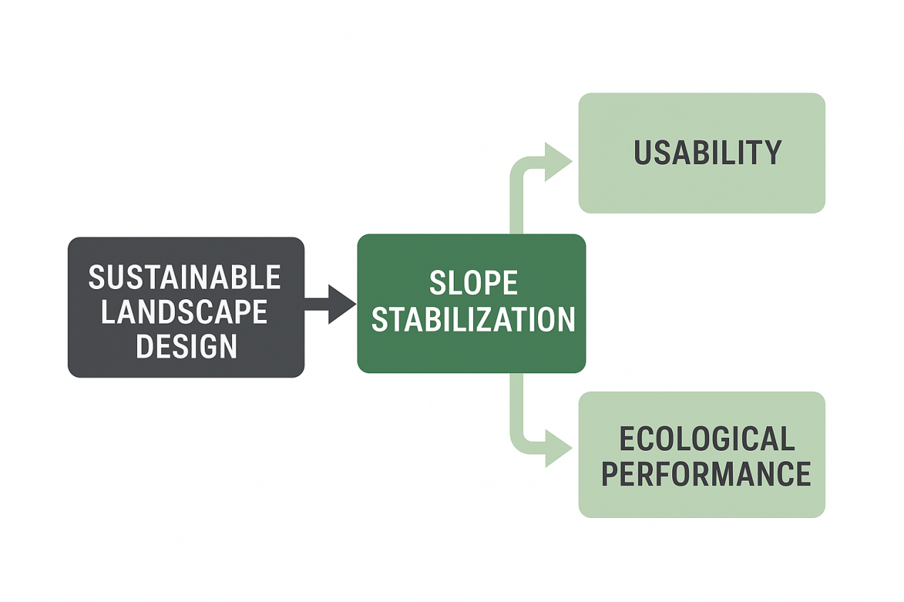
Figure 1: Conceptual Framework
(Source: Authors’, 2025)

3. Research Methodology
The research adopts qualitative, multiple-case study design and complements it with an interpretive analysis of architectural precedents. The methodological approach integrates both theoretical study and empirical case study in an attempt to explore how sustainable landscape design strategies influence slope stability and land use in campus settings (Kreye and Van, 2021). The study takes a comparative approach to explain how topography contributes to architectural and landscape reactions. It also takes into account design suggestions that may be included in guiding principles to strike a balance between ecological performance, structural integrity, and user experience (Barrar and Ruiz-Benezet, 2023).
This research design includes a thorough literature review, a visual and spatial analysis, and a thematic synthesis of chosen case studies. Through triangulation of the methods, the research derives evidence-based design features that can be used in the planning of sustainable campuses, which are located on hilly slopes.

3.1 Research Design and Approach
This study is based on qualitative descriptive research, the main methodological process of which is the case study analysis. Yin (2018) argues that case studies give a detailed understanding of complex situations in real-life and allow the researcher to study the interaction between the environmental, functional, and aesthetic aspects. The methodology is consistent with the objective of the study to come up with versatile landscape principles in the various architectural settings.
A literature review was initially done to develop a theoretical basis related to landscape sustainability, slope stabilization, and campus use. This was followed by analysis of the selected architectural case studies to determine the way in which these theories are applied in practical design settings. The focus was made on the discovery of features that would mediate the relationships between natural topography and built form without damaging the ecological integrity and human comfort.

3.2 Case Study Selection
The purposive sampling was used to sample six case studies (three institutional and three residential) according to their contextual, typological, and topographical relevance. OAU, CURID, and JABU are examples of Nigerian universities that practice land-sensitive campus planning and environmental management. The residential examples include House in Ribela (Spain), Agios Sostis (Greece), and Casas, Interiores De Casas (Itaipuravá, Brazil), which demonstrate the global tendencies in slope-sensitive and ecologically oriented architecture.
However, analyzing both local and international case studies gives different methodologies, allowing comparison and cross-contextual analysis of how adaptive design practices respond to different geographical, climatic, and functional contingencies.

3.3 Data Collection
The information related to each case study was retrieved in the form of archival sources and secondary documents, such as architectural publications, peer-reviewed journals, institutional websites, or online databases like Archives Daily. Form, materiality, and landscape treatment were evaluated by conducting systematic field observations and photographic documentation where applicable. The spatial analysis included site orientation, slope response, drainage system, vegetation use, and circulation design evaluation. These data were systematically coded on the recurring sustainability themes, such as slope stabilization, land usability, ecological integration, and user functionality.

3.4 Data Analysis
The present study applied thematic content analysis following Braun and Clarke (2019) to interpret data derived from the six case studies. Themes were inductively extracted from multiples readings and comparisons, resulting in six variables that were its main themes in accordance with sustainable slope design: Landscape-based stabilization of slopes, Flexibility and Availability of Land-Use, Ecological Integration and Vegetation Integration, Drainage and water management, Passive Design and Environmental Comfort, and Topography-based Spatial Zoning. The cases were juxtaposed against these parameters so as to produce comparative results which were tabulated in the form of a matrix representing the presence of the features of sustainable landscape and their relative intensity.

3. 5 Case Study Framework
In the institutional cases (OAU, CURID, and JABU), it involved investigating the relationships between campus landscape, mobility, and geographic structure. Through the cases, it is shown how Nigerian learning institutions face difficult situations through terracing, retaining structures, and vegetative cover without losing functionality and accessibility. House in Ribela, Agios Sostis, and Casas, Interiorres De Casas, the international cases, note the high degree of integration of architecture and landscape, including excavation, earth-shelving, and passive orientation. These strategies provide conceptual frameworks for slope stability and environmental flexibility that can be used in sustainable campus design in tropical environments.
To get a more detailed perspective of the heterogeneous terrain features at the six case studies, Figures 2-7 allow visualizing the contexts of the sites and the topographic conditions in a comparative manner. Both diagrams outline elevation contours, slope gradient and drainage pattern thus explaining the significance of morphology of terrain in informing interventions through architectural and landscape design. The topographic figures support the methodological analysis by making possible a spatial understanding of the condition of slope affecting usability, accessibility, and stabilization plans. This graphical record supports the analytical model of the research which anticipates the sustainable adjustment of architectural structures to the natural topography.

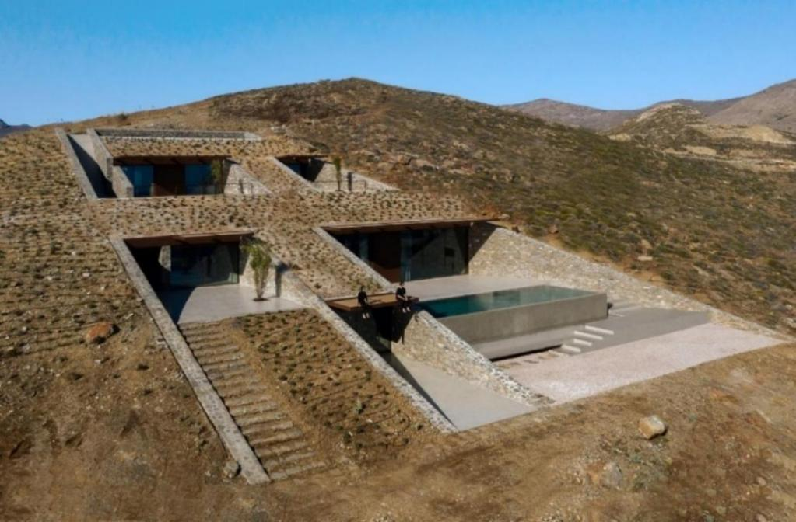

Figure 2: Sectional and Topographic Adaptation, Agios Sostis, Greece.
Source: Archidaily, (2025)
Figure 2 shows how a residential building was incorporated in a steep hill through terraced and embedded construction. Sectional arrangement of the building follows the natural gradient of the ground with the help of retaining walls and green roofs to stabilize the ground and retain the minimal visual interferences. The horizontal banding is a passive approach to the environment that supplements thermal management, cross-ventilations, and natural lighting. This architecture represents landscape-embracing architectural style in topographically arid environments, achieving balance between minimal aesthetics intrusion and environmental flexibility.

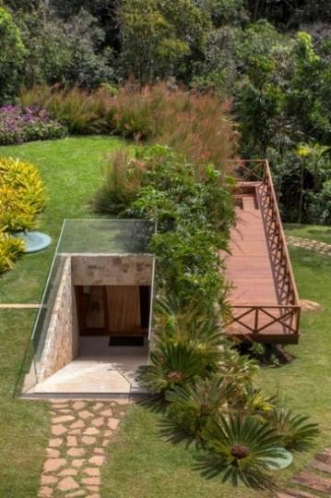
Figure 3: Site Integration and Topographic Response, De Casas, Itaipava, Brasil.
Source: Archidaily, (2025)
Figure 3 depicts a housing building that is presented into the hilly landscape of the tropical forest setting. The architectural composition depicts a sensitive reaction to the topography to some extent sub-grounded the building partially, to achieve thermal efficacy and reduce aesthetic disturbance. The green roof and the landscaped ramp strengthen the continuity between the built and non-built worlds, creating ecology and proper management of stormwater. This design is characteristic of landscape-oriented architecture that can balance human settlement with the natural gradients, vegetation, and microclimatic comfort.
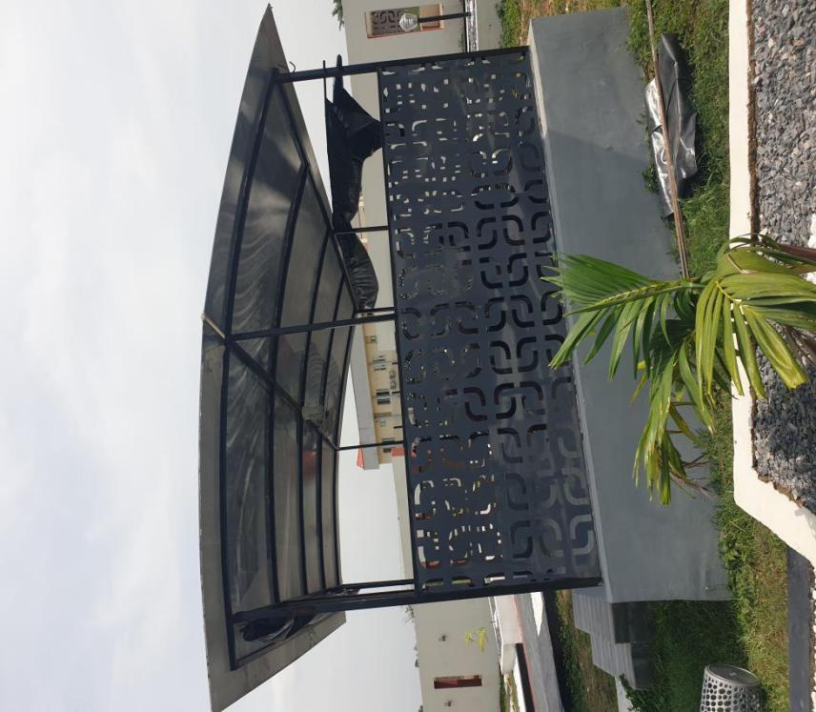
Plate 1. Exterior view of the OAU, IFE, Ideation centre for researchers
Source: Author (2025).
The exterior view of the OAU Ile-Ife Ideation Centre exhibits a lightweight, climate-responsive architecture of buildings to suit the open academic location. The round contour of the roof positively contributes to the shedding of rainwater and passive cooling through the provision of air flow under the canopy, a critical approach to thermoregulation in humid tropical environments. The perforated metal screen serves as a protective cap and a ventilatory system and lets in filtered daylight, cross-ventilates, and retains visual permeability that is essential to communal research areas.

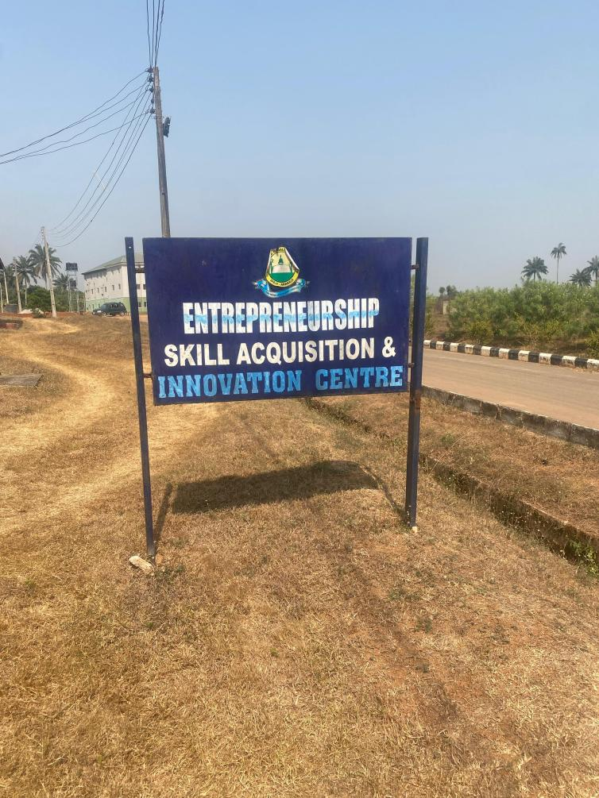
Plate 2. Interior view of the innovation and Entrepreneurship centre, Joseph Ayo Babalola University, JABU
Source: Oludoyi (2025).
Although the facility is mainly an interior space, the edge is a more extensive site approach based on the sloped terrain. The strategic positioning of the building along the natural slope facilitates the internal floor levels to follow the terrain, reducing the need for structural adjustments and facilitating movement into and between functional zones. Extensive openings and circulation areas demonstrate how the building balances the topography to maintain barrier-free access, optimize internal flow across the building, and promote land use of the challenging site conditions.

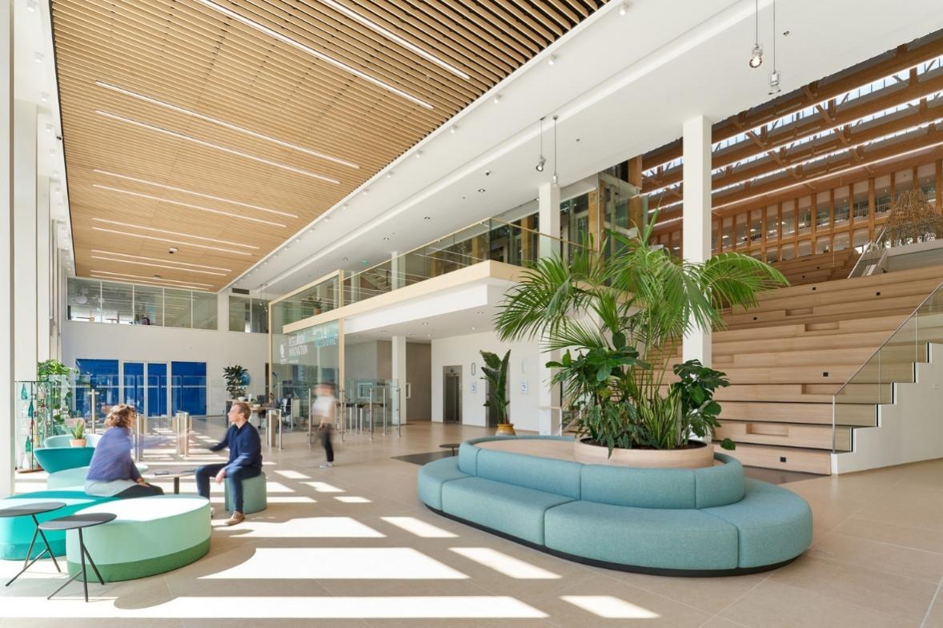
Figue 4. Ideation Centre of the Research Center, Sustainability, Gif-sur-Yvette, France
(source: Archi daily, 2025)

The Ideation Centre idealistically reflects effective use of interior spatial resources, which can be demonstrated by the open interior of this facility, multifunctional seating areas, and unified stepped platform, which stimulates movement and group work. The inclusive glazing of high peaks and clear views increases the clarity of space, which makes navigation effortless for every user. The geometric composition of the paths, seating arrangement, and flora will encourage fluid movement and universal accessibility and at the same time provide inclusive space to engage with each other, cooperate, and relax.

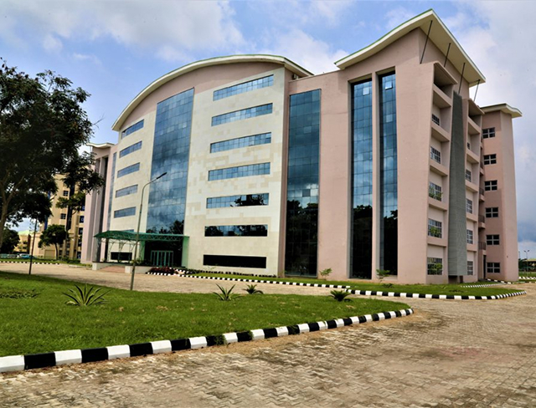
Plate 3. Exterior view of the CURID Research and Innovation Development
(Source: Author, 2025)
Regarding land use and accessibility, the CURID complex is designed strategically so as to take advantage of the natural elevation of the site and place the academic blocks to be placed in gentle slopes that enable free circulation paths and unhindered movement around the facility. Its direction also follows the dominant wind’s direction, creating passive cooling and maintaining open frontages with walkways, which improve the use of the facility.

3.4 Synthesis and Interpretation
A multidisciplinary analysis methodology provides both grounded and situational design knowledge. The research concludes that sustainable slope design extends beyond managing erosion; it encompasses a wider approach within landscape architecture that promotes functional adaptation, environmental balance, and aesthetic permanence. Nigerian cases put greater emphasis on the usability of land and the functionality of the campuses, but the international cases emphasize ecological integration and passive leisure. The analysis of these characteristics leads to the recommendation of a hybrid method of sustainable campus landscape design that is flexible to different situations, such as the topographical conditions of tropical and Nigerian settings.
The use of different data sources improves the reliability and reduction of subjectivity. Ecological landscaping design conceptual frameworks of recognized ecological landscaping designs were used to conduct interpretive analysis of the visual evidence, which was cross-verified by textual and archival material (Spin, 2012; Thompson and Sorvig, 2018). The uniform nature regarding the analytical features investigated across case studies further enhanced credibility. In addition, every data source used for this study was properly credited, since there was no direct human participation.

4. Results and Discussion
This section outlines the findings obtained after analyzing the six main case studies: four institutional campuses in Nigeria (OAU, CURID, and JABU) and two international residential ones (House in Ribela in Spain, Agios Sostis in Greece, Casas, Interiroes De Casas, Itaipava, Brazil), supported by insights provided through similar global examples like the Hongo Campus by the University of Tokyo. The empirical discussion explains how the aspects of sustainable landscape design can stabilize the slopes and improve usability as well as integrate both ecological and aesthetic functions in the topographically heterogeneous environment.
Through thematic content analysis, six reoccurring interrelated principles were identified, including landscape-based slope stabilization, usability and accessibility, ecological and vegetative integration, drainage and water management, passive comfort and microclimatic adaptation, and topography-informed spatial organization. All of these strategies demonstrate how campus design has undergone transformation over time and has shifted beyond a reactive design toward the management of terrain to a proactive way in which landscape is integrated into the design.

4.1 Landscape-based Slope Stabilization
Each of the projects analyzed used context-specific strategies to mediate built form and terrain. The Casas, Itaipava project proves to have one of the most elaborate implementations of structural integration with the landscape. The design is located on a steep hillside in Brazil and, it uses treading concrete steps and retaining walls that have vegetation that spreads the loads and regulates the runoff. The approach demonstrates a bio-structural synthesis; the state of stabilization and aesthetics coexist (Thompson and Sorvig, 2018).
Similarly, terraced retaining systems and contour-sensitive circulation has been adopted in the Obafemi Awolowo University (OAU) campus as a measure of erosion reduction while preserving scenic continuity across the uneven ground. Landscape terraces built using the local stone at Agios Sostis Greece can be seen to harmonise with the natural slope, thus level off the surface of the ground and align with its geological nature.
Norwegian University of science and technology (NTNU) offers a timely example of a campus that has completely pursued the soil bioengineering practice as a proactive measure to mitigate climatic slope stressors especially those linked with the snow-melt induced erosion. The analysis shows that the sustainable slope design cannot be reduced to the ordinary engineering models (Bjørn, 2012). It makes up an ecological dialogue across architectural, landscape, and structural disciplines, whereby the stability is achieved through environmental synergy rather than through brute force application.

4.2 Land Use and Accessibility
The most important performance measure across the institutional cases was land usability. OAU, JABU, and CURID campuses in Nigeria utilize a steep terrain by transforming slopes into outdoor classrooms, plazas with steps, and terraced gardens to ensure the resultant natural contours of the site are used to encourage instead of inhibit academic practice. On the same note, the adaptive topography design of the JABU uses graded pedestrian paths and platformed constructions to establish motion without barriers among the students and staff.
This practice is also extended to domestic functionality, in the Casas, Itaipava project, with each tier of the home committing itself to the distinct functions; social, private and service, therefore making the most out of a space by means of vertical zoning of the structure. By contrast, Hongo Campus, an excellently crafted but busy area of the University of Tokyo, with its complicated elevation changes, carries out a network of ramps, bridges and courtyards, that embody the lack of harmony between disparate levels, and demonstrates how accessibility can exist in the same space with a historical preservation and realist environment (Spirn, 2012).
All these cases show that usability in the sloped environments requires inclusion of both spatial logic and inclusive design in which movement and comfort as well as purpose, are adaptively adjusted to the surrounding landscape.

4.3 Ecological and Vegetative Integration
Across cases, vegetative systems have been shown to be eco-savvy as regards the ecological element of sustainable slope design. The thick vegetation around OAU and the riparian plants at JABU help in reducing the erosion as well as dampening the urban heat island effect. Vegetation is used as an aesthetic and functional buffer in the areas of Casas and Itaipava: the endemic vegetation makes the slope more stable, reduces the surface runoff and aesthetically incorporates the dwelling into the Atlantic rainforest ecosystem.
Similarly, the community of Agios Sostis uses drought-resistant Mediterranean plants to cement their stone terraces, and the House in Ribela becomes part of the hill, allowing vegetative recovery of the roof and the slopes around it as well. A good example of xeriscaping is Pontificia Universidad Católica de Chile, which includes native planting that generates a decrease in the irrigation dependence and keeps or conserves the soil moisture (Sarhan and Rutherford, 2014.).
Through this cross-case study, it has been created that vegetation plays a number of functions in sloped site design, including ecological as well as architectural functions. These multifunctional features encourage stability, environmental control, and the integration of terrain, and at the same time, improve the geographical aesthetic.

4.4 Drainage and Water Management
Hydrological sensitivity has become one of the key characteristics of sustainability. The use of vegetated drainage system, contour ditches, and storage basin in Nigerian institutional cases such as CURID and OAU is used to control stormwater on sloping surfaces whose surfaces are susceptible to runoff and erosion. The JABU on the other hand uses swales and infiltration excavations as part of the slope surface to control the development of landslides, thus contributing towards the process of nature-based water management.
Conversely, the unobtrusive rain water harvesting system at Casas, Itaipava, whereby water on the roof is captivated and reinforced into underground tanks by which it is used to irrigate the fields. This shows that hydrology and architectural design can work hand in hand. Permeable paving and concrete materials reduce the speed of run-off in the case of Agios Sostis, and NTNU eco-campus presents features of sustainable design by converting stormwater corridors into seasonal wetlands that also meet recreational needs (Thompson and Sorvig, 2018).
This case study analysis emphasizes the role of water management in slope stability and long-term site performance and shows that strategic planning is needed instead of reactive hydrogological remedies that must be built into landscape planning early.

4.5 Passive Comfort and Microclimatic Adaptation
Ambient climatic practices play a critical role to slope mindful architecture. At the Casa of Itaipava, an example is the building, which capitalize on the benefits of its sloping environment to maximize airflow and shading, thus producing a substantial improvement in thermal absorption. The thick wall building is used as a thermal resistant structure, which regulates the interior temperature by diurnal heat exchange.
Similarly, OAU and CURID take advantage of the natural elevation gradient of the site and the wind flow direction to utilise maximum passive cooling of academic blocks. The Ribela house is based on an earth-sheltered design, which involves the use of the immediate soil as an insulating layer to reduce heating and cooling requirements, whereas Agios Sostis involves transitional open spaces to reduce variability of the microclimatic.
The fact that these passive strategies align with the arguments of Spirn (2012), who argues that topography acts as an active climatic moderator instead of a passive backdrop. The analysis shows that slope design focus on comfort extends beyond building shapes on the land but involves creating ecological awareness and delivering sustainability by using low-energy, site-informed adaptations.

4.6 Topography informed Spanish organization
Topography has a major impact on the spatial arrangement of each and every site under study. In the OAU campus, zoning is quite hierarchical; academic clusters are occupied by the areas of intermediate terraces, whereas administrative buildings are located on the high-rise areas to grant symbolic importance and increase flood resistance. On the same note, the topography of the CURID site includes terracing, which facilitates visual connectivity of functional areas, hence facilitating social interaction and at the same time providing stability to the structure.
Itaipava design: the Casas features a vertical hierarchy of spaces, which reflects the shape of the mountain, with the personal rooms located at the lowest, the living rooms occupying the middle area and the service rooms at the top. Such a stratification provides the maximum scenic view and efficiency of the building. Houses in Ribela and Agios Sostis also blur the boundaries between inside and outside spaces and use the topographical slope as a sequential tool of spatial changes. The University of Tokyo and the Pontificia Universidad Católica de Chile are two examples where the slope can be used as a compositional tool and guide spatial rhythm and the hierarchy of circulation (Sarhan and Rutherford, 2014).
Altogether, these analyses support the assertion of Groat and Wang (2013) that conscious interpretation of landforms provides a natural logic to offer spatial coherence, accessibility, and perceptual continuity.

4.7 Theoretical and practical implications
In the analysis, it is confirmed that sustainable slope design has optimal effectiveness in conditions when the ecological aspect, structural aspect and social aspect are integrated but not considered individually throughout the design phases. Theoretically, the current research broadens the sustainability framework proposed by Thompson and Sorvig (2018) by foreshadowing adaptability of slope and land usability as two slope landscape performance indicators. Practically, the findings can provide practical advice to institution campuses located in topographically intricate regions, and the recommendations include bioengineered stabilization, multifunctional terraces, and hydrologically responsive landscape design.
A cross-regional comparative analysis shows that Brazilian and European contexts show sophisticated amalgamation of architectural and ecological systems as compared to Nigerian campuses, which show developmental but contextually reactive approaches which unify functional performance and environmental stewardship. Therefore, the synthesis is promoting the academic work internationally, as it suggests a hybrid design paradigm based on ecological responsiveness and usability by humans.
The discussion of six main and three supporting case studies supports the idea that sustainable landscape design as slop stabilization is a twofold enterprise which involves technical and cultural aspects. Good designs are based on three principles, which are interrelated, in diverse geographical contexts:
Terrain as a system of architecture that regulates the structure and the space organization; Plantation and hydrology: single performance systems, which promote comfort and stability; Usability as a sustainability measure that makes environmental interventions relevant to the society. The current results support the importance of a holistic, landscape-based approach in creating resilient, functional and ecologically harmonized campuses in the sloped terrains.

5. Conclusion and Implications
This paper investigated the relationship between landscape-responsive architecture and sustainable design solutions to sloped landscapes, and has specifically looked at the role of sustainable landscape design features in slope stabilization and land utilization in the campus setting. By using comparative study of six architectural case studies (three institutional OAU, JABU, CURID and three international residential House in Ribela, NCaved House, Agios Sostis) the research revealed that topography should not be viewed as an impairment but as an impressive driving force behind architectural innovativeness, environmental balance, and space utilization.
Practically, the outcomes of this research proves that the combination of functional zoning, ecological adaptation, and passive environmental systems is the key to developing an effective landscape pattern on the topographically diverse slopes, which would positively impact the sustainability indicators as well as user experiential results. Examples of Nigerian institutions that present forward capacity building, research governance and acquisition of skills and international case studies are models that include advanced terrain adaptation mechanisms-terracing, embedded architecture and integration of local vegetation. All this evidence supports the creation of a holistic design model that not only promotes environmental awareness but also encourages institutional innovations.
The vision of the project is a flexible and sustainable architectural paradigm, which will bring academic, vocational, and ecological functions to work in a unified landscape system. Bioswales, roof gardens, elevated walks, digitally integrated landscape architecture, all these features can be cited as representing a current day concept of campus planning that balances environmental responsibility and academic output.

6. Recommendations
Research synthesis and case study analysis results in the following recommendations that could help to improve sustainable slope stabilisation and land-usage in campus design:
Appeal to Topography: It is recommendable that the designers align the topography with the design thinking by making it a key parameter of the design cycle. Functional areas are also to be aligned with the contour gradient i.e. locate workshops on the downhill side of the gradient, and laboratories on the uphill side- this will maximize circulation, exposure, and environmental performance.
Embrace a Hybrid Institutional Model: The new type of university innovation centres in the future must be based on the administrative efficiency of domestic institutional models and the environmental sensitivity and design adaptability as shown by international precedents. This kind of hybridization will probably offer a strong governance and architectural creativity.
Consider Passive and Low-Impact: It is suggested to adopt passive ventilation, daylight maximization, orientation-dependent shading, and green roofs to decrease energy requirement. These are not only going to increase thermal comfort, but also promotes sustainable operation.
Interdisciplinary and outdoor learning: The interdisciplinary and outdoor learning must also be encouraged through the use of open-air classrooms, amphitheaters, and co-creation areas where formal collaboration among the students, researchers, and entrepreneurs can take place. Outdoor learning helps in promoting creativity and social interaction.

Effective and efficient zoning: Smooth and efficient zoning requires high and low activity zones such as fabrication and innovation laboratories, and administrative and research offices respectively to be isolated. These classrooms should have flexibility to adapt to the changing pedagogical and technological needs.
Utilize Ecological Assets of the sloped Area: Maintaining natural rocky, indigenous vegetation and drainage channels should preserve and improve the ecological and other environmental assets of the location. The water management systems should be adopted as biological-based water management such as bioswales, infiltration trenches, and rain gardens to control the stormwater and work towards biodiversity.
Develop Phase Development Approach: It is recommended that the topographical and programmatic complexity of the site will require a staged approach to development. The initial stages must focus on the slope stabilization and the formation of base research and innovation departments, where the further development of the experiential and recreational areas should take place.
Further investigation can also investigate the introductions of AI-based design algorithms to streamline the terrain-based architectural model. Also the socioeconomic effects of landscape-receptive university innovation hubs on the local communities. Thirdly, a comparative analysis of African and Latin American scenarios in order to learn further in terms of topography-responsive institutional design.

COMPETING INTERESTS DISCLAIMER:
Authors have declared that they have no known competing financial interests OR non-financial interests OR personal relationships that could have appeared to influence the work reported in this paper.

References
Barrar, H., & Ruiz-Benitez, R. (2023). Exploratory study of the impact of the supply chain on integrated product-service systems design. Business Process Management Journal, 29(1), 262-284. https://doi.org/10.1108/BPMJ-08-2022-0374
Bjørn Syvert Frengstad. 2012. Engineering Geology and Rock Mechanics. Available at https://www.ntnu.edu/igv/research-engineering-geology. (Accessed 24 October 2025)
Braun, V., & Clarke, V. (2019). Reflecting on reflexive thematic analysis. Qualitative Research in Sport, Exercise and Health, 11(4), 589-597. https://doi.org/10.1080/2159676X.2019.1628806
Brown, M., Burland, J., Chapman, T., Higgins, K., Skinner, H., & Toll, D. (Eds.). (2023). ICE Manual of Geotechnical Engineering, Volume I: Geotechnical engineering principles, problematic soils and site investigation. Emerald Group Publishing Limited. https://doi.org/10.1680/icemge.66816
Cerioli, A., Caselli, B., Marinelli, L. J., Vezzani, A., & Burioni, R. (2025). Pedestrian flux analysis in a confined university campus network using entropy and accessibility robustness metrics. Scientific Reports, 15(1), 32274. https://doi.org/10.1038/s41598-025-17185-w
Chen, Y. (2024). Integrating Nature-Based Solutions for urban stormwater management into existing urban fabrics. IOP Conference Series: Earth and Environmental Science, 1402(1), 012016. https://doi.org/10.1088/1755-1315/1402/1/012016
Casino Rubio, D., Rodriguez Ramirez, F., & Fernández-Elorza, H. (2024). Strategies for Sustainable Rooting in Landscape: Arrangements between Architecture and the Ground. Buildings, 14(4), 1006. https://doi.org/10.3390/buildings14041006
Schwab, E. (2018). Spatial Justice and Informal Settlements: Integral Urban Projects in the Comunas of Medellín. https://doi.org/10.1108/9781787147676
Fay, L., Akin, M., & Shi, X. (2012). Cost-effective and sustainable road slope stabilization and erosion control. NCHRP Synthesis 430. https://doi.org/10.17226/22776
FAO, 2025. Sustainable Land Management. Available at https://www.fao.org/land-water/land/sustainable-land-management/en/. (Accessed 12 November 2025)
Furman, A. (2012). Desire Lines: Determining Pathways Through The City. WIT Transactions on Ecology and the Environment, 155, 23-33. https://doi.org/10.2495/SC120031
Glenney, B. (2024). Skateboard crime and the pirating of urban space. Crime, Media, Culture, 21(2), 211-230. https://doi.org/10.1177/17416590241246228
Groat, L. N., & Wang, D. (2013). Architectural research methods. John Wiley & Sons. https://www.wiley.com/en-us/Architectural+Research+Methods%2C+2nd+Edition-p-9780470908556
Guo, C., Wang, R., Lin, P., & Wang, F. (2020). Numerical analyses of a prefabricated retaining system for foundation pits in silt soils. Geotechnical Research, 7(3), 173-190. https://doi.org/10.1680/jgere.20.00015
Hardberger, A., Craig, D., Simpson, C., Cox, R. D., & Perry, G. (2025). Greening up the city with native species: challenges and solutions. Diversity, 17(1), 56. https://doi.org/10.3390/d17010056
Hensel, M. U., & Hensel, D. S. (2024). En Route to Nature-integrated Design: Opportunities and Challenges. In D. Clements-Croome (Ed.), Intelligent Buildings and Infrastructure with Sustainable and Social Values (3rd ed., pp. 95-106). Emerald Publishing Limited. https://doi.org/10.1680/978-1-83549-818-720243008
Irehie, C., Imaah, N. and Youdeowei, P., 2020. Best Practice Building Integration Methods along Slopes (15% To 65% Gradient) N Okigwe Zone, Southeastern Nigeria, Volume 3, 3, 1-16.
Irehie, C., Imaah, N., & Youdeowei, P. (2018). Architectural Design Considerations for Building along Slopes in Okigwe Zone, South-Eastern Nigeria. International Journal of Architecture, Engineering and Construction, 7, 26-34. https://doi.org/10.7492/IJAEC.2018.015
Jauslin, D. (2019). Landscape Strategies in Architecture. A+BE | Architecture and the Built Environment. https://doi.org/10.7480/abe.2019.13
Kirkwood, N. (2017). The role of landscape architecture in urban design education: design studios from Korea University and Harvard University. Proceedings of the Institution of Civil Engineers-Urban Design and Planning, 170(3), 133-142. https://doi.org/10.1680/jurdp.16.00043
Kolkos, G., & Stergiadou, A. (2021). Implementation of hydroseeding methods as bioengineering techniques for soil stabilization and reclamation projects. 17th International Conference on Environmental Science and Technology (CEST2021) Proceedings https://doi.org/10.30955/gnc2021.00104
Kreye, M. E., & Van Donk, D. P. (2021). Servitization for consumer products: An empirical exploration of challenges and benefits for supply chain partners. International Journal of Operations & Production Management, 41(5), 494-516. https://doi.org/10.1108/IJOPM-07-2020-0439
Kukina, O. B., Zolotukhin, S. N., & Byndyukova, E. A. (2020). Design and construction of a low-rise residential building on a landslide slope. In IOP Conference Series: Materials Science and Engineering (Vol. 753, No. 4, p. 042016). https://doi.org/10.1088/1757-899X/753/4/042016
LaGro Jr, J.A., 2011. Site analysis: A contextual approach to sustainable land planning and site design. John Wiley & Sons. Available from: https://www.researchgate.net/figure/Site-analysis-James-A-LaGro-Site-Analysis-A-Contextual-Approach-to-Sustainable-Land_fig8_329001724 [accessed 16 Oct 2025]
Liu, J. (2025). Aesthetic and ecological landscape design for elevated roadside slopes in typical mountainous cities of China. Journal of Computational Methods in Sciences and Engineering. https://doi.org/10.1177/14727978251366479
Lu, X., Liu, R., & Xia, L. (2023). Landscape planning and design and visual evaluation for landscape protection of geological environment. Journal of King Saud University-Science, 35(6), 102735. https://doi.org/10.1016/j.jksus.2023.102735
Melo, M. T. S., Palmeira, E. M., Santos, E. C. G., & da Luz, M. P. (2021). Geosynthetic performance against slope erosion caused by high intensity rainfall. Geosynthetics International, 28(4), 421-434. https://doi.org/10.1680/jgein.20.00052
Moraru, I. (2017). TOPOGRAPHICAL ARCHITECTURE. WHEN ARCHITECTURE TURNS INTO LANDSCAPE. International Multidisciplinary Scientific GeoConference: SGEM, 17, 851–858. https://doi.org/10.5593/sgem2017/62/s27.109
Nektarios, P.A., Ntoulas, N., Paraskevopoulou, A.T., Zacharopoulou, A., & Chronopoulos, I. (2014). Substrate and drainage system selection and slope stabilization in an intensive-type roof garden park: Case study of Athens Concert Hall. Landscape and Ecological Engineering, 10(1), 29-46. https://doi.org/10.1007/s11355-013-0213-z
Norris, J. E., Stokes, A., Mickovski, S. B., Cammeraat, E., Van Beek, R., Nicoll, B. C., & Achim, A. (2008). Slope stability and erosion control: Ecotechnological solutions. Springer Science & Business Media. https://doi.org/10.1007/978-1-4020-6676-4
Opdam, P., Luque, S., Nassauer, J., Verburg, P. H., & Wu, J. (2018). How can landscape ecology contribute to sustainability science? Landscape Ecology, 33(1), 1-7. https://doi.org/10.1007/s10980-018-0610-7
Packard, T. E. (2010). A process for defining landscape-specific design guidelines for the shoreland of Lake Tahoe (Master's thesis, University of Illinois at Urbana-Champaign).
Patil, U.D., Shelton, A.J., Catahay, M., Kim, Y.S., & Congress, S.S.C. (2022). Role of vegetation in improving the stability of a tropical hill slope in Guam. Environmental Geotechnics, 9(8), 562-581. https://doi.org/10.1680/jenge.21.00064
Paudel, S., & States, S.L. (2023). Urban green spaces and sustainability: Exploring the ecosystem services and disservices of grassy lawns versus floral meadows. Urban Forestry & Urban Greening, 84, 127932. https://doi.org/10.1016/j.ufug.2023.127932
Kladnik, D. (Ed.). (2017). Terraced Landscapes. ZRC SAZU, Založba ZRC. https://doi.org/10.3986/9789610500193
Pozo-Antonio, J. S., Alejano, L. R., Veiga, M., & Alberruche, E. (2014). Landscape assessment of engineered and man-made slopes. Proceedings of the Institution of Civil Engineers-Engineering Sustainability, 167(1), 24-38. https://doi.org/10.1680/ensu.13.00003
Psathiti, C., & Charalambous, N. (2025). Evidence-based implications for school architecture: spatial layout and teachers' perceived sense of school control. Archnet-IJAR: International Journal of Architectural Research. https://doi.org/10.1108/ARCH-03-2025-0124
Qu, H., Dong, W., Li, Z., & Madabhushi, G.S.P. (2024). Performance evaluation of prefabricated retaining wall systems based on centrifuge tests. Proceedings of the Institution of Civil Engineers - Engineering Sustainability. https://doi.org/10.1680/jensu.23.00072
Rafferty, J. M. (2011). Design of outdoor and environmentally integrated learning spaces. In Physical and virtual learning spaces in higher education: Concepts for the modern learning environment (pp. 51-70). https://doi.org/10.4018/978-1-60960-114-0.ch004
Ramli, M., Karasu, T. J. R., & Dawood, E. T. (2013). The stability of gabion walls for earth retaining structures. Alexandria Engineering Journal, 52(4), 705-710. https://doi.org/10.1016/j.aej.2013.07.005
Raymond, C. M., Frantzeskaki, N., Kabisch, N., Berry, P., Breil, M., Nita, M. R., Geneletti, D., & Calfapietra, C. (2017). A framework for assessing and implementing the co-benefits of nature-based solutions in urban areas. Environmental Science & Policy, 77, 15-24. https://doi.org/10.1016/j.envsci.2017.07.008
Ribeiro, H., Santana, K. V. D. S., & Oliver, S. L. (2024). Natural environments in university campuses and students’ well-being. International Journal of Environmental Research and Public Health, 21(4), 413. https://doi.org/10.3390/ijerph21040413
Sujatha, E.R., Sudarsan, J.S., & Nithiyanantham, S. (2023). A review on sustainable reinforcing techniques to stabilize slopes against landslides. International Journal of Environmental Science and Technology, 20(12), 13873-13882. https://doi.org/10.1007/s13762-023-04832-w
Sack, C. (2013). Landscape architecture and novel ecosystems: ecological restoration in an expanded field. Ecological Processes, 2(1), 35. https://doi.org/10.1186/2192-1709-2-35
Šantrůčková, M. (2016). The Topographical Changes Created by the Landscape Design Activities. Case Study of The Czernin Parks, Bohemia. Acta Universitatis Carolinae Geographica, 51(1) https://doi.org/10.14712/23361980.2016.6
Sarhan, A., & Rutherford, P. (2014). Integrating sustainability in the architectural design education process - Taxonomy of challenges and guidelines. Fusion - Proceedings of the 32nd eCAADe Conference - Volume 1. https://doi.org/10.52842/conf.ecaade.2014.1.323
Shukla, S.K. (2012). Handbook of Geosynthetic Engineering: Geosynthetics and their applications. ICE Publishing. https://doi.org/10.1680/hge.41752
Sleptsov, O., & Karban, A. (2020). Principles of architectural and planning arrangements for school complexes on difficult terrain. IOP Conference Series: Materials Science and Engineering https://doi.org/10.1088/1757-899X/907/1/012073
Soni, H., Yadav, R. K., & Patra, S. K. (2024). Global impact of urbanization on ecosystems: A comprehensive bibliometric analysis. Natural Hazards Research, 5(1), 21-35. https://doi.org/10.1016/j.nhres.2024.04.001
Spirn, A. W. (1998). The language of landscape. Yale University Press. https://yalebooks.yale.edu/book/9780300082944/the-language-of-landscape/
Strom, S., Nathan, K., & Woland, J. (2013). Site engineering for landscape architects. John Wiley & Sons. https://www.wiley.com/en-us/Site+Engineering+for+Landscape+Architects,+6th+Edition-p-9781118090862
Thompson, J. W., & Sorvig, K. (2018). Sustainable landscape construction: A guide to green building outdoors (Third edition). Island Press. https://islandpress.org/books/sustainable-landscape-construction-third-edition#desc
Vermeersch, P.-W., & Heylighen, A. (2015). Mobilizing Disability Experience to Inform Architectural Practice: Lessons Learned from a Field Study. Journal of Research Practice. http://jrp.icaap.org/index.php/jrp/article/view/495/419
Volynets, I. (2025). A Process-Based Landscape Approach to Landform Architecture. https://hdl.handle.net/1794/31570
Wenham, L. J. (2025). Opportunities for belonging and becoming: using outdoor learning programmes with adolescent students. Quality Education for All, 2(2), 1-18. https://doi.org/10.1108/QEA-09-2024-0091
Widiantara, I. W. A., Nursanty, E., & Cauba, A. G. (2024). Integration of Architecture And Landscape on Sloping Sites: A Sustainable Approach to Building Design. Border: Jurnal Arsitektur, 6(2), 177-196. https://doi.org/10.33005/border.v6i2.779
Wilson, T. (2018). Design guidelines for activating outdoor spaces of university campuses. California Polytechnic State University. https://digitalcommons.calpoly.edu/crpsp/170
Xu, Y., Zhao, S., & Fan, J. (2021). Urban planning construction land standard and its revision based on climate and topography in China. Journal of Geographical Sciences, 31(4), 603-620. https://doi.org/10.1007/s11442-021-1861-9
Yin, R. K. (2018). Case study research and applications: Design and methods. SAGE Publications. https://us.sagepub.com/en-us/nam/case-study-research-and-applications/book246060
Zakharov, A., & Zabalueva, T. (2025). Sustainable Housing Construction On Sloped Terrain: Structural Innovations. International Journal of Ecosystems & Ecology Sciences, 15(2) https://doi.org/10.31407/ijees15.203

