Original Research Article

Assessment of Mechanical properties of Concrete made with All-In-Aggregates sourced from Small-Scale Mining Sites (‘Galamsey Aggregate’)

Abstract
Concrete is vital in building construction industries, however, significantly contributes to the depletion of natural resources (aggregates) leading to global CO₂ emissions. To reduce concrete-related CO₂ emissions, the integration of wastes and by-products as components in concrete production is a promising strategy. One of such by- products is the residue from small scale mining (galamsey) sites which causes environmental pollution and a source of soil contamination. This work sought to assess the properties of concrete made with all-in-aggregates sourced from small-scale mining (galamsey) sites (‘galamsey aggregate’). Conventional gravel and sand were completely replaced with all-in-aggregates from mining (galamsey) sites for concrete and tested for workability, density, compressive, tensile strength and water absorption. The result indicated that the density, compressive strength, tensile strength and water absorption level of the concrete increased as the curing days increased. The study revealed that the density, compressive, tensile strength and water absorption level of the control was 2385.83kg/m³, 33.41N/mm², 3.30N/mm² and 2.60% respectively while the mining sites (galamsey aggregate) concrete recorded density of 2359.22kg/m³, compressive 32.56N/mm2, tensile strength 3.21N/mm2 and water absorption level of 2.67%. The study revealed that the all-in-aggregates from small-scale mining (galamsey) site gave good workability with slump (workability) value of 59mm and 35.67mm for mining site (galamsey) aggregate and granite respectively. The study concluded that the workability, density, compressive, tensile and water absorption of the mining site (galamsey) aggregates are within the acceptable standard requirement for concrete application.
Keywords: Galamsey aggregate, compressive strength, tensile strength, all-in-aggregates.

Introduction
One of the most versatile and widely used building materials in the world's construction industry is concrete (Dinku, 2005). As noted by Res, I. J. A. (2016), nearly 25 billion tons of concrete are utilized worldwide each year (Nduka et al., 2018). Around 70% of the concrete's total volume consists of fine and coarse aggregates. Therefore, the quality of concrete is significantly influenced by the physical and mechanical properties of the aggregates, as well as the chemical composition of the raw materials used to produce them (Dinku, 2005). Garcia-Troncoso et al. (2022) evaluated mining tailing sand mechanical properties in structural concrete combinations. It revealed that the compressive strength of mining tailing aggregates was lower than convention concrete however, they concluded that it may be used in pavements, curbs, floors and cyclopean concrete. Recent research by Ode and Eluozo (2016), Olajumoke et. al. (2014), and Sulymon et al., (2017) have shown that the selection of coarse aggregates in concrete formulation directly impacts its quality (Nduka et al., 2018). Various characteristics of aggregates, including density, size, and shape, play a crucial role in determining the compressive strength of concrete. The roughness and surface area of the aggregates in contact with the cement paste contribute to the strength of the concrete. Concrete made with crushed aggregates typically exhibits higher strength compared to that made with rounded aggregate particles, larger-sized aggregates tend to result in lower concrete strength (Woode et al., 2014).
Yalley et al. (2021) find out that, the morphological analyses at different magnifications showed deep and persistent cracks within the concrete mixed with the contaminated water. Garcia-Troncoso et al. (2022) conducted a research on comparative mechanical properties of conventional concrete mixture and concrete incorporating mining tailings sands. Find that, the higher the amount of the sand replaced with mining tailing the lesser the compressive strength is obtained. Collivignarelli et al. (2020), also researched on the production of sustainable concrete with the use of alternative aggregates and find out that, construction and metallurgical industry categories are the main sources of alternative materials for both the components, with ceramic and lead slag reaching a full replacement for fine and coarse aggregates.
Based on the aforementioned investigations, the study sought to assess the properties of concrete made with all-in-aggregates sourced from Small-scale mining site (galamsey aggregate).
2.0 Materials and Methods
2.1 Materials
The materials that were used for the study include cement (GHACEM Super Strong 42.5R), pit sand (fine aggregate), crushed granite stones (coarse aggregate), All-in-aggregates (galamsey aggregates), and water.
2.1.1 Cement
Ordinary Portland Cement (GHACEM Super Strong 42.5R Grade) per BS EN 197-1, 2011 was used.
2.1.2 Aggregate
Natural quartz sand with a fineness modulus of 3.1 and a gradation of 0.16 - 5 mm and granite gravel with a gradation of 10 - 12 mm which conformed to BS EN 12620-2019 were used for the production of the concrete (Figure 2).
2.1.3 All-in-aggregates
Galamsey aggregates for the test were obtained from Asankrangwa-Gyaman small-scale mining (galamsey) site in the Amenfi West Municipal of the Western Region of Ghana (Figure 1).
2.1.4 Water
The water used was obtained from the Ghana Water Company which conformed to the requirements of BS EN 1008 - 2002.

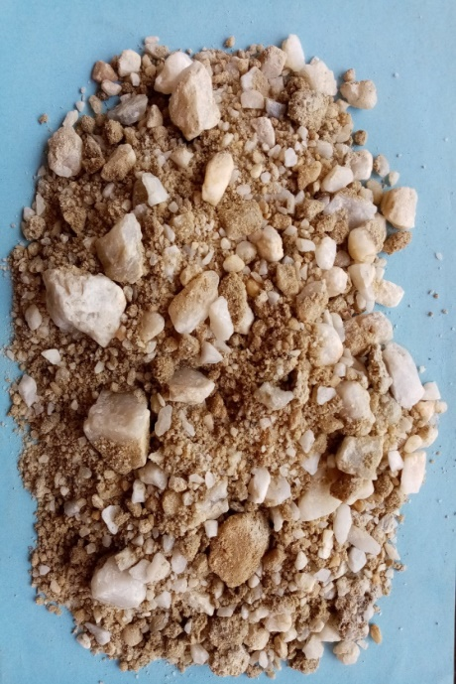
Figure 1: All-in-aggregates from mining sites (galamsey sites)
Figure 2: Granite All-in-aggregate
2.2 Methods
2.2.1 Preparation of Specimens
2.2.1.1 Batching
The batching of materials for concrete production was done by weight.
2.2.1.2 Mixing
Mixing using a mix ratio of 1:2:4 with a water-to-cement ratio of 0.55, mixing of concrete was done in accordance with BS EN 12620:2019. Mixing of the concrete was done by pan mixer. The all-in aggregate was first poured into the mixer followed by the cement and thoroughly mixed in a dry state. This was followed by the gradual addition of water and the whole constituent was mixed until an even paste was obtained.
2.2.1.3 Casting
Casting of the concrete mix was done with steel cubes and cylinders as shown in Figure 2. A 100mm x 100mm x 100mm for cubes and 100mm x 200 for cylinders of diameter 100 mm were moulded in accordance with BS EN 12390-2.
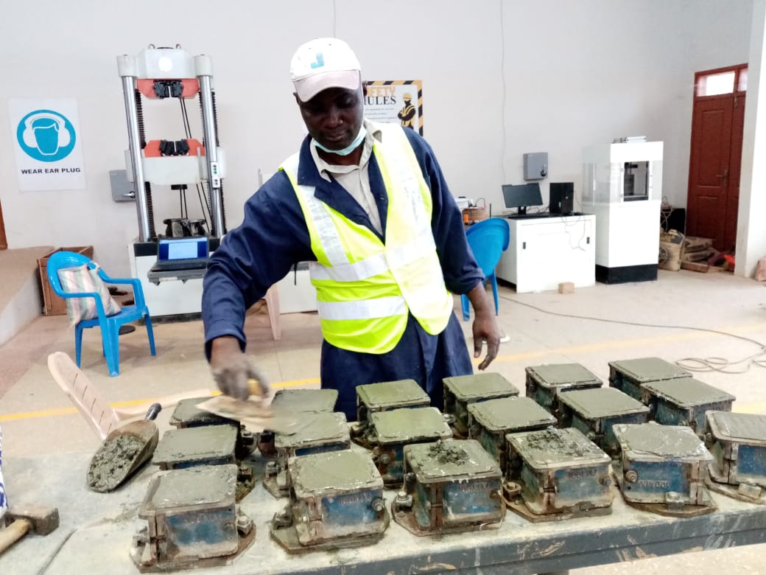
A conventional aggregate (sand and granite) was replaced with all-in-aggregate galamsey aggregate for the concrete production. The mix designs used with their corresponding material quantities are reported in Table 1. A total of 54 specimens were prepared for the study as shown in Table 2. After the specimens were set, they were demoulded and immersed in water for curing.

Figure 3: Concrete casting

Table 1: Materials Quantity

Material Quantity (kg)
Materials (kg) | Type of aggregate |  | Total quantity (kg)
Materials (kg) | Quarry site (Granite) | Mining site (Galamsey agg.) | Total quantity (kg)
Cement | 12.07 | 12.07 | 24.14
Sand | 24.15 | 24.15 | 48.30
Coarse Aggregate | 48.29 | 48.29 | 96.58
Water | 6.04 | 6.04 | 12.08

Table 2: Number of specimens
Total number of specimens
Total number of specimens | Type of test | Quarry site aggregate (Granite) |  |  |  |  | Mining site (galamsey) aggregate |  |  |  | Total specimen per test
Total number of specimens | Type of test | Curing days |  |  |  |  | Curing days |  |  |  | Total specimen per test
Total number of specimens | Type of test | 7 | 14 | 21 | 28 |  | 7 | 14 | 21 | 28
54 | Compressive | 3 | 3 | 3 | 3 |  | 3 | 3 | 3 | 3 | 24
54 | Split tensile | 3 | 3 | 3 | 3 |  | 3 | 3 | 3 | 3 | 24
54 | Water absorption |  |  |  | 3 |  |  |  |  | 3 | 6
54 | Total number of specimens per curing days | 6 | 6 | 6 | 9 |  | 6 | 6 | 6 | 9 | 54

2.2.2 Testing of Fresh Concrete
Slump test
The concrete slump test carried out in accordance with BS EN 12350:2009 was conducted to determine the workability of fresh concrete, as shown in Figure 4.
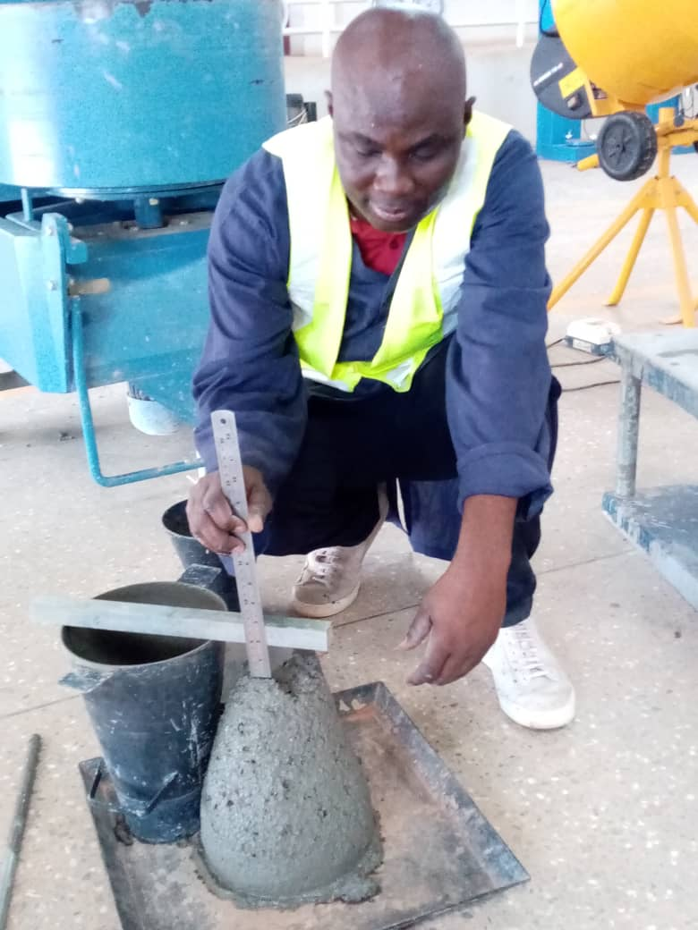

Figure 4: Slump test

2.2.3 Testing of Hardened Concrete
The concrete samples were tested for density, split tensile strength, compressive strength, and water absorption at curing days of 7, 14, 21, and 28.
2.2.2.1 Density: The specimen's density was determined per the BS EN 12390-7: 2019 specifications. Three samples were randomly selected and weighed, and the densities were calculated using the formula $D =\frac{M }{V}$ (kg/m3) ----------------equ.1
2.2.2.2 Compressive Strength: The specimens were tested by the Universal Testing Machine (UTM) in accordance with BS EN 12390-3 (2019) as displayed in Figure 5a. The Compressive strength of concrete was calculated as $Fc= \frac{F}{A}$ ----------------equ. 2
2.2.2.3 Split Tensile Strength: Figure 5b shows the testing of specimens for tensile strength which was determined in accordance with BS EN 12390-3 (2019) using the Universal Testing Machine (UTM). This was calculated as $Ft= \frac{2p}{Лld}$ ---------------- equ. 3
2.2.2.4 Water Absorption Test: The test was conducted in accordance with BS EN 772-11. The specimens were oven-dried at 105ºC for 24 hours after 28 days of cure. After drying, the specimens' mass was recorded. After drying, the specimens were submerged in buckets of water for 30 minutes to absorb as shown in Figure 5c. Absorbed specimen mass was obtained after 30 minutes of complete immersion. The formula for calculating specimen water absorption %:
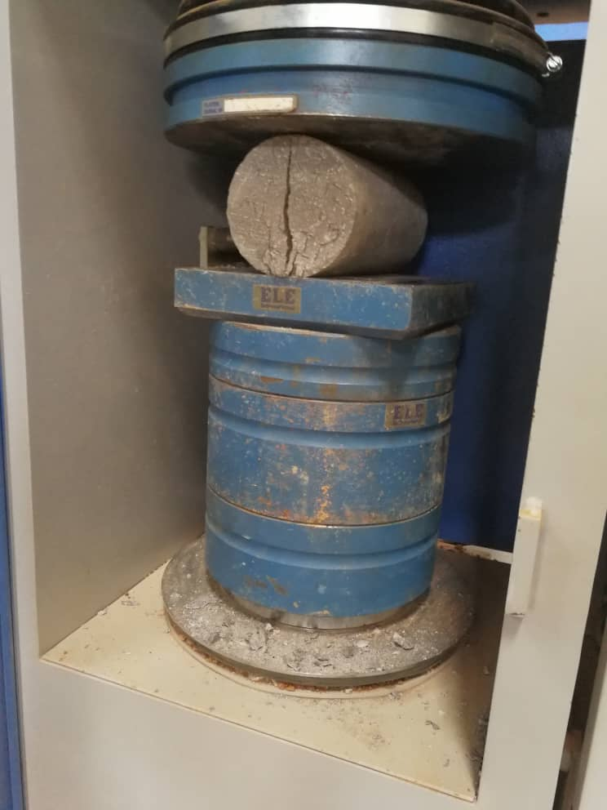
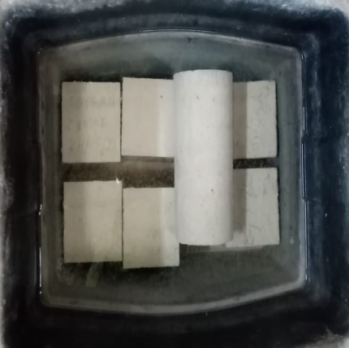
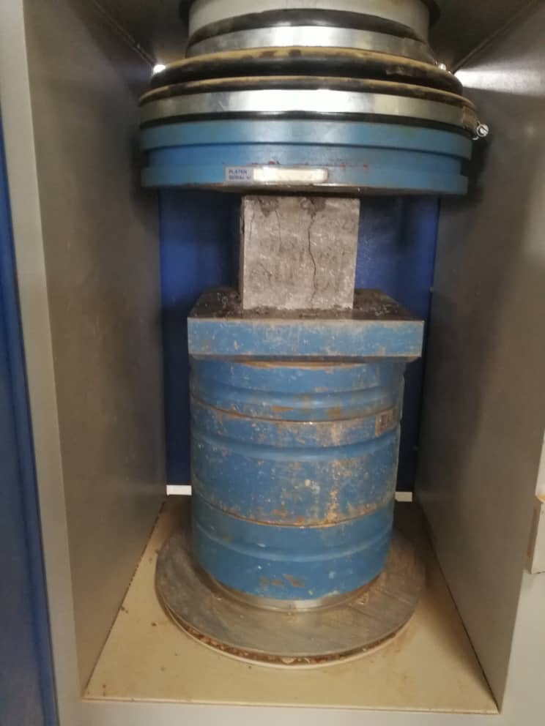
$Wa =\frac{Ms- Md }{Md}x100$ ----------------- equ. 4
- (b) (c)
Figure 5: Testing of specimens (a) Compressive strength (b) Split tensile strength (c) Water absorption test.

2.3 Data analysis
Microsoft Excel was utilized to create charts based on the test outcomes. Using the Pairwise Multiple Comparison method to ascertain the locations of the differences, a one-way ANOVA was carried out to find statistically significant differences between the variables.

3.0 Results and Discussions
3.3 Slump Test (Workability)
The findings revealed that concrete made from granite exhibited low workability with a slump value of 35.67mm, suggesting a low water-to-cement ratio and consequently higher strength. Similarly, concrete produced from mining site (galamsey) aggregate exhibited medium workability - 59mm, characterized by ease of mixing, transportation, and achieving homogeneity, and a moderate water-to-cement ratio resulting in average strength, as reflected in the achieved concrete strength following BS EN 12390-3:2019 standard. Figure 8 provides a visual depiction of the test results. This finding reveals that concrete derived from granite exhibited low workability according to ASTM C143, evidenced by a slump value of 35.67mm. Conversely, concrete produced from mining site (galamsey) aggregates displayed medium workability, as indicated by a slump test value of 59mm. This represents a notable difference of 39.54% between the two types of aggregates. According to the American Concrete Institute (ACI), the standard concrete slump range for general construction projects falls between 2-4 inches (50-100 mm). This range ensures appropriate workability and strength for typical concrete applications such as slabs, beams, and footings. Therefore, considering this standard, the slump value obtained from the mining site (galamsey) aggregates is suitable for various concrete applications.

Figure 8: Slump test (workability)
3.1 Density
Figure 9 shows the graphical outcome obtained for density. The result shows that the average density obtained for concrete made with mining site (galamsey) aggregates was 2325.17 kg/m³, slightly exceeding the 2323.47 kg/m³ recorded for concrete made with granite, representing a variation of 0.07% in values. At the 14th day, the average density recorded for the granite specimens was 2341.71 kg/m³, while for the mining site (galamsey) aggregates specimens, it was 2337.89 kg/m³, indicating a variation of 0.16% in value. By the 21st day, granite specimens achieved a density of 2375.23 kg/m³, compared to 2341.50 kg/m³ for specimens made from mining site (galamsey) aggregates, with a difference of 1.42%. Finally, at the 28th day, the average density for granite specimens was 2385.83 kg/m³, whereas for specimens made from mining site (galamsey) aggregates, it was 2359.22 kg/m³, which is higher than the density of 2000 kg/m³ recommended by Winston et al. (2002).

Figure 9: Average density
3.2 Compressive Strength
The results indicate a progressive increase in compressive strength with longer curing periods, spanning 7, 14, 21, and 28 days. Furthermore, the analysis reveals that concrete made from granite (quarry site) exhibited higher strength compared to that sourced from mining site (galamsey) aggregates. The average compressive strength of concrete built from granite on the 7th day of curing was 23.22 N/mm², whereas concrete from the mining site (galamsey) materials was 22.28 N/mm², a variance of 2.76%. The 14-day compressive strength of granite specimens was 23.51 N/mm², whereas mining site (galamsey) aggregates specimens were 23.31 N/mm², a 0.85% difference. Granite specimens attained 31.92 N/mm² on the 21st day of curing, whereas mining site (galamsey) aggregates reached 31.63 N/mm², a difference of 0.91%. On the 28th day, granite specimens had an average strength of 33.41 N/mm², whereas mining site (galamsey) aggregate specimens had 32.56 N/mm², a difference of 2.54%. Figure 10 is a chart depicting the compressive strength result. This supports Nduka et al. (2018) study on concrete strength utilizing quarry-crushed and locally-produced coarse aggregates. They found that granite aggregate concrete has superior compressive strength at all times. Garcia-Troncoso et al. (2022) also evaluated mining tailing sand mechanical properties in structural concrete combinations. The compressive strength of mining tailing aggregates was lower than convention concrete, however, they concluded that it may be used in pavements, curbs, floors and cyclopean concrete.

Figure 10: Average compressive strength result

3.2.1 Analysis of Variance (ANOVA) for Compressive Strength
An Analysis of Variance (ANOVA) was performed at a 5% significance level to investigate any significant differences in the compressive strength of concrete sourced from granite and mining site (galamsey) aggregates, as outlined in Table 3. The results indicate that, at a 5% significance level, the differences in mean values across the treatment groups are insufficient to exclude the likelihood that the observed variance is due to random sampling variability. As a result, no statistically significant change was discovered (P = 0.611).

Table 3: Descriptive Statistics and One-Way-ANOVA for Compressive Strength

Descriptive Statistics |  |  |  |  |  | One Way ANOVA
Treatment Name | N | Missing | Mean | Std Dev | SEM | Source of Variation | DF | SS | MS | F | P
Quarry site (Granite) | 3 | 0 | 33.413 | 1.397 | 0.807 | Between Subjects | 2 | 1.172 | 0.586
Mining site (galamsey) | 3 | 0 | 32.563 | 1.292 | 0.746 | Between Treatments | 1 | 1.084 | 1.084 | 0.357 | 0.611
 |  |  |  |  |  | Residual | 2 | 6.073 | 3.036
 |  |  |  |  |  | Total | 5 | 8.328 | 1.666

3.3 Split Tensile Strength
Figure 11 displays the results of the tensile strength test in a graphical chart. The results show that the tensile strength obtained for the specimens increases with curing durations of 7, 14, 21, and 28 days. The investigation also found that quarry-site granite concrete was stronger than mining-site (galamsey) aggregate concrete. After 7 days of curing, granite concrete had an average split tensile strength of 2.88 N/mm², while galamsey aggregate concrete had 2.74 N/mm², a differential of 4.86%. Granite specimens had an average split tensile strength of 3.07 N/mm² at day 14, whereas mining site (galamsey) aggregates had 2.97 N/mm², a 3.26% variance. On the 21st day of curing, granite specimens attained 3.10 N/mm², whereas mining site (galamsey) aggregates reached 3.01 N/mm², a 2.90% performance difference. On day 28, granite specimens had an average strength of 3.30 N/mm², whereas mining site aggregate specimens had a value of 3.21 N/mm², a difference of 2.73%. Kosmatka et al. (2002) found that conventional concretes have tensile splitting strengths between 8% and 12% and 10% to 15% of compressive strength (IS 456-2000, section 6.2.2). The results from mining site (galamsey) aggregate specimens are consistent with this. The 28th-day mining site specimen split tensile strength is 9.86% of compressive strength.

Figure 11: Average split tensile strength result

3.3.1 Analysis of Variance (ANOVA) for Split Tensile Strength
The study conducted an Analysis of Variance (ANOVA) at a 5% significance level to examine any significant variations in the split tensile strength of concrete made from granite and mining site (galamsey) aggregates, as seen in Table 4. The results indicate that, at a 5% significance level, the variations in mean values across the treatment groups are insufficient to rule out the potential for the observed difference to be attributed to random sampling variability; hence, no statistically significant difference is identified (P = 0.419).

Table 4: Descriptive Statistics and One-Way-ANOVA for Split Tensile Strength
Descriptive Statistics |  |  |  |  |  | One way ANOVA
Treatment Name | N | Missing | Mean | Std Dev | SEM | Source of Variation | DF | SS | MS | F | P
Quarry site (Granite) | 3 | 0 | 3.297 | 0.0802 | 0.0463 | Between Subjects | 2 | 0.249 | 0.125
Mining site | 3 | 0 | 3.007 | 0.492 | 0.284 | Between Treatments | 1 | 0.126 | 0.126 | 1.02 | 0.419
 |  |  |  |  |  | Residual | 2 | 0.247 | 0.124
 |  |  |  |  |  | Total | 5 | 0.622 | 0.124

3.4 Water Absorption Test
The results indicate that the control samples, produced with aggregates sourced from the quarry site (granite), outperformed those made from aggregates obtained from the mining site. Specifically, the control blocks exhibited a water absorption rate of 2.60%, demonstrating lower porosity compared to the concrete blocks composed of mining site (galamsey) aggregates, which recorded a water absorption level of 2.67%. See Figure 11 for a pictorial view. The percentage difference between the two sets of blocks was calculated at 2.62%. This outcome aligns with the findings of Doiphode et al. (2023), wherein it was observed that the water absorption of Gold Mines Waste (GMW) coarse aggregate exceeds that of local aggregate. Similarly, according to the permeability test results conducted by Khan et al. (2017) on M20 and M40 grade concrete, the depth of penetration in GMW concrete is greater compared to control concrete. This difference could be attributed to the elevated water absorption of GMW coarse aggregate.

Figure 11: Average water absorption
4.0 Summary and Conclusion
- The results showed that the density of specimens produced from small-scale mining site aggregates (galamsey aggregate) falls within acceptable ranges for concrete, with density increasing over curing days.
- The research observed a progressive increase in compressive and split tensile strength of concrete specimens with longer curing periods, meeting the standard strength requirements for quality construction concrete.
- The results of the slump test revealed that the concrete produced with small-scale mining site (galamsey) aggregate exhibited good workability, suggesting a moderate water-to-cement ratio and consequently, average to acceptable strength. In accordance with the American Concrete Institute (ACI) and ASTM C 143 standards, the obtained slump value from the small-scale mining site (galamsey) aggregates ensures appropriate workability and strength for typical concrete uses such as slabs, beams, and footings. This finding also conforms to the findings of Backus (2022).
- Lastly, the results showed that water absorption levels of specimens incorporating small-scale mining site aggregates were within acceptable thresholds, signifying durability and resistance to weather elements with standard protection measures.
The study concluded that the concrete made with all-in-aggregates obtained from the small scale mining site have the necessary properties for efficient use in construction.

References
Abi Farraj, F. (2021). Assessment of fresh and hardened properties of concrete made of crushed aggregates containing no natural sand. https://tel.archives-ouvertes.fr/tel-03343018
ACI (2007). Aggregates for Concrete. American Concrete Institute. Education Bulletin E1-07
ASTM International. (2020). Standard Test Method for Slump of Hydraulic-Cement Concrete (ASTM C143/C143M-20). ASTM International. https://doi.org/10.1520/C0143_C0143M-20
ASTM International. (2011). *Standard Test Method for Splitting Tensile Strength of Cylindrical Concrete Specimens* (C496/C496M-11). https://doi.org/10.1520/C0496_C0496M-11
Gilson Company Inc. (n.d.). Aggregate properties you need to know: Strength & durability. https://www.globalgilson.com/blog/properties-of-aggregates-strength-durability
Baic, I., Koziol, W., & Machniak, L. (2016). Aggregates from mineral wastes. E3S Web of Conferences, 8, 01068. https://doi.org/10.1051/e3sconf/20160801068.
BIBM (Federation of the European Precast Concrete Industry). (n.d.). What is Concrete? https://bibm.eu/precast-concrete/what-is-concrete/
BS EN 1008:2002 Mixing water for concrete. Specification for sampling, testing and assessing the suitability of water, including water recovered from processes in the concrete industry, as mixing water for concrete. BS EN 197-1:2011 - Cement. Composition, specifications, and conformity criteria for common cement. Standard, British Standards Institution, London, 2011.
British Standards Institution. (1992). *Specification for aggregates from natural sources for concrete* (BS 882:1992). https://www.bsigroup.com/en-GB/standards/bs-8821992/
British Standards Institution. (2013). *BS EN 12620:2013 Aggregates for concrete*. https://doi.org/10.3403/30212560
British Standards Institution. (2019). Testing hardened concrete. Part 2: Making and curing specimens for strength tests. https://doi.org/10.3403/30360082U
British Standards Institution. (2011). *BS EN 197-1:2011 Cement. Composition, specifications and conformity criteria for common cements*. https://doi.org/10.3403/30205527U
BSI Standards Publication. (2019). *Testing fresh concrete - Part 2: Slump test* (BS EN 12350-2:2019). https://standards.bsigroup.com/products/bs-en-12350-2-2019
British Standards Institution. (2019). *Testing hardened concrete - Part 3: Compressive strength of test specimens*. https://doi.org/10.3403/30360097
British Standards Institution. (2019). *BS EN 12390-2: Testing hardened concrete - Part 2: Making and curing specimens for strength tests*. https://doi.org/10.3403/30360082U
British Standards Institution. (2009). *Testing hardened concrete. Tensile splitting strength of test specimens* (BS EN 12390-6:2009). https://doi.org/10.3403/30200045
British Standards Institution. (2011). Methods of test for masonry units - Part 11: Determination of water absorption of aggregate concrete, autoclaved aerated concrete, manufactured stone and natural stone masonry units due to capillary action and the initial rate of water absorption of clay masonry units (BS EN 772-11:2011). https://www.bsigroup.com/en-GB/standards/bs-en-772-112011/
Chudley, R. & Greeno, R., (2003). Construction Technology. Longman Group Ltd, UK, 3rd edn
Collivignarelli, M. C., Cillari, G., Ricciardi, P., Miino, M. C., Torretta, V., Rada, E. C., & Abbà, A. (2020). The production of sustainable concrete with the use of alternative aggregates: A review. Sustainability, 12(19), 7903. https://doi.org/10.3390/su12197903
Dinku, A. (2002). Construction Materials Laboratory Manual, Addis Ababa: Addis Ababa University Printing Press.
Dinku, A. (2005). The need for standardization of aggregates for concrete production in Ethiopian construction industry. International Conference on African Development. https://scholarworks.wmich.edu/africancenter_icad_archive/90
Doiphode, S., Dhanuskar, P. D. J., & Deshmukh, D. A. R. (2023). A Review on Use of Gold Mine Waste in Preparation of Concrete. International Journal for Research in Applied Science and Engineering Technology. https://doi.org/10.22214/ijraset.2023.49100
Emmanuel, A. Y., Jerry, C. S., & Dzigbodi, D. A. (2018). Review of environmental and health impacts of mining in Ghana. Journal of Health and Pollution, 8(17), 43–52. https://doi.org/10.5696/2156-9614-8.17.43
Gallagher, L., & Peduzzi, P. (2019). Sand and sustainability: Finding new solutions for environmental governance of global sand resources. United Nations Environment Programme. https://www.grid.unep.ch/activities/sustainable-development/sand-and-sustainability/
Garcia-Troncoso, N., Baykara, H., Cornejo, M. H., Riofrio, A., Tinoco-Hidalgo, M., & Flores-Rada, J. (2022). Comparative mechanical properties of conventional concrete mixture and concrete incorporating mining tailings sands. Case Studies in Construction Materials, 16, e01031. https://doi.org/10.1016/j.cscm.2022.e01031
Harrison, D. J., & Steadman, E. J. (2003). Alternative sources of aggregates. British Geological Survey, Commissioned Report CR/03/095N. https://nora.nerc.ac.uk/id/eprint/507023/
Imtiaz Ahmed (Purdue). (1993). USE OF WASTE MATERIALS IN HIGHWAY.
IS: 456 (2000), “Code of Practice for Plain and Reinforced Concrete (Fourth Revision)”, Bureau of Indian Standards, New Delhi.
IS 383: (1970). Specification for Coarse and Fine Aggregates From Natural Sources for Concrete.
Khan, M. M., Patil, S. G., Nadaf, M. Z., Nidagundi, S., & Vaggappa, S. H. (2017). Preparation of concrete using Goldmines Waste. IOSR Journal of Mechanical and Civil Engineering (IOSR-JMCE), 14(5), 20–25. https://doi.org/10.9790/1684-1405032025
Khatib, J. M., Herki, B. A., & Kenai, S. (2013). Capillarity of concrete incorporating waste foundry sand. Construction and Building Materials, 47, 867-871. https://doi.org/10.1016/j.conbuildmat.2013.05.013 ,
Kosmatka, S. H., Kerkhoff, B., & Panarese, W. C. (2002). Design and control of concrete mixtures (14th ed.). Portland Cement Association. https://www.cement.org/
Martín-Puertas, C., Jiménez-Espejo, F., Martínez-Ruiz, F., Nieto-Moreno, V., Rodrigo, M., Mata, M. P., & Valero-Garcés, B. L. (2010). Late Holocene climate variability in the southwestern Mediterranean region: An integrated marine and terrestrial geochemical approach. Climate of the Past https://doi.org/10.5194/cp-6-807-2010
Matey, E. (2013). Volume 2 / Number 2 November 2013 Article 4. 2(2), 43–50.
Nduka, D. O., Fabgenle, O. I., Joshua, O., Ogunde, A. O., & Omuh, I. O. (2018). Comparative analysis of concrete strength utilizing quarry-crushed and locally sourced coarse aggregates. International Journal of Mechanical Engineering and Technology, 9(1), 609–617. http://www.iaeme.com/IJMET/issues.asp?JType=IJMET&VType=9&IType=1
Neville A.M., (2000). Properties of concrete, Longman Scientific and Technical series.
Ode.T. and Eluozo S.N. 2016 Predictive Model on Compressive Strength of Concrete Made with Locally 3/8 Gravel from Different Water Cement Ratios and Curing Age; International Journal of Scientific and Engineering Research, Volume 7, issue 1 January- pp1528-1551..
Ramachandran, V. S. (1981). Waste and By-Products as Concrete Aggregates. Canadian Building Digest, no. CBD-215. https://doi.org/10.4224/40000983,
Siddique, R. (2008). Waste materials and by-products in concrete. https://doi.org/10.1007/978-3-540-74294-4
Victor, K. J., Armand, K. D., Bernard, T., Bertrand, M. M., & Romaric, M. N. P. (2020). Physical Properties and Environmental Impact of Mine Waste Resulting from the Exploitation of Gold in Bétaré-Oya, Central Africa. Environmental and Earth Sciences Research Journal. https://doi.org/10.18280/eesrj.070204
Wilson, M. L., & Tennis, P. D. (2021). Design and Control of Concrete Mixtures. Portland Cement Association. https://www.cement.org/publications/detail/design-control-of-concrete-mixtures
Woode, A., Amoah, D. K., Ashie, P. N., & Ollenu, I. A. (2014). The Utility of All -In-Aggregates for Concrete Production In Ghana. Journal of Engineering, Computers & Applied Sciences, 3(2), 20–24.
Yalley, P. P. K., Appiah-Kubi, E., Osei-Tweneboah, E., & Kankam, C. K. (2021). Assessing the performance of concrete mixed with different water sources within small scale mining catchment areas in Ghana. *Journal of Materials Science Research and Reviews*, *4*(2), 215–229. https://journaljmsrr.com/index.php/JMSRR/article/view/126 .

