Synthesis, Characterization of Solar Cells Materials and Fabrication of an Inverted Perovskite Device

ABSTRACT
Perovskite solar cells (PSCs) often known as the fourth-generation solar cells have gained much research interest in recent years because of their improved energy conversion efficiency, simple fabrication process, low processing temperature, flexibility, light weight, and low cost of constituent materials when compared with their counterpart silicon based solar cells. However, instability and eco-unfriendliness of PSCs have been an obstacle towards commercialization of PSCs. Hence, the aim of this study is centered on synthesis, characterization of solar cells materials and fabrication of an inverted perovskite device. In this study, lead-free perovskite based solar cells device made of inorganic transport materials have been carefully designed and investigated. This study was conducted at the Nanomaterials Synthesis and Characterization Laboratory, Institute of Nanoscience and Nanotechnology, Universiti Putra Malaysia (UPM) Serdang, Selangor between July 2024 and July 2025. The cuprous oxide (Cu₂O) and zinc oxide (ZnO) were synthesized by wet chemical reduction and sol-gel methods respectively, while the eco-friendly methyl ammonium tin iodide (CH₃NH₃SnI₃) crystals were synthesized using cooling crystallization method. The Cu₂O and ZnO were characterized after synthesis and used as hole and electron transport materials respectively, while the methylammonium tin iodide (CH₃NH₃SnI₃) was used as perovskite material. The synthesized materials were characterized using various techniques which include the X-ray diffractometer (XRD), field emission scanning electron microscopy (FESEM), and ultraviolet visible spectroscopy (UV-Vis). The transport and perovskite material layers were fabricated using spin coating method at room temperature, while the back contact electrode made of aluminum foil was deposited through thermal evaporation method. The mean particle sizes of the synthesized Cu₂O, CH₃NH₃SnI₃ and ZnO were determined to be 207.91 nm, 370.51 nm and 188.22 nm, respectively. The direct energy band gap obtained from the UV-Vis data for Cu₂O, CH₃NH₃SnI_{3,} and ZnO was 2.17 eV, 1.32 eV and 3.20 eV, respectively. The fabricated device produced (J_{SC}) of 13.80 mA/cm², an open circuit voltage (V_{OC}) of 0.90 V, fill factor (FF) of 60.07% and power conversion efficiency (PCE) of 7.44%. The device retained 95% of its performance after 1000 hours of exposure to the standard solar illumination of 1000 W/m².
- INTRODUCTION
Because of the enormous energy demand brought on by the growing global population, the rate of energy consumption is increasing daily (Nyiekaa et al., 2024a). The expansion of renewable energy utilization is necessary since the use of non-renewable energy sources, such as fossil fuels, causes environmental problems (Saha, Singh and Bhattacharya., 2023). The most notable and important of all renewable energy sources is solar energy, which is regarded as the most promising due to its clean, abundant, and limitless nature. Solar energy is inexpensive and environmentally beneficial (Noman, Khan and Jan., 2024). A lot of methodologies have been established to harness solar energy such as solar architecture (Ionescu, 2015), solar heating (Nanda, Pambudi, and Aziz., 2023), artificial photosynthesis (Tian, 2021), photovoltaics and photo-catalytic water-splitting (Li, 2023).
Solar cells have recently been divided into four generations: the first generation is made up of crystalline silicon (c-Si) and gallium arsenide (GaAs), while the second generation is made up of thin films like cadmium telluride (CdTe), amorphous silicon (a-Si), and copper indium gallium selenide (CIGS). Third generation solar cells include the developing class of dye-sensitized solar cells (DSSC), copper zinc tin sulphide (CZTS), and quantum dots (QD), while fourth-generation solar cells include novel solar cells known as "inorganics-in-organics," like the hybrid perovskites (Jonathan, 2022; Et-taya, Ouslimane and Benami, 2020). Researchers have also investigated solar cells based on CdTe (Major, 2016; Arce-Plaza, 2018), quantum dot sensitized-based solar cells (Pan et al., 2018; Carey et al., 2015), CIGS (Zhu, et al., 2017; Feurer et al., 2017), organic photocells (Solak and Irmak, 2023) and perovskite-based solar cells (Afre and Pugliese, 2024; Nur-E-Alam et al., 2025).
The commercialization of solar cells is heavily influenced by factors such as power conversion efficiency, material costs, and techniques related to the preparation and production processes. The highest achievable efficiency of silicon-based solar cells is greater than 26%, which is near its theoretical limit (Hsieh et al., 2020; Kim et al., 2021). Perovskite solar cells, a novel class of fourth-generation solar cells, are alternative to silicon-based solar cells.
Because of their increased efficiencies, low processing temperatures, and low fabrication costs, perovskite solar cells have attracted a lot of scientific interest recently. PSCs have been the subject of numerous studies that have increased energy power conversion efficiencies (PCEs). Unusual characteristics of perovskite materials include a high absorption coefficient, good charge carrier mobility, a low exciton binding energy, and a large charge carrier diffusion (Afre and Pugliese, 2024; Lyu et al., 2017). Pure and modified methylammonium lead halides have been the subject of numerous studies as perovskite materials due to their high photovoltaic performance (Mangrulkar and Stevenson, 2021; Parashar and Kaul 2021). Despite their high-power conversion efficiency, recent research showed that several nations, most notably the European Union, strictly restrict the use of lead-based electronics due to their toxicity to humans and the environment (Li et al., 2020; De Los Santos et al., 2020). Because of their superior optoelectronic qualities and direct band gap of 1.3 eV, which is a suitable range for an absorber layer, methylammonium tin halide (CH₃NH₃SnX₃) perovskites have been suggested in the literature as a promising substitute for lead-based perovskites to address this disadvantage (Shukla et al., 2020; Byranvand, et al., 2022). In this study, methylammonium tin iodide (CH₃NH₃SnI₃) is considered, precisely.
The high cost of transport materials, the toxicity of perovskite materials, and the degradability of solar cells are some of the main obstacles preventing the large-scale manufacture of PSCs. Some perovskite materials, including Spiro-OMeTAD (2,2’,7,7’-Tetrakis [N, N-di(4-methoxyphenyl) amino]-9,9’-spirobifluorene]), a dominating hole-transporting substance in perovskite, usually have a shorter lifespan despite the notable advancements made thus far. Spiro-OMeTAD's expensive price and intricate synthesis could prevent PSCs from being commercialized anytime soon (Wang et al., 2019; Zhao et al., 2019). Additionally, the Spiro-OMeTAD layer facilitates electrode polarization and is crucial to the current density–voltage (J–V) hysteresis phenomenon, which ultimately impacts the device's stability (Gonzales, Guerrero and Bisquert, 2021; Chen et al., 2016). The primary cause of the PSCs' shortened lifespan is their conventional architectures, arising from the use of inorganic metal electrodes and organic transport materials (Wang et al., 2019; Zhao et al., 2019). The presence of pinholes in the HTL has led to poor PSC stability in recent studies. Oxygen and ambient moisture can deteriorate the perovskite absorbent layer (Wan et al., 2022; Asad et al., 2019). In order to address these challenges, numerous investigations have concentrated on creating effective PSCs and using novel hole-transport materials in place of Spiro-OMeTAD (Nyiekaa et al., 2024b; Rahman et al., 2019) or HTL-free PSCs, which can be used to streamline the device's ideal procedure, save production costs, and stop perovskite deterioration (Wang et al., 2016; Raminafshar et al., 2019).
Simplifying PSC manufacturing technology, lowering production costs, and improving performance are the goals of this study. Using the right back contact electrode and the right inorganic transport materials in building solar cells will boost stability and efficiency while also drastically lowering production costs. Furthermore, a greater range of applications in the industry may arise from the possibility of achieving high efficiency by using the inverted planar approach without the requirement for silicon compositions and organic HTMs.
Few studies have been conducted in this field since inverted planar PSCs have been given less attention than the conventional PCSs, despite significant advancements in PSCs research. To enhance and optimize their performance in comparison to the structures of their traditional equivalents, rigorous research is necessary in this area of study. The majority of previous researches on inverted planar PSCs concentrated on the usage of spiro-OMeTAD polymer as the hole transport material (HTM), and gold as the contact electrode. In this study, an inverted planar structure (ITO/Cu₂O/CH₃NH₃SnI₃/ZnO/Al) is adopted for experimental work.
- METHODOLOGY
  - Material synthesis
    - Synthesis of Cu₂O nanoparticles by wet chemical reduction method
In synthesizing cuprous oxide (Cu₂O) nanoparticles, a blue precursor solution was prepared by dissolving 0.799 g of copper (II) sulphate (CuSO₄ 99% BDH) in 50 ml deionized water and stirred vigorously. Then, 6 g of polyethylene glycol 6000 (PEG 6000 Sigma Aldrich) was dissolved in 50 ml deionized water, and the solution was added into the copper sulphate solution and a light blue color solution was obtained. Next, 0.9 g of ascorbic acid (C₆H₈O₆ ≥99.5% Chemiz) and 0.4 g of sodium hydroxide (NaOH 98% Chemiz) was dissolved in 100 ml deionized water, and the final solution was added to the previous solution and it turned orange in color. Finally, an aqueous solution of sodium borohydride (NaBH₄ ≥98% ACROS) was prepared by dissolving 0.4 g of it in 50 ml of deionized water under constant stirring and the prepared solution was added to the previous solution and an aqueous dark red solution was obtained. The dark red solution was allowed to cool at room temperature for 24 hours. The formed precipitate was washed three times with methanol, centrifuged at 3000 rpm for 15 minutes, decanted and the precipitates dried for 24 hours at 60ºC in an oven (Memmert).
    - Synthesis of CH₃NH₃SnI₃ crystals using the cooling crystallization method
Firstly, methyl ammonium iodide (MAI) solution was synthesized by mixing 9.3 ml of methylamine (CH₃NH₂ 40% in water, Merck) with 25 ml of absolute alcohol (C₂H₅OH 99.9%, Chemiz) and 10.0 ml hydroiodic acid (HI 57% in water, Merck) in dropwise at 0°C in an ice bath under continuous stirring for 120 minutes. The mixture was carried out in a 100 ml beaker, sealed with parafilm to reduce the impact of environmental conditions on the reaction. The precipitate was recovered by evaporation using a hot plate (PMC 730 Series), set at 50°C for 30 minutes inside the fume cupboard because of the exothermic nature of the reaction. The product was dissolved in an absolute ethanol (C₂H₅OH, 99.7% Chemiz), recrystallized and washed thrice with diethyl ether (C₄H₁₀O, QReC), decanted and kept in a petri dish and dried at 60°C in a drying oven (Memmert) for 24 hours and the crystals of the white-colored methyl ammonium iodide were formed.
Secondary, CH₃NH₃SnI₃ crystals were synthesized under an ambient atmosphere using 1.144 g of methylammonium iodide (MAI freshly prepared) and 0.969 g of tin (II) oxide (SnO 99%; Alfa Aesar) granules dissolved in a mixed aqueous solution of 7.2 ml hydroiodic acid (HI 57 % in water, Merck) and 7.2 ml hypo-phosphorous acid (H₃PO₂ 50 wt% in water, Chemiz) at 60°C for 2 hours. The precipitated CH₃NH₃SnI₃ crystals were obtained when the solution was cooled to room temperature. The crystallized precipitate was washed with diethyl ether and dried in an air vacuum at 60^{O}C for 2 hours and the green-dark shinny CH₃NH₃SnI₃ crystals were formed.
    - Synthesis of ZnO nanoparticles by sol-gel method
Zinc acetate dihydrate Zn(C₂H₃O₂)₂.2H₂O (2.95 g) was dissolved in 125 ml of methanol while being continuously stirred at 65ºC to create ZnO nanoparticles. Then, over the course of 15 minutes, a dropwise addition of KOH (1.48 g) in methanol (65 ml) was made at 60ºC. At 65°C, the reaction mixture was stirred for 2.5 hours. Following room temperature cooling, the precipitate was washed thrice with methanol, the supernatant decanted, and the precipitate dried for 24 hours at 60ºC in an oven (Memmert).
  - Device Fabrication
An ITO glass measuring 1.5 cm by 1.5 cm with sheet resistance of approximately 10 ohms/sq (Zhuhai Kaivo) was cleansed for roughly five minutes in an ultrasonic bath using commercial detergent, acetone and isopropanol. First, a 6 mg/ml dispersed solution of Cu₂O nanoparticle in a mixed solution of 1-butanol, methanol and chloroform at a ratio of 2:1:1 was spin coated for 30 seconds at 3,000 rpm onto the substrate and a thin layer produced. The freshly prepared CH₃NH₃SnI₃ crystals were dissolved at a concentration of 460 mg/l in N, N-dimethylformamide (DMF 99.8% QReC) dimethyl sulfoxide (DMSO, 99.9% Chemiz), and then spin coated over the Cu₂O layer for 15 seconds at 3,000 rounds per minute. Subsequently, 6 mg/ml dispersed solution of ZnO nanoparticle in a mixed solution of 1-butanol, methanol and chloroform at a ratio of 2:1:1 was applied using spin coating onto the substrate at 3,000 rpm for 20 s and a thin layer was produced. All layers were deposited at an acceleration of 1000 rpm/s. Finally, aluminum foil was applied via thermal evaporation with a base pressure of 1×10⁻⁷ mbar at the deposition rate of 2Å/s and a smooth aluminum nano-layer was formed. All layers of the device were fabricated under an ambient environment and layers dried in air at relative humidity of approximately 50%.
- RESULTS AND DISCUSSION
  - Discussions on the material synthesis
    - Analysis of Cu₂O by wet chemical reduction method
After Cu₂O nanoparticles were synthesized using the procedure reported under the material synthesis of this article, the solution was centrifuged to stabilize the precipitates. The supernatant was decanted and the precipitate washed with deionized water to remove byproducts. The precipitate was dried in a hot-air oven to remove the moisture content from the sample. The polyethylene glycol (PEG) used in the synthesis served as a capping agent, whereas the sodium borohydride (NaBH₄) performed the duty of a primary reducing agent. The ascorbic acid performed the role of an antioxidant, while the sodium hydroxide (NaOH) adjusted the pH of the solution.
    - Analysis of CH₃NH₃SnI₃ crystals using cooling crystallization method
The methyl ammonium iodide (MAI) as a major component of methyl ammonium tin iodide was not bought but freshly prepared in the laboratory. The MAI’s precipitate was recovered by evaporation inside the fume cupboard because of the exothermic nature of the reaction. The dried prepared MAI sample was carefully collected from the petri dish and stored in a clean bottle and the lid was sealed with parafilm in the absence of N₂ filled glove box to avoid degradation of the sample due to oxidation.
For the synthesis of CH₃NH₃SnI₃, the MAI and SnO powders were dissolved in an aqueous mixture of hydroiodic acid (HI) and hypo-phosphorous acid (H₃PO₂) at 60ºC. To stabilize the Sn²⁺ and I⁻ and avoid oxidation during the crystal growth, H₃PO₂ was used as a reducing agent which is in agreement with the literature (Dang et al., 2016; Stoumpos, Malliakas and Kanatzidis, 2013). The CH₃NH₃SnI₃ crystals started to form at the solution's surface when the temperature of the precursor solution was lowered quickly during the process to room temperature.
    - Analysis of ZnO nanoparticles
Zinc acetate as a common precursor for synthesizing ZnO nanoparticles was hydrolysed in methanol to create the ZnO nanoparticles as electron-selective contacts (Kim, Kim and Oh, 2015; Beek et al., 2005). Methanol, as a solvent, influences the process differently compared to water due to its distinct properties, such as lower dielectric constant, lower polarity and different solubility characteristics. In the presence of methanol, the hydrolysis of zinc acetate occurs in a similar fashion to that of water, but with differences in solubility and reaction dynamics. Zinc acetate reacts with methanol to form zinc methoxide and acetic acid. When zinc methoxide forms, it undergoes hydrolysis to form zinc hydroxide. Zinc methoxide reacts with water to form zinc hydroxide and methanol. The zinc hydroxide then undergoes thermal decomposition and ZnO nanoparticles are formed. The obtained ZnO nanoparticles were washed with methanol to remove any residual organic byproducts and then dried under vacuum. The precursor concentration was prepared low, but smaller and uniform nanoparticle sizes were produced. A lower aging time and the temperature of 65°C maximum was used throughout the synthesis period to avoid excessive aggregation and ensured the formation of uniform and well-defined nanoparticles.
  - Sample Characterization Analysis
    - X-ray diffraction (XRD) analysis
The X-axis (2θ, degrees) denotes the diffraction angle while the Y-axis (Intensity, a.u.) represents the relative diffraction intensity. The XRD examination was conducted at 2ϴ ranges from 20 to 80 degrees for Cu₂O and ZnO, 8 to 60 degrees for CH₃NH₃I, while 8 to 45 degrees for CH₃NH₃SnI₃. The XRD peaks are indexed with Miller indices (hkl), representing different crystallographic planes. The sharp and well-defined peaks indicate that the Cu₂O sample is crystalline with high purity, and the strong intensity of the (111) reflection at 36.5º suggests that the material has a preferred orientation along that plane as depicted in Fig. 1(a). Those peaks matched the cubic crystal structure of Cu₂O. The XRD pattern confirmed that the CH₃NH₃I (MAI) sample is highly crystalline, with a dominant orientation along the (101) plane at 18.6º as shown in Fig. 1(b). The presence of multiple sharp reflection verified the crystalline tetragonal/orthorhombic phase of MAI. The absence of unidentified peaks signified high purity. The XRD pattern confirmed that the synthesized CH₃NH₃SnI₃ has a tetragonal perovskite crystal structure that is highly crystalline, and showed dominant reflections at the (200) and (202) planes at 28.5º and 39.5º respectively as shown in Fig. 1(c). The peaks showed characteristics of good-quality CH₃NH₃SnI₃ nanoparticles, hence no significant secondary peaks (from SnI₂, SnI₄, or other impurities) are observed, indicating good phase purity. The dominant peaks at (100), (002), and (101) reflections showed the spherical shape of ZnO, with the (101) peak at 36.2º being the most intense and prominent growth as shown in Fig. 1(d). Excellent crystallinity is shown by the peaks' sharpness and intensity. The nonappearance of additional peaks confirms single-phase material without impurities such as Zn(OH)₂ or Zn.
The XRD patterns are in agreement with the literature for the formations of Cu₂O (Aseena et al., 2022; Mallik et al., 2020; Tahir and Tougaard, 2012), CH₃NH₃I (Wu et al., 2021), CH₃NH₃SnI₃ (Choi Won-Gyu et al., 2022) and ZnO (Aseena et al., 2022; Abraham et al., 2018) respectively.
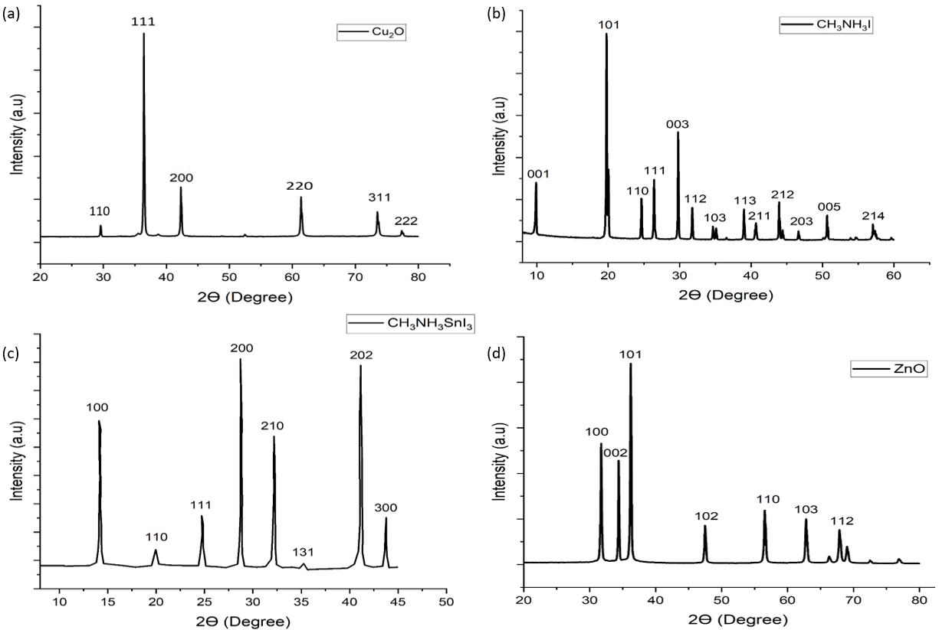
Fig. 1. The X-ray diffraction pattern of the synthesized (a) Cu₂O, (b) CH₃NH₃I, (c) CH₃NH₃SnI₃ and (d) ZnO nanoparticles.
    - Field emission scanning electron microscopy (FESEM) analysis
The powder samples of the synthesized Cu₂O, CH₃NH₃SnI₃ and ZnO were studied using FESEM in order to examine the structure and particle size distribution of the nanoparticles. The FESEM image and the distribution of the particle size for the Cu₂O is presented as Figs. 2(a) and 2(b), respectively. Meanwhile, the FESEM image and the particle size distribution for the CH₃NH₃SnI₃ are presented as Figs. 2(c) and 2(d), respectively. Similarly, the image and the particle size distribution for the ZnO are presented as Figs. 2(e) and 2(f), respectively. The Cu₂O and ZnO samples composed of relatively smooth varying particles sizes of cubic and spherical shapes, respectively while tetragonal particles sizes are observed in CH₃NH₃SnI₃. The mean particle sizes for the Cu₂O, CH₃NH₃SnI₃ and ZnO were found to be 207.91 nm, 370.51 nm and 188.22 nm using ImageJ software as presented in Figs. 2(b), 2(d) and 2(f), respectively.

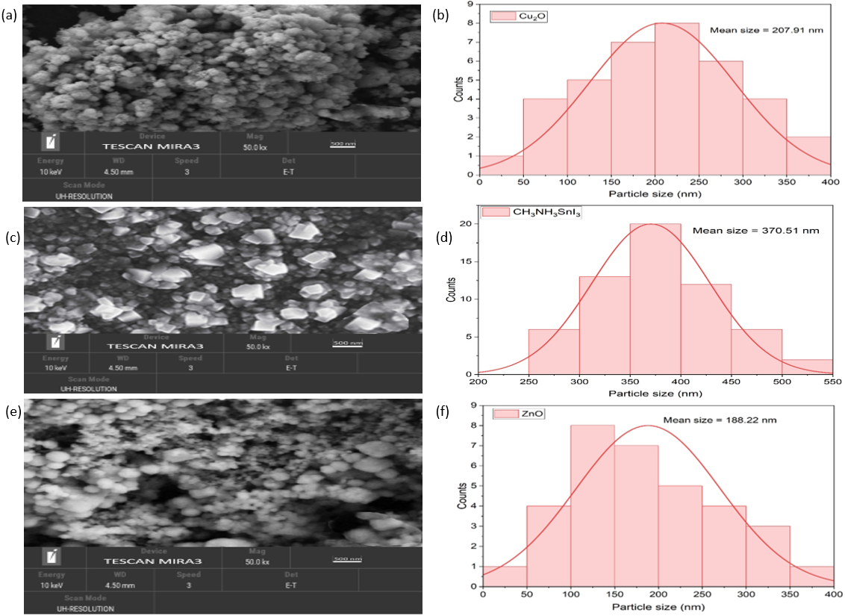
Fig. 2. FESEM image of the (a) CU₂O nanoparticles with (b) the particle size distribution. FESEM image of the (c) CH₃NH₃SnI₃ nanoparticles (d) with the particle size distribution, FESEM image of the (e) ZnO nanoparticles (f) with the particle size distribution.
    - UV-visible spectroscopy analysis
The UV visible spectroscopy was performed with a wavelength scan range between 400 to 800 nm and the corresponding absorbance spectra for Cu₂O nanoparticles dispersed in 1-butanol were recorded, while the UV-visible absorbance spectra at the wavelength scan range between 500 and 900 nm for the CH₃NH₃SnI₃ was obtained when dispersed in N, N-dimethylformamide (DMF). Similarly, the UV visible spectroscopy for ZnO nanoparticles dispersed in methanol was also conducted at the wavelength scan range between 300 and 800 nm and the absorbance spectra were determined. The UV-visible absorbance spectra with Tauc’s plot for the Cu₂O, CH₃NH₃SnI₃, and ZnO are presented as Figs. 3(a), 3(b) and 3(c), respectively. The optical band gap for Cu₂O, CH₃NH₃SnI₃, and ZnO nanoparticles were obtained from Tauc’s plot using the relationship as presented in Equations (1) and (2).
$$α= \frac{2.303 x A}{T} (1)$$
$(αhʋ)={A\left(hv-E_{g}\right)}^{n} (2$)
where $α$ is the absorption coefficient, $A$ is the absorbance, T is the thickness (diameter of the cuvette), $h$ is the Plank’s constant, $ʋ$ is the frequency of the photon, $hʋ$ is the energy of a photon, and $n$ is the exponential coefficient having values of 0.5 and 2 for direct and indirect electronic transitions, respectively. Equation (2) represents the Tauc’s relation equation. An intercept at $hʋ$ axis in ${(αhʋ)}^{2}$ plot against $hʋ$ represents the band gap energy (Viezbicke et al., 2015). The calculated band gaps $E_{g}$ for Cu₂O, CH₃NH₃SnI_{3,} and ZnO are 2.17 eV, 1.32 eV, and 3.20 eV, as shown in Figs. 3(a), 3(b) and 3(c), respectively. It is important to add that for most metal-based nanostructures such as Cu₂O and ZnO, the band gap value increases with reducing crystallite size.
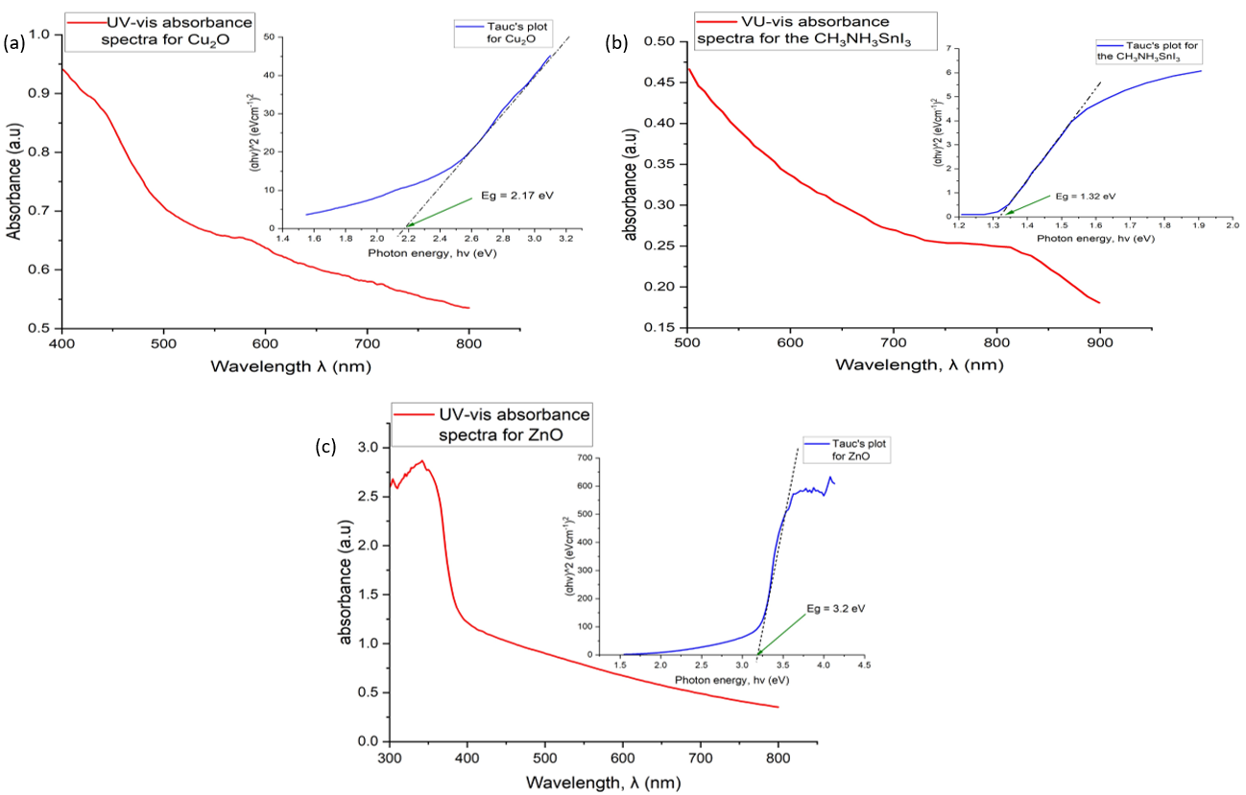
Fig. 3. The UV-visible absorbance spectra and Tauc’s plot of the (a) Cu₂O nanoparticles, (b) CH₃NH₃SnI₃ nanoparticles and (c) ZnO nanoparticles.
  - Device Fabrication Analysis
An indium tin oxide (ITO) coated glass substrate used as the top conducting interface was cleansed in an ultrasonic bath with commercial detergents; acetone and isopropanol to remove any available surface impurity. The Cu₂O nanoparticles used as HTM were dispersed in a mixture of 1-butanol, methanol and chloroform at a ratio of 2:1:1, respectively without additional binders and spin-coated at 3000 rpm for 60 seconds on the ITO substrate without calcination or sintering. The CH₃NH₃SnI₃ was chosen as the perovskite of interest considering its eco-friendly nature. The freshly prepared CH₃NH₃SnI₃ crystals were dispersed in N, N-dimethylformamide (DMF) and dimethyl sulfoxide (DMSO) to improve film morphology and reduce crystal defects for enhanced charge transfer efficiency. The CH₃NH₃SnI₃ layer was spin-coated at 3000 rpm for 20 seconds on the Cu₂O interface substrate. The ZnO nanoparticles used as ETM were dispersed in a mixture of 1-butanol, methanol and chloroform at a ratio of 2:1:1, respectively without additional binders and spin-coated at 3000 rpm for 30 seconds on the perovskite’s substrate with no calcination or sintering required. All layers were deposited at an acceleration of 1000 rpm/s. Finally, instead of the usual aluminium metal, an aluminum foil was applied via thermal evaporation with a base pressure of 1×10⁻⁷ mbar at the deposition rate of 2Å/s and a smooth aluminum nano-layer was formed. All layers of the device were fabricated under an ambient environment and layers dried in air at relative humidity of approximately 50%. The schematic step-by-step procedure for the fabrication and the diagram showing the energy levels of the fabricated inverted device structure are shown as Figs. 4(a) and 4(b), respectively.
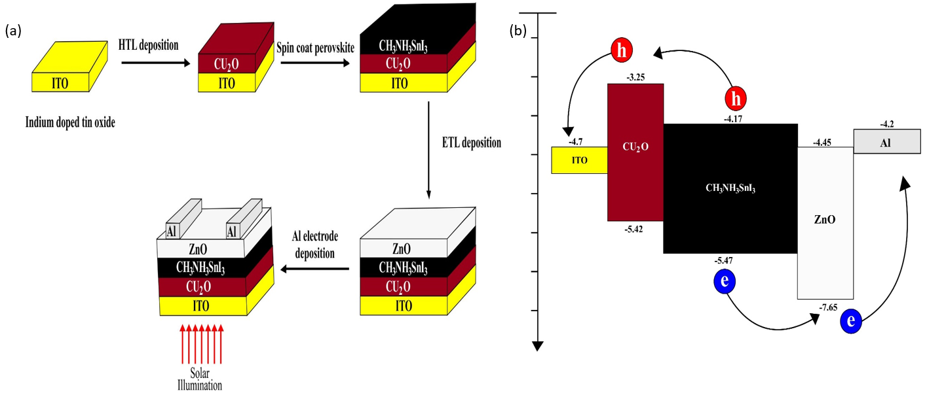
Fig. 4: (a) The schematics of the step-by-step procedure of the inverted device fabrication in 3D (b) Schematic diagram showing the energy levels of the fabricated inverted device structure.
  - Device Testing and Analysis
The curves of the current and voltage of the solar cells measured were generated using a digital source-measurement unit. The J-V characteristics curve of our fabricated device showing the forward and reverse scan curves presented in this paper is similar to the work published by Aseena et al. (2022) in terms of material components. However, our device is of an inverted structure composed of lead-free perovskite (CH₃NH₃SnI₃) with an economical back contact electrode (aluminum). Our inverted device produced a PCE of 7.44%, which is superior to the work done by Aseena et al. (2022) with a PCE of 6.02%. The inverted device structure in this work is the first of its kind considering it structural organization and has not been published anywhere known to us. The top view photograph of the fabricated inverted device structure in 1D and the experimental setup showing testing of the fabricated device under illumination are presented as Figs. 5(a) and 5(b), respectively. The fabricated inverted device showed negligible hysteresis considering the forward and the reverse scan as shown in Fig. 5(c) which is in agreement with the literature (Wang et al., 2021; Yu et al., 2018). Interestingly, the fabricated device showed good and superior stability over work done by Seo et al. (2018) as it retained 95% of its efficiency from 7.44% to 6.98% under a relative humidity of 50% after 1000 hours of exposure to 1000 W/m² solar illumination as represented by the J-V characteristics shown in Fig. 5(d) which supports the work published by Hao et al (2021).
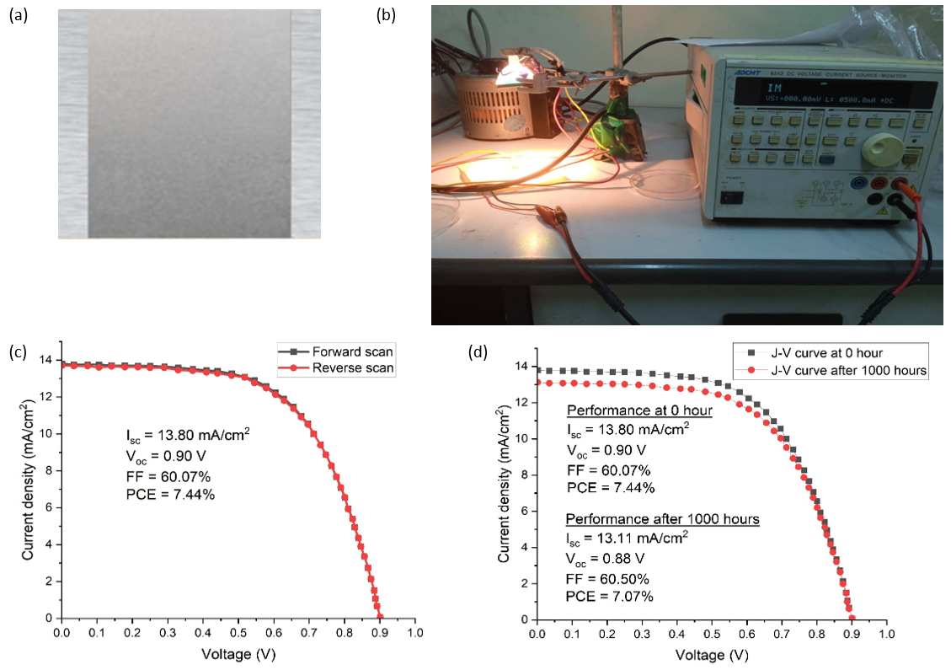
Fig 5: (a) The top view photograph of the fabricated inverted device structure in 1D, (b) the experimental set up for device testing. The J-V characteristics curve of the fabricated inverted device showing (c) the forward and reverse scan, (d) the device performance at 0 hour and after 1000 hours.
- CONCLUSION
The XRD results produced well developed spectra for Cu₂O, CH₃NH₃SnI₃ and ZnO. The EDX results showed correct elemental composition and proportion. The FESEM images of the nanoparticles showed smooth morphology with average particle size distribution of 207.91 nm, 370.51 nm and 188.22 nm for Cu₂O, CH₃NH₃SnI₃ and ZnO, respectively. The Tauc’s plots generated from the UV-Vis spectroscopy data produced acceptable direct energy band gaps of 2.17 eV, 1.32 eV and 3.20 eV for Cu₂O, CH₃NH₃SnI₃ and ZnO, respectively. The fabricated device structure (ITO/Cu₂O/CH₃NH₃SnI₃/ZnO/Al) is the first of its kind made from economical transport materials and eco-friendly perovskite absorber. The test results showed outstanding performance of 7.44% efficiency, which is the highest ever using inorganic transport materials (Cu₂O and ZnO) fabricated at room temperature with relative humidity approximately 50%. 95% device’s stability was retained after 1000 hours of exposure to solar illumination which is highly impressive for methyl ammonium tin-based perovskite devices. It is important to state categorically that the fabricated device structure is novel in terms of configuration and could provide a research path towards achieving eco-friendly, economical, and stable inverted solar cell device with negligible hysteresis using inorganic transport materials.

Competing interests
The authors declared no competing interest that could affect the work reported in the paper.

REFERENCES
Abraham, N., Rufus, A., Unni, C., Philip, D. (2018). Dye sensitized solar cells using catalytically active CuO-ZnO nanocomposite synthesized by single step method, Spectrochimica Acta Part A: Molecular and Biomolecular Spectroscopy. 200: 116-126. https://doi.org/10.1016/j.saa.2018.04.015
Afre, R.A. and Pugliese, D. (2024). Perovskite solar cells: a review of the latest advances in materials, fabrication techniques, and stability enhancement strategies. Micromachines, 15(2), 192. https://doi.org/10.3390/mi15020192
Arce-Plaza, A., Sánchez-Rodriguez, F., Courel-Piedrahita, M., Galán, O.V., Hernandez-Calderon, V., Ramirez-Velasco, S. and López, M.O. (2018). CdTe thin films: deposition techniques and applications. Coatings and Thin-Film Technologies, 131-148. https://doi.org/10.5772/intechopen.82070
Asad, J., Shaat, S.K., Musleh, H., Shurrab, N., Issa, A., Lahmar, A., Al Kahlout, A. and Al Dahoudi, N. (2019). Perovskite solar cells free of hole transport layer. Journal of Sol-Gel Science and Technology, 90(3), 443-449. https://doi.org/10.1007/s10971-019-04957-w
Aseena, S., Abraham, N., Dennis Babu, G. S., Kathiresan, S., Suresh Babu, V. (2022). Solution-Synthesized Cu₂O as a Hole Transport Layer for a ZnO-Based Planar Heterojunction Perovskite Solar Cells Fabricated at room temperature. Journal of electronic Material. 51: 1692-1699. https://doi.org/10.1007/s11664-022-09442-9
Beek, W.J., Wienk, M.M., Kemerink, M., Yang, X. and Janssen, R.A. (2005). Hybrid zinc oxide conjugated polymer bulk heterojunction solar cells. The Journal of Physical Chemistry B, 109(19), 9505-9516. https://doi.org/10.1021/jp050745x
Byranvand, M.M., Zuo, W., Imani, R., Pazoki, M. and Saliba, M. (2022). Tin-based halide perovskite materials: properties and applications. Chemical Science, 13(23), 6766-6781. https://doi.org/10.1039/D2SC01914K
Carey, G.H., Abdelhady, A.L., Ning, Z., Thon, S.M., Bakr, O.M. and Sargent, E.H. (2015). Colloidal quantum dot solar cells. Chemical reviews, 115(23), 12732-12763. https://doi.org/10.1021/acs.chemrev.5b00063
Chen, B., Yang, M., Priya, S. and Zhu, K. (2016). Origin of J–V hysteresis in perovskite solar cells. The journal of physical chemistry letters, 7(5), 905-917. https://doi.org/10.1021/acs.jpclett.6b00215
Choi Won-Gyu, Lee S, Jeon B-C, Moon T (2022). Single-source evaporation of CH₃NH₃SnI₃ for Pb-free perovskite solar cells. Int J Energy Res. 9875 – 9881 https://doi.org/10.1002/er.7761
Dang, Y., Zhou, Y., Liu, X., Ju, D., Xia, S., Xia, H. and Tao, X. (2016). Formation of hybrid perovskite tin iodide single crystals by top‐seeded solution growth. Angewandte Chemie International Edition, 55(10), 3447-3450. https://doi.org/10.1002/anie.201511792
De Los Santos, I.M., Cortina-Marrero, H.J., Ruíz-Sánchez, M.A., Hechavarría-Difur, L., Sánchez-Rodríguez, F.J., Courel, M. and Hu, H. (2020). Optimization of CH3NH3PbI3 perovskite solar cells: A theoretical and experimental study. Solar Energy, 199, 198-205. https://doi.org/10.1016/j.solener.2020.02.026
Et-taya, L., Ouslimane, T. and Benami, A. (2020). Numerical analysis of earth-abundant Cu2ZnSn (SxSe1-x) 4 solar cells based on Spectroscopic Ellipsometry results by using SCAPS-1D. Solar Energy, 201, 827-835. https://doi.org/10.1016/j.solener.2020.03.070
Feurer, T., Reinhard, P., Avancini, E., Bissig, B., Löckinger, J., Fuchs, P., Carron, R., Weiss, T.P., Perrenoud, J., Stutterheim, S. and Buecheler, S. (2017). Progress in thin film CIGS photovoltaics–Research and development, manufacturing, and applications. Progress in Photovoltaics: Research and Applications, 25(7), 645-667. https://doi.org/10.1002/pip.2811
Gonzales, C., Guerrero, A. and Bisquert, J. (2021). Spectral properties of the dynamic state transition in metal halide perovskite-based memristor exhibiting negative capacitance. Applied Physics Letters, 118(7). https://doi.org/10.1063/5.0037916
Hao, L., Li, T., Ma, X., Wu, J., Qiao, L., Wu, X., Hou, G., Pei, H., Wang, X., and Zhang, X. (2021). A tin‑based perovskite solar cell with an inverted hole‑free transport layer to achieve high energy conversion efficiency by SCAPS device simulation. Optical and Quantum Electronics. 53:524. https://doi.org/10.1007/s11082-021-03175-5
Hsieh, M.L., Kaiser, A., Bhattacharya, S., John, S. and Lin, S.Y. (2020). Experimental demonstration of broadband solar absorption beyond the Lambertian limit in certain thin silicon photonic crystals. Scientific Reports, 10(1), 11857. https://doi.org/10.1038/s41598-020-68704-w
Ionescu, C., Baracu, T., Vlad, G.E., Necula, H. and Badea, A. (2015). The historical evolution of the energy efficient buildings. Renewable and Sustainable Energy Reviews, 49, 243-253. https://doi.org/10.1016/j.rser.2015.04.062
Jonathan, L., Diguna, L.J., Samy, O., Muqoyyanah, M., Abu Bakar, S., Birowosuto, M.D. and El Moutaouakil, A. (2022). Hybrid organic–inorganic perovskite halide materials for photovoltaics towards their commercialization. Polymers, 14(5), 1059. https://doi.org/10.3390/polym14051059
Kim, S., Kim, Y.C. and Oh, S.G. (2015). Synthesis of highly concentrated ZnO nanorod sol by sol-gel method and their applications for inverted organic solar cells. Korean Chemical Engineering Research, 53(3).
Kim, S., Trinh, T.T., Park, J., Pham, D.P., Lee, S., Do, H.B., Dang, N.N., Dao, V.A., Kim, J. and Yi, J. (2021). Over 30% efficiency bifacial 4-terminal perovskite-heterojunction silicon tandem solar cells with spectral albedo. Scientific Reports, 11(1), 15524. https://doi.org/10.1038/s41598-021-94848-4
Li, J., Cao, H.L., Jiao, W.B., Wang, Q., Wei, M., Cantone, I., Lü, J. and Abate, A. (2020). Biological impact of lead from halide perovskites reveals the risk of introducing a safe threshold. Nature communications, 11(1), 310. https://doi.org/10.1038/s41467-019-13910-y
Li, X., Zheng, X., Zhen, Y. and Liang, Y. (2023). Photogenerated carrier-assisted electrocatalysts for efficient water splitting. Catalysts, 13(4), 712. https://doi.org/10.3390/catal13040712
Lyu, M., Yun, J.H., Chen, P., Hao, M. and Wang, L., 2017. Addressing toxicity of lead: progress and applications of low‐toxic metal halide perovskites and their derivatives. Advanced Energy Materials, 7(15), p.1602512. https://doi.org/10.1002/aenm.201602512
Major, J.D. (2016). Grain boundaries in CdTe thin film solar cells: a review. Semiconductor Science and Technology, 31(9), 093001. https://doi.org/10.1088/0268-1242/31/9/093001
Mallik, M., Monia, S., Gupta, M., Ghosh, A., Toppo, M.P. and Roy, H. (2020). Synthesis and characterization of Cu₂O nanoparticles. Journal of Alloys and Compounds, 829:154623. https://doi.org/10.1016/j.jallcom.2020.154623
Mangrulkar, M. and Stevenson, K.J. (2021). The progress of additive engineering for CH3NH3PbI3 photo-active layer in the context of perovskite solar cells. Crystals, 11(7), 814. https://doi.org/10.3390/cryst11070814
Nanda, I.R., Pambudi, N.A. and Aziz, M., (2023). Review on the progress of solar water heaters and their future perspectives. Energy Technology, 11(10), 2300191. https://doi.org/10.1002/ente.202300191
Noman, M., Khan, Z. and Jan, S.T. (2024). A comprehensive review on the advancements and challenges in perovskite solar cell technology. RSC advances, 14(8), 5085-5131. https://doi.org/10.1039/D3RA07518D
Nur-E-Alam, M., Islam, M.S., Abedin, T., Islam, M.A., Yap, B.K., Kiong, T.S., Das, N., Rahman, M.R. and Khandaker, M.U. (2025). Current scenario and future trends on stability issues of perovskite solar cells: a mini review. Current Opinion in Colloid & Interface Science, 101895. https://doi.org/10.1016/j.cocis.2025.101895
Nyiekaa, E.A., Aika, T, A., Danladi, E., Akhabue, C.E. and Orukpe, P.E. (2024a). Simulation and optimization of 30.17% high performance N-type TCO-free inverted perovskite solar cell using inorganic transport materials. Scientific Reports 1412024 https://doi.org/10.1038/s41598-024-62882-7
Nyiekaa, E.A., Aika, T.A., Orukpe, P.E., Akhabue, C.E. and Danladi, E. (2024b). Development on inverted perovskite solar cells: A review. Heliyon, 10(2). https://doi.org/10.1016/j.heliyon.2024.e24689
Pan, Z., Rao, H., Mora-Seró, I., Bisquert, J. and Zhong, X. (2018). Quantum dot-sensitized solar cells. Chemical Society Reviews, 47(20), 7659-7702. https://doi.org/10.1039/C8CS00431E
Parashar, M. and Kaul, A.B. (2021). Methylammonium lead tri-iodide perovskite solar cells with varying equimolar concentrations of perovskite precursors. Applied Sciences, 11(24), 11689. https://doi.org/10.3390/app112411689
Rahman, M.S., Miah, S., Marma, M.S.W. and Sabrina, T. (2019), February. Simulation based investigation of inverted planar perovskite solar cell with all metal oxide inorganic transport layers. In 2019 International Conference on Electrical, Computer and Communication Engineering (ECCE) (pp. 1-6). IEEE. https://doi.org/10.1109/ECACE.2019.8679283
Raminafshar, C., Raptis, D., Mohammadi, M.R. and Lianos, P. (2019). Study of hole-transporter-free perovskite solar cells based on fully printable components. Micromachines, 10(4), 266. https://doi.org/10.3390/mi10040266
Saha, P., Singh, S. and Bhattacharya, S., (2023). Efficient and lead-free perovskite solar cells based on defect-ordered methyl ammonium antimony iodide. IEEE Transactions on Electron Devices, 70(3), 1095-1101. https://doi.org/10.1109/TED.2023.3235870
Seo, S., Jeong, S., Bae, C., Park, N.G. and Shin, H. (2018). Perovskite solar cells with inorganic electron‐and hole‐transport layers exhibiting long‐term (≈ 500 h) stability at 85° C under continuous 1 sun illumination in ambient air. Advanced Materials, 30(29), 1801010. https://doi.org/10.1002/adma.201801010
Shukla, A., Sharma, V.K., Gupta, S.K. and Verma, A.S. (2020). Computational determination of the physical-thermoelectric parameters of tin-based organomatallic halide perovskites (CH3NH3SnX3, X= Br and I): Emerging materials for optoelectronic devices. Materials Chemistry and Physics, 253, 123389. https://doi.org/10.1016/j.matchemphys.2020.123389
Solak, E.K. and Irmak, E., 2023. Advances in organic photovoltaic cells: a comprehensive review of materials, technologies, and performance. RSC advances, 13(18), pp.12244-12269. https://doi.org/10.1039/D3RA01454A
Stoumpos, C.C., Malliakas, C.D. and Kanatzidis, M.G. (2013). Semiconducting tin and lead iodide perovskites with organic cations: phase transitions, high mobilities, and near-infrared photoluminescent properties. Inorganic chemistry, 52(15), 9019-9038. https://doi.org/10.1021/ic401215x
Tahir, D. and Tougaard, S. (2012). Electroic and optical properties of Cu, CuO and Cu₂O studied by electronic spectroscopy. J. Phys.: Condens. Matter 24 175002. https://doi.org/10.1088/0953-8984/24/17/175002
Tian, L., Xin, Q., Zhao, C., Xie, G., Akram, M.Z., Wang, W., Ma, R., Jia, X., Guo, B. and Gong, J.R. (2021). Nanoarray structures for artificial photosynthesis. Small, 17(38), 2006530. https://doi.org/10.1002/smll.202006530
Viezbicke, B.D., Patel, S., Davis, B.E. and Birnie III, D.P. (2015). Evaluation of the Tauc method for optical absorption edge determination: ZnO thin films as a model system. physica status solidi (b), 252(8), 1700-1710. https://doi.org/10.1002/pssb.201552007
Wan, S., Zhu, Y., Hong, D. and Tian, Y. (2022). Controllable introduction of surface defects on CH₃NH₃PbI₃ perovskite. Nanomaterials, 12(6), 1002. https://doi.org/10.3390/nano12061002
Wang, Q., Phung, N., Di Girolamo, D., Vivo, P. and Abate, A. (2019). Enhancement in lifespan of halide perovskite solar cells. Energy & Environmental Science, 12(3), 865-886. https://doi.org/10.1039/C8EE02852D
Wang, T., Chen, J., Wu, G. and Li, M. (2016). Optimal design of efficient hole transporting layer free planar perovskite solar cell. Science china materials, 59(9), 703-709. https://doi.org/10.1007/s40843-016-5108-4
Wang, Z., Zhang, D., Yang, G. and Yu, J. (2021). Exceeding 19% efficiency for inverted perovskite solar cells used conventional organic small molecule TPD as hole transport layer. Applied Physics Letters, 118(18). https://doi.org/10.1063/5.0050512
Wu, J., Wang, Y., Su, C. et al. (2021). Preparation and characterization of planar heterojunction perovskite solar cells based on c-TiO₂/CH₃NH₃PbI₃/HTM/Ag structure. J Sol-Gel Sci Technol. 100, 440–450. https://doi.org/10.1007/s10971-021-05682-z
Yu, J.C., Hong, J.A., Jung, E.D., Kim, D.B., Baek, S.M., Lee, S., Cho, S., Park, S.S., Choi, K.J. and Song, M.H., (2018). Highly efficient and stable inverted perovskite solar cell employing PEDOT: GO composite layer as a hole transport layer. Scientific reports, 8(1), 1070. https://doi.org/10.1038/s41598-018-19612-7
Zhao, Z., Gu, F., Rao, H., Ye, S., Liu, Z., Bian, Z. and Huang, C. (2019). Metal halide perovskite materials for solar cells with long‐term stability. Advanced Energy Materials, 9(3), 1802671. https://doi.org/10.1002/aenm.201802671
Zhu, M., Park, S.Y., Kang, T., Han, H.G., Jun, H.Y. and Ryu, S.O. (2017). Investigation of CuIn1− xGaxSe2 thin films prepared by chemical solution-based processes for CIGS solar cells. Molecular Crystals and Liquid Crystals, 645(1), 175-184.

