Original Research Article

Domestic Demand and Export Performance in Gabon: A Single Equation Approach

Abstract:
Aims: To fit well the Model underlying the New Export channel given by the domestic demand one road on the empirical side is to use instrumental variables. Then the aim of this study is to address the alternative issue with the Single Equation Approach as the instrumental variables’s result is dependent of the instruments choice.
Methods: We evaluate an equation that involved only stationary variables and stationary combinations of non stationary variables and to assess whether the equation fit well the Model we evaluate the in-of-sample prediction.
Results: We find that for the Gabonese experience between 1974-2021 the New Export channel continues to hold. In fact, the domestic demand impacts negatively exports with a negative elasticity of around 47%. But contrarely to the literature the price competitiveness channel hold just in the short run even into the Reverse causation from export dynamics to domestic demand.
Conclusion: Over the standard for addressing the model goodness of fit as the listing of the main findings comparatively to the existing literature our equation fit nevertheless well the Model as the loss function associated to the in-of-sample prediction is less than the standard at one.

Keywords: Exports, Domestic Demand, price competitiveness channel, Single Equation Approach, in-of-sample prediction, loss function.

- Introduction

Background information
It’s well established that the Old explanations of exports have failed to explain the international competitiveness (Ca’ Zorzi and Schnatz, 2007, p. 15) generally taken as the export market shares i.e the difference between the exports and foreign demand the latter refers to the average of the imports of the main trading partners those of which import from the national economy. For example, concerning the CEMAC area in Central Africa, characterized by the slight level of intra regional trade the Old explanations of exports can’t really give an answer or an recommandation to increase this moderate level of intra regional trade. In fact, in the one hand the price competitiveness channel as given by the variations of the Real Exchange Rate don’t operate as the currency unit is the same into the area between the members States. In the other hand, the imports of the main trading partners (as given by the foreign demand) are bounded as the exports are concentrated and this is just evidence of Dutch disease (Kuikeu, 2025d). An another strand of illustration coming from the manufactures sector where which the Old explanations of exports it’s difficult to give an answer or an recommendation to the low level of industrialisation process of the area and in Africa globally. In fact, acting on price competitiveness channel as given by the variations of Real Exchange Rate as well as on the manufacturing value added has proven to not be of great interest for African countries characterized as the area with a weak export led growth comparatively to other Regions in the world as East Asia (Bouoiyour, 2003, p. 2).

General Objectives
Beside the New Export channel given with the domestic demand (Esteves and Rua, 2013 ; Bobeica et al., 2015 ; Esteves and Prades, 2016) there are Old explanations of exports (Ca’ Zorzi and Schnatz, 2007, p. 15) given by the price competitiveness channel. In times series modelling, as well as for European countries with the Portuguese experience (Esteves and Rua, 2013) than CEMAC area with the Gabonese experience (Kuikeu, 2025a) it have been found that the Single Equation Approach is an good engine to fit well the data. As the instrumental variables, one category of Single Equation Approach, is the Approach on which relies Kuikeu (2025a) with the Gabonese experience in CEMAC area, while this Approach have output depending on the instruments choice (see the developments in Wooldridge (2002, pp. 118-120) on the endogeneity tests), then the aim of this paper is to know if the Single Equation Approach, without the using of instrumental variables, already use for the case of European countries fit as well the data of CEMAC area members States with the Gabonese experience.

General Hypotheses
Esteves and Prades (2016) suggest that the New Export channel proposed in Esteves and Rua (2013) given by a negative relationship between domestic demand development and export performance is unlikely to occur in countries that are primarily exporters of commodities, as the domestic consumption of those products is generally insignificant. This point was touched upon in Gnimassoun (2015) – a paper focusing on adjustments paths in sub-Saharan countries –. An additional issue for which the Gabonese experience is relevant since this country is a full member of OPËC (The Organization of Petroleum Exporting Countries). Then is the Single Equation Approach a good framework to test the New Export channel considering these stylized facts on export concentration?

Contribution to Research
Until now the evidence for the New Export channel for CEMAC area have been given with an instrumental approach as well as in panel data modelling (Kuikeu, 2024) than times series modelling with the Gabonese experience (Kuikeu, 2025a). Then this study can be view as a comprehensive guide to assess the New Export channel without using the instrumental variables.

Structure of the Study
This study was organized as follows, in the next section (section 2) as Literature Review we present the rationale behind the export concentration of products in explaining the New Export channel as given by the domestic demand, in section 3 the Methods, in section 4 the Results, and finally in section 5 as concluding remarks a summary of the main results.

- Literature Review: does export concentration matter ?

To have an idea on the role of the concentration index of exports in explaining the trade-off between sales to domestic and foreign markets (the New Export channel) it’s intuitive to assess on the subject of active and limited macroeconomic policy. The macroeconomic measures are those actions on stimulating local demand from an accommodating fiscal and monetary policy, put forward by Keynes with the aim of this action to put the economy on a high growth trajectory of North countries. Then these measures are consider as active (respectively, as limited) when they have a greatest (respectively, a smallest) effect on domestic demand. According to Esteves and Prades (2015, p. 7) this latter case can arise when export developments are more linked to external demand, being less sensitive to fluctuations of domestic demand. One very intuitive example concerns an oil producing country: certainly its shares of the world market will not depend on its domestic consumption of oil. In other terms, when exports are concentrated the macroeconomic policy is Limited such that domestic demand for these products is proportionately much smaller than production and exports and its fluctuation is not relevant to affect sales abroad.

To recapitulate all of these statements concerning the adequacy of exports channel, between the Old given by the price competitiveness channel and the foreign demand and the New one given by the domestic demand, we have the following Table 1:

Table 1. The adequacy of export channel
 | Concentrated exports | Diversified exports
Active macroeconomic policy | New Export channel | New Export channel
Limited macroeconomic policy | Old export channel | Old export channel
Source: Author based on Esteves and Prades (2015).

Considering this we have not choice to address the study on a period where the economic policy of Gabon were active (1974-2021). In fact, as numerous African countries yet after the independence the aim of Gabonese Authority was to recover the country’s economy growth (Kuikeu, 2012). But with the large external shocks that have know the country since the middle of the 1980 decade the country experiences the Structural Adjustment Program with the aim of controlling aggregate demand. The failure of this program to not recover the country’s economic growth pushed his Authorities to accept the nominal devaluation of 1994. Overall, the effectiveness of structural adjustment measures on the external level appears relatively mediocre. The trade balance deficit of this country continues to persist, until 1993 before the devaluation of 1994 (Kuikeu, 2025e).
The leadership of this country into the CEMAC area is well known as the country were the origin of the Governor of the cental Bank. Meanwhile this rule have been change, during the mandate of Gabonese Felix Mamalepot the central Bank have followed a policy of accomodating monetary policy and this policy continues until now (Kuikeu, 2009).
Concerning fiscal policy the main aim was to decrease the disparity in standard of living among Gabonese with the place of the higher income country among CEMAC members by GDP per capita. Nevertheless since few time the new Administration of Brice Clothaire Oligui N’guema facing several fiscal imbalances have decided to avoid some misleading of a great accomodative fiscal policy despite the rules of monetary agreement within the CEMAC (Kuikeu, 2009). For example, recently after a visit in USA he have decided to not pay once again the scolarships of students originated from Gabon who live in place as America because this is a loss than a benefit for the country who observes that after her scholarships these students don’t back to work in their home country the Gabon.
Despite that these last events are out of our sample range these are nevertheless revelating of the fact that the preceding Administration of Ali Bongo Ondimba was very fiscal’s accomodative.
Considering the empirical literature review of the New Export channel in CEMAC area this is due mainly to Kuikeu (2025a, 2025b, 2025c, 2025f, 2025g, 2024) on the same sample range (1974-2021 in annual frequency). In kuikeu (2024), using a dynamic panel data model with an error correction mechanism for the 6 CEMAC members countries the study found that over the traditional determinants of exports domestic demand impacts export market share with a negative elasticity of around 53%. In kuikeu (2025a), using an conditional ECM (Error Correction Model) the study found that for the Gabonese experience over the traditional determinants of exports domestic demand impacts export market share with a negative elasticity of around 65%. In Kuikeu (2025b), using a dynamic panel data model with an error correction mechanism for the 6 CEMAC members countries, the study applies on the exports dynamics from the capacity constraints model of Belke et al. (2014, 2013) and uses the output gap as a good proxy to the domestic demand to avoid the using of foreign demand variable who is scare and costly to compute; the study found that over the traditional determinants of exports the output gap impacts negatively the exports dynamics with an unitary elasticity to reveal all the significance of the specification used in assessing the New Export channel. In Kuikeu (2025c) a robustness check is done to account for the particular panel data structure in CEMAC where just one member concentrates at itself over the half of total obvervations; then for this purpose using a dynamic panel data modelling with an error correction mechanism on a CEMAC area at 5 without Gabon the concern member the study found that domestic demand impacts negatively export performance with a negative elasticity around 65%. In Kuikeu (2025f), using a sectoral Approach with a dynamic panel data model on 4 (of the 6) CEMAC members countries, the study found that the domestic demand impacts negatively manufactures exports dynamics. In Kuikeu (2025g), using an dynamic panel data model with an error correction mechanism for the 6 CEMAC members countries the study introduces the idea of complementary issue between domestic demand and exports and the study found that over the traditional determinants of exports in the long term there is an complementary issue while in the short run the substituability issue remains with an negative elasticity around 74%.

- Methods

The starting point for the analysis of export performance behavior is the econometric model that stress the dynamics of export performance over time. The method and the variables selection are then presented in the following.

The Econometric Model
We assume that the export market share of the country i at time t (the difference between exports of goods and services $X_{it}$ and the foreign demand $D_{it}$) follows both short run and long-run determinants. For the long-run dynamics, we consider the Real effective exchange rate ${REER}_{it}$ a price/cost competitiveness indicator defined such as an increase represents an appreciation. For the short-run behavior, the export market share is explained by its own evolution in the previous year, and the present and past developments of the real exchange rate ${REER}_{it}$ and domestic demand ${DD}_{it}$ (Esteves and Rua, 2013 ; Bobeica and al., 2015 ; Esteves and Prades, 2016). Thus considering an error correction model for annual data:

$∆X_{it}-∆D_{it}=α_{i}+β\left({∆X}_{it-1}-{∆D}_{it-1}\right)+\sum_{k=0}^{1}{{φ_{k}∆REER}_{it-k}}+\sum_{l=0}^{1}{ω_{l}{∆DD}_{it-l}}+\sum_{l}{+θ\left(X_{t-1}-D_{t-1}\right)}+λ{REER}_{t-1}+φt$ (1)

where $∆$is the first difference operator. The Model considers all the variables except the trend measured in log allowing for a maximum of one lag. The interpretation of the time trend is not straightforward as it can capture the long-run effects of the so-called non-price competitiveness factors.

Estimation Method: The Single Equation Approach
Under the assumption that the short run dynamics do not exhibit level feedback with respect to the long-run relationship (in other words are weakly exogenous for the parameters of interest) we can factorise the ECM into two blocks: on the one hand, the marginal model that contains variables which are not influenced by the long-run relationship, in this case the short run determinants. On the other hand, the conditional model that contains variables which exhibit level feedback with respect to the long-run relationship, in this case only the export market share. Since the marginal model does not contain information about the long-run parameters we can obtain fully efficient estimates of the long-run parameters from the conditional model (Engle et al., 1983). Thus as an additional robustness check we address the evidence for a stable long-term relationship between export market share and its determinants. In practice, this can be accomplished through the t-ratio of the error correction term coefficient, the speed of mean reversion parameter $θ$ (Ca’ Zorzi and Schnatz, 2007, p. 14). Weak exogeneity is testable (Baffes, Elbadawi and O’Connel, 1999, p. 421). Kuikeu (2025e) reveals a Reverse causation between exports and domestic sales (generally domestic demand). Limited information approach such as two-stages least squares 2SLS (or instrumental variables more generally) are available subject to overcome this issue (Baffes, Elbadawi and O’Connel, 1999, p. 421). Thus it’s expected that domestic demand is endogenous and to test this we should run the Reverse causation.

Criterium of evaluating estimates performance
Since the main objective is to know how the Single Equation Approach fit well the data it’s relevant to present the development about the criterium on evaluating estimates performance. Fundamentally, two approaches can be used to assess the properties at finite sample of arbitrary estimators (Davidson and MacKinnon, 1993): The first proceeds by asymptotic development, while the second uses Monte Carlo experiments. Since the asymptotic development approach (finite-sample approximations) relies on significant mathematical knowledge, Monte Carlo experiments have generally been preferred. The term “Monte Carlo” is very general, its conceptualization depending on the field (discipline) under consideration. Overall, it refers to procedures for which, according to the law of large numbers and the central limit theorem, quantities of interest (the mean of an estimator, the level of a test statistic under the null hypothesis, or the power of a test statistic under any alternative hypothesis) that are difficult to recover analytically, can be approximated by generating numerous random realizations of the equivalent stochastic process.

In order to assess the performance of the different estimation procedures in a finite sample, we can use as criteria the bias (the mean error) and the root mean square error (RMSE). By denoting by $δ^{\left(j\right)}$ the Monte Carlo estimate of the parameter δ, the law of large numbers
guarantees:

$BIAS=\frac{1}{R}\sum_{J=1}^{R}{\left(δ^{\left(J\right)}-δ\right)}$ and $RMSE=\sqrt{\begin{matrix}\frac{1}{R} & \sum_{j=1}^{R}{{\left(δ^{\left(J\right)}-δ\right)}^{2}}\end{matrix}}$

Then if the use of asymptotic developments lies on important Mathematical knowledge the use of the alternative issue with the Monte Carlo experiments lies on important knowledge in the related domain of computer science as the language programming of available software. Then for this purpose to avoid one or another of these issues (asymptotic developments or Monte Carlo), a comparison of the predictive performance is established. To establish predictive performance, it is common practice in the literature to evaluate and then compare the loss associated with forecasting method (in this case the Single Equation Approach). This is referred to as a point comparison of predictive performance. In many applications, the loss function is generally taken as a statistic directly related to the forecast error. The usual statistics are the mean error (bias), the root mean square error (RMSE), and Theil's U statistic (Theil, 1971).

Since the objective is to evaluate the validity of the empirical model, predictive performance will be established on a sample basis (as opposed to out-of-sample predictions). Formally, we will adopt the following procedure: After estimating the Model on the entire sample (1974–2021 in annual frequency), we will perform a forecast of the endogenous variable (the export market shares) based on these observations. At each forecast horizon h (1974$≤h≤2021$), the usual statistics associated with forecast error are evaluated (in order to obtain an overall performance measure, the average of each indicator is considered).

Data Set
The macroeconomic data set for the Gabonese economy covers 1974 to 2021 in annual frequency thus 48 observations. The time frame is bound by the availability of real exchange rates series where the data is available between 1973-2021 such that the start of ours ample range in 1974 is just taking account of first differences among series in the model for exports dynamics (equation (1)). It were able to use the data coming from the World Bank but in this case this would be done at the cost of missing two countries namely Chad and Congo.
They come from the World Bank’s World Development Indicator (WDI) database for the exports of goods and services, the foreign demand, and domestic demand. Exports are measured in real terms and refer to both goods and services. Foreign demand is computed as the geometric weighted average of the imports in real terms of goods and services of the main trading partners, where the weights correspond to the export shares of the Gabonese economy to the respective trading partner countries. The domestic demand measure refers to the final demand including private consumption, gross fixed capital formation and public expenditures in real terms.
The real exchange rates are based on the the most commonly used price series, i.e. Consumer Price Index (CPI) against the top 30 trading partners (narrow-based indices) using weights based on trade. We employ the cepii’s EQCHANGE database (Couharde et al., 2018). The real effective exchange rate measure relies on the Purchasing Power Parity (PPP) and defines the real exchange rate as the relative price of domestic to foreign consumption or production baskets. This definition captures incentives to consume home’s products relatively to foreign’s products. An increase in the real exchange rate will make the consumption of foreign’s products relatively more profitable inducing appreciation of the nominal exchange rate (in other terms, of the currency). A decline in the real exchange rate is perfectly symmetrical.

Table 2. List of Variables
Variables | Abreviation | Source
The exportations of goods and services | $$X$$ | World Bank, WDI
The foreign demand | $$D$$ | World Bank, WDI
The real effective exchange rate | $$REER$$ | Cepii, EQCHANGE
The domestic demand | $$DD$$ | World Bank, WDI
Source: Author

To have an clear cut idea of the data especially concerning the price competitiveness channel we have represented together the export market share of Gabonese economy with their Real effective exchange Rate as depicted in Figure 1 below.

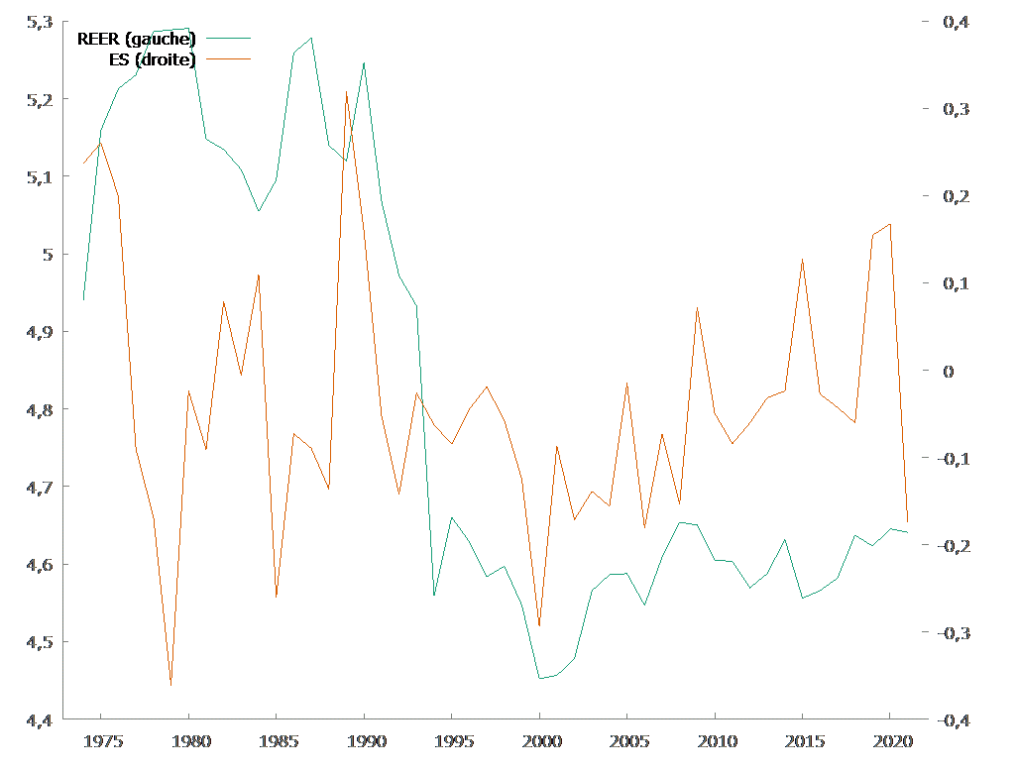
Figure 1: price competitiveness channel
Notes: ES refers to Export market share

As it appears the export market share is negatively correlated to the Real eefective exchange Rate as the conventional reasonning expected (Rey, 2011). Nevertheless there seems to be a trend break in the REER series corresponding to the devaluation of 1994. Then as an final inspection of the data we will assess this point.

- Results

We will first address the unit root test with break on REER series to ensure that the trend break observed in the graphical representation oif the concerning serie corresponds to the nominal devaluation of 1994 (4.1) after the parameters estimates (4.2) and the issue of performance in fitting the Model of the parameters estimates (4.3).

  - The Unit Root test on REER series

We use the famous Zivot and Andrews (1992)’s test. The following Table 3 depicted vthe results of this test following the method used to select lags to include in the base Model, the assumption made on the Break.

Table 3. ZIvot – Andrews Test
Lags of Difference Selected by User
 | Minimum T-Statistic | Break Point
Constant | −4.49 | 1994
Trend | −3.09 | 2001
Both | −5.52** | 1994
Lags of Difference Selected by AIC
Constant | −5.31** | 1994
Trend | −4.27 | 2001
Both | −6.54** | 1994
Lags of Difference Selected by BIC
Constant | −5.31** | 1994
Trend | −4.27 | 2001
Both | −6.54** | 1994
Lags of Difference Selected by Truncation at Longest Lag with P-value< 0.10000
Constant | −5.31** | 1994
Trend | −4.27 | 2001
Both | −6.54** | 1994
Source: Author, *** (**, *) null hypothesis is rejected at the 1% (5%, 10%).

As they aapear the selected Break point in each case corresponds to the year 1994 where the CFA franc devaluation where implemented. Nevertheless despite the rejection of the null of unit rrot in the series w cannot consider the series of REER as stationary. In fact, according to Johansen, Mosconi and Nielsen (2001, p. 217) “an important finding is that a time series given by stationary fluctuation around a broken constant level is better described by a random walk than a stationary time series”.
Then to account for this dynamics we include two separate Dummy variables into the ECM. A dummy defines to account the Break point such that it ($D_{94})$ takes the value 1 in 1994 and 0 otherwise and the second $D_{94-21}$defines such that it takes the value 1 since 1994 until the end of the sample. Then we get :

$∆X_{it}-∆D_{it}=α_{i}+β\left({∆X}_{it-1}-{∆D}_{it-1}\right)+γD_{94}+{δD}_{94-21}+\sum_{k=0}^{1}{{φ_{k}∆REER}_{it-k}}+\sum_{l=0}^{1}{ω_{l}{∆DD}_{it-l}}+\sum_{l}{+θ\left(X_{t-1}-D_{t-1}\right)}+λ{REER}_{t-1}+φt$ (2)

  - Parameters estimates

Equation (1) and Equation (2) represent an conditional Error Correction Model (ECM). For this purpose, since this agenda raises questions about the potential omitted variables problems and with the presence of the lagged endogenous these might suggest the use of instrumental variables. To overcome this issue with the Single Equation Approach the estimates is made with Generalized Least Square (GLS) to account for an AR process of order 10 for the error term. Given the annual periodicity, as in Esteves and Prades (2016) it is assumed that the substitution effect between domestic and foreign markets sales occurs contemporaneously. THen in the first time we should address the New Export channel (4.2.1) and in the second the Reverse causation (4.2.2).

    - The New Export channel

Table 4. Single Equation Approach
$$∆X_{t}-∆D_{t}$$ | (2)  GLS
Error Correction Term
$$X_{t-1}-D_{t-1}$$ | −0.40***  (0.04)
Long run parameters
$${REER}_{t-1}$$ | 0.52***  (0.04)
$$t$$ | −0.16***  (0.01)
$$t^{2}$$ | 0.00***  (0.00)
Short run parameters
$$∆X_{t-1}-∆D_{t-1}$$ | −0.43***  (0.10)
$$D_{94}$$ | −0.67***  (0.08)
$$D_{94-21}$$ | 0.47***  (0.05)
$$∆REER$$ | −0.39***  (0.12)
$$∆DD$$ | −0.47***  (0.07)
Statistics
Centered R² | 0.91
Nobs | 31[1991-2021]
$b\left[D_{94}\right]$=0 | 61,4461  (0.00)
$b\left[D_{94-21}\right]$=0 | 91,4058  (0.00)
Sample | 1974-2021
Source: Author, *** (**, *) null hypothesis is rejected at the 1% (5%, 10%). Nobs is available observations, (.) standard deviation. (.)=significance level.

To the extend that the separate Dummy should be suspected to multicollinearity we test the hypothesis that one or other of these parameters is null the most common case of multicollinearity in the regression variables. These are F tests (F(1, 22)) and as it’s reported in Table 4 above the case of multicollinearity is not significant at the standard level We have choose to not conducted the standard Variance Inflation Factor (VIF) analysis because the regression includes non stationary components that may bias the result.
As obtained with the Portuguese experience (Esteves and Rua, 2013, p. 15) the existence of a stable long-term relationship between export and its determinants is confirmed by the speed of mean reversion. Contrarely to the Portuguese experience this term is sizeable. The real effective exchange rate appears with a positive sign in the long-run, that is, an appreciation don’t hurts exports performance in Gabon, contrarely to the results obtained in Kuikeu (2025a, p. 25). The time trend is strongly significant, evidencing an decrease in exports market share of Gabon with what could not be explained by the real effective exchange rate itself. Concerning the short-run dynamics, the real effective exchange rates series appear to impact market share growth with a negative sign. The one period lag of export market share change exhibit negative coefficients. Over the Old export determinants, domestic demand appears to significantly influence export market share on the short-run with a negative elasticity around 47 per cent.

To the extend to which the parameters estimates may be subjected to parameters change we have made an robustness check by investigating the relationship pn the sub sample corresponding to the post devaluation period the event for which there is a Break trend in the Real exchange rate Rate series. The results are contained in the following Table 5.

Table 5. Sub sample estimates
$$∆X_{t}-∆D_{t}$$ | (1)  OLS
Error Correction Term
$$X_{t-1}-D_{t-1}$$ | −0.48***  (0.11)
Long run parameters
$${REER}_{t-1}$$ | 0.13***  (0.04)
$$t$$ | −0.10***  (0.02)
$$t^{2}$$ | 0.00***  (0.00)
Short run parameters
$$∆REER$$ | −0.59***  (0.17)
$$∆DD$$ | −0.27**  (0.10)
Statistics
Centered R² | 0.77
Nobs | 27[1995-2021]
$b\left[∆DD\right]$=−0.47 | 4,06129  (0.05)
Sample | 1994-2021
Source: Author, *** (**, *) null hypothesis is rejected at the 1% (5%, 10%). Nobs is available observations, (.) standard deviation. (.)=significance level.

Confronting these estimates with the preceding in the full sample it seems that the event of devaluationhave no altered the evidence of the New Export channel. To have an idea on the parameter stability we have test the extend to which the domestic demand parameter is the same accross the two samples, the sub sample and the full sample range. This is a F tests (F(1, 21)) and0 as reported in Table 4 above this hypothesis is significant at the 5% significance level suggesting thus that the stability of the New Export channel.

    - The Reverse causation

The results are reported in the following Table 6. The estimates is made with Generalized Least Square (GLS) to account for an AR process of order 10 for the error term.

Table 6. The Reverse causation
$∆DD$
GLS
Error Correction Term
$$X_{t-1}-D_{t-1}$$ | −0.19***  (0.06)
Long run parameters
$${REER}_{t-1}$$ | 0.18***  (0.05)
$$t$$ | −0.06***  (0.01)
$$t^{2}$$ | 0.00***  (0.00)
Short run parameters
$$∆{DD}_{t-1}$$
$$D_{94}$$
$$D_{94-21}$$ | 0.23***  (0.07)
$$∆REER$$ | 0.32***  (0.11)
$$∆X_{t}-∆D_{t}$$ | −0.61***  (0.06)
Statistics
Centered R² | 0.83
Nobs | 31[1991-2021]
Sample | 1974-2021
Source: Author, *** (**, *) null hypothesis is rejected at the 1% (5%, 10%). Nobs is available observations, (.) standard deviation. (.)=significance level.

The endogeneity of domestic demand is well asserted with the significant speed of mean reversion.Concerning the Reverse causation this is confirmed by the significaant and negative elasticity of around 61% between exports dynamics and domestic demand. According to Kuikeu (2025e) the reverse causation implies guenine domestic value-added industrialization. A novel channel to explain this reverse causation is that export growth may reduce domestic demandbecause export expansion is import-intensive (greater use of imported internediates lowers domestic value-added).

  - Performance of parameters estimates in fitting the Model

This concerns only the results relating to the New Export channel (Table 4).
First of all we conduct the misspecifications test on residuals. Since the autocorrelation haver been taking into account during the estimates these misspecifications tests concern the ARCH and the normality test. Concerning the normality test we employ the BDS test, the BDS (Brock, Dechert, Scheinkman and LeBaron, 1996) test for nonlinearity of the series. In an econometric context this is typically used to test a regression residual for violation of the IID condition. The BDS test is of the portmanteau type: able to detect all manner of departures from linearity but not informative about how exactly the condition was violated. The null is that the rgression residual don’t violate the IID condition.
All the results are reported in the following Table 7.

Table 7. Diagnostics Tests
Order | Statistics | P value
ARCH Test null is no ARCH effect
Lag1 | 1.54 | 0.21
Lag2 | 2.80 | 0.24
Lag3 | 2.88 | 0.41
Lag4 | 3.36 | 0.50
BDS Test null is error is normally distribute
2 | −1.15 | 0.58
3 | 1.74 | 0.41
4 | 1.94 | 0.37
5 | 1.99 | 0.37
Source: Author, *** (**, *) null hypothesis is rejected at the 1% (5%, 10%).

From these tests in Table 7 it appears that the Single Equation Approach performs well in fitting the model. In fact, there is no ARCH effect and the error don’t violate the IID condition.

The performance of parameters estimates in fitting the Model concerns the in-of-sample predictions. To have an first idea on the data we represent in Figure 2 the observed vs the fitted values.

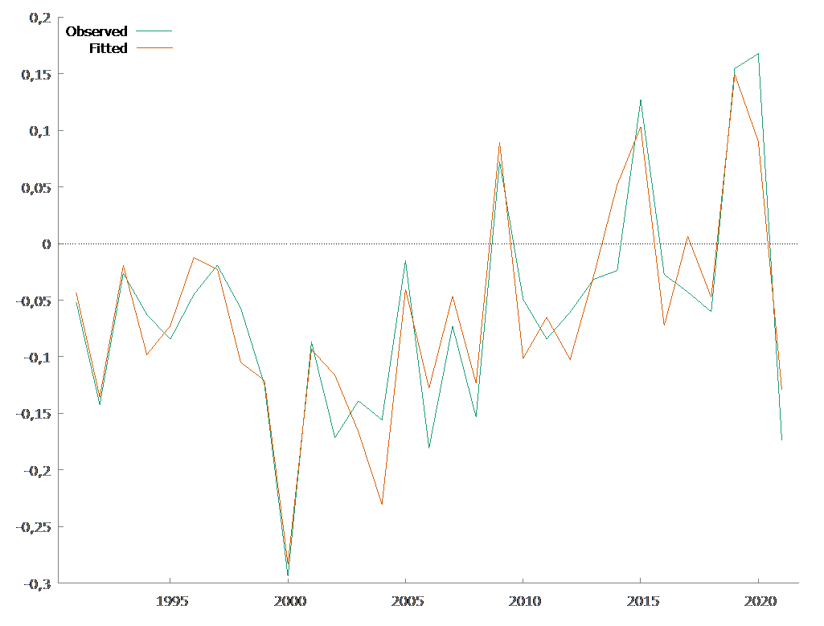
Figure 2: Observed vs Fitted

We use the usual statistics to address the loss function in predictive performance, those that are generally taken as related to the forecast error, the mean error (bias), the root mean square error (RMSE) and Theil's U statistic. We get: BIAS = 0.00, RMSE = 0.03, Theil’s U = 0.40.
Then with these statistics the Single Equation Approach performs well in fitting the Model underlying the New Export channel (the BIAS is null, the RMSE is weak, and the Theil’s U statistic is not greater than one).

- Conclusion

Context
To investigate the New Export channel given by the domestic demand it is common as well as in times series (Kuikeu, 2025a) than panel data modelling (Bobeica et al., 2015 ; Esteves and Prades, 2016 ; Kuikeu, 2025b ; Kuikeu, 2025c; Kuikeu, 2025e ; Kuikeu, 2025f ; Kuikeu, 2024) of using instrumental variables while the cost of this is high considering that the output’s result is choice’s dependent of the instruments used.

General Objectives
Then the aim of this paper is to address parameter estimates with the Single Equation Approach the alternative estimator to the instrumental variables.

Main findings
The Gabonese experience reveals that with the using of this alternative approach the evidence of the New Export channel is well asserted with the data. In fact, the Gabonese experience reveals that domestic demand impacts negatively exports with a negative elasticity of around 47%.

References

Baffes, J., Elbadawi, I. & O’Connel, S. (1999). Single equation estimation of the equilibrium real exchange rate, L. Hinkle, & P. Montiel (Eds), Exchange rate misalignment : concepts and measurement for developing countries, Washington DC: World Bank Research Publication.

Belke, A., Oeking, A. & Setzer, R. (2014). Exports and Capacity Constraints : A Smooth Transition Regression Model for six Euro Area countries. European Central Bank Working Paper Series 1740.

Belke, A., Oeking, A. & Setzer, R. (2013). Exports and Capacity Constraints : A Smooth Transition Regression Model for six Euro Area countries. Conference European Economics and Finance Society 2013, Berlin.

Bobeica, E., Esteves, P. S., Rua, A. & Staehr, K. (2015). Exports and domestic demand pressures: a dynamic panel data model for the euro area countries, European Central Bank Working Paper Series 1777.

Bouoiyour, J. (2003). Trade and GDP Growth in Morroco : Short-run or Long-run Causality ?, MPRA_Paper 28859.

Brock, W. A., Dechert, W. D., Scheinkman, J. A. and LeBaron, B. (1996). A test for independence based on the correlation dimension, Econometric Reviews, 15(3), 1287-1294.

Ca’ Zorzi, M. & Schantz, B. (2007). Explaining and Forecasting Euro Area Exports: which competitiveness indicator performs best?, European Central Bank Working Paper Series 833.

Couharde, C., Delatte, A-L., Grekou, C., Mignon, V. & Morvillier, F. (2018). Eqchange: a world database on actual and equilibruim effective exchanges rates, International Economics, 156(December 2018), 206-230.

Davidson, R., and MacKinnon, J. G. (1993). Estimation and Inference in Econometrics. New York: Oxford University Press.

Engle, R. F., Hendry, D. & Richard, J-F. (1983). Exogeneity, Econometrica, 51(2), 277-304.

Esteves, P. S., Portela, M. & Rua, A. (2021). Does domestic demand matter for firms’ export?, Open Economies Review, 33, 311-322.

Esteves, P. S. & Prades, E. (2016). On domestic demand and export performance in the euro area countries: does export concentration matter?, European Central Bank Working Paper Series 1909.

Esteves, P. S. & Rua, A. (2013). Is there a role for domestic demand pressure on export peformance ?, European Central Bank Working Paper Series 1594.

Gnimassoun, B. (2015), The importance of the exchange rate regime in limiting current account imbalances in sub-Saharan African countries, Journal of International Money and Finance, 53.

Hendry, D.F. (1995). Dynamic Econometrics. Oxford: Oxford University Press.

Johansen, S., Mosconi, R. & Nielsen, B. (2000). Cointegration analysis in the presence of structural breaks in the deterministic trend, Econometric Journal, 3(2), 216-249.

Kuikeu, O. (2025a). Domestic Demand and Export Performance in Gabon: The issue of cointegration, Journal of Economics and Development Studies, 13, 15-28. https://doi.org/10.15640/jeds.v13p2.

Kuikeu, O. (2025b) “Domestic Demand and Export Performance in CEMAC: Investigating from the Point of View of Capacity Constraints”, Journal of Economics and Development Studies, vol. 13, pp. 43-50. https://doi.org/10.15640/jeds.vol13p4.

Kuikeu, O. (2025c). Domestic Demand and Export Performance in CEMAC: A counry’s sensitive case ?. African Scientific Journal, 3(31), 274-286.

Kuikeu, O. (2025d). Export Performance and Productivity: Ratinale for a Macro Level Evidence in CEMAC, Jounal of Economics and Development Studies, 13, 65-78. https://doi.org/10.15640/jeds.v13p6.

Kuikeu, O. (2025e). Domestic Demand and Export Performance in CEMAC: The Reverse Causation. Journal of Economics and Development Studies, 13, 79-86, https://doi.org/ 10.15640/jeds.v13p7.

Kuikeu, O. (2025f). Domestic Demand and Export Performance in CEMAC: The case of Manufactures Sector, Journal of Economics and Development Studies, 13, pp. 96-104. https://doi.org/10.15640/jeds.vol13p8.

Kuikeu, O. (2025g). Domestic Demand and Export Performance in CEMAC: Complementary or Substituables ?, Journal of Economics and Development Studies, 13, pp. 87-95. https://doi.org/10.15640/jeds.vol13p9.

Kuikeu, O. (2024). Domestic Demand and Export Performance in CEMAC: An Assessment with Endogeneity-related Model, Jurnal Ekonomi dan Studi Pembangunan, 16(1), 124-133.

Kuikeu, O. (2012). Estimating the Real Exchange Rate Misalignment: case of Gabon, MPRA_Paper 39625.

Kuikeu, O. (2009). Courbe de phillips néo-keynésienne hybride: résultats empiriques pour la communauté économique et monétaire d’Afrique centrale (CEMAC), 26th international symposium in money, banking and finance, Université d’Orléans, 25 et 26 juin 2009.

Ramanathan, R. (2002). Introductory Econometrics with Applications (5th ed.). Fort Worth: Harcourt.

Rey, S. (2011). Exchange rate fluctuations and extra-eurozone exports: A comparison of Germany and France, Economics Bulletin, 31(2), 1131-1150.

Theil, H. (1971). Principles of Econometrics. New York: Wiley.

Wooldridge, J.M. (2002). Econometric Analysis of Cross Section and Panel Data. Cambridge: MIT Press.

Zivot, E. & Andrews, D.W.K. (1992). Further evidence on the great crash, the oil price shock and the unit root hypothesis, Journal of Business and Economic Statistics, 10(3), 251-270.

CEMAC is the monetary union of the six central African countries (Cameroon, Central African Republic, Chad, Congo Republic, Equatorial Guinea and Gabon) which have in common the sharing of the CFA franc as a common currency, issued by BEAC (Bank of Central African States) and pegged by a fixed parity to the French franc, at the rate of 1 French franc per 100 CFA franc since the devaluation of 1994 or since 1st January 2002, with the advent of the euro, at the rate of 1 euro for 655.957 CFA francs, or 1 euro for 6.55957 French francs.
This means that the equation being estimated involved only stationary variables and stationary combinations of non stationary variables (after the process), that is Hendry (1995) calls “mapping to stationarity” (Baffes, Elbadawi and O’Connel, 1999, p. 421).
This compares the predictive performance of the considered techniques (in this case the Single Equation Approach) to that of a completely ad hoc prediction scenario. Typically, it corresponds to the ratio between the square root of the mean squared error of the model and the square root of the mean squared error of a scenario postulating the identity of the predicted value from one period to another. Thus, values ​​greater than one will reflect the poor predictive performance of the considered techniques (in this case the Single Equation Approach). In other words, it would be preferable to consider the absurd assumption of the same predicted value from one period to another than to use the considered techniques.
Generalized Cochrane–Orcutt iterative procedure (Ramanathan, 2002).
Generalized Cochrane–Orcutt iterative procedure (Ramanathan, 2002).

