Original Research Article
Growth and Effectiveness of Minimum Support Price for Paddy in Gujarat

ABSTRACT
The Minimum Support Price (MSP) policy remains a cornerstone of India’s agricultural price support mechanism, intended to ensure remunerative prices to farmers, reduce price risk and incentivize crop production. This study critically examines the performance and effectiveness of the MSP system for paddy in Gujarat over the period 2002–2022. The analysis is segmented into two sub-periods: 2002–2012 and 2012–2022, to identify changes in trends, responsiveness and regional variations. The study draws on extensive secondary data from government publications, including the Directorate of Economics and Statistics, CACP reports and Directorate of Agriculture, Agriculture & Co-operation Department, Government of Gujarat.The findings reveal that MSP for both common and A-grade paddy increased consistently, with sharper growth in the first decade (CAGR: 9.17% for common and 8.79% for A-grade) compared to the second (5.34% and 5.10%, respectively), reflecting a slowdown in price hikes. Conversely, Farm Harvest Prices (FHP) grew more erratically and though they remained above MSP in the first period, they fell below MSP in four consecutive years post-2017 with the widest negative deviation occurring in 2020–21. While per cent of the years studied showed positive FHP-MSP deviation, the recent shift toward negative trends indicates diminishing effectiveness of MSP in safeguarding farmer’s incomes.

Keywords
Minimum support price, farm harvest price, price deviation, growth rate, effectiveness of MSP

JEL codes
Q13,Q18

INTRODUCTION
In a developing country like India, agriculture plays a vital role and agricultural prices significantly influence the overall price structure. Understanding price behaviour is crucial for formulating effective price policies. Agricultural price policy and the price support system have gained attention, especially with the liberalization of the Indian economy (Sudhakar and Wale, 2017). The Agricultural Prices Commission (APC), established in 1965, aimed to create a balanced pricing structure. In 1980, its focus shifted towards aligning food grain demand and supply, leading to its renaming as the Commission for Agricultural Costs and Prices (CACP) (Acharya, 1997).The Minimum Support Price (MSP), announced annually before sowing, is based on CACP recommendations and ensures farmers a minimum price during market gluts or bumper harvests by enabling government procurement. MSP acts as a long-term price assurance, offering income stability.
Farm Harvest Price (FHP) refers to the average wholesale price at which farmers sell their produce at the farm gate during harvest. Influenced by domestic production, global prices, and trade policies, FHP provides a more accurate measure of actual prices received by farmers than wholesale prices.
The Minimum Support Price (MSP) system in India has long been a subject of policy debate due to its complex implications for agricultural markets and farmer welfare. Its implementation is uneven across states, functioning more effectively in surplus producing regions (Ali et al., 2012). Critics argue that MSPs often diverge from international price trends and domestic market signals, potentially distorting cropping patterns and contributing to income disparities among farmers (Singh et al., 1986). Moreover, over the years, MSP has been increasingly perceived as a political instrument rather than a purely economic tool, raising concerns about its effectiveness in safeguarding farmers' incomes.
In this context, the present study aimed to critically evaluate MSP, with specific focus on paddy, a major food crop in India. By analyzing the growth trends of MSP for paddy announced by the Government of India and comparing them with the actual Farm Harvest Prices (FHP) received by farmers, the study assessed the extent to which FHP has grown in alignment with MSP. It further examined the deviations between FHP and MSP to explore whether market prices have generally ruled above or below the MSP during the study period. Therefore, the study was planned with the following objectives:
- to estimate and compare the growth in MSP and FHP of paddy and
- to analyze the deviations of FHP from MSP.

DATABASE AND METHODOLOGY
The study is based on the secondary data on farm harvest prices and minimum support prices of paddy for various paddy producing districts of Gujarat. To achieve the objectives of the study, the time series data on MSP and FHP of paddy were collected from various official sources like Directorate of Economics and Statistics and the Commission for Agricultural Cost and Prices for 2002-03 to 2021-22. The time-series data on prices of paddy were divided into three sub-periods, viz. period-I (2002-03 to 2011-12) and period-II (2012-13 to 2021-22).The data were compiled and analyzed using standard statistical tools.
The Compound Annual Growth rate (CAGR) was calculated by fitting the function given below:

Y= ${ab}^{t}$ ………. (1)
Where,
Y= Dependent variable for which growth rate is estimated i.e., MSP (₹/q)/ FHP (₹/q)
b = Regression coefficient
a = Constant
t = time period in years
The above can be expressed in logarithmic form as follows:

log y = log a + t log b ………… (2)

The compound growth rate "r" will be computed as:

r = (Antilog of b - 1) x 100 ………. (3)

The significance of compound growth rate (CGR) was tested by using student t-test:

t = $\frac{b}{S.E.\left(b\right)}$

b = Regression coefficient
S.E.(b) = Standard error of b
Trends in Farm Harvest Prices of various districts of Gujarat relative to Minimum Support Prices were analyzed using graphs and growth rate comparisons.
To study the effectiveness of the price policy during the harvest periods, the deviations of Farm Harvest Prices (FHP) from the Minimum Support Prices (MSP) were worked out and divided into positive and negative deviations to examine whether market prices ruled higher or lower over the minimum support prices. The negative deviations reflected ineffectiveness of MSP policy for producers. The formulae used for the mean absolute negative/positive deviation (Ali et al., 2012) were as follows:

MAD = $\frac{1}{n}\sum_{i=1}^{n}{|FHP }$_{i} - MSP _{i} |

If, FHP > MSP = Positive Deviation (PD)
FHP < MSP = Negative Deviation (ND)
where,
MAD = Mean Absolute Deviation,
FHP = Farm Harvest Price,
MSP = Minimum Support Price and
n = Frequency of positive or negative deviations
These deviations was then adjusted with MSP in order to examine the degree of their deviation from the MSP. The formulae used for the adjusted mean negative/ positive deviation were as follows :

AMD = $\frac{1}{n}$ $\sum_{i=1}^{n}{(|FHP}$_{i} - MSP _{i} |/MSP _{i}) * 100

If, FHP > MSP = Positive Deviation (PD)
FHP < MSP = Negative Deviation (ND)
where,
AMD = Adjusted Mean Deviation
FHP = Farm Harvest Price,
MSP = Minimum Support Price and
n = Frequency of positive or negative deviations

The significance of gap between FHP and MSP of food crops was tested by two sample t-test (Ritu et al., 2020):

$$t=\frac{\overline{x}-\overline{y}}{s\sqrt{\frac{1}{n_{x}}+\frac{1}{n_{y}}}}$$
$S_{p}^{2}$⁼ $\frac{ \left( n_{x } -1 \right)S_{x}^{2 }+ \left( n_{y }-1\right) S_{y}^{2}}{\left(n_{x }-1 \right)+ \left( n_{y }-1\right) }$
Where,
x̅ = mean of FHP of size n_{x}
y̅ = mean of MSP of size $n_{y}$
$S_{p}^{2}$ = pooled variance
S_{x}² = Variance of FHP
S_{y}² = Variance of MSP
n_{x =} Sample size of FHP
n_{y =} Sample size of MSP

RESULTS AND DISCUSSION
Keeping in view the objectives of the study, the data were analysed using suitable techniques. The results obtained from this study have been presented and discussed.

Growth in MSP of paddy
Table 1 reveals the compound growth rates of Minimum Support Prices (MSP) for both common and Grade “A” paddy over three time periods: Period I (2002–2011), Period II (2012–2021) and the overall period from 2002 to 2021. In the first period (2002–2011) the MSP increased at a high annual rate of 9.17 per cent for common paddy and 8.79 per cent for Grade “A” paddy. This indicates that during this time the government was actively increasing support prices at a faster rate which may have encouraged more paddy cultivation and helped improve farmer’s incomes.
In the second period (2012–2022), the growth rate of MSP slowed down to 5.34 per cent for common paddy and 5.10 per cent for Grade “A”. This shows a clear decline in the pace at which MSP was increased compared to the earlier period. The slower growth in support prices during this period may have had an impact on farmer’s earnings and production decisions.
When looking at the entire 20-year period from 2002 to 2022, the average compound growth rate of MSP was 7.93 per cent per year for common paddy and 7.67 per cent for Grade “A” paddy. This suggests that overall MSP has increased steadily over time, though at a slower rate in recent years. All the growth rates mentioned in the table 1 are statistically significant at 1 per cent level, which means the changes in MSP over time are reliable and not due to chance.

Table 1: Compound growth rate of minimum support prices of paddy
Period | Compound Growth Rates (% per annum)
Period | Paddy (Common) | Paddy (Grade “A”)
Period I  (2002-2012) | 9.17 | 8.79
Period II  (2012-2022) | 5.34 | 5.10
Overall period  (2002-2022) | 7.93 | 7.67

Note: All the compound growth rates are significant at 1 per cent level.

Figure 1: Trends in MSP growth for Paddy (2002-2022)

Growth in FHP of paddy
The Compound Growth Rate (CGR) analysis of Farm Harvest Prices (FHP) of paddy in Gujarat over the period 2002 to 2022 presents a clear picture of temporal changes in price realization at the farm level. The data as shown in Table 2 is divided into two distinct periods and also covers the overall period. All growth rates were found to be statistically significant at 1 per cent level reinforcing the reliability of the trends observed. During Period I (2002–2011), the FHP of paddy in Gujarat recorded a compound annual growth rate of 7.21 per cent. This relatively high growth rate indicates that farmers experienced substantial increases in market-based price realization during the early part of the study period. This could be associated with increased demand, supportive policy interventions or favourable market conditions.
In contrast, Period II (2012–2021) experienced a sharp deceleration with the CAGR falling to 1.79 per cent per annum. This considerable slowdown reflects a period of stagnation in farm-level price growth despite continued increases in Minimum Support Prices (MSP) at the national level. Over the entire period (2002–2022) the farm harvest price of paddy in Gujarat exhibited a compound growth rate of 5.91 per cent per annum. While this represents a moderate long-term increase, the stark contrast between the two sub-periods highlights an important structural shift in the dynamics of price realization at the farm level. The declining trend in the latter decade suggests the need for policy attention to strengthen market access, enhance procurement effectiveness and improve price transmission mechanisms to ensure that farmers benefit fairly from increases in support prices.

Table 2: Compound growth rate of farm harvest price of paddy in Gujarat
Period | Compound Growth Rates (% per annum)
Period I  (2002- 2012) | 7.21
Period II  (2012-2022) | 1.79
Overall period  (2002-2022) | 5.91
Note: All the compound growth rates are significant at 1 per cent level

Figure 2 : Trend of FHP growth for paddy in Gujarat 2002-2022

Comparison in growth of MSP and FHP for paddy
The comparative analysis of compound growth rates (CGRs) of Minimum Support Price (MSP) for both common and Grade “A” paddy and Farm Harvest Price (FHP) of paddy in Gujarat over the period 2002–2022 (Figure 3) reveals significant insights into the dynamics of price support versus actual market realization. The growth rates across three time periods-Period I (2002–2012), Period II (2012–2022) and the overall period (2002–2022) are all found to be statistically significant at the 1 per cent level confirming the robustness of the trends.
During Period I (2002–2012) the CAGR of MSP (common) was 9.17 per cent and that of MSP (Grade “A”) was 8.79 per cent, whereas the FHP grew at a comparatively lower rate of 7.21 per cent. This suggests that while support prices were increasing at a strong pace the corresponding benefits to farmers as reflected in the farm harvest price were not fully commensurate.
In Period II (2012–2022) the divergence becomes even more pronounced. The CGR for MSP (common) and MSP (Grade “A”) declined to 5.34 per cent and 5.10 per cent, respectively, indicating a moderation in policy-led price hikes. However, the FHP experienced a sharp deceleration growing at only 1.79 per cent per annum. This widening gap suggests a growing disconnect between administered prices and actual market realizations at the farm level.
Over the entire period (2002–2022), the MSP for common paddy and Grade “A” paddy registered compound growth rates of 7.93 per cent and 7.67 per cent, respectively, whereas FHP grew at 5.91 per cent per annum. While all three rates indicate an upward trajectory, the consistently lower growth of FHP compared to MSP across all periods underscores a structural issue wherein farmers do not fully realize the intended benefits of MSP increases.

Figure 3: Comparison of MSP and FHP growth rates of paddy

Figure 4 illustrates the Compound Annual Growth Rate (CAGR) of Farm Harvest Price (FHP) 19 paddy growing districts in Gujarat over the period 2002-03 to 2021-22. The analysis provides insights into regional disparities in price realization at the farm level. While the average FHP growth rate at the state level stood at 5.91 percent per annum, only a few districts managed to surpass this benchmark indicating uneven market performance and effectiveness of the
Minimum Support Price (MSP) policy in practise.

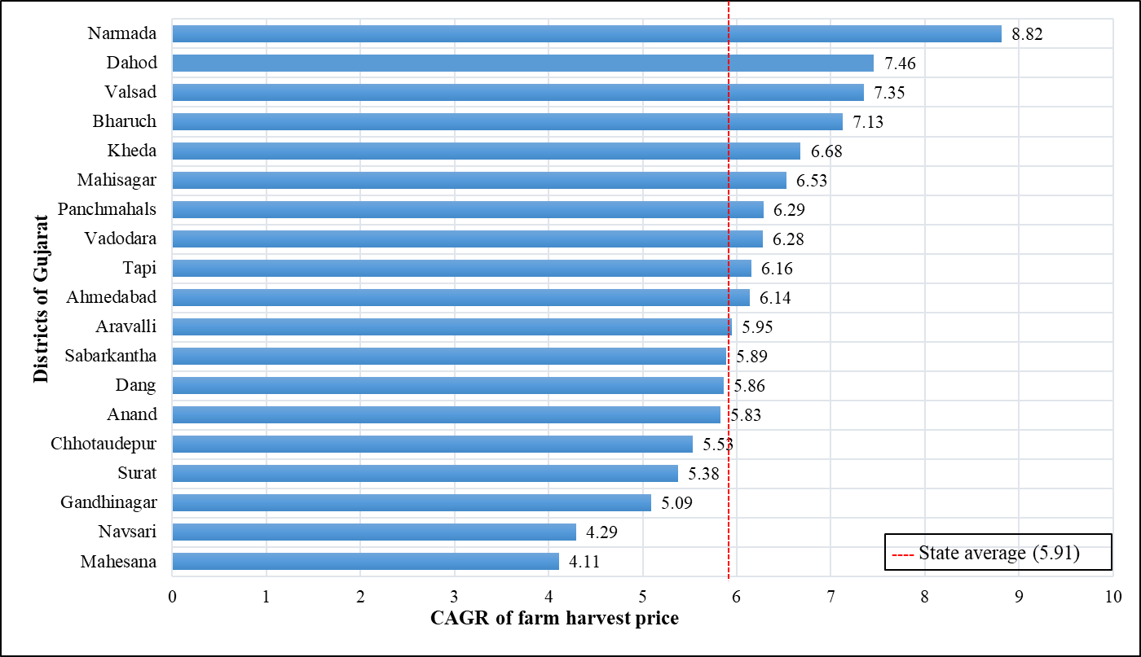
Figure 4 : District-wise FHP growth rate of paddy in Gujarat (2002-03 to 2021-22)

The districts that recorded high FHP growth rates above 7 per cent were Narmada (8.82 %), Dahod (7.46 %), Valsad (7.35 %) and Bharuch (7.13%).One possible reason for the high compound annual growth rate (CAGR) of Farm Harvest Price (FHP) in these districts may be the low base effect. Districts that started with relatively low FHP levels in the early years of the study period could show higher percentage growth over time, even with modest increases in absolute prices.This statistical effect may have amplified the long-term CAGR figures, making the price growth appear stronger in regions that were historically underdeveloped or had limited price realization in the initial phase.
A group of districts reported moderate FHP growth, ranging between 6 to 6.9 per cent. These included Kheda (6.68 %), Mahisagar (6.53 %), Panchmahals (6.29 %), Vadodara (6.28 % ), Ahmedabad (6.14 % ) and Tapi (6.16 %). These values being close to or slightly above the state average, suggest that farmers in these districts experienced fair but not exceptional gains in price realization.
Several districts recorded FHP growth rates that were close to the state average of 5.91 percent. These included Aravalli (5.95 %), Sabarkantha (5.89 %),Dang (5.86 %), Anand (5.83 %) and Chhotaudepur (5.53 %). On the other hand, certain districts showed relatively low FHP growth which is a cause for concern. These include Surat (5.38 %), Gandhinagar (5.09 %), Navsari (4.29 %) and Mehsana (4.11 %).

Deviations of farm harvest from minimum support price of paddy from 2002-22
To examine the effectiveness of MSP policy for paddy in Gujarat, difference between its FHP and MSP was calculated for the study period. The deviations were categorized into two types: negative deviations where FHP was lower than MSP and positive deviations where FHP exceeded MSP. During Period I (2002–2012), there were no instances of negative deviations indicating that farmers

Table 3: Gap between farm harvest price and minimum support price of paddy in Gujarat during 2002-03 to 2021-22
Year | FHP (₹/qtl) | MSP (₹/qtl) | Gap between FHP and MSP (₹/qtl )
2002-03 | 675 | 530 | 145
2003-04 | 646 | 550 | 96
2004-05 | 661 | 560 | 101
2005-06 | 669 | 570 | 99
2006-07 | 751 | 580 | 171
2007-08 | 813 | 645 | 168
2008-09 | 901 | 850 | 51
2009-10 | 1065 | 950 | 115
2010-11 | 1074 | 1000 | 74
2011-12 | 1121 | 1080 | 41
2012-13 | 1388 | 1250 | 138
2013-14 | 1433 | 1310 | 123
2014-15 | 1442 | 1360 | 82
2015-16 | 1437 | 1410 | 27
2016-17 | 1604 | 1470 | 134
2017-18 | 1551 | 1550 | 1
2018-19 | 1623 | 1750 | -127
2019-20 | 1523 | 1815 | -292
2020-21 | 1562 | 1868 | -306
2021-22 | 1681 | 1940 | -259
Note : Positive variations mean that the FHP is higher than MSP. FHP- Farm Harvest Price; MSP- Minimum Support Price.
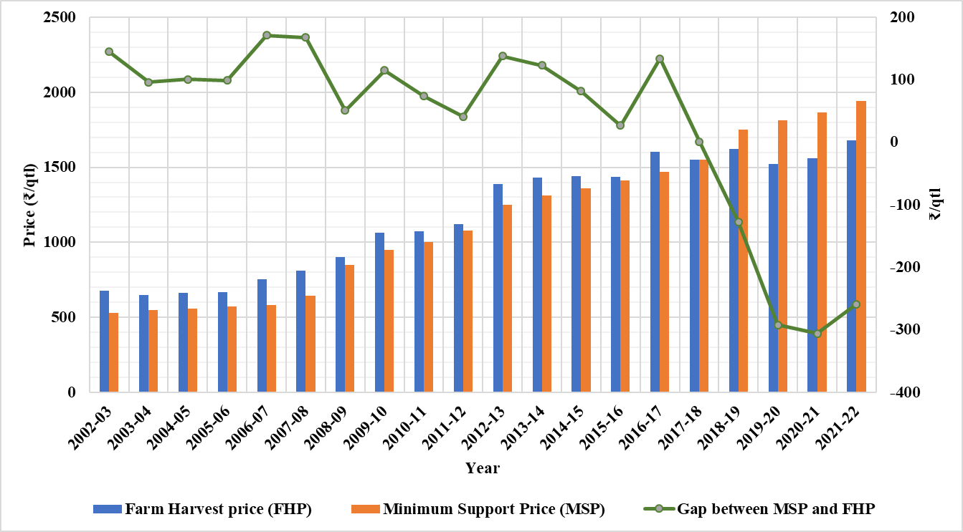

Figure 5: Gap between minimum support price and farmer harvest price of
paddy in Gujarat from 2002-2022

consistently received prices higher than the MSP in the market. All ten observations (100 per cent) in this period showed positive deviations with the Mean Absolute Positive Deviation (MAPD) being ₹102.35 per quintal. The range of positive deviations during this time spanned from ₹41 to ₹171 per quintal and the Adjusted Mean Positive Deviation (AMPD) was 15.70 per cent suggesting that farmers were relatively well-compensated compared to the MSP.
In contrast, during Period II (2012–2022) the scenario changed. Out of 10 years, 4 years (40 per cent) recorded negative deviations where the FHP fell below the MSP. The Mean Absolute Negative Deviation (MAND) was ₹246 per quintal with a range of deviations from ₹-127 to ₹-306. The Adjusted Mean Negative Deviation (AMND) stood at -13.26 per cent, indicating a considerable shortfall in the prices actually received by farmers as compared to the support price. At the same time, 6 years (60 per cent) still showed positive deviations but the MAPD dropped to ₹84.16 per quintal with a narrower range of ₹1 to ₹138 and an AMPD of only 6.25 per cent suggesting weaker market benefits for farmers compared to the earlier decade.
Considering the overall period (2002–2022) out of 20 years, 4 years (20 per cent) showed negative deviations with a MAND of ₹246 and an AMND of -13.26 per cent while 16 years (80 per cent) recorded positive deviations. The MAPD during this full period was ₹95.53, with a deviation range of ₹1 to ₹171 and the AMPD was 12.61per cent indicating that farmers mostly received prices above the MSP. Even though negative deviations emerged in the later period (2012–2022), they were limited to only 4 out of 20 years.

Table 4: Average gap between minimum support price and farmer harvest price of paddy in various districts of Gujarat during 2002-03 to 2021-22
Districts | FHP (₹/qtl) | MSP (₹/qtl) | Gap
Sabarkantha | 1127.08 | 1153.90 | -26.82
Aravalli | 1133.54 | 1153.90 | -20.36
Mehsana | 1491.56 | 1153.90 | 337.66
Gandhinagar | 1267.95 | 1153.90 | 114.05
Ahmedabad | 1230.42 | 1153.90 | 76.52
Anand | 1204.21 | 1153.90 | 50.31
Kheda | 1198.32 | 1153.90 | 44.42
Panchmahals | 1084.37 | 1153.90 | -69.53
Mahisagar | 1143.58 | 1153.90 | -10.32
Dahod | 1116.26 | 1153.90 | -37.64
Vadodara | 1312.34 | 1153.90 | 158.44
Chhotaudepur | 1252.36 | 1153.90 | 98.46
Narmada | 1381.00 | 1153.90 | 227.10
Bharuch | 1297.32 | 1153.90 | 143.42
Surat | 1337.16 | 1153.90 | 183.26
Dang | 1087.05 | 1153.90 | -66.85
Navsari | 1273.97 | 1153.90 | 120.07
Valsad | 1217.89 | 1153.90 | 63.99
Tapi | 1174.37 | 1153.90 | 21
Gujarat | 1207.76 | 1153.90 | 53.86
Note : Positive variations mean that the FHP is higher than MSP. FHP- Farm Harvest Price; MSP- Minimum Support Price.

Table 5: Significance of gap between FHP and MSP of paddy in various districts of Gujarat (2002-03 to 2021-22)
Districts | Mean FHP | Mean MSP | t_{cal(5%)} | t_{tab(5%)} | Degrees of freedom
Sabarkantha | 1106.12 | 1153.90 | 0.72 | 2.02 | 38
Aravalli | 1112.27 | 1153.90 | 0.76 | 2.02 | 38
Mehsana | 1491.56 | 1153.90 | 0.94 | 2.02 | 38
Gandhinagar | 1241.56 | 1153.90 | 0.52 | 2.02 | 38
Ahmedabad | 1201.90 | 1153.90 | 0.74 | 2.02 | 38
Anand | 1177.75 | 1153.90 | 0.86 | 2.02 | 38
Kheda | 1171.80 | 1153.90 | 0.90 | 2.02 | 38
Panchmahals | 1055.40 | 1153.90 | 0.47 | 2.02 | 38
Mahisagar | 1115.72 | 1153.90 | 0.79 | 2.02 | 38
Dahod | 1082.40 | 1153.90 | 0.65 | 2.02 | 38
Vadodara | 1277.88 | 1153.90 | 0.41 | 2.02 | 38
Chhotaudepur | 1205.15 | 1153.90 | 0.72 | 2.02 | 38
Narmada | 1331.95 | 1153.90 | 0.23 | 2.02 | 38
Bharuch | 1263.95 | 1153.90 | 0.50 | 2.02 | 38
Surat | 1411.45 | 1153.90 | 0.20 | 2.02 | 38
Dang | 1063.95 | 1153.90 | 0.51 | 2.02 | 38
Navsari | 1259.47 | 1153.90 | 0.43 | 2.02 | 38
Valsad | 1182.30 | 1153.90 | 0.85 | 2.02 | 38
Tapi | 1174.37 | 1153.90 | 0.90 | 2.02 | 38
Gujarat | 1181.12 | 1153.90 | 0.84 | 2.02 | 38
Note: t_{cal} < t_{tab} that means H₀ is accepted at (5 %) level of significance and conclude that the gap between FHP and MSP do not differ significantly.
Table 6: Deviations of farm harvest prices from minimum support prices of paddy in Gujarat
Period | Negative deviations |  |  |  |  | Positive deviations
Period | Frequency | MAND  (₹/q) | Range  (₹/q) | AMND  (₹/q) | % | Frequency | MAPD  (₹/q) | Range  (₹/q) | AMPD  (₹/q) | %
I (2002-2012) | 0 | - | - | - | - | 10 | 102.35 | 41 to 171 | 15.70 | 100
II (2012-2022) | 4 | -246 | -127 to  -306 | -13.26 | 40 | 6 | 84.16 | 1 to 138 | 6.25 | 60
Overall  (2002-2022) | 4 | -246 | -127 to  -306 | -13.26 | 20 | 16 | 95.53 | 1 to 171 | 12.61 | 80
Note: Zero deviations were considered positive deviations indicating success of the MSP policy, Average= Average of the difference of FHP from MSP (+ve or –ve) , per cent= Percentage of average positive or negative deviations over MSP, MAND/MAPD = Mean Absolute Negative/Positive Deviation and AMND/AMPD =Adjusted Mean Negative/Positive Deviation

CONCLUSIONS
This study set out to assess the performance and effectiveness of the Minimum Support Price (MSP) policy for paddy in Gujarat over the two-decade period from 2002 to 2022. It examined trends in MSP and Farm Harvest Price (FHP), as well as the deviations of FHPs f MSP across various districts. The analysis revealed that the Minimum Support Price (MSP) for both common and “A” grad paddy in Gujarat showed a steady increase over the study period from 2002 to 2022, with a higher growth rate during the first decade (2002–2012) and a slower increase in the second (2012–2022). In contrast, the Farm Harvest Price (FHP) also increased but exhibited fluctuations, especially in the second period with a noticeable decline in the growth rate. In nutshell, compound growth rate of MSP and FHP for paddy were found to be positive and highly significant.
Gap analysis between FHP and MSP from 2002-03 to 2016-17 reveals that, FHPs generally remained above MSPs, reflecting favourable market conditions. However, from 2017–18 onwards FHPs fell below MSPs, with the largest negative gap in 2020–21.These deviations varied across districts with some regions like Narmada, Dahod and Valsad showing higher FHP growth, while others such as Navsari, Mehsana and Gandhinagar recorded lower growth.
REFERENCES
Acharya, S.S. (1997). Agricultural price policy and development: Some facts and emerging issues. Indian Journal of Agricultural Economics, 52(1): 1-47.
Ali, S. Z.; Sidhu, R. S. and Vatta, K. (2012). Effectiveness of minimum support price policy for paddy in India with a case study of Punjab. Agricultural Economics Research Review, 25(2): 231-242.
Basantaray, K. A. (2023). Is Minimum Support Price effective in India? Evidence from state-wise paddy procurement. Asian Journal of Agricultural Extension, Economics & Sociology, 41(1): 53–65.
Dev, K. (2023). Institutional arrangements to enforce the Minimum Support Price (MSP) Policy effectively in India: A case study of wheat and paddy production in Punjab. Advances in Research, 24(5): 60-70.
Devi, G.; Zala, Y. C.; Bansal, R. and Jadav, S. K. (2016). A Study of minimum support price, farm harvest price and their effect on area of major food-grain crops of Gujarat. Indian Journal of Economics and Development, 12(1a): 555-558.
Divya, M. K. and Nithya, K. E. (2023). How effective the MSP is? Empirical evidence from Kerala. Indian Journal of Agricultural Marketing, 37(3): 61-67.
Jha, B. and Mohapatra, B. B. (2003). Liberalisation and agricultural prices: some disconcerting trends. Indian Journal of Agricultural Economics, 58(3): 375-386.
Khowajazada, K. H.; Sekhon, M. K. and Bhardwaj, S. (2022). Growth, impact and effectiveness of administered prices for major crops in Punjab. Journal of Agricultural Development and Policy, 32(1):117-124.
Latika, S.; Nitu, M. and Burark, S. S. (2012). Effectiveness of price in the production of major cereals crops in Rajasthan. Indian Journal of Agricultural Marketing, 26(3): 162-163.
Ritu ; Mehta, V. P.; Malik, D. P. and Kumar, R. (2020). Impact of agricultural price policy on major food crops in Haryana. Economic Affairs, 65(2): 267-274.
Singh, A. (2021). Effectiveness of minimum support price policy for wheat: A study of the bimaru states of India. Indian Journal of Agricultural Marketing, 35(1): 182-195.
Singh, I.P.; Bal, H.S.; Singh, B. and Kumar, N. (1986). Price policy for wheat and paddy vis-a-vis equity in Punjab, Indian Journal of Agricultural Economics, 41(4): 611-616.
Sudhakar, G. and Wale, Z. (2017). Minimum Support Prices and its impact on Agricultural Economy. International Journal of Economics and Business Management, 3(2): 38-46.

