Original Research Article

Spodoptera frugiperda (fall armyworm) population analysis in maize-growing areas of southeastern and south-central Côte d'Ivoire.

.
ABSTRACT

Aims: This study focuses on the analysis of fall armyworm (Spodoptera spp.) populations in three maize-producing areas of Côte d'Ivoire.

Study design: During the laboratory test, the tubes were arranged in completely randomized blocks.
Place and Duration of Study: Central Laboratory of Biotechnology (Centre National de Recherche Agronomique); Sampling, between June 2024 and July 2025
Methodology: The incidence and severity of infestation were assessed. In addition, a diversity analysis was performed using the specific primers JM77 and JM76, targeting the mitochondrial cytochrome oxidase (COI) gene region

Results: The results show significant variability in the level of Spodoptera frugiperda infestation across the studied locations. The southern zone showed higher incidence and severity rates in the towns of Grand-Lahou and Alepé, with 97% and 91.5% infestation rates, and 88% and 80% severity rates, respectively. Molecular analysis did not reveal population diversity with the molecular markers used.

Conclusion: This study shows overall that for the implementation of effective integrated management, having more detailed data on a larger number of populations, from other areas, and the use of different molecular markers, could allow the control of the armyworm population in our orchards, for the implementation of effective integrated management.

Keywords: [Spodoptera frugiperda , Population, maize, infestation, managing

1. INTRODUCTION

[(The fall armyworm, Spodoptera frugiperda, is native to the tropical and subtropical regions of the Americas (Sparks, 1979). This species spreads very rapidly (Idrissa et al., 2017). It has a life cycle of approximately 30 days, a reproductive potential of up to 1,000 eggs per female, and can travel over 100 km by wind (Johnson, 1987; FAO, 2017). This pest was first reported in West Africa in 2016 (Goergen et al., 2016). Its presence also extends to Asia and Australia (Hruska, 2019; IPPC, 2020). It is a polyphagous insect observed on more than 353 plant species worldwide (Montezano et al., 2018; Niassy et al., 2021). This makes it one of the most dangerous pests for crops (Prasanna et al., 2018; FAO, 2018). While it prefers Poaceae such as maize, rice, sorghum, millet, and sugarcane, it can also attack cotton, peanuts, soybeans, and vegetable crops (Day et al., 2017; FAO, 2017). The caterpillar is particularly interested in maize, the most widely cultivated cereal in the world (Abrahams et al., 2017). This preference is noteworthy given that maize is a staple food in sub-Saharan Africa (Sibiya et al., 2013; Ekpa et al., 2018). For the 2024–2025 growing season, global maize production is estimated at approximately 1.52 billion tonnes, while rice production is expected to reach a record 543.6 million tonnes (milled rice equivalent) (FAO, 2025). Losses caused by Spodoptera frugiperda range from 8.3 to 20.6 million tonnes of maize annually for the 12 largest maize producers in Africa (Day et al., 2017; Toepfer et al., 2018). The economic losses caused by S. frugiperda on maize worldwide are estimated at 75% (Nuambote, 2023). This pest threatens the food security of more than 300 million people in Africa and can cause significant economic losses, up to US$4.8 billion in maize production alone (Kouakou et al., 2019). In 2016, an infestation of unidentified caterpillars was first reported in the village of Allékro, Bodokro sub-prefecture in central Côte d'Ivoire, by maize farmers benefiting from the Agricultural Production and Marketing Support Project (PROPACOM) (Kouakou et al., 2019). The following year, the infestation spread throughout the central and northern regions of Côte d'Ivoire (Kouakou et al., 2019). In response to this situation, observation and identification missions were carried out by teams of entomologists from the National Center for Agronomic Research (CNRA). Analysis of damage patterns and the morphology of larvae and moths led to the identification of the pest Spodoptera frugiperda (Kouakou et al., 2019). However, this pest appears to coexist with other species sharing similar morphological characteristics. Furthermore, morphological characteristics and damage analysis in fields are insufficient to distinguish Spodoptera frugiperda from other armyworm species (Toepfer et al., 2018). Consequently, visual identification becomes unreliable, which limits the effectiveness of targeted control strategies (Montezano et al., 2016). This raises the following research question: given the damage caused by this pest in various locations and its economic impact, it is necessary to understand its dispersal. This study aimed to determine the genetic diversity of populations of the pest Spodoptera frugiperda (fall armyworms) in two geographical areas of Ivory Coast.
.]

2. material and methods

2-1 Phytosanitary survey and sampling

2-1-1 Areas Surveyed
The study was conducted in two (2) geographical areas of Côte d’Ivoire, each comprising several localities representative of the country’s ecological and agricultural diversity.
The Southern area includes Agboville, Grand Lahou, Alépé, Dabou, and Sikensi; it is characterized by a sub-equatorial climate, abundant rainfall, and high humidity, conditions favorable to the cultivation of maize, cocoa, and oil palm (FAO, 2005). (Figure 1).
The Central area includes Bouaké, Béoumi, Sakassou, Tiébissou, and Katiola: located in a transition zone, it has a tropical climate with alternating dry and rainy seasons, a mosaic of savannas and open woodlands, and plays a central role in food and industrial production (Kouakou et al., 2019).

2-1-2 Sampling
The samples were collected from maize plots of at least 1 hectare, all infested with the pest. In each village, five fields were selected according to a precise methodology: one field at each of the four cardinal points of the village, as well as a fifth field located in the center, which represents a total of five plots per village. The collections were carried out according to method W (FAO, 2018) in maize plots of at least 1 hectare, all naturally infested with fall armyworms. At each observation point (40), forty maize plants were meticulously examined, plant by plant, by probing the young leaves at the horn when the plant showed symptoms of damage characteristic of these insect pests. The insects collected at each point were carefully preserved in a box and fed with maize leaves.
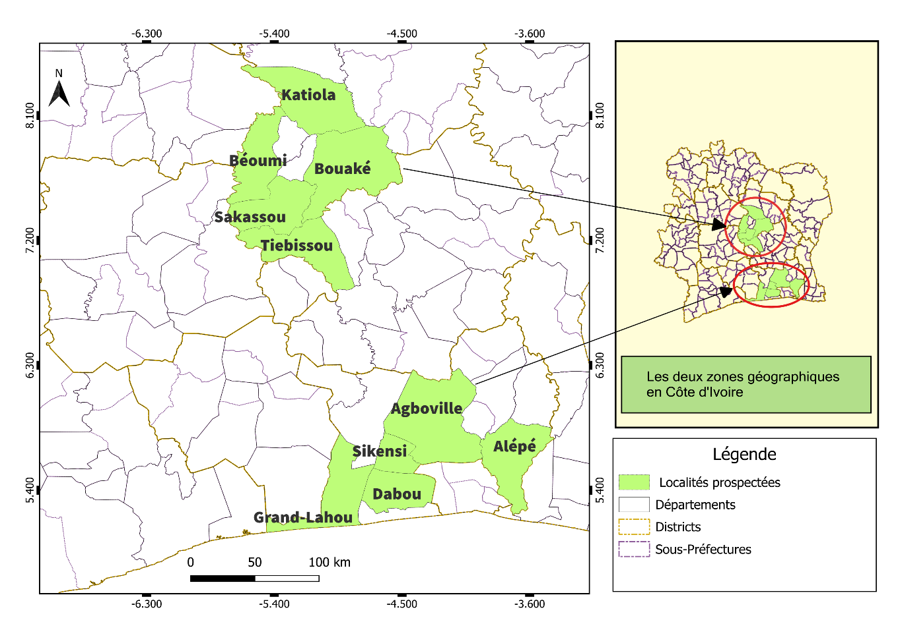
Figure 1: Geolocation of study sites (Central and Southern Zones) (source: GADM, 2018))

2-1-3 Disease severity and incidence assessment
In maize fields attacked by the fall armyworm, the incidence (IC) is calculated as the ratio between the number of infected plants and the total number of plants present in each quadrat (FAO, 2017).:
The average incidence across the entire field was determined by dividing the sum of the incidences measured in the different fields by the total number of fields (Chanda et al., 2020).
• the total number of plants,
• the number of infected plants,
• the number of leaves per plant,
• the number of attacked leaves,
• the number of lesions per leaf,
• and the number of larvae.
From the number of infected plants and the total number of plants, the incidence rate (IR) is calculated, which is the ratio between diseased plants and all plants present in a grid square. It was calculated using the following formula:

$$Attack rate \left(\%\right)=\frac{Number of corn plants attacked}{Total number of corn plants }×100$$

The average incidence across the entire field was determined by relating the sum of the incidences measured in the different quadrats to the total number of quadrats (Chanda et al., 2020).
The severity of fall armyworm infestation was calculated based on the ratio of the total number of leaves to the number of damaged leaves per plant. The rating scale adopted ranges from 0 (absence of symptoms) to 9 (maximum plant damage) (Davis et al., 1992). It is a widely recognized methodological tool for assessing the severity of attacks in maize crops (Koudahe, 2012; Nboyine et al., 2019; Buteme et al., 2020). According to Davis et al., 1992, this scale is as follows:

Table 1: Different types and forms of attacks observed
Score | Description of the damage
0 | No visible damage to the leaves
1 | Limited damage to the pinhole camera on the leaves
2 | Damage to the pinhole camera and the presence of bullet holes on the leaves
3 | Small, elongated lesions (5–10 mm) on 1 to 3 leaves
4 | Medium-sized lesions (10–30 mm) on 4 to 7 leaves
5 | Medium-sized lesions (10–30 mm) on 4 to 7 leaves
6 | Elongated lesions (> 30 mm) and large portions eaten on 3 to 5 leaves
7 | Elongated lesions (> 30 cm) and approximately 50% of the leaves eaten
8 | Elongated lesions (~30 cm) and large portions eaten on approximately 70% of the leaves
9 | The majority of leaves show long lesions with complete defoliation
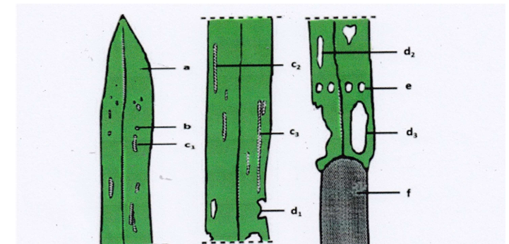

Figure 2 : the different types of damage observed on corn leaves (Davis et al., 1992)

The severity was estimated using the modified leaf damage scale of Davis and Williams (1992) for cereal crops.
$$Severity Index\left(\%\right)=\frac{Number of positive samples}{Number of samples observed}×100$$

2-1-4 Molecular identification
2-1-4-1 DNA extraction and PCR amplification
DNA extraction was performed on 250 fall armyworms (Spodoptera frugiperda), following the modified protocol of Lee et al. (2010). The isolated DNA was then quantified and stored at -20°C. The mitochondrial cytochrome oxidase (COI) gene region was amplified using specific primers JM76 (5'-GAGCTGAATTAGG(G/A) ACTCCAGG-3') and JM77 (5'-ATCACCTCC(A/T) CCTGCAGGATC-3') (Nagoshi RN et al., 2007). PCR was conducted using a MiniAmp thermal cycler from Applied Biosystems and OneTaq 2X Master Mix (NEB), following the manufacturer's guidelines. The PCR products were analyzed by electrophoresis on a 1% agarose gel, which was stained with SyberSafe solution. The PCR products were sequencing performed at BGI Genomics Sequencing Solutions (Hong Kong). Sequences obtained from specimens were reviewed using chromatograms with BioEdit software.

2-1-4-2 Phylogenetic analyses
The obtained sequences were phylogenetically studied with the NCBI BLAST (https://blast.ncbi.nlm.nih.gov) by comparing their counterpart’s sequences in the GenBank database. MEGA version 7.0. Software was used to modify the DNA sequence, Sequence alignments were performed using ClustalW alignment implemented in MEGA version 7 and were manually adjusted to allow maximum sequence similarity (Kumar, Stecher, and Tamura 2016). To demonstrate the relationships between homologous species, the Neighbour-Joining method using Molecular Evolutionary Genetics Analysis (MEGA 7.0) was used to create the phylogenetic tree

2-1-5 Data analysis
The sample data were processed using R software version 4.5.1. The Shapiro-Wilk test was first applied to verify the normality of all measured variables. When the data followed a normal distribution, a two-way ANOVA was performed, followed by the Student-Newman-Keuls test at the 5% significance level to compare the measured parameters.

3. results and discussion

3-1 Species of Spodoptera sp presence surveys and collection of larva

Observations of larvae were made in each plot visited. A total of 60 plots were selected in each area. Over 500 larvae at different stages of development were sampled in all surveyed areas (Figure 3).

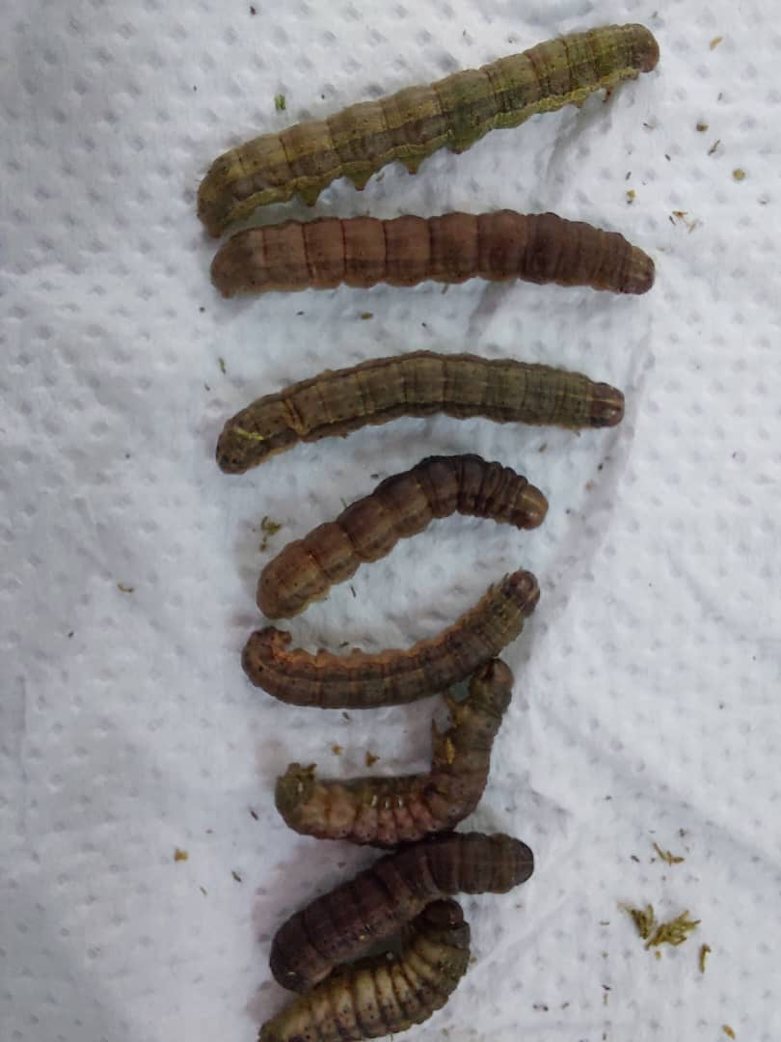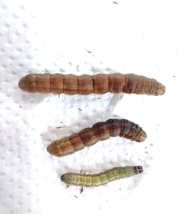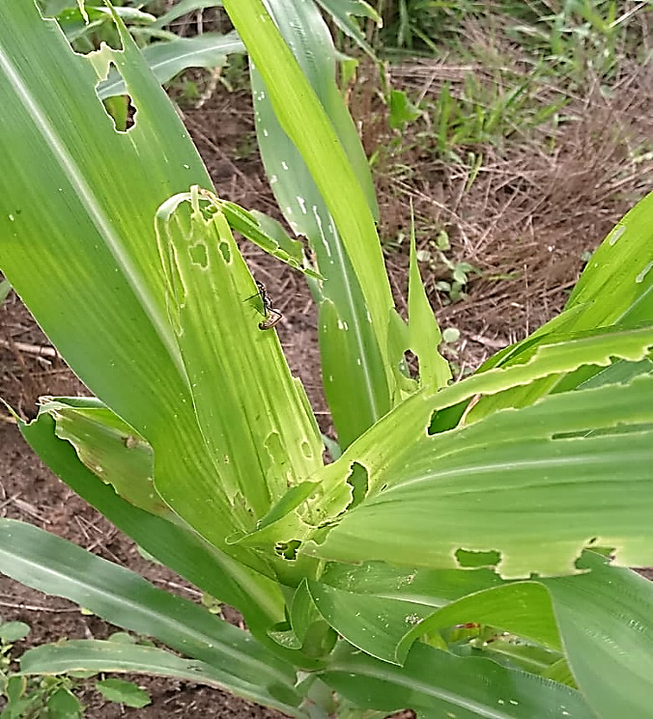

Figure 3: Collected larvae at different stages of development and plant under attack
Figure 3: Collected larvae at different stages of development and plant under attack

3-2 Analysed caterpillar morphologically and phylogenetically identified as Spodoptera frugiperda
From the 500 larvae collected, a total of 250 isolates of fall armyworm distributed across the 03 geographical sampling zones (South, North and Central), were chosen for PCR analyses. Of the 250 caterpillar samples whose DNA was used for PCR analysis, 129 were tested positive with primers JM76 5’ and JM77.
After sequencing, all the 129 positive samples were provisionally identified as part of the Spodoptera frugiperda species based on their morphological and molecular identification.

Table 2 : Sample positivity rates by geographic area and locality
Geographic area | Locality | Total samples | Total positives | Average positivity rate (%)
South | Alépé, Agboville,  Grand Lahou, Dabou, Sikensi | 125 | 73 | 58,4
Centre | Bouaké, Tiébissou, Sakassou, Béoumi | 100 | 38 | 38
North | Katiola | 25 | 18 | 72
Total |  | 250 | 129 | 51,6

3-3 Incidence and Severity assessment
Regarding the severity of caterpillar infestations, the plots surveyed in the central region, near the cities of Bouaké and Sakassou, had a high infestation rate. While the plots surveyed in the north had a medium rate, the trend towards very high infestation was observed in the plots located in the south of Côte d'Ivoire, near the cities of Alepé and Grand-Lahou. The rate was significantly higher, ranging from 3.8% to 5.13% respectively (Table 3).

Table 3: Incidence and severity rates
Geographic area | Locality | Attack rate (%) | Positive samples / Total | severity index (%) | Risk level
Center | Bouaké | 85 | 19 / 25 | 76 % | hight infestation
 | Sakassou | 62,5 | 12 / 25 | 48 % | Medium infestation
North | Katiola | 83 | 15 / 25 | 60 % | Medium infestation
South | Grand-Lahou | 97 | 22 / 25 | 88 % | Very hight infestation
 | Alépé | 91,5 | 20 / 25 | 80 % | Very hight infestation

- Low (<40 %)
- Medium (40–70 %)
- Hight (>70 %)

3-4 Phylogenetic analysis
Phylogenetic analysis was conducted on all identified sequences after BLAST belonging to the Spodoptera frugiperda species. The phylogenetic tree of Spodoptera frugiperda species based on the comparison of rDNA sequences, is presented in Figure 4. This tree shows the relations between the closes strains of the Spodoptera frugiperda species extracted from the NCBI database. All sequenced caterpillars were identified as belonging to the species Spodoptera Frugiperda. From the sequenced isolates, Individuals BK20 and BK24 are somewhat separated from the group, suggesting intraspecific diversity.

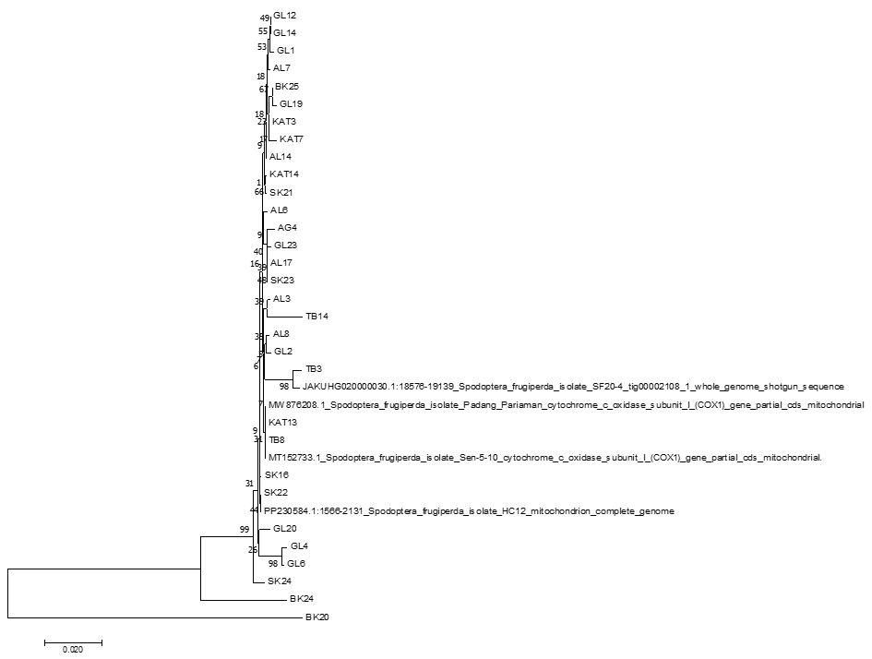

Fig 4: The Phylogenetic tree of Spodoptera frugiperda species based on the comparison of rDNA sequences

4. Conclusion

The south proved to be the area most heavily infested with armyworms, unlike the other areas surveyed. Diversity could not be analyzed in this study.

References

Abissi M. Adjaoke, G. T. Yotto et A. Adandonon, (2023). Assessment of damage and biocontrol agents of fall armyworm spodoptera frugiperda (je smith, 1797) (lepidoptera, noctuidae) on maize in southern of benin republic. Journal of Animal & Plant Sciences, 33(4): P. 1033-1042 ISSN (print): 1018-7081; ISSN (online): 2309-8694 https://doi.org/10.36899/JAPS.2023.4.0696

Abrahams, P., Bateman, M., Beale, T., Clottey, V., Cock, M., Colmenarez, Y. & Witt, A. (2017). Fall armyworm: impacts and implications for Africa. Outlooks on Pest Management, 28(5), P 196-201

Baudron, F., Zaman-Allah, M.A., Chaipa, I., Chari, N. and Chinwada, P., 2019: Understanding the factors influencing fall armyworm (Spodoptera frugiperda J.E. Smith) damage in African smallholder maize fields and quantifying its impact on yield. A case study in Eastern Zimbabwe. Crop Protection 120 (2019) 141–150. DOI: https://doi.org/10.1016/j.cropro.2019.01.028

bdoul Gani DIAO , Issoufou OUEDROGO , Antoine SANON, 2023. Importance de la saison humide et de la saison sèche dans la fluctuation saisonnière des populations de Spodoptera frugiperda J.E Smith (Lepidoptera : Noctuidae) dans un agrosystème maïsicole à l’ouest du Burkina Faso. P18

Buteme, S., Masanza, M. and Masika Fred, B., 2020: Severity and prevalence of the destructive fall armyworm on maize in Uganda: A case of Bulambuli District. African Journal of Agricultural Research, Vol. 16 (6), pp.777-784, DOI:10.5897/AJAR2019.14670
Chanda, M., De Groote, H., Kinoti, L., Munsaka, A., Kuntashula, E., Bruce, A.Y., Nkonde, C., 2020. Farmer evaluation of pesticide seed-coating to control fall armyworm in maize, Crop Protection,

Davis, F.M., Williams, W.P., 1992. Visual rating scales for screening whorl-stage corn for resistance to Fall armyworm. (n°Technical Bulletin 186). Mississippi State University, MS39762, USA

Day, R., Abrahams, P., Bateman, M., Beale, T., Clottey, V., Cock, M. & Witt, A. (2017). Fall armyworm: impacts and implications for Africa. Outlooks on Pest Management, 28(5), P 196201

Early, R., González-Moreno, P., Murphy, S. T., & Day, R. (2018). Forecasting the global extent of invasion of the fall armyworm, Spodoptera frugiperda. NeoBiota, 40, P 25-50.

FAO, (2005). The state of food and agriculture, P211

FAO, 2017c.Training manual on Fall Armyworm. Rome, 202 p Technical Bulletin 186). Mississippi State University, MS39762, USA.

FAO, 2018. Gestion intégrée de la chenille légionnaire sur le maïs, 135 p

FAO. (2017). Fall armyworm: Impacts and implications for Africa. Food and Agriculture Insects, 10(7), P 179.

FAO. (2025). Rapport sur la production mondiale de maïs et de riz. Organisation des Nations Unies pour l’Alimentation et l’Agriculture, P 8
Goergen, G., Kumar, P. L., Sankung, S. B., Togola, A., & Tamo, M. (2016). First report of outbreaks of the fall armyworm Spodoptera frugiperda (J E Smith) (Lepidoptera, Noctuidae), a new alien invasive pest in West and Central Africa. PLOS ONE, 11, No 10
Hruska, A. J. (2019). Fall armyworm (Spodoptera frugiperda) management by smallholders. https://doi.org/10.1016/j.cropro.2021.105691.

Idrissa, A., et al. (2017). Dynamique de la chenille légionnaire d’automne en Afrique de l’Ouest. Bulletin Entomologique Africain, 25(2), P 77-85.
Johnson, S. J. (1987). Migration and the life history strategy of the fall armyworm, Spodoptera frugiperda in the Western Hemisphere. International Journal of Tropical Insect Science, 8(456), P 543-549.

Kouakou, K., Kouassi, K. P., & Koffi, D. (2019). La chenille légionnaire d’automne en Côte d’Ivoire : situation et perspectives. Bulletin du CNRA, 6(2), P 15-23
Koudahe, K., 2012: Inventaire des insectes ravageurs et maladies de la patate douce (Ipomea batatas Lam.) au Bénin: Cas de la station expérimentale de l’IITA-Bénin. Mémoire de licence en production végétale, Université de Lomé, 77 p.

Lee, I.-M., Bottner-Parker, K. D., Zhao, Y., Davis, R. E., et Harrison, N. A. 2010. Phylogenetic analysis and delineation of phytoplasmas based on secY gene sequences. International Journal of Systematic and Evolutionary Microbiology, 60: 2887-2897.

Manish Gadekara, SB Dasun, Abhishek Shuklaun, SK Sharmab, Subhashree Patnaika et Sumit Kakadec, (2025). Quantification of Yield Losses in Maize Attributed to Fall Armyworm (Spodoptera frugiperda) Infestation. Journal of Scientific Research and Reports Volume 31, Issue 9, P. 510-516

Mochiah, M.B., Frimpong, K., Adama I., Darkwah, A.A., 2019. Efficacy of Sauveur 62 EC for the management of fall armyworm frugiperda (Lepidoptera: Noctuidae) on Maize (Zea mays L.). International Journal of Current Research, Vol. 11, Issue, 10, pp.7836-7840. DOI: https://doi.org/10.24941/ijcr.36789.10.2019

Montezano, D. G., Specht, A., Sosa-Gómez, D. R., Roque-Specht, V. F., Sousa-Silva, J. C., Paula-Moraes, S. V., ... & Hunt, T. E. (2018). Host plants of Spodoptera frugiperda (Lepidoptera:

Montezano, D. G., Specht, A., Sosa-Gómez, D. R., Roque-Specht, V. F., Sousa-Silva, J. C., Paula-Moraes, S. V., ... & Hunt, T. E. (2018). Host plants of Spodoptera frugiperda (Lepidoptera:

Nagoshi, R. N., Goergen, G., Tounou, K. A., Agboka, K., Koffi, D., & Meagher, R. L. (2019). Genetic characterization of fall armyworm populations: insights into migration and invasion. PLOS ONE, 14(2), e0217755.

Nagoshi, R. N., Goergen, G., Tounou, K. A., Agboka, K., Koffi, D., & Meagher, R. L. (2019). Genetic characterization of fall armyworm populations: insights into migration and invasion. PLOS ONE, 14(2), e0217755

Nboyine, J.A., Kusi, F., Abudulai, M., Badii, B.K., Zakaria, M., Adu, G.B., Alidu, H., Seidu, A., Osei, V., Alhassan, S., Yahaya, A., 2019: A new pest, Spodoptera frugiperda (J.E. Smith), in tropical Africa: its seasonal dynamics and damage in maize fields in northern Ghana, 21 p.
Niassy, S., Agbodzavu, K. M., Kimathi, E., Mutune, B., Abdel-Rahman, E. M., Salifu, D., ... & Tonnang, H. E. Z. (2021). Bioecology of fall armyworm Spodoptera frugiperda (J E Smith), its management and potential patterns of seasonal spread in Africa. PLOS ONE, 16(4), e0249042.

Noctuidae) in the Americas. African Entomology, 26(2), P 286-300.

Nuambote Yobila O., (2023). Résistance du maïs à la chenille légionnaire d’automne (Spodoptera frugiperda) en Afrique. Génétique des plantes. Thèse de doctorat, Université Paris-Saclay, Français, 153 p.

Otim, M. H., Tay, W. T., Walsh, T. K., Kanyesigye, D., Adumo, S., Abongosi, J., ... & Downes, S. (2018). Detection of fall armyworm, Spodoptera frugiperda, in Uganda: DNA barcoding and implications for management. Pest Management Science, 74(6), 1349-1356.

Prasanna, B. M., Huesing, J. E., Eddy, R., & Peschke, V. M. (2018). Fall armyworm in Africa: a guide for integrated pest management. CIMMYT, Mexico, P 109

Sibiya, J., Tongoona, P., Derera, J., & van Rij, N. (2013). Genetic analysis and selection for maize streak virus resistance in tropical maize. Euphytica, 191(3), P 395-406.

Toepfer, S., Kuhlmann, U., & Zhang, F. (2018). Fall armyworm: global spread and management options. CAB Reviews, 13(034), P 1-13.

