Evaluating the Role of Farmer Producer Organizations (FPOs) in Strengthening Business Ecosystems for Entrepreneurial Growth: Evidence from Nadia District, West Bengal

ABSTRACT
Farmer Producer Organizations (FPOs) have emerged as significant institutional mechanisms for strengthening agribusiness systems and promoting entrepreneurial growth among small and marginal farmers. This study examines the role of FPOs in influencing key business ecosystem functions that support entrepreneurial upscaling. The research was conducted among member farmers of two selected FPOs in Nadia district, West Bengal, based on primary data collected in August 2023 from 150 respondents (75 from each FPO). A mixed-methods approach, integrating structured interviews with qualitative insights, was employed to capture organizational dynamics and ecosystem functioning. The study evaluates critical ecosystem functions, including market linkage facilitation, resource mobilization, institutional coordination, capacity building, value-chain integration, and governance efficiency. The findings indicate that well-functioning ecosystem components significantly enhance farmers’ entrepreneurial orientation, access to services, collective bargaining power, and prospects for enterprise expansion. FPOs operate as catalysts by facilitating market participation and fostering innovation within the agribusiness system. Nevertheless, challenges related to governance, institutional convergence, and capacity enhancement persist. Addressing these gaps are essential for advancing the neo-institutional transformation of FPOs and achieving sustainable entrepreneurial upscaling. The insights generated hold important implications for policymakers, development agencies, and FPO leaders engaged in building resilient and market-responsive farmer collectives.
Keywords: Farmer Producer Organization, Business ecosystem function, Entrepreneurial upscaling, Agribusiness, Capacity building
1.INTRODUCTION
Small and marginal farmers continue to face persistent structural challenges in agricultural systems, including fragmented landholdings, limited access to markets and finance, high transaction costs, and weak bargaining power. These constraints often prevent farmers from benefiting fully from commercialization and integration into modern agribusiness value chains. In response, collective action–based institutional models have gained increasing attention as mechanisms to enhance farmers’ economic participation and resilience (Narayanan & Gulati, 2002; Trebbin & Hassler, 2012). Among these models, Farmer Producer Organizations (FPOs) have emerged as a prominent institutional innovation in India, designed to empower farmers through aggregation, collective decision-making, and improved market engagement. FPOs are member-owned enterprises that enable farmers to pool resources, coordinate production and marketing activities, and access inputs, extension services, and credit on more favourable terms. By leveraging economies of scale, FPOs help reduce transaction costs and improve price realization for farm produce, thereby strengthening farmers’ position within agribusiness systems (Nikam et al., 2019; Kumari et al., 2022). Empirical studies suggest that FPO participation enhances access to organized markets and facilitates stronger forward and backward linkages, enabling smallholders to move beyond subsistence farming toward market-oriented production (Roy et al., 2025). Beyond economic coordination, FPOs play a critical role in fostering entrepreneurial capabilities among farmers. Collective enterprises provide exposure to market information, innovation, risk-sharing mechanisms, and value-added activities, which can influence farmers’ entrepreneurial orientation and decision-making behaviour (Jose et al., 2023). Such entrepreneurial development is increasingly recognized as central to rural transformation, as it supports diversification into secondary agriculture, agro-processing, and other income-generating activities (Anand et al., 2023). From an institutional perspective, FPOs function as intermediaries within broader agribusiness ecosystems, linking farmers with markets, financial institutions, extension agencies, and policy support mechanisms. Their effectiveness depends not only on economic performance but also on governance quality, managerial capacity, and institutional convergence with supporting agencies (Jose & Chathukulam, 2025). However, several studies highlight that many FPOs face constraints related to inadequate capital, weak governance structures, limited professional management, and infrastructural gaps, which often restrict their ability to scale up and sustain long-term operations (Shrivastava et al., 2022; Kumar et al., 2023). Given the growing policy emphasis on promoting FPOs as vehicles of inclusive agricultural growth, there is a need for deeper empirical understanding of how these organizations influence business ecosystem functions at the grassroots level. In regions dominated by smallholder agriculture, such as West Bengal, localized evidence on the role of FPOs in facilitating market linkages, resource mobilization, capacity building, and institutional coordination remains limited. Against this backdrop, the present study examines the role of Farmer Producer Organizations in strengthening business ecosystems for entrepreneurial growth, with specific reference to Nadia district, West Bengal. By analyzing key ecosystem functions, the study seeks to contribute to the broader discourse on agrarian institutional transformation and sustainable agribusiness development.
2.MATERIALS AND METHODS
The study was carried out in Nadia district of West Bengal, situated within the New Alluvial Agro-Climatic Zone. The district was purposively selected owing to the active presence of Farmer Producer Organizations (FPOs) and their significance in fostering agribusiness-oriented entrepreneurial transformation. Two FPO-based institutions—Prova FPO and Spandan Trust—were intentionally chosen based on criteria such as organizational maturity, diversification of business activities, and the extent of member participation. From each organization, 75 member farmers were selected through simple random sampling, resulting in a total sample size of 150 respondents. A mixed-method research design was employed for the study. Primary data were collected using a pre-tested structured interview schedule, which was finalized following a pilot survey to ensure reliability and contextual relevance. Informal interactions with FPO officials, extension functionaries, and member farmers were also undertaken to aid in the refinement of study variables. The independent variables comprised experiential profile (x₁), functional education (x₂), family size (x₃), family education (x₄), gender proportion (x₅), number of land fragments (x₆), size of landholding (x₇), cropping intensity (x₈), yield (x₉), marketable surplus (x₁₀), marketed surplus (x₁₁), expenditure (x₁₂), income from on-farm and off-farm sources (x₁₃), risk perception (x₁₄), crop diversity index (x₁₅), family labour availability (x₁₆), entrepreneurial motivation (x₁₇), entrepreneurial behaviour (x₁₈), and entrepreneurial communication (x₁₉). The dependent variable in the study was Business ecosystem function (y₁). Data were analyzed using, correlation analysis, stepwise regression, multiple regression, and path analysis to examine direct and indirect relationships, with statistical computations performed using IBM SPSS Statistics v25.0 and the web-based package OPSTAT. The study aimed to assess the effectiveness of the business ecosystem created by two selected Farmer Producer Organizations (FPOs) in Nadia district and to examine the influence of institutional support, market linkages, financial access, and managerial efficiency on entrepreneurial transformation, while also identifying key constraints affecting the performance of the FPO-led business ecosystem.

3.RESULTS AND DISCUSSION
Table 1: Coefficient of Correlation (r): Business ecosystem function (y₁) Vs. 19 Independent Variables
Sl. No. | Independent Variables | ‘r’ value | Remarks
1 | Experiential profile (x₁) | 0.196
2 | Functional educational (x₂) | 0.256 | *
3 | Size of family (x₃) | -0.035
4 | Family Education (x₄) | -0.002
5 | Gender proportion (x₅) | 0.139
6 | No. of land fragments (x₆) | 0.245 | *
7 | Size of Land holding (x₇) | 0.410 | **
8 | Cropping Intensity (x₈) | 0.226 | *
9 | Yield (x₉) | 0.440 | **
10 | Marketable Surplus (x₁₀) | 0.435 | **
11 | Marketed Surplus (x₁₁) | 0.431 | **
12 | Expenditure (x₁₂) | 0.401 | **
13 | Income (On farm & off-farm) (x₁₃) | 0.432 | **
14 | Risk Perception (x₁₄) | 0.210 | *
15 | Crop diversity index (x₁₅) | 0.192
16 | Family Labour (x₁₆) | 0.350 | **
17 | Entrepreneurial motivation (x₁₇) | -0.056
18 | Entrepreneurial behaviour (x₁₈) | 0.093
19 | Entrepreneurial communication (x₁₉) | -0.003
**Correlation is significant at the 0.01 level, *Correlation is significant at the 0.05 level
Result: The table 1 explains the coefficient of correlation between Business ecosystem function(y₁) and 19 Independent Variables. It has been found that the Functional educational (x₂), No. of land fragments (x₆), Cropping Intensity (x₈) & Risk Perception (x₁₄) were found significant at 5% significance level. Further, Gender proportion (x₅), No. of land fragments (x₆), Size of Land holding (x₇), Yield (x₉), Marketable Surplus (x₁₀), Marketed Surplus (x₁₁), Expenditure (x₁₂) & Income (On farm & off-farm) (x₁₃) were revealed as significant at 1% significance level.
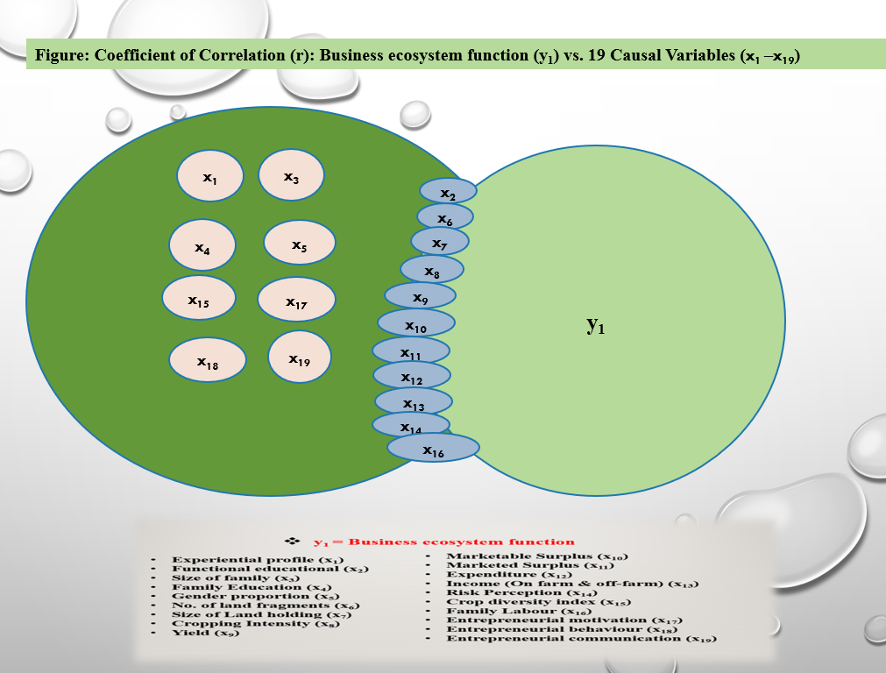
Figure 1: Coefficient of Correlation (r): Business ecosystem function (y₁) Vs. 19 Independent Variables

Revelation
The correlation analysis indicated that Business ecosystem function (y₁) was significantly associated with several socio-economic, production, and institutional variables. Functional education (x₂) exhibited a positive and significant relationship, suggesting that educated farmers are better able to comprehend institutional mechanisms, access market information, and efficiently utilize managerial and financial services provided by FPOs. This finding is consistent with earlier studies emphasizing education as a key determinant of agripreneurial performance and organizational participation (Kahan, 2012; Lans et al., 2014). Farm structural and production-related variables, namely Size of landholding (x₇), Cropping intensity (x₈), Yield (x₉), Marketable surplus (x₁₀), Marketed surplus (x₁₁), Expenditure (x₁₂), and Income from on-farm and off-farm sources (x₁₃) showed strong and statistically significant positive correlations with business ecosystem function. These results imply that farmers possessing better resource endowments and higher production capacity are more capable of engaging with FPO-led value chains and deriving benefits from collective marketing, input procurement, and value addition services. Higher productivity and income levels enhance farmers’ integration into organized agribusiness systems (Barrett et al. ,2001; Birthal et al. 2015). Risk perception (x₁₄) was also positively associated with business ecosystem function, indicating that farmers with a higher tolerance for risk are more inclined to adopt innovative practices and participate in entrepreneurial activities promoted by FPOs. The role of attitudes and perceptions in shaping farmers’ engagement with institutional and market-based innovations (Meijer et al. ,2015). Likewise, Family labour (x₁₆) availability exhibited a significant positive correlation, reflecting its importance in supporting labour-intensive operations, collective enterprises, and value-added activities within the FPO framework (Lans et al., 2014). In contrast, variables such as Experiential profile, Family size, Family education, Gender proportion, Crop diversity index, Entrepreneurial motivation, Entrepreneurial behaviour, and Entrepreneurial communication showed weak or non-significant relationships with Business ecosystem function (y₁). This suggests that individual-level behavioural attributes alone may not be sufficient to influence ecosystem performance unless complemented by strong institutional support, market access, and organizational efficiency. The effectiveness of producer organizations depends more on structural and institutional arrangements than on individual farmer characteristics (Trebbin & Hassler ,2012). Overall, the findings underscore that economic strength, production capacity, and institutional linkages are central to strengthening FPO-led business ecosystems, a view also supported by the World Bank (2017).

Table 2: Multiple Regression Analysis: Business ecosystem function (y₁) Vs. 19 Independent Variables
Sl. No. | Variables | Reg. Coef.  B | S.E. B | Beta | t value
1 | Experiential profile (x₁) | -0.020 | 0.125 | -0.020 | -0.161
2 | Functional educational (x₂) | 0.118 | 0.129 | 0.118 | 0.915
3 | Size of family (x₃) | 0.036 | 0.102 | 0.036 | 0.353
4 | Family Education (x₄) | 0.126 | 0.095 | 0.126 | 1.318
5 | Gender proportion (x₅) | 0.050 | 0.084 | 0.050 | 0.597
6 | No. of land fragments (x₆) | 0.023 | 0.109 | 0.023 | 0.211
7 | Size of Land holding (x₇) | 0.097 | 0.202 | 0.097 | 0.480
8 | Cropping Intensity (x₈) | 0.143 | 0.096 | 0.143 | 1.490
9 | Yield (x₉) | -0.122 | 0.572 | -0.122 | -0.214
10 | Marketable Surplus (x₁₀) | 0.301 | 0.606 | 0.301 | 0.498
11 | Marketed Surplus (x₁₁) | 0.067 | 0.282 | 0.067 | 0.236
12 | Expenditure (x₁₂) | -0.192 | 0.199 | -0.192 | -0.969
13 | Income (On farm & off-farm) (x₁₃) | 0.389 | 0.139 | 0.389 | 2.802
14 | Risk Perception (x₁₄) | 0.140 | 0.091 | 0.140 | 1.538
15 | Crop diversity index (x₁₅) | 0.296 | 0.088 | 0.296 | 3.371
16 | Family Labour (x₁₆) | 0.341 | 0.085 | 0.341 | 4.004
17 | Entrepreneurial motivation (x₁₇) | 0.131 | 0.096 | 0.131 | 1.362
18 | Entrepreneurial behaviour (x₁₈) | 0.184 | 0.087 | 0.184 | 2.117
19 | Entrepreneurial communication (x₁₉) | -0.050 | 0.086 | -0.050 | -0.577
R Square: 52.20%
The standard error of estimate: 0.769
Result: The table 2 explains the complete model of multiple regression analysis, wherein 19 variables together accounted for 52.20 % of the variance in the dependent variable, Business ecosystem function (y₁).

Revelation
The regression results indicate that business ecosystem function is influenced more by economic capacity, diversification strategies, and entrepreneurial orientation than by basic socio-personal characteristics. Income from on-farm and off-farm sources plays a pivotal role by enhancing farmers’ investment capacity, market participation, and adaptive decision-making, thereby strengthening overall ecosystem performance. Crop diversification contributes positively by improving system resilience and reducing both production and market risks within agribusiness environments (Nathans et al., 2012). The availability of family labour further supports ecosystem functioning by enabling timely farm operations and sustaining enterprise activities, particularly in resource-constrained rural settings (Ellis, 1993). Entrepreneurial behaviour also shows a positive influence, highlighting the importance of innovation, proactiveness, and market orientation in strengthening business linkages and value creation (Lumpkin & Dess, 1996). In contrast, demographic and structural attributes exhibit limited influence when analyzed alongside economic and behavioural factors, suggesting that dynamic functional capacities are more critical determinants of business ecosystem performance (Nathans et al., 2012).
Table 3: Stepwise Regression Analysis: Business ecosystem function (y₁) Vs. 19 Independent Variables
Sl. No. | Variables | Reg. Coef. | S.E. B | Beta | t value
1 | Yield (x₉) | 0.173 | 0.110 | 0.173 | 1.579
2 | Family Labour (x₁₆) | 0.349 | 0.081 | 0.349 | 4.322
3 | Crop diversity index (x₁₅) | 0.271 | 0.080 | 0.271 | 3.402
4 | Income (On farm & off-farm) (x₁₃) | 0.367 | 0.110 | 0.367 | 3.349
R Square: 40.89%
The standard error of estimate: 0.785
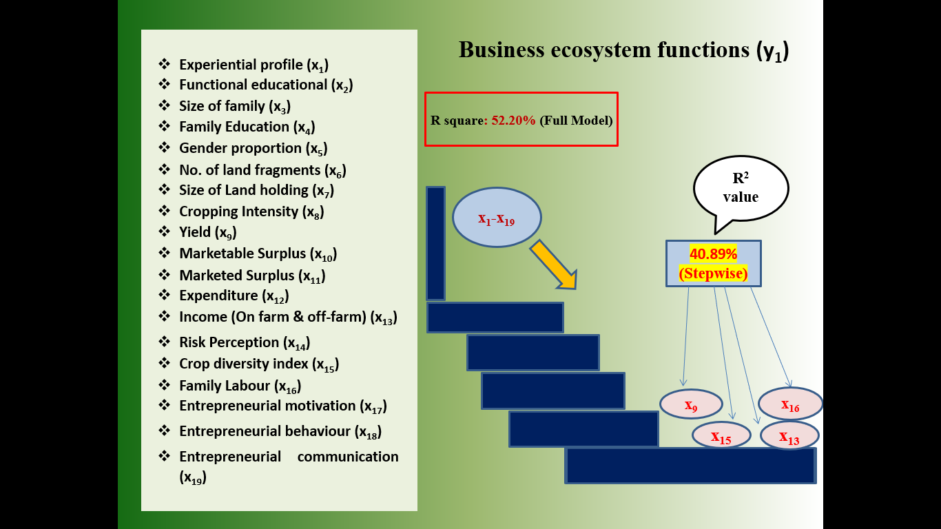
Result: At the final step, four variables—Yield (x₉), Family Labour (x₁₆), Crop diversity index (x₁₅) & Income (On farm & off-farm) (x₁₃) were retained. The model yielded an R² value of 40.89%. Collectively, these four variables explained 78.33% of the total 52.20% variance accounted for in the dependent variable.
Figure 2: Stepwise Regression Analysis: Business ecosystem function (y₁) Vs. 19 Independent Variables
Revelation
The Stepwise multiple regression analysis examined the influence of 19 independent variables on Business ecosystem function (y₁). The model explained 40.89% of the variation in y₁ (R² = 0.4089), with a standard error of estimate of 0.785, indicating reasonable predictive accuracy. Among the predictors, Family labour (x₁₆) had the largest impact on Business ecosystem function (β = 0.349, t = 4.322), demonstrating that greater availability of household labour significantly enhances farmers’ participation in FPO-led activities, including collective production, post-harvest handling, and value addition. This is consistent with evidence that family labour supports operational efficiency and smallholder entrepreneurship (Hazell et al., 2010). Income (on-farm & off-farm) (x₁₃) was also a strong positive predictor (β = 0.367, t = 3.349), suggesting that farmers with higher and diversified income are better equipped to invest in FPO collective initiatives, access market linkages, and strengthen the local business ecosystem. Previous studies indicate that income diversification improves resilience and integration into organized agricultural markets (Ellis, 2000; Reardon et al., 2007). Crop diversity index (x₁₅) had a significant positive effect (β = 0.271, t = 3.402), indicating that farmers practicing diversified cropping systems are more likely to engage in FPO-led activities due to reduced production risk and enhanced market opportunities. Diversified cropping systems are well-documented to support sustainable incomes and resilience in smallholder farming (Joshi et al., 2004; Pingali & Rosegrant, 1995). Although Yield (x₉) showed a smaller effect (β = 0.173, t = 1.579), its positive regression coefficient suggests that higher productivity increases marketable surplus and reinforces farmers’ linkage with organized marketing systems promoted by FPOs. Productivity remains foundational for commercialization and market engagement (Von Braun & Kennedy, 1994). Overall, the regression results indicate that economic capacity, family labour, crop diversity, and yield collectively drive the effectiveness of FPO-led business ecosystems, underscoring the importance of policy interventions that enhance these dimensions to improve entrepreneurial outcomes and ecosystem performance.
Table 4: Path Analysis: Decomposition of Total Effect into Direct, Indirect and Residual Effect: Business ecosystem function (y₁). vs. 19 exogenous variables
Sl. No | Variables | Total Effect | Direct Effect | Indirect Effect | Highest Indirect Effect
1 | Experiential profile (x₁) | 0.196 | -0.021 | 0.217 | 0.084 (x₂)
2 | Functional educational (x₂) | 0.256 | 0.119 | 0.137 | 0.060 (x₁₆)
3 | Size of family (x₃) | -0.035 | 0.035 | -0.070 | -0.061 (x₁₃)
4 | Family Education (x₄) | -0.002 | 0.125 | -0.127 | -0.033 (x₁₆)
5 | Gender proportion (x₅) | 0.139 | 0.050 | 0.089 | 0.066 (x₁₃)
6 | No. of land fragments (x₆) | 0.245 | 0.022 | 0.223 | 0.186 (x₁₃)
7 | Size of Land holding (x₇) | 0.410 | 0.100 | 0.310 | 0.271 (x₁₀)
8 | Cropping Intensity (x₈) | 0.226 | 0.143 | 0.083 | 0.076 (x₁₃)
9 | Yield (x₉) | 0.440 | -0.129 | 0.569 | 0.307 (x₁₀)
10 | Marketable Surplus (x₁₀) | 0.435 | 0.310 | 0.125 | 0.263 (x₁₃)
11 | Marketed Surplus (x₁₁) | 0.431 | 0.063 | 0.368 | 0.296 (x₁₀)
12 | Expenditure (x₁₂) | 0.401 | -0.192 | 0.593 | 0.303 (x₁₃)
13 | Income (On farm & off-farm) (x₁₃) | 0.432 | 0.389 | 0.043 | 0.210 (x₁₀)
14 | Risk Perception (x₁₄) | 0.210 | 0.140 | 0.070 | 0.019 (x₈)
15 | Crop diversity index (x₁₅) | 0.192 | 0.297 | -0.105 | -0.056 (x₁₃)
16 | Family Labour (x₁₆) | 0.350 | 0.341 | 0.009 | 0.039 (x₁₀)
17 | Entrepreneurial motivation (x₁₇) | -0.056 | 0.131 | -0.187 | -0.076 (x₁₃)
18 | Entrepreneurial behaviour (x₁₈) | 0.093 | 0.185 | -0.092 | -0.047 (x₁₀)
19 | Entrepreneurial communication (x₁₉) | -0.003 | -0.050 | 0.047 | 0.050 (x₁₅)

Residual Effect= 0.478, Highest indirect effect (x₁₃), (8 times)
Result &Revelation
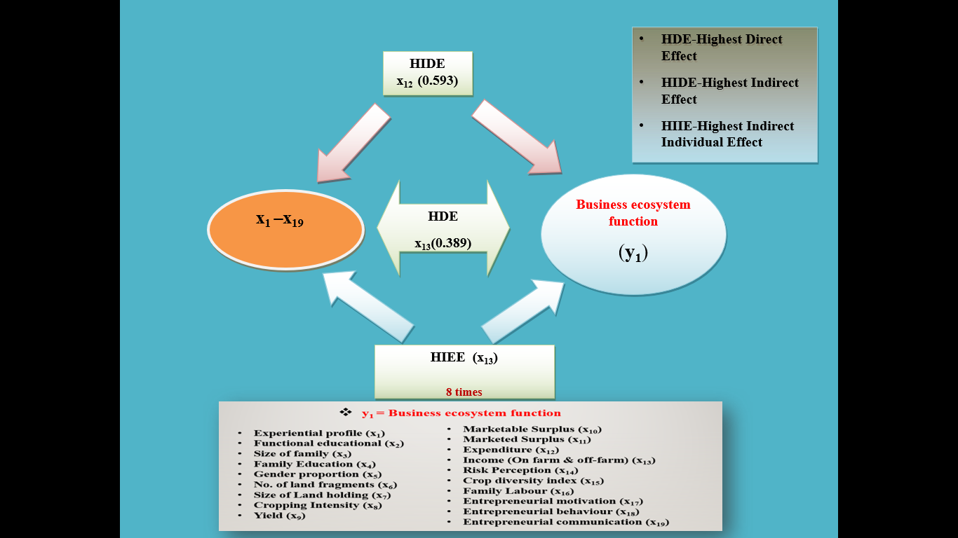
The path analysis decomposed the total influence of 19 exogenous variables on Business ecosystem function (y₁) into direct, indirect, and residual components. The residual effect (0.478) indicates that the selected variables explain a substantial proportion of variation in ecosystem functionality, confirming the adequacy of the causal model. Among all variables, yield (x₉) showed the highest total effect (0.440) on Business ecosystem function(y₁), despite a negative direct effect (−0.129). Its strong indirect influence, mainly through Marketable surplus (x₁₀), suggests that productivity strengthens business ecosystems primarily via surplus generation and market integration rather than direct institutional engagement (Govereh & Jayne, 2003). Income (on-farm & off-farm) (x₁₃) emerged as the most influential variable, exerting a strong direct effect (0.389) and serving as the principal mediating factor across multiple causal pathways. This highlights income as the key linkage between production, commercialization, and institutional participation within FPO systems. Family labour (x₁₆) exhibited a strong direct effect (0.341) with minimal indirect influence, indicating its independent role in supporting collective activities and enterprise management. Market-oriented variables such as Marketable surplus (x₁₀) and Marketed surplus (x₁₁) influenced ecosystem performance mainly through indirect pathways mediated by Income (x₁₃) and Yield (_{x₉}), underscoring the importance of surplus commercialization in ecosystem strengthening (Fischer & Qaim, 2012). Structural variables like Size of landholding (x₇) and Number of land fragments (x₆) affected Business ecosystem function largely through indirect effects, while behavioural variables showed limited independent influence, suggesting that entrepreneurial attributes require supportive economic and institutional conditions to translate into ecosystem outcomes (Welter, 2011). Overall, the findings indicate that Business ecosystem function (y₁) is predominantly shaped by income-mediated indirect effects, with Income (x₁₃), Yield (x₉), Marketable surplus (x₁₀), and Family labour (x₁₆) forming the core causal pathway. These results emphasize the need for FPO strategies that integrate productivity enhancement, surplus commercialization, and income diversification to strengthen agribusiness ecosystems sustainably.

Figure 3: Path Analysis: Decomposition of Total Effect into Direct, Indirect and Residual Effect: Business ecosystem function (y₁). vs. 19 exogenous variables

4.CONCLUSION
The study confirms that the effectiveness of FPO-led agribusiness systems is strongly influenced by farmers’ economic strength, productive capacity, and ability to participate in organized markets. Farmers with better income stability and production performance are more capable of sustaining engagement in collective activities and institutional processes, which strengthens the overall business environment (Poulton et al., 2010). Market participation plays a critical role in translating production gains into ecosystem-level benefits, as surplus commercialization enables farmers to integrate more effectively into value chains and collective marketing arrangements. Income availability further reinforces this process by improving farmers’ capacity to reinvest, absorb risks, and maintain long-term association with producer organizations. Household labour availability contributes significantly by supporting continuity in production, aggregation, and post-harvest activities, thereby enhancing the operational efficiency of collective enterprises (Binswanger-Mkhize & Savastano, 2017). Structural endowments such as land resources influence outcomes indirectly by enabling scale economies and marketable surplus generation rather than through direct institutional effects (Chamberlin & Jayne, 2013). Conversely, entrepreneurial attributes alone show limited influence when not supported by favourable economic and institutional conditions, emphasizing the importance of an enabling ecosystem for entrepreneurial outcomes (Welter, 2011). Overall, the findings highlight that integrated strategies focusing on productivity, market access, income diversification, and institutional coordination are essential for strengthening FPO-based agribusiness ecosystems in smallholder contexts (Dorward et al., 2005).
5.REFERENCES
Anand, S., Ghosh, S., & Mukherjee, A. (2023). Effectiveness of Farmer Producer Organizations (FPOs) at different growth stages in transitioning to secondary agriculture. Indian Journal of Extension Education, 59(3), 90–96.
Barrett, C. B., Reardon, T., & Webb, P. (2001). Nonfarm income diversification and household livelihood strategies in rural Africa: Concepts, dynamics, and policy implications. Food Policy, 26(4), 315–331. https://doi.org/10.1016/S0306-9192(01)00014-8
Binswanger-Mkhize, H. P., & Savastano, S. (2017). Agricultural intensification: The status in six African countries. Food Policy, 67, 26-40.
Birthal, P. S., Roy, D., & Negi, D. S. (2015). Assessing the impact of crop diversification on farm poverty in India. World Development, 72, 70–92. https://doi.org/10.1016/j.worlddev.2015.02.015
Chamberlin, J., & Jayne, T. S. (2013). Unpacking the meaning of ‘market access’: evidence from rural Kenya. World development, 41, 245-264.
Dorward, A., Kydd, J., Morrison, J., & Poulton, C. (2005). Institutions, markets and economic co‐ordination: Linking development policy to theory and praxis. Development and change, 36(1), 1-25.
Ellis, F. (1993). Peasant economics: Farm households in agrarian development (Vol. 23). Cambridge University Press.
Ellis, F. (2000). Rural livelihoods and diversity in developing countries. Oxford University Press.
Fischer, E., & Qaim, M. (2012). Linking smallholders to markets: Determinants and impacts of farmer collective action in Kenya. World Development, 40(6), 1255–1268. https://doi.org/10.1016/j.worlddev.2011.11.018
Govereh, J., & Jayne, T. S. (2003). Cash cropping and food crop productivity: synergies or trade‐offs?. Agricultural economics, 28(1), 39-50.
Hazell, P., Poulton, C., Wiggins, S., & Dorward, A. (2010). The future of small farms: Trajectories and policy priorities. World Development, 38(10), 1349–1361. https://doi.org/10.1016/j.worlddev.2009.06.012
Jose, A. E., Jayalekshmi, G., Lade, A. H., & Karde, R. (2023). Entrepreneurial behaviour of Farmer Producer Organization members: An empirical investigation. Asian Journal of Agricultural Extension, Economics & Sociology, 41(9), 175–189.
Jose, A. M., & Chathukulam, J. (2025). Farmer Producer Organisations and institutional economics. Indian Public Policy Review 2025, 6(3): 27-84 https://doi.org/10.55763/ippr.2025.06.03.002
Joshi, P. K., Gulati, A., Birthal, P. S., & Tewari, L. (2004). Agriculture diversification in South Asia: Patterns, determinants, and policy implications. Economic and Political Weekly, 39(24), 2457–2467.
Kahan, D. (2012). Entrepreneurship in farming. Food and Agriculture Organization of the United Nations.
Kumar, S., Kumar, R., Meena, P. C., & Kumar, A. (2023). Determinants of performance and constraints faced by Farmer Producer Organizations (FPOs) in India. Indian Journal of Extension Education, 59(2), 1-5.
Kumari, N., Malik, J. S., Arun, D. P., & Nain, M. S. (2022). Farmer Producer Organizations (FPOs) for linking farmers to market. Journal of Extension Systems, 38(1), 1–6. https://doi.org/10.48165/jes.2022.38.1.1
Lans, T., van Galen, M., Verstegen, J., Biemans, H., & Mulder, M. (2014). Searching for entrepreneurs among small business owners in agriculture. NJAS – Wageningen Journal of Life Sciences, 68, 41–51. https://doi.org/10.1016/j.njas.2013.12.001
Lumpkin, G. T., & Dess, G. G. (1996). Clarifying the entrepreneurial orientation construct and linking it to performance. Academy of Management Review, 21(1), 135–172. https://doi.org/10.5465/amr.1996.9602161568
Meijer, S. S., Catacutan, D., Ajayi, O. C., Sileshi, G. W., & Nieuwenhuis, M. (2015). The role of knowledge, attitudes and perceptions in the uptake of agricultural and agroforestry innovations among smallholder farmers in sub-Saharan Africa. International journal of agricultural sustainability, 13(1), 40-54.
Narayanan, S., & Gulati, A. (2002). Globalization and the smallholders: A review of issues, approaches, and implications. MSSD Discussion Paper No. 50, IFPRI, Washington, DC.
Nathans, L. L., Oswald, F. L., & Nimon, K. (2012). Interpreting multiple linear regression: A guidebook of variable importance. Practical Assessment, Research & Evaluation, 17(9), 1–19.
Nikam, V., Singh, P., Ashok, A., & Kumar, S. (2019). Farmer producer organisations: Innovative institutions for upliftment of small farmers. The Indian Journal of Agricultural Sciences, 89(9), 1383-1392.
Pingali, P. L., & Rosegrant, M. W. (1995). Agricultural commercialization and diversification: processes and policies. Food policy, 20(3), 171-185.
Poulton, C., Dorward, A., & Kydd, J. (2010). The future of small farms: New directions for services, institutions, and intermediation. World development, 38(10), 1413-1428.
Reardon, T., Berdegué, J., Barrett, C. B., & Stamoulis, K. (2007). Household income diversification into rural nonfarm activities. Transforming the rural nonfarm economy: opportunities and threats in the developing world, 2(4), 115-140.
Roy, A., Singh, N. U., Singh, B. P., Yumnam, A., Paul, P., & Marak, T. B. (2025). Innovative agribusiness and sustainable entrepreneurship. Elite Publishing House.
Shrivastava, S., Jat, M. L., & Shrivastava, K. (2022). Present status, role and challenges of Farmer Producer Organization. Asian Journal of Agricultural Extension, Economics & Sociology, 40(8), 39–47. https://doi.org/10.9734/ajaees/2022/v40i830935
Trebbin, A., & Hassler, M. (2012). Farmers’ producer companies in India: A new concept for collective action? Environment and Planning A, 44(2), 411–427. https://doi.org/10.1068/a44198
Von Braun, J., & Kennedy, E. (1994). Agricultural commercialization, economic development, and nutrition. Johns Hopkins University Press.
Welter, F. (2011). Contextualizing entrepreneurship—Conceptual challenges and ways forward. Entrepreneurship Theory and Practice, 35(1), 165–184. https://doi.org/10.1111/j.1540-6520.2010.00427.x
World Bank. (2017). Enabling the business of agriculture. World Bank Group.

.

.

