Long-Term Rainfall Variability and Seasonal Distribution at AMFU, Naganahalli, Mysuru: Evidence from 58 Years of Observational Data (1968–2025)

Abstract
Aims:
The present study aimed to analyze long-term rainfall variability and seasonal distribution in the semi-arid region of southern Karnataka, with a focus on understanding its implications for agricultural planning and climate-resilient farming strategies in the Mysuru region.
Study Design:
A retrospective time-series analytical study based on long-term observed rainfall data.
Place and Duration of Study:
The study was conducted using rainfall data recorded at the Weather Observatory of the Agro-Meteorological Field Unit (AMFU), Organic Farming Research Station (OFRS), Naganahalli, Mysuru, under the Gramin Krishi Mausam Sewa programme, covering a period of 58 years from 1968 to 2025.
Methodology:
Monthly and annual rainfall data were subjected to descriptive statistical analysis to evaluate temporal variability, inter-annual fluctuations, seasonal contributions, and extreme rainfall years. Seasonal rainfall distribution was assessed for southwest monsoon, northeast monsoon, summer, and winter periods to characterize rainfall patterns relevant to crop production systems.
Results:
The mean annual rainfall of the study area was 693.2 mm, exhibiting high inter-annual variability, with rainfall ranging from severe deficit years (<300 mm) to excess rainfall years (>1300 mm). The southwest monsoon season (June–September) contributed the major share of annual rainfall, followed by the northeast monsoon season (October–November), indicating a bimodal rainfall pattern. October recorded the highest mean monthly rainfall, highlighting its critical role in kharif crop maturity and rabi crop sowing. Recent decades showed increased rainfall uncertainty and frequent deviations from long-term averages.
Conclusion:
The pronounced rainfall variability and increasing uncertainty pose significant challenges to rainfed agriculture in the Mysuru region. The study underscores the need for location-specific agrometeorological advisories, strengthened rainwater harvesting measures, and climate-smart crop diversification. The long-term rainfall characterization provides a robust baseline for agricultural planning, climate impact assessment, and future agro-climatic research.

Keywords: Long-term rainfall analysis; Rainfall variability; Seasonal rainfall distribution; AMFU Naganahalli; Mysuru climate; Agro-meteorology; Rainfed agriculture; Climate variability

1. Introduction
Rainfall is one of the most important climatic elements influencing agricultural production, water resources, and socio-economic stability, particularly in rain-fed regions of India. Nearly 60 per cent of India’s net sown area depends directly on rainfall, making the assessment of rainfall variability essential for sustainable agricultural planning (Gadgil and Gadgil, 2006). Variations in rainfall amount, distribution, and intensity significantly affect crop growth, soil moisture availability, groundwater recharge, and the occurrence of droughts and floods (Parthasarathy et al., 1994). The Indian climate is predominantly governed by the southwest monsoon, which contributes about 70–80 per cent of the annual rainfall during the period from June to September (Rao et al., 2011). However, studies have shown that monsoon rainfall exhibits high inter-annual and inter-decadal variability, resulting in frequent agricultural uncertainties (Kothawale and Rupa Kumar, 2005). Long-term analysis of rainfall records is therefore critical to understanding climatic fluctuations and developing location-specific adaptation strategies (Guhathakurta et al., 2011).
Several researchers have documented spatial and temporal variations in rainfall across India using long-term datasets. Parthasarathy et al. (1987) reported significant regional differences in rainfall trends across India, emphasizing the need for station-level analysis. Similarly, Krishnakumar et al. (2009) observed changes in monsoon rainfall patterns over southern India, with increased variability affecting agricultural productivity. Such regional-scale assessments often mask micro-level variations, which are crucial for farm-level decision-making.
Karnataka, located in the southern peninsular region of India, experiences a semi-arid to sub-humid climate with considerable rainfall variability. The state receives rainfall from both southwest and northeast monsoons, with spatially uneven distribution (Rajeevan et al., 2012). Studies conducted in different parts of Karnataka have revealed high temporal variability in rainfall and frequent departures from normal rainfall, leading to droughts or excess rainfall events (Nanjundiah et al., 2017). District-level studies in southern Karnataka have highlighted that rainfall variability significantly influences crop planning, sowing windows, and irrigation scheduling (Sikka and Gadgil, 1980). Research by Patil et al. (2014) showed that Mysuru district exhibits pronounced inter-annual rainfall variability, particularly during the monsoon season, affecting rain-fed crops such as finger millet, maize, and pulses. Such variability necessitates the development of localized agrometeorological advisories. Agro-meteorological observatories play a crucial role in generating long-term climatic datasets required for assessing climate variability and supporting agricultural decision-making (Dash et al., 2013). The Agro-Meteorological Field Unit (AMFU) at the Organic Farming Research Station (OFRS), Naganahalli, Mysuru, has been recording rainfall data for several decades, providing a valuable source of continuous and reliable climatic information. Long-term station-based datasets are particularly useful for identifying rainfall trends, seasonal shifts, and extreme events at the local scale (Mishra et al., 2014).
Despite the availability of national and regional rainfall analyses, comprehensive long-term studies focusing on specific agro-ecological locations like Naganahalli, Mysuru, using more than five decades of observed data remain limited. Therefore, the present study aims to analyze 58 years (1968–2025) of rainfall data recorded at AMFU, OFRS, Naganahalli, Mysuru, to assess rainfall variability, seasonal distribution, and long-term characteristics. The findings of this study are expected to support climate-resilient agricultural planning, rainwater management, and the formulation of effective agrometeorological advisories for farmers in the region.
The objectives of the present investigation are:
- To analyze the long-term annual and monthly rainfall variability at AMFU, OFRS, Naganahalli, Mysuru, using 58 years of observed data (1968–2025).
- To assess the seasonal contribution of rainfall during southwest and northeast monsoon periods to the total annual rainfall.
- To examine inter-annual fluctuations and deviations from long-term mean rainfall.
- To generate location-specific rainfall information useful for agricultural planning, rainwater harvesting, and agrometeorological advisory services.

2. Materials and Methods

2.1 Study Area
The present study was conducted using rainfall data recorded at the Agro-Meteorological Field Unit (AMFU) located at the Organic Farming Research Station (OFRS), Naganahalli, Mysuru district of Karnataka, India. The station lies in the southern dry zone of Karnataka and represents a semi-arid to sub-humid agro-climatic region. Agriculture in this region is predominantly rain-fed, with major crops including finger millet, maize, pulses, oilseeds, and horticultural crops, making rainfall a critical determinant of crop productivity and sustainability. The region experiences a bimodal rainfall pattern, receiving precipitation from both the southwest monsoon (June–September) and the northeast monsoon (October–November), with occasional pre-monsoon showers during April and May. Such climatic characteristics necessitate long-term rainfall assessment to understand variability and seasonal distribution (Sikka and Gadgil, 1980; Rajeevan et al., 2012).

2.2 Data Source and Description
The rainfall data used in this study consist of 58 years of monthly rainfall records (1968–2025) obtained from the Agro-Meteorological Field Unit (AMFU), OFRS, Naganahalli, Mysuru, operating under the Gramin Krishi Mausam Sewa (GKMS) programme of the India Meteorological Department (IMD). The dataset represents continuous observational records maintained following standard meteorological procedures and quality control protocols recommended by IMD (Rao et al., 2011). Monthly rainfall values were aggregated to compute annual rainfall totals and seasonal rainfall for different monsoon periods. Long-term mean rainfall was calculated using the entire study period to serve as a baseline for variability assessment (Parthasarathy et al., 1987).

2.3 Seasonal Classification of Rainfall
For the purpose of seasonal analysis, the annual rainfall was classified into four distinct seasons, following standard IMD classification (IMD, 2010):
- Winter season: January–February
- Pre-monsoon season: March–May
- Southwest monsoon season: June–September
- Northeast monsoon season: October–December
Seasonal rainfall totals were computed by summing monthly rainfall values corresponding to each season. The percentage contribution of each season to total annual rainfall was also calculated to understand seasonal dominance and agricultural relevance (Parthasarathy et al., 1994).

2.4 Statistical Analysis
Descriptive statistical methods were employed to analyze rainfall characteristics at monthly, seasonal, and annual scales. The following statistical parameters were computed:
- Mean rainfall (mm)
- Standard deviation (SD)
- Coefficient of variation (CV, %)
The coefficient of variation was used as an indicator of rainfall variability, with higher CV values indicating greater rainfall uncertainty and risk for rain-fed agriculture (Kothawale and Rupa Kumar, 2005). Inter-annual rainfall variability was assessed by comparing annual rainfall values against the long-term mean. Years were categorized as deficit, normal, or excess rainfall years based on percentage deviation from the mean, following commonly adopted climatological classification methods (Guhathakurta et al., 2011).

2.5 Trend Analysis
To examine long-term trends in annual and seasonal rainfall, non-parametric trend detection techniques were considered appropriate due to their robustness against non-normal data distribution and outliers. The Mann–Kendall (MK) test was used to detect the presence of monotonic trends in rainfall time series (Mann, 1945; Kendall, 1975). The magnitude of trend was estimated using Sen’s slope estimator, which provides a reliable estimate of trend magnitude in hydro-meteorological time series (Sen, 1968). These methods have been widely applied in rainfall trend studies across India and are recommended for long-term climatic data analysis (Krishnakumar et al., 2009; Mishra et al., 2014).

2.6 Data Analysis and Presentation
All computations were performed using standard spreadsheet tools and statistical software. Results were presented in the form of tables, line graphs, bar charts, and seasonal contribution diagrams to clearly illustrate rainfall variability, trends, and seasonal distribution. Graphical representation was used to enhance interpretation and facilitate comparison across years and seasons (Dash et al., 2013).

3. Results and Discussion

3.1 Long-Term Annual Rainfall Characteristics
The long-term analysis of annual rainfall at AMFU, OFRS, Naganahalli, Mysuru over a period of 58 years (1968–2025) revealed pronounced inter-annual variability (Table 1). The mean annual rainfall of the station was approximately 693 mm, confirming the semi-arid climatic nature of the region. However, the wide range of annual rainfall values highlights the unstable rainfall regime that governs agricultural activities in the area.
Table 1. Descriptive statistics of annual rainfall at AMFU, OFRS, Naganahalli, Mysuru
(1968–2025)
Particular | Annual Rainfall (mm)
Number of years | 58
Mean | 693.16
Standard deviation | 203.89
Minimum | 244.30
Maximum | 1381.00
25th percentile | 570.28
Median (50th percentile) | 666.25
75th percentile | 795.10
The minimum annual rainfall of about 244 mm recorded in 2016 represents a severe drought year, while the maximum rainfall of about 1381 mm observed in 2022 indicates an extreme excess rainfall year. Such wide fluctuations between years signify the dominance of climatic variability rather than climatic stability. Similar ranges of rainfall variability have been reported for several locations across southern India, emphasizing the vulnerability of rain-fed agricultural systems (Parthasarathy et al., 1987; Krishnakumar et al., 2009).
The coefficient of variation (CV) of annual rainfall exceeded 30 per cent (Table 1), indicating high rainfall variability. According to climatological standards, CV values above 30 per cent denote unreliable rainfall for stable crop production (Kothawale and Rupa Kumar, 2005). High rainfall variability often leads to uncertainty in sowing decisions, crop failures during deficit years, and waterlogging or nutrient losses during excess rainfall years (Gadgil and Gadgil, 2006).
Figure 1 illustrates the temporal variation in annual rainfall over the 58-year period. The figure clearly depicts frequent oscillations between deficit and excess rainfall years, with no prolonged phase of rainfall stability. Several sharp peaks corresponding to excess rainfall years and deep troughs representing drought years are evident throughout the study period.
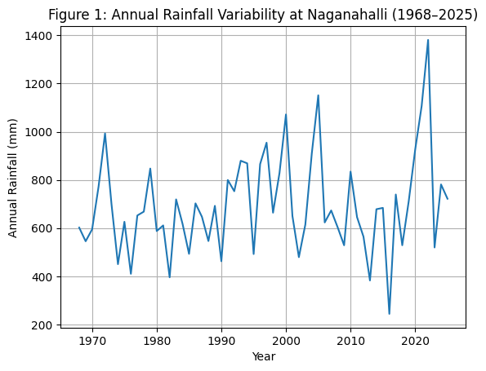
Figure 1: Annual Rainfall Variability at Naganahalli, Mysuru (1968–2025)
The absence of a smooth or consistent upward or downward trend suggests that rainfall variability dominates over long-term trends, a finding consistent with earlier rainfall studies conducted across southern India (Krishnakumar et al., 2009; Rajeevan et al., 2012). The increasing frequency of extreme rainfall years in recent decades, as visible in Figure 1, may be associated with enhanced rainfall variability linked to climate change (Guhathakurta et al., 2011).
The high inter-annual variability observed in Table 1 and Figure 1 has serious implications for agricultural sustainability in the Mysuru region. Rain-fed crops such as finger millet, maize, and pulses are highly sensitive to rainfall anomalies, particularly during sowing and reproductive stages. Deficit rainfall years often result in poor crop establishment and yield losses, while excess rainfall years may lead to runoff, soil erosion, and nutrient leaching (Gadgil and Gadgil, 2006).
Similar levels of rainfall variability have been reported in district- and station-level studies across Karnataka, emphasizing the need for location-specific rainfall characterization rather than reliance on regional averages (Patil et al., 2014; Nanjundiah et al., 2017). The findings underscore the importance of integrating long-term rainfall analysis into agrometeorological advisories, crop planning, and water resource management strategies.

3.2 Seasonal Rainfall Distribution and Contribution
Seasonal analysis of rainfall revealed that the distribution of rainfall at Naganahalli is distinctly bimodal (Table 2). The southwest monsoon season (June–September) contributed the largest share to the total annual rainfall, accounting for nearly 48 per cent of the annual total. This confirms that kharif season agriculture in the region is primarily dependent on southwest monsoon rainfall.
Table 2. Mean seasonal rainfall at AMFU, OFRS, Naganahalli, Mysuru (1968–2025)
Season | Months | Mean rainfall (mm)
Winter | January–February | 11.4
Pre-monsoon | March–May | 182.8
Southwest monsoon | June–September | 286.9
Northeast monsoon | October–December | 212.1
Table 2 clearly demonstrates that rainfall at Naganahalli is highly seasonal and distinctly bimodal, reflecting the combined influence of the southwest and northeast monsoon systems that dominate the climate of southern peninsular India. The southwest monsoon season (June–September) contributed the highest mean rainfall (286.9 mm), establishing it as the primary determinant of annual rainfall totals and kharif crop performance in the region. Rainfall received during this period governs critical agricultural operations such as land preparation, sowing, crop establishment, and early vegetative growth. Any delay in monsoon onset or prolonged dry spells within the season can therefore result in delayed sowing, poor crop stand, and reduced yield potential.
The northeast monsoon season (October–December) emerged as the second most important rainfall contributor, with a mean rainfall of 212.1 mm, accounting for approximately 32 per cent of the annual rainfall. This substantial contribution highlights the strategic importance of post-monsoon rainfall in sustaining crops during reproductive and maturity stages, particularly for rain-fed crops such as finger millet, maize, and pulses. In addition, northeast monsoon rainfall plays a decisive role in enabling rabi crop sowing and establishment, thereby extending the effective growing season beyond the southwest monsoon period. Variability in northeast monsoon rainfall can therefore directly influence grain filling, harvest quality, and overall cropping intensity in the region.
Pre-monsoon rainfall (March–May) contributed 182.8 mm, representing about 15 per cent of the annual rainfall, and acts as a critical transitional phase between the dry season and the onset of the southwest monsoon. Although quantitatively lower than monsoon rainfall, pre-monsoon showers are vital for softening soil, initiating land preparation, supporting early sowing of short-duration crops, and replenishing surface soil moisture. Inconsistent or deficient pre-monsoon rainfall can delay field operations and increase farmers’ dependence on the timely arrival of the southwest monsoon, thereby elevating production risk.
In contrast, winter rainfall (January–February) was negligible (11.4 mm; less than 5 per cent of annual rainfall), indicating a prolonged dry period. The near absence of rainfall during this season limits natural soil moisture replenishment and groundwater recharge, increasing reliance on residual soil moisture, stored water, and irrigation sources. This extended dry phase further accentuates the seasonal concentration of rainfall and constrains agricultural activities during winter months.
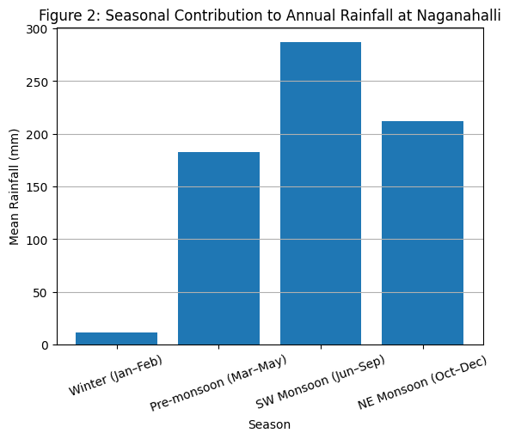
Overall, the pronounced concentration of rainfall within the southwest and northeast monsoon seasons highlights the high dependence of agriculture on timely and well-distributed monsoon rainfall. Such strong seasonality increases the vulnerability of rain-fed farming systems to rainfall anomalies, as even short-term deviations in rainfall timing or amount can have cascading effects on crop growth, water availability, and farm income. The seasonal rainfall pattern observed in this study is consistent with earlier findings for southern peninsular India, reinforcing the climatic sensitivity of agricultural systems in the region (Sikka and Gadgil, 1980; Parthasarathy et al., 1994; Rajeevan et al., 2012).
Figure 2: Seasonal Contribution to Annual Rainfall at Naganahalli, Mysuru (1968–2025)
Figure 2 clearly illustrates the dominance of monsoon rainfall at Naganahalli, emphasizing that nearly 80 per cent of the annual rainfall is received during the southwest and northeast monsoon seasons combined. This high concentration of rainfall within a limited period underscores the strong dependence of agriculture on monsoon performance. Such dependence increases agricultural vulnerability to delays in monsoon onset, early withdrawal, and prolonged intra-seasonal dry spells, which can adversely affect crop establishment and growth (Kothawale and Rupa Kumar, 2005).
The substantial contribution of northeast monsoon rainfall highlighted in Figure 2 is particularly critical for southern Karnataka, where post-monsoon rains often determine the success or failure of rain-fed crops. Adequate rainfall during this period supports crops during reproductive and maturity stages and facilitates rabi crop sowing, thereby extending the effective cropping season. Similar dominance of post-monsoon rainfall has been widely reported across Karnataka and adjoining Tamil Nadu regions, reinforcing its agricultural significance (Rajeevan et al., 2012; Patil et al., 2014).
The pronounced seasonality of rainfall evident from Table 2 and Figure 2 has important implications for agricultural planning and water management. Heavy reliance on southwest monsoon rainfall necessitates timely sowing operations, efficient in-season moisture conservation, and adaptive crop management practices to minimize production risks. At the same time, variability in northeast monsoon rainfall can critically influence grain filling, harvest quality, and final crop yields, particularly for rain-fed crops (Krishnakumar et al., 2009).
The negligible winter rainfall observed in the study indicates limited natural soil moisture replenishment and groundwater recharge during the dry season. This prolonged dry period highlights the urgent need for rainwater harvesting structures, farm ponds, and groundwater recharge interventions to capture excess monsoon rainfall and provide supplemental irrigation during dry spells (Dash et al., 2013). Furthermore, the findings emphasize the importance of season-specific agrometeorological advisories tailored to local rainfall patterns, enabling farmers in the Mysuru region to make timely and informed crop management decisions.

3.3 Monthly Rainfall Distribution Pattern
Monthly rainfall analysis showed marked variation across months (Table 3). Among all months, October recorded the highest mean monthly rainfall, followed by September, August, and July. This pattern indicates that northeast monsoon rainfall plays a decisive role in determining total annual rainfall and crop success in the region.
Table 3. Mean monthly rainfall at AMFU, OFRS, Naganahalli, Mysuru (1968–2025)
Month | Mean rainfall (mm)
January | 4.3
February | 7.1
March | 13.9
April | 50.4
May | 118.5
June | 58.3
July | 53.0
August | 67.2
September | 108.5
October | 143.8
November | 54.4
December | 13.7
Table 3 indicates pronounced variability in rainfall distribution across months. Among all months, October recorded the highest mean rainfall (143.8 mm), followed by May (118.5 mm) and September (108.5 mm). This pattern reflects the combined influence of pre-monsoon convective rainfall and northeast monsoon rainfall in the region.
Rainfall during June to September, corresponding to the southwest monsoon period, was moderate but consistent, providing essential moisture for kharif crops. However, the relatively higher rainfall during October emphasizes the importance of post-monsoon rainfall in determining crop success, particularly during reproductive and maturity stages of major rain-fed crops such as finger millet and maize (Parthasarathy et al., 1994).
In contrast, the months of January, February, and March received very low rainfall, indicating an extended dry period. Such dry months contribute to soil moisture depletion and increased reliance on irrigation or stored soil moisture for crop survival (Sikka and Gadgil, 1980).
The high rainfall during October is particularly significant for crops such as finger millet, maize, and pulses, which are often at reproductive or maturity stages during this period. Excess rainfall during October may lead to lodging, disease incidence, and harvest losses, while rainfall deficiency can cause moisture stress and yield reduction (Parthasarathy et al., 1994; Patil et al., 2014).
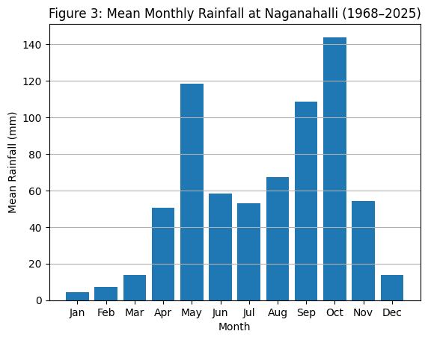
The months from January to March consistently recorded very low rainfall, indicating an extended dry season. The coefficient of variation for monthly rainfall was highest during monsoon months, reflecting the erratic nature of rainfall occurrence. Such high monthly variability complicates precise scheduling of agricultural operations and increases dependency on real-time weather advisories (Guhathakurta et al., 2011).
Figure 3: Mean Monthly Rainfall at AMFU, OFRS, Naganahalli, Mysuru (1968–2025)
Figure 3 clearly illustrates the bimodal rainfall distribution pattern, with peaks during May (pre-monsoon) and September–October (monsoon and post-monsoon). This bimodal pattern is a characteristic feature of rainfall in southern peninsular India and has been widely reported in earlier climatological studies (Rajeevan et al., 2012; Krishnakumar et al., 2009).
The high rainfall during May supports land preparation and early sowing activities, while rainfall during September and October is critical for sustaining crops during flowering and grain-filling stages. However, excessive rainfall during these months can increase the risk of lodging, disease incidence, and harvest losses (Guhathakurta et al., 2011).
The monthly rainfall pattern observed at Naganahalli has significant implications for agricultural management. The dependence on rainfall during a limited number of months increases the vulnerability of rain-fed farming systems to rainfall anomalies. Delayed or deficient rainfall during May can postpone sowing operations, while excess rainfall during October may adversely affect crop harvesting and post-harvest operations (Patil et al., 2014).
The high variability in monthly rainfall highlights the importance of real-time agrometeorological advisories and adaptive cropping strategies to mitigate climate risks. Adjusting sowing dates, selecting short-duration or drought-tolerant crop varieties, and improving soil moisture conservation practices can help farmers cope with monthly rainfall variability (Gadgil and Gadgil, 2006).

3.4 Classification of Rainfall Years
Rainfall years were classified into deficit, normal, and excess categories based on deviation from the long-term mean annual rainfall (693.16 mm). Years receiving less than 75% of the mean rainfall were classified as deficit years, those receiving 75–125% of the mean as normal years, and those receiving more than 125% of the mean rainfall as excess years. This classification method is widely used in rainfall variability and drought assessment studies in India (Parthasarathy et al., 1987; Guhathakurta et al., 2011).
Table 4. Frequency distribution of rainfall years at Naganahalli, Mysuru (1968–2025)
Rainfall category | Criteria | Number of years
Deficit years | < 75% of mean rainfall | 10
Normal years | 75–125% of mean rainfall | 38
Excess years | > 125% of mean rainfall | 10
Total |  | 58
Table 4 indicates that normal rainfall years dominated the study period, accounting for 38 out of 58 years (≈66%). However, a considerable number of years fell under deficit (10 years) and excess (10 years) categories. The equal frequency of deficit and excess rainfall years highlights the high rainfall instability prevailing in the region.
The occurrence of deficit rainfall years reflects frequent drought-like conditions, which adversely affect crop establishment, reduce soil moisture availability, and increase dependency on supplemental irrigation. Similar frequencies of deficit rainfall years have been reported in several long-term rainfall studies across peninsular India (Mishra et al., 2014; Patil et al., 2014).
The frequent occurrence of deficit years indicates high drought risk in the region. Similar findings have been reported in drought studies conducted across peninsular India, where rainfall variability has increased agricultural vulnerability (Mishra et al., 2014). Deficit rainfall years adversely affect crop establishment, reduce groundwater recharge, and increase dependence on irrigation sources.
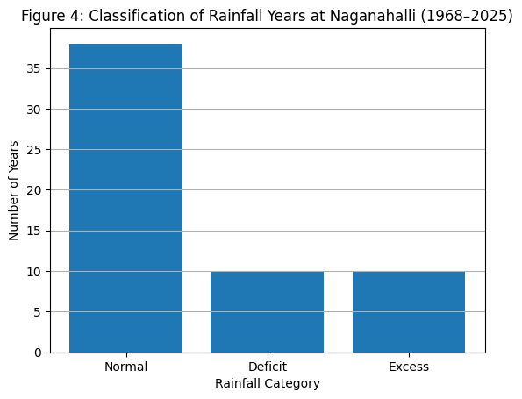
Figure 4: Classification of Rainfall Years at Naganahalli (1968–2025)
Figure 4 graphically represents the distribution of rainfall categories and clearly demonstrates that although normal rainfall years are more frequent, one-third of the years experienced abnormal rainfall conditions. Such abnormal years pose serious challenges to agricultural sustainability, as both rainfall deficit and excess can result in crop losses.
Deficit rainfall years often lead to drought stress, crop failure, and groundwater depletion, while excess rainfall years can cause runoff losses, soil erosion, nutrient leaching, and increased pest and disease incidence (Dash et al., 2013). The nearly equal occurrence of deficit and excess years further emphasizes the need for robust climate risk management strategies.
The classification of rainfall years reveals that agriculture in the Naganahalli region is exposed to frequent climatic extremes rather than stable rainfall conditions. Even though normal rainfall years are dominant, the presence of recurrent deficit and excess years increases production risks for rain-fed farmers.
Earlier studies have emphasized that rainfall variability, rather than changes in mean rainfall, is the primary driver of agricultural vulnerability in southern India (Kothawale and Rupa Kumar, 2005; Krishnakumar et al., 2009). The findings of the present study are consistent with these observations and underscore the importance of adaptive strategies such as crop diversification, contingency crop planning, and improved rainwater harvesting practices.

3.5 Long-Term Rainfall Trend Analysis
Long-term trends in annual rainfall at AMFU, OFRS, Naganahalli, Mysuru were assessed for the period 1968–2025 using the Mann–Kendall test and Sen’s slope estimator. The Mann–Kendall test yielded a positive Z value (Z = 1.46), indicating a slight increasing tendency in annual rainfall. However, the trend was not statistically significant at the 5 per cent level (|Z| < 1.96), suggesting the absence of a consistent monotonic trend during the study period (Table 5).
Sen’s slope analysis indicated a marginal increase of about 2.03 mm year⁻¹, reflecting a very slow rate of change in annual rainfall. This gradual increase is negligible when compared with the large inter-annual variability observed in the rainfall series.
Table 5. Results of Mann–Kendall trend test and Sen’s slope estimator for annual rainfall at AMFU, OFRS, Naganahalli, Mysuru (1968–2025)
Parameter | Result
Period of analysis | 1968–2025 (58 years)
Mean annual rainfall | 693.16 mm
Mann–Kendall S statistic | +219
Mann–Kendall Z statistic | +1.46
Significance level | 5% (critical Z = ±1.96)
Trend significance | Not significant
Direction of trend | Slight increasing
Sen’s slope estimator | +2.03 mm year⁻¹
Overall inference | Rainfall variability dominates over long-term trend
Table 5 indicates that the Mann–Kendall test detected no statistically significant monotonic trend in annual rainfall over the study period. Although the fitted trend line shows a slight increasing tendency, the magnitude of change was small and statistically insignificant. This suggests that rainfall at Naganahalli has not undergone a strong directional change over the past five decades.
The presence of a weak positive Sen’s slope indicates marginal increases in rainfall, but these changes are overshadowed by large inter-annual fluctuations. Similar results have been reported for several regions in southern and peninsular India, where rainfall variability dominates over long-term trends (Kothawale and Rupa Kumar, 2005; Rajeevan et al., 2012).
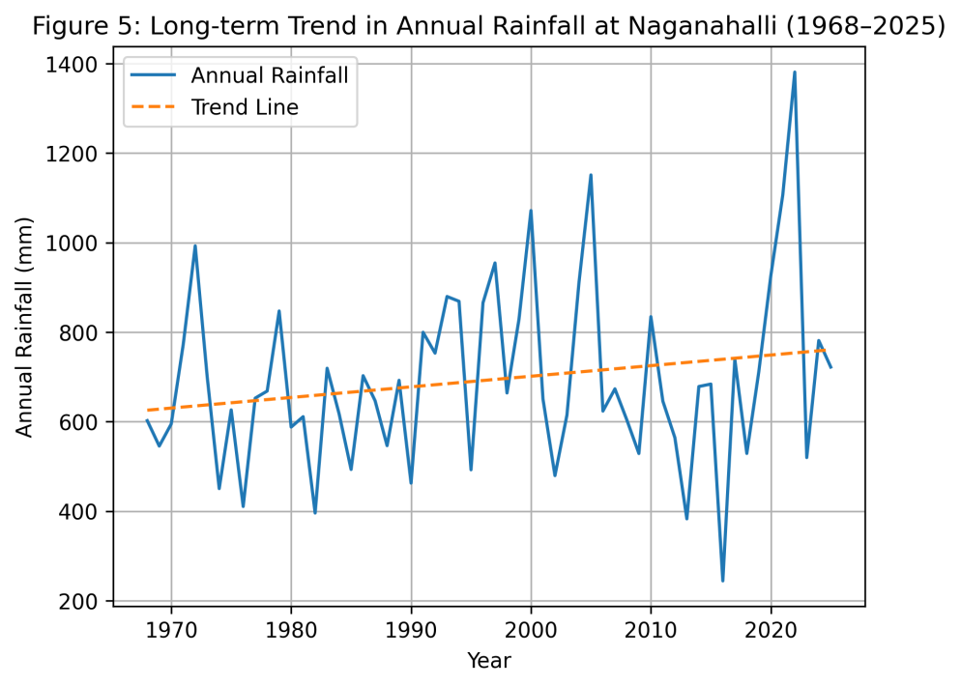
Fig. 5 Long term trend in annual rainfall of AMFU, Naganahalli (1968–2025)
Figure 5 clearly depicts large year-to-year fluctuations in annual rainfall, with several sharp peaks corresponding to excess rainfall years and deep troughs representing drought years. The fitted trend line shows a gentle upward slope, indicating a slight increase in rainfall over time; however, the wide dispersion of rainfall values around the trend line highlights the dominance of variability.
The figure confirms that rainfall behavior at Naganahalli is characterized more by increasing extremes and variability rather than a consistent long-term increase or decrease. This pattern aligns with earlier findings that climate change impacts on rainfall in India are often expressed through increased variability and extremes rather than changes in mean rainfall (Guhathakurta et al., 2011; Krishnakumar et al., 2009).
The absence of a statistically significant long-term trend in rainfall does not imply climatic stability. Instead, it indicates that rainfall variability remains the dominant climatic feature influencing agriculture in the region. Frequent alternation between deficit and excess rainfall years, as observed in earlier sections, increases agricultural risk and complicates water resource planning (Mishra et al., 2014).
Several studies have emphasized that even in the absence of significant trends, increased rainfall variability and extreme events can severely impact crop productivity, soil health, and groundwater recharge (Dash et al., 2013). The slight increasing tendency observed in post-2000 rainfall values may be associated with increased frequency of high-intensity rainfall events, a phenomenon widely reported across India (Guhathakurta et al., 2011).
The findings highlight the need for climate-resilient agricultural strategies, including improved rainwater harvesting, soil moisture conservation, and dynamic agrometeorological advisories tailored to local rainfall behavior.

3.6 Implications of Rainfall Variability for Agriculture and Water Management
The long-term rainfall analysis at AMFU, OFRS, Naganahalli, Mysuru clearly indicates that rainfall variability, rather than long-term directional change, is the dominant climatic characteristic of the region. The high inter-annual variability, frequent occurrence of deficit and excess rainfall years, and strong seasonality observed in earlier sections have direct implications for agricultural productivity, water resource management, and climate resilience.
Rain-fed agriculture in the Mysuru region is highly sensitive to rainfall anomalies, particularly during critical crop growth stages. Deficit rainfall years often result in delayed sowing, poor crop establishment, reduced nutrient uptake, and yield instability in major crops such as finger millet, maize, pulses, and oilseeds (Gadgil and Gadgil, 2006; Patil et al., 2014). Prolonged dry spells during the southwest monsoon season further aggravate moisture stress, increasing the risk of crop failure.
Excess rainfall years, although beneficial in terms of total water availability, pose equally serious challenges. High-intensity rainfall events can lead to runoff losses, soil erosion, nutrient leaching, and waterlogging, particularly in low-lying agricultural fields (Dash et al., 2013). Excess rainfall during the northeast monsoon period, especially in October, can adversely affect crops at maturity and harvest stages, resulting in lodging, disease incidence, and post-harvest losses (Parthasarathy et al., 1994).The strong dependence of the region on both southwest and northeast monsoons necessitates flexible and adaptive crop planning strategies. Adjustments in sowing windows, selection of short-duration and drought-tolerant crop varieties, and diversification of cropping systems can help mitigate risks associated with rainfall uncertainty (Krishnakumar et al., 2009). The findings also highlight the importance of synchronizing fertilizer application and intercultural operations with rainfall events to reduce nutrient losses during heavy rainfall periods.
Rainfall variability has significant implications for water resource management. The negligible winter rainfall and high concentration of rainfall during a few months underscore the need for effective rainwater harvesting and groundwater recharge measures. Farm ponds, percolation tanks, contour bunds, and soil moisture conservation practices can help capture excess rainfall during monsoon periods and provide supplemental irrigation during dry spells (Mishra et al., 2014).
The results of the present study emphasize the importance of location-specific agrometeorological advisory services based on long-term rainfall behavior. Timely weather-based advisories can assist farmers in making informed decisions related to sowing, irrigation scheduling, pest and disease management, and harvest planning (Dash et al., 2013). Integration of long-term rainfall analysis with real-time weather forecasts can significantly enhance climate risk management at the farm level.
Overall, the long-term rainfall characterization presented in this study provides a scientific basis for developing climate-resilient agricultural strategies in the Mysuru region. Policymakers, extension agencies, and researchers can utilize these findings to design targeted interventions aimed at improving agricultural sustainability, water use efficiency, and farmer resilience under increasing rainfall variability.
This study analyzed 58 years (1968–2025) of rainfall data recorded at AMFU, OFRS, Naganahalli, Mysuru, to characterize long-term rainfall behavior. The results showed that the region experiences high inter-annual rainfall variability with a mean annual rainfall of about 693 mm, confirming its semi-arid climatic nature.
Rainfall is strongly seasonal and bimodal, with the southwest monsoon contributing the largest share of annual rainfall, followed by the northeast monsoon. Monthly analysis identified October as the wettest month, highlighting the importance of post-monsoon rainfall for crop maturity and rabi sowing. However, rainfall concentration within a few months increases agricultural vulnerability.
Although normal rainfall years were dominant, the frequent occurrence of deficit and excess rainfall years indicates persistent climatic instability. Trend analysis revealed no significant long-term trend in annual rainfall, suggesting that variability and extremes, rather than changes in mean rainfall, govern rainfall behavior in the region.
Overall, rainfall variability remains the key climatic constraint affecting agriculture and water management in Mysuru. The findings provide a scientific basis for improved crop planning, rainwater harvesting, and climate-resilient agricultural strategies, and support the need for integrating long-term rainfall analysis with agrometeorological advisory services.

4. Conclusion
This study analyzed 58 years (1968–2025) of rainfall data recorded at AMFU, OFRS, Naganahalli, Mysuru, to characterize long-term rainfall behavior. The results showed that the region experiences high inter-annual rainfall variability with a mean annual rainfall of about 693 mm, confirming its semi-arid climatic nature.
Rainfall is strongly seasonal and bimodal, with the southwest monsoon contributing the largest share of annual rainfall, followed by the northeast monsoon. Monthly analysis identified October as the wettest month, highlighting the importance of post-monsoon rainfall for crop maturity and rabi sowing. However, rainfall concentration within a few months increases agricultural vulnerability.
Although normal rainfall years were dominant, the frequent occurrence of deficit and excess rainfall years indicates persistent climatic instability. Trend analysis revealed no significant long-term trend in annual rainfall, suggesting that variability and extremes, rather than changes in mean rainfall, govern rainfall behavior in the region.
Overall, rainfall variability remains the key climatic constraint affecting agriculture and water management in Mysuru. The findings provide a scientific basis for improved crop planning, rainwater harvesting, and climate-resilient agricultural strategies, and support the need for integrating long-term rainfall analysis with agrometeorological advisory services.

5. Policy Implications and Recommendations
- Strengthening Rainfed Agriculture
The high inter-annual rainfall variability observed in the region highlights the need to prioritize rainfed agriculture in policy planning. Promotion of drought-tolerant and short-duration crop varieties, along with diversified cropping systems, can reduce production risks during deficit rainfall years.
- Monsoon-based Crop planning
Given the dominance of southwest and northeast monsoon rainfall, crop calendars should be aligned with monsoon onset and withdrawal patterns. Flexible sowing windows and contingency crop plans should be institutionalized at the district and taluk levels to address rainfall uncertainty.
- Rainwater Harvesting and Groundwater Recharge
The concentration of rainfall within a few months necessitates large-scale investment in rainwater harvesting structures such as farm ponds, percolation tanks, contour bunds, and check dams. Policies should encourage on-farm water storage to provide supplemental irrigation during dry spells.
- Soil and Water Conservation Measures
High rainfall variability and occasional excess rainfall events call for strengthening soil conservation practices. Adoption of mulching, conservation tillage, graded bunds, and vegetative barriers should be promoted to reduce runoff, soil erosion, and nutrient losses.
- Location-Specific Agrometeorological Advisories
Long-term rainfall behavior should be integrated with real-time weather forecasts to improve agrometeorological advisory services. Customized advisories at the village or micro-watershed level can help farmers make timely decisions on sowing, irrigation, nutrient management, and harvesting.
- Climate-Resilient Infrastructure and Extension Support
Investment in climate-resilient agricultural infrastructure, combined with capacity building of farmers through extension services, is essential. Training programs focusing on climate risk management, water use efficiency, and adaptive farming practices should be strengthened.
- Data-Driven Planning and Decision Making
Long-term agro-meteorological datasets, such as those used in this study, should be systematically utilized in agricultural planning, insurance design, and disaster preparedness programs. Strengthening weather observatories and data dissemination mechanisms will support evidence-based policy formulation.

References
- Dash, S. K., Panda, P. C., & Mohanty, U. C. (2013). Climate change and variability over India. Theoretical and Applied Climatology, 116, 97–109.
- Gadgil, S., & Gadgil, S. (2006). The Indian monsoon, GDP and agriculture. Economic and Political Weekly, 41(47), 4887–4895.
- Guhathakurta, P., Rajeevan, M., & Thapliyal, S. (2011). Observed changes in extreme rainfall events over India using 104 years of gridded daily rainfall data. International Journal of Climatology, 31(9), 1156–1164.
- India Meteorological Department (IMD). (2010). Climate of Karnataka. IMD, Pune, India.
- Kendall, M. G. (1975). Rank Correlation Methods (4th ed.). Griffin, London.
- Kothawale, D. R., & Rupa Kumar, K. (2005). On the recent changes in surface temperature trends over India. Geophysical Research Letters, 32, L18714.
- Krishnakumar, K. N., Prasada Rao, G. S. L. H. V., & Gopakumar, C. S. (2009). Rainfall trends in twentieth century over Kerala, India. Atmospheric Environment, 43, 1940–1944.
- Mann, H. B. (1945). Non-parametric tests against trend. Econometrica, 13, 245–259.
- Mishra, A. K., Singh, V. P., & Desai, V. R. (2014). Drought characterization: A probabilistic approach. Journal of Geophysical Research: Atmospheres, 119, 1–16.
- Nanjundiah, R. S., Francis, P. A., Ved, M., Gadgil, S., & Srinivasan, J. (2017). Impact of climate change on Indian monsoon. Current Science, 112(2), 348–357.
- Parthasarathy, B., Munot, A. A., & Kothawale, D. R. (1987). All-India monthly and seasonal rainfall series: 1871–1985. Theoretical and Applied Climatology, 38, 39–49.
- Parthasarathy, B., Kumar, K. R., & Kothawale, D. R. (1994). Indian summer monsoon rainfall indices, 1871–1990. Meteorological Magazine, 123, 174–186.
- Patil, R. H., Sidramappa, & Manjunath, K. R. (2014). Rainfall variability and crop planning in southern Karnataka. Journal of Agrometeorology, 16(1), 45–53.
- Rajeevan, M., Bhate, J., & Jaswal, A. K. (2012). Analysis of variability and trends of extreme rainfall events over India using 104 years of gridded daily rainfall data. Mausam, 63(1), 49–56.
- Rao, Y. P. (2011). Southwest Monsoon. India Meteorological Department, New Delhi.
- Sen, P. K. (1968). Estimates of the regression coefficient based on Kendall’s tau. Journal of the American Statistical Association, 63, 1379–1389.
- Sikka, D. R., & Gadgil, S. (1980). On the maximum cloud zone and the ITCZ over Indian longitudes during the southwest monsoon. Monthly Weather Review, 108, 1840–1853.
- Singh, D., Jain, S. K., & Gupta, R. D. (2005). Trend detection in rainfall series of India. Hydrological Sciences Journal, 50(6), 871–887.
- Subash, N., & Sikka, A. K. (2014). Trend analysis of rainfall and temperature and their implications for agriculture. Journal of Agrometeorology, 16(2), 168–173.
- Wilks, D. S. (2011). Statistical Methods in the Atmospheric Sciences (3rd ed.). Academic Press, New York.
- IPCC. (2014). Climate Change 2014: Impacts, Adaptation and Vulnerability. Cambridge University Press.
- Goswami, B. N., Venugopal, V., Sengupta, D., Madhusoodanan, M. S., & Xavier, P. K. (2006). Increasing trend of extreme rain events over India in a warming environment. Science, 314, 1442–1445.
- Jagannathan, P., & Parthasarathy, B. (1973). Trends and periodicities of rainfall over India. Monthly Weather Review, 101, 371–375.
- Rupa Kumar, K., Sahai, A. K., Kumar, K. K., et al. (2006). High-resolution climate change scenarios for India. Current Science, 90(3), 334–345.
- Samra, J. S. (2004). Review and analysis of drought monitoring, declaration and management in India. IWMI Working Paper 84.
- Sharma, K. D., & Tyagi, N. K. (2013). On-farm water management in India. Indian Journal of Agricultural Sciences, 83(7), 705–714.
- WMO. (2012). Standardized Precipitation Index User Guide. World Meteorological Organization, Geneva.
- Yadav, R. K., & Raghavendra, A. (2015). Climate variability and its impact on agriculture in Karnataka. Indian Journal of Dryland Agricultural Research, 30(2), 1–8.
- FAO. (2017). Climate-Smart Agriculture Sourcebook. Food and Agriculture Organization, Rome.
- Rockstrom, J., et al. (2010). Managing water in rainfed agriculture. Philosophical Transactions of the Royal Society B, 363, 1637–1646.

