Short Research Article

Development of dragon fruit leather (red fleshed) by using tray drying technique

.
ABSTRACT

Aims: The study was carried out to standardized formulations and optimized the drying process parameters by tray drying technique for production of red fleshed dragon fruit leather by using dragon fruit peel as a by-product waste utilization.
Place and Duration of Study: Department of processing and food engineering, College of agricultural engineering, Godhra, Gujarat between January 2024 and May 2024.
Methodology: Tray dried red fleshed dragon fruit leather was prepared by varying process variables i.e., sugar (10, 20, 30, 40 and 50 g/100g), peel (10, 20, 30, 40 and 50 g/100), temperature (50, 55, 60, 65 and 70°C) and thickness (2, 3, 4, 5 and 6 mm) and its responses like vitamin C, acidity, protein content, total soluble solids, color value – L*, a*, b*, overall acceptability of red fleshed dragon fruit leather were analyzed by using Response Surface Methodology (RSM).
Results: The optimum value of overall acceptability (7.95), vitamin C (39.08mg/100g) and color value a*(18.26) of red fleshed dragon fruit leather prepared by tray drying was found at process parameters of sugar (23.29g/100g), peel (29.41g/100g), temperature (69.9°C) and thickness (3mm) by using RSM.

Keywords: Red fleshed dragon fruit, Fruit leather, by product waste utilization, Optimization, RSM

1. INTRODUCTION

Dragon fruit (Hylocereus spp.), a vibrant and nutritious member of the cactaceae family, originates from Central America and Mexico (Wong and Siow, 2015). Characterized by bright red skin, green scales, and either red or white flesh with edible black seeds, it is rich in phytochemicals such as carotenoids, flavonoids, polyphenols, and vitamin C, all contributing to its strong antioxidant potential (Fathordoobady et al., 2019; Kiranmai, 2022).
The flesh of dragon fruit is widely used in products like jams, jellies, juices, ice creams, syrups, and beverages. Its peel and flesh are also utilized as natural coloring agents in the food industry (Wybraniec & Mizrahi, 2002). Fruit leather, a dehydrated fruit-based product with a chewy texture and sweet taste, is made by restructuring fruit pulp with other ingredients through drying (Mahesh et al., 2021).
Although dragon fruit peel is typically discarded or used as fertilizer, it contains valuable compounds like betacyanins and pectin with functional and sensory benefits (Nur Izalin et al., 2016). In light of rising demand for nutritious, ready-to-eat snacks, this study explores the utilization of red-fleshed dragon fruit peel to develop a value-added product—fruit leather. The focus is on optimizing the sugar-to-peel ratio and drying parameters to enhance product quality and consumer appeal.
2. material and methods

2.1 Preparation of Samples
Red-fleshed dragon fruit was washed, peeled manually, and the pulp was homogenized. The mixture was heated to reach the desired total soluble solids (TSS), and additives such as citric acid (0.1 g) and potassium metabisulfite (0.1 g) were incorporated. The resulting thick puree was spread onto plastic or glass sheets and dried in a tray dryer under optimized conditions. The final fruit leather was then packed and stored at room temperature.
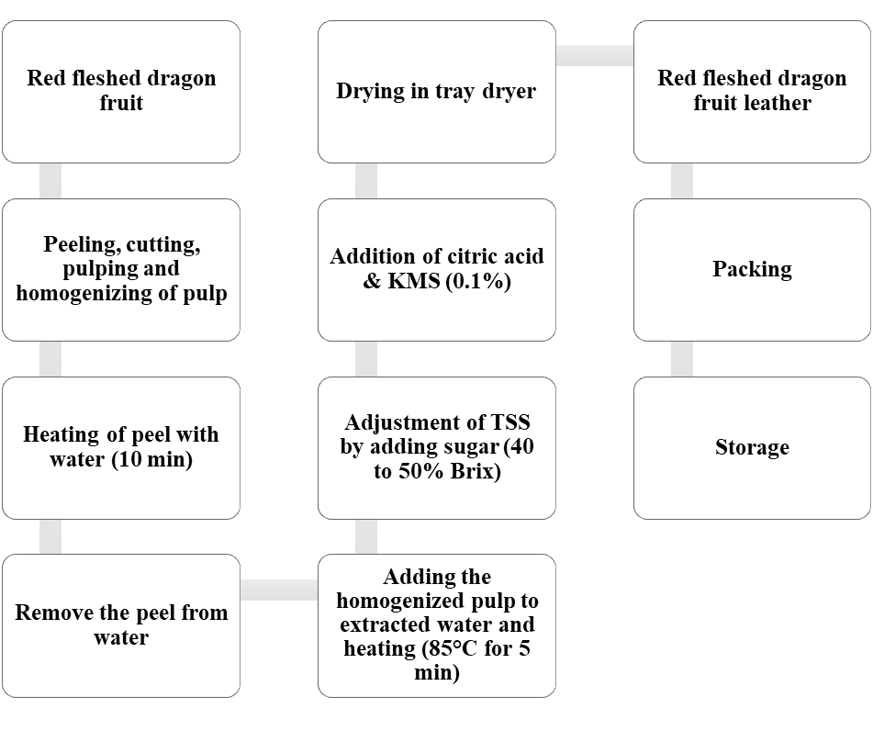
Fig 1: Process flowchart for preparation of red fleshed dragon fruit leather

2.2 Experimental Plan
Red-fleshed dragon fruit leather was prepared using tray drying with various process formulations. Four process variables at five levels each were tested using a central composite rotatable design (CCRD). Thirty experiments were conducted, and response surface methodology (RSM) analyzed the effects and interactions of these variables on the physicochemical, sensory, and color properties of the dried product.
Table 1: Experimental plan for the development of red fleshed dragon fruit leather
Independent Variables
Peel (g/100g of pulp) | : | 10, 20, 30, 40, 50
Sugar (g/100g of pulp) | : | 10, 20, 30, 40, 50
Temperature (°C) | : | 55, 60, 65, 70, 75
Thickness (mm) | : | 2, 3, 4, 5, 6
Dependent Variables
Physico-chemical Parameters | : | Ascorbic acid, pH, TSS., Protein,
Color Values | : | L*, a*, b*
Sensory Evaluation | : | Color, Taste, Flavor and Overall Acceptability

2.3 Physico-Chemical Analysis of Red Fleshed Dragon Fruit Leather
Proximate composition represents the gross content of important chemical constituent such as vitamin C, pH, TSS, acidity, protein. The study of the proximate composition serves as an important base to study the nutritive quality of red fleshed dragon fruit leather.

Table 2: Actual and coded values of different parameters for preparation of red fleshed dragon fruit leather
Sr.  No. | Coded Value |  |  |  | Actual Value
Sr.  No. | Peel (g/100g) | Sugar (g/100g) | Temperature(°C) | Thickness(mm) | Peel (g/100g) | Sugar (g/100g) | Temperature(°C) | Thickness(mm)
1 | -1 | -1 | -1 | -1 | 20 | 20 | 60 | 3
2 | 1 | -1 | -1 | -1 | 40 | 20 | 60 | 3
3 | -1 | 1 | -1 | -1 | 20 | 40 | 60 | 3
4 | 1 | 1 | -1 | -1 | 40 | 40 | 60 | 3
5 | -1 | -1 | 1 | -1 | 20 | 20 | 70 | 3
6 | 1 | -1 | 1 | -1 | 40 | 20 | 70 | 3
7 | -1 | 1 | 1 | -1 | 20 | 40 | 70 | 3
8 | 1 | 1 | 1 | -1 | 40 | 40 | 70 | 3
9 | -1 | -1 | -1 | 1 | 20 | 20 | 60 | 5
10 | 1 | -1 | -1 | 1 | 40 | 20 | 60 | 5
11 | -1 | 1 | -1 | 1 | 20 | 40 | 60 | 5
12 | 1 | 1 | -1 | 1 | 40 | 40 | 60 | 5
13 | -1 | -1 | 1 | 1 | 20 | 20 | 70 | 5
14 | 1 | -1 | 1 | 1 | 40 | 20 | 70 | 5
15 | -1 | 1 | 1 | 1 | 20 | 40 | 70 | 5
16 | 1 | 1 | 1 | 1 | 40 | 40 | 70 | 5
17 | -2 | 0 | 0 | 0 | 10 | 30 | 65 | 4
18 | 2 | 0 | 0 | 0 | 50 | 30 | 65 | 4
19 | 0 | -2 | 0 | 0 | 30 | 10 | 65 | 4
20 | 0 | 2 | 0 | 0 | 30 | 50 | 65 | 4
21 | 0 | 0 | -2 | 0 | 30 | 30 | 55 | 4
22 | 0 | 0 | 2 | 0 | 30 | 30 | 75 | 4
23 | 0 | 0 | 0 | -2 | 30 | 30 | 65 | 2
24 | 0 | 0 | 0 | 2 | 30 | 30 | 65 | 6
25 | 0 | 0 | 0 | 0 | 30 | 30 | 65 | 4
26 | 0 | 0 | 0 | 0 | 30 | 30 | 65 | 4
27 | 0 | 0 | 0 | 0 | 30 | 30 | 65 | 4
28 | 0 | 0 | 0 | 0 | 30 | 30 | 65 | 4
29 | 0 | 0 | 0 | 0 | 30 | 30 | 65 | 4
30 | 0 | 0 | 0 | 0 | 30 | 30 | 65 | 4

2.3.1. Determination of vitamin C
Ascorbic acid of red fleshed dragon fruit leather was determined by Titrimetric (Volumetric) Method.
$$Ascorbic acid(\frac{mg}{100g})=\frac{0.5mg×V_{2}ml×50ml×100}{V_{2}ml×5ml\left(aliquote\right)×Wt. of sample (5g)}$$
2.3.2 Determination of pH
The pH of the red fleshed dragon fruit leather was measured by using digital pH meter.

2.3.3 Determination of protein
Quantity of true protein of red fleshed dragon fruit leather was evaluated by Folin-Lowry assay as per Lowry et al. (1951).
$$Protein (\%)=\frac{gf\left(μg\right)×optical density×dilution factor×total vol(ml)×{10}^{-6} }{sample aliquot\left(ml\right)×weightof sample (g)}×100$$
2.3.4 Determination of total soluble solids (TSS)
Total soluble solid of red fleshed dragon fruit leather was determined by using digital refractometer.
2.3.5 Determination of color value (L*, a*, b*)
The color of the red fleshed dragon fruit leather was measured in terms of L*, a* and b* values. All the color measurements were done using a Digital photoelectric colorimeter.

2.3.6 Organoleptic evaluation of red fleshed dragon fruit leather
Dragon fruit leather samples were evaluated for sensory attributes; color, texture, flavor, and overall acceptability by a panel of faculty and postgraduate students from CAET, AAU, Godhra. Panelists rated the samples on a 9-point hedonic scale, with 9 represent liked extremely and 1 represent disliked extremely. The final overall score was the average of all ratings, with a score of "like moderately" considered as the threshold for product acceptability.

3. results and discussion

3.1. Effect of Process Variables on The Quality of Red Fleshed Dragon Fruit Leather
The table shows experimental design and responses (vitamin C, protein, overall acceptability, pH, TSS and color value L*, a*, b*,) collected for optimization of different process variables (peel, sugar, temperature and thickness) for production of red fleshed dragon fruit leather by using Response Surface Methodology techniques. To visualize the combined effects of two factors on the response, three-dimensional response graphs surfaces (Fig 2 to 7) were also generated for each of the fitted models as a function of two variables, while keeping third variable at the central value. The quadratic models were fitted to the experimental data and statistical analysis was carried for each response by using Design Expert Software 13 (Stat Ease Inc.,)

3.2 Analysis of Responses
Various responses (vitamin C, sensory evaluation in terms of overall acceptability, pH, TSS, color values in terms of L*, a*, b*, and protein) of red fleshed dragon fruit leather were discussed here

3.2.1. Effect on Vitamin C
Vitamin C of the red fleshed dragon fruit leather ranged from 25 to 47.92mg/100g with an average value of 33.22mg/100g. The coefficient of model and other statistics is given in Table 3 The Model F-value of 11.13 implies the model is significant. R² and adjusted R² values of the model are 0.91 and 0.83 respectively. It may be seen from Fig.2 that the increase in sugar proportion in red fleshed dragon fruit leather formulation resulted in no changes in vitamin C whereas increases in peel of red fleshed dragon fruit leather formulation resulted in increase in vitamin C up to certain level this may due to Vitamin C is a water-soluble nutrient, and its concentration might not be significantly affected by changes in sugar content and peel of the red-fleshed dragon fruit contains a considerable amount of vitamin C. Similar result may be obtained by Jethva et. al., 2023 for the dragon fruit leather.

Table: 3 ANOVA effect on different process variables on vitamin-C of red fleshed dragon fruit leather
Source | Sum of Squares | Df | Mean Square | F-value | p-value
Model* | 641.58 | 14 | 45.83 | 11.13 | < 0.0001
A-Sugar | 99.67 | 1 | 99.67 | 24.21 | 0.0002
B-Peel | 0.5075 | 1 | 0.5075 | 0.1233 | 0.7304
C-Temperature | 45.13 | 1 | 45.13 | 10.96 | 0.0048
D-Thickness | 7.25 | 1 | 7.25 | 1.76 | 0.2044
AB | 10.87 | 1 | 10.87 | 2.64 | 0.1250
AC | 162.63 | 1 | 162.63 | 39.50 | < 0.0001
AD | 81.77 | 1 | 81.77 | 19.86 | 0.0005
BC | 15.98 | 1 | 15.98 | 3.88 | 0.0676
BD | 28.06 | 1 | 28.06 | 6.82 | 0.0197
CD | 43.33 | 1 | 43.33 | 10.52 | 0.0054
A² | 8.86 | 1 | 8.86 | 2.15 | 0.1630
B² | 66.46 | 1 | 66.46 | 16.14 | 0.0011
C² | 1.28 | 1 | 1.28 | 0.3106 | 0.5855
D²  Complete Model | 49.78 | 1 | 49.78 | 12.09 | 0.0034
Residual | 61.76 | 15 | 4.12
Lack of Fit | 58.12 | 10 | 5.81 | 7.98 | 0.0167
Pure Error | 3.64 | 5 | 0.7280
Total | 703.34 | 29 | Adeq Precision 13.88
R² 0.91 |  |  | Adjusted R² 0.83
* significant

3.2.2 Effect on pH
pH of the red fleshed dragon fruit leather ranged from 3.0 to 4.1 with an average value of 3.73. The maximum pH at combination of (100g pulp, 30g sugar, 30g peel, 65°C temperature,3mm thickness) and minimum pH at combination of (100g pulp, 20g sugar, 40g peel, 60°C temperature, 3mm thickness). The coefficient of model and other statistics is given in Table 4. The Model F-value of 9.81 implies the model is significant. R² and adjusted R² values of the model are 0.90 and 0.81 respectively. It may be seen from Fig.3 that the increase in sugar and peel proportion in red fleshed dragon fruit leather formulation resulted in decreases in pH. Similar result may be obtained by Jethva et. al., 2023 for the dragon fruit leather.

Table 4. ANOVA effect on different process variables on pH of red fleshed dragon fruit leather
Source | Sum of Squares | df | Mean Square | F-value | p-value
Model* | 0.1229 | 14 | 0.0088 | 2.83 | 0.0273
A-Sugar | 0.0001 | 1 | 0.0001 | 0.0336 | 0.8570
B-Peel | 0.0070 | 1 | 0.0070 | 2.26 | 0.1536
C-Temperature | 0.0100 | 1 | 0.0100 | 3.23 | 0.0926
D-Thickness | 0.0003 | 1 | 0.0003 | 0.1089 | 0.7460
AB | 0.0077 | 1 | 0.0077 | 2.47 | 0.1369
AC | 0.0116 | 1 | 0.0116 | 3.73 | 0.0727
AD | 0.0060 | 1 | 0.0060 | 1.94 | 0.1843
BC* | 0.0371 | 1 | 0.0371 | 11.95 | 0.0035
BD* | 0.0390 | 1 | 0.0390 | 12.58 | 0.0029
CD | 0.0001 | 1 | 0.0001 | 0.0181 | 0.8946
A² | 0.0025 | 1 | 0.0025 | 0.7949 | 0.3867
B² | 0.0009 | 1 | 0.0009 | 0.2904 | 0.5979
C² | 0.0005 | 1 | 0.0005 | 0.1614 | 0.6936
D²  Complete Model | 0.0000 | 1 | 0.0000 | 0.0047 | 0.9462
Residual | 0.0465 | 15 | 0.0031
Lack of Fit | 0.0448 | 10 | 0.0045 | 12.92 | 0.0056
Pure Error | 0.0017 | 5 | 0.0003
Cor Total | 0.1694 | 29 | Adeq Precision 7.02
R² 0.73 |  |  | Adjusted R² 0.47
* significant

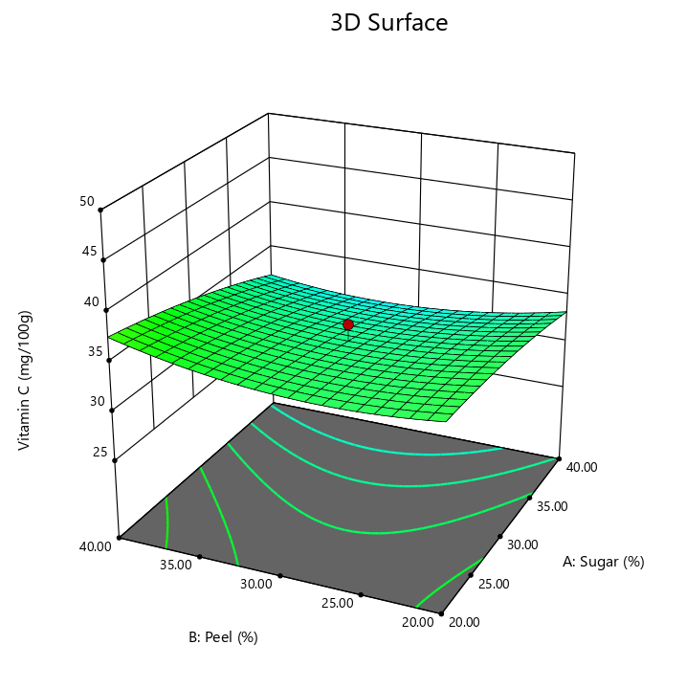 | 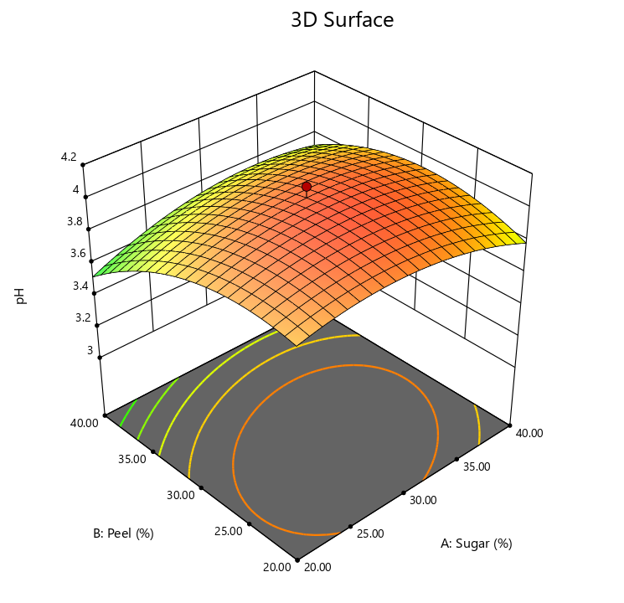
Fig. 2 Variations of vitamin C with respect to sugar and peel in red fleshed dragon fruit leather | Fig. 3. Variations of pH with respect to sugar and peel in red fleshed dragon fruit leather

3.2.3 Effect on Protein
Protein of the red fleshed dragon fruit leather ranged from 5.69 to 10.34% with an average value of 8.39%. The coefficient of model and other statistics is given in Table 5. The Model F-value of 10.24 implies the model is significant. R² and adjusted R² values of the model are 0.90 and 0.82 respectively. It may be seen from Fig.4 that the increase in sugar proportion in red fleshed dragon fruit leather formulation resulted in increase in protein up to certain level and increases Similar result may be obtained by Jethva et. al., (2023) for the dragon fruit leather.

Table 5. ANOVA effect on different process variables on protein of red fleshed dragon fruit leather
Source | Sum of Squares | Df | Mean Square | F-value | p-value
Model* | 45.01 | 14 | 3.21 | 10.24 | < 0.0001
A-Sugar | 0.0925 | 1 | 0.0925 | 0.2947 | 0.5952
B-Peel* | 11.97 | 1 | 11.97 | 38.14 | < 0.0001
C-Temperature | 0.0330 | 1 | 0.0330 | 0.1051 | 0.7502
D-Thickness | 0.2970 | 1 | 0.2970 | 0.9463 | 0.3461
AB | 1.02 | 1 | 1.02 | 3.23 | 0.0923
AC* | 6.44 | 1 | 6.44 | 20.51 | 0.0004
AD* | 3.00 | 1 | 3.00 | 9.56 | 0.0074
BC | 0.0001 | 1 | 0.0001 | 0.0002 | 0.9895
BD | 0.0371 | 1 | 0.0371 | 0.1181 | 0.7359
CD | 0.9653 | 1 | 0.9653 | 3.08 | 0.0999
A²* | 19.97 | 1 | 19.97 | 63.62 | < 0.0001
B² | 0.8836 | 1 | 0.8836 | 2.81 | 0.1141
C² | 0.0259 | 1 | 0.0259 | 0.0825 | 0.7778
D²  Complete Model | 0.0700 | 1 | 0.0700 | 0.2230 | 0.6435
Residual | 4.71 | 15 | 0.3139
Lack of Fit | 3.98 | 10 | 0.3982 | 2.74 | 0.1385
Pure Error | 0.7260 | 5 | 0.1452
Cor Total | 49.72 | 29 | Adeq Precision 10.68
R² 0.90 |  |  | Adjusted R² 0.82
* significant

3.2.4 Effect on TSS
TSS of the red fleshed dragon fruit leather ranged from 72 to 94⁰Brix with an average value of 80⁰Brix. The maximum TSS at combination of (100g pulp, 40g sugar, 20g peel, 60°C temperature, 5mm thickness) and minimum TSS at combination of (100g pulp, 40g sugar, 40g peel, 70°C temperature, 5mm thickness). The coefficient of model and other statistics is given in Table 6. The Model F-value of 5.05 implies the model is significant. R² and adjusted R² values of the model are 0.82 and 0.66 respectively. The adequate precision value of 9.08 indicates that the model can be used to predict the response within the design space more than 0.2.
It may be seen from Fig.5 that the increase in sugar proportion in red fleshed dragon fruit leather formulation resulted in increase in TSS up to certain level than decrease and increase in peel of red fleshed dragon fruit leather. This will due to increase the sugar proportion, the concentration of dissolved sugars in the mixture rises, leading to an increase in TSS levels and peel of the red-fleshed dragon fruit contains various soluble solids such as sugars, organic acids, and other compounds.

Table 6. ANOVA effect on different process variables on TSS of red fleshed dragon fruit leather
Source | Sum of Squares | Df | Mean Square | F-value | p-value
Model | 708.38 | 14 | 50.60 | 5.05 | 0.0018
A-Sugar | 7.04 | 1 | 7.04 | 0.7022 | 0.4152
B-Peel | 35.04 | 1 | 35.04 | 3.49 | 0.0812
C-Temperature | 5.04 | 1 | 5.04 | 0.5028 | 0.4892
D-Thickness | 45.38 | 1 | 45.38 | 4.52 | 0.0504
AB | 27.56 | 1 | 27.56 | 2.75 | 0.1181
AC | 150.06 | 1 | 150.06 | 14.96 | 0.0015
AD | 22.56 | 1 | 22.56 | 2.25 | 0.1544
BC | 27.56 | 1 | 27.56 | 2.75 | 0.1181
BD | 18.06 | 1 | 18.06 | 1.80 | 0.1995
CD | 126.56 | 1 | 126.56 | 12.62 | 0.0029
A² | 187.50 | 1 | 187.50 | 18.70 | 0.0006
B² | 60.86 | 1 | 60.86 | 6.07 | 0.0263
C² | 15.00 | 1 | 15.00 | 1.50 | 0.2401
D²  Complete Model | 51.07 | 1 | 51.07 | 5.09 | 0.0394
Residual | 150.42 | 15 | 10.03
Lack of Fit | 143.58 | 10 | 14.36 | 10.51 | 0.0090
Pure Error | 6.83 | 5 | 1.37
Cor Total | 858.80 | 29 | Adeq Precision 9.08
R² 0.82 |  |  | Adjusted R² 0.66
*significant

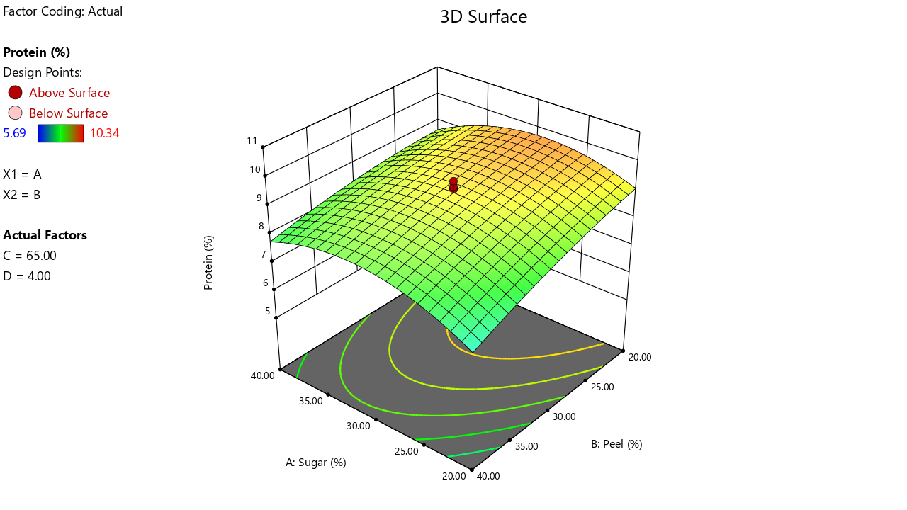 | 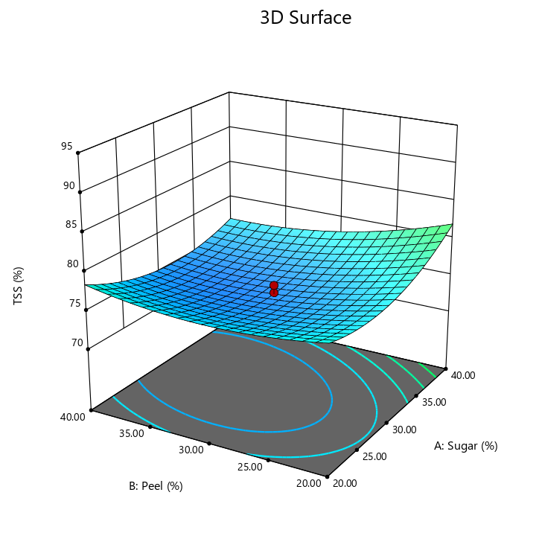
Fig. 4 Variation of protein content with respect to sugar and peel in red fleshed dragon fruit leather | Fig.5 Variations of TSS with respect to sugar and peel in red fleshed dragon fruit leather

3.2.5 Effect on Color Value (a*)
Color value a* of the red fleshed dragon fruit leather ranged from 5.2 to 28.01 with an average value of 16.63. The coefficient of model and other statistics is given in Table 7. The Model F-value of 21.80 implies the model is significant. R² and adjusted R² values of the model are 0.95 and 0.90 respectively. It may be seen from Fig.6 that the increase in sugar content initially increases in color value a* up to certain level than decrease and peel content in red fleshed dragon fruit leather. This may be due to increases in browning reaction with sugar increases and peel of the red-fleshed dragon fruit contains various pigments, including betalains and anthocyanins, which contribute to the color of the fruit.
Table 7. ANOVA effect on different process variables on color value a* of red fleshed dragon fruit leather
Source | Sum of Squares | df | Mean Square | F-value | p-value
Model* | 1361.12 | 14 | 97.22 | 21.80 | < 0.0001
A-Sugar | 5.84 | 1 | 5.84 | 1.31 | 0.2704
B-Peel | 57.17 | 1 | 57.17 | 12.82 | 0.0027
C-Temperature | 51.63 | 1 | 51.63 | 11.57 | 0.0039
D-Thickness | 26.38 | 1 | 26.38 | 5.91 | 0.0280
AB* | 42.19 | 1 | 42.19 | 9.46 | 0.0077
AC* | 82.08 | 1 | 82.08 | 18.40 | 0.0006
AD | 3.98 | 1 | 3.98 | 0.8923 | 0.3598
BC* | 109.83 | 1 | 109.83 | 24.62 | 0.0002
BD | 0.9900 | 1 | 0.9900 | 0.2220 | 0.6443
CD | 11.22 | 1 | 11.22 | 2.52 | 0.1335
A²* | 477.24 | 1 | 477.24 | 107.00 | < 0.0001
B²* | 599.15 | 1 | 599.15 | 134.33 | < 0.0001
C²* | 76.95 | 1 | 76.95 | 17.25 | 0.0008
D²  Complete Model | 4.04 | 1 | 4.04 | 0.9056 | 0.3564
Residual | 66.91 | 15 | 4.46
Lack of Fit | 62.31 | 10 | 6.23 | 6.79 | 0.0237
Pure Error | 4.59 | 5 | 0.9182
Cor Total | 1428.03 | 29 | Adeq Precision 15.75
R² 0.95 |  |  | Adjusted R² 0.90
*significant

3.2.6 Effect on Overall acceptability
OAA of the red fleshed dragon fruit leather ranged from 6.8 to 8.3 with an average value of 7.5. The coefficient of model and other statistics is given in Table 8. The Model F-value of 37.33 implies the model is significant R² and adjusted R²values of the model are 0.97 and 0.95 respectively. It may be seen from Fig.7 that the increase in sugar content may increase in OAA and peel content in dragon fruit leather may decrease in OAA of the red fleshed dragon fruit leather. This may be due to sugar may improve taste and sweetness perception and the peel of the red-fleshed dragon fruit contributes to its flavor profile, including any bitterness. Similar

Table 8. ANOVA effect on different process variables on OAA of red fleshed dragon fruit leather
Source | Sum of Squares | Df | Mean Square | F-value | p-value
Model* | 3.28 | 14 | 0.2343 | 37.33 | < 0.0001
A-Sugar | 0.4004 | 1 | 0.4004 | 63.78 | < 0.0001
B-Peel | 0.0204 | 1 | 0.0204 | 3.25 | 0.0914
C-Temperature | 0.0504 | 1 | 0.0504 | 8.03 | 0.0126
D-Thickness | 0.4004 | 1 | 0.4004 | 63.78 | < 0.0001
AB* | 0.0756 | 1 | 0.0756 | 12.05 | 0.0034
AC* | 0.0306 | 1 | 0.0306 | 4.88 | 0.0432
AD* | 0.3906 | 1 | 0.3906 | 62.22 | < 0.0001
BC* | 0.1406 | 1 | 0.1406 | 22.40 | 0.0003
BD | 0.1406 | 1 | 0.1406 | 22.40 | 0.0003
CD* | 0.6806 | 1 | 0.6806 | 108.42 | < 0.0001
A²* | 0.2357 | 1 | 0.2357 | 37.55 | < 0.0001
B²* | 0.4800 | 1 | 0.4800 | 76.46 | < 0.0001
C²* | 0.1336 | 1 | 0.1336 | 21.28 | 0.0003
D²  Complete Model | 0.0107 | 1 | 0.0107 | 1.71 | 0.2105
Residual | 0.0942 | 15 | 0.0063
Lack of Fit | 0.0858 | 10 | 0.0086 | 5.15 | 0.0422
Pure Error | 0.0083 | 5 | 0.0017
Cor Total | 3.37 | 29 | Adeq Precision 26.33
R² 0.97 |  |  | Adjusted R² 0.95

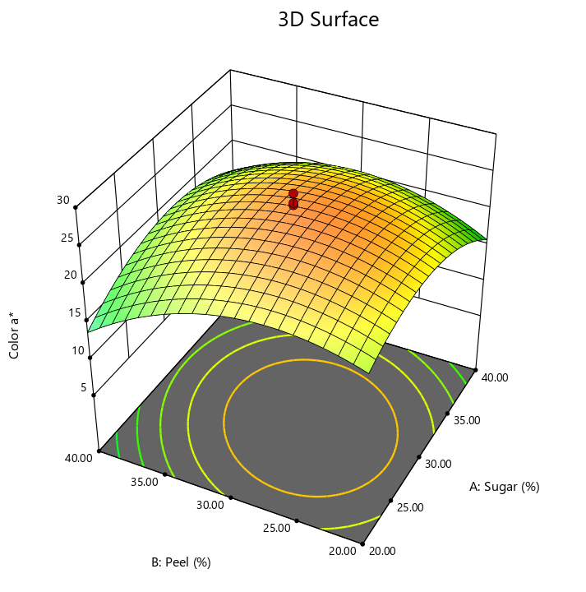 | 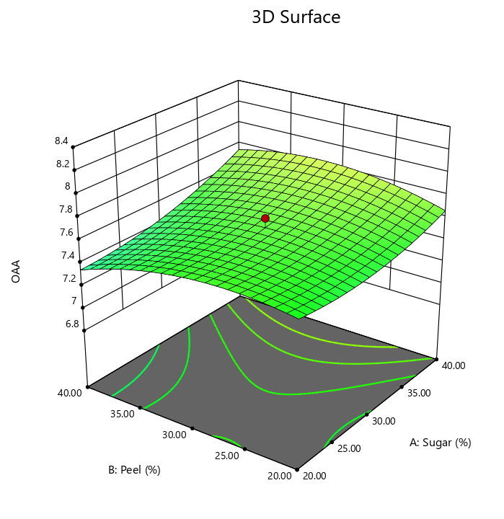
Fig.6 Variation of color value a* with respect to sugar and peel in red fleshed dragon fruit | Fig. 7 Variations of OAA with respect to sugar and peel in red fleshed dragon fruit

3.3 Optimization for Prediction of Process Parameters for Developed Red Fleshed Dragon Fruit Leather
Optimization of process parameters was done using Design Expert 13 software. Numerical optimization was carried out by putting the values of process parameters within the experimental range and by setting desirable goals for the responses. Optimization of process parameters for preparation of red fleshed dragon fruit leather by tray drying techniques was performed on the basis of its dominant quality attributes such as overall acceptability, vitamin C and color value a*.
The optimum range of process parameters for tray dried red fleshed dragon fruit leather was found as: Sugar-23.30g/100g, peel-29.41 g/100g, temperature-69.90°C and thickness-3mm. Corresponding to optimum values of process parameters, predicted values of responses were found as organoleptic score in term of overall acceptability (7.95), Vitamin C (39.08mg/100g) and color value a*(18.26)

4. CONCLUSION
It may be concluded from the study that the tray dried dragon fruit leather (red fleshed) by using dragon fruit peel as a by-product utilization having formulation of sugar: peel: temperature: thickness was found as 23.30g/100g, 29.41g/100g: 69.9°C: 3mm, respectively. Which is extremely useful for satisfying consumer tastes and preference and optimized sample having vitamin C of 39.08mg/100g, overall acceptability of 7.59 and color value a* of 18.26 respectively.

References

F., Fathordoobady, M. Y., Manap, J., Selamat, A. P., Singh (2019). Development of supercritical fluid extraction for the recovery of betacyanins from red pitaya fruit (Hylocereus polyrhizus) peel: a source of natural red pigment with potential antioxidant properties. International Food Research Journal, 26(3), 1023.
Jethva, K. R., Rathod, S. R., and Pargi, A. S. (2023). Optimization of process variables for development of dragon fruit leather by using fruit peel as by-product utilization. The Pharma Innovation Journal, 12(7): 1154-1159.
Kiranmai, M. (2022). Review of exotic fruit: Nutritional composition, nutraceutical properties and food application of Dragon fruit (Hylocereus spp.). The Pharma Innovation Journal, 11(6), 613-622.
Lowry, O. H., Rosebrough, N. J., Farr, A. L. and Randall, R. J. (1951). Protein measurement with the Folin phenol reagent. Journal of Biochemistry, 193(1), 265-275.
Mahesh, A., Champawat, P., Mudgal, V. and Jain, S. (2021). Development of dragon fruit leather. International Journal of Chemical Studies, 9(2), 71–75. https://doi.org/10.22271/chemi.2021.v9.i2b.11969
Nur Izalin, M. Z., Kharidah, M., Jamilah, B. and Noranizan, M. A. (2016). Functional properties of pectin from dragon fruit (Hylocereus polyrhizus) peel and its sensory attributes. Journal of Tropical Agriculture and Food Science, 44(1), 95-101.
Wong, Y. M. and Siow, L. F. (2015). Effects of heat, pH, antioxidant, agitation and light on betacyanin stability using red-fleshed dragon fruit (Hylocereus polyrhizus) juice and concentrate as models. Journal of Food Science and Technology, 52(5), 3086–3092. https://doi.org/10.1007/s13197-014-1362-2
Wybraniec, S., & Mizrahi, Y. (2002). Fruit flesh betacyanin pigments in Hylocereus cacti. Journal of Agricultural and Food Chemistry, 50(21), 6086–6089. https://doi.org/10.1021/jf020145k

