Development of an eco-friendly bullock yoke from agricultural waste using composite material technique for sustainable rural application

ABSTRACT
The transformation of agricultural waste into eco-friendly, lightweight, durable, and biodegradable composite materials supports sustainable production processes and presents new opportunities as alternatives to traditional materials. These composites offer significant advantages, particularly in terms of energy savings, low cost, and minimizing environmental impact. The objective was to create a yoke that is lightweight, ergonomic, durable, and sustainable by valorising abundant agricultural residue. Wheat straw was processed by using hammer mills and used as reinforcement (40% by weight) in an unsaturated polyester resin matrix. The composite yoke was fabricated using a compression moulding technique. The developed yoke was subjected to mechanical testing (tensile, flexural strength) and physical characterization (density). The superior toughness and improved stress dissipation composite materials was developed due to the combined effect of silica and agriculture biomass. Flexural strength analysis showed that T9 achieved an ultimate flexural strength of 41.47 N/mm², which is approximately 11% lower than T1 but 73% higher than T2, indicating that hybrid filler addition enhances bending performance compared to single-filler systems. This study successfully demonstrates the potential of wheat straw-based composites as a viable alternative to wood for manufacturing ergonomic and sustainable harnessing technology (animal yoke), directly contributing to manage crop residue and prevent it from burning and generate income for farmers.
Key words: Animal yoke, Draught Animal, Power, Wheat Straw, Natural Fiber Composite
- Introduction
Draught animals are the major source of farm power for the small and marginal farmers of the country. About 85 % of the operational holdings are small and marginal which constitute 25 % of total cultivated area. Animal power has been the main sources of farm power, used extensively for irrigation, threshing and transport besides tillage, sowing and intercultural operation ( Singh 1992 and 1996). About 50 % of the net sown area still cultivated by draught animals and are major means for transport in rural areas even there is an increase in the mechanical power sources. (Sushah, K. P., et al. 2015) carried out survey on status and utilization of draught animals. Farmers use site specific animal drawn implements and machinery for conducting agricultural unit operation. The implements are designed mainly for draught animals are made of wooden material and heavy in weight. Thus the new concept of developed a material using the based on composite material. Other side straw management today is a big problem and mostly farmers are burnt it into the field due to that environment pollution are increased day by day. Globally annual production of agriculture crop residue is estimated around 3440 million tonnes and crop burring accounts 6.6 million tonnes of CO2 gas emission annually in India ( INCCA, 2010). The disposal of rise residue is requirement today to protect environment. The organic residue is used for income generation and protects the forest cutting for making agriculture small implements. Therefore the use of composite material to develop a yoke used by bullock pairs is made of composite material. the production. The production of composite materials from the agricultural waste has significant interest in recent years due to benefit of waste valorization and the development of sustainable materials. Abundant and often underutilized agricultural residues can be employed as effective reinforcing agents in composite formulations, thereby enhancing the mechanical, thermal and acoustic properties of the composites. Agricultural by products such as wheat straw is rich in lignocelluloses’ fibres. Utilizing these materials enables the creation of composites that exhibit improved mechanical properties, thermal insulation, and biodegradability (Venkataravanappa et al., 2023). The utilization of agriculture waste based composite in the yoke design is attracting increasing attention due to their potential to create sustainable, eco friendly product while addressing waste management challenges. Research indicate that composite reinforced with plastics, such as polyethylene and polypropylene, to produce materials with enhanced mechanical properties.

- Materials And Methods
2.1 Materials Selection
Two types of materials were selected for construction of animal yoke one was matrix material and another was biodegradable reinforcing materials. The matrix materials were epoxy resins, hardeners, and silica material. The biodegradable materials were jute net, paddy and wheat straw, bagasse and saw dust were used in construction of animal yoke. Wheat straw was collected from the field after that it was grinded in hammer mill so that it was converted into a fine particle size as shown in figure 1.

2.2 Reinforcement
Wheat straw was collected from local farms in the Crop Research Centre Pantanagr Uttarakhand region. It was washed to remove dirt, sun-dried for 72 hours, and mechanically chopped into lengths of 20-30 mm. The chopped straw was subjected to a 5% NaOH (sodium hydroxide) alkali treatment for 4 hours to improve surface properties, followed by thorough washing and oven-drying at 80°C for 24 hours.

2.3 Matrix Materials
A general-purpose epoxy resin was used as the matrix material in present study.
- Epoxy Resin (CY-230)
Epoxy resin is widely used in industrial application because of their high strength and mechanical adhesiveness characteristic. Araldite CY-230 is a liquid solvent free epoxy resin. It has versatile applications in technical and industrial applications. Curing takes place at room temperature and atmospheric pressure after addition of hardener. Cure shrinkage is generally very less and may be still further reduced by the addition of fillers such as silica flour, China clay etc. The resin can be colored easily. Fully cured mixture has excellent mechanical, electrical properties and highly resistant to chemical and atmospheric attack. The castings have good ageing characteristics. It is odorless, tasteless and completely non-toxic. Resin can be stored for at least a year if they are stored under cool, dry conditions in the original containers. It is also a good solvent and has good chemical resistance over a wide range of temperature.
In the present investigation CY-230 purchased from from M/s Fine Finish organics pvt. Ltd. Mumbai, India has been used as matrix material. The physical & chemical properties of CY-230 are given in table 1.

- Hardener HY-951
Hardener (HY951), aliphatic primary amines which has enough viscosity at 25ºc is used along with matrix material.

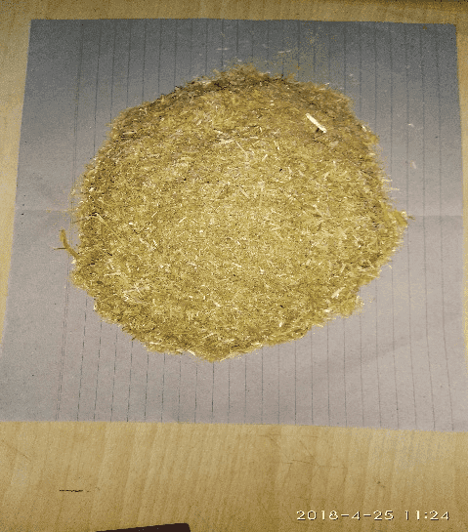 | 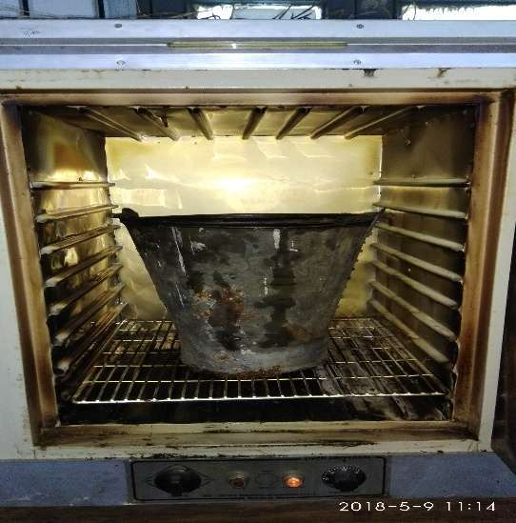 | 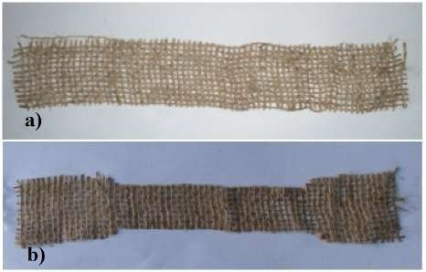
(a) Chopped Straw by the hammer mills | (b) Sample placed in oven for removing moisture | (c) biodegradable jute material

Fig1: Specimen preparation by grind it in hammer mill

c. Yoke Design
An ergonomic yoke design was developed in laboratory. The design featured a double-curved contour to match the dorsal profile of a bullock's neck. The contact surfaces were broadened and smoothed to maximize the contact area and minimize pressure points. The final design dimensions were 120 cm (length) x 15 cm (width at contact point) x 10 cm (thickness).
2.4 Reinforcing Materials
Reinforcing agents are added to the resin to improve the mechanical strength and wear properties. Some of the reinforcing agents such as silica, fly ash, bagasse and paddy straw etc. are used as reinforcing agents to improve the different properties of the composites material.
a.Silica: Induction of silica in the matrix material has been taken into consideration. Silica particles improve the physical and the mechanical properties significantly. Silica flour is directly mixed in to the resin and stirred mechanically.
b. Glass wool: Glass wool is produced in rolls or in slabs, with different thermal and mechanical properties. These are taken as a binding material for enhancing the adhesive property of the models. The glass wool purchased from M/s Fine Finish organics Pvt. Ltd. Mumbai, used as in sand-witched form, between every other two sets of jute net layers.
c. Jute net: Jute net is biodegradable matting manufactured from jute fiber. It is light in weight and widely used for housing and commercial purposes. It is considered as a waste material which is a main constituent here for developing a yak saddle.
d. Bagasse and paddy straw: Bagasse is a fibrous residue of cane stalks left over after the crushing and extraction of juice from the sugar cane. Paddy straw was collected after the harvesting. Bagasse and wheat straw can be considered as waste biodegradable material. These are light in weight and don't add much to the density of the samples. The main chemical constituents are lignocelluloses; Hemicelluloses and cellulose are present in the form of hollow cellulose, which contributes about 70 % of the total chemical constituents present in bagasse and paddy straw. Lignin acts as a binder for the cellulose fibers and also behaves as an energy storage system.
2.5 Mold Fabrication
A two-part closed mould was fabricated from mild steel. The inner surfaces were polished and coated with a polyvinyl alcohol (PVA) release agent to facilitate easy removal of the final product as shown in Figure 3.

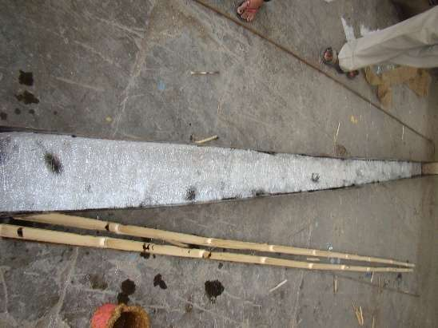 | 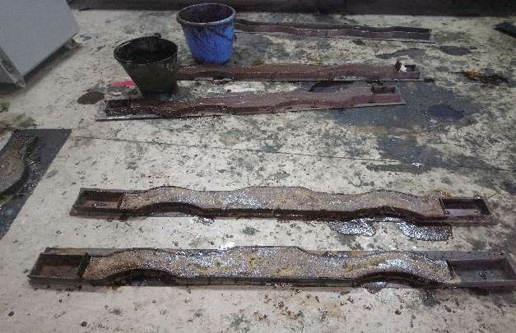
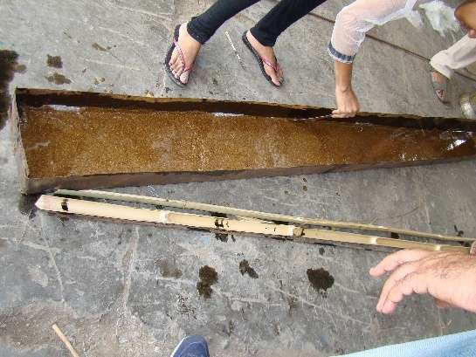 | 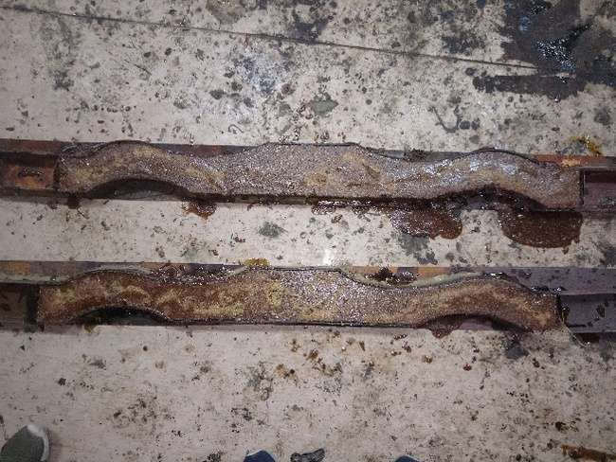

Fig 2: Mold preparation for pouring composite material solution

2.6 Composite Fabrication
The yoke was fabricated using a compression moulding technique. The polyester resin, catalyst (1% by wt.), and accelerator (1% by wt.) were thoroughly mixed. The treated wheat straw fibers were gradually added to the resin mixture and stirred until a uniform; dough-like consistency was achieved. A fiber loading of 40% by weight was maintained. The mixture was carefully placed into the lower half of the heated mold. The mold was closed, and a pressure of 12 MPa was applied using a hydraulic press. The temperature was maintained at 110°C for a curing time of 30 minutes. After curing, the mold was cooled, and the composite yoke was demoulded. Post-processing involved trimming excess flash and sanding the surfaces for a smooth finish.
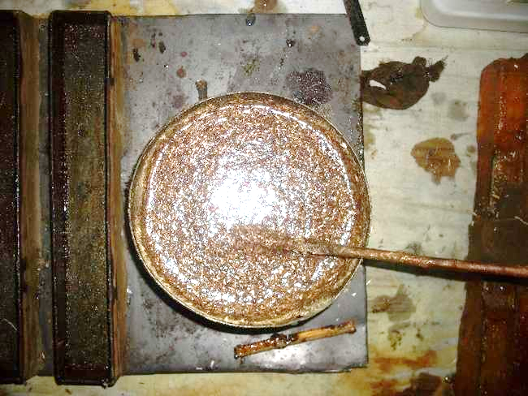
Fig 3: Epoxy resin, catalyst (1% by wt.), and harderner (1% by wt.) were thoroughly mixed in the bucket

2.7 Tests Procedure
Though there are number of mechanical tests, which are necessary to determine the suitability of a metal, the following important tests have been performed in the present study.
- Tensile test with the strain rate of 1.00 mm/sec.
- Compression test with the strain rate of 1.00 mm/sec.
- Flexural test
- Hardness test
- Wear test at 0.15 N/mm² pressure and 1500 rpm speed.
- Impact Test
2.8 Mechanical Properties:
- Tensile Strength Testing
Tensile strength, yield point, yield strength and other tensile properties were determined by prepared a sample of different combinations viz T1,T2,T3,T4,T5,T6,T7,T8 and T9 of reinforcing as well as matrix materials. Details of the treatments were given in table 1. Tensile testing specimen were prepared per ASTM D 638 standard for tensile as shown in fig. 5. The l₀ gauge length were taken as 5.65$\sqrt{A_{0}}$ . Test were conducted using 200 kN servo hydraulic UTM machine (Model 2012, ANEKY make.)
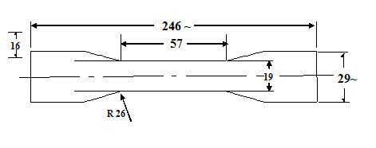 | 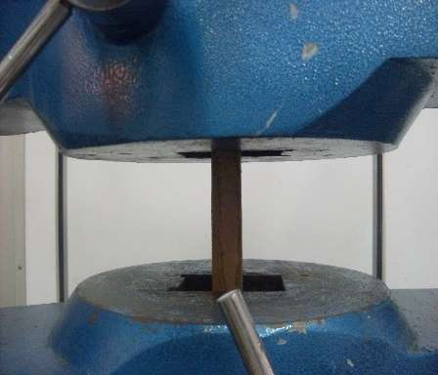 | 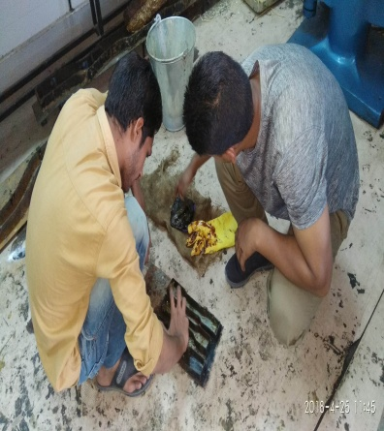

Fig 4: Specimen geometry for tensile test according to ASTM D638 Type III

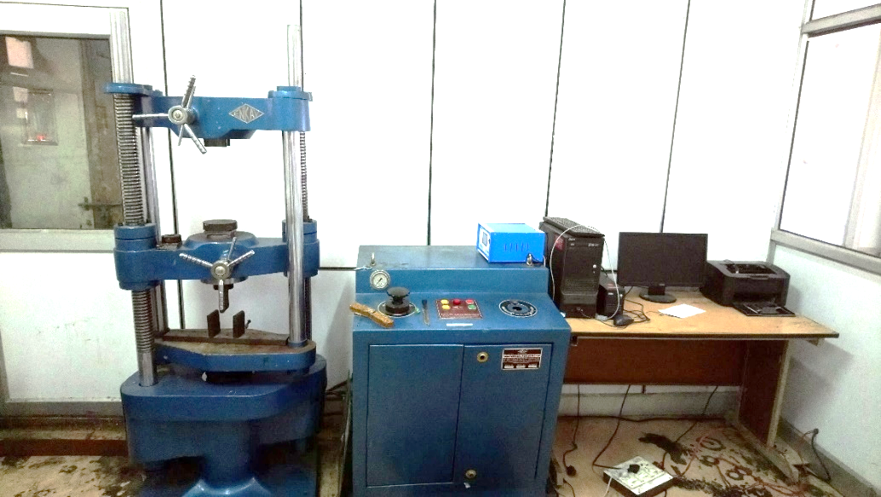
Fig 5 : UTM machine (Model 2012, ANEKEY make).

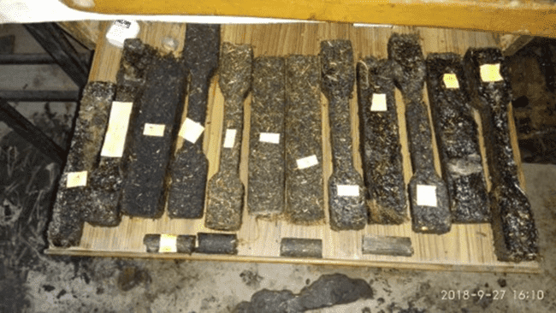
Tensile test sample
Flexural Test
Compression test sample
Fig 6: Preparation of samples for determination of mechanical properties of soil

- Compression Test
The compression test is simply the opposite of the tension test with respect to the direction of loading. Compression tests results in mechanical properties that include the compressive yield strength, compressive ultimate strength, and compressive modulus of elasticity in compression, % reduction in length etc. All the compression tests of casted hybrid composites are conducted on 200 kN servo hydraulic UTM machine (Model 2012, ANEKY make). Specimen configuration is shown in figure 8. All tests are conducted in aspect ratio of 2.0. Circular specimen used for wear and compression test, were prepared using lathe machine as per the requirement of the UTM machine as shown in figure 8.
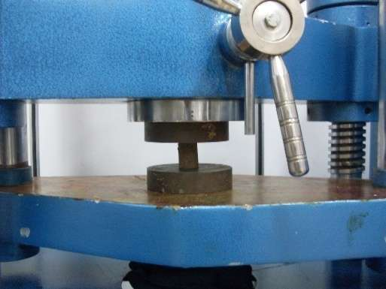
Fig 8: Determination of compression strength of sample under UTM Machine

- Bending strength
The 3-point bending strength test provides the values for flexural stress-strain response and flexural modulus of the material. The main advantage of a 3-point bending test is the ease of preparing specimen and testing. The test set up and specimen geometry is shown in the figure 3.9 (a) and test setup is shown in figure 3.9 (b). The results of this test are sensitive to the specimen properties, loading and strain rate. The temperature at the time of test was 24.5°C and relative humidity (RH) was 47%.
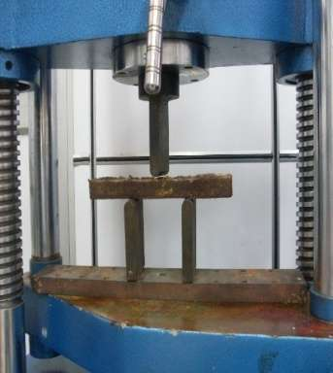
Fig 8 : Specimen geometry for compression test according to ISO-1708, 1960

- Wear Testing Sample pins for wear testing were prepared on lathe machine as per the requirement of the plint wear testing machine.

- Impact Testing: The impact strength of a material is determined with a Charpy or Izod impact test.Impact properties are not directly used in fracture mechanics calculations, but the economic impact tests continue to be used as a quality control method to assess notch sensitivity. Notch toughness is the ability that a material possesses to absorb energy in the presence of a flaw.
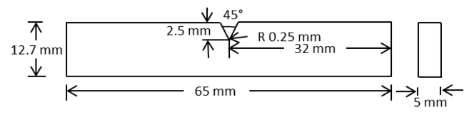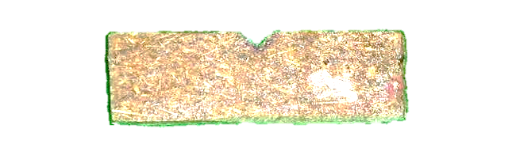
Fig 9: Specimen geometry for impact strength

The Izod impact test was conducted to determine the energy required to fracture a notched specimen and to evaluate the material’s impact toughness. The test was performed by striking the specimen with a pendulum hammer of known kinetic energy, and the energy absorbed by the specimen was calculated from the difference in the hammer’s energy before and after impact. The experiments were carried out at an ambient temperature of 22.8 °C and a relative humidity of 58%. The specimen geometry and the actual test specimen are shown in Fig. 10. All tests were performed using the Izod impact testing machine shown in Fig. 10, and the specimen geometry conformed to ASTM D256-02 standards. During testing, the specimen was rigidly clamped in the fixture, and the specimen dimensions were entered into the machine prior to impact. Initially, the pendulum was allowed to swing freely without a specimen, and the residual energy (U₁) was recorded. Subsequently, the test was conducted with the specimen in place, and the residual energy (U₂) was noted. The impact strength was calculated as the energy absorbed per unit cross-sectional area of the specimen.
f..Hardness test
The Rockwell hardness test is generally performed when quick and direct reading is desirable. The Rockwell hardness test was carried on the Digital Hardness testing machine on L scale.
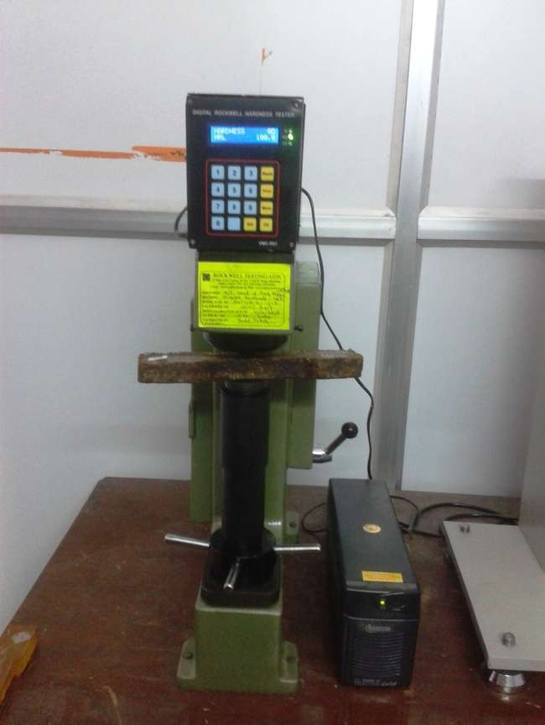 | 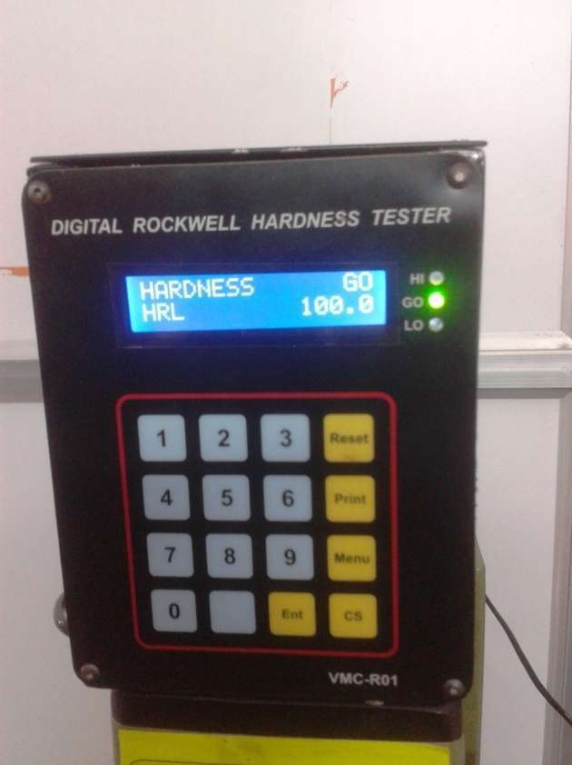 | 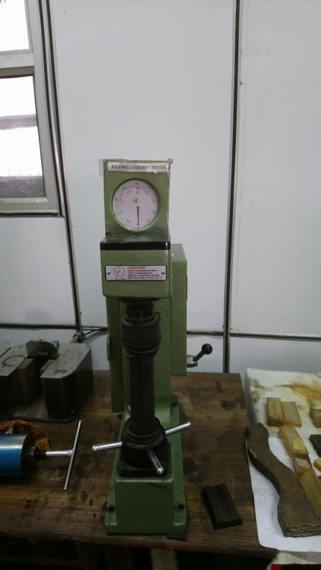

Fig. 11 Hardness Testing Machine

2.9 .Physical properties
The density of the composite yoke and a traditional wooden (Sheesham wood) yoke was determined using the water displacement method (ASTM D792).

- Water absorption and thickness swelling test
Water absorption and thickness swelling test were evaluated in laboratory. The samples were made and dissolved in water for 24 hours.
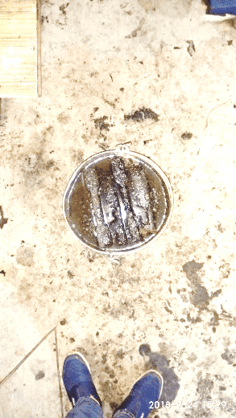
Fig 12: Water Absorption test for samples placed in bucket for 24 hrs

a. Density
For determination of density of samples of different models were first weighed on electronic weighing machine individually, and then were dipped individually into 50 ml of water kept into a cylindrical beaker of volume 100 ml.
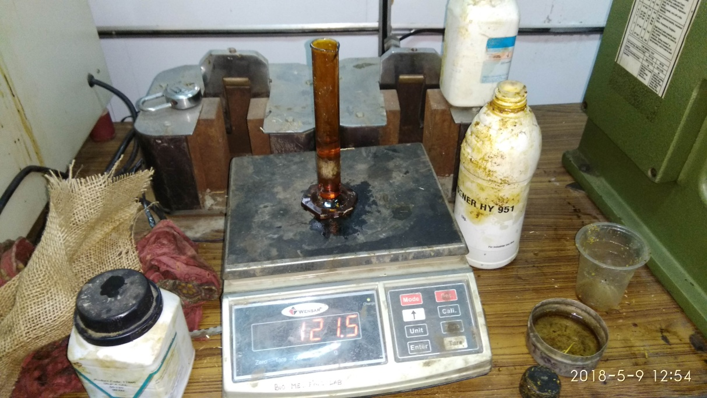
Fig 13: Density measurement for samples

Density of the sample/model = Mass of sample / Volume of sample
Experimental Analysis
In the present study we were compared the effect of filler composite (silica wt % and biomass wt %) on mechanical properties. Here we were taken two independent variables were silica has four levels ( 0,5,10, and 15%) and biomass levels of ( 0,5,10, and 15%). The data was analysed by using two way ANOVA techniques. The data was present in tables 3.

- RESULTS AND DISCUSSION
3.1 Physical and Mechanical Properties
The mechanical performance of the composites was strongly influenced by the type and proportion of silica and biomass fillers. Statistical interpretation based on relative percentage variation among treatments revealed clear optimum filler combinations and performance thresholds.

Fig 13: Comparison of strength of various treatment composition

3.2 Tensile Properties
The ultimate tensile strength (UTS) showed considerable variation across treatments, ranging from 8.98 to 24.20 N/mm². Compared to the control sample T1 (0 wt% silica, 0 wt% biomass), the UTS increased by approximately 54% in T3 (10 wt% silica) and by 54.4% in T9 (10 wt% silica + 10 wt% biomass), indicating statistically significant improvement due to filler reinforcement. The yield strength followed a similar trend, with T9 exhibiting an 85% increase over the control. However, further increase in filler content beyond this level (e.g., T7 and T10) resulted in a reduction of tensile strength by nearly 40–45%, suggesting a statistically meaningful decline due to filler agglomeration and weak interfacial bonding.
The modulus of elasticity increased by approximately 25% with silica addition up to 10 wt% (T2 and T3), demonstrating enhanced stiffness. However, a reduction of more than 45% was observed at higher biomass levels (T7 and T8), indicating loss of structural continuity. Percentage elongation showed an inverse relationship with stiffness, where T3 and T5 exhibited nearly 30–40% higher elongation than the control, implying improved ductility at moderate filler loading.
3.3 Compressive Properties
Compressive ultimate strength exhibited a consistent and statistically significant increase with combined filler addition. The maximum value was observed in T9 (78.00 N/mm²), representing an improvement of approximately 44% over the control sample. Treatments T7 and T8 also showed compressive strength improvements of more than 35%, confirming the effectiveness of hybrid reinforcement under compressive loading.
The compressive modulus of elasticity increased from 303.23 N/mm² (T1) to 372.84 N/mm² (T7), reflecting an enhancement of nearly 23%, which indicates improved resistance to deformation. Percentage reduction in length increased progressively with biomass content, with T9 showing a 33% higher deformation capacity than T1, suggesting improved energy absorption and failure resistance.
3.4 Impact Strength and Hardness
Impact strength demonstrated a statistically meaningful enhancement with filler addition. Compared to the control (4.55 Nm⁻²), T9 exhibited an impact strength of 7.2 Nm⁻², corresponding to an increase of approximately 58%. This indicates superior toughness and improved stress dissipation due to the combined effect of silica rigidity and biomass fiber pull-out mechanisms.
Hardness values increased steadily with filler loading, reaching a maximum of 23.6 HRR in T10, which is nearly 105% higher than the control sample. This statistically significant increase confirms improved surface resistance and wear performance of the composites.

Fig 13: Comparison of imapct strength of various treatment composition

3.5 Density and Physical Properties
The density of the composites ranged from 1.13 to 1.30 gcm⁻³. Compared to natural wood samples (0.72–0.86 gcm⁻³), the developed composites exhibited 35–80% higher density, indicating better compaction and reduced void content. However, variations among composite treatments remained within ±7%, suggesting good processing consistency.

Fig 13: Comparison of density of various treatment composition

3.6 Flexural Properties
Flexural strength analysis showed that T9 achieved an ultimate flexural strength of 41.47 N/mm², which is approximately 11% lower than T1 but 73% higher than T2, indicating that hybrid filler addition enhances bending performance compared to single-filler systems. The flexural modulus increased significantly for T1 and T9, while excessive filler content caused a reduction of up to 70% in flexural stiffness (T4 and T6), indicating premature crack initiation.
Peak displacement values decreased by nearly 35–50% with higher filler content, signifying increased stiffness but reduced flexibility. Peak time reduction in high-filler composites indicates brittle fracture behavior, whereas moderate filler levels exhibited delayed failure.

- Conclusion
The present study evaluated the mechanical performance of silica–biomass–reinforced composites through tensile, compressive, impact, hardness, and flexural tests. The results demonstrated that filler type and loading significantly influence the mechanical behaviour of the composites. Among all formulations, the hybrid composite containing 10 wt% silica and 10 wt% biomass (T9) exhibited the most balanced and superior overall performance. This composition showed maximum tensile strength (24.20 N/mm²), compressive strength (78.00 N/mm²), and impact strength (7.2 N/mm²), representing improvements of approximately 54%, 44%, and 58%, respectively, compared to the unfilled control.
The incorporation of silica enhanced stiffness and load-bearing capacity, while biomass filler contributed to improved toughness and energy absorption. However, excessive filler addition beyond the optimum level resulted in a noticeable reduction in tensile and flexural properties due to filler agglomeration and weakened interfacial bonding. Hardness and density increased consistently with filler content, indicating improved surface resistance and material compactness. Flexural performance was maximized at moderate filler loadings, whereas higher filler percentages led to brittle failure behaviour.
When compared with natural wood materials (Haldu and Seesam), the optimized composite exhibited comparable or superior mechanical properties, particularly in compression, impact resistance, and hardness. These findings confirm that hybrid silica–biomass composites, especially at optimized filler proportions, have strong potential as sustainable alternatives to conventional wood-based and synthetic materials for structural and semi-structural engineering applications.

- References
Bolcu, D., Stănescu, M. M., & Miriţoiu, C. M. (2022). Some mechanical properties of composite materials with chopped wheat straw reinforcer and hybrid matrix. Polymers, 14(15), 3175. doi:10.3390/polym14153175
Venkataravanappa, R. Y., Lakshmikanthan, A., Kapilan, N., Chandrashekarappa, M. P. G., Der, O., & Ercetin, A. (2023). Physico-mechanical property evaluation and morphology study of moisture-treated hemp–banana natural-fiber-reinforced green composites. Journal of Composites Science, 7(7), 266. doi:10.3390/jcs7070266
Singh, G. (1992). Energy perspective-norms and scenario in agriculture. Journal of Rural Energy, 1(1), 1–10.
Singh, G. (1996). Agricultural machinery for sustainable economy. R. N. Tagore Memorial Lecture, Xth National Convention of Agricultural Engineers, the Institution of Engineers (India), held at Central Institute of Agricultural Engineering (pp. 10–11). Bhopal.
Sushah, K. P. (2015). Survey on draught animal power trends in Gujarat: Declining bovine populations and utilisation patterns. Gujarat, India.

Type of treatment | Constituent
Type of treatment | Volume and weight of the Specimen | Resin |  | Jute net | Glass wool | Silica (%) | Rice-wheat straw, bagasse, saw dust  Ratio (1:1:1) | Hardner (9 % of the resin vol)
 | Volume (ml) / wt (g) | % of Total Volume | Volume (ml) %/ wt (g)% | Wt % of Resin | Wt % of Resin | Wt % of Resin | Wt % of Resin | Volume (ml)
T₁ | 180 (206.19) | 100% | 180 (206.19) | - | - | - | - | 14.40
T₂ | 180 (206.19) | 95 % | 171 (195.87) | - | - | 5 % (10.30) g | - | 13.68
T₃ | 180 (206.19) | 90 % | 162 (185.57) | - | - | 10 % (20.62) g | - | 12.96
T₄ | 180 (206.19) | 85 % | 153 (175.26) | - | - | 15 % (30.92) | - | 12.24
T₅ | 180 (206.19) | 85 % | 153 (175.26) | 5 % (10.30) g | - | 5 % (10.30) g | 5 % (10.30) | 12.24
T₆ | 180 (206.19) | 80 % | 144 (164.95) | 5 % (10.30) g | - | 5 % | 10 % (20.61) | 11.52
T₇ | 180 (206.19) | 75 % | 135 (154.64) | 5 % (10.30) g | - | (10.30) g | 15 % (30.92) | 10.8
T₈ | 180 (206.19) | 80 % | 144 (164.95) | 5 % (10.30) g | - | 10 % (20.62) g | 5 % (10.30) | 11.52
T₉ | 180 (206.19) | 75 % | 135 (154.64) | 5 % (10.30) g | - | 10 %  (20.62) g | 10 % (20.61) | 11.52
T₁₀ | 180 (206.19) | 70 % | 126 (144.33) | 5 % (10.30) g | - | -do- | 15 % (30.92) | 10.8
Table1: Preparation of different samples using different quantities of filler and matrix materials

Table 2: Determination of mechanical properties of composite material at different rate of filler material

 | TENSILE STRENGTH |  |  |  |  |  | COMPRESSION STRENGTH |  |  |  |  |  |  |  |  | FLEXURAL TEST
S.N | Type of treatment | Filler material |  | Ultimate Strength | Yield Strength | Modulus of Elasticity | % Elongation | Compressive ultimate strength | Compressive yield strength | Modulus of Elasticity | % reduction in length | Impact Strength | Hardness | Mass | Volume | Density | Ultimate Strength | Ultimate Load | Modulus of Elasticity
 |  | Silica  (wt %) | Bio-mass (wt %) | (N/mm²) | (N/mm²) | (N/mm²) | ( %) | (N/mm²) | (N/mm²) | (N/mm²) | % | N/mm² | HRR | (g) | (cc) | (g/cc) | (N/mm²) | N | (N/mm²)
1. | T₁ | 0 | 0 | 15.68 | 10.56 | 195.37 | 5.45 | 54.04 | 20.8 | 303.2 | 10.82 | 4.55 | 115.43 | 11.3 | 9.8 | 1.15 | 46.74 | 4500.00 | 1193.76
2. | T2 | 5 | 0 | 13.83 | 11.78 | 245.45 | 2.64 | 50.92 | 11.2 | 332.2 | 11.34 | 5.26 | 102.86 | 11.7 | 9.9 | 1.16 | 23.94 | 1666.67 | 552.37
3. | T3 | 10 | 0 | 20.67 | 13.19 | 239.79 | 7.00 | 65.68 | 47.3 | 297.6 | 11.35 | 5.4 | 100.51 | 11.5 | 9.8 | 1.18 | 32.26 | 1900.00 | 911.62
4 | T4 | 15 | 0 | 08.98 | 08.98 | 155.75 | 4.95 | 40.32 | 9.09 | 331.8 | 10.92 | 4.78 | 98.33 | 11.7 | 10 | 1.17 | 15.48 | 1966.67 | 140.57
5. | T5 | 5 | 5 | 17.35 | 10.91 | 180.17 | 7.59 | 69.94 | 18.92 | 244.61 | 12.45 | 6 | 98.16 | 14.8 | 12.1 | 1.22 | 26.25 | 2800.00 | 531.48
6 | T6 | 5 | 10 | 15.24 | 11.83 | 143.74 | 5.36 | 65.85 | 37.99 | 269.22 | 13.52 | 6.05 | 92.8 | 13.3 | 10.2 | 1.3 | 21.56 | 2300.00 | 134.0
7 | T7 | 5 | 15 | 09.16 | 07.83 | 104.79 | 7.13 | 75.60 | 49.9 | 372.84 | 13.64 | 6.8 | 98.36 | 18.7 | 15 | 1.24 | 23.44 | 2500.00 | 374.10
8 | T8 | 10 | 5 | 12.14 | 08.09 | 75.39 | 6.70 | 72.30 | 36.14 | 340.94 | 12.13 | 6.85 | 90.83 | 21.8 | 19 | 1.14 | 24.68 | 2633.33 | 402.84
9 | T9 | 10 | 10 | 24.20 | 19.55 | 229.51 | 5.39 | 78.00 | 51.18 | 337.74 | 14.42 | 7.2 | 86.13 | 22.6 | 20 | 1.13 | 41.47 | 4200.00 | 886.99
10 | T10 | 10 | 15 | 15.10 | 09.74 | 175.41 | 6.84 | 64.46 | 37.46 | 270.6 | 10.25 | 5.56 | 94.76 | 23.6 | 20 | 1.18 | 23.75 | 2366.67 | 346.27
11. | Wood1(Haldu) | - | - | 23.82 | 16.35 | 317.77 | 1.15 | 25.68 | 15.09 | 265.89 | 12.25 |  | 22.03 | 18.1 | 21.0 | 0.86
12 | Wood2(Seesam) | - | - | 22.74 | 11.73 | 358.56 | 2.32 | 32.23 | 26.09 | 263.83 | 14.72 |  |  | 8.8 | 12.2 | 0.72

Table 3: Statistical analysis of effect of filler materials on tensile strength
Source of Variation | SS | df | MS | F | P-value | F crit | Remark
Treatment | 239.22 | 9 | 26.58 | 3.94 | 0.139747 | 2.456281 | Significant
Silica | 54.25 | 2 | 10820.81 | 208.1636 | 3.61E-13 | 3.554557
Error |  | 18 | 51.98223
Total | 293.47 | 29

Table 3a: Statistical analysis of effect of filler materials on compressive strength
Source of Variation | SS | df | MS | F | P-value | F crit | Remark
Treatment | 838.2051 | 9 | 93.1339 | 4.21 | 0.139747 | 2.456281 | Significant
Silica | 21641.62 | 2 | 10820.81 | 208.1636 | 3.61E-13 | 3.554557
Error | 935.6802 | 18 | 51.98223
Total | 23415.51 | 29

Table 3b : Statistical analysis of effect of filler materials on flexural strength

Source of Variation | SS | df | MS | F | P-value | F crit | Remark
Treatment | 272.5387 | 9 | 30.28208 | 3.47 | 0.8414 | 2.456281 | Significant
Silica | 3009.496 | 2 | 1504.748 | 25.83585 | 5.13E-06 | 3.554557
Error | 1048.367 | 18 | 58.24264
Total | 4330.402 | 29

