Agronomic performance and evaluation of genetic parameters of okra varieties [Abelmoschus esculentus (L.) Moench] in Diffa, Niger

Abstract
Genetic parameter estimation is used to develop selection strategies for sustainable and climate smart agriculture. The aim of the study is to determine the level of agromorphological diversity and show which hereditary traits would have good heritability to be taken into account in varietal improvement and genetic progress. Seven hundred and sixty-eight genotypes belonging to four okra varieties were studied during two rainy seasons (2021 and 2022) at the experimental site of the National Institute for Agricultural Research of Niger in Diffa, using a Fisher block experimental design with four replicates. Sixteen agro-morphological parameters were evaluated. The collected data were analyzed using Rv4.3.1 and Minitab.18 software. Comparison of the average performances of the varieties showed significant differences between the variables studied. A principal component analysis (PCA) was performed to group similar individuals of the varieties according to the traits evaluated. The results for genetic parameters show that phenotypic variance and phenotypic coefficient of variation are higher than genotypic variance and genotypic coefficient of variation for all parameters studied. Heritability is well above 50% for all parameters except stem diameter (4.94%). The expected genetic gain from the mean ranges from (0.60) to (402.22) and is high for all parameters except stem diameter (0.60) and fruit width (11.36). The various parameters evaluated that show good heritability combined with high genetic gain could therefore be exploited in selection. In addition, the use of innovative new technologies such as molecular scissors or gene editing techniques could serve to improve these varieties based on the parameters recommended by consumers.
Keywords: Abelmoschus esculentus, genetic variability, heritability, morphological diversity, Niger.

Introduction
Okra belongs to the Malvaceae family and is one of the most important vegetable crops (Charrier, 1983; Thompson and Kelly, 1957). It is a cross-pollinated variety in tropical and subtropical countries. In Niger, okra is the most important vegetable crop after tomatoes and onions. It is an exceptional and unique plant because all of its parts roots, stems, leaves, and fruits are valued for food, crafts, medicine, and even industrial use. The fruits and leaves are most commonly used. The fruits are used in the preparation of many sauces, while the leaves are used like spinach (Marius et al., 1997; Jiro et al., 2011). In fact, among vegetables, it is a plant that provides products with significant nutritional value, even exceeding that of tomatoes (Hamon & Charrier, 1997). Its high content of carbohydrates, proteins, vitamins A and C, iron, phosphorus, potassium, and magnesium has been demonstrated by Hamon (1988), Koechlin (1989), and Nzikou et al. (2006). After the seeds have been pressed, the cake contains 30% protein (Marius et al., 1997). Similarly, its therapeutic properties have been discussed by Lapointe (1987), Nacoulma (1996), and Oyen & Lemmens (2002). Okra cultivation continues to face problems related to climate change, the degradation of natural resources, especially soil (Inès, 2014), diseases and pests (natural enemies), but also varietal selection, which does not provide producers with high-performance varieties (Idi_Saidou et al., 2021). Despite its undisputed importance in people's lives, okra cultivation remains an activity left to women and is mainly practiced during the rainy season on small plots of land (DS/MDA, 2008; Sani, 2009; Idi_Saidou et al., 2019). The heritability of okra, its high nutritional and medicinal value, its export potential, its good portability, and its high yields indicate the proportion of phenotypic variation due to cultivation. It is a warm-season fruit vegetable grown worldwide due to its greater adaptability (Phanikrishna et al., 2010). Genetic progress predicts the expected gain by imposing a particular intensity of selection. However, high heritability alone is not sufficient to ensure effective selection, unless the information is accompanied by substantial genetic progress. The present research was therefore undertaken to determine not only the level of inter- and intra-varietal agro-morphological diversity, but also the extent and scope of heritability and genetic progress in terms of growth variables, yields, and their components.

Materials and Methods
Materials
The plant material consists of four varieties of Niger okra, three of which were collected in Tanout Zinder and one (short spiny) in Diffa. The four varieties were selected on the basis of three criteria:
- The shape of the fruit;
- The type of soil in the production areas;
- Understanding the adaptability of varieties from Zinder.
Thus, the different varieties studied are composed of Zinder okra (long, medium, and short varieties) and a short thorny variety from Diffa (Table 1).
Table 1: Characteristics of the different okra varieties studied.
CHARACTERISTICS
Varieties | Common name | Local name (Hausa) | Fruit shape | Origin
Va1 | Long | Dogouwa | long | Tanout/Zinder
Va2 | Gazelle | Kahon barewa | average | Tanout/Zinder
Va3 | Short | Gagéré | Short | Tanout/Zinder
Va4 | Local | - | Short thorny | Diffa/Diffa
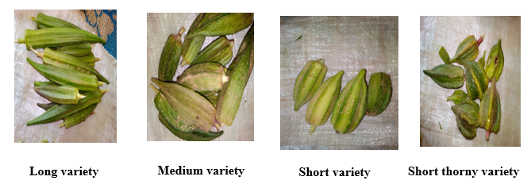

Photo 1 : differ in the shape of the okra fruits studied

Study site
The agro-morphological characterization was conducted over two years (2021 and 2022) during the rainy seasons at the experimental site of the Faculty of Agricultural Sciences of the University of Diffa located at INRAN in Diffa. This site is located between 13°18'53'‘north latitude and 12°35'45.08’' east longitude, at an altitude of 320 m (Figure 1). The average annual rainfall is 516.45 mm over 36 days, with an average annual temperature of 27.4°C recorded in 2022; and the average annual rainfall recorded in 2021 was 345.4 mm over 22 days, with an average annual temperature of 27.69°C. The climate is hot and dry, and the soil at the site is sandy, alkaline, and low in clay, with poor water retention. It is less rich in minerals.
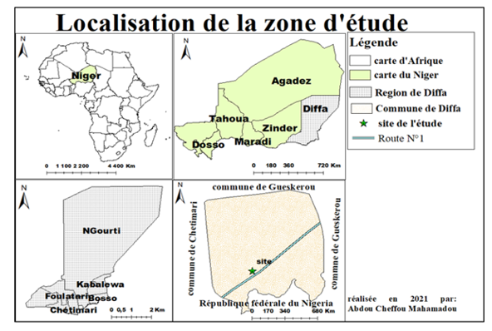
Figure 1: Map of the study area
Experimental design
The trial was set up on an area of 269.1 m² using a block experimental design (Fisher) with 4 replicates (blocks) and 4 treatments (Figure 2). The basic plots have an area of 1.25m² (2.5m x 0.5m). The blocks have an area of 4.4m² and are separated by a 1m aisle, while two consecutive plots are 0.8m apart. In each plot, the holes are spaced 0.5 m apart. Each repetition contains the four varieties of okra. The seeds for each variety were sown randomly by repetition. Two (2) seeds were placed in each hole at a depth of 3 cm. Each elementary plot is represented by twelve (12) plants divided into two (2) rows (with six (6) holes per row). This gives 192 individuals per variety, or 768 individuals in total for all varieties.

Crop management, development cycle
All varieties were sown on the same day, June 17 for 2021 and June 20 for 2022. The seeds were sown in rows with two seeds per hole by hand. The first plowing took place fifteen (15) days after sowing and the second plowing twenty-one (21) days after the first plowing. Harvesting began 67 days after sowing for fruits that were already dry, and much earlier for fruits that were not dry (from the 50th day after sowing). They were made with pruning shears after the fruits had dried on the plants. This species develops after germination. When lifted, it has three (3) branches, which in turn produce other branches, and so on. The branches continue to multiply until the end of flowering. The okra flowers turn into fruit. When ripe, the okra changes color from green to yellowish, and the leaflets begin to dry out and then gradually fall off until the plant is fully mature.
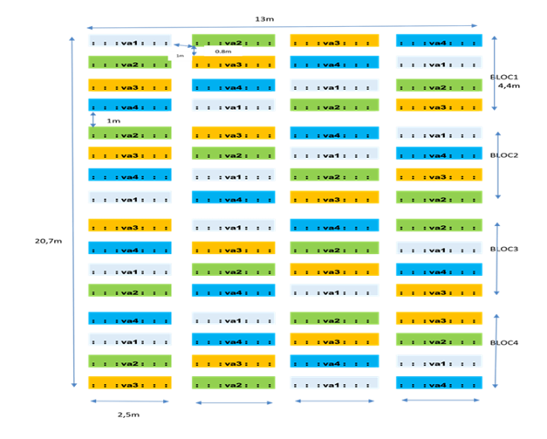
Figure 2: Experimental design

Data collected analysis
The data was entered into an Excel spreadsheet, then we used Minitab 18 and XLSTAT-Pro Version 7.5.2 software to analyze the data. For all of these traits, genetic parameters were estimated based on the components of the analysis of variance. Genotypic and phenotypic variances (VG and VP), genotypic and phenotypic coefficients of variation (GCV and PCV), broad-sense heritability (H2), and expected genetic gain (GA) were calculated using the formulas used by Johnson et al. (1955), Assefa et al. (2001), Rex (2002), Hosseini et al. (2012), and Sawadogo et al. (2014) and presented in Table 2.
Measured characters
The different parameters measured are: height at flowering (HpF), plant height at maturity (HpM); stem diameter (DiaT), number of branches (NR), number of leaves (NFe), number of lobes on the fruit (NLFr), petiole length (LPe), number of fruits on the branch (NFrR), number of seeds per fruit (NGrFr), number of fruits on the main axis (NFrAP), number of fruits on the plant (NFrP), fruit length (LFr), fruit width (LaFr), seed weight per fruit (PGrFr), fruit weight (PFr), and weight of 1000 seeds (PGr).
Table 2: Formula for estimating genetic parameters
Parameters | Formulas | Significance of terms
Genotypic Variance (VG) | VG= (CMG-CME)/r | CMG: Medium Square of Genotypes  CME: Mean Square Error  r: Number of replications
Phenotypic Variance (VP) | VP=VG+ (CME/r) =CMG/r
Héritability VG=(CMG-CME)/r | H² (%) = (VG/VP) × 100
Genotypic Variation Coefficient (CVG) | CVG (%) = (√VG/X) × 100 | √VG: standard deviation  of genotypic variance  √VP: standard deviation of phenotypic variance  I: Constant with a selection of 5%, I equals 2.06 X: is the average
Phenotypic Variation Coefficient (CVP) | CVP (%) = (√VP/X) × 100
Expected genetic progress (PG) | PGA = H² × √VP × I
Expected genetic progress as a percentage (% ) of the average. | PGA (% Moyenne) = (PG/X) × 100

Results
The results of the descriptive statistics show a significant difference between the minimum and maximum values; the minimum ranges from (0.063 to 44.06) and the maximum ranges from (2.24 to 119.38); the mean ranges from (1.69 to 74.80) and the coefficient of variation ranges from (11.50 to 89.57). The mean squares provided by the analysis of variance show highly significant differences for all parameters except for stem diameter and fruit width (Table 3).
Parameters | Minimum | Maximum | Mean (X) | Mean Square of Genotype | Mean Square of Error | CV (%)
HpF | 27.20 | 75.55 | 52.48 | 2557.73*** | 41.90 | 24.23
HpM | 30.00 | 79.28 | 55.59 | 2651.25*** | 40.26 | 23.08
DiaT | 1.3275 | 2.2450 | 1.6989 | 0.04007^{ns} | 0.03809 | 11.50
NR | 0.125 | 5.190 | 2.126 | 45.18*** | 0.1314 | 70.96
Nfe | 7.938 | 22.125 | 14.573 | 164.87*** | 1.898 | 21.33
NLFr | 4.406 | 13.377 | 8.350 | 93.34*** | 0.4499 | 26.44
LPe | 5.090 | 18.538 | 10.380 | 183.62*** | 2.117 | 31.60
NFrR | 0.063 | 5.063 | 1.689 | 43.91*** | 0.2067 | 89.57
NGrFr | 44.06 | 119.38 | 74.80 | 5654.21*** | 70.98 | 24.54
NFrAP | 1.875 | 7.250 | 3.598 | 28.41*** | 0.3287 | 35.88
NFrP | 2.940 | 10.375 | 5.323 | 8.74*** | 1.043 | 22.31
LFr | 4.520 | 24.262 | 14.571 | 601.63*** | 6.210 | 40.35
LaFr | 1.5875 | 3.2225 | 2.1861 | 0.17^{ns} | 0.07243 | 12.71
PGrFr | 2.375 | 7.500 | 4.544 | 40.80*** | 0.3112 | 32.93
PFr | 6.063 | 27.065 | 13.991 | 805.60*** | 6.864 | 47.89
PGr | 36.00 | 78.50 | 54.23 | 1647.50*** | 31.88 | 19.24
Note: HpF: height at flowering. HpM: height of the plant at maturity DiaT: stem diameter. NR: number of branches. NFe: number of leaves. NLFr: number of lobes on the fruit. LPe: petiole length. NFrR: number of fruits on the branch. NGrFr: number of seeds per fruit. NFrAP: number of fruits on the main axis. NFrP: number of fruits on the plant. LFr: fruit length. LaFr: fruit width. PGrFr: seed weight per fruit. PFr: fruit weight. PGr: weight of 1000 seeds. *: significant difference at 5%; **significant difference at 1%; NS: not significant; ***: highly significant; MCG: mean square of genotype; MCE: mean square of error; CV: coefficient of variation
Table 3: Analysis of variance of the 16 quantitative characteristics of the okra varieties studied

Structuring the agromorphological variability of okra varieties in Niger
The results of the principal component analysis show that the first four axes accounted for 86.7% of the total for all parameters studied (Table 4), with 64.9% for axis 1, 12.1% for axis 2, 5.9% for axis 3, and 5.6% for axis 4 (Table 4). All of the parameters studied have an eigenvalue ranging from 1.010 to 11.677. None of the parameters studied correlated with axis 1; the second axis correlated with the number of leaves (NFe); the number of fruits per plant (NFrP); fruit width (LaFr); fruit length (LFr); grain weight (PGr); the third axis correlated with main stem diameter (DiaT); fruit width (LaFr); fruit length (LFr); and the fourth axis correlated with main stem diameter (DiaT); number of fruits per plant (NFrP); fruit width (LaFr); fruit length (LFr). Furthermore, the results of the principal component analysis and ascending hierarchical classification showed that agromorphological diversity was structured into four groups based on fourteen (14) discriminating variables grouped into vegetative growth variables, variety cycle, and variables related to fruit yield parameters and their components (Figure 3 and Figure 4).
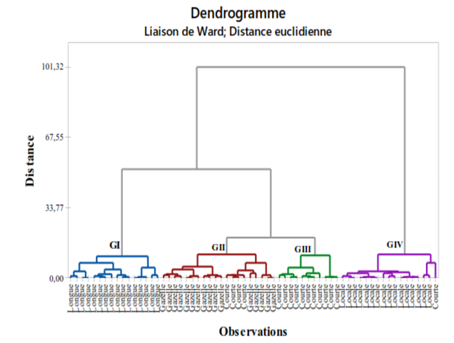
Figure 3: Dendrogram showing the relationships between the okra varieties studied
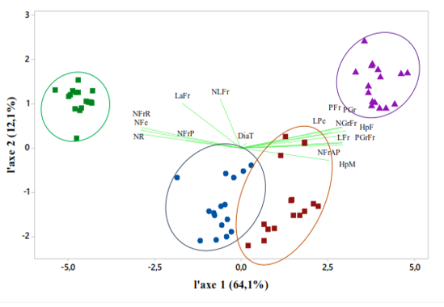
Figure 4: Structuring variability through Principal Component Analysis (PCA) of different varieties based on their characteristics
Table 4: Eigenvalue and percentage of variation expressed by the first four axes.
Principal components | F1 | F2 | F3 | F4
Eigenvalue | 11.677 | 1.861 | 1.063 | 1.010
Total variance (%) | 64.9 | 12.1 | 5.9 | 5.6
Cumulative total variance (%) | 64.9 | 75.2 | 81.1 | 86.7
HpF | 0.254 | 0.033 | -0.015 | -0.208
HpM |  | 0.048 | -0.008 | -0.206
  0.255
DiaT |  | -0.122 | 0.787* | -0.526*
  0.026
NR |  | 0.086 | 0.020 | -0.022
  -0.278
Nfe |  | 0.308* | 0.030 | -0.065
  -0.241
NLFr |  | 0.247 | 0.028
  -0.265
  -0.054
LPe |  | 0.160 | 0.081 | 0.064
  0.256
NFrR |  | 0.214 | -0.040 | -0.166
  -0.265
NGrFr |  | 0.194 | 0.092 | -0.014
  0.252
NFrAP |  | 0.200 | -0.227 | 0.056
  0.256
NFrP |  | 0.486* | -0.208 | -0.370*
  -0.099
LFr |  | 0.317* | 0.501* | 0.670*
  -0.004
LaFr |  | 0.317* | 0.501* | 0.670*
  -0.004
PGrFr |  | 0.155 | -0.026 | -0.078
  0.267
PFr |  | 0.179 | -0.018 | -0.035
  0.263
PGr |  | 0.312* | 0.097 | 0.007
  0.215
Note: HpF: height at flowering, HpM: height of the plant at maturity DiaT: stem diameter, NR: number of branches, NFe: number of leaves, NLFr: number of lobes on the fruit, LPe: petiole length, NFrR: number of fruits on the branch, NGrFr: number of seeds per fruit, NFrAP: number of fruits on the main axis, NFrP: number of fruits on the plant, LFr: fruit length, LaFr: fruit width, PGrFr: seed weight per fruit, PFr: fruit weight, PGr: weight of 1000 seeds,*: significant difference at 5%; **significant difference at 1%; NS: not significant; ***: highly significant; MCG: mean square of genotype; MCE: mean square of error; CV: coefficient of variation

Genotypic variance (GV) and phenotypic variance (PV): The results of the analysis (Table 5) show that for all parameters studied, phenotypic variance is greater than genotypic variance. Phenotypic variance ranges from 0.01 to 1413.55 and genotypic variance ranges from 0.0005 to 1395.81. The number of seeds per fruit has the highest phenotypic and genotypic variance, ranging from 1413.55 to 1395.81, and the diameter of the main stem has the lowest phenotypic and genotypic variance, ranging from 0.01 to 0.0005.
Genotypic (√VG) and phenotypic (√VP) coefficients of variation: For all parameters studied, phenotypic coefficients of variation are higher than genotypic coefficients of variation. Genotypic and phenotypic coefficients of variation are low below 11%, medium between 11% and 20%, and high above 20% (Govindaraj et al., 2011) cited by de Ryck S et al., (2003).
Parameters: stem diameter (0.02–0.10), number of branches (3.36–3.36), number of leaves (6.38 6.42), number of lobes on the fruit (4.82 4.83), petiole length (6.74 6.78), number of fruits on the branch (3.31 3.31), number of fruits on the main axis (2.65 2.67), number of fruits on the plant (1.39 1.48), fruit width (0.16 0.21), seed weight per fruit (3.18 3.19) have low genotypic and phenotypic coefficients of variation, the parameters fruit length (12.20 12.26) and fruit weight (14.13 14.19) have the average genotypic and phenotypic coefficient of variation. The parameters plant height at flowering (25.08 25.29), plant height at maturity (25.08 25.29), weight of 1000 seeds (20.10 20.29), and number of seeds per fruit (37.36 37.60) have a high coefficient of variation (Table 5).
Heritability in the broad sense: Heritability varies from 4.94% to 99.71%. Heritability is considered high above 50%, low below 20%, and average between 20% and 50%, according to Johnson (1955) and Stanfield (1975). Therefore, heritability is high for all parameters studied except for main stem diameter (4.94%) (Table 5).
Expected Genetic Progress (EGP): this varies between (0.01) for stem diameter and (76.24) for number of seeds per fruit. It is low for all parameters studied except fruit length (25.00), fruit weight (28.99), plant height at flowering (51.24), plant height at maturity (51.23), weight of 1,000 seeds (41.00), and number of seeds per fruit (76.48). (Table 5).
Expected genetic progress as a percentage of the mean (PGA%): it varies (0.60) for stem diameter and the number of fruits per branch (402.22); it is high for all parameters except stem diameter (0.60) and fruit width (11.36) (Table 5).

Table 5: Calculated genetic parameters of okra varieties studied in Diffa, Niger.
Variable | VG | VP | H² (%) | √VG | √VP | CVG (%) | CVP (%) | PGA | PGA (%)
HpF | 628.96 | 639.43 | 98.36 | 25.08 | 25.29 | 47.79 | 48.18 | 51.24 | 97.63
HpM | 652.75 | 662.81 | 98.48 | 25.55 | 25.75 | 45.96 | 46.31 | 52.23 | 93.96
DiaT | 0.00 | 0.01 | 4.94 | 0.02 | 0.10 | 1.31 | 5.89 | 0.01 | 0.60
NR | 11.26 | 11.30 | 99.71 | 3.36 | 3.36 | 157.86 | 158.09 | 6.90 | 324.72
Nfe | 40.74 | 41.22 | 98.85 | 6.38 | 6.42 | 43.80 | 44.05 | 13.07 | 89.71
NLFr | 23.22 | 23.34 | 99.52 | 4.82 | 4.83 | 57.71 | 57.85 | 9.90 | 118.60
LPe | 45.38 | 45.91 | 98.85 | 6.74 | 6.78 | 64.90 | 65.27 | 13.80 | 132.91
NFrR | 10.93 | 10.98 | 99.53 | 3.31 | 3.31 | 195.72 | 196.18 | 6.79 | 402.22
NGrFr | 1395.81 | 1413.55 | 98.74 | 37.36 | 37.60 | 49.95 | 50.26 | 76.48 | 102.24
NFrAP | 7.02 | 7.10 | 98.84 | 2.65 | 2.67 | 73.65 | 74.08 | 5.43 | 150.84
NFrP | 1.93 | 2.19 | 88.08 | 1.39 | 1.48 | 26.07 | 27.78 | 2.68 | 50.40
LFr | 148.86 | 150.41 | 98.97 | 12.20 | 12.26 | 83.73 | 84.17 | 25.00 | 171.60
LaFr | 0.03 | 0.04 | 58.05 | 0.16 | 0.21 | 7.24 | 9.50 | 0.25 | 11.36
PGrFr | 10.12 | 10.20 | 99.24 | 3.18 | 3.19 | 70.02 | 70.29 | 6.53 | 143.68
PFr | 199.68 | 201.40 | 99.15 | 14.13 | 14.19 | 101.00 | 101.43 | 28.99 | 207.17
PGr | 403.91 | 411.88 | 98.06 | 20.10 | 20.29 | 37.06 | 37.42 | 41.00 | 75.60

Average performance of different okra varieties
The analysis of variance based on the comparison of the means of the different parameters by variety shows highly significant differences for the four varieties for all parameters studied except for stem diameter and fruit width (P=0.376) and P=0.078) (Table 6).
Table 6: Average performance of the different okra varieties studied
Parameters | Collection |  |  | Grouping of varieties |  |  |  | Probability
 | Mean | Minimum | Maximum | Long | Gazelle | Short | Local | P (value)
HpF | 52.48 | 27.20 | 75.55 | 67.54a | 56.67b | 47.81c | 37.87d | 0.000
HpM | 55.59 | 30.00 | 79.28 | 71.08a | 59.82b | 50.46c | 41.002d | 0.000
DiaT | 1.6989 | 1.3275 | 2.2450 | 1.712a | 1.657a | 1.764a | 1.663a | 0.376
NR | 2.126 | 0.125 | 5.190 | 0.310a | 1.880b | 1.937b | 1.380a | 0.000
Nfe | 14.573 | 7.938 | 22.125 | 12.372b | 13.161b | 13.419b | 19.342a | 0.000
NLFr | 8.350 | 4.406 | 13.377 | 6.341a | 7.521b | 7.676b | 11.861a | 0.000
LPe | 10.380 | 5.090 | 18.538 | 15.134a | 9.782b | 9.494b | 7.112C | 0.000
NFrR | 1.689 | 0.063 | 5.063 | 0.227c | 1.199b | 1.269b | 4.070a | 0.000
NGrFr | 74.80 | 44.06 | 119.38 | 101.736a | 71.329b | 67.913b | 5.212c | 0.000
NFrAP | 3.598 | 1.875 | 7.250 | 5.398a | 3.648b | 3.102c | 2.242d | 0.000
NFrP | 5.323 | 2.940 | 10.375 | 5.329b | 4.853b | 4.745b | 6.364a | 0.000
LFr | 14.571 | 4.520 | 24.262 | 20.685a | 18.182b | 12.452c | 6.962d | 0.000
LaFr | 2.1861 | 1.5875 | 3.2225 | 2.256a | 2.141a | 2.061a | 2.284a | 0.078
PGrFr | 4.544 | 2.375 | 7.500 | 6.605a | 4.898b | 3.757c | 2.914d | 0.000
PFr | 13.991 | 6.063 | 27.065 | 23.904a | 13.219b | 11.7b | 7.14c | 0.000
PGr | 54.23 | 36.00 | 78.50 | 69.375a | 49.781b | 49.968b | 47.781b | 0.000

Discussion
The mean squares (Table 1) revealed highly significant differences between varieties for the parameters studied. These highly significant differences indicate the presence of significant genetic variability for the variables. This result is consistent with that of (Chaudhry et al., 2003); Idi-Saidou et al., 2019 on 357 global collections of okra varieties studied at ICRISAT in Niger and Asare et al., 2020. The phenotypic coefficients of variation are higher than the genotypic coefficients of variation for all parameters studied, but the small difference between the two coefficients shows that these traits are very little influenced by the environment, as indicated by (Singh et al., 2007; Lakshmana et al., 2009; Chand et al., 2008), Govindaraj et al., 2003; Bajaj and Phul (1982). Heritability estimates provide a measure of transmission and suggest that selection based on phenotypic traits and yield will be most effective for breeding. This result is consistent with those of Yassin and Anbu (1997), Dhall et al. (2000), Gandhi et al. (2001), Dhall et al. (2003), Patro and Sankar (2004), Khan et al. (2005), Dakahe et al. (2007), Manivannan et al. (2007), Kumar et al. (2007), Singh (2006), and Pal et al. (2010). The study showed a small difference between the values of the two variances for all traits, consistent with the findings of Sawadogo et al. (2014), who stated that this would indicate a low influence of the environment on the expression of traits and greater genetic control over their expression. Generations depend mainly on the extent of hereditary consistency in the performance of offspring in successive families relative to the base population, which helps breeders control the degree of variation. The genetic gain and genetic progress obtained show a highly significant difference compared to that obtained by (Idi-Saidou et al., 2024) on the estimation of genetic parameters for tiger nuts. Genetic progress refers to the improvement in the average genotypic values of certain traits from one generation to the next and the selection of offspring from the previous generation (Singh and Narayanan; 1993). The genetic gain and genetic progress achieved show a highly significant difference compared to that obtained by (Idi Saidou et al., 2024) on the estimation of genetic parameters of cultivated large-seeded and small-seeded tiger nuts and wild tiger nuts studied in Niger.

Conclusion
The study showed that there is considerable agronomic and morphological variability among okra varieties in terms of vegetative characteristics and yield. Analysis of variance showed a highly significant difference between long, short, medium, and local varieties. The estimation of genetic parameters also revealed a weak influence of environmental factors on the expression of traits, which resulted in small differences between phenotypic and genotypic coefficients of variation. The parameters evaluated concerning yield and morphology have high heritability and genetic progress, so they could be exploited in breeding programs. The various parameters studied can be used as criteria for improving okra varieties through the use of innovative new technologies such as molecular scissors (the revolutionary CRISPR_Cas9 technique) or gene drive technology.

References
Asare, P. A., Kpankpari, R., Adu, M. O., Afutu, E., & Adewumi, A. S. (2020). Phenotypic Characterization of Tiger Nuts (Cyperus esculentus L.) from Major Growing Areas in Ghana. The Scientific World Journal. https://doi.org/10.1155/2020/7232591
Assefa, K., Tefera, H., Merker, A., Kefyalew, T., & Hundera, F. (2001). Variability, heritability and genetic advance in pheno-morphic and agronomic traits of tef [Eragrostis tef (Zucc.) Trotter] germplasm from eight regions of Ethiopia. Hereditas, 134, 103-113. https://doi.org/10.1111/j.1601-5223.2001.00103.x
Charrier, A. (1983). Etude des ressources génétiques du genre Abelmoschus Med. (Gombo). Conseil International des Ressources Phytogénétiques. https://horizon.documentation.ird.fr/exl-doc/pleins_textes/pleins_textes_6/colloques2/010000000.pdf
Dakahe, K., Patil, H. E., & Patil, S. D. (2007). Genetic variability and correlation studies in Okra (Abelmoschus escutentus (L) Moench.). The Asian Journal of Horticulture, 2(1), 201-203. https://www.hindagrihorticulturalsociety.com/
De Ryck, S., Reheul, D., De Riek, J., De Keyser, E., & De Cauwer, B. (2023). Genetic and Morphological Variation of Belgian Cyperus esculentus L. Clonal Populations and Their Significance for Integrated Management. Agronomy, 13(2), 572. https://doi.org/10.3390/agronomy13020572
Dhall RK, Arora SK,Rani M. 2003. Studies on variability, heritability and genetic advance of advance generations Indian Journal of Horticulture, 57(5) : 342-346.
Dhall RK, Arora SK,Rani M .2000. Correlation and path analysis in advanced generations of okra (Abelmoschus esculentus (L.) Moench). Indian Journal of Horticulture, 57(4) : 342-346.
Direction des Statistiques / Ministère du Développement Agricole. (2008). Annuaire Statistique du Niger 2008-2012. Ministère du Développement Agricole, Niger. https://www.reca-niger.org/spip.php?article1000
Gandhi, HT, Yadav MD, Navale PA. 2001. Studies on variability in okra (Abelmoschus esculentus ( L.) Moench ). Journal of Maharashtra Agricultural University, 27(1) : 110-112.
Govindaraj, M., Selvi, B., Rajarathinam, S., & Sumathi, P. (2011). Genetic variability and heritability of grain yield components and grain mineral concentration in India's pearl millet (Pennisetum glaucum (L) R. Br.) accessions. African Journal of Food, Agriculture, Nutrition and Development, 11(3), 4758–4771. https://oar.icrisat.org/id/eprint/700/
Hamon, S., & Charrier, A. (1997). Les gombos. In A. Charrier, M. Jacquot, S. Hamon, & D. Nicolas (Eds.), L'amélioration des plantes tropicales (pp. 313-333). CIRAD; ORSTOM. https://horizon.documentation.ird.fr/exl-doc/pleins_textes/divers10-01/010012932.pdf
Hamon, S. (1988). Organisation évolutive du genre Abelmoschus (gombo) : co-adaptation et évolution de deux espèces de gombo cultivées en Afrique de l'Ouest (A. esculentus et A. caillei). ORSTOM, Travaux et Documents Microédités 46. https://horizon.documentation.ird.fr/exl-doc/pleins_textes/divers10-06/25056.pdf
Hosseini, S. J., Sarvestani, Z. T., Pirdashti, H., Afkhami, A., & Hazrati, S. (2012). Estimation of heritability and genetic advance for screening some rice genotypes at salt stress conditions. International Journal of Agronomy and Plant Production, 3(11), 475-482. http://www.ijappjournal.com
Idi-Saidou, S., Haougui, A., Issaka, S. O., Kumar, S., Ali, M., & Bakasso, Y. (2021). Screening of okra (Abelmoschus species) genotype for resistance to root-knot nematodes (Meloidogyne species). African Journal of Agricultural Research, 17(1), 173-188. https://doi.org/10.5897/AJAR2019.14175
Idi-Saidou S. 2009. Criblage de génotypes de gombo (Abelmoschus spp.) Pour leur résistance aux nématodes (Meloidogyne spp.). Diplôme d’Etudes Approfondies (D.E.A) en Biologie Appliquée, Option : « Protections et Restaurations des Ecosystèmes Soudaniens et Sahélo Sahariens » Université Abdou Moumouni de Niamey 77 p.
Sani, I. S., Grema, M., Sanjeet, K., Yacoubou, B., & Mahamane, A. (2019). Regeneration and Preliminary Characterization of Asian and African Okra (Abelmoschus spp.) Germplasm. European Scientific Journal. https://doi.org/10.19044/esj.2019.v15n6p21
Inès N, Wendkûni P. 2014. Réponse de variété de Gombo (abelmoschus esculentus aux engrais chimiques et à la fumure organique, université polytechnique de Bobo-Dioulasso, diplôme de master en production végétale, p.64
JIRO H, SAWADOGO M, MILLOGO J. 2011. « Caractérisations agro morphologique et anatomique du gombo du Yatenga et leur lien avec la nomenclature locale des variétés », Sciences & Nature Vol. 8, N°1, pp. 23-36
Johnson, H. W., Robinson, H. F., & Comstock, R. E. (1955). Estimates of genetic and environmental variability in soybeans 1. Agronomy Journal, 47(7), 314-318. https://doi.org/10.2134/agronj1955.00021962004700070009x
Koechlin, J. (1989). *Les gombos africains (Abelmoschus spp.) : Etude de la diversité en vue de l'amélioration* [Doctoral dissertation, Institut National Agronomique. Paris-Grignon, France]. https://core.ac.uk/download/pdf/39914000.pdf
Khan SH, Ahmed N, Jabeen N. 2005. Variability and correlation studies in okra (Abelmoschus esculentus ( L. ) Moench). Journal of Research, SKUAST-J, 4(2) : 179-183.
Kumar S, Bhargava L, Yadav JR, Mishra G, Yadav A, Parihar NS. 2007. Correlation coefficient analysis in okra (Abelmoschus esculentus (L.) Moench). Progressive Research, 2 (1/2) : 177-178.
Lapointe A. 1987. Plantes médicinales. Fiche Technique. 161 pp.
Marius C., Gerard V, Antoine G .1997, « Le gombo, Abelmosehus eseulentus (L.) Moench, une source possible de phospholipides », Agronomie et Biotechnologies, Oléagineux, corps gras, lipides, vol. 4 (5), pp. 389-392
Manivannan MI, Rajangam J, Geetharani P. 2007.Variation studies in okra. The Asian Journal of Horticulture, 2(2) : 188-191.
Nacoulma O.1996. Plantes médicinales et pratiques médicales traditionnelles au Burkina Faso. Cas du plateau central. Thèse d’état ; Tome I. Université de Ouagadougou 261p
Bosch, C. H., Siemonsma, J. S., Lemmens, R. H. M. J., & Oyen, L. P. A. (Eds.). (2002). Plant Resources of Tropical Africa / Ressources Végétales de l'Afrique Tropicale. Basic list of species and commodity grouping. PROTA Programme. https://edepot.wur.nl/1660547
Oyen LPN, Jemmens RHMJ., 2002. Ressources végétales de l’Afrique Tropicale. PROTA précurseur, ISBN 90-77114-03-3
Pal MK, Singh B, Kumar R, Singh SK. 2010. Genetic variability heritability and genetic advance in okra (Abelmoschus esculentus (L.) Moench). Environment and Ecology, 28(1A) : 469-471.
PhaniKrishna M, Hameedunnisa B, Rao MA, Kumar SN. 2010. Vegetable Research Station,Agriculture Research Institute, Rajendranagar, Hyderabad-30, APHU, (A.P.), India.Department of Horticulture, College of Agriculture, ANGRAU, Rajendranagar, Hyderabad - 30 (A.P.), India.²NBPGR, Regional Station, Rajendranagar, Hyderabad - 30 (A.P.), India
Patro TS, Kumar KK, Sankar CR.2004. Genetic variability and multivariate analysis in okra (Abelmoschus esculentus (L.) Moench). Tropical Agricultural Research, 16 : 99113
Bernardo, R. (2002). *Breeding for quantitative traits in plants*. Stemma Press. https://stemmapress.com/
Sawadogo, N., Nebié, B., Kiébré, M., Bationo Kando, P., Nanema, K. R., Traoré, R. E., Naoura, G., Sawadogo, M., & Zongo, J. D. (2014). Caractérisation agromorphologique des sorghos à grains sucrés (Sorghum bicolor (L.) Moench) du Burkina Faso. International Journal of Biological and Chemical Sciences, 8(5), 2183-2197. https://doi.org/10.4314/ijbcs.v8i5.22
Singh AK, Ahmed N, Narayan R, Chatoo MA. 2007. Genetic variabiity; correlation and path coefficient analysis in okra (Abelmoschus esculentus (L.) Moench). Under kashmir condition.Indian Journal of horticulture 2007 ; 64(4) 472 –474
Singh P, Narayanan SS.1993. Biometrical techniques in plant breeding. Kalyani publishers, Ludhiana, India: pp-195.
Stansfield, W. D. (1969). Genetics. McGraw-Hill.
Thompson, H. C., & Kelly, W. C. (1957). Vegetable crops. McGraw-Hill Book Co. https://books.google.com/books/about/Vegetable_Crops.html?id=2_0RAAAAYAAJ
Yasin GM, Anbu S.1997. Variability Studies in Bhendi. South Indian Horticulture, 45(1&2) : 13-15.

