Exploring Social Media Utilization among Farmer Producer Organization Members in Jharkhand

ABSTRACT
The rapid growth of digital technologies has transformed agricultural communication, with social media emerging as an important medium for information exchange, networking and knowledge dissemination. This study was conducted to analyse the usage patterns of social media among Farmer Producer Organization (FPO) members in Jharkhand, focusing on the purposes, frequency and timing of use across different platforms. A total of 180 respondents were selected from six FPOs across three agro-climatic zones of the state using simple random sampling. Data were collected with a structured interview schedule and analysed using descriptive statistics. The results indicated that WhatsApp and YouTube were universally used on a daily basis (100%), serving as the primary tools for communication, information sharing and agricultural skill development. YouTube was most preferred for information (96.7%) and entertainment (95.0%), while WhatsApp dominated in networking (40.0%) and information dissemination (92.8%). Other platforms such as Facebook, Instagram and Twitter played marginal roles, mostly for entertainment purposes, whereas LinkedIn and Messenger had negligible use. Evening and night hours (6:01–10:00 PM) emerged as the most common time for social media engagement. Despite widespread adoption, business and marketing applications of social media remained underutilized. The findings underscore the potential of social media as a tool for strengthening farmer collectivization and digital extension. However, targeted interventions are needed to enhance digital literacy, promote agri-business applications and develop localized content to fully harness its benefits. The study concludes that while social media has become integral to the lives of FPO members, its transformative potential in empowering farmers and improving market linkages remains largely untapped.
Keywords: Social media, Farmer Producer Organizations, Jharkhand, usage patterns, digital extension, agricultural communication
Introduction
In recent years, the proliferation of mobile technologies, improved internet access and affordable smartphones has transformed the way agricultural information is exchanged in rural India. The Social media platforms have emerged as important channels for farmers to access knowledge, share experiences and build networks (Kumar, 2023). These platforms allow for real-time dissemination of weather forecasts, market prices, pest and disease alerts and best management practices, which are critical for enhancing productivity and resilience among smallholders (Thakur and Chander, 2018). Farmer Producer Organizations (FPOs) are increasingly being recognized as a mechanism for collective action, resource pooling, better market linkages and improved agricultural growth in India. However, the effectiveness of FPOs heavily depends on how well their members access and use information. Social media, as a tool of digital or cyber extension, holds promise in improving knowledge flows within FPOs (Mukherjee et al., 2025). Yet, there is limited empirical evidence on how FPO members in less-developed agro-climatic zones, like Jharkhand, engage with different social media platforms in terms of frequency, purpose, timing and barriers. Some recent studies shed light on these usage patterns outside Jharkhand. In Punjab, a study among farming community members found that 66 percent of the respondents always used YouTube for agriculture-related information, while other tools like Kisan apps were used “always” or “sometimes” by substantial proportions (Joshi & Dhaliwal, 2020). In Haryana, farmers showed a preference for watching videos and connecting with peers, with YouTube, WhatsApp and Facebook ranking highest among platforms used, social variables like education, income and extension contact were significantly associated with usage levels (Mishra, Singh, Malik & Maurya, 2022). In another study in Uttarakhand, constraints such as lack of digital literacy, lack of awareness about useful apps/websites and limited infrastructure) were major hindrances, especially for older farmers and those with low formal education (Malik & Ansari, 2024). These findings imply that while social media has potential, actual usage patterns vary widely by purpose, platform, and user profile.
Jharkhand, with its varied topography, socio-economic diversity and relatively lower levels of infrastructure and literacy in some areas, represents a critical region for studying how FPO members use social media. Understanding how often and for what purposes these members use different platforms, when (time of day) and for what kind of agricultural functions (information, networking, marketing, skill development, etc.) can inform extension services, NGOs and policy makers aiming to strengthen digital inclusion and agricultural innovation.
Materials and Methods
The present study was carried out in the state of Jharkhand, which is divided into three agro-climatic zones: Central and North-Eastern Plateau (Zone IV), Western Plateau (Zone V) and South-Eastern Plateau (Zone VI). To ensure adequate representation, two Farmer Producer Organizations (FPOs) were randomly selected from each agro-climatic zone, covering the districts of Ramgarh, Lohardaga, Gumla, Saraikela Kharsawan and West Singhbhum. Thus, a total of six FPOs were included in the study. From each FPO, 30 respondents were chosen through simple random sampling, making a total sample size of 180 respondents. An exploratory cum ex-post facto research design was employed, as the independent variables had already occurred and could not be manipulated by the researcher. The primary data were collected during 2023–24 using a structured interview schedule, which was pre-tested and refined before administration. Personal interviews were conducted with the respondents to ensure clarity and completeness of responses. The dependent variable, namely the usage pattern of social media, was measured in terms of purpose, frequency, timing and extent of agricultural information use. Independent variables such as age, caste, education, family size, income, occupation, social participation, economic motivation, extension contact, IT savviness, mass media exposure and innovation proneness were also captured to provide background profiles of respondents. The data were systematically coded, tabulated and analyzed using descriptive statistics such as frequency, percentage, mean and standard deviation to depict patterns and trends.
Results
Purpose of Social Media Use
The results revealed that respondents utilized social media for multiple purposes, including entertainment, information, networking, business and agricultural skill enhancement. According to Table-1, YouTube emerged as the most dominant platform, with 95.0 percent of respondents using it for entertainment, 96.7 percent for acquiring information, and 56.7 percent for agricultural skill development. In contrast, WhatsApp was extensively used for communication and information sharing (92.8%) as well as networking (40.0%), reflecting its utility in group interactions within FPOs. Facebook was mainly preferred for entertainment (46.7%) but had very limited use in agricultural domains (6.1%). Other platforms such as Instagram, Twitter, Telegram, Messenger and LinkedIn were used marginally, mostly for non-agricultural purposes. These findings suggest that FPO members prioritize platforms that provide either rich multimedia content (YouTube) or fast, peer-to-peer communication (WhatsApp).
Table 1. Purpose of Social Media Use by FPO Members
Platform | Entertainment (%) | Information (%) | Networking (%) | Business (%) | Skill Enhancement (%)
YouTube | 95.0 | 96.7 | 15.0 | 10.6 | 56.7
WhatsApp | 65.6 | 92.8 | 40.0 | 18.3 | 21.7
Facebook | 46.7 | 28.3 | 10.0 | 7.8 | 6.1
Instagram | 20.6 | 12.2 | 8.3 | 4.4 | 3.9
Twitter | 5.0 | 6.1 | 2.8 | 2.2 | 1.1
Telegram | 3.3 | 3.3 | 1.1 | 0.6 | 0.6
Messenger | 2.8 | 2.2 | 1.7 | 0.6 | 0.0
LinkedIn | 0.6 | 0.6 | 0.6 | 0.0 | 0.0

Fig .1
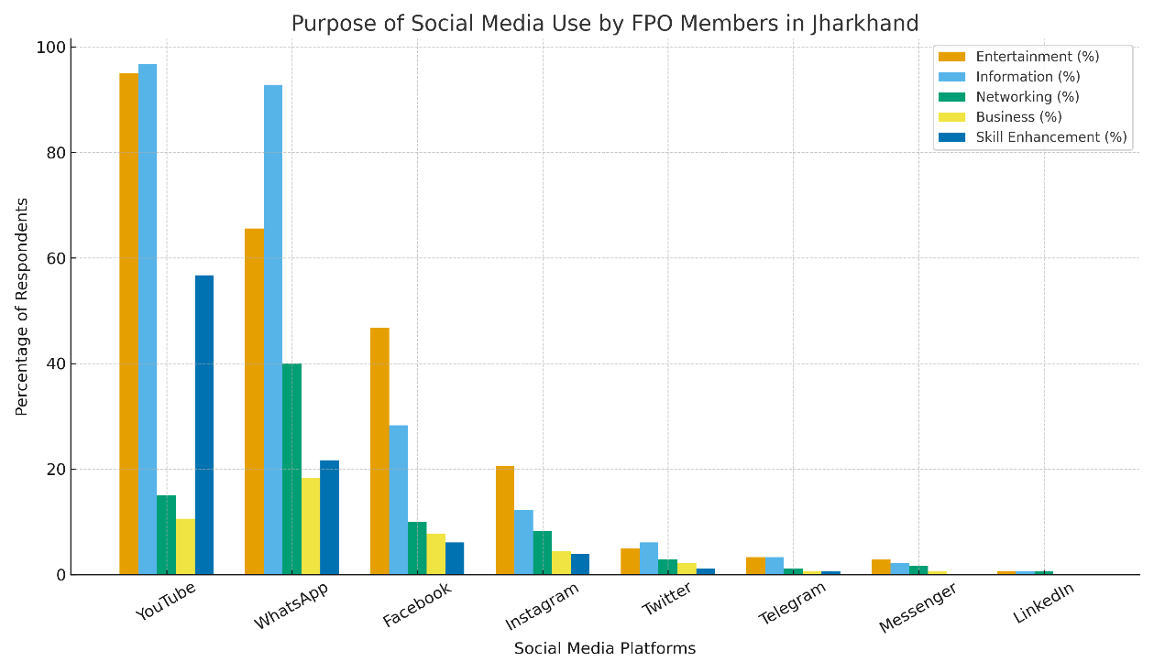

Frequency of Social Media Use
Aa depicted in table -2, analysis of frequency indicated that WhatsApp and YouTube were universally used on a daily basis by 100% of respondents, highlighting their indispensability in day-to-day communication and information exchange. In contrast, Facebook was used daily by only 8.3% of respondents and weekly by 42.8 percent. Instagram had 12.2 percent daily users and 36.1 percent weekly users, while Twitter was used daily by 2.8 percent and weekly by 10.6 percent. Other platforms such as Telegram, Messenger and LinkedIn had negligible regular usage, indicating their minimal role in the communication ecosystem of FPO members.
Table 2. Frequency of Social Media Use by FPO Members
Platform | Daily Use (%) | Weekly Use (%)
WhatsApp | 100.0 | 0.0
YouTube | 100.0 | 0.0
Facebook | 8.3 | 42.8
Instagram | 12.2 | 36.1
Twitter | 2.8 | 10.6
Telegram | 1.1 | 2.8
Messenger | 1.7 | 2.2
LinkedIn | 0.6 | 0.6

Timing of Social Media Use
The timing of social media usage as depicted in table-3, showed a distinct patterns. The night hours (6:01–10:00 PM) were the most preferred time for using social media, with WhatsApp (93.9%), YouTube (85.6%), and Facebook (49.4%) being accessed heavily during this period. Morning use was also significant, with WhatsApp showing high levels of activity (88.9%), followed by YouTube (66.7%). Noon and afternoon usage remained comparatively low across platforms, suggesting that farmers mostly engage with digital platforms after completing their agricultural and household activities.
Table 3. Timing of Social Media Use by FPO Members
Platform | Morning (%) | Afternoon (%) | Evening (%) | Night (%)
WhatsApp | 88.9 | 40.0 | 55.0 | 93.9
YouTube | 66.7 | 28.9 | 48.3 | 85.6
Facebook | 20.0 | 15.0 | 28.3 | 49.4

Use of E-Gadgets
The majority of respondents relied primarily on smartphones as their medium for accessing social media. A smaller fraction used laptops or desktops, mostly limited to younger or better-educated respondents with higher IT savviness. The dominance of smartphones underscores their role as the primary gateway for rural communities into digital communication and agricultural knowledge systems.
Overall Usage Pattern Index
An overall analysis categorized respondents into three groups viz., low, medium and high levels of social media use. The results indicated that a majority of FPO members fell under the medium category of social media usage, followed by those in the high category. Very few respondents exhibited low levels of usage, suggesting that digital penetration among FPO members in Jharkhand is substantial, though intensity varies by platform and purpose.
Discussion
The study reveals that WhatsApp and YouTube dominate the social media landscape among FPO members in Jharkhand, with 100 percent of respondents using these platforms daily. This dominance can be attributed to WhatsApp’s group-based messaging and ease of use, and YouTube’s video-based content delivery, which provides easily understandable agricultural information. These findings align with Mishra et al. (2022), who observed that video viewing and peer-to-peer chatting were the most preferred online activities among farmers, with YouTube, WhatsApp, and Facebook ranking highest in usage.
The timing of use, predominantly in the evening hours, reflects farmers’ daily routines, wherein agricultural and household activities dominate the daytime, leaving evenings for social engagement. This pattern corroborates earlier findings by Ahmad et al. (2018), who noted that rural users typically allocate late evening hours for online activities due to work schedules and availability of leisure time.
The relatively lower usage of Facebook, Instagram and Twitter suggests that these platforms are perceived as less relevant for agriculture-oriented purposes. This contrasts with global studies, such as Zeng and Gerritsen (2014), which highlight Facebook’s role in fostering virtual communities and knowledge exchange. In the Indian context, however, limited digital literacy and preference for vernacular content restrict the adoption of such platforms for agricultural use (Malik & Ansari, 2024).
An important observation is the limited use of social media for business-related activities, with respondents using these platforms more for entertainment, information, and communication. This gap highlights the need for capacity-building initiatives to enhance digital marketing skills among FPO members. Joshi and Dhaliwal (2019) found that while farmers in Punjab widely used YouTube and WhatsApp for information, very few exploited platforms for e-commerce or online marketing. This underutilization reflects a broader challenge in integrating digital tools into agri-business contexts in rural India.
The heavy reliance on smartphones as the primary device for social media access reinforces their importance in rural connectivity. The studies conducted by Kumar (2023) also identified smartphones as the most significant enabler of digital extension services among smallholder farmers. However, challenges such as poor internet connectivity, lack of digital skills, and language barriers continue to limit optimal use (Hota and Verma, 2022).
Overall, the study confirms that social media has become an integral part of agricultural communication among FPO members in Jharkhand, though its potential in areas like market linkage, online transactions and entrepreneurship remains underutilized. The targeted interventions such as training on digital marketing, use of agriculture-specific apps and development of localized content could bridge these gaps and transform social media into a holistic tool for empowerment of FPOs.
Conclusion
The study on usage patterns of social media among Farmer Producer Organization (FPO) members in Jharkhand revealed that WhatsApp and YouTube are the most widely and frequently used platforms, serving as indispensable tools for communication, information sharing and agricultural skill enhancement. Most members accessed these platforms daily, particularly during evening hours, reflecting their integration into farmers’ daily routines. While Facebook, Instagram and Twitter were also used, their role remained marginal and largely entertainment-focused. Smartphones were the primary medium for access, highlighting their importance in bridging digital gaps in rural areas.
Despite significant penetration, social media’s potential in strengthening business linkages and supporting digital marketing remains underutilized among FPO members. This underscores the need for targeted interventions such as digital literacy programs, training in agri-business promotion and the development of localized agricultural content. With proper capacity building and institutional support, social media can evolve from being merely an entertainment and communication tool into a transformative instrument for collective marketing, entrepreneurship and sustainable livelihood enhancement in Jharkhand.

COMPETING INTERESTS DISCLAIMER:
Authors have declared that they have no known competing financial interests OR non-financial interests OR personal relationships that could have appeared to influence the work reported in this paper.

References
Ahmad, N., Hussain, S., & Munir, N. (2018). Social networking and depression among university students. Pakistan Journal of Medical Research, 57(2), 77-82. https://www.researchgate.net/profile/Nasir-Ahmad-19/publication/326112260_Social_Networking_and_Depression_among_University_Students/links/5b39e17a4585150d23ee1be3/Social-Networking-and-Depression-among-University-Students.pdf
Hota, J., & Verma, V. K. (2022). Challenges to Adoption of Digital Agriculture in India. In 2022 International Conference on Maintenance and Intelligent Asset Management (ICMIAM) (pp. 1-6). IEEE. https://ieeexplore.ieee.org/abstract/document/10147002
Joshi, D., & Dhaliwal, R. K. (2019). Utilization of social media by farming community: A case from Punjab state. Indian Journal of Extension Education, 57(1), 47-52. https://epubs.icar.org.in/index.php/IJEE/article/view/109260
Kumar, R. (2023). Farmers’ use of the mobile phone for accessing agricultural information in Haryana: An analytical study. Open Information Science, 7(1), 20220145. https://www.degruyterbrill.com/document/doi/10.1515/opis-2022-0145/html
Malik, A., & Ansari, M. A. (2024). Farmers’ use of social media and constraints faced: A study in Uttarakhand, India. Asian Journal of Agricultural Extension, Economics & Sociology, 42(8), 92-100. 10.9734/ajaees/2024/v42i82535
Mishra, A., Singh, J., Malik, J. S., & Maurya, A. S. (2022). Social media use profile of farmers in Haryana. Indian Journal of Extension Education, 58(3), 51-54. https://www.researchgate.net/profile/Ayush-Mishra-46/publication/361595438_Social_Media_Use_Profile_of_Farmers_in_Haryana/links/62be82527d27ac698c2a5009/Social-Media-Use-Profile-of-Farmers-in-Haryana.pdf
Mukherjee, A., Roy, S., Pradhan, K., Yadav, V. K., Shubha, K., Singh, D. K., ... & Das, A. (2025). Current challenges and solutions for sustainability of Farmers Producer Organisations through grassroots organisational ecosystem. CURRENT SCIENCE, 128(7), 699. https://www.researchgate.net/profile/Anirban-Mukherjee-7/publication/390574083_Current_challenges_and_solutions_for_sustainability_of_Farmers_Producer_Organisations_through_grassroots_organisational_ecosystem/links/67f4bedd9b1c6c487783c6d3/Current-challenges-and-solutions-for-sustainability-of-Farmers-Producer-Organisations-through-grassroots-organisational-ecosystem.pdf
Thakur, D., & Chander, M. (2018). Use of social media in agricultural extension: Some evidences from India. International Journal of Science, Environment and Technology, 7(4), 1334-1346. https://scholar.google.com/scholar?hl=en&as_sdt=0%2C5&q=Thakur%2C+D.%2C+%26+Chander%2C+M.+%282018%29.+Use+of+social+media+in+agricultural+extension%3A+Some+evidences+from+India.+International+Journal+of+Science%2C+Environment+and+Technology%2C+7%284%29%2C+1334-1346.&btnG=
Zeng, B., & Gerritsen, R. (2014). What do we know about social media in tourism? A review. Tourism management perspectives, 10, 27-36. https://doi.org/10.1016/j.tmp.2014.01.001

