Preliminary study of relationship between fruit flies and the bacterium Xantomonas citri pv. mangiferaeindicae, two major constraints on mango production in West Africa

.
ABSTRACT
Aims: The study aimed to shed light on the relationship between fruit flies and Xanthomonas citri pv. mangiferaeindicae.
Study design: It was carried out from early June to mid-July 2018 in four mango orchards and in the laboratory. The laboratory tests were performed at the Farako-Bâ research station located in Bobo-Dioulasso.
Methodology: Mangoes with fruit fly stings and/or bacterial canker symptoms were collected from mango orchards to analyze the coinfection of mangoes by fruit flies and the bacterium X. citri pv. mangiferaeindicae. Fruit flies were captured using food attractants (torula yeast and M3 bait station) to analyze their role in the dissemination of the bacterium. Tests were carried out to isolate the bacteria from the fruit fly samples, nutrient broth and torula solution using YPGA medium. The mango leaves were then infiltrated with the isolated strains to observe typical symptoms caused by the bacteria.
Results: Nine species of fruit flies from three genera (Bactrocera, Ceratitis and Dacus) were captured in mango orchards with food attractants. Among these species, Bactrocera dorsalis, Ceratitis cosyra and Ceratitis silvestrii emerged from mangoes infected with X. citri pv. mangiferaeindicae. On average, 49.66% to 91.66% of the mangoes infected with this bacterium were also attacked by fruit flies, depending on mango variety and symptom type. The severity of the attacks ranged from 42.50 to 210.21 pupae/kg infested mango (F value = 8.7; Pr (˃F) = .006). The pupae survived with a hatching rate of 68.21% to 74.98% (F value = 0.49; Pr (˃F) = .69). Coinfection of mangoes with fruit flies and the bacterium X. citri pv. mangiferaeindicae was therefore established. The bacterium X. citri pv. mangiferaeindicae was isolated from fruit flies captured manually.
Conclusion: Fruit flies can thus be considered passive vectors of the bacterium X. citri pv. mangiferaeindicae. More in-depth studies are needed to elucidate this situation.

Keywords: coinfection; Bactrocera dorsalis; Ceratitis cosyra; Xantomonas citri pv. mangiferaeindicae ; bacterial canker; insect vectors

1. INTRODUCTION
In Burkina Faso, the horticulture sector is dominated by mango, which comprises 58% of all orchards Ouédraogo, 2002). The major production areas include the west-centre and southwest parts of the country. The mango sector alone generates more than 40,000 jobs and contributes to 2.9% of the agricultural GDP (i.e., 0.5% of the national GDP), with a total added value of approximately $ 53,097,350 (Parrot et al., 2018). Approximately 300,000 tons of mangoes are produced each year on an area of 33,701 ha. Furthermore, the mango sector is a source of income and contributes significantly to the country's economy (Vayssières et al., 2012). However, insect pests and diseases, such as fruit flies and mango bacterial canker, hamper the expansion of the mango sector in Burkina Faso. Among the fruit fly species identified in Burkina Faso, Bactrocera dorsalis (Hendel), Ceratitis cosyra (Walker) and Ceratitis silvestrii Bezzi have been found to cause damage to mango fruit (Ouédraogo, 2011; Zida et al., 2020 b). These insect pests reproduce by laying their eggs in mangoes. When the eggs hatch, the maggots feed on the fruit flesh, making galleries. Average attack rates ranging from 0 to 0.43% at the start of the mango season (early April) can reach 20.65 to 86.67% at the end of the season (early July) depending on mango variety (Zida, 2019). With fruit flies being regarded as quarantine pests in Europe, any mango shipment containing infested fruit is intercepted and destroyed. In 2016, 100 containers of mangoes from West Africa, including 16 from Burkina Faso, were intercepted and destroyed in European ports and airports (Europhyt-Interceptions). In 2017, 163 228 tons of mangoes were intercepted in Europe, causing an economic loss estimated at USD $178,067. This destruction of cargo causes great economic losses to many exporters and, therefore, to the mango sector, the main economic engine of horticulture in West Africa (CTA, 2013).
Mango bacterial canker is caused by the bacterium Xanthomonas citri pv. mangiferaeindicae and is present in most mango-producing regions of the world (Gagnevin & Pruvost 2001; Ah-You 2007). In West Africa, it was identified in 2010 in Ghana, Burkina Faso and Mali (Pruvost et al., 2011 a; Pruvost et al., 2011 b), in 2014 in Ivory Coast and Benin, and in 2016 in Togo (Pruvost et al., 2012; Zombre et al., 2016). Xanthomonas citri pv. mangiferaeindicae induces hypertrophy of infected tissues, leading to their necrosis (Gagnevin & Pruvost, 2001). According to Ah-You (2007), mango bacterial canker is mainly caused by humans through the introduction of infected plant material (fruits, grafts, young plants). In addition, the use of contaminated agricultural tools and sprinkler irrigation may be the source of local dissemination of the disease (Gagnevin, 1998). Within an infested area, climatic events combining rain and wind can propagate the bacteria and create wounds in the various organs of the plant, thus promoting infection (Gagnevin & Pruvost, 2001; Ah-You, 2007).
The role of insects on the dispersal of X. citri pv. mangiferaeindicae is unclear. However, in the case of citrus bacterial canker due to Xanthomonas citri pv. citri, the citrus leaf miner Phyllocnistis citrella Stainton, Lepidopterae: Gracillariidae has been cited as being able to spread or facilitate infection through wounds on the leaves due to larvae (Bui Thi Ngoc, 2009). Fruit flies could thus be a factor in the dissemination of X. citri pv. mangiferaeindicae, which could lead to increased mango production losses. The relationship between fruit flies and the bacterium X. citri pv. mangiferaeindicae needs to be clarified to improve the existing control tools against them.
This study was conducted to establish the relationship between fruit flies and the bacterium X. citri pv. mangiferaeindicae associated with mango trees. Specifically, the aim was to determine mango coinfection by fruit flies and the bacterium X. citri pv. mangiferaeindicae and to establish the role of fruit flies in the dissemination of the bacterium X. citri pv. mangiferaeindicae. Two hypotheses were thus formulated: (i) there is a coinfection relationship between fruit flies and the bacterium X. citri pv. mangiferaeindicae; and (ii) fruit flies can be vectors or carriers of the bacterium X. citri pv. mangiferaeindicae.

2. material and methods
2.1 Study site
This study was conducted in the Hauts-Bassins region of western Burkina Faso. This region is bordered to the north by the Boucle du Mouhoun region, to the south by the Cascades region, to the east by the southwest region and to the west by the Republic of Mali. The climate of Hauts-Bassins region is tropical, North Sudanese and South Sudanese. It is marked by two seasons: one is wet, which lasts six months (May to October), and the other is dry, which extends from November to April. Rainfall during the wet season is relatively abundant, with 800 to 1200 mm. Average monthly temperatures vary between 24 and 30 °C with a thermal amplitude of 5 °C (Badolo, 2009).
The mango orchards were chosen during a survey carried out in the village of Diéri Déni and the town of Bobo-Dioulasso. Selection criteria were as follows: (i) presence of fruiting mango; (ii) agreement of orchard owners and their commitment to not carry out phytosanitary treatments in the selected orchards or those nearby; and (iii) accessibility of the site during the study period. Four mango orchards were selected, including two orchards in the city of Bobo-Dioulasso and two orchards located outside the city in the village of Diéri Déni. In each zone, the orchards were at least 2 km apart. Table 1 presents some characteristics of the selected orchards.
Table 1: Characteristics of selected orchards
Province | Zone | Orchard | Area | Age | Mango variety
Houet | Bobo-Dioulasso | Orchard 1  (N 11.1614º; W 004.2577º) | 0.25 ha | 20 years | Amélie, Brooks, Kent*
Houet | Bobo-Dioulasso | Orchard 2  (N 11.1750º; W 004.2548º) | 2 ha | 27 years | Amélie, Brooks*
Kénédougou | Diéri Déni | Orchard 1  (N 10.9889º; W 004.9932º) | 2 ha | ˃25 ans | Ruby*, Valencia*
Kénédougou | Diéri Déni | Orchard 2  (N 10.9628º; W 004.9945º) | one ha | ≈25 years | Ruby*, Valencia*
*Sampled variety.
2.2 Analysis of mango coinfection by fruit flies and the bacterium Xanthomonas citri pv. mangiferaeindicae
Two types of mangoes were collected to analyze the coinfection by fruit flies and X. citri pv. mangiferaeindicae. The first (type 1) was mangoes showing symptoms of mango bacterial canker that did not show apparent fruit fly stings. This type of mango is characterized by star-shaped slits from which a highly infectious gummy exudate can flow (figure 1a&b). The second type (type 2) were the fruits showing both fairly advanced mango bacterial canker and signs of fruit fly attacks. The characteristic symptoms of this type of mango are crateriform lesions with clusters of eggs laid by fruit flies or even bite spots (figure 1c). In each orchard monitored, fruits were randomly collected from the mango trees. Thus, depending on the availability of mangoes exhibiting the symptoms described above, five type 1 mangoes and/or five type 2 mangoes were collected from the trees. Then, each collected mango was coded, and the different batches were kept cool in a cooler box during their transport to the laboratory. A total of three collections were performed every ten days in the mango orchards in Kénédougou Province. In Houet Province, two collections of mangoes were performed. For both sites, 163 mangoes were collected.
In laboratory, symptomatic type 1 and 2 mangoes were rinsed with cotton wool soaked in sterile distilled water. A few lesions were cut out with a sterile scalpel and placed in a sterile Petri dish. These lesions were then broken up in 1 ml of sterile distilled water. The obtained solution was left to stand for 30 min to allow the bacteria to be released into the solution. Then, 50 μL of this solution was spread in three sectors on Petri dishes containing YPGA medium supplemented with antibiotics under a laminar flow hood with two repetitions per sample. The YPGA medium was composed of 7 g of yeast extract, 7 g of peptone, 7 g of glucose, and 18 g of agar dissolved in one litre of distilled water. The antibiotic mixture contained 20 mg/L kasugamycin, 20 mg/L cephalexin and 50 mg/L cycloheximide. Finally, the Petri dishes were incubated for 72 h to 96 h.
After this step, each mango sample was weighed and placed in a plastic dish containing sterilized sand and covered with a muslin cloth attached to the dishes with plastic rings according to variety and type of symptoms. A mesh screen was placed in each dish to separate the fruits from the sand. Incubated fruits were checked for fruit fly pupae every four days for twenty days. The number of fruits attacked by fruit flies and the number of pupae were recorded. The pupae obtained were placed in labelled Petri dishes and stored in rearing cages to allow the fruit flies to emerge. These fruit flies were reared during five days to facilitate the development of the morphological criteria used in the identification process. Identification keys published by De Meyer (1996) and Virgilio et al. (2014) were used to identify fruit flies with binocular magnifying glass.
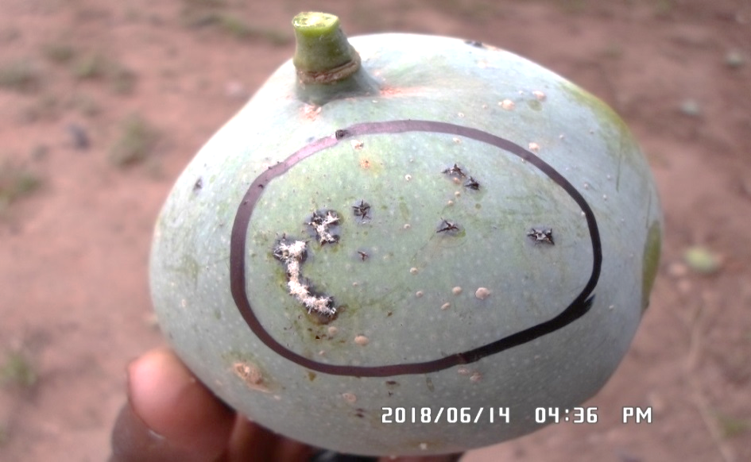
a
b
c
Figure 1: Types of mangoes collected for coinfection analysis
a & b: Type 1 mangoes showing symptoms of bacterial canker without apparent fruit fly stings.
a: Star slits with gummy exudate; b: Crateriform spots.
c: Type 2 mangoes showing symptoms of bacterial canker and egg masses laid by fruit flies.
2.3 Analysis of the role of fruit flies in the dissemination of Xantomonas citri pv. mangiferaeindicae
A trapping system based on food bait was set up in the selected mango orchards to analyze the role of fruit flies in the spread of X. citri pv. mangiferaeindicae. In each mango orchard, the trapping system included five Tephritrap traps containing M3 bait station (River Bioscience (Pty) Ltd., Humewood, South Africa) and five McPhail traps containing torula yeast (ChemTica Internacional SA, Zeta Industrial Park, La Valencia, Heredia, Costa Rica). The M3 bait station consists a sponge soaked in protein hydrolysate, a proprietary mixture of plant extracts and alpha-cypermethrin housed in a plastic device. Torula yeast is a source of protein, used at the rate of four pellets per trap dissolved in 400 ml of water. One pellet of dichlorvos insecticide was placed in the baskets of the McPhail traps to kill trapped fruit flies. The traps were hung using soft wire approximately 1.5 m above the ground on mango trees. Solid grease was applied to the wire to prevent predation by weaver ants on the captured flies. A distance of 20 m was observed between to traps. The torula yeast was renewed every 10 days, while the M3 bait station, which has a duration of action of 10 weeks, was not renewed. The insecticide dichlorvos was renewed after one month of operation.
The traps were visited every 10 days from early June to mid-July 2018 to collect the fruit flies captured. Five fruit flies were collected at random from each trap and placed in sterile Eppendorf tubes containing one mL of nutrient broth. These samples were kept cool in a cooler box for transport to the laboratory. The remaining fruit fly specimens from each trap were kept in labelled vials for identification. The labels included the zone name, orchard number, attractant name and collection date. In the laboratory, the fruit flies were triturated whole in sterile Petri dishes. In addition, the different parts of fruit flies, namely, the head and ovipositor, were separately triturated in 1mL of sterile distilled water. Fifty (50) μL of the ground material was spread in three sectors on Petri dishes containing YPGA medium with antibiotics with two repetitions per sample. Petri dishes were incubated for three to seven days. Additionally, the nutrient broth containing the flies captured in the traps was spread on Petri dishes containing YPGA medium with antibiotics with two repetitions per sample.
We hypothesized that fruit flies captured with traps containing torula could host bacteria and spread them into the torula solution. To do this, 30 mL of torula solution was sampled from each trap and placed in sterile vials using a sterile 10 mL syringe. These samples were taken the day after the traps were set up and on the second trip to survey the traps. In laboratory, 50 µL of torula solution were sampled from each vial to spread in three sectors on Petri dishes containing YPGA medium with antibiotics with three repetitions per sample. The Petri dishes were then incubated for three to seven days.
This capture method was completed by another method to obtain fresh samples of fruit flies. It was applied during the last survey of the traps in the orchards of Diéri Déni. Thus, fruit flies newly entering the traps containing M3 bait station were captured by vigorously shaking the traps in a plastic bag. The flies were then collected with flexible forceps and transferred to Eppendorf tubes containing one mL of nutrient broth with five flies per tube. The tubes were kept cool in a cooler box for transport to the laboratory.
2.4 Isolation and identification of Xantomonas citri pv. mangiferaeindicae
At the end of the incubation of the different samples in the YPGA medium, we proceeded to isolate the bacteria using the following method. Colonies exhibiting the morphological characteristics of the X. citri pv. mangiferaeindicae (creamy white, regular outline, circular and domed) were identified and purified on YPGA medium without antibiotics. After isolation, Gram's test was performed with 3% KOH to confirm that the isolated colonies were gram-negative, which is consistent with the reference strain X. citri pv. mangiferaeindicae. Gram’s test consisted of placing one drop of KOH on a smooth surface in contact with a bacterial colony. If after friction, elasticity was found in the lift, then the strain was determined to be gram-negative. On the other hand, if no elasticity was observed, then the strain was gram-positive. Then, a starch hydrolysis test was performed on all of the gram-negative colonies to confirm that they can hydrolyze starch, similar to the reference strain X. citri pv. mangiferaeindicae. For this purpose, the strains were spread on starch culture medium (5 g of peptone, 2 g of starch, 20 g of agar, 3 g of beef extract and one litre of distilled water) and incubated for 72 h. After incubation, Lugol's iodine solution (10 g of KI and 5 g of iodine per 500 mL of sterile distilled water) was poured onto the medium to examine if the starch had been hydrolyzed. The test was positive when a clear halo was observed around the bacterial strain (figure 2). Otherwise, the test was negative.
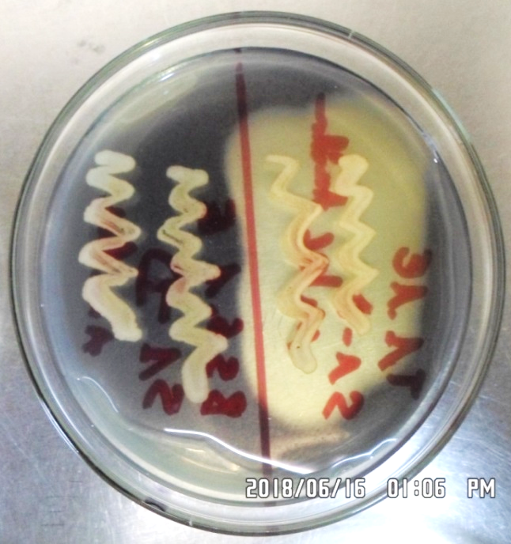
Figure 2: Starch culture medium hydrolyzed by the Xanthomonas citri pv. mangiferaeindicae strain as visualized by the formation of a clear halo around the bacterial strain (right).
2.5 Pathogenicity analysis of the isolated strains of Xantomonas citri pv. mangiferaeindicae
The pathogenicity of the X. citri pv. mangiferaeindicae strains isolated was analyzed to confirm that the typical symptoms observed on mangoes were due to this bacterium and also to situate the role of fruit flies in the dispersion of the bacterium. Thus, colonies that were successful in the Gram and starch hydrolysis tests were used to perform the test. This analysis consisted of inoculation followed by observation of the symptoms developed by the strains on the young shoots of mango leaves. First, each strain identified by the Gram test and starch hydrolysis was plated on YPGA medium without antibiotics for 24 h. A bacterial suspension was then prepared with sterile distilled water and adjusted to an optical density (OD) of 0.06, which corresponded to 108 CFU/mL, using a spectrometer. Finally, using a sterile one mL needle-free syringe, the suspension was infiltrated between two ribs on the underside of a young leaf previously that had been disinfected on both sides with 70% alcohol. Infiltration was carried out on ten points of the chosen leaf. The infiltration sites were observed every ten days to determine whether the manifested symptoms were typical of those caused by X. citri pv. mangiferaeindicae on mango trees. On the 21st day after infiltration, the lesions were removed for isolation and identification of the bacterium X. citri pv. mangiferaeindicae.
Exceptionally, fruit flies captured manually were spread whole on YPGA medium without antibiotics (figure 3). Furthermore, the nutrient broth (NB) containing captured fruit flies was directly inoculated by infiltration on 25 young mango leaves previously disinfected with 70% alcohol. The number of infiltration points varied from one to ten as function of leaves.
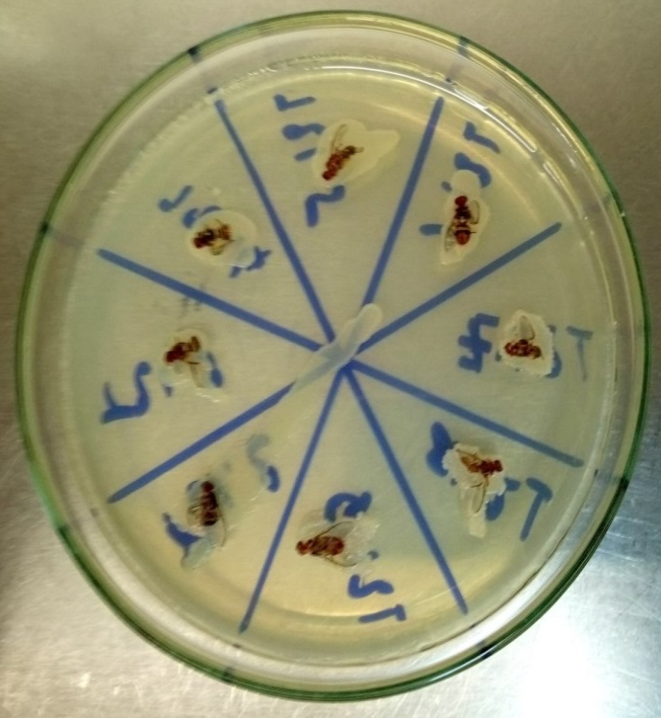
Figure 3: Bactrocera dorsalis specimens plated on YPGA medium without antibiotics for isolation of Xantomonas citri pv. mangiferaeindicae
2.6 Data analysis
The data collected were entered and processed with a Microsoft Excel 2010 spreadsheet. The following parameters were subjected to statistical analyses: rate of attack of mangoes by fruit flies, severity of attack and emergence rate of fruit flies. The following formulas were used to evaluate these parameters:

$$Attack rate (\%)=\frac{number of mangoes attacked}{total number of mangoes sampled}×100$$
$$Severy of attack (pupae/kg)=\frac{number of pupae}{weight \left(kg\right) of mangoes attacked}$$
$$Emergence rate (\%)=\frac{number of hatched pupae}{total number of pupae}×100$$

Data were analysed with R software 3.4.1. Nonparametric analyses were performed for multiple comparisons at the 5% probability level.
3. results
3.1 Coinfection of mangoes with fruit flies and the bacterium Xantomonas citri pv. mangiferaeindicae
3.1.1 Richness of the fruit fly species captured in selected mango orchards
Nine species of fruit flies distributed in three genera (Bactrocera, Ceratitis and Dacus) were captured in the mango orchards. These were Bactrocera dorsalis, Ceratitis bremii Guérin-Méneville, Ceratitis capitate (Wiedemann), Ceratitis cosyra, Ceratitis ditissima (Munro), Ceratitis fasciventris (Bezzi), Ceratitis quinaria (Bezzi), Ceratitis silvestrii and Dacus vertebratus Bezzi. In the traps containing torula yeast, 4 078 fruit flies were captured at Bobo-Dioulasso. With the same food attractant, 27 645 fruit flies were captured at Diéri Déni. In traps containing M3 bait station, the number of fruit flies captured was 1 562 at Bobo-Dioulasso and 1 804 at Diéri Déni. Depending on the location and type of food attractant, the fruit fly species were unevenly distributed. Bactrocera dorsalis and C. cosyra were the two main species encountered, with a predominance of B. dorsalis in Diéri Déni (79.44% of the catches in torula yeast traps and 45.79% in the M3 bait station traps). Conversely, C. cosyra was the dominant species in Bobo-Dioulasso (56.57% of the catches in the torula yeast traps and 85.34% in the M3 bait station traps). The other species represented less than 3% of the catches. Figures 4 and 5 show the proportions of the different species of fruit flies captured by using torula yeast and the M3 bait station.

Figure 4: Richness and importance of the fruit fly species captured with torula yeast traps

Figure 5: Richness and importance of the fruit fly species captured with M3 bait station traps
3.1.2 Attack rate and survival of the fruit flies on mangoes with symptoms of mango bacterial canker
Table 2 and figure 6 present respectively the level of damage caused by fruit flies on mangoes showing bacterial canker and the survival of the fruit flies in these mangoes from Diéri-Déni and Bobo-Dioulasso. At Diéri-Déni, the two mango varieties (Valencia and Ruby) were all infested by fruit flies regardless of the type of symptoms. Indeed, 49.66% to 91.66% of mangoes were infested by fruit flies depending on the type of symptoms (Table 2). The attack rate was significantly higher (F value = 9; Pr(>F) = .006) on mangoes showing symptoms of both bacterial canker and fruit fly attacks than on mangoes showing symptoms of only bacterial canker. When comparing the same type of symptom, attack did not vary significantly between mango variety.
The severity of attack was significantly lower (F value = 8.7; Pr(>F) = .006) in the Valencia variety than in the Ruby variety depending on the type of symptoms. These values were 42.50 pupae/kg for the Valencia variety with type 1 symptoms and 210.21 pupae/kg for the Ruby variety with type 2 symptoms. For the same mango variety, a significant difference was not observed between the types of symptoms related to the severity of attack.
The fruit flies completed their life cycle regardless of the type of symptoms. The emergence rate of fruit flies was 68.21% on the Ruby variety with type 2 symptoms and 74.98% on the Valencia variety with type 2 symptoms. A significant difference was not observed between mango variety and type of symptoms.
At Bobo-Dioulasso, the attack rate varied from 75% (Kent) to 100% (Brooks) depending on the type of symptoms (figure 6). In the same variety, the attack rate was higher on mangoes showing type 2 symptoms. The severity of attack varied from 74.93 pupae/kg (Kent) to 198.31 pupae/kg depending on the type of symptoms. In the Kent variety, the severity of attack was lower for mangoes showing type 1 symptoms. The opposite result was observed in the Brooks variety. In these two mango varieties, fruit flies emerged regardless of the type of symptoms. Indeed, the emergence rate varied from 58.31% (Kent with type 2 symptoms) to 87.5% (Kent with type 1 symptoms). Thus, in the same mango variety, the fruit fly emergence rate was higher for mangoes with type 1 symptoms.
Table 2: Damage and emergence rate of fruit flies associated with mangoes showing bacterial canker symptoms
Mango variety (Symptom) | Attack rate (%) ± SD | Severity (pupae/kg) ± SD | Emergence rate (%) ± SD
Valencia (Type 1 Symptoms) | 49.66±2.92 b | 42.50±31.02 b | 72.52±5.04
Valencia (Type 2 Symptoms) | 91.66±4.16 a | 70.88±16.40 b | 74.98±5.53
Ruby (Type 1 Symptoms) | 65.67±10.05 ab | 121.08±34.70 ab | 70.78±1.65
Ruby (Type 2 Symptoms) | 76.58±3.52 a | 210.21±6.93 a | 68.21±2.75
F value | 9.005 | 8.72 | 0.49
Pr(>F) | 0.0060** | 0.0066** | 0.699
SD-Standard Deviation
Type 1 symptoms: mangoes showing symptoms of bacterial blight without apparent fruit fly bites. Type 2 symptoms: mangoes showing both a fairly advanced stage of bacterial blight and signs of fruit fly attacks.
Different letters within the column indicate significant differences.

Figure 6: Damage caused by, and the emergence rate of fruit flies associated with mangoes showing bacterial canker symptoms from Bobo-Dioulasso.
Type 1 symptoms: mangoes showing symptoms of bacterial blight without apparent fruit fly stings. Type 2 symptoms: mangoes showing both a fairly advanced stage of bacterial blight and signs of fruit fly attacks.
3.1.3 Richness of the fruit fly species emerged from mangoes with symptoms of mango bacterial canker
At the end of the incubation periods, 3 515 fruit fly pupae were collected from mangoes sampled at Diéri-Déni. A total of 2 555 fruit flies emerged. This population was composed of Bactrocera dorsalis, Ceratitis cosyra and Ceratitis silvestrii (Figure 7). Bactrocera dorsalis was most predominant in all mango varieties regardless of the type of symptoms. Its population represented 53.84% to 80% of all emergences. The Ceratitis cosyra population represented 20% to 46.15% of all emergences. Ceratitis silvestrii (2.84% of emergences) appeared from only the Ruby variety showing type 1 symptoms.
At Bobo-Dioulasso, 1 794 pupae were collected. A total of 1 342 fruit flies emerged. Two fruit fly species, B. dorsalis and C. cosyra, were observed from all samples of the two mango varieties (Brook and Kent) regardless of the type of symptoms (figure 8). Bactrocera dorsalis was the most predominant species that emerged from mangoes showing type 1 symptoms (70.58% in the Kent variety and 62.86% in the Brooks variety). In contrast, mangoes showing type 2 symptoms hosted most of the C. cosyra, representing 80.21% and 66.12% of fruit flies that emerged from the Kent variety and Brooks variety, respectively.

Figure 7: Richness and species proportions of the fruit flies that emerged from mangoes showing bacterial canker symptoms collected from Diéri-Déni.
Type 1 symptoms: mangoes showing symptoms of bacterial blight without apparent fruit fly stings. Type 2 symptoms: mangoes showing both a fairly advanced stage of bacterial blight and signs of fruit fly attacks.

Figure 8: Richness and species proportions of the fruit flies that emerged from mangoes showing bacterial canker symptoms collected from Bobo-Dioulasso
Type 1 symptoms: mangoes showing symptoms of bacterial blight without apparent fruit fly stings. Type 2 symptoms: mangoes showing both a fairly advanced stage of bacterial blight and signs of fruit fly attacks.
3.2 Identification of Xantomonas citri pv. mangiferaeindicae associated with different samples
Bacterial colonies exhibiting the morphological characteristics of the reference strain of X. citri pv. mangiferaeindicae (creamy white, smooth, shiny and rounded) were observed in the mangoes’ samples incubated in the laboratory (Table 3). Gram, starch and pathogenicity tests allowed us to identify 61 isolates.
Table 4 shows the results of the isolation of the bacterium X. citri pv. mangiferaeindicae from fruit flies captured manually or with torula yeast and M3 bait station traps. After incubation, the bacterial colonies grew. However, these colonies did not exhibit the morphological characteristics of the reference strain of X. citri pv. mangiferaeindicae. Gram's test was negative.
Table 5 shows the results of the isolation of the bacterium X. citri pv. mangiferaeindicae from the torula solution used in the traps and the nutrient broth used to preserve the fruit flies captured with the traps. At the end of incubation, the observed colonies did not have the morphological characteristics of the reference strain X. citri pv. mangiferaeindicae. Gram's test was negative.
The inoculations with the nutrient broth containing fruit flies captured manually allowed reproduction of the characteristic symptoms of the target bacterium when the captured fruit flies acted as the host. Symptoms observed from these inoculations (I) were classified into four groups (figure 9): absence of spots (I2, I14, I16, I17, I18, I19, I20, I21, I22, I23, I24, I25); oily and smooth spots (I1); brown and smooth spots (I7, I8, I9, I10, I11, I12, I13, I15); and black and rough spots (I3, I4, I5, I6). After isolation and incubation, bacterial colonies from I3, I4, I5 and I6 exhibited the morphological characteristics of the reference strain X. citri pv. mangiferaeindicae. The Gram, starch and pathogenicity tests confirmed our results for all of these infiltrations (Table 6).
Table 3: Number of isolates of Xanthomonas citri pv. mangiferaeindicae correlated to the type of sample
Localities | Type of sample | Number of isolates
Bobo-Dioulasso | Gummy exudates | -
Bobo-Dioulasso | Leaves | 1
Bobo-Dioulasso | Mangoes with Type 1 symptoms | 5
Bobo-Dioulasso | Mangoes with Type 2 symptoms | 1
Diéri Déni | Gummy exudates | 21
Diéri Déni | Leaves | 7
Diéri Déni | Mangoes with Type 1 symptoms | 22
Diéri Déni | Mangoes with Type 2 symptoms | 4
Total |  | 61
Type 1 symptoms: mangoes showing symptoms of bacterial blight without apparent fruit fly bites. Type 2 symptoms: mangoes showing both a fairly advanced stage of bacterial blight and signs of fruit fly attacks.
Table 4: Results of the isolations from the captured fruit flies
Isolation technique | Type of sample | Number of samples |  | Gram test
Trituration on YPGA medium | Whole fruit fly | 60 |  | Negative
Trituration on YPGA medium | Fruit fly Ovipositor | 45
Trituration on YPGA medium | Fruit fly head | 45
Spreading YPGA medium | Whole fruit fly | 125
Total |  |  | 275
Table 5: Results of the isolations from torula yeast solution and the nutrient broth used to preserve the fruit flies captured with traps
Type of sample | Number of samples | Gram test
Torula yeast | 20 | Negative
Nutrient broth (NB) | 40 | Negative
Total | 60 | Negative
Table 6: Number of isolates obtained from the infiltrated leaves
Infiltration number | Number of infiltrated leaves | Number of isolates obtained
I1, I2, I7, I8, I9, I10, I11, I12, I13, I14, I15, I16, I17, I18, I19, I20, I25 | 23 | 0
I3 | 2 | 1
I4 | 2 | 2
I5 | 2 | 1
I6 | 2 | 3

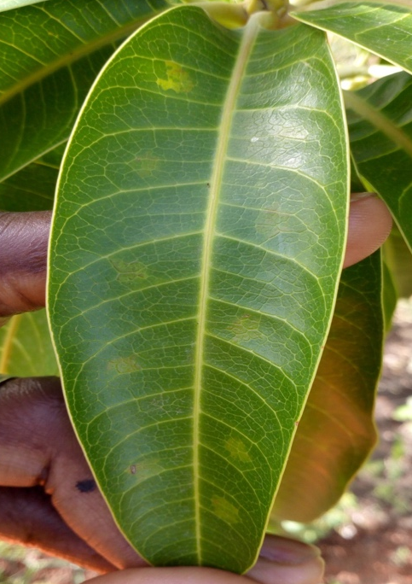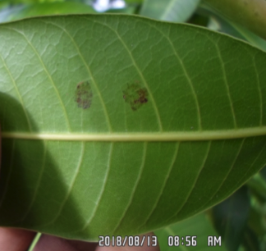
b
a
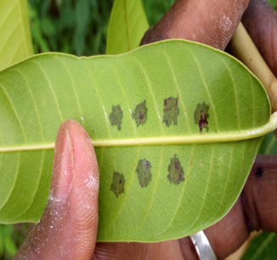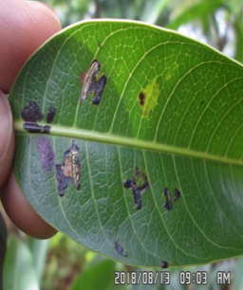
c
d
Figure 9: Groups of symptoms observed 21 days after infiltration of mango leaves with the nutrient broth containing fruit flies captured manually
a: absence of spots; b: oily and smooth spots; c: brown and smooth spots; d: black and rough spots.
3. DISCUSSION
Fruit flies collected from traps and mangoes had established a presence in the four orchards selected in this study. Nine species of fruit flies were identified from the trapping system with torula yeast or M3 bait station. Three of these species cause serious damage to mangoes. These are Bactrocera dorsalis, Ceratitis cosyra and Ceratitis silvestrii, representing 62.10%, 37.49% and 0.41% of the fruit flies that had emerged from the incubated mangoes, respectively. Ouédraogo (2011) report that these three species of fruit flies infest mangoes in the same study area. These species are polyphagous insects that attack other cultivated and wild fruits (Zida et al., 2020 a).
The high attack rate and severity of the attacks in the Bobo-Dioulasso orchards could be attributed to the mango varieties (Kent, Brooks) that were sampled. Previous studies have shown that fruit flies prefer to lay eggs in certain mango varieties.
Incubations of the mango samples showing symptoms of mango bacterial canker allowed the isolation of the bacterium X. citri pv. mangiferaeindicae. The bacterium was isolated from all varieties of mangoes (Kent, Keitt, Valencia) that were sampled. This bacterium was also isolated by Zombré (2016) from many mango varieties in Burkina Faso.
The emergence of fruit flies and the presence of the bacterium X. citri pv. mangiferaeindicae in all mango production areas in West Africa represent a plague for the mango sector. The formal presence of fruit flies and this bacterium has previously been revealed in the main mango-producing areas in western Burkina Faso, notably in the provinces Houet, Kénédougou and Comoé (Ouédraogo, 2011; Zombré et al., 2016). However, no study has established the ecological relationship between these two pests, both of which are associated with mangoes. In our study, the sampled mangoes exhibited both fruit fly stings and symptoms of mango bacterial canker caused by the bacterium X. citri pv mangiferaeindicae. Some mangoes exhibited both fruit fly attacks and the presence of egg clusters found on lesions caused by mango bacterial canker. Incubation of these mangoes in the laboratory allowed the emergence of fruit flies (B. dorsalis, C. cosyra and C. silvestrii) to be observed. These same fruit fly species also emerged from mangoes apparently free from fruit fly stings but showing symptoms of mango bacterial black spot disease.
The preference of fruit flies to lay their eggs on lesions caused by bacteriosis could be linked to the biology and ecology of these insects. According to Bateman (1972), fruits in the diets of most insects are of poor quality in the absence of microorganisms. Fletcher (1987) report that bacteria play an essential role in the nutrition of fruit flies of the Dacinae subfamily. He notes that fruit flies ingest the bacteria present on the fruit to acquire amino acids and possibly other growth factors. The works of Fitt and O'Brien (1985) allowed the isolation of bacteria from the eggs, larvae and adults of four species of fruit flies (Dacus tryoni (Froggatt), Dacus jarvisi (Tryon), Dacus neohumeralis (Hardy) and Dacus cacuminatus (Hering)). Kounatidis et al. (2009) also established the presence of symbiotic bacteria in the olive fly Bactrocera oleae. It emerged from their study that Acetobacter tropicalis (as the majority bacteria) had a specific capacity to colonize the olive fruit fly by becoming lodged in the peritrophic membrane of the fly's intestine, unlike other bacteria that can exert a temporary or permanent association. However, the actual nature of this symbiotic association remains unknown. The hypothesis that X. citri pv. mangiferaeindicae could play a role in the diet of fruit flies could not be confirmed because in the isolations from whole fly mash, the ovipositor and head were negative.
However, the symptoms of stellate spots with a brownish mass of rotting mango skin are characteristic of the simultaneous presence of the bacterium X. citri pv. mangiferaeindicae and fruit flies. These types of symptoms were observed in the mangoes from both Bobo-Dioulasso and Diéri Déni. Coinfection between the bacterium X. citri pv. mangiferaeindicae and the fruit fly species in this study was thus established. The nature and severity of damage from the two pests on the tree or fruit scale could explain the intensified yield losses in recent years in mango production areas in Burkina Faso. The isolation of symptoms obtained from infiltration of the nutrient broth containing fruit flies captured manually allowed us to identify the bacterium X. citri pv. mangiferaeindicae. Fruit flies could passively transport the bacterial inoculum from one fruit to another. Wattier (2009) pointed out that the orientation of fruit flies towards the host plant to lay eggs or feed is done by signals involving smell and vision. The gummy exudates that ooze from lesions caused by this bacterium could diffuse an odour that attracts fruit flies so that they can position themselves on the mango to lay their eggs; once in transit to other mangoes, the fruit flies can passively transport the bacterial inoculum. Indeed, very early in the morning, many gummy exudates are produced. These exudates attract fruit flies that come to rest on their legs and can then jump from one mango to another, disseminating the bacterial inoculum. These exudates contain a significant concentration of the bacterium X. citri pv mangiferaeindicae, which has been shown through isolation. Fruit flies are believed to be passive carriers of the bacterium X. citri pv. mangiferaeindicae, a trend that remains to be explored through the use of other molecular biology techniques such as polymerase chain reaction (PCR), fluorescence techniques and a specific isolation protocol.
4. Conclusion
Fruit flies and mango bacterial canker remain two major constraints for the development of the mango sector in Burkina Faso. Usually, studies carried out on these parasites do not take into account the interactions between them. This study has allowed us to better understand the relationship between fruit flies and the bacterium Xanthomonas citri pv. mangiferaeindicae and highlighted the coinfection of mangoes by these two pests. This coinfection first results in the presence of both the bacteria and the fruit fly larvae in the mangoes. In addition, fruit flies are able to complete their development cycle in mangoes infected with X. citri pv. mangiferaeindicae. Bacterial blight lesions are the preferred sites for fruit fly oviposition. Fruit flies are a factor in the spread of this bacterium in nature, as they carry the bacteria on their bodies, probably looking for egg-laying sites on mangoes already infected. Further studies will elucidate this hypothesis.
AcknowledgEments
The authors would like to thank the mango orchard owners for their collaboration during field data collecting.
Competing interests
Authors have declared that no competing interests exist.
Authors’ Contributions
Author Nébié Karim performed the statistical analysis, wrote the protocol, and wrote the first draft of the manuscript. Author Zombré Tinlé Cyrille wrote the protocol and managed the analyses of the study. Author Lompo David designed the study and managed the literature searches. All authors read and approved the final manuscript.
Consent
Not applicable.
Ethical approval
Not applicable.
References
1. Ouédraogo, S.N. (2002). Étude diagnostique des problèmes phytosanitaires du manguier (Mangifera indica L.), de l'oranger (Citrus sinensis (L.) Osbeck) et du mandarinier (Citrus reticulata Blanco) dans la province du Kénédougou [Mémoire d’Ingéniorat]. Bobo-Dioulasso, Université Polytechnique de Bobo-Dioulasso.
2. Parrot, L., Biard, Y., Kabré, E., Klaver, D., & Vannière, H. (2018). Analyse de la chaîne de valeur Mangue au Burkina Faso - Rapport final. Montpellier: CIRAD-Wageningen University.
3. Vayssières, J.F., Coulibaly, O., Sinzogan, A.A.C., Adandonon, A., Dakouo, D., Dabire, R.A., et al. (2012). Mango cultivation in Burkina Faso. In: S.G. Valavi, K. Rajmohan, J.N. Govil, K.V. Peter & G. Thottappilly (Eds.), Mango vol. 2: cultivation in different countries (pp. 208-229). Houston: Studium Press LLC.
4. Ouédraogo, S.N. (2011). Dynamique spatio-temporelle des mouches des fruits (Diptera, Tephritidae) en fonction des facteurs biotiques et abiotiques dans les vergers de manguiers de l’Ouest du Burkina Faso [Thèse de Doctorat]. Paris, Université Paris Est.
5. Zida, I., Nacro, S., Dabiré, R., & Somda, I. (2020 b). Seasonal abundance and diversity of fruit flies (Diptera : Tephritidae) in three types of plant formations in western Burkina Faso, West Africa. Annals of the Entomological Society of America, 113, 343-354.
6. Zida, I. (2019). Statut des mouches des fruits (Diptera: Tephritidae) au Burkina Faso: diversité spécifique, dynamique des populations et possibilités de lutte intégrée [Thèse de Doctorat]. Bobo-Dioulasso, Université Nazi Boni.
7. CTA 2013). How to Control the Mango Fruit Fly. No. 14. Wageningen, CTA Practical Guide Series.
8. Gagnevin, L. & Pruvost, O. (2001). Epidemiology and control of mango bacterial black spot. Plant Disease, 85, 928-935.
9. Ah-You, N. (2007). Taxonomie et classification en pathovars des Xanthomonas associés aux Anacardiacées par une approche polyphasique [Thèse de Doctorat]. Saint-Denis, Université de la Réunion.
10. Pruvost, O., Boyer, C., Vital, K., Verniere, C., Gagnevin, L., De Bruno Austin, L., & Rey, J.Y. (2011 a). First Report in Ghana of Xanthomonas citri pv. mangiferaeindicae causing mango bacterial canker on Mangifera indica. Plant Disease, 95, 774. http://dx.doi.org/10.1094/PDIS-02-11-0098
11. Pruvost O, Boyer C, Vital K, Verniere C, Gagnevin L, Somda I. 2011 b. First report in Burkina Faso of Xanthomonas citri pv. mangiferaeindicae causing bacterial canker on Mangifera indica. Plant Disease, 95, 1312. https://doi.org/10.1094/PDIS-04-11-0324
12. Pruvost, O., Boyer, C., Vital, K., Verniere, C., Gagnevin, L., & Traoré, Y.N. (2012). First Report in Mali of Xanthomonas citri pv. mangiferaeindicae causing mango bacterial canker on Mangifera indica. Plant Disease, 96, 581. https://doi.org/10.1094/PDIS-01-12-0001-PDN
13. Zombré, C., Wonni, I., Ouédraogo, S. L., Kpemoua, K.E., Assignon, K., Sankara, P., Vernière, C., Boyer, C., Boyer, K., Javegny, S., & Pruvost, O. (2016). First report of Xanthomonas citri pv. mangiferaeindicae causing mango bacterial canker on Mangifera indica in Togo. Plant Disease, 101, 3, 503. https://doi.org/10.1094/PDIS-09-16-1259-PDN
14. Gagnevin, L. (1998). Analyse de la diversité génétique de Xanthomonas citri pv. mangiferaeindicae et sa signification dans le pouvoir pathogène et la biologie de la bactérie. Implications dans l'épidémiologie de la maladie des taches noires du manguier à l'ile de la réunion [Thèse de Doctorat]. Paris, Institut national agronomique Paris-Grignon.
15. Bui Thi Ngoc, L. (2009). Apport de la génétique évolutive dans la taxonomie et l'épidémiologie de Xanthomonas citri pv. citri bactérie responsable du chancre asiatique des agrumes [Thèse de Doctorat]. Saint-Denis, Université de la Réunion.
16. Badolo H. 2009. Monographie de la région des Hauts-Bassins: recensement général de la population et de l’habitation de 2006 (RGPH-2006). Ouagadougou, Institut National de la Statistique et de la Démographie.
17. De Meyer, M. (1996). Revision of the subgenus Ceratitis (Pardalaspis) Bezzi, 1918 (Diptera, Tephritidae, Ceratitini). Systematic Entomology, 21, 15-26.
18. Virgilio, M., White, I., & De Meyer, M. (2014). A set of multi-entry identification keys to African frugivorous flies (Diptera, Tephritidae). ZooKeys, 428, 97-108.
19. Zida, I., Nacro, S., Dabiré, R., Moquet, L., Delatte, H., & Somda, I. (2020 a). Host range and species diversity of Tephritidae of three plant formations in Western Burkina Faso. Bulletin of Entomological Research, 110, 732-742.
20. Zombré, T.C. (2016). Diversité génétique et pathologique de Xanthomona citri pv. mangiferaeindicae, bactérie responsable de la maladie des taches noires du manguier au Burkina Faso et en Afrique de l’Ouest [Thèse de Doctorat]. Ouagadougou, Université Ouaga I Professeur Joseph KI-ZERBO.
21. Bateman, M.A. (1972). The ecology of fruit flies. Annual Review of Entomology, 17, 493-518.
22. Fletcher, B.S. (1987). The biology of Dacine Fruit Flies. Annual Review of Entomology, 32, 115-144.
23. Fitt, G.P., & O’Brien, R.W. 1985. Bacteria associated with four species of Dacus (Diptera:Tephritidae) and their role in the nutrition of the larvae. Oecologia, 67, 447-454.
24. Kounatidis, I., Crotti, E., Sapountzis, P., Sacchi, L., Rizzi, A., Chouaia, B. et al. (2009). Acetobacter tropicalis is a major symbiont of the olive fruit fly (Bactrocera oleae). Applied and Environmental Microbiology, 75, 3281-3288.
25. Wattier, C. (2009). Gamme de plantes-hôtes et spécificité chez les mouches des fruits et légumes (Dipter : Tephritidae) Nuisible à l’Île de la Réunion [Mémoire de Master]. Saint-Denis, Université de Picardie Jules Verne.

