Original Research Article

Development of Desktop Based Breast Cancer Symptoms Self Examination System

ABSTRACT
Aims: The early identification of breast cancer is the most significant method for breast cancer prevention. Breast self-examination has received widespread support and promotion from cancer organizations and authorities worldwide. But for it to be effective, women need to be educated and reached out to, in addition to diligent and frequent self-examination. Breast screenings have been used for early detection of breast cancer, before any symptoms like palpable lumps or other symptoms become apparent.
Study design: Since medical practitioners relied majorly on the information supplied by patient regarding any ailment, there is a need to develop a standalone application that can be used for breast cancer self-examination for easy and early detection of cancer in women.
Place and Duration of Study: Radiology Unit, LAUTECH Teaching Hospital Oyo state, between September and December 2025; Federal Polytechnic Ede, osun State.
Methodology: Visibility study on breast cancer self-examination was carried out on some respondents and a standalone desk application was developed using the PyQt library of the Python software. Responses to questions obtained from individual used the standalone desktop app to check if the individual has the symptoms of breast cancer or not.
Results: The result of the physical examination obtained from the respondents shows that 18% of the respondent were abnormal and 82% were normal. Thes earlier symptoms, given by respondents gave room for further advices to the 82% respondent to go for mammogram test.
Conclusion: The developed desk- based standalone application can be used by female individuals to perform a self-examination and expert so as to determine if there is a need to go for mammography test or not.

Keywords: Standalone Application, Python, PyQt Library, Mammogram, Mammography, Radiologist

- INTRODUCTION
According to World Health Organization (WHO), by 2025, breast cancer cases will hit 19.3 million (Ragab, Sharkas, and Attallah, 2019). Any abnormal growth of certain cells in the breast could be breast cancer (Zhou et al.,2020). When breast cancer is detected early, it lowers mortality rate by providing appropriate treatment which can improve the chances of recovery and extend lives more (Yavari, Mehrabi, and Pourhoseinqoli, 2006).
Breast cancer can be detected through screening such as self-examination, clinical examination, which is done by a physician, and mammography (Gursoy, Ylmaz, and Nural, 2009). Breast self-examination is very useful because it is cheap, easy, confidential, uncomplicated, and does not need a special equipment. Mammography is a common method that is used to detect breast cancer. It assists in the detection of breast cancer early to avoid further damage to the breast tissues (Ragab, Sharkas, and Attallah, 2019). The mammogram is an X-ray image of the breast that is regularly used to detect and treat breast cancer in women (Viegas, Domingues and Mendes, 2021).
Mammography is the most sensitive available means for early detection of breast cancer, but both clinical breast examination (CBE) and breast self-examination (BSE) have the potential to advance the diagnosis of breast cancer without the expense of a mammography facility (Noel, 2003). Most studies have found that survival after a diagnosis of breast cancer tends to be longer among women who practice BSE than among women who do not (Noel, 2003).
Regular screening of all women over a certain age has the potential to sharply increase the proportion of cancer cases that are diagnosed in their earliest stages. There are a number of approaches to the screening of breast cancer. Breast self-examination has been endorsed and widely promoted by cancer organizations and authorities around the world. Its effectiveness, however, is dependent on education and outreach among women, and upon conscientious and regular self-examination (World Health Organization, (2014). The purpose of breast self-examination is for a woman to learn the topography of her breast, know how her breasts normally feel and be able to identify changes in the breast should they occur in the future. Breast self-examination consists of two basic steps: visual and tactile examination of the breast. For visual examination, no woman has two breasts that are exactly identical. Once a woman knows what her breasts look like, she is able to identify any changes in the shape, form, colour or structure of the breast more quickly and can discuss these with the appropriate health care provider. From the age of 20, women should have a clinical breast examination as part of her routine check-up every two or three years, increasing to once a year from the age of 40.
The early identification of breast cancer is the most significant method for breast cancer prevention. Breast self-examination has received widespread support and promotion from cancer organizations and authorities worldwide. But for it to be effective, women need to be educated and reached out to, in addition to diligent and frequent self-examination. Early detection of breast cancer symptoms through self-screening tests helps to increase the rate of survival of breast cancer patients by treating the disease prematurely.
Several works have been done on breast cancer detection but there are few on self-examination using symptoms related to breast cancer. Hence, this study aims at developing a desk-based standalone self-examination breast cancer symptoms detection; for early detection of breast abnormality and to reduce the mortality rate which is associated to breast cancer in female gender.
Breast cancer is the most commonly diagnosed cancer among women worldwide and a leading cause of cancer-related mortality in Nigeria (Akhigbe, and Omuemu, 2009). In the Nigerian context, late presentation is common, with many women seeking medical care at advanced stages of the disease (Akhigbe, and Omuemu, 2009). This delay has been attributed to limited access to organized screening services, poor awareness of early symptoms, sociocultural beliefs, fear, and inadequate health education. Historically, structured monthly breast self-examination was recommended as a screening tool for early breast cancer detection (Akhigbe, and Omuemu, 2009).
Studies conducted across Nigerian universities consistently report high awareness of breast cancer and BSE among female undergraduates, with awareness rates often exceeding 80–90% (Okolie, 2012). Despite this high level of awareness, regular and correct practice of BSE remains suboptimal. Many students either perform BSE irregularly or lack adequate knowledge of correct techniques and appropriate timing (Okolie, 2012). Empirical evidence indicates that although undergraduates often possess general knowledge of breast cancer, their understanding of specific warning signs such as nipple discharge, skin dimpling, breast asymmetry, and axillary swelling is limited. Rural women in Nigeria generally exhibit lower awareness and poorer knowledge of breast cancer symptoms compared to urban and student populations (Oluwatosin and Oladepo, 2006). Most studies rely on cross-sectional or quasi-experimental designs and measure outcomes such as knowledge and self-reported practice rather than clinical endpoints (World Health Organization, 2014).
Emerging digital and mobile health approaches, including the use of smartphone applications and SMS reminders, have shown promise in improving breast awareness in other low- and middle-income countries. However, empirical research evaluating such tools in Nigerian undergraduate and rural settings remains sparse (World Health Organization, 2014). There is increasing work on smartphone apps and digital instruction to teach breast awareness/BSE steps, deliver reminders, and raise symptom knowledge. Different researchers have worked on smartphone app for BSE such as a systematic review assessed smartphone application–based technology for Breast Self-Examination or early detection education. (Nur Indah, Andi Nilawati Usman and Andi Agus Mumang, 2024). Also, a quasi-experimental study evaluating a breast-awareness app reported increases in knowledge of risk factors, warning signs, and confidence in BSE. A quasi-experimental pre and post-test research design were conducted with 41 women participants in Kelantan, Malaysia, before and after using the BrAware apps. Participants were given an online, adapted Breast Cancer Awareness Measure questionnaire. The mean age of women was 39.71. The participants' mean knowledge score of BC warning signs differs before using BrAware was 70.62 and after using the BrAware app was 79.83,
In addition, reviews of breast-cancer prevention or education apps highlight variable quality and the need for validated content, privacy, and behavior-change grounding (Stefanie Altmannshofer et al., 2024). Mobile Health apps could be a feasible and effective tool to raise awareness for breast cancer prevention and to support women to change their behaviour to a healthier lifestyle (Stefanie Altmannshofer et al., 2024. These authors conducted a systematic search for apps covering breast cancer prevention topics in the Google Play and Apple App Store accessible from Germany and analyze the characteristics and quality of apps designed for breast cancer prevention and education using the Mobile Application Rating Scale (MARS). Only apps with a last update after June 2020 were included. The apps identified were downloaded and evaluated by two independent researchers. Associations of app characteristics and MARS rating were analysed by the authors and identified nineteen (19) apps available in the Google Play Store and seven (7) apps available in the Apple App Store that met all inclusion criteria. The mean MARS score was 3.07 and 3.50, respectively. Functionality was the highest-scoring domain. Operating system, developer (healthcare), download rates and time since the last update were significantly associated with overall MARS score. In addition, the presence of the following app functions significantly influenced MARS rating: breast self-examination tutorial, reminder for self-examination, documentation feature and education about breast cancer risk factors. Although most of the apps offer important features for breast cancer prevention, none of the analyzed apps combined all functions. The absence of healthcare professionals’ expertise in developing apps negatively affects the overall quality.
(Dorsa Banihashemia and Meagan E. Brennana,2023) performed a systematic review was performed using PRISMA methodology. Articles were assessed against eligibility criteria. Data were extracted into evidence tables, risk of bias was assessed, narrative synthesis was performed, and results were described. Eligible studies were original research studies assessing the impact of breast awareness on cancer outcomes (such as stage at diagnosis or survival) in women less than 40 years. Medline, PubMed, and Cochrane Library were searched and results after screening the 6,204 abstracts show that no studies met all eligibility criteria. No studies evaluate the impact of breast awareness exclusively in young women were identified. Limited evidence of benefit of breast awareness was found.
2. METHODOLOGY
This study adopts a behavioral pathway framework in which breast cancer knowledge influences self-efficacy and attitudes, which in turn shape breast awareness and Breast Self-Examination practice. These behaviors facilitate early symptom recognition, prompt health-seeking actions, and potentially earlier diagnosis. The study was carried out at a female residential hostel of one tertiary institution in Nigeria. The direct rating method (questionnaire) for data collection was administered after carrying out the awareness campaign. The questionnaires were distributed to the students. The questions consist of the name of the respondent, marital status, age range from 15-20years, 21-25years and 26-30years and questions related to breast cancer signs and symptoms. The results of the responses from the questionnaire were transferred into the developed desktop-based self-examination detection system to predict if the individual has cancer symptom or not.
Formulation of Questionnaire
In examining the breast, changes in the texture and feel of the of breast region were noted and reported to the physician through the questionnaire. Five symptoms relating to breast self-examination was obtained from radiologists and oncologists at LAUTECH teaching hospital; which were used in the formulation of the questionnaire. The symptoms are highlighted below:
- Is there a discharge or bleeding from the nipples?
- Is there a feeling of lumps or thickening in the breast or under the burst?
- Is there any red region in the breast skin?
- Are there any changes in the size of the breast?
- Are the nipples inverted?
These questions were used in the questionnaire for further processing. Table 1 shows the logical representation of questions relating to breast cancer. Since five questions were considered, there is a total of 2⁵ observations i.e., thirty-two (32) observations. If there is a discharge or bleeding from the nipples, the patient is likely to have breast cancer. There are two conditions to ascertain that the patient has no breast cancer.
Condition 1: If there is a feeling of lumps or thickening from the breast and there is no discharge or bleeding from the nipples, no red region in the breast skin, no changes in the size of the breast and the nipples are not inverted, the patient has no breast cancer.
Condition 2: If there is no feeling of lumps or thickening from the breast, and there is no discharge or bleeding from the nipples, no red region in the breast skin, no changes in the size of the breast and the nipples are not inverted, the patient has no breast cancer.
All other conditions outside these two conditions indicates that the patient is likely to have breast cancer. The questions used to represent the results of the data collected are depicted as Q1, Q2, Q3, Q4 and Q5 while the responses are Y and N as indicated.
Q1: Is there a discharge or bleeding from the nipples?
Q2: Is there a feeling of lumps or thickening in the breast or under the burst?
Q3: Is there any red region in the breast skin?
Q4: Are there any changes in the size of the breast?
Q5: Are the nipples inverted?
Y: Yes
N: No

Table 1. Logical Representation of the Data
Observations | Q1 | Q2 | Q3 | Q4 | Q5 | Output
1 | Y | Y | Y | Y | Y | Not Okay
2 | Y | Y | Y | Y | N | Not Okay
3 | Y | Y | Y | N | Y | Not Okay
4 | Y | Y | Y | N | N | Not Okay
5 | Y | Y | N | Y | Y | Not Okay
6 | Y | Y | N | Y | N | Not Okay
7 | Y | Y | N | N | Y | Not Okay
8 | Y | Y | N | N | N | Not Okay
9 | Y | N | Y | Y | Y | Not Okay
10 | Y | N | Y | Y | N | Not Okay
11 | Y | N | Y | N | Y | Not Okay
12 | Y | N | Y | N | N | Not Okay
13 | Y | N | N | Y | Y | Not Okay
14 | Y | N | N | Y | N | Not Okay
15 | Y | N | N | N | Y | Not Okay
16 | Y | N | N | N | N | Not Okay
17 | N | Y | Y | Y | Y | Not Okay
18 | N | Y | Y | Y | N | Not Okay
19 | N | Y | Y | N | Y | Not Okay
20 | N | Y | Y | N | N | Not Okay
21 | N | Y | N | Y | Y | Not Okay
22 | N | Y | N | Y | N | Not Okay
23 | N | Y | N | N | Y | Not Okay
24 | N | Y | N | N | N | Okay
25 | N | N | Y | Y | Y | Not Okay
26 | N | N | Y | Y | N | Not Okay
27 | N | N | Y | N | Y | Not Okay
28 | N | N | Y | N | N | Not Okay
29 | N | N | N | Y | Y | Not Okay
30 | N | N | N | Y | N | Not Okay
31 | N | N | N | N | Y | Not Okay
32 | N | N | N | N | N | Okay

2.1. System Design
Graphical User Interface (GUI) of the breast cancer self-examination application was developed using the PyQt library of the Python software. Responses to questions obtained from individuals were entered into the developed desktop application to check if the individual has the symptoms of breast cancer or not using the logical representation results in Table 1.
- RESULTS AND DISCUSSION
The Graphical User Interface (GUI) of the developed application was shown in Figure 1. The name, marital status and age range of the patient was captured and the responses to the questions was taken and transferred into the developed system; after which the results were displayed on the results section of the application to check the status of the individual.
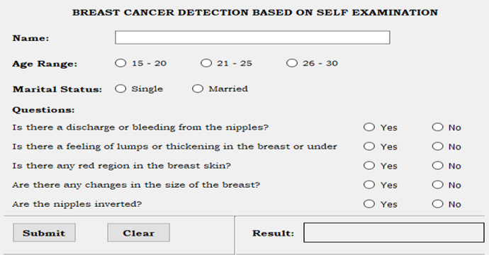
Fig. 1: GUI of the Developed System

Figure 2 shows the results of the physical examination.
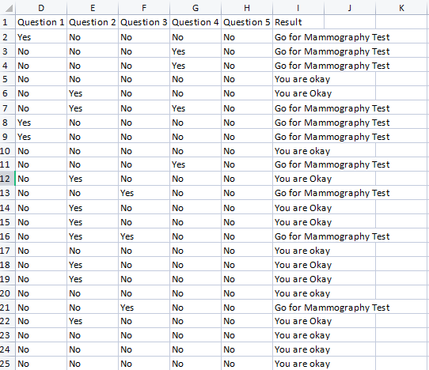
Fig. 2: Results of the Physical Self Examination

The Graphical User Interface (GUI) of the results is shown in Figure 3 and Figure 4.

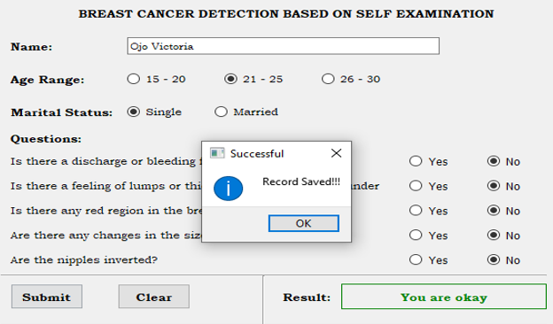

Fig. 3: GUI showing normal test result

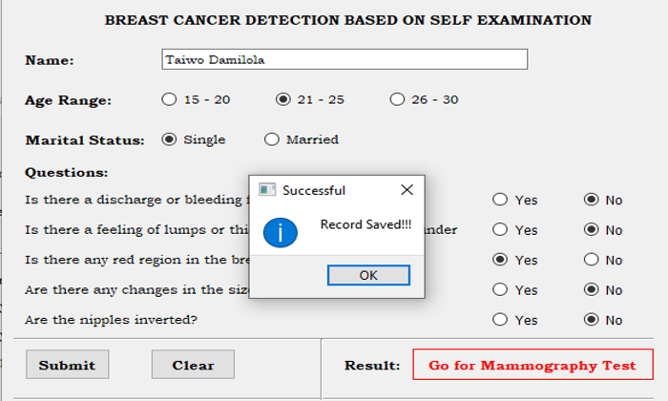

Fig. 4: GUI showing abnormal test result

The results obtained from the data collected from the students were saved in Microsoft Excel format on the Personal Computer, to allow for further referencing and comparison. The essence of self-examination is to ascertain if there is need for mammogram test. Whenever the results of the self-examination showed symptoms of breast cancer, it displayed on the screen as either “You are Okay” or “Go for Mammography”. The result of the self-examination obtained from the students shows that 18% of the respondents were abnormal and 82% were normal. The respondent with abnormality were advised to go for mammogram test for further treatment or quick medication.

- CONCLUSION
The developed desktop-based standalone application can be used by female individuals to perform a self-examination so as to determine if there is a need to go for mammogram test or not. Also, it can be used by experts to determine if there is a need for a patient to go for mammogram test based on observed breast cancer symptoms. The system can be recommended for tertiary institutions during medical test to examine the female students if they have breast cancer or not as this will limit the occurrence of breast cancer related disease at early stage. For Nigerian tertiary institutions, integrating structured breast health education into student health services and orientation programs may strengthen preventive behaviors among undergraduates. Policy efforts should focus on strengthening primary healthcare systems to support and improve early symptom detection, reducing delays in presentation and timely diagnosis in Nigeria.

Declarations
Informed Consent: Informed consent was obtained from all individual participants included in the study.
Conflicts of interest: The authors have no conflicts of interest to declare that are relevant to the content of this article.
References
- Ragab, D. A., Sharkas, M., and Attallah, O. (2019). Breast Cancer Diagnosis Using an Efficient CAD System Based on Multiple Classifiers. Diagnostics (Basel), 9(4). doi:10.3390/diagnostics9040165.
- Zhou, X., Li, C., Rahaman, M. M., Yao, Y., Ai, S., Sun, C., . . . Teng, Y. (2020). A Comprehensive Review for Breast Histopathology Image Analysis Using Classical and Deep Neural Networks. IEEE Access, 8, 90931 - 90956.
- Yavari P, Mehrabi Y, Pourhoseinqoli M. A (2006). Awareness and action of women toward breast self-examination: A Case Control Study. J Ardabil Univ Med Sci, 5, 371-7.
- Gursoy, A.A, Ylmaz, F., Nural, N. (2009). A different approach to breast self-examination education: Daughters educating mothers creates positive results in Turkey. Cancer Nurs, 3, 127-34.
- Viegas, L., Domingues, I., and Mendes, M. (2021). Study on Data Partition for Delimitation of Masses in Mammography. J Imaging, 7(9). doi:10.3390/jimaging7090174.
- American Cancer Society. Cancer Statistics Center. http://cancerstatisticscenter.cancer.org. Accessed September, 10, 2022.
- Akhigbe, A. O., and Omuemu, V. O. (2009). Knowledge, attitudes and practice of breast cancer screening among female health workers in a Nigerian urban city. BMC Cancer, 9(1), 203.
- Azlina Yusuf1*, Yulita Hanum P. Iskandar2 , Imi Sairi Ab Hadi3 , Arryana Nasution1 and Soon Lean Keng1 (2022). “Breast awareness mobile apps for health education and promotion for breast cancer”, Front. Public Health and Sec. Digital Public Health, Vol. 10
https://doi.org/10.3389/fpubh.2022.951641
- Dorsa Banihashemia and Meagan E. Brennana (2023) “The Impact of Breast Awareness on the Early Detection of Breast Cancer in Young Women: A Systematic Review”, Breast Care Journal, a School of Medicine Sydney, The University of Notre Dame Australia, Darlinghurst, NSW, Australia; Westmead Breast Cancer Institute, Westmead Hospital, Westmead, NSW, Australia, Vol. 18, Pp. 60–67.
DOI: 10.1159/000526990.
- Nur Indah, Andi Nilawati Usman and Andi Agus Mumang (2024).” Early detection of self-breast examination using smartphone breast application, therapeutic advance in medical oncology-Sage Journals. P. 1.”
https://orcid.org/0000-0002-1136-1704
- Noel S Weiss (2003), “Breast cancer mortality in relation to clinical breast examination and breast self-examination”, National Library of Medicine-the National Center for Biotechnology Information, doi: 10.1046/j.1524-4741.9.s2.9.x.
- Okolie, U. V. (2012). “Breast self-examination among female undergraduates in Enugu, Nigeria”. Journal of Cancer Epidemiology, 2012, 1–6.
- Oluwatosin, O. A., and Oladepo, O. (2006). “Knowledge of breast cancer and its early detection measures among rural women in Akinyele Local Government Area, Ibadan, Nigeria”. BMC Cancer, 6(1), 271.
- Stefanie Altmannshofer, Madeleine Flaucher, Milena Beierlein, Bjoern M Eskofier, Matthias W Beckmann, Peter A Fasching and Hanna Huebn (2024). “A content-based review of mobile health applications for breast cancer prevention and education: Characteristics, quality and functionality analysis”, DIGITAL HEALTH, Volume 10, pp. 1–17
DOI: 10.1177/20552076241234627
- World Health Organization (2014). Cancer prevention and control in the context of an integrated approach. WHO.

