Case report

Adenocarcinoma Arising in an Enteric Duplication Cyst: A Rare Malignancy at an Uncommon Site. Case report

Abstract
Enteric duplication cysts are rare congenital anomalies usually presenting in early childhood. Malignant transformation within these cysts is exceedingly uncommon, particularly in adults. We report a rare case of moderately differentiated adenocarcinoma arising in a jejunal duplication cyst in a 36-year-old adult. This patient was incidentally diagnosed following surgical resection. Histopathological examination revealed dysplastic intestinal and gastric epithelium with invasive adenocarcinoma infiltrating the muscularis propria and lymph node metastasis. This case highlights the malignant potential of enteric duplication cysts and emphasizes the importance of thorough histopathological evaluation.
Keywords: Enteric duplication cyst, Jejunum, Adenocarcinoma, Adult, Rare malignancy

Introduction
Enteric duplication (ED) cysts are rare congenital malformations characterized by the presence of a well-developed smooth muscle wall and mucosal lining resembling any part of the gastrointestinal tract. ^{1,2} They may occur anywhere along the alimentary tract, most commonly in the ileum, and usually present during infancy or early childhood. Adult presentation is rare, and malignant transformation within duplication cysts is an exceptional occurrence. We present a unique case of adenocarcinoma arising in a jejunal duplication cyst in an adult patient. ¹Most of the patients become symptomatic in early childhood and only a few cases of adult patients have been reported in literature.^{1,2}
Ladd WE first coined the term ‘alimentary duplication cyst’ and described them as congenital malformations which involve the mesenteric duplication cyst’ which involve the mesenteric side of the associated alimentary tract that share a common blood supply with the native bowel.² The prevalence is between 1:4500–1:10000.³ Most enteric duplication cysts are benign; however, neoplastic transformation has been reported in a few cases, with adenocarcinoma being the most common malignant transformation.⁴

Case Report
We present here a case of 36-year-old patient who underwent surgical exploration for an unrelated abdominal complaint. Intraoperatively, multiple cystic lesions were identified along the length of the small intestine. Segmental resection of small intestine was performed, and the specimen was submitted for histopathological examination.

Gross Examination
Gross examination revealed multiple duplication cysts with blind ends distributed throughout the small intestine. The largest cyst measured 6.9 × 5.1 × 2.7 cm. Cut surface showed a thickened cyst wall with areas of ulceration.
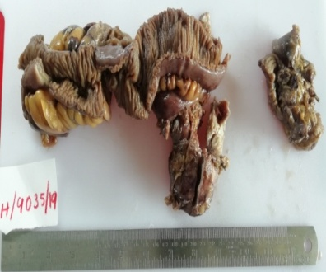
Figure 1: Shows largest cyst measured 6.9 × 5.1 × 2.7 cm.

Microscopic Examination
Histopathological examination demonstrated cyst walls composed of all layers of the intestinal wall. The mucosa was lined by both intestinal and gastric-type epithelium, exhibiting areas of severe dysplasia. Tumour cells infiltrated the muscularis propria. The neoplastic cells were arranged in glandular patterns and showed pleomorphic vesicular nuclei, prominent nucleoli, and moderate amounts of cytoplasm. Two regional lymph nodes showed metastatic tumour deposits with extracapsular extension. Based on gross and microscopic features diagnosis of Moderately differentiated adenocarcinoma arising in a jejunal enteric duplication cyst was made.

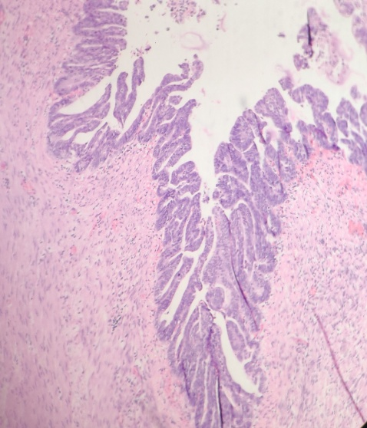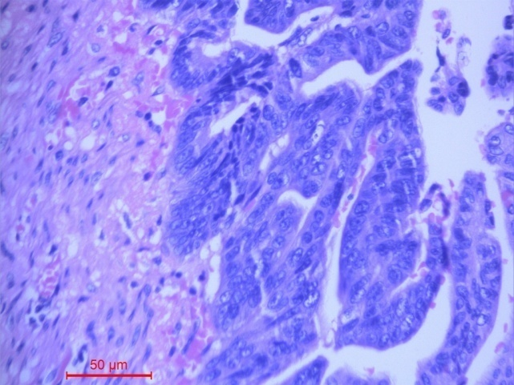
Figure 2 a, b: Shows tumour cells infiltrating muscularis propria.
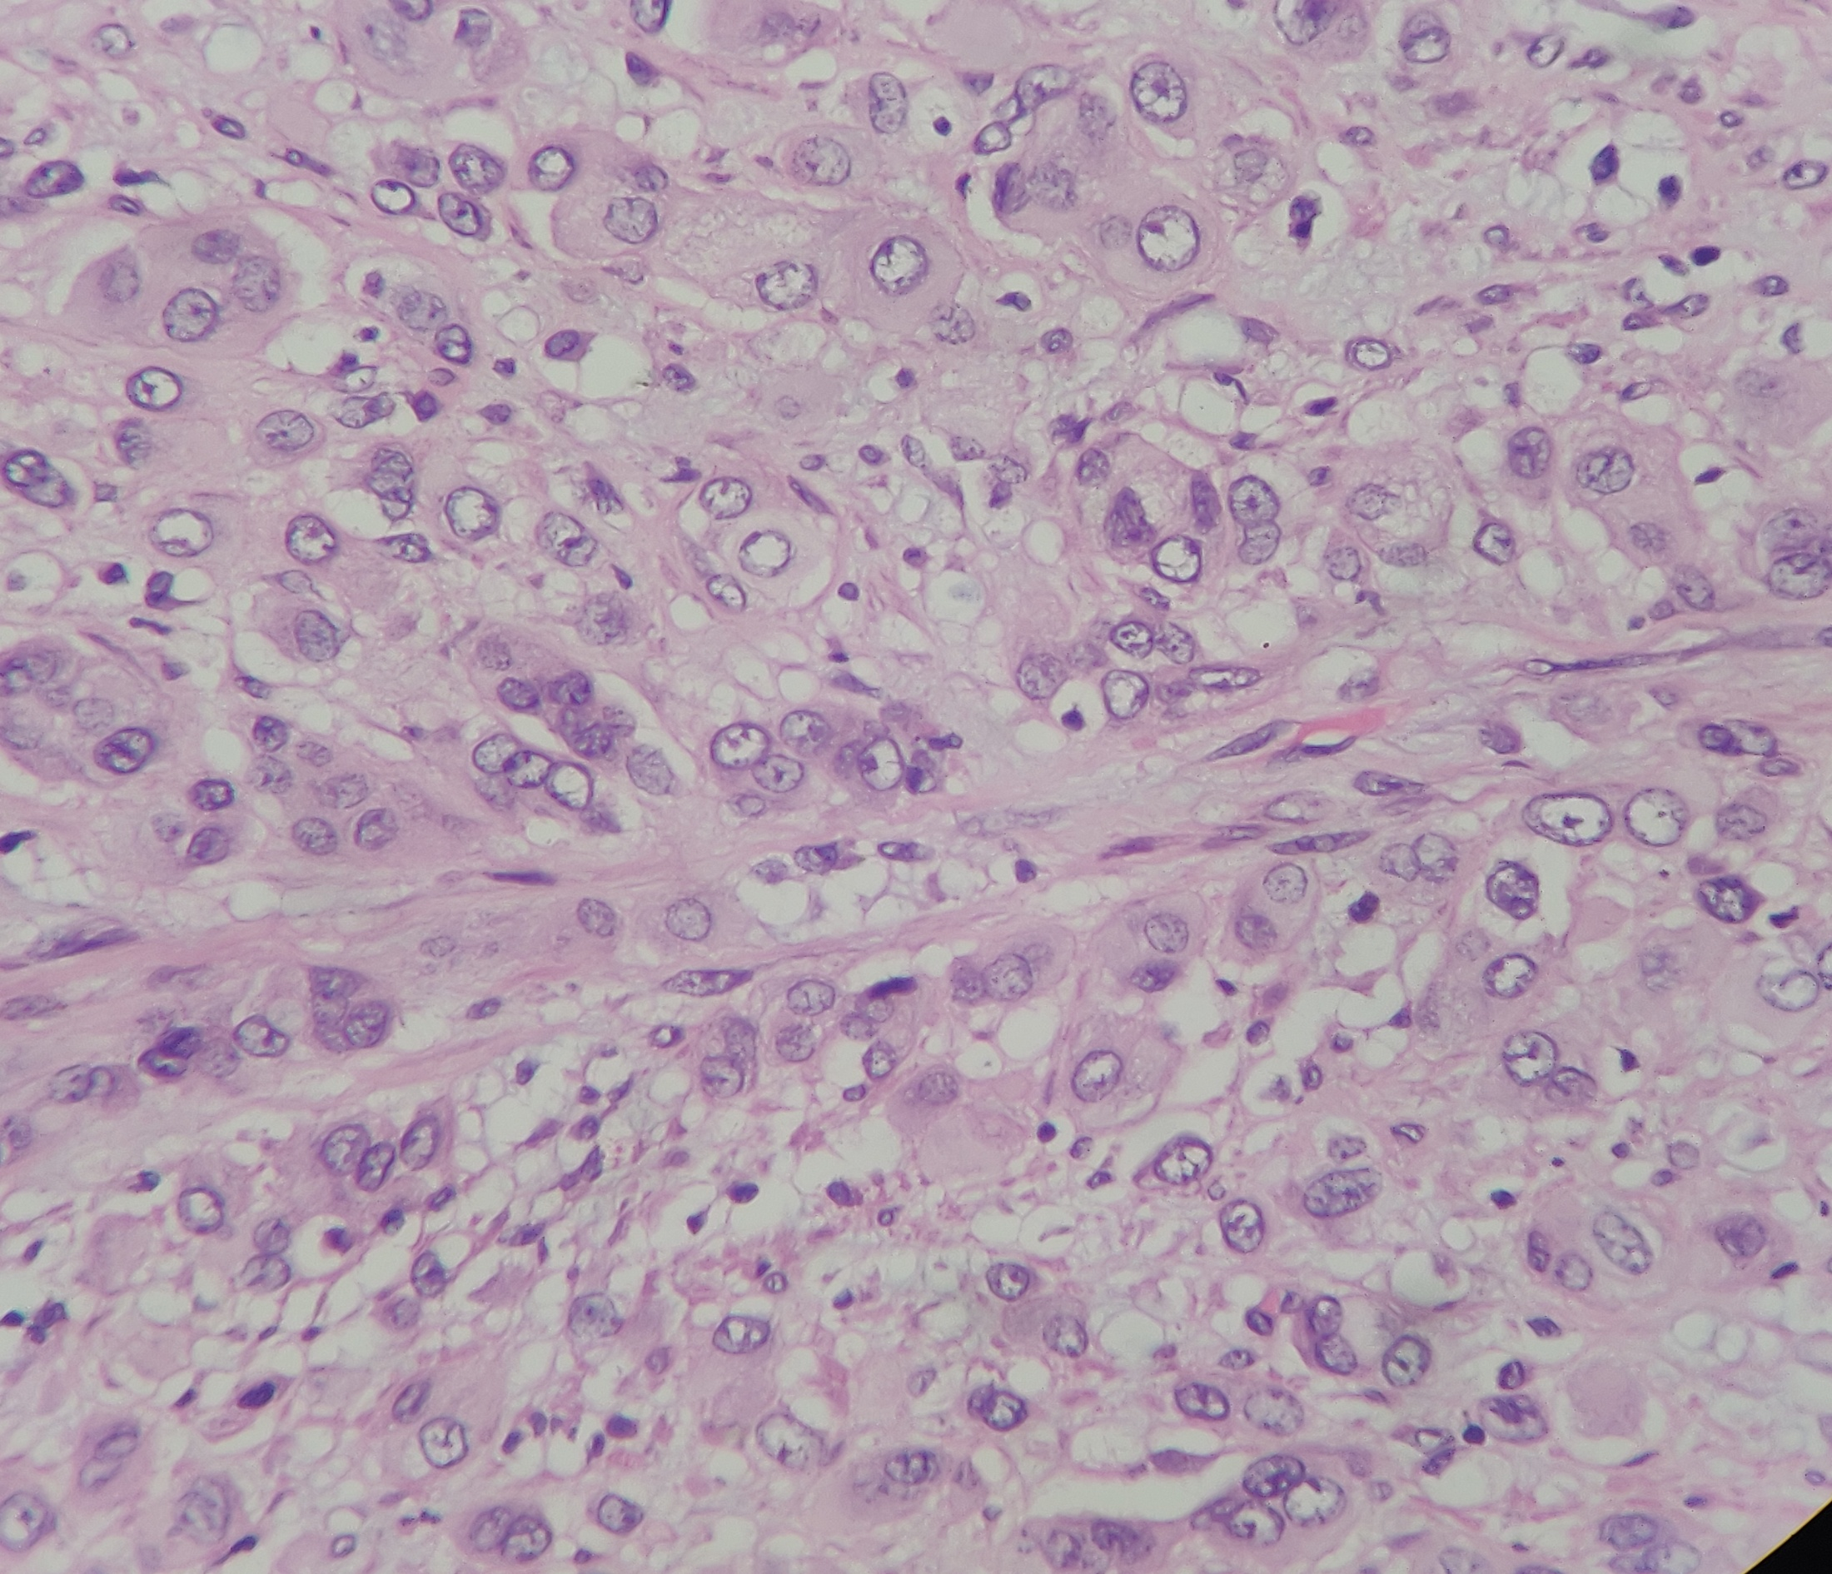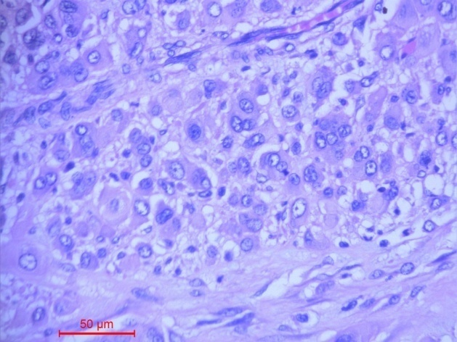
Figure 3 a, b: Shows tumour deposits in the lymph nodes.

Discussion
Enteric duplication cysts often contain heterotopic mucosa, most commonly gastric or pancreatic tissue. Malignant transformation within these cysts is extremely rare, with adenocarcinoma being the most frequently reported malignancy. Commonly patients present vague symptoms which mimic more common pathologies such as volvulus, appendicitis, intussusceptions, pelvic abscess, diverticulitis, achalasia, and Hirschsprung's disease.⁵
The aetiology of ED remains unknown. Theories postulated that abnormal recanalization after the solid epithelial stage of embryonic bowel development ^{6.} Other theories consider persisting embryologic diverticula or 'aborted Gemini', partial twinning, and split notochord theory. However, the most accepted theory is the 'intrauterine vascular accident theory' ⁷.
The pathogenesis is thought to be related to chronic inflammation, acid secretion by heterotopic gastric mucosa, and prolonged mucosal irritation. Small bowel duplication cyst malignancies tend to show aggressive behaviour with a high incidence of lymph node metastasis, as seen in the present case.⁸ The presence of pancreatic tissue or gastric mucosa leads to complications such as peptic ulcers or acute pancreatitis.⁹
Gastric duplications are mostly seen in the greater curvature, because gastric duplications usually originate dorsal to the primitive intestine.¹⁰ Oesophageal duplication cysts (EDCs) are rare congenital anomalies resulting from aberrant development of the posterior division of the primitive foregut^{. 11}In the literature small bowel duplications are frequently the site of malignancy, followed by colonic and rectal duplications. ¹²
Completely isolated advanced enteric duplication cyst are cysts which lack a connection to the gastrointestinal tract or the adjacent mesenteric vasculature and have been reported in only ten case reports. In these reports, only two reports showed malignant transformation. ¹³
Early recognition and complete surgical excision are crucial to prevent malignant transformation and improve prognosis. isolated enteric duplication cysts have lower morbidity prevalence rate.¹⁴Complete removal of the cyst is the treatment of choice to avoid the risk of complications such as obstruction, torsion, perforation, haemorrhage, and malignancy. ¹⁵

Conclusion
Although enteric duplication cysts are rare in adults, the possibility of malignant transformation should always be ruled out. Thorough histopathological examination is essential, especially when dysplasia or invasive carcinoma is suspected. This case adds to the limited literature on adenocarcinoma arising in jejunal duplication cysts and underscores the need for awareness of this rare entity.

References
- Blank, G., Königsrainer, A., Sipos, B., & Ladurner, R. (2012). Adenocarcinoma arising in a cystic duplication of the small bowel: case report and review of literature. *World Journal of Surgical Oncology*, *10*, Article 55. https://doi.org/10.1186/1477-7819-10-55
- Ladd WE, Gross RE. Surgical treatment of duplications of the alimentary tract. Surg Gynecol Obstet. 1940; 70:295–307.
- Macpherson, R. I. (1993). Gastrointestinal tract duplications: Clinical, pathologic, etiologic, and radiologic considerations. Radiographics, 13(5), 1063–1080. https://doi.org/10.1148/radiographics.13.5.8210590
- Fan, M., & Yang, F. (2024). Low-Grade Mucinous Neoplasm Arising in an Enteric Duplication Cyst of Pancreas: A Case Report and Literature Review. *International Journal of Surgical Pathology*, *32*(2), 422-427. https://doi.org/10.1177/10668969231183635
- Kashif, M. M., Satishrao, I., & Sachin, D. V. (2018). Adenocarcinoma arising in a small bowel duplication cyst. J Med Sci Res, 6(2), 59-62. https://doi.org/10.17727/JMSR.2018/6-10
- Bremer JL. Diverticula and duplications of the intestinal tract. Arch Pathol. 1944; 38:132–140.
- Favara, B. E., Franciosi, R. A., & Akers, D. R. (1971). Enteric duplications. Thirty-seven cases: A vascular theory of pathogenesis. American Journal of Diseases of Children, 122(6), 501–506. https://pubmed.ncbi.nlm.nih.gov/5145872/
- Kusunoki, N., Shimada, Y., Fukumoto, S., Iwatani, Y., Ohshima, T., Arahi, E., Miyazaki, N., & Maeda, S. (2003). Adenocarcinoma arising in a tubular duplication of the jejunum. Journal of Gastroenterology, 38(8), 781–785. https://doi.org/10.1007/s00535-002-1146-8 .
- Kang, H. J., Jang, S. J., & Park, Y. S. (2014). Adenocarcinoma arising in gastric duplication cyst. Korean Journal of Pathology, 48(2), 159-161. https://doi.org/10.4132/KoreanJPathol.2014.48.2.159
- Seijo Ríos, S., Lariño Noia, J., Abdulkader Nallib, I., Lozano León, A., Vieites Pérez-Quintela, B., Iglesias García, J., & Domínguez Muñoz, J. E. (2008). Adult gastric duplication cyst: diagnosis by endoscopic ultrasound-guided fine-needle aspiration (EUS-FNA). Rev Esp Enferm Dig, 100(9), 586–590. https://doi.org/10.4321/s1130-01082008000900011
- Narayanan, S., Kumar, S. A., Goyal, H., & Halanaik, D. (2025). Adenocarcinoma Arising in an Esophageal Duplication Cyst With Disseminated Metastases: A Rare Case Detected on 18F-FDG PET/CT. Clinical Nuclear Medicine. https://doi.org/10.1097/RLU.0000000000006135
- Blank, G., Königsrainer, A., Sipos, B., & Ladurner, R. (2012). Adenocarcinoma arising in a cystic duplication of the small bowel: case report and review of literature. World Journal of Surgical Oncology, 10(55) https://doi.org/10.1186/1477-7819-10-55
- Nakashima, S., Yamada, T., Sato, G., Sakai, T., Chinen, Y., Itakura, H., Kato, R., Ueda, M., Tsuda, Y., Ohta, K., Matsuyama, J., & Ikenaga, M. (2019). A case of completely isolated advanced enteric duplication cyst cancer performed partial pancreatectomy. International Journal of Surgery Case Reports, 54, 83-86. https://doi.org/10.1016/j.ijscr.2018.11.060
- Kusunoki, N., Shimada, Y., Fukumoto, S., Iwatani, Y., Ohshima, T., Arahi, E., Miyazaki, N., & Maeda, S. (2003). Adenocarcinoma arising in a tubular duplication of the jejunum. Journal of Gastroenterology, 38(8), 781–785. https://doi.org/10.1007/s00535-002-1146-8
- Mardi, K., Kaushal, V., & Gupta, S. (2010). Foregut duplication cysts of stomach masquerading as leiomyoma. Indian Journal of Pathology and Microbiology. https://doi.org/10.4103/0377-4929.59214

