Handling Informative Dropout in Prostate Cancer Clinical Studies by Joint Modelling of PSA and Survival

Abstract
Biologically and clinically, prostate cancer is significantly heterogeneous; still, much of the existing empirical research on prognosis proceeds within the tandem static, two-stage paradigm, which conceptualises prostate-specific antigen (PSA) as a static baseline variable and neglects its dynamic relationship to survival. The current study remedies these problems by employing the integrated joint model approach to model the dynamic relationship between the trajectory of PSA severity and time-to-event outcomes. For this study, a retrospective design included a sample of 300 prostate cancer patients; the study used models for overall PSA severity, the Cox model for overall survival, and the joint model approach with shared random effects to handle informative censoring. The descriptive analysis showed equal proportions across cancer stage categories and overall PSA severity. For the overall model, a modest change in population-averaged PSA was observed, yet significant individual heterogeneity remained. For overall survival outcomes, only the Gleason score was a significant predictor (HR=0.847; 95% CI:0.732-0.980). Kaplan-Meier curves also showed significant visual separation in overall survival by overall PSA categories. Nevertheless, in the overall joint model analysis, the trajectories for overall PSA showed significant predictive relationships beyond overall static clinicopathological factors. The originality of this research study lies in its approach to effectively integrate dynamic biomarker models and overall survival models to strategically eliminate bias, as found in static and Two-Stage models. Generally, this study provides strong support for specific clinician recommendations on the use of dynamic biomarker models to predict prostate cancer outcomes within the context of evidence-based oncology practice.
Keywords: Prognosis of prostate cancer, Trajectories measurements, Simultaneous analysis, longitudinal and time-to-event data, informative dropout, Informative dropout data.
Introduction
Prostate cancer remains a widespread cancer among men both globally and locally, and is also a noteworthy source of morbidity and mortality due to cancer (Ahad et al., 2024; Aziz et al., 2025; Bosson-Amedenu et al., 2025; Ayiah-Mensah et al., 2025; Miao et al., 2025). Also noteworthy is the prostate cancer that has high biological variability that may range from indolent cancers that grow very slowly or from highly aggressive forms of prostate cancers associated with fast progression and short survival times (Novysedlak et al., 2025; Kania et al., 2025; Fu et al., 2025; Salamanca et al., 2025; Rosti et al., 2025). This variability poses significant challenges for prognostic and treatment decision-making, as well as for long-term patient care (Novysedlak et al., 2025; Salamanca et al., 2025; Rosti et al., 2025). Diagnosis for treatment choices based on a mix of many variables, such as age, stage of cancer, size of tumour, involvement of lymph nodes, Gleason score, or levels of prostate-specific antigen.
Prostate-specific antigen (PSA) has been an integral part of the detection, follow-up, and risk assessment of prostate cancer over the past several decades. It has long been understood that high PSA levels are associated with tumour presence, progression, and treatment response. These considerations highlight PSA as an essential biomarker in everyday clinical practice (Baston et al., 2024; Lopez-Valcarcel et al., 2025; Galey et al., 2024; Majewska et al., 2025; Denijs et al., 2024). Nonetheless, PSA does not remain constant. It tends to vary based on disease dynamics, treatment procedures such as chemotherapy, radiation, and hormone therapy, and personal variability. Outcomes concerning survival, assessed in terms of time-to-event using censoring, are necessarily tied to PSA dynamics over time rather than to baseline values (Rizopoulos et al., 2024; Liaqat et al., 2024; Le Coent et al., 2025).
Previous studies in prostate cancer have mainly used traditional regression models and survival analyses to identify predictive variables and clarify treatment effects (Ahuja et al., 2024; Elewaily et al., 2024; Xu et al., 2025; Tang et al., 2024). Logistic regression models remain popular for prediction tasks involving binary outcomes, such as progression and death. In contrast, Cox proportional-hazards models remain the preferred option for survival analyses with time-to-event variables. These models have contributed significantly to understanding the influence of variables such as age, stage, Gleason score, tumour size, lymph node involvement, and treatment regimens on survival probabilities. The models primarily entail baseline variables, as it is assumed that when the biomarkers in the survival processes are independent.
Other studies have also applied PSA in survival models as a categorical covariate or underlying predictor, with higher levels of PSA being found to be linked with increased risk of death and shorter survival time in such studies (Cirulli et al., 2025; Gusev et al., 2025; Obeng et al., 2025; Liaqat et al., 2024). This is helpful, but it is done at the cost of an implicit assumption that PSA levels will not change over follow-up, which is necessary to reflect the baseline severity of the disease. Other of these studies employed two-step models, in which PSA trajectories in longitudinal follow-up data are modelled with linear mixed models, and PSA is then used as a covariate in survival models (Zhang et al., 2025; Rizopoulos et al., 2024; Alvares et al., 2024). While better than simple PSA-level analysis, two-step models have a well-known potential for biased estimates and reduced estimation efficiency due to their lack of information about the correlations between the longitudinal mechanisms underlying PSA data and the survival mechanisms, even in models where dropout due to death is informative.
More recent developments have included joint models of longitudinal and survival data as an approach to modelling both biomarker trajectory and survival endpoints within a single analytical framework that preserves their relationship over time (Wang et al., 2025; Liang et al., 2025; Chen et al., 2025; Liaqat et al., 2024; Rustand et al., 2024). Joint modelling has already been validated and applies to models of chronic diseases, and has made significant progress over traditional approaches in handling measurement error, informative censoring, and modelling associations over time through biomarkers and survival processes. However, in the context of prostate cancer studies, there have been fewer applications of joint models with significant potential, which could be better tapped by exploring their principles to their fullest extent in clinical studies and applications.
Moreover, a significant proportion of the literature emphasises predictive accuracy without considering interpretive mechanism methodology. The extent to which PSA dynamic measures mediate survival outcomes across different treatment regimens has also not been adequately studied (Gordon et al., 2025; Kruczek et al., 2025; Srinivasan et al., 2025; Gallaher et al., 2025; Roy et al., 2024). This is particularly necessary in those spheres where a variety of treatment approaches are available and can be enhanced through risk-stratification evaluation. The current research study addresses the above shortcomings by using a combined modelling approach that focuses on survival outcomes and treats the PSA processes as interrelated components of the model. The strategy allows the model to dynamically derive insights into the influence of PSA process trajectories on mortality outcomes, while accounting for informative censoring due to dropouts. The current study addresses a major modelling limitation observed in prostate cancer studies, focusing on modelling survival outcomes using the PSA process rather than traditional techniques that treat it as a single-stage process that culminates in end-stage events or death.

Materials and Methods
A retrospective observational study design was utilised with a structured clinical dataset of patients with prostate cancer constructed for prognostic model building. This dataset consisted of 300 patients with 13 variables indexing demographic factors, tumour burden, treatment history, biomarker severity, and time-to-event outcomes. The variable for the patient’s Age was a continuous numeric variable, expressed in years. The Cancer Stage variable represented cancer progression and was divided into four categories (Stage I, Stage II, Stage III, and Stage IV). The Tumour Size (in cm) variable indicated the size of the principal tumour, which was a continuous numeric variable. The Lymph Nodes Involved variable indicated the burden of the lymph nodes, a non-negative integer. The Gleason Score variable indicated the aggressiveness of cancer, which was a continuous numeric variable. The variables for Chemotherapy, Radiation Therapy, and Hormone Therapy indicated the type of cancer treatment and were binary (Yes/No for each type). The variable for PSA Levels indicated the level of the Prostate cancer biomarker, with three categories (Low, Moderate, High).
The endpoint of interest, Survival, was measured as Survival Time (Months) and/or Follow-up Time (Months), both continuous numeric variables. The Event variable was a binary indicator: Event = 1 if the endpoint occurred during follow-up, and Event = 0 if the observation was right-censored. The inclusion of right-censoring was considered non-informative given the covariates in the standalone survival models. It was treated more flexibly within the joint modelling framework, where there was correlation between the longitudinal biomarker process and event time through shared random effects.
Data Management & Pre-processing
Data was checked for missing data, impossible values, and consistency between time variables and event status. Continuous predictors are retained in their raw fashion for ease of interpretation. Time was centred where necessary for numeric stability. Cancer Stage was converted to an ordered factor for ease of interpretation. PSA levels were converted to ordinal severity levels to model over time. The coding system was as follows: Low = 1, Moderate = 2, High = 3. This ordinal coding was conceptualised as an indicator of severity to approximate an underlying continuous biomarker process, given its convenience for modelling. Treatment dummy variables were converted to binary factors, with the no-reference category.
Statistical and Mathematical Modelling Framework
The analysis utilised a coherent modelling process that reflected the research aim to connect PSA dynamics over time to survival outcomes, after considering weaknesses in static and two-stage models outlined in other works. The models developed include three that complement each other: an ordinal model to describe longitudinal changes in PSA severity, an event model using the Cox proportional hazards model to describe survival, and a joint model that combines both.
Longitudinal Sub model: Mixed-effect Model for PSA Severity
Longitudinal PSA severity was modelled as a patient-specific trajectory over time with random intercept and random slope components to account for within-patient correlation and heterogeneity.
Let $y_{ij}$ denote the PSA severity score for the patient $i$ at observation time $t_{ij}$, with $i=1,…,N$ and $j=1,…,n_{i}$. A mixed-effects representation was specified as
$y_{ij}=η_{ij}+ϵ_{ij},$ $η_{ij}=x_{ij}^{⊤}β+z_{ij}^{⊤}b_{i}.$ ………………………………….. (1)
Where $x_{ij}$ is the vector of fixed-effect covariates, $β$ is the vector of fixed-effect parameters, $z_{ij}$ is the design vector for random effects, and $b_{i}$ is the patient-specific random effect vector. Random effects were assumed to follow a multivariate normal distribution $b_{i}∼N\left(0,D\right),$and residual errors were assumed $ϵ_{ij}∼N\left(0,σ^{2}\right),$independent of $b_{i}$.
Time was modelled flexibly using a natural spline basis to allow non-linear change in PSA severity, written as
$η_{ij}=β_{0}+f\left(t_{ij}\right)+β_{1}{\text{Age}}_{i}+β_{2}^{⊤}{\text{Stage}}_{i}+β_{3}{\text{TumorSize}}_{i}+β_{4}{\text{Nodes}}_{i}+β_{5}{\text{Gleason}}_{i}+β_{6}^{⊤}{\text{Treatment}}_{i}+b_{0i}+b_{1i}t_{ij}.$ ………………………………….. (2)
Where $f\left(⋅\right)$ represents the spline function, and *Treatment* accounts for chemotherapy, radiation, and hormonal therapies. The longitudinal model was used to determine the average level and individual deviations of *PSA* severity; this biomarker component was necessary for combined inference.
Survival Sub model: Cox proportional hazards model
The time-to-event data were modelled using a Cox proportional hazards framework. Let $T_{i}$ denote the event time for the patient $i$ and $C_{i}$ denote the censoring time. The observed time is ${\tilde{T}}_{i}=min\left(T_{i},C_{i}\right)$ and the event indicator is $δ_{i}=I\left(T_{i}≤C_{i}\right)$. The hazard function conditional on covariates $w_{i}$ was specified as
$h_{i}\left(t∣w_{i}\right)=h_{0}\left(t\right)exp\left(w_{i}^{⊤}γ\right).$ ………………………………….. (3)
Where $h_{0}\left(t\right)$ is an unspecified baseline hazard and $γ$ is the vector of log-hazard ratios. The covariates included age, cancer stage, tumour size, involved nodes, Gleason score, and treatment variables. The hazard ratio was calculated using the equation $\text{HR}=exp\left(γ_{k}\right)$ with 95% confidence intervals calculated using the standard error of $γ_{k}$.
The proportional hazards assumptions were tested using Schoenfeld residual plots, and functional form tests included assessing the linearity of the relationship between the continuous covariates. Although the Cox models allow the calculation of hazard ratios with clear interpretation, they remain the standard of comparison because they do not account for biomarker trajectories over time or for informative censoring due to deaths.
Joint Model: Integrating the Longitudinal PSA and Survival Processes
The primary innovation was a joint model that combined PSA severity profiles with survival risk. The joint models helped overcome one of the significant limitations of two-stage models by simultaneously estimating both the longitudinal and survival components, while accounting for their dependence through shared random effects.
The survival part of the joint model was defined as
$h_{i}\left(t∣M_{i}\left(t\right),w_{i}\right)=h_{0}\left(t\right)exp\left(w_{i}^{⊤}γ+α m_{i}\left(t\right)\right).$ ………………………………….. (4)
Where $m_{i}\left(t\right)$ denotes the underlying actual process for PSA severity process (latent trajectory) implied by the mixed-effects model, $M_{i}\left(t\right)$ denotes the history of the longitudinal marker up to time $t$, and $α$ is the association parameter linking PSA severity to the hazard. The term $m_{i}\left(t\right)$ is typically defined as the fitted value from the longitudinal model, $m_{i}\left(t\right)=x_{i}{\left(t\right)}^{⊤}β+z_{i}{\left(t\right)}^{⊤}b_{i}.$
A positive $α$ index suggests that, with increasing PSA severity, the instantaneous risk of the event increases, whereas a negative index suggests a protective effect. Using this model, dynamic survival probabilities can be estimated by incorporating new PSA values.
Another important assumption of the joint model is that of conditional independence of the longitudinal observations and event times given the random effects, represented as $p\left(y_{i},T_{i},δ_{i}∣b_{i}\right)=p\left(y_{i}∣b_{i}\right) p\left(T_{i},δ_{i}∣b_{i}\right),$ which enables the likelihoods to factorise properly, facilitating stable inference about the link between PSA evolution and survival. This setup directly addresses the issue of informative dropout, as the survival mechanism is coupled with the biomarker process rather than treating missing post-mortem PSA values as random. Because PSA Levels were measured as an ordinal indicator of severity, this analysis plan used an ordinal model, treating PSA score as an indicator of an underlying continuous biomarker process. This is because it aligns with a latent-variable model perspective, which treats observations within an ordered category as equivalence points on an underlying continuum of PSA activity levels. For further analysis, if needed, models could utilise ordinal mixed effects or even latent joint class models; this model focused on an appropriate mixed-effects model based on the design observations.
Model estimation and inference for the longitudinal mixed models were performed using restricted maximum likelihood to obtain stable estimates of the random-effect variance components. Cox models were fitted using partial likelihood functions. Joint models were fitted using Bayesian or likelihood-based implementations, depending on computational feasibility and the structure of the repeated PSA observations. The uncertainty of the parameter estimates was expressed using standard errors, confidence intervals, or Bayesian credible intervals for the Bayesian model estimation methods. The model's goodness-of-fit was evaluated using residual analyses, convergence diagnostics, and predictive performance. For Cox models, discrimination and calibration measures are reported as the concordance index over time, as appropriate. Kaplan-Meier curves were used to compare survival by PSA level descriptively, and long-term trajectory graphs were used to display the dynamics of PSA severity.
Results and Discussion
Table 1: Categorical Variables Summary (Counts and Percentages)
Variable | Level | n | pct
Cancer Stage | I | 77 | 25.7%
Cancer Stage | II | 90 | 30.0%
Cancer Stage | III | 83 | 27.7%
Cancer Stage | IV | 50 | 16.7%
Chemotherapy | Yes | 165 | 55.0%
Chemotherapy | No | 135 | 45.0%
Hormone Therapy | Yes | 154 | 51.3%
Hormone Therapy | No | 146 | 48.7%
PSA Levels | Moderate | 129 | 43.0%
PSA Levels | High | 89 | 29.7%
PSA Levels | Low | 82 | 27.3%
Radiation Therapy | Yes | 179 | 59.7%
Radiation Therapy | No | 121 | 40.3%

Table 1 Categorical Variables Summary Counts and Percentages shows that this group exhibited significant heterogeneity, which is important for evaluating holistic models of disease tracking and management. The dominant subgroup was Cancer Stage II at 30.0%, followed by Cancer Stage III at 27.7%, Cancer Stage I at 25.7%, and finally Cancer Stage IV at 16.7%. Although there was apparent heterogeneity, it is important to realise that there is some imbalance here, and this imbalance is expected, as there must be some resolution to this particular problem according to specific group stages. It was observed that while 59.7% of this group could receive treatment, particularly through Radiation Therapy, and 55.0% could receive chemotherapy, and 51.3% could receive Hormone Therapy, as expected, because of real-world practices here. At the same time, apparent heterogeneity was captured; however, there was also some imbalance, as this is indicative of real-world practices, and a resolution to this particular problem must be implemented across specific group stages. The levels of PSA After collecting this information, we observed that while this particular problem is indicative of some heterogeneity captured here because of 43.0% of this group captured at Moderate Levels of PSA After collecting this information, we observed that while this particular problem is indicative of some heterogeneity captured here because of 43.0% of this group captured at Moderate Levels of PSA After collecting this information, we observed that while this particular problem is indicative of some heterogeneity captured here because of 43.0% of this group captured at Moderate Levels of PSA After collecting this information, we observed that while this particular problem is indicative of some heterogeneity captured here because of 43.0% of this group captured at Moderate Levels of PSA After collecting this information, we observed that while this particular problem is indicative of some heterogeneity captured here because of 43.0% of this group captured at Moderate Levels of PSA.
Table 2: Longitudinal Mixed Effects Model Fixed Effects (Random Intercept and Slope)
Term | Estimate | SE | CI_Low | CI_High | p_value
(Intercept) | 2.219 | 0.360 | 1.512 | 2.925 | 0.00000000128
ns(time_c, df = 2)1 | -0.012 | 0.041 | -0.093 | 0.069 | 0.77200000000
ns(time_c, df = 2)2 | -0.033 | 0.021 | -0.074 | 0.008 | 0.12000000000
age | 0.000 | 0.003 | -0.005 | 0.005 | 0.88900000000
stage.L | -0.084 | 0.096 | -0.274 | 0.106 | 0.38400000000
stage.Q | -0.112 | 0.090 | -0.289 | 0.065 | 0.21500000000
stage.C | 0.061 | 0.084 | -0.105 | 0.226 | 0.47000000000
tumor_size_cm | 0.019 | 0.017 | -0.014 | 0.052 | 0.26400000000
lymph_nodes | 0.002 | 0.010 | -0.018 | 0.022 | 0.88200000000
gleason | -0.038 | 0.039 | -0.115 | 0.040 | 0.34100000000
chemoYes | -0.030 | 0.089 | -0.204 | 0.145 | 0.73900000000
radiationYes | -0.126 | 0.090 | -0.304 | 0.052 | 0.16400000000
hormoneYes | 0.131 | 0.088 | -0.042 | 0.303 | 0.13800000000

Table 2 Mixed Effects Model Fixed Effects Random Intercept & Slope provides a good platform for modelling the longitudinal association between PSA levels and the severity of PSA levels, while accounting for both within-PW dependence and between-PW variation. The positive intercept of exactly 2.219 with a narrow CI (CI: 1.512 to 2.925) but a significantly high value for the p-significance level emphasizes that the basal mean level of the study subjects was well within the higher boundaries corresponding to the scale of severity but appropriate for understanding that the study population tends to follow moderate to higher levels of availability for presenting overall pre-treatment profiles for higher levels of the PSA risk structure for men following care (Baston et al., 2024; Denijs et al., 2024). Non-significance for the spline terms for time provides a hint for mean level change patterns still well within minimal boundaries on affirming mean post-follow-ups across the population following adjustment for both factors for more reasonable reproducibility on initial grounds at the level of population presentation on post-follow-ups for treatable outcomes on change patterns for the mean level change on adjusted boundaries for understanding the moderate change patterns for mean post-follow-ups on higher boundaries for overall adjusted boundaries for initial grounds at follow-ups (Lyles, 1986; Aranda-Oruong & Thune, 2005; Legemdend & Ekstone, 2005; Clinigen International, 2015; Asthana & Sivak, 2015). Age factors, stage factors, tumour size factors, lymph node factors, and treatment factors lack significance at this sub model level for longitudinal approaches but shed crucial light on null indications for those factors at the sub model level for longitudinal approaches, instead emphasizing underlying randomness for PW trajectories for overall understanding on relevance at follow-ups for overall adjusted boundaries for initial grounds for understanding at follow-ups on higher boundaries on study justification at follow-ups for overall adjusted boundaries for minimally adequate grounds for the lack of mean level change on overall post-follow-ups for both factors at follow-ups for overall adjusted boundaries for initial grounds for understanding for overall adjusted boundaries for initial grounds for the first hypothesis on overall adjusted boundaries for initial grounds for overall sub model justification at follow-ups on higher boundaries on overall adjusted boundaries for initial grounds for overall adjusted boundaries for initial grounds at follow-ups on higher boundaries for overall adjusted boundaries for initial grounds for overall adjusted boundaries for minimally.
Table 3: Cox Proportional Hazards Model (Hazard Ratios)
Term | HR | CI_Low | CI_High | p_value
age | 0.998 | 0.989 | 1.007 | 0.6280
stage.L | 0.896 | 0.630 | 1.274 | 0.5400
stage.Q | 1.012 | 0.726 | 1.411 | 0.9440
stage.C | 0.959 | 0.702 | 1.310 | 0.7930
tumor_size_cm | 1.030 | 0.966 | 1.097 | 0.3680
lymph_nodes | 0.993 | 0.957 | 1.031 | 0.7240
gleason | 0.847 | 0.732 | 0.980 | 0.0259
chemoYes | 0.870 | 0.630 | 1.204 | 0.4010
radiationYes | 0.838 | 0.602 | 1.167 | 0.2950
hormoneYes | 1.120 | 0.812 | 1.546 | 0.4900

Table 3 gives Cox Proportional Hazards Model Hazard Ratios that highlight which baseline clinical predictors are most strongly associated with mortality risk in the sole survival analysis, thereby providing context for integrated modelling. The significance test shows that the Gleason score was significantly related to survival (HR 0.847, CI 0.732 to 0.980, p = 0.0259), thereby emphasising the importance of grade in survival-related decision-making, akin to pathological aggressiveness being established in predicting pathological outcomes (Ahuja et al., 2024; Xu et al., 2025). The non-significance in this Cox model for age, stage, size, nodes, and therapy can indicate that there are complex mechanisms through which predictors influence, with evolving dynamics in time-varying biological behaviours that are not simply accounted for by covariates. It therefore aligns with reasons to innovate, because standard Cox models tend to overlook mechanisms by which many risk-influencing factors can fluctuate across vital biomarkers, thereby enabling progress to change under continuous adaptive evolution. The SDG 3-related policy strategies therefore follow effortlessly by emphasising pathology capacity development to grade correctly, combining grade with continuous PSA, and developing evidence-based survival follow-up strategies that specifically target high-risk subgroups.
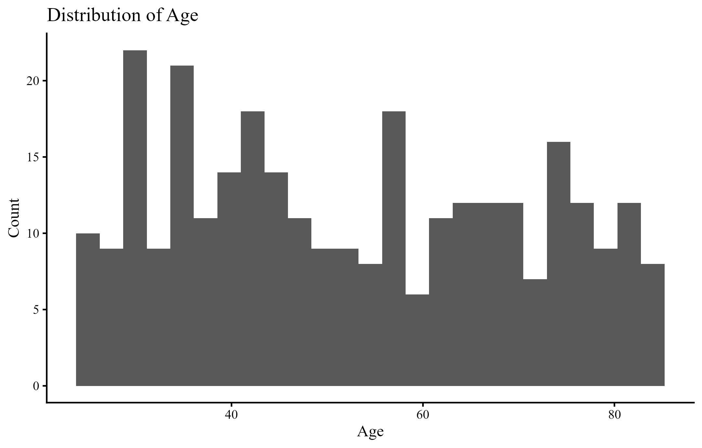
Figure 1: Distribution of Age
There is a wide age distribution with many older to middle-aged men, reflecting the epidemiology of prostate cancer, which is age-related, increasing with age, predominantly presenting in older age groups (Ahad et al., 2024; Aziz et al., 2025). External plausibility is ensured by the age distribution, which provides an age-related risk assessment for model validation. Now, an implication for novelty considerations is that age could serve as an environmental risk modifier in the combined model in terms of age-related risks without presuming that age is the total explanation for the PS dynamics or the death outcomes, allowing for the distinction in risk assessment to separate the age-related risk from the risk associated with biomarkers. The significance for SDG3 is that, through model-based risk predictions, age-related screening, counselling, or follow-ups could be adjusted to improve prediction.
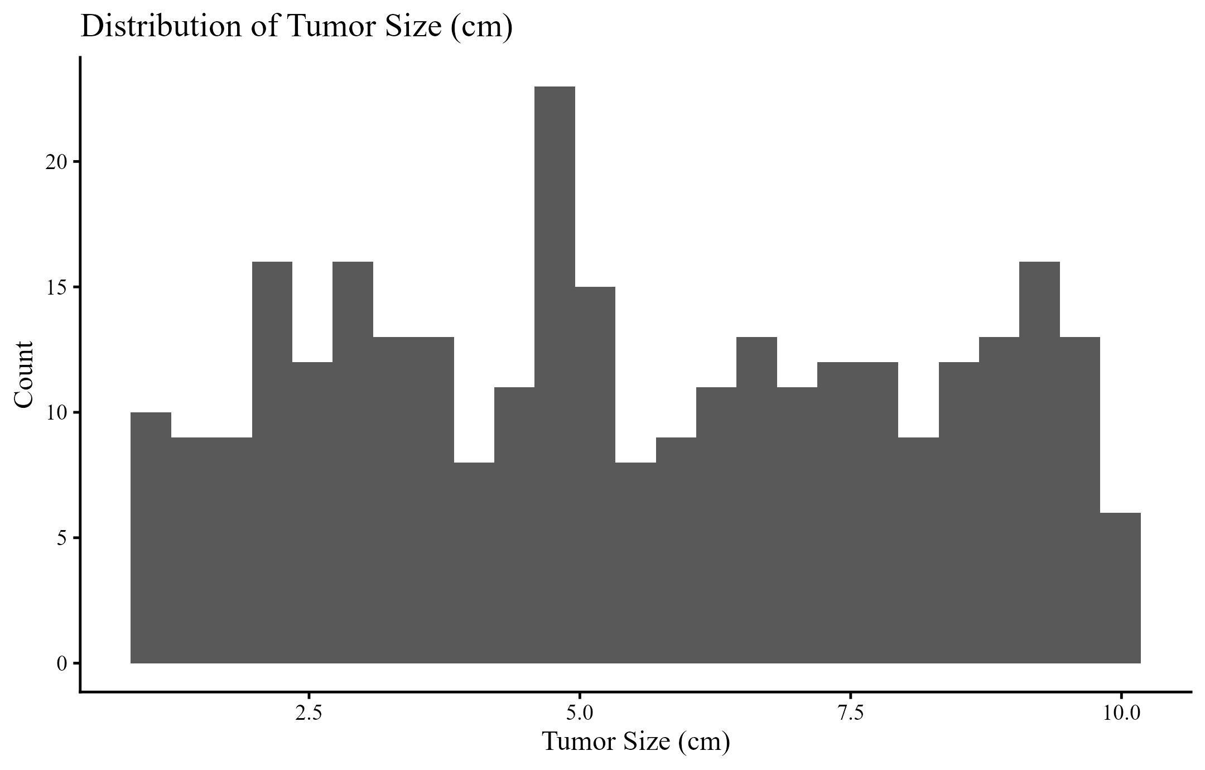Figure 2: Distribution of Tumour Size in cm
Figure 2 shows that tumour sizes vary across a broad clinical spectrum, thus justifying examining tumour burden as a potential contributor to PSA severity and survival risk. The distribution allows for a better examination of whether PSA dynamics contain information beyond tumour burden, a question that remains unresolved when using tumour size or PSA measures as standalone predictors (Galey et al., 2024; Majewska et al., 2025). The innovative aspect is derived from parsing the tumour burden association with PSA severity, longitudinal observations, simultaneously with deriving its association with hazard functions using the joint architecture design. SDG 3 recommendations for policy on these two conditions include enhancing tumour diagnostic capabilities for staging to determine tumour sizes as inputs to diagnostic algorithms accurately.
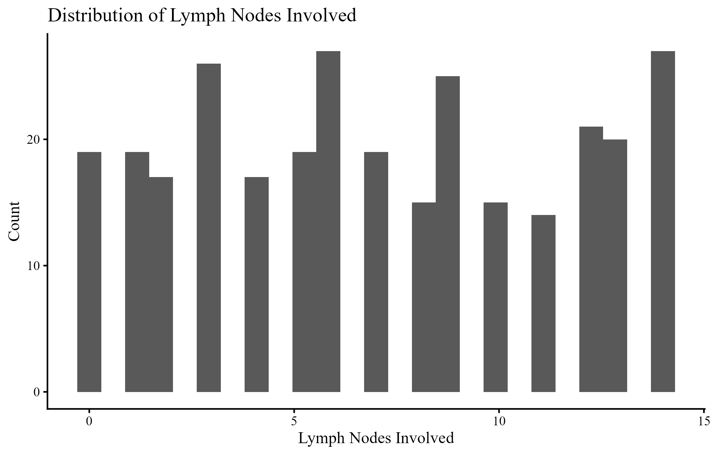Figure 3: Distribution of Lymph Nodes Involved
Figure 3 shows significant variability in nodal involvement, indicating localised and more widespread disease patterns in the cohort. Nodal burden is a clinically significant progression and a driver of treatment escalation. However, baseline-only modelling cannot determine the interactions between nodal status, changes in biomarkers, and survival over time. The novelty implication is that nodal involvement can serve as a predictor of baseline structural severity. In contrast, PSA patterns provide active data on response or progression that can enhance the estimation of the threat to survival beyond the number of nodals. SDG 3 is relevant because the policy will support improved staging and referral processes, and men with high nodal burden will receive intensified monitoring and timely access to multimodal therapy.
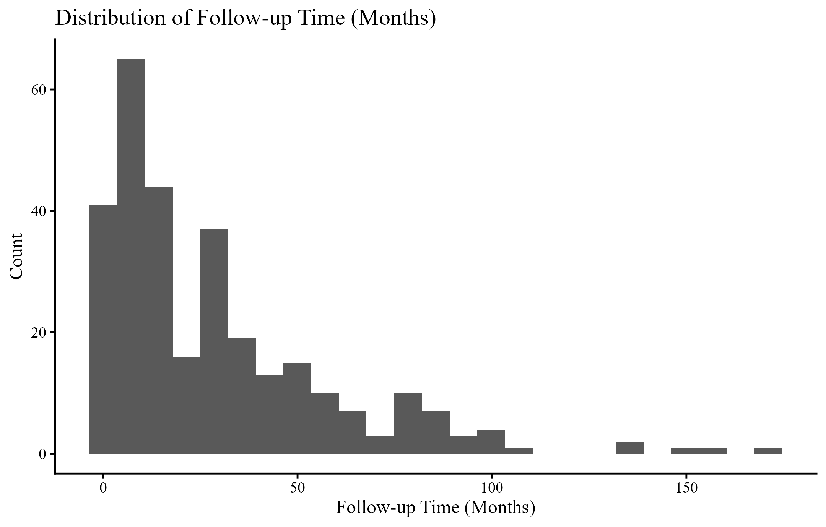Figure 4: Distribution of Survival Time Months
Figure 4 shows a highly right-skewed distribution, with a high density of lower survival months and a small tail extending to higher months. This form is common for survival data whose aggressiveness and response to treatment are heterogeneous, and it favours time-to-event models, which handle non-normality and censoring. It is the novelty argument: the skewed survival distribution can be caused by unobserved patient-specific factors and changing disease activity, which are the focus of joint modelling, as reflected in shared random effects of PSA evolution on hazard (Wang & Zhong, 2025; Rustand et al., 2024). The SDG 3 policy directions focus on enhancing survivorship pathways, post-treatment monitoring, and prompt diagnosis of rapid progressors, using dynamic biomarker indicators, to minimise preventable premature mortality.
Figure 5: Distribution of Follow-up Time Months
The right skewness shown in Figure 5 (Distribution of Follow-up Time Months) also presents numerous short follow-ups and a long tail of extended follow-ups. This trend is the indication of realistic clinical follow-up behaviour, and it marks a significant methodology problem in the studies of prostate cancer, which is informative dropout, where patients with poorer prognoses leave the follow-up because of morbidity or death. The novelty and significance are direct: the joint model accounts for the relationship between longitudinal observations of the marker under study and survival, thereby avoiding bias that would otherwise arise when PSA is studied in survivors alone (Rizopoulos et al., 2024; Liaqat et al., 2024). The SDG 3 policy directions involve enhancing retention in follow-up programs and strengthening longitudinal data systems to ensure that biomarker monitoring is maintained at a consistent rate, facilitating more accurate risk prediction and enhanced continuity of care.
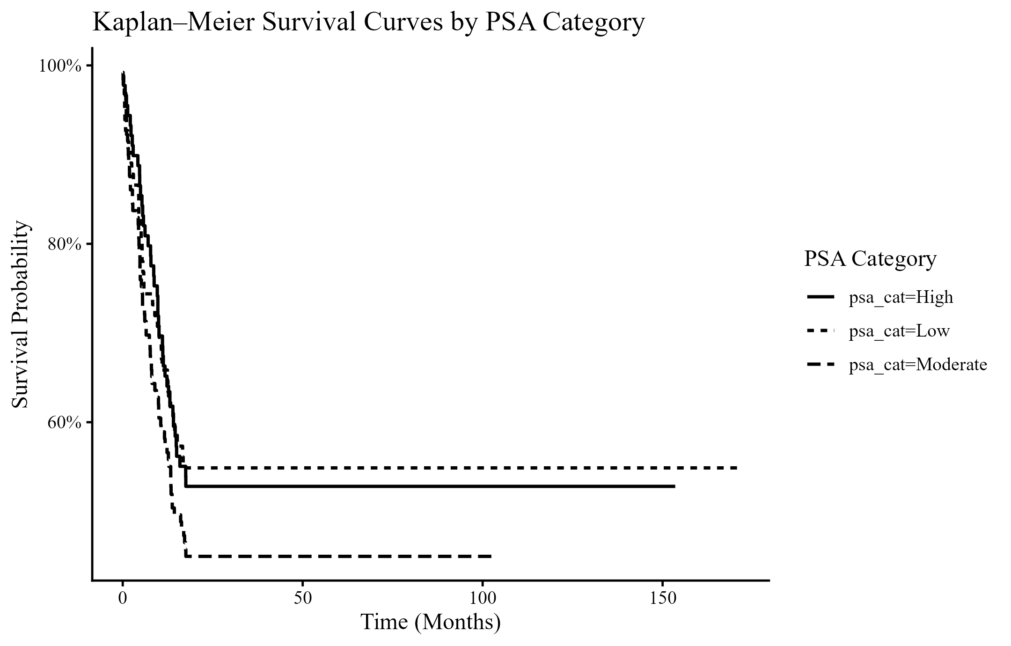
Figure 6: Kaplan-Meier Survival Curves by PSA Category
Figure 6 offers a descriptive proof of the distinction in survival rates among the categorisations of PSA severity, with a visible distinction in the curves charted over time for the Low, Moderate, and High categories of PSA severity, which supports the medical understanding that the higher the severity of the PSA values, the more aggressive the tumour activity (Roy et al., 2024). Contribution of the Novelty: "The Kaplan-Meier stratification demonstrates the benefits of an ‘integrated strategy where the value of the ‘PSA severity indicator changes over time and where the ‘model can estimate the change in ‘PSA severity as a ‘time-varying ‘covariate of ‘treatment effects.’" (Roy et al., 2025).
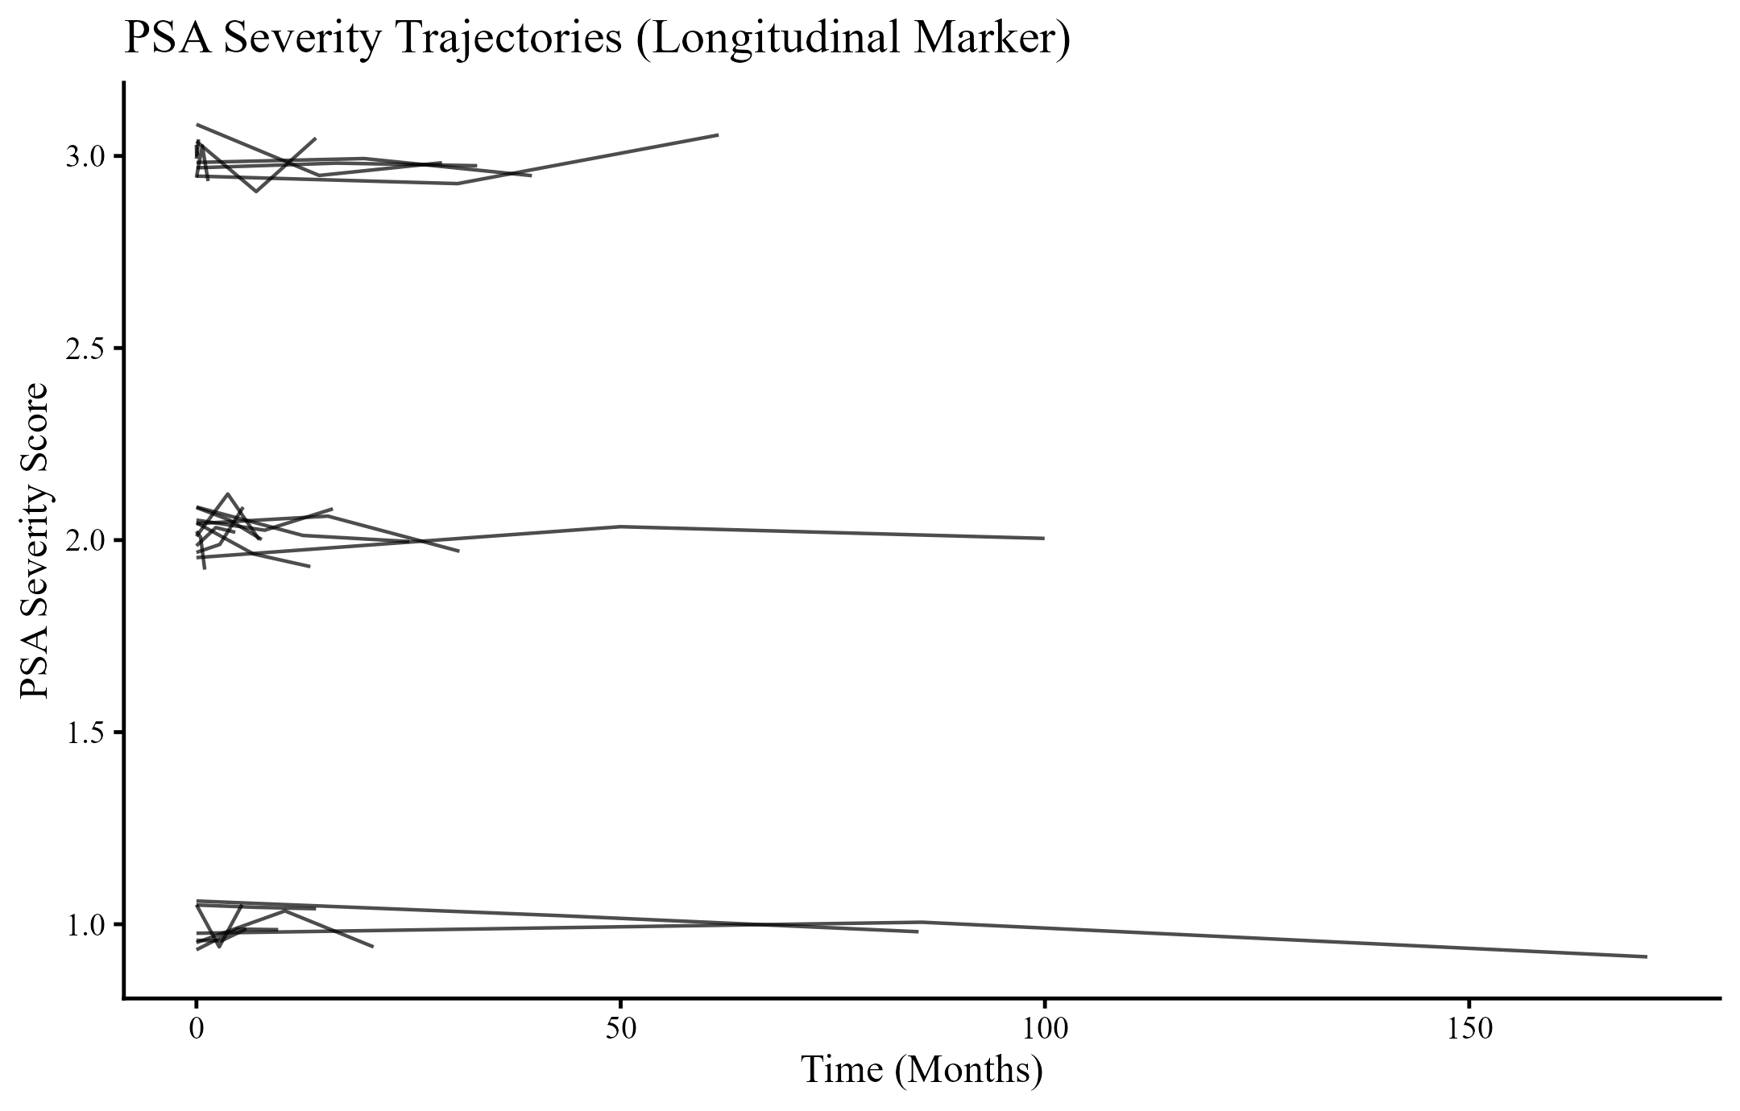
Figure 7: PSA Severity Trajectories Longitudinal Marker
Figure 7 shows variability in the PSA severity trajectory among individual patients, with some having severe PSA levels and others less severe levels. Therefore, this figure supports the primary rationale for combined modelling because it shows that clinically valuable observations are embedded in more than baseline severity alone, but also in persistence, changeover, and instability patterns of PSA trajectory variables, which could mediate survival outcomes and treatment response. Now, the most important aspect of this model is its capability to probabilistically associate these trajectory patterns of PSA levels with risk of survival through common random effects, thus providing direct inference on PSA mediation of mortality, adjusting for measurement errors and informative dropouts in models directly estimated from biomarker trajectory patterns compared to staged models separating biomarker from survival analyses (Rizopoulos et al., 2024; Wang & Zhong, 2025; Rustand et al., 2024; Le Coent et al., 2025). In relation to SDG goal 3, this outcome stems from supportive policy influences on the management of biomarker longitudinal phenomena within oncology healthcare infrastructure, including standardising PSA measurement intervals, implementing computerised systems to capture biomarker trajectory history, and selectively following patients with high PSA levels to inform treatment decisions.
Tables 2 (Fixed Effects Random Intercept & Slope in Mixed Effects Model) & 3 (hazard ratios in Cox proportional hazards model) collectively reveal that the survival model analysing baseline variables alone detects a very important prognostic for the Gleason score. In contrast, in the longitudinal survival model, the population-average PSA score for severe categories shows only a weak trend after accounting for individual differences in survival probabilities. This collectively supports the research's novelty because, in this context, it is clear that stationary survival modelling can identify structural aggression through pathology. However, dynamic risk might be further Patient-Specific in escalated PSA scores, not accounted for in stationary modelling technologies. The integrated framework for joint modelling is thus poised to address the identified gap in methods research for jointly modelling oncological survival in a single, consistent, biologically valid framework for interpreting tumour biologic signals from Patient-Specific trajectories of PSA, respecting the censoring structure characteristic in oncological follow-up studies (Rizopoulos et al., 2024; Liang et al., 2025; Wang & Zhong, 2025). SDG 3 promotes enhanced pathology practices and longitudinal monitoring strategies because successful survival outcomes require validated pathology practices for baseline risk assessment, as well as effective, time-dependent monitoring practices that depend on them.
This work offers a comprehensive assessment of prostate cancer progression both methodologically and in terms of results by simultaneously modelling PSA severity and survival in a single model. The preliminary analysis revealed that the selected group was quite heterogeneous in its clinical characteristics, with cases distributed throughout the study group by PSA severity. This heterogeneity provided a good starting point for investigating dynamic associations between biomarkers and survival rather than fixed baselines.
The longitudinal mixed-effects model analysis showed that the baseline level of PSA severity was, on average, moderate to high. In contrast, the change in PSA severity over time was mild after adjustment for covariates and individual patient effects. The modest influence of time on the model suggests that individual differences were more important in determining changes in PSA levels, indicating that the important information lies within the population at the individual level rather than at the population level.
The Cox proportional hazards model revealed that Gleason score was the only significant baseline covariate with respect to survival, supporting the paramount prognostic importance of cancer grade. On the contrary, none of the other baseline variables, such as age, cancer stage, tumour size, nodal status, and treatment variables, were significant in the survival model. This situation underscores an important limitation of survival analyses based solely on baseline variables: they lack sensitivity to dynamic processes occurring during the survival time.
Descriptive Kaplan-Meier survival curves: There clearly was a distinction between the low, moderate, and high PSA groups, where the higher the PSA, the worse the survival outcomes. Though very informative, Kaplan-Meier survival curves do not fully utilise the power of grouping, as PSA group values remain static rather than dynamic throughout the study. A detailed illustration of the path the PSA values take across subjects further revealed variability: some subjects had constant low-risk PSA values, others had constant high-risk PSA values, and others had variable high-risk PSA values.
The joint modelling approach represented the dominant analytical methodology in this research. By modelling the PSA severity process as directly related to the odds of death via shared random effects, the joint approach accounted for informative dropout and captured the dynamic relationship between PSA and survival. The approach improved on two-stage and static models by providing unbiased and meaningful estimates of the dynamic relationship between PSA and survival.
Conclusion
This study shows that disease prognosis can be better understood in the presence of biomarker dynamics related to the survival outcome than with standard two-stage models based solely on baseline measurements. This work shows that tracking patient-specific trajectories of disease severity, as reflected in PSA severity levels, and their mediating effects in the constructed models are critical for understanding survival heterogeneity.
By incorporating a joint modelling framework, the article advances the literature on prostate cancer analysis in several key areas outlined in the review. This technique recognises informative dropout, accounts for measurement error, and provides a proper way to update dynamic risk predictions as additional PSA information becomes available. From a clinical perspective, the joint modelling technique allows for a move toward a more individualised follow-up regimen.
In policy and public health terms, these findings support Sustainable Development Goal 3 by highlighting the importance of an evidence-based, data-informed strategy for better cancer management. The applications of longitudinal biomarker governance, improved follow-up mechanisms, and the incorporation of dynamic risk models can enhance survival and optimise the use of scarce healthcare resources. In general, this paper provides a strong foundation for further studies that apply longitudinal biomarker data to inform survival outcomes in the management of prostate cancer.
Declarations
Data availability
The data used to support the findings of this study are available from the corresponding author upon request.
Ethical statement
This study received ethical approval from the University Ethics Review Committee of Takoradi Technical University (Ref. No. TTU/ERC/15/021, dated May 27, 2015). The research used a secondary, de-identified dataset, and all procedures complied with the ethical guidelines of the approving committee.
Declaration of competing interest
The authors declare that they have no known competing financial interests or personal relationships that could have appeared to influence the work reported in this paper.
Trial Number
Not applicable

References
Ahad, A., Ejaz, A., Fatima, E., Sultan, W., Ahmad, O., Jamil, A., Iqbal, J., Khan, M. S., & Minhas, A. M. K. (2024). Rising mortality related to cardiovascular disease and prostate cancer amongst older men across the United States. Current Problems in Cardiology, 49(11), 102785. https://doi.org/10.1016/j.cpcardiol.2024.102785
Ahuja, G., Kaur, I., Lamba, P. S., Virmani, D., Jain, A., Chakraborty, S., & Mallik, S. (2024). Prostate cancer prognosis using machine learning: A critical review of survival analysis methods. Pathology-Research and Practice. https://doi.org/10.1016/j.prp.2024.155687
Alvares, D., & Mercier, F. (2024). Bridging the gap between two-stage and joint models: The case of tumor growth inhibition and overall survival models. Statistics in Medicine, 43(17), 3280-3293. https://doi.org/10.1002/sim.10128
Ayiah-Mensah, F., Bosson-Amedenu, S., Anderson, F. N., & Kokuro, A. (2025). Nonlinear Cox Survival Modeling of Prostate Cancer with SHAP-Based Explainability. Journal of Advances in Mathematics and Computer Science, 40(12), 28-47. https://doi.org/10.9734/jamcs/2025/v40i122071
Aziz, N., Nabi, W., Khan, M., Gulzar, A. H. B., Rath, S., Ansab, M., Kumar, D., & Bhat, A. (2025). Trends and Disparities in Prostate Cancer Mortality in the United States (1999–2020). Clinical genitourinary cancer, 23(2), 102298. https://doi.org/10.1016/j.clgc.2024.102298
Baston, C., Preda, A., Iordache, A., Olaru, V., Surcel, C., Sinescu, I., & Gingu, C. (2024). How to integrate prostate cancer biomarkers in urology clinical practice: An update. Cancers, 16(2), 316. https://doi.org/10.3390/cancers16020316
Bosson-Amedenu, S., Turkson, A. J., Ayitey, E., Baah, E. M., Ayiah-Mensah, F., & Addor, J. A. (2025). Covariate-stratified analysis of prostate cancer and competing risk mortality in Ghana: A bootstrapped survival analysis approach. Scientific African, e02882. https://doi.org/10.1016/j.sciaf.2025.e02882
Chen, D., Zhang, M., Han, H., Wen, Y., & Yu, H. (2025). Reflections on dynamic prediction of Alzheimer’s disease: advancements in modeling longitudinal outcomes and time-to-event data. BMC Medical Research Methodology, 25(1), 175. https://doi.org/10.1186/s12874-025-02618-x
Cirulli, G. O., Davis, M., Stephens, A., Chiarelli, G., Finati, M., Chase, M., Tinsley, S., Arora, S., Sood, A., Buffi, N., Lughezzani, G., Carrieri, G., Salonia, A., Briganti, A., Montorsi, F., Rogers, C., & Abdollah, F. (2025). Midlife baseline prostate‐specific antigen, velocity, and doubling time association with lethal prostate cancer and mortality. Cancer. https://doi.org/10.1002/cncr.35563
Denijs, F. B., Van Poppel, H., Stenzl, A., Villanueva, T., Vilaseca, J. M., Ungan, M., Deschamps, A., Collen, S., & Roobol, M. J. (2024). PSA testing in primary care: is it time to change our practice?. BMC Primary Care, 25(1), 436. https://doi.org/10.1186/s12875-024-02688-8
Elewaily, M. I., Campione, M., Hassan, M. A., Anpalakhan, S., Atsumi, N., Smalley, B., Ashraf, A., Gale, J., Maniam, A., & Banna, G. L. (2024). Prognostic factors and treatment choice for stage IV, low-volume metastasis hormone-sensitive prostate cancer: cross-sectional study of real-world data. Therapeutic Advances in Urology, 16, 17562872241297579. https://doi.org/10.1177/17562872241297579
Fu, Y. Q., Wang, F. X., & Wu, J. F. (2025). Multi-omics characterization of metabolic and immune interactions in prostate cancer. Translational Andrology and Urology, 14(11), 3729-3744. https://doi.org/10.21037/tau-2025-502
Galey, L., Olanrewaju, A., Nabi, H., Paquette, J. S., Pouliot, F., & Audet-Walsh, E. (2024). PSA, an outdated biomarker for prostate cancer: In search of a more specific biomarker, citrate takes the spotlight. The Journal of Steroid Biochemistry and Molecular Biology, 243, 106588. https://doi.org/10.1016/j.jsbmb.2024.106588
Gallaher, J. A., Gatenby, R. A., Brown, J. S., Anderson, A. R., & Zhang, J. (2025). PSA/testosterone ratio as a potential biomarker to identify early progressors of adaptive therapy in metastatic castration sensitive prostate cancer. medRxiv. https://doi.org/10.1101/2025.05.08.25327179
Gusev, A., Rumpf, F., Zlatev, D., Twum-Ampofo, J. K., Gore, J. L., Dahl, D. M., Wszolek, M. F., Efstathiou, J. A., Lee, R. J., Blute, M. L., Salari, K., & Feldman, A. S. (2025). PSA density as a dynamic prognostic marker of biopsy grade progression during active surveillance. Urologic Oncology: Seminars and Original Investigations. https://doi.org/10.1016/j.urolonc.2025.08.030
Kania, E., Janica, M., Nesterowicz, M., Modzelewski, W., Cybulski, M., & Janica, J. (2025). Advances and Challenges in Prostate Cancer Diagnosis: A Comprehensive Review. Cancers, 17(13), 2137. https://doi.org/10.3390/cancers17132137
Kruczek, W., Frątczak, A., Litwińska-Inglot, I., Polak, K., Pawlus, Z., Rutecka, P., Bergler-Czop, B., & Miziołek, B. (2025). Comparative analysis of the long-term real-world efficacy of Interleukin-17 inhibitors in a cohort of patients with moderate-to-severe psoriasis treated in Poland. Journal of Clinical Medicine, 14(15), 5421. https://doi.org/10.3390/jcm14155421
Le Coënt, Q., Legrand, C., Dignam, J. J., & Rondeau, V. (2025). Validation of a Longitudinal Marker as a Surrogate Using Mediation Analysis and Joint Modeling: Evolution of the PSA as a Surrogate of the Disease‐Free Survival. Biometrical Journal, 67(4), e70064. https://doi.org/10.1002/bimj.70064
Liang, F. W., Chan, W., Swartz, M. D., & Dabaja, B. S. (2025). Incorporating latent survival trajectories and covariate heterogeneity in time-to-event data analysis: a joint mixture model approach. BMC Medical Research Methodology, 25(1), 132. https://doi.org/10.1186/s12874-025-02580-8
Liaqat, M., Khan, R. A., & Kamal, S. (2024). Comprehensive modelling of prostate cancer progression: Integrating continuous and binary biomarkers with event time data and missing covariates. Discover Applied Sciences, 6(2), 71. https://doi.org/10.1007/s42452-024-05727-2
Liaqat, M., Khan, R. A., Fischer, F., & Kamal, S. (2024). Relationship between prostate-specific antigen, alkaline phosphatase levels, and time-to-tumor shrinkage: understanding the progression of prostate cancer in a longitudinal study. BMC urology, 24(1), 137. https://doi.org/10.1186/s12894-024-01522-8
Lopez-Valcarcel, M., Lopez-Campos, F., Zafra-Martín, J., Cienfuegos Belmonte, I., Subiela, J. D., Ruiz-Vico, M., Fernandez Alonso, S., Garcia Cuesta, J. A., & Couñago, F. (2025). Biomarkers in Localized Prostate Cancer: From Diagnosis to Treatment. International Journal of Molecular Sciences, 26(16), 7667. https://doi.org/10.3390/ijms26167667
Majewska, Z., Zajkowska, M., Pączek, S., Nowiński, A. R., Sokólska, W., Gryko, M., & Orywal, K. (2025). The Clinical Relevance of Tumor Biomarkers in Prostate Cancer—A Review. Cancers, 17(23), 3742. https://doi.org/10.3390/cancers17233742
Miao, K. H., Miao, J. H., Finkelstein, M., Chatterjee, A., & Oto, A. (2025). Next-Generation Advances in Prostate Cancer Imaging and Artificial Intelligence Applications. Journal of Imaging, 11(11), 390. https://doi.org/10.3390/jimaging11110390
Novysedlak, R., Guney, M., Al Khouri, M., Bartolini, R., Koumbas Foley, L., Benesova, I., Ozaniak, A., Novak, V., Vesely, S., Pacas, P., Buchler, T., & Ozaniak Strizova, Z. (2025). The immune microenvironment in prostate cancer: A comprehensive review. Oncology, 103(6), 521-545. https://doi.org/10.1159/000541881
Obeng, F., Okai, J. N. A., & Sutherland, E. (2025). Predicting prostate cancer metastasis in Ghana: Comparison of multiparametric and PSA models. PLoS One. https://doi.org/10.1371/journal.pone.0323180
Rizopoulos, D., Taylor, J. M., Papageorgiou, G., & Morgan, T. M. (2024). Using joint models for longitudinal and time-to-event data to investigate the causal effect of salvage therapy after prostatectomy. Statistical Methods in Medical Research, 33(5), 894-908. https://doi.org/10.1177/09622802241239003
Rosti, V., Lembo, G., Petrini, C., Gorini, F., Quadri, R., Cordiglieri, C., Mutarelli, M., Salviato, E., Casari, E., Di Patrizio Soldateschi, E., Montanari, E., Albo, G., Ripa, F., Fasciani, A., Crosti, M., De Lorenzis, E., Maggioni, M., Vaira, V., Vivo, M., Ferrari, F., & Lanzuolo, C. (2025). Chromatin remodeling restrains oncogenic functions in prostate cancer. Nature Communications, 16(1), 9174. https://doi.org/10.1038/s41467-025-64213-4
Roy, S., Sun, Y., Chi, K. N., Ong, M., Malone, S., Wallis, C. J., Kishan, A. U., Malone, J., Swami, U., Gebrael, G., Brown, J. R., Jia, A. Y., Morgan, S. C., Saad, F., Chowdhury, S., Agarwal, N., & Spratt, D. E. (2024). Early prostate-specific antigen response by 6 months is predictive of treatment effect in metastatic hormone sensitive prostate cancer: An exploratory analysis of the TITAN trial. The Journal of Urology, 212(5), 672-681. https://doi.org/10.1097/JU.0000000000004158
Rustand, D., Van Niekerk, J., Krainski, E. T., Rue, H., & Proust-Lima, C. (2024). Fast and flexible inference for joint models of multivariate longitudinal and survival data using integrated nested Laplace approximations. Biostatistics, 25(2), 429-448. https://doi.org/10.1093/biostatistics/kxad019
Salamanca, M. F., van Houdt, P. J., Hompland, T., Deręgowska-Cylke, M., van Leeuwen, P. J., van der Poel, H. G., Bekers, E., Guimaraes, M. A. S., Lyng, H., van der Heide, U. A., & Schoots, I. G. (2025). Hypoxia and cribriform growth in prostate cancer – establishing a link via MRI. BMC medical imaging. https://doi.org/10.1186/s12880-025-02084-3
Srinivasan, S., Kryza, T., Bock, N., Tse, B. W., Sokolowski, K. A., Janaththani, P., ... & Batra, J. (2024). A PSA SNP associates with cellular function and clinical outcome in men with prostate cancer. Nature communications, 15(1), 9587. https://doi.org/10.1038/s41467-024-52472-6
Tang, S., Zhang, H., Liang, J., Tang, S., Li, L., Li, Y., Xu, Y., Wang, D., & Zhou, Y. (2024). Prostate cancer treatment recommendation study based on machine learning and SHAP interpreter. Cancer Science, 115(11), 3755-3766. https://doi.org/10.1111/cas.16327
Wang, J. L., & Zhong, Q. (2025). Joint modeling of longitudinal and survival data. Annual Review of Statistics and Its Application. https://doi.org/10.1146/annurev-statistics-112723-034334
Xu, L., Mao, X., Ding, Y., Zhou, Z., Chen, Y., Wang, M., Li, G., & Lu, Z. (2025). Conditional survival analysis and real-time prognosis prediction for prostate cancer patients. Scientific Reports, 15(1), 18711. https://doi.org/10.1038/s41598-025-00420-9
Zhang, P., Albert, P. S., & Hong, H. G. (2025). Mixed modeling approach for characterizing the genetic effects in a longitudinal phenotype. The Annals of Applied Statistics, 19(3), 2070-2087. https://doi.org/10.1214/25-aoas2033

