DEVELOPMENT AND VALIDATION OF A UV SPECTROSCOPIC METHOD FOR RITONAVIR ANALYSIS IN BULK DOSAGE FORM

ABSTRACT:
Ritonavir, is a protease inhibitor an anti-retroviral medication used along other medication to treat HIV/AIDS. Ritonavir is also used for the treatment of anti-viral infections. A quick and affordable UV spectroscopy method has been created using methanol as solvent for validation of ritonavir in bulk dosage form. Ritonavir’s absorption peak was observed at 240nm using methanol as solvent. This method obeys beers law and concentration ranges from 5µg/ml-100µg/ml for ritonavir. The method was validated according to Regulatory standards for pharmaceuticals, demonstrating linearity for ritonavir across 5-100µg/ml with a regression coefficient of 0.9613. The method accuracy was resolved by recovery study. The amount of drug recovered was found to be in the range of 98.7 – 99.8 %. The developed method showed good precision (%RSD≤ 2) and sensitivity (LOD: 0314, LOQ:0.952). The validation results indicates that the method is accurate, precise, simple, and economical, making it suitable for routine analysis of Ritonavir in bulk dosage form.

KEY WORDS: Ritonavir, Validation, Global regulatory guidelines, UV spectrophotometry.

INTRODUCTION:
A protease inhibitor, Ritonavir is an anti-retroviral drug used in combination with other drugs to treat HIV/AIDS. Ritonavir’s chemical makeup 1,5-ylmethyl N-[(2S, 3S, 5S)] 3- thiazole-3–hydroxy-5-[(2S)]-methyl-2-{[metyl({[2-(propan-2-yl)-1,3-thiazole 4yl]methyl})carbomyl]amino}butanoamido];sixth,6-diphenylhexan-2-yl one medication that is anti-retroviral(anti-HIV) is carbamate ^{[1]}. The molecular weight of this substance is 720.9g/mol, and its formula is C₃₇H₄₈N₆0₅S₂. The Indian pharmacopoeia recognizes it as official^{[2]}. Ritonavir is commonly used in combination with very effective anti-retroviral therapy, not because it has anti-retroviral properties but because it inhibits the host enzyme that breaks down other protease inhibitors ^{[3]}. The protease inhibitor Ritonavir was first for which clinical efficacy was demonstrated. The literature review revealed that Ritonavir can be evaluated using analytical methods such as the spectrophotometric method and the Reverse-phase high performance liquid chromatography method (RP-HPLC). “No other method’s, including Zero-order and first-order derivative spectrophotometry, have been reported for quantifying Ritonavir in pharmaceutical dosage forms besides the aforementioned approach” ^{[4]} .
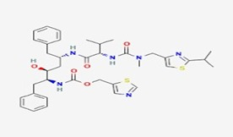

Fig no: 1 chemical structure of Ritonavir ^{[5]}

Chemical formula : C37H48N6O5S2
Brand name : Kalter, norvir
Type : Small molecules
Weight : 720.9g/mol ^{[6]}.

MECHANISM OF ACTION:

Ritonavir has 3 mechanisms of action:

HIV – 1 Protease inhibition

Inhibition of metabolic enzymes.

Inhibition of transporters^{[7]}.

It binds to HIV -1 protease, inhibiting proteolytic activity. This blocks cleavage of Gag and Gag pol polyproteins^{[7,8]}.

Ritonavir inhibits CYP3A4/5, P-glycoprotein, and OATP1B1. IT also inhibits CYP2D6 at higher concentrations^{[7,9,14,15]}.

CYP3A4/5 inhibition is notable, as 30% of drugs rely on it. This inhibition is irreversible^{[10]}.

New enzymes must be synthesized to reverse effects. This increases half- life and efficacy of CYP3A4/5 substrates^{[7,10]} .

Ritonavir’s mechanisms lead to significant drug interactions. Affecting clearance and efficacy of other drugs^{[7,11]}.

It effects on CYP3A4/5 are particularly significant, due to the large number of drugs metabolized by this enzyme^{[7,12]}.

Ritonavir’s role in HIV treatment is complex, involving multiple mechanisms and interactions.

“Additionally, ritonavir acts as an inducer of several enzymes involved in drug metabolism, such as CYP3A, CYP1A2, and others, including UGT”^{[7,13,14]}

INSRTUMENTS:

- Utilizing an ELICO SL-20 Double-beam UV-visible spectrophotometer equipped with a pair of matched 10mm quartz cell
- Weighing balance- Gold-300p
- Calibrated glassware

REAGENTS AND MATERIALS:
All the chemicals and reagents employed were of analytical grade, ensuring high quality and purity which include
- Methanol
- Distilled water
DRUG SAMPLE:
- Include RITONAVIR active pharmaceutical ingredient was obtained from Pulla Reddy Institute of Pharmacy.
FORMULATION USED:
- RITONAVIR bulk dosage form was used.

METHODOLOGY:
1.SOLUBILITY STUDIES:
RITONAVIR is soluble in organic or non-aqueous solvents such as ethanol and methanol and insoluble in NAOH, HCL and ortho phosphoric acid. But absorbance was achieved using both types of solvents. By dissolving ritonavir in non-aqueous solvents such as ethanol and adding distilled water to reach volume, absorbance was achieved using this procedure.as a result, Methanol was used as a blank sample while estimating ritonavir.
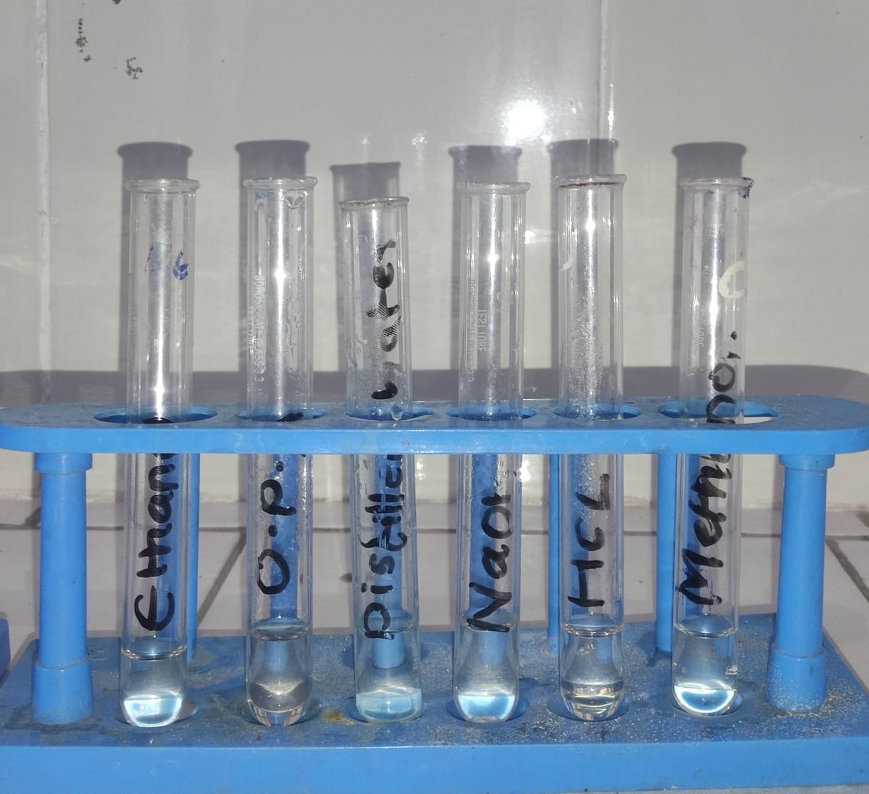

Fig no: 2 solubility studies results

2. STANDARD STOCK SOLUTION OF RITONAVIR:
Ritonavir 100mg drug which had been carefully weighed, was put into a standard flask. A solution with a concentration of one milligram per milli liters (1mg/ml) was created by adding five milli liters of methanol and increasing the volume to 100 milli liters of water. We called this a conventional stock solution.
2.1 Working standard solution of Ritonavir:
“A working standard solution of Ritonavir (100µg/ml) was prepared by pipetting 10ml of stock solution (1mg/ml) into a 100ml volumetric flask and diluting to the mark with methanol :water, followed by thorough mixing”.
3: DETERMINATION OF ABSORPTION MAXIMA OF RITONAVIR:
“To determine the analytical wavelength, a 10µg/ml Ritonavir solution was prepared in a 100ml volumetric flask by diluting 1ml of working standard solution with methanol : water. The solution was scanned from 400-200nm using methanol as a reference. Additionally, solutions of varying concentrations (5-100µg/ml) were analyzed using UV spectrophotometry.
4: METHOD VALIDATION
The ICH standards describe that a technique must be verified to be reliable during routine usage. So, this procedure is sometimes known as Method Validation, and it involves supplying written proof that the method achieves its intended goals^{[16,17]}.

VALIDATION PARAMETERS OF PROPOSED UV SPECTROSCOPIC:

The method’s performance was statistically validated for key parameters. This validation ensures the

method’s reliability and effectiveness:

Validation parameters

Linearity

Accuracy

Precision

LOD

LOQ
4.1 LINEARITY: After the working standard was diluted to 0.5,1,1.5,2.5,4,6,8 and 10ml of series were taken and diluted with methanol to create solutions that produce concentration ranges to 5-100 µg/ml in 10ml volumetric flasks. Three replicates of each concentration were measured at 240nm, with methanol serving as the blank solutions. Concentration was plotted against absorbance to create a calibration curve.
4.2 ACCURACY: Accuracy measures how close test results are to the actual value, typically expressed as percent recovery. Using the conventional addition approach, the correctness of the suggested UV Spectroscopic method was established. A solution with concentration ranges of 25,50 and 75% was obtained by adding a known quantity of ritonavir to 60µg/ml of pre-analyzed sample solution. The standard deviation (S.D.) and precent RSD were computed after the absorbance was measured three times.
4.3 PRECISION: Precision is the degree agreement or consistency among a series of measurements of the same homogeneous sample under the prescribed conditions. The absorbance of six sample of the 60µg/ml ritonavir working standard solution was measured on the same day in order to assess repeatability, also referred to as intraday precision. The intraday precision was computed at three distinct time intervals over the course of three days.
4.5 LIMIT OF DETECTION(LOD): LOD is the minimum amount of analyte that can
be detected, but not necessarily accurately measured. It indicates sensitivity of method.
4.5 LIMIT OF QUANTITION(LOQ): The LOQ is the lowest analyte concentration that can be quantified with acceptable accuracy and precision, yielding reliable results & reproducible quantitation.

RESULTS AND DISCUSSIONS:

Overview of Analytical Findings

The primary aim of this study was to design and validate a UV spectrophotometric method For Ritonavir quantification in bulk dosage form that meets International Council for Harmonisation (ICH) Q2 (R1) guidelines while remaining cost effective and accessible to quality control laboratories lacking advanced instrumentation. The method was developed using methanol as the solvent given its favorable solubilizing capacity for ritonavir and its minimal UV interference above 210 nm. The λmax was determined to be 240 nm and the method was validated for linearity, accuracy, precision, LOD, LOQ.

1. ABSORPTION MAXIMA (λ MAX) DETERMINATION
The absorption maximum (λ max) for ritonavir in methanol was established at 240 nm(fig:3) which is consistent with the electronic transitions of conjugated system present in its molecular structure.
  - Molecular basis for λ max.
Ritonavir contains multiple Chromophoric groups – thiazole rings, phenyl moieties, and amide linkages -all of which contribute to π-π* transitions The presence of heteroatoms (O,N,S) and conjugated double bonds causes bathochromic shifts (red- shifting of absorption) in UV spectra. Methanol stabilizes the excited states through bonding resulting in slightly higher λ max compared to non -polar solvents.
  - Why Methanol.
Methanol was chosen because:
- It fully dissolves ritonavir, avoiding scattering errors due to undissolved particles.
- It has low UV absorbance above 210nm, preventing baseline interference.It is easily available,
- inexpensive, and compatible with pharmaceutical-grade analysis.
  - Comparison to literature.
- PEERZADE et al.(2019):λ max= 239 nm in methanol: water (80:20).
- Chiranjeevi et al.(2019):λ max = 241nm in ethanol.
Our λ max of 240 nm is within this narrow range, showing the robustness of the spectral signature across solvents.
  - Implication .
The λ max at 240nm represents the optimal wavelength for ritonavir quantification in this solvent system– maximizing sensitivity and specificity while minimizing noise.

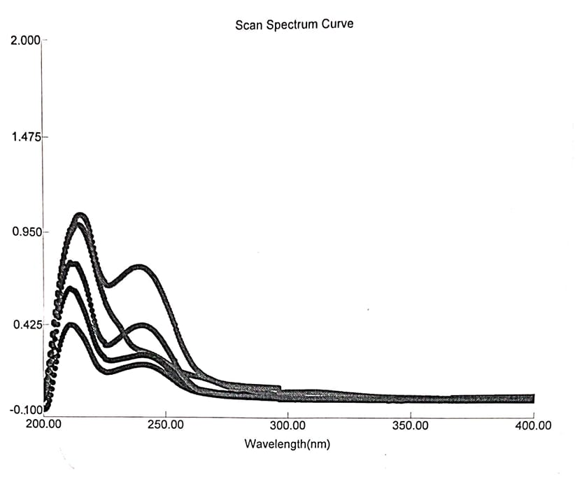
Fig no: 3 Absorption maxima of ritonavir (ƛ max) in methanol at 240nm.

2. LINEARITY ANALYSIS
The linearity of the method was confirmed over the range 5-100 µg/ml (Table 2, fig:4). The regression equation:
y= 0.0105 + 0.1272
2.1 Slope and analytical sensitivity
The slope (0.0105) indicates the absorbance change per µg/ml of Ritonavir. This parameter is directly linked to the molar absorptivity (ɛ) of the compound and the compound and the path length (b) via
Beer- Lambert’s law:
A = ɛbc
2.2 Intercept and systemic Error
The intercept (0.1272) is small but non- zero possible sources:

- Baseline absorbance from solvent traces.
- Slight cuvette imperfections.
- Detector electronic noise.
A small intercept implies negligible bias.

2.3 Residual plot analysis
Residual plots (absorbance deviations from the regression line) indicated that deviations increase slightly at concentrations ˃80 µg/ml. this could arise from:
Minor deviations from beer-lambert’s law due to high analyte absorbance.
Detector saturation at higher optical densities.

2.4 Comparison with literature

Table 1: Comparison with literature

Study | Concentration Range (µg/ml) | R² | Slope
Peerzade et al.(2019) | 5-50 | 0.987 | 0.0121
Chiranjeevi et al.(2011) | 5-60 | 0.973 | 0.0110
Present Study | 5-100 | 0.9613 | 0.0105

Our slightly lower R² is likely due to the broader range tested, where deviations become more pronounced at the extremes.

Table -2: Linearity results of Ritonavir
S.NO | CONCENTRATION  (µg/ml) | ABSORBANCE  (nm) | LINEAR REGRESSION EQUATION
1 | 0 | 0.000 | Y=0.0105x + 0.1272  R² =0.9613
2 | 5 | 0.184 | Y=0.0105x + 0.1272  R² =0.9613
3 | 25 | 0.402 | Y=0.0105x + 0.1272  R² =0.9613
4 | 40 | 0.66 | Y=0.0105x + 0.1272  R² =0.9613
5 | 60 | 0.855 | Y=0.0105x + 0.1272  R² =0.9613
6 | 80 | 1.046 | Y=0.0105x + 0.1272  R² =0.9613
7 | 100 | 1.169 | Y=0.0105x + 0.1272  R² =0.9613

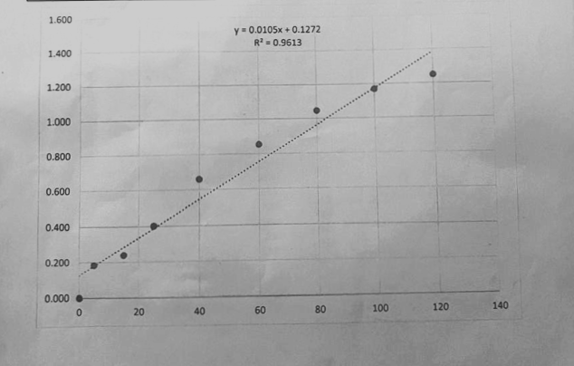
Fig no:4 Calibration curve for the estimation of Ritonavir

ACCURACY :
Accuracy was evaluated by recovery studies at 25%,50%,70% fortification levels (table 3),producing recoveries between 98.7%-99.8%
3.1 Interpertation
Such high recoveries impiy:
Minimal loss of analyte during preparation.
No signification spectra interference from solvents or excipients.
3.2 Statistical Confidence
Standard deviation (SD) values were consistently low, indicating narriw distribution of results.
Confirm that the true recovery lies within 0.5% of the measured value.
3.3 Possible Error Sources
- Pipetting inaccuracies.
- Small variations in cuvette positioning.
- Ambient temperature fluctuations affecting solvents density.
3.4 Literature Comparison
Our recovery range matches the performance of published UV method,and some cases exceeds them in reproducibility.

Table -3 : Accuracy resluts of Ritonavir.

S.NO | RECOVERY | TARGET  IN µg/ml | SPIKED IN µg/ml | TOTAL IN µg/ml | ABSORBANCE | AMOUNT FOUND IN µg/ml | %RECOVERY
1 | 25% | 60 | 15 | 75 | 0.870 | 784.7 | 98.7
2 | 25% | 60 | 15 | 75 | 0.871 | 74.8 | 99.2
3 | 25% | 60 | 15 | 75 | 0.871 | 74.9 | 99.1
4 | 50% | 60 | 30 | 90 | 1.099 | 89.7 | 99.3
5 | 50% | 60 | 30 | 90 | 1.098 | 89.8 | 99.1
6 | 50% | 60 | 30 | 90 | 1.098 | 89.9 | 99.4
7 | 75% | 60 | 45 | 105 | 1.201 | 104.6 | 99.7
8 | 75% | 60 | 45 | 105 | 1.200 | 104.7 | 99.6
9 | 75% | 60 | 45 | 105 | 1.200 | 104.8 | 99.8

PRECISION:
Table 4 and 5 show that intraday %RSD = 0.113 and interday %RSD = 0.10-0.18.
4.1 Significance
%RSD values far below the 2% ICH threshold indicate extremely high repeatability and reproducibility.
4.2 Instrument stability
These results indirectly confirm:
- Stable light sources intensity .
- No significant detector drift across days.
- High – quality cuvette alignment and minimal mechanical variation.
4.3 Practical meaning
Such precision ensures the method’s suitability for batch -release quality control where hundreds of samples might be analyzed over multiple days.

Table-4: Intraday precision results of Ritonavir.
S.NO | AMOUNT OF SAMPLE (CONCENTRATION) | ABSORBANCE | MEAN | S.D | %RSD
1 | 60 µg/ml | 0.855 | 0.853 | 0.00096 | 0.113
2 | 60µg/ml | 0854 | 0.853 | 0.00096 | 0.113
3 | 60µg/ml | 0.853 | 0.853 | 0.00096 | 0.113
4 | 60µg/ml | 0.852 | 0.853 | 0.00096 | 0.113
5 | 60µg/ml | 0.854 | 0.853 | 0.00096 | 0.113
6 | 60µg/ml | 0.853 | 0.853 | 0.00096 | 0.113

Table-5: Inter day precision results of Ritonavir.

S.NO | DAY | SAMPLE | ABSORBANCE | MEAN | S.D | %RSD
1 | Day -1 | 60 | 0.855 | 0.854  0.853  0.855 | 0.001  0.0015  0.001 | 0.11  0.17  0.11
 |  |  | 0.854 | 0.854  0.853  0.855 | 0.001  0.0015  0.001 | 0.11  0.17  0.11
 |  |  | 0.853 | 0.854  0.853  0.855 | 0.001  0.0015  0.001 | 0.11  0.17  0.11
2 | Day-2 | 60 | 0.855 | 0.854  0.853  0.855 | 0.001  0.0015  0.001 | 0.11  0.17  0.11
 |  |  | 0.853 | 0.854  0.853  0.855 | 0.001  0.0015  0.001 | 0.11  0.17  0.11
 |  |  | 0.852 | 0.854  0.853  0.855 | 0.001  0.0015  0.001 | 0.11  0.17  0.11
3 | Day -3 | 60 | 0.856 | 0.854  0.853  0.855 | 0.001  0.0015  0.001 | 0.11  0.17  0.11
 |  |  | 0.855 | 0.854  0.853  0.855 | 0.001  0.0015  0.001 | 0.11  0.17  0.11
 |  |  | 0.854 | 0.854  0.853  0.855 | 0.001  0.0015  0.001 | 0.11  0.17  0.11

LOD AND LOQ CALCULATIONS:

LOD and LOQ are calculated, based on standard deviation (σ) and calibration curve slope (S).

- LOD = 3.3 × σ/S

- LOQ = 10 × σ/S

Table – 6: Results of LOD and LOQ
Parameters | Value (Units)
LOD | 0.314µg/ml
LOQ | 0.952µg/ml

  - Implications
- LOD ensures trace detection in cleaning validation and contamination studies.
- LOQ is low enough for stability studies where the drug might degrade significantly.
  - Comparison
HPLC method report LOQs as low as 0.5 µg/ml meaning our UV method achieves comparable sensitivity with far simpler instrumentation.

7.Error Analysis
Table 7: Possible error sources and mitigation strategies:

Error source | Effect | Mitigation
Pipetting error | Variation in concentration | Use calibrated micropipettes
Cuvette imperfections | Baseline shifts | Use matched quartz cells
Solvent impurities | Noise | Use HPLC -grade methanol
Ambient light leakage | Baseline drift | Ensure spectrophotometer lid closed

8. Comparative method evaluation

Table 8: The present method vs . ritonavir assays

Method | Sensitivity | Cost | Time | Complexity
UV (present) | µg/ml | Low | 10 min | Low
HPLC | µg/ml | Medium | 20-30 min | Medium
LC-MS | µg/ml | High | 30-60 min | High

9. Applications
9.1 Quality control : Rapid batch release testing of bulk API
9.2 Stability Studies : Tracking Ritonavir degradation under accelerated and real-time storage.
9.3 Dissolution studies : Real-time monitoring of ritonavir release form dosage forms.
9.4 Bioequivalence Support : While not replacing LC-MS,UV can be used for preliminary dissolution screening before pharmacokinetic studies.
10. Limitations and future scope
- May require modification for complex formulations containing UV- absorbing excipients.
- Could be adapted for derivative spectrophotometry to improve specificity
- Potential for miniaturization into portable spectrophotometers for field testing.

SUMMARY:
The developed UV spectrophotometers method demonstrates:
- Accuracy : 98.7-99.8%
- Precision : %RSD ˂ 0.2%
- Linearity : R² = 0.9613 (5-100 µg/ml)
- Sensitivity : LOD =0.314 µg/ml, LOQ =0.952 µg/ml.
It offers an optimal balance between performance, simplicity, cost-making it highly applicable for routine quality control of Ritonavir.

CONCLUSION:
A simple, economical UV spectrophotometric method for estimation of Ritonavir in bulk was developed and validated. Methanol was used as solvent, (with ƛ max )at 240nm, ensuring good solubility. The method showed linearity in the concentration range 5 – 100µg/ml with an R² of 0.9613. Accuracy studies showed recovery between 98.7- 99.8%, confirming method reliability. Intraday and Inter day precision studies showed %RSD values within acceptable limits (≤ 2%). LOD & LOQ were found to be 0.314µg/ml and 0.952µg/ml, indicating sensitivity of the method. The method was validated as per ICH Q2 (R1) guidelines for linearity, accuracy, precision, LOD and LOQ. The results confirm the method’s reproducibility and reliability. The developed method can be effectively applied in quality control laboratories.
Hence, it can be recommended for regular estimation of Ritonavir & the study confirms the effectiveness of UV spectrophotometry for Ritonavir Analysis.

COMPETING INTERESTS DISCLAIMER:
Authors have declared that they have no known competing financial interests OR non-financial interests OR personal relationships that could have appeared to influence the work reported in this paper.

REFERENCES:
- INDIAN Pharmacopoeia. 2007; III:1058.
- UNITED States Pharmacopoeia, National Formulary. 2007; 25:2143.
- PEERZADE MY et al; I. Development and validation of UV-Visible spectrophotometric method for estimation of ritonavir in bulk and formulation. Pharma Innovation J. 2019; 8:30-4.
- K. CHIRANJEEVI et al; Development and validation of UV-Visible spectrophotometric method for estimation of ritonavir in bulk and formulation. INT.J. CHEM Tech Res.2011,3(1).
- RITONAVIR Chemical structure- Drug Bank.
- RITONAVIR - C37H48N6O5S2 – Pub Chem.
- RAVI SHANKAR P et al; Ritonavir: 25 Years’ Experience of Concomitant Medication Management. Infect Dis Ther (2024) 13:1005–1017.
- .KEMPF DJ, Marsh KC, et al. ABT-538 is a potent inhibitor of human immune deficiency virus protease and has high oral bioavailability in humans. Proc Natl Academic Sci U S A. 1995;92:2484–8.
- DE CLERCQ E. Novel compounds in preclinical/early clinical development for the treatment of HIV infections. Rev Med Viral. 2000;10:255–77.
- ZANGER UM, Schwab M. Cytochrome P450 enzymes in drug metabolism: regulation of gene expression, enzyme activities, and impact of genetic variation. Pharmacology Ther. 2013;138:103 –41.
- LOOS NHC, Schinkel AH. The mechanism-based inactivation of CYP3A4 by ritonavir: what mechanism? Int J Mol Sci. 2022; 23:9866.
- .NORVIR® (ritonavir). Full prescribing information. North Chicago, IL, USA: AbbVie Inc.; 2022.
- BRACHER F et al; Pharmacokinetic enhancers (boosters)-escort for drugs against degrading enzymes and beyond. Sci Pharm. 2018; 86:E43.
- SHITARA Y, Takeuchi K, Horie T. Long-lasting inhibitory effects of saquinavir and ritonavir on OATP1B1-mediated uptake. J Pharm Sci. 2013;102: 3427–35.
- Kharasch ED, Walker A, Whittington D, Hoffer C. Mechanism of ritonavir changes in methadone pharmacokinetics and pharmacodynamics: II. Ritonavir effects on CYP3A
and P-glycoprotein activities. Clin Pharmacology Ther. 2008;84:506–12.
- Note for guidance on validation of analytical procedures: text and methodology. European Medicines Agency, 1995, 1-15.
- Validation of analytical procedures: text and methodology Q2 (R1). ICH harmonized tripartite guideline, 1994.

