Original Research Article

Achieving Optimal Patient Outcomes After Frontal Sinus Endoscopy

.
ABSTRACT

Aims: Evaluating the Role of Biodegradable Drug-Eluting Stents in Enhancing Outcomes after Frontal Endoscopic Sinus Surgery.
Study design: Prospective case control study.
Place and Duration of Study: The Department of Otorhinolaryngology in Almoosa Specialist Hospital, Al Ahsa, Saudi Arabia, and Helwan University Hospital (Badr Hospital), Egypt. From March 2025 to September 2025.
Methodology: A total of 42 adult participants were enrolled and randomly assigned to either the Propel stent group (n=21) or the control group (n=21). Participants were monitored for six months through clinical and radiographic evaluations, focusing on outcomes such as patency of the ostium, presence of adhesions, and recurrence of polyps.
Results: After nine months, the Propel stent group exhibited significantly higher ostium patency rates compared to the controls. Additionally, lower rates of stenosis, retained secretions, adhesions, and polyp formation were observed in the Propel stent group.
Conclusion: Propel stents significantly enhance frontal sinus patency and reduce the occurrence of postoperative adhesions and polyp recurrence in comparison to non-drug-eluting stents.

Keywords: Functional Endoscopic Sinus Surgery, Biodegradable drug-eluting Propel stents, Frontal sinus.

1. INTRODUCTION

Frontal sinus disease that persists despite medical treatment is typically addressed with Functional Endoscopic Sinus Surgery (FESS), which is the favored minimally invasive surgical approach (1,2). A major challenge in FESS success is the high likelihood of the frontal recess narrowing again (restenosis) after surgery. This is largely due to the recess's naturally constricted anatomy and surgical factors such as intraoperative trauma, which can lead to scarring and stenosis, ultimately compromising the procedure’s long-term effectiveness (1,3,5). Postoperative openings (neo-ostia) smaller than 5 mm are strongly associated with restenosis risk.
To preserve the openness of the ostium during the critical healing phase, frontal sinus stents have been used for over a hundred years. Initial materials, like rubber and gold, have been replaced by modern alternatives, including Silastic tubing and drug-eluting stents (1,6).
The newest development involves biodegradable, drug-releasing implants that resorb over time. These implants locally deliver corticosteroids, which reduce inflammation and prevent scar tissue formation, thereby facilitating clear sinus healing. This innovation is expected to improve surgical outcomes and potentially lower the recurrence of nasal polyps. While some research suggests they may not always surpass conventional sinus packing, they offer a significant advantage for complex cases by allowing targeted drug delivery and avoiding systemic steroid side effects (6–13).
Despite this progress, there are currently no universally accepted protocols for using frontal sinus stents, making their application dependent on the surgeon’s judgment and intraoperative observations. Continued high-quality research is essential to determine the long-term safety and efficacy of these biodegradable drug-eluting devices (7,14,15).
2. material and methods

This prospective case-control study adhered to the ethical standards of the Declaration of Helsinki. Written informed consent was obtained from all participants prior to enrollment. Eligible participants included adults with a strong suspicion of restenosis in the frontal sinus drainage pathway due to severe underlying pathology, excluding those with milder cases or allergies to the materials used.
Randomization was accomplished using a computer-generated table, with concealed allocation. A researcher uninvolved in patient care conducted this process, ensuring blinding to minimize observer bias in outcome assessment.
Eligible patients were randomly assigned into two equal groups; the case group (n = 21) received biodegradable drug-eluting frontal sinus stents Propel (Intersect ENT, Inc., Menlo Park, California, USA) during FESS, and the control group (n = 21) received non-drug-eluting stents with either Merocel (Medtronic Xomed, Jacksonville, Florida, USA) or Rains (Medtronic Xomed, Jacksonville, Florida, USA).
The sample size was calculated using R software version 4.5.1 (R Foundation for Statistical Computing, Vienna, Austria), based on a 95% confidence level, an expected prevalence of chronic frontal sinusitis with polyposis of 4%, a 5% margin of error, and a target population size of 110. The minimum required sample size was estimated to be n = 39, rounded to 42 to allow for drop-out.
Data were statistically analyzed using R software version 4.5.1. Numerical variables were presented as means ± standard deviations. Between-group comparisons for categorical data were conducted using chi-square tests. The unpaired t-test was used for comparisons of numerical data. Statistical significance was defined as a p-value < 0.05. (Fig. 1)
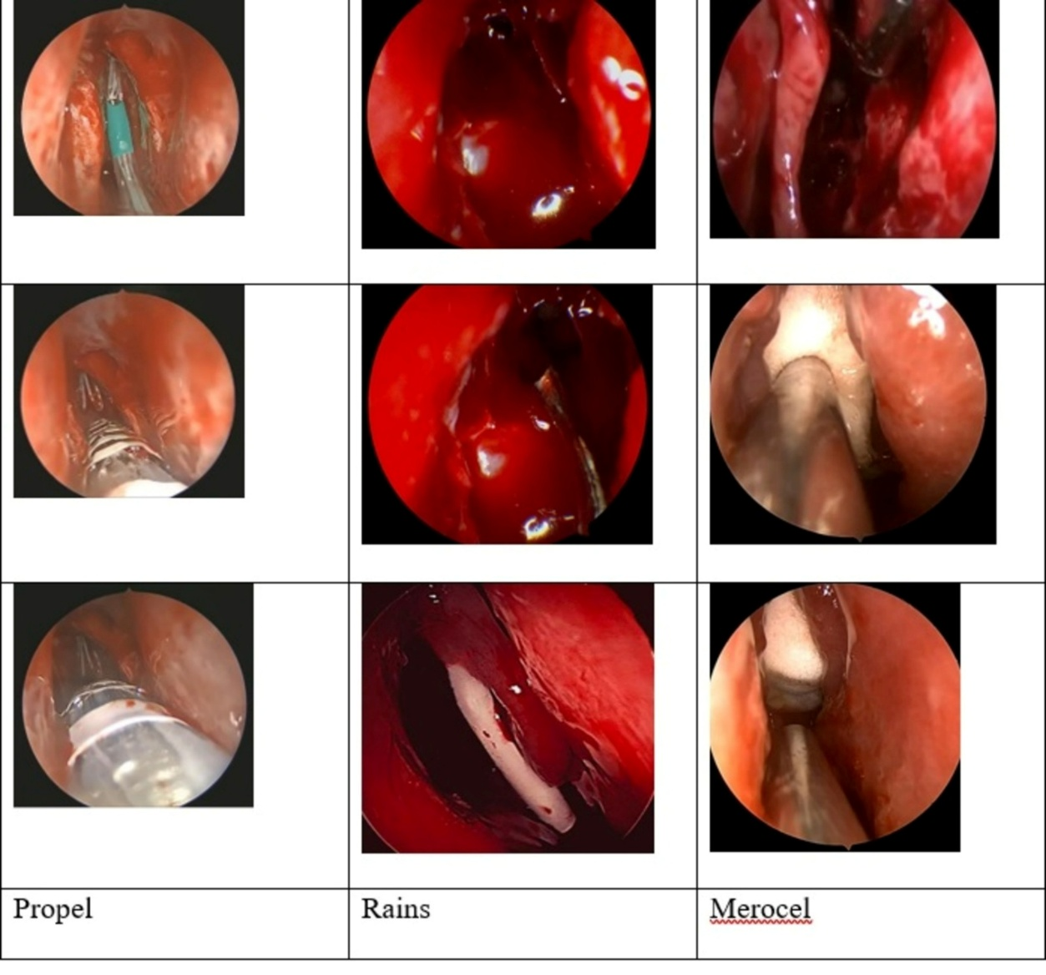
(Figure 1): Frontal Endoscopic Sinus Surgery with insertion of stent. A) Propel stent, B) Rains stent, C) Merocel stent.

3. results and discussion

Baseline characteristics
A total of 42 patients were included, with 21 in the case group and 21 in the control group. The mean age, gender distribution, smoking status, asthma, atopy, diabetes mellitus (DM), or The American Society of Anesthesiologists (ASA) classification compared between the two groups. (Table 1).
(Table 1): Baseline characteristics
Characteristic | Case Group (N=21) | Control Group (N=21) | P-value
Age |  |  | 0.338
Mean +/- SD | 46.19 +/-6.95 | 48.05 +/- 9.00
Median (IQR) | 46.00 (11.00) | 50.00 (14.00)
Gender | N (%) | N (%) | 0.755
Female | 8 (38.1%) | 10 (47.62%)
Male | 13 (61.9%) | 11 (52.38%)
Smoker | 7 (33.33%) | 6 (28.57%) | 1.000
Asthma | 6 (28.57%) | 4 (19.05%) | 0.717
Atopy | 7 (33.33%) | 10 (47.62%) | 0.530
DM (Diabetes Mellitus) | 7 (33.33%) | 6 (28.57%) | 1.000
ASA Classification |  |  | 1.000
ASA I | 1 (4.76%) | 1 (4.76%)
ASA II | 20 (95.24%) | 20 (95.24%)
SD=Standard Deviation, DM= Diabetes Mellitus, ASA=The American Society of Anesthesiologists.
Surgical indications and operative data
The distribution of diagnoses is comparable between groups, p = 1.00. As chronic frontal sinusitis plus deviated nasal septum and inferior turbinate hypertrophy, chronic frontal sinusitis with nasal polyps, frontal mucocele, and frontal osteoma. (Table 2).
(Table 2): Surgical indications and operative data
Characteristic | Case Group (N=21) | Control Group (N=21) | P-value
 | N (%) | N (%)
Diagnosis
Chronic frontal sinusitis + DNS/ITH* | 6 (28.57%) | 7 (33.33%) | 1.00
Chronic frontal sinusitis with nasal polyps | 7 (33.33%) | 8 (38.1%) | —
Chronic frontal sinusitis with polyps + DNS/ITH* | 4 (19.05%) | 4 (19.05%) | —
Frontal mucocele | 3 (14.29%) | 2 (9.52%) | —
Frontal osteoma | 1 (4.76%) | 0 (0%) | —
Operation |  |  | 0.755
FESS* and septoturbinoplasty with stent | 10 (47.62%) | 11 (52.38%)
FESS with application of stent | 11 (52.38%) | 10 (47.62%) | —
Type of Stent
Merocel |  | 9 (42.86%)
Propel | 21 (100%) | 0 (0%) | —
Rains |  | 12 (57.14%) | —
FESS = Functional Endoscopic Sinus Surgery
DNS = Deviated Nasal Septum
ITH = Inferior Turbinate Hypertrophy
All patients underwent FESS with application of a stent. Propel stents were exclusively used in the case group (100%), whereas the control group received either Merocel (42.86%) or Rains stents (57.14%) (p < 0.001). For the control group only, postoperative stent removal done under local anesthesia using endoscopic guidance, with Merocel removed at 1 week and Rains at 1 month.
Postoperative outcomes at 9 months
At the 9-month follow-up (Table 3) the case group demonstrated significantly better frontal sinus ostium patency. Ostium stenosis was more frequent in controls. Ostial obstruction, retained secretions, adhesions and polyp formation occurred in control group but in none of the case group.
(Table 3): Post-operative follow-up at 9-months
Outcome Measure | Case Group (N=21) | Control Group (N=21) | P-value
 | N (%) | N (%)
Frontal Sinus Ostium |  |  | <0.001
Patent | 20 (95.24%) | 8 (38.1%)
Stenosed | 1 (4.76%) | 10 (47.62%)
Obstructed | 0 (0%) | 3 (14.29%)
Inflammation |  |  | 0.184
No | 20 (95.24%) | 16 (76.19%)
Yes | 1 (4.76%) | 5 (23.81%)
Retained Secretions |  |  | 0.009
No retained secretion | 21 (100%) | 14 (66.67%)
Mild retained secretions | 0 (0%) | 2 (9.52%)
Excessive retained secretions | 0 (0%) | 5 (23.81%
Adhesions |  |  | 0.001
No adhesion | 21 (100%) | 9 (42.86%)
Mild adhesions | 0 (0%) | 7 (33.33%)
Excessive adhesions | 0 (0%) | 5 (23.81%)
Polyp Formation |  |  | 0.021
No polyp formation | 21 (100%) | 15 (71.43%)
Polyp formation | 0 (0%) | 6 (28.57%)
Healed Sinonasal Mucosa |  |  | 0.045
Healed | 20 (95.24%) | 14 (66.67%)
Not healed | 1 (4.76%) | 7 (33.33%)

The rate of completely healed sinonasal mucosa was higher in the case group. All Propel stents were completely absorbed by the 9-month follow-up. (Fig. 2).
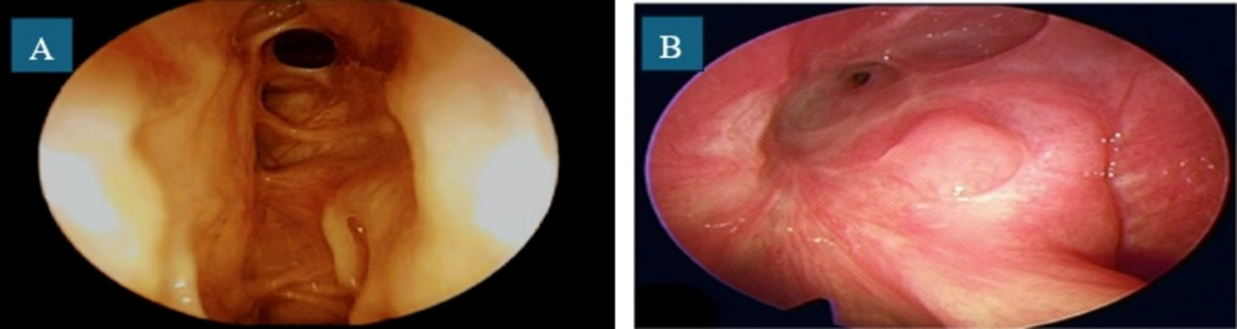
(Figure 2): Postoperative outcomes at 9 months, (A) Case group. (B) Control group.
The research investigated the performance of the Propel drug-eluting stent against non-medicated stents in maintaining an open frontal sinus pathway following FESS. Confounding variables were minimized because both the case and control groups were statistically identical in demographics, baseline disease characteristics, surgical indications, and procedures performed.
The results provide compelling evidence of the drug-eluting stent's benefit, demonstrating a 95.24% patency rate at six months, dramatically exceeding the control group's 38.1% patency (p < 0.001). This success supports the theory that locally released medication effectively inhibits fibrosis and thus reduces restenosis.
The control group, utilizing non-drug-eluting alternatives, suffered from significant postoperative complications, including stenosis (41.18%) and obstruction (17.65%), underscoring the severity of frontal recess scarring. The drug-eluting mechanism's efficacy was further confirmed by the complete absence of adhesion formation in the case group, contrasting sharply with the 57.14% incidence in the control group (p = 0.001), which is attributed to reduced fibroblast activity and collagen deposition.
Additionally, the drug-eluting stent virtually eliminated the recurrence of polyps (0% vs. 28.57%, p = 0.021), a clinically important factor in avoiding repeat surgery. Furthermore, sinonasal mucosal healing was significantly better in the case group (95.24% vs. 66.67%, p = 0.045). While inflammation markers were similar, the absence of retained secretions in the case group (0% vs. 34.33%, p = 0.009) suggests improved drainage.
Although drug-eluting stents cost more initially, their ability to reduce the need for expensive revision FESS positions them as a cost-effective solution in the long run. The Propel stent’s biodegradable property further contributes to savings by eliminating the necessity of a second procedure for removal, a step required for non-resorbable stents like Merocel and Rains, thereby reducing resource consumption and patient morbidity.
Despite the overall debate surrounding stenting in sinonasal surgery, these findings strongly advocate for the routine placement of drug-eluting stents in patients deemed high risk. Nevertheless, the results must be interpreted cautiously due to the study's small size, necessitating subsequent multicenter trials with expanded patient cohorts and longer observation periods to establish universal guidelines.
4. Conclusion

The use of biodegradable, drug-eluting Propel stents during FESS considerably improves frontal sinus ostium patency, minimizes adhesions and polyp recurrence, and fosters mucosal healing compared to conventional non-drug-eluting stents.

Ethical approval

“All authors hereby declare that all experiments have been examined and approved by the appropriate ethics committee and have therefore been performed in accordance with the ethical standards laid down in the 1964 Declaration of Helsinki.”
Ethical Approval Details:
IRB committee name: Almoosa Health Group.
Approval number (ARC-25.3.11)
Approval date (06/03/2025)

References

1. Algahtani S, Alhajlah A, Abuharb AI, Alzarroug AF, Almughira AI, Alsywina N, et al. Outcomes of Functional Endoscopic Sinus Surgery in Chronic Rhinosinusitis: A Systematic Review and Meta-Analysis. Cureus. 2024 Feb;16(2):e53952. https://doi.org/10.7759/cureus.53952
2. Noon E, Hopkins C. Review article: outcomes in endoscopic sinus surgery. BMC Ear Nose Throat Disord. 2016 Aug 5;16:9. https://doi.org/10.1186/s12901-016-0030-8
3. Alharbi A, Alhussain F, Alyamani A, Aljohani M, Alsergani A, AbaAlkhail M, et al. Complications of endoscopic sinus surgery for chronic rhinosinusitis in a tertiary care teaching hospital in Saudi Arabia. Saudi Med J. 2023 Jun;44(6):601–6. https://doi.org/10.15537/smj.2023.44.6.20230911
4. Kar M, Bayar Muluk N, Alqunaee M, Manole F, Cingi C. Functional Endoscopic Sinus Surgery: Key Points for Safer Surgery. Ear Nose Throat J. 2024 Nov 1;103(3_suppl):5S-14S. https://doi.org/10.1177/01455613241287280
5. Papadopoulou AM, Chrysikos D, Samolis A, Tsakotos G, Troupis T. Anatomical Variations of the Nasal Cavities and Paranasal Sinuses: A Systematic Review. Cureus. 2021 Jan 15;13(1):e12727. https://doi.org/10.7759/cureus.12727
6. Brar T, Brown A, Miglani A, Lal D, Marino MJ. Outcomes of Frontal Sinus Stenting With Steroid Impregnated Microsponge Versus Steroid-Eluting Implant. Am J Rhinol Allergy. 2023 Nov;37(6):679–85. https://doi.org/10.1177/19458924231186901
7. Samargandy S, Grose E, Yip J, Lee JM. Endoscopic sinus surgery outcomes in patients with chronic rhinosinusitis and immunoglobulin deficiencies. Journal of Otolaryngology - Head & Neck Surgery. 2023 Jun 29;52:43. https://doi.org/10.1186/s40463-023-00648-3
8. Romano FR, Anselmo-Lima WT, Kosugi EM, Sakano E, Valera FCP, Lessa M, et al. Rhinosinusitis: Evidence and experience – 2024. Braz J Otorhinolaryngol. 2025 May 20;91(5):101595. https://doi.org/10.1016/j.bjorl.2025.101595
9. Cataldo Russomando A, Vogt Sionov R, Friedman M, Gati I, Eliashar R, Steinberg D, et al. Sinonasal Stent Coated with Slow-Release Varnish of Chlorhexidine Has Sustained Protection against Bacterial Biofilm Growth in the Sinonasal Cavity: An In Vitro Study. Pharmaceutics. 2021 Oct 25;13(11):1783. https://doi.org/10.3390/pharmaceutics13111783
10. Zhao XY, Chen M, Cheng L. Current and Emerging Treatment Options in Sinus and Nasal Diseases: Surgical Challenges and Therapeutic Perspectives. J Clin Med. 2023 Feb 13;12(4):1485. https://doi.org/10.3390/jcm12041485
11. Faoury M. Enhanced Evaluation of Bioresorbable Steroid-Releasing Stents and Corticosteroid-Infused Nasal Dressings in Postoperative Management of Chronic Rhinosinusitis. Journal of Otorhinolaryngology, Hearing and Balance Medicine. 2025 Dec;6(2):11. https://doi.org/10.3390/ohbm6020011
12. Lim DJ, Cho DY. The next generation of sinus stents for chronic rhinosinusitis: A systematic review. Precis Future Med. 2022 Sep 7;6(3):161–9. https://doi.org/10.23838/pfm.2022.00065
13. Goshtasbi K, Abouzari M, Abiri A, Yasaka T, Sahyouni R, Bitner B, et al. Efficacy of steroid-eluting stents in management of chronic rhinosinusitis after endoscopic sinus surgery: updated meta-analysis. Int Forum Allergy Rhinol. 2019 Dec;9(12):1443–50. https://doi.org/10.1002/alr.22443
14. Khan MA, Alshareef WA, Marglani OA, Herzallah IR. Outcome and Complications of Frontal Sinus Stenting: A Case Presentation and Literature Review. Case Rep Otolaryngol. 2020;2020:8885870 https://doi.org/10.1155/2020/8885870

