Original Research Article

Evaluation of Lipid Profile and Atherogenic Indices of Automechanics Exposed to Petrol and Petroleum Products in Aba Metropolis, Nigeria

ABSTRACT
Aim: This study evaluates the serum Lipid profiles and health risk indices (atherogenic) of auto mechanics exposed to petrol and petroleum products in Aba Metropolis as toxic chemicals in the environment are known to cause certain biological changes and alteration that could be harmful to the body.
Study Design: This was a cross sectional study that lasted from April 2022 to June 2023.
Methods:The study involved 220 participants (120 auto mechanics and 100 controls). Blood samples were collected to assess total cholesterol (TCH), High -density Lipoprotein (HDL), Low- density Lipoprotein (LDL) and Triglycerides( TG) using enzymatic and colorimetric methods while the atherogenic indices were calculated from standard formula.
Results:A significant mean TCH (4.5 ± 0.11mmol/L) and LDL-C (2.3 ± 0.10mmol/L) among auto mechanic compared to controls (TCH 4.1 ± 0.11mmol/L; LDL-C 2.3 ± 0.10mmol/L).The atherogenic index of plasma (AIP) showed no significant difference between groups (AIP 0.041 ± 0.031 for mechanics while 0.043 ±0.039 for the controls,p= 0.4075) However, the castelli risk index -1 (CRI-1) was significantly higher in the mechanics (4.4677 ± 0.227) compared to controls (3.610 ± 0.200) with p=0.04.Correlation analysis revealed significant association between TCH and TG(r=0.722;p<0.0001) and also between LDL-C and TCH (r=0.8117;p<0.0001) among auto mechanics.
Conclusion:The findings suggest potential future cardiovascular risks among auto mechanics due to occupational exposure to petroleum products hence strict usage of safety measures be enhanced in the mechanic workshop.

KEYWORDS: Lipid Profile, Atherogenic indices, petrol, Petroleum products, automechanics, Aba

1.0 INTRODUCTION
The automotive repair industry is a significant source of heavy metal pollution due to the handling and use of petrol and petroleum products, which contain various heavy metal constituents (Nkwoada et al., 2018, Briffa et al., 2020). Automechanics, in particular, are exposed to these substances during their daily work activities, potentially leading to adverse health effects and environmental contamination (Obianime et al., 2017). Human beings are daily exposed to toxic chemicals in the environment. These chemicals, which are also referred to as environmental pollutants have been reported as sources of health issues such as non-communicable diseases including, cardiovascular diseases (CVDs) (Menicagli et al., 2018 ,Statistics shows that non-communicable diseases (NCD), is the cause of over 40.9 million deaths, representing approximately 70% of annual global death (WHO, 2019).

Petrol has been described as an ‘environmental pollutant’ with cumulative toxic effect; however it is inevitably and widely used for domestic and outdoor applications (Dheyaa, 2023) .Globally it is used as fuel for automobile engine, various industrial machines and equipment. Contamination with these chemicals and the danger to health of the populace has been reported in many countries (Naidu et al., 2021).The nature and the level of pollutants may defer from one geographical area to another but the ability to overcome or tolerate toxic effect depends on mainly nutritional status, immunity, exercise, genetic factors, gender differences and lifestyle (Danek et al., 2022).

In Aba metropolis, the auto mechanics are found in workshops, within and on the outskirts of the cities with little or no protective devices hence are exposed to petrol and petroleum products. The major route of exposure in the mechanic workshop is from inhaling the ambient air, eating food contaminated with dirty hands and dermal contacts (Brucker et al., 2013). Exposure to petrol has been reported variously as a predisposing factor to a catalogue of disease conditions such as dyslipidaemia, cardiovascular diseases, liver pathology and nephropathy with reduced life expectancy in many cases (Ekpeyong & Asuquo, 2017).

It has been reported that the exposure to petrol might constitute a health risk factor since petrol with high lead concentration is presently produced, marketed and consumed in Nigeria (Galadima et al., 2012). Petrol can also impact on the body status hence the determination of body mass index (BMI), the total cholesterol (TCH), high density lipoprotein cholesterol (HDL-C), low density lipoprotein cholesterol (LDL-C) and triglycerides (TG) in both auto mechanics and non auto mechanics is necessary.Also, atherogenic indices and lipid ratios such as the Castelli Risk Index-1 (CRI-1), Castelli Risk Index -11 (CRI-11), atherogenic index of plasma (AIP), and atherogenic coefficient (AC) are of essence.
.
2.0 MATERIALS AND METHODS
2.1 Area of Study
The area of study is Aba and its metropolis including, Aba North, Aba South, Obioma Ngwa, Ugwunagbo and Osisoma local government area (LGA). The City of Aba is in the South Eastern zone of Nigeria. It lies on the geographical coordinates of 5⁰07 N, 7⁰22⁰ E/S, 117⁰ N and 7.36⁰ E.

2.2 Sample Size
The sample size for this study was determined using GPower version 3.1.9.2, at power of 0.88, effect size of 0.5, error of probability (alpha ) of 0.05 and two tails. The sample size obtained was 160(80 auto-mechanics and 80 control). However, this study adopted a total sample size of 220 (100) control and (120) auto-mechanics)
2.3 Inclusion Criteria
The auto mechanics from 16 to 65 years of age, who were resident in Aba Metropolis and have worked as auto mechanics in Aba for not less than two years were included. The individuals who were not auto mechanics served as the control group. Those included were apparently healthy subjects, with no known case of chronic diseases such as liver disease, kidney disorder, hypertension, and blood related diseases such as anaemia , blood cancer, diarrhoea or under any medication within the period of this study. They were not associated with alcoholism or smoking and willingly gave their consent.

2.4 Exclusion Criteria
Subjects who had any known acute or chronic disease condition such as liver disease, kidney disorder, CVDs, diarrhea, diabetes mellitus were excluded.Those undergoing medication whether herbal / orthodox, or associated with alcoholism, drug addicts, smoking and were not willing to give their consent were excluded.

2.5 Ethical Clearance
Ethical standards according to Helsinki considerations (WMA, 2024) were upheld. Ethical approval was given by Abia State Ministry of Health, Umuahia, Abia State with reference no AB/MH/AD/904/T.151.

2.6 Collection of Samples
Fasting blood samples (3 ml) were collected by venopuncture from the antecubital vein, into sterile plain bottles, under aseptic conditions. This was allowed to clot and centrifuged at 3000 rpm for 5 min. Serum was collected and stored frozen at −20°C, and analysis was carried out within 1 week of sample collection. The serum was used for blood lipid profile analysis – TC, LDL-C, HDL-C, and TGs.

2.7 Fasting Lipid Profile
Agappe diagnostic reagent kits were used for cholesterol, Triglycerides, and High density lipoprotein estimation. Full automation equipment, Selectra PRoS was used for determining the lipids. Total cholesterol (TCH) kit (Agappe diagnostics, Switzerland. Catalogue Number:51403003. Triglycerides (TG) kit (Agappe diagnostics, Switzerland. Catalogue Number: 51410004. High density lipoprotein (HDL–C) Agappe diagnostics, Switzerland. (Catalogue Number: 51009003).

2.8 Determination of Total Cholesterol (TCH)
The determination of TCH was by enzymatic and colourimetric method according to Allan et al., (1974).

2.9 Determination of Triglycerides (TG)
The determination was by enzymatic activity according to the method of Shettler and Nussel (1975) using Agappe diagnostic kit.

2.10 Determination of High Density Lipoprotein Cholesterol (HDL-C)
The determination of HDL-C according to the method of Micheal et al., 2006 using Agappe diagnostic kit.

2.11 Calculation of Low Density Lipoprotein (LDL-C)
The LDL-C was by calculation with lipid ratio according to the method of Friedwald et al.,1972 as follows:

LDL= TCH - T G - HDL
2.2
2.12 Determination of Atherogenic Indices and Lipid Ratios
Atherogenic Index of Plasma
The determination of atherogenic index of plasma was calculated by substituting the values of fasting lipid parameters into the lipid ratio according to the method of Bhardwaj et al .(2013) using the following formulae:
TG
AIP = Log
HDL–C
The normal value for AIP is up to 0.1.

Determination of the Castelli Risk Index 1 (CRI-1)
The determination of the Castelli Risk Index 1 (CRI-1) was calculated by substituting the values of fasting lipid parameters into the lipid ratio according to the method of Bhardwaj et al., (2013) using the following formulae:

TC
CRI-I =
HDL-C
The normal value for CRI-I is up to 3.5 in males and up to 3.0 in females.

Determination of the Castelli Risk Index 11 (CRI-11)
The determination of the Castelli Risk Index 11 was calculated by substituting the values of fasting lipid parameters into the lipid ratio according to the method of Bhardwaj et al., (2013) using the following formulae:
LDL-C
CRI-II =
HDL-C
The reference value for CRI-II is up to 3.3.
Determination of Atherogenic coefficient
The determination of Atherogenic coefficient was calculated substituting the values of fasting lipid parameters into the lipid ratio according to the method of Bhardwaj et al. (2013) using the following formulae:
TC – HDL-C
AC =
HDL-C
The reference value for AC is 2.0-4.0 (Bhardwaj et al. (2013)

2.13 Statistical Analysis
The statistical software used for the analysis is the Statistical Analysis System (SAS), STAT 15.1, developed by SAS Institute, North Carolina State University, USA. Data are presented as Means ± SD, comparison of means of more than groups was done using analysis of variance (ANOVA), and the Tukey test of multiple comparisons were used to test for variance within and across groups. Comparison of mean values between two groups was done using the Student t-test. Bivariate Regression analysis and Pearson correlation was carried on the parameters. Variation in means of parameters was considered statistically significant at p < 0.05.

3.0 RESULTS

Table 1: Mean Values of Body Mass Index and Fasting Lipid Profile of Auto mechanics and the Control Subjects.

Parameter
Parameter | Auto mechanic (Exposed) [n=120] | Non-auto mechanic (Control) [n=100] | P-Value
Parameter | Mean ± SD | Mean ± SD | P-Value
BMI | 24.1±0.35 | 24.6±0.41 | 0.3350^{ns}
Fasting Lipid Profile
TCH (mmol/L) | 4.5 ± 0.11 | 4.1±0.10 | 0.0095**
TG (mmol/L) | 1.3 ± 0.07 | 1.3±0.07 | 0.6588 ^{ns}
HDL-C (mmol/L) | 1.2 ± 0.05 | 1.3±0.14 | 0.4064 ^{ns}
LDL-C (mmol/L) | 2.6 ± 0.11 | 2.3±0.10 | 0.0318*
Keys: SD: Standard deviation, body mass index, TCH: total cholesterol, TG: triglyceride, HDL-C: high density lipoprotein, LDL-C: low density lipoprotein. Significance Level: *= p<0.05, ns = not Significant (p>0.05).

Atherogenic Indices and Risk Ratios of Auto mechanics and the Control Subjects
The atherogenic indices; atherogenic index of plasma (AIP) and atherogenic coefficient (AC) and the risk ratios; castelli risk index I (CRI-I) and castelli risk index II (CRI-II) calculated for both the auto mechanics and the non auto mechanics (control group) is shown in Table 2. There was no significant difference in the mean ±SD of AIP between the exposed and the control group (p=0.4075). There was no significant difference in the mean ±SD of AC between the exposed and the control groups (p = 0.1012). The mean ± SD for CRI-I of the exposed was significantly higher compared to control group (p = 0.04). There was no significant difference in the mean ±SD of CRI-II between the exposed and the control groups (p=0.068).Also the Lipid profile results considering duration of exposure are shown in Table 3 and the overlay plots expressed in Figure 1 with no significant difference observed.

Table 2: Atherogenic Indices and Risk Ratios of by Automechanics and the Control Subject

Characteristic | N | AIP  Mean ± SD | CRI-I  Mean ± SD | CRI-II  Mean ± SD | AC  Mean ± SD
Treatment Group  Auto mechanic (Exposed)  Non-auto mechanic  (Control) | 120  100 | 0.043±0.039  0.041±0.031 | 4.467±0.227  3.861±0.166 | 2.828±0.200  2.335±0.134 | 3.477±0.264  2.900±0.158
P value |  | 0.4075 ^{ns} | 0.04* | 0.0685 ^{ns} | 0.1012 ^{ns}
Keys: SD: Standard Deviation, AIP: Atherogenic Index of Plasma, CRI-I: Castelli Risk Index-I, CRI-II: Castelli Risk Index-II, AC: Atherogenic Coefficient. Significance Level: *=p<0.05; ns=Not Significant (p>0.05).

Table 3: Body Mass Index and Fasting Lipid Profile of Automechanics Based on Duration of Exposure

Duration of Exposure (Years) | N | BMI |  | TCH (mmol/L) |  | TG (mmol/L) |  | HDL-C (mmol/L) |  | LDL-C (mmol/L)
Duration of Exposure (Years) | N | Mean ± SD |  | Mean ± SD |  | Mean ± SD |  | Mean ± SD |  | Mean ± SD
<=5  6-10  11-20  21⁺ | 31  13  33  43 | 24.2±0.68  22.8±0.94  24.1±0.70  24.5±0.60 |  | 4.3±0.17  4.4±0.27  4.4±0.26  4.7±0.16 |  | 1.2±0.14  1.3±0.25  1.5±0.13  1.3±0.12 |  | 1.4±0.12 ª  1.0±0.06^{b}  1.1±0.10^{b}  1.1±0.06^{b} |  | 2.4±0.21  2.7±0.29  2.6±0.25  2.8±0.16
P-value |  | 0.5968 ^{ns} |  | 0.6264 ^{ns} |  | 0.3846 ^{ns} |  | 0.0322* |  | 0.6368^{ns}

Keys: SD: Standard Deviation, BMI: Body Mass Index, TCH: Total Cholesterol, TG: Triglyceride, HDL-C: High Density Lipoprotein, LDL-C: Low Density Lipoprotein. Means ± SD with different superscripts are significantly different at p<0.05. Significance Level: *=p<0.05; ns=Not Significant (p>0.05).

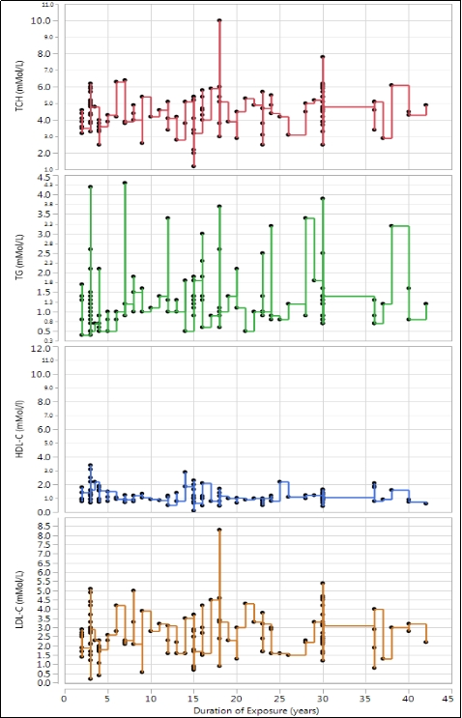

Figure 1: Overlay Plots of Fasting Lipid Profile according to the Duration of Exposure of Automechanics to Petroleum Product.

Atherogenic Indices and lipid Ratios of the Automechanics based on Duration of Exposure to Petrol and Petroleum Products.
The atherogenic indices; atherogenic index of plasma (AIP) and atherogenic coefficient (AC) and the lipid ratios; castelli risk index I (CRI-I) and castelli risk index II (CRI-II) calculated for exposed individuals based on duration of exposure to petrol and petroleum products is shown in table 4. It was observed that the mean ±SD of AIP significantly increased as the years of duration increased (p=0.0216). Graphic representation with bivarate regression analysis of AIP against duration of exposure of automechanics to petroleum products is shown in Figure 2. There was no significant difference in the mean ± SD of AC between the groups of duration of exposure (p >0.05). Graphic representation with bivariate regression analysis of AC against duration of exposure of automechanics to petroleum products is shown in Figure 3. There was no significant difference in the mean ± SD of CRI-I between the groups based on duration of exposure (p >0.05). Graphic representation with bivariate regression analysis of CRI-1 based on duration of exposure of automechanics to petroleum products is shown in Figure 4. There was no significant difference (p >0.05) in the mean values of the CRI-II between exposed and the control. Graphic representation with bivariate regression analysis of CRI-II based on duration of exposure of automechanics to petroleum products is shown in Figure 5

Table 4:Comparison of Atherogenic indices and Risk Ratios of the Automechanics based on Duration of Exposure

Characteristic | N | AIP |  | CRI-I |  | CRI-II |  | AC
 | N | Mean ± SD |  | Mean ± SD |  | Mean ± SD |  | Mean ± SD
Duration of Exposure  (Years)  <=5  6-10  11-20  21⁺ | 31  13  33  43 | -0.107±0.066 ª  0.046±0.079^{b}  0.149±0.064^{c}  0.066±0.042^{b} |  | 3.697±0.287  4.014±0.291  5.035±0.660  4.715±0.289 |  | 2.090±0.273  2.357±0.186  3.317±0.552  3.121±0.280 |  | 2.590±0.299  3.048±0.256  4.097±0.808  3.756±0.304
P-value |  | 0.0216* |  | 0.1379 ^{ns} |  | 0.0877 ^{ns} |  | 0.167 ^{ns}
Keys: SD: Standard error of mean, AIP: Atherogenic Index of Plasma, CRI-I: Castelli Risk Index-I, CRI-II: Castelli Risk Index-II, AC: Atherogenic Coefficient Means ± SD with different superscripts are significantly different at p<0.05. Significance Level: *=p<0.056; ns=Not Significant (p>0.05).

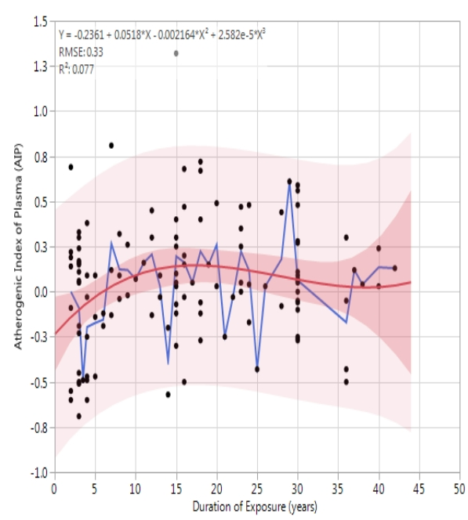

Figure 2: Bivariate Regression analysis of Atherogenic Index of Plasma (AIP) based on Duration of Exposure of Automechanics to Petroleum Products and Showing the fitted line, and confidence regions for the fitted line and individual predicted values

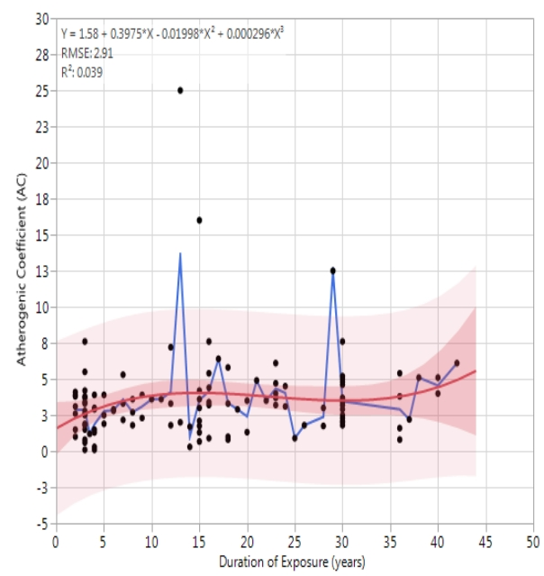
Figure 3: Bivariate Regression analysis of Atherogenic Coefficient (AC) based on the Duration of Exposure of Automechanics to Petroleum products and Showing the fitted line, and confidence regions for the fitted line and individual predicted values

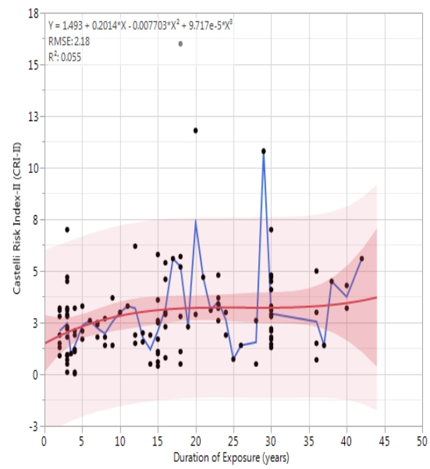

Figure 4: Bivariate Regression analysis of Castelli Risk Index-I (CRI-I) based on the Duration of Exposure of Automechanics to Petroleum Proucts and Showing the fitted line, and confidence regions for the fitted line and individual predicted values.

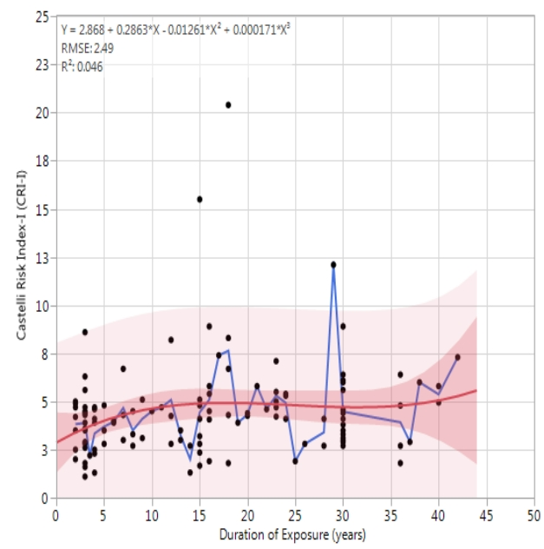

Figure 5: Bivariate Regression analysis of Castelli Risk Index-I (CRI-I1) based on the Duration of Exposure of Automechanics to Petroleum products and Showing the fitted line, and confidence regions for the fitted line and individual predicted values

Pairwise Correlation Analysis Between Body Mass Index and Fasting Lipid Profile in the Control (Non-Auto mechanics) and Exposed (Auto mechanics) Groups
Pairwise Correlation Analysis between body mass index and fasting Lipid profile in the control (Non-Auto mechanics) and exposed (Auto mechanics) groups is shown in table 5. There were ten possible pairs of parameters both in the control and the exposed. In the control group there was only one pair , TG/TC which showed significantly positive correlation (p < 0.05). There was also another significantly different pair, LDL-C/TG (p < 0.05) with negative correlation. In the exposed group there were three pairs of fasting lipid profile parameters that showed significant correlation (p<0.05). Two positively correlated pairs, TG/TCH and LDL-C/TCH and the third pair LDL-C/HDL-C which showed negative correlation.

Table 5: Pairwise Correlation Analysis Between Body Mass Index and Fasting Lipid Profile in the Control (Non-Auto mechanics) and Exposed (Auto mechanics) Groups
Parameter | By Parameter | Correlation (r) | P-value
Control group (Non-Automechanics )
TG (mmol/L) | TCH (mmol/L) | 0.2884 | 0.0090**
LDL-C (mmol/L) | TCH (mmol/L) | 0.7220 | <.0001****
Exposed group (Automechanics)
TG (mmol/L) | TCH (mmol/L) | 0.2899 | 0.0011***
LDL-C (mmol/L) | TCH (mmol/L) | 0.8117 | <.0001****
LDL-C (mmol/L) | HDL-C (mmol/l) | -0.2978 | 0.0008***

Keys :BMI: Body Mass Index, TCH: Total Cholesterol, TG: Triglyceride, HDL-C: High Density Lipoprotein, LDL-C: Low Density Lipoprotein. Significance Level: *=p<0.05

Pairwise Correlation Analysis Between Atherogenic and Risk Indices for the Control (Non- Automechanics) and Exposed (Automechanics) Groups.

Table 6 shows pairwise correlation analysis between atherogenic and risk indices for the control (non- automechanics) and exposed (automechanics) groups. There were six possible pairs of parameters for each treatment group including CRI-II/AIP, CRI-II/AIP, CRI-II/CRI-I, AC/AIP, AC/CRI and AC/CRI-II. All these paired parameters between Atherogenic and risk lipid indices , showed significant positive correlation both in the control group and in the exposed group (p<0.05).

Table 6: Pairwise Correlation Analysis Between Atherogenic and Risk Indices for the Control (Non- Auto mechanics) and Exposed (Auto mechanics) Groups.
Parameter | By Parameter | Correlation (r) | P-Value
Control group
(Non-Automechanics
CRI-I | AIP | 0.5591 | <.0001****
CRI-II | AIP | 0.4080 | 0.0002***
CRI-II | CRI-I | 0.9014 | <.0001****
AC | AIP | 0.5830 | <.0001****
AC | CRI-I | 0.9752 | <.0001****
AC | CRI-II | 0.9258 | <.0001****
Exposed group (Automechanics)
CRI-I | AIP | 0.5951 | <.0001****
CRI-II | AIP | 0.4392 | <.0001****
CRI-II | CRI-I | 0.8576 | <.0001****
AC | AIP | 0.4452 | <.0001****
AC | CRI-I | 0.5282 | <.0001****
AC | CRI-II | 0.4099 | <.0001****
Keys: AIP: Atherogenic Index, CRI-I: Castelli Risk Index I, CRI-II: Castelli Risk Index II, AC: Atherogenic Coefficient. Significance Level: *=p<0.05

4.0 DISCUSSION
Body mass index (BMI) is a parameter that measures overweight or obesity(WHO,2004; Okonugbe et al., 2022). In this study, there was no significant differences in the mean BMI value between the exposed and the control group (P >0.05).Studies have shown BMI as a determinant of health because it impacts on the physical aspect of life (Gabriel, 2019, Nuttaill,2015). This findings corroborates the prospective cohort study of Veronese et al., (2016) where the BMI values were between the normal range of 18.5- 24.9 and this leanness can be attributed to the healthy diets and physical activities against high BMI that could have been linked to metabolic and pathological conditions caused by exposure to sedentary lifestyle and unhealthy diets which is unlikely in most automechanics. However, this study disagrees with the study by Chukwuonye et al., (2015) that cited a significantly high prevalence of obesity in Abia State, South east in which gender and locality were predictors of the obese nature observed. In this study,one could have expected a high BMI value considering the life style of most automechanics regarding consumption of a higher carbohydrate rich foods for energy however the automechanics are seen to be very active because of their various activities in the garage which might have resulted to the burnout of fats and any fat deposits in the body hence assumed as the factor affecting the BMI as reflected in the result observed. The observations in the study concerning the BMI being within normal could be attributed to the physical activities engaged by the auto mechanics as highlighted by a study by Davies et al. (2017) which stated physical activities accounting for about 30–50% of an individual’s daily energy expenditure and one of the factors contributing to a positive energy balance by decreasing energy and fat intake and the prevention of lifestyle diseases .Physical exercise has been shown to be unfavourable to storage of fat via loss of calories (Harris & Kuo ,2021, Iyanu et al., 2023).
Fasting lipid parameters (TCH, LDL-C, HDL-C and TG) are biomarkers for assessing the cardiac health status mohammdshdi et al., 2023 ; Georgeoulis et al., 2022 ;Sharma et al., 2012). In this study there was significant increase in the mean TCH level of the exposed compared to the control (P < 0.05). This study is at variance with the work done by Olamoyegun et al. (2016) considering the males because the lipid profile status (TCH, TG, HDL, LDL) of the automechanics were far higher than the presentation in their study.The increases observed might be attributed to exposure to petrol and petroleum products used by these automechanics which could have predispose them to a dyslipidemic state from alterations in the body system.There has been proven evidence of contaminants from petroleum products in mechanic garage complicating lipid profiling (Unosson et al., 2021). A study carried out by Alaba et al. (2015) also showed the ability of petroleum altering the lipid profile in rats.
There was a significant increase in the mean levels of LDL-C and other lipid fractions of the exposed group compared with control group (P< 0.05) which is in concordance with the study by Obi- Ezeani et al., (2019). Contrary, HDL levels were not increased in this study. The change could be attributed to occupational exposure because these auto mechanics might have possibly ingested or inhaled some of the toxic substances in the petrol or on the other hand, apart from not making use of personal protective equipment, they must have engaged in some unhealthy practices such as sucking of gasoline and washing their hands with the petrol which is a significant source of exposure.Increased levels of low density lipoprotein cholesterol suggest greater risk of atherosclerosis or other forms of cardiovascular issues in the exposed group. Similar observation was reported in occupational studies in India (Kumar et al., 2013).
The value of atherogenic index and risk index parameters are useful tools, often used for assessment and prediction of the risk of atherosclerosis and as a marker of CVD pathologies (Niroumand et al., 2015). There was no significant difference in the mean levels of AIP, AC and CRI-11 between the exposed and unexposed groups (P > 0.05) in contrary to the study by osaretin et al.(2020) where there was significant increases in the parameters in the exposed groups compared to the control. The Castella risk index -1 (CRI-1 or TCH / HDL-C ) was the only lipoprotein ratio that showed significant increase in the mean CRI-1 of the exposed compared with the control group (p< 0.05). This difference could be attributed to occupational exposure of the automechanics which coroborates a similar observation reported in an occupational studies by Ajani et al., (2011) which also confirms that increase in any of the lipid risk indices is an indication of risk of cardiac disease.
TCH correlated positively with LDL-H and TG both in the exposed and control subjects. However correlation studies of the lipid profile indices show strong negative association between HDL-C with LDL-C. This is possible since increase or decrease in either of the two produces an opposite effect to the other in agreement with the study by Holzer et al., (2013). There was also strong positive correlation between the atherogenic lipid risk indices AIP, CRI-I, CRI-II, AC at (p < 0.05) suggesting future potential for developing cardiovascular diseases.
5.0 CONCLUSION
The blood levels of biochemical parameters TCH, LDL-C, CRI- showed significant differences in the exposed subjects compared to the control who are not exposed to petrol or petroleum products.This is an indication of possible future CVDs in Aba compared to the non auto mechanics hence, auto mechanics are encouraged to wear protective gadgets while at work. Periodic workshop training is recommended to create the desired awareness of the dangers in the exposure to toxic chemicals in petrol, also the need to comply with the standard procedure of practice in the mechanic workshops.

REFERENCES
- Nkwoada, A. U., Alisa, C. O., & Amakom, C. M. (2018). Pollution In Nigerian Auto-Mechanic Villages: A Review. IOSR Journal of Environmental Science, Toxicology and Food Technology, 12(7.I), 43-54. https://doi.org/10.9790/2402-1207014354
- Briffa, J., Sinagra, E., & Blundell, R. (2020). Heavy metal pollution in the environment and their toxicological effects on humans. Heliyon, 6(9), e04691. https://doi.org/10.1016/j.heliyon.2020.e04691
- Obianime, A. W., Odili, O., Olorunfemi, O. J., Wokoma, O. T., & Chuemere, A. N. (2017). Toxic Air and Soil in Automobile Workshop Impact Negatively on the Health Status of Automechanics: The Nigeria Environment. International Journal of Pharmaceutics and Pharmacology, 1(3), 111. https://doi.org/10.31531/2581-3080.1000111
- Menicagli, R., Marotta, O., & Menicagli, L. (2018). The Exposure to Pollutants of the Auto Repair Workers: Monitoring their Oxidative Stress. Indian Journal of Occupational and Environmental Medicine. https://doi.org/10.4103/ijoem.IJOEM_99_18
- World Health Organization. (2019). Noncommunicable diseases and air pollution. World Health Organization Regional Office for Europe. https://apps.who.int/iris/bitstream/handle/10665/346416/WHO-EURO-2019-3641-43400-60937-eng.pdf?sequence=1&isAllowed=y
- Al-Rubaye, A. H., Jasim, D. J., Ameen, H. F. M., Al-Robai, H. A., & Al-Assal, J. R. (2023). The Impacts of Petroleum on Environment. IOP Conference Series: Earth and Environmental Science, 1158(3), 032014. https://doi.org/10.1088/1755-1315/1158/3/032014
- Naidu, R., Biswas, B., Willett, I. R., Cribb, J., Singh, B. K., Nathanail, C. P., Coulon, F., Semple, K. T., Jones, K. C., Barclay, A., & Aitken, R. J. (2021). Chemical pollution: A growing peril and potential catastrophic risk to humanity. Environment International, 156, 106616. https://doi.org/10.1016/j.envint.2021.106616
- Danek, T., Weglinska, E., & Zareba, M. (2022). The influence of meteorological factors and terrain on air pollution concentration and migration: a geostatistical case study from Krakow, Poland. Scientific Reports, 12, 11050. https://doi.org/10.1038/s41598-022-15160-3
- Brucker, N., Moro, A. M., Charão, M. F., Durgante, J., Freitas, F., Baierle, M., Nascimento, S., Gauer, B., Bulcão, R. P., Bubols, G. B., Ferrari, P. D., Thiesen, F. V., Gioda, A., Duarte, M. M. M. F., de Castro, I., Saldiva, P. H., & Garcia, S. C. (2013). Biomarkers of occupational exposure to air pollution, inflammation and oxidative damage in taxi drivers. *Science of the Total Environment*, *463-464*, 884–893. https://doi.org/10.1016/j.scitotenv.2013.06.098
- Ekpenyong, C. E., & Asuquo, A. E. (2017). Recent advances in occupational and environmental health hazards of workers exposed to gasoline compounds. International Journal of Occupational Medicine and Environmental Health, 30(1), 1-26. https://doi.org/10.13075/ijomeh.1896.00800
- Galadima A, Okoronkwo MU, Mustapha DG. & Leke L, ( 2012). Petrol in Nigeria: ‘A fuel or a killer’, Is shift to hydroisomerisation not overdue? Elixir Pollution, 43, 6893-6897.
- World Medical Association. (2024). World Medical Association Declaration of Helsinki – Ethical principles for medical research involving human participants. https://www.wma.net/policies-post/wma-declaration-of-helsinki/
- Allain, C. C., Poon, L. S., Chan, C. S. G., Richmond, W., & Fu, P. C. (1974). Enzymatic Determination of Total Serum Cholesterol. Clinical Chemistry, 20(4), 470-475. https://doi.org/10.1093/clinchem/20.4.470
- Schettler G & Nussel E (1975). Trgyceride GPO/ PAP Method. Arav. Medicine, 10, 25-26.
- Langlois, M. R., & Blaton, V. H. (2006). Historical milestones in measurement of HDL-cholesterol: Impact on clinical and laboratory practice. Clinica Chimica Acta, 369(2), 168–178. https://doi.org/10.1016/j.cca.2006.01.031
- Friedewald, W. T., Levy, R. I., & Fredrickson, D. S. (1972). Estimation of the concentration of low-density lipoprotein cholesterol in plasma, without use of the preparative ultracentrifuge. Clinical Chemistry, 18(6), 499-502. https://doi.org/10.1093/CLINCHEM/18.6.499
- Bhardwaj, S., Bhattacharjee, J., Bhatnagar, M. K., Tyagi, S., & Delhi, N. (2013). ATHEROGENIC INDEX OF PLASMA, CASTELLI RISK INDEX AND ATHEROGENIC COEFFICIENT- NEW PARAMETERS IN ASSESSING CARDIOVASCULAR RISK. International Journal of Pharmacy and Biological Sciences, 3(3), 359-364. https://www.ijpbs.com/volume-3-issue-3-jul-sept-2013/atherogenic-index-of-plasma-castelli-risk-index-and-atherogenic-coefficient-new-parameters-in-assessing-cardiovascular-risk/
- WHO Expert Consultation. (2004). Appropriate body-mass index for Asian populations and its implications for policy and intervention strategies. Lancet, 363(9403), 157–163. https://doi.org/10.1016/S0140-6736(03)15268-3
- Okunogbe, A., Nugent, R., Spencer, G., Powis, J., Ralston, J., & Wilding, J. (2022). Economic impacts of overweight and obesity: current and future estimates for 161 countries. BMJ Global Health, 7(9), e009773. https://doi.org/10.1136/bmjgh-2022-009773
- Bobula, G. (2019). Influence, Significance and Importance of Body Mass Index in Scientific Research and Various Fields of Science. American Journal of Biomedical Science & Resource, 4(4). https://doi.org/10.34297/AJBSR.2019.04.000816
- Nuttall, F. Q. (2015). Body Mass Index: Obesity, BMI, and Health: A Critical Review. Nutrition Today, 50(3), 117-128. https://doi.org/10.1097/NT.0000000000000092
- Veronese, N., Li, Y., Manson, J. E., Willett, W. C., Fontana, L., & Hu, F. B. (2016). Combined associations of body weight and lifestyle factors with all cause and cause specific mortality in men and women: prospective cohort study. BMJ, 355, i5855. https://doi.org/10.1136/bmj.i5855
- Chukwuonye II, Chuku A, Onyeonoro UU, Ukegbu A, Anyabolu E & Ogah O. (2015) Body Mass Index, Prevalence and Predictors of Obesity in Urban and Rural Communities in Abia State South Eastern Nigeria. Journal of Diabetes and Metabolism, 6 (7), 570. doi:10.4172/2155-6156.1000570.
- Davis, R. A. H., Halbrooks, J. E., Watkins, E. E., Fisher, G., Hunter, G. R., Nagy, T. R., & Plaisance, E. P. (2017). High-intensity interval training and calorie restriction promote remodeling of glucose and lipid metabolism in diet-induced obesity. American Journal of Physiology-Endocrinology and Metabolism, 313(2), E243-E256. https://doi.org/10.1152/ajpendo.00445.2016
- Harris, M. B., & Kuo, C.-H. (2021). Scientific Challenges on Theory of Fat Burning by Exercise. Frontiers in Physiology, 12, 685166. https://doi.org/10.3389/fphys.2021.685166
- Olateju, I. V., Taiwo, O., Uche, J. E., Jennifer, A., Oladunjoye, K. T., Egbebalakhamen, O., & Oladunjoye, A. F. (2023). A systematic review on the effectiveness of diet and exercise in the management of obesity. Diabetes & Metabolic Syndrome: Clinical Research & Reviews, 17(4), 102759. https://doi.org/10.1016/j.dsx.2023.102759
- Mohammadshahi, J., Ghobadi, H., Matinfar, G., Boskabady, M. H., & Aslani, M. R. (2023). Role of Lipid Profile and Its Relative Ratios (Cholesterol/HDL-C, Triglyceride/HDL-C, LDL-C/HDL-C, WBC/HDL-C, and FBG/HDL-C) on Admission Predicts In-Hospital Mortality COVID-19. Journal of Lipids. https://doi.org/10.1155/2023/6329873 .
- Georgoulis, M., Chrysohoou, C., & Georgousopoulou, E. (2022). Long-term prognostic value of LDL-C, HDL-C, lp(a) and TG levels on cardiovascular disease incidence, by body weight status, dietary habits and lipid-lowering treatment: the ATTICA epidemiological cohort study (2002–2012). Lipids in Health and Disease. https://doi.org/10.1186/s12944-022-01747-2
- Sharma, S. V., Kumar, P., Atam, V., Verma, A., & Murthy, R. C. (2012). Lipid Profiles with Increase Blood Lead Level: Risk of Cardiovascular Disease in Battery Workers of Lucknow City. Journal of Indian Academy of Forensic Medicine, 34(4), 328-331. https://doi.org/10.1177/0971097320120415
- Olamoyegun, M. A., Oluyombo, R., & Asaolu, S. O. (2016). Evaluation of dyslipidemia, lipid ratios, and atherogenic index as cardiovascular risk factors among semi-urban dwellers in Nigeria. Annals of African Medicine, 15(4), 194-199. https://doi.org/10.4103/1596-3519.194280
- Unosson, J., Kabéle, M., Boman, C., Nyström, R., Sadiktsis, I., Westerholm, R., Mills, N. L., Newby, D. E., Blomberg, A., & Bosson, J. (2021). Acute cardiovascular effects of controlled exposure to dilute Petrodiesel and biodiesel exhaust in healthy volunteers: a crossover study. Particle and Fibre Toxicology. https://doi.org/10.1186/s12989-021-00412-3
- Alaba, O. O., Jaja, S. I., Bamidele, O., Babatunde, L. D., & Femmymale, T. F. (2015). Effects of Nigeria Ekete light crude oil on plasma electrolytes, packed cell volume (PCV) and lipids profile in wistar (Rattus norvegicus) rats. AFRICAN JOURNAL OF BIOTECHNOLOGY, 14(24), 2047–2051. https://doi.org/10.5897/AJB2014.13972
- Obi-Ezeani, C. N., Dioka, C. E., Meludu, S. C., Onuora, I. J., Usman, S. O., & Onyema-Iloh, O. B. (2019). Blood Pressure and Lipid Profile in Automechanics in Relation to Lead Exposure. Indian Journal of Occupational and Environmental Medicine, 23(1), 28-31. https://doi.org/10.4103/ijoem.IJOEM_122_18 .
- Kumar AK, Raju PK, Kumar CK & Reddy AR (2013). Plasma lipid profiles and risk cardiovascular disease on occupational exposure in Karimnagar. Journal of Toxicology and Environment chemistry, 95 (2), 359-365.
- Niroumand, S., Khajedaluee, M., Khadem-Rezaiyan, M., Abrishami, M., Juya, M., Khodaee, G., & Dadgarmoghaddam, M. (2015). Atherogenic Index of Plasma (AIP): A marker of cardiovascular disease. Medical Journal of the Islamic Republic of Iran, 29, 240. https://mjiri.iums.ac.ir/article_19000.html
- Igharo, O. G., Akinfenwa, Y., Isara, A. R., Igharo, F. A., Nwachukwu, N. L., Aigbe, J. I., & Osibanjo, O. (2020). Lipid profile and Atherogenic Indices in Nigerians Occupationally Exposed to e-waste: A Cardiovascular Risk Assessment Study. Maedica - a Journal of Clinical Medicine, 15(2), 196-205. https://doi.org/10.26574/maedica.2020.15.2.196
- Ajani, E. O., Ajibola, A., Salau, B. A., Odufuwa, T. K., & Odewabi, A. O. (2011). Preliminary report on hepatic and cardiovascular risk assessment of automobile mechanics in Nigeria. African Journal of Biotechnology, 10(9), 1705-1711. https://doi.org/10.5897/AJB10.1629
- Holzer, M., Trieb, M., Konya, V., Wadsack, C., Heinemann, A., & Marsche, G. (2013). Aging affects high-density lipoprotein composition and function. Biochimica et Biophysica Acta, 1831(9), 1442-1448. https://doi.org/10.1016/j.bbalip.2013.06.004

