Acrometastasis Revealing Pulmonary Squamous Cell Carcinoma in a Patient with Papillary Urothelial Carcinoma: An Unusual Presentation

Abstract
Acrometastases are rare and may exceptionally reveal an occult carcinoma. The prognosis is often poor. Imaging and immunohistochemical studies are essential to determine the primary origin and guide treatment. Bone acrometastasis of the finger as the initial manifestation of an occult primary malignancy is exceptionally reported in the literature. Diagnostic delays and even misdiagnoses are frequent. We report a case of acrometastasis of the first phalanx of the left index finger revealing a pulmonary squamous cell carcinoma in a 61-year-old chronic smoker followed for low-grade papillary urothelial carcinoma.
Keywords: Acrometastasis, squamous cell carcinoma, urothelial carcinoma

Introduction
Acrometastasis revealing an occult malignant tumor is a rare clinical event. Etiological investigation should primarily focus on pulmonary or renal origins. Immunohistochemistry remains an essential diagnostic tool, although aberrant profiles can be misleading. Only anatomo-clinical-radiological correlation allows for a definitive diagnosis and the proposal of an appropriate multidisciplinary therapeutic approach.

Case Report
We report the case of a 61-year-old male, chronic smoker (40 pack-years), with no history of chronic cough or dyspnea. He was followed one year earlier for low-grade papillary urothelial carcinoma not infiltrating the lamina propria.
The clinical history dated back three months, marked by the appearance of a painful swelling of the left index finger, complicated by tonic–clonic seizures, with no associated respiratory or extra-respiratory symptoms. The condition evolved in an afebrile context with general health deterioration, including asthenia, anorexia, and unquantified weight loss.
Clinical examination revealed a patient in poor general condition (PS = 1), correctly oxygenating on room air (SpO₂ 97%), eupneic, normocardic at 122 bpm, normotensive (130/80 mmHg), with a BMI of 20 kg/m².
Dermatological and mucosal examination showed a reddish, painful swelling of the left index finger. Neurological examination revealed positive Mingazzini and Romberg signs on the right side, associated with right hemiparesis and hypoesthesia. Pulmonary and pleural examination, as well as the remainder of the systemic examination, were unremarkable.
X-ray of the hand demonstrated an osteolytic lesion of the first phalanx of the left index. Because of neurological symptoms, a brain CT was performed and revealed a left parietal lesion (Figure 1). Given the history of urothelial carcinoma, bone and cerebral metastases were initially suspected.
Biopsy of the mass of the first phalanx of the left index revealed a tumor proliferation. Immunohistochemistry was consistent with a poorly differentiated, non-keratinizing, infiltrating pulmonary squamous cell carcinoma expressing CK and P63.
Chest X-ray revealed a right hilar spiculated opacity (Figure 2). Thoracic CT scan demonstrated a right mediastino-pulmonary process (Figure 3), and abdominal–pelvic CT revealed a right adrenal mass. Flexible bronchoscopy showed neither endobronchial tumor nor other abnormalities.
The patient underwent radiotherapy and palliative chemotherapy as decided by the multidisciplinary oncology board. Evolution was unfavorable, marked by death three months after initiation of treatment.

Discussion
Acrometastases are rarely reported in the literature. They account for 0.1% of bone metastases, with only 10% presenting as the first manifestation of an undiagnosed malignancy (1). They were first described in the hand by Handley in 1906, and in 1920, Bloodgood reported the first case of foot acrometastasis (2).
A study by Stomeo et al. showed that cancers most commonly responsible for acrometastasis originate from the lung (32.9%), followed by renal tumors (20%), breast (12.9%), and colon cancers (10%) (1). Conversely, another study by Sahoo et al. suggested renal origin as more frequent than pulmonary (3). The same study showed that among lung cancers, squamous cell carcinomas were more likely to metastasize to the extremities than adenocarcinomas (3). In our case, the acrometastasis revealed a pulmonary squamous cell carcinoma.
The mechanism of tumor cell dissemination to distal bones remains unclear. Several hypotheses have been proposed. One suggests hematogenous rather than lymphatic spread, explaining the prevalence of pulmonary acrometastases (4). Other authors have implicated repetitive trauma as a potential factor, favoring tumor cell recruitment through chemotactic substances and prostaglandins secreted at trauma sites (5).
Bone metastases of the hand are most frequently due to lung carcinoma (6,7). Hand acrometastases generally appear on the dominant side, mainly involving the distal phalanx, particularly the thumb, followed by metacarpals and proximal phalanges. Involvement of the middle phalanx is rare, while carpal bone metastasis is exceptional (8). In our case, acrometastasis involved the first phalanx of the index finger.
Foot metastases more frequently affect the tarsal bones, with phalangeal involvement being rare (9,10). In general, regions with lower blood flow are more favorable for secondary tumor growth, which may explain the higher incidence of acrometastases in distal phalanges (11). Most patients present with a solitary lesion, but bilateral hand involvement is observed in up to 10% of cases (8). Foot metastases are more commonly associated with subdiaphragmatic tumors, particularly from the gastrointestinal tract, bladder, kidney, and uterus (12).
The most frequent clinical presentation is pain, sometimes associated with a palpable mass, progressive finger swelling, or impaired hand function interfering with daily activities. Pain is usually deep, intermittent, and resistant to usual analgesics. Initially, the lesion may be painless but can later mimic an inflammatory process with swelling and erythema (13), and in some cases, ulceration or hemorrhagic foci (14). The differential diagnosis includes osteomyelitis, rheumatoid arthritis, tenosynovitis, and gout. In our case, the main clinical symptom was painful swelling of the index finger refractory to analgesic treatment.
Radiographs typically reveal an osteolytic lesion (12,13). Lung and renal carcinomas usually present as solitary lytic lesions of the hand, whereas breast metastases are often multiple, with lytic, sclerotic, or mixed characteristics (12). CT has limited value for hands and feet due to low resolution, while MRI allows better evaluation of marrow involvement and extraosseous extension (9).
A complete staging workup, including radiographs of the lesion, chest and abdominal CT, and bone scan, is necessary in patients with acrometastatic cancer, as the histology of the primary tumor and the extent of disease are crucial for therapeutic planning and prognosis. Bone scintigraphy helps assess lesion multiplicity, while PET scan offers higher sensitivity (15). In our case, staging revealed a mediastino-pulmonary mass with adrenal and cerebral metastases.
For histological diagnosis, fine needle aspiration (FNA) or core needle biopsy may be used, while incisional biopsy should be avoided (16).
After staging, treatment may include surgery (amputation or conservative surgery with reconstruction), external radiotherapy, and chemotherapy. Due to the rarity of acrometastatic cancers, no standardized therapeutic protocols exist. Given the poor prognosis, management is mainly palliative, with priorities being pain relief, adequate tumor excision, rapid recovery, and preservation of maximal hand function (17,18). In our case, the patient received radiotherapy and palliative chemotherapy.
Acrometastatic carcinomas carry a poor prognosis, with a mean survival of 3–6 months (19), consistent with our observation.

Conclusion
Acrometastases are exceedingly rare and may exceptionally reveal an occult primary tumor, most often pulmonary squamous cell carcinoma. Their diagnosis requires a combination of clinical, radiological, and histopathological correlation. Prognosis remains poor, underlining the importance of early recognition and multidisciplinary management.

Figures :

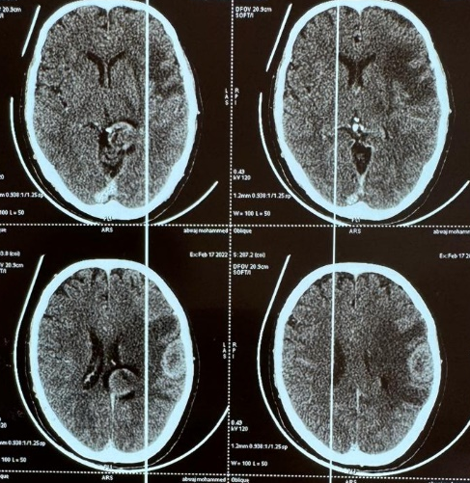
Figure 1: Brain CT scan showing a left parietal mass
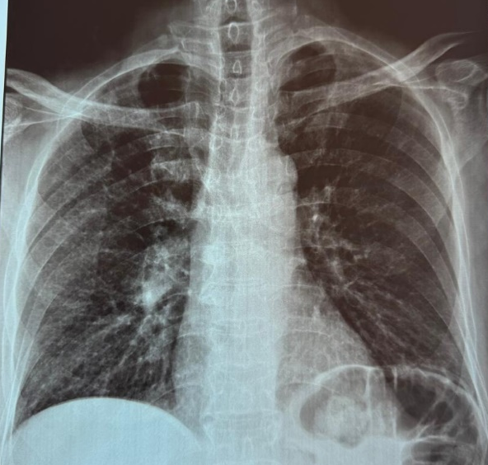
Figure 2: Frontal chest X-ray showing a right hilar spiculated opacity
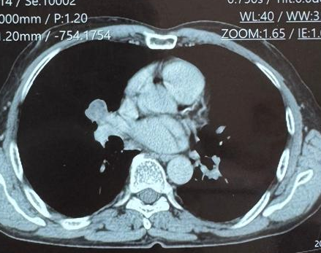
Figure 3: Chest CT scan showing a right mediastino-pulmonary mass

Références

- Arbeláez Echeverri, P., García, M. F., Garzón C, J., Morales, L. C., Messa Botero, O., Zúñiga, M. I., & Lozada Mujica, C. J. (2019). Acrometástasis óseas, serie de casos y revisión de la literatura. Revista Chilena de Radiología, 25(3), 87-93. https://doi.org/10.4067/S0717-93082019000300087
- Stomeo, D., Tulli, A., Ziranu, A., Perisano, C., De Santis, V., & Maccauro, G. (2015). Acrometastasis: a literature review. European Review for Medical and Pharmacological Sciences, 19(15), 2906–2915. https://pubmed.ncbi.nlm.nih.gov/26241547/
- Sahoo, T. K., Das, S. K., Majumdar, S. K. D., Senapati, S. N., & Parida, D. K. (2016). Digital Acrometastasis as Initial Presentation in Carcinoma of Lung A Case Report and Review of Literature. Journal of Clinical and Diagnostic Research, 10(6), XD01–XD02. https://doi.org/10.7860/JCDR/2016/16063.7951
- Mavrogenis, A. F., Mimidis, G., Kokkalis, Z. T., Karampi, E.-S., Karampela, I., Papagelopoulos, P. J., & Armaganidis, A. (2014). Acrometastases. European Journal of Orthopaedic Surgery & Traumatology, 24(3), 279–283. https://doi.org/10.1007/s00590-013-1311-1
- Tolo, E. T., Cooney, W. P., & Wenger, D. E. (2002). Renal cell carcinoma with metastases to the triquetrum: case report. Journal of Hand Surgery, American Volume, 27(5), 876–881. https://doi.org/10.1053/jhsu.2002.34368
- Healey, J. H., Turnbull, A. D., Miedema, B., & Lane, J. M. (1986). Acrometastases. A study of twenty-nine patients with osseous involvement of the hands and feet. Journal of Bone and Joint Surgery. American Volume, 68(5), 743–746. https://doi.org/10.2106/00004623-198668050-00013
- Baran, R., Guillot, P., & Tosti, A. (1998). Metastasis from carcinoma of the bronchus to the distal aspect of two digits. British Journal of Dermatology, 138(4), 708. https://doi.org/10.1046/j.1365-2133.1998.02193.x
- Flynn, C. J., Danjoux, C., Wong, J., Christakis, M., Rubenstein, J., Yee, A., Yip, D., & Chow, E. (2008). Two cases of acrometastasis to the hands and review of the literature. Current Oncology, 15(5), 51-58. https://doi.org/10.3747/co.v15i5.189
- Spiteri, V., Bibra, A., Ashwood, N., & Cobb, J. (2008). Managing acrometastases treatment strategy with a case illustration. Annals of The Royal College of Surgeons of England, 90(7), W8–W11. https://doi.org/10.1308/147870808X303137
- Zindrick, M. R., Young, M. P., Daley, R. J., & Light, T. R. (1982). Metastatic tumors of the foot: case report and literature review. Clinical Orthopaedics and Related Research, (170), 219–225. https://pubmed.ncbi.nlm.nih.gov/7127951/
- Asencio, G., Hafdi, C., Pujol, H., & Allieu, Y. (1982). Osseous metastases in the hand. A general review of three cases. Ann Chir Main. https://doi.org/10.1016/s0753-9053(82)80069-0
- Libson, E., Bloom, R. A., Husband, J. E., & Stoker, D. J. (1987). Metastatic tumours of bones of the hand and foot. A comparative review and report of 43 additional cases. Skeletal Radiology, 16(5), 387–392. https://doi.org/10.1007/BF00350965
- Kerin, R. (1983). Metastatic tumors of the hand. A review of the literature. J Bone Joint Surg Am, 65(9), 1331–1335. https://doi.org/10.2106/00004623-198365090-00016
- Long, L. S., Brickner, L., Helfend, L., Wong, T., & Kubota, D. (2010). Lung cancer presenting as acrometastasis to the finger: A case report. *Case Reports in Medicine*, *2010*, 234289. https://doi.org/10.1155/2010/234289
- Ohta, M., Tokuda, Y., Suzuki, Y., Kubota, M., Makuuchi, H., & Tajima, T. (2001). Whole body PET for the evaluation of bony metastases in patients with breast cancer: comparison with 99Tcm-MDP bone scintigraphy. Nuclear Medicine Communications, 22(8), 875–879. https://doi.org/10.1097/00006231-200108000-00005
- Knapp, D., & Abdul-Karim, F. W. (1994). Fine needle aspiration cytology of acrometastasis. A report of two cases. *Acta Cytologica*, *38*(4), 589–591. https://pubmed.ncbi.nlm.nih.gov/8042428/
- Plotkine, E., Coscas, R., & Guigui, P. (2008). Digital metastasis of nasopharyngeal carcinoma: a surgical trap. Case report and literature review. Chirurgie de la Main, 27(4), 187–190. https://doi.org/10.1016/j.main.2008.07.003
- Trinidad, J., Kaplansky, D., Nerone, V., & Springer, K. (2012). Metastatic adenosquamous carcinoma of the foot: a case report. Journal of Foot and Ankle Surgery, 51(3), 345–351. https://doi.org/10.1053/j.jfas.2012.01.009
- Ammannagari, N., Chinnasamy, R., Laveaux, K., & Grethlein, S. (2013). Digital acrometastasis: An unusual first presentation of an occult lung cancer. Commun Oncol, 10, 159–160. https://doi.org/10.12788/j.cmonc.0009

