Heat Transfer Analysis over a Rectangular Enclosure with Thermally Insulated Prismatic Block Considering the Effect of Pertinent Parameters with Magnetic Field

Abstract
In the present research, heat transfer performance that is cooling efficiency has been analyzed under mixed convective condition in a vented rectangular enclosure having a centered prismatic adiabatic body. The studied problem is governed by the conservation of mass, energy along with momentum equations considering the fluid as two-dimensional, laminar and steady state. Galerkin-weighted residual based Finite element method is applied for computational procedure in this work. Velocity and temperature profiles as well as heat transfer rate are focused in graphically and tabular form for the wide ranges varieties of two pertinent parameters, namely Reynolds number (50 ≤ Re ≤ 500) and Prandtl number (0.71 ≤ Pr ≤ 7.1). Magnetic field parameter Hartmann number is fixed Ha = 50 throughout the simulation. It has been found that Re has a significant role both in flow patterns and thermal distributions whereas Pr has a noteworthy control on temperature field. More cooling efficiency is followed for the higher values of two considered controlling parameters.

Keywords: Heat transfer, Rectangular enclosure, Prismatic block, pertinent parameter

- Introduction
Due to the widespread applications of mixed convection phenomena in engineering and industrial sectors, numerous investigations have been carried out both numerically and experimentally inside different shaped closed and vented cavities along with interior solid body.
A review on heat transfer enhancement in cavity with lid driven has been presented by Saieed et al. [1]. Sereir et al. [2] studied the optimum state of organic and combined convection in a venting rectangle-shaped chamber with a sinusoidal hot barrier placed inside with an insulated austere block. An analysis of convection in combination in a differentially warmed square segment with shifting lids was carried out by Abraham and Varghes [3]. Pinto et al. presented a numerical investigation of the natural convection in a square chamber with inner bodies using the finite element method. [4]. Elsherbiny et al. [5] analyzed heat transfer in inclined air rectangular cavities with two localized heat sources. Guo and Sharif [6] analysed mixed convection in rectangle chambers at different ratios of aspect with circulating isothermal edges and steady flux heat production on the bottom surface. Mixed convection enhancement in a rectangular cavity by triangular obstacle was presented by Afluq et al. [7]. Ibrahim and Hirpho [8] used the finite element approach to examine the flow of mixed convection in a trapezoidal cavity with irregular temperature variations. The author’s shown that Hartmann number has negative impact on the average Nusselt number whereas Richardson number has a positive effect on average Nusselt number. Zheng et al. [9] studied on the phenomenon of natural heat exchange in a closed structure with hot and cold tubes. Natural convection flow analysis has been performed by Akter and Parvin [10] in a trapezoidal cavity containing a rectangular heated body along with external oriented magnetic field. In a thorough study of mixed convection phenomena in a square cavity configuration, Shuja et al. [11] examined how the placement of exit ports has a major impact on the system's overall thermal performance and fluid flow patterns when a rectangular heat-generating body is placed inside. In related work, Papanicolaou and Jaluria [12] performed a detailed study examining mixed convection characteristics resulting from an isolated heat source strategically located within a rectangular enclosure, focussing on the complex interactions between natural and forced convection mechanisms. Meanwhile, Raji and Hasnaoui [13] carried out extensive research on mixed convection heat transfer dynamics in a rectangular cavity that featured both ventilation and side-wall heating, exploring how these boundary conditions affect temperature distribution and heat transfer rates. Mamun et al. [14] analyzed mixed convection analysis in trapezoidal cavity with a moving lid. An introduction to finite element analysis has been performed by Reddy [15]. Rahman et al. [16] explored the phenomenon of mixed convection in a rectangle vented cavity with a thermal conducting square cylindrical structure at the centre. A Numerical analysis of aiding MHD mixed convection inside a vented cavity was undertaken by Sharif et al. [17]. Natural convection in chambers with constant exchange of temperature at the bottom layer and isothermal cooling from interior walls presented by Sharif and Mohammad [18]. Roy and Basak [19] carried out finite element analysis of natural convection flows in a square cavity with non-uniformly heated wall. The flow and heat transfer characteristics for assisting incompressible laminar flow past an open cavity has been analyzed by Striba [20].
As far the authors’ knowledge and based on the above mentioned performed works it is followed that the current geometric configuration with associate boundary conditions has not been investigated earlier. The goal of this study is to analyze mixed convective heat transfer and fluid flow in a rectangular vented cavity in presence of thermally isolated prismatic block subjected to different pertinent parameters.

- Physical Model and Governing Equations
Geometrical representation of the studied problem is portrayed in Fig. 1. The configuration considered here is a vented rectangular enclosure along with centered thermally insulated prism shaped solid block. The exit hole is situated at the top of the cavity's opposite perpendicular wall, while the intake opening is situated at the bottom of the left-most vertical wall. Additionally, the entering port is 0.1L in size, the same as the exit port. The middle half of bottom surface of the cavity is set at a high temperature T_{h}, while two side walls maintain a low temperature T_{c}. The ceiling as well as the remainder two halves (left and right) of bottom surface of the hollow are preserved as thermally insulated. The right wall is subjected to a constant magnetic field of intensity B₀ in a horizontal direction. It is assumed that all of the cavity's solid edges and the internal body are rigid. All solid boundaries of the cavity and interior body are believed to be solid non-slip barriers that is velocity components are fixed to u = v = 0. The flow enters the cavity at a uniform velocity, u_{i} and the ambient temperature, T_{i} whereas the external flow is considered as having zero diffusion flux for all dependent parameters.

T_{c}
B₀
L
g
1.5 L
T_{h}
T_{c}

Fig. 1 – Physical model of the problem

The working fluid of the present problem is supposed to be two-dimensional, steady state, laminar and incompressible with constant thermo-physical properties except for density variation. The principal equations for the problem in non-dimensional are described below:
Continuity equation
(1)
x- momentum equation
(2)
y- momentum equation
(3)
Energy equation
(4)
The definitions of the Reynolds, Prandtl, Hartman, and Richardson numbers are as follows:
, , ,
The related boundary conditions in the dimensionless form are
at the inlet
at the outlet: convective boundary condition (CBC)
the middle part of the bottom surface
at the two side walls
at the top wall as well as the left and right portion of bottom surface
U = 0, V = 0 at every solid boundary within the cavity
at the surface of the centered block
Where N is the non-dimensional distances either along X or Y direction acting normal to the surface.
The average Nusselt number Nu at the hot wall is given by
- Computational Procedure
In this study, the Galerkin weighted residual-based finite element method was used to numerically solve the governing equations and related boundary conditions. To obtain the utmost perfect solution of the considered problem mesh generation and code validation is needed that are performed consecutively.

3.1 Grid Sensitivity Check
Different grid sizes of 2224, 3266, 5402, 13212, 33582 and 45790 elements are taken into consideration for the present simulation in order to verify the independency of the outcomes so that highest accuracy can be ensured. Average Nusselt

Table 1- Average Nusselt number at hot mid part of bottom wall at Pr = 0.71, Re= 100, Ha = 50, Ri = 10

No. of elements | 2199 | 3304 | 5432 | 13102 | 33907 | 45685
Nu_{av} | 4.6158 | 4.7021 | 4.7658 | 4.9509 | 5.0672 | 5.0686
Deviation | - | 0.863 | 0.637 | 0.1851 | 0.1163 | 0.0014
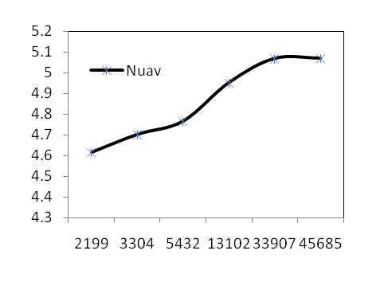

Fig. 2 –Grid independency test shows average Nusselt number for different number of elements

Number that represents the amount of heat movement at the heated mid portion of bottom surface are computed for these selected elements. Variations among the results for different numbers of elements are very minor that is followed from Table 1 and Fig. 2. Finally, based on the results from the table and figure the grid consisting of 33907 elements are chosen for calculating average Nusselt number considering both the correctness of the numerical values and the corresponding solution time.

3.2 Validity of Code
The current study's numerical code has been verified by contrasting its streamline and isotherm results with those of an analysis using finite elements of mixed convection flow in a trapezoidal chamber with non-uniform
Ri = 10 |  | 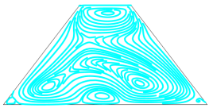
Ri = 1 |  | 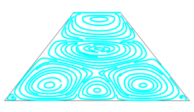
Ri = 0.1 |  | 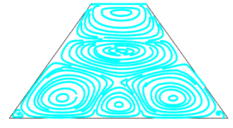
 | (a) Streamlines [8] | Streamlines (present)

Ri = 10 |  | 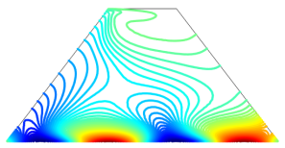
Ri = 1 | 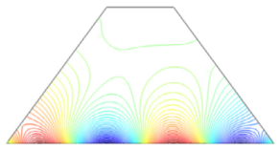 | 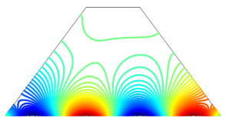
Ri = 0.1 |  | 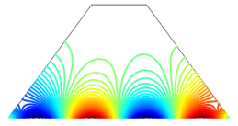
 | (b) Isotherms [8] | Isotherms(present)

Fig. 3 - Comparison of (a) streamlines and (b) isotherm while Gr = 10⁴, Pr = 6.2, Ha=50 and Re = 100

temperature performed by Ibrahim and Hirpho [8]. Fig. 3 depicts the relationships between these two works with wonderful conformity in velocity and temperature profiles that are described in terms of streamlines and isotherms which make an affirmation of the current numerical code.

- Results and Discussions
The effects of Reynolds and Prandtl numbers on flow and thermal field were examined numerically for two-dimensional, steady, laminar, incompressible combined free and forced convection in a rectangular ventilated cavity with an adiabatic prismatic body. For this analysis, the ranges of Re and Pr are set at 50 to 500 and 0.71 to 7.1, respectively, with Ha = 50 and Ri = 10. In order to comprehend the behavior of flow and temperature profiles as well as heat removal performance, the problem's findings are explained in terms of streamlines, isotherms, and average Nusselt number.
Fig. 4 depicts the effect of Reynolds number on flow patterns and temperature distribution that is shown as streamlines and isotherms. It is noticed from Fig. 4(a) that at low Reynolds number Re = 50 and 100, starting from the inlet port flow lines diverse the two sides of the centered block and totally encompassed it. Moreover, the streamlines captured the whole cavity about horizontally and vertically and a small variation is observed between the flow patterns for these two values of Re. At Re = 200, flow behavior inside the domain is almost identical with a tiny eddy above the inlet opening. But a rapid change is found for the highest value of Re = 500; small eddy enlarges and due to its flow suppresses towards the central part, streamlines above the vortex losses its linearity and reduces to more curved shape.
The corresponding isotherms for selected values of Reynolds number are exhibited in Fig. 4(b) and one can notice that at Re = 50, heat lines stretched the whole cavity non-uniformly. Except a little number of heat lines all are formed between the interior prismatic body with bottom and right walls of the enclosure. Also high temperatured thermal lines are found near the bottom heated part. When Re = 100, left sided heat line diminishes and consequently more heat lines are seen above the top-right side of the centered block. Same sequence is followed for the temperature distribution inside the studied domain for higher values of Re = 200 with a thin boundary layer at the central part of the lower surface of the cavity. A drastically variation in thermal behavior is observed for Re = 500; heat lines move towards the right wall and also densed in the vicinity of bottom hot walls of the enclosure with a thick boundary layer. As a result internal solid body is about detached from the heat lines.
Prandtl number’s influence on flow and temperature profile is displayed in terms of streamlines and isotherms in Fig. 5. It is noticed from Fig. 5(a), for all chosen values of Pr flow patterns are almost identical. Flow enters via inlet port and moves towards the opposite side located exit port and streamlines occupies the entire region of the cavity. The isotherms contours are depicted in Fig. 5(b) for selected values of Prandtl number. With a small variation thermal lines are found middle right side of the enclosure that are connected in internal obstacle for two lower values of

Re=500 | 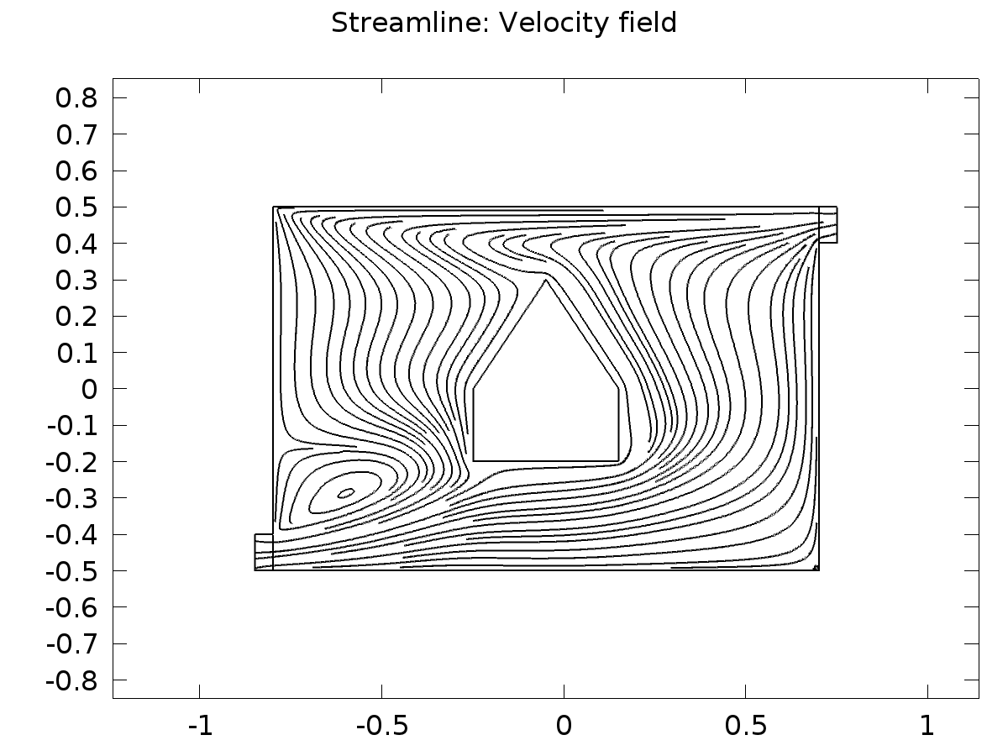 | 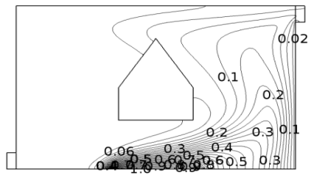
Re=200 | 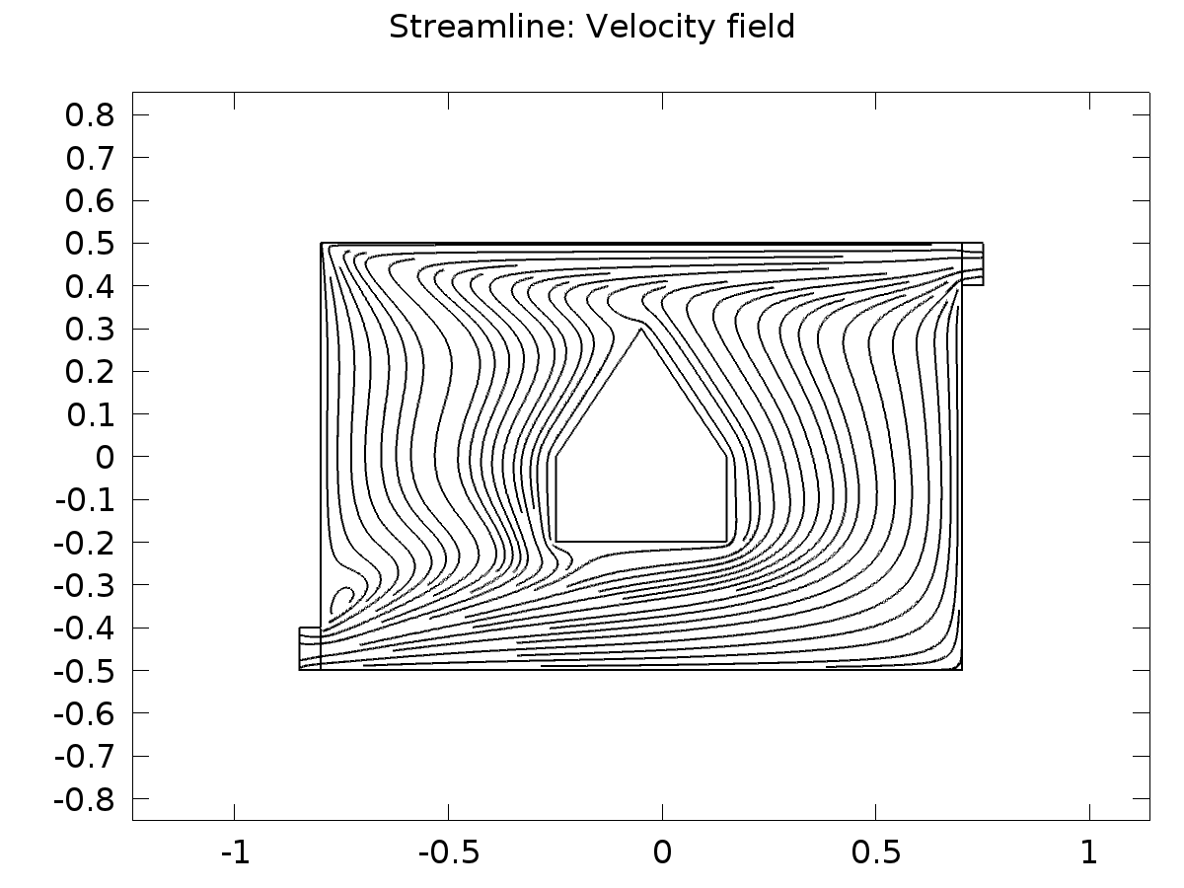 | 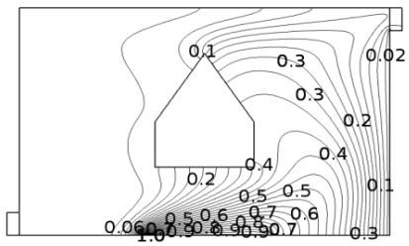
Re=100 | 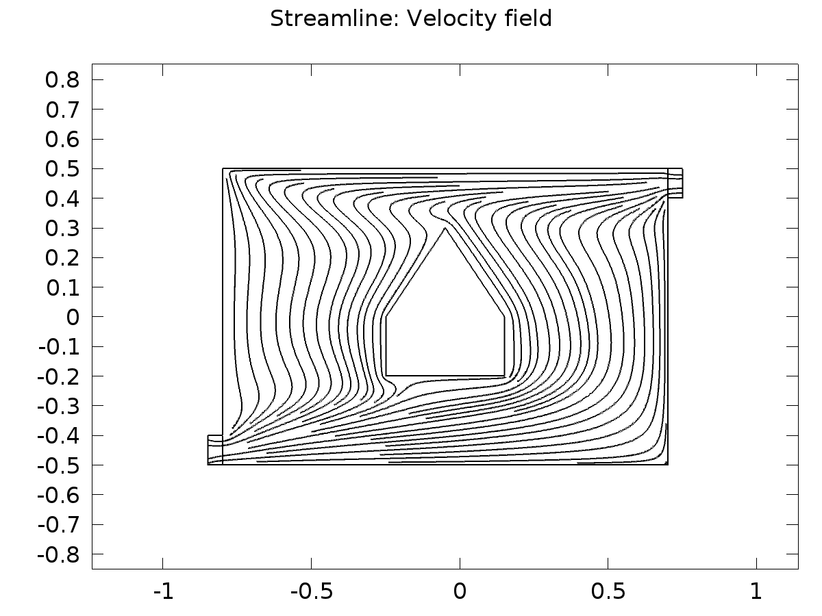 | 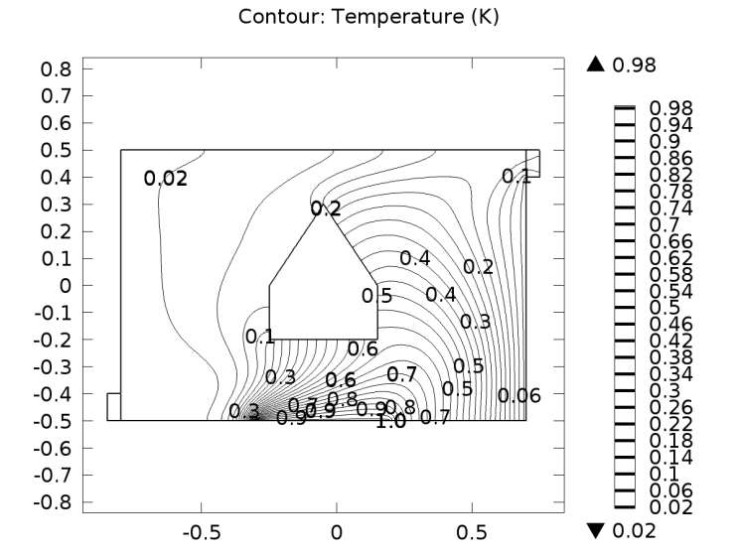
Re=50 | 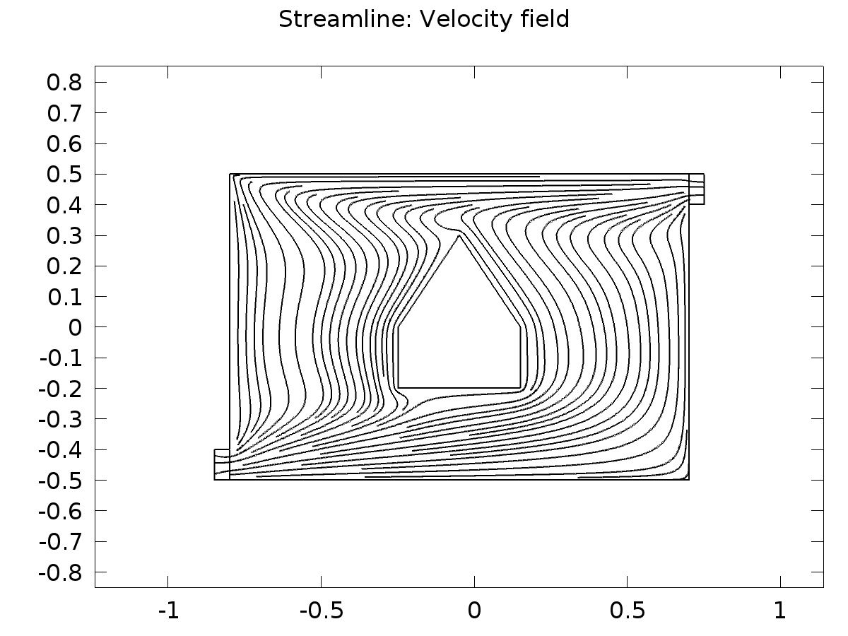 | 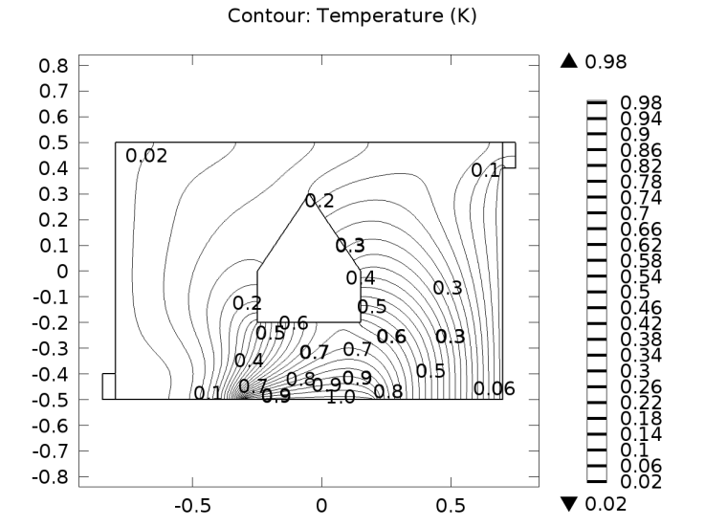
 | (a) Streamlines | (b) Isotherms

Fig. 4 - (a) Streamlines and (b) Isotherms for different values of Re at Pr=0.71, Ha=50, Ri=10

Pr=7.1 |  | 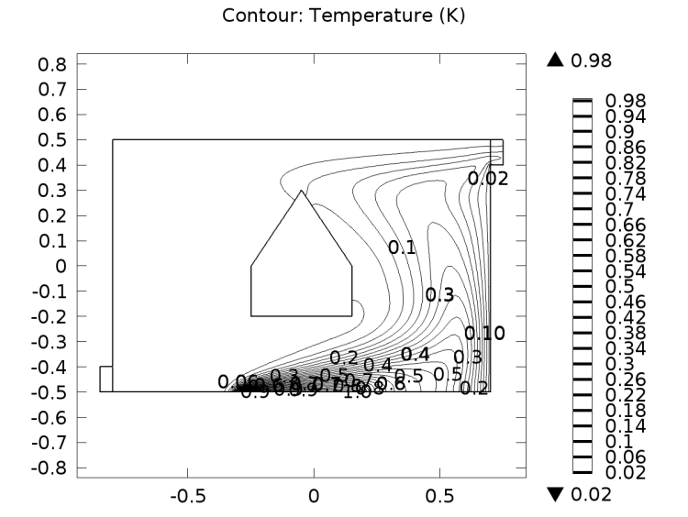
Pr=3 |  | 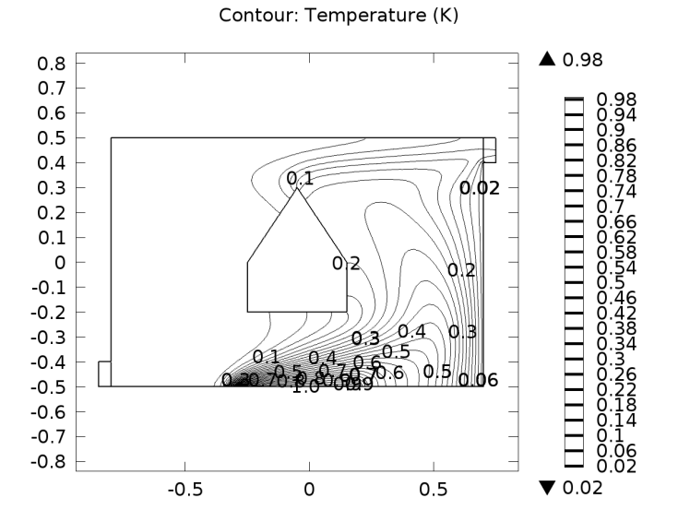
Pr=1 |  | 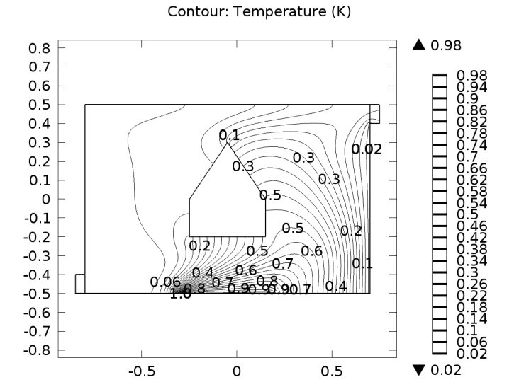
Pr=0.71 |  | 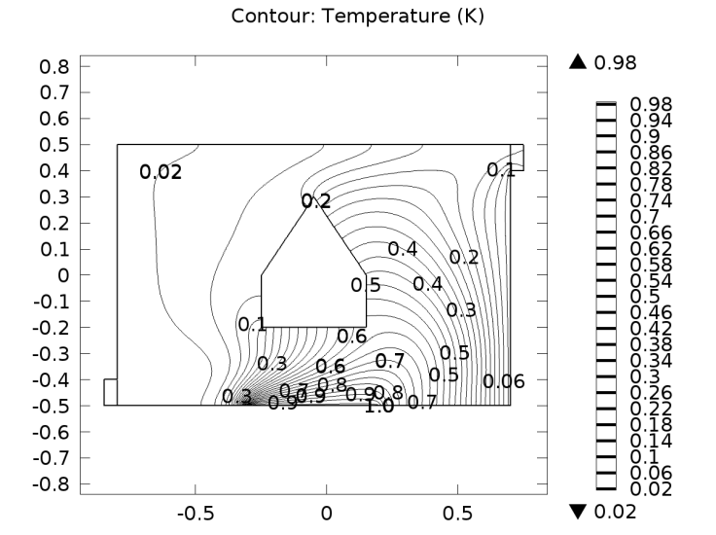
 | (a) Streamlines | (b) Isotherms

Fig. 5 (a) Streamlines and (b) Isotherms for different values of Pr at Re=100, Ha=50, Ri=10

Pr = 0.71 and 1. In addition, for the rest two higher values (Pr = 3, 7.1) heat lines compressed to the heated lower surface and also to right wall of the enclosure. Noteworthy change is seen in the case of largest value of Pr; the bottom surface of solid block disconnected from the cavity lower side through heat lines and a thick thermal boundary layer is developed in the near side of central heated bottom wall of the enclosure.

Lastly, Average Nusselt number at heated portion of the lower surface for considered different values of Reynolds and Prandtl numbers versus magnetic force parameter Ha are exhibited in Fig. 6. It is clearly visible that for both rising values of Re and Pr along with Ha, heat transfer increases. Also heat transfer enhancement is shown in Table 2 and found higher heat removal for higher values of both Re and Pr.

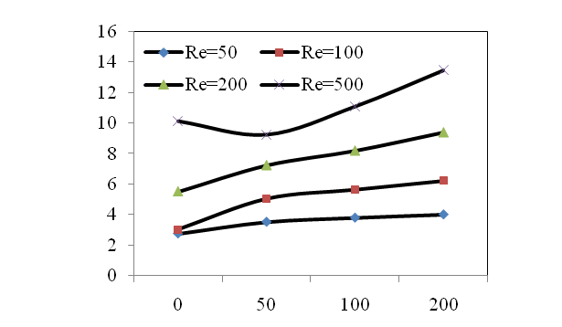
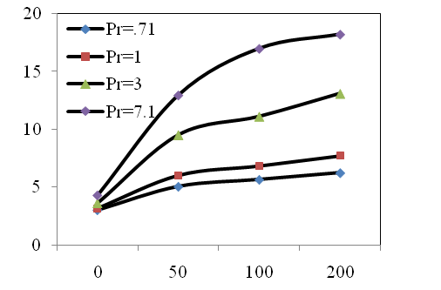
Fig. 6 - Average Nusselt number versus Hartman number for different values of (a) Reynolds number; (b) Prandtl number

Table 2- Variation of average Nusselt number at heated middle part of bottom surface for different values of Re and Pr while, Ha = 50 and Ri = 1

Re | Nu_{av} | Pr | Nu_{av}
50 | 3.5356 | 0.50 | 6.2072
100 | 5.0672 | 0.71 | 7.2445
150 | 6.3116 | 1.0 | 8.2936
200 | 7.2445 | 2.0 | 10.643
250 | 7.9448 | 3.0 | 12.249
300 | 8.4672 | 4.0 | 13.523
350 | 8.8421 | 5.0 | 14.597
400 | 9.0890 | 6.0 | 15.535
450 | 9.2243 | 7.0 | 16.375
500 | 9.2653 | 7.1 | 16.454

- Conclusions
This paper has reported numerical outcome of Reynolds and Prandtl number’s role for laminar, incompressible, two- dimensional, stable mixed convection problem over a rectangular enclosure with exhaust having a thermally insulated prism shaped body. Based on the computed results, the following findings can be drawn to make a summary as:
- Heat transfer generally increases with greater Reynolds and Prandtl numbers gradually at smaller values, while pick values show obvious quick expansion.
- More cooling efficiency is recorded for upper values of Prandtl number along with Hartman number Ha.
- Average Nusselt number’s variation is observed in same sequence for the considered two pertinent parameters.

Declarations:

- Availability of data and materials: Not applicable.
- Competing interests: No competing interests.
References
- Saieed, A. N. A., Mustafa, M. A. S., Ayed, S. K., & Habeeb, L. J. (2020). Review on heat transfer enhancement in cavity with lid driven. Journal of Mechanical Engineering Research and Developments, 43(7), 356-373. https://jmerd.net/Paper/Vol.43,No.7(2020)/356-373.pdf
- Sereir, T., Missioum, A., Mebarki, B., Elmir, M., & Mohammed, D. (2020). Optimal conditions of natural and mixed convection in a vented rectangular cavity with a sinusoidal heated wall inside with a heated solid block. Wseas Transactions on Heat and Mass Transfer, 15, 195-208. https://doi.org/10.37394/232012.2020.15.23
- Abraham, J., & Varghese, J. (2015). Mixed convection in a differentially heated square cavity with moving lids. International Journal of Engineering Research & Technology (IJERT), 4(12), 602-607.
- Pinto, R. J., Guimarães, P. M., & Menon, G. J. (2016). Numerical study of natural convection in square cavity with inner bodies using finite element method. Open Journal of Fluid Dynamics, 6, 75-87. https://doi.org/10.4236/ojfd.2016.62007
- Elsherbiny, S. M., & Ismail, O. I. (2015). Heat transfer in inclined air rectangular cavities with two localized heat sources. Alexandria Engineering Journal. https://doi.org/10.1016/j.aej.2015.07.013
- Guo, G., & Sharif, M. A. R. (2004). Mixed convection in rectangular cavities at various aspect ratios with moving isothermal sidewalls and constant flux heat source on the bottom wall. International Journal of Thermal Sciences, 43, 465–475. https://doi.org/10.1016/j.ijthermalsci.2003.08.008
- Ghanam, S., Siba, M., & Jehhef, K. A. (2020). Mixed convection enhancement in a rectangular cavity by triangular obstacle. IOP Conference Series: Materials Science and Engineering, 881(1), 012083. https://doi.org/10.1088/1757-899X/881/1/012083
- Ibrahim, W., & Hirpho, M. (2021). Finite element analysis of mixed convection flow in a trapezoidal cavity with non-uniform temperature. Heliyon https://doi.org/10.1016/j.heliyon.2021.e05933
- Zheng, J., Zhang, L., Yu, H., Wang, Y., & Zhao, T. (2021). Study on natural convection heat transfer in a closed cavity with hot and cold tubes. Science Progress, 104(2), 1–25. https://doi.org/10.1177/00368504211020965
- Akter, A., & Parvin, S. (2018). Analysis of Natural Convection Flow in a Trapezoidal Cavity Containing a Rectangular Heated Body in Presence of External Oriented Magnetic Field. Journal of Scientific Research, 10(1), 11-23. https://doi.org/10.3329/jsr.v10i1.33848
- Shuja, S. Z., Yilbas, B. S., & Iqbal, M. O. (2000). Mixed convection in a square cavity due to heat generating rectangular body: Effect of cavity exit port locations. International Journal of Numerical Methods for Heat & Fluid Flow, 10(8), 824-841. https://doi.org/10.1108/09615530010359120
- Papanicolaou, E., & Jaluria, Y. (1990). Mixed convection from an isolated heat source in a rectangular enclosure. Numerical Heat Transfer, Part A: Applications, 18, 427-461. https://doi.org/10.1080/10407789008944802
- Raji, A., & Hasnaoui, M. (1998). Mixed convection heat transfer in a rectangular cavity ventilated and heated from the side. Numerical Heat Transfer, Part A: Applications, 33, 533-548. https://doi.org/10.1080/10407789808913953
- Mamun, M. A. H., Tanim, T. R., Rahman, M. M., Saidur, R., & Nagata, S. (2010). Mixed convection analysis in trapezoidal cavity with a moving lid. International Journal of Mechanical and Materials Engineering, 5(1), 18-28.
- Reddy, J. N. (1993). An introduction to the finite element method. McGraw-Hill.
- Rahman, M. M., Elias, M., & Alim, M. A. (2009). Mixed convection flow in a rectangular ventilated cavity with a heat conducting square cylinder at the center. J. of Engineering and Applied Sciences, 4(5), 20-29.
- Sharif, U. M., Rahman, M. M., Saklayen, M. A. , Billah, M. M. , & Elias, M. M. (2012). A numerical study of assisting mhd mixed convection inside a ventilated cavity. Engineering e-Transaction, 7(1), 6-13.
- Sharif, M. A. R., & Mohammad, T. R. (2005). Natural convection in cavities with constant flux heating at the bottom wall and isothermal cooling from the sidewalls. International Journal of Thermal Sciences, 44, 865-878. https://doi.org/10.1016/j.ijthermalsci.2005.02.006
- Roy, S., & Basak, T. (2005). Finite element analysis of natural convection flows in a square cavity with non-uniformly heated wall(s). International Journal of Engineering Science. https://doi.org/10.1016/j.ijengsci.2005.01.002
- Striba, Y. (2008). Analysis of the flow and heat transfer characteristics for assisting incompressible laminar flow past an open cavity. International Communications in Heat and Mass Transfer, 35, 901-907. https://doi.org/10.1016/j.icheatmasstransfer.2008.04.004

