Original Research Article
Phenolic composition and effects on breast development of seed extracts from two lactogenic plants from northern Ivory Coast: Cyperus esculentus L. and Setaria italica P. Beauv

ABSTRACT
Context: Breast milk, which plays a vital role in preventing childhood illnesses, is experiencing a decline in production among many women.
Objective: Objective of this work is to optimize breast milk production through the use of local food plants, namely: Cyperus esculentus And Setaria italica .
Methods: Phenolic compounds were quantified in aqueous and 70% hydro-ethanolic extracts of seeds of each plant using spectrophotometry. The effects of these extracts on mammary development were then evaluated using four batch of adult Wistar rats : two groups treated orally with a mixture of aqueous extracts and a mixture of hydro-ethanolic extracts of the two plants at 200 mg/ mL respectively , one batch treated with a standard lactogen ( Serenatal A), and a control group that remained untreated for one week.
Results: The assay of phenolic compounds in extracts revealed total polyphenol levels ranging from 9.17 ± 0.12 to 22.07 ± 0.97 mg GAE/g dry extract, while those of total flavonoids and tannins ranged from 1.22 ± 0.03 to 5.41 ± 0.02 mg QE/g dry extract and from 2.70 ± 0.14 to 6.27 ± 0.02 mg EAT/g dry extract, respectively. Observation of mammary glands showed more apparent and hypertrophied teats in animals treated with plant extracts in a similar way to those treated with Serenatal A compared to untreated rats.
Conclusion: This highlights the lactogenic effect of seeds of both plant species, justifying their traditional use.
Keywords: Breast development, phenolic compounds, C. esculentus, S. italica

1. INTRODUCTION
Breastfeeding plays a crucial role in the health and well-being of infants, providing essential nutrients and strengthening immune system. It is a complete, balanced, and economically accessible food that meets the infant's physiological needs (Richard et al., 2016). Therefore, according to WHO (2022), exclusive breastfeeding is strongly recommended for the first six months of an infant's life. Globally, a gradual decline in breastfeeding practices has been observed over the past few decades, with a rate of 48% (WHO, 2023). In West Africa, for example, only 20% of infants are exclusively breastfed (UNICEF, 2023).
In Côte d'Ivoire, the breastfeeding rate remains low at 12% ( Adépo et al ., 2017) . This low rate can be explained, on the one hand, by socio-professional constraints faced by breastfeeding mothers, especially in urban areas. On other hand, there is the deficit in breast milk production by breastfeeding women, which constitutes the main problem ( Youassao et al ., 2013). Direct consequence of this situation is the development of malnutrition, which increases child's vulnerability to disease and compromises their overall development (UNICEF, 2023). In this context, to boost breast milk production, women often resort to medical treatments and paramedical (Zizzo et al., 2021). However, although these treatments are effective, they have limitations such as potential side effects and the high cost of some treatments in the medium and long term (McBride et al., 2021 ; Balkam, 2022). Therefore, the immediate alternative available to women is the use of recipes based on food plants from local pharmacopoeia to stimulate milk production (Akouedegni et al., 2013; Hama Garba et al., 2023). Indeed, several studies have shown that plant extracts increase milk production (Youssao et al., 2013). This is the case for seeds or tubers of Cyperus esculentus (Cyperaceae) and Setaria italica (Poaceae), two herbaceous plants cultivated in northern Ivory Coast and in various tropical and subtropical regions (Kadjo et al., 2025). Several studies have already reported traditional consumption of the seeds of these plants to increase breast milk production in women (Thakur et al., 2023). This study therefore aims to optimize breast milk production through the use of edible plants from the local pharmacopoeia.
2. MATERIALS AND METHODS
2.1. Plant material
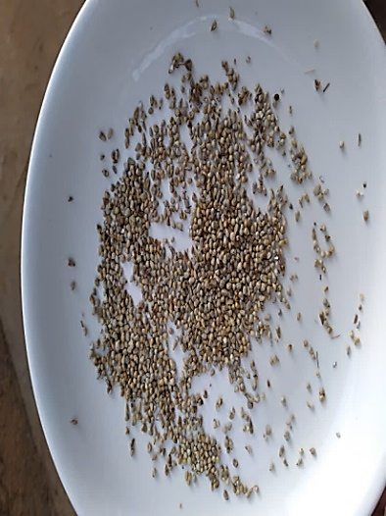
Plant material consisted of seeds from C. esculentus and S. italica (Fig 1) purchased at the main market in the city of Korhogo (Ivory Coast) in April 2024. They were authenticated at plant biology department of the Peleforo Gon Coulibaly University of Korhogo.
After purchase, the seeds were air-dried, protected from light and heat, at room temperature (22 ± 2°C) for 2 months. For each species, the dried seeds were ground using a Moulinex-type mechanical grinder to obtain a fine powder, which was used to prepare the various extracts.
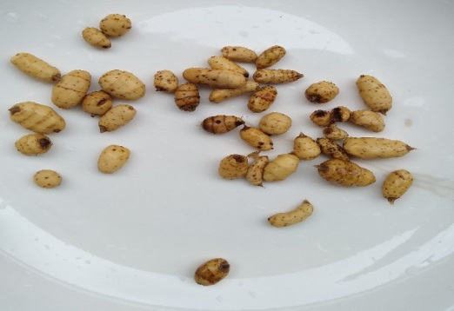

B
A
Fig 1: Seeds of the tested plants
A : S. italica seeds; B : C. esculentus seeds

2.2. Animal material
The mammary development tests of the extracts were conducted on 24 unbred, 14-week-old female Wistar rats with an average weight of 135 ± 77 g. These rats were isolated from stress and insomnia, and their hygiene and feeding conditions were optimized (Adépo et al., 2017).
2.3. Preparation of seed extracts
Two types of extraction (aqueous and hydro-ethanolic) were performed on each powder by maceration. Specifically, 100 g of each powder Seeds were macerated in 1 L of distilled water and 70% ethanol under magnetic stirring for 24 hours. After homogenization of each solution, the resulting mixture was first squeezed through a square of white cloth, then filtered twice through absorbent cotton and once through Whatman filter paper (3 mm). Finally, filtrates were concentrated in an oven at 50 °C until complete evaporation of solvent to obtain the aqueous and 70% hydro-ethanolic dry extracts of the seeds of the two plants (Zirihi et al., 2003).
2.4. Determination of phenolic constituents in seed extracts
2.4.1. Total polyphenols
Total polyphenol content in each seed extract was determined according to method described by Kouamé et al (2021). To 30 μL of extract, 2.5 mL of a 1/10 dilution of Folin-Ciocalteu reagent was added . The resulting mixture was incubated in dark at room temperature for 2 min. Then, 2 mL of a sodium carbonate solution (75 g/L) was added to this mixture. Finally, the resulting solution was incubated at 50 °C for 15 min. After incubation, the absorbance was measured spectrophotometrically at 760 nm against a blank. Gallic acid was used as the reference standard for quantifying the content, expressed in milligrams of gallic acid equivalent per gram of dry extract (mg GAE/g dry extract).
2.4.2. Total flavonoids
Total flavonoid content of the extracts was determined according to method described by Yakupova and Ziyatdinova (2023). Indeed, 0.75 mL of 5% sodium nitrite solution and 0.75 mL of 10% aluminum chloride solution were added to 2.5 mL of a 1/500 (w/v) extract solution. After 5 min of incubation, the mixture was contacted with 5 mL of 1 M sodium hydroxide solution. Resulting volume was adjusted to 25 mL and then vigorously stirred. Absorbance was measured spectrophotometrically at 510 nm against a blank. Quercetin was used as the reference standard for quantifying the contents, expressed as milligrams of quercetin equivalent per gram of extract (mg QE/g extract).
2.4.3. Condensed tannins
Tannin content was determined according to method described by Kouamé et al (2021) To this end, 50 mL of each seed extract was added to 1.5 mL of a 4% vanillin solution in methanol. Resulting mixture was vigorously stirred, and 750 µL of concentrated hydrochloric acid was added. Mixture was left to stand at room temperature for 20 min, and the absorbance was measured spectrophotometrically at 550 nm against a blank. A stock solution of tannic acid was used as a reference standard for quantifying the contents, expressed as milligram equivalents of tannic acid per gram of extract (mg EAT/g extract).
2.5. Evaluation of effects of extracts on mammary development in rats
Evaluation of effects of the extracts on mammary development in rats was carried out according to method described by Adepo et al (2017) with some modifications. Rats were randomized into 4 batch of 6 rats. These rats received the following treatments while fasting:
- batch 1: 5 mL of a mixture of aqueous extracts (200 mg/ mL ), consisting of 50% C. esculentus and 50 % S. italica
- batch 2: 5 mL of a mixture of hydro-ethanolic extracts (200 mg/ mL), consisting of 50 % C. esculentus and 50 % S. italica
- batch 3: 5 mL of Serenatal A at the usual dose of 80 mg/ mL Serenatal A is a food supplement that helps improve breastfeeding and strengthen the baby's growth, available in pharmacies.
- batch 4: (Control): 5 mL of distilled water.
Different treatments lasted 7 days and were administered orally using a feeding syringe. At the end of treatments, the morphology of mammary areola and nipples of each rat was observed and described.
2.6. Statistical analysis of data
Statistical analysis of the results and graphs were generated using Word and Excel 2016. Analysis of variance was performed using multiple ANOVA. Difference between means was determined using Duncan's test at a significance level of 5%. All trials were conducted in triplicate for each sample, and results are expressed as means ± standard error of the mean (SEM).
3. RESULTS
3.1. Phenolic compound content of extracts
3.1.1. Total polyphenols
Calibration curve of gallic acid (y = 0.6484x - 0.0025; R² ⁼ 0.995) allowed us to determine the total polyphenol content (Fig 2). It appears that the highest total polyphenol content was obtained with the aqueous extract of C. esculentus seeds ( 22.07 ± 0.97 mg GAE/g extract ) followed by aqueous extracts of S. italica (13.7 ± 0.18 mg GAE/g) and hydroethanolic extract (13.66 ± 2.23 mg GAE/g extract) of S. italica . Finally, hydroethanolic extract of C. esculentus had lowest content (9.17 ± 0.12 mg GAE/g).

Fig 2: Total polyphenol content of seed extracts

AqCE : Total aqueous extract of C. esculentus seeds ; HeCE : Hydro-ethanolic extract of C. esculentus seeds ; AqSI : Total aqueous extract of S. italica seeds ; HeSI : Hydro-ethanolic extract of S. italica seeds . Histograms with different letters are statistically different. (p > 0.05).
3.1.2. Total flavonoids
From quercetin calibration curve (y = 0.6455x - 0.0075; R2 ⁼ 0.9983), total flavonoid contents were determined and presented in Fig 3. Analysis of the results revealed that the aqueous extract of C. esculentus had the highest content (5.41 ± 0.02 mg QE/g of extract), followed by the hydro-ethanolic (3.03 ± 0.11 mg QE/g of extract) and aqueous (2.29 ± 0.01 mg QE/g of extract) extracts of S. italica , and finally hydro-ethanolic (1.22 ± 0.03 mg QE/g of extract) extract of C. esculentus . Statistical analysis showed that there is a significant difference between total flavonoid content of all these extracts (P < 0.05).
3.1.3. Condensed tannins
The tannin contents, determined from the curve established with different concentrations of tannic acid (y = 0.0004x + 0.062; R2 ⁼ 0.9933) are shown in Fig 4. These results show that the tannin content in the aqueous extracts of both seeds was higher than that in the hydro-ethanolic extracts, with a significant difference between the two (P < 0.05). Specifically, the content in the aqueous extracts was 6.27 ± 0.02 mg EAT/g and 4.46 ± 0.07 mg EAT/g for the seeds of C. exulentus and S. italica , respectively . As for the hydro-ethanolic extracts of the two seeds, the content was 2.70 ± 0.14 mg EAT/g for C. italica . esculentus and 2.80 ±0.03 mg EAT/g of S. italica extract .

Fig 3: Total flavonoid content of seed extracts

AqCE : Total aqueous extract of C. esculentus seeds ; HeCE : Hydro-ethanolic extract of C. esculentus seeds ; AqSI : Total aqueous extract of S. italica seeds ; HeSI : Hydro-ethanolic extract of seeds of S. italica . Histograms with different letters are statistically different. (p > 0.05).

Fig 4: Total flavonoid content of seed extracts

AqCE : Total aqueous extract of C. esculentus seeds ; HeCE : Hydro-ethanolic extract of C. esculentus seeds ; AqSI : Total aqueous extract of S. italica seeds ; HeSI : Hydro-ethanolic extract of S. italica seeds . Histograms with different letters are statistically different. (p > 0.05).

3.2. Effects of the extracts on mammary development in rats
Fig 5 shows observations of the ventral surface of treated and untreated rats. After 7 days of treatment, rats treated with the combined (50:50) extracts of C. esculentus and S. italica seeds showed a change in mammary morphology, compared to untreated control animals where no changes were observed. Indeed, the mammary glands of rats in batch 1 treated with aqueous extracts of C. esculentus and S. italica seeds and batch 4, rats treated with the reference product (Serenatal A) exhibited more hypertrophied and localized breast enlargement in the abdominal region. Their nipples were also much more prominent with stronger pigmentation. These changes were also observed in animals from batch 3 treated with hydro-ethanolic extracts, but to a lesser extent.

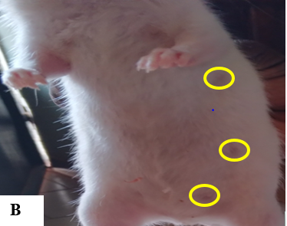
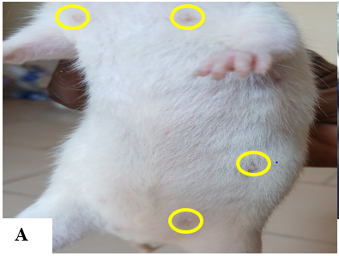

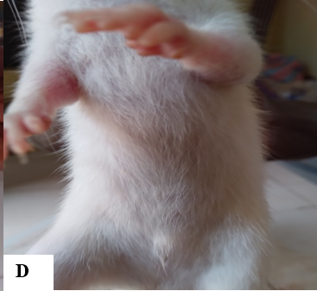
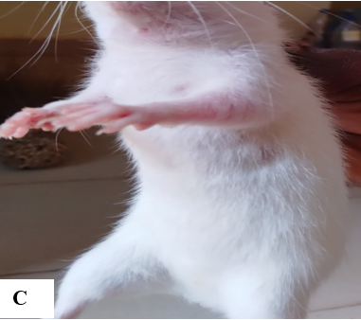

Fig 5: Effects of extracts on mammary development in rats

A: Ratte from batch 1, treated with aqueous extracts of C. esculentus and S. italica ; B: Rat from batch 3, treated with Serenatal A (standard ); C: Rat from batch 2, treated with hydroethanolic extracts of C. esculentus and S. italica D : Ratte from lot 1 control, untreated

4. DISCUSSION
Maceration was the extraction technique used to obtain extracts in this study. This technique accelerates the extraction process and minimizes contact time between the water and extract while preserving the bioactivity of phenolic compounds (Kamarudin et al., 2016). Phenolic compounds (total polyphenols, total flavonoids, and tannins) of different extracts from the seeds of C. esculentus and S. italica were analyzed, and results showed that aqueous and 70% hydro-ethanolic extracts of seeds of both plant species are rich in phenolic compounds. Indeed, total polyphenol content ranged from 9.17 ± 0.12 to 22.07 ± 0.97 mg GAE/g of dry extract, while the condensed flavonoid and tannin content ranged from 1.22 ± 0.03 to 5.41 ± 0.02 mg QE/g of dry extract and from 2.70 ± 0.14 to 6.27 ± 0.02 mg QE/g of dry extract, respectively. These results concerning the phenolic composition of studied seeds are consistent with those obtained by several researchers. Indeed, Alloka-Kouamé et al (2022) recorded similar levels of total polyphenols, flavonoids and tannins in whole tubers and defatted flour of C. esculentus with respective values of 3.7 mg GAE/g- 4.57 mg GAE/g and 5.997- 14.5 mg GAE/g and 3.03 mg AC/g. Similarly, levels around 1 mg GAE/g, 0.6 mg QE/g and 0.7 mg AT/g were reported by Kumar et al (2022) respectively for total polyphenols, flavonoids and condensed tannins of S. italica seeds . Based on these results, it appears that aqueous extracts were richer in phenolic compounds than the hydro-ethanolic extracts. This could be explained by fact that the solubility of phenolic compounds is affected by the polarity of the solvent used for their extraction. According to Kakesse et al (2022), total polyphenols are more soluble in water than in organic solvents. This would justify the fact that water is a polar solvent that can extract many more chemical compounds (Piba et al., 2021).
Results of tests on rats showed that those treated with a mixture of aqueous extracts of C. esculentus and S. italica exhibited significantly larger mammary glands with simultaneous appearance of a super-pigmentation of teats similar to that of rats treated with the standard lactogenic product ( serenatal A). These morphological changes could be due to the chemical composition of seeds of plants studied. Indeed, analysis of phytochemical compounds in the seed extracts in this study revealed presence of phenolic compounds such as flavonoids and tannins. These phytomolecules would confer lactogenic effects to the tested extracts by serving as a basic matrix for phytohormones, according to Adepo et al (2017). Due to their estrogenic properties, they would act on lactation by increasing prolactin secretion in rats. These substances would then be able to stimulate prolactin biosynthesis in rats and, consequently, induce mammary development (Ekman et al., 2015). The results obtained are consistent with those of Adepo et al (2017) who showed that aqueous extracts of Euphorbia hirta L. and Secamone afzelii exhibited significant lactogenic effects through mammary development in rats. Furthermore, several studies have reported that the seeds of C. esculentus and of S. italica were rich in carbohydrates, proteins, lipids, fiber, trace elements and vitamins (C, B1, B6), sterols, etc., all essential for breast milk production (N'Diaye et al., 2018; Srilekha et al., 2019). Regular consumption of these types of seeds by breastfeeding mothers could increase the quality and quantity of breast milk (Thakur et al., 2023).
5. CONCLUSION
In this study, the phenolic composition of aqueous and hydro-ethanolic extracts of C. esculentus and S. italica seeds was determined, and their effects on mammary development in female rats were evaluated . The results showed that these extracts induced mammary development and pigmentation in unmated female rats. These changes could be linked to their high total polyphenol content, particularly flavonoids and condensed tannins. This suggests that these extracts may possess lactogenic properties, justifying their traditional use in treating agalactia . Future work will focus on evaluating the effects of extracts on production of prolactin, the lactation hormone.
ETHICAL APPROVAL
Female rats used for the mammary development tests were bred and treated in accordance with guidelines of official ethics and animal experimentation oversight committee of Ivory Coast.
DISCLAIMER (ARTIFICIAL INTELLIGENCE)
Author (s) hereby declared that NO generative AI technologies such as Large Language Models ( ChatGPT , COPILOT, etc.) and text -to-image generators have been used during the writing or editing of this manuscript .

COMPETING INTERESTS
Authors have declared that no competition interests exist .

REFERENCES

Adepo, Y.P., Bolou, G.E.K., et Akoa, E.E.F. (2017). Effect on breast development and phytochemical analysis of two lactogenic plants from the traditional Ivorian pharmacopoeia: Euphorbia hirta L. and Secamone afzelii ( Roem . & Schult .). Int. J. Biol. Chem. Sci., 11,1872-1877. https://doi.org/10.4314/ijbcs.v11i4.35
Akouedegni, C. G., Tossa, I. G., Daga, F. D., Koudandé, D. O., et Hounzangbé-Adoté, M. S. (2012). Synthèse des connaissances sur les plantes galactogènes et leurs usages en République du Bénin. Bull. Rech. Agron. Bénin., 24-35.
Alloka-Kouamé , G.A., Diané , F., Bagui-Broune , M., Kouassi , N.C., Mamyrbekovia-Békro , J.A., et Békro, Y.A. (2022). Phytochemical and nutritional composition of tubers whole grains of C.esculentus and flour degreased. Am. J. Pharm Tech Res., 12(2): 1-15.
Balkam, J. J. (2022). Galactagogues and lactation: Considerations for counseling breastfeeding mothers. MCN Am. J. Matern. Child Nurs., 47(3), 130–137. https://doi.org/10.1097/NMC.0000000000000810
Ekman , B., Wahlberg , J et Landberg , E. (2015) . Urine oligosaccharide pattern in patients with hyperprolactinaemia . Glycoconj. J., 32 (8), 635-641. https://doi.org/10.1007/s10719-015-9610-x
Hama Garba, R., Idrissa, M., Sadou, H., Sahabi, B., Idi Issa, A. M., Amadou Arouna, N., et Bazanfare, M. N. (2023). Plantes médicinales et soins du couple mère-enfant au Niger : formulation du Djitti pour nourrisson et des recettes galactogènes pour mères allaitantes. Psy Cause, (84), 23–39. https://doi.org/10.3917/psca.084.0023
Kadjo, M. L. M. R., Koko, K. B., Yéboué, K. H., Anin-Atchibri, L. A et Ahui-Bitty, M. L. (2025). Galactogenic effect of milk powder from nutsedge tubers (Cyperus esculentus) in lactating rats. World J. Adv. Res. Rev., 27(2), 1215–1225. https://doi.org/10.30574/wjarr.2025.27.2.2886
Kakesse, M., Wangso, H., Oksom, J.B.S., Bakaranga , V.I., Nadjioroum , N.A., et Otchom ,B.B. (2022) . Phytochemical evaluation, in vitro antioxidant and anti-inflammatory potential of Commelina leaf extracts benghalensis Linn. ( Commelinaceae ). Int. J. Biol. Chem. Sci., 16 (6), 2673-268.
Kamarudin , N.A., Markom , M., et Latip , J. (2016) . Effects of Solvents and Extraction Methods on Herbal Plants Phyllanthus niruri , Orthosiphon stamineus and Labisia pumila ., Indian J. Sci. Technol, 9 (21), 1-5. https://doi.org/10.17485/ijst/2016/v9i21/95235
Kouamé, T.K., Siaka, S., Kassi, A.B.B., et Soro,Y. (2021) . Determination of total polyphenol, total flavonoid and tannin content of young, unopened leaves of Piliostigma thonningii ( Caesalpiniaceae ). Int. J. Biol . Chem . Sci ., 15(1): 97-105. https://doi.org/10.4314/ijbcs.v15i1.9
Kumar, R. R., Singh, N., Singh, S., Vinutha, T., Krishnan, V., Goswami, S., Kumar, B., Jat, S. L., Yogeesh, L. N., Singh, S. P., Mishra, G. P., Satyavathi, C. T., Sachdev, A., et Praveen, S. (2022). Nutritional supremacy of pearl- and foxtail millets: Assessing the nutrient density, protein stability and shelf-life of flours in millets and cereals for developing nutri-stable foods. J. Plant Biochem. Biotechnol., 31(4), 837–852. https://doi.org/10.1007/s13562-021-00761-2
McBride, G. M., Stevenson, R., Zizzo, G., Rumbold, A. R., Amir, L. H., et Keir, A. K. (2021). Use and experiences of galactagogues while breastfeeding among Australian women. Plos one, 16(7), 1-15. https://doi.org/10.1371/journal.pone.0254049
N'Diaye , B., Ayessou , N.C., Cissé , I.K.O., Baldé, S., Cissé , M., Diop , C.M et Sakho , M. (2018). Potentials Technological evaluation by biochemical evaluation of tuber flour of tiger nut (C. esculentus L.). African Science, 14 (2): 209-214. http://www.afriquescience.info/numeros/volume14/N2/209-214.pdf
Piba , S.C., Konan, P.A.K., Kone , L.N., Kouame, A.G., Kouakou, R.K.D., et Tra , H.F.B. (2021) . Phytochemistry , antioxidant activity and acute toxicity of medicinal plants used against the sequelae of stroke in Côte d'Ivoire. Int. J. Biol. Chem. Sci., 15 (2), 652-663. https://doi.org/10.4314/ijbcs.v15i2.2
Richard, C., Lewis, E.D., et Field, C.J. (2016). Evidence for the essentiality of arachidonic and docosahexaenoic acid in the postnatal maternal and infant diet for the development of the infant's immune system early in life. Appl . Physiol . Nutr . Metab., 41(5), 461-75. https://doi.org/10.1139/apnm-2015-0660
Srilekha, K., Uma Maheswari, K., Kamalaja, T et Neela Rani, R. (2019). Evaluation of physical, functional and nutritional quality parameters of kodo millet flour. J. Pharmacogn. Phytochem., 8(4), 192–195. https://www.phytojournal.com/archives/2019/vol8issue4/PartC/8-4-10-600.pdf
Thakur, M., Khedkar, R., Singh, K., et Sharma, V. (2023). Ethnopharmacology of botanical galactagogues and comprehensive analysis of gaps between traditional and scientific evidence. Curr. Res. Nutr. Food Sci. J., 11(2), 589–604. https://doi.org/10.12944/CRNFSJ.11.2.11
UNICEF. (2023). Global breastfeeding scorecard increase around the world through improved protection and support, 14p. https://iris.who.int/handle/10665/375796
WHO. (2022). Global Strategy for Breastfeeding of Infants and Young Children, 30p. https://www.who.int/publications/i/item/9241562218
WHO. (2023). Global breastfeeding scorecard: rates of breastfeeding increase around the world through improved protection and support, 40p. https://iris.who.int/handle/10665/375796
Yakupova, E.N., et Ziyatdinova, G. K. (2023). Modern methods and current trends in the analytical chemistry of flavanones. J. Anal. Chem., 78(4), 403–425. https://doi.org/10.31857/S0044450223040163
Youssao , A.K.I., Dahouda , M., Attakpa , E.Y., Koutinhouin , G.B., Ahounou, G.S., Toleba , S.S., et Balogoun, B.S. (2013). Diversity of Borgou cattle farming systems in the Sudanian zone of Benin. Int. J. Biol. Chem. Sci., 7 (1), 125-146. https://doi.org/10.4314/ijbcs.v7i1i.11
Youssao , A.K.I., Dahouda , M., Attakpa , E.Y., Koutinhouin , G.B., Ahounou, G.S., Toleba , S.S., et Balogoun, B.S. (2013). Diversity of Borgou cattle farming systems in the Sudanian zone of Benin. Int. J. Biol. Chem. Sci., 7 (1), 125-146. https://doi.org/10.4314/ijbcs.v7i1i.11
Zirihi, N. G., Kra, A. K. M., et Guédé-Guina, F. (2003). Evaluation of the antifungal activity of extracts of Terminalia catappa, Manilkara zapota, Morinda morindoides and their mixture (MISCA) used in Côte d’Ivoire in traditional medicine. African Journal of Traditional, Evid. Based Complement. Altern. Med., 2(2), 31–39.
Zizzo, G., Rumbold, A.R., et Grzeskowiak, L. E. (2021). Fear of stopping” vs “wanting to get off the medication”: Exploring women’s experiences of using domperidone as a galactagogue – a qualitative study. Int. Breastfeed. J., 16(1), 1–12. https://doi.org/10.1186/s13006-021-00438-5

