Trait Interrelationships Governing Yield and Nut Quality in Walnut (Juglans regia L.)

ABSTRACT
Understanding relationships among various parameters of vegetative growth, flowering behaviour, yield and nut quality traits is important for improving selection efficiency in walnut. The present study evaluated the phenotypic correlations among different vegetative traits, flowering stages, yield and quality parameters in walnut genotypes. Yield showed low significance with vegetative traits such as bud break (r = −0.17), leaf length (r = 0.06) and leaflet length (r = 0.04). Several vegetative traits exhibited negative correlations with nut size parameters, including leaf length with nut diameter at suture (r = −0.54) and nut diameter at cheek (r = −0.52). Leaflet width showed a significant positive correlation with protein content (r = 0.44). Flowering traits showed significant positive correlation with kernel recovery percentage, particularly first male bloom (r = 0.45), peak male bloom (r = 0.46), last male bloom (r = 0.46) and first female bloom (r = 0.52). Flower number per inflorescence (r = 0.38) and flowering overlap (r = 0.44) showed positive but weak associations with yield. The results indicate that flowering behaviour is more closely associated with kernel recovery than vegetative growth traits in walnut.
Key words: Walnut, vegetative morphology, correlation analysis, flowering behaviour, kernel quality.
1. Introduction
Walnut (Juglans regia L.) is an important temperate nut crop with high economic and nutritional value, which is extensively cultivated for its kernels which are rich in oil, protein, and other nutrients. In addition to the nutritive value, walnut cultivation contributes significantly to the living standards of people in the temperate regions (Mukarram, et al., 2024). Despite its high importance walnut productivity as well as the quality varies extensively due to genetic diversity, environmental factors and cultural practices (Vahdati, et al., 2020; Devin and Bujdoso, 2022). Enhancement in the quality of the kernel and production is a prime objective of walnut breeding programme. Productivity is a complicated trait which is affected by a set of morphological, phenological and physiological attributes, making it less effective for direct selection (Manthos, et al., 2023; Einollahi, et al.,2024).
For walnuts grown in plantations, the kernel quality and yield potential can pay an even more role in terms of economic performance. Such traits are linked to growth habit, flowering and development of the walnuts (McGranahan & Leslie, 2012; Lone, et al., 2023).
The role of vegetative morphological parameters like bud break timing as well as parameters like leaf and leaflet size in regulating photosynthetic potential and allocation of assimilates is very fundamental (Solar and Stampar, 2011). In walnuts, reproductive effectiveness is highly dependent on flo9wering coordination based on dichogamy requirements to ensure synchronization between male and female flowering phases (Germain, 1997; Kumar et al., 2024). Understanding the interaction between vegetative parameters and yield parameters is essential for identifying the useful parameters in walnut improvement.
Correlation helps to identify the traits that are positively or negatively associated with yield or quality traits (Panahi et al., 2022). But correlation analysis does not elucidate the relationship between cause and effect, besides the fact that related traits can affect the yield indirectly. Although several studies have described the relationships between the traits related to the nut, kernel, and flower in the walnut species, there is a lack of information available about the relationship between the vegetative morphological traits related to the yield or quality parameters in temperate regions. Specifically, there is a lack of understanding about the relationship between the bud break, leaf, and leaflet traits related to the yield parameters or the kernel quality (Sovelli and Khadivi, 2023).
In the light of the above considerations, the present study was conducted to examine the relationship of bud break, leaf length, leaf width, leaflet length, leaflet width, and the number of leaflets with the parameters of yield, nut, kernel, flowering, and quality of walnut (Juglans regia L.). The findings of this study are expected to provide valuable information for identifying key traits for walnut improvement programme.
2. Materials and Methods
The experiment was carried out at the Walnut orchard in the Faculty of Agriculture, Wadura, SKUAST-K (at 1,610 MSL) in the 2023-2024 growth year. The experimental material comprised of twenty-one walnut (Juglans regia L.) genotypes evaluated under uniform orchard management practices. The trees selected for the study were healthy, of similar age, vigorous, and grown under recommended agronomic conditions. Vegetative morphological observations included the bud break, leaf length, leaf width, leaflet length, leaflet width, and number of leaflets.
Parameters related to yield and nut quality, like yield per tree, nut weight, length, diameter at the suture and cheek, shell thickness, kernel weight, kernel recovery, protein, and oil, were determined using standard analytical procedures (AOAC, 2000). The yield parameters included first, highest, and final male and female bloom, and the extent female flower overlap with the staminate bloom.
The correlation coefficients (r) were computed to estimate the extent and nature of association that existed between the vegetative morphological traits and the yield and quality related characters. The levels of statistical significance were tested at 5%, 1%, probability levels following the standard procedures of statistical analysis (Panse and Sukhatme, 1985). All the statistical analysis was conducted using the standard statistical software.
3. Results and discussion
The phenotypic correlation coefficients among the variables of vegetative, flowering, yields and quality parameters are given in Table 1. The majority of the variables under vegetation showed low to moderate correlation values with the variables related to yields as well as the physical parameters of the nut, though the phenology of flowering demonstrated relatively stronger association with the kernel recovery percentage. The time of bud break showed a low non-significant correlation with the given yields (r = −0.17) and most of the physical parameters for the nut. However, significant positive correlation values between the bud break phenology and the parameters: first male bloom(r = 0.54), peak male bloom (r = 0.50), last male bloom (r = 0.54), first female bloom (r = 0.55), peak female bloom (r = 0.44) as well as flowering overlap phenology (r = 0.44), measures were found, indicating the indirect contribution of the initial or synchronized bud break to the increase of the overlap duration between the male as well as female flowering, which is a vital component for the successful process of pollination of the walnut trees.
Leaf length was found to have a highly significant negative relationship with nut diameter at suture (correlation coefficient= −0.54) and nut diameter at cheek (correlation coefficient = −0.52). Whereas, was found to have a highly significant positive relationship with the first male bloom (correlation coefficient = 0.57), peak male bloom (correlation coefficient = 0.50), last male bloom (correlation coefficient = 0.54), first female bloom (correlation coefficient = 0.55), and peak female bloom (correlation coefficient = 0.44).
Leaf width was found to be highly significantly and negatively correlated with nut diameter at suture (-0.54) and nut diameter at cheek (-0.53) whereas, it was non-significantly correlated with other traits. Likewise, the values of leaflet length recorded positive correlations with first male bloom, which was (0.55), peak male bloom (0.49), last male bloom (0.54), first female bloom (0.53) and peak female bloom (0.43). Leaflet length was also found to be negatively correlated with the persistence of female flowers (r =-0.38).
Leaflet width showed significant positive correlation with the protein content of the kernel (r = 0.44) although highly significant negative correlation exists between width of leaflets and overlap of female flowering and staminate inflorescences (r = -0.56). The variable number of leaflets is not significantly associated with most of the characters measured.
Flowering characteristics were generally displayed to possess relatively stronger and more significant associations with kernel recovery percentage. First male flowering (r = 0.45), peak male bloom (r = 0.46), last male bloom (r = 0.46), and first female flowering (r = 0.52) revealed significantly positive associations with kernel recovery percent, underscoring the significance and role of flower characteristics in determining the kernel efficiencies and recoveries. It is clear that genotypes with synchronized and longer flowering phases are associated with enhanced fertilization and kernel development and are responsible for improved recoveries to a higher extent. Flowering coordination and association with kernel characteristics has been established in walnut and other nut trees, to emphasize reproduction and the role of successful nut-production phases and efficiencies in determining the quality and yield.
Yield per tree was generally weakly associated with vegetative growth traits, indicating a limited direct influence of leaf morphology on productivity in walnut. Bud break showed a weak negative association with yield (r = −0.17), whereas the correlation of yield with leaf length was almost negligible (r = 0.06). Similarly, the associations of yield with leaflet length (r = 0.04) and leaf width (r = −0.04) were also weak. Furthermore, the number of leaflets was also weakly associated with yield (r = −0.05), suggesting that variability in leaf number did not have a major impact on yield under the studied conditions.
The high correlation between the timing of bud break and the floral traits indicates that the dormancy breaks in vegetative buds influences the control of flowering time in walnut trees (Charrier, et al., 2011; Bernard, et al., 2020). The early bud break, in this case promotes the male and female phases in the emergence of the flowers, which can influence pollination process in temperate regions (Germain, 1997; Solar and Stampar, 2011; Szot and Lysiak, 2025).
Leaf length, leaf width, leaflet length and leaflet width were vegetative traits that depicted the strong negative, non-significant correlation with the nut size characters, such as nut diameter at suture and cheek. The result indicated that an increase in vegetative growth does not necessarily increase the nut growth, possibly affected by the competition from the vegetative and reproductive sinks for assimilates. This was witnessed in some other nut trees, (McGranahan & Leslie, 2012; Zhang et al., 2021; Marino, et al., 2023). Similar studies in walnut and other fruit crops were witnessed in earlier studies, in which the result showed that a large vegetative growth does not exhibit positive correlation with the fruit/nut size (Aslamarz et al., 2009; Gandev, 2014; Christopoulos, et al., 2021). The positive correlation of leaflet width and kernel protein concentration depicted the positive influence of the vegetative traits on the kernel biochemical constituents. The non-significant correlation of the vegetative traits with the total yield of the trees depends on various factors such as synchronicity of flowers (Abedi and Parvaneh, 2016; Bogdziewicz, et al., 2020). The efficacy of the pollination system and the environment in which it grows (Falconer & Mackay, 1996; Chen et al., 2023).
Flowering phenology was found as the most relevant component that influenced kernel recovery percentage. The significant positive correlation of kernel recovery with first male bloom, peak male bloom, last male bloom, and first female bloom indicates that timely and longer flowering phases favor better fertilization and kernel filling. These results are in agreement with the previous studies indicating the importance of flowering synchronization and duration in determining kernel development and nut quality in walnut (Germain, 1997; Solar et al., 2012; Marrano, et al., 2019; Gurjar, et al., 2025). The strong association of first female bloom with kernel recovery further supports that early receptivity of female flowers may favor effective fertilization, leading to higher kernel proportion (Banyal, et al., 2023). Yield per tree had a significant positive relation with flowering overlap that again underlined the role of reproductive synchrony in yield determination. Sufficient coincidence between male and female flowering phases guarantees efficient pollen transfer and fertilization, culminating in improved fruit set and stability of yield (Mutke, et al., 2012; Sharma and Kumar, 2015; Din, et al, 2019). In this regard, previous studies have alsos reported flowering overlap as the key yield determinant factor in walnut and other wind-pollinated nut crops (Polito et al., 1998; Koubouris et al., 2010; Pollegoni,et al., 2010; Soleimani, et al., 2023).
5. Conclusion
The present study revealed that the vegetative morphological traits in walnut genotypes have a closer association with flowering behaviour and kernel quality attributes as comparison to yield per tree. Traits such as time of bud break, leaf and leaflet dimensions, and leaflet width showed the significant relationships with flowering synchrony and kernel protein content. These vegetative characters may therefore be considered as the useful indicators for indirect selection aimed at improving flowering behaviour and kernel quality in walnut breeding programmes.

Trait | Yield | Nut weight | Nut Length | Nut Diameter Suture | Nut Diameter Cheek | Shell Thickness | Kernel weight | Kernel percentage | Protein Content | Oil Content
First Male Bloom | 0.21 | -0.09 | -0.10 | -0.14 | -0.24 | 0.12 | 0.21 | 0.45** | 0.20 | -0.21
Peak Male Bloom | 0.20 | 0.07 | 0.06 | -0.02 | -0.09 | 0.30 | 0.38 | 0.46** | 0.16 | -0.25
Last Male Bloom | 0.16 | 0.02 | -0.01 | 0 | -0.03 | 0.22 | 0.33 | 0.46** | 0.22 | -0.20
First Female Bloom | 0.14 | -0.05 | -0.04 | -0.10 | -0.20 | 0.2 | 0.31 | 0.52** | 0.14 | -0.33
Peak Female Bloom | -0.05 | 0.11 | 0.07 | -0.03 | -0.14 | 0.18 | 0.35 | 0.36 | 0.06 | -0.36
Last Female Bloom | -0.09 | 0.03 | 0 | 0.01 | -0.09 | 0.09 | 0.30 | 0.39 | 0.08 | -0.36
Female flower per inflorescence | 0.38 | 0.36 | 0.30 | 0.33 | 0.35 | 0.20 | 0.11 | -0.25 | -0.07 | 0.24
Duration of female flower overlapped by staminate bloom | 0.44** | 0.09 | 0.05 | 0.12 | 0.31 | 0.34 | 0.09 | 0.06 | 0.25 | 0.38
Table1: Correlation coefficients among vegetative morphological, yield and quality traits of walnut genotypes (Juglans regia L.)
Table 1 shows the value of correlation coefficients between the various trait characters in both vegetative and flower phases and those related to yield and quality. The nature and trend in the correlation coefficients are also demonstrated in the heatmap below (Figure 1). The graph indicates the intensity and signs associated with the correlation coefficients in the various traits involves in the study. The correlation in the various characters was higher in vegetative features, and those related to yield and quality /kernel biochemical constituents.
Figure 1. Heatmap showing phenotypic correlation coefficients (r) among vegetative morphological, yield, and quality traits in 21 walnut (Juglans regia L.) genotypes. Red indicates positive correlations and blue indicates negative correlations, while colour intensity represents the magnitude of the correlation coefficient (r).
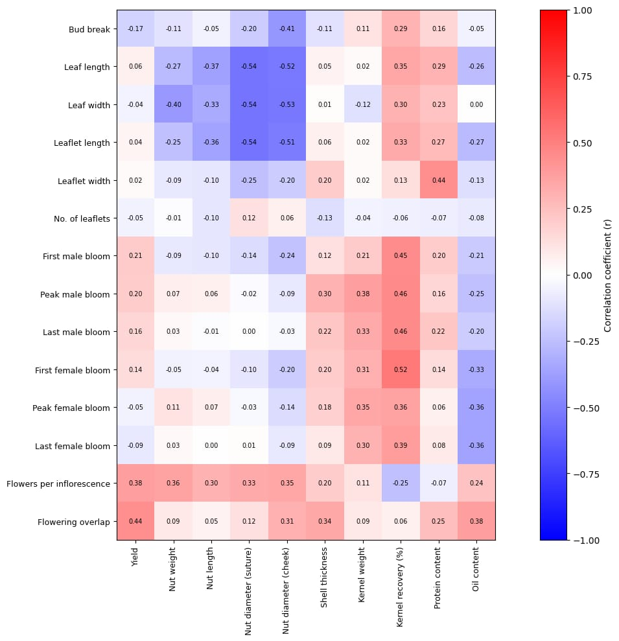

References
AOAC, 2000. Official Methods of Analysis, 17th ed. Association of Official Analytical Chemists, Washington, DC.
Abedi, B. and Parvaneh, T., 2016. Study of correlations between horticultural traits and variables affecting kernel percentage of walnut (Juglans regia L.).
Aslamarz, A. A., Vahdati, K., Rahemi, M., & Hassani, D. (2009). Correlation between vegetative growth and nut traits in walnut. Scientia Horticulturae, 121, 229–233.
Banyal, S.K., Patial, U.R. and Banyal, A.K., 2023. Pollination Management. In Temperate Nuts (pp. 149-170). Singapore: Springer Nature Singapore.
Bernard, A., Marrano, A., Donkpegan, A., Brown, P.J., Leslie, C.A., Neale, D.B., Lheureux, F. and Dirlewanger, E., 2020. Association and linkage mapping to unravel genetic architecture of phenological traits and lateral bearing in Persian walnut (Juglans regia L.). BMC genomics, 21(1), p.203.
Bogdziewicz, M., Pesendorfer, M., Crone, E.E., Pérez‐Izquierdo, C. and Bonal, R., 2020. Flowering synchrony drives reproductive success in a wind‐pollinated tree. Ecology Letters, 23(12), pp.1820-1826.
Charrier, G., Bonhomme, M., Lacointe, A. and Améglio, T., 2011. Are budburst dates, dormancy and cold acclimation in walnut trees (Juglans regia L.) under mainly genotypic or environmental control?. International journal of biometeorology, 55(6), pp.763-774.
Chen, Y., Li, X., Wang, J., 2023. Relationships between vegetative growth, flowering phenology and nut quality in walnut (Juglans regia L.). Scientia Horticulturae 317, 112058.
Christopoulos, M.V., Kafkaletou, M., Karantzi, A.D. and Tsantili, E., 2021. Girdling effects on fruit maturity, kernel quality, and nutritional value of walnuts (Juglans regia L.) alongside the effects on leaf physiological characteristics. Agronomy, 11(2), p.200.
Devin, S.R. and Bujdoso, G., 2022. Walnut genotypes for high density orchards. Horticulturae, 8(6), p.490.
Din, S., Wani, R.A., Ab Waheed Wani, F.N., Farwah, S., Rizvi, S. and Nisar, T.F.W.S., 2019. enhancement in temperate fruit crops. Journal of Pharmacognosy and Phytochemistry, 8(2), pp.1203-1216.
Einollahi, F. and Khadivi, A., 2024. Morphological and pomological assessments of seedling-originated walnut (Juglans regia L.) trees to select the promising late-leafing genotypes. BMC Plant Biology, 24(1), p.253.
Falconer, D.S., Mackay, T.F.C., 1996. Introduction to Quantitative Genetics, 4th ed. Longman Group Ltd., Harlow, UK.
Gandev, S. (2014). Relationships between vegetative growth and productivity in walnut. Journal of Horticultural Research, 22, 57–64.
Germain, E., 1997. Genetic improvement of walnut (Juglans regia L.). Acta Horticulturae 442, 21–32.
Gurjar, T.D., Pandey, A.K. and Rodge, R.R., 2025. Floral Biology, Pollination, and genetic resources in nut crops. In Temperate Nut Crops (pp. 51-108). Apple Academic Press.
Koubouris, G. C., Metzidakis, I. T., & Vasilakakis, M. (2010). Influence of flowering phenology on yield in nut crops. Scientia Horticulturae, 123, 333–338.
Kumar, A., Dangi, G., Kumar, P., Sharma, D.P., Sharma, G., Sajwan, P., Dogra, R.K. and Gundogdu, M., 2024. Exploring pollination mechanisms in walnut: Production and breeding perspectives. South African Journal of Botany, 171, pp.673-681.
Lone, F.A., Ganaie, M.I., Ganaie, S.A., Rather, J.A. and Bhat, M.S., 2023. Economic and profitability analysis of walnut production in Kashmir Valley, India. Asian Journal of Agriculture and Development, 20(2), pp.69-82.
Marrano, A., Sideli, G.M., Leslie, C.A., Cheng, H. and Neale, D.B., 2019. Deciphering of the genetic control of phenology, yield, and pellicle color in Persian walnut (Juglans regia L.). Frontiers in plant science, 10, p.1140.
Marino, G., Guzmán-Delgado, P., Santos, E., Adaskaveg, J.A., Blanco-Ulate, B., Ferguson, L., Zwieniecki, M.A. and Fernández-Suela, E., 2023. Interactive effect of branch source-sink ratio and leaf aging on photosynthesis in pistachio. Frontiers in Plant Science, 14, p.1194177.
McGranahan, G., Leslie, C., 2012. Walnuts (Juglans). In: Badenes, M.L., Byrne, D.H. (Eds.), Fruit Breeding. Springer, New York, pp. 827–846.
Manthos, I., Rouskas, D., Sotiropoulos, T. and Botu, M., 2023. Description of two promising walnut (Juglans regia L.) selections with lateral bud fruitfulness and large nuts. Horticulturae, 9(7), p.820.
Mukarram, S.A., Wandhekar, S.S., Ahmed, A.E.M., Pandey, V.K., Csaba, O., Lajos, D., József, P., Harsányi, E. and Bela, K., 2024. Exploring the Ecological Implications, Gastronomic Applications, and Nutritional and Therapeutic Potential of Juglans regia L.(Green Walnut): A Comprehensive Review. Nutrients, 16(8), p.1183.
Mutke, S., Calama, R., González-Martínez, S.C., Montero, G., Javier Gordo, F., Bono, D. and Gil, L., 2012. 4 mediterranean stone pine: Botany and horticulture. Horticultural reviews, 39(1), pp.153-201.
Panahi, B., Tajaddod, S., Mohammadzadeh Jallali, H., Hejazi, M.A. and Zeinalabedini, M., 2022. Variability and association among some pomological and physiochemical traits in spring frost tolerant genotypes of Persian walnut (Juglans regia L.) and selection of genotypes with superior traits based on machine learning algorithms. Genetic Resources and Crop Evolution, 69(3), pp.959-971.
Panse, V.G., Sukhatme, P.V., 1985. Statistical Methods for Agricultural Workers, 4th ed. ICAR, New Delhi.
Polito, V. S., Pinney, K., & Olson, W. H. (1998). Flowering biology and yield in walnut. HortScience, 33, 890–893.
Pollegioni, P., Woeste, K., Olimpieri, I., Ducci, F. and Malvolti, M.E., 2010. Pollen biology and hybridization process: open problem in walnut. Pollen: Structure, Types and Effects. Nova Science Publishers, Hauppauge, New York, pp.65-99.
Sharma, N. and Kumar, A., Factors Affecting Fruit Set, Development and Quality. G (2015): Fundamental of Fruit production, p.98.
Solar, A., Stampar, F., 2011. Characterisation of walnut cultivars in relation to flowering and yield behaviour. Scientia Horticulturae 128, 1–8.
Soleimani, A., Rabiei, V., Hassani, D., Mozaffari, M.R. and Dastjerdi, R., 2023. Yield related traits in some Persian walnut cultivars: Analysis of genetic and genetic by environment interaction. Advances in Horticultural Science, 37(4).
Soveili, S. and Khadivi, A., 2023. Selecting the superior late-leafing genotypes of Persian walnut (Juglans regia L.) using morphological and pomological evaluations. BMC Plant Biology, 23(1), p.379.
Szot, I. and Łysiak, G.P., 2025. Factors Influencing the Formation, Development of Buds, and Flowering of Temperate Fruit Trees. Agriculture, 15(12), p.1304.
Vahdati, K., Arab, M.M., Sarikhani, S., Sadat-Hosseini, M., Leslie, C.A. and Brown, P.J., 2020. Advances in Persian walnut (Juglans regia L.) breeding strategies. In Advances in Plant Breeding Strategies: Nut and Beverage Crops: Volume 4 (pp. 401-472). Cham: Springer International Publishing.
Zhang, L., Liu, P., Zhao, S., 2021. Source–sink relationships affecting nut development and quality in walnut. Journal of Integrative Agriculture 20, 3125–3134.

