Nematicidal Activity of Bacillus thuringiensis and Trichoderma harzianum against Meloidogyne incognita under in Vitro Conditions

Abstract
The root-knot nematodes (Meloidogyne spp.) are an important group of plant-parasitic nematodes with worldwide distributions and extensive host ranges, making control difficult. The main aims of this study are to evaluate the nematicidal impact of three indigenous Trichoderma harzianum and Bacillus thuringiensis isolates to control root-knot nematodes, Meloidogyne incognita, under laboratory. Morphological, microscopic, and biochemical analyses confirmed the identity of the biocontrol agents and the target nematode species. All Bacillus thuringiensis isolates were identified as Gram-positive, rod-shaped bacteria producing oval endospores, and their biochemical profiles obtained using the VITEK-2 Compact system showed a 98% probability of identification as B. thuringiensis. The Trichoderma harzianum isolates exhibited typical morphological characteristics, including branched conidiophores, flask-shaped phialides, abundant conidia, and the presence of chlamydospores. The perineal pattern analysis of adult females revealed morphological features characteristic of Meloidogyne incognita, including a high and square dorsal arch with wavy striations, confirming species identity. In vitro bioassays revealed significant differences (p ≤ 0.05) between microbial treatments and control groups in terms of egg-hatching inhibition and second-stage juvenile (J2) mortality. All B. thuringiensis and T. harzianum isolates exhibited strong nematicidal activity against M. incognita. The B. thuringiensis isolate Sh.Sa.3 showed the highest ovicidal effect, with egg-hatching inhibition percentages of 95.33%, 91.67%, and 88.67% after 24, 48, and 72 h, respectively, and corrected inhibition values exceeding 87%. Similarly, the T. harzianum isolate Sh.Sa.6 demonstrated substantial egg-hatching inhibition, with corrected inhibition percentages above 81% across all exposure periods. Moreover, the highest J2 mortality rates were recorded for B. thuringiensis isolate Sh.Sa.3, reaching 86.67% after 72 h, followed by T. harzianum isolate Sh.Sa.6, which induced 76.00% mortality at the same exposure time. In contrast, the control treatments exhibited minimal effects on egg hatching and juvenile mortality.
Keywords: Trichoderma harzianum, Bacillus thuringiensis, root-knot nematodes, Meloidogyne incognita.
1. Introduction
The root-knot nematodes (Meloidogyne spp.) are an important group of plant-parasitic nematodes with worldwide distributions and extensive host ranges, making control difficult. Nematodes are a major constraint to successful vegetable production all over the world, causing severe damage that leads to yield losses (Sikora and Fernandez, 2005; Karssen and Moens, 2006). Root-knot nematodes are microscopic plant parasites from the genus Meloidogyne (Yue et al., 2019). Meloidogyne species are obligate endoparasites that are economically the most important group of plant-parasitic nematodes in the world (Lambert and Bekal, 2002). There are more than 90 species of Meloidogyne have been described in several studies (Ghasemzadeh et al., 2019). Among these, three species of root-knot nematode such as Meloidogyne incognita, M. javanica, and M. arenaria, are the most damaging all over the world (Hunt and Handoo, 2009). Among them, M. incognita is an extensively widely distributed and economically important nematode in tropical and subtropical regions. It can live in many soil types, while damage and yield losses in many crops were found to be severe in coarse-textured sandy soils (Van Gundy, 1985).
Root-knot nematode affects the water and nutrients absorption and translocation in host plants; the photosynthesis rate decreases in infected plants, which is negatively correlated with inoculum levels; the photosynthetic products move toward the roots, specifically into giant cells which were developed by the nematode infections and support nematode development and reproduction (Maleita et al., 2012). Several culture-dependent methods were established to isolate nematode-associated soil bacteria, and it was discovered that J2 of M. hapla established a very specific subset of bacterial community from different soils (Topalovic et al., 2019).
Chemical control is often too expensive for growers and, in some cases, ineffective. Moreover, the use of such chemicals has been reduced due to environmental and consumer constraints. Biological control methods are environmentally sound and effective for reducing or mitigating other crop diseases (Sahebani and Hadavi, 2008). For example, the fungus Trichoderma harzianum can be used to control a range of plant diseases because it competes for nutrients, produces compounds that are toxic to other microorganisms, and induces plant resistance to diseases (Chamswarng, 2004). Trichoderma harzianum has been reported to suppress M. incognita, M. javanica, and M. arenaria populations and to increase yields in vegetables and other crops in many countries (Sharon et al., 2001).
Biological control as an environmentally friendly alternative in an integrated pest management strategy has been gaining momentum recently (Pocurull et al., 2020). Bacillus thuringiensis (Bt), a gram-positive soil bacterium possessing nematicidal crystal proteins, is being used widely to control plant parasitic nematodes (PPNs). Scientists also explained the mechanism of nematode control by Cry proteins. The crystal proteins of different molecular weights are known to enter via the stylet of nematodes, causing pores in the esophagus and thereby killing them. Naturally isolated Bt often acts as an effective location-specific control agent. The toxicity of Bt to nematodes has been well established since 1972 when the first study showing the toxicity of Bt against Meloidogyne spp. was published (Prasad et al., 1972). As an additional beneficial effect, Bt can also promote plant growth (Radhakrishnan et al., 2017). The reason might be the bacterium and the nematode might be involved in that particular ecosystem. The toxicity of location-specific Bt is always found to be effective and more novel proteins can be expected out of them. The main objective of this study is to study the effects of Trichoderma harzianum and Bacillus thuringiensis on egg hatch and juvenile mortality of root-knot nematodes (Meloidogyne incognita).
2. Materials and Methods
2.1 Isolation and identification of Bacillus thuringiensis
The three local isolates of Bacillus thuringiensis were isolated from three different soil samples collected from Abu Ghraib, Baghdad governorate. Each sample underwent serial dilution individually; one ml from each dilution was disseminated over a petri dish containing a Nutrient Glucose 1% Agar (NGA) medium, then incubated at 28 °C for 48 hours (Abd-El-Khair et al., 2016). Smears were taken carefully in sterile disposable transport media swabs, then kept in an incubator at 37 ºC (24–48 hr.). Such swabs were cultured in a brain-heart infusion (B.H.I. broth) medium and incubated at 37 ºC for 24 hours to promote bacterial growth. After that, they were streaked on the general and differential culture media and also incubated for 18–24 hours at 37 ºC. The positive growth was diagnosed depending on morphological characteristics (shape, size, margin, consistency, and color of colonies), microscopic features, molecular diagnosis, and biochemical tests by using the Vitek II system for identification.
2.2 Isolation and identification of Trichoderma harzianum
The three local isolates of Trichoderma harzianum were isolated from three different soil samples collected from Abu Ghraib, Baghdad governorate. Each sample of T. harzianum isolates was isolated by the dilution method (Samuels et al. 2011). In this method, one gram of each soil sample was added to 9 ml of sterile distilled water as stock, and different dilutions were prepared from it and placed on a shaker for one hour; one ml from each dilution was disseminated over a petri dish containing a Potato Dextrose Agar (PDA) medium, then incubated at 25 °C for 5 days (Abdulla et al., 2023). The morphological and morphometric properties of Trichoderma isolates were examined and compared using an optical microscope. Macroscopic features include colony color, growth rate, and growth pattern, as well as molecular diagnosis.
2.3 Microscopic identification of Trichoderma harzianum and Bacillus thuringiensis
The microscopic characters of conidia, phialides, conidiophores, and chlamydospores were observed under a light microscope. Smears were prepared from a single colony of young bacterial isolate grown on nutrient agar (NA) medium for 18–24 hours and fixed on a clean and dry slide, then dyed with Gram stain (Fluka/Switzerland) and examined under a light microscope to see the shape, arrangement, and colors of the cells according to their interaction with the gram stain.
2.4 The Vitek 2 system of Bacillus thuringiensis
According to the manufacturing company (BioMérieux/France), this system was used by inoculating gram-positive bacterial isolates on a blood agar plate (BAP) and then incubating at 37 ºC for 24 hours. All bacterial isolates were identified at the species level using the VITEK-2 compact system to identify gram-positive bacteria. A colorimetric reagent card (BCL) is used to detect the spore-forming Gram-positive bacilli (e.g., Bacillus) provided by the BIOMERIEUX/French company.
2.5 Laboratory experiments
2.5.1 Preparation of the fungal and bacterial culture filtrates
Bacterial culture filtrates were prepared by inoculating each Bacillus thuringiensis isolate in a conical flask (250 ml) including 200 ml of nutrient glucose (2%) broth (NGB) medium prepared according to the following formula (glucose 10 g, beef extract 3 g, peptone 5 g, distilled water 1 L). Following that, the pH was adjusted to 7.2. The inoculated flasks were incubated at 28 ± 2 °C for four days (El-Nagdi and Abd-El-Khair, 2019). A McFarland standard solution tube with a concentration of 1.6×10⁸ CFU/ml obtained from the supplier company (BIOMERIEUX) was used as a reference to adjust the turbidity of the Bt inoculum of each isolate. Whereas the fungus was grown on potato dextrose agar (PDA) at 28 ◦C for 7 days until sporulation. Trichoderma harzianum spores were collected in sterile distilled water to form a homogenous spore suspension, and then a 10 mL spore suspension was used as a starter inoculum for liquid PD medium. After 7 days, the suspension cultures, maintained in an incubator with agitation (150 rpm), were used to inoculate the tomato seedlings as biocontrol (Yin et al., 2014). The spore suspension concentration was adjusted to 1.5 × 10⁷ spores/mL.
2.5.2 The source of root-knot nematodes, Meloidogyne incognita inoculum
The method described by Hussey and Barker (1973) was used to obtain the nematode inoculum by collecting samples of infested cucumber roots that were infected with root-knot nematodes, Meloidogyne incognita. The roots were cut into small pieces (2–3 cm) after washing them with water to remove the soil from the roots, and then put into a 1000-ml measuring cylinder. 500 ml of 1% sodium hypochlorite solution was poured into a measuring cylinder to dissolve the gelatinous matrix. Then the roots are placed in an electric blender and short-spin for 10 seconds to ensure that juveniles do not rupture, and then they are left for three minutes to precipitate the root pieces. The supernatant is taken and passed through different-sized sieves (75, 50, and 25), respectively. The eggs and juveniles were collected from a 25-microliter sieve and placed in a 1000-ml measuring cylinder after sieving through a mesh, and the number of eggs and juveniles was counted per ml by using a special nematode counting slide.
2.5.3 Evaluate the nematicidal impact of Bacillus thuringiensis and Trichoderma harzianum on egg hatching
The experiment was conducted in a laboratory to determine the effect of Bacillus thuringiensis and Trichoderma harzianum isolates on the hatching rate of eggs of the root-knot nematode Meloidogyne spp. Three ml of each bacterial and fungal isolate suspension at a concentration of 1.6×10⁸ and 1.5 × 10⁷ CFU/ml, respectively, were added to each test tube capacity of 10 ml containing 300 µL of nematode inoculum at a concentration of 100 ± 5 eggs. Three ml of NGB, PDA medium, and sterilized distilled water were separately added to 300 µL of nematode suspension containing 100 ± 5 eggs, which served as standard checks. Each treatment included three replications to evaluate the inhibition of egg hatching in a completely randomized design (CRD). The test tubes were incubated at a temperature of 28 ± 2 °C. At the same time, the number of unhatched eggs was counted after 24, 48, and 72 hours of exposure by a Sedgewick Rafter cell counting slide under a compound light microscope with 4x magnification.
2.5.4 Evaluate the nematicidal impact of Bacillus thuringiensis and Trichoderma harzianum on second-stage juvenile mortality
The experiment was carried out in the laboratory to investigate the nematicidal effectiveness of Bacillus thuringiensis (Bt) isolates on second-stage juvenile mortality of the root-knot nematodes (RKN). A concentration of 1.6×10⁸ and 1.5 × 10⁷ CFU/ml of each bacterial and fungal isolate inoculum, respectively, was prepared. Furthermore, 300 µL of root-knot nematode inoculum containing 100 ± 5 juveniles (J2) was added to the test tube capacity of 10 ml. Then three ml of each bacterial and fungal isolate inoculum was added to each test tube, in addition to the three comparison treatments of NGB, PDA medium, and sterilized distilled water. Each treatment consisted of three replications to assess the mortality of juveniles in a completely randomized design (CRD). The test tubes were incubated at 28 ± 2 °C. Observation on the number of dead juveniles (J2) was counted after 24, 48, and 72 hours of exposure by a sedgewick rafter cell counting slide under a compound light microscope with 4x magnification. When probed with a small needle, the juveniles did not move, indicating that they had died.
2.6 Statistical Analysis
The data on egg hatching and second-stage juvenile mortality were analyzed statistically using a complete randomized design (CRD) by the statistical program GenStat 12, and the data were arranged using Excel. The significant differences between means were compared with the least significant difference (LSD) test at a significance level of 0.05.
3. Results and discussion
3.1 Morphological identification of Trichoderma harzianum and Bacillus thuringiensis isolates
The microscopic features of the three Bacillus thuringiensis isolates revealed the presence of gram-positive rods that produced oval spores (Figure 1). The results of the 46 biochemical tests of three Bt isolates using the VITEK-2 compact system with identification (BCL) cards exhibited that all the isolates belong to the species Bt with a probability of 98%. The morphological and microscopic features of the three Trichoderma harzianum isolates illustrated conidia, phialides, conidiophores, and chlamydospores, were also observed under a light microscope, as revealed in Figure 1.
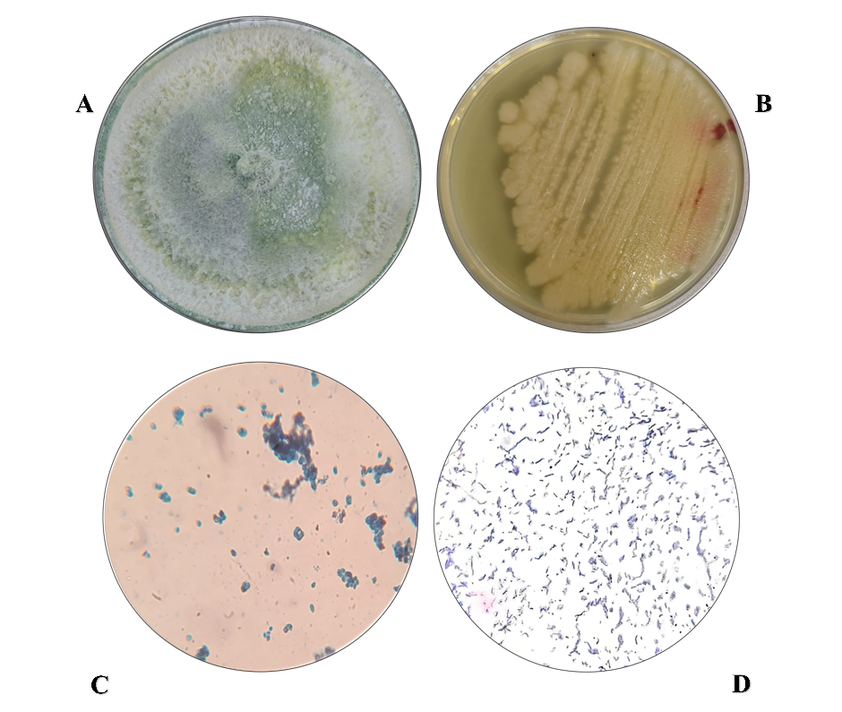
Figure 1: The morphological and microscopic features of the Trichoderma harzianum and Bacillus thuringiensis (A): Colonies of T. harzianum were grown on Potato dextrose agar. (B): Young bacterial isolate grows on nutrient agar. (C): Mass of conidia and conidia observed under a light microscope at 40x magnification (D): B. thuringiensis spores with Gram stain were illustrated as gram-positive with a purple color observed under a light microscope at 40x magnification.
3.2 Morphological identification of Meloidogyne incognita
When analyzing the morphology of the perineal pattern of adult females microscopically, revealed the presence of Meloidogyne incognita, (Figure 2). which was characterized by presenting generally a shape elongated with a dorsal arch high and square, with soft grooves to wavy with some bifurcations in the lateral lines. This morphology coincided with that described in the literature for M. incognita (Taylor and Sasser, 1983).
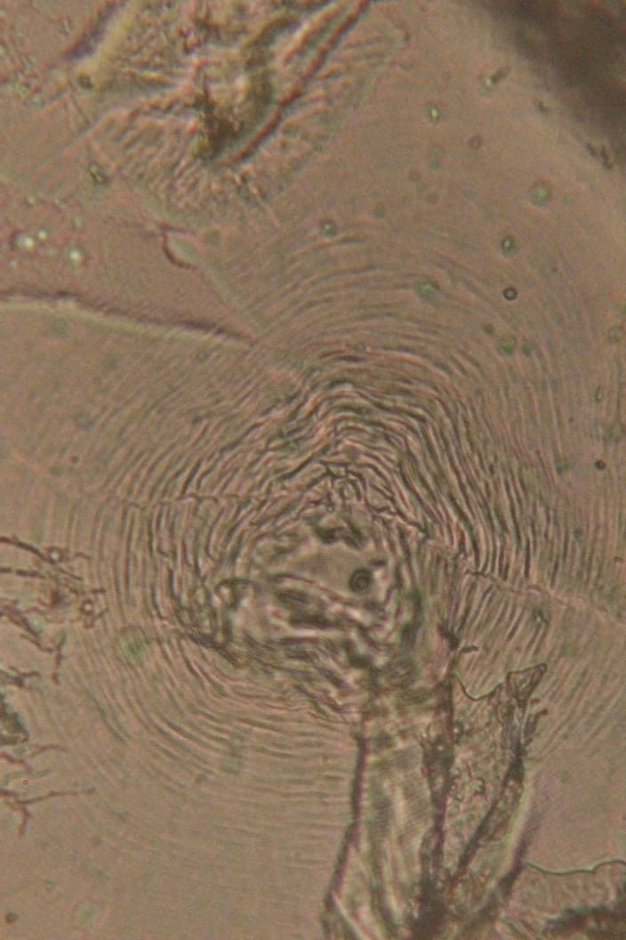
Figure 2: Microphotography of perineal patterns obtained from root-knot nematode females of Meloidogyne incognita revealed a high and square dorsal arch observed under a light microscope at 40x magnification.
3.3 Evaluate the nematicidal impact of Bacillus thuringiensis and Trichoderma harzianum isolates on egg hatching
The data shown in Table 1 revealed significant differences between B. thuringiensis and T. harzianum isolates and control groups when applied as nematicidal against eggs of root-knot nematodes. The result indicated that all isolates effectively inhibited eggs when observed under a microscope, as presented in Figure 3. All Bt and Th isolates demonstrated a high percentage of egg inhibition. Therefore, the highest egg inhibition was observed in the Bt isolate Sh.Sa.3 in the ranges of 95.33%, 91.67%, and 88.67%, with a corrected percentage of egg inhibition of 93.06%, 88.89%, and 87.45% after 24, 48, and 72 hours of treatment, respectively. The highest egg inhibition was noticed in the Th isolate Sh.Sa.6 in the ranges of 89.33%, 87.00%, and 83.00%, with a corrected percentage of egg inhibition of 84.15%, 82.66%, and 81.18% after 24, 48, and 72 hours of treatment, respectively, compared to the three comparison treatments, NGB medium, PDA medium, and control (sterilized distilled water), which gave the lowest inhibition percentage of eggs 35.00%, 27.33%, 11.00%, and 33.67%, 25.67%, 10.00%, and 32.67%, 25.00%, 9.67% after 24, 48, and 72 hours. Our findings were consistent with those of a study conducted by Ravari and Moghaddam (2015) found that two strains of B. thuringiensis (ToIr65 and ToIr67) exhibited 70% nematicidal activity against juveniles and eggs of Meloidogyne javanica. Moreover, a study conducted by Mohammed et al. (2008) revealed that the nematicidal effects of 10 Bacillus thuringiensis isolates in vitro against Meloidogyne incognita exhibited the greatest nematicidal activity, with a death rate of 86–100%. Jouzani et al. (2008) used twenty-two isolates of Bacillus thuringiensis with nematode-active cry genes and conducted preliminary bioassays on Meloidogyne incognita. According to those tests, four isolates were selected for further bioassays. At a 2×10⁸ CFU/mL concentration, strains YD5 and KON4 exhibited 77% and 81% toxicity against Meloidogyne incognita, respectively. An in vitro experiment was conducted by Abdulla et al. (2023) to evaluate the effects of two Iraqi isolates of Trichoderma harzianum and Trichoderma asperellum against Meloidogyne incognita. It was noted T. harzianum and T. asperellum had a clear impact on egg-hatching inhibition of root-knot nematode, Meloidogyne incognita. The percentage of egg-hatching inhibition after the seventh day, reached 86.50% and 83.75%, respectively. In vitro studies done by Khattak et al. (2008) revealed that the hatching of M. javanica eggs was inhibited by the action of Culture filtrates (CF) of T. harzianum at different concentrations, (standard, 1:1, 1:10, and 1:100) and this inhibition was positively correlated with increase in the concentration of culture filtrates. Maximum inhibition of egg hatching (80.36%) was observed at standard concentration, followed by 68.08% at 1:1, and minimum inhibition (10.66%) was recorded at the lowest concentration.
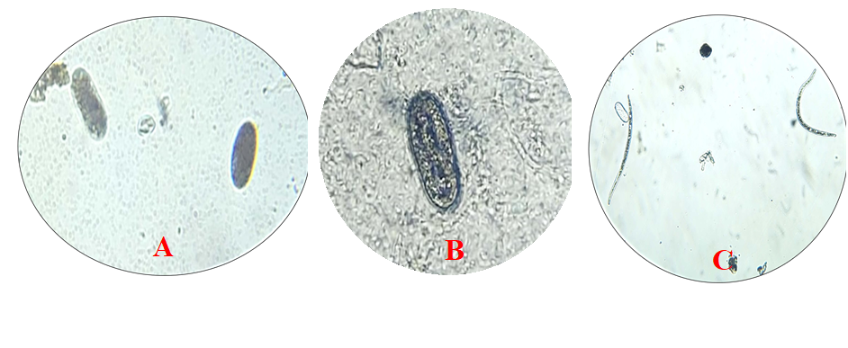
Figure 3: The effect of culture filtrate of Bacillus thuringiensis and Trichoderma harzianum isolates on egg hatching observed under a light microscope at 10x magnification. (A): Unhatched eggs were examined after being treated with T. harzianum suspension. (B): An unhatched egg was examined after being treated with Bt culture filtrate. (C). An untreated eggs hatched into a juvenile (J2).
Table 1: The Nematicidal impact of Bacillus thuringiensis and Trichoderma harzianum isolates on egg hatching
Treatment | Egg inhibition percentage% | Corrected egg inhibition percentage | Egg inhibition percentage% | Corrected egg inhibition percentage | Egg inhibition percentage% | Corrected egg inhibition percentage | Mean
Treatment | 24/hr. | 24/hr. | 48/hr. | 48/hr. | 72/hr. | 72/hr. | Mean
Control | 32.67 |  | 25.00 |  | 9.67 |  | 22.45
NGB | 35.00 | 3.46 | 27.33 | 3.10 | 11.00 | 1.47 | 24.44
PDA | 33.67 | 1.48 | 25.67 | 0.89 | 10.00 | 0.36 | 23.11
Bt isolate Sh.Sa.1 | 91.00 | 86.63 | 87.67 | 83.56 | 83.67 | 81.92 | 87.45
Bt isolate Sh.Sa.2 | 93.33 | 90.09 | 89.67 | 86.22 | 86.00 | 84.50 | 89.67
Bt isolate Sh.Sa.3 | 95.33 | 93.06 | 91.67 | 88.89 | 88.67 | 87.45 | 91.89
Th isolate Sh.Sa.4 | 83.00 | 74.75 | 79.00 | 72 | 76.67 | 74.17 | 79.56
Th isolate Sh.Sa.5 | 86.00 | 79.20 | 82.67 | 76.89 | 79.67 | 77.49 | 82.78
Th isolate Sh.Sa.6 | 89.33 | 84.15 | 87.00 | 82.66 | 83.00 | 81.18 | 86.44
LSD 5% | 3.14** |  |  |  |  |  | 1.81**
Mean | 71.04 |  | 66.19 |  | 58.71 |  | 1.81**
LSD 5% | 1.05** |  |  |  |  |  | 1.81**
*Means are averages of three replicates
3.4 Evaluate the nematicidal impact of Bacillus thuringiensis and Trichoderma harzianum on second-stage juvenile mortality
The data shown in Table 2 revealed significant differences between B. thuringiensis and T. harzianum isolates and control groups when applied as nematicides against second-stage juveniles of root-knot nematodes. Comparably, the mortality of J2 was observed under a compound microscope, and the results showed that the culture filtrate-treated juveniles were dead, as they were straight and did not move even when probed with a small needle. In contrast, untreated juveniles (treated with sterilized distilled water) were found to be alive due to their curved and comma-shaped movements (Figure 4). Moreover, the highest mortality percentage of second-stage juveniles (J2) was recorded in the Bt isolate Sh.Sa.3, which amounted to 32.67%, 65.33%, and 86.67% after 24, 48, and 72 hours of exposure, respectively. The highest mortality percentage of second-stage juveniles was noticed in the Th isolate Sh.Sa.6 were in the ranges of 26.67%, 42.67%, and 76.00%, after 24, 48, and 72 hours of exposure respectively, as opposed to the three comparison treatments, NGB, PDA medium, and control which gave the lowest mortality percentage of J2, were in the ranges of 6.00%, 7.33%, 10.67%, and 5.33%, 6.67%, 9.33%, and 4.67%, 6.00%, 8.33%, after 24, 48, and 72 hours of exposure respectively, exhibited in Table 14. The findings in Tables (2) and 13 show that the NGB and PDA media have a minor influence on egg inhibition and juvenile mortality. I observed that the dead second-stage juvenile (J2) was straight or vertical, with the body mostly devoid of internal viscera, and a bubble on one side of its body was noticed. After 72 hours of exposure, the juveniles and eggs turned a dark color, in addition to distorting their contents. Our findings were consistent with those of a study conducted by Ramalakshmi et al. (2020), who tested the effectiveness of the fourteen native Bacillus thuringiensis isolates against Meloidogyne incognita. After 72 hours of treatment, six of 14 isolates demonstrated 100% inhibition of second-stage juvenile emergence from M. incognita egg masses. Chen et al. (2024) discovered that the Bacillus thuringiensis Berliner strain NBIN-863 has substantial fumigant nematicidal activity and a high attraction impact on the root-knot nematode M. incognita. Santos et al. (2022) evaluated sixteen strains of Bacillus thuringiensis against second-stage juveniles in the presence and absence of resorcinol extracted from B. thuringiensis, and the results revealed juvenile death rates ranged from 4 to 36%. In vitro studies conducted by Sayed et al. (2019) demonstrated that egg hatching and second juvenile vitality of root-knot nematodes were significantly inhibited by chitinase-containing growth culture of the four selected chitinolytic Trichoderma species. However, the reduction effect was directly correlated with the concentration of fungal growth suspension. Fan et al. (2020), who tested the effectiveness of the Snef1910 strain identified as Trichoderma citrinoviride showed high virulence against second-stage juveniles (J2s) of M. incognita. Furthermore, T. citrinoviride Snef1910 significantly inhibited egg hatching with the hatching inhibition percentages of 90.27%, 77.50%, and 67.06% at 48, 72, and 96 hours after the treatment, respectively.
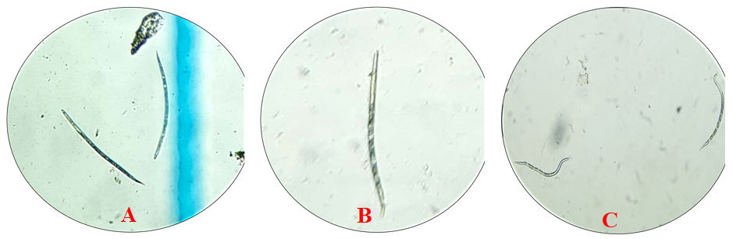
Figure 4: The effect of culture filtrate of Bacillus thuringiensis and Trichoderma harzianum isolates on second-stage juvenile (J2) mortality observed under a light microscope at 10x magnification. (A): A dead second-stage juveniles were discovered with no movement after being treated with T. harzianum suspension. (B): A dead second-stage juvenile was discovered with no movement after being treated with Bt suspension. (C): Untreated juveniles were spotted moving in the control group.
Table 2: The Nematicidal impact of Bacillus thuringiensis and Trichoderma harzianum on juvenile mortality
Treatment | Juvenile mortality percentage |  |  | Mean
Treatment | 24/hour | 48/hour | 72/hour | Mean
Control | 4.67 | 6.00 | 8.33 | 6.67
NGB | 6.00 | 7.33 | 10.67 | 8.00
PDA | 5.33 | 6.67 | 9.33 | 6.78
Bt isolate Sh.Sa.1 | 20.67 | 44.67 | 77.33 | 47.56
Bt isolate Sh.Sa.2 | 27.33 | 55.33 | 81.67 | 54.78
Bt isolate Sh.Sa.3 | 32.67 | 65.33 | 86.67 | 61.56
Th isolate Sh.Sa.4 | 17.33 | 30.33 | 67.67 | 38.44
Th isolate Sh.Sa.5 | 22.67 | 38.33 | 74.00 | 45.00
Th isolate Sh.Sa.6 | 26.67 | 42.67 | 76.00 | 48.45
LSD 5% | 5.51** |  |  | 3.18**
Mean | 18.15 | 32.96 | 54.63 | 3.18**
LSD 5% | 1.84** |  |  | 3.18**
* Means are averages of three replicates
4. Conclusion
The present study demonstrated that locally isolated Bacillus thuringiensis and Trichoderma harzianum possess strong nematicidal activity against Meloidogyne incognita under in vitro conditions. Both microbial agents significantly inhibited egg hatching and increased second-stage juvenile mortality in a time-dependent manner, with B. thuringiensis isolate Sh.Sa.3 showing superior efficacy compared to other isolates. These results confirm the potential of B. thuringiensis and T. harzianum as effective and environmentally friendly biocontrol agents for managing root-knot nematodes. Further investigations under greenhouse and field conditions are recommended to validate their efficacy and to explore their integration into sustainable nematode management programs.

References
Abdulla, G.A., Saleh, H.M., and Al-Hakeem, A.M. (2023). Effects of Trichoderma Harzianum and Trichoderma Asperellum Against Egg of Meloidogyne Incognita under Laboratory Condition. IOP Conference Series Earth and Environmental Science, 1213(1): 012011. DOI: 10.1088/1755-1315/1213/1/012011
Chamswarng, C. 2004. Biological control of vegetable diseases. In: Biocontrol pest in soil less culture and green house. Faculty of Agricultural Technology, King Mongkut’s Institute of Technology Ladkrabang.
Chen, L., Wang, Y., Zhu, L., Min, Y., Tian, Y., Gong, Y., and Liu, X. (2024). 3-(Methylthio)Propionic Acid from Bacillus thuringiensis Berliner Exhibits High Nematicidal Activity against the Root Knot Nematode Meloidogyne incognita (Kofoid and White) Chitwood. International Journal of Molecular Sciences, 25 (3): 1708. doi.org/10.3390/ijms25031708
El-Nagdi Wafaa, M. A. And Abd-El-Khair, H. (2008). Biological control of Meloidogyne incognita and Rhizoctonia solani in eggplant. Nematol Medit, 36:85-92.
Fan, H., Yao, M., Wang, H., Zhao, D., Zhu, X., Wang, Y., Liu, X., Duan, Y., and Lijie Chen, L. (2020). Isolation and effect of Trichoderma citrinoviride Snef1910 for the biological control of root-knot nematode, Meloidogyne incognita. BMC Microbiology,20 (1): 299. DOI: 10.1186/s12866-020-01984-4
Ghasemzadeh, A., S. Jamali, M. Esfahani and H. Pedramfar. 2019. Assessment of photosynthetic fluorescence in tomato cultivars infested with root-knot nematode. Pak. J. Nematol. 37(1): 91–101.
Hunt, D.J. and Z.A. Handoo. 2009. Taxonomy, identification and principal species, pp. 55–97. In: R.N. Perry, M. Moens and J.L. Starr, (Eds.), Root-knot Nematodes. CABI Publishing, Oxford Shire, UK.
Hussey, RS., and KR. Barker .1973. Comparison of methods for collecting inocula of Meloidigyne spp. including a new technique. Plant Disease Reporter.57: 1025-1028.
Jouzani, G. S., Seifinejad, A., Saeedizadeh, A., Nazarian, A., Yousefloo, M., Soheilivand, S., Mousivand, M., Jahangiri, R., Yazdani, M., Amiri, R. M., and Akbari, S. (2008). Molecular detection of nematicidal crystalliferous Bacillus thuringiensis strains of Iran and evaluation of their toxicity on free-living and plant-parasitic nematodes. Canadian Journal of Microbiology, 54 (10): 812-822. DOI: 10.1139/W08-074
Karssen, G., Wesemael, W. M. L. and Moens, M. (2013). Root-knot nematodes.- In: Perry, R. N., Moens, M. (eds.) Plant nematology, CABI, Wallingford, UK
Khattak, B., Saifullah., and Stephen, M. (2008). Effect of some indigenous isolates of Trichoderma harzianum on root knot nematode, Meloidogyne javanica (TREUB) chitwood. Sarhad Journal of Agriculture, 24 (2): 285-288.
Lambert, K. and S. Bekal. 2002. Introduction to plant-parasitic nematodes. Plant Health Instr. 10: 1094–1218
Maleita, CMN., RHC. Curtis., SJ. Powers and IMO. Abrantes .2012. Inoculum levels of Meloidogynehispanica and Mjavanica affect nematode reproduction, and growth of tomato genotypes. Phytopathol. Mediter. 51: 566-576
Mohammed, S. H., El Saedy M. A., Enan, M. R., Ibrahim, N. E., Ghareeb, A., and Moustafa, S. A. (2008). Biocontrol efficiency of Bacillus thuringiensis toxins against root-knot nematode, Meloidogyne incognita. Journal of Cell and Molecular Biology, 7(1): 57-66.
Pocurull M et al. (2020) Commercial formulates of Trichoderma induce systemic plant resistance to Meloidogyne incognita in tomato and the effect is additive to that of the Mi-1.2 resistance gene. Front Microbiol 10: 3042-3042.
Prasad SSSV, Tilak K, Gollakota K. 1972. Role of Bacillus thuringiensis var. thuringiensis on the larval survivability and egg hatching of Meloidogyne spp., the causative agent of root knot disease. J Invertebr Pathol 20: 377-378.
Rajalakshmi, S. (2017). Different types of PCR techniques and its applications. International Journal of Pharmaceutical, Chemical and Biological Sciences, 7(3):285-292
Ramalakshmi, A., Sharmila, R., Iniyakumar, M., and Gomathi, V. (2020). Nematicidal activity of native Bacillus thuringiensis against the root knot nematode, Meloidogyne incognita (Kofoid and White). Egyptian Journal of Biological Pest Control, 30: 90. DOI: 10.1186/s41938-020-00293-2
Ravari, S. B., And Moghaddam, E. M. (2015). Efficacy of Bacillus thuringiensis Cry14 Toxin against Root Knot Nematode, Meloidogyne javanica. Plant Protection Science, 51(1): 46-51. DOI: 10.17221/93/2013-PPS
Sahebani, N., Hadavi, N. 2008. Biological control of the root-knot nematode Meloidogyne javanica by Trichoderma harzianum. Soil Biol. Biochem. 40, 2016-2020.
Samuels G, Chaverri P, Farr D, McCray E (2011) Trichoderma Online, Systematic Mycology and Microbiology Lab. ARS, USDA.
Sharon, E., Bar-Eyal, M., Chet, I., Herrera-Estrella, A., Kleifeld, O., Spiegel, Y. 2001. Biological Control of the Root-Knot Nematode Meloidogyne javanica by Trichoderma harzianum, Phytopathology 91 (7), 687-692.
Sikora, R. A. and Fernandex, E. (2005). Nematode parasites of vegetables. In: Luc, M., Sikora, R. A.and Bridge, J. (Eds.): Plant Parasitic Nematodes in Subtropical and Tropical Agriculture. CAB International, London, pp 319-392.
Taylor, A. L., and Sasser, J. N. (1983). Biología, identificación y control de los nemátodos de nódulo de la raíz. Raleigh, USA. Universidad del Estado de Carolina del Norte. 111 p.
Toralovie , Elhady A, Hallmann J, Richert-Piiggeler KR and Heuer H .2019. Bacteria isolated from the cuticle of plant-parasitic nematodes attached to and antagonized the root-knot nematode Meloidogyne hapla. Scientific Reports.9:11477.
Van Gundy, S.D. 1985. Ecology of Meloidogyne spp.–emphasis on environmental factors affecting survival and pathogenicity, pp. 177–182. In: J.N. Sasser and C.C. Carter, (Eds.), An Advanced Treatise on Meloidogyne. Volume 1. Biology and Control. North Carolina State University Graphics, Raleigh, North Carolina, USA.
Yue, L., S. Ahmed, Q. Liu, and H. Jian. 2019. Management of Meloidogyne incognita on tomato with different biocontrol organisms. Pak. J. Nematol. 37(2): 161–170

