HPTLC-Assisted Quantification of Active Phytoconstituents in the Aqueous Extract of Anti-hyperlipidemic herbal Formulation

ABSTRACT
Hyperlipidemia represents a significant metabolic abnormality characterized by elevated lipid levels that predispose individuals to cardiovascular complications. Although synthetic hypolipidemic drugs are widely prescribed, their prolonged administration is often associated with undesirable effects, encouraging the exploration of plant-based therapeutic strategies. The present study focused on the phytochemical standardization of the aqueous extract of a polyherbal formulation through quantitative estimation of selected bioactive markers using High Performance Thin Layer Chromatography (HPTLC). The formulation was prepared using Nigella sativa, Terminalia arjuna, Withania somnifera, and Linum usitatissimum, medicinal plants traditionally employed for cardiovascular and metabolic disorders. The aqueous extract was subjected to HPTLC analysis for the determination of thymoquinone, arjunolic acid, withaferin A, and linolenic acid using validated chromatographic conditions. Separation was achieved on silica gel plates with optimized solvent systems, and densitometric scanning was performed at compound-specific wavelengths. Quantitative analysis revealed the presence of thymoquinone (85.2 µg/g), arjunolic acid (12.9 µg/g), withaferin A (1.2 µg/g), and linolenic acid (0.1 µg/g) in the aqueous extract. The analytical method demonstrated satisfactory linearity, precision, and specificity, confirming its suitability for phytochemical profiling of complex herbal matrices. Peak purity and spectral overlay further ensured the authenticity of the identified constituents. The presence of these bioactive compounds supports the therapeutic relevance of the formulation and highlights its potential role in lipid regulation and cardiovascular protection. The findings establish a reliable quality control framework and provide a foundation for further experimental and clinical studies on the antihyperlipidemic efficacy of the herbal formulation.
Keywords: Aqueous extract, HPTLC, Herbal formulation, Hyperlipidemia, Thymoquinone, Arjunolic acid, withaferin A, linolenic acid.
INTRODUCTION
Hyperlipidemia is a complex metabolic abnormality marked by elevated concentrations of lipids and lipoproteins in the circulating blood, which significantly contributes to the development of cardiovascular and metabolic disorders (Jani, 2011). The condition may arise from genetic defects affecting lipoprotein metabolism or occur secondarily due to underlying systemic illnesses, endocrine disorders, or lifestyle-related factors (Barriga and Fonturbel, 2011). Among the modifiable risk factors, dietary patterns play a crucial role; excessive intake of high-fat and cholesterol-rich foods markedly increases the likelihood of lipid imbalance. In recent decades, the prevalence of hyperlipidemia has shown a consistent upward trend, largely driven by sedentary lifestyles, unhealthy dietary habits, and reduced physical activity, all of which negatively influence overall health status and quality of life (Dyer et al., 2014).
Pharmacological management of hyperlipidemia predominantly relies on synthetic lipid-lowering agents such as statins and fibrates. Statins exert their therapeutic action by inhibiting endogenous cholesterol synthesis, whereas fibrates facilitate enhanced clearance of triglyceride-rich lipoproteins from the bloodstream (Jani, 2011). Despite their proven efficacy, long-term administration of these drugs is frequently associated with adverse effects, including hepatotoxicity, myopathy, and gastrointestinal disturbances, which restrict their prolonged use and patient compliance (Boden et al., 2011).
These limitations have led to increasing interest in plant-based therapeutic approaches as safer and more sustainable alternatives. Medicinal plants are rich sources of bioactive phytochemicals that possess lipid-lowering, antioxidant, anti-inflammatory, and hepatoprotective properties, often with fewer side effects. The growing acceptance of herbal medicines, either as standalone therapies or in combination with conventional pharmacological agents, reflects their favorable safety profile, improved tolerability, and multifaceted therapeutic potential. Consequently, herbal interventions for the management of hyperlipidemia have gained considerable scientific and clinical attention in recent years (Jani, 2011).
Nigella sativa, commonly referred to as black seed, is a highly valued medicinal plant with extensive historical, cultural, and religious importance. Its seeds and oil have been traditionally utilized for centuries across diverse civilizations to manage a wide array of ailments. In the Indian subcontinent, N. sativa occupies a prominent position in traditional medical systems such as Unani and Ayurveda. The plant is known to exhibit a broad range of pharmacological activities, including antidiabetic, anticancer, immunomodulatory, analgesic, antimicrobial, anti-inflammatory, bronchodilatory, spasmolytic, hepatoprotective, renoprotective, gastroprotective, and antioxidant effects (Maheswari et al., 2022).
Terminalia arjuna, a large deciduous tree widely distributed throughout India, is another important medicinal plant extensively employed in traditional medicine. The bark of T. arjuna has been traditionally prescribed for the treatment of cardiovascular ailments, bone fractures, dermatological disorders, polyuria, vertigo, fever, and parasitic infestations. Experimental studies have demonstrated that administration of T. arjuna bark extract significantly reduces plasma total cholesterol, triglycerides, and low-density lipoprotein (LDL) cholesterol levels in hypercholesterolemic animal models, highlighting its potent cardioprotective and lipid-lowering properties (Patil et al., 2011).
Withania somnifera, commonly known as Ashwagandha, has been a cornerstone of Ayurvedic medicine for over three millennia. The plant is renowned for its adaptogenic properties and exhibits a wide spectrum of pharmacological activities, including antibacterial, antifungal, antidiabetic, and antitumor effects. Traditionally, W. somnifera has been used to combat stress, anxiety, insomnia, and nervous exhaustion, and is also valued for its immunostimulatory potential, particularly in individuals with compromised immune function (Sharma et al., 2018).
Linum usitatissimum, popularly known as flaxseed, is recognized for its exceptional nutritional and therapeutic value due to its high content of biologically active compounds. It is a rich source of omega-3 fatty acids, especially alpha-linolenic acid, as well as lignans and dietary fiber. These constituents contribute to its diverse pharmacological effects, including anti-inflammatory, antioxidant, diuretic, anticancer, and antidiabetic activities, making flaxseed a valuable functional food and therapeutic agent (Qureshi et al., 2018).
The present study was designed to quantitatively analyze the major active phytoconstituents present in the selected herbal formulation. By establishing a scientific correlation between the phytochemical profile and the observed therapeutic efficacy, the study aims to provide a mechanistic basis for the lipid-lowering potential of the formulation. Such an approach not only strengthens the pharmacological justification for traditional herbal combinations but also supports their rational development as effective and safer therapeutic agents for the management of hyperlipidemia.
MATERIALS AND METHODS
Location of the Study
The present investigation was carried out in the Department of Veterinary Pharmacology and Toxicology, College of Veterinary Science and Animal Husbandry, Nanaji Deshmukh Veterinary Science University, Jabalpur, Madhya Pradesh, India. All experimental procedures and laboratory analyses were performed using the facilities available in the department under controlled conditions.
Collection and Processing of Plant Materials
Fresh plant materials comprising seeds of Nigella sativa, bark of Terminalia arjuna, roots of Withania somnifera, and seeds of Linum usitatissimum were procured from the Department of Plant Physiology, Jawaharlal Nehru Krishi Vishwa Vidyalaya (J.N.K.V.V.), Jabalpur, Madhya Pradesh. The collected plant materials were carefully cleaned to remove extraneous matter and then subjected to shade drying at ambient temperature to preserve their bioactive constituents. Upon complete drying, the plant parts were coarsely powdered using a mechanical grinder and further processed into a fine powder to ensure uniformity. The powdered materials were stored in airtight containers until extraction.
The aqueous extraction of the herbal formulation was carried out following the method described by El-Desouky (2021), with minor modifications to optimize extraction efficiency.
Preparation of Aqueous Extract of the Herbal Formulation
The aqueous extract of the herbal formulation was prepared by accurately weighing and mixing the powdered seeds of Nigella sativa and Linum usitatissimum in a predetermined fixed ratio. The powdered mixture was transferred into clean conical flasks containing 650 ml of distilled water. The flasks were securely sealed with cotton plugs and aluminum foil to prevent contamination and evaporation losses.
The mixture was then incubated in a shaker incubator maintained at 37°C with continuous gentle agitation at 120 rpm for a period of 24 hours to facilitate maximum extraction of water-soluble phytoconstituents. Following incubation, the extract was filtered through Whatman filter paper No. 1 to remove particulate matter and obtain a clear filtrate.
The filtrate was subsequently concentrated under reduced pressure using a rotary evaporator maintained at 40°C until complete removal of the solvent. The concentrated extract was dried, weighed to determine extraction yield, and stored in airtight containers at appropriate conditions until further use for experimental and analytical studies.
Quantification of Active Phytoconstituents in the Herbal Formulation
Quantitative estimation of the major bioactive constituents present in the herbal formulation namely thymoquinone, arjunolic acid, withaferin A, and linolenic acid, was carried out using High Performance Thin Layer Chromatography (HPTLC). The analytical procedures were performed in accordance with previously established methods reported by Alam et al. (2013), Bharti (2021), Tomar et al. (2019), and Chauhan et al. (2015), respectively, with minor modifications wherever required to ensure optimal resolution and reproducibility.
Preparation of Standard Solutions
Reference standards of thymoquinone and arjunolic acid were accurately weighed and dissolved separately in methanol to obtain stock solutions with a concentration of 1 mg/ml. The standard solution of withaferin A was prepared in methanol at a concentration of 0.01 mg/ml due to its high potency, whereas linolenic acid standard solution was prepared in methanol at a concentration of 10 mg/ml. All standard solutions were freshly prepared and stored under appropriate conditions until use.
Preparation of Sample Solutions
Sample solutions were prepared using the aqueous extract of the herbal formulation. An accurately weighed quantity of 10 g of the dried extract was dissolved in 100 ml of methanol to ensure complete solubilization of the phytoconstituents. The resulting solution was filtered through a 0.45 μm membrane microfilter to remove particulate matter and obtain a clear filtrate suitable for chromatographic analysis.
HPTLC Procedure
The HPTLC analysis was performed using a CAMAG Linomat 5 automatic sample applicator equipped with WinCATS software for precise application, development, and data processing. Standard and sample solutions were applied as discrete narrow bands on precoated silica gel 60 F₂₅₄ aluminum-backed TLC plates. Chromatographic development was carried out using appropriate mobile phases optimized for each analyte in a twin-trough development chamber under controlled laboratory conditions.
Following plate development, densitometric scanning was performed using a CAMAG TLC scanner at specific wavelengths corresponding to the maximum absorbance of each marker compound. Quantification was achieved by measuring the intensity of reflected light from the resolved spots. Calibration curves were constructed using standard solutions, and the concentrations of active constituents in the sample extracts were calculated by applying linear regression equations derived from the standard plots.
The HPTLC technique employed in the present study enabled sensitive, accurate, and reproducible quantification of the selected bioactive markers, thereby providing a reliable assessment of the phytochemical composition of the herbal formulation.
RESULTS AND DISCUSSION
The evaluation of the herbal formulation for its antihyperlipidemic potential highlights its promise as a safe and effective alternative to conventional lipid-lowering therapies. Herbal formulations, owing to their multicomponent and multitarget nature, offer therapeutic advantages over synthetic allopathic drugs by minimizing adverse effects while providing sustained pharmacological benefits. The present investigation focused on the quantitative estimation of selected bioactive marker compounds—thymoquinone, arjunolic acid, withaferin A, and linolenic acid in the aqueous extract of the herbal formulation, as these constituents are well documented for their lipid-lowering, antioxidant, and cardioprotective properties.
Quantification of Active Phytoconstituents in the Herbal Formulation
Thymoquinone
A validated HPTLC method was developed for the quantitative determination of thymoquinone using n-hexane:ethyl acetate (8:2, v/v) as the mobile phase. This solvent system enabled effective resolution of thymoquinone from other matrix components, yielding a well-defined and compact chromatographic band with a mean retardation factor (Rf) value of 0.57 (Plate 01 and Plate 02). Optimal chromatographic performance was achieved by saturating the development chamber for 45 minutes, with a solvent front migration distance of 80 mm, which ensured reproducibility and sharp peak formation.
The developed method exhibited good linearity over a concentration range of 50–250 ng with respect to peak area, indicating its suitability for quantitative analysis. Densitometric scanning of the developed plates was carried out at 254 nm, where thymoquinone showed maximum absorbance. The identity of thymoquinone present in the aqueous extract of the herbal formulation was confirmed by overlaying the UV absorption spectra of the sample band with that of the corresponding reference standard (Plate 03). Furthermore, the purity of the detected band was established by comparing spectral profiles recorded at the start, apex, and end of the chromatographic spot, which demonstrated spectral homogeneity and absence of co-eluting impurities.
Quantitative analysis revealed that the concentration of thymoquinone in the aqueous extract of the herbal formulation was 85.2 µg/g. The presence of a considerable amount of thymoquinone supports the antihyperlipidemic efficacy of the formulation, as this bioactive compound is known to modulate lipid metabolism through antioxidant activity, inhibition of lipid peroxidation, and regulation of cholesterol biosynthesis pathways. The obtained results corroborate earlier reports highlighting the role of thymoquinone as a key contributor to the lipid-lowering and cardioprotective effects of Nigella sativa, thereby reinforcing its inclusion in the herbal formulation.
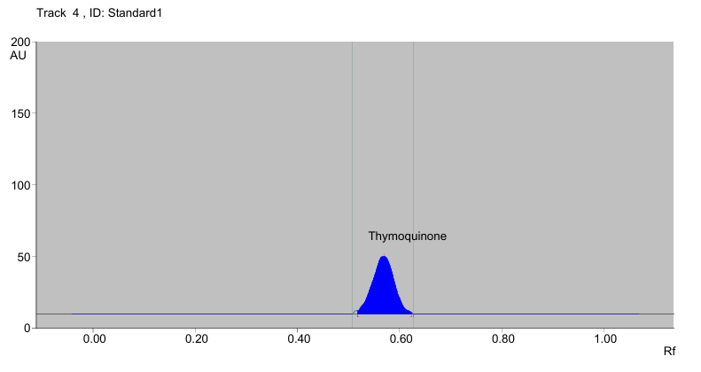
Plate 01: HPTLC chromatogram of standard thymoquinone at 254 nm

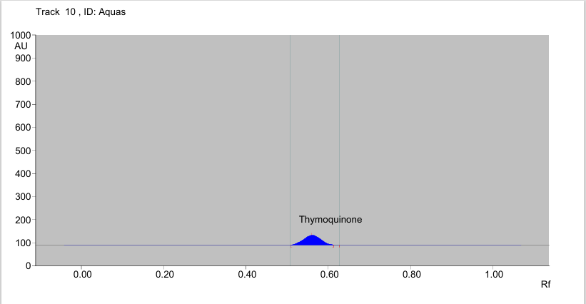

Plate 02: HPTLC chromatogram of thymoquinone in aqueous extract of herbal formulation

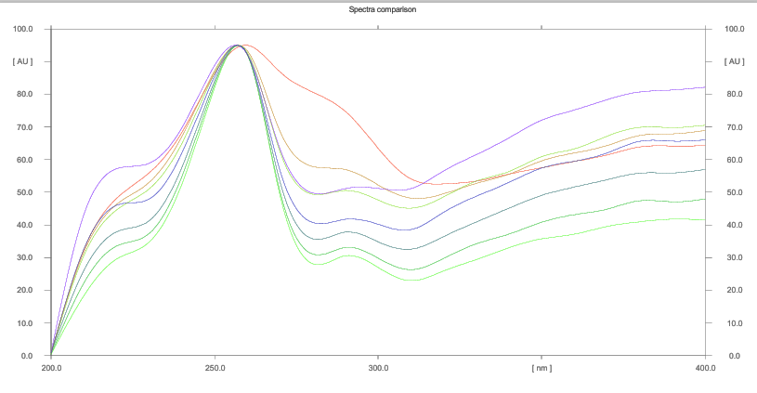

Plate 03: Superimposable spectra of thymoquinone

Arjunolic Acid
A robust and reproducible HPTLC method was developed for the quantitative estimation of arjunolic acid using a mobile phase composed of toluene:ethyl acetate:formic acid:methanol in the ratio of 6:3:1:0.1 (v/v/v/v). This optimized solvent system facilitated effective resolution of arjunolic acid from other constituents present in the herbal matrix, yielding a sharp and well-defined chromatographic band with a mean retardation factor (Rf) value of 0.36 (Plate 04 and Plate 05).
The developd method demonstrated satisfactory linearity over a concentration range of 100–500 ng in terms of peak area, confirming its suitability for quantitative analysis. Prior to chromatographic development, the chamber was saturated for 45 minutes, and a solvent migration distance of 80 mm was maintained to ensure reproducible separation and optimal spot migration. These chromatographic conditions resulted in compact and symmetrical spots, indicative of efficient analyte separation.
Densitometric scanning of the developed HPTLC plates was performed at 600 nm, and the resulting chromatograms were analyzed and compared (Plate 06). The identity of arjunolic acid in the aqueous extract of the herbal formulation was confirmed by superimposing the UV absorption spectra of the sample band with that of the corresponding reference standard. Additionally, the purity of the resolved band was established by comparing spectral profiles obtained at the beginning, apex, and end of the chromatographic spot, which confirmed the absence of co-eluting impurities.
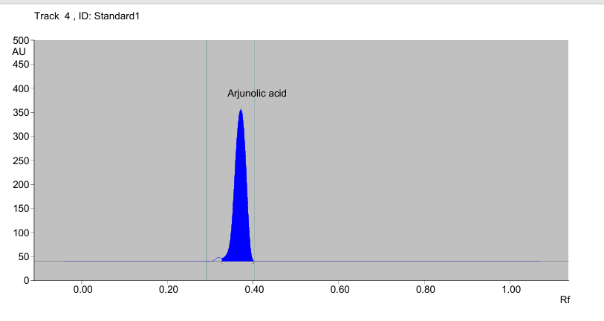
Quantitative evaluation revealed that the concentration of arjunolic acid present in the aqueous extract of the herbal formulation was 12.9 µg/g. The presence of arjunolic acid in appreciable quantity substantiates the cardioprotective and antihyperlipidemic potential of the formulation, as this triterpenoid compound is known to exert lipid-lowering effects through modulation of cholesterol metabolism, antioxidant defense mechanisms, and prevention of lipid peroxidation. These findings are in agreement with earlier reports highlighting the therapeutic significance of Terminalia arjuna in the management of hyperlipidemia and associated cardiovascular disorders.

Plate 04: HPTLC chromatogram of standard arjunolic acid at 600 nm

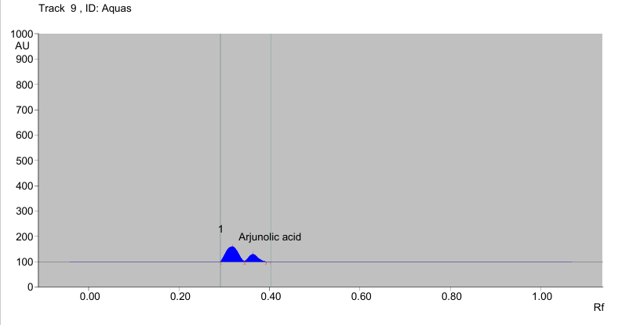

Plate 05: HPTLC chromatogram of arjunolic acid in aqueous extract herbal formulation
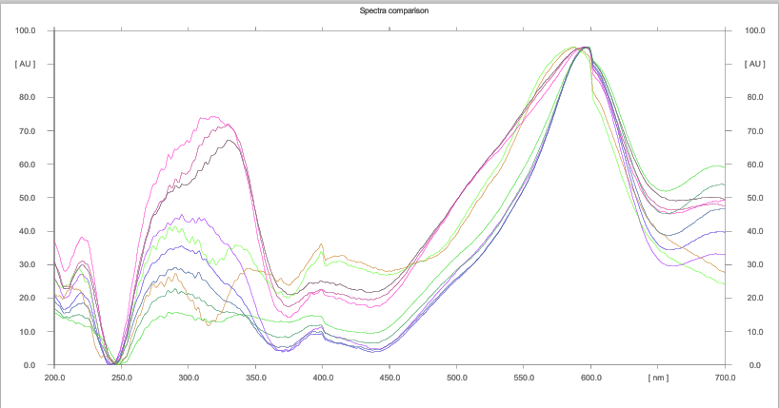

Plate 06: Superimposable spectra of arjunolic acid
Withaferin A
A sensitive and reliable HPTLC method was established for the quantitative determination of withaferin A using a mobile phase consisting of ethyl acetate:toluene:acetic acid in the ratio of 9:1.1:0.6 (v/v/v). This optimized solvent system resulted in efficient separation of withaferin A from other components of the herbal matrix, producing a sharp and compact chromatographic band with a mean retardation factor (Rf) value of 0.38 (Plate 07 and Plate 08).
The method exhibited excellent linearity over a low concentration range of 2–10 ng with respect to peak area, reflecting the high sensitivity of the analytical procedure. Prior to plate development, the chromatographic chamber was saturated for 45 minutes, and the solvent front was allowed to migrate up to a distance of 80 mm. These standardized chromatographic conditions ensured consistent migration, optimal resolution, and reproducible spot formation.
Densitometric scanning of the developed plates was performed at 220 nm, corresponding to the maximum absorbance of withaferin A, and the resulting chromatograms were analyzed and compared (Plate 09). The identity of withaferin A in the aqueous extract of the herbal formulation was confirmed by superimposing the UV absorption spectra of the sample band with that of the authentic reference standard. Furthermore, the purity of the analyte was verified by evaluating spectral congruence at the start, apex, and end positions of the chromatographic band, confirming the absence of interfering compounds.
Quantitative analysis indicated that the concentration of withaferin A present in the aqueous extract of the herbal formulation was 1.2 µg/g. Although present in relatively lower concentration, withaferin A is a highly potent bioactive steroidal lactone known for its antioxidant, anti-inflammatory, adaptogenic, and lipid-modulating properties. Its presence in the formulation likely contributes synergistically to the overall antihyperlipidemic and cardioprotective efficacy of the herbal combination by mitigating oxidative stress and regulating lipid metabolism. These findings support earlier studies emphasizing the pharmacological significance of Withania somnifera in metabolic and cardiovascular health.

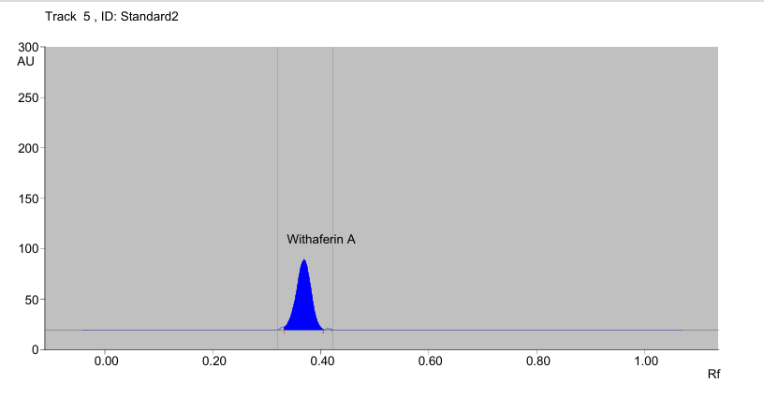

Plate 07: HPTLC chromatogram of standard withaferin A at 220 nm

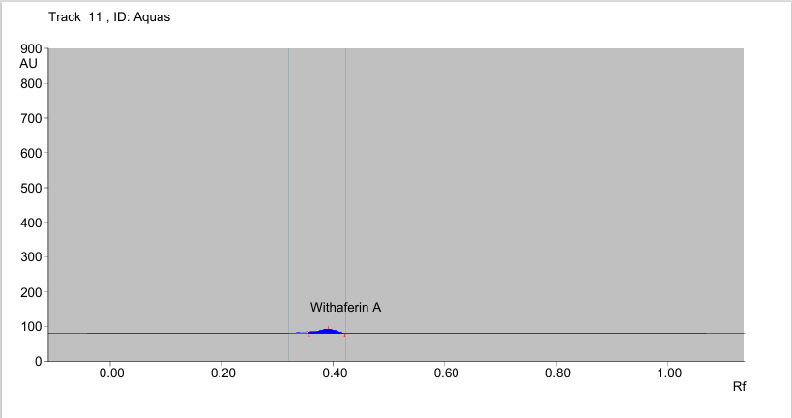

Plate 08: HPTLC chromatogram of withaferin A in aqueous extract of herbal formulation
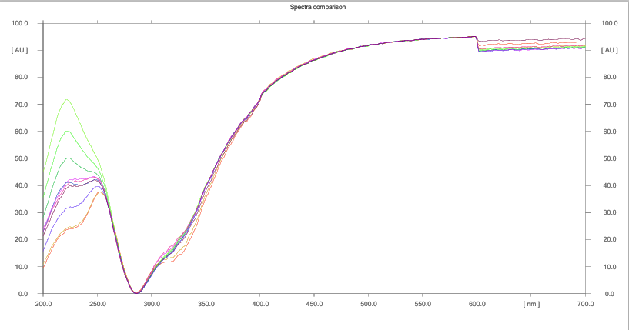

Plate 09: Superimposable spectra of withaferin A
Linolenic Acid
An optimized HPTLC method was developed for the quantitative estimation of linolenic acid using a mobile phase comprising chloroform:toluene in the ratio of 8:2 (v/v). This solvent system provided efficient separation of linolenic acid from other constituents of the herbal matrix, resulting in a distinct and compact chromatographic band with a mean retardation factor (Rf) value of 0.57 (Plate 10 and Plate 11).
The developed method exhibited satisfactory linearity over a wide concentration range of 1 ng to 5 µg with respect to peak area, demonstrating the robustness and sensitivity of the analytical procedure. Prior to chromatographic development, the chamber was equilibrated for 45 minutes, and the solvent front was allowed to migrate up to a distance of 80 mm. These standardized chromatographic conditions ensured consistent analyte migration, optimal resolution, and reproducibility of results.
Densitometric scanning of the developed HPTLC plates was carried out at 430 nm, corresponding to the maximum absorbance of linolenic acid, and the resulting chromatograms were analyzed and compared (Plate 12). The identity of linolenic acid in the aqueous extract of the herbal formulation was confirmed by superimposing the UV absorption spectra of the sample band with that of the respective reference standard. Furthermore, the purity of the analyte was established by comparing spectral profiles recorded at the start, apex, and end of the chromatographic band, thereby confirming the absence of co-eluting impurities.
Quantitative estimation revealed that the concentration of linolenic acid present in the aqueous extract of the herbal formulation was 0.1 µg/g. Although detected in relatively low concentration, linolenic acid is a biologically potent omega-3 polyunsaturated fatty acid known to exert lipid-lowering, anti-inflammatory, and cardioprotective effects. Its presence in the formulation is likely to contribute synergistically to the overall antihyperlipidemic efficacy by improving lipid profile, reducing oxidative stress, and modulating inflammatory pathways. These findings further substantiate the therapeutic relevance of Linum usitatissimum as a functional component of the herbal formulation.

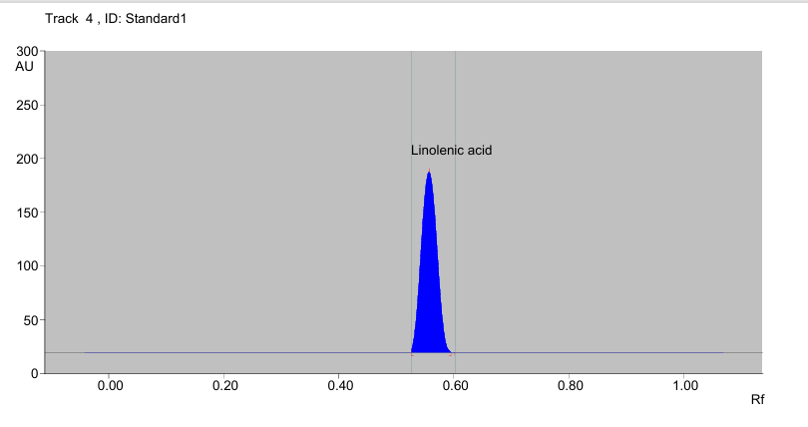

Plate 10: HPTLC chromatogram of standard linolenic acid at 430 nm

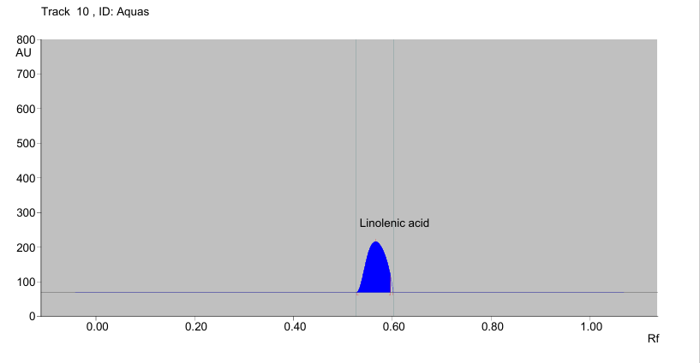

Plate 11: HPTLC chromatogram of linolenic acid in aqueous extract of herbal formulation

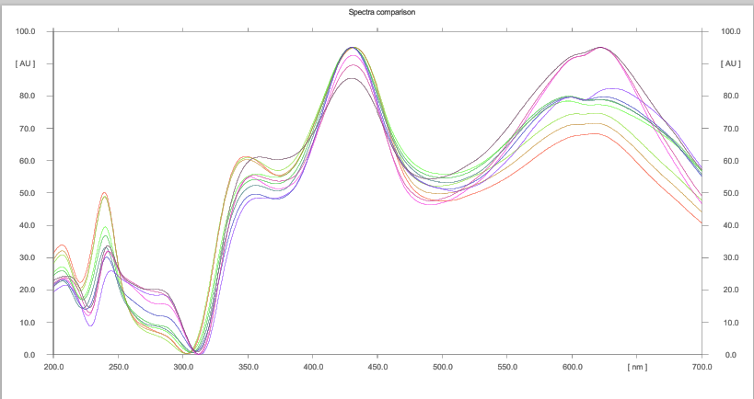

Plate 12: Superimposable spectra of linolenic acid

The concentration of various active ingredients in aqueous extract of herbal formulation was summarized in Table 1 and illustrated in Figure 01 and Figure 02.
Table 1: Concentration of active ingredients in herbal formulation
Active ingredients | Amount in µg/g
Active ingredients | Aqueous extract
Thymoquinone | 85.2
Arjunolic acid | 12.9
Withaferin A | 1.2
Linolenic acid | 0.1

Figure 01: Concentration of thymoquinone and arjunolic acid in herbal formulation

Figure 02: Concentration of withaferin A and linolenic acid in herbal formulation

The findings of the present study are in consonance with earlier reports documenting the applicability of HPTLC for phytochemical analysis. Alam et al. (2013) established a sensitive and accurate HPTLC method for the quantitative estimation of thymoquinone in Nigella sativa extracts, thereby validating the reliability of this technique for phytochemical standardization and quality assessment. In a similar context, Bharti (2021) performed an extensive phytochemical evaluation of Terminalia arjuna stem bark extracts and reported considerable variation in arjunolic acid content, ranging from 0.003 per cent to 0.54 per cent across different solvent fractions. This variation underscores the significant role of solvent selection in influencing the extraction efficiency and yield of bioactive constituents.
Collectively, these studies reinforce the significance of HPTLC as a robust, reproducible, and cost-effective analytical approach for the identification, quantification, and standardization of pharmacologically active phytoconstituents in medicinal plants. The use of HPTLC thus ensures batch-to-batch consistency, reliability, and quality control of herbal formulations, which is essential for their scientific validation and therapeutic acceptance.

CONCLUSION
The present investigation successfully established the phytochemical profile of the developed herbal formulation through the quantitative estimation of selected bioactive marker compounds using High Performance Thin Layer Chromatography (HPTLC). The analytical results unequivocally confirmed the presence of thymoquinone (85.2 µg/g), arjunolic acid (12.9 µg/g), withaferin A (1.2 µg/g), and linolenic acid (0.1 µg/g) in the aqueous extract of the formulation. The detection and quantification of these pharmacologically significant constituents validate the rational selection of plant materials and support the therapeutic relevance of the formulation in the management of hyperlipidemia.
HPTLC analysis proved to be a reliable, sensitive, reproducible, and cost-effective analytical technique for the standardization of complex herbal formulations. The optimized chromatographic conditions employed in the present study enabled effective separation, precise identification, and accurate quantification of individual marker compounds within a multi-component herbal matrix. The successful application of HPTLC further reinforces its suitability as a routine quality control tool for herbal drugs, ensuring batch-to-batch consistency and reproducibility, which are essential prerequisites for the scientific validation and regulatory acceptance of herbal medicines.
The presence of thymoquinone in the highest concentration among the quantified constituents highlights the significant contribution of Nigella sativa to the overall pharmacological potential of the formulation. Thymoquinone is widely recognized for its lipid-lowering, antioxidant, and anti-inflammatory properties, which play a crucial role in mitigating oxidative stress and regulating lipid metabolism key pathological mechanisms underlying hyperlipidemia. Its substantial concentration in the aqueous extract suggests that it may serve as a principal bioactive marker responsible for the antihyperlipidemic activity of the formulation.
Arjunolic acid, identified in appreciable quantity, further strengthens the cardioprotective profile of the formulation. As a triterpenoid saponin derived from Terminalia arjuna, arjunolic acid has been extensively reported to exert hypolipidemic, antioxidant, and myocardial protective effects. Its presence in the formulation supports the traditional use of T. arjuna in cardiovascular disorders and suggests a synergistic interaction with other bioactive constituents to enhance lipid-lowering efficacy and protect against lipid-induced oxidative damage.
Although present in comparatively lower concentrations, withaferin A represents a highly potent bioactive compound with diverse pharmacological actions. Derived from Withania somnifera, withaferin A is known for its adaptogenic, anti-inflammatory, antioxidant, and metabolic regulatory properties. Even at low concentrations, withaferin A can exert significant biological effects, particularly by modulating stress-induced metabolic disturbances and improving antioxidant defense mechanisms. Its inclusion in the formulation likely contributes to the overall therapeutic efficacy by complementing lipid-lowering effects with systemic stress modulation and immunoregulatory benefits.
Linolenic acid, an essential omega-3 polyunsaturated fatty acid obtained from Linum usitatissimum, was detected in minor quantity in the aqueous extract. Despite its low concentration, linolenic acid is biologically significant due to its well-documented role in improving lipid profiles, reducing inflammation, and supporting cardiovascular health. The presence of linolenic acid adds nutritional and functional value to the formulation and may contribute synergistically to its antihyperlipidemic action by influencing lipid metabolism and membrane stability.
The combined presence of these four bioactive markers reflects the pharmacological nature of the herbal formulation, wherein multiple constituents act through complementary and overlapping mechanisms to produce a cumulative therapeutic effect. Unlike single-molecule synthetic drugs, polyherbal formulations offer a holistic approach by targeting multiple pathways involved in disease pathogenesis, thereby enhancing efficacy while minimizing adverse effects. This multi-target strategy is particularly relevant in chronic metabolic disorders such as hyperlipidemia, which involve complex interactions between lipid metabolism, oxidative stress, inflammation, and hormonal regulation.
Furthermore, the successful quantification of marker compounds provides a scientific basis for correlating phytochemical composition with therapeutic efficacy. Such standardization is crucial for ensuring quality control, reproducibility, and safety of herbal formulations, which have traditionally faced challenges due to variability in raw materials, extraction methods, and processing conditions. The present study contributes valuable baseline data that can be utilized for formulation optimization, dosage standardization, and future pharmacological and clinical evaluations.
In conclusion, the findings of the present study substantiate the phytochemical integrity and therapeutic potential of the formulated herbal combination. The HPTLC-based quantification of thymoquinone, arjunolic acid, withaferin A, and linolenic acid not only confirms the presence of key bioactive constituents but also supports the rational use of this herbal formulation as a promising natural antihyperlipidemic agent. The study lays a strong foundation for further in vivo pharmacological investigations, mechanistic studies, and clinical trials aimed at validating efficacy, safety, and long-term therapeutic benefits. Ultimately, this work contributes to the growing body of scientific evidence supporting the integration of standardized herbal formulations into modern therapeutic strategies for the management of hyperlipidemia and associated cardiovascular disorders.
REFERENCES
Alam, P., Yusufoglu, H. and Alam, A. (2013). HPTLC densitometric method for analysis of thymoquinone in Nigella sativa extracts and marketed formulations. Asian Pacific Journal of Tropical Disease, 3(6): 467-471.
Barriga, C.V. and Fontúrbel, F.E. (2011). Cholesterol, glucose and triglycerides role in the prevalence of hyperlipidemia in dogs at higher elevations. Revista Cientifica-Facultad De Ciencias Veterinarias, 21(1): 22-26.
Bharti, S. (2021). Agro-climatic zone based identification of elite Terminalia arjuna accessions concerning to arjunolic acid production. SN Applied Sciences, 3(2): 246.
Boden, W.E., Probstfield, J.L., Anderson, T., Chaitman, B.R., Desvignesnickens, P., Koprowicz, K. and Weintraub, W. (2011). Niacin in patients with low HDL cholesterol levels receiving intensive statin therapy. New England Journal of Medicine, 365(1): 2255–2267.
Chauhan, R., Chester, K., Khan, Y., Tamboli, E. T. and Ahmad, S. (2015). Characterization of Linum usitatissimum oil obtained from different extraction technique and in vitro antioxidant potential of supercritical fluid extract. Journal of Pharmacy and Bioallied Sciences, 7(4): 284-288.
Dyer, S. M., Gomersall, J. S., Smithers, L. G., Davy, C., Coleman, D. T. and Street, J. M. (2017). Prevalence and characteristics of overweight and obesity in indigenous Australian children: A systematic review. Critical Reviews in Food Science and Nutrition, 57(7): 1365-1376.
El-Desouky, T.A. (2021). Evaluation of effectiveness aqueous extract for some leaves of wild edible plants in Egypt as anti-fungal and anti-toxigenic. Heliyon, 7(2):1-6.
Jani Dilip, K. (2011). A study of anti-hyperlipidemic activity of polyherbal formulation using various experimental animal models. Inventi Rapid: Ethnopharmacology, 2(1): 3.
Maheswari, K. U., Dilara, K., Vadivel, S., Johnson, P., & Jayaraman, S. (2022). A review on hypo-cholesterolemic activity of Nigella sativa seeds and its extracts. Bioinformation, 18(4), 343.
Patil, R. H., Prakash, K., & Maheshwari, V. L. (2011). Hypolipidemic effect of Terminalia arjuna (L.) in experimentally induced hypercholesteremic rats. Acta Biologica Szegediensis, 55(2), 289-293.
Qureshi, J.A., Zahida, M., Mirza, K.M., Agha, S., Fizza, S. and Fatima, S. (2018). Anti-hyperglycemic and anti-hyperlipidemic activity of Linum usitatissimum and Glycyrrhiza glabra extracts in streotozotocin induced diabetic rats. Asian Journal of Research in Medical and Pharmaceutical Sciences, 5(2): 1-10.
Sharma, S., Singh L, S.B. and Das, M.K. (2018). Evaluation of antihyperlipidemic activity of ethanolic extract of Withania somnifera in Triton X-100 induced hyperlipidemic rats. International Journal of Pharmacy and Biological Sciences, 8(2): 639-646.
Tomar, V., Beuerle, T. and Sircar, D. (2019). A validated HPTLC method for the simultaneous quantifications of three phenolic acids and three withanolides from Withania somnifera plants and its herbal products. Journal of Chromatography B, 1124(1): 154-160.

