Evaluation of slow freezing and vitrification methods of cryopreservation in in vitro produced buffalo embryos

ABSTRACT
This study compared re-expansion dynamics during culture of slaughtered origin bovine blastocysts cryopreserved either by slow-freezing or vitrification. Also, the extent of DNA fragmentation in re-expanded embryos were studied. Frozen-thawed (91.46%; 43/47) embryos showed a significantly lowered-expansion rate during culture after thawing compared to devitrified (96% ;48/50) embryos. The DNA fragmentation (apoptosis rate) was assessed using the TUNEL assay. TUNEL assay revealed a significantly apoptosis in frozen-thaw blastocysts compared to vitrified-devitrified group (13.73 ± 0.67 Vs 8.99 ± 0.71) however, vitrification also having high apoptosis rate as compare to fresh control blastocysts (6.60 ± 0.51). Hence, the study results suggest that the vitrification of blastocysts is causing lesser DNA fragmentation (apoptosis) and higher re-expansion and hatching rate than the slow-freezing. Indeed, vitrification is more competent suitable method than the slow freezing for cryopreservation of in vitro produced transferable buffalo embryos.
1. Introduction
In India Buffalo contributing 49 % to the milk industry. However, their reproductive efficiency is poor due to delayed puberty, silent heat, prolonged inter-calving interval, longer postpartum ovarian quiescence, seasonality and lowered conception rates particularly when bred artificially (Gordon, 1996; Singh et al., 2009). Hence many research groups and breeding agencies tried various Assisted Reproductive Technologies (ART) and its combinations to increase the number of offspring from genetically superior buffaloes in order to decrease generation interval and spread germplasm globally (Berglund, 2008). Application of superovulation and embryo transfer technologies (ETT) in the buffalo has marginal success (Madan et al., 1994). Hence, increasing interest in production of embryos using third generation ART like in vitro embryo production (IVEP) technology is a rapidly growing field in the bovine ART (Suthar, 2008; Suthar and Shah, 2009; Do et al., 2019). At the same time, it is difficult to get good recipient with optimum nutrition, reproductive health and synchronized status for IVEP practitioners. Cryopreservation techniques have been greatly improved for IVEP embryos, making on-farm transfers very convenient and facilitating the storage and shipment of these embryos. The successful storage and survival of cells depend critically on the ability to induce and reverse low temperature states in a controlled manner that minimizes or ameliorates transition-related damage (Bojic et al., 2021). So, to test the which method of cryopreservation is the best study was planned to know effect of slow-freezing and vitrification on re-expansion rate and hatching rate and apoptosis rate of frozen thawed and devitrified embryos produced from slaughter ovaries
2. Materials and methods
2.1. Experimental design
Ovaries were collected from the slaughter house and immature COCs were obtained and classified according to the classification described by Das et al., 1996. These recovered COCs were matured, fertilized and cultured. After the 72h of culture cleavage rate were checked. On 6th day of IVC, EBl, Bl and ExBl of grades I and II were segregated and allocated in three groups. The first group was maintained as a control, the second and third groups were cryopreserved either by slow freezing or vitrification and stored in LN₂. Thawing and devitrification of Bls performed and observed at 0 hr, 2 hr, 12hr, 24 hr and 48 hr for viability, re-expansion and hatching. Further from each group representative Bls were also offered to the TUNEL assay to study apoptotic index.
2.2 In vitro embryo production
Buffalo ovaries obtained from slaughterhouse facility of Ahmedabad Municipal Corporation, Ahmedabad were washed with a normal saline having 1% (w/v) antibiotic (10000 IU/ml penicillin, 10000 µg/ml streptomycin and 25 µg/ml amphotericin B; Gibco, USA; Vassena et al., 2003) and stored in isothermal container with normal saline at 34-36 °C during transit.Cumulus–oocyte complexes (COCs) were aspirated from follicles having 3 to 8 mm diameter. The COCs were classified, based on their morphology as described by Das et al., 1996. Then COCs were washed in wash media followed by 3 drops of pre-equilibrated IVM media and finally COCs were transferred into pre-equilibrated IVM media drop and placed in benchtop incubator having 5% CO_{2,} 5% O₂ and balanced N₂ with set at 38.5°C for 22 hours. The maturation of COCs were assessed based on the cumulus expansion. Matured COCs were transferred to fertilization medium. The frozen semen doses of buffalo bulls,motile spermatozoa were obtained using Semen Pre media and used at a total concentration of 02 x 10⁶ sperm/ml introduced in the IVF media drops with the COCs and incubated at 38.5°C in benchtop incubator with 5% O2, 5% CO2 and 90% N2 for 18-22 hours. After coincubation, the presumptive zygotes were washed and denuded gently to remove all the cumulus cells. Once all the zygotes were denuded, they were pre-equilibrated IVC media. After washing presumptive zygotes were transferred into pre-equilibrated IVC drops and placed in bench top incubator for 6 days.

2.3 Cryopreservation
On day six Early Blastocysts (EBl), Blastocysts (Bl) and Expanded Blastocysts (ExBl; EBL, Bl and ExBl define jointly BLs) of grade I and II were subjected to slow freezing or vitrification.

2.3.1 Slow freezing and thawing
Bls were cryopreserved using ethylene glycol (EG) and sucrose (Ref 029102; IMV France). at room temperature. Bls were segregated from IVC drops and kept in holding media and transferred to freezing media and equilibrated for 8 min at room temperature. BLs were individually mounted in 250 µL straws (Product Code 006430; IMV technologies, France), respecting proportion of 4:2:4. The first column was composed of freezing media, the second column contained embryos with freezing media and the third column was composed of freezing. The column containing Bl (EBl, Bl and ExBl) was separated from each other’s by 2-4 mm of air. The straws were closed with marker stick, marked with the details of the Bl as per formats prescribed by IETS and immediately straws were loaded in pre-cooled cryochamber of the freezing machine. Straws were placed in the cryochamber of the freezer (Crysalys, IMV technologies, France), and commanded as start, after 8 min equilibration time at −6 °C. The seeding was manually induced at -6 °C. Post-seeding the command start was given so that the temperature dropped to -32°C at a rate of −0.5°C/min., and hold the embryos at -32°C. At the end of the program, straws were directly plunged in LN₂ and stored until thawing was performed.
For thawing the Bls, the straws were exposed to RT in air for 10 sec and then plunged into the water bath at 32°C for 30 sec and transferred to IVC medium and incubated in bench top incubator for re-expansion and hatching.

2.3.2 Vitrification and warming
Bls were vitrified using vitrification kit (Vitrogen, Brazil) at the room temperature 25°C as directed in manufacturer’s guideline. Briefly vitrification media V1 and V2 were drawn out from the vitrification kit for each batch of embryos in 2 ml centrifuge tubes and warmed at room temperature for around 30 minutes. BLs were transferred to V1 media for 8 minutes. Subsequently BLs were transferred to V2 media drop and equilibrated for 40 seconds. After transferring in V2 media drop, BLs loaded immediately in vitrification device and extra media was removed using denuding pipette and keeping it as little as approximately 0.3 μl on the tip of the device. The device was then plunged immediately into LN₂ and closed with precooled lid. Subsequently, the device was transferred into pencil goblet in canisters of LN₂ tank for storage till devitrification.
Warming was of vitrified Bls were performed using de-vitrification media (Vitrogen, Brazil) as per the manufacturer’s guideline briefed hereafter. Micro drops were prepared with D1, D2 and D3 in 100 mm Petri dish. The vitrified devices were open within LN₂ and then immediately were kept in D1 drop. The BLs were recovered by observing under stereo zoom microscope and kept for 1 min. Subsequently, the Bls were transferred using denuding pipette in D2 for 3 minutes and D3 for 5 minutes. Bls were subsequently transferred to IVC for re-expansion, hatching rate for further analyses.

2.4 TUNEL assay
TUNEL assay was performed following the manufacturer’s instructions (APO-BrdU TUNEL Assay Kit, Molecular Probes, Invitrogen, Catalog number A23210). In brief, bovine embryos were washed twice in wash buffer (ABO-BRDU Kit) along with 1% polyvinylpyrrolidone (PVP) then Bls were fixed in 4% paraformaldehyde (PFA) in PBS at RT for 60 min. After washing Bls permeabilized with 0.5% triton-x 100 for 30min at RT wash again in DPBS. Treat the sample with DNA labeling solution for 60 min at 37°C for incubation on orbital shaker. At the end of incubation embryo were rinsed with rinse buffer. After washing twice in rinse buffer (ABO-BRDU Kit), embryos were incubated in the dark for 30 min at room temperature with antibody solution (fluorescein-labeled anti-BrdU monoclonal antibody and rinse buffer). Countered stained with 0.5% Propidium iodide (PI) for 30 min in darkroom at RT. TUNEL-positive nuclei appeared bright yellowish-green and the PI staining allowed counting the total cell number and identification, localization and quantification of normal, fragmented or condensed nuclei. Bls of the positive control were treated with DNase solution (100 U/mL) for 30 min at 37°C before incubation with DNA labeling solution. In negative control, the step of antibody labelling was excluded in this assay.
3. Results and Discussion
3.1 Cleavage and blastocyst rate
In the present study, total 1640 presumptive zygotes were kept in IVC medium, after 72 h total 1015 presumptive zygotes were cleaved, with observed cleavage rate of 63.1%; 1015/1640) and 295 (20%; 295/1640) reached either early blastocysts or blastocyst stages (BLs) on day 6.
3.2 Re-expansion rate of blastocysts using different cryopreservation methods
The vitrification of Bls is elucidated in Figure 1. To observe re-expansion rate 47 frozen-thawed and 50 vitrified-devitrified BLs were used. The significant effect of hours was observed on re-expansion rate in both the frozen-thawed and vitrified-devitrified BLs (Figure 1). In both groups most, re-expansion of BLs was occurred at 2h, followed by 12h and 24h (P < 0.05). Further higher re-expansion rate was achieved in vitrified-devitrified BLs than the slow-freezing BLs (P <0.001). The representative pictures of re-expansion of fresh, after frozen-thawed and devitrification is elucidated in Figure.2, 3 and 4, respectively. The re-expansion rate at 2h of frozen-thawed BLs was 74% which was significantly lower than devitrified BLs (84%: P = 0.0001; Table 1). Further the total re-expansion rate of frozen thawed BLs was 91.46% which was significantly lower than devitrified BLs (96%: P = 0.001; Figure 1).
3.3 Hatching rate of blastocysts using different cryopreservation methods
To observe hatching rate 47 frozen-thawed BLs, 50 vitrified-devitrified and 34 fresh BLs were examined for their hatching rate at 2h, 12h, 24h and 48 h. An effect of hours was observed on hatching rate of BLs in all three groups (P < 0.05; Table.2) and higher hatching rate observed between 24 h to 48 h in all three groups (P = 0.001). The higher hatching rate was observed in fresh (79.41%) than the vitrified-devitrified (76%) and frozen-thawed (68.09 %; P < 0.001). Further higher hatching rate was observed in vitrified-devitrified BLs (76%) than the frozen-thawed BLs (68.09 %; P < 0.05).
3.4 Apoptotic index in fresh, frozen-thawed and vitrified-devitrified blastocysts
In the present study, 47 frozen-thawed BLs, 50 vitrified-devitrified and 34 fresh BLs were examined for apoptosis rate using TUNEL assay. Fresh groups BLs demonstrated lower TUNEL reacted cells compared to freeze-thaw and vitrified-devitrified Bls (P < 0.005; Table 4). Further freeze-thaw Bls demonstrated significantly higher apoptosis rate than the vitrified-devitrified Bls (P < 0.05). Similarly, ICM and TE cells in fresh Bls demonstrated significantly lower TUNEL positive (reacted) cells than in ICM and TE cells of freeze-thaw and vitrified-devitrified BLs (P < 0.05). Further ICM and TE cells of freeze-thaw Bls demonstrated significantly lower TUNEL positive (reacted) cells than in ICM and TE cells of vitrified-devitrified BLs (P < 0.05).
4. Conclusions
The following conclusions are drawn from the present study
- In the present study COCs recovery rate was 2.6 per ovary, cleavage rate was 63.1% and blastocyst rate was 20% (n=295).
- Effect of hours was observed on re-expansion, blastocyst rate and apoptosis rate in both cryopreservation methods treated blastocysts. The study revealed vitrified-devitrified embryos demonstrated significantly higher re-expansion rate than the slow-freezing treated blastocysts.
- In this study frozen thawed and vitrified-devitrified Bls hatching observed during 12 to 24 h. The fresh (Control) group blastocysts has demonstrated significantly higher hatching rate compared with the Bls treated with frozen-thawed or vitrified-devitrified cryopreservation methods. Further vitrified-devitrified Bls demonstrated significantly higher hatching rate compared with frozen-thawed blastocysts.
- TUNEL assay demonstrated significantly higher number of apoptotic cells in frozen-thawed blastocyst then the vitrified-devitrified or control group blastocysts. Overall control group demonstrated lower number of apoptotic cells then the vitrified or frozen-thawed blastocysts.
- Overall vitrified-devitrified blastocysts having more competence than the frozen-thawed blastocyst and appears more suitable method for cryopreservation of IVEP transferable embryos.

Table.1. Number of presumptive zygotes in IVC and their cleavage and blastocyst rate
achieved during 29 sessions
Sr No | Zygote in IVC | No. of zygote cleaved | Cleavage rate | No. of Blastocyst | Blastocyst %
1 | 47 | 37 | 78.7 | 14 | 29.79
2 | 20 | 15 | 75 | 8 | 40
3 | 36 | 29 | 80.6 | 13 | 36.11
4 | 63 | 40 | 63.5 | 8 | 12.7
5 | 75 | 60 | 80 | 10 | 13.33
6 | 102 | 77 | 75.5 | 14 | 13.73
7 | 36 | 24 | 66.7 | 12 | 33.33
8 | 41 | 30 | 73.2 | 9 | 21.95
9 | 75 | 31 | 41.3 | 11 | 14.67
10 | 50 | 28 | 56 | 10 | 20
11 | 58 | 37 | 63.8 | 12 | 20.69
12 | 62 | 32 | 51.6 | 10 | 16.13
13 | 78 | 48 | 61.5 | 7 | 8.97
14 | 98 | 61 | 62.2 | 14 | 14.29
15 | 53 | 26 | 49.1 | 16 | 30.19
16 | 69 | 36 | 52.2 | 6 | 8.7
17 | 78 | 31 | 39.7 | 8 | 10.26
18 | 34 | 26 | 76.5 | 12 | 35.29
19 | 59 | 29 | 49.2 | 11 | 18.64
20 | 43 | 27 | 62.8 | 9 | 20.93
21 | 47 | 36 | 76.6 | 11 | 23.4
22 | 53 | 29 | 54.7 | 12 | 22.64
23 | 47 | 30 | 63.8 | 6 | 12.77
24 | 49 | 36 | 73.5 | 6 | 12.24
25 | 61 | 34 | 55.7 | 6 | 9.84
26 | 58 | 29 | 50 | 9 | 15.52
27 | 53 | 34 | 64.2 | 10 | 18.87
28 | 49 | 30 | 61.2 | 11 | 22.45
29 | 46 | 33 | 71.7 | 10 | 21.74
Total | 1640 | 1015 | 63.1 % | 295 | 20 %
(Mean ± SE) | (56.55 ± 3.33) | (35 ± 2.27) | (63.10±2.09) | (10.17 ±0.49) | (19.97 ± 1.58)

Figure 1. Re-expansion rate of devitrified and frozen thawed blastocysts

Figure.2. Re-expansion of blastocysts after the devitrification and thawing
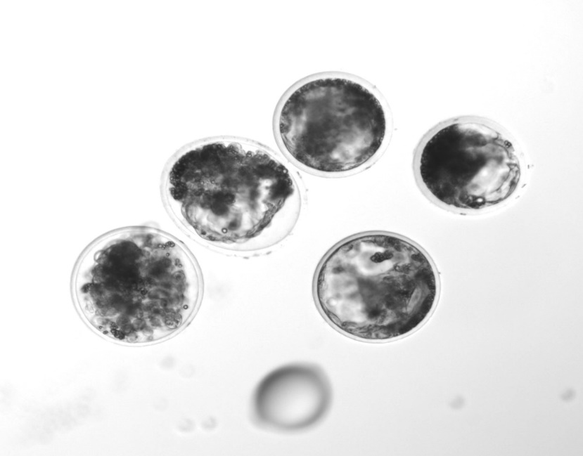
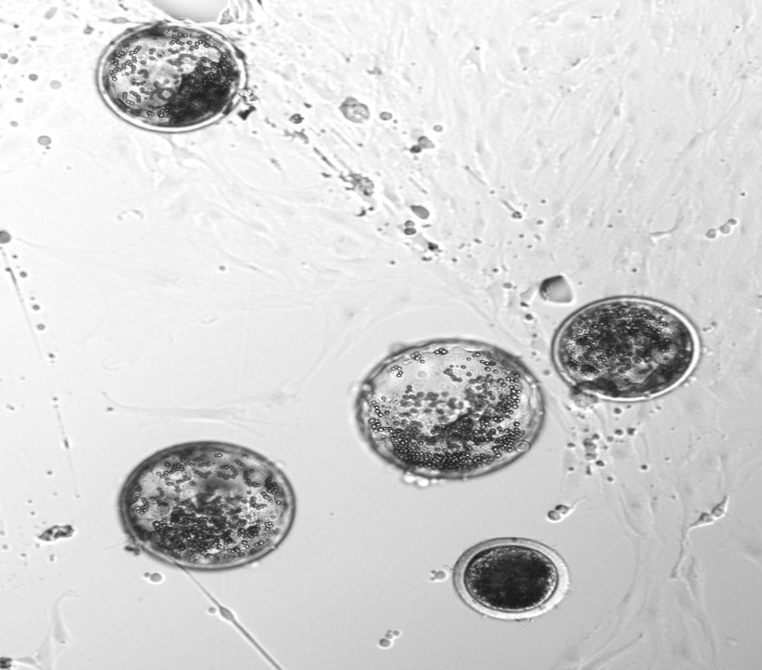

Re-expansion of devitrified blastocysts Re -expansion of thawed blastocysts
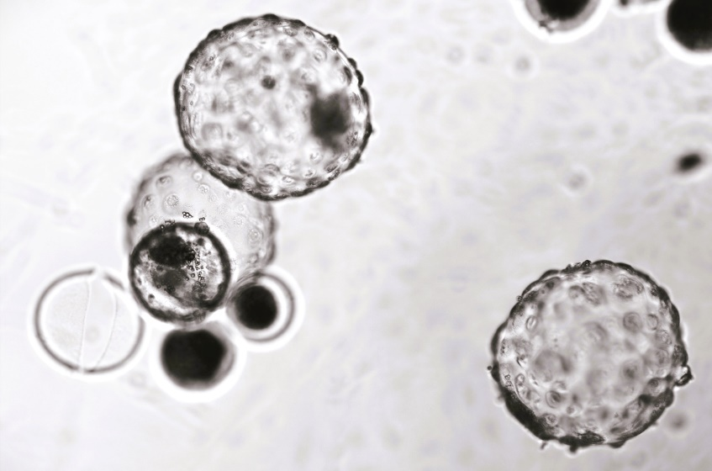
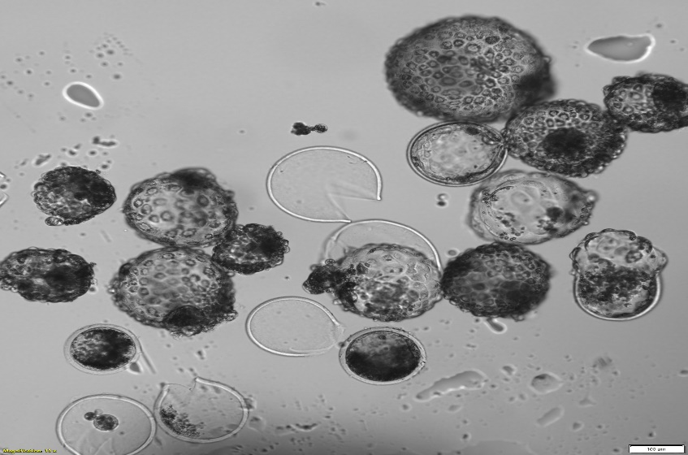
Figure 3. Hatching of fresh and vitrified group

\
Fresh hatched blastocysts Vitrified hatched blastocysts

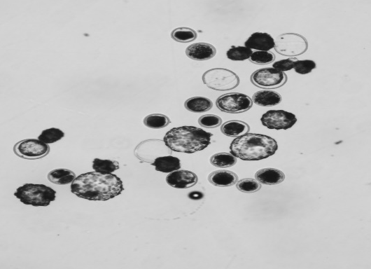
Figure.4. Hatching in slow freezing group

Slow freezing hatched blastocysts

Figure.5. Line chart showing hatching rate of devitrified and frozen thawed blastocysts

Table.2. Re-expansion rate of devitrified or frozen thawed blastocysts
Group | N | Re-expansion (2h) | Re-expansion (12h) | Re-expansion (24h) | Total  re-expansion
Vitrification | 50 | 41 (82%) ª | 4 (8%) ª | 3 (6%) ª | 48 (96.0%) ª
Slow frozen | 47 | 35 (74%) ^{b} | 5 (10.6%) ª | 3 (6.38%) ª | 43 (91.49%) ^{b}
^{a,b} Colum with different superscripts differ significantly at 0.05 level.

Table.3. Hatching rate (%) of devitrified and frozen thawed Blastocysts
Group | Number of BLs | Hatching (2h) | Hatching (12h) | Hatching (24h) | Hatching (48h) | Total hatched
Fresh  (N; %) | 34 | 0 | 2  (5.88) | 13  (38.24) | 12  (35.3) | 27 (79.41)ª
Vitrification  (N; %) | 50 | 0 | 0 | 10  (20) | 28  (56.0) | 38 (76.0)^{b}
Slow freezing  (N; %) | 47 | 0 | 0 | 9  (19.15) | 23  (48.9) | 32 (68.09)^{c}
^{a,b} Colum with different superscripts differ significantly at 0.05 level.

Table.4. Apoptosis rate in inner cell mass (ICM) and trophectoderm (TE) cells in fresh, vitrified and slow frozen blastocysts using
TUNEL assay
Group | No. | ICM | T +ve ICM | TE | T +ve TE | Total cells | T +ve | Apoptotic index
Fresh | 35 | 42.01 ± 0.79ª | 2.84 ± 0.28 ª | 100.98 ± 0.85ª | 6.50 ± 0.514ª | 142.99 ± 1.17ª | 9.34 ± 0.67 ª | 6.60 ± 0.51 ª
Vitrified | 20 | 36.2 ± 1.1^{b} | 3.15 ± 0.39 ª | 98.43 ± 1.83ª | 8.79 ± 0.72^{b} | 134.63 ±1.63^{b} | 11.94 ± 0.94 ^{b} | 8.99 ± 0.71 ^{b}
Slow frizzing | 24 | 27.89 ± 1.03^{c} | 2.76 ± 0.37ª | 95.91 ± 1.11^{b} | 14.23 ± 0.67^{c} | 123.80 ± 1.53^{c} | 16.99 ± 0.88^{c} | 13.73 ± 0.67^{c}
TUNEL positive inner cell mass: T +ve ICM; TUNEL positive Trophectoderm cells: T+ve TE; Total TUNEL positive: T +ve
^{a,b,c} Colum with different superscripts differ significantly at 0.05 level.

REFERENCES
Berglund, B. (2008). Genetic improvement of dairy cow reproductive performance. Reproduction in domestic animals, 43, 89-95.https://doi.org/10.1111/j.1439-0531.2008.01147.x
Bó, G. A., & Mapletoft, R. J. (2013). Evaluation and classification of bovine embryos. Animal Reproduction (AR), 10(3), 344-348.
Bojic, S., Murray, A., Bentley, B. L., Spindler, R., Pawlik, P., Cordeiro, J. L., & De Magalhães, J. P. (2021). Winter is coming: the future of cryopreservation. BMC biology, 19(1), 1-20.
Das, G. K., Jain, G. C., Solanki, V. S., & Tripathi, V. N. (1996). Efficacy of various collection methods for oocyte retrieval in buffalo. Theriogenology, 46(8), 14031411. https://doi.org/10.1016/S0093-691X(96)00319-6
de Andrade Melo-Sterza, F., & Poehland, R. (2021). Lipid metabolism in bovine oocytes and early embryos under in vivo, in vitro, and stress conditions. International Journal of Molecular Sciences, 22(7), 3421.
https://doi.org/10.3390/ijms22073421
De Rosa, A., Di Palo, R., Attanasio, L., Monaco, E., Campanile, G., & Gasparrini, B.
(2006). 89 OPEN PULLED STRAW VITRIFICATION FOR IN VITROPRODUCED BUFFALO (BUBALUS BUBALIS) EMBRYOS. Reproduction,
Fertility and Development, 18(2),153-153. https://doi.org/10.1071/rdv18n2ab89
Do, V. H., Catt, S., Kinder, J. E., Walton, S., & Taylor-Robinson, A. W. (2019). Vitrification of in vitro-derived bovine embryos: targeting enhancement of quality by refining technology and standardizing procedures. Reproduction, Fertility and Development, 31(5), 837-846. https://doi.org/10.1071/rd18352
Gordon, I. 1996. Controlled reproduction in cattle and buffaloes. CABI, Wallingford, UK. vol. 1. pp. 452.

Madan, M. L., Chauhan, M. S., Singla, S. K., & Manik, R. S. (1994). Pregnancies established from water buffalo (Bubalus bubalis) blastocysts derived from in vitro matured, in vitro fertilized oocytes and co-cultured with cumulus and oviductal cells. Theriogenology, 42(4), 591-600. https://doi.org/10.1016/0093-691X(94)90376-
T
Sanches, B. V., Marinho, L. S. R., Pontes, J. H. F., Basso, A. C., Meirinhos, M. L. G., Silva-Santos, K. C., & Seneda, M. M. (2013). Cryosurvival and pregnancy rates after exposure of IVF-derived Bos indicus embryos to forskolin before vitrification.
Theriogenology, 80 (4), 372-377.
https://doi.org/10.1016/j.theriogenology.2013.04.026
Singh, B., Chauhan, M. S., Singla, S. K., Gautam, S. K., Verma, V., Manik, R. S., ... & Mukesh, M. (2009). Reproductive biotechniques in buffaloes (Bubalus bubalis): status, prospects and challenges. Reproduction, Fertility and Development, 21(4), 499-510. https://doi.org/10.1071/RD08172
Sudano, M. J., Paschoal, D. M., da Silva Rascado, T., Magalhães, L. C. O., Crocomo, L. F., de Lima-Neto, J. F., & da Cruz Landim-Alvarenga, F. (2011). Lipid content and apoptosis of in vitro-produced bovine embryos as determinants of susceptibility to vitrification. Theriogenology, 75(7), 1211-1220.
https://doi.org/10.1016/j.theriogenology.2010.11.033
Suresh, K. P., Nandi, S., & Mondal, S. (2009). Factors affecting laboratory production of buffalo embryos: a meta-analysis. Theriogenology, 72(7), 978-985.
https://doi.org/10.1016/j.theriogenology.2009.06.017
Suthar, V. S. (2008). In vitro embryo production (IVEP) through transvaginal ultrasoundguided aspiration of follicles in crossbred cattle. M. V. Sc (Doctoral dissertation, Thesis submitted to Anand Agricultural University).
Suthar, V. S., & Shah, R. G. (2009). Bovine In vitro embryo production: an overview. Veterinary world, 2(12), 478-479.
Tajimi, H., Yamazaki, T., Oike, S., Yoshida, T., Okada, K., Kuwayama, M., & Ushijima,
H. (2018). Vitrification for bovine embryos with low‐quality grade. Animal Science Journal, 89(8), 1194-1200.https://doi.org/10.1111/asj.13024
Vassena, R., Mapletoft, R. J., Allodi, S., Singh, J., & Adams, G. P. (2003). Morphology and developmental competence of bovine oocytes relative to follicular status. Theriogenology, 60(5), 923-932.https://doi.org/10.1016/S0093691X(03)00101-8

