Original Research Article
Production of Lignocellulolytic Enzymes by Bacillus albus strain BCA3 Isolated from Biogas Slurry under Different Substrate Conditions

ABSTRACT
Lignocellulolytic enzymes, such as Carboxymethyl cellulase (CMCase), filter paper activity (FPase), and β-Glucosidase (BGL), amylase, and xylanase, are essential for the efficient degradation of lignocellulosic biomass into fermentable sugars. In this study, the production of these enzymes by Bacillus albus strain BCA3, isolated from biogas slurry, was investigated under different substrate conditions. The bacterium was grown on various NaOH-treated lignocellulosic substrates (rice straw, wheat straw, and corn cobs) and analytical grade substrates (CMC, filter paper, birchwood xylan, soluble starch and cellobiose). Enzyme production was assessed in minimal salt medium (MSM) supplemented with analytical-grade substrate or pretreated biomass as the sole carbon source. Results indicated that CMCase, CS, and BGL production were highest in the presence of corn cob among lignocellulosic substrates, with CMCase reaching 17.63 ± 0.055 U/g, FPase 14.14 ± 0.162 U/g, and BGL 45.42 ± 0.52 U/g, respectively. Wheat straw also supported substantial enzyme production, particularly for amylase (29.15 ± 0.713 U/g), while rice straw showed delayed enzyme induction, likely due to its dense lignin content. Xylanase production was maximum at 228.95 ± 5.36 U/g in xylan-supplemented media, but was lower in biomass-based media, with wheat straw supporting the highest production (7.11 ± 0.148 U/g). The study highlights the significant substrate-specific differences in enzyme induction and production, with corn cob being the most effective low-cost inducer of cellulolytic and glucanase activities. Overall, the results demonstrate the potential of the Bacillus albus strain BCA3 for lignocellulosic biomass degradation, particularly when using pretreated agricultural residues, providing insights into the optimisation of enzyme production for biotechnological applications in biofuel production and waste management.
Keywords: Bacillus albus; lignocellulolytic enzymes; CMCase; FPase; β-glucosidase; xylanase; amylase; biomass degradation; agricultural residues; biogas slurry; biofuel production.
1. INTRODUCTION
Microorganisms are the primary source of industrial enzymes due to their rapid growth, genetic tractability, and diverse metabolic capabilities (Zhang et al., 2021). Among them, bacteria from the genus Bacillus are particularly noteworthy for their ability to secrete a wide array of robust extracellular enzymes, including cellulases, xylanases, and amylases (Paul et al., 2023). Species such as Bacillus subtilis and Bacillus cereus have been extensively studied for their lignocellulolytic potential (Liu et al., 2024). More recently, Bacillus albus has emerged as an effective producer of cellulases with promising characteristics for industrial applications, such as biofuel production (Ullah et al., 2025). Isolating novel strains from unique ecological niches, such as agricultural waste environments, can lead to the discovery of enzymes with superior catalytic properties (Cai et al., 2024).

Biogas slurry, a nutrient-rich effluent of anaerobic digestion, has been recognised for its agricultural value, particularly in enhancing soil fertility and crop yields (Mgxaji et al., 2025). This effluent offers a sustainable alternative to synthetic fertilisers by supplying readily available nitrogen, phosphorus, potassium, dissolved organic carbon, and beneficial metabolites, thereby enhancing microbial activity and promoting plant growth (Mgxaji et al., 2025). In addition to this, it also harbours a complex and metabolically active microbiome dominated by members of Firmicutes, Bacteroidetes/Bacteroidota, Proteobacteria, Chloroflexi, Actinobacteria, and methanogenic archaea, many of which are directly involved in the hydrolysis and degradation of complex lignocellulosic materials (Kumar et al., 2022; Nguyen et al., 2018). These taxa give rise to hydrolytic enzymes responsible for degrading cellulose, hemicellulose, and other polysaccharides, indicating that biogas slurry is a rich reservoir of lignocellulose-degrading microorganisms with industrial potential (Rana et al., 2025).

Although cultivation and sequencing-based studies indicate that biogas systems harbour diverse hydrolytic microbes with strong cellulolytic and xylanolytic abilities, offering promising prospects for enhancing the degradability of recalcitrant lignocellulosic feedstocks (Jensen et al., 2021; Poszytek et al., 2016). However, direct isolation and detailed characterisation of lignocellulose-degrading bacteria from biogas slurry remain limited, especially regarding their application as enzyme producers for biomass valorisation. This gap highlights the need to explore biogas slurry as a reservoir of potent microbial enzymes. In this point of view, Bacillus species are particularly attractive due to their robust extracellular enzyme production and substrate adaptability. Therefore, a Bacillus albus strain BCA3 isolated from biogas slurry is hypothesised to possess an efficient lignocellulolytic enzyme system capable of degrading agricultural residues effectively.

This study focuses primarily on Bacillus albus strain BCA3 potential for producing a wide array of lignocellulolytic enzymes, including CMCase, FPase, BGL, xylanase, and amylase. The production of these enzymes will be assessed under different cultivation conditions: a defined minimal salt medium with specific substrates to understand induction, and a minimal medium supplemented with different lignocellulosic biomass to simulate a practical application for agricultural waste valorisation. The findings from this research aim to elucidate the enzymatic capabilities of this novel isolate and assess its potential as a biocatalyst for the efficient bioconversion of lignocellulosic materials.

2. MATERIALS AND METHODS
2.1 Bacterial strain and preparation of inoculum
Bacillus albus strain BCA3 (16S rRNA gene sequence deposited in GenBank under accession number PV444460), isolated from biogas slurry collected from a biogas plant at Nagla, G.B.P.U.A.T., Pantnagar, Uttarakhand, was employed for the production of lignocellulolytic enzymes. The bacterial culture was routinely maintained on nutrient agar slants at 4 °C and periodically subcultured prior to experimental use. For inoculum preparation, a single colony of B. albus strain BCA3 was transferred into Luria Bertani (LB) broth and incubated at 35 °C with shaking at 180 rpm for 18–24 h to attain the exponential growth phase. The actively growing culture was then standardised to an optical density (λ₆₀₀) of 0.8 and used as the inoculum for subsequent experiments, following the method described by Abada et al. (2021).

2.2 Lignocellulosic substrate preparation
Rice straw, Wheat straw and Corn cobs were collected from the Crop Research Centre (CRC), G.B.P.U.A.T., Pantnagar, U.S. Nagar, Uttarakhand, India. These biomasses were washed thoroughly to remove soil and debris, oven-dried at 60 °C, and milled to a particle size of approximately 2-5mm. Each biomass at 1% (w/v) was then pretreated with 1% (w/v) NaOH and incubated overnight at room temperature. After pretreatment, the biomass was washed repeatedly with water and subsequently rinsed with 0.1N HCl until the filtrate reached a neutral pH (6.8–7.0). The neutralised biomass was dried and used as a substrate for enzyme production experiments (Chen et al., 2013). Analytical grade substrates were used for enzyme induction and assays, including carboxymethyl cellulose (CMC) for CMCase, Whatman No. 1 filter paper for FPase, birchwood xylan for xylanase, cellobiose for BGL and soluble starch for amylase.

2.3 Culture media and experimental design
The effect of different nutrient environments on lignocellulolytic enzyme production was evaluated in minimal Salt Medium (MSM) contained KH₂PO₄ (1.5g/L), K₂HPO₄ (3.5 g/L), MgSO₄·7H₂O (0.2g/L), NaCl (0.5g/L), and (NH₄) ₂SO₄ (1.0 g/L). The medium was supplemented with 1% (w/v) CMC, xylan, starch, or cellobiose and 0.5% (w/v) filter paper, depending on the enzyme to be assessed (Abada et al., 2021). Each 150 mL Erlenmeyer flask contained 20 mL of medium, inoculated with 1% (v/v) bacterial suspension, and incubated at 37°C, 150 rpm for up to 72-120 hours. In another set of experiments, minimal Salt Medium was amended with 1% (w/v) pretreated biomass (1% NaOH) as the sole carbon source. Cultures were incubated at 37 °C, pH 7 in SSF with moistioning ratio of 1:10 for 72–120 h with periodic sampling for enzyme analysis (Anu et al., 2020).

2.4 Enzyme extraction and assay
At designated intervals (24-120 h), 5 mL aliquots of culture broth were collected and centrifuged at 10,000 rpm for 10 min at 4 °C. The cell-free supernatant was used as the crude enzyme source for all biochemical assays. In the case of SSF substrate, the enzymes were extracted by mixing 20 mL of distilled water and 0.1% (v/v) Tween 80 at 35°C, 150 rpm for 1 h. After incubation, the mixture was centrifuged at 10,000 rpm for 10 min at 4°C. The resulting supernatant was collected and used for subsequent enzyme production (Anu et al., 2020). CMCase production was determined using 1% (w/v) CMC in 50 mM citrate buffer (pH 5.0). The reaction mixture (0.5 mL enzyme extract + 0.5 mL substrate) was incubated at 50 °C for 30 min, and the reducing sugars released were estimated using the dinitrosalicylic acid (DNS) method. FPase production was measured following the IUPAC standard procedure using a Whatman No. 1 filter paper strip (1 × 6 cm). The reaction was incubated at 50 °C for 60 min, and the liberated sugars were quantified by the DNS method (Chen et al., 2024) (Abada et al., 2021). BGL production was assessed using p-nitrophenyl β-D-glucopyranoside (pNPG) as the substrate. After incubation at 50 °C for 10 min, the reaction was stopped with sodium carbonate, and absorbance was measured at 405 nm (Rana et al., 2025). Xylanase production was determined using 1% (w/v) birchwood xylan in citrate buffer (pH 5.0). After incubation at 50 °C for 30 min, reducing sugars were quantified using DNS reagent (Bombardi et al., 2024). Amylase production was evaluated using 1% (w/v) soluble starch under the same reaction conditions as CMCase, followed by DNS quantification of reducing sugars (Almanaa et al., 2020). One enzyme unit (U) was defined as the amount of enzyme required to release 1 µmol of reducing sugar or 1 μmol p-nitrophenol per minute under the assay conditions and then normalised into U/g substrate.

2.5 Statistical analysis
All assays were performed in triplicate, and results were expressed as mean ± standard error. Data were subjected to one-way analysis of variance (ANOVA) to compare enzyme production across the culture conditions. When applicable, Tukey’s honestly significant difference (HSD) post hoc test was used for multiple comparisons. Differences were considered statistically significant at P = .05.

3. Results and discussion
Lignocellulosic enzymes, such as CMCase (Carboxymethyl cellulase), FPase (filter paperase), BGL, Amylase, and Xylanase, are critical for the degradation of lignocellulosic biomass. These enzymes are produced by various microorganisms (fungi, bacteria) as part of their metabolic processes to break down complex lignocellulosic polymers into simpler sugars, which can then be utilised as carbon sources for growth and energy production. The production of these enzymes from the Bacillus albus strain BCA3 varies under different substrate conditions due to biochemical and physiological responses of this bacterium to the availability of substrate.

3.1 CMCase production
In the CMC-supplemented minimal media, CMCase production initiated early and increased progressively with growth, rising from 18.5 ± 0.449 U/g of substrate at 6 h to a maximum of 77.945 ± 1.095 U/g at 36 h (Fig. 1). Although this peak is slightly lower than the ~90 U/g (converted from U/mL) reported at 72 h for Bacillus subtilis SL9-9 by Kim et al. (2012). The variation in the result could be from different strain and methodologies used. In contrast, CMCase production on lignocellulosic substrates was slower and substrate-specific (Fig. 2). Optimum production was found at 72–96 h, with corn cob producing the highest CMCase (17.63 ± 0.055 U/g), followed by wheat straw (10.23 ± 0.229 U/g) and rice straw (9.21 ± 0.143 U/g). The delayed enzyme induction is commonly due to the heterogeneous and recalcitrant structure of biomass, which requires initial extracellular enzyme secretion before fermentable sugars become accessible (Himmel et al., 2007; Sun & Cheng, 2002). Comparable studies show similarly modest biomass-induced activities in Bacillus strains, for example, B. subtilis AS3 produced only 0.75 U/mL cellulase, while B. subtilis JJBS300 reached ~9.7 U/g on a wheat bran–rice straw mix (Anu et al., 2020). CMCase production in analytical grade was approximately 4–7 times higher than biomass-based activities, which is supported by literature showing that CMC is far more accessible than native cellulose in biomass (Blanch et al., 2011). Corn cob was found superior for the induction of CMCase (17.63 ± 0.055 U/g) which may be due to its high cellulose and low lignin content (Kumar et al., 2009), which enhances cellulase accessibility and induction.
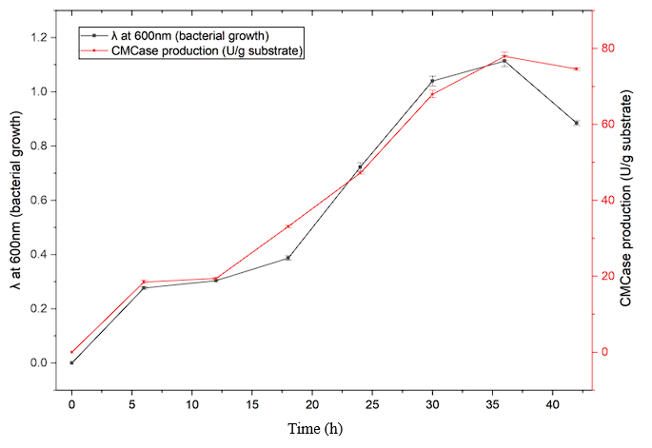
Fig. 1. Time-course relationship between bacterial growth and CMCase production by Bacillus albus strain BCA3 grown on CMC-supplemented minimal media. Bacterial growth was monitored at λ 600nm (left Y-axis), and CMCase production was expressed as units per gram of substrate (U/g; right Y-axis). Data represent mean values of three independent biological replicates (n = 3), and error bars indicate mean ± standard error (SE).
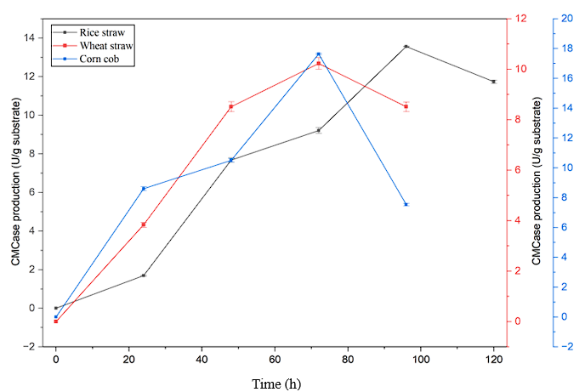
Fig. 2. Time-course of CMCase production by Bacillus albus strain BCA3 on different lignocellulosic substrates. CMCase activity was measured during bacterial cultivation on rice straw, wheat straw, and corn cob and expressed as units per gram of substrate (U/g). Enzyme production was monitored at different incubation times (0–120 h). Data represent the mean of three independent biological replicates (n = 3), and error bars indicate ± standard error (SE).
3.2 FPase production
FPase production in media supplemented with filter paper produced 26.52 ± 0.414 U/g at 30 h (Fig. 3). This showed a consistent pattern of FPase with typical filter paper degradation dynamics as reported for Bacillus and Paenibacillus species (Sukumaran et al., 2005). A higher FPase value has been reported in Bacillus sp. 8E1A, where the enzyme production reached ~90.3 U/g (Dobrzyński et al., 2022). Under various biomass supplementation in the minimal medium, FPase production varied significantly among substrates (Fig. 4). Wheat straw and corn cob both supported higher FPase production at 72 h (13.99 ± 0.095 U/g and 14.14 ± 0.162 U/g, respectively), whereas rice straw exhibited delayed induction and produced FPase only at 96 h (4.56 ± 0.006 U/g). It had been reported that FPase produced ~8 U/g FPase (converted from U/mL) (Kazeem et al., 2017). However, we have reported FPase production in the presence of wheat straw and corn cob. This could be attributed to their more accessible cellulose regions by FPase and lower lignin severity. In contrast, rice straw’s delayed response aligns with its well-documented high silica content and dense lignin–phenolic network, which substantially restricts enzyme penetration (Oladosu et al., 2016). It was also found that FPase production was nearly double in the presence of filter paper as a substrate compared to biomass as a substrate. This was expected because native biomass contains crystalline cellulose, lignin, and cross-linking phenolics that strongly limit cellulase accessibility (Chundawat et al., 2011).
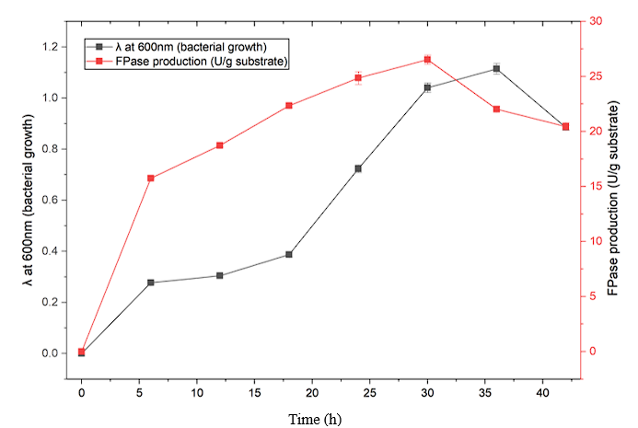
Fig. 3. Time-course relationship between bacterial growth and FPase production by Bacillus albus strain BCA3 grown on filter paper supplemented minimal media. Bacterial growth was monitored at λ 600nm (left Y-axis), and FPase production was expressed as units per gram of substrate (U/g; right Y-axis). Data represent mean values of three independent biological replicates (n = 3), and error bars indicate mean ± standard error (SE).
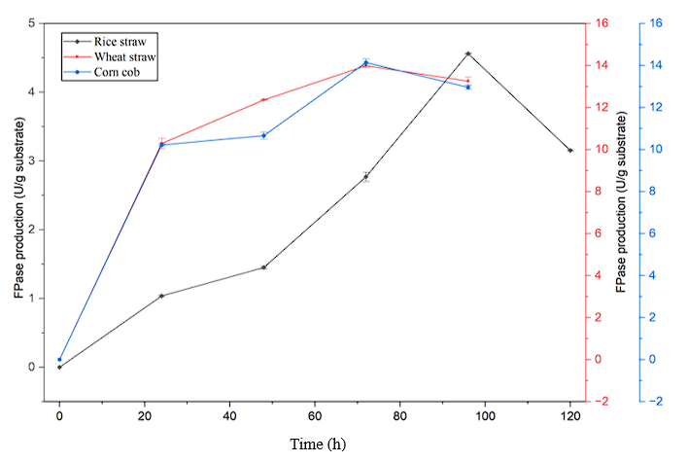
Fig. 4. Time-course of FPase production by Bacillus albus strain BCA3 on different lignocellulosic substrates. FPase activity was measured during bacterial cultivation on rice straw, wheat straw, and corn cob and expressed as units per gram of substrate (U/g). Enzyme production was monitored at different incubation times (0–120 h). Data represent the mean of three independent biological replicates (n = 3), and error bars indicate ± standard error (SE).
3.3 BGL production
BGL production increased steadily with substrate p-nitrophenyl β-D-glucopyranoside, reaching 46.512 ± 0.242 U/g at 36 h (Fig. 5). Biomass supplemented in minimal medium showed clear substrate dependence on BGL production as corn cob produced exceptionally high BGL 45.424 ± 0.520 U/g, wheat straw produced moderate levels 17.708 ± 0.055 U/g, and rice straw showed minimal production 1.85 ± 0.047 U/g (Fig. 6). The strong response to corn cob likely reflects greater cellobiose release during hydrolysis, a key natural inducer of BGL (Teugjas & Väljamäe, 2013). These values fall within and, in some cases, exceed reported Bacillus systems. Bacillus subtilis RA10 produced 21–32 U/g from paddy straw, 16–33 U/g from wheat straw, and 11–19 U/g from parthenium biomass (Tiwari et al., 2017), indicating that the corn cob production in the present study is comparatively high. Unlike CMCase and FPase, BGL was induced more strongly by biomass than p-nitrophenyl β-D-glucopyranoside as substrate, consistent with its regulatory dependence on cellobiose formation. This property is advantageous for biomass saccharification, as high BGL minimises cellobiose inhibition and enhances overall cellulose conversion (Yang & Wyman, 2007).
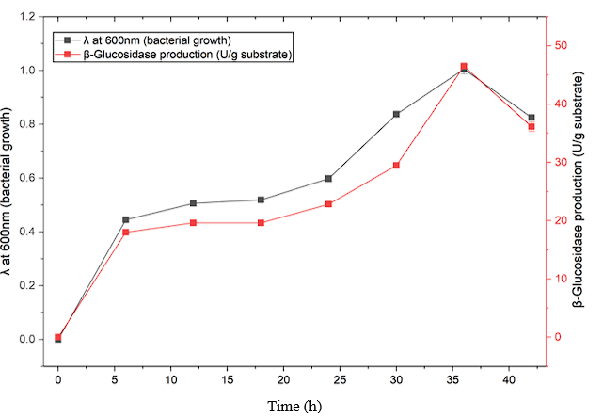
Fig. 5. Time-course relationship between bacterial growth and β-Glucosidase production by Bacillus albus strain BCA3 grown on cellobiose-supplemented minimal media. Bacterial growth was monitored at λ 600nm (left Y-axis), and β-Glucosidase production was expressed as units per gram of substrate (U/g; right Y-axis). Data represent mean values of three independent biological replicates (n = 3), and error bars indicate mean ± standard error (SE).
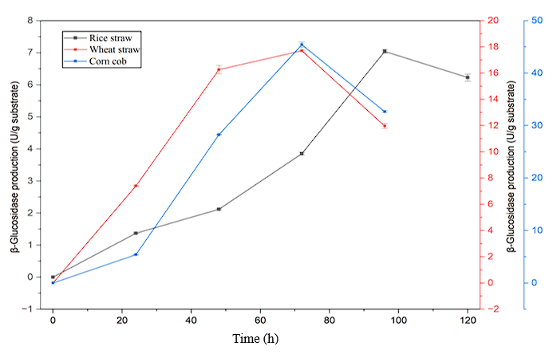
Fig. 6. Time-course of β-Glucosidase production by Bacillus albus strain BCA3 on different lignocellulosic substrates. β-Glucosidase activity was measured during bacterial cultivation on rice straw, wheat straw, and corn cob and expressed as units per gram of substrate (U/g). Enzyme production was monitored at different incubation times (0–120 h). Data represent the mean of three independent biological replicates (n = 3), and error bars indicate ± standard error (SE).
3.4 Amylase production
A sharp increase of amylase at 83.150 ± 0.041 U/g at 30 h in soluble-starch supplemented minimal media (Fig. 7). Wheat straw supplemented in minimal media produces the highest amylase production (29.153 ± 0.713 U/g at 72 h), followed by corn cob (18.875 ± 0.481 U/g) and rice straw (9.997 ± 0.095 U/g) (Fig. 8). The strong wheat-straw response is likely due to the presence of residual starch-like polysaccharides and water-soluble glucans, which act as natural inducers of amylase expression (Saha, 2003). These values are comparable to bacterial amylase production on lignocellulosic substrates reported in the literature. For example, Bacillus cereus MTCC 1305 produced 94 U/g amylase on wheat bran under solid-state fermentation (Anto et al., 2006), while submerged cultures of B. cereus yielded 16–98.3 U/g on soluble starch after conversion from U/mL (Raplong et al., 2014). Although soluble starch substrate produces the highest overall amylase levels, wheat straw demonstrated strong potential as a natural and low-cost inducer for industrial amylase production.
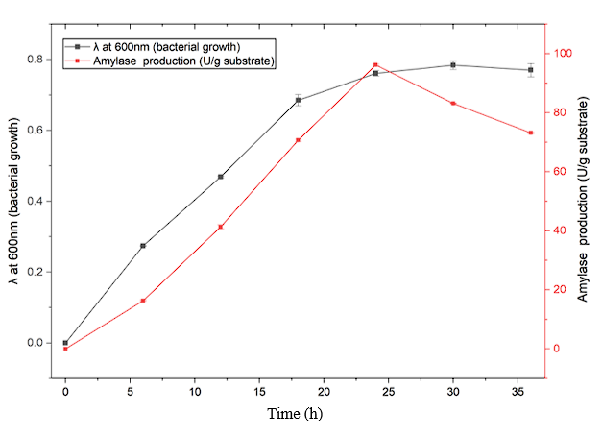
Fig. 7. Time-course relationship between bacterial growth and amylase production by Bacillus albus strain BCA3 grown on soluble starch-supplemented minimal media. Bacterial growth was monitored at λ 600nm (left Y-axis), and amylase production was expressed as units per gram of substrate (U/g; right Y-axis). Data represent mean values of three independent biological replicates (n = 3), and error bars indicate mean ± standard error (SE).
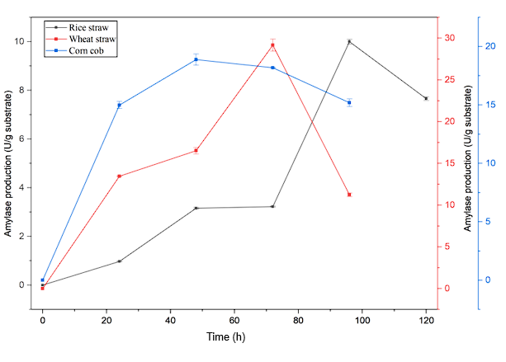
Fig. 8. Time-course of amylase production by Bacillus albus strain BCA3 on different lignocellulosic substrates. amylase activity was measured during bacterial cultivation on rice straw, wheat straw, and corn cob and expressed as units per gram of substrate (U/g). Enzyme production was monitored at different incubation times (0–120 h). Data represent the mean of three independent biological replicates (n = 3), and error bars indicate ± standard error (SE).
3.5 Xylanase production
A maximum xylanase enzyme was produced among all enzymes evaluated. Xylan supplementation caused a rapid increase in xylanase production, reached 228.952 ± 5.362 U/g at 36 h (Fig. 9). This reflects the high responsiveness of bacterial xylanolytic systems to soluble hemicellulose (Beg et al., 2001). A comparable high production has also been reported in an anaerobic bacterium Clostridium beijerinckii G117, which was 106.4 U/g (Ng et al., 2015). While our isolated bacteria showed two times higher xylanase. Although the amount of xylanase production was found to be very low in the presence of various biomass supplemented in minimal media. Among of biomass, wheat straw produced the highest xylanase production (7.108 ± 0.148 U/g at 72 h), followed by corn cob (7.678 ± 0.080 U/g), while rice straw yielded lower levels (1.497–2.307 U/g) (Fig. 10). Wheat straw was found best for xylanase production corresponds to its higher arabinoxylan content and reduced lignin–hemicellulose crosslinking, which increase hemicellulose accessibility (Subramaniyan & Prema, 2000; Berlin et al., 2006; Saha, 2003). These biomass-derived values fall within the range reported for Bacillus species, where xylanase production typically reaches 5–15 U/g under submerged fermentation or 40–50 U/g under solid-state conditions, as seen in Bacillus subtilis ATCC 6633 grown on soybean hulls (Heng, 2014). Overall, analytical grade xylan induced xylanase levels nearly 30-fold higher than biomass substrates, underscoring the limited accessibility of hemicellulose in native plant residues due to lignin–hemicellulose crosslinking and structural recalcitrance (Chundawat et al., 2011).
A comparative summary of the maximum activities of CMCase, FPase, β-Glucosidase, amylase, and xylanase produced under defined analytical-grade substrates and lignocellulosic biomasses is presented in Table 1.

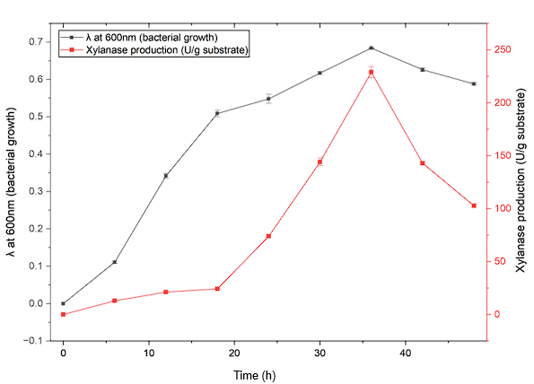

Fig. 9. Time-course relationship between bacterial growth and xylanase production by Bacillus albus strain BCA3 grown on birchwood xylan-supplemented minimal media. Bacterial growth was monitored at λ 600nm (left Y-axis), and xylanase production was expressed as units per gram of substrate (U/g; right Y-axis). Data represent mean values of three independent biological replicates (n = 3), and error bars indicate mean ± standard error (SE).
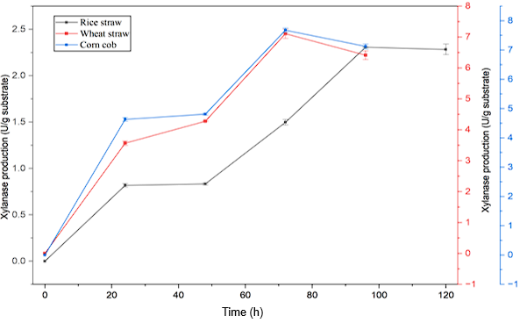
Fig. 10. Time-course of xylanase production by Bacillus albus strain BCA3 on different lignocellulosic substrates. Xylanase activity was measured during bacterial cultivation on rice straw, wheat straw, and corn cob and expressed as units per gram of substrate (U/g). Enzyme production was monitored at different incubation times (0–120 h). Data represent the mean of three independent biological replicates (n = 3), and error bars indicate ± standard error (SE).
Table 1. Comparative maximum enzyme production under different substrates
Enzyme | Substrate | Time (h) | Enzyme production (U/g substrate)
CMCase (Endoglucanase) | CMC | 36 | 77.945 ± 1.095
 | Corn cob | 72 | 17.63 ± 0.055
FPase (Exoglucanase) | Filter paper | 30 | 26.522 ± 0.414
 | Corn cob | 72 | 14.14 ± 0.162
β-Glucosidase | Cellobiose | 36 | 46.512 ± 0.242
 | Corn cob | 72 | 45.424 ± 0.520
Amylase | Soluble starch | 30 | 83.150 ± 0.041
 | Wheat straw | 72 | 29.153 ± 0.713
Xylanase | Birchwood Xylan | 36 | 228.952 ± 5.362
 | Corn cob | 72 | 7.678 ± 0.080
All experiments were performed in triplicate, and results are expressed as mean ± standard error. Differences in enzyme activities among substrates and biomasses were analysed using one-way ANOVA followed by Tukey’s HSD post-hoc test. Variations were considered statistically significant at P = .05

4. Conclusion
This study successfully demonstrated the potential of Bacillus albus strain BCA3 for the production of lignocellulolytic enzymes, including CMCase, FPase, BGL, amylase, and xylanase, under different substrate conditions. The bacterium showed notable enzyme production in both analytical grade and biomass-based substrates, with corn cob emerging as the most effective inducer for cellulase and glucanase activities, likely due to its high cellulose content and low lignin levels. Wheat straw also supported substantial enzyme production, especially amylase, while rice straw exhibited delayed enzyme induction, consistent with its dense lignin content and structural recalcitrance. The results underscore the importance of substrate composition and pretreatment in enhancing enzyme production, highlighting the advantages of using pretreated lignocellulosic residues as a low-cost, sustainable source for industrial enzyme production. Overall, the findings suggest that B. albus BCA3 is a promising candidate for lignocellulosic biomass degradation, with potential applications in biofuel production, waste valorisation, and other biotechnological processes. Future studies should focus on optimising fermentation conditions, scaling up enzyme production, and exploring the synergistic effects of mixed substrates to maximise lignocellulose conversion efficiency.

Disclaimer (Artificial Intelligence)
Author(s) hereby declare that NO generative AI technologies such as Large Language Models (ChatGPT, COPILOT, etc) and text-to-image generators have been used during the writing or editing of this manuscript.

References
Abada, E., Elbaz, R., Sonbol, H., & Korany, S. (2021). Optimization of Cellulase Production from Bacillus albus (MN755587) and Its Involvement in Bioethanol Production. Polish Journal of Environmental Studies, 30, 2459-2466. https://doi.org/10.15244/pjoes/129697.
Almanaa, T., Vijayaraghavan, P., Alharbi, N., Kadaikunnan, S., Khaled, J., & Alyahya, S. (2020). Solid state fermentation of amylase production from Bacillus subtilis D19 using agro-residues. Journal of King Saud University - Science, 32, 1555-1561. https://doi.org/10.1016/j.jksus.2019.12.011.
Anto, H., Trivedi, U., & Patel, K. (2006). Alpha-amylase production by Bacillus cereus using solid-state fermentation. Food Technology and Biotechnology, 44(2), 241–245. https://hrcak.srce.hr/109861
Anu, N., Kumar, S., Kumar, A., Kumar, V., & Singh, B. (2020). Optimization of cellulase production by Bacillus subtilis subsp. subtilis JJBS300 and biocatalytic potential in saccharification of alkaline-pretreated rice straw. Preparative Biochemistry & Biotechnology, 51(7), 697–704. https://doi.org/10.1080/10826068.2020.1852419
Ashoor, S., & Sukumaran, R. K. (2020). Mild alkaline pretreatment can achieve high hydrolytic and fermentation efficiencies for rice straw conversion to bioethanol. Preparative Biochemistry & Biotechnology, 50(8), 814–819. https://doi.org/10.1080/10826068.2020.1744007
Beg, Q. K., Kapoor, M., Mahajan, L., & Hoondal, G. S. (2001). Microbial xylanases and their industrial applications: a review. Applied Microbiology and Biotechnology, 56(3–4), 326–338. https://doi.org/10.1007/s002530100704
Berlin, A., Balakshin, M., Gilkes, N., Kadla, J., Maximenko, V., Kubo, S., & Saddler, J. (2006). Inhibition of cellulase, xylanase and β-glucosidase activities by softwood lignin preparations. Journal of Biotechnology, 125(2), 198–209. https://doi.org/10.1016/j.jbiotec.2006.02.021
Blanch, H. W., Simmons, B. A., & Klein‐Marcuschamer, D. (2011). Biomass deconstruction to sugars. Biotechnology Journal, 6(9), 1086–1102. https://doi.org/10.1002/biot.201000180
Bombardi, L., Salini, A., Aulitto, M., Zuliani, L., Andreolli, M., Bordoli, P., Coltro, A., Vitulo, N., Zaccone, C., Lampis, S., & Fusco, S. (2024). Lignocellulolytic Potential of Microbial Consortia Isolated from a Local Biogas Plant: The Case of Thermostable Xylanases Secreted by Mesophilic Bacteria. International Journal of Molecular Sciences, 25(2), 1090. https://doi.org/10.3390/ijms25021090
Cai, Z., Wang, Y., You, Y., Yang, N., Lu, S., Xue, J., Xing, X., Sha, S., & Zhao, L. (2024). Introduction of Cellulolytic Bacterium Bacillus velezensis Z2.6 and Its Cellulase Production Optimization. Microorganisms, 12(5), 979. https://doi.org/10.3390/microorganisms12050979
Chen, W., Chen, Y., & Lin, J. (2013). Study of chemical pretreatment and enzymatic saccharification for producing fermentable sugars from rice straw. Bioprocess and Biosystems Engineering, 37(7), 1337–1344. https://doi.org/10.1007/s00449-013-1106-0
Chundawat, S. P., Beckham, G. T., Himmel, M. E., & Dale, B. E. (2011). Deconstruction of lignocellulosic biomass to fuels and chemicals. Annual Review of Chemical and Biomolecular Engineering, 2(1), 121–145. https://doi.org/10.1146/annurev-chembioeng-061010-114205
Dobrzyński, J., Wróbel, B., & Górska, E. B. (2022). Cellulolytic Properties of a Potentially Lignocellulose-Degrading Bacillus sp. 8E1A Strain Isolated from Bulk Soil. Agronomy, 12(3), 665. https://doi.org/10.3390/agronomy12030665
Heng, H. L. H. K. L. (2014). Xylanase Production by Bacillus subtilis in Cost-Effective Medium Using Soybean Hull as Part of Medium Compostion under Submerged Fermentation (Smf) and Solid State Fermentation (SsF). Journal of Biodiversity Bioprospecting and Development, 2(01). https://doi.org/10.4172/2376-0214.1000143
Himmel, M. E., Ding, S., Johnson, D. K., Adney, W. S., Nimlos, M. R., Brady, J. W., & Foust, T. D. (2007). Biomass recalcitrance: engineering plants and enzymes for biofuels production. Science, 315(5813), 804–807. https://doi.org/10.1126/science.1137016
Jensen, M. B., De Jonge, N., Dolriis, M. D., Kragelund, C., Fischer, C. H., Eskesen, M. R., Noer, K., Møller, H. B., Ottosen, L. D. M., Nielsen, J. L., & Kofoed, M. V. W. (2021). Cellulolytic and xylanolytic microbial communities associated with Lignocellulose-Rich wheat straw degradation in anaerobic digestion. Frontiers in Microbiology, 12, 645174. https://doi.org/10.3389/fmicb.2021.645174
Kazeem, M. O., Shah, U. K. M., Baharuddin, A. S., & AbdulRahman, N. A. (2017). Prospecting Agro-waste Cocktail: Supplementation for Cellulase Production by a Newly Isolated Thermophilic B. licheniformis 2D55. Applied Biochemistry and Biotechnology, 182(4), 1318–1340. https://doi.org/10.1007/s12010-017-2401-z
Kim, Y., Lee, S., Cho, Y., Oh, H., & Ko, Y. H. (2012). Isolation of Cellulolytic Bacillus subtilis Strains from Agricultural Environments. ISRN Microbiology, 2012, 1–9. https://doi.org/10.5402/2012/650563
Kumar, A., Verma, L. M., Sharma, S., & Singh, N. (2022). Overview on agricultural potentials of biogas slurry (BGS): applications, challenges, and solutions. Biomass Conversion and Biorefinery, 13(15), 13729–13769. https://doi.org/10.1007/s13399-021-02215-0
Kumar, P., Barrett, D. M., Delwiche, M. J., & Stroeve, P. (2009). Methods for pretreatment of lignocellulosic biomass for efficient hydrolysis and biofuel production. Industrial & Engineering Chemistry Research, 48(8), 3713–3729. https://doi.org/10.1021/ie801542g
Liu, X., Wang, A., Zhu, L., Guo, W., Guo, X., Zhu, B., & Yang, M. (2024). Effect of additive cellulase on fermentation quality of whole-plant corn silage ensiling by a Bacillus inoculant and dynamic microbial community analysis. Frontiers in Microbiology, 14, 1330538. https://doi.org/10.3389/fmicb.2023.1330538
Mgxaji, Y., Mutengwa, C. S., Mukumba, P., & Dzvene, A. R. (2025b). Biogas slurry as a sustainable organic fertilizer for sorghum production in sandy soils: A review of feedstock sources, application methods, and agronomic impacts. Agronomy, 15(7), 1683. https://doi.org/10.3390/agronomy15071683
Ng, C. H., He, J., & Yang, K. (2015). Purification and Characterization of a GH11 Xylanase from Biobutanol-Producing Clostridium beijerinckii G117. Applied Biochemistry and Biotechnology, 175(6), 2832–2844. https://doi.org/10.1007/s12010-014-1470-5
Nguyen, L. N., Nguyen, A. Q., & Nghiem, L. D. (2018). Microbial community in Anaerobic digestion System: Progression in Microbial Ecology. In Energy, environment, and sustainability (pp. 331–355). https://doi.org/10.1007/978-981-13-3259-3_15
Oladosu, Y., Rafii, M. Y., Abdullah, N., Magaji, U., Hussin, G., Ramli, A., & Miah, G. (2016). Fermentation quality and additives: a case of rice straw silage. BioMed Research International, 2016, 1–14. https://doi.org/10.1155/2016/7985167
Paul, M., Mohapatra, P. K. D., & Thatoi, H. (2023). Purified cellulase‐mediated simultaneous sugar utilization by Bacillus albus isolated from Similipal, Odisha, India. Journal of Basic Microbiology, 63(7), 759–780. https://doi.org/10.1002/jobm.202300006
Poszytek, K., Ciężkowska, M., Skłodowska, A., & Drewniak, Ł. (2016). Microbial Consortium with High Cellulolytic Activity (MCHCA) for Enhanced Biogas Production. Frontiers in Microbiology, 7, 324. https://doi.org/10.3389/fmicb.2016.00324
Rana, G. S., Naudiyal, N., Bal, R., Verma, A. K., Dubey, A., Singh, B. R., & Singh, T. P. (2025). A comprehensive Extraction-Precipitation Method and Characterization study to optimize biogas slurry enzyme recovery. Waste and Biomass Valorization, 16(7), 3761–3771. https://doi.org/10.1007/s12649-025-02884-2
Raplong, H. H., Odeleye, P. O., Hammuel, C., Idoko, M. O., Asanato, J. I., & Odeke, E. H. (2014). Production of Alpha Amylase by Bacillus cereus in Submerged Fermentation. Aceh International Journal of Science and Technology, 3(3), 124–130. https://doi.org/10.13170/aijst.3.3.1592
Saha, B. C. (2003). Hemicellulose bioconversion. Journal of Industrial Microbiology & Biotechnology, 30(5), 279–291. https://doi.org/10.1007/s10295-003-0049-x
Subramaniyan, S., & Prema, P. (2000). Cellulase-free xylanases from Bacillus and other microorganisms. FEMS Microbiology Letters, 183(1), 1–7. https://doi.org/10.1111/j.1574-6968.2000.tb08925.x
Sukumaran, R.K., Singhania, R.R., & Pandey, A. (2005). Microbial cellulases ─ Production, applications and challenges. Journal of Scientific & Industrial Research, 64, 832-844.
Sun, Y., & Cheng, J. (2002). Hydrolysis of lignocellulosic materials for ethanol production: a review. Bioresource Technology, 83(1), 1–11. https://doi.org/10.1016/s0960-8524(01)00212-7
Teugjas, H., & Väljamäe, P. (2013). Product inhibition of cellulases studied with 14C-labeled cellulose substrates. Biotechnology for Biofuels, 6(1), 104. https://doi.org/10.1186/1754-6834-6-104
Tiwari, R., Singh, P. K., Singh, S., Nain, P. K. S., Nain, L., & Shukla, P. (2017). Bioprospecting of novel thermostable β-glucosidase from Bacillus subtilis RA10 and its application in biomass hydrolysis. Biotechnology for Biofuels, 10(1), 246. https://doi.org/10.1186/s13068-017-0932-8
Ullah, H., Khan, F., Khan, M. S., Khan, N., Ali, I., Muhammad, Y., Durrani, F., & Ullah, W. (2025). Characterization and optimization of glutaminase enzyme from Bacillus albus isolated from agriculture waste. Journal of Applied Biological Sciences, 19(2), 130–140. https://doi.org/10.71336/jabs.1427
Yang, B., & Wyman, C. E. (2007). Pretreatment: the key to unlocking low‐cost cellulosic ethanol. Biofuels Bioproducts and Biorefining, 2(1), 26–40. https://doi.org/10.1002/bbb.49
Zhang, Z., Shah, A. M., Mohamed, H., Tsiklauri, N., & Song, Y. (2021). Isolation and screening of microorganisms for the effective pretreatment of lignocellulosic agricultural wastes. BioMed Research International, 2021(1), 5514745. https://doi.org/10.1155/2021/5514745

