Review Article
Microplastic Pollution in Agricultural Soils of Northeast India: Current Status and Knowledge Gaps

ABSTRACT
Context: Microplastics contamination is an escalating environmental threat in Northeast India, critically impacting its fragile ecosystems, agriculture, and public health. The region, recognized as a global biodiversity hotspot, faces growing microplastics pollution from diverse sources such as domestic waste, agriculture, industrial activities, and aquaculture. This study explores the comprehensive understanding that can guide future research, governance, and regional mitigation strategies.
Objective: This review aims to synthesize existing research on microplastics contamination in Northeast India, assess their sources and environmental pathways, evaluate ecological and agricultural impacts, identify critical knowledge gaps, and highlight policy and community-level interventions required for effective management.
Methodology: The review compiles and analyzes available scientific literature, government reports, and regional environmental assessments related to microplastics contamination in Northeast India. Studies focusing on aquatic ecosystems, soils, biodiversity impacts, and regional waste-management practices were systematically evaluated.
Results: The review reveals widespread microplastics contamination across Northeast India, with significant presence recorded in major freshwater ecosystems such as Loktak Lake, Deepor Beel, and associated river systems. Evidence shows ingestion of microplastics by fish and other aquatic organisms, indicating potential trophic transfer and risks of bioaccumulation. Agricultural soils are also notably affected, primarily due to the use of plastic mulching films and irrigation pipelines. Despite these growing concerns, research efforts remain limited and inconsistent, with a lack of standardized methodologies and long-term monitoring.
Significance: This review highlights the urgent need for comprehensive monitoring, standardized assessment techniques, and targeted policy action to address microplastics contamination in Northeast India.

Keywords: Agriculture, Microplastic, Northeast, Soil, wetland
GRAPHICAL ABSRACT

- INTRODUCTION
Plastics are extensively used in households and various commercial and industrial sectors, including packaging, consumer products, transportation, textiles, medicine, and construction (Andrady & Neal, 2009; Geyer et al., 2017). Their popularity has surged globally due to their durability, low cost, lightweight nature, and the ease with which they can be moulded into various shapes (Singh et al., 2024). However, the prevalent use of single-use plastic packaging has exacerbated waste management issues, as these products are intended for short-term use yet remain in the environment for decades. Packaging waste alone contributes millions of tons of plastic debris to waterways each year (MacArthur et al., 2016; Hartmann et al., 2019). A significant portion of this discarded plastic degrades into microplastics (MPs), which are plastic particles ranging from 1 μm to 5 mm in diameter (Thompson et al., 2004). MPs have been documented in soils, groundwater, wastewater, landfill leachate, freshwater, oceans, and even the atmosphere (Barnes et al., 2009; Browne et al., 2011; Rillig, 2012; Liu et al., 2019; Zhang et al., 2020; Moeck et al., 2023). Their increasing prevalence is closely linked to the global rise in plastic consumption and inadequate waste management practices. Landfills and open dumping sites act as major sources, while river systems serve as transport pathways, extending MPs’ reach into distant ecosystems.
Every year, more than 400 million metric tonnes of plastic are produced worldwide (Najahi et al, 2025). Alarmingly, nearly 90% of this waste is either sent to landfills or discharged into aquatic systems, where breakdown processes continually produce microplastics (MPs) (OECD, 2022). Human exposure to MPs is a growing concern, with estimates indicating that individuals ingest between 4,000 and 52,000 MPs particle annually through tap water and caloric intake, rising to 121,000 particles when inhalation is factored in (Cox et al., 2019). Children, in particular, may consume over 200 particles each day. In a vast country like India, studies show increasing burdens of MPs in freshwater ecosystems such as rivers and lakes, highlighting the urgent need for standardized sampling and analytical protocols, particularly in Northeast basins (Kannaiyan & Indra, 2023). Terrestrial sources contributing to this issue include agricultural plastics (like mulch films), wastewater, sewage sludge, and surface runoff (Huang et al. 2020). Documented effects on soils encompass altered soil pH, microbial enzyme activity, decreased water retention, and disrupted microbial communities (Rashid et al. 2025).
The Northeastern (NE) states of India, comprising of Arunachal Pradesh, Assam, Manipur, Meghalaya, Mizoram, Nagaland, Sikkim, and Tripura, spans approximately 262,382 km², accounting for about 8% of India’s total land area. Geographically, it lies between 22º N and 29º 5' N latitudes 88º 00' E and 97º 30' E longitudes (Barik, 2018), sharing international borders with Nepal, Bhutan, China, Myanmar, and Bangladesh. The region is globally recognized as one of the world’s top biodiversity hotspots, containing over one-third of India’s biodiversity (Dhyani et al. 2015). Its fragile ecosystems, characterized by high rainfall, dense forests, and extensive river networks, make it particularly susceptible to plastic pollution. Rapid urbanization, inadequate waste management systems, and increasing reliance on packaged goods further exacerbate this risk. Despite these challenges, systematic research on MPs in the Eastern Himalayas is limited, resulting in significant knowledge gaps (Talukdar et al. 2023). Socio-economically, the region is defined by its rich natural resources, indigenous farming systems such as shifting and terrace cultivation, and diverse ethnic and cultural identities (Bhuyan, 2019). These factors sustain traditional livelihoods and contribute to India’s food and genetic resource security. Furthermore, the region serves as a cultural and biogeographic gateway between India and Southeast Asia, fostering cross-border trade and connections (Tase, 2024). Ecotourism, based on its natural beauty and biodiversity, also bolsters local economies. This review is to synthesize existing knowledge on global and Indian research concerning MPs pollution, with a particular focus on its sources, pathways, and documented impacts on terrestrial and aquatic ecosystems. Special attention is given to the Northeast region of India, which, despite its ecological fragility and socio-economic importance, remains largely unexplored in terms of MPs contamination. By examining global patterns, national contexts, and the unique vulnerabilities of the Eastern Himalayas, this review seeks to identify critical knowledge gaps, especially in freshwater and soil ecosystems, and highlight the need for standardized methodologies in sampling and analysis.
- Classification of Microplastics
2.1 Primary vs. secondary MPs
Primary MPs are plastic particles, intentionally produced for uses like cosmetics, paints, and cleaning products, or generated unintentionally through plastic use such as tire wear and textile fibre release (Rogers, 2024). They are categorized as type A (deliberately added) and type B (formed unintentionally). Major sources include plastic resins, paints, tires, and synthetic fabrics, with tire abrasion and laundry effluents being significant contributors. Since many escape treatment systems, they accumulate in terrestrial and aquatic environments, where synthetic fibre mainly polyester (78%) and acrylic (22%) are frequently detected in wastewater and sediments (Browne et al. 2011). Secondary MPs originate from the breakdown of larger plastic items, mainly due to UV radiation, mechanical abrasion, and environmental factors (Adetuyi, 2024). Common sources include fragmented litter, industrial activities, and degradation of synthetic materials, with items like bottles, bags, fishing gear, and agricultural mulching, greenhouse film contributing significantly. These particles are a major source of MPs pollution and are widely found across ecosystems, including soil, air, freshwater bodies, and marine environments (Liu et al, 2020).
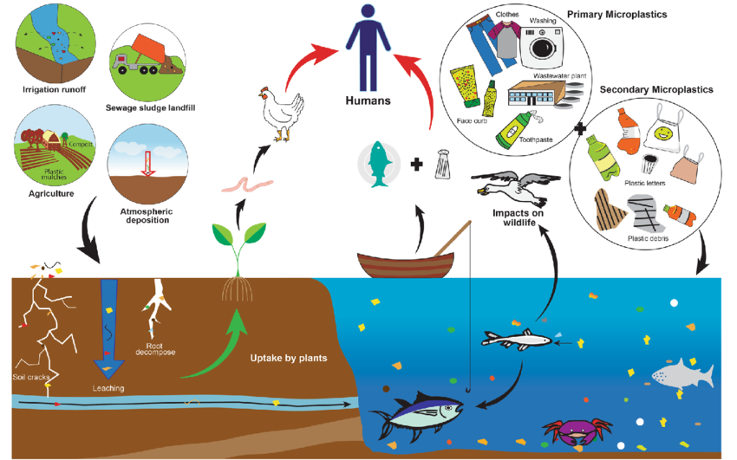
Figure 1. Primary and secondary MPs sources and their ecological risks (The reader is directed to the online version of this article for an explanation of the colour references in this figure legend.) https://doi.org/10.1007/s44218-024-00064-8)
2.2 Morphology of MPs
MPs exhibit considerable variation in shape, ranging from uniform spheres and cylindrical pellets to elongated fibres with a high aspect ratio (Chen et al, 2021). Once in the environment, plastics undergo physical and chemical degradation, leading larger items to break into smaller, more irregular pieces. A common approach to classifying MPs is to identify their morphologies based on observable traits, which can be assessed without specialized instruments (Rodríguez-Seijo et al, 2017). This morphological classification not only helps determine probable sources but also provides insights into how specific debris behaves in the environment, such as fibres from synthetic textiles, fragments of fishing gear, or industrial pellets. However, accurately categorizing these diverse three-dimensional forms can be challenging. Studies on MPs pollution in Northeast India are summarised in table 1 with main morphological categories.
- Sources of Microplastics Pollution in Northeast India
3.1 Domestic and landfill waste leakage
One of the main sources of soil MPs is domestic waste, which comes from disposable objects, household goods, and plastic packaging. Particularly, food delivery services produce a lot of single-use plastics like tableware and bags. (Molina-Besch, 2020), with rising consumption driving waste accumulation (Ahuja et al., 2021). Plastics that have been illegally or improperly disposed of along roadsides and in bodies of water break up into MPs and are carried by runoff and wind. (Tunnell, 2008). In mountainous regions, open dumping on the hillside or by the side of the road is the most common way to dispose of solid trash (Kumar et al. 2016; Malav et al. 2020). In NE India, recent studies show similar patterns on how domestic and municipal waste are important contributors to MPs in soils (Nath & Joshi 2024). The NE Region of India generates about 2,907 tons of waste per day, with 86.96% collected, 31.09% treated, and 33.67% landfilled (Ao & Ngullie, 2024). Plastics in landfills undergo a variety of physical and biological reactions that turn them into secondary MPs (Zhao & Lou, 2016). Su et al., 2019 observed that irregular and fractured structures in landfill MPs, indicating that the fragmentation of plastic waste is a major source of secondary MPs. Landfills are a significant source of microplastics due to the high concentration of MPs in waste (Golwala, et al., 2021). Large volumes of waste in landfills and open dumps further act as point sources, leaching MPs into deeper soil layers and groundwater (Duis & Coors, 2016).
Study Area | Ecosystem Type | Sample Matrix | MPs Type | Polymer Identified | Methods Used | Size Range | Key Findings | Reference
Brahmaputra River (main stream), Assam | River | Sediments | Fragments, fibres | PE, PP, PS | Density separation, visual microscopy, FTIR | 50 µm – 300 µm | Abundant MPs in sediments (20–3,485 items/kg); rivers act as temporary sinks | Tsering et al., 2021
Bhogdoi River, Assam | River | Fish (GI tracts) | Fibres, fragments | PA, PE, PP, PS, CA | KOH digestion, stereomicroscopy, FTIR | 100 µm – 5 mm | 100% occurrence of MPs in sampled fishes | Ahmed et al., 2023
Loktak Lake, Manipur | Wetland (Ramsar site) | Fish (GI tracts) | Fragments, fibres | PE, PP, PA | H₂O₂ digestion, density separation, FTIR | 50 µm – 2 mm | 91% of sampled fishes ingested MPs; high prevalence across species | Borah et al., 2024
Deepor Beel, Assam | Wetland (Ramsar site) | Water, sediment, fish | Fibres, fragments, films | PP, PVC, PC, PS | H₂O₂ digestion, NaCl separation, Raman spectroscopy | 20 µm – 5 mm | MPs widely present in water, sediment, and fish tissues; ecological risk index indicates concern | Saikia & Handique, 2024
Brahmaputra River(Arunachal/Assam) | Rivers & adjacent soils | Sediment, soil | Fibres, fragments | PE, PET, PP | Density separation, H₂O₂ digestion, FTIR | 100 µm – 1 mm | MPs present even in low-population catchments; transport linked to runoff | Goswami & Bhadury, 2024
Jia Bharali River, Assam | River | Water and sediments | fibres, fragments, films and  foams | PE, PP, PS, PES, LDPE | H₂O₂ digestion, NaCl, FTIR stereomicroscopy, | < 0.5 mm | Fibres account  36.13% in surface water and 38.23% in sediments | Lahon, & Handique, 2024
Thekera Beel, Assam | Wetland | Fish (GI tracts) | fibre, fragment, film,beads | PE, PAM, PS, Nylon, PVA | H₂O₂ digestion, NaI separation,stereomicroscopy, FTIR | 100–500μm | Polyethylene was the most common polymer, followed nylon | Borah et al., 2025
Sonitpur district,  Assam | Groundwater | water | fibres  and fragments | PA, PMMA PE, PAN; PVC, PP, | NaCl digestion, H₂O₂+ FeSO₄, FTIR |  | Polypropylene (41%)  were the most abundant while polymethacrylate  (8%) were found to be the most hazardous | Saha et al., 2025
Table 1. Summarized study of Microplastics Studies in the Northeast Region of India

3.2 Agricultural activities
Agriculture is a significant source of MPs, originating from mulching films, greenhouse covers, irrigation pipelines, plastic equipment, fertilizers, and wastewater irrigation. The global use of agricultural plastic films increased from 4.4 million tons in 2012 to 7.4 million tons in 2019, reaching 15.6 million tons by 2021 and accounting for about 4% of total plastic consumption (Feydeau, 2019; Plastics Europe, 2022). Mulch films alone exceed 3 million tons annually, covering more than 20 million ha worldwide (Mormile et al., 2017; Sander, 2019). Over the period of its use, these plastics undergo fragmentation, chemical aging, mechanical tear, and partial degradation, generating MPs (Steinmetz et al., 2016; Eydi Gabrabad et al., 2024). Polyethylene (PE) mulches, which often last longer than crop cycles, are difficult to remove and are commonly left in fields as shown in the figure 1, incorporated into soil by tillage, or burned nearby, causing slow and gradual cumulative contamination. The significance uses of mulching were found in Sikkim for the cultivation of strawberry, red cherry pepper, cardamon (Gudade et al., 2018; Pandey et al., 2025). The risk of MPs contamination from irrigation with contaminated river water, which contains MPs from industrial waste, urban runoff, and fishing operations, is highlighted by a study conducted by Tsering et al., 2021 along the agricultural lands near the Brahmaputra River.
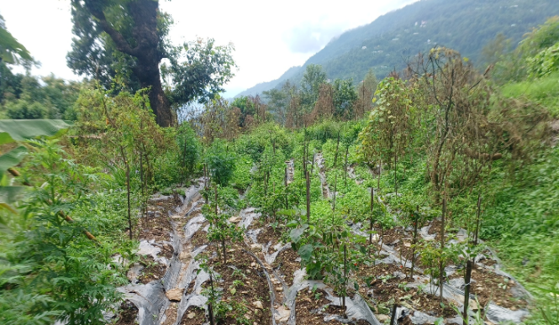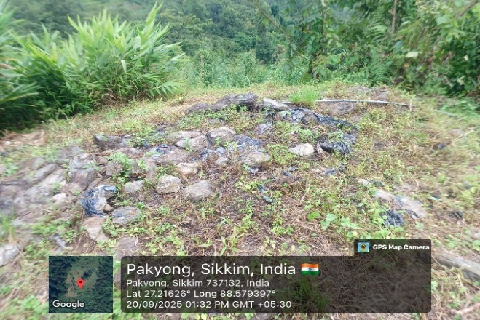
b
a
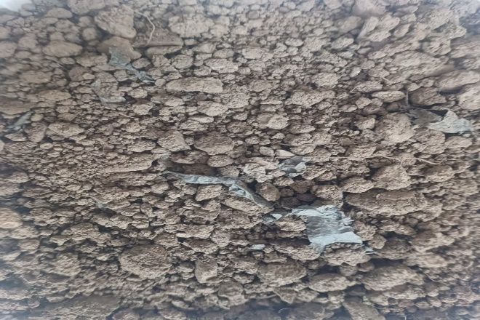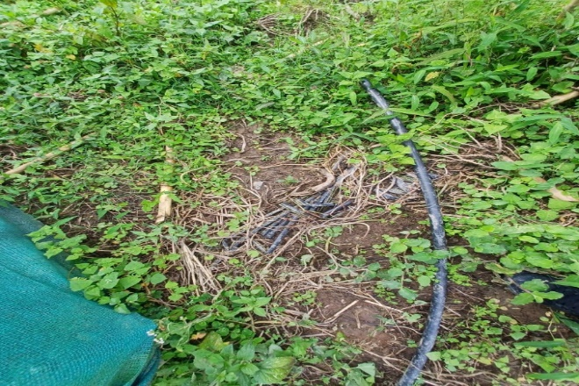
d
c
Figure 2. Plastic mulch and irrigation pipelines residues on agricultural land (a) damage of plastic mulch in the field, (b) dumping of plastic mulch, (c) visible plastic fragments in the soil and (d) Dumping of irrigation pipes in the field (original photographs taken by the authors in Pakyong district of Sikkim on 10 September 2025).
3.3 Industries
Industrial activities in NE India, including textile manufacturing, plastic production, and construction, are significant contributors to MPs pollution in the region. Small plastic pellets are made by factories as raw materials for a variety of goods, some of which are used as abrasives in cosmetics and cleaning supplies (Kalčíková et al., 2017). Due to the massive volumes of PET, polyamide (PA), and other synthetic fibres emitted during fabric production and washing, the textile sector also makes a substantial contribution (Browne et al., 2011). Additionally, tires, paints, and building materials are examples of polymer-based products that are sources of diffuse MPs. These materials weather and release particles, which are then scattered throughout the environment by wind and precipitation (Galafassi et al., 2019).
3.4 Fishing and aquaculture
The NE region of India has been recognized as one of the global hotspots for freshwater fish diversity (Kottelat & Whitten 1996). The economic growth and livelihood security of Northeast India are significantly influenced by the fishing and aquaculture. Fishing gear in aquaculture is a significant source of MPs. Nets, floating balls, ropes, and other plastic equipment break after prolonged immersion, erosion, wear, and UV exposure (Food and Nation, 2018; Song et al., 2017). According to Wright et al. (2021), twisted and braided ropes have the potential to release 300–1277 ± 431 fragments per meter of beach, with an estimated plastic volume of 0.78–6.39 ± 2.33 cm³ per meter. Lost or abandoned fishing gear, whether washed away by waves or detached from ropes, further exacerbates uncontrolled MPs pollution in aquaculture environments (Chaves & da Silveira, 2016; Chen et al., 2018; Huntington, 2019).
3.5 Floods, landslides, and monsoon-driven transport as accelerators of MPs mobilization.
Northeast India, characterized by steep terrain, high rainfall, and extensive river networks, is particularly vulnerable to floods and landslides. These natural events can facilitate the mobilization and transport of MPs from soils to streams (figure 2), rivers, wetlands, and agricultural lands. Lahon et al. (2024) observed significant variations in MP concentrations in the Jia Bharali River during flood events, underscoring the impact of hydrological dynamics on MP distribution in the region. Additionally, landslides triggered by intense rainfall can displace MPs from soils and surface litter in hilly states like Sikkim, Arunachal Pradesh, and Meghalaya, spreading them into valleys and river systems and increasing environmental exposure (Tsering et al., 2021; Bora et al., 2025). These factors contribute to NE India's heightened susceptibility to MP pollution associated with monsoon-driven hydrological events. Research indicates that runoff flow rate, catchment size, and impervious surface area all factors positively correlated with MP abundance, with estimates suggesting that a single outfall can release between 1.9 million and 9.6 billion MPs during one storm event (Ross et al., 2023).
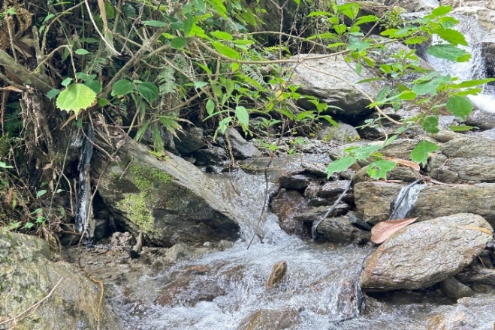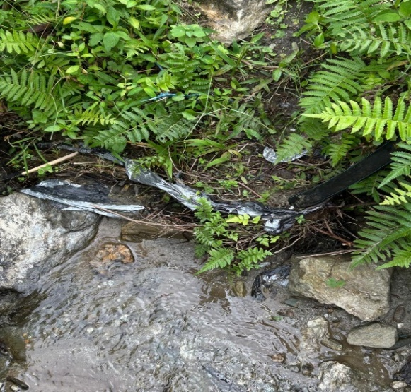
Figure 3: Accumulation of plastic debris, including plastic mulch, along stream banks, highlighting a major source and pathway of MPs contamination in freshwater ecosystems.
  - Tourism
The NE region of India is seeing positive tourism growth due to strategic efforts to enhance connectivity, promote eco-tourism, and highlight unique cultural heritage. Sikkim, Arunachal Pradesh, and Meghalaya have become popular tourist destinations, offering attractions like monasteries, hiking and natural landscapes, while other states like Assam, Manipur, Mizoram, Nagaland, and Tripura are actively expanding their tourism facilities (Jain & Rathi, 2025). NE region has 12.781 million domestic tourists and 0.22 million foreign tourists visited from 2005 to 2024 (Ministry of Tourism, 2024). Tourist access spots, camping areas, and recreational spaces were associated with MPs fibres of anthropogenic origin (Free et al., 2014; Xiong et al.,2018). Synthetic clothing worn by mountain climbers and trekkers is a significant source of MPs fibers (Ambrosini et al., 2019). These fibers are shed during activity and lead to the direct deposition of MPs in high-altitude environments, potentially polluting remote areas previously considered pristine (Padha et al, 2022).

- State-wise occurrence and distribution of microplastics in Northeast India
Significant ecological concerns have been raised by recent research that revealed the presence of MPs in important wetlands and rivers in Northeast India. Figure 3 illustrates the sites in Northeast India where MPs have been detected as well as areas where systematic research is currently in progress.
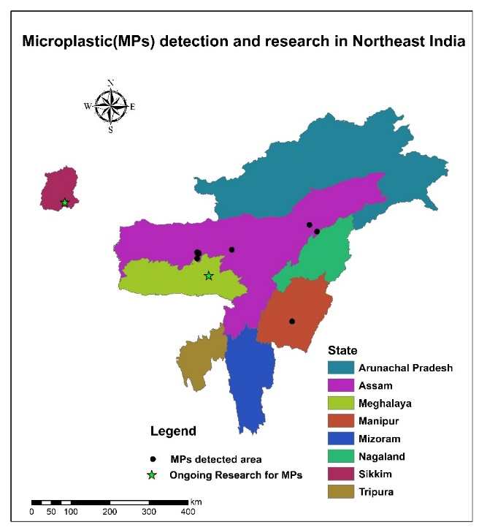
Figure 4: Microplastic detected area and ongoing research projects of Northeast India
- Assam: In the Bhogdoi River of Assam, MPs were found in the gastrointestinal tracts of fish, with polyamide and polypropylene being the most prevalent polymers (Ahmed et al., 2023). At Deepor Beel, a Ramsar site, MPs were detected in sediments, surface water, and the digestive systems of commonly consumed fish species such as Puntius sophore and Gudusia chapra (Saikia & Handique, 2024). Although the overall pollution load index appeared low, ecological risk indices indicated "danger" and "extreme danger" levels, suggesting that harmful polymers were present even in small amounts.
The Brahmaputra River system and its tributaries show concerning patterns, with MPs found in concentrations ranging from 20 to 3,485 items/kg in shore sediments along the Indian Himalayan section of the river. Notably, these MPs were particularly abundant in the 20–150 µm size range, indicating potential for long-distance transport (Tsering et al., 2021). In Thekera Beel, MPs such as fibres, fragments, films, and beads were detected in fish gastrointestinal tracts, with polyethylene dominating in carnivorous species and nylon being more common in omnivores (Borah et al., 2025). Similarly, in the Jia Bharali River, a tributary of the Brahmaputra, surface water and sediment samples contained fibers, fragments, films, and foams, with fibers comprising 36.13% in water and 38.23% in sediments (Lahon & Handique, 2024). These findings underscore the prevalence of various polymer types, including polyethylene, polypropylene, polystyrene, and nylon, in Assam’s freshwater systems.
- Manipur: Freshwater ecosystems serve as a significant transport pathway for MPs to marine environments, highlighting the importance of investigating these habitats. In Loktak Lake, Manipur, a designated Ramsar site, research found that nearly 91% of sampled fish contained MPs, with fragments morphotypes being predominant, accompanied by the detection of plastic polymers and heavy metals. being the most common type. This indicates a direct exposure pathway for local communities (Borah et al., 2024).
- Sikkim: The state recognised for its progressive policies, was the first Indian state to ban disposable plastic bags in 1998. In 2016, the state enacted a statewide ban on thermocol and Styrofoam, and it later extended its prohibitions to include packaged drinking water in government buildings and activities. Currently, a project titled “Assessment of Microplastic Pollution in the Agricultural Soils of Eastern Himalayan Region of Sikkim State,” under the National Mission on Himalayan Studies (NMHS), has been ongoing since 2025 at College of Agricultural & Post-Harvest Technology, Sikkim (CAU, Imphal). The Central Agricultural University, Imphal, is working with the Sikkim State Council of Science and Technology to carry out this three-year project (2025–2028). The primary objective of the project is to assess the degree of MPs pollution in agricultural soils in four districts of Sikkim state: Gyalshing, Pakyong, Namchi, and Soreng districts.
- Meghalaya: State efforts to curb single-use plastics have been strengthened by a High Court directive enforcing state-wide restrictions. Additionally, a "Green Deposit" initiative, set to launch in 2025, aims to reduce plastic waste generated by tourists at popular natural attractions. A related NMHS-supported project, “Monitoring and Source Tracking of Microplastics by Lichens in Khasi Hills of Meghalaya,” is also being conducted by North Eastern Hill University (NEHU), Shillong. Lichens are used as bio-indicators in this three-year experiment (2025–2028) to monitor the deposition of air MPs in the Khasi Hills across different altitudinal zones. The project aims to establish lichens as early-warning indicators of airborne plastic pollution and to create an environmental evaluation framework based on bio-monitoring by examining seasonal and regional variations.
- However, there is still a lack of research on Arunachal Pradesh, Nagaland, Mizoram, and Tripura. Northeast India's absence of standardized datasets is frequently highlighted in national and basin-scale evaluations, which makes these states priority locations for baseline sampling. To address these issues, researchers have suggested the creation of a Northeast-specific technique that would standardize mesh sizes, digesting processes, and quantification control.
- Ecological and Human Health Implications
After entering the aquaculture environment, MPs contaminants will persist for a long time and have an impact on water transmittance. Furthermore, during photocatalytic degradation, certain chlorine-containing plastics (like PVC) may emit HCl, which would cause the aqueous environment to become more acidic (Gewert et al., 2015). The ecological balance of the aquaculture environment can be impacted by the harmful effects of microplastics and additives on waterborne microalgae (Zhang et al., 2022). Fish metabolic states can be altered by microplastics, which can also increase reactive oxygen species
(ROS) generation and trigger an oxidative stress response (Jeong et al., 2017). The immune system of fish is toxically affected by microplastics. Contamination of MPs in Ramsar-listed wetlands such as Loktak Lake (Manipur) and Deepor Beel (Assam) threatens wetland-dependent species such as fish, aquatic birds, and even the endangered “Sangai deer”, which indirectly relies on wetland food webs. Similar findings in rivers like the Brahmaputra and Bhogdoi highlight ecosystem-wide exposure and risks of bioaccumulation, threatening aquatic food webs and traditional fisheries. Microplastics (MPs) are traditionally thought to be eliminated through the biliary and gastrointestinal tracts, but new research has found them in human blood, which raises questions about their potential effects on health (Leslie et al., 2022). MPs have been found in at least 15 human biological components, including the spleen, liver, colon, lungs, faeces, placenta, and breastfeeding, and they can be carried via blood circulation (Kutralam et al., 2023). Notably, higher concentrations were reported in the colon (28.1 particles/g) and liver (4.6 particles/g) (Li et al, 2023). Common polymers detected include PE, PET, PP, PS, PVC, and PC. Understanding their intake, distribution, accumulation, and metabolism is thus essential for assessing potential risks. In agriculture, plastic mulching films, irrigation pipes, and greenhouse sheets contribute MPs to soils, altering porosity, aeration, and microbial activity, ultimately reducing fertility and crop productivity (Machado et al, 2019). MPs also act as carriers of pollutants such as heavy metals, pesticides, and persistent organic pollutants, compounding stresses from mining, sewage, and industrial discharges in the region. The Northeast is a recognised biodiversity hotspot, home to unique species and sensitive ecosystems. MPs have the ability to move from herbivores to carnivores, accumulating and intensifying along the food chain as they do so (Tang et al., 2021). MPs have been found in around 80% of the major edible fish species, making aquaculture products a substantial source of human exposure (Walkinshaw et al., 2020). MPs can reach the human body through the ingestion of aquaculture products, according to additional evidence (Liu et al., 2021). Crucially, humans are already exposed by eating tainted fish and crops, which raises questions regarding long-term public health, nutrition, food safety, and water quality.
- Challenges and Knowledge Gaps
MPs research in Northeast India is still in its early stages. Awareness of MPs pollution remains limited among local government agencies, universities, research institutes, and funding organizations, hindering systematic investigations. Access to essential analytical equipment, such as high-quality stereomicroscopes and Fourier-Transform Infrared (FTIR) spectroscopy instruments, is restricted, particularly in institutions located in remote or hilly states. The region’s difficult terrain, characterized by steep slopes, dense forests, and high-altitude sites, further complicates sample collection and transportation, making field studies labour-intensive and time-consuming. The high cost and technical expertise required for MPs analysis also constrain research efforts. Consequently, these challenges including limited awareness, inadequate infrastructure, financial constraints, and logistical difficulties due to terrain, have slowed the progress of MPs research in the region, leaving significant knowledge gaps regarding the distribution, sources, and impacts of MPs, particularly on soils.
Standardized protocols (SOP) for soil sampling, pre-treatment, and analysis specifically tailored to MPs are still lacking. Agricultural soils are highly heterogeneous, and common sampling methods may not adequately capture the spatial and depth-wise variability of MPs. Field accessibility, especially in remote or hilly areas of this region, limits the collection of representative samples, and sampling volumes can vary widely, affecting study reliability (Steinmetz et al., 2016; Lwanga et al., 2022). Contamination control is also crucial during sampling and laboratory analysis, as external MPs can easily bias results, leading to under- or overestimation of true abundances (Jeong et al., 2023; Eydi Gabrabad et al., 2024).
- Policy and Management Implications
- Strengthening the enforcement of India’s Plastic Waste Management Rules (2016, amended 2022) is crucial for mitigating MPs pollution in Northeast India. The 2022 amendments, including Extended Producer Responsibility (EPR) and requirements for traceable plastic packaging, aim to improve compliance and accountability, yet enforcement in remote and hilly regions remains challenging due to limited infrastructure and logistical constraints (Ministry of Environment, Forest and Climate Change, 2022; Recore-CircPack, 2023).
- Adoption of flood-resilient waste management infrastructure is also critical, as Northeast India experiences frequent monsoon-driven floods that mobilize plastic debris into rivers and wetlands.
- Initiatives such as mechanized dry waste centres and enhanced drainage systems in flood-prone urban areas of India serve as models for resilient infrastructure in this region.
- Community engagement, including citizen science programs and eco-tourism initiatives, can further support mitigation efforts by raising public awareness and involving local communities in monitoring and reducing plastic pollution (Kahil et al., 2024; Borah et al., 2023).
- Finally, trans-boundary cooperation for river systems such as the Brahmaputra and Barak is essential, as these rivers traverse multiple countries and carry significant volumes of plastic debris downstream. Collaborative research and policy frameworks among riparian nations can help manage MPs pollution and safeguard freshwater ecosystems (APN-GCR, 2023; Sharma et al., 2022). Together, these measures will provide a comprehensive approach to reducing plastic and MPs pollution in Northeast India.
- Conclusion
In Northeast India, MPs pollution is a serious environmental hazard that has an impact on agriculture, ecosystems, and public health. Despite the implementation of progressive laws by governments such as Sikkim and Meghalaya, there is evidence of widespread contamination of wetlands, rivers, and soils. The vulnerability of mountain ecosystems, inadequate waste management techniques, dependence on agricultural plastics, and a lack of study all contribute to this problem. Stricter enforcement of legislation, community-based waste management systems, and consistent monitoring are all necessary to address this issue. The area may preserve biodiversity, promote agriculture, and defend public health by emphasizing proactive prevention and remediation. It can also operate as a model for sustainable plastic governance in delicate environments.
Declaration of competing interest: The authors have stated that they have no conflicts of interest.
Data availability: The data will be provided upon request.
HIGHLIGHTS
- Synthesizes current evidence of widespread microplastics contamination in Northeast India’s freshwater and agricultural ecosystems.
- Identifies key sources, pathways, and ecological risks, including ingestion and potential bioaccumulation in aquatic organisms and soil.
- Reveals major knowledge gaps due to limited standardized monitoring and inconsistent research across the region.
- Emphasizes the need for stronger policy enforcement and improved regional strategies for sustainable plastic governance.

References
Adetuyi B.O., Mathew J.T., Inobeme A., Falana, Y.O. Adetunji, C.O. Shahnawaz, M. O.A. Oyewole, KIT, E., Yerima, M.B., (2024). Sources, uses, and transport of secondary microplastics from land to marine environment, Microplastic Pollution, 35–49. https://doi.org/10.1007/978-981-99-8357-5_3
Ahmed, M., Phukan, B., Talukdar, A., Ahmed, I., Sarma, J., Ali, A., Gogoi, R., Borah, K., & Xavier, M. (2023). Assessment of microplastic contamination in the gastrointestinal tracts of indigenous fishes from north eastern hill regions of Bhogdoi, a tributary of River Brahmaputra, India. Environmental Science and Pollution Research International, 30(57), 121124–121137. https://doi.org/10.1007/s11356-023-30821-0
Ahuja, K., Chandra, V., Lord, V., Peens, C., (2021). Ordering In: The Rapid Evolution of Food Delivery, vol. 22. McKinsey & Company, pp. 1–13. https://www.mckinsey.com/industries/technology-media-and-telecommunications/our-insights/ordering-in-the-rapid-evolution-of-food-delivery
Ambrosini, R., Azzoni, R.S., Pittino, F., Diolaiuti, G., Franzetti, A., Parolini, M., (2019). First evidence of microplastic contamination in the supraglacial debris of an alpine glacier. Environ. Pollut. 253, 297–301. https://doi.org/10.1016/j.envpol.2019.07.005
Andrady, A.L., Neal, M.A., (2009). Applications and societal benefits of plastics. Philos. Trans. R. Soc. B Biol. Sci. 364, 1977–1984. https://doi.org/10.1098/rstb.2008.0304
Ao, M., & Ngullie, N. (2024). Overview of municipal solid waste management in sub-tropical climatic region of North Eastern India. In Environmental Science and Pollution Research. 31(16): 23307–23321. https://doi.org/10.1007/s11356-024-32689-0
Barik, S., (2018). North-East Ecoregion Biodiversity Strategy and Action Plan, Kalpavriksh. India. Retrieved from https://coilink.org/20.500.12592/2k43vc on 26 Sep 2025. COI: 20.500.12592/2k43vc. https://coilink.org/20.500.12592/2k43vc on 26 Sep 2025. COI: 20.500.12592/2k43vc.
Barnes, D.K.A., Galgani, F., Thompson, R.C., Barlaz, M., (2009). Accumulation and fragmentation of plastic debris in global environments. Philos. Trans. R. Soc. B: Biol. Sci. 364, 1985–1998. https://doi.org/10.1098/rstb.2008.0205
Bhuyan, R. (2019). Review Note on Shifting Cultivation in Northeast India amidst Changing Perceptions. Dhaulagiri Journal of Sociology and Anthropology, 13, 90–95. https://doi.org/10.3126/dsaj.v13i0.24252
Bora, G., Phukan, B., Talukdar, A., Ahmed, I., Chutia, S. J., Gogoi, R., Sarma, J., Ali, A., Gowala, T., & Xavier, K. A. M. (2025). Assessment and quantification of microplastic contamination in fishes with different food habits from Beel wetlands. Journal of Hazardous Materials Advances, 17. https://doi.org/10.1016/j.hazadv.2025.100618
Borah, P., Kshiar, N., Reang, D., Jyoti Nath, A., & Kumar Baruah, K. (2024). Incidence of microplastic contamination in fishes of the Ramsar Wetland, Loktak – The world’s only floating lake from the Indian Himalayan region. Journal of Environmental Management, 358. https://doi.org/10.1016/j.jenvman.2024.120928
Browne, M.A., Crump, P., Niven, S.J., Teuten, E., Tonkin, A., Galloway, T., et al., (2011). Accumulation of microplastic on shorelines worldwide: sources and sinks. Environ. Sci. Technol. 45, 9175–9179. https://doi.org/10.1021/es201811s
Chaves, P.D., da Silveira, B.E., (2016). Artisanal fishing net float loss and a proposal for a float design solution. Braz. J. Oceanogr. 64, 89–94. https://doi.org/10.1590/S1679-87592016114306401v
Chen, C.-L., Kuo, P.-H., Lee, T.-C., Liu, C.-H., (2018). Snow lines on shorelines: solving Styrofoam buoy marine debris from oyster culture in Taiwan. Ocean Coast. Manag. 165, 346–355. https://doi.org/10.1016/j.ocecoaman.2018.09.005v
Chen, J., Wang, W., Liu, H., Xu, X., & Xia, J. (2021). A review on the occurrence, distribution, characteristics, and analysis methods of microplastic pollution in ecosystems. Environmental Pollutants and Bioavailability, 33(1), 227–246. https://doi.org/10.1080/26395940.2021.1955429
Cox KD, Covernton GA, Davies HL, Dower JF, Juanes F, Dudas SE. (2019). Human Consumption of Microplastics. Environ Sci Technol 53(12):7068–74. https://doi.org/10.1021/acs.est.9b01517
Dhyani, P. P., Sundriyal, R. C. & Kanwal, K. S. (2015). Development dilemma for the North East Region of India. Current Science, 108(10). http://www.currentscience.ac.in/Volumes/108/10/1778.pdf
Duis, K., Coors, A., (2016). Microplastics in the aquatic and terrestrial environment: sources (with a specific focus on personal care products), fate and effects. Environ. Sci. Eur. 28, 1–25. https://doi.org/10.1186/s12302-015-0069-y
Eydi Gabrabad, M., Yari, M., Bonyadi, Z., (2024). Using spirulina platensis as a natural biocoagulant for polystyrene removal from aqueous medium: performance, optimization, and modeling. Sci. Rep. 14, 2506. https://doi.org/10.1038/s41598-024-53123-y
Feydeau, M., (2019). Reduction of the environmental impact of the agronomic solutions of mulching and crops protection. Acta Hortic. 1252, 115–120. https://doi.org/10.17660/ActaHortic.2019.1252.16
Free, C.M., Jensen, O.P., Mason, S.A., Eriksen, M., Williamson, N.J., Boldgiv, B., (2014). High levels of microplastic pollution in a large, remote, mountain lake. Mar. Pollut. Bull. 85, 156–163. https://doi.org/10.1016/j.marpolbul.2014.06.001
Galafassi, S., Nizzetto, L., Volta, P., (2019). Plastic sources: a survey across scientific and grey literature for their inventory and relative contribution to microplastics pollution in natural environments, with an emphasis on surface water. Sci. Total Environ. 693, 133499 https://doi.org/10.1016/j.scitotenv.2019.07.305
Gewert, B., Plassmann, M.M., MacLeod, M., (2015). Pathways for Degradation of Plastic Polymers Floating in the Marine Environment. Environ. Sci.: Process. 17, 1513–1521. https://doi.org/10.1039/C5EM00207A
Geyer, R., Jambeck, J.R., Law, K.L., (2017). Production, use, and fate of all plastics ever made. Sci. Adv. 3, 25–29. https://doi.org/10.1126/sciadv.1700782
Golwala, H., Zhang, X., Iskander, S. M., & Smith, A. L. (2021). Solid waste: An overlooked source of microplastics to the environment. Science of the Total Environment (Vol. 769). https://doi.org/10.1016/j.scitotenv.2020.144581
Goswami, P., & Bhadury, P. (2024). Characteristics of microplastics in tributaries of the upper Brahmaputra River along the Himalayan foothills, India. Environmental Research Communications, 6(7), 075013.
Gudade, B., Vijayan, A. K., Chhetri, P., Gudade, B. A., Bora, S. S., & Bhat, S. K. (2018). Importance of organic mulches in large cardamom (Amomum subulatum Roxburgh) in Sikkim Sasanka Sekhar Bora Importance of organic mulches in large cardamom (Amomum subulatum Roxburgh) in Sikkim. https://www.researchgate.net/publication/325216663
Hartmann, N.B., Hüffer, T., Thompson, R.C., Hassellov, ¨ M., Verschoor, A., Daugaard, A.E., Rist, S., Karlsson, T., Brennholt, N., Cole, M., Herrling, M.P., Hess, M.C., Ivleva, N.P., Lusher, A.L., Wagner, M., (2019). Are we speaking the same language? Recommendations for a definition and categorization framework for plastic debris. Environ. Sci. Technol. 53, 1039–1047. https://doi.org/10.1021/acs.est.8b05297
Huang, Y., Liu, Q., Jia, W., Yan, C., & Wang, J. (2020). Agricultural plastic mulching as a source of microplastics in the terrestrial environment. Environmental Pollution, 260. https://doi.org/10.1016/j.envpol.2020.114096
Huntington, T., (2019). Marine litter and aquaculture gear–white paper. Report produced by poseidon aquatic resources management Ltd for the aquaculture stewardship Council. 20. https://www.ascaqua.org/wpcontent/uploads/2019/11/ASC_Marine-Litter-and-Aquaculture-Gear-November-2019.pdf
Jain, Myiesha and Rathi, Rishab, From Margins to Mainstream: Tourism and the Transformation of Northeast India (March 17, 2025). Available at SSRN: https://ssrn.com/abstract=5198649 or http://dx.doi.org/10.2139/ssrn.5198649
Jeong, C. B., Kang, H. M., Lee, M. C., Kim, D. H., Han, J., Hwang, D. S., ... & Lee, J. S. (2017). Adverse effects of microplastics and oxidative stress-induced MAPK/Nrf2 pathway-mediated defense mechanisms in the marine copepod Paracyclopina nana. Scientific reports, 7(1), 41323. https://doi.org/10.1038/s41598-017-04132-7
Kalˇcíkov´ a, G., Aliˇc, B., Skalar, T., Bundschuh, M., Gotvajn, A.Z., (2017). Wastewater treatment plant effluents as source of cosmetic polyethylene microbeads to freshwater. Chemosphere 188, 25–31. https://doi.org/10.1016/j.chemosphere.2017.08.131
Kottelat M., & Whitten T. (1996) Freshwater Biodiversity in Asia: with special reference to fish, Vol. 343. https://doi.org/10.1596/978-0-8213-3808-7
Kumar S, Dhar H, Nair VV, Bhattacharyya JK, Vaidya AN, Akolkar AB (2016) Characterization of municipal solid waste in high altitude sub-tropical regions. Environ Technol (United Kingdom) 37:2627–2637. https://doi.org/10.1080/09593330.2016.1158322
Kutralam-Muniasamy, G.; Shruti, V. C.; Perez-Guevara, F.; Roy, P. D. (2023). Microplastic Diagnostics in Humans: ″The 3Ps″ Progress, Problems, and Prospects. Sci. Total Environ. 856, 159164 https://doi.org/10.1016/j.scitotenv.2022.159164
Lahon, J., & Handique, S. (2024). Flood-induced variation and source apportionment of microplastics in Jia Bharali River of mid-Brahmaputra Valley, India. Environmental Monitoring and Assessment, 196(12). https://doi.org/10.1007/s10661-024-13432-1
Leslie, H. A.; van Velzen, M. J. M.; Brandsma, S. H.; Vethaak, A. D.; Garcia-Vallejo, J. J.; Lamoree, M. H. (2022). Discovery and Quantification of Plastic Particle Pollution in Human Blood. Environ. Int. 163, 107199. https://doi.org/10.1016/j.envint.2022.107199
Liu, K., Wang, X., Wei, N., Song, Z., Li, D., (2019). Accurate quantification and transport estimation of suspended atmospheric microplastics in megacities: implications for human health. Environ. Int 132, 105127. https://doi.org/10.1016/j.envint.2019.105127
MacArthur, D.E., Waughray, D., Stuchtey, M.R., (2016). The new plastics economy, rethinking the future of plastics. In European Conference on Plastics in Freshwater Environments 21–22 June 2016 in Berlin, p. 51. https://ellenmacarthurfoundation.org/the-new-plastics-economy-rethinking-the-future-of-plastics
Machado, A. A. de S., Lau, C. W., Kloas, W., Bergmann, J., Bachelier, J. B., Faltin, E., Becker, R., Görlich, A. S., & Rillig, M. C. (2019). Microplastics can change soil properties and affect plant performance. Environmental Science & Technology, 53(10), 6044–6052. https://doi.org/10.1021/acs.est.9b01339
Malav, L. C., Yadav, K. K., Gupta, N., et al. (2020). A review on municipal solid waste as a renewable source for waste-to-energy project in India: Current practices, challenges, and future opportunities. Journal of Cleaner Production, 277, 123227. https://doi.org/10.1016/j.jclepro.2020.123227
Ministry of Tourism, (2024). India Tourism Data Compendium Key Highlights 2024. Assessed: https://tourism.gov.in/sites/default/files/202502/India%20Tourism%20Data%20Compendium%20key%20highlights%202024.pdf
Moeck, C., Davies, G., Krause, S., & Schneidewind, U. (2022). Microplastics and nanoplastics in agriculture—A potential source of soil and groundwater contamination? Grundwasser, 28, 23–35. https://doi.org/10.1007/s00767-022-00533-2
Molina-Besch, K. (2020). Food delivery packaging and tableware waste. Nature Food, 1(9), 531–532. https://doi.org/10.1038/s43016-020-00146-z
Mormile, P., Stahl, N., & Malinconico, M. (2017). The world of plasticulture. In M. Malinconico (Ed.), Soil degradable bioplastics for a sustainable modern agriculture (pp. 1–21). Springer. https://doi.org/10.1007/978-3-662-54130-2_1
Najahi, H., Banni, M., Nakad, M., Abboud, R., Assaf, J. C., Operato, L., Belhassen, M., Gomes, L., & Hamd, W. (2025). Plastic pollution in food packaging systems: impact on human health, socioeconomic considerations and regulatory framework. Journal of Hazardous Materials Advances. https://doi.org/10.1016/j.hazadv.2025.100667
Nath, P. C., & Joshi, A. K. (2024). India on the Verge of a Microplastic Disaster-The Indestructible and Invisible Pollutant. Pollution, Bioremediation & Biodegradation Journal. https://academicstrive.com/PBBJ/
OECD. (2022). Education at a Glance 2022: OECD Indicators. OECD Publishing. https://doi.org/10.1787/3197152b-en
Pandey, B., Chakraborty, S., Singh, A. K., & Kumar, A. (2025). Efficacy of Different Mulches on Strawberry (Fragaria x ananassa Dutch.) cv. Chandeller under Organic Production System in Sikkim, India. Journal of Advances in Biology & Biotechnology, 28(3), 1–8. https://doi.org/10.9734/jabb/2025/v28i32063
Padha, S., Kumar, R., Dhar, A., & Sharma, P. (2022). Microplastic pollution in mountain terrains and foothills: A review on source, extraction, and distribution of microplastics in remote areas. Environmental Research, 207, 112232. https://doi.org/10.1016/j.envres.2021.112232
Plastics Europe. (2022). Plastics — the facts 2022. https://plasticseurope.org/wp-content/uploads/2022/10/PE-PLASTICS-THE-FACTS_V7-Tue_19-10-1.pdf
Rashid, S., Majeed, L. R., Mehta, N., Radu, T., Martín-Fabiani, I., & Bhat, M. A. (2025). Microplastics in terrestrial ecosystems: sources, transport, fate, mitigation, and remediation strategies. *Euro-Mediterranean Journal for Environmental Integration*, *10*(4), 2633–2659. https://doi.org/10.1007/s41207-025-00766-6
Ratnayake, A. S., Gunawardhana, G. M. S. S., & Perera, U. L. H. P. (2024). The biography of microplastics (MPs): occurrences, sources, weathering/degradation, characterization, ecological/human risks, removal methods, policy development, and current trends and future perspectives. Anthropocene Coasts. https://doi.org/10.1007/s44218-024-00064-8
Rillig, M. C. (2012). Microplastic in terrestrial ecosystems and the soil? Environmental Science & Technology, 46(12), 6453–6454. https://doi.org/10.1021/es302011r
Rodríguez-Seijo, A., & Pereira, R. (2017). Morphological and physical characterization of microplastics. In *Comprehensive Analytical Chemistry* (Vol. 75, pp. 49-66). https://doi.org/10.1016/bs.coac.2016.10.007
Rogers, K. (2025). Microplastics. In *Encyclopedia Britannica*. https://www.britannica.com/technology/microplastic
Ross, M. S., Loutan, A., Groeneveld, T., Molenaar, D., Kroetch, K., Bujaczek, T., Kolter, S., Moon, S., Huynh, A., Khayam, R., Franczak, B. C., Camm, E., Arnold, V. I., & Ruecker, N. J. (2023). Estimated discharge of microplastics via urban stormwater during individual rain events. Frontiers in Environmental Science. https://doi.org/10.3389/fenvs.2023.1090267
Saha, A., Saikia, K. K., & Handique, S. (2025). Distribution characteristics of microplastics and potentially toxic elements as co-contaminants in groundwater in mid-Brahmaputra Valley, northeastern India. Environmental Monitoring and Assessment https://doi.org/10.1007/s10661-025-14266-1
Saikia, K. K., & Handique, S. (2024). Microplastics abundance and potential ecological risk assessment in sediment, water and fish of Deepor Beel—a Ramsar Wetland of the Brahmaputra plain, India. Environmental Monitoring and Assessment. https://doi.org/10.1007/s10661-024-13138-4
Sander, M. (2019). Biodegradation of polymeric mulch films in agricultural soils: Concepts, knowledge gaps, and future research directions. Environmental Science & Technology, 53(5), 2304–2315. https://doi.org/10.1021/acs.est.8b05208
Singh, J., Yadav, B. K., Schneidewind, U., & Krause, S. (2024). Microplastics pollution in inland aquatic ecosystems of India with a global perspective on sources, composition, and spatial distribution. Journal of Hydrology: Regional Studies, 53. https://doi.org/10.1016/j.ejrh.2024.101798
Song, Y. K., Hong, S. H., Jang, M., Han, G. M., Jung, S. W., & Shim, W. J. (2017). Combined effects of UV exposure duration and mechanical abrasion on microplastic fragmentation by polymer type. Environmental Science & Technology, 51(8), 4368–4376. https://doi.org/10.1021/acs.est.6b06155
Su, Y., Zhang, Z., Wu, D., Zhan, L., Shi, H., & Xie, B. (2019). Occurrence of microplastics in landfill systems and their fate with landfill age. Water Research, 164, 114968. https://doi.org/10.1016/j.watres.2019.114968
Su, Y., Zhang, Z., Wu, D., Zhan, L., Shi, H., & Xie, B. (2019). Occurrence of microplastics in landfill systems and their fate with landfill age. Water Research, 164, 114968. https://doi.org/10.1016/j.watres.2019.114968
Talukdar, A., Bhattacharya, S., Bandyopadhyay, A., & Dey, A. (2023). Microplastic pollution in the Himalayas: Occurrence, distribution, accumulation and environmental impacts. Science of the Total Environment. https://doi.org/10.1016/j.scitotenv.2023.162495
Tase, M. (2024). Historical, Geographical, and Cultural Linkages: India’s Northeast as a Strategic Gateway to Southeast Asia. Educational Administration Theory and Practice. https://doi.org/10.53555/kuey.v30i1.9692
Thompson, R. C., Olsen, Y. S., Mitchell, R. P., Davis, A., Rowland, S. J., John, A. W. G., McGonigle, D., & Russell, A. E. (2004). Lost at sea: Where is all the plastic? Science, 304(5672), 838–838. https://doi.org/10.1126/science.1094559
Tsering, T., Sillanpää, M., Sillanpää, M., Viitala, M., & Reinikainen, S. P. (2021). Microplastics pollution in the Brahmaputra River and the Indus River of the Indian Himalaya. Science of the Total Environment, 789. https://doi.org/10.1016/j.scitotenv.2021.147968
Tunnell, K. D. (2008). Illegal dumping: Large and small scale littering in rural Kentucky. Journal of Rural Social Sciences, 23(2), 29–42. https://egrove.olemiss.edu/jrss/vol23/iss2/3
Wright, L. S., Napper, I. E., & Thompson, R. C. (2021). Potential microplastic release from beached fishing gear in Great Britain's region of highest fishing litter density. Marine Pollution Bulletin, 173, 113115. https://doi.org/10.1016/j.marpolbul.2021.113115
Xiong, X., Zhang, K., Chen, X., Shi, H., Luo, Z., & Wu, C. (2018). Sources and distribution of microplastics in China’s largest inland lake – Qinghai Lake. Environmental Pollution, 235, 899–906. https://doi.org/10.1016/j.envpol.2017.12.081
Zhang, X., Liu, C., Liu, J., Zhang, Z., Gong, Y., & Li, H. (2022). Release of microplastics from typical rainwater facilities during aging process. Science of The Total Environment, 813, 152674. https://doi.org/10.1016/j.scitotenv.2021.152674
Zhang, Y., Kang, S., Allen, S., Allen, D., Gao, T., & Sillanpää, M. (2020). Atmospheric microplastics: A review on current status and perspectives. Earth-Science Reviews, 203, 103118. https://doi.org/10.1016/j.earscirev.2020.103118
Zhao, Y., & Lou, Z. (2016). *Pollution Control and Resource Recovery: Municipal Solid Wastes at Landfill*. Butterworth-Heinemann. https://www.elsevier.com/books/pollution-control-and-resource-recovery/zhao/978-0-12-811867-2

