In vitro Evaluation of Fungicides, Botanicals and Biological Control Agents against Stagonosporopsis cucurbitacearum

Abstract
Gummy Stem Blight (GSB), caused by Stagonosporopsis cucurbitacearum, is a highly destructive disease of cucurbitaceous crops such as cucumber, melon, bitter gourd and ridge gourd, leading to substantial yield losses under favorable conditions. The present investigation was carried out at Horticultural Research Station, Anantharajupeta, College of Horticulture, Anantharajupeta during the year 2020-21 aimed to evaluate the in vitro efficacy of selected synthetic fungicides, plant-based botanicals and biological control agents as potential components of an eco-friendly management strategy. Seven fungicides were tested at concentrations ranging from 50 to 750 ppm using the poisoned food technique. Mancozeb recorded the highest mean mycelial growth inhibition (77.17%) and complete inhibition at 500 and 750 ppm. Among six botanicals evaluated at 5%, 10%, and 15% concentrations, Azadirachta indica (neem) exhibited the greatest antifungal activity, with 93.70% inhibition at 15%. In dual culture assays, Trichoderma harzianum demonstrated the strongest antagonism against the pathogen (98.05%), followed by T. viride (93.33%). The findings underscore the potential of integrating chemical, botanical and biological components into an Integrated Disease Management (IDM) framework for sustainable and environmentally sound control of GSB in cucurbit crops.
Keywords: Gummy Stem Blight, Stagonosporopsis cucurbitacearum, fungicides, botanicals and biocontrol agents
Introduction
Cucurbitaceous crops such as cucumber, melon, bitter gourd, and ridge gourd constitute an important group of vegetables grown worldwide. However, their productivity is severely threatened by Gummy Stem Blight (GSB), a devastating disease caused by Stagonosporopsis cucurbitacearum (syn. Didymella bryoniae, anamorph: Phoma cucurbitacearum). The pathogen has been widely reported across tropical, subtropical, and temperate regions, and is known to infect a broad range of cucurbit hosts, causing stem cankers, leaf necrosis, fruit rot, and ultimately leading to vine collapse (Sitterly, 1969; Punithalingam and Holliday, 1972). First identified in France in 1891, the disease has since been documented in many countries, including the USA, UK, Japan, Germany and India, with yield losses ranging from 30% to as high as 100% under severe epidemics (Bala and Hosein, 1986; Keinath and Duthie, 1998). Management of GSB has traditionally relied on synthetic fungicides, which provide quick and effective suppression of the pathogen. However, prolonged and excessive fungicide usage has led to the emergence of resistant strains and has raised serious concerns regarding environmental contamination, non-target effects, and disruption of beneficial soil microbiota. This highlights the urgent need to identify sustainable and environmentally benign alternatives for disease management. Integrated disease management (IDM) has emerged as a holistic and eco-friendly approach that combines chemical, botanical, and biological strategies to reduce disease pressure with minimal environmental impact. The present study was undertaken to assess the in vitro efficacy of selected synthetic fungicides, plant-derived botanicals, and biocontrol agents against S. Cucurbitacearum.
Material and methods
Fungicides
A total of seven different fungicides at five different concentrations (50ppm, 100ppm, 250ppm, 500ppm and 750ppm) and five different botanicals at three different concentrations 5%, 10% and 15% were evaluated against S. cucurbitacearum using poisoned food technique (Grower and Moore, 1962) under in vitro. In this technique, test pathogen was inoculated on the medium containing test chemical. PDA was used as a basal medium. Appropriate quantity of fungicidal and botanical suspensions of different concentrations were prepared aseptically in 100 ml of PDA in 250 ml flasks by dissolving requisite quantities of each fungicide and botanical in warm sterilized PDA media. Flask containing media without fungicide or botanical was used as control. About 20 ml of sterilized media was poured in each 9 cm sterilized Petri dish. After solidification of media, the plates were aseptically inoculated with 5 mm mycelial disc, cut from the periphery of 7 days old culture of fungi with the help of sterilized cork borer and then placed at the centre of poisoned PDA. Suitable control was maintained simultaneously by growing the fungus on chemical free PDA. Three replications were used for each concentration of all fungicides. The petri plates were incubated at 25±1°C and the observations on mycelial growth of test fungus were recorded after full growth of the pathogen in the control plate. Per cent inhibition of radial growth of fungus due to different fungitoxicant treatments at different concentrations were computed using the following formula given by Vincent (1947).

Bioagents
Bioagents were evaluated for their antagonism against the pathogen through dual culture technique. Sterilized PDA media (15 to 20 ml) was poured aseptically into sterilized petri dishes. Mycelial disc of 5 mm diameter of the pathogen from seven days old culture was placed on one side of the plate (Skidmore and Dickson, 1976) and then 5 mm mycelial disc of fungal bioagent was placed on other side of the plate four centimetres away from the pathogen. For bacteria, a line of streak was done on the other edge of Petri dish (Utkhede and Rahe, 1983). For each isolate three replications were maintained. Plate with pathogen alone was served as control. The plates were incubated at room temperature for seven days and observed daily until the control exhibits full growth of the pathogen.
The percent of inhibition of the pathogen will be calculated using the formula Vincent (1947):
X 100
C-T
C
Percent inhibition (PI) =
PI = Per cent inhibition
C = Growth of the pathogen in control (mm)
T = Growth of the pathogen in dual culture (mm)
Results and discussion
Fungicides
Seven fungicides-chlorothalonil, mancozeb, hexaconazole, copper oxychloride, azoxystrobin, thiophanate-methyl and propineb-were tested at five concentrations (50 ppm to 750 ppm) against S. Cucurbitacearum under in vitro. All fungicides significantly inhibited fungal growth, with inhibition increasing at higher concentrations table 1. and figure 1.
Mancozeb showed the highest mean inhibition (77.17%), followed by propineb and azoxystrobin, while chlorothalonil was least effective (35.48%). Complete inhibition (100%) was observed with mancozeb (500 ppm and 750 ppm) and propineb (750 ppm). Azoxystrobin at 750 ppm also showed high efficacy (96.13%). The lowest inhibition (29.32%) was by chlorothalonil at 50 ppm.
These findings are supported by earlier studies (Hopkins, 2002; Bharath et al., 2005; Mangala et al., 2018) confirming mancozeb's effectiveness against GSB. Azoxystrobin's broad-spectrum antifungal activity is attributed to its role as a strobilurin, inhibiting mitochondrial respiration (Becker et al., 1981; Ypema and Gold, 1999).

Botanicals
Six plant extracts - Eucalyptus spp., Zingiber officinale (ginger), Allium sativum (garlic), Azadirachta indica (neem), Ocimum sanctum (tulsi), and Gliricidia sepium were evaluated at 5%, 10%, and 15% concentrations against S. Cucurbitacearum using the poisoned food technique. All botanicals significantly inhibited fungal growth compared to control, with inhibition increasing with concentration table 2. and figure 2.
Neem leaf extract showed the highest mean inhibition (78.51%), followed by garlic (68.88%). Maximum inhibition (93.70%) was observed with neem at 15%, while the least inhibition (27.77%) occurred with eucalyptus at 5%. These findings are consistent with earlier studies (Tasleem et al., 1998; Sangdee and Kawicha, 2006; Seixas et al., 2012), supporting the antifungal efficacy of compounds like allicin in garlic (Bayan et al., 2014), gingerol in ginger (Nile et al., 2015), and quercetin and sitosterol in neem (Singh et al., 1980).
Bioagents
Five bioagents, including three fungi (Trichoderma asperellum, Trichoderma viride, Trichoderma harzianum) and two bacteria (Bacillus subtilis, Pseudomonas fluorescens) were evaluated for their antagonistic effect against S. Cucurbitacearum. Per cent inhibition of mycelial growth ranged from 62.50% to 98.05%. T. harzianum showed the highest inhibition (98.05%), statistically on par with T. viride (93.33%). T. asperellum (79.16%) and B. subtilis (78.88%) followed, while P. fluorescens was the least effective (62.50%) table 3. and figure 3.
These findings align with earlier reports (Nofal et al., 1996; Patel et al., 201; Kaewkham et al., 2016), highlighting the superior antagonistic potential of Trichoderma spp. due to mechanisms like mycoparasitism, antibiosis and enzyme production (Martinez et al., 2013; Shi et al., 2012; Sunpapao et al., 2018). Pseudomonas and Bacillus spp. inhibit pathogens via antibiotics, lytic enzymes and siderophores (Defago and Keel, 1995; Raaijmakers et al., 2002; Siddiqui, 2006).
Conclusion
The present study demonstrates that, seven fungicides were tested at concentrations ranging from 50 to 750 ppm using the poisoned food technique. Mancozeb recorded the highest mean mycelial growth inhibition (77.17%) and complete inhibition at 500 and 750 ppm. Among six botanicals evaluated at 5%, 10% and 15% concentrations, Azadirachta indica (neem) exhibited the greatest antifungal activity, with 93.70% inhibition at 15%. In dual culture assays, Trichoderma harzianum demonstrated the strongest antagonism against the pathogen (98.05%), followed by T. viride (93.33%). The in vitro efficacy of selected synthetic fungicides, plant-based botanicals and biological control agents as potential components of an eco-friendly management strategy of GSB in cucurbit crops.
Disclaimer (Artificial Intelligence)
Author(s) hereby declare that NO generative AI technologies such as Large Language Models (ChatGPT, COPILOT, etc.) and text-to-image generators have been used during the writing or editing of this manuscript.

References
Punithalingam, E., & Holliday, P. (1972). Didymella bryoniae. Descriptions of Fungi and Bacteria. https://doi.org/10.1079/DFB/20056400332
Sitterly, W. R. (1968). A new symptom of gummy stem blight (Mycosphaerella melonis) on cucumber fruit. Plant Disease Reporter, 52, 49–51. https://hdl.handle.net/2027/uiug.30112007000000?urlappend=%3Bseq=59
Keinath, A.P. and Duthie, J.A. 1998. Yield and quality reductions in watermelon due to anthracnose, gummy stem blight and black rot. Recent Research Developments in Plant Pathology. 2: 77-90.
Bala, G., & Hosein, F. (1986). Studies on gummy stem blight disease of cucurbits in Trinidad. Tropical Agriculture, 63, 195-197. https://journals.sta.uwi.edu/ojs/index.php/ta/article/view/2128
Skidmore, A. M., & Dickinson, C. H. (1976). Colony interactions and hyphal interference between Septoria nodorum and phylloplane fungi. Transactions of the British Mycological Society, 66, 57-64. https://doi.org/10.1016/S0007-1536(76)80092-7
Utkhede, R. S., & Rahe, J. E. (1983). Interactions of antagonist and pathogen in biological control of onion white rot. Phytopathology, 73, 890-893. https://doi.org/10.1094/Phyto-73-890
Vincent, J. M. (1947). Distortion of fungal hyphae in the presence of certain inhibitors. Nature, 159(4051), 850. https://doi.org/10.1038/159850b0
Hopkins, D.L. 2002. Control of gummy stem blight of watermelon with plant defense activators combined with fungicides. Canadian Journal of Plant Pathology. 67: 125-27.
Bharath, B. G., Lokesh, S., Rai, V. R., Prakash, H. S., Yashovarma, B., & Shetty, H. S. (2005). Role of foliar spray in the infection biology and management of fungal diseases of watermelon [Citrullus lanatus (Thunb.) Matsum and Nakai]. *World Journal of Agricultural Sciences*, *1*(2), 105-108. https://idosi.org/wjas/wjas1(2).htm
Mangala, K. G., & Rajkumar, H. G. (2018). Efficacy of Fungicides and Culture Filtrate of Native Bioagents against Didymella bryoniae Causing Gummy Stem Blight Disease in Gherkin. International Journal of Pure & Applied Bioscience, 6(1), 1122-1132. https://doi.org/10.18782/2320-7051.6054
Becker, W. F., von Jagow, G., Anke, T., & Steglich, W. (1981). Oudemansin, strobilurin A, strobilurin B and myxothiazol: new inhibitors of the bc1 segment of the respiratory chain with an E-beta-methoxyacrylate system as common structural element. FEBS Letters, 132(2), 329–333. https://doi.org/10.1016/0014-5793(81)81190-8
Ypema, H. L., & Gold, R. E. (1999). Kresoxim-methyl: Modification of a naturally occurring compound to produce a new fungicide. Plant Disease, 83(1), 4–19. https://doi.org/10.1094/PDIS.1999.83.1.4
Tasleem, K, Nasir, M.A. and Bokhan, S.A.A. 1998. Antifungal properties of some plant extracts. Pakistan Journal of Phytopathology. 10: 62-65.
Seixas, P. T. L., Castro, H. G., Cardoso, D. P., Chagas Junior, A. F., & Nascimento, I. R. (2012). Bioactivity of essential oils on the fungus Didymella bryoniae of the cucumber culture. Brazilian Journal of Applied Technology for Agricultural Science, 5(3), 61-66. https://doi.org/10.5777/paet.v5i3.1978
Sangdee, A. and Kawicha, P. 2006. Primary selection of essential oil from some medicinal plants to inhibit Didymella bryoniae, causal agent of gummy stem blight disease of watermelon. Khon Kaen Agriculture. 34(3): 185-92.
Nile, S. H., & Park, S. W. (2015). Chromatographic analysis, antioxidant, anti-inflammatory, and xanthine oxidase inhibitory activities of ginger extracts and its reference compounds. Industrial Crops and Products, 70, 238-244. https://doi.org/10.1016/j.indcrop.2015.03.033
Singh, U. P., Singh, H. B., & Singh, R. B. (1980). The fungicidal effect of neem (Azadirachta indica) extracts on some soil-borne pathogens of gram (Cicer arietinum). *Mycologia*, *72*(6), 1077–1093. https://doi.org/10.1080/00275514.1980.12021288
Bayan, L., Koulivand, P. H., & Gorji, A. (2014). Garlic: a review of potential therapeutic effects. Avicenna Journal of Phytomedicine, 4(1), 1-14. https://doi.org/10.22038/ajp.2014.1741
Nofal, M. A., El-Naggar, M. A. A., & Ismail, B. R. (1996). Biological control of gummy stem blight (Mycosphaerella melonis L. Passerini) on cantaloupe plants under protected cultivations. Acta Horticulturae, 434, 169-176. https://doi.org/10.17660/ActaHortic.1996.434.18
Patel, M.J, Solanki, V.A, Rakholia, K.B. and Khunt, M.D. 2017. Efficacy of biocontrol agents against Didymella bryoniae under field co. Trends in Biosciences . 10(40): 8547-51.
Kaewkham, T., Hynes, R. K., & Siri, B. (2016). The effect of accelerated seed aging on cucumber germination following seed treatment with fungicides and microbial biocontrol agents for managing gummy stem blight by Didymella bryoniae. Biocontrol Science and Technology, 26(8), 1048-1061. https://doi.org/10.1080/09583157.2016.1183189
Martínez, B., Pérez, J., Infante, D., Duarte, Y., & Moreno, M. (2013). Antagonism of Trichoderma spp. isolates against Didymella bryoniae (Fuckel) Rehm. Revista de Protección Vegetal, 28(3), 192-198. https://censa.edicionescervantes.com/index.php/RPV/article/view/347
Shi, M., Chen, L., Wang, X. W., Zhang, T., Zhao, P. B., Song, X. Y., Sun, C. Y., Chen, X. L., Zhou, B. C., & Zhang, Y. Z. (2012). Antimicrobial peptaibols from Trichoderma pseudokoningii induce programmed cell death in plant fungal pathogens. Microbiology, 158(1), 166-175. https://doi.org/10.1099/mic.0.052670-0
Sunpapao, A., Chairin, T., & Ito, S. (2018). The biocontrol by Streptomyces and Trichoderma of leaf spot disease caused by Curvularia oryzae in oil palm seedlings. Biological Control, 123, 36-42. https://doi.org/10.1016/j.biocontrol.2018.04.017
Siddiqui, Z. A. (2006). PGPR: Prospective biocontrol agents of plant pathogens. In Z. A. Siddiqui (Ed.), PGPR: Biocontrol and Biofertilization (pp. 111–142). Springer. https://doi.org/10.1007/1-4020-4152-7_4
Raaijmakers, J. M., Vlami, M., & de Souza, J. T. (2002). Antibiotic production by bacterial biocontrol agents. Antonie Van Leeuwenhoek, 81, 537–547. https://doi.org/10.1023/a:1020501420831
Defago, G. and Keel, C. 1995. Pseudomonads as biocontrol agents of diseases caused by soil-borne pathogens. In Biological Control: Benefits and Risks ed. Hokkanen, H.M.T. and Lynch, J.M. 137–48.

Table 1. In vitro efficacy of fungicides against Didymella sp.
Treatments | 50 ppm |  | 100 ppm |  | 250ppm |  | 500 ppm |  | 750 ppm |  | Mean % inhibition | Mean  Growth(mm)
Treatments | Growth (mm) | Inhibition (%) | Growth (mm) | Inhibition (%) | Growth (mm) | Inhibition (%) | Growth (mm) | Inhibition (%) | Growth (mm) | Inhibition (%) | Mean % inhibition | Mean  Growth(mm)
Chlorothalonil | 63.61 (52.9)* | 29.32  (32.78) | 61.94 (51.91) | 31.17  (33.94) | 57.69 (49.42) | 35.90  (36.80) | 57.10 (49.08) | 36.55  (37.20) | 49.99 (44.99) | 44.45  (41.81) | 35.48  (36.56) | 58.07  (49.66)
Mancozeb | 45.41 (42.37) | 49.54  (44.73) | 40.38 (39.45) | 55.13  (47.94) | 16.92 (24.29) | 81.20  (64.31) | 0 .00  (0) | 100  (90.00) | 0.00  (0) | 100  (90.00) | 77.17  (72.23) | 20.54  (21.22)
Hexaconazole | 32.21 (34.58) | 64.21  (53.26) | 31.16 (33.93) | 65.37  (53.95) | 29.73 (33.04) | 66.96  (54.92) | 29.56 (32.94) | 67.15  (55.03) | 8.36 (16.81) | 90.71  (72.27) | 70.88  (57.34) | 26.20  (30.26)
Copper oxy chloride | 59.83 (50.67) | 33.52  (35.35) | 58.77 (50.05) | 34.70  (36.08) | 58.32 (49.79) | 35.20  (36.38) | 57.62 (49.38) | 35.97  (36.85) | 54.89 (47.81) | 39.01  (38.64) | 35.68  (36.68) | 57.89  (49.54)
Azoxystrobin | 43.83 (41.46) | 51.30  (45.74) | 43.13 (41.05) | 52.07  (46.18) | 21.38 (27.54) | 76.24  (60.84) | 14.52 (22.4) | 83.86  (66.36) | 3.48 (10.75) | 96.13  (78.66) | 71.92  (58.00) | 25.27  (28.64)
Thiophanate methyl | 59.36 (50.39) | 34.04  (35.66) | 42.94 (40.94) | 52.28  (46.31) | 38.20 (38.17) | 57.55  (49.35) | 38.12 (38.13) | 57.64  (49.40) | 33.56 (35.4) | 62.71  (52.38) | 52.84  (46.63) | 42.44  (40.61)
Propineb | 46.97 (43.26) | 47.81  (43.74) | 35.14 (36.36) | 60.95  (51.32) | 32.36 (34.67) | 64.04  (53.16) | 5.69 (13.8) | 93.67  (75.47) | 0.00 (0) | 100  (90.00) | 73.29  (58.80) | 24.03  (25.62)
Control | 90.00  (71.57) | 0.00  (71.57) | 90.00  (71.57) | 0.00 | 90.00  (71.57) | 0.00 | 90.00  (71.57) | 0.00  (0) | 90.00  (71.57) | 0.00  (0) | 0.00  (0) | 90.00  (71.57)
Mean | - | 38.71  (38.71) | - | 43.96  (41.53) | - | 52.13  (46.22) | - | 59.35  (50.39) | - | 66.62  (54.71) | - | -
Factors | CD at 5 % |  |  |  |  | SE m
Factor (A) | 1.343 |  |  |  |  | 0.476
Factor (B) | 1.061 |  |  |  |  | 0.376
Factor (A×B) | 3.002 |  |  |  |  | 1.065
*Figures in parentheses are arc sine transformed values

Table 2. In vitro efficacy of botanicals against growth of Didymella sp.
Treatments | 5 % |  |  | 10 % |  | 15% |  | Mean % inhibition | Mean Growth (mm)
Treatments | Growth (mm) | Inhibition (%) |  | Growth (mm) | Inhibition (%) | Growth (mm) | Inhibition (%) | Mean % inhibition | Mean Growth (mm)
Eucalyptus | 65.00 (53.73)* | 27.77  (31.80) |  | 47.66 (43.66) | 47.03  (43.30) | 29.66 (33) | 67.03  (54.96) | 47.28  (43.44) | 47.44  (43.46)
Ginger | 50.33 (45.19) | 44.07  (41.59) |  | 35.33 (36.47) | 60.74  (51.20) | 31.33 (34.04) | 65.18  (53.84) | 56.66  (48.83) | 39.00  (38.57)
Garlic | 48.00  (43.85) | 46.66  (43.08) |  | 26  (30.66) | 71.11  (57.49) | 10.00  (18.43) | 88.88  (70.54) | 68.88  (56.09) | 28.00  (30.98)
Neem | 34.33 (35.87) | 61.85  (51.85) |  | 18.00 (25.1) | 80.00  (63.44) | 5.66 (13.76) | 93.70  (75.48) | 78.51  (62.38) | 19.33  (24.91)
Tulasi | 36.33 (37.07) | 59.63  (50.55) |  | 33.33 (35.26) | 62.96  (52.51) | 31.33 (34.04) | 65.18  (53.84) | 62.59  (52.29) | 33.66  (35.46)
Glyricidia | 51.33 (45.76) | 42.96  (40.95) |  | 48.33 (44.04) | 46.29  (42.87) | 26.66 (31.09) | 70.37  (57.02) | 53.21  (46.84) | 42.11  (40.3)
Control | 90.00  (71.57) | 00.00  (0) |  | 90.00  (71.57) | 00.00  (0) | 90.00  (71.57) | 00.00  (0) | 90.00  (71.57) | 90.00  (71.57)
Mean B | - | 40.42  (36.89) |  | - | 52.59  (46.52) | - | 64.33  (58.25) | -
Factors | CD at 5 % |  | SE m
Factor (A) | 0.732 |  | 0.255
Factor (B) | 0.479 |  | 0.167
Factor (A×B) | 1.267 |  | 0.442
*Figures in parentheses are arc sine transformed values

Table 3. In vitro efficacy of bioagents against growth of Didymella sp.
S. No. | Bioagents | Mean radial growth of pathogen (mm) | Per cent inhibition
1. | Trichoderma asperellum | 18.75 | 79.16  (62.84)*
2. | Trichoderma viride | 6 | 93.33  (75.16)
3. | Trichoderma harzianum | 1.75 | 98.05  (82.20)
4. | Bacillus subtilis | 19 | 78.88  (62.72)
5. | Pseudomonas fluorescens | 33.75 | 62.50  (52.24)
6. | Control | 90
 | SE m | 1.033
 | C.D. at 5% | 3.094
*Figures in parentheses are arc sine transformed values

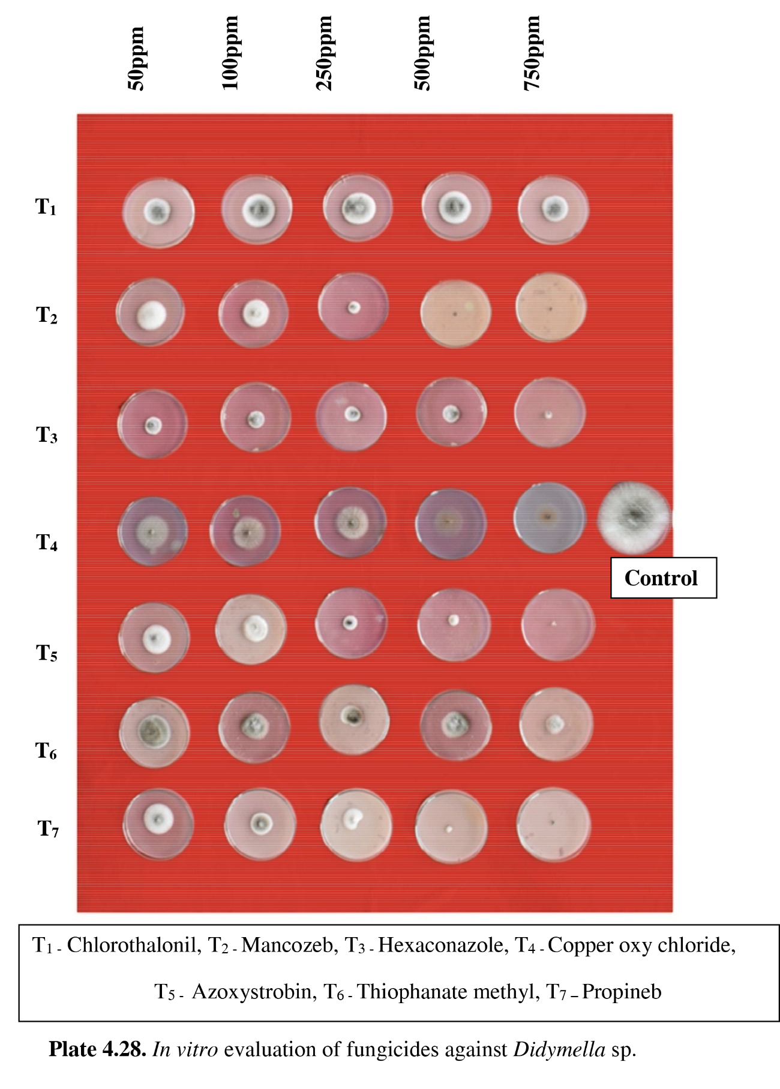
Figure 1. In vitro evaluation of fungicides against Didymella sp.

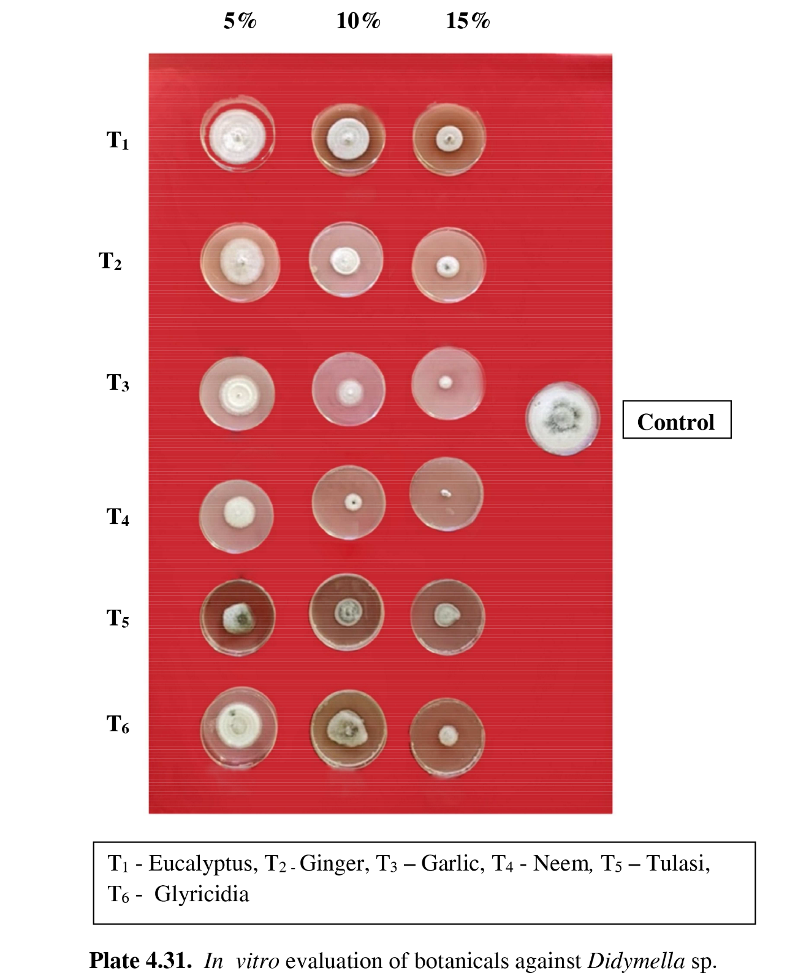
Figure 2. In vitro evaluation of botanicals against Didymella sp.

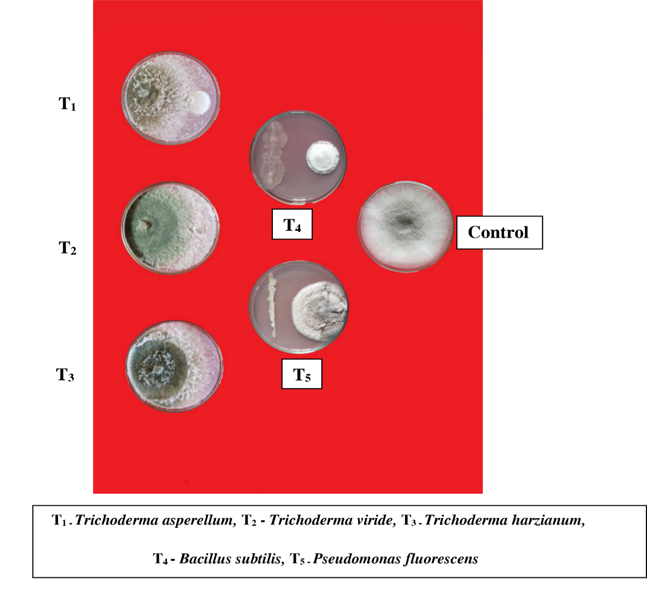
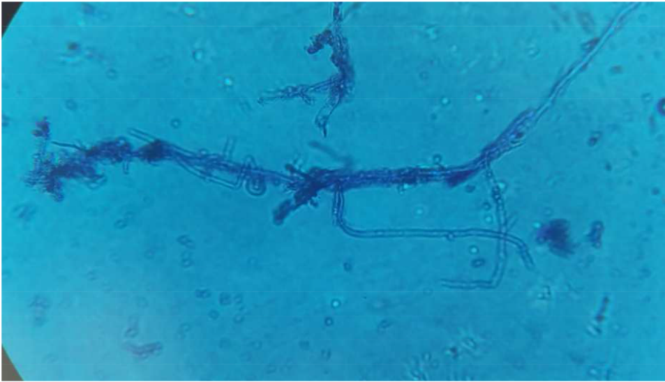

Figure 3. Coiling of Trichoderma sp.with Didymella sp.

