Comparative Evaluation of Butter Extraction from Discarded Seeds of Garcinia gummi-gutta and Garcinia indica

Abstract
The sustainable utilization of agro-industrial waste has gained increasing importance for generating value-added products while addressing environmental and economic concerns. Discarded seeds of Garcinia gummi-gutta and Garcinia indica, produced during fruit processing, represent an underutilized resource with potential as an alternative source of seed butter. The present study evaluated butter extraction efficiency from seeds of these two Garcinia species using acetone, petroleum ether and petroleum benzene through Soxhlet extraction and assessed variation among selected accessions. Significant variation in butter recovery was observed among cambodge accessions, whereas kokum accessions showed relatively uniform performance across solvents. Species-wise comparison revealed that kokum seeds yielded significantly higher butter recovery than cambodge seeds across all solvents, with acetone producing the highest butter yield in both species, while petroleum ether and petroleum benzene yielded butter of superior colour and acceptability. Butter recovery ranged from 43.26 to 47.19 per cent in cambodge and 48.88 to 50.67 per cent in kokum using acetone, with comparatively lower but acceptable recovery using petroleum ether and petroleum benzene. The consistently higher butter recovery observed in kokum seeds corroborates earlier findings and highlights its superior oil-bearing potential. Overall, the study demonstrates the influence of solvent type and genetic variability on butter extraction efficiency and supports the valorization of discarded Garcinia seeds into economically valuable butter for food and allied industrial applications.
Keywords: Garcinia gummi-gutta, Garcinia indica, seed butter ext, solvent efficiency, agro-waste valorization.
Introduction
The sustainable utilization of agri-food waste and by-products has gained global attention as a viable strategy to generate value-added products with potential applications in food, pharmaceutical, and cosmetic industries, while simultaneously addressing environmental and economic challenges. Agro-industrial residues generated during processing of plant materials often pose disposal difficulties; however, these by-products are rich sources of valuable components such as fats, fibres, proteins, minerals, essential oils, and diverse bioactive compounds including fatty acids, phenolics, terpenes, antioxidants and antimicrobial agents (Ben-Othman et al., 2020; Visakh et al., 2024). Harnessing such resources can enhance sustainability and provide additional income opportunities for agro-based industries.
Growing global population, increasing demand for edible oils and rising oil prices have intensified the need to explore alternative and non-conventional oil sources. Traditional edible oils are becoming increasingly scarce, prompting research into underutilized oil-bearing seeds, particularly from perennial tree species, which have received relatively less scientific attention compared to annual crops (Ajayi et al., 2007). Although extensive data exist on conventional oil seeds, limited information is available on non-conventional species such as those belonging to the genus Garcinia, despite their potential as alternative fat sources.
The genus Garcinia belonging to the family Clusiaceae comprises nearly 200 species distributed across tropical regions of Asia and Africa (Kar et al., 2008). Among them, fruit-bearing species such as cambodge (Garcinia gummi-gutta (L.) Robs.) and kokum (Garcinia indica (Thouars) Choisy) are indigenous to the Western Ghats of India and are traditionally valued as tree spice crops. Cambodge is widely cultivated in homesteads of Kerala, while kokum is predominantly grown in coastal Karnataka, Goa, the Konkan region of Maharashtra, and parts of northern Kerala (Rema and Krishnamurthy, 2000; Tharachand and Avadhani, 2013). The rinds of both species are commercially exploited for culinary and medicinal purposes due to the presence of bioactive compounds such as hydroxycitric acid, garcinol, and anthocyanins (Anju and Rameshkumar, 2017). Hydroxycitric acid, in particular, is well recognized for its anti-obesity and cholesterol-lowering properties (Leonhardt and Langhans, 2002; Kim et al., 2011).
Despite the economic importance of the fruit rind, the seeds of both cambodge and kokum are largely discarded after processing, except for a small fraction retained for seedling production. Lack of awareness regarding their biochemical composition has resulted in Garcinia seeds being treated as agro-waste, often leading to pest infestation and environmental issues. Earlier studies have suggested that Garcinia seeds contain substantial amounts of fat, indicating their suitability for butter extraction and valorization into commercially viable products (Parthasarathy et al., 2014; Raveena, 2019; Raysad, 2016).
Recent investigations have emphasized the potential of Garcinia seed butter as a non-conventional fat source with promising functional and nutritional attributes (Nagavekar et al., 2019; Niveditha, 2013; Ramachandran, 2014). However, comprehensive studies comparing butter recovery across species, accessions, and extraction solvents remain limited. Understanding the extraction efficiency and quality attributes of Garcinia seed butter is crucial for promoting its utilization and supporting the development of small-scale, value-added industries.
In this context, the present study was undertaken to evaluate the butter extraction efficiency from discarded seeds of Garcinia gummi-gutta and Garcinia indica using different solvents, to compare butter recovery among selected accessions and to assess the potential of these underutilized seeds as alternative fat sources. The findings aim to contribute to sustainable waste utilization and support the transformation of Garcinia seed waste into economically valuable products
3. Materials and Methods
3.1. Collection of seed materials
Cambodge (Garcinia gummi-gutta) and kokum (Garcinia indica) are perennial, tall-growing, dioecious tree species exhibiting alternate bearing habit. The fruiting seasons of the two species are distinct, with cambodge bearing fruits mainly during June–July, while kokum fruits are available from January to April. Ripe fruits were collected during the peak fruiting period from selected accessions of cambodge and kokum.
Different accessions were selected for each species, with each accession representing a single tree. Details of the accessions and their sources of collection are presented in Table 1.

Table 1. Accessions of cambodge and kokum used for seed collection
Garcinia spp. | Accessions | Source of collection
Cambodge | ACC.FSC.C-1 | Garcinia block, Dept. of Fruit Science, COA, Vellanikkara.
Cambodge | ACC.PSMA.1 | Plantation and Spice farm, Dept. of Plantation, Spices, Medicinal and Aromatic Crops, COA, Vellanikkara
Cambodge | IC244101-2 | ICAR-NBPGR, Regional Station, Vellanikkara, Thrissur
Kokum | ACC.FSC.1 | College orchard, Dept. of Fruit Science, COA, Vellanikkara.
Kokum | IC342296-1 | ICAR-NBPGR, Regional Station, Vellanikkara, Thrissur
Kokum | IC342302-2 | ICAR-NBPGR, Regional Station, Vellanikkara, Thrissur

3.2. Extraction of seed kernels from Garcinia fruits
Fully ripe fruits of cambodge and kokum were harvested during the peak season and transported to the laboratory. Fruits were split manually into two halves and seeds were separated along with the adhering pulp. The seeds were washed thoroughly under running water to remove pulp residues, facilitating faster drying. Seed drying was carried out using a hot air oven maintained at 50–60 °C for 4–5 days. In the case of kokum, sun drying was also adopted due to favourable summer climatic conditions during harvest. Drying was continued until the seed coat became brittle. The dried seeds were shelled manually by twisting or using a seed dehuller to obtain kernels, followed by winnowing to separate kernels from shells. Extracted kernels were stored in moisture-free containers until further processing.
3.3. Processing of seed kernels
The collected seed kernels were slightly roasted to remove adhering impurities and to facilitate loosening of fat content. Roasted kernels were ground into a fine powder using a mixer grinder. The resulting cambodge and kokum seed powders were packed in airtight polythene bags and stored in moisture-free containers for butter extraction.
3.4. Estimation of butter from seed powder
Butter extraction from selected accessions of cambodge and kokum was carried out following standard procedures using solvent extraction in a Soxhlet apparatus. The solvents employed for butter extraction were acetone, petroleum ether and petroleum benzene. After completion of extraction, solvents were removed by evaporation and the recovered butter was collected and weighed. Butter recovery was expressed as percentage on a dry weight basis.
3.5. Statistical Analysis
The data obtained from butter extraction and recovery were subjected to statistical analysis. A Completely Randomized Design (CRD) was used to compare butter recovery among different accessions of cambodge and kokum. A T-test was employed to assess differences in butter recovery between cambodge and kokum.
Results and Discussion
4.1. Extraction of Butter
The percentage recovery of seed butter from cambodge and kokum varied significantly among accessions and Garcinia species (Table 2 and Table 3). The results clearly indicate the influence of solvent type and genetic variability on butter extraction efficiency.
Among cambodge accessions, a significant difference in butter recovery was observed across all solvents used. Extraction using acetone resulted in the highest butter recovery, with accession ACC.FSC.C-1 recording significantly higher recovery (47.19%), followed by ACC.PSMA.1 (44.49%) and IC244101-2 (43.26%). When petroleum ether was used as the extraction solvent, ACC.PSMA.1 exhibited the highest butter recovery (42.01%), followed by IC244101-2 (36.86%) and ACC.FSC.C-1 (36.30%). Similarly, petroleum benzene extraction resulted in the maximum butter recovery in ACC.PSMA.1 (41.32%), which was significantly higher than IC244101-2 (36.56%) and ACC.FSC.C-1 (33.86%). These variations may be attributed to inherent genetic differences among the accessions, influencing seed composition and lipid accumulation.
In contrast, among kokum accessions, no significant difference was observed in butter recovery irrespective of the solvent used. Using acetone, the highest butter recovery was recorded in ACC.FSC.1 (50.67%), followed by IC342302-2 (49.28%) and IC342296-1 (48.88%). Petroleum ether extraction yielded the highest butter recovery in IC342296-1 (41.57%), followed by IC342302-2 (40.01%) and ACC.FSC.1 (39.27%). With petroleum benzene, IC342296-1 recorded marginally higher butter recovery (42.67%) compared to ACC.FSC.1 (42.11%) and IC342302-2 (41.96%). The uniformity in butter recovery among kokum accessions suggests stable lipid content across the accessions studied.

Table 2. Per cent recovery of butter using different solvents in cambodge and kokum accessions
Crop | Accessions | Acetone (%) | Petroleum ether (%) | Petroleum benzene (%)
Cambodge | ACC.FSC.C-1 | 47.19ª | 36.30^{b} | 33.86^{c}
Cambodge | ACC.PSMA.1 | 44.49^{ab} | 42.01ª | 41.32ª
Cambodge | IC244101-2 | 43.26^{b} | 36.86^{b} | 36.56^{b}
Cambodge | SE(m) | 0.99 | 0.78 | 0.68
Cambodge | C.D. @5% | 3.06 | 2.42 | 2.30
Cambodge | C.V. (%) | 4.95 | 4.57 | 4.08
Kokum | ACC.FSC.1 | 50.67ª | 39.27ª | 42.11ª
Kokum | IC342296-1 | 48.88ª | 41.57ª | 42.67ª
Kokum | IC342302-2 | 49.28ª | 40.01ª | 41.96ª
Kokum | SE(m) | 0.53 | 0.63 | 0.74
Kokum | C.D. @5% | NS | NS | NS
Kokum | C.V. (%) | 2.39 | 3.50 | 3.90

Superscripts with same alphabets in column represents no significant difference at the 5% level.
*NS-Non significant
A significant difference in butter recovery was observed between cambodge and kokum seeds across all solvents used. Extraction using acetone resulted in significantly higher butter recovery in kokum (49.61%) compared to cambodge (44.98%). Similarly, petroleum ether extraction yielded higher butter recovery in kokum (40.29%) than in cambodge (38.41%). Petroleum benzene extraction also followed the same trend, with kokum recording significantly higher butter recovery (42.25%) compared to cambodge (37.25%). Overall, kokum seeds consistently exhibited superior butter recovery than cambodge seeds, indicating their higher oil-bearing potential.

Table 3. Per cent recovery of cambodge and kokum seed butter using different solvents
Solvents | Cambodge |  |  | Kokum |  |  | T  value | P  value
Solvents | Mean | SE (m) | C.V.  (%) | Mean | SE (m) | C.V.  (%) | T  value | P  value
Acetone (%) | 44.98^{b} | 0.69 | 0.06 | 49.61ª | 0.35 | 0.03 | -5.99 | 0
Petroleum ether (%) | 38.41^{b} | 0.81 | 0.08 | 40.29ª | 0.42 | 0.04 | -2.06 | 0.049
Petroleum benzene (%) | 37.25^{b} | 0.9 | 0.09 | 42.25ª | 0.40 | 0.04 | -5.07 | 0
Superscripts with same alphabets in row represents no significant difference at the 5% level.
Among the solvents evaluated, acetone proved to be the most efficient solvent for butter extraction in terms of yield for both cambodge and kokum. The higher extraction efficiency of acetone may be attributed to its strong solvent polarity, which enhances the solubilization of lipid fractions from seed kernels. However, butter extracted using acetone was light brown in colour, likely due to the co-extraction of pigments and other non-lipid compounds.
Butter extracted using petroleum ether and petroleum benzene was white in colour, indicating higher purity and reduced extraction of pigments. Although petroleum ether resulted in slightly lower butter yield compared to acetone, the quality of butter obtained was superior in terms of colour and acceptability. Petroleum ether extracted butter is generally considered more suitable for daily and edible use. Nevertheless, the extracted butter is typically subjected to further refining processes, including alkali refining and deodorization, to enhance its edible quality and shelf stability.
The consistently higher butter recovery observed in kokum seeds in the present study is in agreement with earlier findings reported by several researchers. Nagavekar et al. (2019) reported a butter recovery of 42.80% from kokum seeds, which closely aligns with the results obtained in the present investigation. Similar observations on high butter yield in kokum and cambodge seeds were also reported by Raveena (2019) and Raysad (2016), who highlighted the superior oil-bearing potential of kokum seeds compared to other Garcinia species. Chate et al. (2019) further reported that variations in butter recovery may be influenced by factors such as solvent type, extraction technique and genetic variability among accessions. The slightly higher butter recovery recorded in the present study may therefore be attributed to improved solvent extraction methods as well as differences in accession characteristics and seed composition.
The present study clearly demonstrates that solvent type and species significantly influence butter extraction efficiency. While acetone yielded the highest butter recovery, petroleum ether produced butter of superior quality and acceptability. Kokum seeds, owing to their higher butter content, uniform extraction performance across accessions and better recovery across solvents, exhibit greater potential for commercial butter production compared to cambodge seeds.
Conclusion
The study revealed that kokum seeds yielded significantly higher butter recovery than cambodge across all solvents used. Acetone resulted in the highest butter extraction, while petroleum ether and petroleum benzene produced butter of superior colour and acceptability. Considerable variation in butter recovery was observed among cambodge accessions, whereas kokum accessions showed relatively uniform performance. Overall, kokum seeds demonstrated greater potential for butter production, highlighting the importance of solvent selection and accession variability in optimizing butter extraction.
References
Ajayi, I.A., Oderinde, R.A., Ogunkoya, B.O., Egunyomi, A., Taiwo, V.O., 2007. Chemical analysis and preliminary toxicological evaluation of Garcinia mangostana seeds and seed oil. Food Chemistry 101, 999-1004. https://doi.org/10.1016/j.foodchem.2006.02.053
Anju, V., Rameshkumar, K.B., 2016. Phytochemicals and bioactivities of Garcinia gummi-gutta (L.) N. Robson-A review. Diversity of Garcinia species in the Western Ghats: Phytochemical Perspective, JNTBGRI. 250. https://doi.org/10.25173/978-81-924674-5-0
Ben-Othman, S., J˜ oudu, I., Bhat, R., 2020. Bioactives from agri-food wastes: Present insights and future challenges. Molecules 25, 1–34. https://doi.org/10.3390/molecules25030510
Kar, A., Borkakoti, S., Borthakur, S.K., 2008. Extended distribution of the genus Garcinia L. in Sonitpur district, Assam, India. Pleione 2, 165-170. http://pleione.ehsst.org/vol2_2/165-170.pdf
Kim, J.E., Jeon, S.M., Park, K.H., Lee, W.S., Jeong, T.S., McGregor, R.A., Choi, M.S., 2011. Does Glycine max leaves or Garcinia cambogia promote weight-loss or lower plasma cholesterol in overweight individuals: a randomized control trial. Nutrition Journal 10, 1-11. https://doi.org/10.1186/1475-2891-10-94
Leonhardt, M., Langhans, W., 2002. Hydroxycitrate has long-term effects on feeding behavior, body weight regain and metabolism after body weight loss in male rats. The J. of nutrition 132, 1977-1982. https://doi.org/10.1093/jn/132.7.1977
Nagavekar, N., Kumar, A., Dubey, K., Singhal, R.S., 2019. Supercritical carbon dioxide extraction of kokum fat from Garcinia indica kernels and its application as a gelator in oleogels with oils. Industrial Crops and Products 138, 111459. https://doi.org/10.1016/j.indcrop.2019.06.022
Niveditha, M. (2013). Morphological and chemical characterisation of different fruit morpho types in Garcinia indica Choisy (M.Sc. Thesis, University of Agricultural Science, Dharwad).
Parthasarathy, U., Nandakishore, O.P., Senthil Kumar, R., Parthasarathy, V.A., 2014. A comparison on the physico-chemical parameters of seed butters of selected Indian garcinia spp. J. Global Biosci. 3, 872-880. https://www.researchgate.net/publication/260090000_A_COMPARISON_ON_THE_PHYSICO-CHEMICAL_PARAMETERS_OF_SEEDBUTTERS_OF_SELECTED_INDIAN_GARCINIA_SPP
Ramachandran, H.D., Fayaz, P., Kusum, R., 2014. Plant profile, phytochemistry and pharmacology of Garcinia indica: A review. Int. J. Pharm. Sci. Rev. Res. 27, 376-381. https://www.globalresearchonline.net/journalcontents/volume27issue2.aspx
Kapatia, R. (2019). Morphological and biochemical diversity of Garcinia indica germplasm (Master's thesis). Kerala Agricultural University.
Raysad, K.S. 2016. Morpho-Physiological diversity assessment of Garcinia gummigatta (L.) Robs. Germplasm collection. M.Sc. (Forestry) thesis, Kerala Agricultural University, Thrissur, 105p.
Rema, J. and Krishnamoorthy, B. 2000. Garcinia species of economic importance, distribution and uses. Indian spices. 37(1): 20-23.
Tharachand, S.I., Avadhani, M., 2013. Medicinal properties of malabar tamarind [Garcinia cambogia (Gaertn) DESR]. Int. J. Pharm. Sci. Rev. Res. 19, 101-107. https://www.globalresearchonline.net/
Visakh, N.U., Pathrose, B., Chellappan, M., Ranjith, M.T., Sindhu, P.V. and Mathew, D., 2023. Extraction and chemical characterisation of agro-waste from turmeric leaves as a source of bioactive essential oils with insecticidal and antioxidant activities. Waste Management, 169, pp.1-10. https://doi.org/10.1016/j.wasman.2023.06.030

60
50
40
30
20
10
0
Cambodge
Kokum
Acetone
Petroleum ether
Solvents
Petroleum benzene

Figure 1. Quantity of butter extracted using different types of solvents in cambodge and kokum

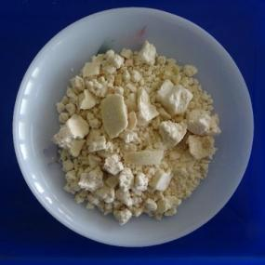
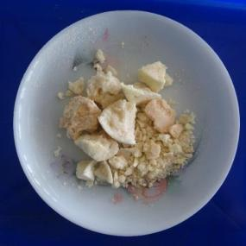
Cambodge seed butter
Kokum seed butter

Plate 1. Physical state of butter at room temperature (32 ℃)

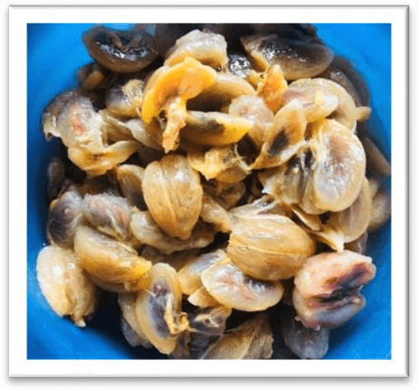
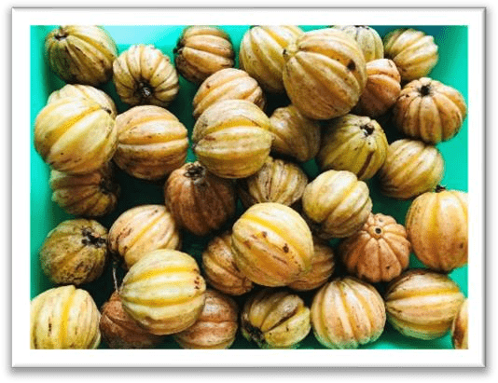

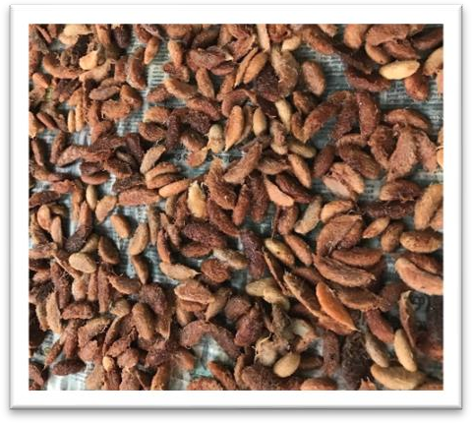
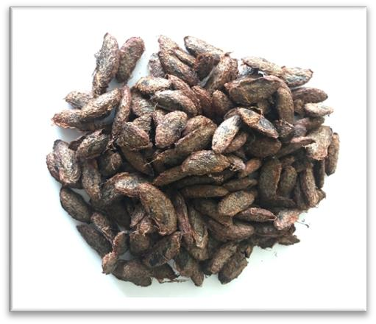
Cambodge seeds with pulp
Ripen cambodge fruits
Seeds dried in hot air oven
Removal of seed mucilage
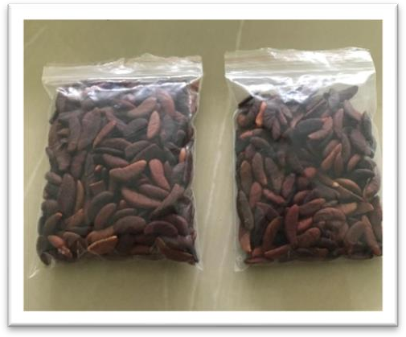
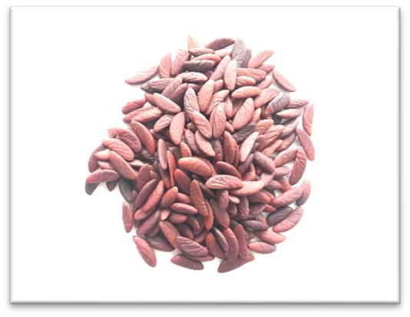
Kernels packed in polythene bags

Nibbed kernels

Plate 2. Steps followed for extraction of cambodge seed kernels

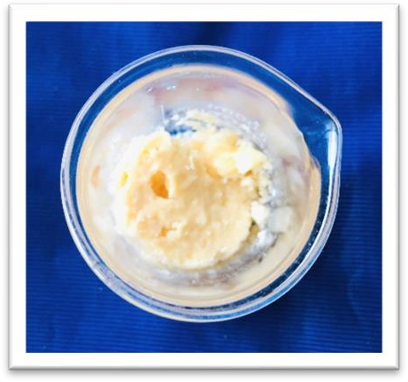
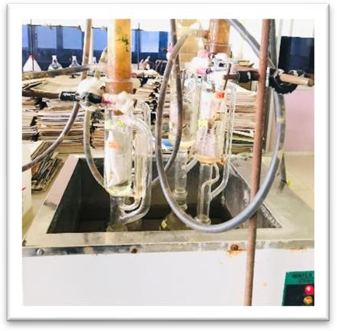
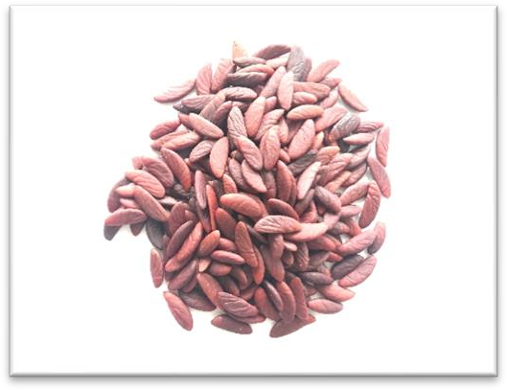
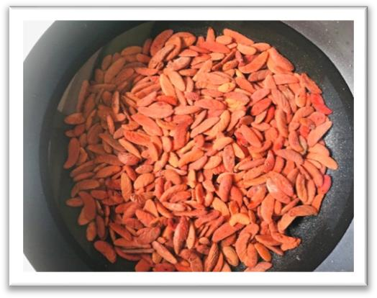
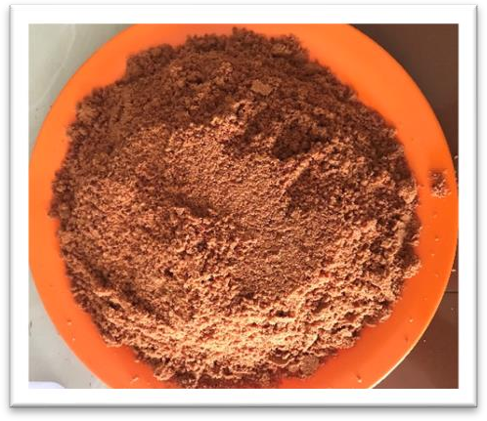
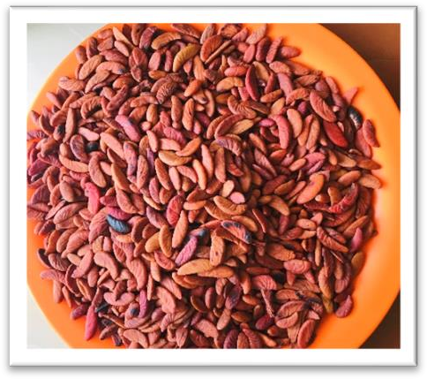
Cambodge butter

Soxhlet extraction

Cambodge butter
Rosted kernels
Cambodge seed powder

Kernels dipped in hot water

Cambodge kernels

Plate 3. Procedure followed for extraction of butter from cambodge seed kernels

