Original Research Article
Variation in Seed Characters of Calophyllum inophyllum L.and Changes in Oil content and Germination with Storage

Abstract
The present study was intended to identify better Germplasm from different seed sources and to assess the variability of morphometric , Oil and germination characters of Germplasm from different seed sources for future improvement work . The study was also intended to assess the changes in oil content, germination and seedling characters with storage and identify the best storage condition. The fruits were collected from 21 CPTs from Calophyllum inophyllum L .seed sources present in coastal district Puri, Odisha, India. The seeds collected were recorded morphometric characters, Oil content and Seedling characters and variability was observed in different characters. Oil content, seed weight, kernel weight, kernel length, kernel width and fruit weight found to have high heritability and high-moderate genetic gain which can be taken into consideration for selection of plant material for further genetic improvement. In case of Progeny testing higher heritability and genetic gain was observed in Germination percentage, Fresh seedling biomass, vigour index and seedling height which can be taken into consideration for selection of plant material for future genetic improvement.The correlation among the all fruit characters revealed that Oil content has no significant correlation with Morphometric characters of fruit /seeds, germination characters and seedling characters. The interaction effect of storage conditions and storage durations expressed that Oil content, germination percentage, Seedling height and seedling Vigour in all storage conditions decreased continuously till 90 days of storage and maximum oil extracted in seed stored under CPD. The effect of storage condition irrespective of storage duration revealed germination and seedling characters are found to be maximum in seeds stored under CPD. Similarly, the effect of storage duration irrespective of storage condition revealed that the germination and seedling characters maximum at the time of initial storage and decreased to minimum after 90 days of storage. Storage study found that the Oil content of stored seed was highly positively correlated with the germination percentage, seedling shoot height and seedling shoot vigour index.
Key words: Calophyllum inophyllum , Seed Source, Morphometric characters , Oil content, Progeny testing, Storage Effect
Introduction
Genus Calophyllum contains nearly 187 species of which 179 species are distributed in India –Malayan region and rest 8 in Mexico, Carribean- Argentina region (Chinthu et al., 2022). Calophyllum inophyllum belonging to family Calophyllaceae is an important littoral Tree borne Oil seed of the tropics, occurring above the high-tide mark along sea coasts of northern Australia and extending throughout Southeast Asia and southern India (Sundur et al,2014) .In india it is widely distributed in the eastern and western coast and commonly known as Alexandrian laurel, Indian Laurel, beauty leaf or Poong and locally called “Polanga”. The species comes under least concern category of IUCN Red data list (Chinthu et al., 2022). In odisha , it is found mostly in Puri district , however it is also found in small patches in Khurdha ,Jagatsinghpur , Kendrapara and Ganjam district along the sea coast and high tide areas. It is a medium-sized to large evergreen tree that grows up to 8–20 m in height with a broad spreading crown of irregular branches (Sundur et al., 2014). The tree has a dense canopy of glossy elliptical leaves, fragrant white flowers and large round nuts (Friday.and Okano, 2006). C.inophyllum fruits profusely (3,000-10,000 seeds/tree/season) with seeds having 50-73% oil (Atabani et al., 2014; Karthik et al., 2024 ; Fadhlullah et al., 2015; shinde et al., 2012 & Sudalai et al., 2024). The fruits are harvested twice/year in the study site. The oil from seed kernels of C.inophyllum is also known as Tamanu oil. The major fatty acids content in the oil reported by Huynh Cang Mai et al. (2020) were Oleic acid (49%); linoleic acid (21%); palmatic acid (15%); stearic acid (13%), cicosanoic acid (1.7%) and linolenic acid (0.3%). The seed oil is an acceptable source of sustainable biodiesel (Dorla et al., 2019; Gupta & Gupta, 2020 & Atabani and César, 2014). It was also mentioned that C. inophyllum biodiesel can be used in the recent diesel engines with a blend of diesel fuel up to 10% (Jain et al. , 2018) and 20% (Ariharan et al. 2014) which falls within ASTM biodiesel standards. Besides recent scope for as biodiesel, then oil has medicinal value and is traditionally used to cure sunburn, psoriasis , diabetic wounds and abrasions. In southern Africa, it is useful for treating arthritis, rheumatism, eye inflammation, herpes, scalp and hair problems (Sundur et al., 2014; Sutrisno et al., 2020). Calophyllum oil contains natural squalene which is used as a raw material for cosmetics (Saputra et al., 2014)
The oil can also be used to cure skin, acne and scalp treatment by inhibiting the related bacteria and fungus (
Léguillier et al.,2025 ; Chris ,2015 & Huynh Cang Mai, 2020). The oil contains friedelin, canophyllo, canophyllic acid and inophynone which has antibacterial activities which are found to be comparable to those of ampicillin and amoxicillin against Proteus mirabilis. The oil has also antiworm and inflammatory properties (Bhalla et al, 1980 ; Chris ,2015 & Huynh Cang Mai, 2020).Its unique UV absorbing property (260nm-400 nm) enabling its application in skin and ophthalmic preparations (Gopalakrishnan et al, 1980 and Huynh Cang Mai, 2020). The oil possesses the capacity to promote the formation of new tissue, thereby accelerating healing and the growth of healthy skin (Petard, 1972 ) along with antioxidant properties (Ansel et al, 2016 & Mahmud et al., 1998) which can also be helpful for cancer treatment (Kilus et al, 2023).
This species shows a wide range of geographical distribution (Friday.and Okano ,2006). Geo-climatic variations may influence plastic changes in plant performance (Dharmaratne, 2002). Therefore, Source variation tests are necessary to screen the naturally available variation for further improvement work on the species for higher productivity. This also enable to find out the best tree sources for collection of seeds. Karthik et al.(2024) reported the seed source variation in coastal taluks of Uttara Kannada district, Karnataka for seed moropholgical, oil and seedling characters of C.inophyllum. Similar morphological and oil variation study in C.inophyllum was also carried out by Shinde et al.(2012) in the Konkan Coasts of Maharashtra.
The seeds are believed to be recalcitrant and need high moisture content to retain their viability which is supported by Allen (2002, however, seed storage behaviour of C. inophyllum was also reported to be intermediate (Ng ,1992 ; Gupta et al., 2009 & Hathurusingha and Ashwath, 2012) reported that seed storage behaviour of C. inophyllum is intermediate. The relationship between the seed oil content and germination of the seed for this species has not been properly studied. The oil content and germination in seeds also undergo changes with time in post-harvest period for which the harvested seeds should be properly stored under controlled condition to minimise the loss Oil content and germination percentage.
The present study was conducted to assess the varaiation and variability in morphometric, Oil and Germination characters of seeds of different seed sources for future improvement programme and also to identify the best available tree sources for present collection of seeds for oil extraction.In addition, the effect of different storage on Oil content and seed germination of C. inophyllum has also been assessed to get a better storage option of seeds for future utilisation.

2. Materials and Methods

2.1 Oil Content (%) and Fruit Morphometric Characters of Calophyllum inophyllum L.
2.1.1 CPT selection and Morphometric Observations recorded
The seed sources are mainly distributed in the coastal Puri district of Odisha, India. Most of them are situated near the Brackish water lake ‘Chilika’ and on the river beds in the district. During sampling process, healthy sample trees of nearly same DBH, age class (30-40 years),larger crown area, higher no. of fruit bunches/tree, higher no. of fruit/bunch and larger seed size were also taken into consideration from which 21 CPT were identified (ODCPT1-ODCPT21). The place of collection in different blocks of Puri district is given in the below in tabular form.
Table-1: Detail of CPTs Identified in Various Seed sources
CPT | Place of Seed Source | Block | District | CPT | Place of Collection | Block | District
ODCPT-1 | KasiJagannathpur | Brahmagiri | Puri | ODCPT-12 | Gorapur | Krushnaprasad | Puri
ODCPT-2 | KasiJagannathpur | Brahmagiri | Puri | ODCPT-13 | Gorapur | Krushnaprasad | Puri
ODCPT-3 | KasiJagannathpur | Brahmagiri | Puri | ODCPT-14 | Pirijpur | Brahmagiri | Puri
ODCPT-4 | Gorapur | Krushnaprasad | Puri | ODCPT-15 | Guptapur | Brahmagiri | Puri
ODCPT-5 | Nuagaon | Krushnaprasad | Puri | ODCPT-16 | Kakuaradi | Brahmagiri | Puri
ODCPT-6 | Nuagaon | Krushnaprasad | Puri | ODCPT-17 | Ghatakudi | Brahmagiri | Puri
ODCPT-7 | Chandikhol | Krushnaprasad | Puri | ODCPT-18 | Rengali | Delanga | Puri
ODCPT-8 | Chandikhol | Krushnaprasad | Puri | ODCPT-19 | Rengali | Delanga | Puri
ODCPT-9 | Chandikhol | Krushnaprasad | Puri | ODCPT-20 | Rengali | Delanga | Puri
ODCPT-10 | Chandikhol | Krushnaprasad | Puri | ODCPT-21 | Rengali | Delanga | Puri
ODCPT-11 | Chandikhol | Krushnaprasad | Puri
* ODCPT stands for Odisha Candidate Plus Tree
From each CPT (Treatment) randomly 3 samples (Replications) of fully ripened matured fruits each containing 25 fruits were collected. Fresh and fully matured fruits for each CPT sample collected were treated with cold water for 1 hour, depulped and seeds were extracted. The extracted Seeds were again treated with water for 48 hours. The fruit length (cm) , fruit width (cm) , seed length (cm) , seed width (cm) ,kernel length (cm) , kernel width (cm) were measured using Vernier calliper, 25 fruits weight (gm) , 25 seed weight (gm), 25 kernel weight (gm) were measured by using digital balance.
2.1.2 Estimation of Oil Content (%)
The kernels were separated out from the seeds of which 50 g of kernel were taken and cut into small pieces, oven dried at 50ºC and grinded. The grounded samples were then extracted for oil by Soxhlet apparatus using diethyl ether as extractions. The extraction chamber was fixed over a round bottom flask containing Diethyl ether as extraction solvent for 8hours till the extraction chamber became clear and containing no oil. The flask containing the mixture diethyl ether was distilled to obtain the oil and recovered diethyl ether. It was further kept in open for 6 hours till traces of diethyl ether evaporates and the oil is left over in the flask. The flask was then weighed to estimate extracted oil and the percentage of oil content was calculated as given below

$OC\left(\%\right)=\frac{W3-W2}{W1}x 100$ Where, OC (%)- Oil Content (%) on Oven Dry Weight basis of Kernel
W₁- Weight of Oven Dry Kernel (g)
W₂- Weight of Flat Bottom Flask (g)
W₃- Weight of Oil & Flat Bottom Flask (g)
2.1.3 Seed Germination Characters assessment
The extracted seeds were mixed with Dithane M-45 @3g/kg of seed and sown in the nursery bed separately for each CPT and observations like No. of seed germinated daily up to 40 Days after sowing whereas Seedling length (cm), Collar diameter (cm), Fresh seedling biomass(g), Oven dry seedling Biomass(g) were recorded after 90 days of sowing. Some germination parameters like Germination Percentage (%) and Shoot Vigour Index (SVI) were estimated.
2.1.4 Analysis and Correlation between Morphological, Germination and Oil Characters
The recorded observations of seed morphometric characters, germination characters and oil content were subjected to ANOVA, Range, Magnitude of Variance (%),Genotypic Coefficient of Variance (GCV) &, Phenotypic Coefficient of Variance (PCV) by Burton and Vane (1953)., Heritability by Burton (1952) and Genetic gain by Johnson et al. (1955) were estimated. PCV and GCV were classified into three classes; less than 10% (Low), 10 – 20% (Moderate) and more than 20% (High). Heritability was categorized according to Robinson et al. (1949) to three classes: 0.0-30% (Low), 31-60% Medium) and more than 60% (High). Genetic gain was classified by Johnson et al. (1955 as low, moderate, and high with 0–10%, 10–20%, and >20%, respectively. Pearson correlation coefficients among oil, seed characters and germination characters were also analysed.

2.2 Oil Content and Germination Characters of stored seeds of Calophyllum inophyllum L.
2.2.1 Storage of Material
Fruits collected from a CPT during the month of March 2014 were air dried and stored in polythene bags under different storage conditions (Closed light, Open light, Closed dark, Open dark) for 30, 60, 90 days respectively with 3 replications.
2.2.2 Estimation of Oil Content (%)
The oil was then extracted using Diethyl Ether in Soxhlet apparatus and the Oil Content (%) estimated as described earlier in 2.1.2 and its degradation percentage was calculated.
2.2.3 Seed Germination Characters assessment
The extracted seeds from the stored fruits were treated and assessed for germination characters after sowing as per the methods explained in 2.1.3.
2.2.4 Analysis and Correlation between Germination and Oil Characters of stored seeds
The oil content and germination characters were statistically analysed through Factorial CRD and the Pearson correlation coefficient between Oil content (%) and Germination parameters of stored seeds were also analysed
3. Results and Discussion
3.1 Assessment of solvent system for extraction of Oil from seeds of Calophyllum inophyllum L.
During the Investigation initially the solvent for maximum fixed oil extraction from seeds of C. inophyllum was carried out in which highest oil was extracted by Diethyl Ether (57.49%) followed by 51.13 % with Petroleum ether (60⁰ - 80⁰ C) ), 48.36% with Petroleum ether (40⁰ - 60⁰ C and least (44.94% ) with n-Hexane (Figure-1). It may be because maximum extraction of Triglycerides, Free Fatty Acids, carbonyl and other lesser polar compounds extracted with Diethyl Ether.
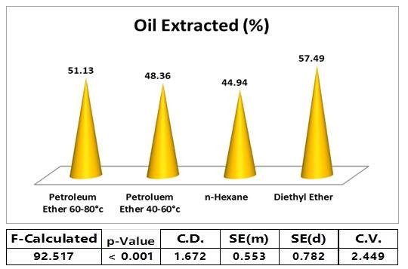
Figure 1: Assessing extracted Oil (%) from Calophyllum inophyllum L. Kernels

3.2 Studies on Seed Characters of Calophyllum inophyllum L.
The analysis of variance revealed that there were significant difference among the fruit length, fruit width, 25 fruit weight, Seed length, 25seed weight, kernel length, Kernel width , 25kernel weight and oil content (kernel wt. basis) of the seeds collected from 21 different Seed sources (Table-2).
Maximum fruit length (3.92cm) , fruit width (3.64cm) , 25fruit weight (401.49g) and seed length (3.60 cm ) were observed in case of seeds from ODCPT-12, maximum 25seed weight ( 202.82g) and 25kernel weight (130.18g) were observed in case of ODCPT-15 , maximum kernel width in ODCPT -1(2.36cm) and maximum kernel length was observed (2.71cm) and oil content on kernel wt. basis (70.05%) in ODCPT-17, (Table-2). The maximum values for different traits are observed in different germplasm which the may be due to the environmental ,genetic factors and their interactions favouring maximum growth of different seed traits for those germplasm.

Variation is the difference observed in individuals for a particular fruit or seed character whereas variability is a measure or index to access the extent of variation. The standard deviation of a sample represents its deviation from mean and more the standard deviation higher is the variation. In the present investigation the mean Fruit length with its SD [3.61cm (0.40)], Fruit width [3.34cm (0.33)], 25 Fruit weight [337.50g (36.21)], Seed length [3.15cm (0.41)], Seed width [3.09cm (2.32)], 25 Seed weight [174.91g (4.34)], Kernel length [(2.49 cm (0.13)] , Kernel width [2.17cm (0.07))], 25 Kernel weight [(109.54 g (4.63)] and Oil content [(56.99% (6.59)] indicates variation in each character (Table-2&3). However, the maximum SD was observed in case of 25 Fruit weight (36.31) whereas, the SD observed for 25 seed weight (4.34) was lesser which may be attributed to higher amount of variation in fruit pulp. The CPTs showed variation in seed which ranges in case of fruit length (3.25cm-3.92cm), fruit width (2.98cm -3.64cm), 25 fruit weight (265.12g-401.49g), seed length (2.84cm- 3.60cm) , seed width (2.68cm-5.22cm) , 25 seed weight (119.86gm-202.82g) , kernel length (2.13cm-2.71cm) , kernel width (1.97cm-2.36cm) , 25 kernel weight (78.69g-130.18g) and oil content (47.57%-70.05%) (Table-3). These variations may be due to the genotypes, environmental (edaphic & micro climatic conditions) and their interactions in different seed sources. Similar types of study assessing the variability in fruit and seed characters were revealed by Karthik et al. (2024), Shreekumar & Gunaga (2017), Shinde et al. (2012) & Hathurusingha et al. (2011) in Calophyllum inophyllum L.

Table-2: Seed Characters of Calophyllum inophyllum L.
Seed  Sample | Fruit Length  (cm) | Fruit Width  (cm) | 25 Fruit Weight  (g) | Seed Length  (cm) | Seed Width  (cm) | 25 Seed Weight  (g) | Kernel Length  (cm) | Kernel Width  (cm) | 25 Kernel Weight  (g) | Oil Content  (%)
ODCPT-1 | 3.61 | 3.29 | 319.79 | 3.07 | 2.87 | 172.37 | 2.13 | 2.36 | 106.53 | 59.61
ODCPT-2 | 3.70 | 3.39 | 367.63 | 3.16 | 3.00 | 177.14 | 2.26 | 2.05 | 107.20 | 57.92
ODCPT-3 | 3.65 | 3.39 | 311.08 | 3.14 | 2.96 | 170.65 | 2.25 | 1.97 | 102.36 | 55.80
ODCPT-4 | 3.57 | 3.28 | 324.85 | 2.98 | 2.87 | 163.27 | 2.30 | 2.11 | 99.81 | 55.58
ODCPT-5 | 3.65 | 3.37 | 316.82 | 2.98 | 5.22 | 179.91 | 2.26 | 2.10 | 109.9 | 58.84
ODCPT-6 | 3.51 | 3.22 | 321.99 | 3.11 | 2.88 | 165.34 | 2.34 | 2.04 | 100.85 | 59.32
ODCPT-7 | 3.59 | 3.37 | 336.69 | 3.22 | 3.02 | 176.62 | 2.49 | 2.21 | 119.73 | 57.74
ODCPT-8 | 3.83 | 3.48 | 377.02 | 3.40 | 3.14 | 200.57 | 2.63 | 2.25 | 119.49 | 54.96
ODCPT-9 | 3.74 | 3.49 | 356.76 | 3.24 | 3.21 | 199.83 | 2.60 | 2.18 | 120.73 | 57.10
ODCPT-10 | 3.65 | 3.44 | 370.78 | 3.34 | 3.19 | 197.74 | 2.61 | 2.18 | 121.75 | 59.72
ODCPT-11 | 3.62 | 3.40 | 359.63 | 3.30 | 3.02 | 187.19 | 2.67 | 2.24 | 115.06 | 60.96
ODCPT-12 | 3.92 | 3.64 | 401.49 | 3.60 | 3.28 | 188.06 | 2.67 | 2.27 | 112.87 | 56.94
ODCPT-13 | 3.76 | 3.46 | 375.91 | 3.27 | 2.97 | 195.76 | 2.70 | 2.26 | 120.45 | 55.34
ODCPT-14 | 3.64 | 3.30 | 313.61 | 2.97 | 2.84 | 144.48 | 2.52 | 2.21 | 112.47 | 58.84
ODCPT-15 | 3.73 | 3.45 | 372.03 | 3.29 | 3.18 | 202.82 | 2.65 | 2.30 | 130.18 | 50.74
ODCPT-16 | 3.25 | 2.98 | 265.12 | 2.86 | 2.68 | 119.86 | 2.32 | 2.06 | 78.69 | 47.57
ODCPT-17 | 3.52 | 3.19 | 306.32 | 3.20 | 3.00 | 165.29 | 2.71 | 2.25 | 110.67 | 70.05
ODCPT-18 | 3.56 | 3.26 | 324.92 | 3.15 | 2.87 | 164.91 | 2.54 | 2.15 | 102.10 | 49.56
ODCPT-19 | 3.38 | 3.21 | 315.21 | 3.01 | 2.88 | 172.12 | 2.57 | 2.21 | 102.19 | 56.34
ODCPT-20 | 3.45 | 3.24 | 301.65 | 3.08 | 2.75 | 160.65 | 2.42 | 2.12 | 96.25 | 56.34
ODCPT-21 | 3.60 | 3.36 | 348.37 | 2.84 | 3.03 | 168.70 | 2.67 | 2.16 | 111.13 | 57.66
Mean | 3.61 | 3.34 | 337.5 | 3.15 | 3.09 | 174.91 | 2.49 | 2.17 | 109.54 | 56.99
F-Value | 2.88 | 3.79 | 17.52 | 3.97 | 1.01 | 446.63 | 37.81 | 34.74 | 124.21 | 9.98
p-Value | 0.002 | <0.001 | <0.001 | <0.001 | 0.464 | <0.001 | <0.001 | <0.001 | <0.001 | <0.001
CD (5%) | 0.25 | 0.20 | 22.67 | 0.26 | N/A | 2.71 | 0.08 | 0.05 | 2.91 | 4.127
SED | 0.124 | 0.10 | 11.17 | 0.13 | 0.72 | 1.34 | 0.04 | 0.02 | 1.43 | 2.034
SEM | 0.087 | 0.071 | 7.902 | 0.09 | 0.507 | 0.948 | 0.029 | 0.016 | 1.010 | 1.438

Table-3: Variation and Variability of Seed Characters of Calophyllum inophyllum L.
Seed Characters | Range | SD | Magnitude of Variance (%) | GCV (%) | PCV (%) | ECV (%)
Fruit Length | 3.25 – 3.92 | 0.40 | 17.09 | 3.32 | 5.34 | 4.19
Fruit Width | 2.98 – 3.64 | 0.33 | 18.13 | 3.54 | 5.10 | 3.67
25 Fruit weight | 265.12 – 401.49 | 36.21 | 33.96 | 9.51 | 10.34 | 4.05
Seed Length | 2.84 – 3.60 | 0.41 | 21.11 | 5.00 | 7.09 | 5.03
Seed Width | 2.68 – 5.22 | 2.32 | 48.65 | 2.26 | 28.52 | 28.43
25 Seed weight | 119.86 – 202.82 | 4.34 | 40.90 | 11.43 | 11.47 | 0.93
Kernel Length | 2.13 – 2.71 | 0.13 | 21.40 | 7.12 | 7.41 | 2.03
Kernel Width | 1.97 – 2.36 | 0.07 | 16.52 | 4.34 | 4.53 | 1.29
25 Kernel weight | 78.69 – 130.18 | 4.63 | 39.55 | 10.26 | 10.39 | 1.60
Oil content | 47.57 – 70.05 | 6.59 | 32.09 | 8.31 | 9.40 | 4.37

The magnitude of variation was moderate in most of the seed traits with maximum in seed width (48.65%) followed by 25seed weight (40.90%), 25kernel weight (39.55%), fruit length (33.96%) and oil content in kernel (32.09%) (Table-3). This indicates these seed characters of Calophyllum inophyllum L. has higher variation and may be taken up for improvement of the species. Similar types of findings were also reported by Gingwal et al. (2005) & Kaushik et al. (2007) in Jatropha curcus.

The tendency of individual genotypes in a population to vary from each other is measured by Genetic variability. Genetic variability in a population plays an important role in biodiversity as higher the variability more it adapts to the environmental changes and less prone to extinction (Shah et al., 2015; Kumar et al., 2016). Genetic parameters like GCV and PCV of a character are useful in assessing the variability present in the germplasm (Kumar et al., 2019; Upadhyay et al., 2019 & Subramaniam et al., 1995). All the seed traits showed higher value for PCV than GCV (Table-3) indicating that all fruit and seed characters are more or less influenced by environment. Higher value of PCV and GCV also indicates significant genetic variability (Singh et al., 2020). Most of the seed characters categorized under Low GCV class except 25 seed weight (11.43%) and 25 Kernel weight (10.26%) under moderate GCV class. In case of PCV only seed width (28.52%) categorized under Higher class whereas 25 Fruit weight (10.34%), 25seed weight (11.47%) , 25 kernel weight (10.39%) under Moderate class and rest characters under lower class.

Heritability in broad sense is a measure of the extent of phenotypic variation caused by action of the genes (Johnson et al. 1955) which is heritable (Lush, 1937 & Allard, 1960). The selection of elite genotypes from diverse genetic population by the breeder is estimated by heritability (Falconer and Mackay 1996). The estimate of heritability is more useful when expressed in terms of genetic gain (Johnson et al., 1995; Shinde et al., 2012; Yashpal et al., 2020 & Gupta et al., 2019).

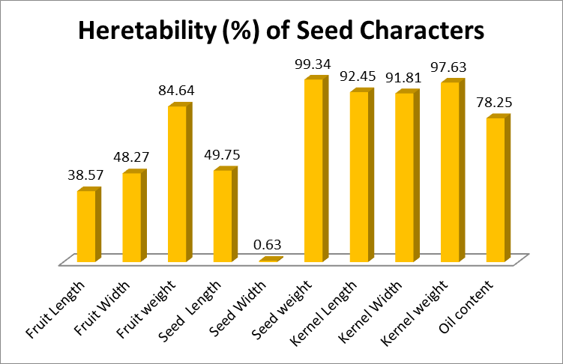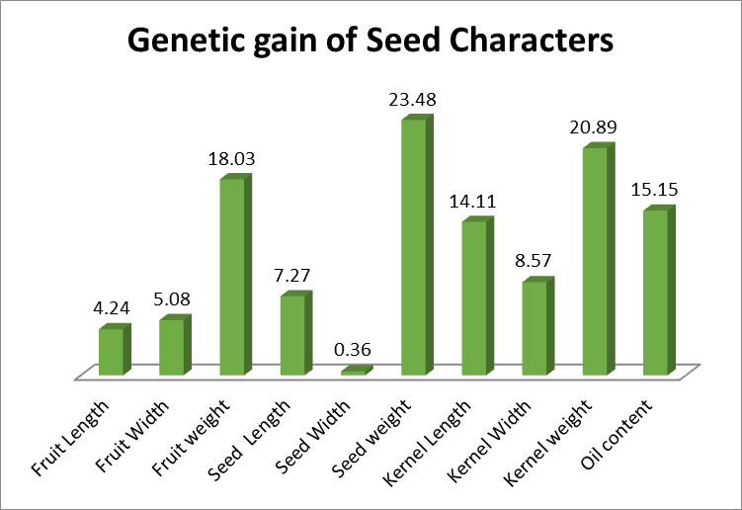
Figure 2: Heritability (%) of Seed Characters Figure 3: Genetic gain (%) of Seed Characters

Heritability value for seed weight (99.34%), kernel weight (97.63%), kernel length (92.45%), kernel width (91.81%) , fruit weight (84.64%) and oil content (78.25%) were found very high in all the seed characters (Figure-2). Although heritability in broad sense may give useful indication about the relative value of selection in the material at hand but to arrive at a more reliable conclusion heritability associated with genetic gain may be considered. The seed characters like seed weight (23.48%), kernel weight (20.89%), fruit weight (18.03%), were found to be associated with higher amount of genetic gain whereas oil content (15.15%) and kernel length (14.11%) were found to be associated with moderate amount of genetic gains (Figure-3) indicating a wide scope of genetic improvement. These findings are in line with those of Hathurusingha et al.(2011) & Shinde et al. (2012) in Calophyllum inophyllum L. but contradicts with findings of Karthik et al. (2021) which revealed no statistical significance between fruit and seed characters. ,
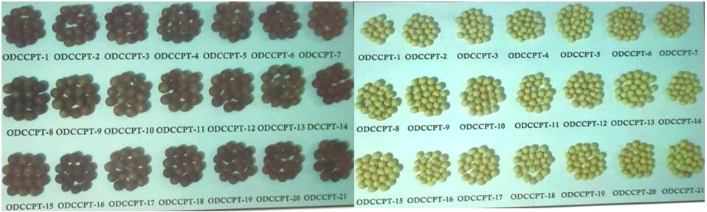
Figure-4 : Fruits and Seeds of Different CPTs of Calophyllum inophyllum L.

3.3 Studies on seedling variability of Calophyllum inophyllum L.
Germination percentage of the seeds collected from various provenances showed significant differences. The maximum Germination percentage (78.30%) was recorded in ODCPT-19 (Table-4), however, it was found to be statistically at par with germination percentage of ODPCT-6 (75.0%), ODCPT-9 (73.3%), ODCPT-11 (71.6%) and ODCPT- 17 (70.0%). It may be due to the interaction of stored food , enzymes and other phytochemicals stored in seeds with the present environmental conditions favouring better seed germination . Similar type of progeny testing at seedling level are made by Mayavel et al.
(2023) in Azadirachta indica and Vakshasya et al. (1992) in Dalbergia sissoo. They found that the variation observed in the seed characters may be attributed to adverse environmental and differences in their distribution range which in turn affect the germination of seeds along with the environmental conditions in which the seeds were subjected to progeny testing.
Maximum seedling height (27.00 cm) was observed in ODPCT-9 (Table-4) which was at par with seedling height of ODPCT-19 (25.60cm) which may be due to early germination of these seeds causing early establishment and there by promoting better growth than other seedlings. Besides that, higher seed weight of ODPCT-9 with more stored food material may be favouring healthy seedling in the earlier stages promoting better seedlings. Similar types of progeny study was carrired out by Karthik et al. (2024) in Calophyllum inophyllum.
The maximum Vigour index (2010.00) was found in ODCPT-19 (Table-4) which was found to be statistically at par with ODCPT-9(1981.67) may be due to synergic effect of higher values of germination percentage and seedling length.
The maximum Fresh weight of seedlings (5.91g) was recorded in ODCPT-17 (Table-4). The seed kernel of the germplasm also showed highest kernel length and higher kernel weight which may promoted early germination of seeds and establishment of seedlings respectively there by resulting better growth. The finding was also inline as reported by Saveninattu and Westoby (1996) that the seedling from a larger sized seed may have sufficient reserves to continue growth for a much longer period. Zimmernan and Weis (1983) also reported that seed size also affects the seedling biomass.

Maximum oven dry weight (Table-4) was recorded in ODCPT-9 (1.47g) followed by ODCPT-17 (1.36 g) . This is because of less moisture content in case of ODCPT -9 which may be due to higher biomass accumulation in stem as stem length and diameter are higher than that of ODCPT-17.

In the present investigation, observable differences were observed for all seedling characters recorded the mean value of Germination percentage with standard deviation was found [57.14 (15.29)], seedling height [21.46 (2.47)], vigour index [1264.52 (353.77)], collar diameter [0.35 (0.09)], fresh seedling biomass [3.72 (0.41)] and oven dry seedling biomass [0.92 (0.09)] in all seeds with significant difference (Table-4&5).
The seedling raised from the seeds of various seed sources also showed variation in seedling characters as presented in (Table-5), which ranges in case of germination percentage (36.60%-78.30%), seedling height (13.30-27.00cm), collar diameter (0.3 – 0.46) , vigour index (523.33-2010.00), fresh seedling biomass (1.83 – 5.91g) and oven dry seedling biomass (0.38 – 1.47). These observations shows magnitude of variation high in oven dry seedling biomass (74.14%), vigour index (73.96%), fresh seedling biomass (69.03%) and moderate in germination percentage (53.25%), seedling height (50.74%) and collar diameter (34.78%) as shown in the (Table-4). This indicates that variations in seedling characters occurs and has good scope for improvement.
All the germination and seedling characters showed higher value for phenotypic coefficient of variation than genotypic coefficient of variation (Table-5) indicating that all these traits are influenced by environment.
Heritability value for fresh seedling biomass (98.0%), Oven dry seedling biomass (98%), seedling height (94.0%), germination percentage (82.0%), vigour index (80.0%) and were found very high in all the germination, seedling germination & morphometric parameters (Figure-5). All seedling characters like Oven dry seedling biomass (76.47%), Fresh seedling biomass (75.05%), vigour index (58.65%) , Germination percentage (41.01%), seedling height (35.99%) and collar diameter(27.54%) were found to be associated with higher amount of genetic gains (Figure-6) indicating a wide scope of genetic improvement.
As literature was not available regarding the progeny study of Calophyllum inophyllum , similar type of works were done by Nayak and Sahoo (2020) in Madhuca latifolia , Das et al.(2020) in Terminalia bellerica ,Wani and Ahmad (2013) in Madhuca indica, Devagiri et al. (1997) in Heracleum candicans , Srivastava et al. (1993) in Terminalia arjuna , Sharma and Sharma (1995) in Grewia optiva and Subramanium et al. (1995) in Eucalyptus grandis.
From the existing seed sources on basis of Oil content and Germination percentage ODCPT-17 can be extracted for Oil and Germination purposes .

Table-4: Germination Characters of Calophyllum inophyllum L.
Seed Sample | Germination  Percentage  (%) | Seedling Height (cm) | Collar Diameter  (cm) | Shoot Vigour Index | Fresh seedling biomass  (g) | Dry seedling biomass  (g)
ODCPT-1 | 45.00 | 13.30 | 0.35 | 598.33 | 2.37 | 0.56
ODCPT-2 | 36.60 | 14.30 | 0.30 | 523.33 | 1.88 | 0.38
ODCPT-3 | 50.00 | 22.50 | 0.31 | 1129.17 | 3.02 | 0.87
ODCPT-4 | 48.30 | 21.00 | 0.30 | 1028.33 | 2.97 | 0.93
ODCPT-5 | 41.60 | 19.16 | 0.35 | 801.67 | 2.89 | 0.84
ODCPT-6 | 75.00 | 21.60 | 0.30 | 1623.33 | 2.37 | 0.62
ODCPT-7 | 66.60 | 23.00 | 0.38 | 1530.00 | 5.25 | 1.24
ODCPT-8 | 61.80 | 24.30 | 0.36 | 1502.50 | 3.46 | 0.88
ODCPT-9 | 73.30 | 27.00 | 0.46 | 1981.67 | 5.41 | 1.47
ODCPT-10 | 45.00 | 18.83 | 0.30 | 858.33 | 2.51 | 0.69
ODCPT-11 | 71.60 | 25.00 | 0.31 | 1788.33 | 5.25 | 1.17
ODCPT-12 | 65.00 | 20.00 | 0.30 | 1315.00 | 1.83 | 0.79
ODCPT-13 | 51.60 | 21.50 | 0.35 | 1125.00 | 2.99 | 0.96
ODCPT-14 | 51.60 | 25.30 | 0.46 | 1308.33 | 4.63 | 1.08
ODCPT-15 | 60.00 | 23.00 | 0.45 | 1383.33 | 4.47 | 0.95
ODCPT-16 | 66.60 | 23.30 | 0.30 | 1551.67 | 4.99 | 1.26
ODCPT-17 | 70.00 | 23.60 | 0.43 | 1660.00 | 5.91 | 1.36
ODCPT-18 | 41.60 | 13.60 | 0.33 | 571.67 | 1.93 | 0.38
ODCPT-19 | 78.30 | 25.60 | 0.43 | 2010.00 | 4.93 | 1.18
ODCPT-20 | 60.00 | 24.60 | 0.43 | 1476.67 | 5.46 | 1.07
ODCPT-21 | 40.00 | 19.60 | 0.30 | 788.33 | 3.56 | 0.72
Mean | 57.14 | 21.46 | 0.35 | 1264.52 | 3.72 | 0.92
F-Value | 15.10 | 51.32 | 7.57 | 34.193 | 228.88 | 168.46
p-Value | < 0.001 | < 0.001 | < 0.001 | < 0.001 | < 0.001 | < 0.001
CD (5%) | 9.57 | 1.56 | 0.06 | 221.46 | 0.26 | 0.07
SED | 4.72 | 0.77 | 0.03 | 109.17 | 0.13 | 0.03
SEM | 3.336 | 0.54 | 0.02 | 77.20 | 0.09 | 0.02

Table-5: Variation and Variability of Germination Characters of Calophyllum inophyllum L.
Seedling Characters | Range | SD | Magnitude of Variance (%) | GCV (%) | PCV (%) | ECV (%)
Germination Percentage | 36.60 – 78.30 | 15.29 | 53.25 | 21.92 | 24.14 | 10.11
Seedling Height | 13.30 – 27.00 | 2.47 | 50.74 | 17.98 | 18.51 | 4.39
Collar  Diameter | 0.30 – 0.46 | 0.09 | 34.78 | 16.13 | 19.47 | 10.89
Shoot Vigour Index | 523.33-2010.00 | 353.77 | 73.96 | 31.63 | 35.15 | 10.57
Fresh Seedling Biomass | 1.83 – 5.91 | 0.41 | 69.03 | 36.67 | 36.91 | 4.20
Dry Seedling Biomass | 0.38 – 1.47 | 0.09 | 74.14 | 37.38 | 37.64 | 4.33

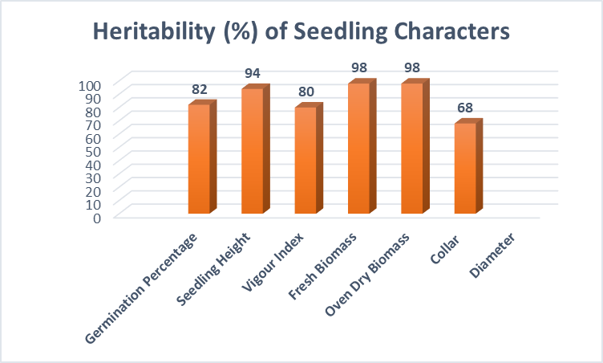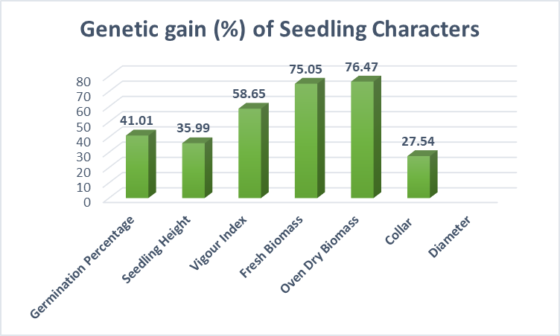
Figure 5: Heritability (%) of Seed Characters Figure 6: Genetic gain (%) of Seed Characters

3.4 Correlation between seed and seedling traits of Calophyllum inophyllum L.

Correlation coefficient among seed and seedling traits studied is prescribed in Table-6. Oil content showed no significant correlation with any seed and seedling characters although it shows positive correlation with all characters. Fruit length showed significant positive correlation with fruit width (0.947), 25 fruit weight (0.863) seed length (0.720), 25 seed weight (0.761) & 25 kernel weight (0.749). Fruit width showed significant positive correlation with 25 fruit weight (0.904) seed length (0.744), 25 seed weight (0.842) & 25kernel weight (0.782). 25 Fruit weight showed significant positive correlation in case of seed characters with Seed length (0.770), 25seed weight (0.845), Kernel length (0.524) & 25Kernel weight (0.773) in addition to fruit length and fruit width as mentioned earlier. Seed length showed significant positive correlation with 25seed weight (0.724), Kernel weight (0.608), Kernel length (0.484) in addition to Fruit length, Fruit width & 25 Fruit weight as mentioned earlier. Seed width showed no significant correlation with any seed and seedling characters. 25 Seed weight showed significant positive correlation with Kernel length (0.440), Kernel width (0.435) and 25 kernel weight (0.851) in addition to Fruit length, Fruit width, 25 Fruit weight & seed length as mentioned earlier. Kernel length showed significant positive correlation with Kernel width (0.510) and 25 kernel weight (0.575) in addition to 25 Seed weight as mentioned earlier. Kernel width showed significant positive correlation with Fruit length, Fruit width, 25 Fruit weight, Seed length, 25 Seed weight & Kernel length as mentioned earlier.

Germination and seedling Characters showed positive significant relationship with themselves but not with morphometric character of fruit and oil content. Germination percentage showed significant positive correlation with seedling height (0.739), vigour index (0.957), seedling fresh biomass (0.618) and seedling oven dry biomass (0.695). Seedling Height showed significant positive correlation with germination and all seedling parameters collar diameter (0.540), vigour index (0.895), seedling fresh biomass (0.790) and seedling oven dry biomass (0.867). Collar diameter showed significant positive correlation with vigour index (0.491), seedling fresh biomass (0.668) and seedling oven dry biomass (0.579) in addition to seedling height as mentioned above. Vigour Index showed significant positive correlation with seedling fresh biomass (0.748) and seedling oven dry biomass (0.820) in addition to germination percentage, seedling height and collar diameter as mentioned above. Seedling fresh biomass showed significant positive correlation with seedling oven dry biomass (0.899) in addition to germination percentage, seedling height, collar diameter and vigour index as mentioned above. Seedling Oven dry biomass showed significant positive correlation with all germination & seedling characters.

Table -6: Correlation Matrix of Seed morphometric, Oil and Germination Characters of Calophyllum inophyllum L.

Seed & Oil Characters | FL | FW | 25 FWt | SL | SW | 25 SWt | KL | KW | 25 KWt | OC | GMN | SH | CD | SVI | SFB | SODB
FL | 1.000
FW | 0.947** | 1.000
25 FWt | 0.863** | 0.904** | 1.000
SL | 0.720** | 0.744** | 0.770** | 1.000
SW | 0.294^{NS} | 0.304^{NS} | 0.120^{NS} | 0.023^{NS} | 1.000
25 SWt | 0.761** | 0.842** | 0.845** | 0.724** | 0.308^{NS} | 1.000
KL | 0.319^{NS} | 0.389^{NS} | 0.524* | 0.484* | -0.116^{NS} | 0.440* | 1.000
KW | 0.367^{NS} | 0.343^{NS} | 0.431^{NS} | 0.427^{NS} | -0.054^{NS} | 0.435* | 0.510* | 1.000
25 KWt | 0.749** | 0.782** | 0.773** | 0.608** | 0.252^{NS} | 0.851** | 0.575** | 0.583** | 1.000
OC | 0.112^{NS} | 0.095^{NS} | 0.048^{NS} | 0.132^{NS} | 0.149^{NS} | 0.152^{NS} | 0.141^{NS} | 0.204^{NS} | 0.264^{NS} | 1.000
GMN | -0.227^{NS} | -0.141^{NS} | -0.091^{NS} | 0.246^{NS} | -0.244^{NS} | 0.012^{NS} | 0.348^{NS} | 0.171^{NS} | -0.020^{NS} | 0.132^{NS} | 1.000
SH | -0.128^{NS} | -0.036^{NS} | -0.114^{NS} | 0.042^{NS} | -0.112^{NS} | 0.006^{NS} | 0.418^{NS} | 0.027^{NS} | 0.110^{NS} | 0.087^{NS} | 0.739** | 1.000
CD | -0.031^{NS} | -0.028^{NS} | -0.131^{NS} | -0.009^{NS} | -0.017^{NS} | 0.100^{NS} | 0.296^{NS} | 0.396^{NS} | 0.319^{NS} | 0.142^{NS} | 0.375^{NS} | 0.540* | 1.000
SVI | -0.210^{NS} | -0.111^{NS} | -0.106^{NS} | 0.166^{NS} | -0.206^{NS} | 0.023^{NS} | 0.404^{NS} | 0.121^{NS} | 0.036^{NS} | 0.123^{NS} | 0.957** | 0.895** | 0.491* | 1.000
SFB | -0.408^{NS} | -0.323^{NS} | -0.358^{NS} | -0.176^{NS} | -0.178^{NS} | -0.179^{NS} | 0.337^{NS} | 0.169^{NS} | 0.019^{NS} | 0.184^{NS} | 0.618** | 0.790** | 0.668** | 0.748** | 1.000
SODB | -0.243^{NS} | -0.162^{NS} | -0.252^{NS} | -0.033^{NS} | -0.063^{NS} | -0.089^{NS} | 0.348^{NS} | 0.162^{NS} | 0.054^{NS} | 0.173^{NS} | 0.695** | 0.867** | 0.579** | 0.820** | 0.899** | 1.000

FL- Fruit Length , FW-Fruit weight, 25 FWt- 25 Fruit Weight, SL-Seed Length, SW-Seed Weight, 25 SWt- 25 Seed Weight, KL-Kernel Weight, KW-Kernel Width, 25 KWt – 25 Kernel Weight, OC-Oil Content(%), GMN-germination Percentage(%), SH-Seedling Height, CD-Collar Diameter, SVI-Shoot Vigour Index SFB – Seedling Fresh Biomass, SODB-Seedling Oven Dry Biomass

* 5% level of significance ; ** 1% Level of significance

3.5 Effect of Storage on Oil content and germination characters of fruits of Calophyllum inophyllum L.
3.5.1 Effect of Storage on Oil content of fruits of Calophyllum inophyllum L.
Deteriorations of seed during storage include cytological, physiological, biochemical and physical degradation in seeds. The major factors affecting it are seed moisture content, temperature, relative humidity, and damage of tissues by microorganisms and insects which reduces the viability, germination percentage, vigour of seed & seedling it produces even causing seed death (Khatun et al, 2009; Biabani et al, 2011&Tilebeni and Golpayegani, 2011). High temperature the rate of biochemical reactions triggering rapid\ deterioration which promotes quick losses in seed having high moisture content (Shelar et al, 2008). Seeds stored at high moisture content shows increased respiration, heating, and fungal attack affecting seed vigor and viability (Mahjabin et al.,2015).

Storability of seeds is also a genetically regulated character and is influenced by quality of the seed at the time of storage (Shelar et al, 2008; Baleševic-Tubic et al., 2005). Plants that have originated from deteriorated seed has also been reported to have reduce growth rate (Kapoor et al, 2010). During seed storage, lipids slowly reacts with oxygen forming hydrogen peroxides, oxygenated fatty acids and free radicals. Free radicles are reactive and unstable in nature and damage other phytochemicals of the seed. In stored oven dried seeds with very less moisture content Oxygenated fatty acids accumulate in the absence of enzymes and damage cellular components (Mahjabin et al., 2015). After planting of deteriorate seeds, seedling emergence may be poor and transmission of pathogens to the new crop may occur. Lower temperature and humidity result in delayed seed deteriorative process and there by leads to prolonged viability period (Mohammadi et al, 2011), however, below 4-6% seed moisture content lipid autoxidation becomes a damaging factor and seeds become more susceptible to damage (Mahjabin et al., 2015).
3.5.1.1 Interaction Effect of storage condition and duration on Oil content
The interaction effect of storage conditions and durations on oil content of stored fruits of Calophyllum inophyllum L found to be statistically significant (Table-9) . The oil content of the seeds decreased significantly with increase in storage time in all storage condition (Figure-7). Decrease in Oil content with increase in storage duration under different storage conditions has been reported for other Tree Borne Oil seed species by Nayak and Sahoo (2021) in Mahuca latifolia seeds , Tandon et al. (2023) in Schleichera oleosa seeds, Rout and Nayak (2015) in Pongamia pinnata seeds, Sahoo et al. (2015) & Akowuah et al.(2012) in Jatropha curcas seeds.

The Oil content was maximum (57.6%) during the time of storage of seeds and minimum (38.85%) after 90 days of storage under OPL with maximum degradation (32.55%) which may be due to oxidative as well hydrolytic degradation of triglycerides and free fatty acids (Figure-7&8). Such degradation is encouraged with exposure to oxygen and light in OPL condition for a longer period. This may be the reason for the decrease in oil content of stored seeds for different duration. The metabolism of seeds during the storage to provide energy for its physiological activities and higher activity of storage fungi which increase the free fatty acids may be the other reasons for the seed oil reduction during long storage period.

According to Awuor et al. (2025) and Morello et al. (2004), the development of rancidity due to oxygen dependent deterioration of lipids in vegetable oil recognized as the principal cause of oil deterioration and reduction during storage. Nayak et al.(2025) in Storage study of Buchanania lanzan and Awuor et al. (2025) also reported that deterioration of oil is due to oxidation process which is a reaction between unsaturated fatty acid and oxygen. The decrease in oil content has been related to peroxidation of lipid by peroxidase enzyme (Verma et al. 2003 Anuja Gupta and Aneja 2004 in soyabean), nonenzymic lipid autotoxidation (Awuor et al. (2025)) and also to fungi invasion (Verma et al. 2003, Shelar et al, 2008). Ghasemnezhad and Honermeier (2009) mentioned metabolism of seed could be another reason for seed oil reduction during long storage of seed.
3.5.1.1 Effect of Storage condition on Oil content
The effect of storage conditions on Oil content in stored fruit of C. inophyllum L irrespective of storage duration found to statistically significant (Table-9). The Oil content was found to be maximum in seed storage in closed polythene bag kept in dark (48.57%) whereas the minimum oil content (46.83%) was obtained in the seeds stored in open polythene bags kept in light (Table-7). The loss in oil content may be due to the combined effect of high atmospheric temperature, moisture maintained in the storage place and moisture content of the seeds favoring enzymatic and non-enzymatic autotoxidation of lipids which occurs at higher storage temperature, relative humidity and higher seed moisture content. Similar decrease in oil content was noticed by Nayak et al. (2025) in storage of Buchanania lanzan seeds, Narayanswamy (2003) in groundnut. Production of lipase by fungal species favoured by storage condition might have another reason for the decrease in oil content of oilseeds. Decrease in oil content was positively related with increase in lipase activity on account of fungi infection by Saxena et al. (1998), Taung and Mcdonald (1995). Embaby et al. (2006) reported that most reduction and loss percent was found with fat, carbohydrate in legume seeds by Fusrium oxysporum. Kakde and chavan (2011a) also reported the change in crude fat by various fungi in oil seeds.
3.5.1.2 Effect of Storage Duration on Oil content
The effect of storage duration on Oil content in stored fruit of C. inophyllum L irrespective of storage conditions found to be statistically significant (Table-9). The Oil content was found to be maximum during the initial fruit storage (57.60%) which decreased continuously and reached to minimum (40.18%) after 90 days of storage (Table-8). The decrease in Oil content may be auto oxidation and long-time exposure to favourable conditions for its degradation. These result observed in the study is also in confirmative with Nayak and Sahoo (2021) in Madhuca latifolia ,Nayak et al. (2025) in Buchanania lanzan. Balasevic-Tubic et al. (2005) who reported in seed oil crops like soyabean and sunflower auto-oxidation of lipids and increase in free fatty acid content are the main reason for rapid deterioration of oil seeds. The fatty acid composition and the proportion of different fatty acid of oil seed during storage are also affects the degradation rate of different fatty acid which convert to each other. Ghasemezhad et al. (2007) also reported with increase in storage time there is a corresponding rapid decrease of oil percent.
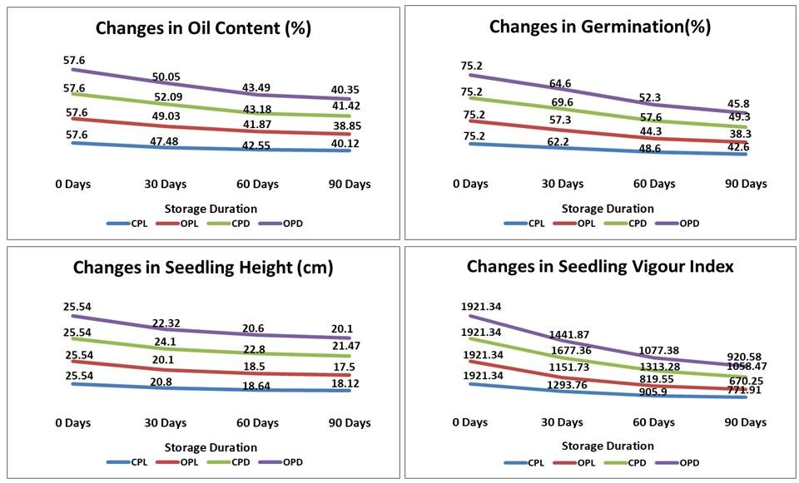
Figure-7 : Changes in Oil Content, Germination percentage and seedling characters with Storage
3.2.2 Effect of Storage condition on germination of seeds of Calophyllum inophyllum L.

3.5.2.1 Interaction Effect of storage condition and duration on germination of seeds
The interaction effect of storage conditions and durations on germination percentage of seeds from stored fruits of Calophyllum inophyllum L found to be statistically significant (Table-9) . The germination percentage of the seeds decreased significantly with increase in storage time in all storage condition (Figure-7). The species being a Tree borne oil seeds behaves like moderate recalcitrant may be due to hard seed coat for which the germination percentage decreases gradually at a lower pace than other recalcitrant species like neem and other oil seeds.
The germination percentage of seeds after 90 days of storage showed maximum (49.30%) in fruits stored in CPD which was 34.44% lower than initial germination percentage (Figure-7&8) . The minimum germination percentage (38.3%) after 90 days of storage was in fruits stored in OPL which was 49.07% lower than initial germination percentage (Figure-7&8). Low germination observed in case of seed stored in open polythene bag kept in light condition may be due to deterioration of the seeds because of physiochemical changes and fungal decay caused due to longer exposure to air temperature, high humidity and oxygen content in air. These finding corresponds to those reported elsewhere that unfavorable storage conditions like high humidity of air accelerates seed deterioration causing seed quality losses and there in lower germinability percentage of stored seed (Depaula et al.1996 & Al-Yahya, 2001).
3.5.2.2 Effect of storage condition on germination of seeds
The effect of storage conditions on germination percentage of seed for stored fruit of Calophyllum inophyllum L irrespective of storage duration found to statistically significant (Table-9). The germination percentage was found to be maximum in seed storage in CPD (62.92%) whereas the minimum germination percentage (46.83%) was obtained in the seeds stored in open polythene bags kept in light (Table-7). Maximum germination in CPD may be due to less deterioration of the seeds as the seeds were not in contact with atmospheric moisture and comparatively at low temperature because of darkness which also favoured by the hard seed coat. According to Simic et al. (2008) also stated that the longevity of stored seeds in any crops considerably depends on the storage condition, primarily in term of air temperature and relative humidity in storage.

3.5.2.2 Effect of storage duration on germination of seeds
The effect of storage duration on germination percentage of seed for stored fruit of Calophyllum inophyllum L irrespective of storage condition found to statistically significant (Table-9). The germination percentage was found to be maximum during the initial fruit storage (75.20%) which decreased continuously and reached to minimum after 90 days of storage (44.00%) (Table-8). This may be due to detoriation of seed quality with long exposure to external environment and detoriation of enzymes and phytochemicals helpful for germination with seed ageing. Similarly, Esscandon et al. (2013) also reported natural aging in case of Jatropha curcus the germinability decreases with increase in age of seeds.

3.5.3 Effect of storage condition and duration on seedling height of Calophyllum inophyllum L.
3.5.3.1 Interaction Effect of storage condition and duration on seedling height
The interaction effect of storage conditions and durations on height of germinated seedlings from stored fruits of C.inophyllum L found to be statistically significant (Table-9). The seedling height decreased significantly with increase in storage time in all storage condition (Figure-7).
The decline in these parameter may be attributed to the age induced retardation in germination, deteriorating changes in the seeds during storage due to biochemical changes and fugal infestation there by producing weaker seedlings and affecting the growth of seedlings. Similar result reported by Krishnappa et al. (2001in sesamum. The height of seedlings after 90 days of storage showed maximum (21.47cm) in fruits stored in CPD which was 15.94% lower than initial germination percentage (Figure-7&8). The reason being lesser detoriation in storage material, enzymes favouring biochemical changes for better growth and development in initial days resulting healthy seedlings.
3.5.3.2 Effect of storage condition on seedling height
The effect of storage conditions on height of germinated seedlings from stored fruit of Calophyllum inophyllum L irrespective of storage duration found to statistically significant (Table-9). The seedling height was found to be maximum in fruit stored in CPD (23.47 cm) as less degradation of food material and enzymes took place due to absence of light and air (Table-7).
3.5.3.2 Effect of storage duration on seedling height
The effect of storage duration on height of germinated seedlings from stored fruit of Calophyllum inophyllum L irrespective of storage condition found to statistically significant (Table-9). The seedling height was found to be maximum during the initial fruit storage (25.54cm) which decreased continuously and reached to minimum after 90 days of storage (19.29cm) (Table-8). The reason behind slow growth in height was mainly due to age induced detoriation in food storage, enzymes and decline in biochemical synthesis for height growth.
3.5.4 Effect of storage condition and duration on Shoot Vigour Index of seedlings of Calophyllum inophyllum L.
3.5.4.1 Interaction Effect of storage condition and duration on Shoot Vigour Index
The interaction effect of storage conditions and durations on Shoot vigour index of germinated seedlings from stored seeds of C. inophyllum L found to be statistically significant (Table-9). The Shoot vigour index decreased significantly with increase in storage time in all storage condition (Figure-7). The Shoot vigour index after 90 days of storage was found to be maximum in seeds srored in CPD (1058.47) with 44.91 % decrease than initial storage whereas the minimum Shoot vigour index in OPL (670.25) with 65.12 % decrease than initial storage was obtained in the seed stored in OPL (Figure-7&8).
3.5.4.2 Effect of storage condition on Shoot Vigour Index
The effect of storage conditions on Shoot Vigour Index of seedlings from stored seed of C.inophyllum L irrespective of storage duration found to statistically significant (Table-9). The maximum Shoot vigour Index was observed in seedlings produced from seeds stored in CPD (1492.62) and minimum in case of OPL (1140.72) (Table-7).
3.5.4.3 Effect of storage duration on Shoot Vigour Index
The effect of storage duration on Shoot Vigour Index of seedlings from stored seed of C. inophyllum L irrespective of storage conditions found to statistically significant (Table-9). The maximum Shoot vigour Index was observed in seedlings produced from seeds sown during initial period of experiment (1921.34) and minimum after 90 days of storage (855.23) (Table-8).
As Shoot Vigour Index is a multiplicative index the maximum and minimum values in different storage condition ,durations and effect their interaction depends upon the product of both germination percentage and seedling height.

Table-7 : Effect of storage condition on Oil content and Germination parameters of stored fruits of Calophyllum inophyllum L.

Storage condition | Oil Content (%) | Germination (%) | Seedling Height (cm) | Vigour Index
CPL | 46.93 | 57.15 | 20.78 | 1223.23
OPL | 46.83 | 53.77 | 20.41 | 1140.72
CPD | 48.57 | 62.92 | 23.48 | 1492.62
OPD | 47.87 | 59.47 | 22.14 | 1340.22

Table-8 : Effect of storage Duration on Oil content and Germination parameters of stored fruits of Calophyllum inophyllum L.

Storage Duration | Oil Content (%) | Germination (%) | Seedling Height (cm) | Vigour Index
0 Days | 57.60 | 75.20 | 25.54 | 1921.34
30 Days | 49.66 | 63.42 | 21.83 | 1391.18
60 Days | 42.77 | 50.70 | 20.13 | 1029.03
90 Days | 40.18 | 44.00 | 19.29 | 855.23

Table-9 : ANOVA Analysis of Oil Content and germination Parameters of Stored fruits

Stored fruit Parameters | F-value | CD at 5% | SE (d) | SE  (m) | Stored fruit Parameters | F-Value | CD at 5% | SE (d) | SE  (m)
Oil Content(%) |  |  |  |  | Germination Percentage (%)
Storage Condition | 10.004 | 0.753 | 0.368 | 0.26 | Storage condition | 708.00 | 0.419 | 0.205 | 0.145
Storage Duration | 899.224 | 0.753 | 0.368 | 0.26 | Storage Duration | 9122.19 | 0.419 | 0.205 | 0.145
Storage Condition x Storage Duration | 3.271 | 1.505 | 0.736 | 0.52 | Storage condition x Storage Duration | 81.578 | 0.838 | 0.410 | 0.290
Seedling Height (cm) |  |  |  |  | Vigour Index
Storage Condition | 77.113 | 0.461 | 0.225 | 0.159 | Storage condition | 95.188 | 45.301 | 22.139 | 15.654
Storage Duration | 301.964 | 0.461 | 0.225 | 0.159 | Storage Duration | 905.38 | 45.301 | 22.139 | 15.654
Storage Condition x Storage Duration | 8.929 | 0.922 | 0.451 | 0.319 | Storage condition x Storage Duration | 11.363 | 90.601 | 44.278 | 31.309

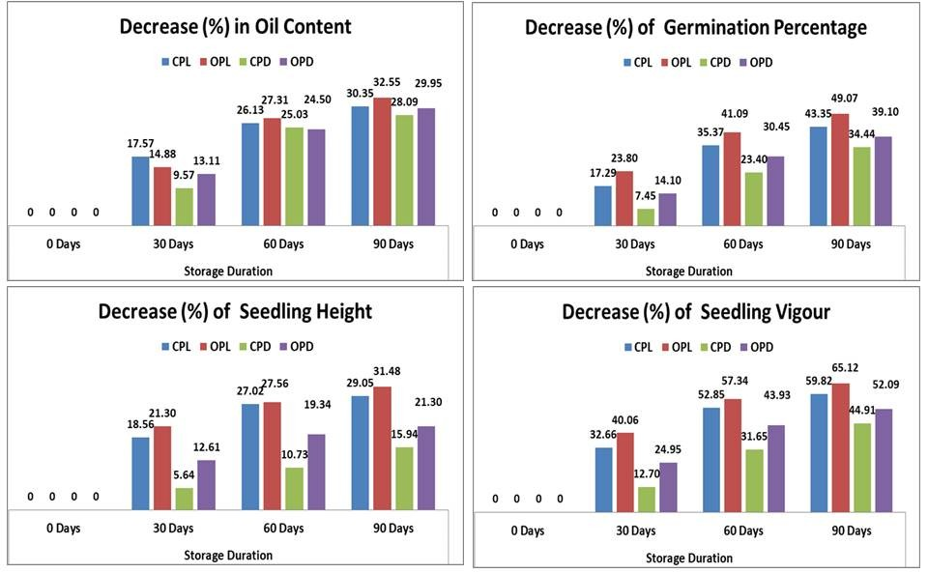
Figure-8 : Decrease (%) in Oil ,Germination and seedling characters with respect to Initial Storage
3.5.5 Periodic decrease in Oil and Germination Characters in Stored seed
The decrease in Oil content of seeds were higher between 0-30 days and 30-60 days of storage and gradually lessens between 60-90 days of storage (Figure-9). This may be because of lesser amount of triglycerides left after 60 days of storage. The decrease in germination percentage of seeds was also higher between 30-60 days of storage and gradually lessens between 60-90 days of storage which may account for higher amount of triglycerides converted into sugar during the previous period which gradually decreases from 60-90 days. However, the seedling height decreases gradually over each period for which both converted sugar and environmental condition it grows are responsible. The seedling vigour also decreases over each period for which decrease in both germination percentage and shoot height are responsible.
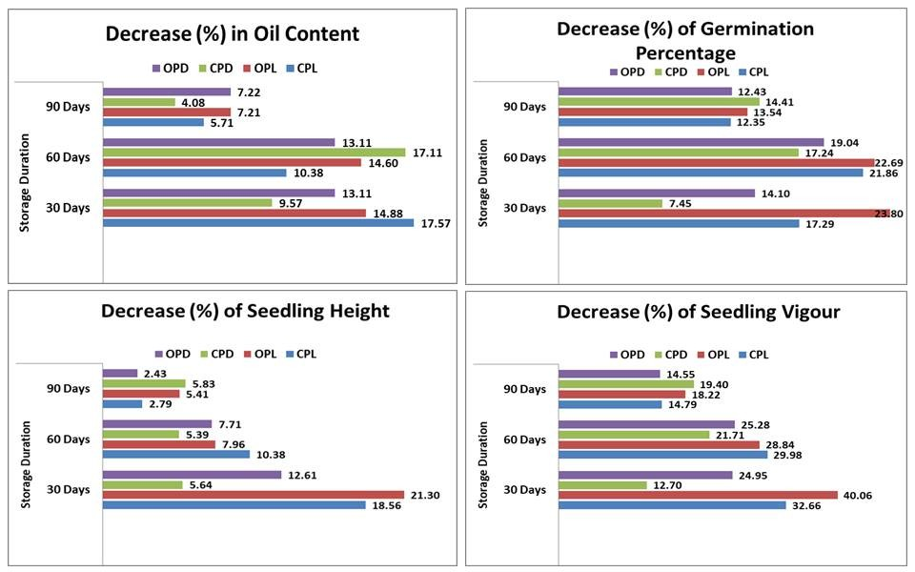
Figure-9 : Decrease (%) in Oil ,Germination and seedling characters in each period of Storage

3.6 Correlation of Oil Content and Germination Characters of Stored seeds

During the storage study it was evident from the correlation (Table-10) between oil and germination characters that Oil content is highly positively correlated with Germination percentage (0.971) , Seedling height (0.901) and seedling vigour (0.979). This is because when seeds are ready to germinate tryglycerides are hydrolysed to free fatty acids which metabolised to sugars by gluconeogenesis. The sugars are then transported to the different parts for growth and development of newly sprouted seedlings. Zhang et al.(2013) reported Oil content was positively correlated with germination(%) and seedling growth in case of Brassica napus L.

Table -10 : Pearson Correlation Matrix of Oil and Germination Characters
Character | Oil Content | Germination Percentage | Seedling Height | Seedling Vigour
Oil Content | 1.000
Germination Percentage | 0.971** | 1.000
Seedling Height | 0.901** | 0.949** | 1.000
Seedling Vigour | 0.965** | 0.990** | 0.979** | 1.000
* 5% level of significance ; ** 1% Level of significance
Conclusion
The seed sources of Calophyllum inophyllum L distributed in the Puri district of Coastal Odisha showed variation in morphometric and Oil characters. The oil content in the seed kernel was extracted maximum by using diethyl ether as a solvent which indicates extraction of maximum triglycerides in addition to some other non-polar phytochemicals which can be usd for oil with neutraceutical or medicinal values.
The evaluation of CPTs from different seed sources resulted Higher value of PCV than GCV in most characters indicating influence of environment also responsible for the variation of fruit characters. The morphometric and oil characters like Oil content, seed weight, kernel weight, kernel length, kernel width and fruit weight can be taken into consideration for selection of plant material for further genetic improvement for their high heritability and high-moderate genetic gain ability.
Progeny testing of CPTs of different seed sources revealed that Higher value of PCV than GCV in most characters indicates influence of environment also responsible for the variation of Seedling characters. The germination and Seedling characters like Germination percentage , Fresh seedling biomass, vigour index and seedling height can be taken into consideration for selection of plant material for further genetic improvement for their high heritability and genetic gain values.
From the existing seed sources, seeds can be harvested from ODCPT-17 for its high Oil content and higher germination percentage .
The correlation among the all fruit characters revealed that Oil content has no significant correlation with Morphometric characters of fruit /seeds, germination characters and seedling characters. Morphometric characters showed significant positive correlation between themselves not with germination and seedling characters. Similarly, Germination and seedling Characters showed positive significant relationship with themselves. This indicates for this species, the biochemical variations in different CPTs and the environmental factors influences more in seed metabolism for germination and seedling growth.
The stored seeds collected from a single Germplasm evaluated found that Oil content, germination percentage, Seedling height and seedling Vigour in all storage conditions decreases continuously till 90 days of storage and maximum oil extracted in seed stored under CPD. The effect of storage condition irrespective of storage duration revealed germination and seedling characters are found to be maximum in seeds stored under CPD. Similarly, the effect of storage duration irrespective of storage condition revealed that the germination and seedling characters maximum at the time of initial storage and decreased to minimum after 90 days of storage. Incase of storage study, the Oil content of stored seed found to be highly positively correlated with the germination percentage, seedling shoot height and seedling shoot vigour index.
Declarations
Conflicts of interest: The authors declare that they have no conflicts of interest.
Disclaimer (Artificial Intelligence)
Author(s) hereby declare that NO generative AI technologies such as Large Language Models (ChatGPT, COPILOT, etc.) and text-to-image generators have been used during the writing or editing of this manuscript

COMPETING INTERESTS DISCLAIMER:
Authors have declared that they have no known competing financial interests OR non-financial interests OR personal relationships that could have appeared to influence the work reported in this paper.

References
Abraham, Z., Yadav, S., Latha, M., Mani, S., & Mishra, S. (2010). Seed variability in Madhuca longifolia (Koenig) J. F. Macbride, a source of oil for use as bio-energy. Genetic Resources and Crop Evolution, 57, 619-623. https://doi.org/10.1007/s10722-010-9536-x
Abulude, F. O., Ogunkoya, M. O., & Ogunleye, R. F. (2007). Storage properties of oils of two Nigerian oil seeds Jatropha curcas (Physic Nut) and Helianthus annuus (Sunflower). American Journal of Food Technology, 2(3), 207-211. https://doi.org/10.3923/ajft.2007.207.211
Akowuah, J. O., Addo, A., & Kemausuor, F. (2012). Influence of storage duration of Jatropha curcas seed on oil yield and free fatty acid content. ARPN Journal of Agricultural and Biological Science, 7(1), 41-45. https://www.arpnjournals.com/jabs/volumes/vol7no1/vol7no1.htm
Allard, R.W.(1960). Principles of Plant Breeding. John Willey and Sons, Inc., New York, p. 485.
Al-Yahya, S. A. (2001). Effect of storage conditions on germination in wheat. Journal of Agronomy and Crop Science. https://doi.org/10.1046/j.1439-037x.2001.00402.x
Ansel, J. L., Lupo, E., Mijouin, L., Guillot, S., Butaud, J. F., Ho, R., Lecellier, G., Raharivelomanana, P., & Pichon, C. (2016). Biological Activity of Polynesian Calophyllum inophyllum Oil Extract on Human Skin Cells. Planta Medica, 82(11-12), 961–966. https://doi.org/10.1055/s-0042-108205
Ariharan, V., Devi, V.M., Kumar, S.G., & Nagendra, P.(2014). Physico-Chemical Properties of Biodiesel Obtained from Callophyllum innophyllum Oil, Research Journal of Pharmaceutical, Biological and Chemical Sciences, 5(1) :. 64-71. https://api.semanticscholar.org/CorpusID:98268938
Atabani, A. E., & César, A. D. S. (2014). Calophyllum inophyllum L. – A prospective non-edible biodiesel feedstock. Study of biodiesel production, properties, fatty acid composition, blending and engine performance. Renewable and Sustainable Energy Reviews. https://doi.org/10.1016/j.rser.2014.05.037
Awuor, O. L., Orwa, A. O., & Lugasi, S. O. (2025). Rancidity in Edible Vegetable Oils: Mechanisms, Challenges, and Preservation Strategies. Journal of Materials Science Research and Reviews, 8(3), 735–756. https://doi.org/10.9734/jmsrr/2025/v8i3437
Bhalla, T. N., Saxena, R. C., Nigam, S. K., Misra, G., & Bhargava, K. P. (1980). Calophyllolide—A new non-steroidal anti-inflammatory agent. The Indian Journal of Medical Research, 72, 762–765. https://pubmed.ncbi.nlm.nih.gov/7203581/
Biabani, A., Boggs, L. C., Katozi, M., & Sabouri, H. (2011). Effects of seed deterioration and inoculation with Mesorhizobium ciceri on yield and plant performance of chickpea. Australian Journal of Crop Science, 5(1), 66-70. http://www.cropsciencejournal.org
Chinthu, R. V., Praveen Kumar, B. R., & Raveendran, M. (2023). A review on the genus Calophyllum (Clusiaceae): a potential medicinal tree species. Plant Science Today. https://doi.org/10.14719/pst.1818
Kilham, C. (2004). Tamanu Oil: A Tropical Topical Remedy. HerbalGram. The Journal of the American Botanical Council, 63, 26-31. https://www.herbalgram.org/authors/kilham-chris/
Das, H., Nayak, S., & Sadangi, D. N. (2020). Variation in morphometric characters, germination and oil content of Terminalia bellirica (Gaertn.) Roxb. seeds collected from various provenances of Odisha, India. Journal of Applied and Natural Science, 12(3), 319–327 https://doi.org/10.31018/jans.v12i3.2310
Depaula, M., Perezotaola, M., Darder, M.,Torres, M., Frutos, G., Martinezhonduvilla,C.J..1996.Function of ascorbate glutathione cycle in aged sunflower seeds.Physiologia Plantraum.96(4):543-550.
Devagiri, G. M., Singh, J. M., Chand, R., & Srivastava, L. J. (1997). Genetic variability in Heracleum candicans Wall. *Indian Journal of Genetics and Plant Breeding*, *57*(3), 280–286. https://epubs.icar.org.in/index.php/IJGPB/issue/view/100000
Dorla, E., Grondin, I., Hue, T., Clerc, P., Dumas, S., Gauvin-Bialecki, A., & Laurent, P. (2018). Traditional uses, antimicrobial and acaricidal activities of 20 plants selected among Reunion Island’s flora. South African Journal of Botany, 122, 447–456. https://doi.org/10.1016/j.sajb.2018.04.014
Embaby, E. Mona, M..and Abdel-Galil, M. (2006). Seed Borne Fungi and Mycotoxins Associated with Some Legume Seeds in Egypt. Journal Applied Science Research 2: 1064-1071
Moncaleano-Escandon, J., Silva, B. C. F., Silva, S. R. S., Granja, J. A. A., Alves, M. C. J. L., & Pompelli, M. F. (2013). Germination responses of Jatropha curcas L. seeds to storage and aging. Industrial Crops and Products, 44, 684-690. https://doi.org/10.1016/j.indcrop.2012.08.035
Fadhlullah, M., Widiyanto, S. N. B., & Restiawaty, E. (2015). The Potential of Nyamplung (Calophyllum inophyllum L.) Seed Oil as Biodiesel Feedstock: Effect of Seed Moisture Content and Particle Size on Oil Yield. Energy Procedia, 68, 177-185. https://doi.org/10.1016/j.egypro.2015.03.246
Falconer, D. S., & Mackay, T. F. C. (1996). Introduction to quantitative genetics. Longman.
Friday, J. B., & Okano, D. (2006). Calophyllum inophyllum (kamani). In C. R. Elevitch (Ed.), Species Profiles for Pacific Island Agroforestry. Permanent Agriculture Resources. http://www.traditionaltree.org
Ghasemnezhad, A. Cergel, S. and Honermeier, B. (2007). The impact of storage time and storage temperature on the quality of the oil of evening primrose (Oenothera biennis L.). Journal of Medicinal and Spice Plants 12: 175-180.
Ghasemnezhad, A., & Honermeier, B. (2009). Influence of storage conditions on quality and viability of high and low oleic sunflower seeds. International Journal of Plant Production, 3(4), 39-47. https://doi.org/10.22069/ijpp.2012.662
Gopalakrishnan, C., Shankaranarayanan, D., & Nazimudeen, S. K. (1980). Anti-inflammatory and C.N.S. depressant activities of xanthones from Calophyllum inophyllum and Mesua ferrea. Indian Journal of Pharmacology, 12(3), 181–191.
Gupta, M. C., Roy, H. S., & Bhadauria, S. S. (2019). Genetic variability analysis in F2/F3 population derived through interspecific hybridization in oilseed Brassica. Electronic Journal of Plant Breeding, 10(3), 1275–1282. https://doi.org/10.5958/0975-928X.2019.00163.7
Gupta V., Kak A., Dashora K., Bharadwaj M, Gupta A.(2009). Calophyllum inophyllum: an apomict or a true seed? Current Science, 97: 114.
Gupta, A. and Aneja, K.R. (2004) Seed deterioration in soybean varieties during storage-physiological attributes. Seed Research, 32: 26-32.
Gupta, S., & Gupta, P. (2020). The genus Calophyllum: Review of ethnomedicinal uses, phytochemistry and pharmacology. Bioactive Natural Products in Drug Discovery https://doi.org/10.1007/978-981-15-1394-7_5
Hathurusingha, S., & Ashwath, N. (2012). Calophyllum inophyllum: recalcitrant or intermediate seed? Journal of Forestry Research, 23(1), 103−107. https://doi.org/10.1007/s11676-012-0222-z
Hathurusingha, S., Ashwath, N., & Midmore, D.J. (2011). Provenance variations in seed-related characters and oil content of Calophyllum inophyllum L. in northern Australia and Sri Lanka. New Forests, 41(1), 89–94. https://doi.org/10.1007/s11056-010-9218-8
Huynh Cang Mai, Le, T. T. T., & Bui, T. Y. N. (2020). Maceration extraction of oil from tamanu (Calophyllum inophyllum L.) seeds: Effect of process parameters and oil characterisations. International Journal of Engineering Research and Applications, 10(6)III, 31-39. https://doi.org/10.9790/9622-1006033139
Jain, M., Chandrakant, U., Orsat, V., & Raghavan, V. (2018). A review on assessment of biodiesel production methodologies from Calophyllum inophyllum seed oil. Industrial Crops and Products. https://doi.org/10.1016/j.indcrop.2018.01.051
Johnson, H. W., Robinson, H. F., & Comstock, R. E. (1955). Estimates of genetic and environmental variability in soybeans. Agronomy Journal, 47(7), 314–318. https://doi.org/10.2134/agronj1955.00021962004700070009x
Kakde, R. B., & Chavan, A. M. (2011). Extracellular Lipase Enzyme Production by Seed-Borne Fungi under the Influence of Physical Factors. International Journal of Biology, 3(1), 94–100. https://doi.org/10.5539/ijb.v3n1p94

Karthik, H. N., Rathod, C. B., & Rathod, A. B. (2024). Characterization of Fruit, Seed Traits and Seedling Growth Performance of Different Seed Sources of Calophyllum Inophyllum. Journal of Scientific Research and Reports, 30(11), 646–653. https://doi.org/10.9734/jsrr/2024/v30i112592

Khatun, A., Kabir, G., & Bhuiyan, M. A. H. (2009). Effect of harvesting stages on the seed quality of lentil (Lens culinaris L.) during storage. Bangladesh Journal of Agricultural Research, 34(4), 565-576. https://doi.org/10.3329/bjar.v34i4.5833

Krishnappa N, Narayanaswamy S, Balakrishna P, Lokesh K, Prashant Shankhinamath(2003). Influence of storage mycoflora on seed quality of groundnut (Arachis hypogaea L.) varieties stored in different packaging materials. Res. on Crops, 4(3):409-417.
Kumar, N., Paul, S. & Singh, D.R. (2016). Study on genetic variability, heritability and genetic advance for agro-morphological traits of linseed (Linum usitatissimum L.),Res. Environ. Life Sci. 9 (1), 16–18.

Kumar, S., Ram, S., Chakraborty, M., Ahmad, E., Verma, N., Lal, H.C., Prasad, Y., Kumar, K., Bhushan, S., & Choudhary, A.K. (2019). Role of genetic variability for seed yield and its attributes in linseed (Linum usitatissimum L.) improvement. Journal of Pharmacognosy and Phytochemistry, 8(2S), 266–268. https://www.phytojournal.com/archives/2019/vol8issue2S/PartE/8-2S-10-266.pdf

Léguillier, T., Lecsö-Bornet, M., Lémus, C., Rousseau-Ralliard, D., Lebouvier, N., Hnawia, E., Nour, M., Aalbersberg, W., Ghazi, K., Raharivelomanana, P., & Rat, P. (2015). The Wound Healing and Antibacterial Activity of Five Ethnomedical Calophyllum inophyllum Oils: An Alternative Therapeutic Strategy to Treat Infected Wounds. PLoS One, 10(9):e0138602. https://doi.org/10.1371/journal.pone.0138602

Lush, J. L. (1940). Intra-sire correlations or regressions of offspring on dam as a method of estimating heritability of characteristics. Journal of Animal Science, 33, 293-301. https://doi.org/10.2527/JAS1940.19401293X

Mahjabin, S., Bilal, S., & Abidi, A. B. (2015). Physiological and biochemical changes during seed deterioration: A Review. *International Journal of Recent Scientific Research*, *6*(4), 3416-3422. http://www.recentscientific.com/sites/default/files/2185.pdf

Mahmud, S., Rizwani, G.R., Ahmad, M., Ali, S., Perveen, V.U., & Ahmad, U. (1998). Antimicrobial studies on fractions and pure compounds of Calophyllum inophyllum Linn. Pakistan Journal of Pharmaceutical Sciences, 15(2), 13-25.

Mayavel, A., Krishnan, S., Warrier, R. R., Lingeshwaran, P. K., Raj, J. S., & Sivakumar, V. (2023). Provenance variation in seed biometry, germination and seedling traits in Azadirachta indica A. Juss (Neem). International Journal of Bio-resource and Stress Management. https://doi.org/10.23910/1.2023.3268a

Kilus, M., Samad, N. A., & Daud, S. (2023). A review of the effects of Calophyllum spp. on cancer cells. *Journal of Angiotherapy*, *7*(1), 1-6. https://doi.org/10.25163/angiotherapy.717339

Mohammadi, H., Soltani, A., Sadeghipour, H. and Zeinali, E. (2011). Effects of seed aging on subsequent seed reserve utilization and seedling growth in soybean. International Journal of Plant Production, 5(1), 65-70. doi: 10.22069/ijpp.2012.720
Morelló, J. R., Motilva, M., Tovar, M., & Romero, M. (2004). Changes in commercial virgin olive oil (cv Arbequina) during storage, with special emphasis on the phenolic fraction. Food Chemistry, 85(3), 357-364. https://doi.org/10.1016/j.foodchem.2003.07.012
Nayak, S., Sahoo, U. K., Thangjam, U., & Garnayak, L. M. (2020). Provenance variations of morphometric traits and oil contents of Madhuca latifolia Macbride in Odisha: implication for tree improvement. Journal of Experimental Biology and Agricultural Sciences, 8(3), 224–232. https://doi.org/10.18006/2020.8(3).224.232
Nayak, S., & Sahoo, U. K. (2020). Effect of Seed Source on Germination and Early Growth in Madhuca latifolia in Odisha. International Journal of Ecology and Environmental Sciences, 46(2), 203-210. https://nieindia.org/Journal/index.php/ijees/
Ng FSP. (1992). Manual of forest fruits, seeds and seedlings. Malayan Forest Record 34(2). Kuala Lumpur, Malaysia: Forest Research Institute.
Pétard, P. (1986). Quelques plantes utiles de Polynésie française et Raau Tahiti. Editions Haere Po No Tahiti. https://catalogue.nla.gov.au/Record/1670254
Rout, S., & Nayak, S. (2015). Influence Of Storage Condition and Duration on Oil Content of Pongamia pinnata L.Pierre. Seeds. Online International Interdisciplinary Research Journal, 5, 139-144. https://oiirj.org/oiirj/vol-v-mar-2015-special-issue/
S. Balesevic-Tubic, D. Malencic, M. Tatic and J. Miladinovic,(2005) “Influence of Ageing Process on Biochemical Changes in Sunflower Seed,” Helia, 28, (42):107- 14.http://dx.doi.org/10.2298/HEL0542107B
Sahoo, P. K. , Behera , L. K. and Nayak, S. K.(2015).Storage conditions and durational effect on seed germination of physic nut (Jatropha curcas L.) . Res. Environ. Life Sci.8(1): 57-60 . 8(1): 57-60 .
Sahoo, P. K., & Das, L. M. (2009). Combustion analysis of Jatropha, Karanja and Polanga based biodiesel as fuel in a diesel engine. Fuel, 88, 994-999. https://doi.org/10.1016/j.fuel.2008.11.012
Saputra, T., Claratika, A., & Gunawan, S. (2014). Identifikasi kandungan Squalene dari Minyak Nyamplung (Calophyllum Inophyllum). Jurnal Teknik Pomits. https://doi.org/10.12962/j23373539.v3i2.6551
Saverimuttu, T., & Westoby, M. (1996). Seedling longevity under deep shade in relation to seed size. Journal of Ecology, 84(5), 681–689. https://doi.org/10.2307/2261331

Saxena, N. Karan, D. and Mohana. (1998). Enzymatic studies of seed borne fungi of safflower seeds and their role in seed deterioration during storage. Seed Tech News 28: 25-26.
Shah, K. A., Farhatullah, Shah, L., Ali, A., Ahmad, Q., & Zhou, L. (2015). Genetic variability and heritability studies for leaf and quality characters in flue cured Virginia tobacco. Acad. J. Agric. Res. https://doi.org/10.15413/ajar.2015.01052
Sharma, R. K., & Sharma, S. S. (1995). Heritability and association analysis in Grewia optiva. Indian Forester, 121(4), 318-320. https://doi.org/10.36808/if/1995/v121i4/7005
Shelar, V. R., Shaikh, R. S., & Nikam, A. S. (2008). Soybean seed quality during storage: A review. Agricultural Reviews, 29(2), 125-131. https://arccjournals.com/journal/agricultural-reviews/archive/volume-29-issue-2-june-2008/article/soybean-seed-quality-during-storage-a-review
Shinde, P.P., Rane, A.D. , Bhave, S.G., Gunaga , R.P. and Narkhede, S.S..(2012). Variability and Genotype Selection in Callophyllum inophyllum for Quality Fruit Yield in the Central West Coast of India, J tree Sci. 31 (1&2): 8-14
Sundur, S., Shrivastava, B., Sharma, P., Raj, S. S., & Jayasekhar, V. L. (2014). A review article of pharmacological activities and biological importance of Calophyllum inophyllum. *International Journal of Advanced Research*, *2*(12), 599-603. https://www.journalijar.com/uploads/64_IJAR-2014-12-12-599-603-A.pdf
Simic B., Cosic J., Liovic I., Krizmanic M., Postic J. (2008): The influence of weather conditions on economic characteristics of sunflower hybrids in macro experiments from 1997 to 2007. 17th International sunflower conference. Cordoba (Spain). 8-12june-2008. p.p. 261-264.
Sreekumar, R., & Gunaga, R. P. (2017). Variation in Fruit and Seed Traits among Different Seed Sources of Calophyllum inophyllum L. Collected from Coastal Regions of Konkan, India. International Journal of Current Microbiology and Applied Sciences, 6(12), 441-448. https://doi.org/10.20546/ijcmas.2017.612.054
Srivastava, D.P., Srivastava, P.K., Goel, A.K. and Thangavelu,, K.(1993). Genetic variability in Terminalia arjuna Bedd. Ind. J.For. 16(3):223-225.
Subramanian, K. N., Mandal, A.K. and Nicodemus, A. (1995). Genetic variability and characters association in Eucalypyus grandis. Ann. For., 3(2):134-137
Sudalai, S., Ishwaryarani, S., Philip, J. F., Devanesan, M. G., & Arumugam, A. (2024). Potential Use Calophyllum inophyllum Oil as Biodiesel Feedstock: A Scientometric Analysis and Review of the Production Process. J. Inst. Eng. India Ser. E, 105, 89–102. https://doi.org/10.1007/s40034-024-00289-9
Sutrisno, A. J., Diandasari, G., & Rahmandari, A. V. (2020). Kapasitas Pohon Nyamplung (Calophyllum Inophyllum L .) dan Pohon Spathodea (Spathodea Campanulata) Dalam Menjerap Debu. Jurnal Planologi, 17(1), 88–95. https://doi.org/10.30659/jpsa.v17i1.5197
Taung, U. and McDonald, M.B. (1995). Changes in esterase activity associated with peanut (Arachis hypogaeaL.) seed deterioration. Seed Science and Technology, 23:101-111.
Tilebeni, G. H. and Golpayegani, A. (2011). Effect of seed aging on physiological and biochemical changes in rice seed (Oryza sativa L.). Int. J. Agri. Sci., 1:38-143
Upadhyay, S., Mehta, N., & Tiwari, A. K. (2019). Assessment of variability among flax type linseed genotypes (Linum usitatissimum L.) of Chhattisgarh plains. International Journal of Current Microbiology and Applied Sciences, 8(6), 2633–2637. https://doi.org/10.20546/ijcmas.2019.806.316
Shelar, V. R., Shaikh, R. S., & Nikam, A. S. (2008). Soybean seed quality during storage: A Review. Agricultural Reviews, 29(2), 125–131. https://arccjournals.com/journal/agricultural-reviews
Vakshasya, R. K., Rajora, O. P., & Rawat, M. S. (1992). Seed and seedling traits of Dalbergia sissoo Roxb.: seed source variation studies among ten sources in India. Forest Ecology and Management, 48(3-4):265-275. https://doi.org/10.1016/0378-1127(92)90149-4
Verma, S. and Dubey, R.S. (2003). Lead Toxicity Induces Lipid Peroxidation and Alters the Activities of Antioxidant Enzymes in Senescing Soybean Leaves, Plant Physiology, 121: 453-461.
Wani, M. S., & Ahmad, L. (2013). Estimation of Field Environment Variability for Germination and Seedling Traits in Madhuca indica Gmel. American Journal of Experimental Agriculture, 3(2), 361-373. https://doi.org/10.9734/AJEA
www.traditionaltree.org, accessed on Sep. 17, 2007. Traditional Tree Initiative. (2007). www.traditionaltree.org
Saini N, Y., Singh, N., Chaudhary, R., Yadav, S., Singh, R., & Yadava, D. K. (2020). Genetic Improvement of Oil Quality Using Molecular Techniques in Brassica juncea. In S. H. Wani, A. K. Thakur, & Y. J. Khan (Eds.), Brassica Improvement: Molecular, Genetics and Genomic Perspectives (pp. 109–125). Springer. https://doi.org/10.1007/978-3-030-34694-2
Zhang, J., Cui, Y., Zhang, L., Wang, Y., Li, J., Yan, G., & Hu, L. (2013). Seed coat color determines seed germination, seedling growth and seed composition of canola (Brassica napus). International Journal of Agriculture and Biology, 15(3), 535–540. http://www.fspublishers.org
Zimmerman, J. K., & Weis, M. I. (1983). Fruit size variation and its effects on germination and seedling growth in Xanthium strumarium. Canadian Journal of Botany, 61, 2309-2315. https://doi.org/10.1139/b83-253

